Shahid, Syed Salman.^{1,2}, Christian, Kerskens.³, Caitriona, Lally.^{1,2}
¹Trinity Centre for Bioengineering, Trinity Biomedical Sciences Institute, Trinity College Dublin
²Department of Mechanical and Manufacturing Engineering, School of Engineering, Trinity College Dublin
³Trinity College Institute of Neuroscience, Trinity College Dublin
email: (shahids@tcd.ie)

use of high-resolution micro-diffusion tensor imaging to estimate the ultra-structure of the arterial wall

Introduction
The density and the arrangement of collagen fibers have a significant influence on the mechanical characteristics of blood vessels. The principal direction of collagen fibers is a major contributor in defining the tissue anisotropic response and in reshaping the overall mechanical profile of the tissue. Whilst a number of techniques have been used to assess arterial tissue composition and structure to-date, they are generally limited by the fact that they are destructive in nature [1].
Among various non-invasive imaging techniques, diffusion-weighted magnetic resonance imaging (DW-MRI) and its derivatives can provide micron level details of collagen fiber architecture in intact biological samples [1, 2]. In diffusion tensor imaging (DTI), 6 non-collinear diffusion-encoded directions should be sufficient to trace local morphological variation of collagen fibers. However, poor signal to noise ratio (SNR) associated with DWI acquisition, short T2 of arterial tissue and long acquisition time (>12 hours) limits the application of DTI in fiber assessments. The aim of this study is to accurately estimate collagen fiber arrangement and extracellular matrix density in intact arterial walls using a spin-echo echo-planar (SE-EPI) based DTI sequence.

Materials and methods
Two sets (2 samples each) of carotid arteries from pigs aged five months were surgically harvested. Samples were cryo-preserved at -80ºC prior to scanning. DT-MRI was performed on a Bruker BioSpin 7T-MR scanner equipped with a cryo-probe. Parameter-selective multishell diffusion encoding scheme, based on SE-EPI sequence was used. Each acquisition was carried out with a b-value of 800 s/mm², 128 directions and 10 (b=0) reference images. For each dataset the image resolution was set to 0.117 mm³ and each acquisition took approximately 80 minutes.
The acquired DWIs were post-processed in FMRIB software library (FSL,Oxford, UK) to obtain local tensor information. The calculated tensor information was then used to calculate fractional anisotropy (FA), mean diffusivity (MD), axial diffusivity (AD), radial diffusivity (RD) and three geometric measures (C_{L}, C_{P} and C_{S}).

results and discussion
For each sample, six volumes of interest (VOI) were manually drawn; namely M1_R/L, encompassing region close to the intima-media interface, M2_R/L, the central region of the media and M3_R/L, the outer region of the media (Fig.1c). The suffixes ‘L’ and ‘R’ in Fig.1(c) represent left and right sections of each VOI, respectively. Each VOI was 2×7×4 mm³. For the intact sample the geometric measures showed distinct clusters corresponding to each VOI (Fig.1a). Compared to M1_R/L, a noticeable shift in pattern distribution was observed in M3_R/L. For the open cut sample, the distributions for each VOI were clustered in the same region without any clear distinction (Fig.1b).
Intact samples showed an increase in anisotropy (FA) from inner media to outer media. MD showed a clear drop in diffusivity in the outer media. AD and RD also displayed lower values in outer media compared to the inner media. For the open cut samples, no clear pattern was observed in terms of changes in FA, MD, AD and RD across the media layer.
Results of this study show that it is possible to accurately estimate changes in collagen structure and fibre density in a more time efficient manner using SE-EPI. Thus, the proposed acquisition and post-processing scheme can be used to gain further insights into the role of collagen structure in arterial disease progression.
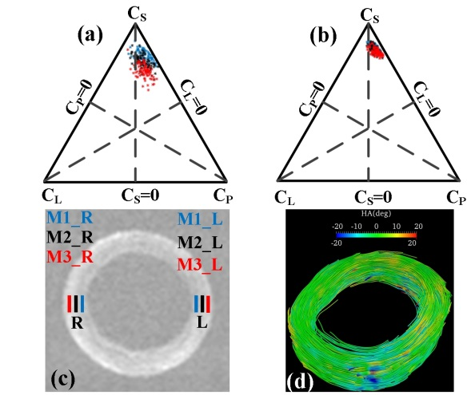

Figure 1 Isotropic/anisotropic diffusion representation using barycentric space (3P). (a and b), The estimated C_{L} and C_{P} values for the tensor measurement of the three regions of media for the intact and open cut sample, respectively. (c) Individual VOIs drawn on an axial slice (T2-W) of the intact sample. (d) Projection of helical angles on the reconstructed collagen fibre tracts.

References
- Flamini et al., EURASIP J Adv Sig PR, (2010).
- Ghazanfari et al., Biochem Biophys Res Co 426, 54-58 (2012)
- Pierce et al., Ann Biomed Eng 38, 2447-2463 (2010)

ACKNOWLEDGEMENT
This project has received funding from the European Research Council (ERC) under the European Union’s Horizon 2020 research and innovation programme (grant agreement No. 637674)

