A strategic assessment of micro-hydropower in the UK and Irish water industry: identifying technical and economic constraints

J. Gallagher^{a,*}, I.M. Harrisª, A.J. Packwoodª, A. McNabola^{b}, A.P. Williamsª
ª School of Environment, Natural Resources & Geography, Bangor University, United Kingdom
^{b} Dept. of Civil, Structural & Environmental Engineering, Trinity College Dublin, Ireland
* Corresponding author. Tel: (+44) 1248 38 2338
Email address: j.gallagher@bangor.ac.uk

Abstract
Energy recovery using micro-hydropower (MHP) technology can enhance the sustainability of the water industry. This paper presents a structured four-step methodology for assessing potential energy recovery sites in water and wastewater infrastructure in regions of the UK and Ireland; at service reservoirs (SRVs), pressure reducing valves (PRVs) and wastewater treatment plants (WWTPs). Step 1 helped identify different all potential energy recovery sites in water and wastewater infrastructure. Step 2 shortlisted the most feasible sites for energy recovery, with the potential to generate an estimated 17.9 GWh per annum. Step 3 considered the technical and economic challenges relating to energy recovery and considered turbine selection, varying flow and site characteristics, feed-in tariffs (FITs) and overall project costs. Lastly, Step 4 provided evidence for the most feasible projects for Wales and Ireland based on capacity; larger than 3.6 or 18.2 kW at WWTP locations, 4.8 or 24.8 kW at PRVs and 12.8 or 22.2 kW at SRV sites, respectively. However, cheaper turbine technology and better financial incentives may improve the feasibility of smaller potential energy recovery sites. The results provide water companies with an estimated feasible capacity for potential energy recovery through MHP installations at different water and wastewater infrastructure sites.

Keywords: energy recovery; geographical information systems; feed-In tariffs; flow and pressure variations.

Introduction
Considerable energy demands are associated with the treatment and distribution of water [1]. The water sector is currently the UK’s 4th most energy-intensive industry, and the significant increase in electricity cost over the last decade is partially responsible for the 159% price rise for water supply since 2004 [2]. The projected population growth in countries such as the UK and Ireland [3, 4] is likely to put additional pressure on water demands. These factors highlight the need to reduce the energy demands of water supply and treatment. In the UK, water companies have adopted a target to reduce their carbon footprint by 20% by 2020 [5], to meet the EU Directive 2009/29/EC [6]. This is likely to lead to greater adoption of renewable energy, where such technology is viable. Given the further predicted increase in electricity prices [7], these projects can serve as a method of reducing the economic and environmental impacts of water supply and treatment [8, 9]. The installation of micro-hydropower (MHP) turbines can provide such opportunities [10, 11]. MHP technology can be integrated into water infrastructure without affecting the quality of service, to extract energy at locations where pressure exists that is in excess of operational requirements [1].

Previous investigations examining the recovery of energy in water infrastructure have outlined suitable locations for MHP installations, including: storage/service reservoirs and water treatment works in the raw water network; break pressure tanks (BPTs) and pressure reducing values (PRVs) in the water distribution network; and inlets and outlets to wastewater treatment plants (WWTPs) at the end of the network. Storage or service reservoirs (SRVs) are located in upland areas and feed into water treatment plants (gravity fed or balance diurnal flow, respectively). SRVs sites typically present the greatest potential for electricity generation as two recent case studies have both demonstrated economic income in excess of €100,000 per annum [8, 12]. BPTs are located in upland water pipelines to release excess pressure to the atmosphere. Energy recovery can take place prior to the break point and does not interfere with downstream pressure [8]. An average of 12 kW (range 2-27 kW) was calculated for potential energy recovery at a number of BPT sites in Ireland [8]. BPTs have been replaced by mechanised PRVs, which are cheaper, require less space and reduce the pressure of flow passing through them to a pre-set level. Their use in water distribution networks has become widespread to reduce leakage losses in the system through pressure management. Replacing a PRV with a MHP turbine can reduce pressure and recover energy in some circumstances, with the potential of generating up to 47 kW highlighted in previous case studies [11, 13, 14]. At the end of the network, the flow of sewage effluent entering, or the treated effluent exiting a WWTP can also be considered for energy recovery using MHP [15-20]. Studies have estimated a potential to produce 100-200 kW of electricity for a number of WWTP sites.

Only a small fraction of the overall potential energy recovery in the water industry has been captured by MHP systems [12, 14, 16]. The typical energy recovery potential for undeveloped sites is due to their smaller size, which make MHP implementation less economically viable. However, government-funded financial incentives for renewable energy generation such as Feed-in Tariffs (FITs) have encouraged water companies to implement some MHP systems. These FITs can be claimed for gravity-fed systems, and not where active pumping occurs. Cost estimations for MHP installations lies in the range of €3,000 to €6,000 per kW [1, 21], and typically need to have a payback period of less than 10 years to be considered economically viable [22]. However, MHP installations less than 25 kW have not been examined in detail and available data on which to base costs estimates is limited at this end of the scale [23]. In addition, PRV sites require flow and pressure control turbines which are more expensive. Similar to other hydropower investigations, these results are likely to be sensitive when a breakdown of project costs is provided – turbine/generator costs, grid connection and civil works [24]. Previous investigations have shown that the cost of the turbine and generator can account for 30 to 40% of the total costs [25]. In a study by Khennas and Barnett [24], these costs averaged 49% (range 8–88%) for a number of MHP installations in the developing world. This suggests that turbine and generator costs have a more significant impact on the economics of a smaller capacity MHP installation.

A geodatabase was created to facilitate the assessment of potential energy recovery sites in regions of the UK and Ireland. The structured four-step methodology developed would help water companies to only consider the most suitable sites to implement MHP within their infrastructure and to prioritise investment in those sites with greatest potential returns. In addition to existing MHP turbines, previously unpublished data on a purpose built pressure control (PC) MHP turbine system was considered as part of the technical and economic assessment for energy recovery in water infrastructure.

Methods

Energy recovery in the water industry

Study area
The study area used to conduct this investigation combined regions of Wales and Ireland as defined by the Hydro-BPT project (www.Hydro-BPT@bangor.ac.uk). This took into account the majority of counties in the east and south of Ireland and some of the major cities in Ireland. The majority of the country was included in the study in Wales as Dŵr Cymru / Welsh Water managed the majority of water infrastructure.

Calculating potential energy
To quantify the potential energy recovery with the installation of the MHP turbines at each of the sites, the estimated power output was calculated using Equation 1.

$P=QρgHe_{o}$ (Eqn. 1)

Where P = power output (kW); Q = flow rate through the turbine (m³/s); ρ = fluid density (kg/m³); g = acceleration due to gravity (9.81 m/s²); H = head available at the turbine (m); e_{o} = overall efficiency of the system (estimated at 65%, similar to that used by previous study [11]).

Economic payback of MHP turbine and generator
An acceptable payback period is currently the primary driver for a MHP installation. The cost of the turbine and generator can be estimated based on flow conditions for each site, and are considered as the most expensive components of a MHP installation. The costs of variable flow and pressure control (PC) turbine/generator units that are designed for water infrastructure were used [26]. Unlike other current turbines, the PC turbine provides a suitable replacement for a PRV in water distribution networks. Costs for Pelton, Francis and Kaplan turbines and generator units were calculated based on previous research by Ogayar and Vidal [25] and are shown in Eqn. 2 and Table 1. In this case, the equations were updated for MHP installations as projects greater than 300 kW were omitted from the dataset to develop the equations. In addition, inflation since 2008 (year of original data collation) was accounted for, to provide more accurate costs in 2014. The economic payback was calculated using Eqn. 3.

$T =a.P^{b}.H^{c}$ (Eqn. 2)

$E = T/{\left(p ×i\right)}$ (Eqn. 3)

Where T = cost of turbine and generator (€); P = power (kW); H = head (m); E = annual electricity generated (kWh); a = constant (2008 to 2014 inflation rate of 1.15005 in Table 1 [27]); b and c = co-efficient for power and head, respectively (Table 1); E = economic payback for turbine and generator (years); p = total power output over one year (kWh); i = income from FITs (€/kWh).

Table 1 – Coefficients for calculating turbine/generator costs adapted from previous studies [25, 26].
Turbine | a |  | b | c |  | Equation
Turbine | ‘08 | ‘14* | b | c |  | n | kW range | R²
PC turbine | - | 37,792¹ | 0.531 | -0.119 |  | 13 | 11-30 | 0.94
Pelton | 6,361 | 7,316² | 0.698 | -0.114 |  | 13 | 25-300 | 0.98
Francis | 131 | 150² | 1.309 | 0.028 |  | 6 | 80-300 | 0.98
Kaplan | 19,264 | 22,155² | 0.440 | -0.152 |  | 23 | 9-300 | 0.98
* It is assumed turbine/generator fixed price across Europe (unlike the other project costs e.g. installation)
¹ Based on 2014 UK pricing list and changed to Euro rate.
² Calculated based on 2014 Euro Spanish inflation rate since 2009 for turbines installed in Spain.

The equations provided a reasonably accurate estimate of the turbine and generator costs and payback within a range of ±12% for the PC turbine, ±20% for the Pelton and Francis turbines and ±30% for the Kaplan turbines. The lack of lower scale MHP data that was used to generate the equation for the Francis turbine costs (n = 6, sites 80-300 kW) led to this turbine not being considered in the economic assessment for this study.

GIS database and mapping resources
For the GIS database, the European Terrestrial Reference System (ETRS89) was used as it is the EU-recommended frame of reference for geodata for Europe [28]. The geodatabase allowed for a spatial and temporal examination of site characteristics and allowed for a comparison of energy recovery and project cost data. The database provided the key variables: site type (e.g. BPT or PRV); coordinates (longitude and latitude, ETRS89 grid); site information (place name, county and country); daily site flow characteristics (mean pressure head (m) and flow (l/s)); the energy recovery (kW); population statistics; economic costs; other relevant site classification details (e.g. nearest grid location). Water infrastructure data were collected from over 10 local authorities in Ireland and Dŵr Cymru Welsh Water in Wales. The quantity and quality of data provided varied significantly but included the location and type of all energy recovery sites and a measure of the pressure and flow characteristics.

Population and boundary data were sourced from the Central Statistics Office in Ireland [29-31] and the Office for National Statistics in the UK [32-34], with reference data accessed through Eurostat, the European Commission statistics database [35, 36]. To overcome problems associated with combining different national census geographies, an approach outlined by the European Forum for GeoStatistics [35] to produce 1 km population grid data was followed, using the baseline 2006 grid as a reference year. The national and European statistics bodies provided census data for 2011 and similar population grids were produced. Sites were then classified as remote, rural or urban, based on European definitions (≥300 people per km² is an urban area) [37]. Sites were also classified as residential, domestic or industrial using a visual examination process. All sites were categorised based on the predominant land use (e.g. housing estates, pasture or industrial area) within the vicinity of each MHP installation. This was undertaken using Bing Maps and Google seamless orthophoto backdrops via the Arc2Earth extension within ArcGIS (ESRI, 2009-2013) [38].

Feasibility process for examining MHP sites
Energy recovery is dependent on the characteristics of sites that were collated and input to the geodatabase. From previous findings, the energy recovery potential for most sites in water infrastructure in regions of Wales and Ireland ranged from 1-25 kW [9]. The economic feasibility for implementing MHP becomes more challenging as the capacity for generating electricity is reduced. The feasibility of MHP sites is also affected by the technical challenges presented by different sites characteristics. Figure 2 displays the four-step methodology adopted for this study to assess the technical and economic challenges of a MHP installation in water infrastructure.

This strategic approach outlined in Figure 2 considers only the most suitable sites by examining energy recovery potential (Step 2) and examining the technical and economic constraints for each MHP installation (Step 3). The first stage (Step 1) outlined the types of site that exist in water and wastewater infrastructure for energy recovery: SRVs, BPTs, PRVs and WWTPs. Following this, local infrastructure was examined at each MHP site to identify the technical challenges of implementing MHP. The shortlisted sites were considered based on an estimation of energy recovery at each site. The technical and economic constraints were explored for shortlisted sites and included assessing grid connection and FIT, turbine selection and economic payback. The cost of the turbine/generator unit for each site provides an initial estimate for the primary components required for energy recovery. Based on this, the additional project costs were estimated based on local site characteristics to determine the economic feasibility of the shortlisted sites.

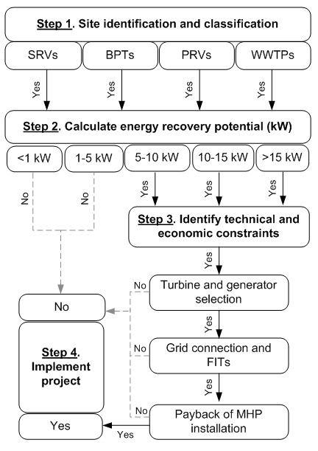
Figure 1 – Four-step methodology for selecting a feasible MHP site in water or wastewater infrastructure.

Step 1. Site identification and classification
Site categorisation was based on (i) local population grid densities and (ii) a visual examination of each site. This was to strengthen the spatial and temporal analysis and enhance details relating to site classification in the geodatabase. It provides evidence for water companies to assess energy recovery at each type of site and supports other technical and economic decisions for developing a MHP project.

Step 2. Calculate energy recovery potential
The energy recovery potential for each site was calculated based on 2011 average flow and pressure data using Eqn.1. Sites were grouped based on the estimated energy recovery. These groupings were created to determine the number of sites on the lower and higher ends of the energy recovery spectrum. Based on previous literature, sites less than 5 kW (and in some cases <10 kW) were considered too small to be economically viable for implementing MHP technology [39, 40]. Furthermore, sites larger than >15 kW were grouped together as they were classified at a different FIT capacity band, thus the economic payback was different between these and the smaller sites.

Step 3. Identify technical and economic constraints
Each installation can have a range of variable components: the turbine/generator, civil works, electricity grid connection and other ancillary or consultancy costs. The technical constraints of the remaining sites were examined and the geodatabase was used to estimate the costs associated with the selection of a suitable MHP turbine and generator.

The selection of a suitable turbine and generator is dependent on having an understanding of historical demands at each MHP site. Flow and pressure characteristics in pipes can be difficult to predict due to the diurnal, weekly and seasonal variations in water supply and wastewater collection. This provided a number of challenges relating to turbine design and costing, as it would affect long-term efficiencies and the energy recovery at each site. Flow variations are also influenced by external strategies implemented to reduce water demand, such as smart metering, leakage control and behavioural change [41]. Historical flow and pressure data were examined for a subset of PRV sites as they represented the most economically sensitive sites. The analysis provided a better understanding of the level of robustness required for each MHP installation. The flow data used to develop the turbine cost equations was also used to select the most suitable turbine at each site.

Step 4. Implement project
This step will define what sites are feasible based on the previous findings and summarise the requirements for MHP projects to be successfully implemented.

Results & discussion

Step 1. Site identification and classification
Based on site classification, some assumptions can be made relating to local infrastructure. However, an evidence base to justify these assumptions can provide a clearer picture for the true potential of these MHP installations. A number of factors were considered in Table 2 to highlight the technical challenges for installing MHP at water and wastewater infrastructure sites.

Table 2 – Identifying local infrastructure at MHP sites in water and wastewater networks.
Site type | Considerations
SRV | - Storage reservoirs typically feed into water treatment works, while service reservoirs can store treated water. The availability of an electricity grid connection depends on the type of reservoir.  - These sites typically have high flows and/or pressure heads, therefore good turbine efficiencies can be achieved to maximise energy recovery.  - Electricity generated from a storage reservoir can be used directly by the water treatment works that they feed. In addition, these energy recovery sites are likely to be the only locations where FITs are applicable.
PRV | - PRVs are located throughout the water distribution network and the availability of a suitable electricity grid connection will therefore vary significantly.  - Site infrastructure for PRVs typically consists of a chamber which varied in size and the need for additional civil works depended on the specific dimensions of a chamber.  - The electricity generated at PRV sites is restricted by the diurnal changes in flow and the limited allowance for MHP turbines to extract only excess energy in the system.
WWTP | - As WWTPs require electricity to power operations, a suitable grid connection at each site is likely. Electricity can optionally be used on site.  - Robust turbine design and suitable screening is required prior to treatment for energy recovery from raw sewage.  - Low head presents more notable challenges for electricity generation as a more robust turbine design is required for MHP installations at both inlet and outlet points of WWTPs.  - In some cases, treatment outflows present variable flows for outlets located in tidal zones, which requires pumping and significantly limits energy recovery.

From the findings outlined in Table 2, the technical challenges presented are unique for each type of site. The availability of an electricity grid connection at energy recovery sites was a common constraint. Two methods of analysis were considered to determine the proximity of a suitable grid connection: (i) 1 km population grid densities to classify sites as remote, rural or urban and (ii) a visual inspection to determine if a site was in an agricultural (A), domestic (D) or industrial (I) area. This exercise strengthened the spatial and temporal analysis and enhanced the degree of detail relating to site classification.

The majority of PRVs were noted to be in urban areas and thus near to an electricity grid connection. As previously stated in Table 2, SRVs typically feed into water treatment works which require electricity grid connections. Similarly, WWTPs would have access to electricity for similar reasons. The capacity of single- and three phase supply for small scale generation is up to 20 kW and 5 MW [42], which is suitable for MHP installations. The majority of domestic (D) and agricultural (A) consumers would be connected to a single-phase supply [43], while industrial consumers are likely to require a three-phase connection.

Based on the visual inspection process, all PRV sites were classified as domestic or industrial in Ireland and Wales, with the majority of sites in both countries identified as domestic. With the exception of four control valve sites, the maximum energy recovery at PRV sites was calculated to be 31 kW, thus all grid connections were considered suitable for MHP installations. The control valves all exceeded this value and a three-phase connection would be considered necessary at two of the sites, with 99 kW and 212 kW of potential energy. These sites were considered to be in domestic areas, thus an upgrade to the local grid may need to be considered. The small number of both SRV and WWTP energy recovery sites were located in all three types of site. In total, five SRV sites and two WWTP sites were considered to exceed the 20 kW single-phase threshold. For most of these sites, the electricity generated would be used directly on site. If it was exported, both WWTP sites and two SRV sites were located in industrial areas and the availability of a suitable three-phase supply was more probable. The visual inspection of sites improved the decision-making process and can be a more effective method of determining the proximity of an electricity grid connection. Different limits currently exist for grid connections to single- and three-phase supply for both regions. However, this may change in the future with upgrades of the grid networks. Therefore, the lack of uniformity of the grid provides a constraint for carrying out a technical feasibility of sites at a regional scale.

Step 2. Calculate energy recovery potential
The energy recovery potential was estimated using Eqn.1 and was based on 2011 average flow and pressure characteristic data supplied by water suppliers in Ireland and Wales. From the data supplied by water companies, a number of sites were discounted due to missing data. Almost 100 WWTP sites were omitted from the study due to low flow rates and head conditions. Table 3 provides the potential for energy recovery across five different generation capacity groupings.

The results from Table 3 show that a significant fraction of sites in both regions falls within the two lower generation capacity groups, yet these sites only contribute to a small percentage of the total estimations for energy recovery potential (10.7%). Based on previous literature, a lower threshold limit of 5-6 kW would make these MHP installations not economically feasible [39, 40]. Therefore, a 5 kW threshold was set at this step of the analysis to allow for sites that may cross the threshold due to variations and increases in their energy recovery potential. Of the initial 238 sites, only 80 of the sites were shortlisted for Step 3, with these sites having the potential to generate 17.9 GWh of electricity per annum. This translated as focusing development of 34% of the sites could recover 89% of the total energy potential.

Table 3 – Estimated energy recovery at MHP sites in Ireland and Wales for 2011.
 |  | Energy recovery potential (kW) |  |  |  |  | Total
 |  | <1 kW | 1-5 kW | 5-10 kW | 10-15 kW | >15kW | Total
Ireland | No. of sites | 10 | 13 | 6 | 6 | 16 | 51
Ireland | Potential (GWh) | 0.03 | 0.25 | 0.42 | 0.65 | 7.91 | 9.26
Ireland | Homes supplied¹ | 5 | 49 | 84 | 129 | 1,578 | 1,845
Ireland | Financial savings² | €4 k | €34 k | €58 k | €88 k | €1,084 k | €1,268 k
Ireland | t CO₂e savings³ | 14 | 131 | 223 | 341 | 4,178 | 4,239
Wales | No. of sites | 58 | 77 | 30 | 10 | 12 | 187
Wales | Potential (GWh) | 0.19 | 1.68 | 1.95 | 1.05 | 5.94 | 10.82
Wales | Homes supplied¹ | 51 | 443 | 516 | 278 | 1,569 | 2,857
Wales | Financial savings² | €23 k | €201 k | €234 k | €127 k | €713 k | €1,298 k
Wales | t CO₂e savings³ | 93 | 810 | 943 | 509 | 2,869 | 5,225
Total | No. of sites | 68 | 90 | 36 | 16 | 28 | 238
Total | Potential (GWh) | 0.22 | 1.93 | 2.37 | 1.70 | 13.85 | 20.07
Total | Homes supplied | 56 | 492 | 600 | 407 | 3,146 | 4,702
Total | Financial savings | €27 k | €235 k | €292 k | €215 k | €1,797 k | €2,566 k
Total | t CO₂e savings | 107 | 941 | 1,166 | 850 | 7,047 | 10,112
¹ Average household consumption of 5,016 and 3,787 kW per annum in Ireland & UK [44, 45].
² Disaggregated business electricity prices in 2013 of 13.7 c/kWh (Ireland) and 12.0 c/kWh (UK) [46].
³ 2013 figures of 528 and 483 g CO₂e per kWh in Ireland & UK for electricity generation [47, 48].

In total, 238 sites were included in Step 2 of the analysis and the potential energy recovery was estimated at 20.1 GWh per annum from the water network.

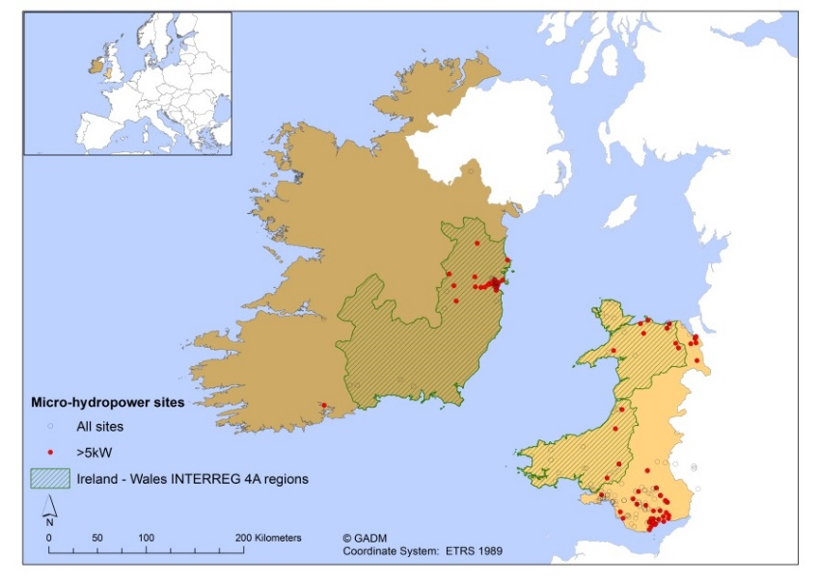
Figure 2 – Potential energy recovery sites (>5 kW) from Step 1 of feasibility study for MHP installations in Ireland-Wales regions.

Based on the different types of site, Table 4 presents the breakdown of sites for each group. No BPTs were found to have a capacity greater than the 5 kW threshold and thus were omitted.

Table 4 – MHP site classification in Ireland and Wales.
Site classification |  | No. of sites |  |  |  |  | Energy recovery  (kW)
 |  | 5-10 kW | 10-15 kW | >15kW | Total |  | Energy recovery  (kW)
Ireland | SRV | 1 | 3 | 4 | 8 |  | 276
Ireland | PRV* | 5 | 1 | 10 | 16 |  | 585
Ireland | WWTP | 0 | 2 | 2 | 4 |  | 164
Wales | SRV | 1 | 0 | 5 | 6 |  | 490
Wales | PRV | 25 | 8 | 5 | 38 |  | 397
Wales | WWTP | 4 | 2 | 2 | 8 |  | 134
Total | SRV | 2 | 3 | 9 | 14 |  | 766
Total | PRV* | 30 | 9 | 15 | 54 |  | 982
Total | WWTP | 4 | 4 | 4 | 12 |  | 298
* Four control valves included within PRV group in Ireland.

PRVs represented two-thirds of energy recovery sites in both countries and almost half of the total potential for energy recovery. A similar number of SRV and WWTP sites were identified in both countries.

Step 3. Identify technical and economic constraints

Turbine and generator selection
Examining historical flow and pressure characteristics can provide a better understanding of the long-term potential for energy recovery in water and wastewater infrastructure. In particular, PRV locations are part of the distribution network responsible for supplying domestic and industrial consumers. SRV and WWTP sites are located at the start and end of the water supply cycle and flow characteristics can be linked to growth or decline in population or industry. However, network data was not available for analysis of these sites.

A subset of ten PRV sites in Ireland (four trunk and six distribution mains) was examined to explore trends in 12 years of historical flow and pressure data. This analysis identified variations at these energy recovery sites. The maximum flow and pressure values indicated the broad range of flows that has occurred at the energy recovery sites. Expressing the standard deviation (SD) as a percentage of the average, the trunk mains demonstrated higher values (29-52%) than the smaller distribution mains (19-24%). The variability in pressure was less significant; an average SD of 23% for trunk mains compared to 13% for distribution mains (excluding 88% for Site 10 as the PRV was only fully open or closed). The capacity of these sites were all within the >15 kW category, and variability (expressed as percentage SD) followed a similar pattern to the pressure results; 2-6% for most sites, with high pressure SD measurements of 16% and 25% at Site 10 and Site 4, respectively.

Suitability of grid connection and FIT rate
In the UK and Ireland, the government offers financial incentives such as FITs to support growth in the renewable energy sector [49]. The FIT band is selected based on the energy recovery potential of a site. A breakdown of annual differences in flow and pressure was examined for a number of sites to identify the impact of variability on selecting a suitable turbine size and maximising the income from FITs. Figure 3 illustrates the breakdown of annual flow and pressure variations and the energy recovery for three of the sites over the same period. Figure 3(a) demonstrates the unique flow and pressure characteristics of each site. The power output in Figure 3(b) includes the SD for each year.

The results shows that the average historical analysis does not consider circumstances where the capacity falls below the >15 kW threshold. These findings lead to questions relating to the selection of a turbine, as future changes in flow characteristics may change the systems efficiency, the suitability of the existing grid connection and the potential to change the FIT band (e.g. from generating less than 15kW to greater than 15 kW). Energy recovery from water and wastewater infrastructure is likely to be impacted due to growing populations and climate change impact on water sources.

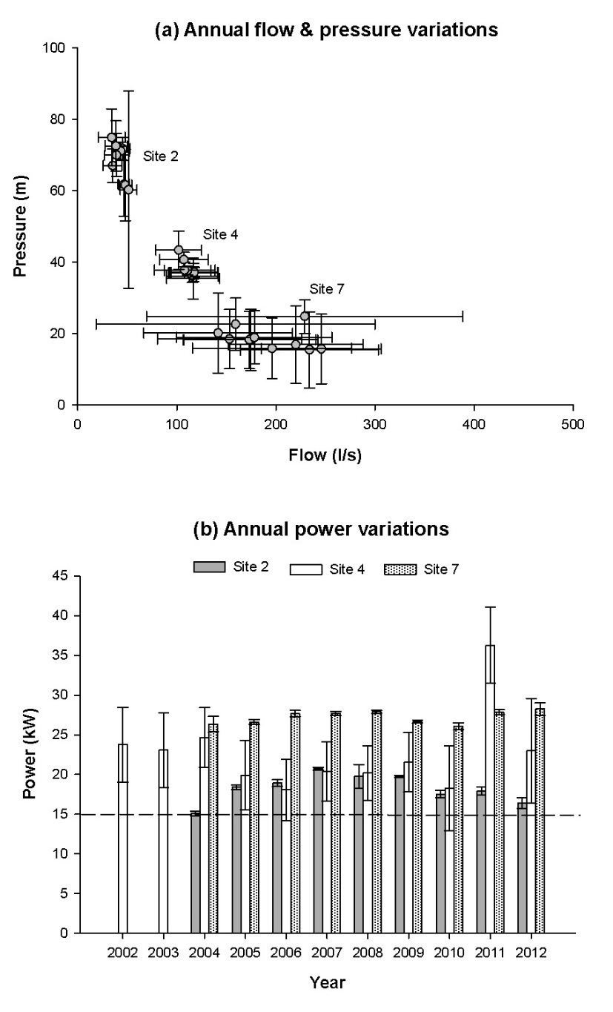
Figure 3 – Annual variations from 2002 to 2012 for (a) flow and pressure and (b) power at three PRV sites.

Economics of turbine selection
The International Renewable Energy Agency report notes that the cost of the turbine/generator unit varies significantly as a percentage of the total project costs [50]. This ranges in literature from 30% [25] to an average of 49% (ranging from 8% and 88%) in developing countries [24]. The British Hydropower Association (BHA) outlined the key differences in costs between low and high pressure installations, with low head projects requiring more robust equipment which makes these projects more expensive [51]. Turbine suitability was defined based on site details and costs were calculated for each site type accordingly (Figure 4).

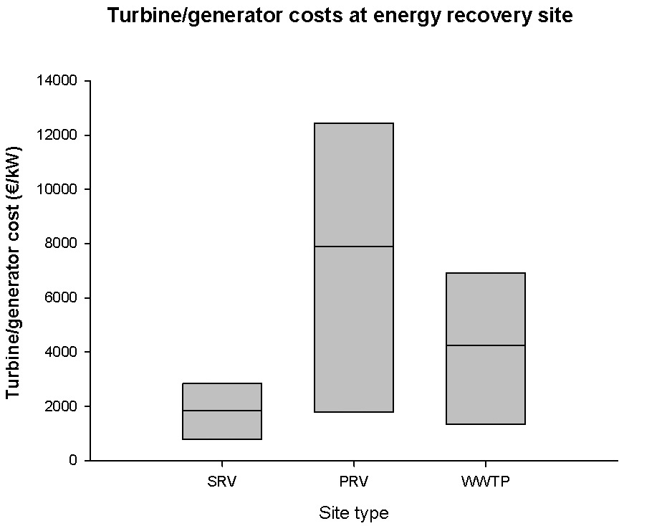
Figure 4 – Calculated turbine/generator costs for MHP sites in water and wastewater infrastructure (includes average, minimum and maximum costs; expressed as € per kW capacity).

The results from the economic analysis demonstrated the considerable variability in estimation of costs for MHP installations. For example, a PC turbine is necessary at PRV sites and has been successfully implemented by water companies in the UK [52], yet is substantially more expensive than the other turbines. Based on these criteria, a sensitivity analysis was undertaken to determine what installations are economically feasible. Table 5 accounts for additional project costs, such as consultancy costs, civil works and grid connection. A payback of greater than 10 years was considered unfeasible based on current turbine/generator costs [22].

Table 5 – Sensitivity analysis for MHP turbines to ensure economic feasibility at water and wastewater infrastructure sites (based on current FIT rates in Ireland and Wales).
Site info |  |  |  | Turbine selection* | Minimum size of turbine installations (kW)  (based on % contribution of turbine/generator to total cost)
Country | Type | n |  | Turbine selection* | 30% | 50% | 70%
Ireland¹ | SRV | 8 |  | Pelton | 22.2 ± 16.1 | 13.3 ± 9.7 | 9.5 ± 6.9
Ireland¹ | PRV | 16 |  | PC turbine | 57.8 ± 34.7 | 34.7 ± 20.8 | 24.8 ± 14.9
Ireland¹ | WWTP | 4 |  | Kaplan | 30.3 ± 22.3 | 18.2 ± 13.4 | 13.0 ± 9.5
Wales² | SRV | 6 |  | Pelton | 12.8 ± 10.9 | 7.7 ± 6.5 | 5.5 ± 4.7
Wales² | PRV | 38 |  | PC turbine | 11.3 ± 3.3 | 6.8 ± 2.0 | 4.8 ± 1.4
Wales² | WWTP | 8 |  | Kaplan | 5.9 ± 4.4 | 3.6 ± 2.7 | 2.5 ± 1.9
* Most suitable turbine selected based on site flow characteristics and site requirements.
¹ FIT rate of 0.09 c/kwh generated for micro-generation set by Electric Ireland [53].
² FIT rate bands in UK ranging from 15-22 p/kWh and savings of 12 p/kWh for on-site use [46, 54].

Based the different payback scenarios outlined in Table 5, it is clear that the additional projects costs can greatly impact on the feasibility of MHP installations. It displays average costs and variability (as standard deviations) which is significant in the estimation for most installations. These results are dependent of the allowance of FITs at all energy recovery sites; however tariffs are not guaranteed at sites where pumping takes place within a network.

Step 4. Implement project
Based on the findings of Step 3, the results outlined projects that can be successfully implemented if they meet the capacity thresholds and select the advised turbine. Firstly, SRV sites showed the greatest potential, representing some of the highest capacity sites. The Pelton turbine could provide a cost effective system for these sites. Based on regional FIT rates and assuming the turbine/generator accounts for only 30% of the total project costs, sites smaller than 12.8 kW in Ireland and 22.2 kW in Wales may not be economically feasible.

The need for pressure control turbines and the typically low potential for electricity generation highlight the challenges of ensuring an acceptable economic payback for water companies at PRV sites. If the turbine/generator is assumed to account for 70% of the total project costs, installations over 4.8 kW are feasible in Wales based on current FITs. However, the lower FIT rate in Ireland means that PC turbines are not feasible unless energy recovery is greater than 24.8 kW.

The Kaplan turbine was considered the most suitable for low head conditions at WWTP sites. In most cases, the economic payback was considered acceptable for sites where the turbine/generator contributed 50% of the total project costs. Energy recovery is feasible at sites greater than 18.2 kW in Ireland and for all sites over 3.6 kW in Wales.

The economic payback for potential energy recovery sites in water and wastewater infrastructure is sensitive to changes in FITs and the variability in costs for civil works, grid connection and turbine selection to suit flow characteristics. The feasibility of MHP implementation requires strategies to minimise project costs through adopting new and cheaper turbine technology and a modular design for a range of installation types.

Conclusions
This study assesses the technical and economic constraints for potential energy recovery sites in water and wastewater infrastructure for regions of Wales and Ireland. A structured, four-step methodology was developed to help identify potential sites for water companies. Step 1 helped identify different potential energy recovery sites in water and wastewater infrastructure (SRV, BPT, PRV and WWTP sites) with each site type presenting different technical challenges. Step 2 shortlisted eighty of the sites as the most suitable for energy recovery, with the potential to generate 17.9 GWh per annum. PRV sites represented two-thirds of the total number of sites, yet had a lower average energy recovery compared to other locations. Step 3 considered the technical and economic challenges of capturing this potential. Turbine selection for each type of site presented challenges based on historical flow characteristics and three turbines were assessed (two established designs and a pressure control turbine) for energy recovery at these sites. Calculated turbine/generators costs as a fraction of the total project costs varied significantly for different turbines and site types, with future Feed-in Tariffs (FITs) presenting a long term uncertainty. Step 4 provided evidence for the most feasible projects for Wales and Ireland based on capacity; sites larger than 3.6 or 18.2 kW at WWTP sites, 4.8 or 24.8 kW at PRV sites and 12.8 or 22.2 kW at SRV sites, respectively. However, cheaper turbine technology and better incentivisation of MHP could improve the uptake of smaller sites in the future. The results provide water companies with an estimated capacity that is feasible for potential energy recovery through MHP installations at different water and wastewater infrastructure sites.

Acknowledgements
This project is part funded by the European Regional Development Fund (ERDF) through the Ireland–Wales Programme (INTERREG 4A).



References
[1] A. McNabola, P. Coughlan, L. Corcoran, C. Power, A.P. Williams, I.M. Harris, J. Gallagher, D. Styles, Energy recovery in the water industry using micro-hydropower: an opportunity to improve sustainability, Water Policy, 16 (2014) 168-183.
[2] C. Thomas, Energy Bills Will Rise, Warns Ofgem Chief: Over Reliance On Gas, Inflation And Power Station Closures To Blame, in, The Huffington Post UK, 2013.
[3] ONS, Mid-1971 to Mid-2011 Population Estimates: England, Wales and regions; estimated resident population in, Office for National Statistics, Fareham, 2013.
[4] CSO, Census of Population 2011 Preliminary Results, in, Central Statistics Office, 2011.
[5] DECC, Sub–national total energy consumption statistics for 2008, in, Department of Energy & Climate Change, 2010.
[6] EA, A low carbon water industry in 2050, in: Evidence, Environment Agency, Bristol, 2009, pp. vi, 41 p.
[7] DECC, Electricity Generation Costs, in, Department of Energy & Climate Change, 2012.
[8] A. McNabola, P. Coughlan, A.P. Williams, The technical & economic feasibility of energy recovery in water supply networks, in: M. Perez-Donsion (Ed.) International Conference on Renewable Energies and Power Quality, Las Palmas de Gran Canaria, 2011.
[9] A. McNabola, P. Coughlan, L. Corcoran, Power C., A.P. Williams, I.M. Harris, Taylor R., A. Packwood, Energy recovery in the water & waste water industry using micro-hydropower: a review, in: IASTED International Conference on Power and Energy Systems, Naples, Italy, 2012, pp. pp1-7.
[10] C. Power, P. Coughlan, A. McNabola, The applicatility of hydropower technology in waste water treatment plants, in: Proceedings of the International Water Association World Congress on Water, Climate and Energy, Dublin, Ireland, 2012.
[11] L. Corcoran, P. Coughlan, A. McNabola, Energy recovery potential using micro hydro power in water supply networks in the UK & Ireland, Water Science & Technology, 13 (2013) pp 552-560.
[12] J.S. Ramos, H.M. Ramos, Sustainable application of renewable sources in water pumping systems: Optimized energy system configuration, Energy Policy, 37 (2009) 633-643.
[13] B.L.A. Da Silva, F.L. Tofoli, L.S. Scartazzini, Case Study: Hydroelectric generation employing distribution network in pato branco, Brazil, in: Proceedings of the IASTED International Conference on Power and Energy Systems, Crete, Greece, 2011.
[14] M. Giugni, N. Fontana, D. Portolano, Energy Saving Policy in Water Distribution Networks, in: International Conference on Renewable Energies and Power Quality (ICREPQ’09), European Association for the Development of Renewable Energies, Environment and Power Quality, Valencia (Spain), 2009.
[15] A.A. Williams, N.P.A. Smith, C. Bird, M. Howard, Pumps as Turbines and Induction Motors as Generators for Energy Recovery in Water Supply Systems, Water and Environment Journal, 12 (1998) 175-178.
[16] R.K. Saket, Design, development and reliability evaluation of micro hydro power generation system based on municipal waste water, in: Electric Power Conference, 2008. EPEC 2008. IEEE Canada, 2008, pp. 1-8.
[17] EcoGeneration, Powering Sydney Waters carbon nuetral future, in: News article, 2008.
[18] Engineering & Technology, Power generation by Archimedes screw, in: Engineering & Technology, 2010.
[19] F.M. Griffin, Feasibility of energy recovery from a wastewater treatment scheme, Proceedings of the Institution of Mechanical Engineers, Part A: Journal of Power and Energy, 214 (2000) 41-51.
[20] C. Power, A. McNabola, P. Coughlan, Development of an evaluation method for hydropower energy recovery in wastewater treatment plants: Case studies in Ireland and the UK, Sustainable Energy Technologies and Assessments, 7 (2014) 166-177.
[21] T. Gaius-obaseki, Hydropower opportunities in the water industry, International Journal of Environmental Sciences, 1 (2010) 392-402.
[22] A. McNabola, P. Coughlan, A.P. Williams, Energy recovery in the water industry: an assessment of the potential of micro-hydropower, Water and Environment Journal, 28 (2014) 294–304.
[23] O. Paish, Micro-hydropower: Status and prospects, Proceedings of the Institution of Mechanical Engineers, Part A: Journal of Power and Energy, 216 (2002) 31-40.
[24] S. Khennas, A. Barnett, Best practice for sustainable development of micro hydro power in developing countries, in, London Economics & deLucia Associates, Cambridge Massachusetts, USA, The Schumacher Centre for Technolgoy and Development, 2000.
[25] B. Ogayar, P.G. Vidal, Cost determination of the electro-mechanical equipment of a small hydro-power plant, Renewable Energy, 34 (2009) 6-13.
[26] Zeropex, Pricelist for Difgen tubines, in, 2014.
[27] FXtop, Inflation calculator, in, 2014.
[28] Georepository, Datum: European Terrestrial Reference System 1989, in: Geodetic Datum used in Europe - ETRS89, 2014.
[29] CSO, Standard Report on Methods and Quality (v1) for Census of Population, 2006, in: C.S. Office (Ed.), 2009.
[30] CSO, Census 2011 Boundary Files, in: C.S. Office (Ed.), 2014.
[31] CSO, Census 2011 Small Area Population Statistics (SAPS), in: C.S. Office (Ed.), 2014.
[32] ONS, 2011 Census Data Catalogue (Version 16), in: O.f.N. Statistics (Ed.), 2014.
[33] ONS, OA boundary data in: O.f.N. Statistics (Ed.), 2014.
[34] ONS, 2011 Census Bulk Data Download (Release 2), in: O.f.N. Statistics (Ed.), 2014.
[35] EFGS, GEOSTAT 1A – Representing Census data in a European population grid in: E.F.f. GeoSstatistics (Ed.), 2012.
[36] Eurostat, Population Distribution - Demography, in: E.F.f. GeoStatistics (Ed.), 2014.
[37] Eurostat, Urban-intermediate-rural regions, in: Around 40% of the EU27 population live in urban regions… …and almost a quarter in rural regions, Eurostat news release, 2012.
[38] Google Earth, Getmapping plc 2014, in, 2014.
[39] EES Consulting, City of Homer: Water Supply System Micro-Hydro Feasibility Study, in, 2009.
[40] Renewables First, Introducing micro and small hydropower, in, Renewables First, 2011.
[41] Royal Geographical Society (with IBG), Water policy in the UK - The challenges, in, RGS-IBG Policy Briefing, 2012.
[42] Northern Ireland Electricity, Connection for small scale generation, in, 2014.
[43] SEAI, A Report on Micro-Generation in Ireland, in, Sustainable Energy Authority of Ireland, 2010.
[44] SEAI, Energy in the Residential Sector - 2013 Report, in: E. Dennehy, M. Howley (Eds.), Sustainable Energy Authority of Ireland, 2013.
[45] DECC, Sub-national electricity consumption statistics 2012 - Regional and local authority level statistics (2012 data), in: S. Khan, S. Stadnyk (Eds.), Department of Energy & Climate Change, 2013.
[46] SEAI, Electricity & Gas Prices in Ireland. 2nd Semester (July - December) 2013, in: M. Howley, M. Holland (Eds.), Sustainable Energy Authority of Ireland, 2014.
[47] SEAI, Energy in Ireland: Key Statistics 2013, in: M. Howley, M. Holland (Eds.), Sustainable Energy Authority of Ireland, 2013.
[48] Defra, 2013 GHG conversion factors for company reporting: methodology paper for emission factors, in, DEFRA, UK, 2013.
[49] DECC, Sub-regional Feed-in Tariffs confirmed on the CFR statistics, in, Department of Energy & Climate Change, 2013.
[50] IRENA, Renewable Energy Technologies: Cost Analysis Series, in, International Renewable Energy Agency, 2012.
[51] BHA, A Guide to UK Mini-Hydro Developments, in, The British Hydropower Association, 2005.
[52] Zeropex, Pen y Cefn Water Treatment Works - Difgen Turbine Installation, in: I. Goddard (Ed.), 2013.
[53] Electric Ireland, Micro-generation Scheme, in, 2014.
[54] OFGEM, Feed-in Tariff Payment Rate Table for Non-Photovoltaic Eligible Installations for FIT Year 5 (1 April 2014 to 31 March 2015), in.

