Evaluation of an eLearning teaching innovation to assist clinical radiation therapy educators in the provision of student feedback.

Abstract
Background
Clinical placement is an integral part of the Radiation Therapy undergraduate programme. Feedback and formative assessment during clinical placement are regarded as key to developing clinical skills and competencies. Students regularly report dissatisfaction with the feedback process while clinical educators report heavy clinical workloads and a lack of guidance on feedback mechanisms as barriers to providing meaningful student feedback.
Methods
An eLearning teaching intervention was developed to support radiation therapists in the provision of student feedback in the clinic. Thematic analysis was used to report attitudes to feedback and feedback practices collected in a pre and a post intervention evaluation.
Results
30 radiation therapists completed the module and pre and post intervention evaluations. Prior to taking the module just over half of respondents stated that they offered regular and on-going feedback throughout the student’s placement. Positive attitudes to feedback were reported. Following completion of the eLearning tool respondents reported a higher level of confidence in the provision of student feedback and almost 70% said the module had changed how they would approach the feedback process by using feedback models in the future.
Discussion
Good and timely feedback is essential and allows a student opportunity to improve prior to the end of the placement. It also teaches students how to self-assess and self-reflect - skills that they can use in continuous professional development after they graduate. Radiation therapists appreciate the structure that using a model in the feedback process offers.
Conclusion
This eLearning teaching intervention was received favourably by radiation therapists who are key to creating a culture of feedback in the clinical environment that will facilitate students in becoming competent healthcare professionals.

Introduction

The development of clinical skills is central to the training of all healthcare professionals. Feedback and formative assessment in clinical skills acquisition and assessment is key to enhancing learning within any teaching institution. Yet, despite the importance of feedback in student learning, clinical educator and student perception and actions related to feedback have historically received less attention than assessment (1).

In radiation therapist education, the value of regular feedback is highly regarded by both students and their clinical educators with formative feedback to students reported as ‘usually’ or ‘always’ available (2). While this is positive, others have stressed the importance of developing knowledge and understanding among clinical radiation therapy educators about the different types of feedback and how these can be adapted to different clinical contexts (3).

In order to ensure that students become competent clinicians, education in the clinical learning environment needs to be more than just supervision. Feedback is widely accepted to be an important part of the learning process and it is an important part of the academic component of a students’ life (4). It is fundamental to facilitating students’ development as independent learners, who can monitor, evaluate and regulate their own learning (5).

The provision of meaningful feedback can greatly enhance students learning and achievement (6). Without feedback mistakes can go unchecked, excellence may not be reinforced, and the student may mistakenly perceive a lack of input as a sign that a reasonable standard has been achieved (7). Teaching and learning quality increases the academic reputation of an institution – a metric which is weighted highly in compiling university rankings(8) - attracting both national and international students(9).

Culturally, feedback can be difficult for clinical educators and students alike and the clinical learning environment is universally deemed challenging (10). Clinical educators and students should be empowered to understand the qualities of good feedback. The development of self-assessment abilities is desirable to encourage professionalism, life-long learning and competency in the health professional graduate (11).

The purpose of this eLearning intervention was to instruct and support clinical educators involved in giving feedback in the clinical learning environment. This tool provided participants with a comprehensive overview of feedback and the application of feedback in the clinical setting. Participants’ attitudes to feedback were evaluated before completing the learning intervention to assess the perception of feedback and current feedback practices in RT departments. A post intervention evaluation was used to assess the impact of the intervention on promoting a culture of support and student participation in teaching and learning among clinical educators.

Materials and Methods
Ethical approval was requested from the xxxxxx on October 1st 2019. As part of the ethics application process a participant information leaflet was submitted as supporting documentation detailing the purpose of the study and how to participate. Respondents were informed that all data collected would be anonymised and stored confidentially. Participants were also reminded that participation in the study was voluntary and not a prerequisite to accessing and completing the module material. This research study was approved by the xxxxxxxxxxx on November 22nd 2019 and research conducted between January and May 2020.

Developing the eLearning Teaching Intervention
An e-Learning teaching innovation was developed to enhance, develop and support clinical educators and students in feedback exchange in the clinical learning environment in xxxxxxxxxx. A final version was developed and made available on the xxxxxxxxx virtual learning environment. This novel eLearning intervention could be completed in two hours and was suitable for clinical educator and student use. The intervention tool consisted of the following elements:
1. Pre-intervention evaluation - anonymous questionnaire to ascertain baseline attitudes and feedback practices prior to completing this eLearning tool (Appendix 1).
2. Online module - The module explained the concept of feedback in the clinical environment and emphasised the importance of feedback in the learning process. Theoretical components of feedback such as the components of a successful learning cycle, role of the student in the feedback process, the types of feedback that can be offered (formal and informal) and how the Ask-Tell-Ask Model is applied in the feedback process. Videos including clinical scenarios specific to radiation therapy practice illustrating the concepts of good and poor feedback based on the Ask/Tell/Ask model were also included. The emphasis was on teaching and learning and student engagement in the process. Participants were offered assessment opportunities, in the form of multiple-choice questions, at intervals throughout the module to self-evaluate key learning principles around feedback.
3. Post intervention evaluation - anonymous questionnaire to ascertain if attitudes and future approaches to feedback have changed after completing the eLearning innovation (Appendix 2).

Study Design
All members of the research team were involved in the design of the pre and post intervention evaluations. The survey tool used was Microsoft Forms. Demographics surveyed included age, years of clinical experience, education level and experience of eLearning activities. The personal attitudes and perceptions of participants towards the feedback process (before and after completing the teaching module) were measured using a combination of multiple choice, open ended and Likert scale questions. Finalised evaluations were embedded in the module. If participants did not wish to participate in the study, they had the option to skip the evaluation and proceed to the teaching content only.
Participant Recruitment
The career structure for radiation therapists in the Republic of Ireland is radiation therapist grade (Post graduation up to 3 years experience), senior grade (over 3 years experience) and Clinical Specialist (over 6 years experience), coupled with completion of competences for each grade level. As all radiation therapists, regardless of career level have a role in clinical education, all radiation therapists working in the Republic of Ireland were invited to complete the eLearning intervention and participate in the study. An information leaflet was emailed to all departments inviting radiation therapists to register for the module. A hard copy was also mailed to all departments to be displayed in common areas such as staff rooms. After the information leaflets were distributed a total of 60 radiation therapists requested access to the module.

Data analysis
The Statistical Package for the Social Sciences (SPSS), Version 24.0 and NVivo, Version 12.0 were used for data analysis. Descriptive and inferential statistics were used to analyse the findings. Spearman’s correlations were used to determine the association between years of experience working as a radiation therapist and confidence in providing feedback to students and years of experience in assessing students and confidence in providing feedback prior to taking this teaching intervention. Thematic analysis was performed and identified themes coded in NVivo. Word frequency analysis of open responses was also performed using NVivo.

Results

Participant Demographics:
30 radiation therapists participated in the evaluations. 87.9% of respondents were female. 72.7% had a Bachelor’s degree as their highest education level. Age ranges, years of experience working both in the field of radiation therapy and assessing students are given in Table 1. Almost half of participants (46.7%) had fewer than 5 years’ experience in assessing students. Participants were young with almost 97% less than 45 years old.

Age range (percentage of participants) | Years of experience in radiation Therapy (percentage of participants) | Years of experience in assessing students (percentage of participants)
18-24 years: 20%  25-34 years: 36.67%  35-44 years: 40%  45-54 years: 3.33% | <5 years: 26.7%  - Years: 30%  10-14 years: 10%  15-20 years: 20%  >20 years: 13.3% | <5 years: 46.7%  5-9 years: 10%  10-14 years: 20%  15-20 years: 20%  >20 years: 3.3%

Table 1. Participant Demographics.

 | Provided feedback throughout clinical placement rotation | Provided equal amounts of feedback to ‘strong’ and ‘weak’ students | Provided more feedback to ‘weak’ students than to ‘strong’ students | Provided feedback to all students under their supervision in past 12 months
Proportion of respondents | 57.6% | 63.6% | 21.2% | 27.3%
Provision of and attitude towards clinical feedback prior to completing the eLearning intervention
Radiation Therapist confidence levels in providing feedback to students was reported as 6.47 (SD 2.030) out of a possible score of 10 prior to completing the eLearning intervention. On Spearman’s correlation, no significant association was found between years of experience working as a radiation therapist and confidence in providing feedback to students prior to the teaching intervention, r_{s}= 0.290 nor between years of experience in assessing students and confidence in providing feedback, r_{s}=0.297. Most respondents (57.6%) stated that they gave students feedback throughout their clinical placement rotation. 63.6% stated that they gave equal amounts of feedback to ‘strong’ and ‘weak’ students while 21.2% stated that they gave more feedback to the students who were struggling. Just 27.3% stated that they had offered feedback to all students under their supervision (Table 2). In the past year, half of the respondents had supervised fewer than 5 students and half had supervised between 5-10 students. Most respondents (80%) selected ‘Workload/ time resource pressures’ when asked what were the main challenges in the provision of student feedback.

Table 2. Summary of feedback provision

A frequency word cloud was created on NVivo to capture the participants’ attitudes on the purpose of feedback prior to taking the online feedback module (Appendix 3). The words with the highest weighted percentages in relation to feedback were ‘improve’ (3.57%, cited 24 times), ‘learning’ (3.12%, cited 21 times) ‘ask’ (2.23%, cited 15 times), ‘help’ (2.23%, cited 15 times) and ‘encourage’ (2.08%, cited 14 times). Specific comments were as follows: One CSRT stated “To help guide and improve the student performance in a logical, positive and understandable manner”, another CSRT stated “To improve learning and to bring the student closer to working as a Radiation Therapist”, one CSRT with 15 years' experience
teaching students stated that the purpose of feedback was: ‘to ultimately improve the content of the clinical practice module’. While another CSRT with 13 years' experience stated that the purpose of feedback was ‘to enable students to know what areas they need to focus on, what they are not doing so well in, to encourage and praise them for good work and to encourage learning’. One basic grade RT stated “To improve learning opportunities and encourage students when they are making good progress” while other basic grade RTs, just starting to contribute to student education stated that: ‘I believe feedback is necessary for student learning. It helps to provide a platform for students to set goals to achieve and/or gives the assessor the opportunity for praise or encouragement’ and ‘giving the recipient the opportunity to learn/improve their skills/practice, to share knowledge and to open a conversation’.

Responses were also analysed for themes and coded in NVivo. Like word frequency analysis, ‘improvement’ was the theme with the highest number of coding references (n=17). This was followed by the themes of ‘encouragement’ (n=9), ‘learning’ (n=9) and ‘progression’ (n=4).

Impact of the eLearning Teaching Intervention
After completing the eLearning intervention Radiation Therapist confidence levels in providing feedback to students increased to 8.97 (SD: 1.033). Therefore, the teaching intervention elicited a significant increase in confidence in providing student feedback, t(29)=7.179, p<0.005. 69.7% of respondents stated ‘Yes’ when asked if the teaching intervention had changed their approach to providing student feedback with the importance of the role of the student in the feedback process noted. One respondent stated: ‘I will focus more on allowing the student to play a role in their own learning - asking them for their opinion on how the learning is going and refraining from being so specific that it will stifle the learning’ while another stated it was: ‘useful to grasp the student's perspective and to allow them to reflect on changes, improvements, things that went well or could have been done differently’. Analysis of free-text responses as to how their approach to feedback had changed referred to the use of the Ask-Tell-Ask model covered in the eLearning intervention. NVivo yielded ‘ask’ as the most highly cited word in relation to a change in approach (weighted percentage 2.77%, cited 15 times) (Appendix 4). One senior radiation therapist stated: ‘Ask tell Ask is beneficial. I will use that’ while others welcomed the consistent structure that the Ask-Tell-Ask model provides stating: ‘I feel I will have a more structured approach to feedback now and a more structured approach in creating two-way dialogue in feedback.’ When responses were analysed for themes and coded, the theme of ‘feedback models’ had the highest number of coded references (n=9). The themes of constructive feedback and timely feedback each had 4 coded references. One participant stated: ‘I must consider allocating time to provide timely and thorough feedback away from the pressures of the treatment unit’, while another noted that feedback could be given in a very time-efficient manner: ‘I realised that it doesn’t take a long time to give feedback. It can be as little as 2-3minutes with the student. 2 minutes can provide a student with the information they need regarding how they are performing daily and how they can improve’.
When asked on scale of 1-5 (where 1 is ‘Not changed’ and 5 ‘Completely changed’) how the module had changed their perception of the value of feedback just over 70% selected 3 and 4 suggesting moderate to high levels of change.

Course-Specific Evaluation
72.7% stated that it had excellent relevance to the profession and 69.7% found it sufficiently flexible to complete while working and a convenient way to access further education. 100% stated that they would avail of eLearning again in the future. 63.6% of respondents stated that the module was of excellent quality and 51.5% stated that it had good variety. 54.5% found the presentation of reading materials excellent and 75.8% stated that the sequence and flow of the module was excellent. 60.6% found the expertise of the instructor to be excellent along with her style of delivery.

Discussion

Impact of eLearning intervention

Providing health care professionals with professional development training is recommended to empower their ability to engage in effective feedback practices (12). Clinical educators must have the skills to provide both positive and negative feedback in a constructive manner (7). The impact of this eLearning intervention on attitudes and feedback practices of clinical radiation therapists forms the main part of this discussion.

Attitudes to the provision of feedback

The purpose of feedback is to encourage learners to reflect on what they are doing and how to improve their performance (13) and prior to the teaching intervention the themes of ‘improvement’, ‘encouragement’, ‘learning’ and ‘progress’ in the provision of feedback rated highly among our respondents. The provision of adequate and timely feedback during clinical placements is integral to improving students' knowledge and clinical skills (7) with timeliness and frequency cited as critical components in the provision of ‘quality’ feedback (14).Yet, prior to this teaching intervention, just over half of respondents stated that they provided students with feedback throughout their clinical placement. This may indicate that informal effective feedback (15) given shortly after a specific observation is less common in radiation therapy clinical education in the Republic of Ireland than more formal summative assessment sessions that take place at the end of placement. When clinical educators neglect to provide timely feedback, students cannot determine possible discrepancies between their actual and perceived performance (16) and it is too late to implement feedback and improve performance at the end of placement(17). Time restraints in busy clinics are continuously reported as obstacles in the provision of student feedback (14, 18) with workload and time resources also stated as the main challenges in providing feedback in our study. Feedback does not have to be a time-consuming process – it should be brief and limited to just one or two items given shortly after an observed event (13). Following completion of the eLearning intervention respondents noted factors to help overcome time and resource constraints: one senior RT stated ‘I realised it doesn't take a long time to give feedback. For example, it can take a little as 2/3 min with the student to answer any questions he/she may have. 2 minutes can provide a student with information they need regarding how they are performing on a daily basis and how they can improve’, another senior RT stated “I must consider allocating time to provide timely and thorough feedback away from pressures of the treatment unit”, while another respondent stated:
“More effort will be made in ensuring feedback is given in a timely fashion and not left until the end of clinical placement”. Clinics should create a culture where time commitments to student feedback are valued as important duties essential to progress student learning and develop clinical competencies for the future workforce (19). Feedback should be built into the clinical learning process and provided to all students which will help cultivate an environment where feedback is the norm and welcomed by students rather than perceived as negative and only applicable to students that are struggling (20).

Feedback practices

Within clinical educational settings, students receive feedback in many different formats. Feedback can be given in a structured, highly regimented way or in a more unstructured ad hoc manner. In general students regularly report dissatisfaction with feedback processes noting that feedback is often too general and not related to specific facts (21) while clinical assessors report lack of confidence as a barrier to providing effective feedback (22). One of the main advantages of using a structured feedback approach is that both student and clinical educator know what is expected of them during a feedback session; the structure provides a framework for the interaction. The ‘Ask-Tell-Ask’ feedback model covered in this eLearning intervention is learner centred and is guided by the student self-assessing their performance and informing their supervisor what they feel is going well and what requires improvement(23). Other models of structured feedback models include Pendleton’s model, the sandwich model (Praise, criticism and praise) (24), EEC (Example, effect, change/congratulate) and the Chicago model(25). Points to consider in the development of a good model of feedback provision are reported in the literature (1, 26-31) and summarised in Table 3.
Reflection in learning
Development of self-assessment skills and the delivery high quality information to students about their learning
Promotion of positive motivation beliefs and self-esteem
Opportunities to close the gap between current and desired performances
Feed forward longitudinal development of learning
Using tutor feedback in future assessments
Self-regulation- the ability to regulate the student’s thinking, motivation and behaviours during learning
A feed up focus in terms of feeding up to the student learning objectives
Dialogue to help the learner make sense of the learning
Table 3 Points to consider in the development of models of feedback provision

The Ask-Tell-Ask model is student centred and encourages the student to take responsibility for their learning and be receptive, reflective and responsive to feedback in a dynamic clinical setting in order to meet their training goals (32). Almost 70% of respondents stated that the module had ‘moderately’ or ‘significantly’ changed how they would provide students with feedback in the future. Thematic analysis of the responses of participants regarding changes in feedback approaches indicated that they would use the Ask-Tell-Ask model in the future. Respondents stated:
“I will keep in mind the Ask, Tell, Ask model” and ‘Ask tell Ask model is beneficial, I will use that”, ‘Ask tell ask method - could be useful to grasp the student's perspective and to allow them to reflect on changes, improvements, things that went well or could have been done differently’, ‘In the future I will try to use the ask/tell/ask model to ensure that I gather the student's account of events to help improve the feedback that I provide’.
The importance of student participation in the feedback process was noted with one participant stating: “I will focus more on allowing the student to play a role in their own learning-asking them for their opinion on how the learning is going and refraining from being so specific that it will stifle learning”. Respondents also addressed frequency of feedback stating ‘Try to allow more time for more regular feedback’, ‘more effort will be made in ensuring feedback is given in a timely fashion and not left to end of placement’, and ‘I will aim to give more feedback’.
Overall participants’ confidence in providing feedback to students increased significantly in this study after completing the teaching intervention, from a pre-module score of 6.47 (SD 2.030) to 8.97 (SD: 1.033), t(29) =7.179, p<0.005 with 73% stating that they felt more informed in the provision of feedback e.g. ‘I feel I will have a more structured approach to feed back now’. This indicates the value of the intervention as a supportive educational resource for radiation therapists in the clinic.

Participant Demographics
Most participants in this study were relatively young (97% less than 45 years old) and female (87.9%). This demographic is a true reflection of the current status of the radiation therapy workforce in the Republic of Ireland rather than a suggestion that age is a prohibitive factor to engaging in e-learning (33). No statistically significant association was found between years of experience assessing students and confidence in providing student feedback, which is attributable to almost half of the respondents having fewer than 5 years of experience in student assessment. As this intervention was delivered online in an asynchronous format, participants could choose when and where to engage with the material, at their convenience and participants reported an overwhelmingly positive response (100%) to availing of future eLearning resources.

Limitations and Further Study

The small sample size is recognised as a limitation of this study. We are therefore planning on measuring the impact of this eLearning intervention in other professions in future studies. Fellow Disciplines in the Faculty of Health Sciences e.g., Occupational Therapy, Physiotherapy, Speech and Language Therapy are currently offering this eLearning intervention to clinical educators involved in clinical supervision. We are also planning a similar study offering students the same eLearning intervention on the feedback process. Evaluating their perceptions and attitudes may provide valuable insight. Student participation is essential to the effectiveness of the feedback process. The delivery of well-constructed and meaningful feedback from clinical educators is just one part of the process. Students must be willing to perceive and engage in the feedback process in a positive manner. It should be noted that in general self-reflection and self-assessment skills (vital in the feedback process) of students are cited as being poor (34). Therefore, reflective learning has been integrated into the curriculum in the Discipline of Radiation Therapy to encourage students to engage in the reflective process and apply this in the clinical environment. If the student lacks the skills to self-assess their performance accurately or regard feedback as criticism rather than constructive this may induce a negative response and a reluctance to act on feedback received (35).

Conclusion

Clinical practice is an important part of the Radiation therapy undergraduate programme. Clinical assessment is not an adequate substitute to the provision of good quality and timely student feedback that is essential to meet learning objectives and build clinical competencies. This eLearning teaching intervention which assisted radiation therapists in the provision of student feedback was well received with respondents stating that they would change their approach to feedback in the future by using feedback models and encouraging student participation in the process. Creating a culture of feedback where all students expect, participate and act upon feedback is an important step in providing meaningful clinical placements, developing clinical competencies and professional radiation therapists.

References

1. Orsmond P, Merry S. Feedback alignment: effective and ineffective links between tutors’ and students’ understanding of coursework feedback. Assessment & Evaluation in Higher Education. 2011;36(2):125-36.
2. Bridge P, Carmichael MA. Factors influencing radiation therapy student clinical placement satisfaction. J Med Radiat Sci. 2014;61(1):45-50.
3. O'Keefe M, Burgess T, McAllister S, Stupans I. Twelve tips for supporting student learning in multidisciplinary clinical placements. Med Teach. 2012;34(11):883-7.
4. Boud D, Molloy E. Feedback in Higher and Professional Education: Understanding it and Doing it Well: Routledge, Taylor and Francis Group.; 2013.
5. Ferguson P. Student perceptions of quality feedback in teacher education. Assessment & Evaluation in Higher Education. 2011;36(1):51-62.
6. Stenger M. 5 Research-Based Tips for Providing Students with Meaningful Feedback https://www.edutopia.org/blog/tips-providing-students-meaningful-feedback-marianne-stenger2014 [
7. Burgess A, Mellis C. Feedback and assessment for clinical placements: achieving the right balance. Adv Med Educ Pract. 2015;6:373-81.
8. Education TH. World Reputation Rankings 2019 https://www.timeshighereducation.com/world-university-rankings/2019/reputation-ranking - !/page/0/length/25/sort_by/rank/sort_order/asc/cols/stats: Times Higher Education 2019 [
9. Hazelkorn E. Reshaping the world order of higher education: the role and impact of rankings on national and global systems. Policy Reviews in Higher Education. 2018;2(1):4-31.
10. Gerzina TM, McLean T Fau - Fairley J, Fairley J. Dental clinical teaching: perceptions of students and teachers. Journal of Dental Education. 2005;69(12):1377-84.
11. Mays KA, Branch-Mays GL. A Systematic Review of the Use of Self-Assessment in Preclinical and Clinical Dental Education. J Dent Educ. 2016;80(8):902-13.
12. Russell KP. The art of clinical supervision: strategies to assist with the delivery of student feedback. Australian Journal of Advanced Nursing. 2019;36:6-13.
13. Cantillon P, Sargeant J. Giving feedback in clinical settings. Bmj. 2008;337:a1961.
14. Feedback in a clinical setting: A way forward to enhance student&apos;s learning through constructive feedback. Jpma Journal of the Pakistan Medical Association. \2017;67(7):1078-84.
15. Qureshi NS. Giving effective feedback in medical education. The Obstetrician & Gynaecologist. 2017;19(3):243-8.
16. Taras M. ASSESSMENT – SUMMATIVE AND FORMATIVE – SOME THEORETICAL REFLECTIONS. British Journal of Educational Studies. 2005;53(4):466-78.
17. Ende J. Feedback in Clinical Medical Education. JAMA. 1983;250(6):777-81.
18. Martinez RG, Lewis CC, Weiner BJ. Instrumentation issues in implementation science. Implement Sci. 2014;9:118-.
19. Anderson PAM. Giving feedback on clinical skills: are we starving our young? J Grad Med Educ. 2012;4(2):154-8.
20. Lefroy J, Watling C, Teunissen PW, Brand P. Guidelines: the do's, don'ts and don't knows of feedback for clinical education. Perspect Med Educ. 2015;4(6):284-99.
21. De SK, Henke PK, Ailawadi G, Dimick JB, Colletti LM. Attending, house officer, and medical student perceptions about teaching in the third-year medical school general surgery clerkship. Journal of the American College of Surgeons. 2004;199(6):932-42.
22. Hardavella G, Aamli-Gaagnat A, Saad N, Rousalova I, Sreter KB. How to give and receive feedback effectively. Breathe (Sheff). 2017;13(4):327-33.
23. French JC, Colbert CY, Pien LC, Dannefer EF, Taylor CA. Targeted Feedback in the Milestones Era: Utilization of the Ask-Tell-Ask Feedback Model to Promote Reflection and Self-Assessment. J Surg Educ. 2015;72(6):e274-9.
24. Shaddel F, Newell-Jones K, O'Leary D. Providing contextually apt feedback in clinical education. Int J Med Educ. 2018;9:129-31.
25. Burr SA, Brodier E, Wilkinson S. Delivery and use of individualised feedback in large class medical teaching. BMC Med Educ. 2013;13:63-.
26. Bennett NL. Donald A. Schön, Educating the reflective practitioner. San Francisco: Jossey-Bass Publishers, 1987. 355 pages. Journal of Continuing Education in the Health Professions. 1989;9(2):115-6.
27. Nicol DJ, Macfarlane‐Dick D. Formative assessment and self‐regulated learning: a model and seven principles of good feedback practice. Studies in Higher Education. 2006;31(2):199-218.
28. Gibbs G, and Simpson, C. Conditions Under Which Assessment Supports Students’ Learning. . Learning and Teaching in Higher Education. 2005:3-31.
29. Pintrich PR, Zusho A. The development of academic self-regulation: The role of cognitive and motivational factors. Development of achievement motivation. A volume in the educational psychology series. San Diego, CA, US: Academic Press; 2002. p. 249-84.
30. Hattie J, Timperley H. The Power of Feedback. Review of Educational Research. 2007;77(1):81-112.
31. Nicol D. From monologue to dialogue: improving written feedback processes in mass higher education. Assessment & Evaluation in Higher Education. 2010;35(5):501-17.
32. Klaber B. Effective feedback: an essential skill. Postgrad Med J. 2012;88(1038):187-8.
33. Fleming J, Becker K, Newton C. Factors for successful e-learning: Does age matter? Education & Training. 2017;59(1):76-89.
34. Eva KW, Regehr G. "I'll never play professional football" and other fallacies of self-assessment. J Contin Educ Health Prof. 2008;28(1):14-9.
35. Algiraigri AH. Ten tips for receiving feedback effectively in clinical practice. Med Educ Online. 2014;19:25141.

Appendix 1
Pre Module Questionnaire
- What do you believe is the purpose of feedback?

________________________________________________
2. Which of these statements applies best to your feedback approach?
I offer feedback more often to weak students
I offer feedback more often to strong students
I offer feedback equally to weak and strong students
3. At what stage of a clinical placement would you typically offer student feedback? (Tick all that apply)
Beginning
Interim
End
Throughout
4. What are the main challenges you have experienced in the provision of student feedback? (Tick all that apply)
Workload/time resource pressures
Rapport/relationship between staff and student
Willingness of student to accept feedback
Willingness of staff to offer feedback
Other (please state) _________________________________________
5. On a scale of 1-10 how informed are you to confidently offer student feedback? (where 1 is ill informed and 10 is well informed)
1_________________________________________10
Clinical Supervision
6. In the past year how many students (Both undergraduate and postgraduate, if appropriate) have been under your clinical supervision?
<5
5-10
11-15
16-20
>20
7. To what percentage of these students have you offered feedback?
<10%
11-25%
26-40%
41-60%
61-80%
80-90%
100%
8. How would you describe your level of IT proficiency?
Poor
Average
Good
Excellent
9. Have you any prior experience in eLearning activities?

Yes
No
9. a. If yes, Please give details (topic, course duration, etc.)

_____________________________________________________

Employment History
10. In terms of post graduate work experience how many years have you been working professionally?
_______________________
11. During your professional career how much experience (in years) have you teaching and assessing students?
_______________________
Demographics
12. How would you describe your gender?
Male
Female
Other
13. What is your age?
18-24
25-34
35-44
45-54
55-64
65+
Level of Education
14. What is your current education level (tick all that apply)?
Cert/Diploma
Bachelor Degree
Masters
Doctorate

Appendix 2
Post Module Evaluation
1. On a scale of 1-10 how confident do you feel in giving student feedback (where 1 is ill informed and 10 is well informed)?
1_________________________________________10
2. Have you changed your approach to providing student feedback following completion of this module?
Yes
No
2. a. If YES, how has your approach changed?
__________________________________________________________________________________________________________
3. On a scale of 1-5 where 1 is 'Not Changed' and 5 is 'Completely Changed' has your perception of the value of student feedback changed following
completion of this module?
1____________________________5
4. Tick which statement best applies to you
Having taken this module I feel that I am more informed in the provision of student feedback than I was before
Having taken this module I feel that I am similarly informed in the provision of student feedback than I was before
Having taken this module I feel that I am less informed in the provision of student feedback than I was before
5. How do you rate the content of this eLearning module in terms of:
 |  |  | Excellent | Good | Average | Poor
a. Quality
b. Variety
c. Presentation of reading material
d. Sequence and flow of presentations
e. Relevance to my profession
f. Expertise of Instructor
g. Delivery style of instructor
h. Length of module
6. Which statements best apply to this module and the eLearning environment? (tick all that apply)
This module is a convenient way for staff to access further education opportunities
This module offers sufficient flexibility to complete the module while working
I did not enjoy this module as I prefer face to face interactions with my instructor
I would have preferred if the module offered more opportunities for interacting with my fellow students
7. Did you experience any of the following connectivity issues during the course of this module?
 |  | Yes | No
Links not working
‘Bugs' in system
8.Would you avail of eLearning modules in the future?
Yes
No

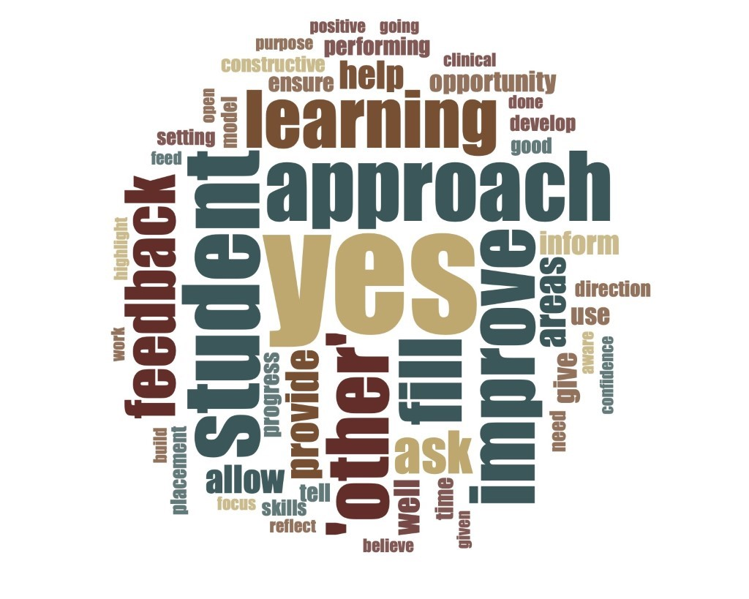

Appendix 3. Frequency word cloud to capture participants’ attitudes towards the purpose of feedback.

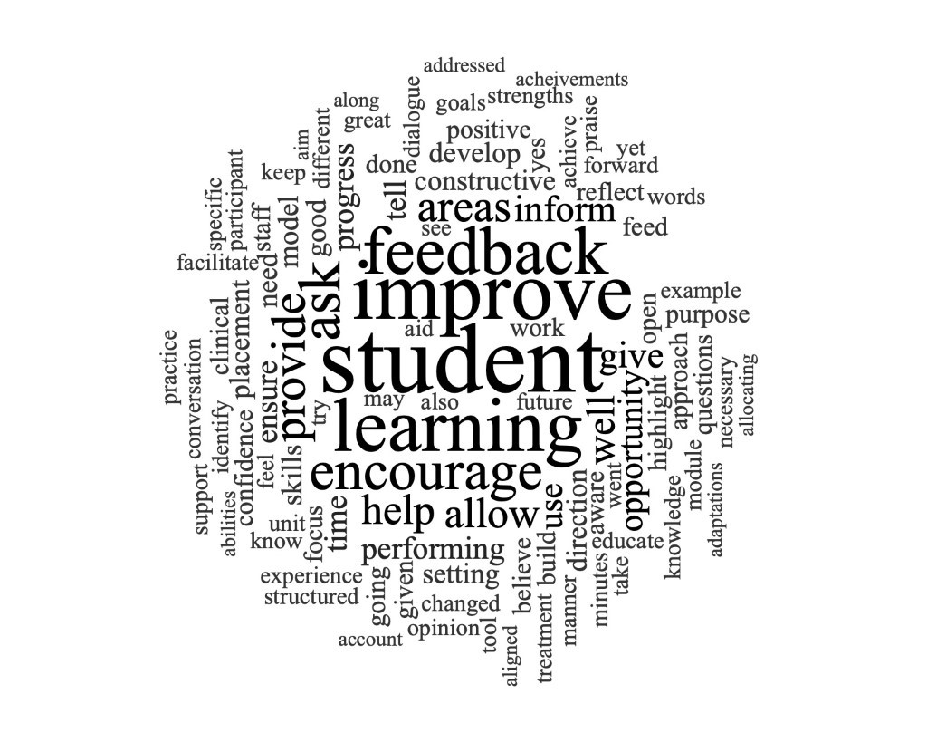
Appendix 4. Frequency word cloud to capture participants’ changed approaches to providing feedback.

