Leveraging Machine Learning and Generative AI for Content Engagement: An exploration of drivers for the success of YouTube videos
Abstract
The market for digital content creation has exploded in the last decade. It offers immense opportunities for brands and content creators to connect to potential customers. It also presents a highly competitive platform. Video analytics may help generate ideas and prioritises efforts. Extant literature has looked at visual aspects of the content as a predictor. However, there needs to be more literature on textual and aural content to determine video success. Also, a big challenge in content analysis emerges from the collection of data and subsequent analysis, which is a laborious process. We have tried to leverage the use of three different Generative AIs, namely, GPT3.5, GPT4 and Gemini, to extract video transcripts and calculate related metrics. This study examined over 1055 YouTube videos released between 2021 and 2023 across three popular smartphones. We extracted semantic metrics from the transcript and comments to build models to explore the drivers of video success. We have also compared various Generative AI-based measures and compared them to traditional computation methods in the exploratory models. The results from this study confirm the superior performance of GPT4 compared to the other two Generative AI tools.
Keywords: Video Analytics, Natural Language Processing, Customer Engagement Theory, Construal Level Theory, Large Language Models, ChatGPT

Introduction
Brands use video-based content platforms such as YouTube to acquire, convert, and retain customers. Literature has shown that video-based content management can strongly affect these marketing outcomes (Park et al., 2023). It also leads to a greater participation of firms in the content industry, which is often viewed as a multi-actor ecosystem (Ho et al., 2020). In this light, the role of content creators is highly important for the success of brands because they can exhibit greater credibility than brand-owned channels (Tsai & Men, 2013). However, content creators may face high competition, especially on platforms such as YouTube. Some researchers have highlighted the importance of visual appeals such as video brightness, speaker intonation, and video length (Schwenzow et al., 2021; Park et al., 2023). However, limited literature examines the content of videos and related comments (Oh & Choi, 2017; Tafesse, 2020; Agrawal & Mittal, 2022); for e.g. the aural aspect of video analytics has been overlooked.
Next, online video-sharing platforms add value to consumers and firms alike. Firstly, marketing costs are greatly reduced by creating sub-fields within the core activities of marketing in an organisation, such as social media and content marketing (Rowley, 2008; Rather, 2021). Secondly, they provide excellent opportunities for firms to connect with their customers. For example, users have been found to be highly engaged on these platforms, such as an average view time of 19.35 minutes of content per day on YouTube (Cook, 2022).
In the subsequent stages, we outline the gaps in the literature that we intend to address in this study. First, scholars have adopted a multitude of metrics for video success, such as video helpfulness, number of views, hours watched and increase in subscribers. In this study, we adopt the number of likes of a video as the primary metric to measure its success. Often, the success of a video depends on its narrative, which signifies its information content (Cao et al., 2021; Gan et al., 2023; Lång, 2016; Schwenzow et al., 2021; Wilkens et al., 2003). Therefore, we investigate the effects of social distance, affect and temporal orientation of the video narrative towards the success of a video (Cao et al., 2021; Gan et al., 2023; Glaser et al., 2023; Pera & Viglia, 2016) using the Construal Level Theory. This leads to our first research question:
RQ1: What are the determinants of video success (number of likes) based on its narrative?
Second, we look at the effects of viewer’s engagement towards the success of a video. Increasing engagement with the video content is a major objective of creating videos and sharing them on content-sharing platforms such as YouTube. Therefore, content creators must understand what works best for their audience (Cao et al., 2021; Gan et al., 2023; Munaro et al., 2021). In particular, the viewer’s engagement has been measured by the number of comments and replies (Teixeira & Kornfeld, 2014); subjectivity, temporal indicators, negative tonality and arousal (Munaro et al., 2021). However, related literature did not investigate the contributions of viewer’s engagement towards the number of likes as a measure of success. This leads to our second research question:
RQ2: How does the viewer’s engagement contribute to video success (number of likes)?
Third, we look at the role of Generative AI (GenAI) during the content analysis of videos. McKinsey estimates that GenAI could contribute to an annual increase in productivity of 0.1% to 0.6% until 2043. Surprisingly, recent academic research on the role of AI in marketing has been mostly conceptual and are academic discourses (Cillo & Rubera, 2024; Fui-Hoon Nah et al., 2023; Mariani & Dwivedi, 2024) or experiments (Stabler & Haenlein, 2024). The only study that comes closest to ours is by Arora et al. (2024), who applied a human-with-LLM hybrid approach to report higher efficiency and effectiveness in marketing activities. Instead, we posit that LLMs can be used as an alternative to traditional text analytics to examine video content, such as providing summaries and semantic analyses. Therefore, in this current study, we intend to focus on practice-oriented research related to the applications of GenAI in marketing and therefore, develop a methodologically rigorous study. Building upon these literature gaps, we pose the third research question:
RQ3: How can we apply GenAI to extract metrics that affect video success (number of likes)?

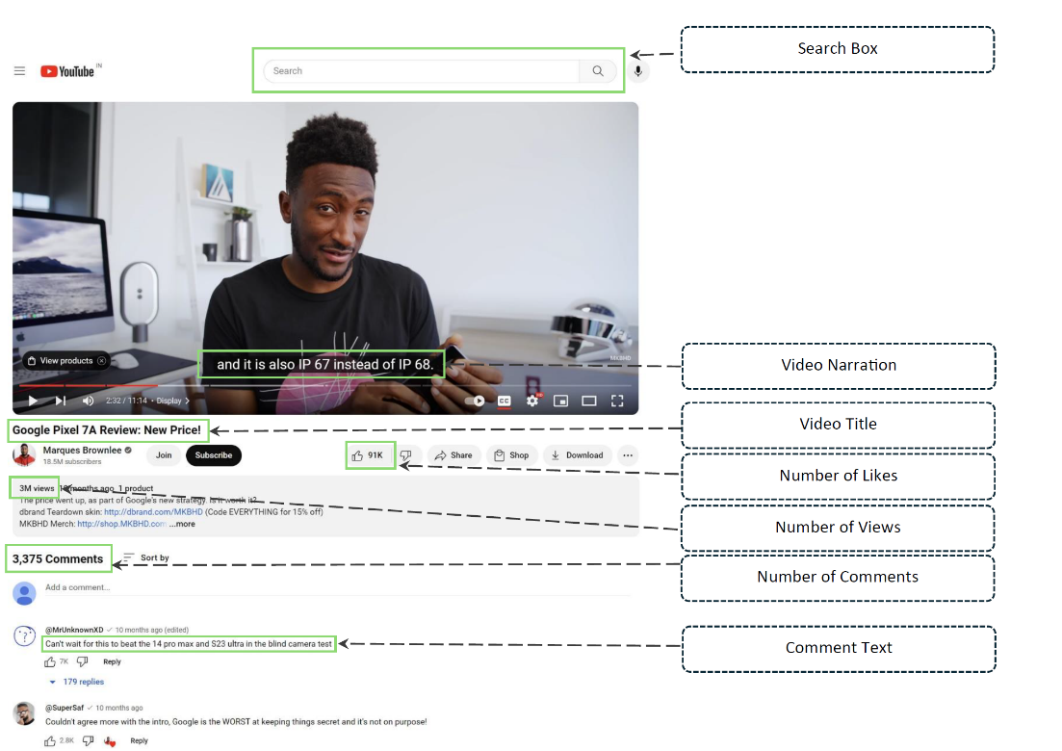
Figure 1: Overview of video metrics used in this study
To answer these questions, we adopted the following novel methodological steps in the light of Construal Level (RQ1) and Customer Engagement Theories (RQ2). First, we extracted video-related data such as the transcripts, meta-data about the video and YouTube channels, and metrics related to viewer engagement such as the number of likes and comments. Second, we used the YouTube API v3 to mine this information-rich data based on the parameters selected by the users. Third, we employed prompt engineering to craft technically strong prompts for subjectivity and polarity. We used three different GenAI tools to generate the sentiment polarity and subjectivity from the textual corpus of video transcripts and then compared them with outputs generated using textblob. In this manner, we compared GenAI-based outputs with traditional text analytics. Fourth, we used the OpenAI API to calculate the subjectivity, polarity, and Flesch reading scores for the video narratives. Figure 1 highlights the dependent variable (number of likes) and key metrics (such as the number of likes and comments) used in our study. To the best of our knowledge, no studies have leveraged the capabilities of GenAI tools to calculate numeric metrics from the transcripts and viewer responses to understand the sentiment polarity and gauge customer engagement.
The subsequent sections of the paper are as follows. Section 2 examines the literature and theoretical frameworks to study various forms of video content and viewer engagement behaviour. Then, we present our empirical methodology in Section 3, followed by the data-mining techniques and related empirical analysis. Subsequently, we report the results, present the findings, and discuss the results in Section 4. The conclusion and implications are presented in Section 5, followed by limitations and future scope in Section 6.

Literature Review and Theoretical Background
YouTube is the largest video-sharing platform, with over 933 million users worldwide (Statista, 2024). Users consume more than 1 billion hours of videos, choosing from about 720,000 hours of content uploaded daily (Shewale, 2024). Therefore, dealing with the enormity of data from this platform is often challenging (Bazi et al., 2023). In the subsequent paragraphs, we summarise the related literature that has looked at various aspects of a video to ascertain the success of videos have been summarised in Table 1.

Large language models (LLM)
Generative AI uses artificial intelligence to create content such as text, images and videos based on user inputs. Companies adopt new technologies to evolve themselves, creating innovations and value streams for the entire ecosystem (Burström et al., 2021). However, one of the biggest challenges remains in implementing AI in organisations (Loureiro et al., 2021; Mishra & Pani, 2021). Within the wide gamut of AI technologies, GenAI, particularly the Large Language Models (LLMs), has been widely discussed as a breakthrough technology (Kocoń et al., 2023; Wu et al., 2023). It is also considered by many as one of the greatest technological concerns of recent times (Fui-Hoon Nah et al., 2023). In our study, we propose to evaluate the possibility of using ChatGPT, the most widely used LLM, to analyse videos (Borji & Mohammadian, 2023). We posit that LLMs can be used as an alternative to traditional text analytics to provide summary and semantic scores for the video. This will allow users to save considerable time compared to traditional machine-learning methods.

Customer Engagement Theory (CET)
Customer Engagement (CE) refers to the interactions with a firm or a brand by the customer beyond the purchase (van Doorn et al., 2010). A major goal of the marketing activities is to enhance customer engagement with the firm (Lim et al., 2022). This becomes particularly important when we consider the influence of building communities with the help of customer engagement (Algesheimer et al., 2005). Consequently, brands worldwide have taken a proactive approach towards developing communities, especially through social media platforms. In this aspect, video-sharing services such as YouTube provide a suitable customer engagement platform (Lee & Watkins, 2016).
Customer Engagement Theory perceives customers as dynamic and ingenious associates with the ability to supplement the traditional marketing efforts of firms (Pansari & Kumar, 2017; Harmeling et al., 2017). CE initiatives can be categorised into two broad types – firm-initiated (such as marketer-generated content or MGCs such as product description) and customer-initiated (such as user-generated content or UGCs, eWOMs) (Brodie et al., 2011; Harmeling et al., 2017). Customer Engagement Theory also emphasises the importance of interaction and satisfaction from the content (Brodie et al., 2011; De Oliveira Santini et al., 2020). Another aspect of the video-sharing platform is value co-creation, which posits that higher engagement would lead to higher customer value (Żyminkowska, 2019). Therefore, the level of engagement in a video reflects a customer’s satisfaction with the content, which leads to a propensity to co-create value by commenting on the video and indulging in activities such as liking and sharing the content. Past research has shown that the semantic and structural aspects of the video, such as length, subjectivity and time, may impact customer engagement (Munaro et al., 2021). When the viewers browse these videos, watch them, and write comments about their pros and cons, other viewers also reply to those comments, leading to an active interaction representing customer engagement. Customers participate in these activities because they may find them inherently motivating or derive social and utilitarian values through participation (Brodie et al., 2011; Eigenraam et al., 2018).

Construal Level Theory (CLT)
Construal Level Theory posits that information perception can be concrete (detailed information) or abstract (Liberman & Trope, 2003). This is governed by the individual’s psychological distance from the context of information. When individuals are close to the context, they construe the information concretely. Instead, when they are far away, they construe the information abstractly (Trope et al., 2007). For example, if the content creator talks about unboxing an electronic gadget, then the information content of the video will be more detailed (i.e., rich in information) than if the content creator makes a video about the announcement of the launch of an electronic gadget. Therefore, when readers are exposed to more concrete information, they perceive its usefulness to be more (Zhang et al., 2021). Gan et al. (2023) examined the interactive effects of visual and verbal framing in promotional tourism short videos on travel intention using construal level theory and the elaboration likelihood model. They conducted two scenario-based experiments to explore these relationships.
Next, the two most commonly used dimensions of CLT are temporal and social distances (Mishra et al., 2020). First, we measure the temporal distance with the help of the future orientation of the video narrative. It was calculated by the future focus variable that was extracted using LIWC-22 (Boyd et al., 2022). We propose that a higher future video orientation will result in lower success due to information abstraction, as predicted by CLT. On the other hand, users who have present orientation will show a greater engagement behaviour. The second dimension of CLT is social distance, which may hinder the acceptance of information (Liberman et al., 2007). The social distance of a person describes whether they think about self vs others (Fujita et al., 2008). Therefore, higher uses of words indicating social distance, such as you, he and she, indicate a large social distance, which is congruent with the tenets of CLT (Boyd et al., 2022). We thereby propose that higher social distance of the creator will result in more abstract thinking and a higher construal level, leading to lower levels of engagement.

Drivers of YouTube success
The first strand of background literature on YouTube videos examined video-related meta-data and built predictors from them. Feroz Khan and Vong (2014) examined the meta-data of 100 all-time-most-viewed YouTube videos and the characteristics of users associated with those videos. They examined the user’s characteristics (e.g., view count, subscriber count, total videos posted, join date), video’s characteristics (e.g., published date, length, category) towards the virality of the video (e.g., count of favourites, count of views, count of comments, count of likes, and count of dislikes). Tellis et al. (2019) studied various factors such as information and risk characteristics (e.g., argument structure of the content, the introduction of a new product, low/medium/high price product) in addition to emotional characteristics that could drive the sharing of video advertisements across multiple social media platforms, including YouTube.
Second, we study the background literature on YouTube videos that have created determinants from emotion-related constructs. Using unsupervised and supervised learning techniques, Chen et al. (2017) classified YouTube videos according to emotions. The study built four predictors using textual sections of YouTube videos (i.e., titles, tags, descriptions, and comments) using pointwise mutual information and leading to six categories of emotions (e.g., angry, disgust, happy, horror, sad, and surprise). In their study, Tellis et al. (2019) found that positive emotions such as amusement, excitement, inspiration, and warmth positively affected user video-sharing behaviour. Further, video advertisements with higher emotional content, such as positive emotions and surprises, were shared highly on social media platforms (Facebook, Google, Twitter). Agrawal and Mittal (2022) examined the effect of emotions (e.g., eight emotions from Plutchik’s wheel) expressed through the user content posted for product review videos on YouTube. Finally, they led to purchase intentions (measured by “likes”). Park et al. (2023) examined the effect of various visual characteristics (e.g., brightness, visual dynamics) and vocal characteristics (e.g., voice pitch and speech rates) of YouTube videos for online review, which were associated with their perceived helpfulness. They also found that consumers perceived videos with higher positive facial emotions as more helpful.
Third, we study the background literature on YouTube videos that have created determinants from engagement-related constructs. Oh and Choi (2017) employed a qualitative content analysis using variables such as real-time audience participation, virtual celebrity and diversified content and structure of the most popular shows on Afreeca TV to identify elements that made them successful. Tafesse (2020) identified the following features: video titles (e.g., information content, emotional intensity), information content of video descriptions and volume of video tags. Finally, Tafesse (2020) analysed the effect of these features on the views of those YouTube videos.
The fourth strand of literature applies semantic and temporal variables to examine their effect on customer engagement. Munaro et al. (2021) built an empirical model to study how word-level elements (e.g., function words, personal pronouns, regular verbs), linguistic style (e.g., analytical style, subjectivity), emotional valence, and video category drove engagement (i.e., count of views, likes, dislikes, and comments).
The fifth strand of literature examines video narratives and factors responsible for success among the audience. Pera and Viglia (2016) employed a qualitative multimethod approach to explore the meanings embedded in video narratives and their connection to relationship experiences. They examined a case study centered on Airbnb's social media platforms. Cao et al. (2021) suggested that the narrative aspect of short videos can shape attitudes toward destination brands. Building on this idea, they expanded both the antecedent and outcome variables associated with narrative transportation using the narrative transportation theory. Glaser et al. (2023) investigated how the use of celebrities versus unknown actors in narrative video advertisements influences brand attitudes, as well as explored the potential mechanisms through which the type of actor may enhance or diminish persuasive impact. Gan et al. (2023) examined the interactive effects of visual and verbal framing in promotional tourism short videos on travel intention using construal level theory and the elaboration likelihood model. They conducted two scenario-based experiments to explore these relationships.
Finally, the sixth strand of literature discusses the advent of GenAI as an upcoming tool used in various domains of research. Cillo and Rubera (2024) discuss the application of Gen AI in two specific domains. First, they focus on how firms can connect the potential of GenAI throughout the innovation process. Second, they examine the result of using GenAI to analyse the relationship between market-based assets and firm value. Stabler and Haenlein (2024) establish through their exploratory analysis that the voice of market research can be given more visibility using GenAI, such as ChatGPT. Arora et al. (2024) demonstrated that a human-with-LLM hybrid approach leads to higher efficiency and effectiveness in marketing research. However, a few studies applied GenAI to extract transcripts from videos of content created for products in the current market. To the best of our knowledge, no studies have leveraged the capability of GenAI to calculate numeric metrics from the transcripts and viewer responses to understand the sentiment polarity and gauge customer engagement. Table 1 provides a summary of key research findings from previous studies.
Table 1: Summary of Key Determinants of Video Success from relevant literature
Theme | Study | Features | Important Findings
Theme 1: Predictors using video-related meta-data | Feroz Khan and Vong (2014), Tellis et al. (2019), Munaro et al. (2021) | Video Meta-data | Medium-length videos, brand placement, in-links, number of tags, and view counts contribute to the higher virality of videos.
Theme 2: Predictors using emotion-based constructs | Chen et al. (2017). Tellis et al. (2019), Agrawal and Mittal (2022), Park et al. (2023) | Emotion | Positive emotions and surprises in videos help increase online content sharing and purchase intention.
Theme 3: Predictors built from customer-engagement | Oh & Choi (2017). Agrawal and Mittal (2022), Tafesse (2020), | Customer Engagement | Higher engagement and detailed information lead to more views and higher viewer participation.
Theme 4: Predictors using semantics and temporality | Munaro et al. (2021) | Semantic and temporal variables | Subjective language and negative tonality enhance video success. Temporal indicators enhance video views
Theme 5: Examine the narratives of videos for audience success | Pera and Viglia (2016)  Cao et al. (2021)  Glaser et al. (2023)  Gan et al. (2023) | A qualitative multimethod approach  Narrative transportation theory  Narrative transportation theory  Construal-level Theory and elaboration likelihood model | Enhance the power of stories in narratives.  Narrative of short videos promotes brand attitude.  Presence of celebrities increased perceptions with the actor.  Moderating role of narration message appeal.
Theme 6: Predictors built using GenAI tools | Cillo and Rubera (2024)  Stabler and Haenlein (2024)  Arora et al. (2024)  Our study | Companies using GenAI to create products and marketing activities  Voice of market research can be made more visible by using GenAI tools  Create personas using LLMs  Video meta-data, engagement, semantic variables | Roadmap for future research on GenAI in marketing  Female co-authorship, involving a practitioner can boost citations  A human-with-LLM hybrid approach leads to higher efficiency and effectiveness during the generation of insights.  Higher social distance decreases video success. Video content with future focus decreases video success, and the present focus of viewer engagement increases video success.

We propose a conceptual model for video success based on the predictors chosen from the relevant literature and the theoretical frameworks. The proposed model is shown in Figure 2.
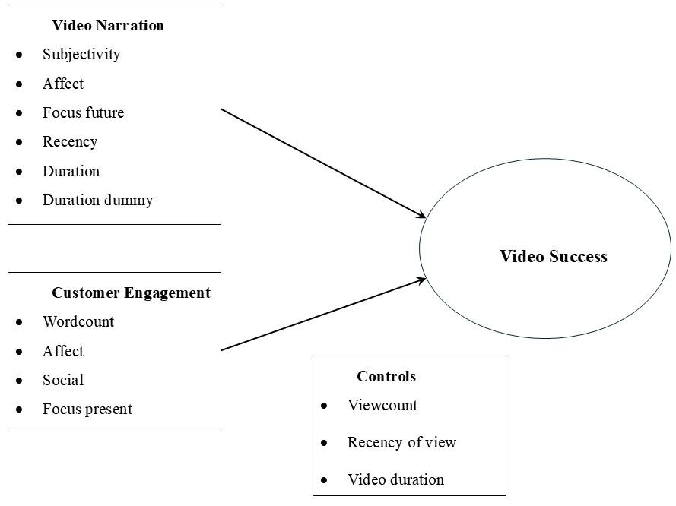
Figure 2: Conceptual Model

Data and Methodology

Video mining
Our study focused on smartphones as a popular theme for examining product reviews on YouTube. Past researchers have also studied smartphones as a product category to analyse customer engagement (Silva et al., 2018). To generalise the results and findings of our study, we collected data for three separate smartphones (i.e. iPhone 14, MotoGPlay, and Pixel 7A) with varying prices. We also chose these products to be quite similar, and videos discussing their pros and cons were available on YouTube. Our initial dataset comprised 1055 YouTube videos with 633,896 comments collected worldwide. The entire study uses Python, R Studio and LIWC-22 software for all data processing and analysis, and the steps are detailed below.
Step 1 Data Extraction: We first scraped the video ID of each YouTube video using the YouTube Data API v3, using the product names as the keywords. We began the data extraction using these video IDs, which were subsequently used to extract transcripts for each video from YouTube. We also scraped the corresponding viewers’ comments using YouTube API v3.
Step 2 Translation: As an intermediate step, we ran the comments and transcripts through the Google Translate Cloud API to convert non-English texts to English.
Step 3 Data Cleaning in R Studio: We used R programs to perform basic text pre-processing and cleaning, such as removal of punctuations, stop words, extra whitespaces, and changing cases uniformly across the texts.
Semantic Analysis
Step 4a LIWC: The translated video transcripts were processed through LIWC-22 to calculate the lexical metrics such as affect, social distance, temporal focus, and word count. The same process was repeated for the viewers’ comments.
Step 4b Python: We computed the subjectivity, polarity (textblob package in Python), and Flesch reading scores (textstat package in Python) for each comment.
Then, we aggregated the computed values using the video IDs because our unit of analysis is each YouTube video.
Step 5 LLM Semantic Analysis: We used three LLM tools, GPT3.5, GPT4, and Gemini, to summarise the video narratives and calculate the polarity, subjectivity and readability scores for each text. The details are presented later in Section 3.2.
At the end of the data processing, they were merged by matching the video IDs to build a combined dataset consisting of the metadata and computed metrics (from Step 4a and Step 4b)
Step 6: The Negative Binomial empirical models were applied to the final dataset using R Studio.
A flow diagram of the steps undertaken for the video mining tasks is presented in Figure 3 below.
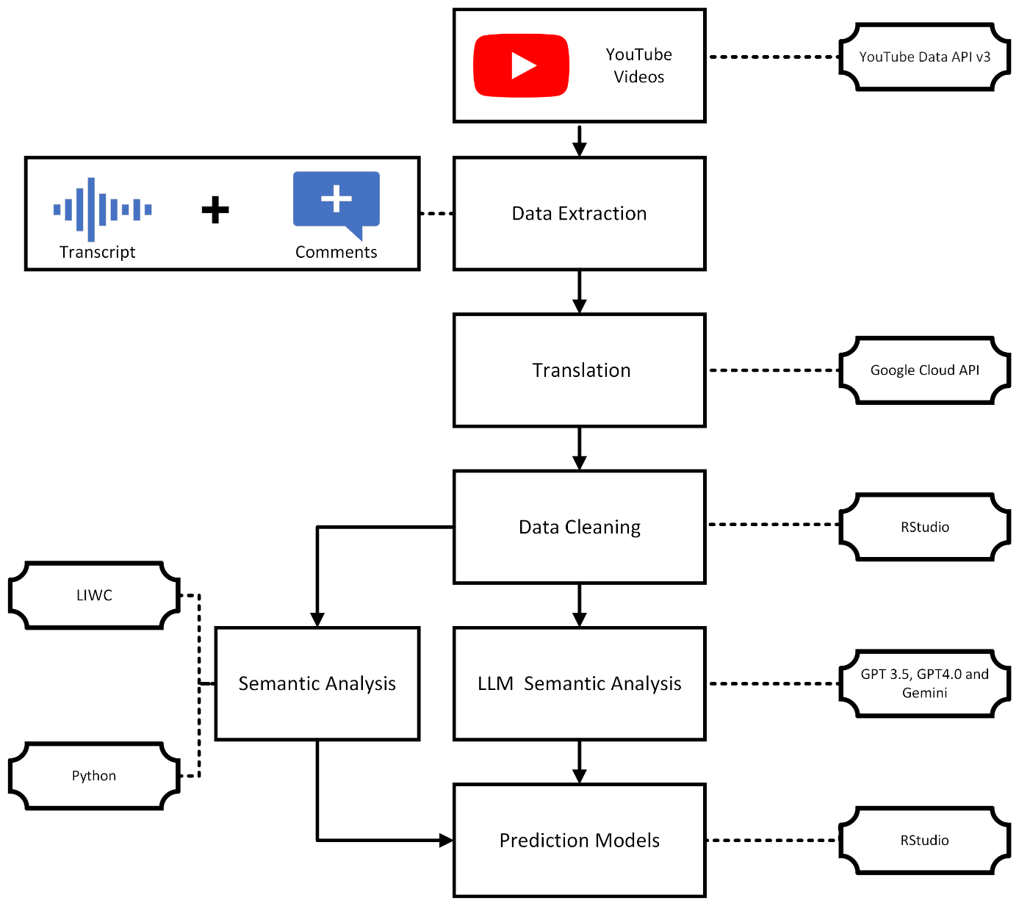
Figure 3: Steps involved in data collection, pre-processing and empirical modelling

Using LLMs for data analysis and prompt engineering
Large language models are technologies that use neural networks to comprehend and create human-like language (Chang et al., 2023). These models are based on many parameters that allow them to process natural language quickly, which has been impossible for a long time (Rae et al., 2022). Among the most popular LLMs is GPT3.5, which stands for generative pre-trained transformers. The GPT version 3.5 has been developed by OpenAI (OpenAI.com, 2024). This technology attempts to tackle the usual challenges associated with language processing, such as text entailment, responding to queries, semantic analysis, and classification of documents (Radford et al., 2018). In this study, we used GPT3.5 as it reflects the most commonly used LLM model within OpenAI and the overall landscape of GenAI (Koubaa, 2023). The results can differ objectively between different LLM models based on their training, and it can be especially improved with purpose-specific model tuning and training (Borji & Mohammadian, 2023; Nguyen-Mau et al., 2024). Figure 4 shows how we used video transcripts as inputs for ChatGPT and then instructed it to generate a summary of the video and semantic measures such as subjectivity, polarity, and Flesch reading scores.
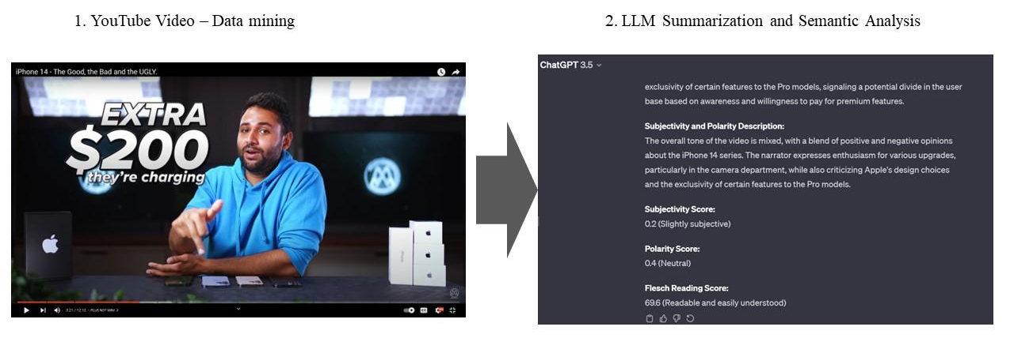
Figure 4: Processing and Output using LLMs
We used the prompt for ChatGPT as provided in Figure 5.
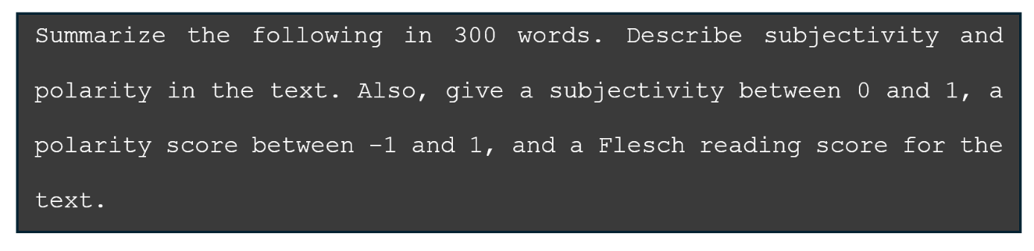
Figure 5: Prompt for summarising and Providing Subjectivity, Polarity and Readability Scores
Figure 6 provides a pseudocode for calculating the Flesch Reading Score using OpenAI API.
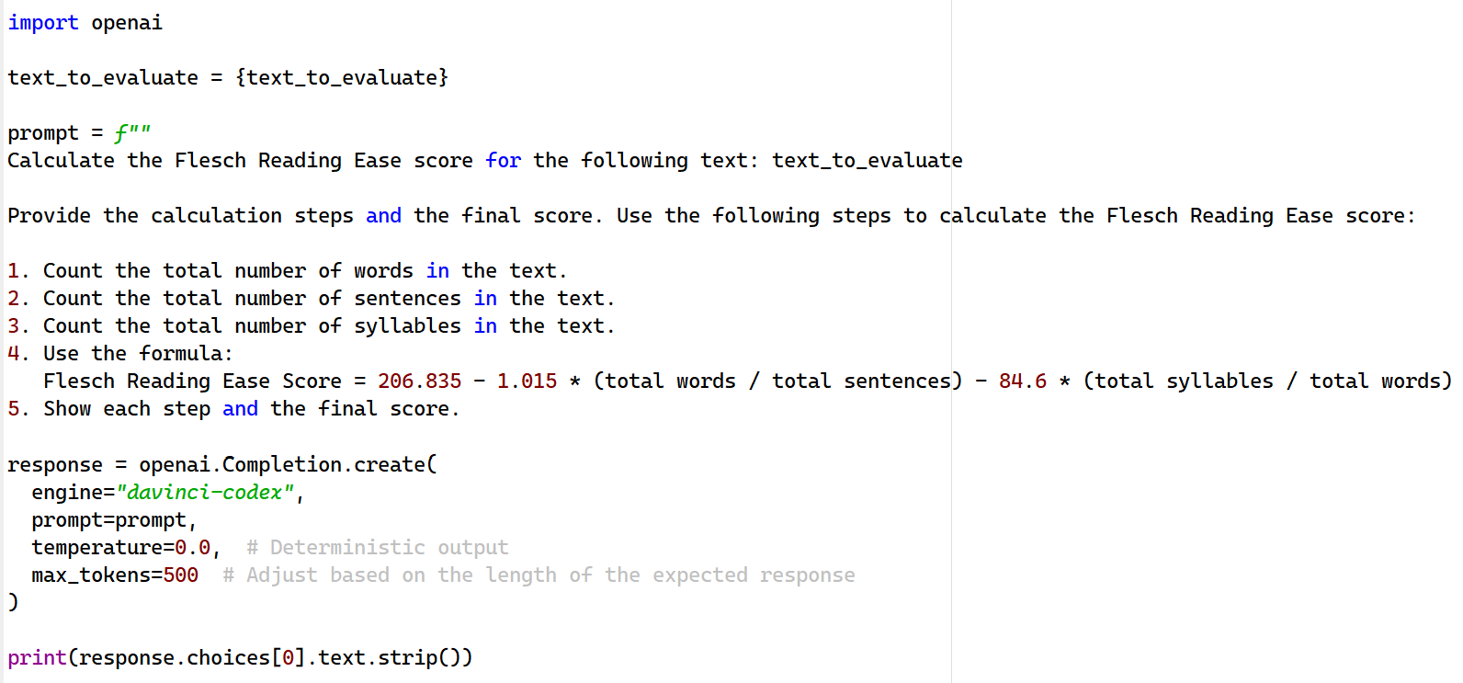
Figure 6: Pseudocode for calculating Flesch Reading Score using OpenAI API
Further, we approached the problem of generating subjectivity and sentiment scores for the text corpus employing similar approach using OpenAI API. The pseudocodes for the Flesch Reading Score and Sentiment polarity are provided in Figure 6 and Figure 7 respectively. Evident from the shared code, the algorithm provides the steps to calculate these scores from the basic principles. Additionally, the calculation steps are elicited from the model to get a better understanding of how it is calculating the same (Zhang et al., 2022). This helps in enhancing the explainability of the model.

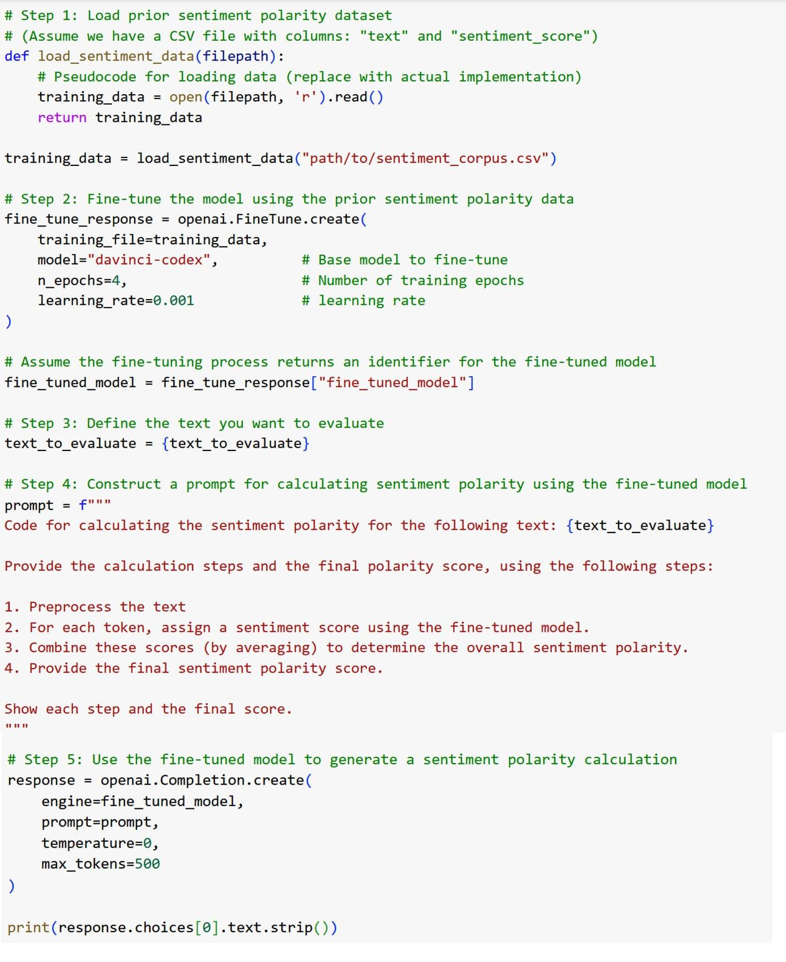
Figure 7: Pseudocode to generate Sentiment Polarity using OpenAI API

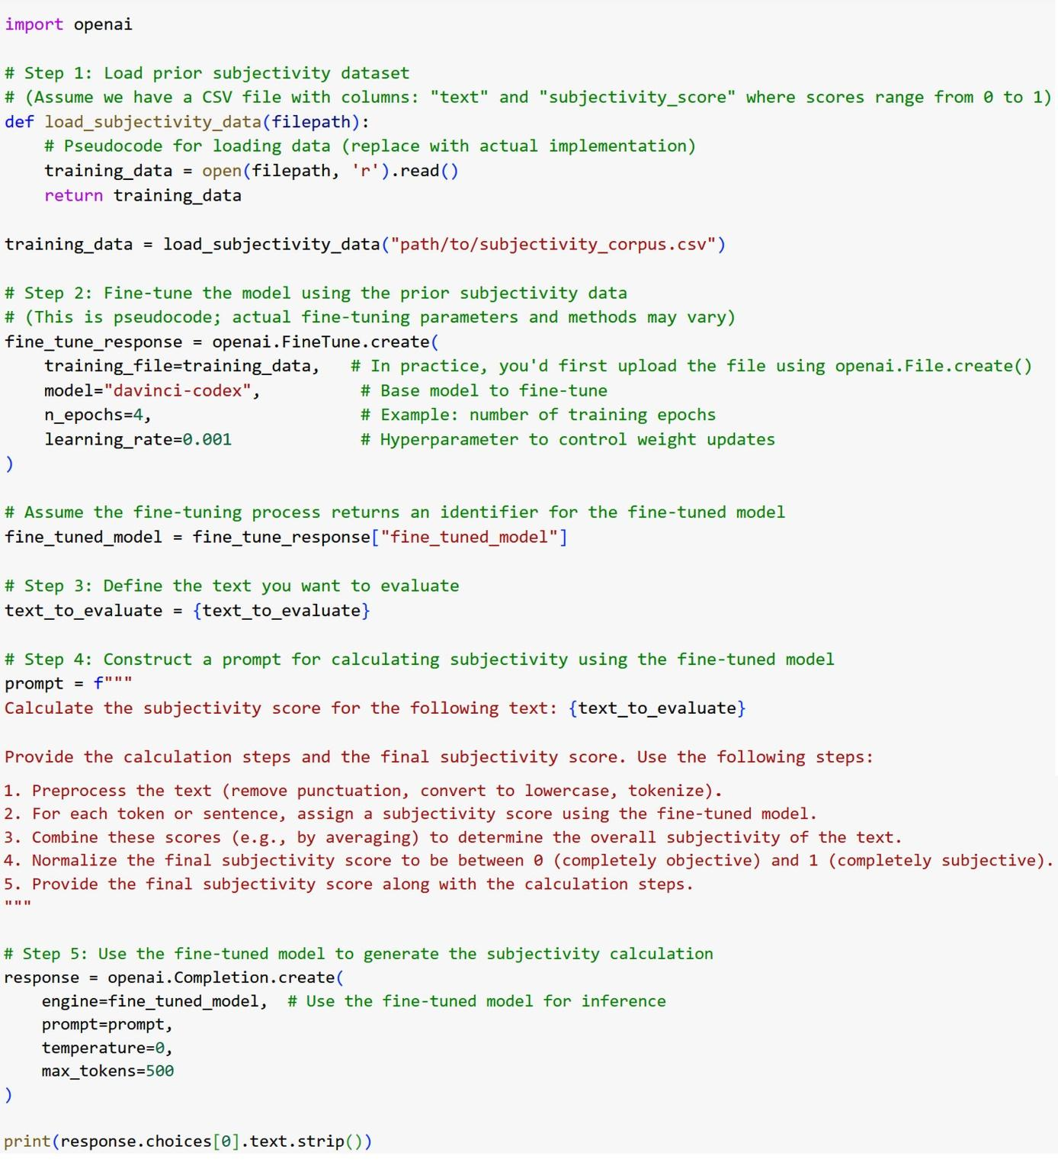
Figure 8: Pseudocode to calculate Subjectivity using OpenAI API

Feature engineering
Having scraped the textual content of the comments and the video narratives, we computed further relevant numeric metrics from them. First, we computed the sentiment polarity and subjectivity score for each comment. Then, we aggregated the values using the video ID because our unit of analysis is each YouTube video. We used the textblob package in Python to calculate these metrics. The polarity score lies between -1 and +1, where values closer to -1 indicate higher negative sentiment and values closer to +1 indicate stronger positive sentiment. On the other hand, subjectivity lies between 0 and +1, where 0 indicates mostly objective textual content, and +1 indicates a pure choice of subjective words.
Additionally, some other meta-variables were also calculated for use in this study. These constructs were generated using LIWC-22. LIWC-22 software is considered the gold standard for analysing word use. For instance, the present focus is based on 373 words such as “is, are, I’m, can” and has an internal consistency of 0.96, as reported by Boyd et al. (2022). All of these variables exhibit acceptable levels of internal consistency and validity. For example, we extracted the temporal component, like the future focus of the video narrative and the present focus of the viewers’ comments. The future focus and present focus variables are extracted from LIWC-22 software by mining for words and temporal words. Affect represents the subjective experience of emotions and feelings (Barrett, 1996). The effect of the video creator and the viewer was also determined through the tonality of the video narrative and viewers’ comments, respectively (Jaidka et al., 2020; Sun et al., 2020). LIWC-22 was also used to measure the social distance of the video creator from the viewer. It represents the social distance in written language and consists of words that reflect positive or negative markers for interpersonal communications, represented by exemplars such as you, he, and she (Huang et al., 2023). Finally, we also included the word count of each review. It was used as a surrogate measure for the length of the review. We note that the numeric measures from the corpus of review text are all in the form of percentages. A study of extant literature also reveals other studies that have used similar metrics (Munaro et al., 2021).

Descriptive analysis
Table 2 defines the variables and provides the univariate measures of central tendency and dispersion along with the minimum and maximum for each feature used in the study. Table 3 presents the pairwise correlations and VIF for all the variables. The values of all VIFs are well below the threshold of ten. Thus, there is no potential threat of multicollinearity to the empirical model. Table 4 provides the results from Sheffe’s pairwise tests for the different LLMs. The test compares all possible pairs of polarity and subjectivity scores calculated using three different GenAI tools (GPT3.5, GPT4, and Gemini) with the traditional metrics calculation using textblob in Python.

Table 2: Descriptive Analysis of the variables used in this study.
 | Variables | Description | Mean | Std. Dev. | Min. | Max.
Video narration (CLT) | Polarity | Sentiment polarity | 0.147 | 0.097 | -0.125 | 0.506
Video narration (CLT) | Subjectivity | Subjectivity expressed in the video narration | 0.386 | 0.159 | 0 | 0.752
Video narration (CLT) | Affect of video creator | The affective state of content creator | 3.321 | 1.31 | 0 | 12
Video narration (CLT) | Social distance of video creator | Average social distance expressed in the video narrative | 2.845 | 2.038 | 0 | 24
Video narration (CLT) | Focus future (Video narration) | Temporal focus on future time | 1.311 | 0.908 | 0 | 4.82
Video narration (CLT) | Duration dummy* | Dummy to identify if the video is longer than 8 minutes or not | - | - | 0 | 1
Viewer engagement (CET) | Length of comments (wordcount) | Average word count of comments received | 9.542 | 3.944 | 3.19 | 25.491
Viewer engagement (CET) | Affect of the comment creator | The affective state of the creator of the comment | 3.801 | 6.8 | 0 | 30.178
Viewer engagement (CET) | Social distance of comment creator | Average social distance expressed in the comments | 1.227 | 2.514 | 0 | 19.283
Viewer engagement (CET) | Focus Present (comments) | Average temporal focus on the present time | 1.462 | 1.378 | 0 | 4.265
Control variables | Views | Number of views of the video | 1278088 | 3679524 | 112 | 46421370
Control variables | Recency of video | Time gap between posting the video and the date of scraping the video data. | 516.66 | 528.505 | 29 | 3680
Control variables | Video duration | Length of video in minutes | 11.239 | 5.865 | 0 | 56.283
DV | Number of likes | Number of likes received by the video | 33858 | 82494 | 14 | 875000
* Binary variable, therefore, no mean and std. deviation.
We have used three different GenAI tools to generate the sentiment polarity and subjectivity metrics from our textual corpus of video transcripts. As a natural choice to compare the mean across different categories, we use analysis of variance (Gnewuch et al., 2023). Then, a one-way analysis of variance (ANOVA) revealed significant variation in the sentiment polarity values across different GenAI tools ($F_{Polarity}=158.8, p-value≪0.005$). Planned pairwise contrasts confirmed that these values were significantly different between the following pairs, namely, GPT3.5 and Gemini (diff= -0.532), GPT3.5 and GPT4 (diff= -0.228), GPT4 and Gemini (diff= 0.304), textblob and GPT3.5 (diff= -0.216), and textblob and Gemini (diff= 0.315). However, no significant difference existed between GPT4 and textblob . The results of pairwise comparison between subjectivity were, however, only significantly different for the pairs Gemini and GPT3.5 (diff= 0.087), Gemini and GPT4 (diff= -0.118), and textblob and Gemini (diff= -0.120). One-way ANOVA established that there was a significant difference between at least a pair of sources of the subjectivity metric ($F_{subjectivity}=17.3, p-value≪$ $0.005$)
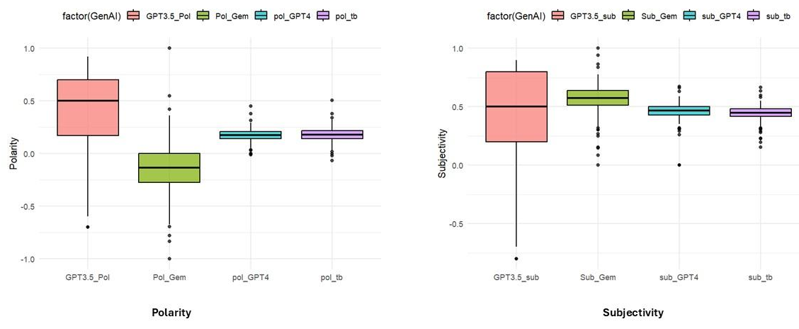
Note: GPT3.5_Pol = Polarity calculated by GPT3.5; GPT3.5_Sub = Subjectivity calculated by GPT3.5;
Pol_Gem = Polarity calculated by Gemini; Sub_Gem = Subjectivity calculated by Gemini;
Pol_GPT4 = Polarity calculated by GPT4; Sub_GPT4 = Subjectivity calculated by GPT4;
Pol_tb = Polarity calculated by textblob (Python); Sub_GPT4 = Subjectivity calculated by textblob (Python);

Figure 9: Boxplot comparing the distribution of polarity and subjectivity
The results for the one-way ANOVA and the post-hoc tests are presented in Table 4. Figure 7 displays the boxplots for polarity and subjectivity calculated using GPT3.5, GPT4, Gemini and textblob in Python. The median polarity represented for the box plots across the four methods shows that there is a difference in central tendency between GPT3.5, GPT4, and Gemini. However, for GPT4 and textblob, they are almost the same. This aligns with the pairwise test results shown in Table 4. In the case of subjectivity, the median subjectivity is almost the same from GPT3.5, GPT4 and textblob . The only discernible difference is seen in the case of Gemini.
Table 3: Pair-wise correlations calculated for this study
 | Variables | VIF | [1] | [2] | [3] | [4] | [5] | [6] | [7] | [8] | [9] | [10] | [11] | [12] | [13]
(DV) | Count of Likes [1] |  | 1.00
Video Narration (IVs) | Polarity [2] | 2.14 | 0.06 | 1.00
Video Narration (IVs) | Subjectivity [3] | 2.67 | 0.23 | 0.53 | 1.00
Video Narration (IVs) | Affect of video creator [4] | 4.90 | 0.30 | -0.25 | -0.23 | 1.00
Video Narration (IVs) | Social distance of video creators [5] | 4.42 | 0.05 | -0.46 | -0.44 | 0.87 | 1.00
Video Narration (IVs) | Focus future (Video narration) [6] | 1.42 | 0.01 | 0.16 | 0.25 | -0.21 | -0.24 | 1.00
Viewer engagement (IVs) | Length of comments (wordcount) [7] | 4.06 | 0.16 | 0.04 | 0.04 | 0.01 | -0.06 | -0.22 | 1.00
Viewer engagement (IVs) | Affect of the comment creator [8] | 3.53 | -0.30 | 0.07 | 0.04 | -0.20 | -0.15 | 0.18 | -0.64 | 1.00
Viewer engagement (IVs) | Social distance of comment creator [9] | 1.63 | -0.09 | 0.07 | -0.23 | -0.24 | -0.18 | 0.19 | -0.24 | 0.21 | 1.00
Viewer engagement (IVs) | Focus Present (comments) [10] | 3.81 | 0.36 | -0.04 | 0.03 | 0.11 | 0.05 | -0.03 | 0.61 | -0.52 | -0.18 | 1.00
Control variables | Count of Views [11] | 3.23 | 0.30 | -0.06 | 0.07 | 0.03 | -0.04 | 0.03 | 0.59 | -0.47 | -0.19 | 0.66 | 1.00
Control variables | Recency of video [12] | 1.80 | -0.12 | -0.15 | -0.14 | 0.05 | 0.03 | -0.07 | -0.30 | -0.01 | 0.12 | -0.35 | -0.17 | 1.00
Control variables | Video duration [13] | 1.63 | -0.10 | 0.17 | 0.26 | -0.07 | -0.06 | 0.11 | 0.29 | -0.12 | -0.20 | 0.18 | 0.15 | -0.21 | 1.00
DV = dependent variable; IV = independent variable; Duration dummy is a Binary variable; therefore, no pairwise correlations were calculated.

Table 4: Sheffe’s Pairwise Test
 | Difference | p-value | Sig
Polarity
Gemini - GPT3.5 | -0.532 | 2.00E-16 | ***
GPT4 - GPT3.5 | -0.227 | 2.00E-16 | ***
TB - GPT3.5 | -0.216 | 7.30E-16 | ***
GPT4 - Gemini | 0.304 | 2.00E-16 | ***
TB - Gemini | 0.316 | 2.00E-16 | ***
TB - GPT4 | 0.011 | 0.975
Subjectivity
Gemini - GPT3.5 | 0.087 | 1.50E-04 | ***
GPT4 - GPT3.5 | -0.031 | 0.441
TB - GPT3.5 | -0.033 | 0.387
GPT4 - Gemini | -0.118 | 4.20E-08 | ***
TB - Gemini | -0.120 | 2.40E-08 | ***
TB - GPT4 | -0.002 | 0.999
Note: $^{*}$p$<$0.1; $^{**}$p$<$0.05; $^{***}$p$<$0.01 $^{****}$p$<$0.001;

Development of empirical model
The response variable (i.e., count of likes) is count data, so our choice for empirical modelling was initially Poisson regression. (Salehan & Kim, 2016). However, there is a drawback to this method of modelling. Poisson assumes equality of mean and variance, an assumption which is violated in most real-life data, which we have seen in this data as well. This type of inflation traditionally leads to over-dispersion (Lambert, 1992), and for modelling over-dispersed count data, a better option is using the Negative Binomial regression.
Let y_{i} be the count of likes for the $i^{th}$ video, and y_{i} follows a Negative Binomial distribution with mean µ. The response (count of likes) y_{i} ∼ Negative Binomial (r, p), where r is the count of likes and p is the probability of success. Moreover, r * p = µ is the mean rate of the count of likes given by viewers. Thus, the linear component in the regression model helps in parametrising the mean rate of the count of likes given by viewers is µ and expressed in the following functional form:
y_{i} = log µ = β₀ + β₁x₁ + · · · + β_{k} x_{k} (1)

The Negative Binomial regression model is used for fitting the expected count of likes, as follows:
$log(μ) =β_{0}+β_{1}\left(Polarity_{video}\right)+β_{2}\left(Subjectivity_{video}\right)+β_{3}\left(Affect_{video}\right)+β_{4}\left(Social_{video}\right)+β_{5}\left(Focus future_{video}\right)+β_{6}\left(duration dummy\right)+β_{7}\left(WC_{comment}\right)+β_{8}\left(Affect_{comment}\right)+ β_{9}\left(Social_{comment}\right)+β_{10}\left(Focus present_{comment}\right)+ β_{11}\left(Likes\right)+ β_{12}\left(Recency_{video}\right)+ β_{13}\left(Duration_{video}\right)$ (2)
where the link function g(µ) = log(µ) is the (natural) logarithm. In Equation (2), β₀ is the intercept, and the coefficients β₁, β₂, β₃, . . ., β_{k} are unknown parameters which are to be estimated from the available data from YouTube videos. The final estimates of these coefficients are labelled as b₁, b₂, b₃, . . ., b_{k}. We fitted the Negative Binomial regression using the VGAM package in R. Implementing VGAM fits two separate models to parametrise the mean and dispersion parameters. Thus, the output provides two intercepts in the results.

Results and Discussion

Main results
Our primary objective was to ascertain the relationship between different video characteristics and the success of a video (measured by the count of likes). Therefore, we focused on the semantic analysis of video narration and comments in the main model. We also examined the transcripts and comments received from the viewers. We explored the main effects of these factors on the success of YouTube videos using the high-level constructs generated by text mining and LIWC-22. We have provided a summary of the main results in Table 5.

Video narration
The video transcripts were analysed to reveal the important relationships with the semantic variables. Thus, we looked at the effects of affect, social distance, and temporal orientation on the number of video likes. We found that affect has a positive impact on the count of likes. However, the impact is not statistically significant. The social distance attribute also has an insignificant negative impact on the number of likes. The attribute social distance for the content creator represents a greater social distance between the creator and the viewers, which is measured in LIWC-22 by exemplars like you, he, and she (Huang et al., 2023). Thus, the higher use of these words may be construed as an indicator of higher social distance. Gaining support from the construal level theory, we posited that the social distance of a YouTube video would hurt the count of likes. Thus, the results from our model demonstrate that with increased social distance, the appeal to the viewers is less, lowering the count of likes. Next, focusing on the future has a significant positive impact on the count of likes. Therefore, the impact is significantly positive on the count of likes across those videos where the narration is more focused on the future (e.g., pre-launch videos). Next, the subjectivity in the video turned out to be insignificant in our model, but it had a positive coefficient. This contrasts with existing literature (Munaro et al., 2021), where they found that subjectivity was negatively associated with the count of likes. Thus, from our study, the count of likes also increases with the higher manifestation of subjective language in the video. The positive association of subjectivity with a count of likes is consistent for all four models, where the subjectivity metric is calculated using the textblob package in Python and the ones generated through GPT3.5, GPT4, and Gemini. A similar pattern of negative association is seen between sentiment polarity and the count of likes. If sentiment polarity is higher, i.e. positive then the count of likes decreases. Thus, video narration that explains the bugs or faults in the product (and the video creator expresses his negative sentiment) increases the likeability of the videos. However, the negative association is insignificant. We also tested the impact of readability (measured by Flesch reading score) and the results are congruent with existing literature with positive relationship with the number of likes (Biswas et al. 2022). But the association is statistically insignificant.

Viewer Engagement
Duration dummy has an insignificant effect on video performance (measured by the count of likes). The dummy variable indicated whether the video was created with 8 minutes as the breakpoint in video duration. This variable takes 1 when the video duration exceeds 8 minutes and 0 otherwise. The positive coefficient from the model results, which controls for video recency and view count (Table 4), indicates that the count of likes is higher for videos longer than 8 mins than those of length less than 8 mins.

Viewer Comments
Only comment length (measured by word count) is statistically significant among all the metrics derived from viewers’ comments, and the direction is positive. Thus, longer comments from viewers can positively impact the count of likes of a video. The present temporal component expressed through viewers' comments has a marginal positive significance in the model. This leads us to conclude that with a high emphasis on the present focus expressed in the comments, the like count of the videos increases.
Table 5: Results from the Main Model (dependent variable: Number of Likes)
Variable | Baseline (Python) | GPT3.5 | GPT4 | Gemini
(Intercept):1 | 7.721***  (1.051) | 7.266***  (0.631) | 7.535***  (0.793) | 7.295***  (0.939)
(Intercept):2 | -0.941***  (0.087) | -0.933***  (0.087) | -0.939***  (0.087) | -0.941***  (0.087)
Polarity (textblob) | -2.451  (2.161)
Subjectivity (textblob) | 0.712  (2.386)
Readability (textstat) | 0.573  (3.858)
Polarity (GPT3.5) |  | -0.024  (0.405)
Subjectivity (GPT3.5) |  | 0.779  (0.486)
Readability (GPT3.5) |  | 0.248  (0.519)
Polarity (GPT4) |  |  | -3.154  (2.386)
Subjectivity (GPT4) |  |  | 1.088  (1.503)
Readability (GPT4) |  |  | 2.423  (4.005)
Polarity (Gemini) |  |  |  | -0.704  (0.621)
Subjectivity (Gemini) |  |  |  | 0.366  (1.225)
Readability (Gemini) |  |  |  | 0.623  (1.387)
$${Affect}_{transcripts}$$ | 0.228  (0.169) | 0.139  (0.161) | 0.225  (0.163) | 0.228  (0.169)
$${Social distance}_{transcripts}$$ | -0.113  (0.133) | -0.049  (0.124) | -0.093  (0.127) | -0.113  (0.133)
$${Focusfuture}_{transcripts}$$ | 0.553***  (0.152) | 0.430**  (0.155) | 0.552***  (0.153) | 0.553***  (0.152)
$${Word count}_{comments}$$ | 0.142***  (0.027) | 0.165***  (0.027) | 0.143***  (0.026) | 0.142***  (0.027)
$${Affect}_{comments}$$ | -0.075**  (0.024) | -0.081***  (0.024) | -0.075**  (0.024) | -0.075**  (0.024)
$${Social distance}_{comments}$$ | -0.155*  (0.072) | -0.138  (0.071) | -0.155*  (0.071) | -0.155*  (0.072)
$${Focuspresent}_{comments}$$ | 0.349  (0.190) | 0.248  (0.191) | 0.343  (0.190) | 0.349  (0.190)
$${Duration}_{dummy}$$ | 0.520  (0.285) | 0.691*  (0.279) | 0.580*  (0.283) | 0.520  (0.285)
Recency of Video | -0.335*  (0.139) | -0.295*  (0.142) | -0.313*  (0.139) | -0.335*  (0.139)
View count | 0.998***  (0.033) | 1.007***  (0.033) | 1.002***  (0.034) | 0.997***  (0.033)
*Standard Errors are reported under the estimates within parentheses.

Benchmarking with standard machine-learning models
LLM is a relatively new technology that presents two major challenges: more literature in the field and highly dynamic updates (Wu et al., 2023). A comparative assessment of such new technologies may help future researchers understand their strengths and limitations. Previous studies have looked at benchmarking the output of LLMs in the context of medicine (Thirunavukarasu et al., 2023) and education (Kasneci et al., 2023). In this study, we used the same set of predictors that we had used in our proposed model, i.e. those that were extracted using LLM, namely, GPT_sub (subjectivity extracted using GPT), GPT_pol (polarity extracted using GPT) and GPT_Flesch (Flesch readability extracted using GPT). Then, we built prediction models using traditional machine-learning algorithms such as Random Forests, Support Vector Machines, Bagging Trees, Gradient Boosting, Extreme Gradient Boosting (XGBoost) and Neural Networks. A multilayer perceptron (MLP) was designed for regression tasks which used fully connected layers, ReLU activation functions in the hidden layers, L2 regularisation, and dropout. During the grid search operations, we restricted the number of trials to 10 and executions per trial to 3. Finally, we compared the performance of our proposed model with the results generated from traditional algorithms.
The input variables were scaled before feeding them into the machine-learning algorithms to improve their performance. Hyperparameter-tuning was employed in each algorithm (except linear regression) with the help of a grid-based search strategy. The hyperparameter-tuning helped us to reach optimal values for the relevant parameters, which reached higher performance and lower RMSE values for those algorithms. For instance, the learning rate for the GBM (η) was varied from a minimum of 0.01 up to 0.3 instead of keeping it constant at 0.1 and operating at an optimal value of 0.05. In addition, a repeated cross-validation scheme with 10 partitions and 5 repeats for each machine-learning algorithm was enabled. Based on the error metrics such as RMSE, MAE, MASE, SMAPE and the adjusted R² values, the models were compared, sorted and presented in Table 6 and Table 7.
Table 6: Optimised hyperparameters for each algorithm
Algorithm | Hyperparameters
Linear Regression | no hyperparameters
Random Forest | no. of variables at each split = 15, no. of trees = 200
Bagging Tree | no. of bootstrap samples = 200; minimum no. of observations in a node before splitting = 5; complexity = 0.01; maximum depth of tree = 10
GBM | no. of trees = 1000; interaction depth = 5; learning rate = 0.05; minimum number of samples = 5
XGBoost | max depth = 3; learning rate = 0.1; gamma = 1; colsample by tree = 0.7; minimum child weight = 5; subsample = 0.5
SVM Linear | cost = 0.01
SVM Radial | sigma = 0.01; cost = 5.623
MLP | first layer = 32 neurons, dropout rate =0.1; second layer = 32 neurons; dropout rate =0.4; learning rate = 0.001
NB Models | Maximum iterations = 100; lambda = 0.1; epsilon = 0.001
Bagging Tree = Bootstrap aggregating decision tree; GBM = Gradient Boosting Machines; XGBoost = Extreme Gradient Boosting; SVM = Support Vector Machine; MLP = Multilayer Perceptron; NB = Negative Binomial regression using vglm()
Therefore, the MLP neural net emerged as the best-performing model and the negative binomial as the worst.
$Neural Net≈ XGBoost> GBM> Bagging Tree>Radial SVM>Linear SVM>Random Forest>Linear Regression >>Negative Binomial$.
When compared across various LLM tools, our baseline Python-based model performed best, followed by GPT 4 and GPT 3.5, and the model run with Gemini-based features performed the worst (see Table 7). These findings were also congruent with those generated from the ANOVA analysis (see Table 4 and Figure 9).
Table 7: Summary of comparative performance for each algorithm based on error metrics
Algorithm | RMSE | MAE | MASE | SMAPE | Adj. R2 /  Pseudo R2
MLP | 2613.581 | 1078.408 | 0.298 | 0.427 | 0.416#
XGBoost | 2851.584 | 1069.644 | 0.305 | 0.411 | 0.412#
GBM | 3288.596 | 1381.418 | 0.419 | 0.435 | 0.437
Bagging Tree | 3474.520 | 1425.565 | 0.368 | 0.483 | 0.408
SVM Radial | 3689.078 | 1342.161 | 0.370 | 0.507 | 0.284#
SVM Linear | 4087.503 | 1610.224 | 0.444 | 0.593 | 0.216#
Random Forest | 5000.868 | 1681.760 | 0.463 | 0.502 | 0.305#
Linear Regression | 7000.165 | 3344.487 | 0.505 | 0.553 | 0.335
Baseline Python (NB) | 10429.888 | 6618.693 | 0.648 | 0.625 | 0.183#
GPT 4.0 (NB) | 11429.943 | 7309.347 | 0.724 | 0.654 | 0.152#
GPT 3.5 (NB) | 11714.873 | 7618.685 | 0.745 | 0.692 | 0.157#
Gemini (NB) | 13018.873 | 7910.112 | 0.782 | 0.800 | 0.109#
Bagging Tree = Bootstrap aggregating decision tree; GBM = Gradient Boosting Machines; XGBoost = Extreme Gradient Boosting; SVM = Support Vector Machine; MLP = Multilayer Perceptron; Neg. Bin. = Negative Binomial regression using vglm() RMSE = Root Mean Squared Error; MAE = mean absolute Error; MASE = Mean Absolute Scaled Error; # = pseudo-R-square calculated separately outside the model execution.

Conclusion and Implications

Theoretical Implications
Our findings suggest that the viewer’s engagement attributes significantly contribute to the determinants of the success of YouTube videos describing product reviews. Also, the textual metrics of the narrative content of these product review videos may act as an incentive or deterrent for the video’s success. We contribute to theory in the following ways. Firstly, this is among the first academic studies to explore important attributes of video narratives from a corpus of product review and analysis-related YouTube videos. We contribute to the literature on YouTube video analytics by providing new insights into the drivers of a video’s success. A new finding is that the video content creator's affective state and social distance can significantly influence its success, measured by the count of likes. This supports CLT in social distance between video content creators and viewers.
Secondly, our findings support CLT in the context of the temporal effect on the success of videos. We found that the future focus of the video narration negatively impacted its success. Thus, a higher temporal distance created a sense of abstraction, making the videos less appealing. However, the present focus of the viewers’ comments emphasised the “here and now”, thereby significantly increasing viewership. These results find support for RQ1.
Thirdly, our study supported CET by combining metrics from viewers’ comments into the model to explore drivers of videos’ success. However, the results showed that only the length of comments significantly affected the videos’ viewership. Longer comments significantly reduced the video's viewership, diminishing the viewer’s engagement with videos with lengthy accompanying comments. This finding answers the RQ2 and provides a link between viewer engagement and video success.
Finally, this study is one of the first to consider using GenAI (such as ChatGPT) to summarise and analyse video content and generate metrics such as sentiment polarity, subjectivity, and readability, further determining a video’s success. In this study, we have analysed the textual content of the video narrative through LIWC-22 and combined it with the metrics generated from ChatGPT. We performed confirmatory tests to establish that using LLMs, in contrast to traditional NLP methods, produces significantly varying results. We also extended the methodological boundaries of YouTube video analysis to assess video success. This finding answers RQ3 as we have developed an approach towards using Gen AI for NLP tasks. The approach may provide better results as the LLM performance increases over time.

Managerial Implications
Our study is useful for practitioners for the following reasons. Firstly, the results highlight the importance of the temporal component of the video narration. Since the future focus creates a higher abstraction and reduces the view count of the videos, content creators can plan the release of the videos about the product closer to their launch date. Thus, it increases the helpfulness of the videos for the viewers. This is especially true of products like mobile phones, and we studied product-review videos for mobile phones. Next, videos with more present-focus content decrease the speculative nature of the videos while remaining concentrated on available facts about the product. Marketing managers can also apply this finding during product launches and marketing events.
Secondly, another construct that hurts the viewership is the social distance. In LIWC-22, the social processes measure the social distance between the creator or narrator and the viewers. If video creators are inclusive and indulge in using more self-oriented words in their videos, such as I, we and refrain from using words such as he, she, them, then the videos will become more popular among the viewers. This, in turn, will increase the likes of the videos and make them more successful. Hence, this is another attribute of the narrative of videos that the content creators can focus on to improve the success of their videos.
Thirdly, practitioners could use the approach we have developed to quickly look at a corpus of text. This would be especially helpful for getting an insight into user generated content like online customer reviews like understanding the subjectivity, polarity and sentiments. They can then explore the same using traditional methods for further analysis and validation of results as with the initial LLMs the results were not that accurate. Subsequent models may show better performance so similar approach can be applied.

Conclusion
Our study presents some intriguing findings that contribute to both theory and practice in marketing by applying machine learning and Generative AI to shape the future of marketing. We have found factors that contributed to the video's success based on text analysis of narration and viewer comments. Specifically, we found that aural content is a rich source of information in these videos. To the best of our knowledge, this is one of the first studies that looked at large-scale aural data related to YouTube videos as a determinant for success. In our proposed methodology, we converted audio into text and applied natural language processing to answer our research questions. In the case of video narration metrics, future focus in the narration had a significant negative impact. The higher social distance between the narrator and the viewer negatively impacts the video's view count.
Content creators often make videos longer than 8 minutes to engage more viewers. However, it may lead to a drop in the viewership of those videos. Further, the average length of comments is longer for videos with fewer likes. Therefore, as the likes accumulate over time, the number of comments may increase, but their length may decrease. The YouTube algorithm initially shows the video to a smaller cohort of viewers who are highly aligned with the video and may submit longer comments. In contrast, when the video becomes viral, it may reach peripheral viewers who have engaged marginally so far and so contribute using shorter comments.

Limitations and Future Scope
Some of the limitations of this study are as follows. First, in terms of data, we have focused on a single product category, i.e., smartphones. Each product category has its uniqueness, which may alter the interpretation of the findings. Therefore, future researchers may extend and test this study across other product categories. Second, we examined product reviews of smartphones posted on YouTube. Future studies may look at other categories of YouTube videos, such as travel, cooking, and lifestyle and personal finance tutorials. Third, another limitation arises from our adopted empirical methodology, particularly our attempt to use LLMs in feature extraction. Our study has employed LLMs as black box which means that we have not taken an active role in training the model; we have fine-tuned the model based upon traditional output. Developing an LLM and training it was beyond the scope of this study as it focuses on the business application of LLMs by evaluating their potential in NLP tasks. However, future studies may try to build a more robust analytical design with other LLMs.

References
Agrawal, S. R., & Mittal, D. (2022). Optimizing customer engagement content strategy in retail and E-tail: Available on online product review videos. Journal of Retailing and Consumer Services, 67, 102966.
Algesheimer, R., Dholakia, U. M., & Herrmann, A. (2005). The Social Influence of Brand Community: Evidence from European Car Clubs. Journal of Marketing, 69(3), 19–34.
Barrett, L. F. (1996). Hedonic Tone, Perceived Arousal, and Item Desirability: Three Components of Self-reported Mood. Cognition and Emotion, 10(1), 47–68.
Bazi, S., Filieri, R., & Gorton, M. (2023). Social media content aesthetic quality and customer engagement: The mediating role of entertainment and impacts on brand love and loyalty. Journal of Business Research, 160, 113778.
Borji, A., & Mohammadian, M. (2023). Battle of the Wordsmiths: Comparing ChatGPT, GPT-4, Claude, and Bard. GPT-4, Claude, and Bard (June 12, 2023). https://papers.ssrn.com/sol3/papers.cfm?abstract_id=4476855
Boyd, R. L., Ashokkumar, A., Seraj, S., & Pennebaker, J. W. (2022). The development and psychometric properties of LIWC-22. Austin, TX: University of Texas at Austin, 1–47.
Brodie, R. J., Hollebeek, L. D., Jurić, B., & Ilić, A. (2011). Customer Engagement: Conceptual Domain, Fundamental Propositions, and Implications for Research. Journal of Service Research, 14(3), 252–271.
Burström, T., Parida, V., Lahti, T., & Wincent, J. (2021). AI-enabled business-model innovation and transformation in industrial ecosystems: A framework, model and outline for further research. Journal of Business Research, 127, 85–95.
Chang, Y., Wang, X., Wang, J., Wu, Y., Yang, L., Zhu, K., Chen, H., Yi, X., Wang, C., Wang, Y., Ye, W., Zhang, Y., Chang, Y., Yu, P. S., Yang, Q., & Xie, X. (2023). A Survey on Evaluation of Large Language Models (arXiv:2307.03109). arXiv.
Chen, Y.-L., Chang, C.-L., & Yeh, C.-S. (2017). Emotion classification of YouTube videos. Decision Support Systems, 101, 40–50.
Cook, S. (2022, June 28). 30+ YouTube Statistics and Facts 2024. Comparitech. https://www.comparitech.com/tv-streaming/youtube-statistics/
De Oliveira Santini, F., Ladeira, W. J., Pinto, D. C., Herter, M. M., Sampaio, C. H., & Babin, B. J. (2020). Customer engagement in social media: A framework and meta-analysis. Journal of the Academy of Marketing Science, 48(6), 1211–1228.
Eigenraam, A. W., Eelen, J., Van Lin, A., & Verlegh, P. W. J. (2018). A Consumer-based Taxonomy of Digital Customer Engagement Practices. Journal of Interactive Marketing, 44, 102–121.
Feroz Khan, G., & Vong, S. (2014). Virality over YouTube: An empirical analysis. Internet Research, 24(5), 629–647.
Fui-Hoon Nah, F., Zheng, R., Cai, J., Siau, K., & Chen, L. (2023). Generative AI and ChatGPT: Applications, challenges, and AI-human collaboration. Journal of Information Technology Case and Application Research, 25(3), 277–304.
Fujita, K., Eyal, T., Chaiken, S., Trope, Y., & Liberman, N. (2008). Influencing attitudes toward near and distant objects. Journal of Experimental Social Psychology, 44(3), 562–572.
Google Developers. (2024). YouTube Data API. Google for Developers. https://developers.google.com/youtube/v3
Harmeling, C. M., Moffett, J. W., Arnold, M. J., & Carlson, B. D. (2017). Toward a theory of customer engagement marketing. Journal of the Academy of Marketing Science, 45(3), 312–335.
Ho, M. H.-W., Chung, H. F. L., Kingshott, R., & Chiu, C.-C. (2020). Customer engagement, consumption and firm performance in a multi-actor service eco-system: The moderating role of resource integration. Journal of Business Research, 121, 557–566.
Jaidka, K., Giorgi, S., Schwartz, H. A., Kern, M. L., Ungar, L. H., & Eichstaedt, J. C. (2020). Estimating geographic subjective well-being from Twitter: A comparison of dictionary and data-driven language methods. Proceedings of the National Academy of Sciences, 117(19), 10165–10171.
Kocoń, J., Cichecki, I., Kaszyca, O., Kochanek, M., Szyd\lo, D., Baran, J., Bielaniewicz, J., Gruza, M., Janz, A., & Kanclerz, K. (2023). ChatGPT: Jack of all trades, master of none. Information Fusion, 101861.
Koubaa, A. (2023). GPT-4 vs. GPT-3.5: A Concise Showdown.
Lambert, D. (1992). Zero-inflated Poisson regression, with an application to defects in manufacturing. Technometrics, 34(1), 1–14.
Lång, J. (2016). Subtitles vs. narration: The acquisition of information from visual-verbal and audio-verbal channels when watching a television documentary. Eyetracking and Applied Linguistics, 2, 59–81.
Lee, J. E., & Watkins, B. (2016). YouTube vloggers’ influence on consumer luxury brand perceptions and intentions. Journal of Business Research, 69(12), 5753–5760.
Liberman, N., & Trope, Y. (2003). Construal level theory of intertemporal judgment and decision.
Liberman, N., Trope, Y., & Wakslak, C. (2007). Construal Level Theory and Consumer Behavior. Journal of Consumer Psychology, 17(2), 113–117.
Lim, W. M., Rasul, T., Kumar, S., & Ala, M. (2022). Past, present, and future of customer engagement. Journal of Business Research, 140, 439–458.
Loureiro, S. M. C., Guerreiro, J., & Tussyadiah, I. (2021). Artificial intelligence in business: State of the art and future research agenda. Journal of Business Research, 129, 911–926. https://doi.org/10.1016/j.jbusres.2020.11.001
Mishra, A. N., & Pani, A. K. (2021). Business value appropriation roadmap for artificial intelligence. VINE Journal of Information and Knowledge Management Systems, 51(3), 353–368.
Mishra, A. N., Raj, A., & Pani, A. K. (2020). Construal Level Research in Decision Making: Analysis and Pushing Forward the Debate Using Bibliometric Review and Thematic Analysis. American Business Review, 23(1), 8.
Munaro, A. C., Hübner Barcelos, R., Francisco Maffezzolli, E. C., Santos Rodrigues, J. P., & Cabrera Paraiso, E. (2021). To engage or not engage? The features of video content on YouTube affecting digital consumer engagement. Journal of Consumer Behaviour, 20(5), 1336–1352.
Nguyen-Mau, T., Le, A.-C., Pham, D.-H., & Huynh, V.-N. (2024). An information fusion based approach to context-based fine-tuning of GPT models. Information Fusion, 104, 102202.
Oh, S.-K., & Choi, H.-J. (2017). Broadcasting upon a shooting star: Investigating the success of Afreeca TV’s livestream personal broadcast model. International Journal of Web Based Communities, 13(2), 193–212.
OpenAI.com. (2024). OpenAI API documentation. Open AI Platform. https://platform.openai.com
Pansari, A., & Kumar, V. (2017). Customer engagement: The construct, antecedents, and consequences. Journal of the Academy of Marketing Science, 45, 294–311.
Park, K., Lee, S., Doosti, S., & Tan, Y. (2023). Provision of helpful review videos: Effects of video characteristics on perceived helpfulness. Production and Operations Management, 32(7), 2031–2048.
Radford, A., Narasimhan, K., Salimans, T., & Sutskever, I. (2018). Improving Language Understanding by Generative Pre-Training [Preprint].
Rae, J. W., Borgeaud, S., Cai, T., Millican, K., Hoffmann, J., Song, F., Aslanides, J., Henderson, S., Ring, R., Young, S., Rutherford, E., Hennigan, T., Menick, J., Cassirer, A., Powell, R., Driessche, G. van den, Hendricks, L. A., Rauh, M., Huang, P.-S., … Irving, G. (2022). Scaling Language Models: Methods, Analysis & Insights from Training Gopher (arXiv:2112.11446). arXiv. http://arxiv.org/abs/2112.11446
Rather, R. A. (2021). Monitoring the impacts of tourism-based social media, risk perception and fear on tourist’s attitude and revisiting behaviour in the wake of COVID-19 pandemic. Current Issues in Tourism, 24(23), 3275–3283.
Rowley, J. (2008). Understanding digital content marketing. Journal of Marketing Management, 24(5–6), 517–540.
Salehan, M., & Kim, D. J. (2016). Predicting the performance of online consumer reviews: A sentiment mining approach to big data analytics. Decision Support Systems, 81, 30–40.
Schwenzow, J., Hartmann, J., Schikowsky, A., & Heitmann, M. (2021). Understanding videos at scale: How to extract insights for business research. Journal of Business Research, 123, 367–379.
Shewale, R. (2024, January 10). YouTube Statistics For 2024 (Users, Facts & More). https://www.demandsage.com/youtube-stats/
Silva, A. T., Moro, S., Rita, P., & Cortez, P. (2018). Unveiling the features of successful eBay smartphone sellers. Journal of Retailing and Consumer Services, 43, 311–324.
Statista. (2024). Global: YouTube users 2019-2028 (Global Youtube Users). Statista. https://www.statista.com/forecasts/1144088/youtube-users-in-the-world
Sun, J., Schwartz, H. A., Son, Y., Kern, M. L., & Vazire, S. (2020). The language of well-being: Tracking fluctuations in emotion experience through everyday speech. Journal of Personality and Social Psychology, 118(2), 364–387.
Tafesse, W. (2020). YouTube marketing: How marketers’ video optimization practices influence video views. Internet Research, 30(6), 1689–1707.
Teixeira, T., & Kornfeld, L. (2014, January). YouTube for Brands—Case - Faculty & Research - Harvard Business School.
Tellis, G. J., MacInnis, D. J., Tirunillai, S., & Zhang, Y. (2019). What Drives Virality (Sharing) of Online Digital Content? The Critical Role of Information, Emotion, and Brand Prominence. Journal of Marketing, 83(4), 1–20.
Thirunavukarasu, A. J., Ting, D. S. J., Elangovan, K., Gutierrez, L., Tan, T. F., & Ting, D. S. W. (2023). Large language models in medicine. Nature Medicine, 29(8), 1930–1940.
Trope, Y., Liberman, N., & Wakslak, C. (2007). Construal Levels and Psychological Distance: Effects on Representation, Prediction, Evaluation, and Behavior. Journal of Consumer Psychology, 17(2), 83–95.
Tsai, W.-H. S., & Men, L. R. (2013). Motivations and Antecedents of Consumer Engagement With Brand Pages on Social Networking Sites. Journal of Interactive Advertising, 13(2), 76–87.
van Doorn, J., Lemon, K. N., Mittal, V., Nass, S., Pick, D., Pirner, P., & Verhoef, P. C. (2010). Customer Engagement Behavior: Theoretical Foundations and Research Directions. Journal of Service Research, 13(3), 253–266.
Wilkens, T., Hughes, A., Wildemuth, B. M., & Marchionini, G. (2003). The role of narrative in understanding digital video: An exploratory analysis. Proceedings of the American Society for Information Science and Technology, 40(1), 323–329.
Wu, T., He, S., Liu, J., Sun, S., Liu, K., Han, Q.-L., & Tang, Y. (2023). A brief overview of ChatGPT: The history, status quo and potential future development. IEEE/CAA Journal of Automatica Sinica, 10(5), 1122–1136.
Zhang, Z., Wang, X., & Wu, R. (2021). Is the devil in the details? Construal-level effects on perceived usefulness of online reviews for experience services. Electronic Commerce Research and Applications, 46, 101033.
Zhang, Z., Zhang, A., Li, M., & Smola, A. (2022). Automatic chain of thought prompting in large language models. arXiv Preprint arXiv:2210.03493.
Żyminkowska, K. (2019). Customer Engagement in Theory and Practice: A Marketing Management Perspective. Springer International Publishing.

Other variables, such as hours watched and number of subscribers, are available to the content creator only (Google Developers, 2024)
The economic potential of generative AI: The next productivity frontier : https://www.mckinsey.com/capabilities/mckinsey-digital/our-insights/the-economic-potential-of-generative-ai-the-next-productivity-frontier#introduction
Google Developers. (2024). YouTube Data API. Google for Developers. https://developers.google.com/youtube/v3
As suggested by one reviewer, we checked for the quality of translation in the following manner. In a validation sub-sample of five percent videos, approximately, ten percent of the videos were non-English, and ninety percent were English. For the English language videos, they were further cross-checked for correct language detection, and for translation accuracy.
GPT4 uses textblob package in Python to calculate these metrics.

