Recycling Waste Heat from Industrial Wastewater Treatment Processes
Madhu K. Murali⁽¹⁾, Jan Spriet⁽²⁾ and Aonghus McNabola⁽³⁾
^{(1,2,3)} Department of Civil, Structural & Environmental Engineering, Trinity College Dublin, Dublin, Ireland
⁽¹⁾muralim@tcd.ie
⁽²⁾sprietj@tcd.ie
⁽³⁾amcnabol@tcd.ie

Abstract

Significant amounts of energy are consumed in heating water for domestic, commercial, and industrial activities. In addition, significant amounts of the energy transferred to water heating is still embedded in the wastewater discharged to the sewer and wastewater treatment systems. This paper examines the potential for wastewater heat recovery in the wastewater generated by the meat processing industry using two case study sites. Temperature monitoring at these sites showed that wastewater in the inlet of the on-site wastewater treatment plants could reach peak temperatures of up to 40°C and around 30°C on average. A pilot wastewater heat recovery system was developed and tested on-site for the potential to recover this heat using a demonstration unit that used existing technologies to directly and indirectly recover the heat in the wastewater. Initial testing showed that the largest quantity of heat recovery, up to 18.5kW using the demonstration unit’s direct heat exchange, is available in the inlet of the treatment plant; but implementing a system in this location is challenging due to the high concentration of solids present in the wastewater. Initial treatment of the wastewater with a dissolved air flotation tank reduces the solids significantly and subsequently reduces most of the operational issues at the cost of lower heat recovery. Additional testing showed that the consideration of feedwater temperatures to be heated and novel heat exchanger design are also important to consider in future work in this area.

Keywords: Wastewater heat recovery; Drain water heat recovery; Meat processing; Dissolved air flotation

- INTRODUCTION

There are growing financial and environmental pressures on heating energy with only around 23% of the overall heating in the European Union (EU) coming from renewable sources and increasing concerns around the supply and costs of fossil fuels (Eurostat, 2020). The significant embedded heat in wastewater has been recognised for some time and has resulted in the declaration of wastewater as a renewable source of heat by the EU (Garcia Pardo et al., 2012). Around 15-30% of the energy used in a building is lost through wastewater discharged to sewers after use for various purposes (Spriet and Hendrick, 2017). This results in a significant loss of heat considering the energy expended on heating water, which can be in the range of around 600 GWh/yr heat lost to sewers in Switzerland alone (Nagpal et al., 2021). Some of this lost heat can be recovered from wastewater using the process of Wastewater Heat Recovery (WWHR).
WWHR can be performed on wastewater that originates from household, commercial, and industrial uses. Previous research has found that while WWHR is not likely to be financially viable in the household-scale (Spriet and McNabola, 2019), it is commercially viable in municipal wastewater treatment plants especially when there is a large heat demand nearby (Spriet et al., 2020). WWHR in industrial sites can also be particularly viable, with around 300TWh of waste heat released from industries in the European Union every year (Papapetrou et al., 2018). With growing concerns around the sustainability and growing demand of meat consumption (Stoll-Kleemann and O’Riordan, 2015) and ambitious climate targets within the EU to achieve climate neutrality by 2050 (European Commission, 2023), the meat processing industry is an ideal candidate to investigate for WWHR potential. Reducing the energy related to hot water in the meat industry will both reduce the carbon emissions and cost associated with meat production.
To assess the potential for WWHR in the meat industry, wastewater temperatures were monitored at the on-site Wastewater Treatment Plants (WWTPs) in two Irish meat processing plants. In one of the sites (Site 1), initial monitoring showed that the inlet wastewater temperatures were found to be around 30°C on average while meat processing was operational with peak recorded temperatures going up to 40°C (Figure 1). Monitoring at two downstream locations within the WWTP showed a decline in temperature through the treatment process with averages of 24°C and 12°C recorded after the dissolved air treatment process and at the outlet, respectively. With a daily inflow around 600 m³/day at one of the on-site WWTPs, a significant heating resource is available for use through WWHR. For example, considering an average feedwater temperature of 13.1°C to be heated, the average mains water temperature for Dublin from Gill (2016), and 200 days of WWHR operation annually, a heating resource of up to 2,300MWH/yr may be available for extraction at the inlet of the treatment plant. Even recovering a fraction of this resource would save a significant portion of fuel costs and reduce carbon emissions at Site 1.

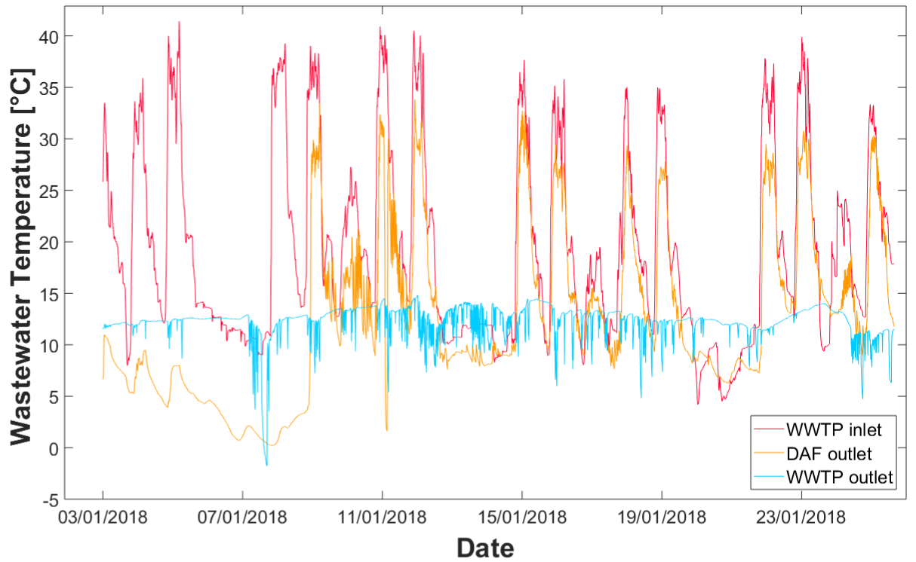
Figure 1. Measured wastewater temperatures at Site 1 in the on-site treatment plant of an Irish meat processor at the inlet(WWTP inlet), outlet of the dissolved air flotation tank (DAF outlet), and the outlet of the treatment plant (WWTP Outlet). Please note that there was an issue with the dissolved air flotation tank during the initial monitoring period till 09/01/2018 resulting in the low temperatures seen here.

An initial assessment of the relatively high wastewater temperatures alongside the significant volume of wastewater generated indicate that there is a high potential for WWHR in Irish meat processing plants. However, there are many questions remaining on the implementation of a WWHR system at a meat processing plant. These include quantifying the variability of the heating resource available in meat processing wastewater, the ideal location for WWHR within the on-site WWTP, and the design and operability of a WWHR system. This manuscript aims to address some of these questions by detailing the implementation of a mobile WWHR demonstration unit that was developed to run in multiple locations at one of the on-site WWTP. Monitoring and operability results from this units testing will provide a valuable insight into the resource available and the design of future WWHR systems in industrial food processing.

- METHODOLOGY

  - Wastewater Heat Recovery Unit Design and Description

WWHR can occur through two main methods: ‘Directly’ by using only heat exchangers to pre-heat incoming cold feedwater to a boiler system and ‘Indirectly’ by using both heat exchangers and heat pumps to heat cold feedwater up to the temperature required for use in the plant (Nagpal et al., 2021). Direct heat exchange has lower capital costs as compared to indirect systems, however they also recover less heat as compared to an indirect system. The conceptual design for the WWHR demonstration unit incorporated both methods into the unit through the use of multiple heat exchangers (Figure 2) with certain heat exchangers allocated to be used for either method. The heat exchanger choice was driven mainly by the commercial availability of the selected heat exchanger and its appropriateness for use with wastewater. During the measurement of wastewater temperature in the on-site WWTP, the significant vertical drop available at the outlet of some of the process tanks, such as the dissolved air flotation tank, was noted. Hence, the potential use of this drop to drive wastewater flow through a heat exchanger to reduce pumping costs was an additional criteria that was considered.

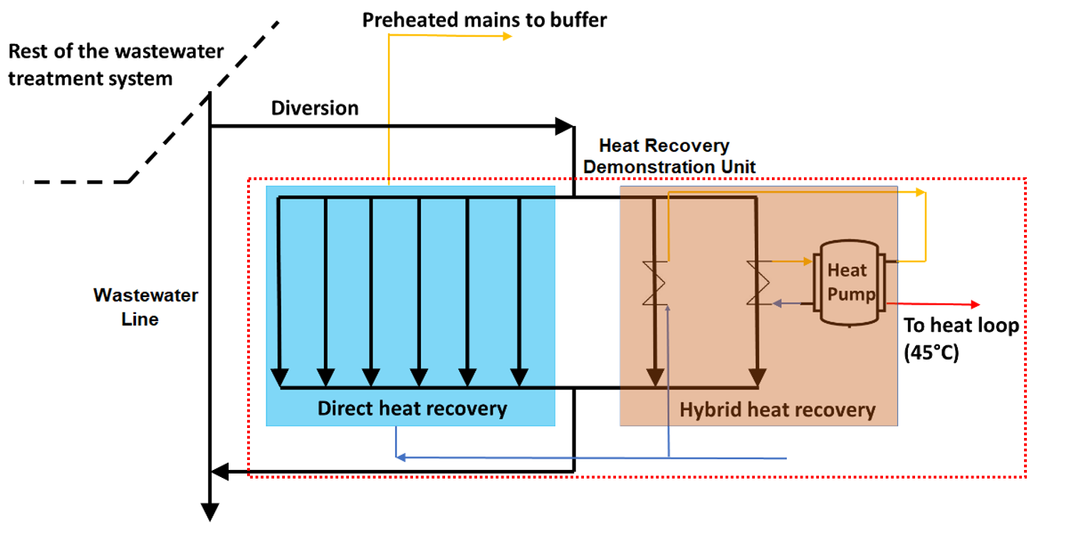
Figure 2. Conceptual design of the demonstration unit designed for wastewater heat recovery at a meat processing plant.
These criteria led to the selection of a copper shower heat exchanger produced by Q-Blue. These heat exchangers were suitable for both gravity-based flow and wastewater while also being commercially available. Ten of these heat exchangers were combined into a movable rig by Q-Blue with a distributor to introduce wastewater through the heat exchangers at the top of the rig (Figure 3a). Six of the heat exchangers were used for direct heat recovery and four for indirect heat recovery. A submersible wastewater pump, heat pump, piping, and monitoring equipment were installed onto the WWHR unit in-house by technical staff at Trinity College Dublin (Figure 3b). Monitoring equipment included sensors to measure temperature at the inlet and outlet of the wastewater and feedwater lines alongside with flowmeters to measure wastewater and feedwater outflow. The unit was designed such that it could be moved with the use of a forklift and be operated at different locations within the on-site WWTP of the meat processing plant.
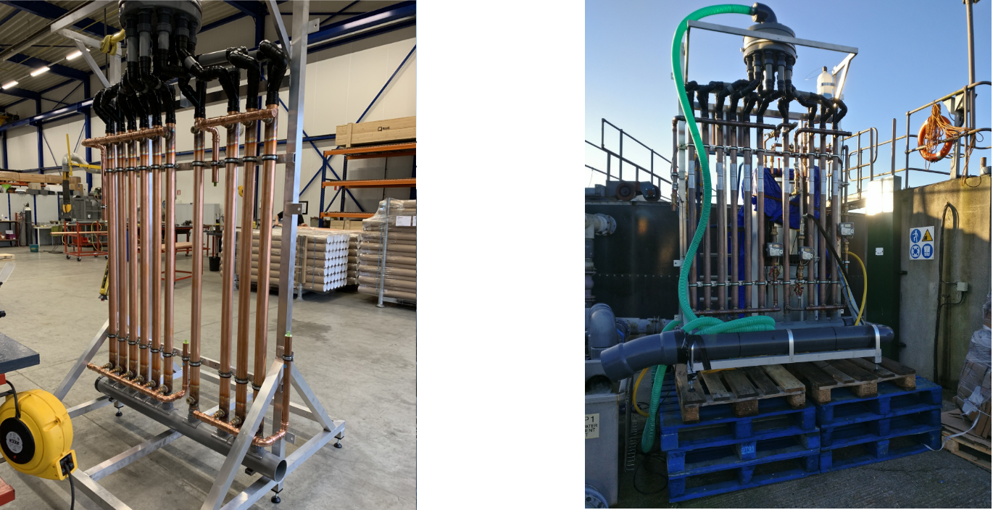
(a) (b)
Figure 3. Pictures of the pilot demonstration unit showing the: (a) installation of the copper shower heat exchangers and (b) complete unit in operation at the on-site treatment plant.

  - Site Description

Site 2 was the location for the both the initial and long-term tests of the demonstration unit. It is a meat processing plant that predominantly processes beef, accepting live animals and delivering packaged products to retailers. The on-site WWTP (Figure 4) receives wastewater from the beef processing chain alongside some wastewater from a nearby rendering plant that treats by-products of meat processing. On average, the WWTP receives around 600 m³/day of wastewater inflows. Raw wastewater is initially screened before being processed by the dissolved air flotation tank to remove solids and grease. The wastewater then undergoes biological treatment through an anoxic tank followed by an aeration tank after which sludge is settled out in clarifiers before the wastewater is discharged to a nearby river. Sludge from the DAF and clarifiers are collected and thickened for disposal. Initial monitoring at Site 2 showed that the heating resource was lower than in Site 1 (Figure 1). Hence, additional long-term monitoring was put in place at the inlet and outlet of the dissolved air flotation tank to quantify the heating resource at this site. The WWTP has a supply of washdown water which is a combination of treated wastewater and rainwater harvested from the meat processing plant roofs. This washdown water was used as the feedwater source for the demonstration unit as it was readily available and would reduce additional tap water use on site.

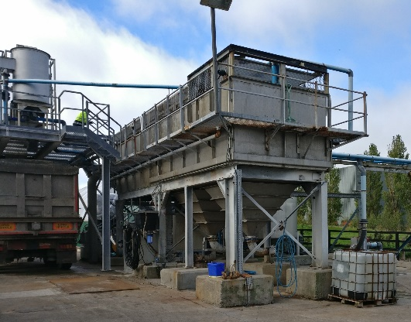
Figure 4. Dissolved air flotation tank at the on-site treatment plant where the demonstration unit was installed.

  - Initial Testing

After commissioning the unit on-site, initial testing at the inlet of the WWTP and at the outlet of the dissolved air flotation tank was conducted. The unit was run for one week at two locations in early 2020 with the main purpose of determining the change in recoverable heat between the two locations. The inlet was selected as one of the locations as it had the largest heating resource available on-site. The outlet of the DAF tank was also selected as an additional spot due to the vertical drop available here (Figure 4), which may be of particular significance for a full-scale system where wastewater flow can be driven by gravity. Further, a significant amount of solids and fats are removed from the wastewater at the end of the dissolved air flotation process which also allows us to compare the difference that wastewater quality causes in heat recovery and operability of the heat recovery unit.

  - Long-term Testing

No on-site testing was possible for a significant amount of time after the initial tests due to access restrictions to Site 1 during the COVID-19 pandemic. After access was reestablished and the pilot unit was restored, a long-term test was planned at the inlet of the wastewater treatment plant in summer 2022. The main aim of these tests was to quantify the variability of the heat produced through WWHR over time, with a particular focus on the impact of biofilm growth on heat exchanger efficiency. The inlet of the WWTP was selected as the location for these tests as the increased biological and solids content would be more likely to cause biofilm growth. Further, heat recovery using the pilot unit at the outlet of the dissolved air flotation tank was not possible for a long-term test as it resulted in the diversion of wastewater from the outlet back to the inlet of the dissolved air flotation tank due to the site layout. This resulted in increased chemical consumption from the increased inflows due to the wastewater diversion back to the inlet of the dissolved air flotation tank. The long-term testing was scheduled to be undertaken over two-three months, with wastewater from the inlet continuously being pumped through the heat exchangers in the demonstration unit during the operating hours of the meat processing plant. To reduce feedwater waste, the feedwater line was planned to be operated one day a week over the testing period to determine the difference in WWHR after continued wastewater flow through the heat exchangers.

- RESULTS AND DISCUSSION

  - Wastewater Temperature Monitoring at Site 2

Wastewater temperature was monitored at Site 2 for over six months between the initial and long-term tests to determine the heating resource available from WWHR at the on-site WWTP. The monitoring confirmed that the heating resource in Site 2 is lower than in Site 1 despite similar meat processing occurring in both sites (Figure 5). The outlet of the dissolved air tank in Site 2 had an average temperature of around 21°C during operating hours as compared to around 24°C at Site 1. This variation is likely to be from the differences in sewer drainage and distances between the processing area and the on-site WWTPs. This variability highlights the importance of monitoring to determine the resource for WWHR in the meat processing industry. However, both the inlet and outlet dissolved air flotation tank temperatures in Site 1 were consistently above ambient air temperatures for the site, considered as a proxy for mains water temperature on-site, across the monitoring period. This indicates that there is still a significant heating resource available in Site 2 despite the temperatures being lower than in Site 1. There also appears to also be a significant seasonal variation in the wastewater temperature during the monitoring, but this is in line with the change in ambient air temperature for the period. Lastly, there appears to be very little difference in the inlet and outlet temperatures for the dissolved air tank. This is an interesting observation and indicates that there may be a significant insulating effect within the dissolved air flotation tanks at meat processing plants due to the presence of a grease layer on the water surface of these tanks.

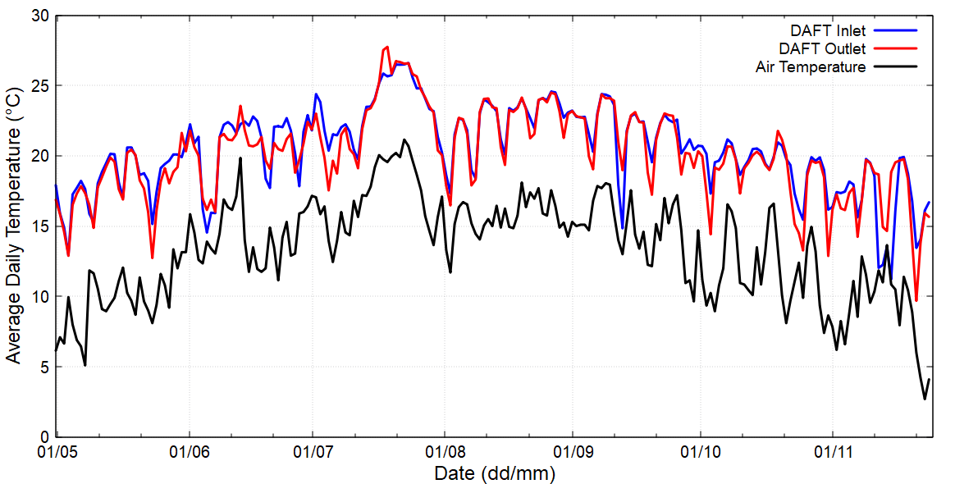
Figure 5. Monitored average daily temperature at the inlet and outlet of the dissolved air flotation tank at Site 2 (DAFT Inlet and Outlet, respectively) along with average daily ambient air temperature. Please note that this monitoring occurred in 2021.

  - Initial Testing

During the initial testing, two persistent issues were identified with the operation of the demonstration unit. There were issues when the unit was used at the WWTP inlet with the submersible pump being blocked after use for some hours due to the large concentration of suspended solids present in the wastewater. This led to an inconsistent performance over the testing week at the inlet of the WWTP (Figure 6a) with no operation possible on certain days due to the pump blockages. However, the high wastewater temperatures at the inlet resulted in the highest WWHR with a power output of around 18.5 kW recorded on the first day of operation through direct WWHR. The variability in the outputs for this location are a result of the change in wastewater flowrate due to the continuing blockage of the pump. The second issue identified was the difficulties in operating the indirect WWHR through the heat pump due to difficulties in controlling the feedwater inlet flow to the heat pump. Feedwater inlet flows had to be set manually by operating staff at the on-site WWTP and also varied based on consumption by other washdown activities on site. When flows were higher than the maximal incoming flow rate of the heat pump unit, it resulted in the automatic shutdown of the unit leading to difficulties in any data collection using indirect heat recovery.

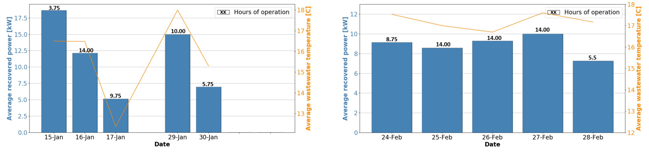
(a) (b)
Figure 6. Wastewater heat recovery performance of the demonstration unit at the: (a) inlet of the wastewater treatment plant and (b) at the outlet of the dissolved air flotation tank.

The demonstration unit’s operation was more consistent at the outlet of the dissolved air flotation tank (Figure 6b) location. No blockages of the pump occurred during the operation of the unit here due to the wastewater being cleaner than at the inlet. There was a reduction in the quantity of direct WWHR with the resulting heating power usually being between 8-10 kW (Figure 6b), but the power remained more consistent than in the previous location through the week. Similar to the previous location, the indirect heat recovery through the heat pump could not be operated consistently due to the variability in the feedwater flow through the demonstration unit. However, even the impact of direct WWHR using only the demonstration unit is significant at this location; assuming that an average heat recovery power of 8.85 kW can be maintained for the full year at this location, around 14MWh of heating energy can be obtained considering 200 operating days of WWHR.

  - Final Testing

As a result of the difficulties with the long-term operation of the unit at the outlet of the dissolved air flotation tank and the submersible pump blockages when the unit was operated the WWTP inlet, a new submersible pump was sourced that could handle the solids loading at the WWTP inlet for the long-term tests. However, after testing and initial operation of the new pump, it was found that the heat exchangers themselves were prone to blockages due to the combined effects of the larger particles and adhesion from the fats in the wastewater. Cleaning out the heat exchangers did not have any appreciable impact and the blockages occurred continuously after the pump was operated for only 2-3 hours. Further, as the long-term tests were carried out in the summer months during a low rainfall period, the feedwater was predominantly composed of treated wastewater which still retained a significant amount of heat. This resulted in a marked reduction in WWHR as compared to the initial tests, with heating power being in the range of 1-2.5 kW and overall energy recovered being around 10kWh-20 kWh/day when the system was operational. These findings are not necessarily representative of the WWHR possible at Site 2, but indicate that feedwater temperatures play a significant role in WWHR and should form a part of future monitoring campaigns. These tests also provide some guidance on issues around the operability and implementation of WWHR systems in the food industry.

  - Lessons Learned on Operability and Future Work

Despite the significant heating resource available in meat processing wastewater, our results show that it is essential to understand the variability in this resource between different sites and seasonally within a site. A consideration of the source of the feedwater is important and feedwater temperatures could play an important role in the feasibility of a WWHR system. Further, for meat processing wastewater a heat exchanger designed for internal use within one of the treatment tanks may be more suitable than the shower heat exchangers used in the demonstration unit which required wastewater flow through them. Prioritizing the use of the off-the-shelf solutions may result in a system that is not suitable for this use case. A branch of future research in this area should focus on designing suitable heat exchangers for use in meat processing WWTPs. Further research could also focus on understanding and quantifying the variability of the WWHR resource within different sites based on the site layout and feedwater source.

- CONCLUSIONS
This manuscript set to answer key questions regarding the implementation of WWHR systems in the meat processing industry by designing and implementing a demonstration unit at an on-site WWTP of a meat processing plant. The inlet of the WWTP was found to have the highest heating resource both in monitoring studies and during the use of the demonstration unit. However, the high solids loading in the wastewater at this location also resulted in an inconsistent performance with particular difficulties in pumping with wastewater and blockages in heat exchangers. However, the physical treatment of the inlet wastewater in a dissolved air tank resulted in a consistent performance during our initial testing stage. Long-term testing was difficult to implement at the selected site due to the layout of the site and consistent blockages resulting from the solids loading at the WWTP inlet. However, the results from the second round of testing highlight the importance of considering feedwater temperature in the feasibility of WWHR systems. Lastly, the issue of high-solids wastewater blocking heat exchangers may be overcome through the design of an internal heat exchanger for use within wastewater tanks.

- ACKNOWLEDGEMENTS

This research was part funded by the ERDF Interreg Ireland-Wales Programme 2014-2020, through the Dŵr Uisce Project.

- REFERENCES

European Commission, 2023. 2030 Climate Target Plan [WWW Document]. URL https://climate.ec.europa.eu/eu-action/european-green-deal/2030-climate-target-plan_en (accessed 4.16.23).
Eurostat, 2020. Just over 20% of energy used for heating and cooling is renewable [WWW Document]. URL https://ec.europa.eu/eurostat/web/products-eurostat-news/-/ddn-20201229-1 (accessed 4.20.21).
Garcia Pardo, N., Vatopoulos, K., Krook Riekola, A., Perez Lopez, A., Olsen, L., 2012. Best available technologies for the heat and cooling market in the European Union. Publications Office of the European Union, LU.
Gill, L., Mac Mahon, J., Ryan, K., 2016. The performance of an evacuated tube solar hot water system in a domestic house throughout a year in a northern maritime climate (Dublin). Solar Energy 137, 261–272. https://doi.org/10.1016/j.solener.2016.07.052
Nagpal, H., Spriet, J., Murali, M.K., McNabola, A., 2021. Heat Recovery from Wastewater—A Review of Available Resource. Water 13, 1274. https://doi.org/10.3390/w13091274
Papapetrou, M., Kosmadakis, G., Cipollina, A., La Commare, U., Micale, G., 2018. Industrial waste heat: Estimation of the technically available resource in the EU per industrial sector, temperature level and country. Applied Thermal Engineering 138, 207–216. https://doi.org/10.1016/j.applthermaleng.2018.04.043
Spriet, J., Hendrick, P., 2017. Wastewater as a Heat Source for Individual Residence Heating: A Techno-economic Feasibility Study in the Brussels Capital Region. Journal of Sustainable Development of Energy, Water and Environment Systems 5, 289–308. https://doi.org/10.13044/j.sdewes.d5.0148
Spriet, J., McNabola, A., 2019. Decentralized drain water heat recovery: A probabilistic method for prediction of wastewater and heating system interaction. Energy and Buildings 183, 684–696. https://doi.org/10.1016/j.enbuild.2018.11.036
Spriet, J., McNabola, A., Neugebauer, G., Stoeglehner, G., Ertl, T., Kretschmer, F., 2020. Spatial and temporal considerations in the performance of wastewater heat recovery systems. Journal of Cleaner Production 247, 119583. https://doi.org/10.1016/j.jclepro.2019.119583
Stoll-Kleemann, S., O’Riordan, T., 2015. The Sustainability Challenges of Our Meat and Dairy Diets. Environment: Science and Policy for Sustainable Development 57, 34–48. https://doi.org/10.1080/00139157.2015.1025644

