Fig. 1: PRISMA flowchart
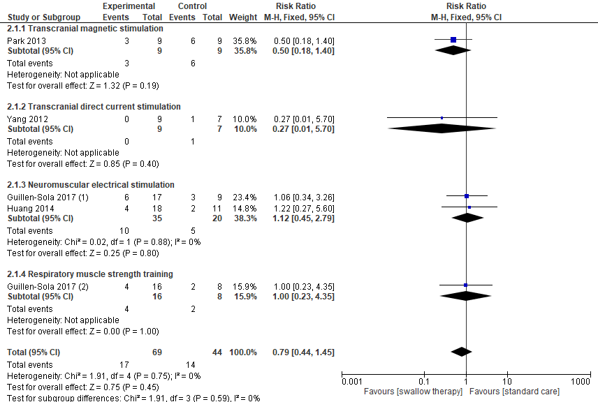

Fig. 2: Swallowing therapy versus standard care: aspiration incidence post intervention.

Fig. 3: Swallowing therapy versus standard care: incidence of pneumonia.

