Density Scaling In Ionic Glass-Former Controlled By Grotthuss Conduction
Z. Wojnarowska^{1,2*}, L. Tajber², M. Paluch¹
¹Institute of Physics, University of Silesia, SMCEBI, 75 Pulku Piechoty 1A, 41-500 Chorzow, Poland
²School of Pharmacy and Pharmaceutical Sciences, Trinity College Dublin, College Green, Dublin 2, Ireland

*Corresponding Authors
To whom correspondence should be addressed to zaneta.wojnarowska@smcebi.edu.pl

ABSTRACT
We present investigations of the charge transport in an ionic glass-former carvedilol dihydrogen phosphate (CP) at various T-P-V thermodynamic conditions in terms of density scaling concept. The studied material was found to reveal superprotonic properties both at ambient end elevated pressure as proved by Walden rule. Surprisingly, from isobaric conductivity data, the relaxation times τ_{σ} presented in volume formalism showed no visual evidence of a liquid-glass transition. The different behavior of relaxation dynamics above and below T_{g} was only revealed from the analysis of logτ_{σ}(V_{sp}) data at isochronal conditions. The τ_{σ} experimental data of CP plotted as a function of (TV^{γ})⁻¹ satisfy the thermodynamic scaling criterion in the supercooled liquid as well as in the amorphous regime, however with a different γ coefficient (γ^{SL}=1.12; γ^{G}=0.48). Nevertheless, by introducing the idea of fictive temperature T_{f}, the transport properties of glassy and supercooled Grotthuss-type conductor measured at various T-P points obey the universal scaling with the use of single γ parameter.

INTRODUCTION
“Nearly all materials can, if cooled fast enough and far enough, be prepared as amorphous solids” was stated by D. Turnbull in 1969. This assertion has been supported by nearly 50 years of research on preparation of a very wide range of liquid-like disordered solids characterized by the presence of all bond types (covalent, ionic, van der Waals, hydrogen bonding, metallic) and multitude of possible applications.,, Although the glass-forming ability is almost a universal property of condensed matter, the physics behind the vitrification phenomenon has been intensively debated, with many aspects of it remaining unknown and to be elucidated.
One of the main features of an amorphous solid is the glass transition temperature (T_{g}), which splits the metastable supercooled liquid (SL) from the non-equilibrium glass (G). The T_{g} appears as a characteristic crossover on the temperature dependence of state functions - volume and enthalpy. Alternatively, a fall in the thermal expansion coefficient,
α_{P}=V⁻¹(∂V/∂T)_{P}, and heat capacity, C_{p}=(∂H/∂T)_{P}, can be employed as the onset temperature of vitrification. Essentially, the glass formation is also reflected in the behavior of the molecular dynamics with respect to temperature and pressure. The time scale of structural rearrangement of molecules in a supercooled liquid increases during cooling/compression, in a manner determined by its fragile or strong nature, and reaches T_{g} at isochronal τ_{α} equal to 100-1000 s.,, Due to the intrinsically slow primary relaxation times below T_{g} the molecules remains trapped in one of the metastable states and tend to achieve an equilibrium during the physical aging process. Such an unstable nature of glasses together with the difficulty to measure very large values of τ_{α} limits the information on the relaxation processes that can be obtained for glasses to fast secondary inter/intramolecular motions.
A new insight into the dynamics of amorphous materials can be brought by studying the charge transport in a unique class of Grotthuss diffusion-enabled ionic glass-formers, which are also promising fuel-cell electrolytes. In these materials, the proton migration through the extended three-dimensional hydrogen bond network results in the enormously efficient charge transport being decoupled from structural dynamics/viscosity and occurring even when molecular mobility becomes frozen below the T_{g}. Consequently, at the T_{g} the conductivity relaxation time τ_{σ}, describing the translational ionic motions, becomes many decades shorter than 100-1000 s, providing access to the glassy regime that otherwise remains inaccessible on a laboratory time scale. Additionally, it has been demonstrated that after crossing the liquid-glass transition the temperature dependence of τ_{σ} can be described by the Arrhenius expression, just like τ_{α}(T) does. This unambiguously indicates the sensitivity of conductivity relaxation to the variables defining structure and thermodynamics of glass, such as aging time or the fictive temperature T_{f} and thereby gives a unique opportunity to investigate the fundamental aspects of the liquid-glass transition by monitoring τ_{σ}(T,P).
One of the most striking experimental findings regarding the dynamics of glass-forming liquids is the density scaling concept. According to this idea, the dynamic quantities (such as structural relaxation time, viscosity and conductivity) determined at various thermodynamic conditions can be expressed as a single universal curve if plotted against the control variable Γ=(TV^{γ})⁻¹, with the γ parameter considered as a material constant. Such a simple scaling behavior has been confirmed hundreds of times for multiple classes of materials (e.g. van der Waals systems, polymers) with exception of strongly associated liquids. The scalability of data was also reported for various conventional aprotic ionic liquids,,,, although their dynamic properties are determined by a combination of hydrogen bonding, van der Waals and electrostatic interactions. Importantly, despite the scaling of different transport quantities (viscosity, conductivity) the γ exponent remains the same for a given ionic liquid. From the above, the thermodynamic scaling concept emerges as a universal and intuitive feature of glass-forming systems in the supercooled regime. Nevertheless, the scaling of dynamics of glasses has never been investigated to date.
In this work, we provide verification of the (TV^{γ})⁻¹ rule for ionic glass-formers with Grotthuss-type conduction by investigating the properties of carvedilol dihydrogen phosphate (CP) salt as a model of such substances. Additionally, by taking advantage of unique properties of this proton conductor we address a fundamental issue of physics of glasses, which is the validity of density scaling concept below T_{g}. The analysis of conductivity relaxation data of CP collected in the T-P-V thermodynamic space indicates a significant decrease of the scaling exponent as the glass transition is traversed. Furthermore, the studies of isobaric logτ_{σ}(V_{sp}) dependences in terms of the Avramov entropic model highlight a unique feature of a liquid-glass transition and reveal the role of fictive temperature T_{f} in density scaling of proton conductors.

EXPERIMENTAL
For details of dielectric and PVT measurements of carvedilol dihydrogen phosphate see ref. 28.

RESULTS & DISCUSSION
Carvedilol dihydrogen phosphate (CP) has a melting point of 438 K and is an ionic material. It is, as many other systems belonging to this class of materials, formed by a proton transfer between a Brønsted acid (AH) and a Brønsted base (B) according to the reaction HA+B↔A⁻+BH⁺. The donor-acceptor capabilities of both parent compounds and a very well developed H-bond network results in a fast proton transport in the disordered CP. The non-aqueous Grotthuss transport is especially efficient in the vicinity of the liquid-glass transition and is reflected in an enormously short conductivity relaxation time at T_{g} as well as high conductivity (see Figure 1).

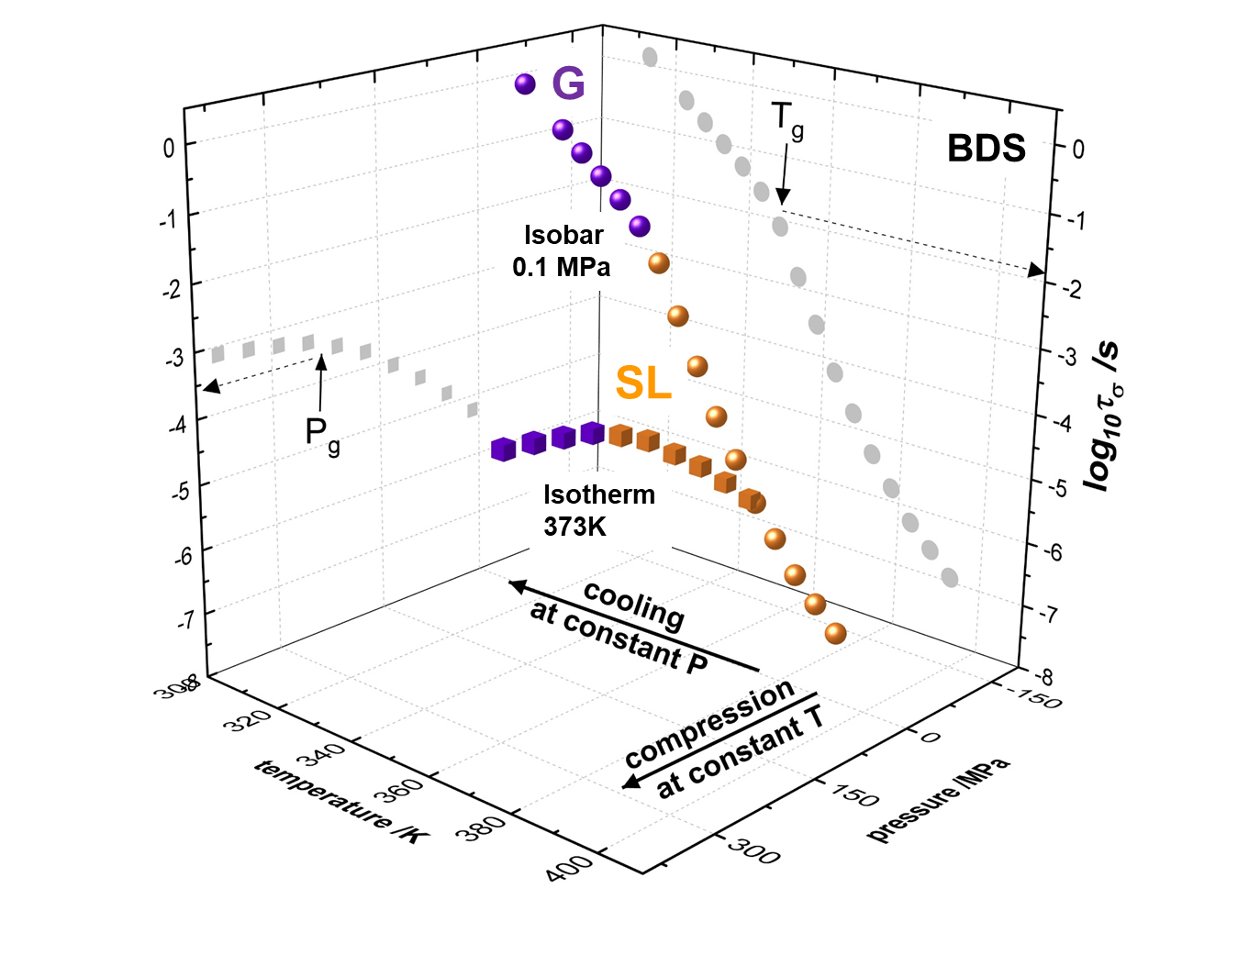
Figure 1 The isobaric and isothermal dependence of conductivity relaxation times of CP presented in a 3D T-P-τ_{σ} thermodynamic space and in 2D projections. T-P-τ_{σ} experimental data were taken directly from the electric modulus peak maximum (see ref. 28). For clarity the experimental points in the glassy (G) and supercooled liquid (SL) states are highlighted with different colours (violet and orange, respectively).

The τ_{σ}(T_{g}) equal to 0.015 s is even lower than the value found for phosphoric acid, considered as the best proton conductor., Also, as seen for all glass-formers, the structural dynamics of CP reaches the order of 10³ s as the liquid-glass transition is traversed as determined by TMDSC technique, thereby clearly demonstrating a significant time scale separation between the charge and mass transport in this system (see ref. 28). The origin of decoupling phenomenon has been revealed by high pressure dielectric experiments. Namely, the τ_{σ} determined at the liquid-glass transition is getting markedly faster at an elevated pressure thereby indicating higher efficiency of charge transport in the densified material due to the Grotthuss-type conduction. ^{28,} As presented in Figure 1, isothermal compression of supercooled phase of CP performed at 373 K results in crunching at P_{g}=200 MPa and τ_{σ}=0.3 ms, which is almost 2 decades below τ_{σ}(T_{g})^{p=atm}. As a consequence, the Arrhenius dependence of conductivity relaxation times in amorphous CP can be observed across around 4 or 6 decades at ambient and elevated pressure, respectively. It is noteworthy that T_{g}(P_{g}) behavior determined directly from the crossover of isobaric τ_{σ}(T) and isothermal τ_{σ}(P) data is in accordance with the T_{g}(P_{g}) dependence coming from crossover of isobaric V_{sp}(T) in dilatometric measurements (see Figure 2). As a result, dT_{g}/dP values determined from both these methods are also similar and indicate a relatively strong sensitivity of structural dynamics to compression (dT_{g}/dP=170 K/GPa).

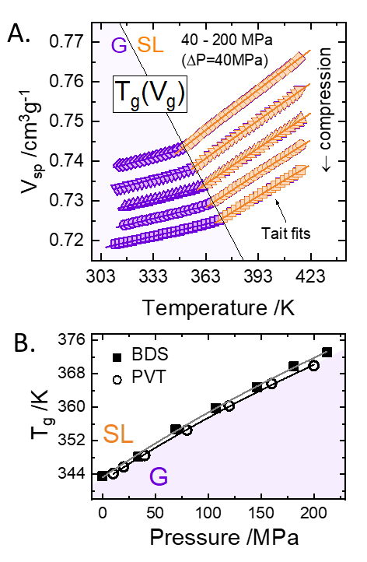
Figure 2 A) PVT data of CP measured above and below T_{g} and parametrized by means of the Tait formula with the following fit parameters. G: V₀ = 0.74 cm³/g, V₁ = 1.22·10⁻⁴ cm³/g·C, V₂= 0; b₀ = 439 MPa, b₁ =7.46·10⁻⁴ ºC⁻¹. SL: V₀ = 0.72 cm³/g, V₁ = 3.79·10⁻⁴ cm³/g·C, V₂ = -6.35·10⁻⁸ cm³/g·C², b₀ = 410 MPa, b₁ = 2.77·10⁻³ ºC⁻¹; C is a universal constant equal to 0.0894 in both cases. B) T_{g}(P_{g}) dependence determined from dielectric and dilatometric measurements. The dT_{g}/dP coefficient was found to be equal 167 K/GPa (PVT) and 170 K/GPa (BDS). The BDS and PVT experimental data were performed with approximately the same cooling rate of 1 K/min. Note that the PVT experimental data were measured on the isobaric pathways while the BDS points were recorded during isothermal compression.

To examine the premise of density scaling in supercooled and glassy regimes of protic ionic conductor, the conductivity relaxation times of CP measured at various T-P conditions need to be expressed as a function of volume (see SI for all measured isothermal log τ_{σ}(P) data). In practice, to calculate volume at each T-P state point an additional set of V_{sp}(T,P) data, described by the means of equation of state, is required. Herein, the PVT results of CP were parameterized with the use of Tait equation²⁰, $V_{sp}(T,P)=(V_{0}+V_{1}T+V_{2}T^{2})[1-Cln\left(1+\frac{P}{b_{0}\exp\left(-b_{1}T\right)}\right)]$, above and below T_{g} with the numerical parameters collected in the caption to Figure 2. The results of τ_{σ}(V_{sp}) are demonstrated in Figure 3A. For clarity, the experimental data in glassy and supercooled regimes are marked with different colors (violet and orange, respectively).

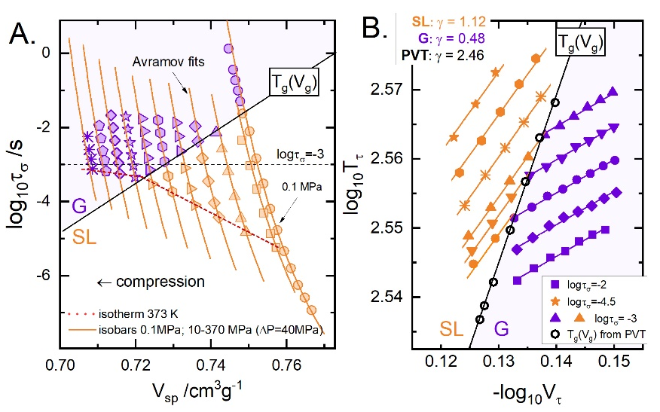
Figure 3 Panel A. The isothermal and isobaric dependences of conductivity relaxation times of CP presented as a function of volume. Solid lines denotes fits of the Avramov model to the experimental data collected in the supercooled liquid state. Fit parameters: logτ_{σ}=-11.54±0.38s; D=4.95±0.27; A=396±13; γ=1.125±0.02. Panel B was obtained by horizontal crossing the logτ_{σ}(V_{sp}) data at multiple isochronal conditions. Open black points denote T_{g}(V_{g}) line on V_{sp}(T) plot (see inset to Figure 1). The exponents γ were determined from separate linear global fitting of T_{τ}(V_{τ}) points above and below T_{g}.

As seen in Figure 3A, the isothermal τ_{σ}(V_{sp}) dependences show a kinked nature, exactly like both τ_{σ}(T) and τ_{σ}(P) do, while a very peculiar behavior can be observed for isobaric τ_{σ}(V_{sp}) data; specifically, the crossover from Vogel-Fulcher-Tammann to Arrhenius behavior evidently disappears. Furthermore, the τ_{σ}(V_{sp})^{P=const} points in the amorphous region follow reasonably well the extrapolated fits of T-V version of Avramov entropic model $τ_{σ}=τ_{σ0}{\left(\frac{A}{{TV}^{γ}}\right)}^{D}$to the experimental points collected above the T_{g}. Hence, it is practically impossible to identify the liquid-glass transition by monitoring the changes of τ_{σ} accompanying density fluctuations at isobaric conditions. This suggests temperature rather than free volume as a decisive factor in controlling the dynamics of the studied proton conductor. A quantitative approach reflecting the relative importance of these two effects on the dynamic properties of any glass-former, including protic ionic compounds, is the ratio of the activation energy at constant volume ${\left.{E_{V}=∂logτ}_{σ}/∂T^{-1}\right|}_{V}$ to the activation enthalpy at constant pressure $E_{p}={\left.{∂logτ}_{σ}/∂T^{-1}\right|}_{P}$.The E_{v}/E_{p} ratio ranges from 0 to 1, solely indicating free volume activated and ideally thermally activated behavior, respectively. The E_{v}/E_{p} calculated directly as the slope of isobaric and isochoric experimental data on logτ_{σ}(T⁻¹) plot at the T_{g} (data not shown) and ambient pressure is equal to 0.8 and it increases to 0.85 in the normal liquid state of CP, thereby implying a prevailing role of temperature over the volume on the transport properties of this system, as suggested above. Interestingly, the value of E_{v}/E_{p} obtained for the investigated proton conducting material is even higher than those reported before for conventional imidazolium-based ionic liquids as well as strongly associated systems (e.g. methanol-0.58, ethanol-0.66) where volume exerts a weak effect on their dynamics due to the strong hydrogen bonding. The lack of VFT-Arrhenius crossover on logτ_{σ}(V_{sp})^{P=const} curves, reported here for the first time, can be considered as new universal feature of the liquid-glass transition for materials with thermally activated dynamics. Nevertheless, more experimental results are needed to support this suggestion.
The next step in relation to verifying the scaling criterion in Grotthuss-conducting systems is to determine the γ exponent. For this purpose, a model-independent procedure based on the analysis of logτ_{σ}(V_{sp}) data at isochronal conditions was employed. Then, the slope of double logarithmic plot of T_{τ} vs. V_{τ} provides a direct estimate of the γ parameter. As presented on Figure 2B, T_{τ}(V_{τ}) points collected above and below T_{g} evidently follow a different behavior, reflected in two values of the γ exponent: 1.12±0.04 and 0.48±0.02 in the supercooled liquid and glassy state, respectively. It should be mentioned that the value of coefficient γ obtained from T_{τ}(V_{τ}) data in the supercooled liquid state matches that determined from the numerical fitting procedure with the use of Avramov entropic model (see the lines in Figure 3A). However, it is markedly lower than the γ calculated from linear regression of T_{g}(V_{g}) dilatometric data (γ^{PVT}=2.46). This divergence can be easily understood by taking into account that the PVT data reveal the structural rearrangement of molecules (mass transport), while the conductivity relaxation describes the charge transport in a system, with these two properties being strongly decoupled from each other in Grotthuss-type conductors. In this context, the ratio γ_{τσ}/γ_{τα} is expected to follow the value of decoupling index defined as the exponent k in fractional Stokes-Einstein relation, τ_{σ}τ_{α}^{-k}=const. The γ_{τσ}/γ_{τα} ratio equal to 0.47±0.03 together with k^{SE}=0.6±0.05 make the relation γ_{τσ}/γ_{τα}≈k^{SE} quite well satisfied in case of CP.
The results of density scaling of CP are demonstrated in Figure 4A. It can be observed that all isothermal and isobaric τ_{σ}(TV^{γ})⁻¹ dependences illustrating the dynamics of supercooled CP overlaid and with a high precision formed a single master curve (orange data points). It is obvious that the studied proton conductor with the extensive H-bond network does not have characteristics of strongly associated liquids. Another important observation made from Figure 4A is that the experimental data of supercooled liquid and glassy regimes formed two independent master curves when plotted as a function of scaling variable (TV^{γ})⁻¹. This finding provides a clear evidence that the density scaling concept is obeyed in a decoupled Grotthuss-type conductor, however with a different γ parameter above and below T_{g}. Therefore, the following question can be raised: Is there a possibility to scale the entire pressure-sensitive dynamics of CP by using a single γ coefficient? To further advance this hypothesis one need to recall the isobaric logτ_{σ}(V_{sp}) data and their parameterization by means of Avramov model (Figure 3A).
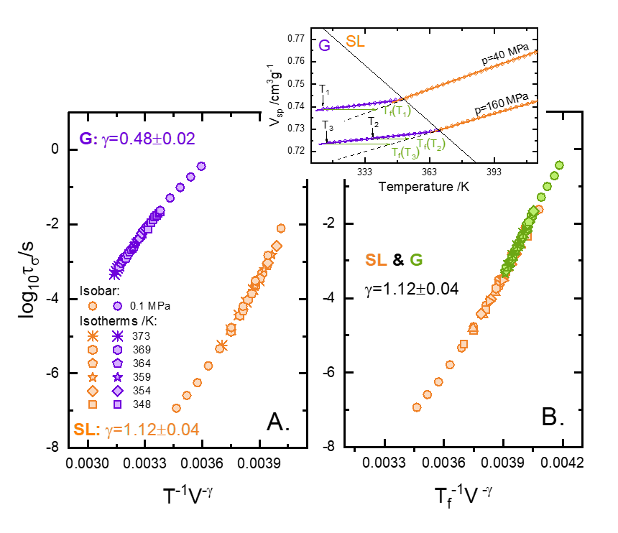
Figure 4 Panel A. The experimental verification of density scaling rule for CP above (orange master curve) and below (violet master curve) the liquid-glass transition. On panel B the density scaling rule of glass (green points) and supercooled liquid (orange points) was tested by using the idea of fictive temperature T_{f} (see inset).
As mentioned above the experimental points recorded in the glassy regime follow reasonably well the lines extrapolated along the Avramov fits. Thus, it might be possible that that re-assigning the temperature conditions of the non-equilibrium logτ_{σ}(V_{sp}) points below the T_{g} may result in merging τ_{σ} of both glass and supercooled liquid into a single master curve when plotted as a function of (TV^{1.12})⁻¹. To verify this postulate, the concept of fictive temperature, T_{f}, was explored, with T_{f} defined as the temperature at which the glass and equilibrium liquid have the same specific volume,,. As presented in the inset to Figure 4B T_{f} takes different value for various pressure conditions. As demonstrated in Figure 4B, application of T_{f} as a variable parameter results in simultaneous scaling of glassy and supercooled dynamics. Based on the presented results is can be said that the dynamical behavior of liquids and glasses can be explained and analyzed within the same theoretical framework.

CONCLUSIONS
Summarizing, this study presents the first experimental evidence of density scaling for carvedilol dihydrogen phosphate, an ionic glass-former with well extended H-bond network and Grotthuss-type conductivity mechanism. We found that the scaling rule is obeyed by the pressure-sensitive conductivity relaxation dynamics both in the supercooled liquid as well as in the glassy regime. The scaling parameter obtained for the glass, γ^{G}=0.48, is, however, different from that of the supercooled liquid, γ^{SL} = 1.12, as well as that obtained from isobaric V_{sp}(T) data, γ^{PVT}=2.46. Nevertheless, we proved that adopting the idea of fictive temperature leads to the scaling of transport properties above and below T_{g}. In addition, the strongly decoupled charge and mass transport in CP revealed a unique feature of glass-formers with thermally activated dynamics, which is no visual evidence of a liquid-glass transition during the isobaric densification.
ACKNOWLEDGEMENTS
Authors are also deeply grateful for the financial support by the National Science Centre within the framework of the Opus8 project (Grant DEC-2014/15/B/ST3/04246). This publication has emanated from research conducted with the financial support of Science Foundation Ireland (SFI) under Grant Numbers 15/CDA/3602 and supported by the Synthesis and Solid State Pharmaceutical Centre (SSPC), financed by a research grant from Science Foundation Ireland (SFI) and co-funded under the European Regional Development Fund (Grant Number 12/RC/2275).
REFERENCES

Chen, H.S.; Turnbull, D. Specific Heat and Heat of Crystallization of Amorphous Germanium Journal of Applied Physics 1969 40, 4214-4215
Wu, W.; Israel, C.; Hur, N.; Park, S.; Cheong, S-W.; de Lozanne, A. Magnetic imaging of a supercooling glass transition in a weakly disordered ferromagnet Nature Materials, 2006 5, 881–886
Lindsay, A. Greer New horizons for glass formation and stability Nature Materials, 2015, 14, 542–546
Tanaka, H.; Kawasaki, T.; Shintani, H.; Watanabe, K. Critical-like behaviour of glass-forming liquids Nature Materials, 2010, 9, 324–331
Sciortino, F. Disordered materials: one liquid, two glasses, News and Views, Nature Materials, 2002, 1, 145–146
Angell, C.A. Formation of Glasses from Liquids and Biopolymers Science 1995, 267, 1924
MacFarlane, D. R.; Kar, M.; Pringle, J. M. Fundamentals of Ionic Liquids: From Chemistry to Applications 2017 Wiley‐VCH Verlag GmbH & Co. KGaA
Ngai, K. Relaxation and Diffusion in Complex Systems 2011 Springer Science & Business Media
Kremer, F.; Schönhals, A. Broadband dielectric spectroscopy, 2003 Springer
Hasse, W.; Wróbel, S. Relaxation Phenomena, 2003 Springer
Sangoro, J.; Kremer, F. Charge Transport and Glassy Dynamics in Ionic Liquids Acc. Chem. Res. 2012, 45, 4, 525-532
Kreuer, K.D. Proton Conductivity: Materials and Applications Chem. Mater., 1996, 8, 610–641.
Armand, M.; Endres, F.; MacFarlane, D. R.; Ohno, H.; Scrosati, B. Ionic-liquid materials for the electrochemical challenges of the future Nat. Mater., 2009 8, 621–629
Gainaru, C.; Stacy, E. W.; Bocharova, V.; Gobet, M.; Holt, A. P.; Saito, T.; Greenbaum, S.; Sokolov, A.P. Mechanism of Conductivity Relaxation in Liquid and Polymeric Electrolytes: Direct Link between Conductivity and Diffusivity J. Phys. Chem. B, 2016, 120 (42), pp 11074–11083
Paluch, M. Dielectric properties of ionic liquids; 2016 Springer: Berlin
Wojnarowska, Z.; Roland, C. M.; Swiety-Pospiech, A.; Grzybowska, K.; Paluch, M. Anomalous electrical conductivity behavior at elevated pressure in the protic ionic liquid procainamide hydrochloride. 2012 Phys. Rev. Lett. 108, 015701
Zhao, J.; Simon, S. L.; McKenna, G. B. Using 20-million-year-old amber to test the super-Arrhenius behaviour of glass-forming systems Nat. Commun. 2013 4, 1783.
Gundermann, D.; Pedersen, U. R.; Hecksher, T.; Bailey, N. P.; Jakobsen, B.; Christensen, T.; Olsen, N. B.; Schrøder, T. B.; Fragiadakis, D.; Casalini, R. et al, Predicting the density-scaling exponent of a glass-forming liquid from Prigogine–Defay ratio measurements Nature Physics, 2011, 7, 816–821.
Pensado, A. S.; Pádua, A. A. H.; Comuñas, M. J. P.; Fernández, J. J. Phys. Chem. B, Relationship between Viscosity Coefficients and Volumetric Properties Using a Scaling Concept for Molecular and Ionic Liquids 2008, 112 (18), pp 5563–5574
Roland, C. M., Hensel-Bielowka, S., Paluch, M. & Casalini, R. Supercooled dynamics of glass-forming liquids and polymers under hydrostatic pressure Rep. Prog. Phys. 2005 68, 1405-1478.
Roland, C. M., Casalini, R., Bergman, R. & Mattsson, Role of hydrogen bonds in the supercooled dynamics of glass-forming liquids at high pressures Phys. Rev. B 2008 77, 012201.
López, E. R.; Pensado, A. S.; Fernández, J.; Harris, K.R. On the density scaling of pVT data and transport properties for molecular and ionic liquids. J. Chem Phys. 2012 136(21):214502
Ribeiro, M. C. C.; Pádua, A. A. H.; Costa Gomes, M. F. Glass transition of ionic liquids under high pressure J. Chem. Phys. 2014 140, 244514.
Paluch, M.; Wojnarowska, Z.; Goodrich, P.; Jacquemin, J.; Pionteck, J.; Hensel-Bielowka, S. Can the scaling behavior of electric conductivity be used to probe the self-organizational changes in solution with respect to the ionic liquid structure? The case of [C8MIM][NTf2] Soft Matter, 2015 11, 6520.
Wojnarowska, Z.; Jarosz, G.; Grzybowski, A.; Pionteck, J.; Jacquemin, J.; Paluch, M. On the scaling behavior of electric conductivity in [C4mim][NTf2] Phys.Chem.Chem.Phys., 2014 16, 20444.
López, E.R.; Pensado, A.S.; Comuñas, M.J.; Pádua, A.A.; Fernández, J.; Harris, K.R. Density scaling of the transport properties of molecular and ionic liquids J Chem Phys. 2011 14,134, 144507.
Wojnarowska, Z.; Roland, C. M.; Kolodziejczyk, K.; Swiety-Pospiech, A.; Grzybowska, K.; Paluch, M. Quantifying the Structural Dynamics of Pharmaceuticals in the Glassy State J. Phys. Chem. Lett., 2012 3, 1238.
Wojnarowska, Z.; Wang, Y.; Pionteck, J.; Grzybowska, K.; Sokolov, A. P.; Paluch, M. High Pressure as a Key Factor to Identify the Conductivity Mechanism in Protic Ionic Liquids Phys. Rev. Lett. 2013 111, 225703
Wojnarowska, Z.; Wang, Y.; Paluch, K. J.; Sokolov, A. P.; Paluch, M. Phys.Chem.Chem.Phys, Observation of highly decoupled conductivity in protic ionic conductors 2014 16, 9123.
Vilciauskas, L.; Tuckerman, M. E.; Bester, G.; Paddison, S. J.; Kreuer, K.-D. The mechanism of proton conduction in phosphoric acid Nature Chem., 2012, 4, 461–466.
Wojnarowska, Z.; Feng, H.; Diaz, M.; Ortiz, A.; Ortiz, I.; Knapik-Kowalczuk, J.; Vilas, M.; Verdía, P.; Tojo, E.; Saito, T. et al Revealing the charge transport mechanism in polymerized ionic liquids: Insight from high pressure conductivity studies Chemistry of Materials 2017, 29,19, 8082-8092
Fulcher, G. S. Analysis of recent measurements of the viscosity of glasses J. Am. Ceram. Soc., 1925, 8, 339.
Casalini, R.; Mohanty, U.; Roland, C.M. Thermodynamic interpretation of the scaling of the dynamics of supercooled liquids J. Chem. Phys. 2006 125, 014505.
Floudas, G.; Paluch, M.; Grzybowski, A.; Ngai, K.L. Molecular Dynamics of Glass-Forming Systems: Effects of Pressure (Series: Advances in Dielectrics, Series Editor: Friedrich Kremer), 2011 Springer-Verlag Berlin Heidelberg
Wojnarowska, Z.; Paluch, M. Recent progress in dielectric properties of protic ionic liquids Journal of Physics: Condensed Matter, 2015 27, 7
Wojnarowska, Z.; Paluch, K. J.; Shoifet, E.; Schick, C.; Tajber, L.; Knapik, J.; Wlodarczyk, P.; Grzybowska, K.; Hensel-Bielowka, S.; Verevkin, S. P. et al. Molecular origin of enhanced proton conductivity in anhydrous ionic systems. J. Am. Chem. Soc. 2015 137 876 (3), 1157−1164
Köddermann, T.; Ludwig, R.; Paschek, D. On the validity of Stokes-Einstein and Stokes-Einstein-Debye relations in ionic liquids and ionic-liquid mixtures. Chemphyschem. 2008 15;9(13):1851-8
Jabraoui, H.; Malki, M; Hasnaoui, A.; Badawi, M.; Ouaskit, S.; Lebegue, S.; Vaills, Y. Thermodynamic and structural properties of binary calcium silicate glasses: insights from molecular dynamics, Phys. Chem. Chem. Phys. 2017 DOI: 10.1039/c7cp03397d
Rodríguez-Tinoco, C.; González-Silveira, M.; Barrio, M.; Lloveras, P.; Tamarit, J.-L. Garden, J.; Rodríguez-Viejo, J. Ultrastable glasses portray similar behaviour to ordinary glasses at high pressure Scientific Reports, 2016 6:34296, DOI: 10.1038/srep34296.
Rodríguez-Tinoco, C.; Ràfols-Ribé, J.; González-Silveira, M.; Rodríguez-Viejo, J. Relaxation dynamics of glasses along a wide stability and temperature range Scientific Reports, 2016 6:35607, DOI: 10.1038/srep35607 TOC GRAPHICS 

