Numerical Simulations of Heat Transfer in Moderately High Swirling Pipe Flows

Testa Lorenzo
Dept. Mechanical, Manufacturing and Biomedical Engineering
Trinity College Dublin
Dublin, Ireland
testal@tcd.ie
Tim Persoons
Dept. Mechanical, Manufacturing and Biomedical Engineering
Trinity College Dublin
Dublin, Ireland
persoont@tcd.ie

Abstract—Flows having tangential or swirling velocity component can be challenging to model. Yet accurate prediction of their behaviour is required in industry, where they often find use for their enhancing mixing and heat transfer properties. This work investigates the capability of two turbulence models to calculate the thermal field of moderately high swirling developing pipe flows.
Keywords— swirling, pipe flow, simulation, heat transfer

NOMENCLATURE
Acronyms
SST Shear Stress Transport
RSM Reynolds Stress Model
Greek letters
ρ air density kg/m³
ν kinematic viscosity m²/s
ω angular velocity rad/s
Roman letters
x axial coordinate m
r radial coordinate m
D pipe diameter m
R pipe radius m
Re Reynolds number -
Nu Nusselt number -
S swirl intensity -
S₀ inlet swirl intensity -
Pr Prandtl number -
Pr_{t} turbulent Prandtl number -
Tu turbulence intensity %
l_{s} turbulence length scale m
U average axial velocity m/s
U₀ inlet axial velocity m/s
q heat transfer rate W
ΔP pressure drop Pa
q’’ surface heat flux W/m²
k thermal conductivity W/mK
T₀ inlet air temperature K
T_{b} bulk temperature K
T_{w} wall temperature K
h convective heat transfer coefficient W/m²K
u axial velocity m/s
w tangential velocity m/s

Introduction
Swirling flows can be broadly defined as having a tangential velocity component alongside a primary axial component. According to this definition, many flows can be labelled as swirling, yet their interaction with the surrounding can strongly differ depending on the mechanism adopted to generate the swirl and other parameters, like swirl intensity, turbulence, rate of decay and so on. In general, whether the swirl is generated by guided vane [1], axial vanes [2], other helical vanes [3,4], imposing a forced inlet condition [5] or by a rotating axial fan [6], increased heat transfer rates have been consistently reported when compared to purely axial flows. Industrially relevant applications involving swirling flows include server cooling, where the tangential component is imparted by the rotation of axial fan blades. Fan-driven airflows have been shown to be complex [7] and so challenging to describe numerically. Yet, proper modelling could help designers to develop solutions to reduce swirl, which in this context is often accounted as a loss of efficiency [8]. The first step before delving into simulations involving complex flows and realistic geometries is to prove sufficient reliability of turbulence models to describe benchmarking flows, such as pipe flows. This work aims to assess the capability of two turbulence models, namely k-ω SST and RSM, to describe pipe flows in the presence of swirl and heat transfer. The inlet swirl considered in the study has a forced-vortex velocity profile. Swirl decay follows a qualitative exponential trend with both the SST and RSM, with better agreement with the literature for the former, while experimental velocity profiles are better replicated by the RSM. The heat transfer enhancements predicted by both models are poorly correlated to the reference empirical equation.

Methodology

Domain and boundary conditions
Simulations were made on Ansys Fluent 2024R1. The flow was modelled on the 2-dimensional axisymmetric domain shown in Fig. 1.
Fig. 1 Schematic of the 2-dimensional axisymmetric domain and pipe dimensions
Inlet axial velocity u was constant along the radial coordinate, whereas the inlet tangential velocity profile w was a forced-vortex velocity profile:
$$\begin{aligned}\text{w}\left(\text{r}\right)\text{=}\text{ω∙r}\#\left(1\right)\end{aligned}$$
shown in Fig. 2. The constant of proportionality ω is the angular velocity of the solid-body rotating at the inlet around the pipe axis, forming the forced-vortex tangential velocity profile.

Fig. 2 Qualitative representation of different inlet tangential velocity profiles. From top to bottom: forced-vortex, free-vortex and mixed-vortex
The flow was simulated for Reynolds numbers 10000, 30000, 40000 and 60000 and defined as:
$$\begin{aligned}\text{Re=}\frac{{\text{U}}_{\text{0}}\text{D}}{\text{ν}}\#(2)\end{aligned}$$
With U₀ the inlet velocity, D the pipe diameter and ν the kinematic viscosity of air. ω was changed at every Re so that a constant value of inlet swirling intensity S₀=1 was kept for all the simulations. Swirl intensity S is a local variable commonly defined as the axial flux of tangential momentum to the axial flux of axial momentum [9]:
$$\begin{aligned}\text{S=}\frac{\text{2π}\int_{\text{0}}^{\text{R}}{\text{ρu}\left(\text{r}\right)\text{w(r)}{\text{r}}^{\text{2}}\text{dr}}}{\text{R∙2π}\int_{\text{0}}^{\text{R}}{\text{ρ}{\text{u}}^{\text{2}}\left(\text{r}\right)\text{rdr}}}\#\left(3\right)\end{aligned}$$
Where R is the pipe radius while r is the radial position. Inlet turbulence intensity and turbulence length scale were Tu=5% and l_{s}=D, respectively. Inlet air had a uniform inlet temperature of T₀=298 K and pipe wall temperature was kept constant at T_{w}=333 K, while air Prandtl number Pr and turbulent Prandtl number Pr_{t} were kept constant at 0.71 and 0.85, respectively. To assess heat transfer, local Nusselt number Nu_{x} was measured and defined as:
$$\begin{aligned}{\text{Nu}}_{\text{x}}\text{=}\frac{\text{h(x)D}}{\text{k}}\#\left(4\right)\end{aligned}$$
With k the thermal conductivity of air and h is the local convective heat transfer coefficient defined as:
$$\begin{aligned}\text{h}\text{(x)}\text{=}\frac{\text{q"}\text{(x)}}{{\text{T}}_{\text{w}}\text{-}{\text{T}}_{\text{b}}\left(x\right)}\#\left(5\right)\end{aligned}$$
Where q” is the local wall heat flux and T_{b} is the bulk temperature of air defined as:
$$\begin{aligned}{\text{T}}_{\text{b}}\text{(x)=}\frac{\int_{\text{0}}^{\text{R}}{\text{u(r)T(r)}\text{rdr}}}{\int_{\text{0}}^{\text{R}}{\text{u(r)}\text{rdr}}}\#\left(6\right)\end{aligned}$$

Mesh sensitivity study
The discrete domain was progressively refined to reduce sensitivity of the solution to the mesh. The meshes were all fully structured. The final grid selected for the simulations had about 2.58 million cells and a first cell thickness of 0.025 mm. The y⁺ was lower than 1 for over 99% of the pipe length. The mesh was tested at Re = 60000 and with the k-ω SST turbulence model. The variables of interest selected for the mesh sensitivity study were pressure drop ΔP and heat transfer rate q shown in Fig. 3. The simulations were then run for all the combinations of inlet conditions with both the k-ω SST and Reynolds Stresses turbulence models.
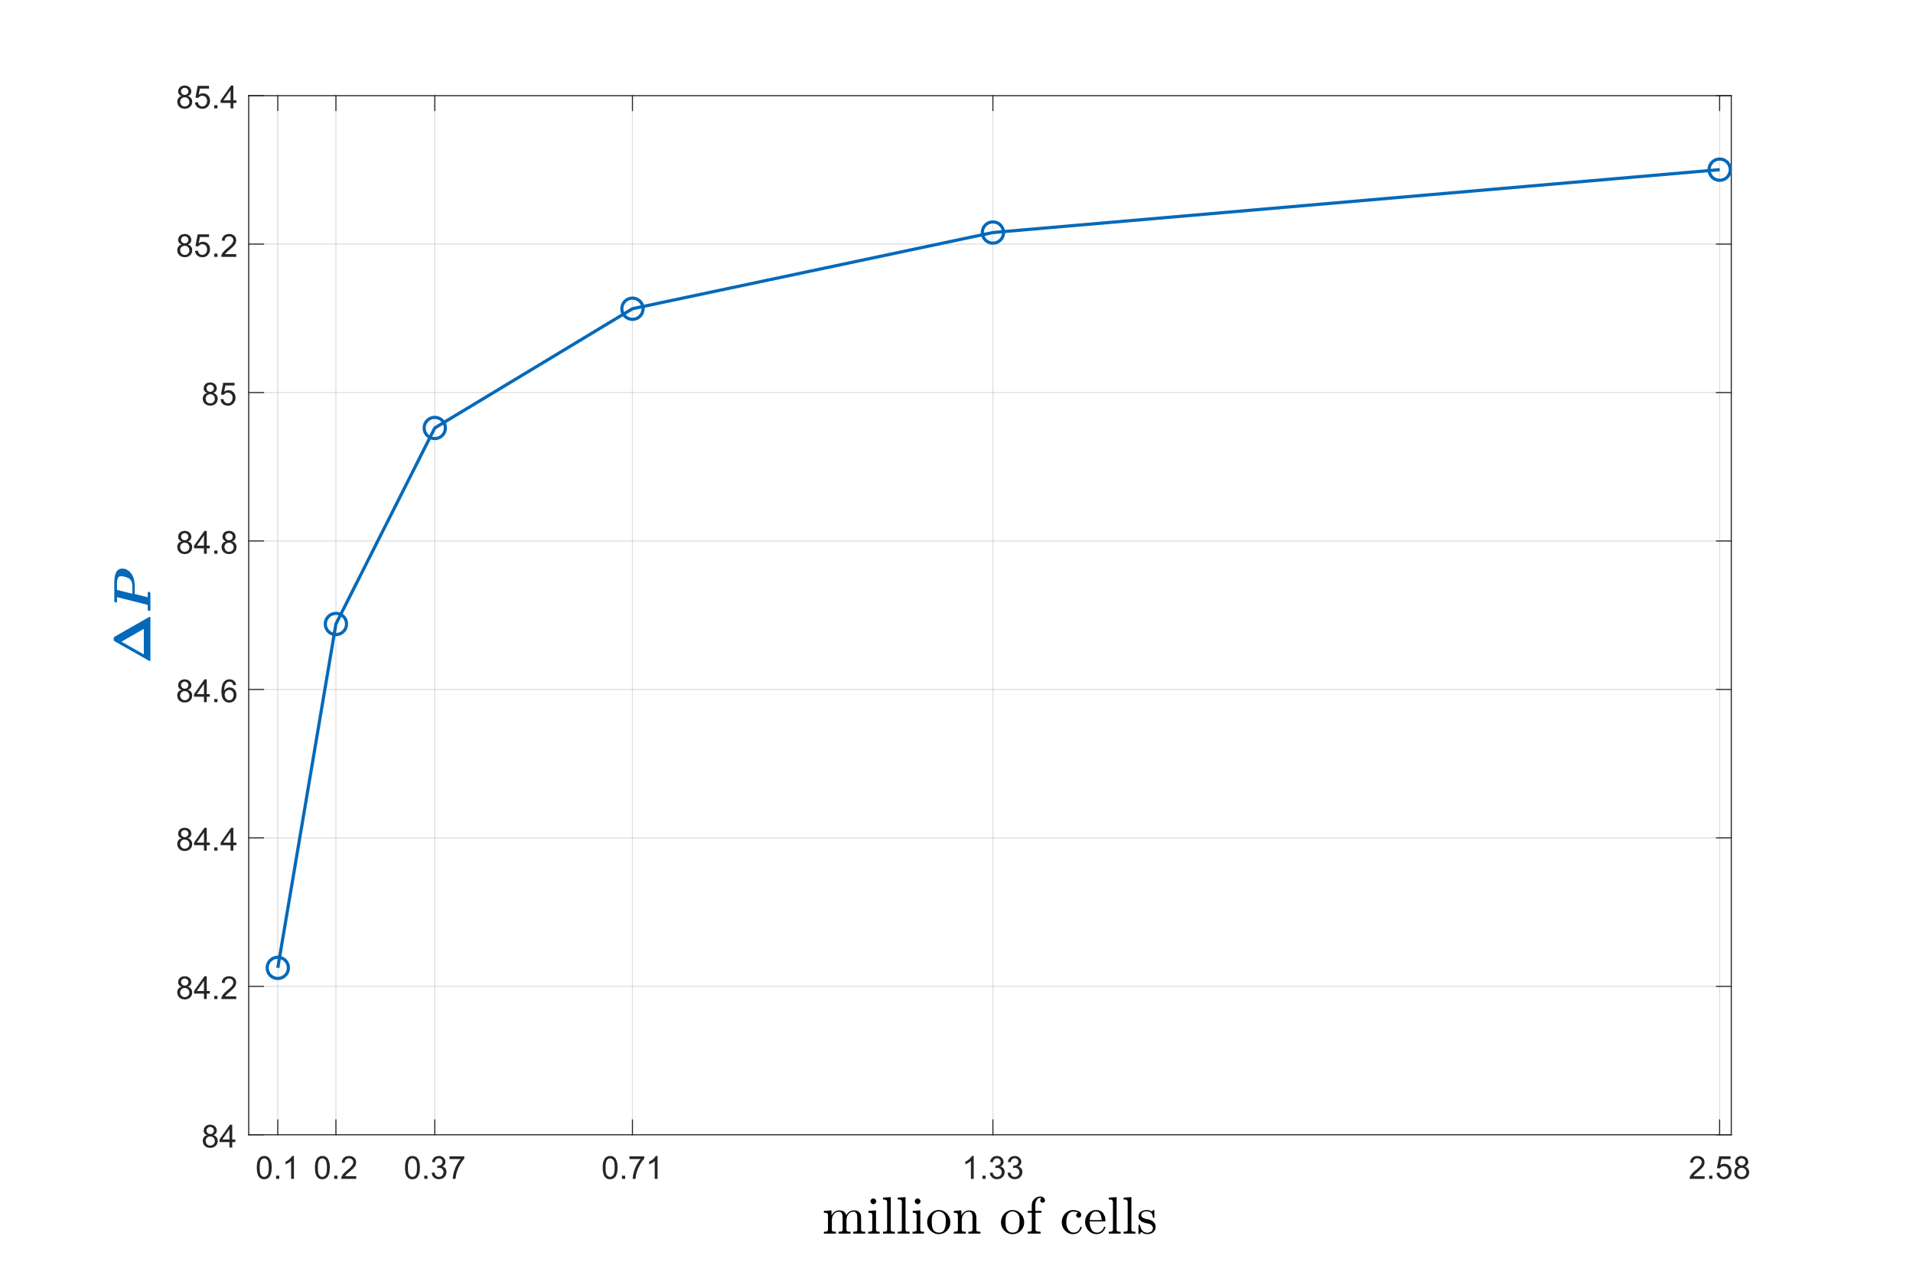
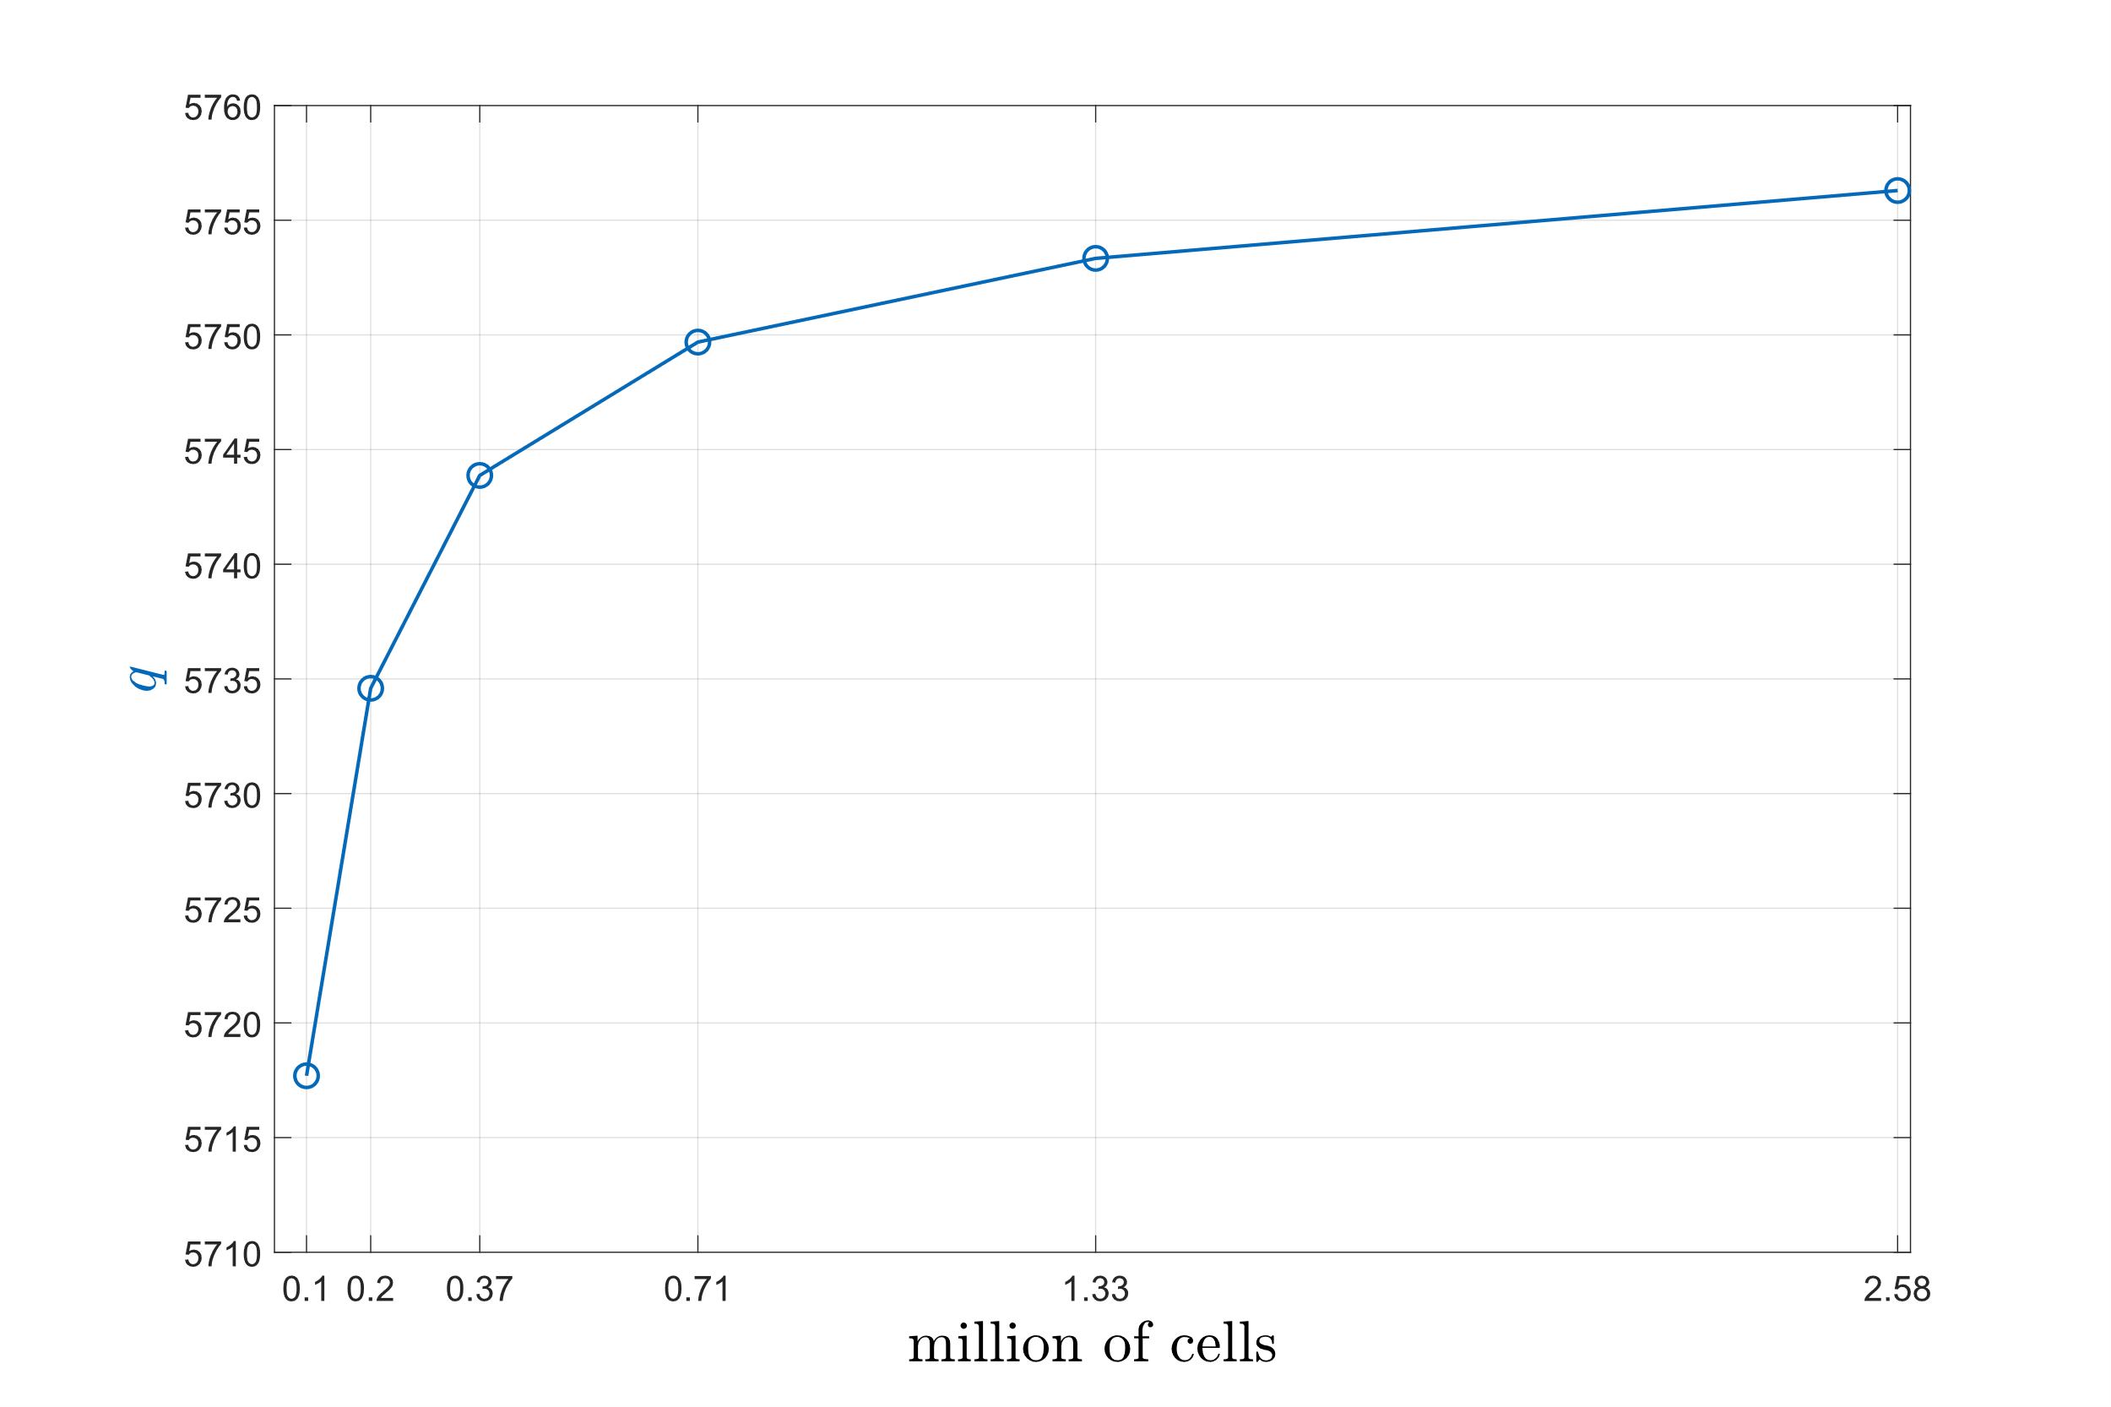
Fig. 3 Mesh sensitivity study for variables of interest ΔP (top) and q (bottom)

Comparison with data in literature
The evolution of three main aspects have been identified as indexes of the overall quality of the solution. The first is the rate of decay of the swirl component, which has been shown to follow an exponential trend. Swirl intensity S was then measured along several sections on the pipe axis and then compared to the empirical correlation developed by Hay and West [10]:
$$\begin{aligned}\frac{\text{S}}{{\text{S}}_{\text{0}}}\text{=}{\text{e}}^{\text{-0.04}\frac{\text{x}}{\text{D}}}\#\left(7\right)\end{aligned}$$
The second index is the axial and tangential velocity profiles measured at appropriate locations, which allows comparison with those reported in literature and obtained under similar flow conditions. The reference data here are those provided by Kitoh [11] and Weske and Sutrov [12]. The third and last index is the enhancement of heat transfer, measured here as an increase of Nu_{x} and compared to a second empirical correlation proposed by Hay and West [10]:
$$\begin{aligned}\frac{{\text{Nu}}_{\text{x}}}{{\text{Nu}}_{\text{∞}}}\text{=}{\text{(1+S)}}^{\text{1.75}}\#\left(8\right)\end{aligned}$$
Where Nu∞ is the Nusselt number for fully developed pipe flows and calculated here through the Dittus-Boelter equation:
$$\begin{aligned}{\text{Nu}}_{\text{∞}}\text{=0.023∙}{\text{Re}}^{\text{0.8}}\text{∙}{\text{Pr}}^{\text{0.71}}\#\left(9\right)\end{aligned}$$

RESULTS
The qualitative exponential rate of decay has been captured by both the k-ω SST and the RSM and for all the Reynolds numbers. k-ω SST has shown better agreement with the correlation (7), see Fig. 4.
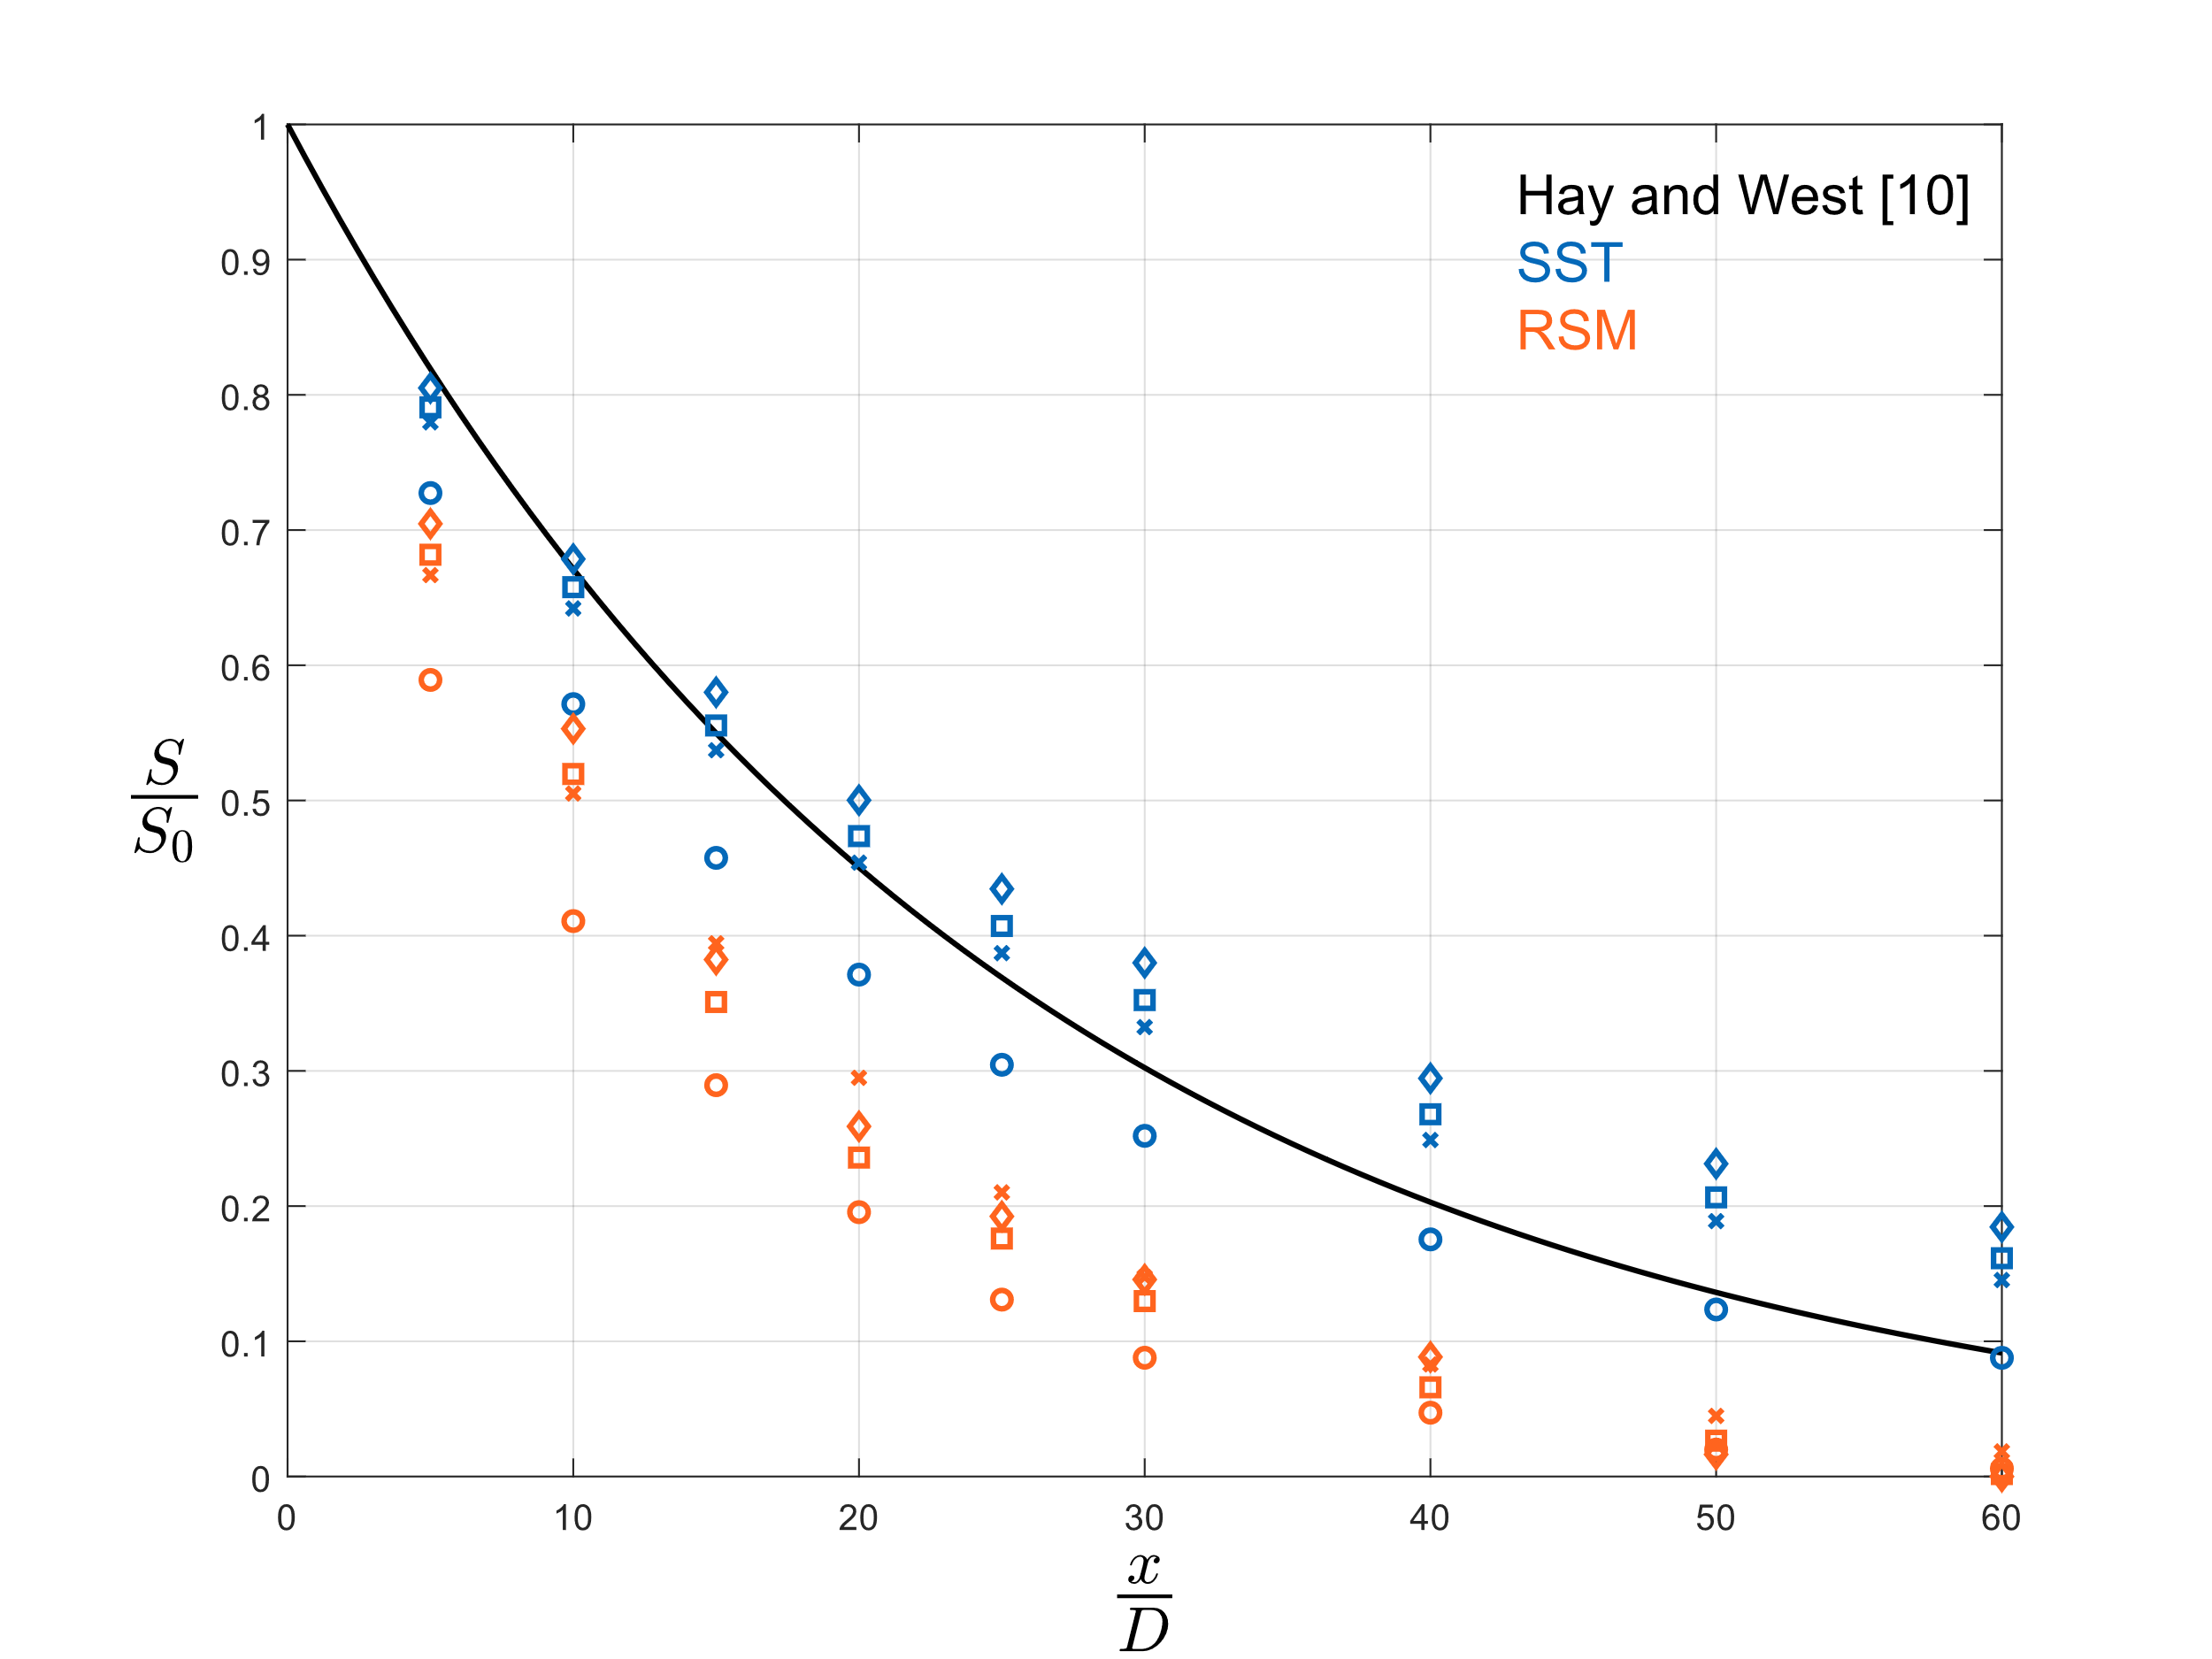
Fig. 4 Rate of decay of S normalised by S₀ at different distances from pipe inlet for the two turbulence models considered. Solid line is the correlation (7), scattered points are for Re=10000, ○; Re=30000, x; Re=40000, □; Re=60000, ◇
For fully axial pipe flows, it is common practice to compare velocity profiles between flows of similar Re and same normalised distance x/D. In the presence of swirl, it was assumed more meaningful to compare profiles where S(x/D) assumes similar value, even if this might occur at significantly different x/D depending on rate of decay which in turn is influenced by other flow conditions. Kitoh defines swirl intensity in a different way than (3):
$$\begin{aligned}{\text{S}}_{\text{K}}\text{=}\frac{\text{2πρ}\int_{\text{0}}^{\text{R}}{\text{u}\left(\text{r}\right)\text{w}\left(\text{r}\right){\text{r}}^{\text{2}}\text{dr}}}{\text{ρπ}{\text{R}}^{\text{3}}{\text{U}}^{\text{2}}}\#\left(10\right)\end{aligned}$$
To allow for comparison of the velocity profiles for the same swirl intensities, it is necessary to convert swirl intensity calculated with (3) into the definition calculated with (10). S_{K} can be calculated as a function of S as:
$$\begin{aligned}{\text{S}}_{\text{K}}\text{=}\frac{\text{2S}\int_{\text{0}}^{\text{R}}{{\text{u}}^{\text{2}}\text{(r)}}\text{rdr}}{{\text{R}}^{\text{2}}{\text{U}}^{\text{2}}}\#\left(11\right)\end{aligned}$$
A summary is shown in Fig. 5.
 | Re | x/D | S | S_{K}
k-ω SST | 30000 | 15 | 0.54 | 0.67
RSM | 30000 | 10 | 0.51 | 0.64
Kitoh [11] | 60000 | 28 | - | 0.68
Weske [12] | 30000 | 20 | - | 0.68
Fig. 5 Measurement sections for present and reference studies
Axial velocity profiles for both the reference studies from Kitoh (free-vortex inlet tangential velocity profile) and from Weske and Sutrov (forced-vortex inlet velocity profiles) breakdown into a core region, an annular region and the wall region. Simulations with both the k-ω SST, Fig. 6, and the RSM, Fig. 7, tend to match the reference profiles in the annular region, while strong discrepancy exists in the core region. This is at least partially attributed to the different initial velocity profile [11].
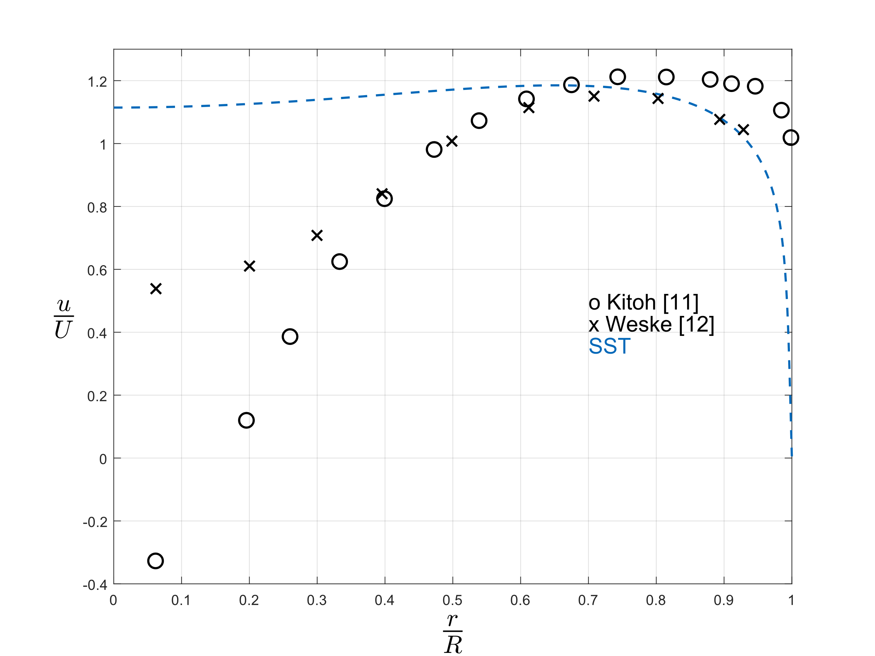
Fig. 6 Axial velocity profiles normalised by the mean axial velocity U, k-ω SST turbulence model
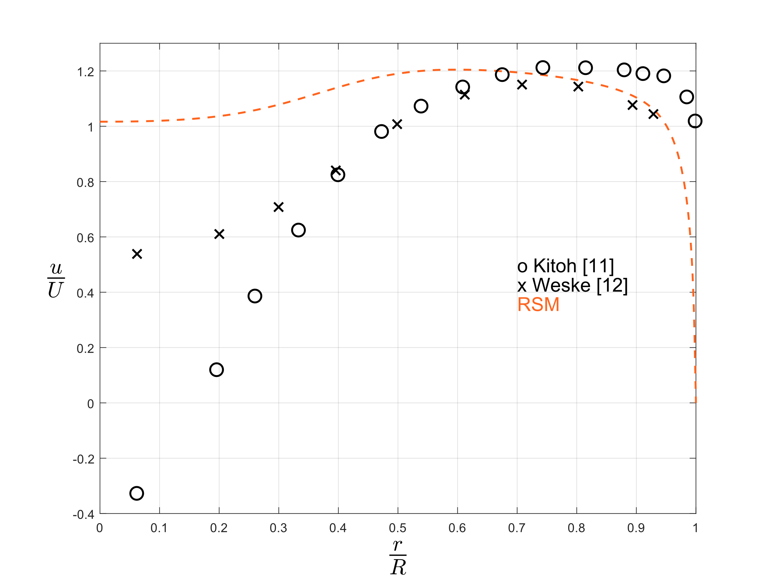
Fig. 7 Axial velocity profiles normalised by the mean axial velocity U, RSM
The inlet forced-vortex tangential velocity profile modelled through the SST does not break down into a mixed-vortex, Fig. 8, as it was instead observed experimentally [11, 12]. Simulations with the RSM better agree with the experiments, showing the mixed-vortex profile, Fig. 9.
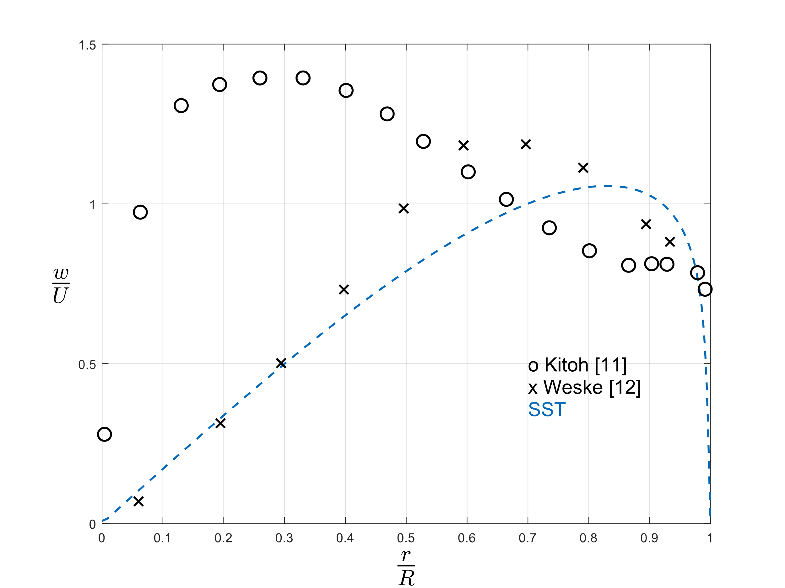
Fig. 8 Tangential velocity profiles normalised by the mean axial velocity U, k-ω SST turbulence model
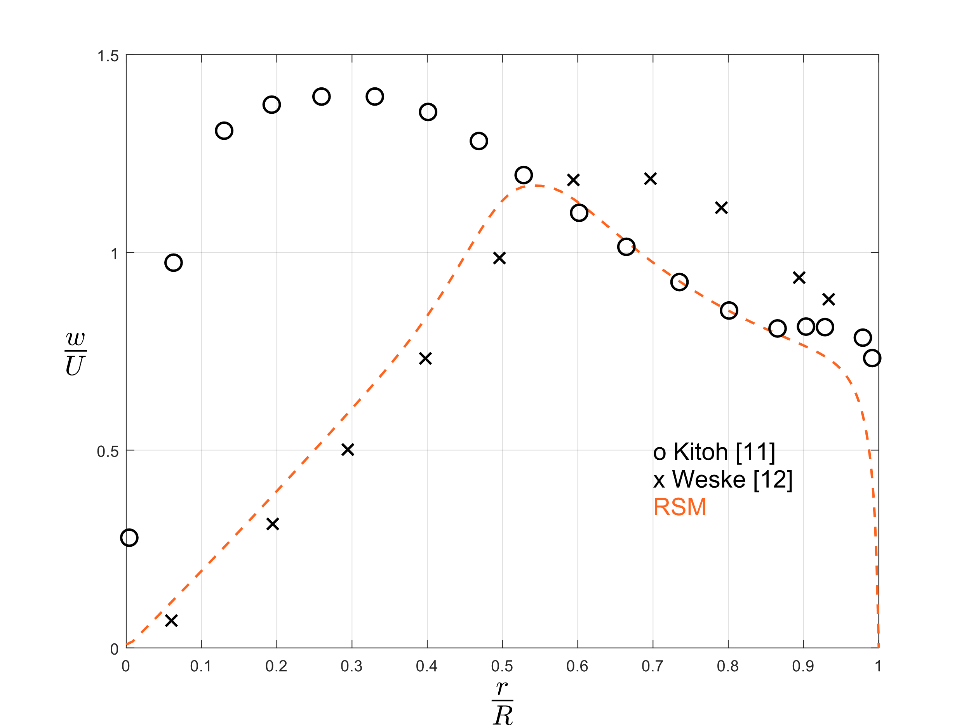
Fig. 9 Tangential velocity profiles normalised by the mean axial velocity U, RSM
Predictions of heat transfer enhancement calculated with both turbulence models are not represented by the correlation provided by [10], with possible better agreement with RSM at sufficiently high S values, see Fig. 10.
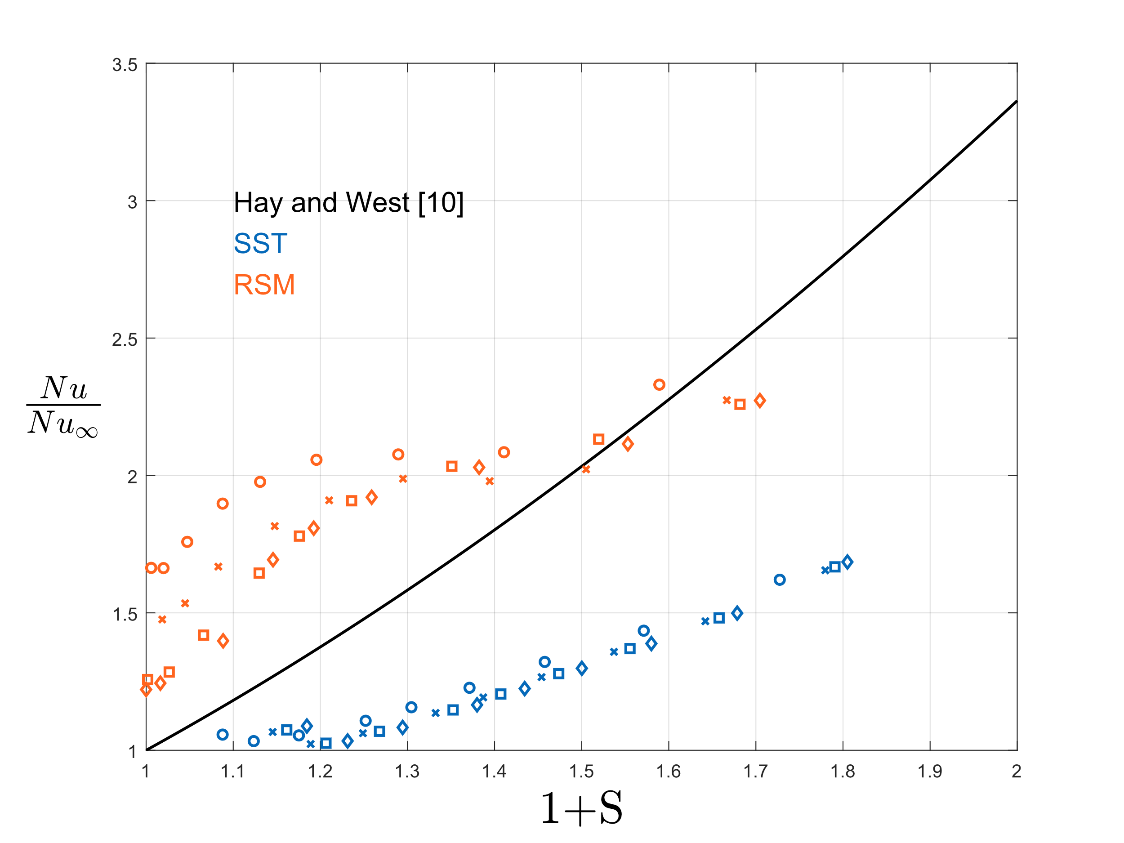
Fig. 10 Nusselt number normalised by reference value for axial fully developed flows at different swirl intensities. Correlation is not representative of the numerical solutions for none of the two turbulence models. Symbols and corresponding Re are the same as in Fig. 4

Conclusions
This work modelled heat transfer in pipe flows in presence of swirl. Different flow conditions were analysed and particular attention was dedicated to the rate of decay of swirl, shape of velocity profiles for specific values of swirl intensity and increase of Nusselt number compared to fully axial conditions. Results were compared with correlations found in literature. k-ω SST has shown better agreement with empirical correlation in terms of swirl decay, although also RSM captured the exponential trend. Annular region of the axial velocity profile were in good agreement with reference data for both models, while the value in the core region was overestimated. k-ω SST failed in developing a mixed-vortex tangential velocity profile, maintaining a fully forced-vortex shape, with the only exception of the wall region, while RSM was more accurate. None of the models have followed the reference correlation in predicting the increase of Nusselt number due to swirl. Future work will investigate the effect of turbulent Prandtl number on the thermal field and the influence of lower inlet swirl intensities.

Acknowledgment
This publication has emanated from research conducted with the financial support of Taighde Éireann – Research Ireland under the Strategic Partnership Programme Grant Number SFI/21/SPP/3756.

References
- M. Yilmaz, O. Comakli, Sinan Yapici, and O. Nuri. Sara, “Heat transfer and friction characteristics in decaying swirl flow generated by different radial guide vane swirl generators,” Energy conversion and management, vol. 44, no. 2, pp. 283–300, Jan. 2003, doi: https://doi.org/10.1016/s0196-8904(02)00053-5.
- M. Ahmadvand, A. F. Najafi, and S. Shahidinejad, “An experimental study and CFD analysis towards heat transfer and fluid flow characteristics of decaying swirl pipe flow generated by axial vanes,” Meccanica, vol. 45, no. 1, pp. 111–129, Jul. 2009, doi: https://doi.org/10.1007/s11012-009-9228-9.
- Y. Sun, G. Wen, X. Xiao, B. Ren, N. Yang, and L. Zhang, “Numerical Study on Heat Transfer and Flow Characteristics for Laminar Flow in a Circular Tube with Swirl Generators,” Transactions of Tianjin University, vol. 24, no. 3, pp. 244–255, Feb. 2018, doi: https://doi.org/10.1007/s12209-018-0132-z.
- H. Siddique, Md. S. B. Hoque, and M. Ali, “Effect of swirl flow on heat transfer characteristics in a circular pipe,” AIP Conference Proceedings, vol. 1754, 2016, doi: https://doi.org/10.1063/1.4958419.
- K. M. Saqr and M. A. Wahid, “Effects of swirl intensity on heat transfer and entropy generation in turbulent decaying swirl flow,” Applied Thermal Engineering, vol. 70, no. 1, pp. 486–493, Sep. 2014, doi: https://doi.org/10.1016/j.applthermaleng.2014.05.059.
- J. M. Gorman, E. M. Sparrow, S. Ilamparuthi, and W. J. Minkowycz, “Effect of fan-generated swirl on turbulent heat transfer and fluid flow in a pipe,” International Journal of Heat and Mass Transfer, vol. 95, pp. 1019–1025, Apr. 2016, doi: https://doi.org/10.1016/j.ijheatmasstransfer.2015.12.038.
- R. Grimes and M. Davies, “Air Flow and Heat Transfer in Fan Cooled Electronic Systems,” Journal of Electronic Packaging, vol. 126, no. 1, pp. 124–134, Mar. 2004, doi: https://doi.org/10.1115/1.1649241.
- Fans - Performance testing using standardized airways, BN EN ISO 5801:2017+A1:2015, BSI Standards Publication, United Kingdom, 2025.
- H. A. Vaidya, Ö Ertunç, B Genç, F. Beyer, Ç Köksoy, and A. Delgado, “Numerical simulations of swirling pipe flows- decay of swirl and occurrence of vortex structures,” Journal of Physics Conference Series, vol. 318, no. 6, pp. 062022–062022, Dec. 2011, doi: https://doi.org/10.1088/1742-6596/318/6/062022.
- N. Hay, P.D. West, “Heat Transfer in Free Swirling Flow in a Pipe,” Journal of Heat Transfer, vol. 97(3), pp. 411-416, Aug. 1975, doi: https://doi.org/10.1115/1.3450390.
- O. Kitoh, “Experimental study of turbulent swirling flow in a straight pipe,” Journal of Fluid Mechanics, vol. 225, p. 445-479, April 1991, doi: https://doi.org/10.1017/S0022112091002124.
- D.R. Weske, G. Sutrov, “Experimental study of turbulent swirled flows in a cylindrical tube,” Fluid Mechanics – Soviet Research, vol. 3, pp. 77-82, 1974.

