Supplementary Information

Table S1: Site description and classification based on farming intensity (extensive, intermediate, intensive) and linear habitat types¹. The overall habitat quality scores (0 - 1) are calculated for both linear and adjacent grassland habitats based on several variables including physical structure (e.g. width, height), vegetation structure (profile, how many layers of vegetation, cover of trees, shrubs), management pressure (grazing pressure, poaching) and number and cover of plant species indicators.
Site no. | Parcel  area (ha) | LU/ha | NV  score | Linear habitat type | Linear  habitat score | Grassland habitat score
Extensive
1 | 18.30 | 0.59 | 6.90 | DH | 0.37 | 0.65
2 | 3.12 | 0.24 | 7.50 | DH_{W} | 0.55 | 0.80
3 | 3.91 | 0.24 | 7.50 | OH | 0.36 | 0.70
4 | 7.83 | 0.59 | 6.90 | OH_{W} | 0.32 | 0.60
5 | 45.05 | 0.36 | 8.20 | W | 0.11 | 0.70
Intermediate
6 | 12.31 | 1.18 | 3.80 | DH | 0.51 | 0.00
7 | 7.73 | 0.78 | 4.10 | DH_{W} | 0.62 | 0.50
8 | 7.47 | 1.00 | 4.60 | OH | 0.43 | 0.40
9 | 1.95 | 1.18 | 3.80 | OH_{W} | 0.66 | 0.15
10 | 15.61 | 0.74 | 3.90 | W | 0.73 | 0.95
Intensive
11 | 3.05 | 0.75 | 3.40 | DH | 0.39 | 0.00
12 | 10.40 | 0.75 | 3.40 | DH_{W} | 0.71 | 0.60
13 | 9.22 | 1.02 | 3.30 | OH | 0.48 | 0.15
14 | 5.38 | 1.11 | 3.30 | OH_{W} | 0.51 | 0.35
15 | 10.40 | 0.75 | 3.40 | W | 0.315 | 0.60

¹Linear habitat types are categorised as: Dense hedgerow (DH); Open hedgerow (OH); Dense hedgerow with adjacent watercourse (DH_{W}); Open hedgerow with adjacent watercourse (OH_{W}); and watercourse only (W).

Table S2: Syrphidae species recorded on farms in Co. Sligo, Ireland

Species | Total Abundance | % Total Abundance
Anasimyia contracta Claussen & Torp, 1980 | 2 | 0.02
Anasimyia lineata (Fabricius, 1787) | 8 | 0.09
Arctophila superbiens (Müller, 1776) | 3 | 0.03
Baccha elongata (Fabricius, 1775) | 29 | 0.33
Chalcosyrphus nemorum (Fabricius, 1805) | 18 | 0.21
Cheilosia albipila Meigen, 1838 | 1 | 0.01
Cheilosia albitarsis (Meigen, 1822) | 14 | 0.16
Cheilosia sp* | 1 | 0.01
Chrysogaster cemiteriorum (Linnaeus, 1758) | 3 | 0.03
Chrysotoxum bicinctum (Linnaeus, 1758) | 28 | 0.32
Chrysotoxum festivum (Linnaeus, 1758) | 1 | 0.01
Dasysyrphus albostriatus (Fallén, 1817) | 1 | 0.01
Dasysyrphus venustus (Meigen, 1822) | 4 | 0.05
Epistrope eligans (Harris, 1780) | 50 | 0.57
Epistrophe nitidicollis (Meigen, 1822) | 1 | 0.01
Episyrphus balteatus (De Geer, 1776) | 183 | 2.09
Eristalis abusiva Collin, 1931 | 3 | 0.03
Eristalis arbustorum (Linnaeus, 1758) | 6 | 0.07
Eristalis horticola (De Geer, 1776) | 11 | 0.13
Eristalis intricaria (Linnaeus, 1758) | 41 | 0.47
Eristalis nemorum (Linnaeus, 1758) | 41 | 0.47
Eristalis pertinax (Scopoli, 1763) | 94 | 1.07
Eristalis tenax (Linnaeus, 1758) | 16 | 0.18
Eupeodes corollae (Fabricius, 1794) | 342 | 3.90
Eupeodes latifasciatus (Macquart, 1829) | 889 | 10.13
Eupeodes luniger (Meigen, 1822) | 12 | 0.14
Helophilus hybridus Loew, 1846 | 41 | 0.47
Helophilus pendulus (Linnaeus, 1758) | 1160 | 13.22
Lejogaster metallina (Fabricius, 1781) | 83 | 0.95
Leucozona lucorum (Linnaeus, 1758) | 9 | 0.10
Melangyna lasiopthalma (Zetterstedt, 1843) | 6 | 0.07
Melangyna spp* | 4 | 0.05
Melanogaster hirtella (Loew, 1843) | 11 | 0.13
Melanostoma [melanic]* | 10 | 0.11
Melanostoma mellinum (Linnaeus, 1758) | 679 | 7.74
Melanostoma scalare (Fabricius, 1794) | 778 | 8.87
Meligramma sp* | 1 | 0.01
Meliscaeva cinctella (Zetterstedt, 1843) | 3 | 0.03
Meliscaeva auricollis (Meigen, 1822) | 1 | 0.01
Myathropa florea (Linnaeus, 1758) | 2 | 0.02
Neoascia obliqua Coe, 1940 | 3 | 0.03
Neoascia podagrica (Fabricius, 1775) | 62 | 0.71
Neoascia tenur (Harris 1780) | 15 | 0.17
Orthonevra nobilis (Fallén, 1817) | 1 | 0.01
Parasyrphus punctulatus (Verrall, 1873) | 2 | 0.02

Table S2 continued

Species name | Total abundance | % Total Abundance
Parhelophilus versicolor (Fabricius, 1794) | 1 | 0.01
Pipiza sp* | 1 | 0.01
Pipiza noctilucaa (Linnaeus, 1758) | 3 | 0.03
Platycheirus [melanic]* | 2 | 0.02
Platycheirus albimanus (Fabricius, 1781) | 421 | 4.80
Platycheirus angustatus (Zetterstedt, 1843) | 238 | 2.71
Platycheirus clypteatus (Meigen, 1822) | 1071 | 12.21
Platycheirus granditarsus (Forster, 1771) | 939 | 10.70
Platycheirus manicatus (Meigen, 1822) | 1 | 0.01
Platycheirus peltatus (Meigen, 1822) | 13 | 0.15
Platycheirus rosarum (Fabricius, 1787) | 94 | 1.07
Platycheirus scambus (Staeger, 1843) | 1 | 0.01
Platycheirus scutatus (Meigen, 1822) | 14 | 0.16
Rhinga campestris Meigen, 1822 | 698 | 7.96
Riponnensia splendens (Meigen, 1822) | 21 | 0.24
Scaeva pyrastri (Linnaeus, 1758) | 50 | 0.57
Sericomyia silentis (Harris, 1776) | 212 | 2.42
Sphaerophoria interrupta (Fabricius, 1805) | 38 | 0.43
Sphaerophoria scripta (Linnaeus, 1758) | 5 | 0.06
Sphaerophoria philanthus (Meigen, 1822) | 4 | 0.05
Syritta pipiens (Linnaeus, 1758) | 3 | 0.03
Syrphus torvus Osten Sacken, 1875 | 1 | 0.01
Syrphus ribesii (Linnaeus, 1758) | 48 | 0.55
Syrphus vitripennis Meigen, 1822 | 4 | 0.05
Trichopsomyia flavitarsis (Meigen, 1822) | 20 | 0.23
Tropidia scita (Harris, 1780) | 142 | 1.62
Volucella bombylans (Linnaeus, 1758) | 17 | 0.19
Volucella pellucens (Linnaeus, 1758) | 10 | 0.11
Xylota jakutorum Bagachanova, 1980 | 3 | 0.03
Xylota segnis (Linnaeus, 1758) | 21 | 0.24
Xylota sylvarum (Linnaeus, 1758) | 5 | 0.06

* Identified to genus only since females could not be identified or distinguished from each other.
Table S3: Sciomyzidae species recorded on farms in Co. Sligo, Ireland
Species name | Total abundance | % Total abundance
Coremacera marginata (Fabricius, 1775) | 11 | 4.0
Elgiva cucularia (Linnaeus, 1767) | 1 | 0.4
Ilione albiseta (Scopoli, 1763) | 4 | 1.5
Ilione lineata (Fallen, 1820) | 19 | 7.0
Limnia paludicola Elberg, 1965 | 4 | 1.5
Limnia unguicornis (Scopoli, 1763) | 2 | 0.7
Pherbina coryleti (Scopoli, 1763) | 4 | 1.5
Renocera pallida (Fallén, 1820) | 50 | 18.3
Renocera striata (Meigen, 1830) | 2 | 0.7
Sepedon spinipes (Scopoli, 1763) | 1 | 0.4
Tetanocera arrogans Meigen, 1830 | 57 | 20.9
Tetanocera elata (Fabricius, 1781) | 40 | 14.7
Tetanocera ferruginea Fallén, 1820 | 35 | 12.8
Tetanocera fuscinervis (Zetterstedt, 1838) | 13 | 4.8
Tetanocera hyalipennis Roser, 1840 | 11 | 4.0
Tetanocera robusta Loew, 1847 | 17 | 6.2
Trypetoptera punctulata (Scopoli, 1763) | 2 | 0.7

Table S4: P values for the mean species richness and abundance of Sciomyzidae collected for each linear habitat type¹. Numbers in bold indicate significant P values (GLMM followed by LSD pairwise comparisons, P < 0.05).
Boundary type | Sciomyzidae species richness |  |  | Sciomyzidae abundance
 | d.f | t | P | d.f. | t | P
DH × DH_{W} | 4 | 1.40 | 0.17 | 4 | 1.81 | 0.08
DH × OH | 4 | 0.04 | 0.97 | 4 | 1.03 | 0.31
DH × OH_{W} | 4 | 2.56 | 0.01 | 4 | 2.83 | 0.01
DH ×W | 4 | 2.51 | 0.02 | 4 | 3.22 | <0.001
DH_{W} × OH | 4 | 1.44 | 0.16 | 4 | 0.84 | 0.40
DH_{W} × OH_{W} | 4 | 1.19 | 0.24 | 4 | 1.26 | 0.21
DH_{W} × W | 4 | 1.14 | 0.26 | 4 | 1.72 | 0.09
OH × OH_{W} | 4 | 2.60 | 0.01 | 4 | 2.02 | 0.04
OH × W | 4 | 2.54 | 0.01 | 4 | 2.45 | 0.02
OH_{W} × W | 4 | 0.06 | 0.95 | 4 | 0.49 | 0.63

¹Linear habitat types are categorised as: Dense hedgerow (DH); Open hedgerow (OH); Dense hedgerow with adjacent watercourse (DH_{W}); Open hedgerow with adjacent watercourse (OH_{W}); and watercourse only (W).
22
Table S5: P values for the mean species richness and abundance of Syrphidae and Sciomyzidae collected per site at each of the three-farming intensities. Numbers in bold indicate significant P values (GLMM followed by LSD pairwise comparisons, P < 0.05).

Farming intensity | Syrphidae
Farming intensity | Species richness |  |  |  | Abundance
Farming intensity | d.f | t | P |  | d.f | t | P
Extensive × Intermediate | 2 | 3.25 | <0.01 |  | 2 | 1.31 | 0.20
Extensive × Intensive | 2 | 4.19 | <0.001 |  | 2 | 1.81 | 0.08
Intermediate × Intensive | 2 | 0.67 | 0.51 |  | 2 | 0.53 | 0.60
Farming intensity | Sciomyzidae
Farming intensity | Species richness |  |  |  | Abundance
Farming intensity | d.f | t | P |  | d.f | t | P
Extensive × Intermediate | 2 | 3.86 | <0.001 |  | 2 | 4.66 | <0.001
Extensive × Intensive | 2 | 4.69 | <0.001 |  | 2 | 5.26 | <0.001
Intermediate × Intensive | 2 | 0.91 | 0.37 |  | 2 | 1.13 | 0.26

Table S6a Results of Kruskall-Wallis test to determine differences between environmental variables across three farming intensities and linear habitat types. Numbers in bold indicate significance.
Parameter | Farming intensities |  |  |  | Linear habitat types
Parameter | d.f | t | P |  | d.f | t | P
Flowering plant species richness/linear habitat | 2 | 1.86 | 0.39 |  | 4 | 3.22 | 0.52
Flowering plant species richness/grassland habitat | 2 | 3.29 | 0.19 |  | 4 | 2.73 | 0.60
Linear habitat quality score | 2 | 5.47 | 0.07 |  | 4 | 3.97 | 0.41
Grassland habitat quality score | 2 | 5.60 | 0.06 |  | 4 | 5.48 | 0.24
% Soil moisture | 2 | 8.66 | 0.01 |  | 4 | 3.60 | 0.46
% Soil Organic matter | 2 | 7.02 | 0.03 |  | 4 | 4.53 | 0.34
Soil pH | 2 | 1.82 | 0.40 |  | 4 | 7.47 | 0.11

Table S6b Pairwise comparisons for % soil moisture and soil organic matter between the three farming intensity categories using Bonferroni correction for multiple comparisons. Numbers in bold indicate significance (P < 0.05).
Comparison | % Soil moisture |  |  | % Soil organic matter
Comparison | t | P |  | t | P
Extensive × Intermediate | 7.40 | 0.03 |  | 5.40 | 1.69
Extensive × Intensive | 7.00 | 0.04 |  | 7.20 | 0.03
Intermediate × intensive | -0.04 | 1.00 |  | 1.80 | 1.00

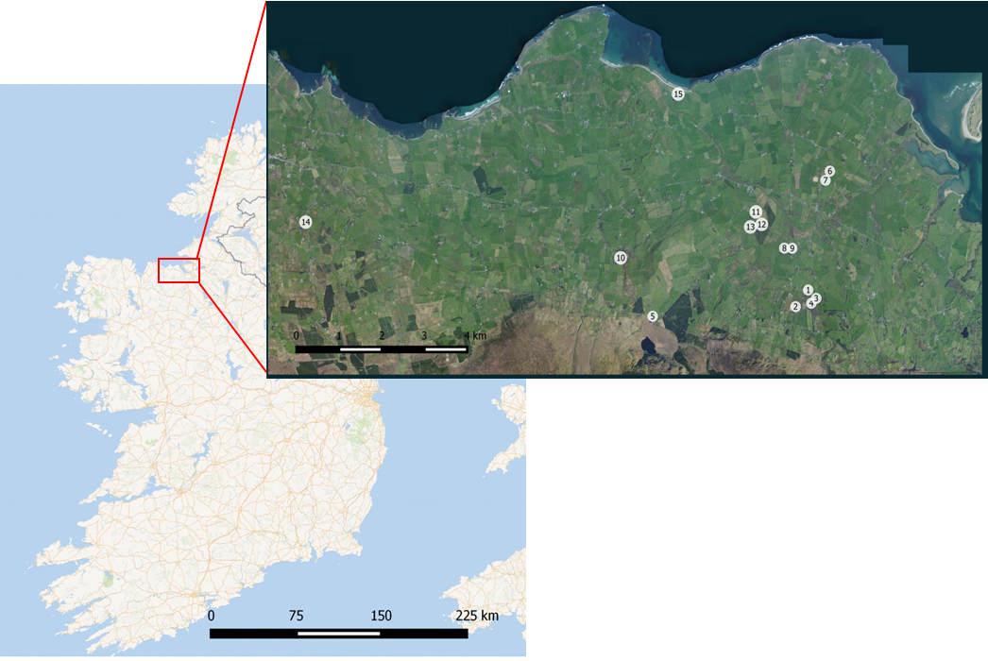

Fig. S1: A map showing location of the study sites in County Sligo, Northwest of Ireland (left). Farming intensity categories are denoted with different numbers (right). Extensive = 1-5; Intermediate = 6 -10; and Intensive = 11-15.

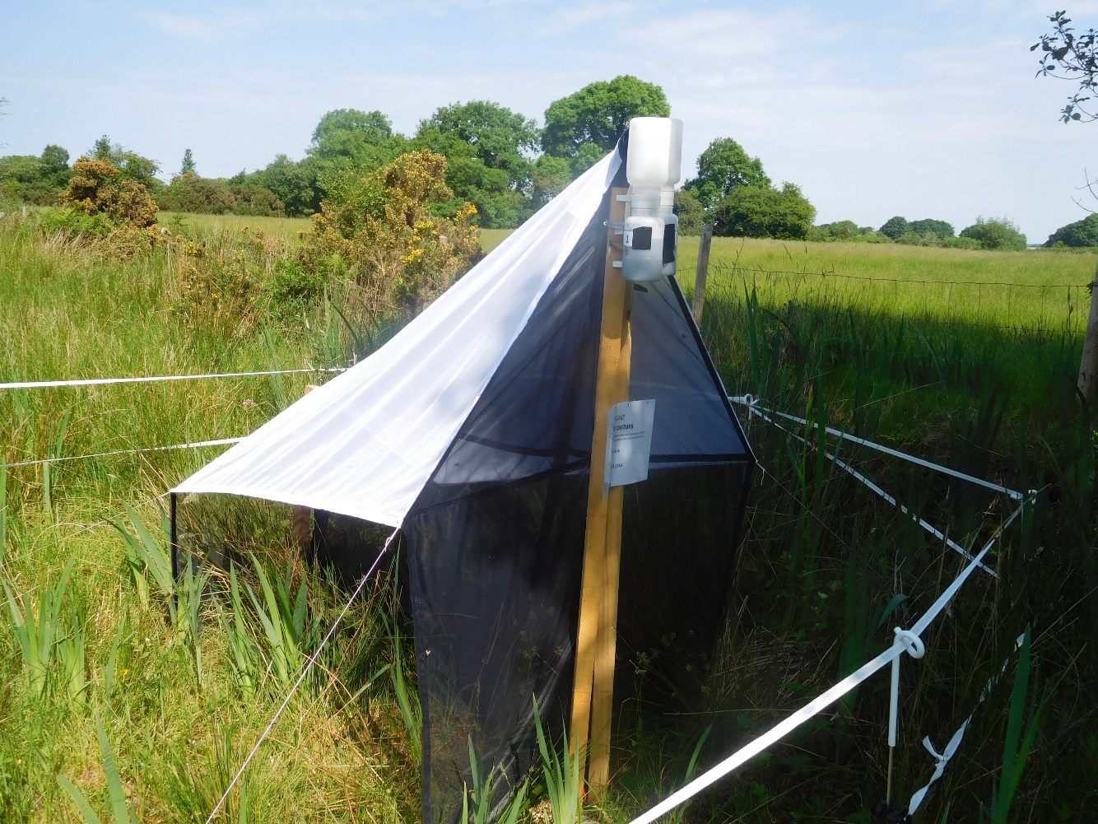
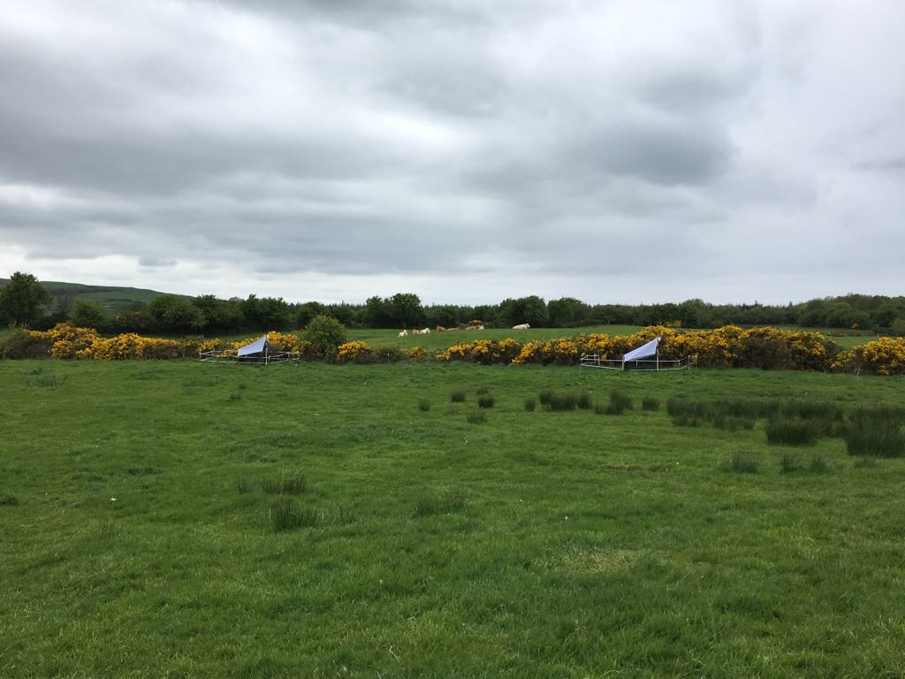
20m

Fig. S2: Bi-directional Malaise traps used throughout the study.
17
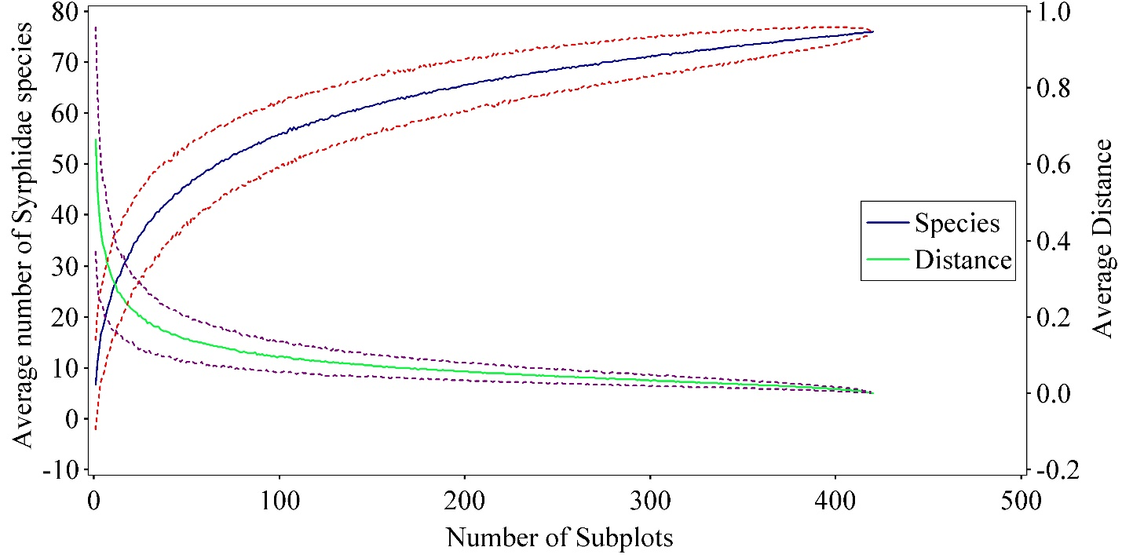
a)

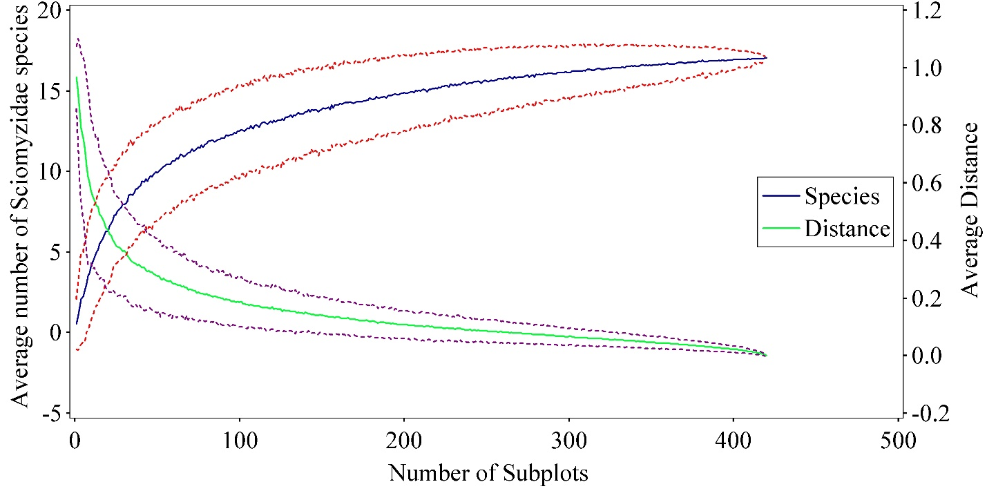
b)

Fig. S3: Species area curves for Syrphide (a) and Sciomyzidae (b). Dotted lines represent ±2SDs. First-order jackknife estimates of total species richness were 90.75 (Syrphidae) and 18.9 (Sciomyzidae).

