Figures
Figure 1. Mean visit volume per month (A) and mean time to appointment in days (B) plotted by time, separately for all visits (including telehealth) and in-person visits only. Plotted is the mean function as estimated using a kernel-weighted local polynomial smoother with an Epanechnikov kernel and a third degree polynomial.
Figure 2. Number of in-person visits by zip code of patient residence, separately for the periods March 23, 2019 through June 14, 2019 (A and B) and March 23, 2020 through June 14, 2020 (C and D). Plotted are the entire state (A and C) and the northeastern corner (B and D).
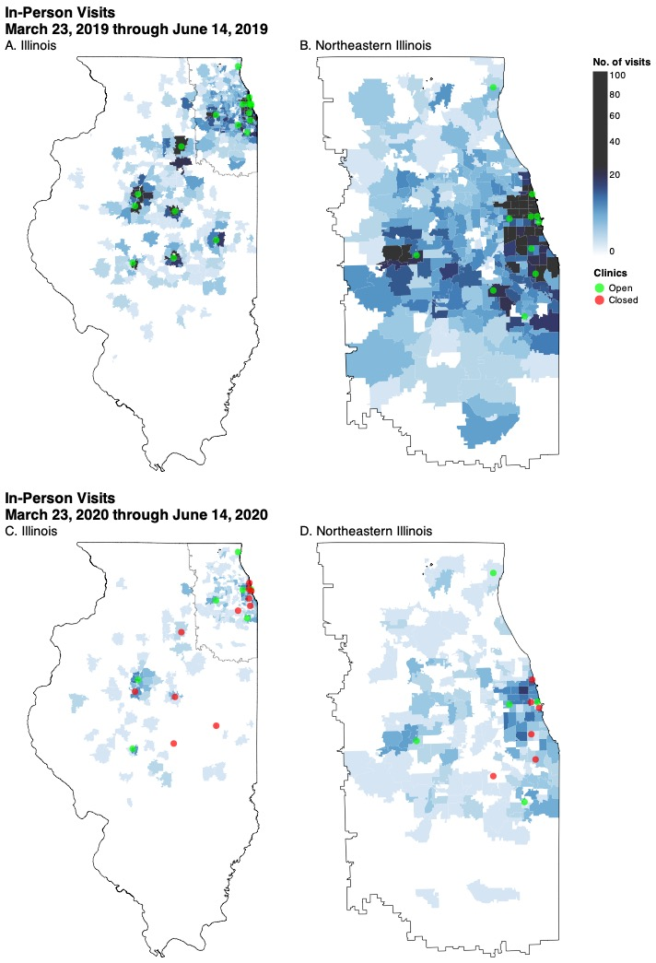
Supplemental Figure 1. Number of telehealth visits by zip code of patient residence from April 2020 through October 2020 (entire state).
