Guided by theory, grounded in practice: evidence-based development of teaching resources for multisite interprofessional education.

¹Roche, Cicely*; ¹Grimes, Tamasine; ¹Kavanagh, Jack; ²Guinan, Emer

- School of Pharmacy & Pharmaceutical Sciences, Trinity College Dublin
- School of Medicine, Trinity College Dublin

Contents
Title: 2
Abstract 2
Purpose and Format 2
Target audience 3
Project goal and objectives of this paper. 3
Activity description 3
Assessment 4
Evaluation 5
Development of the IPICMs aligned with NKT 5
Validation of IPICMs by registered healthcare practitioners (Expert group)/ results 6
Impact 7
Supplementary files 8
*Correspondence: 8
Acknowledgements: 8
References 9

Title:
Guided by theory, grounded in practice: evidence-based development of teaching resources for multisite interprofessional education.
¹Roche, C*., ¹Grimes, T., ¹Kavanagh, J., ²Guinan, E

[¹Roche, Grimes, Kavanagh – School of Pharmacy; ²Guinan, School of Medicine]

Abstract
The purpose of this paper is to describe the development and validation of a curricular resource to support the interprofessional development of moral reasoning competencies and the related abilities underpinning decision-making through professional dilemmas.
This curricular resource aligns with an evidence-based approach to engaging practitioner-experts in the development of resources for teaching and assessment.
The resource comprises 13 healthcare-related dilemma scenarios, each with 12 hypothetical action options for the practitioner in the scenario, arranged into five plausible practice settings and representative of authentic interprofessional collaborations, for use in Interprofessional education (IPE). Dilemma scenarios are provided in both text and animated video formats.
Educators of healthcare practitioner students seeking to develop interprofessional skills and/ or the ability to work interprofessionally should find this resource supports teaching and learning in face-to-face or online contexts, and in a manner that can be objectively assessed.

Purpose and Format
The purpose of this paper is to describe the development and validation of a curricular resource to support the interprofessional development of moral reasoning competencies, and the related abilities and skills underpinning decision-making through professional dilemmas.
This curricular resource aligns with an evidence-based approach¹⁻⁴ to engaging practitioner-experts in the development of resources for teaching and assessment. The format of the resource produced has been shown to assist educators to overcome common student engagement, assessment and logistical challenges^{1,3,5,6} as those identified for interprofessional education (IPE) .⁷⁻¹⁰
The resource comprises 13 healthcare-related dilemma scenarios, each with 12 hypothetical action and justification options that incorporate eight shared interprofessional values^{11,12} and common biases^{10,13} for the practitioner in the scenario [Appendix 1], arranged into five plausible practice settings and representative of authentic interprofessional collaborations, for use in IPE [Table 1].
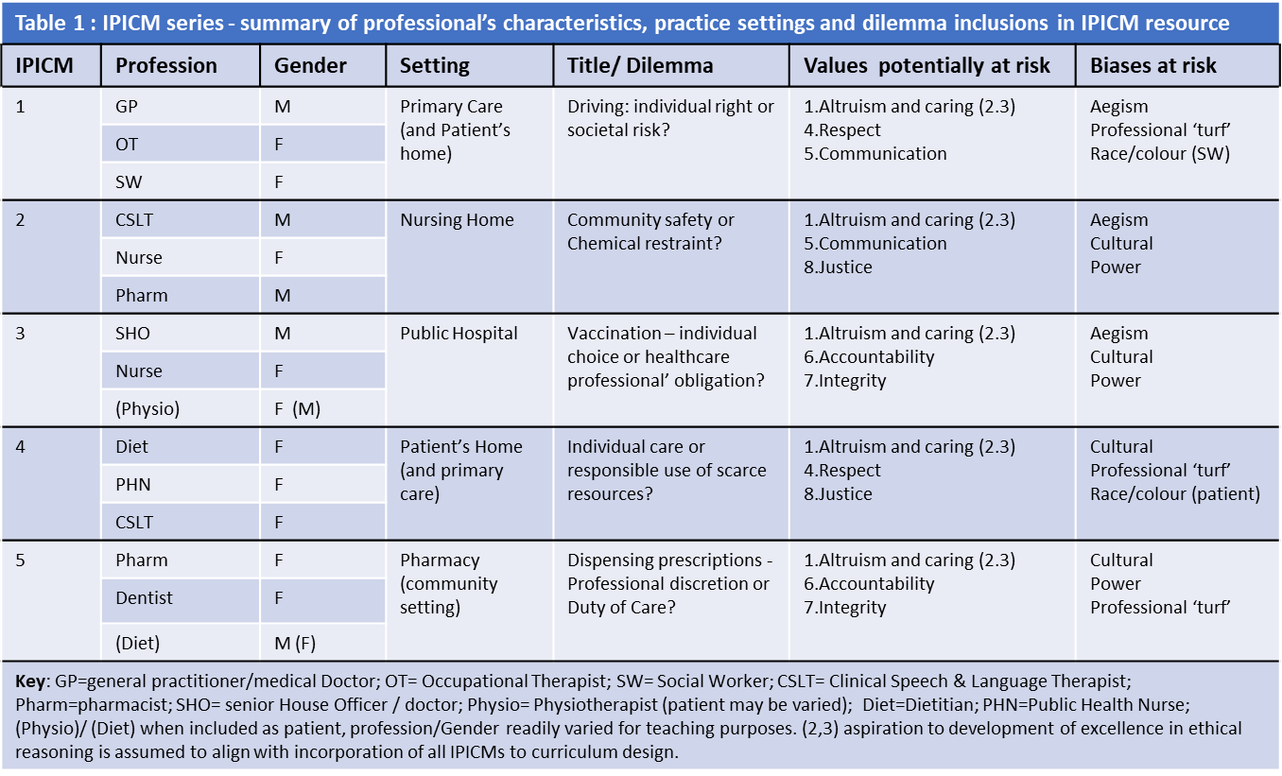

Target audience
Educators of a variety of healthcare practitioner students seeking to develop interprofessional skills and/ or the ability to work interprofessionally⁹, as dictated by the scenario (Table 1), should find this resource supports teaching, learning and assessment. The resource is applicable to undergraduate, postgraduate and continuing professional development.

Project goal and objectives of this paper.
The goal of the project was to develop and validate a resource to support educators engaging in IPE teaching and assessment.
Objectives of this paper:
- To explore how a teaching and assessment process known as intermediate concept measures (ICMs), traditionally employed uniprofessionally in moral reasoning development, can be adapted to engage students from a variety of professions in IPE.
- To adapt interprofessional ICMs (IPICMs) to teaching resource format(s) that support student development and assessment^{5,6,14,15} [Appendix 1].
The IPE activity learning outcomes are that participants are able:
- To critically review a plausible, authentic healthcare dilemma scenario.
- To develop competence in reasoning through a professional dilemma as an individual and in group contexts.

Activity description
ICMs comprise a short healthcare-specific dilemma scenario which students individually review to respond to questions posed by educators, and a series of action and justification options which students rate for moral defensibility. Following the rating activity, students then rank the options in descending order of defensibility [Appendix 1]. Action and justification options are designed to reference behaviours and motivations with a focus on three categories (1) self-interest, (2) maintaining rules and norms, and (3) ‘patient’ and/or societal interests.^{1,2} Teaching strategies in IPE can sequence activities in a manner that students complete IPICMs individually before being allocated to small mixed-professional groups to revisit their ranking choices, and to interact with peers in a defined timeframe to reach group ‘agreement’ regarding optimum ranking. The educator might also require the groups to collaboratively compose advice to the practitioner(s) as to resolution of the dilemma [Figure 1].

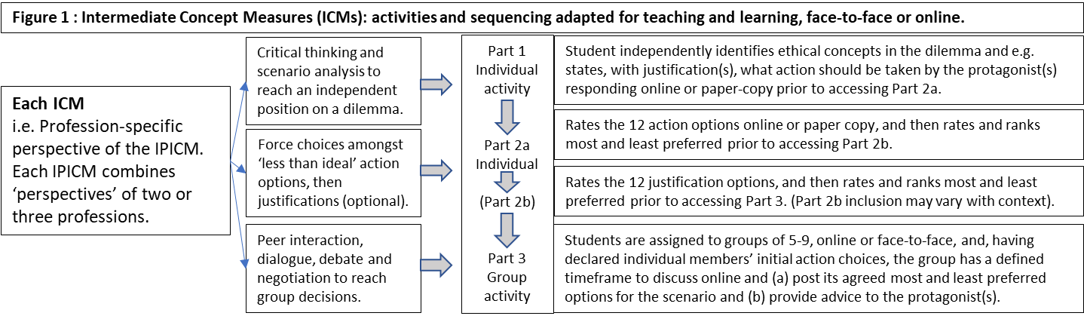

The process of debate and negotiation towards group agreement, when starting from a range of individually committed and publicly declared decisions, drives student development by expanding the students’ range of perspectives related to the dilemma proposed and the stakeholder professions represented.^{4,16,17}
The resource is appropriate for teachers engaging interprofessional cohorts of students or practitioners in an academic setting, or for those preparing students in professional programmes for engagement in IPE. Students may be at an early stage of exploring interprofessional collaboration such as in the first three years of many professional programmes.^{8,18}
In consideration that readiness for IPE changes over the course of training, the individual student’s review of the scenarios may be completed before or during scheduled interprofessional workshops, thereby enabling preparation for IPE to accommodate students at different stages in professional development.^{11,18} All of the activities can be provided in paper-based or online formats. Therefore, IPE activities and workshops may be undertaken face-to-face, remotely or using a blended approach thereby potentially ameliorating timetabling and logistical challenges associated with co-locating students from different programmes within an institution, of from different institutions, for face-to-face workshops.^{8,18,19}

Assessment
Assessment design may require that each student submits an individual critical review of the scenario as an assignment, in written or oral format, for feedback and/or grading. Following this, the individual submission may be shared with the group to provide a range of reviews upon which to begin discussion and debate (Figure 1).
The student’s individually submitted rating and ranking of action options may be assessed by comparison to ‘expert’ opinion, facilitating student feedback or grade provision as appropriate. Submitted responses to the action choices in the dilemma can be appraised in real time to identify students who chose options that are inconsistent with expert practitioner opinion, following which educators may intervene to address identified potential professional development concerns.
Individual contributions to discussions leading to group decisions and group outputs, e.g. advice to the protagonist, can be assessed for feedback and/ or grading, and this is amenable to either face-to-face or online context.^{5,6,14,15,19}
Rubrics sufficiently detailed to guide both students and assessors²⁰ have been shown to align well with assessment processes such as individual critical review of the scenario, justification of decisions made and/or reflection, and for group activities in both face-to-face and online contexts.^{14,15}

Evaluation
This resource of scenarios, action options and justification options was developed for IPE and based upon Neo-Kohlbergian Theory (NKT) and an established validation process used for the NKT ICM assessment tool.^{1,2} NKT proposes that a series of five ICMs, that collectively address key professional conflicts likely to be experienced by practitioners in the professions involved, can be used for development and assessment of competencies which enable reasoning through dilemma scenarios in an ethically defensible manner.^{1,2} Student development is activated by stimulation of the mix of logic, role-play and peer interaction that has been shown, in previous studies, to scaffold moral reasoning competencies development.^{4,17} Sequencing of activities in a defined process provides evidence of development that can be objectively assessed^{1,4-6,14,15,17} [Figure 1; Figure 2].

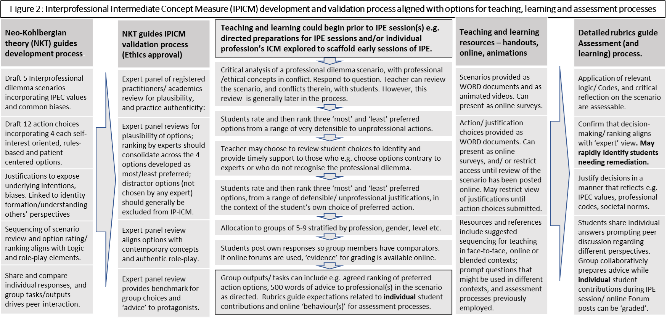

Development of the IPICMs aligned with NKT
NKT proposes that an authentic dilemma scenario should satisfy the following:
- be 200 to 400 words in length,
- incorporate conflicts of ethical concepts or values relevant to the profession(s) as a shared language or ‘logic’ on which reasoning through the dilemma is grounded.
- facilitate collaborative decision-making through ambiguity,
- support accommodation of incomplete information and / or non-ideal action options, in order to resolve the dilemma.^{1,2}
Eight well recognised interprofessional values were employed to ground development of the IPICMs, namely: altruism and caring, excellence, ethics, respect, communication, accountability, integrity, and justice^{11,12} (Table 1). To further prime students for interaction and debate, common society-wide biases (ageism, cultural, power (gender)) with the potential to undermine some or all of the eight interprofessional values were deliberately alluded to in the scenarios and/ or options provided (Table 1).^{10,13} Professional ‘turf’, a reference to challenges to interprofessional communication deriving from strongly held professional identities^{9,10.13.18}, is inferred in several of the IPICMs (Table 1).
Inclusion of up to four action or justification options in each of the three categories, namely (1) self-interest, (2) maintaining rules and norms, and (3) ‘patient’ and/or societal interests^{1,2}, had previously been identified as supportive of educational interventions.^{5,6,14,15,21} Therefore, the development team adopted this approach and, in order to create common interprofessional dilemmas in each IPICM, the action and justification options for different professions’ perspectives were closely aligned. Appendix 1 includes scenarios, animated videos, and action and justification options for all five IPICMs developed for this project.
The five IPICMs were aligned with common healthcare settings e.g. hospital, pharmacy, nursing home, patient’s home, or the healthcare practitioner’s ‘office’ (Table 1). Professions already engaged in IPE in the university were prioritised for inclusion in the resource - namely Medicine, Nursing, Dentistry, Pharmacy, Clinical Speech & Language Therapy, Occupational Therapy, Physiotherapy and Social Work. However, some scenarios were designed with a view to enabling interchangeability of the profession represented as an educator’s needs necessitated e.g. the vaccination clinic manager or patient in scenario 3 could be a member of any profession [Appendix 1].

Validation of IPICMs by registered healthcare practitioners (Expert group)/ results
In line with the underpinning Neo-Kohlbergian theory^{1,2} registered healthcare professionals/ educators (referred to as experts) from across the professions represented in the resource were recruited to form ‘expert groups’ for each IPICM. This process seeks to identify any omissions or inconsistencies, for example, validating that the scenarios presented are representative of dilemmas that might face healthcare practitioners, that no one obvious best or worst option is included in any IPICM, and that no obvious potential action or justification option had been excluded.
Following this expert validation, the experts’ individual rankings of action and justification options were collated and reviewed. Results indicated alignment with Neo-Kohlbergian theory as follows:
- Expert ranking of the most preferred options aligned with actions/justifications likely to be in the patient’s/society’s best interests.
- Expert ranking of options did not consolidate to an agreed answer i.e. no single action option was chosen as the MOST or LEAST preferred by all experts for any IPICM.
- Expert ranking did not identify distractor options i.e all ‘self-interest’ options were ranked by at least one expert as a LEAST preferred choice, and all options drafted as ‘patient’s/ society’s best interests’ were ranked by at least one expert as a MOST preferred choice.
Findings indicate that the Neo-Kohlbergian theory-based approach to development of ICMs offers transferable insight to those engaged in IPE, and that the process has been adapted to IPICM development in a credible manner .^{2,5}
As results for the IPICM validation process indicate transferability to the IPE context, the research team therefore anticipates that learning assessment processes used in NKT could be applied¹⁻³ (Figure 2), and curriculum design principles previously applied in profession-specific educational interventions are likely to be transferable to IPE.^{5,6,14,15}

Impact
Research indicates that IPE initiatives face challenges when seeking to: (i) identify teaching materials that appropriately stimulate interaction and collaboration between students from different professions;^{7,22} (ii) design objective assessment of students’ development;²³ and (iii) accommodate the timetabling demands of students from a range of professional programmes in a given location at the one time.^{8,24,25}
The chosen resource format (Appendix 1) has previously been shown to assist educators to overcome common student engagement, assessment and logistical challenges in face-to-face, blended and/or remote educational contexts.^{1-6,17}
Text versions of scenarios, and action and justification options, may be presented in a hardcopy format ready for manual completion (Appendix 1), and have also been successfully employed as surveys and tests in a range of virtual learning environments (VLEs).^{5.6.15} The use of controlled or adaptive release tools in VLEs enables controlled sequencing and student-centered timing of access to subsequent stages in the activity sequence (Figure 1). Collated cohort responses to action choices rated and ranked in online surveys or tests can be downloaded to support interactive teaching and feedback for students (Figure 2). Animated video clips with scenario voiceover are provided for each IPICM to provide further flexibility for multiple teaching and learning styles,¹⁵ including that an educator may choose to amend the voiceover as appropriate to his/ her context e.g. the vaccination service video had multiple prepared recordings with the service manager enacted as a pharmacist, a nurse or a doctor, as circumstances required [Appendix 1: IPICM3]. The use of animation software, even as a novice user, provides additional flexibility to vary the skin colour, ethnicity (race/colour) or attire of the characters involved, or to depict personal habits that might represent (in)appropriate behaviour in certain contexts, thereby provoking challenge to conscious or unconscious bias in a manner that the educator might require.^{10.13}
IPICMs enable simulation of challenging decision-making processes in the collaborative practice setting of interprofessional healthcare teams^{7,26,27} (Table 1; Figure 1; Figure 2) while also enabling timely sharing of ‘other’ profession’s perspectives e.g. When facilitating multiprofessional groups of students through the process in real-time, playing a short video of each profession’s perspective enables the educator to assure that every student ‘sees’ the entire scenario, including situations where different professionals have slightly different information available to them, in a defined timeframe.
The development of IPICMs as a resource to support IPE, in a manner that the evidence base indicates will stimulate peer interaction and collaboration during IPE, in face-to-face or online contexts, and in a manner that can be objectively assessed is likely to be of value to educators across the professions.
The addition of interprofessional communication as a distinct domain in the IPEC competency framework^{25,26} further reinforces that early exposure to IPE should prioritise interaction and collaboration, and should compel students to contemplate expectations of other healthcare professions. Emphasis on stimulation of role-play and peer interaction can be supported by this resource. The IPEC framework establishes linkages between the determinants and processes of collaboration at several levels, including links among learners, teachers and professionals.⁷ The collaboration between educators and practitioners in the IPICM validation process also accommodates these critical linkages.

Future research.
The IPICMS were drafted and validated by healthcare professionals and educators familiar with the Irish context and therefore may require further validation and/ or adaptation to accommodate legislation, professional practice and societal norms in other jurisdictions.
However, while this resource does not claim to be a comprehensive consideration of all issues related to adaptation of ICM theory to IPE contexts, findings nonetheless indicate that it has the potential to help address common challenges for those engaged in IPE in face-to-face, blended and remote learning contexts. Future work should evaluate students’ experience of engaging with these IPE resources and activities to generate student-centred insights for improvement of the resource, its incorporation into curriculum design and the further development of IPE teaching strategies, and student achievement of learning outcomes.

Supplementary files
Text and videoclip formats of materials are included as supplementary files. Ethics approval (for the expert review process) was obtained from the University’s Faculty of Health Sciences’ research ethics committee.
*Correspondence: Cicely Roche, Trinity College Dublin. Ph 00 353 86 8158121 rocheci@tcd.ie

Acknowledgements:
Trinity College, University of Dublin (Faculty of Health Sciences) Dean’s ‘Innovation in Teaching Award’ 2018 to Dr Cicely Roche enabled access to an appropriate software licence for the development of animated videos by Dr Cicely Roche and Mr Eoin Roche BA, M.Sc., and administrative support for the project.

The engagement of healthcare practitioners and educators across the relevant disciplines is sincerely appreciated, as are the contributions of gatekeepers in each school, Kevin O Connor and colleagues in Academic Practice, TCD.

References
- Rest J, Narvaez D, Bebeau MJ, Thoma SJ. Postconventional moral thinking: A Neo-Kohlbergian approach. Mahwah, NJ: Lawrence Erlbaum Assoc. 1999.
- Bebeau MJ, Thoma SJ. “Intermediate” concepts and the connection to moral education. Ed. Psyc.y Rev. 1999; 11:343-360.
- Bebeau MJ, Faber-Langendoen K. Remediating lapses in Professionalism. In: Remediation in Medical Education: A Mid-Course Correction. Eds: Kalet, A and Chou, C.L. New York. 2014. 103-127.
- Schlaefli A, Rest JR, Thoma SJ. Does moral education improve moral judgment? A meta-analysis of intervention studies using the Defining Issues Test. Rev Educ Res. 1985; 55(3):319-352.
- Roche C, Thoma SJ, Grimes T, Radomski M. Promoting peer debate in pursuit of moral reasoning competencies development: spotlight on educational intervention design. Innovations in Pharmacy. 2017; 8(4):Article 2. http://pubs.lib.umn.edu/innovations/vol8/iss4/
- Roche C, Flood M, Lynch M, Sahm LJ. Balancing Assessment with “In-Service Practical Training”: A Case Report on Collaborative Curriculum Design for Delivery in the Practice Setting. Pharmacy. 2019; 7(3):93. https://doi.org/10.3390/pharmacy7030093
- Oandasan I, Reeves S. Key elements of interprofessional education. Part 1: The learner, the educator and the learning context. J of Interprof Care. 2005 May Supplement; 1:21-38. https://doi:10.1080/13561820500083550
- Oandasan I, Reeves S. Key elements of interprofessional education. Part 2: Factors, processes and outcomes. J of Interprof Care. 2005 May Supplement; 1:39-48. https://doi:10.1080/13561820500081703
- Jones L, Fowler D, Bialocerkowski A, Sheeran N. 2021. Learning how to work in an interprofessional environment: how students transition to allied health professionals working interprofessionally. J of Interprof Care, 2021. DOI: 10.1080/13561820.2021.1950130
- Lawliss TR, Anson J, Greenfield D. Barriers and enablers that influence sustainable interprofessional education: a literature review. J of Interprof Care, 2014; 28(4): 305–310
- Barr H, Gray R, Helme M, Low H, Reeves S. CAIPE Interprofessional Education Guidelines 2016. Centre for the Advancement of Interprofessional Education. 2016. Available at: www.caipe.org Accessed 16th July 2020.
- Tsou P, Shih J, Ho M. A comparative study of professional and interprofessional values between health professional associations. Journal of Interprofessional Care. 2015; 29(6):628-33. https://doi.10.3109/13561820.2015.1046159
- Reeves, S.; Lewin, S.; Espin, S.; Zwarenstein, M. 2010. Interprofessional Teamwork for Health and Social Care. Series Ed: Hugh Barr. Wiley/CAIPE series.
- Roche C, Thoma S, Wingfield J. From Workshop to E-Learning: Using Technology-Enhanced “Intermediate Concept Measures” As a Framework for Pharmacy Ethics Education and Assessment. Pharmacy. 2014; 2(2):137-160. https://doi.org/10.3390/pharmacy2020137
- Roche C. Case Study: Online discussion Forums in Blackboard. 2018. Trinity College Dublin, Centre for Academic practice and Student Learning. Available at: https://tcd.cloud.panopto.eu/Panopto/Pages/Viewer.aspx?id=fe1474d6-9ceb-4949-87a8-a9ad00e785ae&start=0 Accessed 8th September 2021.
- West C, Graham L, Palmer RT, Fuqua Miller M, Thayer EK, Stuber ML, Awdishu L, Umoren RA, Wamsley MA, Nelson EA, Joo PA, Tysinger JW, George P, Carney PA. Implementation of interprofessional education (IPE) in 16 U.S. medical schools: Common practices, barriers and facilitators. Journal of Interprofessional Education & Practice. 2016; 4:41-49. https://doi.org/10.1016/j.xjep.2016.05.002
- Penn WY. Teaching ethics – a direct approach. J Moral Educ. 1990; 19(2):124-138. doi.org/10.1080/0305724900190206
- Coster S, Norman I, Murrells T, Kitchecn S, Meerabeau E, Sooboodoo E, d’Avray L. 2008. Interprofessional attitudes amongst undergraduate students in the health professions: A longitudinal questionnaire survey. International Journal of Nursing Studies 45 (2008) 1667–1681
- Begley K, O'Brien K, Packard K, Castillo S, Haddad AR, Johnson K, et al. Interprofessional Telehealth Case Activities Improve Students’ Perceptions of Their Ability to Provide Collaborative Care. American journal of pharmaceutical education. 2018;6880.
- Reddy M.Y, Andrade H. A review of rubric use in higher education. Assess. Eval. High. Educ. 2010, 35, 435–448.
- Roche C, Thoma SJ. Insights from the Defining Issues Test on Moral Reasoning Competencies Development in Community Pharmacists. American journal of pharmaceutical education. 2017; 7; Article 5913. https://doi:10.5688/ajpe5913
- Remington TL, Foulk MA, Williams BC. Evaluation of Evidence for Interprofessional Education. American journal of pharmaceutical education. 2006; 70(3) Article 66.
- Simmons BS, Wagner SJ, Reeves S. Assessment of Interprofessional Education: Key issues, ideas, challenges and opportunities. In: Assessing competence in professional performance across disciplines. Eds: Wimmers PF, Mentkowski M. 2016. Springer International Publishing. Switzerland. 237-252. https://doi.org/10.1007/978-3-319-30064-1_12.
- Carney PA,Thayer EK, Palmer R, Galper AB, Zierler B, Eiff MP. The benefits of interprofessional learning and teamwork in primary care ambulatory training settings. Journal of Interprofessional Education & Practice. 2019; 15:119-126 https://doi.org/10.1016/j.xjep.2019.03.011
- Olenick M, Flowers M, Munecas T, Maltseva T. Positive and Negative factors that influence health care faculty intent to engage in Interprofessional Education (IPE). Healthcare. 2019; 29:7. https://doi:10.3390/healthcare7010029
- Canadian Interprofessional Health Collaborative (CIHC): A National Interprofessional Competency framework. Canadian Interprofessional Health Collaborative. Vancouver BC, Canada. (2011).
- Interprofessional Education Collaborative (IPEC). Core Competencies for Interprofessional Collaborative Practice: 2016 Update. Interprofessional Education Collaborative, Washington, D.C. (2016).

