Gaul, R.T.^{1,2}, Nolan, D.R.^{1,2}, Ristori, T.³, Loerakker S.³, Lally, C.^{1,2}
¹Trinity Centre for Bioengineering, Trinity College Dublin, Dublin, Ireland.
²School of Engineering, Trinity College Dublin, Dublin, Ireland.
³Department of Biomedical Engineering, Eindhoven University of Technology, The Netherlands
email: rgaul@tcd.ie

Strain Mediated Arterial Degradation is Critically Influenced by Matrix Content and Collagen Crimp

Introduction
Collagen fibre turnover is a key feature of the mechano-biologically driven remodelling of arterial tissue, with crucial implications in the development of chronic diseases and the efficacy of medical devices [1]. Remodelling is a load mediated process which is stimulated by the degradation of existing collagen. Despite this, literature has predominantly focused on strain induced collagen fibre reorientation rather than degradation [2]. Understanding the mechanisms behind strain mediated degradation is therefore crucial for the prevention and treatment of arterial disease.
It has previously been shown that collagen itself and highly collagenous tissues exhibit a ‘V’ shaped degradation profile as a function of strain (Figure 1a), and that collagen fibre direction is modulated by this degradation process [3,4].
This study aims to identify, for the first time, the strain mediated degradation behaviour of arterial tissue using a combination of experimental and theoretical methods.

Materials and methods
Circumferential and axial dogbone samples were cut from porcine common carotid arteries. The intimal and adventitial layers were then carefully removed to ensure a consistent fibre architecture for subsequent tests.
Next, uniaxial stress relaxation tests were carried out on circumferentially aligned specimens in the presence of purified bacterial collagenase to mimic in vivo enzymatic degradation (Figure 1b). Degradation rate constants, $1/τ$, were calculated for each strain level (Figure 1b) and small angle light scattering analysis (SALS) was used in parallel to identify changes in fibre alignment (eccentricity) in response to collagenase treatment under strain.
To help fully explore the influence of the complex structure of arterial tissue on its degradation profile, a 1D numerical model of the tissue was developed. The model consists of two spring elements in parallel, one representing collagen fibres, the other non-collagenous ground matrix. The collagen element degrades according to the ‘V’ shaped profile and, importantly, can incorporate a transmural gradient of collagen fibre crimp.

results
Degradation results showed an initial increase in degradation rate with strain followed by a plateau, before a final sharp increase (Figure 1c). Structural analysis using SALS found an inverse trend, with initial fibre alignment increasing at low strain levels followed by reduced alignment as strain increased (Figure 1d).
The 1D model predicted a similar degradation response, but only once fibre crimp and non-collagenous ground matrix were incorporated into the model (Figure 1c).
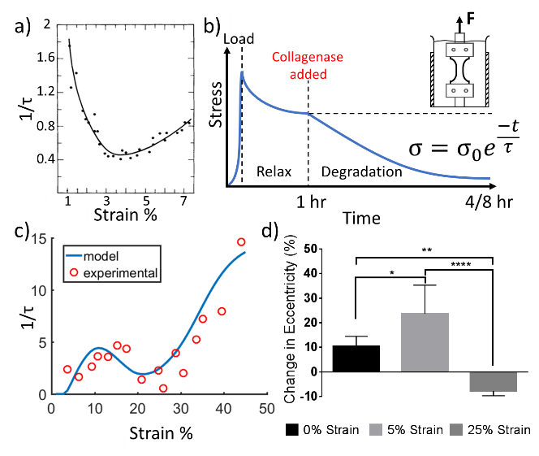
Figure 1 a) ‘V’ shaped degradation response for pure collagen used for the 1D numerical artery model (adapted from [3]), b) schematic of experimental protocol, c) experimental results (circles) overlaid on the numerically predicted response (solid line), d) relative degradation induced changes in fibre eccentricity under different strain regimes observed using SALS, n=7, *p<0.05, **p<0.01,****p<0.0001.

Discussion
Using a combined experimental and numerical approach, this study has identified, for the first time, the complex strain mediated degradation mechanism of arterial tissue. The complementary numerical model helps unravel the mechanisms at play. No degradation occurs initially; as collagen fibres are crimped at low strain they bear no load and hence do not undergo degradation. Next, degradation increases as fibres begin to uncrimp and take up the the load. When all fibres are fully stretched, the ‘V’ shaped behaviour resumes. SALS results further support this finding, identifying a similar trend in relative fibre alignment post degradation.
These findings offer substantial new insights into arterial degradation and may be used to aid the design of novel intravascular devices to induce controlled remodelling or repair in potentially vulnerable, rupture prone arteries.

References
1. Abdul-Hussien et al. Am. J. Pathol., 170:809-817, 2007.
2. Gaul et al., JMBBM, 75:359-368, 2017.
3. Huang & Yannas, J. Biomed. Mater. Res., 11:137-154, 1977.
4. Ghazanfari et al., Acta Biomaterialia, 35:118-126, 2016.

Acknowledgements
This publication has emanated from research conducted with the financial support of the IRC (GOIPG/2014/515), SFI under the Grant Number SFI/13/ERC/B2775 and the European Research Council (ERC) under the European Union’s Horizon 2020 research and innovation programme (grant agreement No. 637674).

