Fig. 1.
Comparisons of the HPMC and HG capsules measured using DVS at 25ºC (n=3) of: (A) Moisture sorption and desorption isotherms, and (B) Hysteresis (%) values between the desorption and sorption processes calculated from sorption-desorption isotherms.

Fig. 2.
Water distributions for HPMC and HG capsules presented as monolayer, multilayer, and absorbed moisture, predicted according to the Young−Nelson model.

Fig. 3.
Effect of % Relative Humidity on HPMC and HG capsules thickness layers (l) measured after DVS experiments at 25ºC (n=3).

Fig. 4.
Water vapour parameters determined for HPMC and HG capsule shells at 25 °C (n=3) of: (A) water solubility coefficients S, (B) water diffusion coefficients D, and (C) water permeability coefficients P .

Table 1.
Factors and levels investigated in the statistical analysis of S, P and D across capsules.

Code | Factor | Levels | Values
A | Relative Humidity (%) | 6 | 20, 30, 40, 50, 60, 70
B | Capsules Type | 2 | HG, HPMC
C | Process Type | 2 | Desorption, Sorption

Table 2.
Analysis of Variance for solubility coefficients (S).

Source | DFª | Seq SS^{b} | Adj SS^{c} | Adj MS^{d} | F | P^{e}
% Relative Humidity, (A) | 5 | 0.0517501 | 0.0517501 | 0.0103500 | 8842.82 | 0.000
Capsules Type, (B) | 1 | 0.0049690 | 0.0049690 | 0.0049690 | 4245.37 | 0.000
Process Type, (C) | 1 | 0.0003547 | 0.0003547 | 0.0003547 | 303.06 | 0.000
(A)*(B) | 5 | 0.0143180 | 0.0143180 | 0.0028636 | 2446.60 | 0.000
(A)*(C) | 5 | 0.0038562 | 0.0038562 | 0.0007712 | 658.94 | 0.000
(B)*(C) | 1 | 0.0001347 | 0.0001347 | 0.0001347 | 115.10 | 0.000
(A)*(B)*(C) | 5 | 0.0022868 | 0.0022868 | 0.0004574 | 390.76 | 0.000
Error | 48 | 0.0000562 | 0.0000562 | 0.0000012
Total | 71 | 0.0777258
S = 0.00108187 R-Sq = 99.93% R-Sq(adj) = 99.89%
ª Degrees of freedom.
^{b} Sequential sums of squares.
^{c} Adjusted sums of squares.
^{d} Adjusted mean squares.
^{e} Probability.

Fig 5.
Main effects plot for S (× 10⁻¹³) in Kg moisture/ m³ capsules Pa.

Fig 6.
Interaction plot for S (× 10⁻¹³) in Kg moisture/ m³ capsules Pa.

Fig 7.
Main effects plot for D (× 10⁻¹³) in m²/s.

Fig 8.
Interaction plot for D (× 10⁻¹³) in m²/s.

Fig 9.
Main effect plot P (× 10⁻¹³) in Kg moisture/ m³ capsules Pa × m²/s.

Fig 10.
Interaction plot for P (× 10⁻¹³) in Kg moisture/ m³ capsules Pa × m²/s.

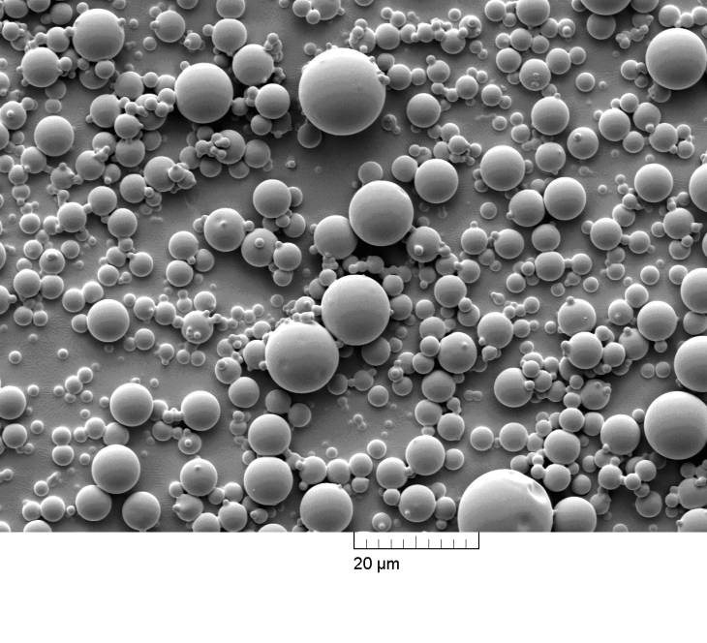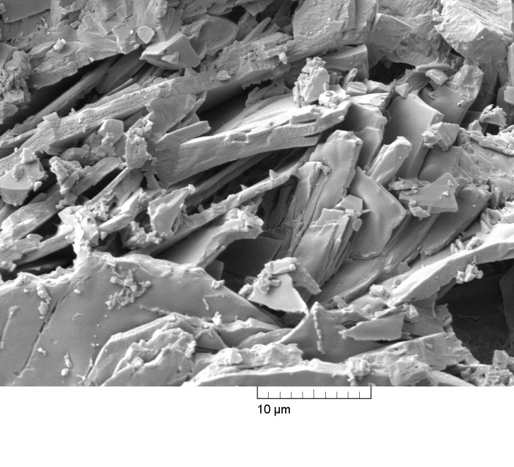
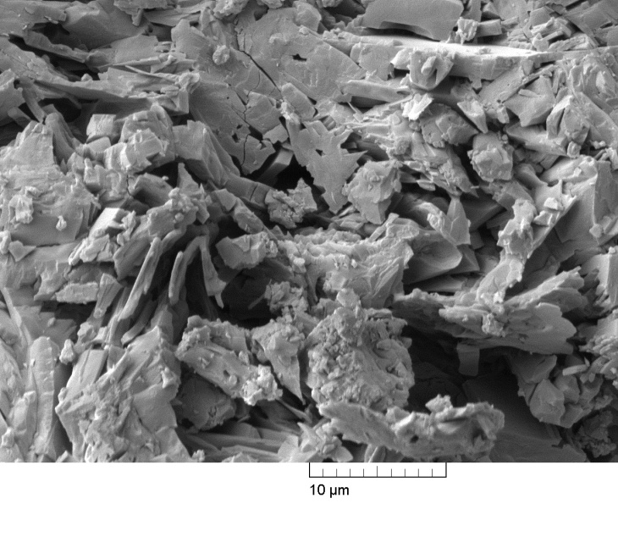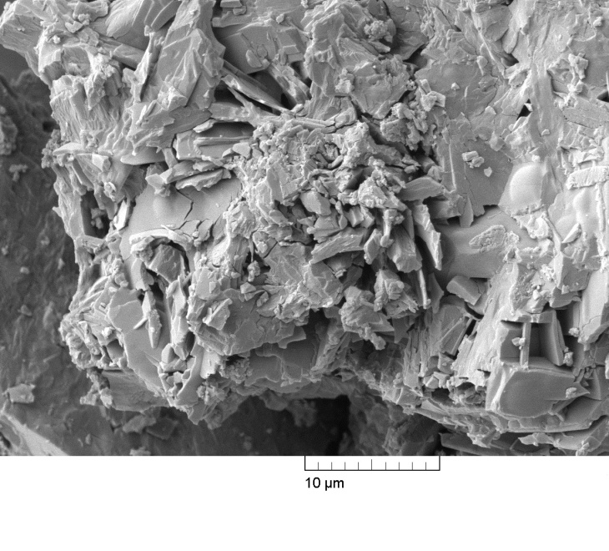
Fig. 11.
SEM micrographs of (A) anhydrous spray dried lactose, and (B) the recrystallised lactose from the amorphous state (C) HPMC (D) HG capsules upon exposure to humid air between 50-70% RH in the DVS apparatus (magnification of 5K).

Fig. 13.
Typical XRD patterns of: (A) anhydrous spray-dried lactose (directly recorded after the spray-drying process), (B) spray-dried lactose (free powder), (C) spray-dried lactose loaded into HPMC capsule, and (D) spray-dried lactose loaded into HG capsule. Samples (B-D) were recorded immediately following the DVS experiments between 0%−70%−0% RH for consecutive 12 steps at 25ºC.

Fig. 14.
Comparative DSC thermograms of: (A) anhydrous spray-dried lactose (directly recorded after the spray-drying process), (B) spray-dried lactose (free powder), (C) spray-dried lactose loaded into HPMC capsule, and (D) spray-dried lactose loaded into HG capsule. Samples (B-D) were recorded immediately following the DVS experiments between 0%−70%−0% RH for consecutive 12 steps at 25ºC.

Fig. 12.
Kinetic profiles of unloaded spray dried lactose, HPMC contained lactose and HG contained lactose upon moisture uptake between 50% to 70%RH at 25ºC.

Appendix A. Supplementary data

Supplementary Table 1. Summary of the calculated mean values of solubility (S, Kg moisture/(m³ capsules Pa), ×10⁻³), water vapour diffusion coefficients (D, m²/sec, ×10⁻¹⁴), and permeability (P, [(Kg moisture/ m³ capsules Pa ) × (m²/s)], ×10⁻¹⁵) characteristic parameters of empty HPMC and HG capsules.

Capsules | RH (%)
Capsules | 0-20 | 20-30 | 30-40 | 40-50 | 50-60 | 60-70
 | S×10⁻³ (sorption isotherm)
HPMC | 43.6 | 13.5 | 10.5 | 13.7 | 13.4 | 15.7
HG | 93.3 | 33.0 | 22.9 | 18.0 | 12.6 | 13.8
 | S×10⁻³ (desorption isotherm)
HPMC | 52.2 | 17.8 | 15.4 | 12.3 | 12.1 | 10.7
HG | 157.5 | 34.9 | 19.7 | 9.3 | 8.1 | 7.2
 | D×10⁻¹⁴ (sorption isotherm)
HPMC | 52.9 | 61.0 | 69.1 | 33.2 | 33.0 | 31.6
HG | 5.1 | 6.7 | 13.1 | 21.9 | 32.7 | 24.9
 | D×10⁻¹⁴ (desorption isotherm)
HPMC | 35.7 | 50.9 | 57.0 | 72.3 | 59.9 | 69.9
HG | 7.3 | 26.7 | 47.2 | 92.4 | 70.8 | 88.0
 | P×10⁻¹⁵ (sorption isotherm)
HPMC | 23.0 | 8.2 | 7.3 | 4.6 | 4.4 | 5.0
HG | 4.8 | 2.2 | 3.0 | 3.9 | 4.1 | 3.4
 | P×10⁻¹⁵ (desorption isotherm)
HPMC | 18.6 | 9.1 | 8.8 | 8.9 | 7.3 | 7.5
HG | 11.6 | 9.3 | 9.3 | 8.6 | 5.7 | 6.4

Supplementary Table 2. Analysis of Variance for diffusion coefficients (D × 10⁻¹³).
Source | DFª | Seq SS^{b} | Adj SS^{c} | Adj MS^{d} | F | P^{e}
% Relative Humidity, (A) | 5 | 78.442 | 78.442 | 15.688 | 78.27 | 0.000
Capsules Type, (B) | 1 | 44.995 | 44.995 | 44.995 | 224.49 | 0.000
Process Type, (C) | 1 | 107.145 | 107.145 | 107.145 | 534.56 | 0.000
(A)*(B) | 5 | 79.773 | 79.773 | 15.955 | 79.60 | 0.000
(A)*(C) | 5 | 97.632 | 97.632 | 19.526 | 97.42 | 0.000
(B)*(C) | 1 | 33.239 | 33.239 | 33.239 | 165.83 | 0.000
(A)*(B)*(C) | 5 | 5.299 | 5.299 | 1.060 | 5.29 | 0.001
Error | 48 | 9.621 | 9.621 | 0.200
Total | 71 | 456.145
S = 0.447698 R-Sq = 97.89% R-Sq(adj) = 96.88%

ª Degrees of freedom.
^{b} Sequential sums of squares.
^{c} Adjusted sums of squares.
^{d} Adjusted mean squares.
^{e} Probability.

Supplementary Table 3. Analysis of Variance for permeability coefficients (P × 10⁻¹³).
Source | DFª | Seq SS^{b} | Adj SS^{c} | Adj MS^{d} | F | P^{e}
% Relative Humidity, (A) | 5 | 0.0700697 | 0.0700697 | 0.0140139 | 221.44 | 0.000
Capsules Type, (B) | 1 | 0.0202565 | 0.0202565 | 0.0202565 | 320.08 | 0.000
Process Type, (C) | 1 | 0.0171512 | 0.0171512 | 0.0171512 | 271.01 | 0.000
(A)*(B) | 5 | 0.0322756 | 0.0322756 | 0.0064551 | 102.00 | 0.000
(A)*(C) | 5 | 0.0023522 | 0.0023522 | 0.0004704 | 7.43 | 0.000
(B)*(C) | 1 | 0.0058252 | 0.0058252 | 0.0058252 | 92.05 | 0.000
(A)*(B)*(C) | 5 | 0.0082745 | 0.0082745 | 0.0016549 | 26.15 | 0.000
Error | 48 | 0.0030377 | 0.0030377 | 0.0000633
Total | 71 | 0.1592426
S = 0.00795527 R-Sq = 98.09% R-Sq(adj) = 97.18%

ª Degrees of freedom.
^{b} Sequential sums of squares.
^{c} Adjusted sums of squares.
^{d} Adjusted mean squares.
^{e} Probability.

