Abstract
In 2010, figures show that only 45 per cent of Irish students took Higher Level mathematics for the Junior Certificate examination and only 16 per cent took Higher Level mathematics for the Leaving Certificate examination (www.examinations.ie). Research suggests that there are two major reasons for such low numbers, namely; ineffective teaching (NCCA, 2006) and a subsequent lack of student interest in the subject (PISA, 2003). Traditional styles of teaching make it difficult for students to take an interest in a confusing topic in which they can see no immediate relevance (MacGregor, 2004). This is particularly true regarding the topic of algebra and its teaching in school (Herscovics and Linchevski, 1994). Taking steps to enhance student interest in the mathematics classroom is one of the most direct ways to approach the problem of ineffective mathematics teaching (Mitchell, 1993).

This thesis describes a pedagogical framework designed by the author for the purpose of promoting student interest in mathematics through effective teaching using the topic of algebra as an exemplar. The framework identifies and integrates three theoretical perspectives, one for each of the main issues highlighted in italic. These theoretical perspectives include pedagogical principles, a model for conceptualising algebraic activity and a model for interest development. Once the design of the framework is complete it is field-tested through the development, implementation and evaluation of a teaching intervention. This intervention takes the form of an algebra revision package for 1st year (12 -14 year old) students. It was implemented in five Irish Second level schools between September 2009 and June 2010. Its evaluation reached a successful conclusion showing that an appropriately designed pedagogical framework supported theoretically can bring about positive changes in student attitude.

Declaration of Originality
This thesis is presented in fulfilment of the requirements for the degree of Doctorate of Philosophy. It is entirely my own work and has not been submitted to any other University or higher education institution, or for any other academic award in this University. Where use has been made of the work of other people it has been fully acknowledged and fully referenced.

Name: Mark Prendergast

Signature: _______________________

Date: _______________________

Dedication
This dissertation is dedicated to my parents Pat and Aine
Thanks for everything

“Nothing in this world can take the place of persistence.
Talent will not; nothing is more common than unsuccessful men with talent.
Genius will not; unrewarded genius is almost a proverb.
Education will not; the world is full of educated derelicts.
Persistence and determination alone are omnipotent”

Acknowledgements
To my supervisor Professor John O’Donoghue, for giving me the opportunity to undertake this research and for your constant supervision, guidance and humouring during this research.

To my family for all your support and encouragement throughout the duration of this project.

To Aine for always being there and ‘putting up’ with me!

To my fellow postgrads and friends for your support throughout the course of this study.

To my colleagues in the National Centre for Excellence in Mathematics and Science Teaching and Learning (NCE – MSTL) especially Dr. Olivia Gill and Dr. Ailish Hannigan for your expert advice and help throughout.

To all the schools, teachers and students who took part in this research. Thank you for your time.

Table of Contents
Abstract ii
Declaration of Originality iii
Dedication iv
Acknowledgements v
Table of Contents vi
List of Figures xii
List of Tables xiv
List of Appendices xv

1. Introduction 1
1.1 Introduction 1
1.2 Background to the Study 2
1.2.1 Identifying the Problem 2
1.2.2 Understanding the Problem 3
1.2.3 Addressing the Problem 6
1.3 Research Questions 7
1.4 Theoretical Perspectives 7
1.5 Methodology 8
1.6 Research Design 9
1.7 Significance of the Research 10
1.8 Description of Terms used in the Study 12
1.9 Outline of the Chapters 14
1.10 Conclusion 15

2. Effective Teaching, Student Interest and Algebra 16
2.1 Introduction 16
2.2 Mathematics and Mathematics Education 17
2.2.1 Introduction 17
2.2.2 What is Mathematics? 17
2.2.3 The Importance of Mathematics 18
2.2.4 Mathematics Education in Ireland 19
2.2.5 The Need for Change 23
2.2.6 Summary 24
2.3 Teaching and Learning of Mathematics 25
2.3.1 Introduction 25
2.3.2 Teaching 25
2.3.3 Learning 32
2.3.4 Issues which may Impact upon Effective Teaching and Learning in Mathematics 37
2.3.5 Summary 59
2.4 Interest in Mathematics 59
2.4.1 Introduction 59
2.4.2 What is Interest? 60
2.4.3 Types of Interest 61
2.4.4 Importance of Interest 63
2.4.5 How to Promote Interest in Mathematics? 64
2.4.6 Summary 66
2.5 Algebra 67
2.5.1 Introduction 67
2.5.2 What is Algebra? 67
2.5.3 Importance of Algebra 68
2.5.4 Difficulties Regarding Algebra Teaching and Learning 69
2.5.5 Teaching Algebra 73
2.5.6 Summary 77
2.6 Conclusion 78

3. Methodology 80
3.1 Introduction 80
3.2 Discussion on Research Paradigms 81
3.3 Methodology for this Study 82
3.4 Research Purpose and Questions 83
3.5 Theoretical Perspectives 85
3.6 Research Design 86
3.7 Chronology of Research 87
3.7.1 Phase 1: Literature Review 87
3.7.2 Phase 2: Design of Framework 88
3.7.3 Phase 3: Development of Intervention 88
3.7.4 Phase 4: Implementation 89
3.7.5 Phase 5: Evaluation 91
3.8 Multi – Method Approach 93
3.9 Methodological Tools 93
3.9.1 Quantitative Analysis 93
3.9.2 Qualitative Analysis 97
3.10 Validity and reliability (Quantitative and Qualitative research) 97
3.10.1 Validity 97
3.10.2 Reliability 100
3.11 Triangulation 101
3.12 Ethics 102
3.13 Limitations of the Study 102
3.14 Conclusion 103
4. Design of Framework 104
4.1 Introduction 104
4.2 A Model for Conceptualising Algebraic Activity 105
4.2.1 Generational Activities 107
4.2.2 Transformational Activities 107
4.2.3 Global/ Meta Level Activities 108
4.2.4 Implications of Kieran’s Model for Framework 108
4.3 A Four Phase Model of Interest Development 109
4.3.1 Stage 1: Triggered Situational Interest 110
4.3.2 Stage 2: Maintained Situational Interest 110
4.3.3 Stage 3: Emerging Individual Interest 111
4.3.4 Stage 4: Well-Developed Individual Interest 111
4.3.5 Implications of Hidi and Renninger’s Model for Framework 112
4.4 Pedagogical Principles 112
4.4.1 Behaviourism Learning Theory 113
4.4.2 Social Learning Theory 114
4.4.3 Constructivism Learning Theory 115
4.4.4 Implications of Learning Theories for Framework 118
4.5 Integrating the Theoretical Perspectives into one Framework 120
4.5.1 Effective Teaching 121
4.5.2 Student Interest 122
4.5.3 Algebra 124
4.5.4 Summary 124
4.6 Conclusion 125

5. Development and Implementation of Intervention 126
5.1 Introduction 126
5.2 Development of Intervention 127
5.2.1 Feedback from Teachers 127
5.2.2 The Finalised Intervention 129
5.3 Structure of Intervention 129
5.3.1 Lesson 1 – Phase 1 130
5.3.2 Lesson 2 – Phase 1 132
5.3.3 Lesson 3 – Phase 1 134
5.3.4 Lesson 4 – Phase 1 136
5.3.5 Lesson 1 – Phase 2 139
5.3.6 Lesson 2 – Phase 2 141
5.3.7 Lesson 3 – Phase 2 143
5.3.8 Lesson 4 – Phase 2 145
5.4 Implementation 146
5.4.1 Selection of Intervention Schools 148
5.4.2 Sample Size and Consent forms 150
5.4.3 Age and Gender Distribution 150
5.4.4 Control and Experimental Groups 151
5.4.5 Delivery 151
5.5 Conclusion 152

6. Evaluation of Intervention 153
6.1 Introduction 153
6.2 Treatment Effectiveness 154
6.2.1 Reliability of the Scales 155
6.2.2 Correlation of Aiken’s Enjoyment Scale 156
6.2.3 Descriptive Analysis of Enjoyment Scale 156
6.2.4 Further Analysis of Enjoyment Scale 160
6.2.5 Descriptive Analysis of Diagnostic Examination 166
6.2.6 Further Analysis of Diagnostic Examination 169
6.3 The Integrity of the Intervention 172
6.4 Social Validity of the Intervention 173
6.4.1 Rating Phase 1 and 2 173
6.4.2 Rating the Overall Intervention 174
6.5 Intervention Acceptability 177
6.5.1 Nodes Evolving from the Data 177
6.5.2 Other Factors which may affect the Acceptability of the Intervention 186
6.6 Conclusion 187

7. Conclusions, Contributions, Recommendations and Further Research 189
7.1 Introduction 189
7.2 Summary 190
7.3 Key Findings for the Research Questions 191
7.3.1 Key Findings for Research Question 1 191
7.3.2 Key Findings for Research Question 2 196
7.3.3 Key Findings for Research Question 3 197
7.3.4 Key Findings for Research Question 4 199
7.4 Significant Overall Conclusions 206
7.5 Contributions to Research 208
7.6 Recommendations 210
7.7 Further Research 211
7.8 Conclusion 214
Bibliography 307

List of Figures
Figure 1.1: Theoretical Perspectives 8
Figure 1.2: Mixed Method Approach for Undertaking Research 9
Figure 1.3: Research Design 10
Figure 2.1: Teacher Characteristics (% ‘very important’) of Effective Teaching 30
Figure 2.2: Characteristics which Help Students Learn Best in Class 36
Figure 3.1: Mixed Method Approach for Undertaking Research 83
Figure 3.2: Theoretical Perspectives 85
Figure 3.3: Phases of the Research 86
Figure 3.4: Chronology of Research 87
Figure 3.5: Influence of Theoretical Perspectives in Design of Framework 88
Figure 3.6: The Evaluation Model 93
Figure 4.1: Theoretical Perspectives 105
Figure 4.2: Kieran’s (1996) Model of Algebraic Activity 107
Figure 4.3: Interest Development: A Four Stage Model 109
Figure 4.4: Integrating the Theoretical Perspectives into one Framework 120
Figure 5.1: The Role of the Framework in Developing Lesson 1 of Phase 1 132
Figure 5.2: The Role of the Framework in Developing Lesson 2 of Phase 1 134
Figure 5.3: The Role of the Framework in Developing Lesson 3 of Phase 1 136
Figure 5.4: The Role of the Framework in Developing Lesson 4 of Phase 1 138
Figure 5.5: The Role of the Framework in Developing Lesson 1 of Phase 2 140
Figure 5.6: The Role of the Framework in Developing Lesson 2 of Phase 2 142
Figure 5.7: The Role of the Framework in Developing Lesson 3 of Phase 2 144
Figure 5.8: The Role of the Framework in Developing Lesson 4 of Phase 2 146
Figure 6.1: Means of Five Enjoyment Scales 156
Figure 6.2: Magnified Means of Five Enjoyment Scales 159
Figure 6.3: Means of Five Enjoyment Scales (School 2 Only) 161
Figure 6.4: Performance of Schools in Baseline Enjoyment Scale 163
Figure 6.5: Performance of Gender in Enjoyment Scale 164
Figure 6.6: Performance of Gender in Enjoyment Scale (Mixed Schools Only) 165
Figure 6.7: Performance of Students in Algebra Diagnostic Examination 168
Figure 6.8: Performance of Students in Equations Diagnostic Examination 169
Figure 6.9: Performance of Schools in Diagnostic Examination 170
Figure 6.10: Performance of Gender in Diagnostic Examination 171
Figure 6.11: Performance of Gender in Diagnostic Examination (Mixed Schools) 172
Figure 6.12: Results from Question 1 175
Figure 6.13: Results from Question 4 176
Figure 7.1: Recorded Interactions in Co – educational Classes by Gender 203
Figure 7.2: Percentage of Students taking Higher Level in 2nd year 212
Figure 7.3: Percentage of Grades achieved in Final Examination 213

List of Tables
Table 2.1 ‘Some teachers are better than others’ – Students’ Responses 27
Table 3.1: Characteristics of Qualitative and Quantitative Research 82
Table 3.2: Timing of Implementation in Schools 1,2 and 3 90
Table 3.3: Timing of Implementation in Schools 4 and 5 90
Table 5.1: Structure of Teaching Intervention in Schools 130
Table 5.2: Diary of Implementation in Schools 1,2 and 3 147
Table 5.3: Diary of Implementation in Schools 4 and 5 148
Table 5.4: Number of Students in each School 150
Table 6.1: Cronbach Alpha Value of each Enjoyment Scale 155
Table 7.1: Gender Composition of Schools in Ireland 202

List of Appendices
Appendix A: Aiken’s Enjoyment Scale 215
Appendix B: Diagnostic Examinations for Algebra 217
Appendix C: Diagnostic Examinations for Equations 220
Appendix D: Example of Teacher Journal 223
Appendix E: Information Sheets for Participants 228
Appendix F: Consent Forms for Participants 232
Appendix G: Teaching Materials for Lesson 1 Phase 1 235
Appendix H: Teaching Materials for Lesson 2 Phase 1 243
Appendix I: Teaching Materials for Lesson 3 Phase 1 247
Appendix J: Teaching Materials for Lesson 4 Phase 1 254
Appendix K: Teaching Materials for Lesson 1 Phase 2 257
Appendix L: Teaching Materials for Lesson 2 Phase 2 267
Appendix M: Teaching Materials for Lesson 3 Phase 2 281
Appendix N: Teaching Materials for Lesson 4 Phase 2 294
Appendix O: CD of ‘Teacher Guidelines’ Handbook 300
Appendix P: Correlation of Aiken’s Enjoyment Scale 302
Appendix Q: List of Papers 304

________________________________________

Introduction
________________________________________

1.1 Introduction
The poor uptake of Higher Level Junior and Senior Cycle (lower and upper secondary education) mathematics is one of the main concerns regarding mathematics education in Ireland at present. In 2010, figures show that only 45 per cent of the Junior Cycle cohort took the Junior Certificate Higher Level mathematics’ course (State Examinations Commission (SEC) - www.examinations.ie). More worryingly only 16 per cent opted for the Higher Level Leaving Certificate examination (SEC- www.examinations.ie). These figures are very low in comparison to other subjects. For example, in the same year 68 per cent of students took Higher Level English in the Junior Certificate examination, while 64 per cent took Higher Level English in the Leaving Certificate examination (SEC- www.examinations.ie). As a result of such low numbers studying Higher Level mathematics, concern is widespread in many Irish third level institutions regarding the mathematical under - preparedness of their entrant’s (Gill and O’Donoghue, 2006). Many professions particularly those in science, engineering and technology are affected by graduate deficiencies in mathematics. This has serious repercussions for the Irish economy, particularly in relation to the technology and industrial sectors (Expert Group on Future Skills Needs (EGFSN), 2008). In order to meet the future needs of the economy, the author submits that a figure in the region of at least 60 - 70 per cent of students must take Higher Level Junior Certificate mathematics. This figure is in line with other subjects at this level and also with government targets (www.ncca.ie). However, this requires a 15 - 25 per cent increase in the numbers currently taking Higher Level. Such a large increase is a difficult challenge as there are many reasons for such low numbers, reasons which this thesis will investigate in more detail.

1.2 Background to the Study

1.2.1 Identifying the Problem
Mathematics is apparent as a core area of learning in most educational systems throughout the world. Though enjoyable and valid in its own right, it is also relevant to learning in many other curricular areas. It has been described as the “cornerstone from which all other subjects can be built” (Georgewill, 1990: 380). Mathematics supports many disciplines and is fundamental to our understanding of the world we live in (NCCA, 2006). However, despite its contributions to society, numerous problems remain in the teaching and learning of the subject itself. As previously highlighted figures show, approximately only 45 per cent of Irish Junior Cycle students opt for the Higher Level mathematics’ course (SEC- www.examinations.ie). If only 45 per cent take Higher Level for the Junior Certificate, then it is inevitable the number taking Higher Level for the Leaving Certificate will be even smaller than this. For example, the present proportion of student cohort taking each of the three syllabus levels in Leaving Certificate mathematics is approximately 12 per cent at Foundation Level, 72 per cent at Ordinary Level, and 16 per cent at Higher Level. In other words, approximately 84 per cent of students who take Leaving Certificate school mathematics do not study the subject at it highest level. This does not match the expected pattern of uptake when these syllabuses were first being developed which were 20-25 per cent, 50-60 per cent and 20-25 per cent respectively (NCCA, 2005a).
This relatively poor take-up of Higher Level mathematics rightly gives cause for concern. It not only affects the individual student’s personal progress, but also has far reaching consequences for society in general, particularly in such a technically dominated era. There is understandable unease about the low level of mathematical skills of students emerging from second level education and, in particular, of those proceeding to third level education (NCCA, 2005a). Such institutions have expressed concern at this development. O’Donoghue (2002) (as cited in NCCA, 2005a: 30) noted “observations by university lecturers regarding the lack of fluency in fundamental arithmetic and algebraic skills, gaps in basic knowledge in important areas such as trigonometry and complex numbers, and an inability to use or apply mathematics except in the simplest or most practised way”. This does not just affect mathematics courses, but also impacts on other courses such as science, technology, engineering, business and finance where mathematics provides an important basis for development. An adequate supply of high quality graduates from such courses is crucial to Ireland’s future social and economic growth (EGFSN, 2008).

1.2.2 Understanding the Problem
The Irish Government has come under increasing pressure to take action as a result of such deficiencies in mathematics. Nevertheless, the solution to such a complex problem is in no way straight forward. Increasing the numbers taking Higher Level mathematics for the Junior Certificate would undoubtedly be a start. This could increase numbers sitting Higher Level mathematics for the Leaving Certificate and in a knock-on effect this would have positive implications for the follow-on study of mathematics at third level. However, this is easier said than done. A greater insight into the issue is first needed. Why do so few students opt for Higher Level mathematics? What are the reasons why approximately 55 per cent of our Junior Cycle cohorts do not take Higher Level? Many contributing reasons have been identified in the literature namely;

- Negative Public Image
In modern life it appears acceptable to readily admit to a dislike of mathematics. In contrast to the “shame associated with illiteracy, innumeracy is almost a matter of pride amongst educated people” (Ernest, 1995: 449). The widespread public image is largely a negative and inaccessible one, far removed from many people’s professional and personal concerns. This dates back to the age old image of mathematics as difficult, cold, abstract, theoretical and largely masculine (Ernest, 2004). There is a stereotype of mathematics being “remote and inaccessible to all but a few super – intelligent beings with ‘mathematical mind”’ (Ernest, 1995: 449). Such a damning public image is certain to affect students’ confidence and willingness to achieve success in the subject.

- Class Allocation
For some, the choice of studying Higher Level mathematics has been eliminated before they even commence post - primary education. Many students are allocated to mathematics classes in their first year of post-primary education or even before they start. Class allocation and timetabling processes should facilitate as many students as possible to having the opportunity to study the Higher-Level course. However, it is often the case that students are locked into a level due to either late development of their mathematical knowledge and skills or initial under-achievement.

- Difficult Content
Unlike most other subjects where Higher Level is intended for the majority of students, the Irish Higher Level mathematics syllabus states that it is targeted at students of above average mathematical ability. One wonders what the reasons are for this. It is logical to expect Higher Level to be targeted at students of above average ability. However, it is illogical that mathematics is the only subject where this is the case. This is reinforced by the low numbers achieving the higher grades e.g. A1 and A2 (7 per cent of students achieved an A1 and 7 per cent achieved an A2 in the 2010 Leaving Certificate Higher Level).

- Race for Points
In Ireland, third level places are allocated based on students’ performance in the Leaving Certificate. A specific number of points are allocated per subject to students based on how they performed in each particular subject in the Leaving Certificate examination. Students’ scores from their top six subjects are added together to give a total score. They are then ranked based on these scores and students with higher scores receive first preference for courses of study at third-level institutions. Students who take the Higher Level paper receive more points than students who opt for the Ordinary Level paper. However, due to the difficult content and heavy course work in comparison to other subjects, many students feel that studying Higher Level mathematics can be detrimental to their success. A1’s can be achieved in other subjects with less effort and workload. Thus, many students who are more than capable of taking Higher Level mathematics decide against it so their efforts for points can be more evenly spread in other ‘grade friendly’ subjects.

Despite the extent and importance of each of these issues, research suggests that the two main reasons for the low numbers taking Higher Level mathematics in Ireland are;
- Ineffective Teaching
Research carried out by the NCCA (2005b) describes mathematics teaching in Ireland as procedural in fashion and highly didactic. There is a formal, behaviourist style evident which consists of whole class learning and the replication of procedures demonstrated by the teacher (Morgan and Morris, 1999). Lessons are dominated by ‘talk and chalk’ with little evidence of group work, whole class discussion or reflection (NCCA, 2005a). This approach results in students learning the ‘how’ rather than the ‘why’ of mathematics. There appears to be little or no emphasis on students relating to or indeed understanding the mathematics which they are taught. Lyons et al (2003) also found that students were not given insights into any of the applications of mathematics in everyday life.

- Lack of Student Interest in Mathematics
While effective teaching methodologies and resources are of paramount importance, such efforts are futile unless students have a desire and motivation to learn. This is backed up by Hidi and Harackiewicz (2000) who established that the key to impacting an individual’s academic performance lies in increasing the individual’s interest in the particular domain. Current research figures in Ireland show that there is much work to do in this respect. Statistics released by PISA (2003) show that less than half (48 per cent) of Irish students agree that they are interested in the things they learn in mathematics. This figure was slightly down on the Organisation for Economic Co-operation and Development (OECD) average of 53 per cent. In addition, only 32 per cent of Irish students declare that they look forward to their mathematics lessons, while only 33 per cent concur that they do mathematics for the enjoyment. The same study disclosed that over two-thirds of Irish 15 year olds ‘often feel bored’ at school, while the OECD average for this was under 50 per cent (PISA, 2003). Again this particular problem is interlinked with those mentioned previously. Students are reluctant and unwilling to engage in a subject which has little use or relevance to their own lives.

1.2.3 Addressing the Problem
It is clear that much work has to be done by the Government, schools, teachers and researchers alike in order to increase the numbers taking Higher Level mathematics in Ireland. The author’s personal interest in this area extends from his qualification as a secondary school mathematics teacher and his own educational experiences. When the author was doing the Leaving Certificate, 7 students out of a possible 119 took the Higher Level mathematics examination. Many of the author’s peers were well capable of taking Higher Level but were discouraged by many of the issues mentioned in the last section such as negative public image, overly difficult content, class allocation and the ‘race for points’. These issues are serious obstacles and are thwarting student’s attempts at studying mathematics at the highest level, thus narrowing the career options of many. Hence, the author decided to concentrate his research on two of the main reasons which discourage students from taking Higher Level namely, ineffective teaching and a lack of student interest in the subject. These are the most difficult barriers which students must overcome in order to study Higher Level and are interlinked in many ways. Taking steps to enhance interest in the mathematics classroom is one of the most direct ways to approach the problem of ineffective mathematics teaching (Mitchell, 1993). Thus, the author decided to design a pedagogical framework which will promote student interest in mathematics through effective teaching of the subject. Algebra was chosen as the exemplar topic. This framework is field-tested through the development, implementation and evaluation of a teaching intervention. The teaching intervention is a resource which may be used by second level teachers when revising algebra with 1st year (12 – 14 year old) students.

1.3 Research Questions
The main purpose of this research is to promote student interest in mathematics through effective teaching of the subject, using the topic of algebra as an exemplar.
The key objectives of this research are to:
- Identify, describe and critique effective classroom practice in mathematics in order to advance and improve mathematics teaching in Irish classrooms.

- Examine approaches to improve student’s interest in mathematics as a strategy for effective mathematics teaching.

- Investigate the topic of algebra and identify methods of improving the teaching and learning of the topic as an exemplar topic for the purposes of this research.

With such aims and objectives in mind, the following research questions were derived and helped guide each phase of research.
- What are the issues contributing to effective mathematics teaching which can stimulate and maintain student interest in topics at Junior Cycle level, for example the topic of algebra?

- What theoretical perspectives address such issues?

- How can such perspectives be integrated into a pedagogical framework which provides the basis for the design and development of an exemplar teaching intervention?

- How can such a teaching intervention be developed, implemented and evaluated?

1.4 Theoretical Perspectives
Effective teaching, student interest and algebra are the three main domains on which this study is based. Thus, various researchers work on each of these domains was examined and a theoretical perspective was identified for each domain. These theoretical perspectives include pedagogical principles which adopt constructivism as the main teaching approach. The other models include a model for conceptualising three different school algebraic activities and a four stage model of interest development. Each of these theoretical perspectives, as illustrated by Figure 1.1 underpin the research and will be discussed in more detail in Section 4.2.

Framework

Model of Algebraic Activity
Model of Interest Development
Pedagogical Principles
Generational Activities
Global / Meta
Activities
Transformational Activities
Triggered Situational
Maintained Situational
Emerging Individual
Well Developed Individual
Constructivism

Figure 1.1: Theoretical Perspectives

1.5 Methodology
A mixed method approach is used for undertaking this study. Such an approach combines the use of both quantitative and qualitative methods of research. Many authors support the integration of quantitative and qualitative research. The use of multiple methods reflects an attempt to secure an in-depth understanding of the phenomenon in question and allows for broader and better results (Denzin and Lincoln, 1998). It may also overcome the biases inherent in any single method (Creswell, 2003). In addition Bryman (1988) highlights the idea of ‘triangulation’. By incorporating more than one approach to data collection, the validity of findings are enhanced. Such methodology is described in more detail in Chapter 3 of this thesis.
Pragmatism/ Methodological Pluralism

Quantitative/ Positivist Paradigm
Qualitative/ Interpretivist Paradigm
Mixed Method Approach

Figure 1.2: Mixed Method Approach for Undertaking Research

1.6 Research Design
The author carried out the research in five main phases, the first of which began in October 2007 and the last phase was completed in October 2010. Phase 1 is a review of the current literature regarding the key issues underlying the study namely; effective teaching, student interest and algebra. This phase ran concurrently throughout the study. Phase 2 involved the selection of theoretical perspectives and the design of a pedagogical framework. It was decided to field-test this framework through the development of an intervention for teaching algebra to 1st year (12 – 14 years old) students. The development of this intervention occurred in Phase 3 of the research. It was implemented and evaluated in Phase 4 and Phase 5 respectively. Each of these phases are described in more detail in Chapter 3 of this thesis.


Literature Review
Design of Framework
Implementation of Intervention
Development of Intervention
Evaluation of Intervention
Figure 1.3: Research Design

1.7 Significance of the Research
The framework designed by the author is a novel idea, which combines three theoretical perspectives in order to promote student interest in mathematics through effective teaching, using the topic of algebra as an exemplar. Each of the key words highlighted in italics are issues of concern in present day mathematics education, both from an Irish and an international perspective. For example Hidi and Harackiewicz (2000) ascertained that interest has a powerful effect on student academic performance. Sanders (1999) and Wenglinsky (2000) asserted that effective teaching is the single biggest contributor to student success. Lastly, MacGregor (2004) acknowledged that algebra is a prerequisite for the study of mathematics, and indeed many forms of further education and employment. However, despite the recognised importance of the three domains, many problems remain in relation to each. For example, while on average across OECD countries, about half of the students report being interested in the things they learn in mathematics, only 38 per cent agree or strongly agree with the statement that they do mathematics because they enjoy it (PISA, 2003). Problems regarding effective teaching make up the main concerns in mathematics education nationally and internationally (NCCA, 2005a; b) and to compound matters, algebra is seen as an area where mathematics abruptly becomes a non-understandable world (Artique and Assude, 2000). In view of the importance of each of these domains, it is of national and international importance that the problems and concerns regarding each are confronted.

The study certainly confronts such concerns and it is hoped that the interest developed through the pedagogical framework will evolve in a cyclical way leading to further value, enjoyment and success for students in mathematics, thus in the long term, increasing the numbers taking Higher Level. This is an important educational aim of the Irish Government at present, as confirmed in 2007 by the then Minister for Education Mary Hanafin. In order to achieve this aim and help ‘solve the maths problem’, the Irish Government has taken two major steps. Firstly, they have undertaken a major new initiative entitled ‘Project Maths’. ‘Project Maths’ intends to introduce revised syllabuses for both Junior and Leaving Certificate mathematics. These revised syllabuses involve changes to what students learn in mathematics, how they learn it and how they will be assessed (www.projectmaths.ie). Secondly the Government have set up a National Centre for Excellence in Mathematics and Science Teaching and Learning (NCE – MSTL). This centre is based in the University of Limerick and its main aim is to research, develop and implement programmes to enhance Irish science and mathematics teaching and learning at all levels (www.nce-mstl.ie). It is hoped that each initiative will assist and facilitate each other in the universal aim of improving the teaching and learning of mathematics in Ireland. The framework designed by the author will also support the work of both initiatives by providing the basis for the development of teaching materials which coincide with the aims and objectives of both ‘Project Maths’ and the NCE-MSTL.

It is anticipated that the framework will also have positive teacher, as well as student, outcomes. It is envisaged that the teaching materials will help teachers develop;
- An advanced understanding of how students’ academically relevant interests can be stimulated, nurtured, and maintained,
- A further understanding of the important components of school algebra which include rule based symbol manipulation, teaching for understanding and providing purpose to the activities,
- An extended range of teaching methodologies employed in the teaching of mathematics which include whole class teaching, group work, discussion, peer learning, discovery learning and problem solving,
- An extended range of ICT skills through the use of internet resources and PowerPoint presentation.

As a qualified mathematics teacher the author submits that such outcomes will contribute significantly to the continuous profession development (CPD) of teachers. CPD is a highly contentious issue in present day mathematics education in both Irish and international circles. Research from an Irish perspective is sparse but evidence from Finucane (2004) paints a bleak picture regarding CPD in this country (See Section 2.2.4). Hence, the anticipated teacher outcomes are very favourable and afford teachers the opportunity to develop their knowledge of mathematics, particularly from a pedagogical perspective. In addition they will also help teachers prepare for the introduction of ‘Project Maths’ in Ireland by advocating a ‘teaching for understanding’ approach to mathematics and incorporating more activities and ICT into the classroom.

1.8 Description of Terms used in the Study
Second Level Education
Second level education can also be referred to as ‘Secondary’ or ‘Post – Primary’ education. It is the second stage of education following primary school (compulsory education between the ages of 5 -12) and consists of two main cycles, namely Junior and Senior Cycle

Junior Cycle
The Junior Cycle lies within the compulsory period of education and is usually taken by students between the ages of 12 and 15. The Junior Cycle in Ireland is similar to the middle school or junior high school period in the United States. It is a three year cycle, at the end of which the students sit a formal examination known as the Junior Certificate.

Senior Cycle
The Senior Cycle is a two year course which is the follow-on from the Junior Cycle, and culminates in a formal examination commonly referred to as the Leaving Certificate.

Higher, Ordinary and Foundation Level Mathematics
There are three levels of mathematics which Irish second level students can chose to study for the Junior Certificate or Leaving Certificate examinations. The most challenging level is referred to as Higher (often referred to as Honours), a lower level is referred to as Ordinary (often referred to as Pass), and the lowest level that can be taken is called Foundation.

Secondary School
Secondary schools, which educate approximately 54 per cent of second level students, are privately owned and managed (www.educationireland.ie). The majority are conducted by religious communities and the remainder by Boards of Governors or by individuals and they may be fee-paying or non-fee-paying. Non-fee-paying schools that participate in the free education scheme get a range of grants and subsidies from the State. Traditionally, these schools provided an academic type of education but in recent years have tended towards the provision also of technical and practical subjects.

Community School
Community schools are managed by Boards of Management representative of local interests. These schools offer a broad curriculum embracing both practical and academic subjects. They also provide facilities for adult education and community development projects. These schools are entirely funded by the State through the Department of Education and Science.

Third Level Education
Third level education can also be referred to as ‘Higher’ or ‘Tertiary’ education and follows on from second level. This education sector in Ireland consists of Universities, Institutes of Technology and Colleges of Education.

1.9 Outline of the Chapters
Chapter 2 is a review of the current literature regarding the key issues on which the framework is to be based namely effective teaching, student interest and algebra. This is accomplished by a detailed examination of relevant literature from Ireland, the UK and other countries where such issues have been addressed. The chapter allowed the author to develop a better understanding of the problems which the framework may face and how best to overcome them. It also assisted the author in formulating appropriate research questions and an appropriate research design.

Chapter 3 discusses the methodology and selection of methods chosen for this study and outlines the rationale for implementing the chosen research design to address the research questions. The methodology refers to the inquiry process and is used to analyse the methods for collecting data. The author was faced with many possible methodological choices including a range of approaches, procedures and instruments with which to undertake this study. This chapter offers the rationale behind such choices along with comprehensive overview on issues related to validity, reliability, triangulation, ethics and limitations.

Chapter 4 provides a comprehensive description of Phase 2 of the research which involves the design of a framework. This framework identifies and integrates three theoretical perspectives, one for each of main domains on which this study is based, namely effective teaching, student interest and algebra.

Chapter 5 describes the subsequent intervention development (Phase 3) and implementation (Phase 4). The development of the intervention is detailed and an account provided of the role played by the framework in this phase. Lastly this chapter describes the implementation of the intervention in five second level Irish schools from September 2009 to June 2010.

Chapter 6 describes the evaluation (Phase 5) of the intervention. Shapiro (1987) identifies four key parameters by which intervention research can be evaluated namely; treatment effectiveness, treatment integrity, social validity and treatment acceptability. This chapter will examine each parameter in more detail, specifically in relation to this study using the analysis of both quantitative and qualitative data.

Chapter 7 concludes the thesis by addressing the four research questions outlined in Chapter 1 and by summarising the main findings of the study. The contributions and significance of such findings to research in Ireland, to research internationally and to the domain of mathematics education will be discussed along with recommendations and suggestions for future research.

1.10 Conclusion
This introductory chapter was designed to set out the nature and the scope of the research. It began with a description of the background to the research describing the low uptake of Higher Level mathematics in Ireland. The reasons behind such low numbers were examined particularly the effects of poor teaching and a lack of student interest in the subject. As a possible solution to such problems it was outlined that this study aims to design a pedagogical framework which promotes student interest in mathematics through effective teaching, using the topic of algebra as an exemplar. This framework will be field-tested through the development, implementation and evaluation of a teaching intervention in Irish schools. Objectives which will help realise this aim were then identified, along with key questions which guided the research process. The theoretical perspectives and methodology adopted for undertaking the present work were also discussed. The long and short term significance of such a framework was subsequently noted. Chapter 2 proceeds to set out in greater detail, the background for the research by examining the literature on effective classroom teaching of mathematics, student interest and algebra.

________________________________________

Effective Teaching, Student Interest and Algebra
________________________________________

2.1 Introduction
In Chapter 1, effective teaching, student interest and algebra were identified as the key domains on which the design of the pedagogical framework is to be based. The purpose of this chapter is to explore the background research and help the author develop a better understanding of the issues contributing to effective mathematics teaching which can stimulate and maintain student interest in the topic of algebra. This is accomplished by a detailed review of relevant literature from Ireland, the UK and other countries where such matters have been addressed. This review will allow the author to identify concerns within each domain and suggest strategies for the framework on how best to overcome them. It will also assist the author in formulating appropriate research questions and an appropriate research design. However, firstly the chapter will provide a brief overview of mathematics and mathematics education in order to offer an insight into the most complex of disciplines.

2.2 Mathematics and Mathematics Education

2.2.1 Introduction
All stakeholders including teachers, students, parents, policy makers and researchers need some common ground when they speak of mathematics. In addition, the author needs an understanding of the domain on which to base this research. Thus, the background of the discipline will be examined along with its importance. The area of mathematics education will also be examined particularly from an Irish perspective.

2.2.2 What is Mathematics?
There are many definitions of the discipline offered throughout the ages. These definitions range from the concrete to the abstract, the straight forward to the complicated. Devlin (1997) determined that mathematics simply means working with numbers. Greenwood (1993), merely believed that mathematics is a way of thinking. The renowned American mathematician Benjamin Peirce defined mathematics as ‘the science that draws necessary conclusions’ (Peirce, 1956: 1773). Moving onto more abstract accounts Ernest (1995: 450), describes mathematics as an “objective, absolute, certain and incorrigible body of knowledge, which rests on the firm foundations of deductive logic”. Each of these definitions offers some insight into the basic underpinnings of the discipline. However, because of the complex nature of mathematics, its actual essence is difficult to capture. Indeed, no definition can claim total acceptance. The fact is that mathematics is more than just a set of rules, formulas and procedures to be memorised. Mathematics is not a single subject but is an accumulation of several dissimilar but related subjects. As pointed out by Aghadiuno (1992: 684), mathematics comprises “arithmetic, algebra, geometry, analytic geometry, calculus, statistics, trigonometry, logic, topology and mathematical modelling”.
It could be said that mathematics is a language based on symbols and diagrams (NCCA: www.curriculumonline.ie). However “its symbols unlike ordinary language need, not stand for any physical reality” (Aghadiuno, 1992: 685). It is a language of complete abstraction and highlights the free creative power of the human mind. It takes ‘assumptions’ as a starting point, from which a chain of deductive reasoning is derived. This can then be justified in its application to real life problems. However, while such portrayals indeed paint an impressive picture of the discipline, what is its actual importance?

2.2.3 The Importance of Mathematics
The importance of mathematics is noted throughout the literature (Smith, 2004; NCCA, 2005a; Muijs and Reynolds, 2001). However a brief look at the history of mankind and the importance of the discipline is highlighted for itself. By 3000BC, a practical use of mathematics had developed independently in each of the four great ancient civilisations of Egypt, India, China and Babylonia. It was utilised in practical areas of everyday life such as engineering, agriculture and Government. There are many examples in the legacy of each civilisation on their uses of mathematics. The great pyramids constructed by the Egyptians are one such illustration noted by Siu and Tsing (1984). The largest one was built almost 4800 years ago. It has a base perimeter of nearly 1km and a height of 147 metres. The building of such a tomb employed the use 2.3 million blocks of stone. One can only wonder in awe about the amount of mathematics used in designing, surveying, computing and organising such a project. Fast forward this to the work of the Greeks and the Romans, and again to the famous mathematics such as Galileo and Einstein whose work though written many years ago is still marvelled at and used extensively in schools today. Fast forward this to 1962, where President Kennedy acknowledged the contributions made by mathematics to space travel and announced the goal for landing a man on the moon. Today, as the evolution of mankind continues to progress, its reliance on mathematics also increases. Whether it is shopping, personal finances, construction or maybe winning the lottery…mathematics and its concepts are to the fore. There are many other examples. Progress in the arms industry, telecommunication and air navigation are to name but a few. For instance, during the busiest period in an international airport, planes come and go every half minute. How are flights scheduled? How should delays be estimated? The use of mathematics in the overall organisation of such a system shows the progress in recent years. These are amazing applications and must not be underestimated. Emenalo and Okpara (as cited in Aghadiuno, 1992: 693), sum everything up stating that “mathematics and mathematics education are indispensable in the efforts of any nation towards achieving great heights in science and technology”.
Thus, despite the poor perception of mathematics held by the general public (Section 1.2.2), there is a general acceptance of the importance of mathematics in education. As previously mentioned in Chapter 1, it is apparent as a core area of learning in most educational systems throughout the world. Its value as a component of general education, for employment, and for further and higher education is recognised by the community at large. This recognition is supported by research which demonstrates its importance in adult daily life (Muijs and Reynolds, 2001). For example a study conducted by ‘The Times’ newspaper (1999) in England found that adults with a higher secondary school mathematics qualification had average earnings 10 per cent higher than people without this qualification. Hence, notwithstanding all the negative perceptions associated with it, the truth is that mathematics is important.
This importance is recognised by students, teachers and employers alike. Mathematics is one of only two subjects (English being the other) which the vast majority (84 per cent) of all respondents to the NCCA (2005a) online questionnaire survey considered should be compulsory for all students. Significantly, 88 per cent of employers who responded to the survey were of this view, as were 79 per cent of students (NCCA, 2005a:5). Hence, its inclusion as a curricular area in schools has widespread support. It reflects its worth in providing students with knowledge, skills and procedures which are necessary tools of education for everyday life.

2.2.4 Mathematics Education in Ireland
Ireland’s education system has come a long way since its foundation in 1831. One hundred years ago, post-primary schooling was only accessible to an elite minority who were destined for a career in the civil service or a profession. However in modern day Ireland, second level education is a given for the vast majority of young people. In 1965, just over 12,000 students sat the Leaving Certificate. Today that figure is in the region of 58,000 (SEC, 2010). This is also evidenced by the NCCA (2005b), who established that four out of five students, who start school, go on to complete the Leaving Certificate. Such improvements are a direct result of a growing recognition that education is a critical driver of economic success and social progress in modern civilisation. The provision of quality education and training is central to the creation of a high-skilled, knowledgeable and innovation-based society. The importance of mathematics in such a society has already been highlighted (Section 2.2.3). Hence, there is no doubting the paramount importance of mathematics education which describes how mathematics is taught and learned in schools (Kilpatrick, 1992).

Present Day Mathematics Structure in Irish Schools
Mathematics has traditionally formed a substantial part of the education of young people in Ireland throughout their schooldays. Unlike many other countries across the developed world (Le Metais, 2003), mathematics is virtually compulsory in Ireland until the completion of second level education. Students follow a national curriculum in mathematics which begins in primary school and progresses through secondary school at Junior and Senior Cycle level.

Primary School
Mathematics in the primary years is extremely important for many different reasons. A student’s attitude to mathematics is often fixed by the end of the primary years and will determine the way in which he/she will approach mathematics at second level (Cockcroft, 1982). In addition, students are often streamed at entry to second level. Therefore those who leave primary school with low attainment levels, irrespective of ability, will be unable to enter the higher streams at second level. This can have knock on effects right through the student’s academic life.

In Ireland, students generally attend primary school between the ages of 5 and 12. There are eight different groupings ranging from junior infants to sixth class. The Irish mathematics primary school curriculum seeks to provide the child with a mathematical education that is “developmentally appropriate as well as socially relevant” (NCCA, www.curriculumonline.ie). This in keeping with Cockcroft (1982: 84) who states that the primary school mathematics curriculum should enrich children’s aesthetic and linguistic experience, develop their powers of logical thought, as well as equipping them with numerical skills. With reference to the programme itself, the Irish primary school curriculum comprises five main strands namely Number, Algebra, Shape and Space, Measure and Data. These strands, although separate areas, are interlinked with each other in such a way that understanding of one area is dependent upon knowledge of the others. By the end of the programme, the NCCA determine that the following skills should be developed by means of the content included;
- applying and problem-solving
- communicating and expressing
- integrating and connecting
- reasoning
- implementing
- understanding and recalling.
(NCCA, www.curriculumonline.ie)
Hence, from investigating the Irish primary school mathematics curriculum it is clear that in documentation it succeeds in its aim of providing opportunities for the student to explore the nature of mathematics. Through the five strands the student is capable of acquiring the knowledge, concepts and skills required for everyday living and for use in other subject areas. There is also a great emphasis on students being the instruments of their own learning. This constructivist approach to learning is central to this revised mathematics curriculum of 1999. Since the alteration to the curriculum the students are encouraged to develop their own mathematical strategies for solving problems by using their knowledge of different areas. However, while this has many benefits, the students may be less equipped to cope with the behaviourist learning approach, which as evidence suggests still remains at second level (NCCA, 2005a).

Secondary School
The second level mathematics curriculum has been highlighted as an area of concern in recent Irish studies (NCCA, 2005a; Lyons et al., 2003, Chief Examiner Reports, 1999; 2003; 2006). While a constructivist approach to teaching may be evident in primary school, the NCCA (2005a) found that the current Irish second level curriculum emphasises rote learning and is assessment driven. As mentioned previously almost all students study mathematics at second level, which is one of only three subjects (the others being English and Irish) which are provided at three syllabus levels: Foundation, Ordinary and Higher. Achievement in mathematics is regularly monitored by both teachers in classrooms as an integral part of the teaching and learning process, and by the Department of Education and Skills (DES), who on behalf of the State gather information on the general performance of the educational system. The students are assessed by means of a terminal, written examination, centrally set and marked by the SEC at the end of the Junior Cycle and Senior Cycle.

The Junior Cycle
The Junior Cycle lies within the compulsory period of education and is usually taken by students between the ages of 12 and 15. The Junior Cycle in Ireland is similar to the middle school or junior high school period in the United States. It is a three year cycle that prepares students for the Senior Cycle. It was first introduced in 1989 and revised in 1992 when the syllabuses were renamed and examined as they are now known (Higher, Ordinary and Foundation level syllabuses). A revised syllabus, also covering all three levels was introduced in 2000 and first examined in 2003. The uptake of each level (Higher, Ordinary and Foundation) is approximately in the ratio 1:3:2 respectively (Lyons et al., 2003). Most students who begin Junior Cycle have spent eight years in primary school. Thus, the curriculum builds on the students existing knowledge and also prepares them for transition to Senior Cycle education. The Junior Cycle curriculum itself comprises of eight main strands namely Sets, Number Systems, Applied Arithmetic and Measure, Algebra, Statistics, Geometry, Trigonometry, Functions and Graphs. Similar to the primary school curriculum these strands are interlinked with each other in such a way that understanding of one area is dependent upon knowledge of the others.

The Senior Cycle
Senior Cycle mathematics is a two year course which is the follow on from the Junior Cycle. Again there are three syllabuses’ (Higher, Ordinary and Foundation level). Similar to the primary school and Junior Cycle curriculums, the Senior Cycle curriculum is again differentiated into different strands. However, there are different strands for Higher, Ordinary and Foundation Level, in addition to optional topics for the Higher and Ordinary level. The current Leaving Certificate mathematics syllabuses at Ordinary and Higher level were introduced in 1992 and first examined in 1994. The Foundation level was also re-designed and examined in 1995. The poor performance of students in the Leaving Certificate mathematics examination is currently an issue of major debate in Ireland. Only 16 per cent of the cohort took the Higher Level paper in 2010. More worryingly 4000 of those who took the Ordinary Level paper failed the examination in 2010 (SEC, 2010).

2.2.5 The Need for Change
Major changes have occurred in mathematics education internationally, in response to previously highlighted concerns such as poor take up rate, attainment and other debates within the field. The NCCA (2005b) review reveals the transformation of mathematics in countries such as Australia, Japan, Singapore, US and UK. These changes are in light of the concern regarding mathematics informed by the results of international comparative studies (TIMSS, 1999; PISA, 2003, PISA, 2009). Many new national initiatives in mathematics education policy were developed in each of the countries mentioned. For example, recent work in Australia has been on the value added by the use of computer algebra systems (CAS) (Stacey et al, 2000 as cited in NCCA, 2005b). This work, sponsored by the Government, has focused on the use of modern technologies in changes in the algebra curriculum, in supporting pedagogy and in assessment. In Japan, concern is widespread over the creativity of their students as a result of a demanding, difficult curriculum. Meetings have occurred between researchers in the US and Japan on how best to foster such innovation and creativity in the learning of mathematics. In Singapore, schools have adopted a mathematics teaching programme called ‘Heymath’. According to the NCCA review (2005b), Heymath’s mission is to establish a web based platform that enables every student and teacher to learn from ‘the best teacher in the world’. They have essentially taken the best textbooks, teaching and assessment tools, together with animation tools, and delivered them through the internet so that any teacher in the world can adopt or use them. In the U.S., all 50 states have embarked on education initiatives in mathematics. The role of assessment has been reinforced particularly with the passing of President George Bush’s ‘No Child Left Behind’ (NCLB) Act of 2001(http://www.ed.gov). In the U.K, the declining number of mathematics teachers is key policy focus (NCCA, 2005b). They have also established a national centre for excellence in the teaching of mathematics.

However, until the recent introduction of ‘Project Maths’, Ireland had remained relatively removed from such international developments. According to the NCCA Review (2005b), the PISA shock that led to such concern regarding mathematics in other countries, was not mirrored in Ireland. This is despite the fact that on international tests, the performance of Irish students dropped from a moderate 16th position in 2006 to 26th position in 2009 (OECD, 2010). Irish students now perform statistically significant below the OECD average (OECD, 2010). This state of affairs is exacerbated by many other problems currently facing mathematics education in Ireland such as low grades, high failure rates and low numbers studying the subject at its highest level. Major reviews of the mathematics syllabuses are currently underway in the Junior and Senior Cycle in Ireland with the introduction of ‘Project Maths’. However, this change is long overdue since it is as far back as the 1960’s when a major review of the Irish mathematics syllabuses at second level was undertaken, “highlighting mathematical structures, abstraction and rigorous presentation” (Oldham, 1993 as cited in Lyons et al., 2003:5). These syllabuses have resulted in a highly didactic and procedural approach to mathematics teaching in Ireland (NCCA, 2005b). There is now a realisation that such syllabuses and teaching methods are inadequate in providing students with the skills and knowledge which the twenty first century requires. Mathematics teaching today must emphasise the process of learning, applications of mathematics to the everyday world and problem solving (NCCA, 2005b).

2.2.6 Summary
This section has helped generate a more coherent view of the general aspects of mathematics and mathematics education. The importance of mathematics in everyday life and in education was discussed. Subsequently the structure of mathematics education in Ireland was highlighted along with the need for change in light of the many concerns. Such change is currently being undertaken with major syllabus reform by initiatives such as ‘Project Maths’. However, improvements in the mathematical performance of Irish students can also be brought about through less dramatic changes which involve nurturing and utilising student interest in the subject. This can be done through the promotion of effective teaching strategies which can develop and maintain student interest in the classroom. Standard school practice, rooted in traditions that are several centuries old, simply cannot engage and prepare students adequately for the needs of the twenty-first century. New methods of teaching and learning must focus on promoting understanding through relevant, engaging applications and providing students with a purpose to the mathematics which they are learning. However, effective teaching and learning such as this is a complex endeavour and there are many factors which can impact upon it. Hence, the next section of this chapter will examine the teaching and learning of mathematics in more detail and examine how to improve its quality.

2.3 Teaching and Learning of Mathematics

2.3.1 Introduction
One cannot examine effective teaching of mathematics without also looking at learning and its complexities. Both endeavors are tightly intertwined and learning is habitually dependent upon the former taking place. However, the assumption that provided something is taught, it is learned must be dismissed. Such simplification ignores the way in which learning occurs. The literature regarding teaching and learning will now be considered in more detail along with different issues which may impact upon both.

2.3.2 Teaching
Teaching constitutes a strategic factor in the educational system in helping students gain the knowledge, skills, feelings and values that they will need to function effectively in society (Cockcroft, 1982). Mandla (2000) reiterated this role when he referred to teaching as a social service career. Elliot (1993) (as cited in Adu and Olatundun, 2007) also saw teaching as a humane activity in which one creatively and imaginatively uses himself and his knowledge to promote the learning and welfare of others.

In Chapter 1, it was acknowledged that poor teaching is a contributing factor regarding the low number of students who currently study mathematics at its highest level. In order to improve students overall performance and interest in the subject and ultimately increase the numbers talking Higher Level, the quality of teaching must be improved. The aim of this section is to investigate the teaching profession in more detail and uncover where such improvements are needed. The phenomenon of teacher effectiveness will be studied and also the different factors which can impact upon it.

Importance of Effective Teaching
The importance of effective teaching is recognised throughout the literature. Tarr et al. (2006) asserts that at the heart of quality education is quality teaching. In the U.S.A the NCTM (2000: 21) identify that “the kind of experiences teachers provide play a major role in determining the extent and quality of student learning”. In addition both Sanders’ (1999) and Wenglinsky’s (2000) work asserted that teacher effectiveness is the single biggest contributor to student success. Sanders, Wright and Horn (1997:3), also concluded that successive years with effective teachers created “an extreme educational advantage”. However, effective teaching does not just have advantages in terms of student success. It can make the classroom a more fun and enjoyable place (Gourneau, 2005). Furthermore, effective teachers with their own unique personas and traits can exercise a wholesome and inspiring influence on their students. This influence can shape how students view themselves both inside and outside of school, thus leaving an indelible impression on their lives.

Does a problem exist?
There is much evidence across the literature highlighting problems regarding the ineffective teaching of mathematics. However, this is not just a recent phenomenon. As summed up by the famous mathematician R.C. Archibald (as cited in Brown, 1915: 16), “the greater part of the failure of mathematics is due to poor teaching”. Indeed, ineffective mathematics teaching experienced by the author was one of the motivations for this study. The differences between effective and ineffective teachers are not hard to distinguish and can often be recognised by the students themselves.

Table 2.1 ‘Some teachers are better than others’ – Students’ Responses
School | Yes | No | Don’t Know | Total
A | 7 | 4 | 1 | 12
B | 33 | 3 | 0 | 36
C | 15 | 3 | 1 | 19
D | 20 | 0 | 0 | 20
E | 13 | 3 | 0 | 16
F | 16 | 2 | 0 | 18
G | 24 | 4 | 0 | 28
H | 17 | 2 | 0 | 19
I | 19 | 0 | 0 | 19
J | 16 | 4 | 0 | 20
Total | 180 | 25 | 2 | 207
% | 87 | 12 | 1 | 100
(Morgan and Morris, 1999: 35)

As this table illustrates, an Irish study carried out by Morgan and Morris (1999) found that the clear majority (87 per cent) of students across all participating schools felt that some teachers teach better than others. But what makes some teachers better than others? What qualities define an effective teacher? In essence, what is effective teaching?

Defining an Effective Teacher
“A poor teacher tells, an average teacher informs, a good teacher teaches,
an excellent teacher inspires!”
(Emenalo, 1994: 365)

The concept of an effective mathematics teacher is a problematic one. Papanastasiou (1999: 6) stated “that no single teacher attribute or characteristic is adequate to define an effective teacher”. This view is backed up by many educators who claim that effective teaching cannot be defined because the criteria differ for every instructional situation and for every teacher (Perrot, 1982). Undoubtedly all teachers bring their own experiences, skills, knowledge and personality into the classroom. On top of this, certain values of mathematics are embodied in each individual teacher (Ernest, 1995). However, if the experiences, skills and values of every teacher are so diverse, how does one set about defining an effective teacher?
Despite the claims that it is difficult to define, there is an abundance of definitions offered across the literature. Swank et al. (1989) created a model of effectiveness that was based upon teacher actions. For them, effective meant more educational questions and less unproductive practices, such as negative feedback. Million (1987) classified effectiveness on the lesson design and method of delivery. Clark (1993) and Sullivan (2001) related effective teaching to the ability to demonstrate knowledge of the syllabus, use a variety of teaching and learning methods, and noticeably to increase student achievement. Although wide ranging, each of these characterisations, certainly offer an insight into the intricacies of effective teaching. Good teachers make teaching look effortless and this makes the nature of their underlying knowledge and skill hard to pin down (Fox, 2005). Indeed, some educators believe that a greater insight is gained, simply by listing the characteristic of an effective teacher, rather than having to dismantle such complex definitions. With this in mind, Charters and Wables (1929) (as cited in Emenalo, 1994: 364), compiled a list of the qualities of an ideal efficient teacher:
- adaptability,
- carefulness,
- attractive personal appearance,
- dependability,
- fluency,
- forcefulness,
- good judgement,
- industry,
- originality
- scholarship,
- neatness,
- progressiveness.

Although this list was accumulated nearly ninety years ago, many of these same qualities characterise an effective teacher today. In his own publication, Emenalo (1994: 365) himself submitted a list of what in his opinion certified an effective teacher. In short the list was as follows; an effective teacher of mathematics is one who;
  - Prepares good and standard lesson notes based on approved schemes of work.
  - Selects an appropriate method of teaching for any given topic.
  - Uses appropriate and adequate teaching aids to illustrate his/her lessons.
  - Motivates and inspires students.
  - Teaches students not to hate or fear mathematics, but to love and cherish it.
  - Evaluates appropriately.
  - Succeeds in maximising output from a given input.
  - Based on outcome of the evaluation, successfully reassesses and reorganises his course outline and lesson notes in relation to the approved curriculum.

This list undoubtedly certifies an effective teacher. However, although first-class in theory, research suggests that this does not transfer in practice. As mentioned previously, a staggering 87 per cent of students asserted that some teachers teach better than others (Morgan and Morris, 1999). The Smyth et al. (2006) study investigated this further and offered an insight into the characteristics which second year (13 - 14 year old) students themselves felt contributed to effective teaching. During this study, students were asked about the teacher characteristics that helped them to learn best, as on balance effective teaching results in effective learning. Figure 2.1 shows the results of the survey.

Figure 2.1: Teacher Characteristics (% ‘very important’) of Effective Teaching
Symth et al. (2006: 120)

The majority of students noted ‘teachers enjoying teaching the subject’, ‘being able to talk to teachers’ and ‘being able to have a laugh with teachers’ as important qualities. In the subsequent group interviews carried out, similar responses were made known. However, according to Symth et al. (2006), the single frequently mentioned aspect was the ‘teachers’ ability to explain the subject or topic to students’. Although this is not mentioned directly by any of the researchers, it is implied indirectly in many of the definitions and criteria offered. In a different study carried out by Backhouse et al. (1992: 6), a student declared “a good maths teacher is one who can understand your problem fully and does not get angry if they have to explain it a few times”. Once again the verb ‘explain’ is at the heart of the description.

Evaluation of Teacher Effectiveness
Thus, several different depictions of what effective teaching actually entails have been portrayed. The next elusive question is how may one assess or evaluate such teaching? Although there exists extensive literature about how to evaluate a teacher and what method is best, there has been very little published that relates directly to quantifying teacher effectiveness (Markley, 2004). In order to carry out such an investigation, effective teachers must to be studied in contrast to ineffective teachers. However, these comparisons are difficult to make and teachers are obviously reluctant to do them. Davey (1991) explained that evaluating teachers is different from evaluating labourers or assembly line workers in that there is no end product to assess. As there is no simple way to evaluate teachers, multiple methods have evolved.
In line with NCCA (2002), one technique being employed by a number of practising teachers of mathematics to analyse their effectiveness is the completion of a teacher’s log/diary. Typically, this activity takes place daily and takes no more than one or two minutes. It involves teachers reflecting and writing down brief notes on good and bad lessons, unusual incidents and students’ difficulties. Other methods include teacher portfolios, student evaluations, value-added assessment, and peer evaluations. However, by in large the most common method of evaluation involves observation and feedback (Markley, 2004). Wilson and Wood (1996) pointed out a number of flaws with such methods. Observations do not take teaching differences into account; instead, observers tend to look for the same practices from different subject teachers. Principal observations force teachers to limit their performance to established evaluation criteria. Another caution with observation evaluations is “the implication that, if it looks good, then it is good. Unfortunately, it is just not that simple” (Clark, 1993:18). Feedback may also be biased and influenced by external factors such as the relationship between principal and teacher.
Hence, it is evident that there are a number of ways to assess teacher quality, but each has its limitations. Sullivan’s (2001) research into evaluation methods concluded that nearly all methods are subjective in nature. According to Sullivan, the only measure that is objective is the use of examination results to determine teacher effectiveness. However, there are also concerns over the validity of such an exercise as there are many factors which can effect examination results such as student attitudes, parental involvement and availability of resources. Thus although evaluating teacher effectiveness with an emphasis on student learning has many advantages, it is not faultless. Other factors related to student learning and its endeavours also need to be considered.

Summary
It is clear that effective teaching is an important but complex and intricate endeavour. In the words of William Glasser (b.1925) it may well be “the hardest job there is”. No matter how one defines effectiveness, there is an understanding that teaching “involves a complex set of knowledge, abilities, and personal attributes in dynamic interplay” (Davey, 1991: 121). However, in the eyes of the students the idea of a teacher “being able to explain things well” was foremost in helping them to learn. This concept of ‘learning’ is now examined in more detail.

2.3.3 Learning
This section investigates what is meant by the term ‘learning’. Hergenhalm and Olson (2001) declare that although learning is a central topic in present day psychology, it is an extremely difficult concept to define. An overabundance of differing definitions are available throughout the literature. In many definitions, the verb ‘change’ plays a central role. For example, Bigge (1982:1) recognises that learning is an “enduring change in a living individual that is not heralded by his genetic inheritance”. Similarly, Carl Rodgers (1902 - ) notes that “the man who has learned how to learn, has learned how to adapt and change” (as cited in Toumasis, 1993:553). Fincher (1994) establishes that this change may involve the change from ignorance to knowledge, from inability to competence, and from indifference to understanding. Essentially it is a change in behaviour, which as evidenced by Birkenholz (1999) is demonstrated by people implementing knowledge, skills, or practices derived from education. However, learning as a ‘behavioural change’ is not the only form of definition offered. Some theorists suggest that learning takes place in a social context by modelling and imitating others (Ormrod, 1999). Another view put forward is that learners construct their own knowledge through guided discovery (Handal, 2003), while a similar theory suggests that learning is in fact the result of direct experience (Conner, 2007). With such diverse definitions at large, it is evident that much scope for confusion remains over the actual meaning of learning and how it actually happens.

Importance of learning
While uncertainty may exist in relation to the definition of learning, there is no such doubt concerning its importance. Bruner (1975: 113) argues that “the single most important thing about human beings is that they learn”. This is important in every aspect of life. For example it would be extremely wasteful and difficult if after each generation, man once again had to learn how to make fire, to fly, to build proper houses. As Bruner (1975) points out, man is born into a culture that has the maintenance and spread of past knowledge as one of its principal functions. In order to prosper in the future, it is important to learn from the successes and mistakes of the past. While this is an important life philosophy, the same can be applied to education. Much has been unearthed in recent years about how students best learn. However, this knowledge must not be ignored. It must be built upon, facilitated and developed.

How does learning occur?
Learning in most situations is often taken for granted. “It is so deeply ingrained in man that it is almost involuntary” (Bruner, 1975:113). As denoted by Royer and Allan (1978), virtually all organisms can learn, but humans are particularly capable. The mechanics behind learning show that from the day of birth, and even before, humans’ brains are ready to capture experiences and encode them into a web of nerve connections. A hundred billion or more nerve cells are crammed inside the human brain. Each of these cells is capable of making thousands of connections with others (National Retired Teachers Association (NRTA), 2006). These connections not only deal with new information but also allow the learner to access the prior knowledge that already exists in memory. In light of these connections, much is learned from an early age, often unbeknownst to ourselves. For example, if one watches a child play, they can often be observed counting blocks, sharing out sweets, etc. They may even manage to do simple addition and subtraction without even knowing. However according to research, the transition between this prior out of school knowledge and children’s mathematical learning in school, is where the difficulties begin (Aubrey, 1993 as cited in Muijs and Reynolds, 2001). The underlying assumption is that by setting up compulsory education and creating the roles of teacher and student, learning happens. The brain must merely absorb what the teacher is saying, hence learning should occur. However, the mechanics behind learning do not appear so straight forward in the school environment. For example, while the majority of children may be able to count confidently before they come to school, their grasp of the meaning and appliance of numbers is vague. It is at this juncture where good schooling and teacher effectiveness comes to the fore, beginning in primary school and progressing from here.
Problems with Learning
Despite its perceptible straightforwardness, there are many problems surrounding learning particularly in the school context. In line with Bruner (1975), the problem exists not so much in learning itself, but in the constraints which the school environment imposes. These constraints often restrict the natural energies that sustain spontaneous learning such as the child’s inherent curiosity. Learning in the school is too frequently associated with the sole purpose of attaining grades. There is little emphasis on linking the material to everyday life and students have little interest or concern in what they are learning. This is where the misconception between memorisation and learning occurs. Memorisation merely implies rote learning of material with little or no understanding of its concepts, theories or practice. This is not learning. It is what is resorted to when what learning makes no sense and is often a quick route to good grades. Although there is a need for some memorisation in mathematics, there is a danger that current teaching and assessment practices are leading to mass reproduction, with little ‘real learning’. This is an adverse outcome. The learning of mathematics should require not just an ability to do mathematics but also ensure the development of a logical and reasoned mind. As concluded by Benn (1997:130) “attainment in itself is not sufficient, it must be based on real understanding”.
However, this is only one such problem in relation to learning. Many more exist. Recent Ofsted reports in the U.K. have indicated that teachers are offering too limited time to learn especially for the lower attaining students (Watson, 2004). They are moving through the curriculum too quickly and with too frequent changes in topic for lasting learning to take place. The teacher must remember that the classroom is made up of approximately thirty individuals each of whom learn and absorb information at different paces. This must be taken into account and a happy medium pace found to cater for all students. The teacher must also be aware of other variables which may affect a student’s learning. These may involve poor self-concept, a fear of mathematics or perhaps a lack of parental involvement. Each of these has the potential to affect each individual student differently. For example, challenging mathematics may for some be fun and interesting. However, for others it may be daunting and frustrating. As established by Wilson and Berne (1998), learning, real learning, is hard work. It is not always straightforward, especially as it often requires students to acknowledge what they do not know. Indeed, as Szasz (1973) concluded, every act of conscious learning requires the willingness to suffer an injury to one's self-esteem. In light of these difficulties, in order for learning to occur, students often need some form of motivation.

Motivation for Learning
Motivation for learning often takes the form of intrinsic value. “An intrinsic motive is one that does not depend upon reward that lies outside the action it impels” (Bruner, 1975: 113). The reward may lie in the completion of the actual activity or even in the activity itself. Curiosity is an example of intrinsic motivation. One’s attention is attracted to the task because it is unclear or vague. Attention is given until it becomes more certain. In this example, the achievement of clarity is the motivating factor. However in the traditional classroom, such curiosity is often frowned upon. Students are frequently reprimanded for asking questions, not encouraged. There is a didactic style present, where students are expected to learn what the teacher puts on the board, and whether they understand it or not, they must reproduce it on the day of the examination. One must begin to understand that such didactical methods do not necessarily entail teaching and such memorisation does not necessarily entail learning. Indeed as quoted by Albert Einstein “it is in fact nothing short of a miracle that the modern methods of instruction have not yet entirely strangled the holy curiosity of enquiry” (as cited in Rogers and Freiberg, 1994:ix). The child’s curiosity must not be suppressed, it must be nurtured. As mentioned, learning is a social process and classroom interactions ensure such motivation to learn. Another intrinsic motive for learning is the drive to achieve competence. For example, if a student is competent at problem solving, then it is likely that he/she will be motivated to try more questions of that type. However, a lack of competence can also have the reverse effect. It is difficult to sustain interest in an activity unless one achieves some form of success.
Motivations to learn can also take an extrinsic shape. The ‘race for points’ in Ireland is a well-documented example of such. Students may learn mathematics, not for the desire to understand and apply it to everyday life, but in order to get a good grade and perhaps receive bonus points for their study in university. This is the dilemma facing mathematics teachers today. Even if teachers try and teach for relational understanding, students may not be interested. Often their sole motive is access to university and rote learning is a proven strategy in this regard. However, genuine motivations and characteristics which promote learning do exist. Many of these are highlighted in the following illustration.

Figure 2.2: Characteristics which Help Students Learn Best in Class
Symth et al. (2006:125)

The preceding illustration taken from an Irish study identifies a number of characteristics which promote learning in the classroom. As the figure shows, four out of a possible seven are in some way connected with the teacher. This exemplifies the important role that teachers play in the learning process. The ability of the teacher to explain well tops the list in how to help students learn best in class. In order to encourage learning, teachers’ explanations must be presented clearly and concisely. The explanation must also arouse students’ interest in the subject and relate the topic to everyday life, irrespective of its complexity.

Summary
Far too often, teachers teach the way they were taught and expect students to learn the way they learned. However, from this section it is evident that learning is as complex an effort as teaching. Some suggest that it is a change in behaviour. Others, that it is a social process or a process in which knowledge is constructed through discovery or experience. Such theories will be examined more in Chapter 4. Before this, other issues which can impact upon teaching and learning must be discussed in more detail.

2.3.4 Issues which may Impact upon Effective Teaching and Learning in Mathematics
Little improvement in mathematics teaching and learning can be brought about until more is known about the issues which can impact upon both (Skemp, 1971). These issues are broad and wide ranging. They may be concerns regarding government policy, use of resources, the teacher, the student or even the parents. What is clear is that, each can impact upon the teaching and learning of mathematics in their own unique way.

- Varying Beliefs, Expectations and Attitudes of Teachers
- Beliefs
A teacher’s beliefs about mathematics can often influence how they teach and therefore the learning activities which students will experience (Nickson, 1992). These beliefs are often the result of their personal experiences as students of mathematics and may have been developed while observing their own mathematics teacher (Ball, 1988 as cited in Brown et al., 2006: 103). These personal beliefs have a substantial influence on classroom practice (Mcleod, 1992; Ruffell, Mason and Allen, 1998; Thompson, 1992). They control much of what is taught in the class and what instructional practices are used. For example, an individual teacher’s beliefs can determine decisions based on the pace, extensiveness, and complexity of the mathematics lesson. These decisions influence how and what students study in class, which in turn, influences their learning. Furthermore, if a teacher believes an area of mathematics as straightforward and trouble free, then it is likely that their students will respond the same (Midgley, Feldlaufer and Eccles, 1989).

- Expectations
Studies carried out show the importance of high expectations as the basis of effective teaching and learning (Joyce et al., 1999; Teddlie and Reynolds, 2000; as cited in Glover and Law, 2002). Research has found that teachers’ expectations of their students can become a self-fulfilling prophecy. Students that teachers expect to do well, tend to achieve better, while students who are expected to do badly, usually tend to fulfil these expectations as well (Muijs and Reynolds, 2001). While it is generally the case that teachers have accurate expectations based on their students’ ability, many expectations are biased and are related to student ethnic, gender and background characteristics (Muijs and Reynolds, 2001). Teachers tend to have lower expectations of working class students than of middle class and tend to have lower expectations of girls than boys in the mathematics classroom. Although gender expectations in many cases have been reversed (Barker, 1997, Knodel, 1997), discrepancies still occur. For example, in a study carried out by Tiedemann (2000), mathematics teachers were asked to consider boys and girls achievement in the mathematics classroom. The results of the study show teachers holding a definite gender differentiated view of their students’ academic abilities. Teachers thought that their average achieving girls were less talented than equally achieving boys. Girls were thought to exert relatively more effort to achieve success while boys’ success was attributed to ability. Teachers also rated mathematics as more difficult for average achieving girls than for equally achieving boys. This study by Tiedemann is a prime example of the prejudice often held by teachers. This prejudice can affect students in a variety of ways. Many attempt to conform to their teachers’ expectations, whether good or bad. If a student believes that a teacher has a low opinion of him/ her, then it is quite possible that the student will act according to that expectation. Thus, it is important that teachers avoid any negative expectations. They can “wreak havoc in the youthful mind that can never be undone and often exerts a baleful influence in later life” (Einstein, www.heartquotes.net). Factors such as class, gender and ethnicity must not be treated as signs of lesser ability.

- Attitudes
Teaching has been described by many as “an intensely psychological process” (Pianta, 1999; Watson, 2003). It can be a demanding profession that leads to high levels of stress. It often entails a heavy workload and teaching of some unruly students. Therefore, a teacher’s ability to maintain productive classroom environments, motivate students, and make decisions, depends on their personal qualities and the ability to create individual relationships with their students. This ultimately comes down to the attitudes employed by each specific teacher. In keeping with Kyriacou (1998), the manner and attitude displayed by teachers as they carry out a particular task is just as important as the task itself. For example, asking a question with enthusiasm conveyed in the tone and facial expression, as opposed to sounding tired and uninterested, makes a difference to the response obtained, no matter the question asked. Gourneau (2005:1) discussed five main attitudes and actions which in his opinion summed up effective teaching. They included;
- A genuine caring and kindness of the teacher,
- A willingness to share the responsibility involved in a classroom,
- A sincere sensitivity to the students’ diversity,
- A motivation to provide meaningful learning experiences for all students, and
- An enthusiasm for stimulating the students’ creativity.
Each of these attitudes if demonstrated successfully by the teacher can leave lasting impressions on students and contribute to a positive learning environment in the classroom.

- Varying Self-Concepts and Attitudes of Individual Students
The learning of mathematics is affected by the student’s attitudes, beliefs and feelings toward mathematics (Coben, 2003). In a class of thirty, each student will also have their own attitudes, beliefs and interest towards mathematics. All of these can greatly influence an individual’s outlook and indeed achievement in the subject. There is a significant and strong correlation found between student’s self-concept / attitude towards mathematics and their achievement in the subject (Leder, 1988; Marsh et al, 1985; Mura, 1987). This is logical, as a liking for and an interest in mathematics leads to a greater effort. This in turn leads to higher confidence, and hence higher achievement. Such points will now be examined further.

- Self-Concept
Drew and Watkins (1992) define self-concept as a psychological construct of ideas and attitudes an individual holds about themselves. With specific reference to mathematics, Reyes (1984) defined self-concept as “perceptions of personal ability to learn and perform tasks in mathematics” (as cited by Townsend and Wilton, 2003:474). Bandura (1997) believes a person’s self-concept in mathematics is a reflection of their belief in their own ability in mathematics. This reflection of self is formed through experience with the environment and is influenced by environmental reinforcements and the reinforcements of significant others (Shavelson et al., 1976 as cited in Relich, 1996). Thus, a person’s academic self-concept may be influenced by many factors including their relationship and interaction with parents, teachers and peers. Drew and Watkins (1998) report that academic self-concept is significantly related to confidence and achievement in the subject. This is worrying from an Irish perspective. Figures released by PISA (2003) show that 26 per cent of Irish second level students admit to getting very nervous when they have to do a mathematics problem. The same percentages also admit to feelings of helplessness in the same situation. 60 per cent agree that they worry about getting poor results in mathematics. A theory known as ‘mathematics anxiety’, or ‘mathophobia’, is often used to describe such self-concept issues in mathematics. “Mathematics anxiety, or mathophobia, is an irrational fear of mathematics” (Baya’a, 1990:319). It is the term used to describe the panic, helplessness, paralysis, and mental disorganisation that arises among some people when they are required to solve a mathematical problem (Tobias, 1978; Kogelman and Warren, 1978). It is essential that teachers recognise students with such anxieties regarding mathematics. Simple actions such as offering positive reinforcement to a helpless student can be a turning point for their self-concept and confidence levels. A student may have ample mathematical ability but they need to realise and believe in it or it may not ever be nurtured.

- Attitudes
Just as teachers’ attitudes are essential to effective teaching, student attitudes are essential to effective learning. As signalled by TIMSS (2000), student attitudes have an enormous impact on student performance in a particular subject area. Attitudes largely determine what students learn and their willingness to learn. Lindgren (1980) supported this view by stressing the importance of students holding favourable attitudes if learning experiences are to be successful. Unfavourable attitudes can “powerfully inhibit intellect and curiosity and can keep us from learning what is well within our power to understand” (Tobias, 1978:54). Dweck and Bush, (1976), investigated a phenomenon called ‘learned helplessness’. “Learned helplessness exists when a person believes that failure at a task is insurmountable, and hence, is accompanied by a deterioration in performance” (Cockcroft, 1982: 282). Dweck and Bush found that some students become incompetent following a failure, while others rise to the challenge, persist and improve their performance. Gagne and Brigs (1979) believe that positive attitudes can be “conditioned through experience with rewarding events” (as cited in Good and Brophy, 1990:1333). In other words attitudes are learned and so it is important that teachers concentrate on encouraging positive attitudes and changing negative attitudes of students.

- Parental Involvement
The foremost influencing factor for the majority of students is their parents. This can have a positive or negative impact on student learning depending on the parent’s outlook towards education and also their level of involvement. Parents’ influence has been identified as an important factor affecting student academic performance in a number of areas (Dryfoos, 1990; Buttery & Anderson, 1999). In keeping with Berger (1991), student attendance in school is one such area. Other positive influences include support, supervision, help with homework (Heath and Clifford, 1990) and encouraging good study habits (Tozer et al., 2006). Parents could also “encourage children to make use of mathematics during normal family activities” (Cockcroft, 1982: 62). Arguably however, parents most important influence is shaping their children’s perception of education. The importance of the attitudes and beliefs of both teachers and students has already been discussed. However, there is also a direct link between the beliefs, attitudes and values of parents and those of their children (Youniss and Smollar, 1985). Various studies (Armstrong and Price, 1982; Lantz and Smith, 1981) have shown that students’ attitudes towards mathematics and their decision to continue with mathematics are linked with their parents’ perception of the subject. Positive perception usually leads to positive results as those who wish to please their parents appear to have a better attitude. However, this can work both ways and may also have negative results. Some parents can expect too little, “don’t worry dear, I could never understand mathematics at school either” (Cockcroft, 1982:62). In other cases, parents can expect too much of their children, exerting pressure which can lead to failure and consequent dislike of mathematics.
Nonetheless, one must accept that consciously or unconsciously, parents have the ability to influence their children’s educational performance, either positively or negatively. However, the question is how do teachers’ use this parental influence to everybody’s advantage, primarily to the advantage of the students. For a starting point, more must be done to combat the lack of parental involvement in schools. According to Ryan & Cooper (2007: 338), this “is the single largest roadblock to students’ academic achievement”. Many barriers exist such as a lack of time (Brown, 1989), parents’ past experiences, (Karther & Lowden, 1997) and low teacher expectations toward parents (Karther & Lowden, 1997). It is essential that such barriers are overcome. “Both teachers and parents have a common goal to educate children; therefore, simple logic points out the fact that they should be natural allies” (Ryan & Cooper, 2007 as cited in Seda, 2007: 151). When parents and teachers work together, students are provided with the reassurance that both sides are in contact with each other and that both are looking to maximise their educational prospects. These students are characterised by higher attendance rates, positive attitudes toward school, positive behaviour and increased positive interactions with peers (Koonce & Harper, 200). There are also many advantages from a teacher’s perspective. While a teacher may actually see a student for a number of hours each school day, their knowledge of the student is actually extremely limited. Parental involvement is pivotal in understanding the student from another perspective (Molland, 2004). A teacher, who has quick access to parents, also has quick access to the solution to many of the student’s problems (Tozer et al., 2006).

- Insufficient Class Time
Evidence from international studies indicates that the proportion of class time allocated in Ireland to mathematics is low by international comparison (Travers and Westbury, 1990; Lapointe et al., 1992 as cited in NCCA, 2005a: 10). Time allocated to mathematics classes varies from school to school, but is usually four to five periods of thirty – five to forty – five minutes per week. This problem of time is exacerbated, by the short length of the Irish school year in comparative terms. The Irish school year comprises 179 days (September to the end of May) for second level students (Eurydice, 2005). Although this is similar to schools in the United States who average 180 days of instruction per year (N.C.E.S., http://nces.ed.gov ), many other countries have much longer school years. Schools in the U.K. meet for 380 half-day sessions (190 days) in each year (Teachernet, http://www.teachernet.gov.uk ). However, even this pales in comparison to countries such as Germany (240 days per year), Japan (240 days per year) and Singapore (280 days per year) (Public Policy Institute, 2001). “The time constraints we currently live with have got to give way to something new and different” (Public Policy Institute, 2001).
- Varying Teaching Styles and Methods in Mathematics
There is no definite style for the teaching of mathematics (Cockcroft, 1982). Each individual teacher will have their own styles and methods for delivery, which are undoubtedly influenced by their personal beliefs, expectations and attitudes. Some teachers combine styles and vary this combination from lesson to lesson and from class to class. Some may even use several methods during one mathematics lesson (Marland, 1975 as cited in Dean, 1982). For example, a teacher may start the lesson with a discussion or tutorial regarding the previous night’s homework questions. This may be followed up by drill and practice or demonstration of new material. Finally the lesson may end with guided discovery or problem solving (i.e. the students investigating the new concepts). Hence, the teacher has used many different methods of teaching in one lesson. However, the same teacher may once again change methods with a different class, altering their teaching style to suit the students. In short, teaching styles depend on many variables ranging from teachers’ personalities, abilities and expectations to students personalities, abilities and expectations. However, at the very outset, teaching styles can perhaps be distinguished into two main categories; a formal teaching style and an informal teaching style.

- Formal Teaching Style
This has often been described as the ‘traditional’ teaching approach and is the style most commonly found in Irish mathematics classrooms today (NCCA, 2005a). In keeping with Morgan and Morris (1999), words like ‘didactic’, ‘chalk and talk’ and ‘whole class teaching’ are associated with this approach. Mathematics is presented as the replication of procedures demonstrated by the teacher (Brown et al., 1990; Cobb et al., 1992). “Traditional classroom tasks instruct the learner to carry out certain symbolic procedures; to do, not to think, to become an automaton, not an independent exerciser of critical judgment” (Ernest, 1995: 450). As evidenced by Dossey (1992), this dysfunctional approach results in students learning the ‘how’ rather than the ‘why’ of mathematics’, hence, raising the debate between relational understanding and instrumental understanding. Skemp (1976) defines relational understanding as “knowing both what to do and why” (as cited in Backhouse et al., 1992: 36). In contrast, Skemp describes instrumental understanding as “rules without reasons”. Backhouse et al. (1992) offers a number of examples of such ‘rules without reasons’ which are often used by teachers, for example, solving equations, dividing fractions and ‘two minuses make a plus’. Often no explanation for such actions are provided and many students leave school without ever fully understanding these rules. If teachers were to advocate relational understanding, such simple matters would have to be explained. However, teachers are often reluctant to teach and students are often reluctant to learn, for relational understanding (Backhouse et al., 1992). Correct answers are often the measure of success and these are immediate with an instrumental approach grounded on memorisation and reproduction of procedures. This is often counterproductive as it leads to greater difficulties in future teaching and learning (Backhouse et al., 1992). Students are unable to understand the concepts they have formed and are unable to make connections, thus making mathematics meaningless.

- Informal Teaching Style
In contrast to the traditional teaching approach, an informal style focuses on developing within all students, a concrete understanding of mathematics. The style is synonymous with a constructivist approach in which activities are student centred, giving them more control and direction over their work (Kyriacou, 1998). These activities attempt to increase the use of practical work and concrete materials in which concepts are explored and procedures are reflected upon. Although this may take many teachers outside their comfort zone, it leads to situations where students have to draw upon their own initiatives, knowledge and problem solving skills. Lesson ideas involve student-centred investigative work, student and teacher dialogue, project work and collaborative learning. Collaborative learning is defined as “students working together, usually in small groups, on a shared activity and with a common goal” (Boaler, 2000:145). While working with others, students have the opportunities to see and hear other ways of thinking, to build on the ideas of others and thus develop more effective solutions. Teachers also have the opportunity to circulate the classroom and work independently with students who may be struggling.

By adapting teaching styles it is possible to improve the quality of mathematics teaching. An approach that suits one teacher, working with a particular class, may not suit another teacher, or indeed the same teacher with a different class. All in all, effective mathematics teaching must make use of both formal and informal styles. For example, students may need to know particular formulas and methods automatically, but subsequently understand how to use these in context. The essential ingredient for improvement is the teachers’ willingness to try new approaches and methods. Teachers must put aside their apprehensions and create an environment whereby children construct knowledge and meaning by interaction with others. The recognition that mathematics needs to be taught in a context is also important. New knowledge must be linked to previously learned concepts. These concepts can then be linked to the curriculum and indeed other subjects. In addition, ensuring that the mathematics taught has a relevance to real life is important. The traditional public image advocates that “mathematics is a highly cerebral activity, far removed from the practical realities of daily life” (Harris, 1997:171). At every available opportunity, the teacher must dismantle this image by making connections to real life situations using up to date examples and resources. This may require teachers stepping outside their comfort zones and being fully competent in their own subject knowledge. However, such competence in subject knowledge amongst mathematics teachers is problematic of late, which brings us directly to the next issue which may impact upon effective teaching and learning.

- Inadequate Teacher Subject Knowledge
While researching this particular issue, the author came across a series of questions in a study carried out by Shulman (1986: 8). The questions were intended for the reader and deliberate so that the extensive functions of teachers’ subject knowledge could be portrayed. The questions were as follows;
- Where do teacher explanations come from?
- How do teachers decide……..
  - What to teach?
  - How to represent it?
  - How to question students about it?
  - How to deal with problems of misunderstanding?
The questions were asked, but no explanations offered. They had served their purpose. A quick reflection on each and one quickly realises the role of subject knowledge in effective mathematics teaching. The importance of such knowledge cannot be under-estimated. Teachers with a broad and integrated knowledge of mathematics can have a major impact on student learning (Shulman, 1986). They are more likely to be able to use a variety of teaching approaches and styles (Irwin and Britt, 1999), are not restricted by use of the textbook and are more likely to step outside of the comfort zone of formal teaching (Askey, 1999). When knowledge is restricted to what is in the text, the teacher will frequently be at a loss when students come up with an answer or method different to the one provided. In mathematics there is often more than one method to solving a particular problem. Just because the student develops a solution which is not in the textbook, does not necessarily mean that the method is incorrect. On the other hand, it may well be. The teacher needs to be able to establish this and explain to the students why. In addition, firm subject knowledge allows the teacher to make subtle connections between different elements of mathematics and indeed other subject areas (Smith, 2004). This is very important especially when showing the relevance of mathematics to everyday life and when trying to teach real life examples.
However despite such importance, the lack of firm content knowledge of many teachers is one of the most critical problems facing mathematics education today (Askey, 1999). Many reasons are cited for this throughout the literature. Brown and Borko (1992) suggest that there are limitations in teachers’ knowledge in mathematics when leaving training college (Brown and Borko, 1992). There needs to be a greater connection linking the content which prospective mathematics teachers learn in college and the content which they will be teaching in schools as one is often far removed from the other. There is also a high number of ‘out of field’ teachers currently teaching the subject. These teachers generally possess a teaching qualification but will have little or no training or education in the area of mathematics education. In the U.S, a study carried out by Ingersoli (1999), found that 33 per cent of practising mathematics teachers had neither a major nor a minor in undergraduate mathematics and these teachers taught 26 per cent of the country’s mathematics students. A further study carried out in the U.S by Cuoco (2003) found that there were as many as 50,000 inadequately prepared teachers entering the profession each year. However, this is not just an American problem. A recent Irish study carried out by Ni Riordain and Hannigan (2009) found that 48 per cent of the teachers did not have a mathematics teaching qualification. Furthermore, the lack of a continuous professional development (CPD) program in Ireland means that practising teachers do not continue to update their subject knowledge. In 1983, a report by O’Donoghue found it “inconceivable in modern times that teachers could live through their working lives without up – dating their subject knowledge” (O’Donoghue, 1983:58). Over twenty five years on and the issue remains and is still inconceivable.

- Lack of Continuous Professional Development (CPD)
The provision of high quality CPD is a central component to effective teaching (Smith, 2004). Teaching is a complex practice that can be learned and continually improved (Ball, 2001), starting with initial training and continuing until retirement. It is an active process. However, development does not happen merely as a result of years of teaching. Dean (1991) makes the point that teachers must actually work to develop. CPD involves many possible forms of support for teachers to update and enhance their subject knowledge and pedagogy and to sustain their enthusiasm and commitment to teaching (Day, 1999). Its ultimate aim is to improve the quality of teaching and learning (Tomlinson, 1997). Wide ranging research in education has led to changes in content, applications and assessment of mathematics. However, these cannot impact on the educational lives of students unless their teachers have the knowledge, know-how and motivation to do so (Borko, 2004). For example, in order to foster students’ relational understanding of mathematics, teachers must have a rich and flexible knowledge of the material (Smith, 2004). They must understand the central facts and concepts of the discipline, how these theories are connected and the process used to establish new knowledge (Anderson, 1989; Ball, 1990 as cited in Borko, 2004). This is certainly not an easy endeavour and can pose problems for new or ‘out of field’ teachers whose knowledge is limited. This is where the importance of CPD comes to the fore. However, its provision is also important for experienced teachers. It is essential they are given the opportunity to refresh their skills and to renew their enthusiasm for the subject. They must also be kept up to date in new content and curricular changes such as those proposed by ‘Project Maths’. “Teachers need the opportunity to develop their understanding of mathematics and their teaching throughout their careers” (MET Report, 2001 as cited in Cuoco, 2003: 785). Smith (2004) ascertained that this is essential in order to develop and challenge the full range of students whom they teach.
Despite such obvious importance, many problems remain regarding the provision of CPD. In the U.S., as far back as 1967, Davies offered a strong condemnation of CPD in his testimony before the Senate Subcommittee on Education. He concluded, “In-service education is the slum of American education-disadvantaged, poverty stricken, neglected, psychologically isolated, riddled with exploitation, broken promises, and conflict” (as cited in Guskey, 1986: 5). Nearly thirty years later, Sykes (1996: 465) characterises the failure of professional development as “the most serious unsolved problem for policy and practice in American education today”. How can this be the case? Staff development efforts in American schools can be traced to the initiation of the Teacher Institutes in the early 19th century (Guskey, 1986). Millions, if not billions of dollars on in-service seminars and other forms of professional development are spent in the country each year (Borko, 2004). Nevertheless as Guskey (1986) points out, instead of a history characterised by steady progress based on advances in teachers knowledge and understanding, the history of staff development is characterised primarily by disorder, conflict, and criticism. However, problems affecting CPD are not just confined to the U.S. Respondents to the Smith Inquiry (2004) in the U.K have noted with concern that in contrast to other professions, there is not a strong tradition of CPD among teachers in England, Northern Ireland and Wales. Responses from England and Northern Ireland in particular indicate clear needs for both subject matter and pedagogy CPD. Teachers in Northern Ireland also expressed the view that more mathematics subject specific CPD would be desirable. Furthermore, the Advisory Committee on Mathematics Education (ACME) Report (2002) makes clear that there is an urgent need to provide infrastructure to support the enhancement of existing teachers of mathematics in the U.K.
Research from an Irish perspective is sparse but a study carried out by Finucane (2004) paints a very bleak picture regarding CPD in this country. The majority of teachers attend in – school developments or short or once off courses. Such courses have come under much criticism, particularly because of their short duration and the lack of any sufficient follow up. Research conducted by Finucane (2004) determines that the average amount of time spent on CPD by respondents in her study is 2.5 days a year. This figure suggests that a mere 0.7 per cent of a year is spent by teachers on their development. To make matters worse, almost 60 per cent of the respondents in her study reported that their participation at in – service was decided upon by their schools, based on Government initiatives. Just over 20 per cent of teachers made a personal choice to attend based on self-development needs. Such percentages is in stark contrast to the findings of Osterman and Kottkamp (1993), who argued that the motivating force behind CPD is a personal desire to improve one’s teaching and professional capacity.
Many possible improvements to professional development which are in place in other countries have been highlighted in the literature. For example, Scotland currently employs a most successful CPD program. One of their initiatives involves incorporating CPD responsibilities and entitlements into a written agreement between local authorities and teachers. This was put in place in Scotland following the report of the McCrone Inquiry (2001). The aims of the agreement are to enhance opportunities available to all teachers. Every teacher has an annual CPD plan and every teacher is required to maintain an individual CPD record. In a similar initiative, the recognised professional status of teachers in the Netherlands brings with it a requirement that 10 per cent of the working year (171 hours) must be devoted to the individuals CPD (Le Metais, 1997). Up to 50 hours may be spent meeting schools’ needs (for example the school CPD plan). However, the remainder is at the discretion of the individual teacher who must account for the way in which the time is spent. In addition the Dutch Government has introduced a ‘package’ of shorter hours and less demanding, non-contact duties, to retain ‘seniors’ who are retiring prematurely due to the demands of the job and the lack of salary increases (Le Metais, 1997). Their new duties involve mentoring and induction to newly qualified teachers. Furthermore, in France, staff are entitled to pay leave (at 85 per cent of salary) to undertake personal or professional training. This may be to prepare for competitive examinations within or outside the teaching profession, or to undertake other long term studies leading to university credits or diplomas (Le Metais, 1997). Wilson and Berne (1998) confirm that for teachers in countries such as Japan and China developing professional knowledge and skills are part of their work. Not only do they have time to learn and improve their practice as part of the regular work week, but what they work on is practice –curriculum, mathematical content, students’ learning- together with other professionals. Their learning is on-going, systemic and systemically connected to the professional career (Ball, 2001).

- Problematic Assessment System
Discrepancies regarding the Irish assessment system are no secret. While it is agreed that assessment is an important part of the educational process, there is a sense of disillusionment in the manner in which it has been undertaken at present. Elwood and Carlisle (2003) assert that the narrow view of achievement in mathematics which is promoted by the current assessment system, conflict with the aims and objectives in the Irish mathematics syllabus. Close (2005) as cited in the NCCA (2005b) makes a similar point in his comparison between the content of questions in the Junior Certificate examination and the syllabus aims and objectives. Close notes that only four of the ten aims outlined in the syllabus are actually assessed in the Junior Certificate examination. The NCCA (2005a) also published a discussion paper reviewing mathematics in post primary education in Ireland. Chapter 4 of the paper focused on the syllabus and standard of examination papers. Some of the evidence found is quite alarming. For example, the style of the present Leaving Certificate syllabus was set in the 1960s. As a result, examination papers still reflect the formal language and meticulous specification of questions that characterise that era. Many questions are not set in context, but instead are set out as ‘mathematical tasks’. Also questions which are in context, tend to involve a great deal of reading. Other problems with papers include them being overly technical and not enough emphasis on solving problems set in everyday situations. There is far too much emphasis placed on reproduction and little correlation between topics. A Close and Oldham study (2005) found that in 2003 the Junior Certificate examination comprised of 83.1 per cent reproduction. Teaching and learning for understanding cannot be promoted while the assessment structures in place do the opposite.
A high level of predictability and conformity in mathematics examination papers also encourages ‘teaching to the test’. This is highlighted by Clarke (1996: 329), when he stated that “what is assessed determines what is taught”. Teachers and students look to previous examination papers to predict and identify what is likely to being assessed. “There’s no point in knowing about stuff that’s not going to come up on the exams” (Leaving Certificate student - NCCA, 2005b:32). Such an outlook can lead to good examination results in which students rehearse skills but does not lead to mathematical thinking skills in which a student is challenged to solve an unfamiliar problem. However, the fact that similar questions come up every second or third year does little to discourage such practice. Furthermore, the format of the paper remains the same year in, year out. Each question corresponds to a certain topic. For example Paper 1, Question 1 is always Algebra. This reinforces the notion that rote learning is the way to score highly. Students also have a choice of questions (answer six out of eight) and so often do not study certain topics in the knowledge that they will still be able to do the required amount of questions. These are problems not just in mathematics but also with every subject assessed in the Junior and Leaving Certificate examinations.
Other general problems with the current assessment system in Ireland include concerns over the number of subjects and also the huge content volume of each specific subject in which students are assessed. For example, with regard to the Junior Certificate examination, students generally have to sit examinations for twelve subjects, some of which have two different papers. These exams take place in a compact period of two to three weeks. In the case of the Leaving Certificate, it is recommended that students be tested in seven subjects (which 78 per cent of students are), but some students are tested on more than nine subjects (Rules and Programme for Secondary Schools, 1999). This places huge pressure on students. Another consequence of this lack of specialisation is that the total school time available has to be shared amongst each subject NCCA (2005a). Hence, as discussed previously, time allocated to any one subject is low by international comparison (NCCA, 2005a: 10). Compare this to the UK, where students only take three subjects for their A Levels (formal examinations in the UK equivalent to Leaving Certificate in Ireland).
In addition to the heavy workload, the absence of any type of coursework in subjects such as mathematics adds to the pressure which is placed on Irish students to perform at their best on the day of the examination. As mentioned previously, the performance of students in the Leaving Certificate is the deciding factor in determining which third-level institution a student may enrol and what courses he or she can or cannot take. This examination can only be taken once a year during the month of June. Therefore, if a student does not do well due to sickness or personal reasons, he or she cannot simply retake the test. As a result, students face tremendous pressure to succeed in this examination. In addition there exists an enduring preoccupation with grades due to the ‘race for points’ and this intimidates the student. In keeping with this view and with particular regard to mathematics, the Mathematics and Science Education Board (MSEB) (1993) recommend that assessments need to evaluate real understanding in mathematics, not the ability to rote memorise and recognise correct answers. However, while the current assessment structures remain in place in Ireland, this is not possible. For example a study carried out by Crawford et al. as cited in Berry and Nyman (2002), found that over 75 per cent of students learn mathematics using repetitive and surface approaches.
Assessment must not dictate instruction. Its role is to provide feedback to instruction. It must examine the extent to which students have integrated and made sense of mathematical concepts and whether they can apply these to everyday life. This level of understanding in mathematics cannot be taught merely through individualised rote learning. Such understanding of mathematics can only be developed through group work, discussions and indeed practice. Reform of assessment is the key, not only to a more effective testing of students’ knowledge, but also effective teaching. As highlighted by the MSEB (1993:6) “assessment can be the engine that propels reform forward, but only if education rather than measurement is the driving force”.

- Negative Classroom Climate
Classroom climate is defined as a wide ranging concept encompassing the ‘atmosphere or climate that is created in a classroom’ (Muijs and Reynolds, 2001: 57). Although the subject matter may be dominant, the classroom should be a non-threatening place, which encourages students to explore, imagine, reason, and make decisions. Teachers have a responsibility for creating a positive climate, which encourages students to develop knowledge of key mathematical ideas and positive attitudes towards the subject. This climate is affected by different factors such as layout and the hidden curriculum.

- Layout
The physical appearance and layout of the classroom is one of the main influences on the type of climate created (Kyriacou, 1986). Duke (1998) (as cited in Glover and Law, 2002) carried out much research on the impact of learning environment on outcomes. He found that air quality, temperature, lighting and noise absorption all have the potential to affect outcomes. Other problems such as the seating arrangements must also be dealt with by the teacher. Some evidence suggests that the type of seating arrangement used is dependent on how the teacher intends students to learn (Korbosky et al., 1989; Backhouse et al., 1992). This evidence is backed up by Muijs and Reynolds (2001) who found that there is a pedagogic aspect to the choice of seating arrangements in the classroom. For example, if the chief method employed is whole class teaching, then it is essential that all of the students are able to see the teacher and all of the resources which are being used. However, other lesson plans may require different seating arrangements. For collaborative learning such as group work, it is recommended that the students sit in groups around tables to allow them to interact easily with one another. Other lessons which may require whole class discussion can be facilitated by seating students around a big table or seating them in a circle or semicircle. The underlying problem with these seating arrangements is that many schools do not have designated classrooms and it is difficult for a teacher to have to change the layout for the start of every class. However, the lack of designated ‘mathematics classrooms’ does not only lead to difficulties in seating arrangements, it also provides problems in having the classroom equipped with subject specific resources and materials. According to Kyriacou (1986), subject specific classrooms also allow the teacher to create attractive and pleasant displays. For example, mathematics classrooms can be decorated with posters that create a lively, interesting environment for the learning of the subject. As well as brightening up the classroom, these posters provide the opportunity for peripheral learning to occur in an almost subconscious way.

- The Hidden Curriculum
Kyriacou (1986), suggest the most important aspect of classroom climate is the hidden curriculum. This is defined as “the ways in which the teacher’s actions convey information concerning his or her perceptions, expectations, attitudes and feeling about the teacher’s role, the students role, and the learning activities in hand” (Kyriacou, 1986: 143). Hence, the hidden curriculum is concerned with the context of learning activities. There is a growing recognition that mathematics education takes place in a social context, and the experience of the subject is mediated through the interactional experience in the classroom (Boaler, 1997, Watson, 1998). Teacher – student, student – teacher and student – student interactions should be encouraged as they are vitally important in determining the type of classroom climate created (Kyriacou, 1986). In line with such evidence, who says what, when and how, lies at the heart of the hidden curriculum.
However, despite the realisation that mathematics education takes place in this social context, this practice is not conveyed in the classrooms. Flanders and Simons (as cited in Chacko, 1989), reported that most classrooms are overwhelmingly dominated by teacher talk, with most of the remaining time taken up by brief, rote answers by the students. In an Irish study carried out by Lyons et al. (2003) it was found that overall, teacher initiated interactions comprised over 96 per cent of all interactions that took place. This problem of low level of student initiated interactions in mathematics must be tackled in order for student centred learning to occur. Students must be encouraged and praised by their teacher for asking questions. They must be active, rather than passive learners and take part in group work and discussions regarding mathematics.

- Improper Classroom Management
One of the main factors which can effect classroom management is student discipline. From an education perspective discipline refers to the maintenance of order and control for effective learning (Kyriacou, 1986). Many forms of ill-discipline can be avoided if the learning activities are well planned and prepared (Kyriacou, 1998). On top of this, activities which maintain students’ attention, interest and involvement and provide realistic challenges often prevent misbehaviour occurring in the first place. Other successful strategies known to pre-empt misbehaviour include regular circulation and scanning of the classroom, making eye contact, facial expressions and moving students. However, even the most effectively taught lesson will not avoid misbehaviour occurring at certain times (Muijs and Reynolds, 2001). Indeed as evidenced by Bigge (1982: 5), “classrooms have often seemed like battlegrounds in which teachers and students made war against each other”. An Irish study carried out by Symth et al. (2006) found that the prevalence of student misbehaviour in the classroom is quite high and can vary greatly. It can range from simple non-compliance (e.g. not paying attention) to overtly disruptive behaviour which disrupts the whole classroom. Such ill-discipline can disrupt the lesson and impede student learning if not dealt with appropriately by the teacher.
In addition to maintaining discipline in the classroom, the structuring of each lesson is also an important issue in classroom management. In keeping with Bruner (1960), structuring involves deciding what shall be taught, when and how. The lesson should have a clear structure, so students can easily understand the content of the lesson and how it relates to previous material. Through the literature studied it is suggested that the structure of mathematics lessons need to be more spontaneous in nature (Leedy et al., 2003) At present, most tend to be monotonous with little diversity from day to day. Such lessons may result in a well ordered classroom, likely to generate minimal frustration for both the teachers and the students. However, acquiring higher level knowledge may require a less structured approach. Learning difficult concepts of mathematics can be a messy and emotional affair, and teachers and students alike have to be comfortable with this disarray.

- Poor Quality Textbook
Concerns have been expressed about the quality of textbooks, about the way they are written and the influence they exert over what is taught in Irish mathematics classrooms. The role of the textbook in the classroom is often vastly underestimated. An Irish study carried out by Looney (2003) (as cited by the NCCA (2005b)) found that many post primary teachers believed that the textbook was more influential than the curriculum in making decisions about classroom teaching. Teachers often decide what to teach, how to teach, and what sorts of exercises to give to their students largely on the basis of which textbook they are using (Tarr et al., 2006). Essentially, whatever is included in the textbook is what is taught in Irish mathematics classrooms today. The whole class often revolves around explanations, examples and exercises taken directly from the text with little or no teacher input. This is perhaps more characteristic of the teaching of mathematics than of any other subject (Grouws, 1992). Such over-dependence is undoubtedly an area of concern regarding effective teaching and learning, particularly given the quality of some mathematics textbooks, the way they are written and their persuasive influence (Grouws, 1992). Worryingly, there is often a high prevalence of incorrect mathematics included (Askey, 1999) and also a lack of exercises and examples based on real life problems and applications. This was highlighted in a study carried out by O’Keeffe (2010) in which she analysed eight Irish second level mathematics textbooks. O’Keeffe found that only 18 per cent of the exercises and only 17 per cent of examples, which are included in Irish mathematics textbooks, are real life problems. For example in one particular textbook, there are approximately 4700 exercises provided throughout the book. Out of this 4700, only 700 of the exercises are based on real life. Similarly there are approx. 430 examples offered throughout the book. Worryingly only 60 of these examples can be linked to real life situations. It is little wonder that students have difficulty in relating mathematics to everyday life when the textbooks they are using appear to have similar problems.
Although effective teaching is not entirely dependent on high-quality textbooks, the provision of such would certainly contribute to effective teaching. Thus, it is time to create a new version of textbooks (Brumbaugh et al., 1997). In keeping with Trafton (1980), there is a general agreement that the mathematics textbook has two primary functions. The first function is to convey information about the field of mathematics. The second function is to instil in students a positive perception and stimulate interest in the discipline. There are many suggestions as to what the ideal textbook should encompass in promoting these two functions. Undoubtedly, many more real life examples and exercises must be included. Topics must be put into contexts that appeal to the users, not to the authors who write them (Brumbaugh et al., 1997). With reference to the content included, ideally textbooks should emphasise explanations, theory and applications. In addition, well-chosen tasks and projects along with effective questioning techniques can extend students’ thinking and promote classroom discussion. Such discourses may help students connect ideas to prior knowledge and experiences. With these changes in place, textbooks may continue to be a major medium through which new ideas and teaching methods are circulated and live up to its reputation as “the main classroom aid” NCCA (2005a: 21).

- Ineffective use of ICT
As the 21st century progresses, technology is having more and more impact on the daily lives of individuals throughout the world. This impact is felt in all aspects of life, including the teaching and learning of mathematics. “Technology is essential in teaching and learning mathematics, it influences the mathematics that is taught and enhances students learning” (NCTM, 2000:24). Through the use of technology teachers have the opportunity to promote students’ learning of mathematical concepts through new and exciting techniques. It enables students to concentrate on more interesting and important aspects of content (Oldknow and Taylor, 2000) and can also facilitate their understanding of relationships among numerical, graphical, and algebraic representations. The flexibility and capacity of software programmes such as Microsoft Excel, enables teachers and students alike to be involved in meaningful mathematics activities such as analysing, organising and exploring data. Advanced mathematics computer packages such as DERIVE and GeoGebra are vibrant, dynamic software, which in addition to being more interesting and enjoyable for the students, often lead to better understanding. Furthermore such technologies enhance the opportunity for individualised and group learning, both inside and outside the classroom (Lawrenz, Gravely and Ooms, 2006). Through tools such as discussion boards and chat rooms, students are able to interlink with students of their own age and abilities in other parts of the world. Virtual classrooms can be entered anywhere at any time. Sinclair (2005) in her account of mathematics on the internet suggests that sites such as ‘AskDrMath’ provide opportunities for curious students to investigate non-school related mathematics independent of the school situation. Greater access is also provided to students who are unable to mainstream into regular classrooms, as well as those students who wish to learn at their own pace (Santoro, 1995). Such flexibility can enable students to assume greater responsibility for their own learning and according to Handal and Herrington (2003), foster a culture of self-learning, problem solving, and activity-based learning. These are some of the advantages which the effective use of ICT has to offer.
However despite such advantages, the use of ICT in Irish mathematics classrooms remains the exception rather than the norm (Lyons et al., 2003). Mulkeen (2004) confirms this by reporting that just 17 per cent of post primary schools used ICT in mathematics monthly or more in the year 2002. However, this is not a new phenomenon. As far back as 1992, Duffy and O’Donoghue suggested that the novelty of the computer in education had diminished. TIMSS (1995) revealed that 96 per cent of students never used computers in mathematics class. The same report evidenced 99 per cent of teachers who admitted that their students never or hardly ever use computers in mathematics class. In light of these figures, the Irish Government recognised that action needed to be taken to promote the use of technology in schools. In 2000, the Department of Education launched a program called Schools IT 2000. In 2001, Ireland spent approximately 40 million on this program to achieve specific goals such as;
- 60,000 computers placed in Irish schools,
- All Irish schools have access to the internet,
- 20,000 teachers received technical training,
- Technology integrated with the curriculum of all subjects.
Hence, most second level schools in Ireland now have access to some computing facilities. However, research still shows that few teachers actually use computers in their own teaching. Comparisons drawn in 2003 by the OECD for 15 year olds in 30 countries reveal that Ireland had the highest proportion of students (49 per cent) who make ‘rare or no use’ of computers in school (PISA, 2003). As a direct result the capabilities of technology in education and indeed mathematics education are not being fully realised. Given the many previously mentioned advantages, one wonders why the use of technology is not more widespread in all classrooms. In order to explain this, Knezek et al. (2000) found several barriers to the use of technology in schools. These included cost, logistical problems, the changing roles of teachers, time and accountability in terms of the type of learning that is taking place. These barriers, although complex and wide ranging can be overcome. For the advantage of teachers and students alike, they must be overcome. As ascertained by the NCCA (2005b), the best solution may be to learn from international practice and localise it to suit the Irish context. For example, many countries such as Austria, Denmark, Luxembourg, Singapore, and New Zealand have made ICT a mandatory part of the syllabus. Perhaps Ireland should follow suit and incorporate more explicit use of ICT in Senior and Junior Cycle mathematics. Whatever the method, there must be a raised consciousness among mathematics teachers of the potential for improving their teaching by use of technology in classrooms. CPD has a major role to play here, particularly for the more experienced teachers. The use of ICT for more efficient and effective teaching and learning can be the most direct way of changing classroom settings and attitudes towards mathematics (NCCA, 2005b).

Summary
Many factors which may impact upon the teaching and learning of mathematics have been discussed in this section. In short, the beliefs, expectations and attitudes of the teacher must not be underestimated in influencing the teaching and learning which students will experience. Students own personal self-concepts and attitudes towards mathematics are also important, as are those of their parents. As established, effective mathematics teaching involves not only talk and chalk but also teaching for relational understanding. However, teaching in such a manner requires a broad and integrated knowledge of mathematics which is lacking with many mathematics teachers at present. This is a consequence of current problems with teacher training and continued professional development. As mentioned previously, 48 per cent of Irish mathematics teachers do not have a mathematics teaching qualification (Ni Riordain and Hannigan, 2010). To compound this problem, a fragmented, ineffective CPD structure is in place. This does little to promote the concept of effective teaching. However, its cause is furthermore not helped by the problematic assessment system in which there is a preoccupation with grades. Other issues such as layout, interactions, discipline, structuring, class time, poor quality textbook and an ineffective use of ICT were also established to play a vital role.

2.3.5 Summary
The primary theme of this section was effective teaching and learning and the many issues which can impact upon it. Definitions of teaching and learning were provided, along with the importance and problems associated with each domain. A clearer understanding of the complexities of both phenomena has undoubtedly been gained. Furthermore the many factors which can impact upon both have been identified and discussed. Such knowledge will be invaluable in the design of the framework from a pedagogical point of view. The other key aspects of the framework, namely student interest and algebra, will now be examined in more detail.

2.4 Interest in Mathematics

2.4.1 Introduction
As discussed in Section 1.2.2, there is much negativity surrounding the current public image of mathematics. This negativity consequently has an off-putting effect on the uptake and performance in school mathematics. Students are reluctant and unwilling to engage in a subject in which they have little interest. Much of the problem lies in out-dated teaching methods and tiresome predictable course work. In addition, mathematics is perceived as a domain far removed from the realities and applications of everyday life. However, this perception could not be further from the truth. Mathematics affects everything from the food eaten, to the investments made make, to the size and shape of the cities built. It provides the tools for coping with the technology that increasingly penetrates modern society (Steen, 1990). Hence, it is critically important that the existing public image is reversed and students acknowledge the contributions which mathematics has to offer in today’s increasingly technological society. With these worthwhile acknowledgements in mind, students may subsequently develop an interest in mathematics and its complexities.
The long term key to boosting the numbers taking Higher Level mathematics in Ireland is to increase students’ interest in the subject. While effective teaching methodologies and resources are of paramount importance, such efforts are futile unless students have a desire and motivation to learn. Hidi and Harackiewicz (2000) established that the key to impacting an individual’s academic performance lies in increasing the individual’s interest in the particular domain. As Csikszentmihalyi (1990:126) stated “if intrigued by the opportunities of the domain, most students will make sure to develop the skills they need to operate within it”.
Current research figures in Ireland show that there is much work to do in this respect. Statistics released by PISA (2003) show that less than half (48 per cent) of Irish students agree that they are interested in the things they learn in mathematics. This figure was slightly down on the OECD average of 53 per cent. In addition, only 32 per cent of Irish students declare that they look forward to their mathematics lessons, while only 33 per cent concur that they do mathematics for the enjoyment. The same study disclosed that over two-thirds of Irish 15 year olds ‘often feel bored’ at school, while the OECD average for this was under 50 per cent (OECD, 2003). However, despite such alarming figures little is known about how best to develop interest and utilise it to enhance students learning. Boekaerts and Boscolo (2002) address the question: how does a person become interested in a specific topic or domain and how does this interest affect subsequent learning processes? This, along with other questions, will be investigated throughout this section. Firstly however, a closer look at interest and its underlying characteristics is required.

2.4.2 What is Interest?
Many definitions are offered throughout the literature regarding interest. However, what is the most appropriate? Can interest be defined as a temporary fixation, attraction or appeal? Is it just an inclination or an attitude? Boekaerts and Boscolo (2002) propose that interest is conceptualised as the affect that relates one’s self to the activities that provide the type of novelty, challenge, or aesthetic appeal that one desires. Hidi and Harackiewicz (2000) describe interest as an interactive relation between an individual and certain aspects of his or her environment (e.g., objects, events, ideas). It can be viewed both as a state and as an outlook of a person, and it has a cognitive as well as an affective component. Indeed, many researchers went as far as arguing that interest is a basic emotion (Fredrickson & Branigan, 2000; Silvia, 2001). Hidi (2006) considers interest to be a unique motivational variable, as well as a psychological condition that occurs during interactions between persons and their objects of interest, and is characterised by increased attention, concentration and affect.

2.4.3 Types of Interest
There are two main types of interest, namely, situational interest and individual interest.

- Situational interest
Situational interest is environmentally triggered and involves an affective reaction and focused attention (Hidi, 2006). Boekaerts and Boscolo (2002) acknowledge that it is dependent on favorable environmental conditions, and is therefore more transient in nature. However, De Favero et al. (2007) note that it can influence learning by inducing stronger attention to learning materials and by increasing persistence in the task. Research suggests that situational interest should play an important role in learning, especially when students do not have pre-existing individual interests in academic activities, content areas, or topics (Hidi and Harackiewicz, 2000). Indeed, more specifically, the same authors suggest that the employment of situational interest could make a significant contribution to the motivation of academically unmotivated children.

- Individual interest
This is often referred to as personal interest. Boekaerts and Boscolo (2002) define individual interest as interest built on stored knowledge about a class of objects or ideas which leads to a desire to be involved in activities related to such. It is the interest that students bring to some environment or context. Those experiencing this type of interest possess an inner drive to seek out opportunities to learn more about a specific topic. Hidi and Harackiewicz (2000) ascertain that it is a relatively enduring predisposition that develops over time and is associated with increased knowledge, value, and positive feelings. The learners’ individual interests energise and motivate their thoughts and actions in a very goal-directed way (Alexander, 1997). An interested person can therefore formulate curiosity questions, and attenuate negative feelings, such as frustration and anxiety (Hidi & Renninger, 2006). Indeed, Hidi and Harackiewicz (2000) note that investigations focusing on individual interest have shown that those who are interested in particular activities or topics pay closer attention, persist for longer periods of time, learn more and enjoy their involvement to a greater degree than individuals without such interest.

Differences between individual and situational interest
Differences between individual and situational interest are noted throughout the literature. For example, Hidi and Harackiewicz (2000) determine that while individual interest develops slowly and tends to be relatively long-lasting, situational interest is triggered more suddenly by environmental factors across individuals. In addition, while the individual interest approach tends to focus on enduring preferences, the situational interest approach centres on responses to environmental factors that promote interest in a particular context (Bergin, 1999; Hidi & Baird, 1988). Research carried out by Alexander (1997) shows that situational interest is expected to play a stronger role in the early periods of learning than individual interest. Something about the topic or the context grabs the student’s attention and urges them onward. However, as individuals progress toward competence in the target domain, individual interest becomes increasingly more important, with the effects of situational interest levelling off. Individually interested students bring an inner excitement or passion to the task at hand.
Nevertheless, while individual and situational interests are undoubtedly distinct, they are not completely dissimilar phenomenon. Studies carried out by researchers such as Hidi and Harackiewicz (2000) and Alexander (1997) provide evidence that both can interact and influence each other’s development. For example, individual interest in a particular topic may help students persevere through boring presentations or texts about that topic, and situational interest elicited by presentations or texts may maintain motivation and performance when individuals have no personal interest in particular topics. In addition, situational interest can actually contribute to the development of long-lasting individual interests. For example, students who are exposed to an exciting lesson in statistics may be stimulated and pay more attention in class than they ever have before. For some students, this interest may evaporate as soon as the lesson ends. For others, the interest triggered in this situation may persist over time and may develop into individual interest in statistics.

2.4.4 Importance of Interest
Hidi (2006) argues that the importance of interest was already recognized in the late 19th century. Scholars like Ebbinghaus (1885/1964) and James (1890) acknowledged that interest made a significant contribution to what people paid attention to and remembered. In the early part of the 20th century there was a continued understanding of the important role interest played in learning and development. Dewey (1913) maintained that interest facilitated learning, improved understanding and stimulated effort as well as personal involvement. Others like Arnold (1906) and Bartlett (1932) also noted the importance of interest.
However, its importance has also been recognised in recent times. Present-day research has demonstrated that interest has a powerful influence on academic performance (Hidi and Harackiewicz, 2000). Del Favero et al. (2007) determine that many studies have shown the energising function of interest in fostering remembering and understanding material, and stimulating students’ positive attitude towards a topic (e.g. Hidi, 1990; Mason & Boscolo, 2004; Schiefele, 1991, 1998). This view is supported by Hidi and Anderson’s (1999) work who argue that interest has a profound effect on students’ recollection and retrieval processes, their acquisition of knowledge, and their effort expenditure. In addition, an interested individual is more likely to develop high competence and to receive positive feedback from others (Hidi et al., 2002). Being interested may also serve as protection against the negative effects of failure (Hidi & Renninger, 2006). On top of this, theorists have suggested that interest may be the key to early stages of learning, as well as to differences between expert and moderately skilled performers (Alexander, 1997; Renninger, Hidi, & Krapp, 1992). When interested in a topic or domain, students are more likely to use higher-order learning thus improving their knowledge (Murphy & Alexander, 2002). With such benefits in mind, one wonders why focusing on academically relevant interest development is not one of the major goals of education (Hidi, 2006). Hidi and Harackiewicz (2000) point out that students’ academic motivation, interest and attitudes toward school tend to deteriorate over time. Little is known about why this is the case. Indeed, little is known about how interests develop in the first place, or why some early interests lead to long-term interests and others do not, or how one could best nurture and utilise students' individual interests in the educational process.

2.4.5 How to Promote Interest in Mathematics?
A study carried out by Weiss (1990) in the United States found that only 31 per cent of secondary mathematics teachers state that they give a heavy emphasis to getting students more interested in mathematics. One reason for this lack of emphasis from teachers may be a lack of knowledge about how to systematically develop interest in their classrooms. Thus, how can teachers promote interest in their classrooms? Steen (1990) determines that mathematics can be made exciting for students if fresh perspectives on mathematical concepts are adopted and presented in schools. Teachers undoubtedly play a central role here. Helping them to fulfil this role is an important aspect of this study. There are many recommendations offered throughout the literature. Firstly, it is important that teachers always demonstrate their own interest in the subject matter (Bergin, 1999). The next task for them is to engage their students in the topic. This can be done using certain aspects of the learning environment, such as modification of teaching materials and strategies, and how tasks are presented (Hidi and Harackiewicz, 2000). Hidi (2006) suggests other means to achieve interest such as selecting resources that trigger interest. These may include games, puzzles, and hands-on activities, depending on the particular topic. The textbook also has a major role to play here. In Section 2.2.4, the textbook was identified as a main classroom tool and it was noted that the whole lesson often revolves around the textbook. Thus it has the potential to play a major role in stimulating and promoting student interest in mathematics. According to Mikk (2000: 245) interest in textbooks can be increased with the inclusion of:
- Historical Data: references to discoveries and applications
- Practical Implications: concrete examples as opposed to theoretical explanations.
- Inclusion of Problems: questions aimed at reproducing, analysing and applying information.
- Humour: proverbs, riddles, jokes, etc.
- Figurative Representations: illustrations and mental images.
- Narrate about People: interlinked with historical data, information on mathematics, about modern people for realistic problems.

Apart from content, many researchers highlight the need for relevant, bright, attractive illustrations in textbooks to trigger initial student interest (Mikk, 2000; Dowling, 1996). These graphics not only assist with students understanding but also assist in grabbing and engaging a student’s attention (Mikk, 2000). However, while resources such as games, puzzles, hands-on activities and bright illustrated textbooks definitely trigger student interest, many of them fail to maintain the student’s interest over time (Mitchell, 1993). Thus the question remains, how can academically relevant interests can be nurtured, utilised and indeed maintained.
A study carried out by Mitchell (1993) in the US found that the two main factors in maintaining student interest over time were meaningfulness of task and student involvement. Meaningfulness refers to students’ perception of topics in mathematics as meaningful to their own lives. For example, presenting mathematics in more relevant contexts illustrates the value of the subject and makes it more personally relevant for the student. Meaningfulness appeared effective because content that is perceived as being personally meaningful to students is a direct way to empower students and hold their interest (Mitchell, 1993). Involvement refers to the degree to which students feel they are active participants in the learning process. In Mitchell’s study, involvement also appeared effective because when the process of learning is experienced as absorbing, then that process is perceived as empowering to students and will therefore hold their attention (Mitchell, 1993). Basically, students are more interested when they learn by doing as opposed to sitting and listening. Thus the notion of involvement fits with some of the research implications of constructivism and this will be discussed more in Chapter 4.

Similar to empowering students through meaningfulness and involvement, Hidi and Harackiewicz (2000) found that affording students more choice, or promoting perceived autonomy can also promote individual interest. Affording more choice may be a simple undertaking such as allowing students to choose what topic to progress onto next. Perceived autonomy could involve trusting that the students have their homework done without checking each individual. Del Favero et al. (2007) also suggested that several forms of social interaction may also support the development of interest at various stages. This view was supported by Hidi and Harackiewicz (2000) who found that working in the presence of others resulted in increased interest for some individuals. This supports the case for the inclusion of group work and discussion in the classroom, again aspects of constructivism. Furthermore Del Favero et al. (2007) determines that problem-solving often can maintain interest by making students aware of inadequacies or inconsistencies of their previous knowledge of a topic, thus encouraging further exploration of concepts and ideas. Hence there are many high-quality proposals on how to enhance both situational and individual interest in mathematics. Many of these are simple endeavours which can easily be adapted in any classroom.

2.4.6 Summary
This section offers a comprehensive review of student interest. The two main types of interest, namely situational and individual are described along with the main differences between each. Subsequently the important role which interest plays in student learning is discussed. Such importance can be summed up in a statement by Krapp (2002: 384) who found that “an interest triggered learning activity leads to better learning results”. Finally, the section outlines different strategies for promoting student interest in mathematics. Such knowledge will be vital when selecting a model of interest development for the theoretical perspectives of the framework.

2.5 Algebra

2.5.1 Introduction
The central aim of this research project is to promote student interest in mathematics through effective teaching of the subject. The topic of algebra was chosen as an exemplar topic. This section of the literature review will provide a rationale for the selection of the topic as well as discussing algebra as a school subject, its importance and the difficulties associated with teaching the subject.

2.5.2 What is Algebra?
Coxford and Shulte (1988) make the argument that algebra is not easily defined. Perhaps the main reason for this is that the algebra taught in school has quite a different appearance from the algebra taught at third level. School algebra has to do with the understanding of variables and their operations (Coxford and Shulte, 1988) while more advanced algebra involves the study of structure, relation and quantity. However, general definitions for the domain can be found throughout the literature. During a four year study aimed at exploring algebraic understanding, Lee (1996) presented the question ‘What is algebra?’ to a cohort of mathematicians, teachers, students, and mathematics education researchers. The seven themes that emerged from her interviews were:
- Algebra is a school subject,
- Algebra is generalised arithmetic,
- Algebra is a tool,
- Algebra is a language,
- Algebra is a culture,
- Algebra is a way of thinking,
- Algebra is an activity.
(as cited in Kieran, 2004:22)
The theme of algebra as a language is prevalent across the literature (Lee, 1996; Kieran, 2004, Sutherland, 1997)). It is claimed that algebra is the language in which much of mathematics is written (Open University, 1993). The language was developed because arguments in natural language were too inept (Kellett, 1998). In comparison with plain English, algebra is far more concise making it a powerful means of communicating abstract and complex ideas. An important feature of the language of algebra is that it contains its own manipulative rules which need to be followed with the intent of finding the unknown. Typical operations involve constructing and using equations as statements of equivalence while relating known and unknown quantities.
The view of algebra as generalised arithmetic is widely debated in mathematics education circles. Many argue that simple algebraic equations such as ‘x – 8 = 9’ can be solved using purely arithmetic means such as counting procedures or an inverse operation. This may be the case for such straightforward problems. However as the mathematics become more abstract and the figures and ideas used become more complex, the significance of algebra becomes more obvious. It is here that students must make the transition from arithmetic to algebraic thinking. Once this transition is complete, students will have the opportunity to engage with conceptual ideas and to experience the pleasure and satisfaction of using a powerful symbol system to support logical thinking (Macgregor, 2004).

2.5.3 Importance of Algebra
Algebra may be viewed as a tool for solving many types of problems. This is an important application which establishes the domain’s importance and relevance to everyday life. Appropriately used, algebra can enhance the students’ powers of communication, facilitate simple modelling and problem-solving, and hence illustrate the power of mathematics as a valuable subject of study (Bednarz, Kieran and Lee, 1996). Without skills in algebra, students lack the technical preparation for study of other subjects in school and further education, including mathematics itself. Indeed, in the U.S. educators and policy makers alike distinguish algebra as an important gatekeeper, not only for college preparation but also for many employment opportunities and everyday life (Choike, 2000). In 1989, a U.S. report stated that “over 75 per cent of all jobs require proficiency in simple algebra and geometry, either as a prerequisite to training or as part of a licensure examination” (National Research Council, 1989:4). With the emergence of new technologies and innovative industries, many employment requirements and qualifications have since changed. Hence, this figure may not be quite so high today. However it gives an indication of the important position in which algebra was regarded. This position is reinforced by the NCTM in their Principles and Standards (2000) report, in acknowledging that algebraic competence is important in adult life Examples of such importance are exposed everywhere, for instance the use of algebraic representations such as graphs, tables, spreadsheets and traditional formulas are among the most powerful intellectual tools that this civilisation has developed (Kaput, 2000). Without some form of symbolic algebra, there could be no higher mathematics and no quantitative science, hence no technology and modern life (Kaput, 2000). Its importance is summed up by MacGregor (2004:318) who acknowledges that algebra:
- Is a necessary part of the general knowledge of members of an educated and democratic society,
- Is a prerequisite for further study of mathematics, certain higher education courses, and many fields of employment,
- Is a crucial component of adult literacy, which underpins a nation’s technological future and economic progress,
- Is an efficient way to solve certain types of problems,
- Promotes the intellectual activities of generalisation, organised thinking and deductive reasoning.

2.5.4 Difficulties Regarding Algebra Teaching and Learning
The previous section highlighted algebra as an important domain within mathematics and indeed everyday life. However, despite its obvious importance, Artique and Assude (2000) posit that many students see algebra as the area where mathematics abruptly becomes a non-understandable world. This view is not a new phenomenon. As far back as 1982, Cockcroft identified algebra as a source of considerable confusion and negative attitudes among students. This was followed by Herscovics and Linchevski (1994: 62) who reported that many students consider algebra an unpleasant, even alienating experience and find it difficult to understand.”How can we multiply by x when we don't know what x is?” (12 year old student).
Evidence of this confusion can also be found in Irish classrooms. Algebra was identified as an area of difficulty at in – service courses in a Irish study carried out by McConway (2006). In addition, Chief Examiners’ Reports have identified algebra as an area of weakness over the past number of years. According to these reports, Irish student performance in algebra has shown little or no progress in the last ten years. In the 1999 Junior Certificate higher level paper, there were two questions based primarily on algebra, while other parts of questions also involved algebra. The long questions on algebra were both low scoring and unpopular choices. Question 3, yielding an average mark of 24.3 out of 50, was the lowest scoring on the paper thus reflecting the extent of candidates' difficulties with algebra. Furthermore, candidates often ignored parts of other questions which involved the topic. The Chief Examiner Report (1999) concluded that attention must be focused, in particular, on improving students' proficiency in algebra especially as the basics of this area are essential for success in senior cycle mathematics. In the 2003 Junior Certificate Higher Level paper, the Chief Examiner Report (2003) concluded that while there was some improvement in relation to algebraic skills, further improvement was still needed. Questions 3 and 4 relating to algebra demonstrated that the algebraic skills of candidates need to be enhanced so that they can handle with ease such topics as manipulation of formulae, quadratic equations, solving inequalities and setting up equations. Again the lowest scoring question on the paper (Question 4, yielding an average mark of 29.1 out of 50), was based on algebra (Chief Examiners Report, 2003). This was also the case in the most recent Chief Examiners Report (2006). On this occasion Question 4 yielded an average mark of 27.1 out of 50. This report noted that improvements were required in areas such as simplifying and removing brackets from algebraic expressions, particularly expressions containing minuses and also simplifying algebraic fractions. Hence on the evidence of these reports it is quite clear that although algebra has long enjoyed a place of distinction in the mathematics curriculum, many students have difficulty in understanding and applying even its most basic concepts. “Algebra means hours of instruction that you don’t even come close to understanding” (seventh - grade student as cited in House, 1988:1).

The literature seems to point to a number of possible explanations for such student difficulty. Herscovics and Linchevski (1994) feel that the problem may be linked to the pace at which the topic is covered and also the formal approach often used in its instruction. Much of the research (Grouws, 1992; Lyons et al, 2003) has found that many mathematics teachers feel there is no alternative to teaching mathematics through the traditional chalk and talk or the common method of following sections through a textbook. Using such a method with algebra forces students to memorise procedures and solve artificial problems that bear no meaning to their lives. They are drilled on the possession of mathematical rules and manipulations and they are graded not on their understanding of the mathematical concepts, but on producing the right symbol series. Although such procedures and skills are important outcomes of learning algebra, what students need even more is a sound understanding of algebraic concepts and the ability to use knowledge in new and often unexpected ways. Furthermore students need to be given the opportunity to construct their own mathematical knowledge along with understanding its importance and usefulness in every day applications. Students inability to relate any of the mathematics they learn to everyday life is highlighted by Carpenter, Lindquist, Matthews, & Silver (1983) where a group of the students working a problem wrote that the number of buses required to transport a group of soldiers to an army base was ‘31 remainder 12’. This simple example emphasises the lack of meaningfulness which students demonstrate toward school mathematics.
In addition to this lack of meaningfulness, student’s lack of readiness has also been cited as another possible explanation for poor algebraic performance (Herscovics and Linchevski, 1994). It seems that many teachers and textbook authors are unaware of the serious cognitive difficulties involved in the learning of algebra. As a result, many students do not have the time to construct an insightful basis for the ideas of algebra or to connect these with the ideas they have developed in primary school. They fail to construct meaning for the new symbolism and are reduced to performing futile operations on symbols they do not understand. Research carried out by MacGregor and Stacey (1997) has found that the majority of students up to age 15 seem unable to interpret algebraic letters as generalised numbers or even as specific unknowns. Instead, they replace the letters with numerical values, or regard them as shorthand names. MacGregor and Stacey (1997) highlight such cognitive limitations of some students. Through their research they notice that some students beginning algebra associate letters with numbers according to the position in the alphabet (e.g. ‘h’ with 8). Other students present letters as abbreviated words (e.g., c could stand for ‘cat’, so 5c could mean ‘five cats’) or as the name of an object (e.g., interpreting r to mean ‘red pencils’, so 6r means ‘six red pencils’). These misinterpretations are a well-known and serious obstacle to writing expressions and equations in certain contexts. MacGregor and Stacey (1997) suggest that one of the reasons for this may be due to the fact that concepts in mathematics are usually denoted by the initial letters of their names (a for area, m for mass, t for time, etc.). Such a use of letters may reinforce the belief that letters in mathematical expressions and formulas stand for words or objects rather than for numbers.
There is also evidence of students experiencing difficulties in relation to the equality symbol. For example when faced with a breakdown such 9 = 4 + 5, many students refused to accept it, claiming that it was written backwards and re-write it as 4 + 5 = 9 (Herscovics and Linchevski, 1994). Such misconceptions are a result of students becoming increasingly habituated to working routine. Chazan (1996) illustrates this cleverly using the following example; “There are 26 sheep and 10 goats on a ship. How old is the captain?” According to Chazan (1996) the odds are roughly three out of four that a young student would produce a numerical answer to the problem by combining the given numbers. Students are not taking time to read the questions carefully and reflect on their answers. Stereotyped exercises and questions must be varied to prevent such practices in the classroom.
Another difficulty which students experience with algebra is their attempts to translate word problems into algebraic equations. Stacey and MacGregor (2000) concludes that students often have difficulty in formulating algebraic equations to represent the information given in word problems, even for simple equations. Many factors that contribute to making this a difficult task have been identified. Several research studies have identified contextual and grammatical features of word problems that affect students' success in solving them. For example’ Tall and Thomas (1991) report that due to similar meanings of ‘and’ and ‘plus’ in natural language it is common for students to consider ‘ab’ to mean the same as ‘a+b’ (as cited in Tirosh et al., 1998).

It is clear from the literature that many problems remain in the teaching and learning of school algebra. The extent of these problems means that failure in algebra does not reflect the students' learning potential but does reflect poor instruction (Herscovics and Linchevski, 1994). What students learn is a collection of rules to be memorised and tricks to be performed having no logical coherence, very little connection with previously learned arithmetic, and no applications in other school subjects or in the outside world (MacGregor, 2004).

2.5.5 Teaching Algebra
In the previous section many of the difficulties regarding algebra teaching and learning were outlined. Many of these difficulties are undoubtedly the consequence of poor teaching. The over reliance on traditional teaching methods in Ireland means transformational (rule and procedure) based activities dominate algebra lessons. Each day of instruction is textbook led and focuses on a particular type of manipulation. For example, the textbook starts by introducing the concept of a variable, followed by the notion of algebraic expressions, and then equations are presented (Kieran, 1992). This structure fits this approach to a curriculum that considers algebra as a series of skills to be mastered (Chazan, 1996). Success in the subject is determined by the ability to memorise procedures by rote, nothing else (Bracey, 1992). As a result of student difficulty with such an approach, Kieran (1996) developed a model in which she identified three important activities of school algebra, namely;
- Transformational – rule and procedure based
- Generational – teaching for understanding
- Global/ Meta Level – providing purpose.
Kieran’s model acknowledges that teachers must place emphasis on each particular type of algebraic activity. Each activity is important. Certainly there must be a shift from traditionally taught classes. However, symbol manipulation and rule based procedures must not be completely bypassed. Techniques and conceptual understanding must be taught together rather than in opposition to each other.
There are many other models and approaches for the teaching of school algebra suggested throughout the literature. A number of different ways in which the teaching of algebra could be approached, using categories are outlined by Bednarz, Kieran and Lee (1996: 73). These categories include;
- a generalisation approach – centres around the idea that appreciating generality lies at the heart of mathematics. This approach to algebra teaching has tended to be confined to finding formula for patterns (Stacey and MacGregor, 2001).
- a problem solving approach – involves introducing students to algebra through traditional word problems, with a focus on solving equations and viewing letters as unknowns. This approach involves the fundamental issue of transition for arithmetic to algebra, in terms of symbolism as well as reasoning.
- a modelling approach – introduces algebra through the means of ‘mathematical narratives’ which are constructed in describing events and situations (Nemirovsky, 1996).
- a functional approach – views functions as fundamental mathematical objects (Sutherland, 2004). Such an approach to algebra focuses on developing an understanding of functional representations (table of values, graph) and the idea of a variable. It is greatly enhanced by the availability of new software such as graphical calculators.
Despite certain advantages of each of these approaches, a Working Group at the 12th ICMI Study could not agree on what an approach to teaching algebra is or should be. Indeed, many found it difficult to use the categories outlined to make sense of algebra education in their own countries (Sutherland, 2004). This is not surprising as there are many different emphases in the algebra curricula throughout the world (Sutherland, 2000; Kendal and Stacey, 2004). Hence, it was concluded that some aspects of ‘approaching’ algebra were missing. Further discussion and work led the group to develop a multi – dimensional toolkit to analyse algebraic activity. The are four interrelated dimensions to the toolkit including;
- Problem domain,
- Teaching approach,
- Theoretical perspective,
- Community of students.
Thus, the ICMI Working Group agreed that any approach to algebra has to take into account the problem domain, the choice of pedagogical strategies, beliefs, theories about teaching and learning, and the knowledge and experience of the students themselves.

Other less specific approaches and strategies to teaching school algebra in the literature focus on incorporating the use of resources such as manipulatives and ICT when teaching the domain. Such resources attempt to bring a more concrete understanding of algebra to students (Chazan, 1996). This is because the great majority of learners need concrete or possibly visual materials to develop abstract mathematical ideas (Backhouse et al., 1992). Whether it is presenting three dimensional models such as pyramids, cones, etc., enabling practical work or visually demonstrating an algebraic representation, manipulatives and ICT can prove to be essential aids. However, this is provided they are used in a purposeful manner and aided by effective teaching. Resources no matter how innovative, if used by themselves can do nothing for a teacher (Backhouse et al., 1992). Kyriacou (1998) suggests that the golden rule concerning the use of any resource is always to check their quality and appropriateness for the lesson. In relation to the teaching and learning of algebra, the two main resources which are most frequently used are manipulatives and ICT.

The use of Manipulatives
These resources use concrete models to introduce concepts. Their use in teaching algebra is quite common and many are readily available (Raymond and Leinenbach, 2000). However, as a result of an inadequate in-service and professional development set up in Ireland, they are not being promoted with teachers. “The ideas are presented briefly and put to one side for the most part by teachers, until they hear it mentioned again at the next in- service” (Lehane, 2006:9). One such idea is the use of algebra tiles. This approach was developed in the United States and is an active methodology for algebra where abstract variables and constants are given a physical representation. This allows students to learn via their visual and tactile intelligence rather than just via their logical/mathematical intelligence, as is often the case (McConway, 2006). The tiles, which students can make themselves, consist of small squares, large squares, and rectangles, each of which represent different variables or constants. For example a green rectangle represents, while a small yellow square represents the constant 1. Much research has been carried out on the use of algebra tiles. Leitze and Kitt (2000) believe that students benefit from seeing algebra concepts developed from such a geometric perspective. The tiles assist students who are not abstract thinkers and help to sequence learning from the concrete level, through the pictorial level and finally to the abstract or symbolic level. They have been identified as an invaluable resource especially suitable for weaker students who require more stimuli to understand a new concept (McConway, 2006).
Another resource for introducing algebra concepts to students is called the ‘Hands on Equations Program’ (Raymond and Leinenbach, 2000). This program works with manipulatives that include blue pawns and white pawns, representing x and −x, respectively, and red number cubes and green number cubes, representing positive and negative integers, respectively. Students use these materials to represent simple algebraic equations (on a mat picturing a balanced scale) and then make ‘legal moves’, such as removing the same number value from both sides of the equation or removing the same number of pawns from both sides. This is carried out with the intention of arriving at a value for the pawn or x. By using such a method, students are taught a means of representing their actions with the manipulatives pictorially, making the move toward a more abstract representation of algebraic solutions. The resource is excellent in showing students the technique, step by step.

Manipulatives such as Algebra Tiles and ‘Hands on Equations’ are invaluable aids in bringing a more concrete understanding of algebra to students. In addition to providing a better understanding towards mathematics, students are significantly more positive when learning with manipulatives (Hinzman, 1997). They provide a welcome change from the traditional algebraic activities in which rote learning and following procedures dominate. Another resource which can help shift the focus towards generational activities is the use of ICT.

The use ICT
Perhaps more than any other area of school mathematics, the study of algebra has the possibility to change dramatically through the introduction and use of currently available and emerging technology. In a technological world, algebra more than ever, becomes a language of representation using the function approach mentioned previously (Heid, 1995). Students have free access to graphing tools, to symbolic – manipulation programs, and to spread sheets of ever increasing sophistication. Such technology allows a shift towards more conceptual understanding and meaningful representations of functions, variables and relations. Lesson after lesson of ‘simplify these expressions’ or ‘solve these equations’, will no longer characterise the school algebra experience. Such symbolic manipulation which is a treasured skill of the traditional curriculum can now be carried out by the click of a button (Macgregor, 2004). However, while such technology can open the door to many exciting new possibilities for teaching, it also has the potential to devalue some algebraic skills. An example of this occurred in the UK where techniques for manual symbolic manipulation are in danger of becoming a thing of the past. While such routine procedures were often stripped of meaning, they did require many favourable traits and skills from students. Hence, while ICT is undoubtedly the way forward, this should not prevent teachers from asking students to work with paper (Sutherland, 1997). In effect, traditional teaching methodologies and new resources must work together. Both can certainly benefit from each other’s existence. The use of the calculator in the mathematics classroom is one such example. Calculators have not hindered effective teaching, they have helped it. This was evidenced more than twenty years ago when a U.S. study carried out by Hembree and Desert (1986) found that students who use calculators in conjunction with traditional mathematics instruction perform better on paper-and-pencil tests of basic skills, possess better attitudes, and have better self-concepts in mathematics than non-calculator users. The NCTM (2000) also acknowledge that by utilising the graphing and symbol manipulation capabilities of modern day calculators, students are enabled to think differently, not just faster. Other recent developments in ICT discussed have the potential to do the same, particularly in the area of algebra.

2.5.6 Summary
The importance of algebra as a domain within mathematics and indeed everyday life has been highlighted. However, despite such importance many problems remain in the teaching and learning of the topic in schools. There are many suggestions and approaches to improve the teaching of algebra noted throughout the literature, and much work was carried out in this respect at the 12th ICMI Study. However, despite certain advantages of each of these approaches, researchers cannot agree on what a specific approach to teaching algebra is or should be. This is because there are many different emphases in the algebra curricula throughout the world (Sutherland, 2000; Kendal and Stacey, 2004). For example, the USA advocates a functional approach while the UK advocates a generalisation approach. With specific reference to Ireland, the author feels that the approach which may best suit the Irish curricula and teachers is the model proposed by Kieran (1996). Currently there is an over reliance on transformational (rule and procedure) based activities in Irish classrooms. This approach fits a curriculum that considers algebra as a series of skills to be mastered. However, there must be an even mix of the three activities of school algebra identified in Kieran’s model. In other words traditional exposition and practice must be retained alongside more opportunities for practical work, problem solving, investigations and discussion and providing purpose to the activities (Sutherland, 1997). The work of ‘Project Maths’ in Ireland must facilitate the curriculum and teachers in making such a transition. However, it is also important that the algebraic purpose behind such activities is not lost, with teachers’ not knowing how to support students’ move from their informal constructions to a formal and algebraic relationship (Stacey & MacGregor, 1997). This was evidenced in the UK as a consequence of neglect in teaching the transformational, rule-bound aspects of the algebraic language (Sutherland, 1997, Kieran, 2004).

2.6 Conclusion
This chapter began with a brief review of mathematics and mathematics education particularly from an Irish perspective. Then the author carried out a detailed exploration of the key domains on which the design of the framework is to be based, namely;
- effective teaching,
- student interest and,
- Algebra.
Much is learned about each particular domain. A clearer understanding of effective teaching and learning has undoubtedly been gained along with a synopsis of the many factors impacting upon both. The comprehensive review of student interest details the important role it plays in student learning and discussed the different teaching strategies for promoting interest in mathematics. The background to the exemplar topic of algebra was also investigated along with different approaches to teaching the domain. Such an extensive literature review allowed the author to develop a better understanding of the issues contributing to effective mathematics teaching which can stimulate and maintain student interest in the topic of algebra. Furthermore, it helped the author identify concerns within each domain and suggested strategies for the framework on how best to overcome them. Finally it assisted in formulating appropriate research questions and an appropriate research design which will be explained in more detail along with other methodological issues in the next chapter.

________________________________________

Methodology
________________________________________

3.1 Introduction
The previous chapters have established and derived research questions relating to effective teaching and the creation and maintenance of student interest in mathematics with particular reference to algebra. The purpose of this chapter is to design and discuss the methodology and selection of methods chosen for this study and outline the rationale for implementing the chosen research design to address these research questions. The methodology refers to the inquiry process and is used to analyse the methods for collecting data. The author was faced with many possible methodological approaches including a range of approaches, procedures and instruments and there were a number of issues which the author was obliged to consider. These issues included careful consideration of which research tools to employ, and which methodology paradigm was deemed appropriate.

3.2 Discussion on Research Paradigms
There are two main paradigms for undertaking research namely; the quantitative paradigm and the qualitative paradigm. The quantitative paradigm can be distinguished under various headings such as traditional, conventional, scientific, experimental, positivist, empiricist and hypothetic-deductive. It contends that by following rational methods of inquiry the researcher can find regularities and relationships and discover the causes of social, educational and other phenomena. Knowledge gained through scientific and experimental research is objective and measurable. Hence, quantitative research takes an ‘analytic’ approach to understand a few controlled variables (Leedy, 1993). Qualitative research on the other hand is a broad umbrella term for research methodologies that describe and reveal peoples’ experiences, behaviours, interactions and social contexts (Merriam, 2001). Other terms often used interchangeably to describe this orientation include naturalistic, constructivist, interpretivist, post – positivist, holistic – inductive and alternative. There is a long established debate about the relative merits of quantitative and qualitative research methods. At the centre of this debate are the many differences of what are presented as two opposing paradigms. Table 3.1 summarises the main points of comparison between the two.

Table 3.1: Characteristics of Qualitative and Quantitative Research
Points of Comparison | Qualitative Research | Quantitative Research
Focus of research | Quality | Quantity
Associated phrases | Fieldwork, ethnographic, naturalistic, grounded, constructivist. | Experimental, empirical, statistical.
Goal of investigation | Understanding, description, discovery, meaning. | Prediction, control, description, confirmation.
Design characteristics | Flexible, evolving, developing. | Predetermined, structured.
Sample | Small, non- random, purposeful. | Large, random, representative.
Data collection | Researcher as primary instrument, interviews, observations. | Inanimate instruments (scales, tests, surveys, questionnaires, computers).
Mode of analysis | Inductive (by researcher) | Deductive (by statistical)
Findings | Comprehensive, holistic, expansive, richly descriptive. | Precise, numerical.
(Merriam, 2001:9)

3.3 Methodology for this Study
It is fair to conclude that the quantitative and qualitative paradigms take different stances on many different issues. One such issue is the question of the nature of ‘reality’. Reality for a quantitative perspective is stable, observable, and quantifiable. However in qualitative research, education is considered to be a process and school is a lived experience. Qualitative researchers are interested in understanding the meaning people have constructed, that is, how they make sense of their world and the experiences they have in their world (Merriam, 2001). Hence qualitative methods of enquiry and analysis are more suitable when humans are the instruments of enquiry, which is why the author decided on an intervention method of this nature. However, in order to evaluate the intervention, a quantitative measure relating to the change in students’ interest is needed. Thus, a mixed method approach is used by combining both quantitative and qualitative methods of research. Many authors support the integration of quantitative and qualitative research. The use of multiple methods reflects an attempt to secure an in-depth understanding of the phenomenon in question and allows for broader and better results (Denzin and Lincoln, 1998). It may also overcome the biases inherent in any single method (Creswell, 2003). In addition, Bryman (1988) highlights the idea of ‘triangulation’. By incorporating more than one approach to data collection, the validity of findings are enhanced.

Pragmatism/ Methodological Pluralism

Quantitative/ Positivist Paradigm
Qualitative/ Interpretivist Paradigm
Mixed Method Approach

Figure 3.1: Mixed Method Approach for Undertaking Research

3.4 Research Purpose and Questions
The main purpose of this research is to promote student interest in mathematics through effective teaching of the subject, using the topic of algebra as an exemplar. Essentially the research intends to:
- Identify, describe and critique effective classroom practice in mathematics in order to advance and improve mathematics teaching in Irish classrooms.

- Examine approaches to improve student’s interest in mathematics as a strategy for effective mathematics teaching.

- Investigate the topic of algebra and identify methods of improving the teaching and learning of the topic as an exemplar topic for the purposes of this research.

With such purpose and intentions in mind, the following research questions were derived and helped guide each phase of research:
- What are the issues contributing to effective mathematics teaching which can stimulate and maintain student interest in topics at Junior Cycle level, for example the topic of algebra?

- What theoretical perspectives underpin such issues?

- How can such perspectives be integrated into a pedagogical framework which provides the basis for the design and development of an exemplar teaching intervention?

- How can such a teaching intervention be developed, implemented and evaluated?

3.5 Theoretical Perspectives
The broad and extensive review of literature outlined in Chapter 2 informed the development of this study and highlighted the importance of the three key issues namely: effective teaching; student interest; and algebra. Consequently, various researchers work proved important and led to an attempt to integrate three theoretical perspectives identified as essential. These theoretical perspectives include pedagogical principles which adopt constructivism as the main teaching approach, while the models include a model for conceptualising algebraic activity and a model of interest development. Each of these theoretical perspectives as illustrated by Figure 3.2, underpin the research and provide the foundations for the design of a viable framework for teaching algebra to students 12 – 14 years old. Each perspective will be discussed in more detail in Section 4.2.

Framework

Model of Algebraic Activity
Model of Interest Development
Pedagogical Principles
Generational Activities
Global / Meta
Activities
Transformational Activities
Triggered Situational
Maintained Situational
Emerging Individual
Well Developed Individual
Constructivism

Figure 3.2: Theoretical Perspectives

3.6 Research Design
The overall research was carried out in five main phases as illustrated by the Figure 3.3. Phase 1 is a review of the current literature regarding the key issues underlying the study namely effective teaching, student interest and algebra. This phase ran concurrently throughout the study. Phase 2 involved the selection of theoretical perspectives and the design of a pedagogical framework. It was decided to field-test this framework through the development of an intervention for teaching algebra to 1st year (12 – 14 years old) students. The development of this intervention occurred in Phase 3 of the research. It was implemented and evaluated in Phase 4 and Phase 5 respectively.

Literature Review
Design of Framework
Implementation of Intervention
Development of Intervention
Evaluation of Intervention
Figure 3.3: Phases of the Research

3.7 Chronology of Research
The research began in October 2007 and was completed in December 2010.

October 2007 – October 2008
October 2008 – April 2009
September 2009 – June 2010
May 2009 - September 2009
June 2010 – September 2010
May 2009
Transfer from masters to PhD
September 2010 – December 2010
Write up of Final Draft
Transfer from MSc to PhD
Write - Up
Figure 3.4: Chronology of Research

3.7.1 Phase 1: Literature Review
The first phase involved an extensive literature review of both national and international documents, studies and research articles. This broad and wide ranging review informed the future directions of the study and identified three key issues on which to base the research. The first issue was concerned with the area of effective classroom practice in mathematics (NCCA, 2005a; b; NCCA, 2006; Lyons et al, 2003). Literature was also examined regarding approaches to improving student’s interest in mathematics (Hidi and Renninger, 2006; Krapp, 2002; Mitchell, 1993). In addition, a general review of algebra was carried out to determine its suitability as an exemplar topic (The 12th ICMI Study, 2004; Chief Examiner Reports, 1999; 2003; 2006, Grouws, 1992). Once its suitability was established the topic was investigated in more detail with specific reference to how it is taught (Kieran, 1996; 2004; Kaput, 2000; Bednarz, Kieran and Lee, 1997). This extensive literature review began in October 2007 and ran concurrently throughout the study.

3.7.2 Phase 2: Design of Framework
The second stage of the research design involved the selection of theoretical perspectives and the design of a pedagogical framework. The extensive literature review carried out in Phase 1 informed the research and identified three theoretical perspectives recognised as essential. These theoretical perspectives include pedagogical principles and two models which provide the foundations for a viable framework. The pedagogical principles revolve around constructivism as the main teaching approach, while the models include a model for conceptualising algebraic activity and a model of interest development. Each of these components is integrated in the design of a new framework for teaching algebra to children 12 – 14 years old.

Design of Framework
Theoretical Perspectives
Pedagogical Principles
Algebra Model
Interest Model
Figure 3.5: Influence of Theoretical Perspectives in Design of Framework

3.7.3 Phase 3: Development of Intervention
This phase is concerned with the development of the intervention which is used to field – test the framework. According to the Oxford English Dictionary (http://oxforddictionaries.com), the act of intervening means “to take part in something so as to prevent or alter a result of a course of events”. Essentially, an intervention is a new idea or conceptualisation that is intended to result in a positive outcome rather than the negative one that would ordinarily occur. It means imposing a change or something new (an activity strategy or approach) in an already on-going relationship with the goal of improving it. In this study an intervention is needed to field – test the framework designed in the previous phase. Teaching materials were developed on the basis of the framework and were implemented and evaluated in Irish schools. The materials were developed to promote and maintain student interest in mathematics. They were presented as a revision package for 1st year algebra. Such development is outlined in more detail in Chapter 5.

3.7.4 Phase 4: Implementation
Program implementation is the execution of the design. Once the intervention has been developed, it must be implemented in a classroom situation. This requires the full co – operation of researcher, teacher and students.

The research sample
Cohen et al. (2000) identifies two main types of sampling strategies namely probability /random sampling or non – probability/ purposive sampling. Purposive sampling was used for this study. Five schools were selected to take part in the study. None of these schools were randomly selected. However, the author feels that because of the sample size (N = 230) and the range of school types (mixed, single sex, Secondary, Community, and Catholic, rural and urban) that the findings which are common to all schools in the sample, may apply to the general population of students in Irish second level schools.
Two 1st year mixed ability mathematics groups from each of the five schools took part in the study. One group acted as a ‘control group’ while the other group were the ‘experimental group’. In order to eliminate any potential bias from the outset, the ‘control’ and ‘experimental’ groups in each school were randomly chosen by flipping a coin between the two participating teachers. Preferably, the author wanted to select schools in which the same teacher taught both groups. Hence the students in both the control and experimental groups would be taught in the same way. This would eliminate any discrepancies which may arise from having two different teachers. Such discrepancies may include different teaching methods, teacher quality, teacher experience and qualifications. However, this proved to be very difficult and such a scenario only existed in one of the five schools taking part (School 2). Such implications have been taken into account in the analysis of the data.

Delivery
The implementation as illustrated by Tables 3.2 and 3.3 took place between September 2009 and June 2010. There were two main phases. Phase 1 was the revision of Algebra 1 and Phase 2 was the revision of Equations. In both phases the control group spent four lessons revising the topic using the traditional textbook method. However, the experimental group revised using teaching materials from the intervention which were delivered by their classroom teacher. The interest and ability levels of each group were measured before and after each phase. Interest levels were again measured in a Post –Delayed test taken two months after the end of Phase 2. The timing varied for each school as teachers taught algebra at different times during the school year. This implementation will be discussed in more detail in Chapter 4.

Table 3.2: Timing of Implementation in Schools 1,2 and 3
 | School 1 | School 2 | School 3
Commencement of Phase 1 | 18th November 2009 | 3rd February 2010 | 9th December 2009
End of Phase 1 | 27th November 2009 | 11th February 2010 | 18th December 2009
Commencement of Phase 2 | 19th January 2010 | 10th March 2010 | 2nd February 2010
End of Phase 2 | 27th January 2010 | 19th March 2010 | 10th February 2010
Post Delayed Test | 29th March 2010 | 18th May 2010 | 9th April 2010

Table 3.3: Timing of Implementation in Schools 4 and 5
 | School 4 | School 5
Commencement of Phase 1 | 2nd February 2010 | 22nd February 2010
End of Phase 1 | 10th February 2010 | 2nd March 2010
Commencement of Phase 2 | 8th March 2010 | 18th March 2010
End of Phase 2 | 16th March 2010 | 26th March 2010
Post Delayed Test | 18th May 2010 | 26th May 2010
Discussion of Grades & Levels | 10th June 2010 | 10th June 2010

3.7.5 Phase 5: Evaluation
A central component of any intervention is its evaluation. Consequently the important question which must be discussed is “what are the critical parameters by which intervention research can be evaluated?” (Shapiro, 1987:290). There are four key parameters, outlined by Shapiro (1987), by which intervention research can be evaluated. These parameters are not concerned with how the change is brought about, but with establishing the boundaries of effectiveness or the relevance to practice.
The four components outlined by Shapiro (1987:290) are:
- Treatment effectiveness,
- Treatment integrity,
- Social validity,
- Treatment acceptability.
Each of these components is considered in the following sections in relation to an educationally based in – school intervention strategy.

The effectiveness of an intervention
The effectiveness of an intervention is an important measure in the evaluation of any strategy employed. The degree of effectiveness is essentially a quantitative measure related to the amount of change or improvement evident among the experimental group, ideally in comparison with a control group who have not experienced the intervention. The control and experimental groups are selected to be similar in their mix of ability and are taught for the same length of time while the students are tested to distinguish improvements or change.

The integrity of an intervention
The integrity of the intervention is of utmost importance to ensure that the intervention can be implemented with replicable results. This is related to the extent to which the intervention is actually executed in the manner prescribed in the documentation. Hence, it is important to provide comprehensive documentation of the intervention program (Shapiro, 1987). A ‘Teacher Guidelines’ handbook was provided to each teacher in this study to ensure the intervention was implemented with adherence to the same procedures across all schools to enable valid conclusions to be drawn.

Social validity of an intervention
Social validity is defined as “the evaluation of the intervention” by the participants (Shapiro, 1987:293). This evaluation is determined through the completion of a journal by teachers examining their opinions on the success of different aspects of the intervention.

Intervention acceptability
This is closely related to social validity but is a measure of the degree to which participants receiving or giving the strategy like the intervention procedures. It is defined as “judgements by laypersons, clients and others on whether treatment procedures are appropriate, fair and reasonable for the problem and client” (Kazdin, 1981 as cited in Elliott, 1988:68). Acceptability is an important criterion because even highly effective, socially valid interventions may fail as a result of being deemed as unacceptable by either the participants or the clients. A study reported in School Psychology Report pointed to a number of factors that influence teachers’ acceptability of interventions. These factors ranged from the time required to implement the scheme, the cost, understanding of the intervention and the previously mentioned factors of treatment effectiveness and integrity (Reimers et al., 1987). From a teaching perspective, these factors are understandable considering that teachers cannot devote much teaching time from an already overcrowded curricular schedule. Additionally, whether the intervention is replicable and transportable is important if it is to be utilised by teachers themselves in their own classrooms. All of these considerations were taken into account in the development of the evaluation model.

Figure 3.6: The Evaluation Model

3.8 Multi – Method Approach
No one methodological instrument guarantees a holistic grasp of the ‘truth’ (Stromquist, 2000). Thus a multi method approach for monitoring the effectiveness of the intervention was used in the evaluation process. Such an approach is standard process in evaluation studies (Jones, 2007). Darling – Hammond (2006) suggest that the use of multiple measures involving both quantitative and qualitative research, result in a comprehensive view of what effects the intervention had on participants. Quantitative research, in the form of a test instrument or survey, presents findings analytically (Creswell, 2009). However, due to the complex nature of both teaching and learning (as established in Section 2.2), Hitchcock and Hughes (1995:25) believe that the use of quantitative methods alone would be “of limited value”. While they offer a numeric value of the amount of change based on the initiative, the qualitative data collected facilitate increased understanding of teachers’ acceptability of the intervention.

3.9 Methodological Tools

3.9.1 Quantitative Analysis
Pre and post statistical analysis was conducted to determine the interest levels and ability of both the control and experimental groups before and after each phase. These interest levels were again measured in a post delayed test two months after the completion of Phase 2. This was to determine whether any gains / losses in interest were maintained over a period of time.

Instrument Measuring Student Interest: Aiken’s (1974) Scale
In order to gain a quantitative measure of students’ interests many possible options were considered. Established scales for assessing attitudes and individual/situational interests are available in most subject areas. For example, the Student Opinion Survey in Chemistry (SOSC) scale developed by Heikkinen (1974) is a measure of student attitudes towards chemistry, while the Estes Scale (1971) is a measure of student attitude toward reading. The Educational Testing Service also has a number of books which are bibliographies listing available measures of student attitude towards school. Included among these are self-report, paper and pencil instruments and observation instruments. Despite the advantages of many of these methods, the researcher wanted a mathematics specific scale. Mitchell’s (1993) Scale of Interest was considered. However, the scale was very long (39 statements) and there was also a fear that some of the statements would make participating teachers feel that their teaching was being judged. Hence, it was decided upon the use of the use of Aiken’s (1974) Scale which is a subject specific mathematics scale used to measure the attitude of students.
Aiken’s developed two scales of attitude towards mathematics, namely the ‘Enjoyment Scale’ and the ‘Value Scale’. According to Aiken (1974:70) “the E scale is more highly related to measures of mathematical ability and interest…” whereas “the V scale is more highly correlated with measures of verbal and general – scholastic ability”.
There are four statements on the E scale which may be linked directly to student interest;
2: Mathematics is enjoyable and stimulating to me.
4: I am interested and willing to use mathematics outside school and on the job.
9: I am interested and willing to acquire further knowledge of mathematics.
11: Mathematics is very interesting, and I have usually enjoyed classes in the subject.
Hence it was decided that students would only be required to complete the E scale, as measures of mathematical ability and interest are the primary concerns of this research. The inclusion of the V scale would double the time taken for each student, thus using up more class time. In addition the E and V scales combined length (over 20 items) would make it difficult for students to maintain attention (Mulhern and Rae, 1998). As a final point, Aiken (1974:70) also believed “further research should be conducted, to conclude with confidence, that the V Scale measures a significant dimension of attitude, independent of that assessed by the E scale”.
The Enjoyment scale consists of 11 statements assessing students’ attitudes to mathematics. Aiken worded approximately half of the items on each scale in the direction of a favourable attitude and the other in the direction of an unfavourable attitude towards mathematics. Respondents were asked to indicate their level of agreement or disagreement with each item; 0 = strongly disagree, 1= disagree, 2 = undecided, 3 = agree, 5 = strongly agree. Scoring on negatively worded items was reversed (i.e 0 = strongly agree, 1 = agree, 2 = undecided, 3 = disagree, 4 = strongly disagree). Thus a high score would indicate a more favourable attitude towards mathematics and could be used to gain a quantitative measure of the change in students’ interest and enjoyment of mathematics following the intervention.

Word Changes: The wording of one of the items on the original E Scale was adapted to make it suitable for use with 1st year mathematics students. The 11th and final statement on the E Scale reads ‘Mathematics is very interesting and I have usually enjoyed courses in this subject’. The word ‘courses’ was changed to ‘classes’ for the benefit of second level students.

Instrument Measuring Student Ability: Diagnostic Examination
The author drafted four diagnostic examinations, two for Algebra (Pre-Algebra Revision Diagnostic and Post-Algebra Revision Diagnostic) and two for Equations (Pre-Equations Revision Diagnostic and Post-Equations Revision Diagnostic). These diagnostic examinations each contained five short revision questions on the topic. The author wanted the same level of difficulty in the Pre and Post-examinations to see what improvements, if any, had been achieved during the revision weeks. Hence, there were only numerical changes between the two diagnostic examinations for Algebra and the two for Equations. The four examinations were drafted using the author’s own personal experience as a mathematics teacher along with the help of teachers in the five participating schools. The guidance of a number of 1st year mathematics textbooks was also invaluable along with some worthwhile research in the area. The four diagnostic examinations were also piloted with two 2nd year mathematics classes in October 2009. The purpose of this was to ensure level of difficulty and length of each examination was appropriate. Both pilot classes had not yet started Algebra 2 so would have covered the same material as the final research sample. The author spoke to teachers of the pilot classes following their completion of the examination. Difficulty, wording of questions and length of examinations were discussed. Following these discussions, each examination was revisited and revised accordingly to make suitable adjustments for the sample. Hence, this helped to increase the validity and reliability of the diagnostic examinations.

Instrument Measuring Teacher Acceptability towards Intervention
Throughout each phase of the intervention, teachers of the experimental group (N=5) were asked to complete a journal to reveal their opinions and outlook on the effectiveness of the teaching materials. These journals were collected by the researcher after each phase. Teachers were asked questions to rate each phase of the intervention and also rate the overall intervention. A five point Likert scale (analysed using Statistical Package for Social Sciences (SPSS), Version 16.0) was used in this instance. This is a rating scale which provides a range of responses to a given question or statement. It is the most widely used self-report procedure as regards measurement of attitudes (Kulm, 1980). The scale combines the opportunity for a flexible response with the ability to determine frequency correlations and other forms of quantitative analysis. This affords the researcher freedom to use measurements with opinion, quantity and quality (Cohen et al., 2000). With such a scale, teachers were allowed to express indifference to a statement. If they had a stronger feeling, one way or another, they were able to indicate their preference of the appropriate side of the scale.

3.9.2 Qualitative Analysis
The teacher journal also acted as an instrument for the collection of qualitative data. At the end of each lesson, three open ended questions (analysed using NVivo) were asked of teachers along with an option for further comments. The three questions were the same for each lesson:
- Do you think the lesson was successful in stimulating student interest in the topic?
- Did the lesson help students develop an extended understanding of the topic?
- What is your opinion on the teaching methods employed in the lesson?
The use of such open ended questions has a number of advantages. They are flexible, they make truer assessments of what the respondents really believe and they encourage freedom of expression from respondents (Cohen et al., 2000; Foddy, 1993). Each of the teachers identities are also coded when analysing the data for example,
- T1: Teacher of experimental class from School 1
- T2: Teacher of experimental class from School 2

3.10 Validity and reliability (Quantitative and Qualitative research)
The validity and reliability of any particular measurement instrument influence the extent to which useful meanings can be discovered about the phenomenon being studied (Leedy and Ormrod, 2001). When both quantitative and qualitative methods are used in research, issues of validity and reliability must be addressed. Qualitative research is often seen as being less purposeful than quantitative research in terms of results and yield. This is because qualitative methods can be influenced by any bias or opinions which the participants may hold, whereas quantitative experiments are not. However, the use of a ‘multi method’ approach as used in this study overcomes any weaknesses of the individual methods, thus making the findings more reliable (Petrou, 2007; Creswell, 2009).

3.10.1 Validity
The validity of a measurement instrument is the extent to which the instrument measures what it is supposed to measure (Leedy and Ormrod, 2001). The purpose of validating the research is to convince those interested that the data has not been misinterpreted or misrepresented. “If a piece of research is invalid, then it is worthless” (Cohen et al., 2000:105). It is thus an essential condition for both quantitative and qualitative research. Quantitative validity can be enhanced through careful sampling, appropriate instrumentation and suitable statistical treatment of the data (Cohen et al. 2000). In the context of this research, the large sample size (N = 230) and the careful statistical analysis ensure appropriate levels of validity. In qualitative research the subjectivity of respondents, their opinions, attitudes and perspectives together contribute to a degree of bias (Cohen et al, 2000). Therefore, the level of validity depends on the impartiality of the researcher and the honesty, extent and depth of the data obtained (Cohen et al, 2000).

Threats to the validity of this study were minimised at the design stage by adhering to a number of points outlined by Cohen et al. (2000:115), such as;

- Choosing an appropriate time scale
Choosing an appropriate time scale was very important for this study and there were a number of factors which had to be taken into account. Firstly, once algebra was chosen as an exemplar topic, research was carried out into when it is generally taught in the Irish syllabus and what aspects are covered in 1st, 2nd and 3rd year respectively. Furthermore, the timing of the intervention had to coincide with the theoretical perspectives particularly the model of interest development. The first stage of this model is ‘triggered situational interest’ in which students have very little or no interest in the domain. When starting a topic for the first time, it can be assumed that the majority of students will be at this stage. Thus it was important that the intervention would begin when students are introduced to algebra in 1st year of secondary school. However, the exact timing of this varied for each school. For example, teachers in School 1 taught algebra in November, whereas teachers in three other schools taught the topic in February. Thus it was important to make contact with each individual teacher at an early stage and find out when exactly they would be teaching the topic so that everything could be organised and resources put in place. Choosing an appropriate time scale was also important to allow for students to progress through the four stages of interest development. Such time can vary from student to student and also from stage to stage.

- Ensuring availability of resources for the research to be undertaken
The eight lessons which make up the intervention required many different resources in order to be successfully implemented (for example internet connection, laptop and projector, hall, bibs, tag rugby belts, etc.). Thus it was important to visit each school beforehand and ensure that all the adequate resources were available. Certain resources were lacking in different schools and these had to be catered for.

- Selecting and devising appropriate instruments for the collection of data
Three main methodological tools were selected or devised for the collection of data in this study. In order to measure student interest, Aiken’s (1974) Enjoyment Scale was selected. This is a scale which has been used in many educational studies and is firmly grounded in research. More importantly correlational analyses carried out on the Enjoyment Scale indicate that it highly related to measures of mathematical ability and interest (Aiken, 1974). The validity of the diagnostic examinations which were devised by the author was ensured through their piloting with 2nd year classes and also the feedback of teachers involved in the study. The final research instrument used was a journal which teachers were asked to complete to reveal their opinions and outlook on the effectiveness of the teaching materials. The use of open ended questions and a rating scale affords the researcher freedom to use measurements with opinion, quantity and quality (Cohen et al., 2000).

- Demonstrating internal and external validity
Internal validity seeks to demonstrate that the particular findings and conclusions resulting from the analysis can be supported and sustained by the data gathered (Cohen, et al., 2000). This was ensured through the original soundness of the research design and by the careful recording, storing and analysis of the data using mechanical means and the constant advice of a statistician. External validity on the other hand refers to the degree to which the results can be generalised to the wider population, cases or situations (Cohen, et al., 2000). In this study, the large sample size (N = 230) and the wide range of different type schools (mixed, single sex, rural, urban, community, secondary, catholic) used, gives reasonable basis for limited generalisation to other Irish 1st year students.

- Having specific time periods between the pre, post and post delayed tests.
This was important so that each class experienced the same amounts of revision and thus the improvements of both the control and experimental groups could successfully be measured. It was also important to have a specific time period between the Post-Equations Revision tests and the Post-Delayed test so that students’ improvement or drop in interest over a certain period of time could be evaluated.

- Matching control and experimental groups fairly
Two 1st year mixed ability mathematics groups from each of the five schools took part in the study. One group acted as a ‘control group’ while the other group were the ‘experimental group’. In order to eliminate any potential bias from the outset, the ‘control’ and ‘experimental’ groups in each school were randomly chosen by flipping a coin between the two participating teachers.

- Ensuring consistency in implementation
A ‘Teacher Guidelines’ handbook was provided to each teacher in this study to ensure the intervention was implemented with adherence to the same procedures across all school to enable valid conclusions to be drawn

3.10.2 Reliability
The reliability of a measurement is the extent to which it yields consistent results when the characteristic being measured hasn’t changed (Leedy and Ormrod, 2001).

Reliability (Quantitative Research)
Reliability involves precision and accuracy. Cohen et al. (2000) explain that if quantitative research is to be reliable it must demonstrate that if carried out on a similar group of respondents similar findings would be obtained. This indicates the ‘internal consistency’ of the scale, which refers to the degree to which all the items on the scale are measuring the same underlying construct (Pallant, 2007). The author calculated the Cronbach’s Alpha value of each Aiken Scale to indicate its reliability. Ideally the Cronbach Alpha coefficient of a scale should be above .7 (Pallant, 2007). Each scale showed high reliability (See Section 5.2.1).

Reliability (Qualitative Research)
Reliability, with regards to qualitative data, is described by Cohen et al. (2000) as a fit between the data recorded by researchers and what actually occurs in the natural setting that is being researched. The author pursued reliability in a number of ways, for example by underpinning the research theoretically and in a multi method approach; by adopting a rigorous approach to data collection, analysis and write up, and by collecting different forms of data from a variety of sources.

3.11 Triangulation
Triangulation is defined as the use of two or more methods of data collection in the study of some aspect of human behaviour, thus improving confidence in results (Cohen et al., 2000). Denzin and Lincoln (1994) identify four types of triangulation in research namely;
- Data triangulation involves gathering data through several sampling strategies, so that data is gathered at different times and on a variety of people.
- Investigator triangulation concerns the use of more than one researcher in the field to gather and interpret the data.
- Theoretical triangulation refers to the use of more than one theoretical position in interpreting the data.
- Methodological triangulation is the use of more than one method for gathering data.

Data triangulation, theoretical triangulation and methodological triangulation were used in this study. Data was obtained from 230 second level students who were tested five times over a period of up to eight months as well as 5 second level teachers. A variety of perspectives and multi - method approach, as explained in Section 3.3, was adopted when interpreting the data. Furthermore, three different instruments (Aiken’s Scale, diagnostic examination and teacher journal) were used to collect the data. Such contrasting methodological approaches and tools ensure triangulation occurred. For example, the author was able to evaluate the effectiveness of the intervention using a quantitative measure of any improvements in students’ attitudes and ability, as well as the views of the participating teachers.

3.12 Ethics
Before research began, ethical approval was sought from the University of Limerick Research Ethics Committee (ULREC). Ethical issues were recognised and ethical guidelines were adhered to throughout. The subsequent research methodology was designed such that:
- Participation in the study was voluntary.
- All of the teachers involved in the study, the principal of each school and the parent/ guardian of every student involved, were provided with an information sheet outlining the main aims of the research being undertaken and what would be required of participants.
- The principal of each school, participating students and their parent/ guardian were required to sign a consent form before research began.
- Any school/ teacher/ student had the right to withdraw at any time while the research was being conducted.
- Participant confidentiality was ensured through the allocation of an individual code number, which was used in all documentation.
- The data is used for research purposes only.
- The data is stored according to ULREC regulations.

3.13 Limitations of the Study
There were 230 students involved in this study. Each student was tested on five different occasions for measures of attitude and ability. Thus a large amount of data was produced and so decisions had to be made with regard to how specific and from what perspectives the data was analysed. Therefore, there is concern about what areas should be focused on in detail and which areas should be overlooked from the central argument. For example, there are many factors which could impact upon the students’ attitude and abilities throughout the testing period. These factors include gender, school and teacher and each must be taken into account when analysing the data and deriving successful conclusions.
In addition, as noted in Section 3.9.1, the researcher employed the help of participating teachers when drafting the diagnostic examinations. Thus teachers’ had prior knowledge of the questions that would be on the pre and post tests and this must be taken into account when considering the validity of the findings.
Furthermore, many assumptions needed to be made when developing the intervention in relation to the interest levels of each individual student. The intervention assumes that at the start of the intervention the majority of students will be in the first stage of interest development and by the end of the intervention many will have entered the last stage. However, some students may already have a well-developed individual interest in algebra prior to the intervention. Likewise, some students may never even leave the first stage of interest development. However, these assumptions are necessary as it is impossible to cater for the individual interest levels of every student.

3.14 Conclusion
This chapter outlines the theoretical perspectives that guided the author’s research process and explains the methodologies employed in the study. The author has adopted a five phase multi method approach and a detailed breakdown of each phase is provided in addition to the overall research design. The overall research purpose is detailed along with specific questions which will be addressed by the study. A detailed discussion of the research paradigms is provided along with comprehensive overview on issues related to validity, reliability, triangulation, ethics and limitations of the study. The next chapter is concerned with Phase 3 of the research, namely the design of the framework.

________________________________________

Design of Framework
________________________________________

4.1 Introduction
This chapter will address the author’s actions during Phase 2 of the research which involves the design of a pedagogical framework. This framework identifies and integrates three theoretical perspectives, one for each of main domains on which this study is based, namely effective teaching, student interest and algebra. These theoretical perspectives include pedagogical principles which adopt constructivism as the main teaching approach. The other models include a model for conceptualising algebraic activity and a model of interest development. Each of these theoretical perspectives, as illustrated by Figure 4.1, underpin the research and are integrated in the design of a pedagogical framework for teaching algebra to children 12 – 14 years old.
Framework

Model of Algebraic Activity
Model of Interest Development
Pedagogical Principles
Figure 4.1: Theoretical Perspectives

4.2 A Model for Conceptualising Algebraic Activity
In 1996, Kieran developed a model for conceptualising algebraic activity which identified three important components of school algebra namely generational, transformational and global / meta level activities. Kieran suggests that teachers must place equal emphasis on each particular activity when teaching the domain. This model is the most appropriate for this study because such equal emphasis seldom occurs in the traditionally taught classes of Ireland. In Irish classrooms, transformational based activities dominate. Algebra is a paper and pencil activity involving the following of rules and procedures. Each day of instruction is textbook led and focuses on a particular type of manipulation. For example, one of the main Irish textbooks starts by introducing the concept of a variable, followed by the notion of algebraic expressions and substitutions, and then equations are presented. This structure fits this approach to a curriculum that considers algebra as a series of skills to be mastered (Chazan, 1996). A minimalist approach to algebraic sense making takes place and competence in the subject is determined by the ability to memorise procedures. There are few, if any, global / meta – level activities to provide a context or purpose.
Such an approach was common in the U.K. and various other countries up until about the mid – 60’s (Kieran, 2004). However, research studies during the 1970’s and early 1980’s yielded evidence of beginner students’ difficulties in learning algebra. There was a realisation that the transition from arithmetic to algebraic thinking was not a straight forward activity. Early school arithmetic was generally, answer, not process orientated. This was in stark contrast to the transformational rule based activities involved in learning algebra. Furthermore, when solving problems, students emerging from arithmetic found it difficult to represent the situation (Kieran, 2004). These difficulties led to a belief that more time needed to be spent creating meaning and sense for the objects that were being manipulated. Research turned to teaching experiments to try out new approaches related to generational activities. This was the beginning of using computing technology in the learning and teaching of algebra (Kieran, 2004). However, much of the algebra research with technology seemed to minimise the importance of transformational activities. If students could solve algebra type problems with spreadsheets and other such tools, there seemed to be little need to learn algebraic transformations. Indeed in the UK, the search for meaning and the consequent suppression of symbolism led to a situation in the early 1990s where students were doing hardly any symbol manipulation (Sutherland, 1997). Problem solving by whatever means had all but replaced algebra (Kieran, 2004). The hope was that, in focusing on algebraic understanding, the techniques would take care of themselves. However, a study carried out by Artique in France in the mid 1990’s on the use of DERIVE in French classrooms found that the techniques did not take care of themselves (Kieran, 2004). As anticipated, the researchers found that the teachers were emphasising the conceptual elements while neglecting the role of the procedural work in algebra learning. However, this emphasis on conceptual work was producing neither a clear understanding of the procedural aspects, nor a definite enhancement of students’ conceptual understanding, “easier calculation did not automatically enhance students reflections and understanding” (Lagrange, 2003 as cited in Kieran, 2004:28).
Thus Kieran’s model recognises the need to place an equal emphasis on each particular type of algebraic activity. Such a position is far removed from the practical, transformational based approach to algebra that currently dominates in Ireland, as well as its successor in other countries that emphasises almost exclusively sense making generational activity. The global / meta level is also important because it gives purpose to the activities. Students are provided with contexts which encourage them to seek reasons for why something works. Each activity will now be explained in more detail.

Figure 4.2: Kieran’s (1996) Model of Algebraic Activity

4.2.1 Generational Activities
Generational activities are most associated with promoting understanding of algebra. They involve the forming of expressions and equations. Kieran (2004:23) outlines typical cases which include;
- Equations containing an unknown which represent number problem situations.
- Expressions of generality from geometric patterns or numerical sequences.
- A numerical relationship leading to an algebraic expression.
In this framework, generational activities will be focused on the initial sense making of algebra and will mostly involve the representation and interpretation of situations. For example “The length of a basketball court is 13 metres more than its width. Find in terms of ‘x’ the perimeter of the court”. When working on such generational activities it is always important to place an emphasis on meta – level activities which the students can relate to (for example basketball).

4.2.2 Transformational Activities
This is the second type of algebraic activity and is often referred to as rule-based activities. Such activities include for example;
- collecting like terms;
- factorising;
- expanding;
- substitution;
- manipulating and simplifying algebraic expressions;
- working with inverse operations;
- solving equations.
(Kieran, 2004:24)
These activities are predominantly concerned with changing the form of an expression or equation in order to maintain equivalence (Kieran, 2004). They require an appreciation of the need to adhere to well-defined rules and procedures. Transformation activities are particularly important in the design of this framework as it is aimed at first year students for whom learning such skills of algebra is vitally important.

4.2.3 Global/ Meta Level Activities
The global/ meta level mathematical activities are the activities for which algebra is used as a tool but which are not exclusive to algebra (Kieran, 2004). Such activities involve problem solving, awareness of mathematical structure and constraints, explaining and justifying and proving and predicting (Kieran, 2004:24). For example, ‘The cost of a badminton racket is €16 and the cost of a shuttlecock is €2. Write an expression illustrating the cost of x rackets and y shuttlecocks. Use this expression to determine the cost when four friends buy a racket and 2 shuttles each’. Such an example could be engaged in without using any algebra at all. However, this removes any need or context that one might have for using algebra. It is particularly important that this framework encourages global meta-level activities as students work on generational activities; otherwise their algebraic purpose will be lost.

4.2.4 Implications of Kieran’s Model for Framework
The objective for the framework based on Kieran’s model is to find a balance between algebraic activities. The model acknowledges that teachers must place emphasis on each particular type of activity. Each activity is important. There must be a shift from traditionally taught classes to one which does not completely bypass symbol manipulation and rule based procedures. Techniques and conceptual understanding must be taught together rather than in opposition to each other.

Kieran’s model for algebraic activity influences the design of the framework in relation to algebra (see Section 5.3.1). The model recognises that each activity is important, thus the framework must place emphasis on each particular type. However, different input is needed to influence the design in relation to interest development.

4.3 A Four Phase Model of Interest Development
The review of interest discussed in Chapter 2 identified two related types of interest, namely situational interest and individual interest. The importance of each in a framework for developing and maintaining interest was highlighted. The activities and resources in the early stages of an intervention must be aimed at stimulating and maintaining situational interest in students. However, over time and certainly in the latter stages of the intervention individual interest must be catered for. With this in mind the author has chosen a model proposed by Hidi and Renninger (2006) to support interest development in his framework. This model builds on the work of Gottfredson (1981), Todt (1990) and Krapp (2002) in which the notion of general stages of interest development was discussed and expanded. Hidi and Renninger (2006) propose a four stage model which identifies situational interest as providing a basis for an emerging individual interest. Both situational and individual interests have been described as consisting of two stages. Situational interest involves a stage in which interest is triggered and a subsequent stage in which interest is maintained (Hidi, 2006). In individual interest, the two stages include an emerging individual interest and well-developed individual interest (Hidi and Renninger, 2006). The proposed four-stage model as denoted by Figure 4.3, integrates these conceptualisations.
Stage 1: Triggered Situational Interest
Stage 2: Maintained Situational Interest
Stage 3: Emerging Individual Interest
Stage 4: Well – Developed Individual Interest
Figure 4.3: Interest Development: A Four Stage Model
(Hidi and Renninger, 2006)

The first stage of interest development is a triggered situational interest. If sustained, this first stage evolves into the second stage, a maintained situational interest. The third stage, which is characterised by an emerging individual interest, may develop out of the second stage. The third stage of interest development can then lead to the fourth stage, a well-developed individual interest.
Differing levels of knowledge, effort and self-efficacy, have been found to typify each stage of interest (Hidi and Renninger, 2006). Hence, in a class of thirty, one is unlikely to be able to characterise all students in the same stage. The length and make-up of a given stage is influenced by individual experience and temperament and so can differ for each student (Hidi and Renninger, 2006). However, the four separate stages are considered to be sequential where students can progress from one stage to the next when interest is supported and sustained. Conversely, if not supported, students’ interest can become inactive, retreat to a previous stage, or disappear altogether (Hidi and Renninger, 2006). Each stage will now be examined in more detail.

4.3.1 Stage 1: Triggered Situational Interest
“Triggered situational interest refers to a psychological state of interest which results from short-term changes in affective and cognitive processing” (Hidi and Renninger, 2006:114). It is typically externally supported and can be sparked by;
- environmental or text features such as bizarre, surprising information;
- character identification or personal relevance;
- intensity.
(Hidi and Renninger, 2006:114)

Instructional practices and resources such as group work, puzzles and ICT have also been found to stimulate this type of interest (Hidi and Renninger, 2006).

4.3.2 Stage 2: Maintained Situational Interest
“Maintained situational interest refers to a psychological state of interest that is subsequent to a triggered state, involves focused attention and persistence over an extended episode in time, and/or reoccurs and again persists” (Hidi and Renninger, 2006:114). This type of interest is also typically externally supported and is held and sustained through the meaningfulness of tasks and personal involvement (Hidi and Renninger, 2006). Hence, the inclusion of activities in the teaching intervention such as quizzes, problem solving, and games may contribute to the maintenance of situational interest.

4.3.3 Stage 3: Emerging Individual Interest
“Emerging individual interest refers to a psychological state of interest as well as to the beginning phases of a moderately enduring predisposition to seek repeated re - engagement with particular classes of content over time” (Hidi and Renninger, 2006:114). Such interest is characterised by positive feelings, stored knowledge, and stored value (Hidi, 2006). Based on previous experience, students value the opportunity to re - engage with tasks and can often exceed demands in their work (De Favero et al., 2007). They are likely to be resourceful when conditions do not immediately allow a question to be answered and may be able to anticipate subsequent steps (Hidi and Renninger, 2006). This is a particularly useful trait when studying the problem solving aspect of algebra when the next step is not always obvious. Similar to the previous two phases, instructional conditions or the learning environment can enable the development of an emerging individual interest (Hidi and Renninger, 2006). However, an emerging individual interest may not necessarily lead to well-developed individual interest. In contrast to Phase 1 and Phase 2, Phase 3 is typically but not exclusively self-generated (Hidi and Renninger, 2006). It does require some external support which can increase understanding and may encourage individuals to persist when confronted with difficulty.

4.3.4 Stage 4: Well-Developed Individual Interest
“Well-developed individual interest refers to the psychological state of interest as well as to a relatively enduring predisposition to re – engage with particular classes of content over time” (Hidi and Renninger, 2006:114). A well-developed individual interest is characterised by positive feelings, and more stored knowledge and more stored value for particular content than for any other activity (Hidi and Renninger, 2006). This phase shares many of the same characteristics as the previous stage. For example, students are curious, resourceful and will persevere to work or address a question even in the face of frustration (Hidi and Renninger, 2006). Their interest enables them to sustain a constructive and realistic endeavour, which is again, very useful when solving real life problems with algebra. Students consider both the context and content of a problem (Hidi and Renninger, 2006). Like Phase 3, this type of interest is typically but not exclusively self-generated (Hidi and Renninger, 2006). In addition, instructional conditions or the learning environment can facilitate the development and deepening of well-developed individual interest.

4.3.5 Implications of Hidi and Renninger’s Model for Framework
Hidi and Renninger’s model provide a structure for the framework in which each student’s interest can be stimulated, nurtured and maintained throughout the intervention. In a class of thirty students, there will be many differing levels of interest amongst students. Hidi and Renniger’s model takes this into account. Teachers must be aware that in one particular lesson, they may encounter students who have no personal interest in the topic and also students who are very passionate about the topic. The four stages proposed by Hidi and Renninger acknowledge this and suggest teaching strategies and tasks which can support students’ interest whether they are in the first stage or the last stage.

Thus, Hidi and Renninger’s model for interest development is integrated into the design of the framework (see Section 5.3.1). The model proposes four stages of interest development in which situational interest provides a basis for an emerging individual interest. However, pedagogical principles also need to be integrated into the framework.

4.4 Pedagogical Principles
Many argue that the main purpose of effective teaching is for learning to occur. As documented by Carson (1996), the lasting measure of good teaching is what the individual student learns and carries away. Indeed in Chapter 2 it was established that effective teaching is often judged or measured by how much or how little students learn. Hence, being aware of how, what or why an individual learns is an important step in the pursuit of effective teaching. Thus, the author decided to determine the pedagogical principles of the framework by looking at learning from a specific view.
Throughout human history, people have learned without troubling themselves as to the nature of the process (Bigge, 1982). The methodologies were basic; the learners were told and shown how to do a task. They were praised when they did well and criticised when they did poorly. However, learning has since ceased to be so straight forward. Many new theories of learning have evolved due to a new awareness about how students learn most effectively. Perhaps the most well-known and individually contrasting of these learning theories are behaviourism, social learning theory and constructivism.

4.4.1 Behaviourism Learning Theory
The behavioural learning theory focuses on modifying behaviours that will eventually lead to learning. In essence, education is an observable change in behaviour, which is measurable and hopefully permanent. It is believed a student should be able to “do something after instruction that he could not do before” (Eisenberg, 1975: 163). Behaviourism is the learning approach used in many traditionally taught classrooms. Accordingly, the approach stresses practices that emphasise rote learning and the memorisation of formulas, single solutions, and adherence to procedures and drills. Learning is considered to have occurred when the correct solution is reached consistently (Safford-Ramus, 2008). This stresses the value of the end product rather than the processes involved in getting there. Dean (1982) ascertains these methods imply the learning of skills which are not fully understood. According to Wood, Cobb and Yackel (1991), behaviourism also puts great value on isolated and independent learning. Hence, developing curricula solely within a behaviourist framework misses much of the essence of education such as understanding material and developing socially.
Skinner is perhaps the most famous scholar associated with behaviourism and the concept of operant conditioning. This is the use of reinforcement to strengthen and encourage desired behaviour as well as discourage undesired (Ormrod, 1999). Behaviourism rejects the idea that some people were born to study mathematics and others were not. Neyland (1995:36) summed this up with the view that “a student can learn almost anything, given enough time and the proper prerequisite learning”. This was also backed up by Leder (1994:35), who compared “the mind to a muscle that needs to be exercised for it to grow stronger”. However, the behaviourist approach is often seen as ‘anti – mathematical’. The focus in a behaviourist classroom tends to be on the amount taught, rather than on what understandings and meanings have been achieved. Wood, Cobb, and Yackel (1991) argued that such an approach leads to passive modes of learning and is linked with instrumental understanding.

4.4.2 Social Learning Theory
Snowman and Biehler (2006: 276) suggest that this learning theory was “based on the premise that neither spontaneous behaviour nor reinforcement was necessary for learning to occur”. Hence, it is in somewhat of a contrast to the theory set out by behaviourism. Learning can occur without a change in behaviour. The theory focuses on learning that occurs within a social context (Safford – Ramus, 2008). It considers that people learn from observing, imitating and modelling the behaviours, attitudes and emotional reactions of others (Ormrod, 1999). Albert Bandura is generally considered the leading advocate of this theory. He reiterates the above views that “most human behaviour is learned observationally through modelling: from observing others one forms an idea of how new behaviours are performed, and on later occasion this coded information acts as a guide for action” (Bandura, 1977: 22).

Such a process of learning from observation is linked to the work of Vygotsky on social constructivism and the practice of ‘scaffolding’. Scaffolding posits that the learner functions as an apprentice to a master and there are four stages of learning, namely;
- student observes the teacher,
- student performs the task simultaneously with the teacher,
- student practices the skill under the watchful eye of the teacher,
- student performs the task unassisted.
(Safford, 2000:7)

The social learning theory, using the work of activists such as Bandura, Schunk and Zimmerman, is also used to describe how people become self-controlled and self-regulated learners.
“Self-control is the ability to control one’s actions in the absence of external reinforcement or punishment” (Snowman and Biehler, 2006: 278). An example of this would be a student revising notes after each class, even though the teacher does not examine them each day. This takes immense self-control as they receive no praise from the teacher or no immediate high grades.
“Self – regulation is when the individual has his own ideas about what is appropriate or inappropriate behaviour and chooses actions accordingly” (Ormrod, 1999:4). Self-regulation is important because students are expected to become increasingly independent learners as they progress through school (Snowman and Biehler, 2006). They must assume greater responsibility for their own learning and become more self-directed and autonomous learners. An example of a self-regulated learner is one who prepares for an upcoming examination by studying for two hours each night for several nights instead of trying to cram all the studying on the last night. They have not been instructed to do so, but have held themselves accountable for their own learning and have drawn up an effective study plan.

Undoubtedly, self-control and self-regulation are important traits for educational success. However, many students have difficulty in acquiring and putting to use such skills. As a result of its complex nature, self-regulated learning develops gradually over many years. Characteristics such as self-efficacy, interest and motivation are most associated with this type of learning and play an important role because of their extensive influence. For example, students who have exactly the same mathematical ability may perform much differently on an examination because of such varying traits. A student with poor self-efficacy and little interest will think negatively, be poorly motivated and persevere for a shorter period of time than students with high self-efficacy and interest.

4.4.3 Constructivism Learning Theory
Constructivists believe that “learners actively construct their own understandings rather than passively absorb or copy the understandings of others” (Mayers and Britt, 1995: 60). Hence, constructivism is in sharp contrast to the social learning theory in which observation, imitation and modelling of others shapes an individual’s behaviour.
A constructivist approach to mathematics learning sees the child playing a central role. He / she are active participants in the learning process. Learning depends on the way the learner looks at the situation as people determine their own knowledge (Biggs and Moore, 1993 as cited in Handal, 2003). Knowledge cannot be instructed, only constructed. Wang et al. (1993) speak of education in construction terms when they refer to learners as “architects building their own knowledge structures” (as cited in Anthony, 1996:349). These knowledge structures are built from the learners’ previous experiences combined with active engagement in new activities.
This constructivist approach to learning is not a new idea. Scholars such as Dewey, Piaget and Vygotsky have contributed much to its explanations. Another such contributor was Jerome Bruner who theorised an early constructivist perspective from which he introduced the concept of discovery learning. As cited in Snowman and Biehler (2006), Bruner argues that in school, learners become too dependent on other people. They are ‘spoon fed’ information. This view is strongly supported by Biggs (1969:4) who charges that “the only time children have the opportunity to think for themselves is before they get to school and it is in this period that they do their best learning”. Hence, discovery learning takes a different approach. It sees the child doing the majority of the work. The teacher acts as a facilitator in the classroom. The teacher’s concepts and knowledge are not transferred directly to the learner. Instead, according to Simon and Shifter (1991) the teacher attempts “to maximise opportunities for students to construct concepts, give fewer explanations and expect less memorisation and imitation” (as cited in Mayers and Britt, 1995: 60). Collaborative learning is another major vehicle of constructivism and is one of the main ways in which knowledge can be constructed. It provides a social framework in which students can interact with each other (Neyland, 1994). Such interactions lead the students to view ideas and problems from multiple perspectives.
The importance of providing the child with these structured opportunities to engage in exploratory activity in the context of mathematics cannot be overemphasised and is in line with the Irish primary school curriculum for mathematics (NCCA: www.curriculumonline.ie). The teacher has a crucial role to play in transforming from the ‘sage on the stage’ to the ‘guide on the side’. This is often difficult and disempowering for the teacher. Other disadvantages include the theory’s time consuming nature and the high demand placed on the learner. However, the advantages certainly outweigh the disadvantages. Enabling students to learn how to learn is providing them with the best education of all. Griffin (1989) acknowledges this in his conclusion that while teaching takes place in time, learning takes place over time. Although learning mathematics remains the ultimate objective, learning how to learn mathematics with self-instruction and self-encouragement, is the immediate goal. In keeping with Griffin, Boaler (2000) determined that students must not just learn methods and processes in mathematics classrooms, they must ‘learn to be mathematics learners’ (Boaler, 2000, as cited in Lyons et al, 2003:23).

Thus, each learning theory has different practices and principles. Behaviourism focuses on modifying behaviours that will lead to learning and is the approach used in many traditional classrooms. It stresses practices that emphasis rote learning and the memorisation of formulas, single solutions, and adherence to procedures and drills. However, social learning theory determines that learning can occur without a change in behaviour. The theory considers that people learn from observing and imitating the actions of others. Constructivism on the other hand contrasts with this. It posits that learners actively construct their own knowledge and the teacher merely acts as a facilitator in the classroom.
Each of these theories foreshadow approaches that are important to develop in order for learning to occur. Indeed aspects of each are needed in every learning experience as no one method serves all of the students in a class successfully (Belcastro, 1988). However, the author feels that the learning theory which best serves the needs of this intervention is constructivism. Current styles in Ireland rely too much on rote learning, followed by the repetitive practice of skills and procedures. This behaviourist style of learning is undoubtedly needed to some extent in mathematics, along with elements of the social learning theory such as self-control and self-regulation. However, the constructivist learning approach provides an opportunity for students to understand and develop an interest in the material as opposed to memorising for the purpose of attaining good grades. Thus the pedagogical principles will be based principally on this theory.

4.4.4 Implications of Learning Theories for Framework
In the last section, the main learning theories which have developed and been in use in classrooms over the past century were considered. However, each of these theories of learning are descriptive rather than prescriptive (Bruner, 1975). They tell us what happens after the fact. Pedagogical principles on the other hand, might attempt to set forth the best possible means of leading the student toward the fact. This is not to say that learning theories are irrelevant to the pedagogical principles. In fact, pedagogical principles must be congruent with the theory of learning to which it subscribes (Bruner, 1975), hence the reason why it is important to consider learning theories before considering pedagogical principles.

Based on the consideration of three main learning theories the author felt that constructivism best addressed the issues which contributed to effective teaching for student interest. Constructivism gives recognition and value to new instructional strategies in which students are able to learn mathematics by personally and socially constructing mathematical knowledge (Handal, 2003). In other words, all knowledge is internal to the learner and can only be constructed, not instructed. Essentially, students are encouraged to form new understandings of mathematics using their analysis of the existing ones. These understandings depend on the way the learner interacts with situations, beliefs, attitudes, and previous experiences (Biggs & Moore, 1993). Learners using this approach tend to look for similarities and differences within their own experiences as they encounter new situations. Hence, constructivist teaching strategies include more adaptive, experiential and reflective learning activities, some of which will now be reviewed in more detail.

Problem Solving
Problem solving has always been an important mathematical activity, but has been given special emphasis in some national curricula in the last twenty years. According to the NCCA (2005a:5) by solving mathematical problems, “students acquire ways of thinking, habits of persistence and curiosity, and confidence in unfamiliar situations that serve them well outside the mathematics classroom”. Teachers present mathematics in context and underline that the main reason for doing mathematics is to solve problems. They emphasise problems rather than rules, and allow a variety of solutions to any one problem. Hence, this shows students that in mathematics, similar to real life, there is also more than one way to solve a problem. Consequently the skills learned through problem solving, such as curiosity and perseverance and higher order thinking, can have application in other, possibly non-mathematical, aspects of a student’s life. Students are encouraged to be inventive of their own ways of solving problems and to investigate new ideas. It gives students a taste “for making knowledge rather than just receiving it” (Neyland, 1995:43). Many believe that the mathematics curriculum should be organised around problem solving. This is as a result of the changing demands of society which require students to apply mathematics to everyday situations “Mathematical knowledge and skills have little value if they cannot be applied to new of unfamiliar situations” (Ubuz, 1994: 367).

Discovery Methods of Teaching
Dean (1982:71) proposes that discovery in learning is often associated with “rediscovery of knowledge”. The material is known by the teachers but their knowledge of it does not prevent the students from constructing their own understanding and discovering it for themselves. Discovery methods of teaching typically take the form of directed discovery, guided discovery or free discovery. Each of these methods involve the student experiencing mathematics for themselves and involve some form of experimentation and investigation. The directed discovery method contains a small element of discovery and requires very little initiative from the students. Dean (1982) describes this as students being prodded along a pre – determined path. The guided discovery method begins with the teacher starting the lesson but then students having to use their own initiative in pursuing a mathematical investigation. This method brings more success to some students and less success to others, when compared with directed discovery (Dean, 1982). Finally free discovery comes from the natural curiosity of the student (Dean, 1982). Although it is not initiated by the teacher, he does have a part to play through providing encouragement and advice. Discovery methods of teaching serve the students better than the teacher simply writing questions and solutions on the board and the students rewriting them in their copies “What you have been obligated to discover by yourselves leaves a path in your mind which you can use again when the need arises” (Lichtenberg, cited in Dossey, 1992: 45).
Group Work
Teachers providing opportunities for group work is one of the main ways in which knowledge can be constructed. Group work provides a social framework in which students can interact with each (Neyland, 1994). Through such interactions, students can help each other, share ideas and conduct meaningful discussion. Such discussion is much more than a conversation. “It is purposeful talk on a mathematical subject, in which there are genuine student contributions and interactions” (Backhouse et al., 1992:132). The primary role of the teacher is as facilitator and ensuring an even mix between the groups. For example, it is often a good idea to merge students of different ability levels in each group in order to facilitate peer teaching and learning.

Thus the main pedagogical principles which the author considers important for the framework undoubtedly include practices such as problem solving, discovery methods and group work. These will be the main instructional practices on which the framework will be based (see Section 5.3.1). However, particular pedagogical principles which subscribe to the learning theories of behaviourism and social learning will also be evident in many, if not all, of the lessons. Transformational based activities of algebra are primarily rule and procedural based and are often taught best using behaviourist teaching strategies such as ‘drill and practice’ and whole class teaching. The framework will also include some instructional practices such as scaffolding as well as providing students with the opportunity to display traits of self-regulation and self-control.

4.5 Integrating the Theoretical Perspectives into one Framework
Design of Framework
Theoretical Perspectives
Pedagogical Principles
Algebra Model
Interest Model
Figure 4.4: Integrating the Theoretical Perspectives into one Framework

The extensive literature review detailed in Chapter 2 allowed the author to develop a better understanding of the issues contributing to effective mathematics teaching which can stimulate and maintain student interest in the topic of algebra. Furthermore it helped the author identify concerns within each domain and suggested strategies for the framework on how best to overcome them. Such strategies helped choose three theoretical perspectives each of which has something special to offer. The challenge for the author is to combine these perspectives into a viable integrated framework. Kieran’s (1996) model for conceptualising algebraic activity determines that there are three important components of school algebra namely generational activities, transformational rule-based activities and global/ meta-level activities. Each activity is important, thus the framework must place equal emphasis on each particular type. Hidi and Renninger (2006) propose a four stage model of interest development. The model identifies situational interest as providing a basis for an emerging individual interest. The pedagogical principles consider various theories of learning and select instructional practices which subscribe primarily to the constructivism learning theory. Thus the framework must place equal emphasis on each particular type of algebraic activity and must make use of a variety of teaching methods. However, it also must have a structure whereby each student’s interest in algebra can be developed and nurtured through the stages. Each domain will now be looked at individually.

4.5.1 Effective Teaching
The issues which contribute to effective mathematics teaching were recognised in the review of literature in Chapter 2. Emenalo (1994: 365) submitted a list of what in his opinion certified an effective teacher. In short the list was as follows; an effective teacher of mathematics is one who;
  - Prepares good and standard lesson notes based on approved schemes of work.
  - Selects an appropriate method of teaching for any given topic.
  - Uses appropriate and adequate teaching aids to illustrate his/her lessons.
  - Motivates and inspires students.
  - Teaches students not to hate or fear mathematics, but to love and cherish it.
  - Evaluates appropriately.
  - Succeeds in maximising output from a given input.
  - Based on outcome of the evaluation, successfully reassesses and reorganises his course outline and lesson notes in relation to the approved curriculum.

This list undoubtedly certifies an effective teacher and was used by the author when selecting the pedagogical principles for the framework. The pedagogical principles selected for the framework ensure a variety of such teaching methods, primarily based on a constructivist approach can be used throughout each lesson, for example problem solving, group work, guided discovery. Such pedagogical principles also permit the use of appropriate and adequate teaching aids in each lesson. Furthermore, they allow the teacher to make the content fun and interesting and where possible relate it to the lives of students. It is hoped that this will motivate and inspire students and lead them not to hate or fear the subject, but to enjoy and appreciate it.

4.5.2 Student Interest
The issues which contribute to effective mathematics teaching link directly to the issues which can stimulate and maintain student interest in the subject as the teacher again plays a major role here. Helping them to fulfil this role is an important part of this framework. There are many recommendations offered throughout the literature which were noted in Chapter 2. Firstly, it is important that teachers always demonstrate their own interest in the subject matter (Bergin, 1999). The next task for them is to engage their students in the topic. This can be done using certain aspects of the learning environment, such as modification of teaching materials and strategies, and how tasks are presented (Hidi and Harackiewicz, 2000). For example, interest may be stimulated by presenting educational materials in more meaningful contexts that illustrate the value of learning and make it more personally relevant to the students. Hidi (2006) suggests other means to achieve interest such as selecting resources that trigger interest. These may include games, puzzles, and hands-on activities, pending the particular topic. The selected pedagogical principles ensure that such resources are a central aspect of the framework. However, while actions such as games, puzzles, hands-on activities and bright illustrated presentations definitely trigger student interest, many of them fail to maintain the student’s interest over time (Mitchell, 1993). Thus the issue aroused of how the framework can nurture, utilise and indeed maintain academically relevant interest over time.

A study carried out by Mitchell (1993) in the US found that the two main factors in maintaining student interest over time were meaningfulness of task and student involvement. Meaningfulness refers to students’ perception of topics in mathematics as meaningful to their own lives. For example, presenting mathematics in more relevant contexts illustrates the value of the subject and makes it more personally relevant for the student. Meaningfulness appeared effective because content that is perceived as being personally meaningful to students is a direct way to empower students and hold their interest (Mitchell, 1993). Involvement refers to the degree to which students feel they are active participants in the learning process. In Mitchell’s study, involvement also appeared effective because when the process of learning is experienced as absorbing, then that process is perceived as empowering to students and will therefore hold their attention (Mitchell, 1993). Basically, students are more interested when they learn by doing, as opposed to sitting and listening. This is advocated through the pedagogical principles of constructivism.

Similar to empowering students through meaningfulness and involvement, Hidi and Harackiewicz (2000) found that affording students more choice, or promoting perceived autonomy can also promote individual interest. This is incorporated into the framework through the influence of the social learning theory on the pedagogical principles. This theory encourages the students to become self-controlled and self-regulated learners. Del Favero et al. (2007) also suggested that several forms of social interaction may also support the development of interest at various stages. This view was backed up by Hidi and Harackiewicz (2000) who found that working in the presence of others resulted in increased interest for some individuals. Furthermore, Del Favero et al. (2007) determines that problem-solving often can maintain interest by making students aware of inadequacies or inconsistencies of their previous knowledge of a topic, thus encouraging further exploration of concepts and ideas. Thus both the work of Hidi and Harckiewicz (2000) and Del Favero et al. (2007) supports the case for the promotion of group work and discussion in lessons, which are again endorsed in the framework by the constructivist teaching approach.

4.5.3 Algebra
Perhaps the biggest issue which can contribute to effective mathematics teaching for interest in the topic of algebra is to provide understanding and purpose to the abstract theory. Despite the topic’s obvious importance students are unable to see the everyday use of algebra in their own lives (Chazan, 1996). They are unlikely to see their parents solving equations or rewriting expressions. In fact, they are unlikely to see anyone around them use such algebraic manipulations. Informing a 12 year old student that they will need algebra to get a job is unlikely to be a motive for learning. Thus, it is very difficult for students to take an interest in a topic in which they can see no immediate relevance. What students learn is a collection of rules to be memorised and tricks to be performed having no logical coherence, very little connection with previously learned arithmetic, and no applications in other school subjects or in the outside world (MacGregor, 2004). The challenge for the framework is to find ways of teaching that create classroom environments which allow students to learn with understanding and generate a genuine interest in the topic. If students are to learn algebra, ways to reach those who are unmotivated or uncooperative must be found. The pedagogical principles and strategies for interest development discussed in the previous sections propose different methods aimed at making learning more meaningful and interesting. Such methods aim to provide a purpose and to bring a more concrete understanding of algebra to students. This need for a more concrete understanding is because the great majority of learners need visual materials to develop mathematical ideas (Backhouse et al., 1992). Visual demonstrations can help some students who are unable to deal with such abstraction theoretically. Other methods proposed such as the use of quizzes and games can provide a purpose to the algebraic activity for the students and help relate the topic to their everyday lives, while not neglecting the rules and procedures.

4.5.4 Summary
It is clear there is an obvious overlap between effective teaching and student interest. Each theoretical perspective, although connected to different domains share many similar characteristics, and different aspects of each overlap and interlink with each other. This made it easier for the author to integrate the perspectives into a viable framework to promote interest in algebra through effective teaching. For example, Hidi and Renninger’s (2006) model suggest that situational interest in students is best stimulated and maintained through the meaningfulness of tasks and their personal involvement in hands on activities. Such strategies all coincide with a constructivist approach to teaching, incorporating problem solving, group work and discovery. These strategies also coincide with promoting understanding and providing purpose to the rule based activities of algebra which is the main focus of Kieran’s (1996) model for conceptualising algebraic activity. This is a general example just to show how the three perspectives were reconciled and combined into one framework. More specific examples will be provided in the next section where the development of the intervention is detailed and the role of the framework and each theoretical perspective is highlighted in all eight lessons.

4.6 Conclusion
This chapter provided a comprehensive description of Phase 2 of the research which was concerned with the process of designing a pedagogical framework. The chapter identified and described three theoretical perspectives, one for each of main issues on which this study is based, namely effective teaching, student interest and algebra. These theoretical perspectives include pedagogical principles, a model for conceptualising algebraic activity and a model of interest development. Each of these theoretical perspectives had something special to offer and the challenge for the author was to combine them into a viable integrated framework. The next chapter is concerned with Phase 3 and Phase 4 of the research, namely the development and implementation of the intervention used to field-test the framework.

________________________________________

Development and Implementation of Intervention
________________________________________

5.1 Introduction
This chapter will address the author’s actions during the process of intervention development (Phase 3) and implementation (Phase 4). In order to field – test the framework designed in Phase 2, an intervention was developed for mathematics teachers nationally as a resource for effective teaching of algebra with the aim of stimulating and maintaining student interest in the subject. As mentioned in Chapter 3, it was implemented in five second level Irish schools from September 2009 to June 2010.

5.2 Development of Intervention
The intervention was developed in Phase 3 of the research as an algebra revision package for 1st year (12 -14 year old) students. The framework played an important role in the development phase. Every lesson was developed using activities and content which interlink with the framework and each theoretical perspective played an important role. In some cases one aspect of a particular theoretical perspective dominated a lesson. However, in other cases different aspects of each perspective are combined in one lesson or in different parts of one lesson. In addition to these perspectives, the author used the internet when brainstorming for innovative lessons and several mathematics textbooks to guide the difficulty level of the content. The help of participating teachers was also central to development.

5.2.1 Feedback from Teachers
Throughout the development stage of the intervention, a series of meetings took place between the researcher and potential participating teachers. At these meetings the author showed teachers rough drafts of the teaching materials which had been developed and asked for any views. Plenty of valuable feedback was provided and teachers expressed concerns over many aspects such as;

- The difficulty of the content – some of the content which the author had included was too ambitious for mixed ability classes.

- Time management – class time varied in different schools from 35 to 40 minutes. Time was an issue especially for games classes when the gym was not easily accessible and the students had to change.

- Resources available – none of the schools had access to a data projector. Some problems with access to gym and computer rooms.

- Use of ICT – some of the teachers were very worried about using basic ICT, even PowerPoint presentations.

- Intervention timeline – The author had planned to use Phase 1 of the intervention for the revision of Algebra 1 (including Equations) and Phase 2 for the revision of Algebra 2. However, through these meetings it was made clear that Algebra 1 and Equations are treated as two separate topics at second level and take 4/5 weeks to cover each. In addition, Algebra 2 is not covered until 2nd year. This forced a rethink of the intervention and it was decided to revise Algebra 1 in the first phase and Equations in the second phase.

- Reservations were expressed over the use of two variables to denote some of the colours in the snooker substitution question. For example black (bk), blue (bl) and brown (br). Hence, starting alphabetically the author gave each colour a single variable, for example black (a), pink (b), blue (c), brown (d).

- In order to explain the addition of like and unlike terms an example of adding four sliotars and three tennis balls was used. However, one teacher felt that some students would just take this as having seven balls. Hence, it was decided to change this to two objects which could not be categorised together, for example hurleys and sliotars (apparatuses used to play hurling - Irish Gaelic game).

- Some teachers preferred the use of the word ‘letter’ to ‘variable’. They felt the students would understand this better. If teachers were not too insistent, they were encouraged to refer to the term as a variable when teaching. However, one teacher felt strongly on the matter and it was decided to change all references from ‘variable’ to ‘letter’ for their particular intervention pack.

- Discussions were also carried out on different teaching points. For example, when teaching equations such as x + 3 = 10, many teachers instruct the students to bring the 3 across the equals sign and change signs. However, while this method is not incorrect, students do not understand why they are allowed to do this. The intervention encourages teachers to explain the solution to students step by step, for example Step 1: Subtract 3 from both sides.

- It was also agreed to make certain changes to content for individual schools. For example, School 1 is a very rugby oriented school. Hence, when illustrating the addition of like and unlike terms, rugby balls and kicking tees were used instead of sliotars and hurleys. In addition there were also some changes made for the single sex schools. For example changing some of the names from male to female characters and changing some of the sports to more female oriented (karate classes to step aerobics, baseball to hockey) and vice versa.

The feedback offered by teachers in these series of meetings proved invaluable in the design of the intervention. While carrying out desk research and design, one is always planning for the ideal situation. However, these meetings were a timely reminder that the ideal situation rarely exists in the everyday running of a school and the implementation of the intervention will encounter many unforeseen obstacles. Many adaptations were made to the intervention based on the concerns discussed.

5.2.2 The Finalised Intervention
The finalised intervention is presented as a resource pack for teachers when revising 1st year algebra. The resource packs includes a ‘Teacher Guidelines’ handbook and a CD with an electric copy of any PowerPoint presentations and worksheets needed. Also included are any resources needed for the implementation of the intervention, for example two dice, SNAP Algebra playing cards and orienteering stations.

5.3 Structure of Intervention
The revision package comprises of two phases; Phase 1 – Revision of Algebra 1, Phase 2 – Revision of Equations. Each phase is made up of four 40 minute lessons. Teacher guidelines and any resources needed for each lesson are also included.

Table 5.1: Structure of Teaching Intervention in Schools
 | Phase 1  Revision of Algebra 1 | Phase 2  Revision of Equations
Lesson 1 | General Revision of Algebra | General Revision of Equations
Lesson 2 | Substitution | Solving equations
Lesson 3 | Substitution | Solving equations
Lesson 4 | Recognition and Addition of like terms and Multiplication of Indices. | Solving equations involving word problems.

Note: In any classroom there are approximately thirty individual students, each with differing interests and attitudes towards mathematics. Thus, the intervention could only realistically attempt to engage the interests of the majority of students. There may be some students in the class who already have a well-developed individual interest in algebra (Stage 4) and other students who may never have anything other than a very slight interest (Stage 1 - triggered situational interest).

5.3.1 Lesson 1 – Phase 1
The main aim of the first lesson in Phase 1 is to revise the main aspects of the ‘Introduction to Algebra’ and to stimulate students’ interest in the topic of algebra. The broad range of these aims proved difficult in the design of the lesson. On one hand, the lesson must revise many different transformational aspects of algebra such as substitution, adding and subtracting algebraic terms and removing brackets. On the other hand, the lesson must engage students and trigger interest for those who have no previous personal interest in the topic (Phase 1 – trigger situational interest). The lesson must also engage students who may have some previous interest in the topic (Phase 2 – maintain situational interest). It is not anticipated that any students will have yet developed an individual interest in the domain as the topic is still relatively new.

In order to revise each of the main aspects in one lesson, a large amount of whole class teaching involving the repetition of rules and procedures, leading to independent learning is needed. Such activities are purely transformation (rule based) in nature and bear the hallmark of a behaviourist (repetition) teaching approach, doing little to stimulate student interest in the topic. In order to combat this it was decided that the lesson be taught through the use of a PowerPoint presentation, many aspects of which have the ability to grab the students attention such as the use of ICT and colourful presentation. Research also suggests that the inclusion of historical data can stimulate interest amongst students (Mikk, 2000). Hence, a brief account of the origins of algebra is presented along with an illustration of the first true algebra text still in existence.

In addition, in order to stimulate and maintain further student interest and indeed further student understanding, it was decided to include a second activity. The final five slides of the PowerPoint presentation attempt to incorporate magic and mathematics and create a context that make the learning of algebraic concepts such as variable and expression meaningful for students. A simple mathematics problem is revealed to students such as ‘think of a number, add 7, subtract 3 …’ When students complete the computations they discover that they all end up with the same number. The next slide links this ‘magic’ to mathematics by inserting a variable for the number. This illustrates to students that the algebraic expressions never change regardless of the original numbers which they choose. As a follow on to this a ‘Math Magic’ worksheet is provided where students can create their own magic by filling in each algebraic expression based on the directions provided. This is a very appealing and engaging activity for students which has the ability to trigger and indeed maintain situational interest in algebra depending on the individual. The completion of this worksheet involves both generational (understanding) and global /meta level (providing purpose) activities to algebra. It also incorporates directed discovery (constructivism) as the main pedagogical principle. Hence, the influence of each theoretical perspective is evident throughout the lesson. However, as Figure 16 also illustrates different aspects of each perspective overlap and interlink with each other. For example, generational activities of algebra focus on understanding and incorporate the use of ICT and student interactions. Such activities bear the hallmarks of a constructivist teaching approach and also generate situational interest.
Aim:
- To briefly revise the main aspects of ‘Introduction to Algebra’.
- To stimulate students interest in the topic of Algebra.

Activity 1
General revision through use of PowerPoint presentation
Pedagogical Principles

Constructivism:
Directed Discovery
Pedagogical Principles

Behaviourism:
Whole class teaching of rule based activities and repetition.

Interest Development

Phase 1: Trigger Situational Interest
- Surprising Information/ puzzle

Phase 2: Maintained Situational Interest
- Personal Involvement

Algebra Activities

Transformational:
Symbol manipulation and rule based activities.

Algebra Activities

Generational:
Teaching for understanding

Global / meta level:
Providing purpose and problem solving.

Interest Development

Phase 1: Trigger Situational Interest
- Use of ICT
- Historical References
- Personal Relevance
- Colourful Presentation

Activity 2
Mathmagic
Figure 5.1: The Role of the Framework in Developing Lesson 1 of Phase 1

5.3.2 Lesson 2 – Phase 1
The main aim of the second lesson in Phase 1 is to revise substituting numbers for variables and to maintain students’ interest in the topic of algebra. It is anticipated that all of the students’ situational interest (Phase 1) will have been triggered in the previous lesson. Thus the majority of students are likely to be in Phase 2 of Hidi and Renninger’ (2006) model (maintained situational interest).

In the first activity, each student is provided with a ‘Roll the Dice’ worksheet. Students take turns rolling the dice and evaluate each expression independently by following the rules (behaviourist approach) of substituting variables (transformational activity). In doing so, they understand the use of variables in solving expressions (generational activity) and how variables are important when solving expressions and problems (constructivist approach). Situational interest is maintained throughout the activity through the meaningfulness of the task and the personal involvement of each student.

In the second activity, each student is provided with a hand-out (What Sport is this?) for completion. This is a puzzle where an algebraic code leads to students unscrambling different types of sports. In order to unscramble the code students must repeat a reverse procedure first demonstrated by the teacher (social learning approach) for substituting variables (behaviourist approach and transformational activity). In doing so, they recognise that each variable can stand for a different letter and that this is important when problem solving (constructivism and generational activity). As an extra activity, students can think of other sports and rewrite them using the same code. They can then challenge their classmates/ friends/ family to figure out what they are. This provides purpose to the activity and promotes discussion (constructivism approach and global/ meta level activity). Situational interest in maintained throughout the activity through the meaningfulness of the task, the personal involvement of each student and their interactions with others.

Aim:
- To revise substituting numbers for variables.
- To maintain students interest in the topic of Algebra.

Activity 1
Roll the Dice
Pedagogical Principles

Constructivism:
Problem solving and discussion

Behaviourism:
Procedure based

Social Learning Theory:
Scaffolding
Pedagogical Principles

Constructivism:
Problem Solving

Behaviourism:
Repetition and procedures.

Interest Development

Phase 2: Maintained Situational Interest

- Meaningfulness of tasks.
- Personal Involvement
- Interactions with others.

Algebra Activities

Transformational:
Rule and procedure based.

Generational:
Teaching for understanding

Algebra Activities

Transformational:
Procedure based

Generational:
Teaching for understanding

Global / meta level:
Providing purpose and problem solving.

Interest Development

Phase 2: Maintained Situational Interest

- Meaningfulness of tasks.
- Personal Involvement

Activity 2
What Sport is this?
Figure 5.2: The Role of the Framework in Developing Lesson 2 of Phase 1

5.3.3 Lesson 3 – Phase 1
The main aim of the third lesson in Phase 1 is to revise substituting numbers for variables and to maintain students’ interest in the topic of algebra. The author anticipates that the majority of students are still likely to be in Phase 2 of Hidi and Renninger’ (2006) model (maintained situational interest).

In the first activity, students are divided into mixed ability groups of two/ three and engage in a substitution Sports Quiz illustrated through use of a PowerPoint presentation. In order to answer the questions, students must follow algebraic rules and procedures learned previously (behaviourist approach and transformational activity). In adhering to such procedures the students are solving real life problems using their understanding of algebra (constructivist approach, generational and global / meta level activities). The use of group work ensures the discussion and interaction amongst students (constructivist approach). Situational interest is maintained throughout the quiz through the use of ICT, the meaningfulness of the questions, the personal involvement of each student and their interactions with others in their group.

In the second activity, students are introduced to the internet game ‘Postman Phil’. The game is illustrated to the whole class using a data projector. The teacher uses scaffolding to demonstrate how to evaluate the expressions and ensure all students are aware of how to play the game (social learning approach). Students then evaluate each expression independently (behaviourist approach) and put up their hand when they know the answer. The evaluation requires students to follow the procedure for substituting different variables into expressions (behaviourist approach and transformational activity). In doing so, the students are solving problems using their understanding of algebra (constructivist approach, generational and global / meta level activities). If students have access to the internet at home, they are encouraged to spend more time practising ‘Postman Phil’ for homework and see what level they can reach. This is extra work which will not be obligatory, but offers students the chance to take responsibility for their own learning and to become self-controlled and self-regulated learners (social learning approach). Situational interest is maintained throughout the activity through the use of ICT, the meaningfulness of the task, the personal involvement of each student and their interactions with others.

Aim:
- To revise substituting numbers for variables.
- To maintain students interest in the topic of Algebra.

Activity 1
Sports Quiz on PowerPoint Presentation
Pedagogical Principles

Constructivism:
Problem solving

Behaviourism:
Procedure based

Social Learning Theory:
Scaffolding, Self-control and regulation.
Pedagogical Principles

Constructivism:
Problem Solving and group work.

Behaviourism:
Rules and procedures.

Interest Development

Phase 2: Maintained Situational Interest

- Meaningfulness of tasks.
- Personal Involvement
- Use of ICT.

Algebra Activities

Transformational:
Rule and procedure based.

Generational:
Teaching for understanding

Global / meta level:
Providing purpose and problem solving.

Algebra Activities

Transformational:
Procedure based

Generational:
Teaching for understanding

Global / meta level:
Providing purpose and problem solving.

Interest Development

Phase 2: Maintained Situational Interest

- Meaningfulness of tasks.
- Personal Involvement
- Interactions with others.
- Use of ICT.

Activity 2
Postman Phil
Figure 5.3: The Role of the Framework in Developing Lesson 3 of Phase 1

5.3.4 Lesson 4 – Phase 1
The main aim of the fourth lesson in Phase 1 is to revise the recognition and addition of ‘like’ terms and the multiplication of indices. In addition the lesson aims to maintain students’ interest in algebra. The author anticipates that the majority of students are still likely to be in Phase 2 of Hidi and Renninger’ (2006) model (maintained situational interest).
The first activity concentrates on the recognition of ‘like’ terms. Students are divided into pairs and given a deck of specially made SNAP Algebra playing cards. The 52 card deck is divided equally between the students. Each student holds their cards, face down in front. On their turn, each student turns over the top card from their pile. When someone turns over a card that matches a card already face up, each student races to be the first to call ‘SNAP’. Whoever calls ‘SNAP!’ first wins both piles and adds them to the bottom of their pile. Play continues until one student wins all of the cards. In order to play this game the students must be aware of the rules of algebra concerning ‘like’ terms (behaviourist approach and transformational activity). The practical nature of the game provides a purpose to the rules (global / meta level activity) and enables students to actively construct their own understanding through guided discovery (constructivist approach and generational activity). Situational interest is maintained throughout the game through the meaningfulness of the task, the personal involvement of each student and their interactions with their opponents.
The second activity comprises of two different games which take place in the school gym. The first game focuses on the rules regarding the addition of like terms. The class is divided in two. Half the students are given blue bibs while the other half are given red. The students disperse around the marked out area. The teacher calls out certain expressions, for example 6r + 5b. For each particular expression the students must firstly arrange themselves in a group depending on their colour i.e. six students in red bibs must join together and five students in blue bibs must join together. One group of blue bibs must then join with a group of red bibs. If any students fail to get in a group, they must join together and tell the teacher the expression that they represent.

The second game focuses on the rules regarding the multiplication of indices. Each student is given a belt and a red and blue tag which they attach onto their belt. Hence, at the start of the game each student can be represented by the expression b¹ x r¹. The students must then chase each other around the marked out area and try to collect as many tags as possible. At the end of the game students are asked to multiply their collected bands together. For example, if a student has two blue bands and four red bands, they can be represented by the expression b² x r⁴. If a student has no blue bands and three red bands, they can be represented by the expression b⁰ x r³.
Each of these games require students to be aware of the rule based aspects of algebra concerning ‘like’ terms and indices (behaviourist approach and transformational activity). The practical nature of the games provides a purpose to these rules (global / meta level activity) and enables students to actively construct their own understanding through guided discovery and group work (constructivist approach and generational activity). Situational interest is maintained throughout both games through the meaningfulness of each task, the personal involvement of each student and their interactions with others.

Aim:
- To revise recognition and addition of ‘like’ terms and multiplication of indices.
- To maintain students interest in the topic of Algebra.

Activity 1
SNAP Algebra
Pedagogical Principles

Constructivism:
Guided Discovery and group work

Behaviourism:
Rule based

Pedagogical Principles

Constructivism:
Guided Discovery

Behaviourism:
Rule based

Interest Development

Phase 2: Maintained Situational Interest

- Meaningfulness of tasks
- Personal Involvement
- Interactions with others

Algebra Activities

Transformational:
Rule based

Generational:
Teaching for understanding

Global / meta level:
Providing purpose and problem solving

Algebra Activities

Transformational:
Procedure based

Generational:
Teaching for understanding

Global / meta level:
Providing purpose and problem solving

Interest Development

Phase 2: Maintained Situational Interest

- Meaningfulness of tasks
- Personal Involvement
- Interactions with others

Activity 2
Gym Based Activities
Figure 5.4: The Role of the Framework in Developing Lesson 4 of Phase 1

5.3.5 Lesson 1 – Phase 2
The main aim of the first lesson in Phase 2 is to revise the main aspects of the ‘Equations’ and to stimulate and maintain students’ interest in the topic of algebra. Similar to the first lesson of Phase 1, the broad range of these aims proved difficult in the design of the lesson. On one hand, the lesson must revise many different transformational activities of equations such as balancing, working with inverse operations and solving. On the other hand, the lesson must engage with students and trigger interest for those whose personal interest in the topic has become inactive since Phase 1 concluded (Phase 1 – trigger situational interest). The lesson must also engage with students whose interest has not retreated to the previous phase (Phase 2 – maintain situational interest). Furthermore, it is anticipated that some students will begin to progress to Phase 3 of Hidi and Renninger’s (2006) model (emerging individual interest).
In order to revise each of the main aspects in one lesson, a large amount of whole class teaching involving the repetition of rules and procedures is needed (behaviourist approach and transformational activity). The lesson is taught through the use of a PowerPoint presentation, many aspects of which have the ability to trigger students’ situational interest (Phase 1) such as the use of ICT, colourful presentation, personal relevance and historical data. In addition, towards the end of the presentation, four real life word problems are included which may also engage with students’ interest (Phase 2). A demonstration is provided on how to solve these problems using students’ understanding of the rules of algebra (constructivist approach, generational and global / meta level activities).

The second activity of the lesson incorporates different games and activities from the internet. The games are illustrated to the whole class using a projector. In each game the students must solve different equations requiring various rules and procedures of algebra (behaviourist approach and transformational activity). By adhering to such procedures the students are solving equations using their understanding of algebra (constructivist approach, generational and global / meta level activities). If students have access to the internet at home, they are encouraged to spend more time practising the different games. This is extra work which will not be obligatory, but once again offers students the chance to take responsibility for their own learning and to become self-controlled and self-regulated learners (social learning approach). Situational interest is maintained throughout the activity through the use of ICT, the meaningfulness of the task and the personal involvement of each student. It is also anticipated that some students will begin to progress to Phase 3 of Hidi and Renninger’ (2006) model (emerging individual interest). Such interest becomes evident during this activity as students are using their stored knowledge and solving equations effortlessly.

Aim:
- To briefly revise the main aspects of ‘Equations’.
- To stimulate and maintain students interest in the topic of Algebra.

Activity 1
General revision through use of PowerPoint presentation

Pedagogical Principles

Constructivism:
Guided discovery, problem solving

Behaviourism:
Rule based

Social Learning Theory
Self-control and regulation
Pedagogical Principles

Constructivism:
Problem solving

Behaviourism:
Whole class teaching, rule based and repetition.

Interest Development

Phase 2: Maintained Situational Interest
- Meaningfulness of tasks
- Personal Involvement
- Use of ICT

Phase 3: Emerging Individual Interest
- Stored knowledge
- Effortless

Algebra Activities

Transformational:
Rule and procedure based

Generational:
Teaching for understanding

Global / meta level:
Providing purpose and problem solving

Algebra Activities

Transformational:
Procedure based

Generational:
Teaching for understanding

Global / meta level:
Providing purpose and problem solving

Interest Development

Phase 1: Trigger Situational Interest
- Use of ICT
- Historical References
- Personal Relevance
- Colourful Presentation

Phase 2: Maintained Situational Interest
- Meaningfulness of tasks

Activity 2
Internet Games
Figure 5.5: The Role of the Framework in Developing Lesson 1 of Phase 2

5.3.6 Lesson 2 – Phase 2
The main aim of the second lesson in Phase 2 is to revise solving equations and to maintain students’ interest in the topic of algebra. The author anticipates that the majority of students are likely to be split between Phase 2 (maintained situational interest) and Phase 3 (emerging individual interest) of Hidi and Renninger’ (2006) model.

The main activity is based on an adapted version of the television show ‘Who wants to be a Millionaire?’ in which contestants must solve 15 successive equations of increasing difficulty. The contestant (student) is selected through use of a preliminary ‘Fastest Finger’ question. Once in the hot seat, the contestant also has three ‘lifelines’ to aid them with questions they are finding difficult. The first lifeline is 50: 50 in which the teacher points to two of the wrong answers. The second lifeline is ‘Ask the Class’ and this allows each student in the class to vote on what they think is the correct option to choose. The third lifeline ‘Ask a Friend’ allows the contestant to ask one other classmate what the answer is. The classmate has thirty seconds to reply. If the wrong answer is given at any stage the game is over and a different contestant is selected. In order to answer the questions, students must follow algebraic rules and procedures for solving equations (behaviourist approach and transformational activity). In adhering to such procedures, the students are solving problems using their understanding of algebra (constructivist approach, generational and global / meta level activities). The ‘lifelines’ ensure that all students are involved in the game. Situational interest is maintained throughout the game through the use of ICT, the meaningfulness of the task, the personal involvement of each student and their interactions with others in the ‘audience’. Emerging individual interest is evident as students are using their stored knowledge when answering questions and are resourceful in the face of difficulty.

At the end of the lesson, students are provided with a revision worksheet compiled of 10 questions. Students are recommended to answer Questions 1 to 6 for homework. In order to answer the questions, students must follow algebraic rules and procedures for solving equations (behaviourist approach and transformational activity). In doing so, the students are solving problems using their understanding of algebra (constructivist approach, generational and global / meta level activities). Completing Question 1 – 6 is not obligatory. The teacher will not be checking the homework until the fourth class by which students will be required to have Questions 1- 10 complete. This offers students the chance to take responsibility for their own learning and to become self-controlled and self-regulated learners (social learning approach). Situational interest in maintained through the meaningfulness of the task. Emerging individual interest is evident as students are using their stored knowledge to solve the questions and are motivated by self-set challenges.

Aim:
- To revise solving equations.
- To maintain students interest in the topic of Algebra.

Activity 1
Who Wants to be a Millionaire?
Pedagogical Principles

Constructivism:
Problem Solving

Behaviourism:
Rule based

Social Learning Theory:
Self control and regulation.

Pedagogical Principles

Constructivism:
Problem solving

Behaviourism:
Rule based

Interest Development

Phase 2: Maintained Situational Interest
- Meaningfulness of tasks

Phase 3: Emerging Individual Interest
- Stored knowledge
- Self set challenges

Algebra Activities

Transformational:
Rule based

Generational:
Teaching for understanding

Global / meta level:
Providing purpose and problem solving.

Algebra Activities

Transformational:
Procedure based

Generational:
Teaching for understanding

Global / meta level:
Providing purpose and problem solving.

Interest Development

Phase 2: Maintained Situational Interest
- Meaningfulness of tasks
- Personal Involvement
- Interactions with others
- Use of ICT

Phase 3: Emerging Individual Interest
- Stored knowledge
- Resourcefulness
Activity 2
Equation Revision Worksheet
Figure 5.6: The Role of the Framework in Developing Lesson 2 of Phase 2

5.3.7 Lesson 3 – Phase 2
The main aim of the third lesson in Phase 2 is to revise solving equations and to maintain students’ interest in the topic of algebra. The author anticipates that by the end of the lesson the majority of students are likely to be in Phase 3 (emerging individual interest) of Hidi and Renninger’s (2006) model. Some students may progress to Phase 4 (well developed individual interest).

This main activity focuses specifically on solving equations through the use of orienteering. Orienteering is an activity that can take place both indoors and outdoors and involves students collecting a series of clues in various locations. Students are divided into mixed ability groups of three (constructivist approach) and given a map. The control points are marked on the map. Students must go to each control and solve the equations by following algebraic rules and procedures (behaviourist approach and transformational activity). In adhering to such procedures, the students are solving equations using their understanding of algebra (constructivist approach, generational and global / meta level activities). Students then find the mean of their three answers and this directs them to the next control point (global meta level activity). Situational interest is maintained throughout the activity through the meaningfulness of the task, the personal involvement of each team member and their interactions with others in their group. Emerging individual interest is evident as students are using their stored knowledge when effortlessly solving equations and are resourceful in the face of difficulty.

At the end of the lesson students are reminded that they must complete the remaining questions (7 – 10) on the revision worksheet. In order to answer the questions, students must follow algebraic rules and procedures for solving equations (behaviourist approach and transformational activity). In doing so, the students are solving problems using their understanding of algebra (constructivist approach, generational and global / meta level activities). The teacher will be checking that Questions 1- 10 are complete in the next lesson. This should not be a problem for students who have demonstrated self-control and regulation by completing Questions 1 - 6 already (social learning approach). Emerging individual interest is evident as students are using their stored knowledge to solve the questions. Well-developed individual interest is evident as students show perseverance and resourcefulness when answering the remaining questions.

Aim:
- To revise solving equations.
- To maintain students interest in the topic of Algebra.

Activity 1
Equation Orienteering
Pedagogical Principles

Constructivism:
Problem Solving

Behaviourism:
Rule based

Social Learning Theory:
Self control and regulation.

Pedagogical Principles

Constructivism:
Problem solving and group work

Behaviourism:
Rule based

Interest Development

Phase 3: Emerging Individual Interest
- Stored knowledge

Phase 4: Well Developed Individual Interest
- Resourcefulness
- Perseverance

Algebra Activities

Transformational:
Rule based

Generational:
Teaching for understanding

Global / meta level:
Providing purpose and problem solving.

Algebra Activities

Transformational:
Procedure based

Generational:
Teaching for understanding

Global / meta level:
Providing purpose and problem solving.

Interest Development

Phase 2: Maintained Situational Interest
- Meaningfulness of tasks
- Personal Involvement
- Interactions with others

Phase 3: Emerging Individual Interest
- Stored knowledge
- Resourceful and effortless.

Activity 2
Equation Revision Worksheet
Figure 5.7: The Role of the Framework in Developing Lesson 3 of Phase 2

5.3.8 Lesson 4 – Phase 2
The main aim of the fourth lesson in Phase 2 is to revise solving equations and to maintain students’ interest in the topic of algebra. The author anticipates that the majority of students are likely to be split between Phase 3 (emerging individual interest) and Phase 4 (well developed individual interest) of Hidi and Renninger’ (2006) model.

The main activity focuses specifically on the revision of forming and solving equations. Students work independently and engage in a Sports Quiz illustrated through use of a PowerPoint presentation. In order to answer the questions, students must follow algebraic rules and procedures (behaviourist approach and transformational activity). In adhering to such procedures, students are able to solve real life word problems using their understanding of algebra (constructivist approach, generational and global / meta level activities). Working alone also ensures that students must take responsibility for their own learning (social learning theory). Emerging individual interest is evident as students are using their stored knowledge to effortlessly solve equations. Well-developed individual interest is evident as students show perseverance and resourcefulness when eagerly answering the more difficult questions.

Aim:
- To revise solving word problems using equations.
- To maintain students interest in the topic of Algebra.

Activity 1
Sports Quiz on PowerPoint Presentation
Pedagogical Principles

Constructivism:
Problem solving

Behaviourism:
Rule based

Social Learning Theory:
Self-control and regulation
Algebra Activities

Transformational:
Rule based

Generational:
Teaching for understanding

Global / meta level:
Providing purpose and problem solving.

Interest Development

Phase 3: Emerging Individual Interest
- Stored knowledge
- Effortless.

Phase 4: Well Developed Individual Interest
- More stored knowledge
- Positive feelings
- Perseverance
- Resourceful

Figure 5.8: The Role of the Framework in Developing Lesson 4 of Phase 2

5.4 Implementation
Implementation is the actualisation of the design. Once the development phase was complete, the intervention was implemented in a classroom situation. This was carried out in Phase 4 of the research and required the full co-operation of researcher, teacher and students. The study which involved 9 teachers and 230 mixed ability 1st year (12 -14 year old) students, took place between September 2009 and June 2010.

Table 5.2: Diary of Implementation in Schools 1,2 and 3
 | School 1 | School 2 | School 3
Date of Meeting 1  Meeting with Principal | 1st October 2009 | 29th September 2009 | 25th September 2009
Date of Meeting 2  Meeting with Teachers | 13th October 2009 | 6th October 2009 | 9th October 2009
Date of Meeting 3  Meeting with Teachers | 20th October 2009 | 20th October 2009 | 21st October 2009
Date of Meeting 4  Finalised Intervention  & Consent forms | 4th November 2009 | 4th November 2009 | 3rd November 2009
Date of Meeting 5  Distribution of Materials | 9th November 2009 | 28th January 2010 | 4th December 2009
Commencement of Phase 1 | 18th November 2009 | 3rd February 2010 | 9th December 2009
End of Phase 1 | 27th November 2009 | 11th February 2010 | 18th December 2009
Date of Meeting 6  Distribution of Materials | 14th January 2010 | 4th March 2010 | 29th January 2010
Commencement of Phase 2 | 19th January 2010 | 10th March 2010 | 2nd February 2010
End of Phase 2 | 27th January 2010 | 19th March 2010 | 10th February 2010
Post Delayed Test | 29th March 2010 | 18th May 2010 | 9th April 2010
Discussion of Grades & Levels | 16th June 2010 | 4th June 2010 | 11th June 2010

Table 5.3: Diary of Implementation in Schools 4 and 5
 | School 4 | School 5
Date of Meeting 1  Meeting with Principal | 29th September 2009 | 1st October 2009
Date of Meeting 2  Meeting with Teachers | 6th October 2009 | 13th October 2009
Date of Meeting 3  Meeting with Teachers | 19th October 2009 | 19th October 2009
Date of Meeting 4  Finalised Intervention  & Consent forms | 4th November 2009 | 25th November 2009
Date of Meeting 5  Distribution of Materials | 28th January 2010 | 11th February 2010
Commencement of Phase 1 | 2nd February 2010 | 22nd February 2010
End of Phase 1 | 10th February 2010 | 2nd March 2010
Date of Meeting 6  Distribution of Materials | 4th March 2010 | 15th March 2010
Commencement of Phase 2 | 8th March 2010 | 18th March 2010
End of Phase 2 | 16th March 2010 | 26th March 2010
Post Delayed Test | 18th May 2010 | 26th May 2010
Discussion of Grades & Levels | 10th June 2010 | 10th June 2010

5.4.1 Selection of Intervention Schools
The first step in the implementation of the intervention was the selection of schools which were to take part in the study. This began in September 2009 when the researcher contacted ten schools including a range of different school types via telephone. The Principals of seven schools agreed to a meeting to discuss the project. In this meeting, the researcher described the background to the study and discussed the problems facing mathematics education in Ireland at present with a particular focus on second level. The researcher explained the project in detail outlining the aims, objectives and significance of the study. It was also made clear what would be required of the school, teachers and students for participation in the study. Each principal expressed an awareness of the value of such a study and all promised to discuss the project with the mathematics department in their school.
Following on from these meetings, two schools contacted and declared they were not willing to take part due to reluctance on the part of the teachers to get involved. This reluctance was on the basis of time constraints and also a hesitation to take on extra workload. However, five schools contacted and confirmed that they would be willing to participate in the project. Their teachers were keen to participate in the project and find out about the effectiveness of their teaching. None of these schools involved had been randomly selected. However, the author feels that because of the sample size and the range of school types (mixed, single sex, Secondary, Community, and Catholic, rural and urban) there can be reasonable doubt that those findings which are common to all schools in the sample apply to the general population of students. Results which are not uniform across schools point to the influence of factors specific to particular school.

School 1 is a boy’s secondary school enrolling nearly 300 students. The school is situated in a city.

School 2 is a mixed community school with a current enrolment of 614 students with 301 boys and 313 girls. It is located in a small village but has a large catchment area.

School 3 is a mixed secondary school with a current enrolment of 220 students with 119 boys and 101 girls. It is located in a small town.

School 4 is a girl’s secondary school, with over 400 pupils. It is situated in a large town.

School 5 is a mixed community school with a current enrolment of 566 students with 282 boys and 284 girls. It is located in a small town with a large catchment from the surrounding areas.

5.4.2 Sample Size and Consent forms
The total sample size was made up of 230 students. No student chose to withdraw throughout the course of the study. The distribution of students across the schools is depicted in the table below.

Table 5.4: Number of Students in each School
 | Number in control group. | Number in experimental group. | Total
School 1 | 24 | 23 | 47
School 2 | 28 | 25 | 53
School 3 | 15 | 16 | 31
School 4 | 31 | 31 | 62
School 5 | 17 | 20 | 37
Total | 115 | 115 | 230

The author issued information sheets and consent forms to a number of parties including;
- The Principal in each school was provided with an information sheet and consent form which was signed by both the Principal and the researcher.
- The participating teachers in each school were provided with an information sheet.
- The parent/ guardian of each student taking part in the study were also given information sheets and consent forms. These had to be signed by the parent/ guardian and the student themselves.
These information sheets contained a brief outline of the study along with information about what was required for each individual’s participation.

5.4.3 Age and Gender Distribution
38.7 per cent of the students were 12 years of age while 59.6 per cent were 13 years of age. The remaining 1.7 per cent of students were aged 14. As mentioned previously, the schools participating in the study included one all - boys school, one all - girls school and three mixed schools. Hence, an even gender distribution was expected. Females, however, were in the slight majority making up 54.3 per cent of the sample.

5.4.4 Control and Experimental Groups
Two 1st year mixed ability mathematics groups from each of the five schools took part in the study. One group acted as a ‘control group’ while the other group were the ‘experimental group’. In order to eliminate any potential bias from the outset, the ‘control’ and ‘experimental’ groups in each school were randomly chosen by flipping a coin between the two participating teachers. Preferably, the author wanted to select schools in which the same teacher taught both groups. Hence the students in both the control and experimental groups would be taught the same. This would eliminate any discrepancies which may arise from having two different teachers. Such discrepancies may include different teaching methods, teacher quality, teacher experience and qualifications. However, this proved to be very difficult and such a scenario only existed in one of the five schools taking part (School 2). Such implications have been taken into account in the analysis of the data.

5.4.5 Delivery
As mentioned previously, the intervention consisted of two phases and was implemented between September 2009 and June 2010. In both phases the control group spent four lessons revising the topic using the traditional textbook method. However, the experimental group revised using teaching materials from the intervention which were delivered by their classroom teacher. Some teachers were uncomfortable with certain aspects of lessons. For example, one teacher never used a laptop while others were not comfortable with the lessons which took place outside the classroom. Therefore, the researcher was at hand to help teachers in their preparation and set up of lessons if needed. However, the lesson was always solely delivered by the teacher, who followed specific procedures from the ‘Teacher Guidelines’ handbook which they were provided with. This was to ensure consistency in the implementation of the intervention so the validity of the study would not be threatened.

5.5 Conclusion
This chapter described the development of the intervention used to field – test the framework and provided an account of the role played by the framework in each of the eight lessons. In some cases one aspect of a particular theoretical perspective dominated a lesson. However, in other cases different aspects of each perspective are combined in one lesson or in different parts of one lesson. In the final section, the reader received detailed information regarding the implementation of the intervention in five second level Irish schools from September 2009 to June 2010. The next chapter, Chapter 6 reports on the fifth and final phase on the study, the evaluation of the intervention. The evaluation phase focuses on the four key components outline by Shapiro (1987) and presents both quantitative and qualitative findings.

________________________________________

Evaluation of Intervention
________________________________________

6.1 Introduction
In the previous chapter, Phase 3 and Phase 4 of the research concerning the development and implementation of the intervention were described fully. The fifth and final phase, concerning the evaluation of the intervention will be detailed in this chapter. A central component of any intervention is its evaluation. The four key parameters, outlined by Shapiro (1987), by which intervention research can be evaluated were listed in Chapter 3. They included:
- Treatment effectiveness,
- Treatment integrity,
- Social validity,
- Treatment acceptability.
This chapter will examine each parameter in more detail with specific attention paid to this intervention.

6.2 Treatment Effectiveness
As mentioned in Chapter 3, the degree of effectiveness of the intervention is essentially a quantitative measure related to the amount of change or improvement evident among the experimental group, ideally in comparison with a control group who have not experienced the intervention. The randomly assigned (flip of a coin) control and experimental groups are selected to be similar in their mix of ability and are taught for the same length of time while the students are tested to distinguish improvements or change. Such tests involved attitude and diagnostic measures which were analysed using SPSS (Version 16.0). There were five attitude scales given to the both the control and experimental groups at different times namely:
      - Baseline Enjoyment Scale – This scale took place before the intervention began. The students had just finished studying algebra but had not yet revised it.
      - Post-Algebra Revision Enjoyment Scale – This scale took place after the students had revised algebra for four lessons.
      - Pre-Equations Revision Enjoyment Scale – This scale took place when the students had just finished studying equations but had not yet revised it.
      - Post-Equations Revision Enjoyment Scale - This scale took place after the students had revised equations for four lessons.
      - Post-Delayed Enjoyment Scale – This scale took place two months after the completion of the intervention.

There were also four diagnostic examinations given to the both the control and experimental groups at different times namely:
- Pre-Algebra Revision Diagnostic Examination – This took place before the intervention began. The students had just finished studying algebra but had not yet revised it.
- Post-Algebra Revision Diagnostic Examination – This took place after the students had revised algebra for four lessons.
- Pre-Equations Revision Diagnostic Examination – This took place when the students had just finished studying equations but had not yet revised it.
- Post-Equations Revision Diagnostic Examination - This took place after the students had revised equations for four lessons.
The data consisted of responses from 230 students (115 in the control group and 115 in the experimental group). Each student’s background information was recorded (age, gender, school attended, teacher and class). As mentioned previously, each statement on the Enjoyment scale was coded to indicate students’ level of agreement or disagreement with each item; 0 = strongly disagree, 1= disagree, 2 = undecided, 3 = agree, 4 = strongly agree. Scoring on negatively worded items was reversed (i.e. 0 = strongly agree, 1 = agree, 2 = undecided, 3 = disagree, 4 = strongly disagree). Thus a high score would indicate a more favourable attitude towards mathematics. The highest possible score on the Enjoyment scale was 44. In addition, each question on the diagnostic examination was coded as ‘1’ for a correct answer and ‘0’ for an incorrect answer. The highest possible score on any of the four diagnostic examinations was 5.
Missing data was also coded to account for any unanswered questions, cases in which two or more answers were circled or if a student was absent. The reliability of the attitude scale was analysed using Cronbach Alpha scores. Descriptive analysis revealed the mean and standard deviation for all items. Further, more in depth analysis of the data looked at correlations (Pearson’s), mixed design ANOVA and independent samples t - tests.

6.2.1 Reliability of the Scales
The ‘internal consistency’ of the scale is one of the main concerns regarding reliability (Pallant, 2007). This refers to the degree to which all the items on the scale are measuring the same underlying construct. The Cronbach’s Alpha coefficient is one of the most commonly used indicators of internal consistency. Ideally the Cronbach Alpha coefficient of a scale should be above 0.7 (Pallant, 2007). To determine the reliability of each scale, the values of Cronbach’s Alpha were calculated and outlined in the table below. Each scale indicated very good reliability.

Table 6.1: Cronbach Alpha Value of each Enjoyment Scale
 | Cronbach’s Alpha Value
 | Baseline | Post-Algebra | Pre-Equations | Post-Equations | Post-Delayed
Value | .89 | .91 | .93 | .93 | .92

6.2.2 Correlation of Aiken’s Enjoyment Scale
‘Correlation analysis is used to describe the strength and direction of the linear relationship between two variables’ (Pallant, 2007:126). Similar to Aiken (1974), total scores on the E Scale were calculated and the internal consistency of the scale was analysed by correlating item scores with total scores. This was to give a clearer view of which statements correlated highly or not with enjoyment of mathematics. Pearson’s correlation was used. Pearson correlation coefficients (r) can only take on values from -1 to +1. The size of the value indicates the strength of the relationship. The sign (+ / -) indicates whether there is a positive correlation (as one variable increases so too does the other) or a negative correlation (as one variable increases, the other decreases). A correlation of 0 indicates no linear relationship. Strong correlations (.50 to1.0) were found for all items scores and total scores on the Enjoyment Scale. The highest correlation, r = .89, was found in the Pre-Equations Revision Enjoyment Scale between item 11 and the total E score (‘Mathematics is very interesting, and I have usually enjoyed classes in the subject’).

6.2.3 Descriptive Analysis of Enjoyment Scale

Figure 6.1: Means of Five Enjoyment Scales
Baseline Enjoyment Scale
This was the first scale carried out on the sample and took place prior to the commencement of Phase 1 of the intervention. Hence the results show the levels of student’s enjoyment of mathematics at the outset. The scale was conducted when the teachers had finished teaching Algebra 1 but before they had started to revise the topic with students. As illustrated by the accompanying diagram, the students in the control group (Mean: 26.84; Standard Deviation: 8.39), enjoyed mathematics slightly more than those in the experimental group (Mean: 25.40; Standard Deviation: 8.95) prior to the intervention taking place. However, an independent samples t-test found that there was no significant difference between the baseline enjoyment scores of each group; t (215) = 1.22, p = .22 (two tailed).

Post-Algebra Revision Enjoyment Scale
This scale was carried out after the teachers had spent four classes revising Algebra 1 with the students. The control group revised as normal using the textbook while the experimental group revised using the teaching materials developed from the framework. The mean score of students for the Enjoyment Scale was calculated again. The mean of students in the control group (Mean: 26.59; Standard Deviation: 9.31) dropped slightly while the mean of those in the experimental group (Mean: 26.23; Standard Deviation: 9.52) increased. A paired – samples t – test was conducted and found that there was not a statistically significant decrease in Enjoyment scores of students in the control group from the Baseline Scale (M = 26.87, SD = 8.57) to the Post - Algebra Revision Scale (M = 26.57, SD = 9.39), t (97) = -.79, p = .43. However, a paired – samples t – test did find that there was a statistically significant increase in Enjoyment scores of students in the experimental group from the Baseline Scale (M = 24.81, SD = 9.12) to the Post - Algebra Revision Scale (M = 25.86, SD = 9.44), t (93) = 2.5, p = .01.

Pre-Equations Revision Enjoyment Scale
This scale was carried out when the teachers had finished teaching Equations but before they had started to revise the topic with students. It took place prior to the commencement of Phase 2 of the intervention. Approximately three/ four weeks would have passed since the end of Phase 1. The scores for this scale show that the mean of students in the control group stayed relatively stable (Mean: 26.49; Standard Deviation: 10.64). However the mean of those in the experimental group dropped from 26.23 to 25.79 (Standard Deviation: 9.56). Although this is relatively still a very small drop, it may indicate student’s dissatisfaction in returning to customary methods of teaching and learning since the end of Phase 1. A paired – samples t – test was conducted and found that there was not a statistically significant decrease in Enjoyment scores of students in the control group from the Post Algebra Revision Scale (M = 26.48, SD = 9.52) to the Pre - Equations Revision Scale (M = 26.45, SD = 10.92), t (96) = -.065, p = .95. A second paired – samples t – test also found that there was not a statistically significant decrease in Enjoyment scores of students in the experimental group from the Post Algebra Revision Scale (M = 25.67, SD = 9.46) to the Pre - Equations Revision Scale (M = 25.34, SD = 9.84), t (93) = -.9, p = .37.

Post-Equations Revision Enjoyment Scale
This scale was carried out at the end of Phase 2 after the teachers had spent four classes revising Equations with the students. The control group revised as normal using the textbook while the experimental group revised using teaching materials developed from the intervention. Again the mean scores of students in the control group remained relatively stable (Mean: 26.39; Standard Deviation: 10.70). However, the mean scores of those in the experimental group rose by 0.86 to 26.65 (Standard Deviation: 9.73). A paired – samples t – test was conducted and found that there was not a statistically significant decrease in Enjoyment scores of students in the control group from the Pre - Equations Revision Scale (M = 26.75, SD = 10.67) to the Post - Equations Revision Scale (M = 26.32, SD = 10.88), t (103) = -.1.62, p = .11. A second paired – samples t – test also found that there was not a statistically significant increase in Enjoyment scores of students in the experimental group from the Pre - Equations Revision Scale (M = 25.88, SD = 9.65) to the Post - Equations Revision Scale (M = 26.38, SD = 9.73), t (100) = 1.54, p = .13.

Post-Delayed Enjoyment Scale
This scale was carried out in each school two months after the end of Phase 2 to determine whether any gains in interest were maintained over a period of time. Similar to the Post-Equations Revision Enjoyment Scale, students in the experimental group (Mean: 26.99; Standard Deviation: 9.48), enjoyed mathematics slightly more than those in the control group (Mean: 26.48; Standard Deviation: 10.10). However, similar to the Baseline Enjoyment Scale an independent samples t-test found that the difference between the groups was not statistically significant; t (209) = -.39, p = .71 (two tailed).

Summary of Descriptive Analysis of Mean and Standard Deviation
This descriptive analysis shows that there was no statistically significant difference between the mean enjoyment scores of the control and experimental groups before or after the intervention. However, there was a statistically significant increase in the mean enjoyment scores of students in the experimental group after Phase 1 of the intervention. From Figure 6.1 it was evident that any changes in student enjoyment which are talked about are very small and hardly noticeable. However, when the zoom level is increased on the scale, these changes become more apparent.

Figure 6.2: Magnified Means of Five Enjoyment Scales

At the outset, students in the control group (Mean: 26.84; Standard Deviation: 8.39), enjoyed mathematics slightly more than those in the experimental group (Mean: 25.40; Standard Deviation: 8.95). However, in the final measure of enjoyment (Post-Delayed), students in the experimental group (Mean: 26.99; Standard Deviation: 9.48), enjoyed mathematics slightly more than those in the control group (Mean: 26.48; Standard Deviation: 10.10). Such improvements in enjoyment however small are promising. However, it must be noted that the mean of students in the experimental group did drop marginally between Phase 1 and Phase 2 when the customary methods of teaching and learning would have been once again employed. Nevertheless, encouragingly they did not drop in the post delayed scales. There may be a number of possible reasons for this. One such reason is that the students have now reached stage three or four (Emerging or Well – Developed Individual Interest) of Hidi and Renninger’s Model of interest development, and now enjoy a more stable disposition towards the subject.

6.2.4 Further Analysis of Enjoyment Scale
In order to get a more in-depth knowledge of the data, further analysis was conducted. This analysis had to take into account the many factors which may have affected such changes in Enjoyment. Such factors include the school, class and gender and the baseline level of enjoyment of each student (i.e. each student’s initial level of enjoyment). However, this analysis also had to take into account that there were two different research designs. When selecting schools for the implementation of the intervention, the author wanted to select schools in which the same teacher taught both classes. Hence the students in both the control and experimental classes would be taught the same. This would eliminate any discrepancies which may arise from having two different teachers. Such discrepancies’ may include different teaching methods, teacher quality, teacher experience and qualifications. However, this proved to be very difficult and such a scenario only existed in one of the five schools taking part (School 2). In the other four schools, two different teachers taught the control and experimental groups. This had to be taken into account in the analysis of the data.

Further Analysis for School 2
This analysis was carried out for School 2 where the same teacher taught the control and experimental group. For this analysis, a mixed design ANOVA with repeated measures of enjoyment over time, independent factors of group, and gender and a covariate of baseline enjoyment was conducted.

From this test it was found that there was a statistically significant effect for the baseline enjoyment level of each student, F (1,28) =64.01, p $<$ .001. This means that the changes were dependent on where each student’s level of enjoyment started out. However, the test also showed that there were no statistically significant effects for gender (F (1,28) =.18, p=.68) or class (F (1,28) =2.57, p =.12). Nevertheless, as illustrated from the following figure, the mean enjoyment of students in the experimental group did increase slightly after Phase 1 and Phase 2, while the mean enjoyment of students in the control group decreased after Phase 1 and Phase 2.

Figure 6.3: Means of Five Enjoyment Scales (School 2 Only)

At the outset students in the control group (Mean: 21.94; Standard Deviation: 8.15) and experimental group (Mean: 21.94; Standard Deviation: 7.51) shared similar levels of enjoyment. However in the final scale (Post-Delayed), students in the experimental group (Mean: 23.06; Standard Deviation: 8.61), enjoyed mathematics slightly more than those in the control group (Mean: 19.19; Standard Deviation: 9.58). Independent samples t-test’s found that there was no significant difference between the enjoyment scores of each group at the beginning (t (47) = -.87, p = .39 (two tailed)) or at the end (t (46) = -1.56, p = .13 (two tailed)) of the intervention. Nonetheless, there is a positive difference between the two groups after the intervention. It must also be noted that the mean of students in the experimental group did drop slightly between Phase 1 and Phase 2 when the customary methods of teaching and learning would have been once again employed. However similar to the results in the other four schools, they did not drop in the post delayed scales. As mentioned previously, one of the many possible reasons for this may be that the students have now developed a more individual interest towards mathematics. However, the interest levels of students in the control group have also increased during this period so it could be any of a number of reasons; for example students are now learning a topic of mathematics which they enjoy more.

Further Analysis for the other Schools
This analysis was carried out for the other four schools, where two different teachers taught the control and experimental groups. For these four schools a mixed design ANOVA with repeated measures of enjoyment over time, independent factors of school, teacher, group, and gender and a covariate of baseline enjoyment was conducted.

Group Effect
This analysis showed that there was a statistically significant effect for group, F (1,122) =7.08, p=.01. This is important because it shows that even after adjusting for the effect of other variables, the enjoyment levels of the experimental group did change statistically significantly in comparison to the enjoyment levels of the control group.

Teacher Effect
This analysis also showed that there was a statistically significant effect for teacher, F (3,122) =7.60, p $<$.001. This highlights the differing levels of effectiveness which exists between teachers. Such differences between effective and ineffective teachers are not hard to distinguish and can often be recognised by the students themselves. In the literature review, a study carried out by Morgan and Morris (1999) was highlighted, in which an overwhelming 87 per cent of students asserted that some teachers teach better than others.

School Effect
There was also a statistically significant effect for school, F (3,122) =3.32, p=.02. With the inclusion of School 2, five different schools took part in the study. Included in these five schools was a wide range of school types (mixed, single sex, secondary, community, and catholic, rural and urban). Such a difference between schools was evident in the baseline scale of enjoyment prior to the intervention taking place. As can be evidenced from Figure 6.4, students of School 1 (single sex boys) recorded an average score of 32.36 out of 44.

Figure 6.4: Performance of Schools in Baseline Enjoyment Scale

The nearest score to School 1 was recorded by students in School 4 (26.22 out of 44) (single sex girls). Thus the two top ranking schools in terms of students enjoyment of mathematics were both single sex schools. This is an interesting finding as there has been much debate in mathematics education over the preference for single sex or co – educational schools. Ireland is unusual in a European context in that a large number of schools are still single sex institutions at both primary and second level. A study by Lyons et al. (2003) found that 42 per cent of second level students in Ireland still attend single sex schools, with half of girls attending such schools.

Gender Effect
Despite such discrepancies between mixed and single sex schools the effect for gender was not statistically significant, F (1,122) =1.37, p=.24. However, a look at the overall results for the five schools does offer some interesting findings in relation to gender and mathematics. In short, males tend to enjoy mathematics more. This was evident from every scale of enjoyment where males showed higher levels than females.

Figure 6.5: Performance of Gender in Enjoyment Scale

Independent samples t-tests were conducted on the scores of each enjoyment scale comparing the mean scores of males and females.
- Baseline Enjoyment Scale – t (215) = 2.29, p = .02 (two tailed)
- Post-Algebra Revision Enjoyment Scale – t (202) = 2.01, p = .05 (two tailed)
- Pre-Equations Revision Enjoyment Scale – t (212) = 2.64, p = .01 (two tailed)
- Post-Equations Revision Enjoyment Scale – t (215) = 1.65, p = .10 (two tailed)
- Post-Delayed Enjoyment Scale – t (209) = 3.79, p $<$ .001 (two tailed)

There was a statistically significant difference between the scores of males and females in four of the five scales. The only scale which was not statistically significant was the Post-Equations Revision Enjoyment Scale, where males still had a higher mean (27.76; SD: 10.34) than females (25.47; SD: 10.01). Hence, although the interaction effect for gender was not statistically significant, the importance of these findings cannot be underestimated. There is significant and strong correlation established in several studies between students’ attitudes towards mathematics and achievement (Leder, 1988; Marsh et al, 1985; Mura, 1987). Such studies assume that a liking for, and an interest in, mathematics leads to a greater effort which in turn should lead to higher confidence, and hence higher achievement.

The author was worried that these figures may have been affected by the high performance of students in single sex schools. Thus, a more specific examination of the findings took place which centred solely on the performance of both sexes in mixed schools only. These generally proved consistent with the overall findings. Excluding the first scale, males once again exhibited greater enjoyment on every scale. Independent samples t-test found that the differences in scores were only statistically significant on the last scale (Post Delayed) where males had a much higher mean (25.41; SD: 8.51) than females (21.72; 9.55) – t (105) = 2.09, p = .04 (two tailed). Thus, these findings clearly show that some form of a gender issue still exists in mathematics education.

Figure 6.6: Performance of Gender in Enjoyment Scale (Mixed Schools Only)

Baseline Effect
The baseline level is the measure of each student’s enjoyment at the start of data collection. It was used to compare initial levels of enjoyment with changes in response to the intervention. All students had different initial levels of enjoyment before the intervention began. Some students already had a high enjoyment level of mathematics. For example, three students scored 44 out of 44 in the first scale. Thus the intervention could not increase their enjoyment levels any further. However, other students’ enjoyment was very low to begin with. For example one student scored 4 out of 44. This analysis showed that there was a statistically significant effect for initial enjoyment level of each student, F (3,122) =7.60, p=.00. This means that the changes were dependent on where each student’s level of enjoyment started out.

Summary of Further Analysis
All of these findings from the further analyses are very positive. They show that even when the many factors such as school, teacher, class, gender and baseline enjoyment are taken into account, there are positive changes in student attitude resulting from the intervention. Interesting trends in relation to the differences between teacher, school and gender will be discussed more in the next chapter. However, now more quantitative analysis for treatment effectiveness must be carried out. It has been shown that the students of the experimental groups enjoy mathematics more after the intervention, but does this enjoyment result in student learning?

6.2.5 Descriptive Analysis of Diagnostic Examination
As mentioned previously, in addition to the measures of enjoyment, there were also four diagnostic examinations given to both the control and experimental groups at different times namely:
- Pre-Algebra Revision Diagnostic Examination – This took place the same time as the Baseline Enjoyment measure. The students had just finished studying algebra but had not yet revised it.
- Post-Algebra Revision Diagnostic Examination – This took place after the students had revised algebra for four lessons.
- Pre-Equations Revision Diagnostic Examination – This took place when the students had just finished studying equations but had not yet revised it.
- Post-Equations Revision Diagnostic Examination - This took place after the students had revised equations for four lessons.

Pre-Algebra Revision Diagnostic Examination
Similar to the performance in the Baseline Enjoyment, the results of this examination show that students in the control group had a slightly better understanding of Algebra 1 than those in the experimental group. Students in the control group achieved a mean of 2.48 (Standard Deviation: 1.63) while those in the experimental group achieved a mean of 2.29 (Standard Deviation: 1.60). However, an independent samples t-test found that there was no significant difference between the diagnostic examination scores of each group; t (216) = .87, p = .38 (two tailed).

Post-Algebra Revision Diagnostic Examination
After four revision lessons in which the control group revised using the textbook and the experimental group revised using the intervention, students took a similar diagnostic examination. The mean of the students in the control group increased by .36 (SD: 1.30) to 2.88 (SD:1.70), while the mean of the students in the experimental group increased by .52 (SD:1.30) to 2.80 (SD: 1.75). A paired – samples t – test was conducted and found that there was a statistically significant increase in the diagnostic scores of students in the control group from the Pre - Algebra Revision Examination (M = 2.50, SD = 1.64) to the Post - Algebra Revision Examination (M = 2.86, SD = 1.68), t (97) = 2.72, p = .01. A second paired – samples t – test found that there was also a statistically significant increase in the diagnostic scores of students in the experimental group from the Pre - Algebra Revision Examination (M = 2.34, SD = 1.65) to the Post - Algebra Revision Examination (M = 2.85, SD = 1.74), t (94) = 3.86, p $<$.001.

Figure 6.7: Performance of Students in Algebra Diagnostic Examination

Pre-Equations Revision Diagnostic Examination
The performance of students in the Pre-Equations diagnostic examination, suggest that students in the control group also had a slightly better understanding of Equations than those in the experimental group. Students in the control group achieved a mean of 3.16 (Standard Deviation: 1.33) while those in the experimental group achieved a mean of 2.88 (Standard Deviation: 1.68). However, an independent samples t-test found that there was no significant difference between the diagnostic examination scores of each group; t (213) = 1.35, p = .18 (two tailed).

Post-Equations Revision Diagnostic Examination
These scores were calculated once again after four revision classes in which the control group used the textbook and the experimental classes used teaching materials from the intervention. The mean of the students in the control group increased by .49 (SD: 1.08) to 3.61 (SD:1.60), while the mean of the students in the experimental group increased by .69 (SD:1.38) to 3.59 (SD: 1.40). A paired – samples t – test was conducted and found that there was a statistically significant increase in the diagnostic scores of students in the control group from the Pre - Equations Revision Examination (M = 3.16, SD = 1.35) to the Post - Equations Revision Examination (M = 3.65, SD = 1.60), t (104) = 4.63, p$<$.001. A second paired – samples t – test found that there was also a statistically significant increase in the diagnostic scores of students in the experimental group from the Pre - Equations Revision Examination (M = 2.91, SD = 1.62) to the Post - Equations Revision Examination (M = 3.60, SD = 1.41), t (100) = 5.03, p $<$.001.

Figure 6.8: Performance of Students in Equations Diagnostic Examination

6.2.6 Further Analysis of Diagnostic Examination
Similar to the Enjoyment Scale, further analysis was also carried out on the Diagnostic Examinations. This analysis examined the school and gender effect in more detail in order to get a more in-depth knowledge of the data.

School Effect of Diagnostic Examinations
Similar to the Enjoyment Scale, differences are evident between the performances of students in each school in the diagnostic examinations.

Figure 6.9: Performance of Schools in Diagnostic Examination

The lowest mean score was achieved by students in School 2 in both the pre and post algebra revision examinations. In the pre-examination, the mean score of students’ was 1.31 out of 5. Compare this to students in School 5 whose mean score was 2.76. The reason for the comparison between School 2 and School 5 is that they are both comparable school types (mixed community with similar enrolments and similar catchment areas). This makes the differences between each school even harder to explain. Furthermore, in the pre and post equation revision examinations, students from School 2 perform equally as good as any other school. This too is hard to explain as a good understanding of the material from Algebra 1 is important when learning Equations.
The highest mean score (3.84) was achieved by students in School 4. This is interesting as we learned from the analyses of the enjoyment scale that this is a single sex school. What makes it even more interesting is that is an all-girls school. The gender effect of the diagnostic examinations will now be examined in more detail.

Gender Effect of Diagnostic Examinations
In the examination of results of the Enjoyment Scale, it was found that males tended to show higher levels of enjoyment than females. Interestingly, when analysing the results of the diagnostic examinations with a specific focus on gender, there were some further contradictory findings. While males may enjoy the subject more, females outperformed them on the diagnostic examinations. In the Pre-Algebra revision diagnostic examination, females (Mean: 2.57, SD:1.51) outperformed their male classmates (Mean: 2.16, SD:1.71). Such findings were standard throughout the intervention with females scoring higher than males on each of the four examinations. Such findings do not support the significant and strong correlation established in several studies between students’ attitudes towards mathematics and achievement (Leder, 1988; Marsh et al, 1985; Mura, 1987). Females are outperforming males even though they enjoy the subject less.

Figure 6.10: Performance of Gender in Diagnostic Examination

Similar to the analysis of the Enjoyment Scale, the author was concerned that these figures may have been affected by the high performance of students in single sex schools. Thus, once again a specific examination of the findings took place which centred solely on the performance of both sexes in mixed schools only. These again proved consistent with the overall findings with females scoring higher than males on every examination. These findings, along with those of the Enjoyment Scale, clearly show that some form of a gender issue still exists in mathematics education. Although out scoring their male classmates, females still have lower levels of enjoyment.

Figure 6.11: Performance of Gender in Diagnostic Examination (Mixed Schools)

Summary of Analysis of Diagnostic Examination
The analysis of the diagnostic examinations is very encouraging. It shows that students in the experimental groups are learning just as much, if not more, than those in the control group using fun and innovative methods of teaching. This is promising as teachers are often reluctant to adopt new practices or procedures unless they feel sure they can make them work (Lortie, 1975 as cited in Guskey, 1986). The further analysis of the school and gender effect also reveals some interesting findings, for example, the differences in performance between students in certain schools and particularly the differences in the performance of males and females. These will be discussed in more detail in Chapter 7.
However, it must be made clear that the researcher employed the help of participating teachers when drafting the diagnostic examinations. Thus teachers’ had prior knowledge of the questions that would be on the pre and post tests and this must be taken into account when considering the soundness of the findings.

6.3 The Integrity of the Intervention
The integrity of the intervention is of utmost importance to ensure that the intervention can be implemented with replicable results (Shapiro, 1987). This is greatly influenced by the validity of the study. Threats to the validity of this study were minimised at the design stage by adhering to a number of points described in detail in Section 3.10. Such points included;
- Choosing an appropriate time scale,
- Ensuring availability of resources for the research to be undertaken,
- Selecting and devising appropriate instruments for the collection of data,
- Demonstrating internal and external validity,
- Having specific time periods between the pre, post and post delayed examinations,
- Matching control and experimental groups fairly,
- Ensuring consistency in implementation.
Each of these points ensured that the intervention was executed in the same manner in each school thus ensuring reliability and the integrity of the intervention. However, one issue which may be problematic for the integrity of the intervention is that the study involved nine different teachers. This factor had to be taken into account when analysing the data.

6.4 Social Validity of the Intervention
Social validity is defined as ‘the evaluation of the intervention’ by the participants (Shapiro, 1987:293). Teachers were also asked questions to rate each phase of the intervention and also rate the overall intervention. A Likert scale (analysed using SPSS) was used in this instance. This is a rating scale which provides a range of responses to a given question or statement. It is the most widely used self-report procedure as regards measurement of attitudes (Kulm, 1980). The scale combines the opportunity for a flexible response with the ability to determine frequency correlations and other forms of quantitative analysis. This affords the researcher freedom to use measurements with opinion, quantity and quality (Cohen et al., 2000).

6.4.1 Rating Phase 1 and 2
After Phase 1 and 2, teachers were asked to rate three questions using a five point Likert scale. With such a scale, teachers were allowed to express indifference to a statement. If they had a stronger feeling, one way or another, they were able to indicate their preference of the appropriate side of the scale.

Question 1: Do you think the phase was successful in stimulating and maintaining student interest in algebra / equations?
All of the teachers felt that Phase 1 and Phase 2 were successful in stimulating and maintaining student interest in the topic of algebra/ equations. 3 out of 5 teachers felt that each phase was very successful.

Question 2: Was the phase successful in helping students’ to develop an extended understanding of the different components of algebra / equations namely;
- Rule based activities
4 out of 5 teachers felt that Phase 1 and 2 were successful / very successful in helping students to develop an extended understanding of rule based activities of algebra and equations.
- Teaching for Understanding
All of the teachers felt that Phase 1 and 2 were successful in helping students to develop an extended understanding of teaching algebra and equations for understanding. 2 out of 3 teachers felt that it was very successful.
- Purpose/ context to the activities
All of the teachers felt that Phase 1 and 2 were successful in helping students to develop an extended understanding of giving a purpose/context to algebraic activities. 1 out of 5 felt that Phase 1 was very successful, while 2 out of 5 felt that Phase 2 was very successful.

Question 3: A wide variety of teaching methods were employed throughout the phase. How successful were these methods in facilitating student learning?
All of the teachers felt that the wide variety of teaching methods employed throughout Phase 1 and 2 were successful in facilitating student learning. 2 out of 5 felt that they were very successful throughout Phase 1, while 3 out of 5 felt that they were very successful throughout Phase 2.

6.4.2 Rating the Overall Intervention
In rating the overall intervention, teachers were also asked to rate five questions, again using a five point Likert scale.

Question 1: Do you think the intervention was successful in stimulating and maintaining student interest in;
- school algebra?
All of the teachers felt that the intervention was successful in stimulating and maintaining student interest in school algebra. 3 out of 5 felt that it was very successful.
- mathematics?
3 out of 5 teachers felt that the intervention was successful / very successful in stimulating and maintaining student interest in mathematics. 1 teacher felt that it was unsuccessful.

Figure 6.12: Results from Question 1 (- mathematics)

Question 2: Was the intervention successful in helping students’ to develop an extended understanding of the different components of algebra?
All of the teachers felt that the intervention was successful in helping students developed an extended understanding of the different components of school algebra. 4 out of 5 felt that it was very successful.

Question 3: Were the teaching methods employed throughout the intervention successful in facilitating student learning?
All of the teachers felt that the teaching methods employed throughout the intervention were successful in facilitating student learning. 3 out of 5 teachers felt that they were very successful.
Question 4: Would you use these teaching materials if revising algebra with 1st year classes in the future?
3 out of 5 teachers felt that they would use these teaching materials if revising algebra with first year classes in the future. 1 teacher felt that they probably would.

Figure 6.13: Results from Question 4

Question 5: Do you think similar teaching materials for other topics in mathematics would be helpful to students in improving their;
- understanding of mathematics?
4 out of 5 teachers felt that similar teaching materials for other topics in mathematics would be helpful / very helpful to students in improving their understanding of mathematics.
- interest in mathematics?
All of the teachers felt that similar teaching materials for other topics in mathematics would be helpful to students in improving their interest in mathematics. 3 out of 5 felt that they would be very helpful.

These findings from the teachers’ journal indicate that overall teachers found the intervention a very worthwhile successful initiative which helped students to develop an interest and understanding of school algebra and facilitated student learning. Encouragingly, the majority feel that they would use the teaching materials when revising algebra again and also expressed a wish for similar teaching materials for other topics in mathematics.

6.5 Intervention Acceptability
This is closely related to social validity but is a measure of the degree to which participants receiving or giving the strategy like the intervention procedures. Given the findings regarding ‘social validity’ of the intervention, the author believes that the ‘likeability’ rating of the intervention among the cohort was extremely high. This is particularly evident from qualitative data obtained from the completion of a journal by teachers of the experimental group (N=5) examining their opinions and outlook on the effectiveness of the intervention. At the end of each lesson, three open ended questions were asked of teachers along with an option for further comments. The three questions were the same for each lesson:
- Do you think the lesson was successful in stimulating/ maintaining student interest in the topic?
- Did the lesson help students’ develop an extended understanding of the topic?
- What is your opinion on the teaching methods employed in the lesson?

The teacher responses from each lesson, to these three open ended questions were analysed using NVivo software. After careful analyses (which involved the help of a mathematics education colleague from the University of Limerick), a wide range of nodes emerged from the data. These nodes embrace the key issues which presented throughout the data. As mentioned previously the identity of each of the teachers was coded when analysing the data for example;
- T1: Teacher of experimental class from School 1
- T2: Teacher of experimental class from School 2
- T3: Teacher of experimental class from School 3
- T4: Teacher of experimental class from School 4
- T5: Teacher of experimental class from School 5

6.5.1 Nodes Evolving from the Data
Node: Promoting Interest
One of the main aims of the framework was to stimulate and promote student interest in mathematics. The responses of the teachers indicate that this aim was achieved through the intervention in the majority of the lessons.
- T2: The students took a real interest in today’s class (Phase 1 – Lesson 3).
- T5: They were really interested and spoke about it at length on the following day (Phase 2 – Lesson 3).
- T3: Definitely increased student interest in maths (Phase 2 – Lesson 3).

Steen (1990) determines that mathematics can be made exciting for students if fresh perspectives on mathematical concepts are adopted and presented in schools. Many of the teachers mentioned different activities and methods which they felt were successful in presenting such concepts. These ranged from the Math Magic activity, to the lifelines during ‘Who Wants to be a Millionaire?’ to the use of sporting themes and different examples, illustrations and graphics.
- T3: Many aspects of the lesson helped stimulate the students’ interest particularly the Math Magic activity at the end. The students were amazed at how the number at the end was predicted and how this related to mathematics (Phase 1 – Lesson 1).
- T3: The lifelines kept the others in the class attentive and interested (Phase 2 – Lesson 2).
- T2: Substituting numbers of relevance (sports scores) for variables generated a real genuine interest in the students during this lesson (Phase 1 – Lesson 3).
- T2: The graphics and sporting references stimulated an interest (Phase 2 – Lesson 1)
- T5: Some of the illustrations and examples did stimulate student interest (Phase 2 – Lesson 1)

Node: Promoting Enjoyment
It was hoped that such interest would evolve into a cyclical series leading to further enjoyment in the subject. An increase in student enjoyment of mathematics is noted by teachers in their responses throughout the intervention. Teachers felt that many of the lessons and different activities were fun and enjoyable for the students.
- T5: Both of these activities were so enjoyable. I think it offered a new dimension totally to Algebra (Phase 1 – Lesson 2).
- T2: They enjoyed the games and were impressed by them (Phase 1 – Lesson 2).
- T5: They really enjoyed ‘What sport is this?’ and ‘Roll the Dice’ (Phase 1 – Lesson 2).
- T4: Students really enjoyed the internet games at end. Many said they were going playing them when they got home (Phase 2 – Lesson 1).
- T4: I asked the students what they thought and the response was very positive (Phase 1 – Lesson 3).
- T5: Super idea, made the learning of maths fun and enjoyable for students (Phase 2 – Lesson 2).
- T2: Lessons show that learning maths can be fun (Further comments – Phase 1)
- T4: Students enjoyed coming to maths lessons and were talking about them in the corridors! (Further comments – Overall).

Judging by the teachers comments, the students particularly enjoyed the lessons which took place outside of the classroom (i.e. Phase 1 – Lesson 4 and Phase 2 – Lesson 3).
- T4: They found this to be great fun. It was effortless learning (Phase 1 – Lesson 4).
- T3: Excellent, was a bit nervous at first in taking the students into the PE hall as this was definitely outside my comfort zone. However, students really enjoyed the lesson and different concepts of algebra were painlessly reinforced (Phase 1 – Lesson 4).
- T2: Students enjoyed being out of the classroom (Phase 1 – Lesson 4).
- T3: The students enjoyed being out of the classroom and learning algebra using fun activities (Phase 1 – Lesson 4).
- T3: The students loved it. It was fun and competitive (Phase 2 – Lesson 3)
- T2: The lesson was fun and useful for the students (Phase 2 – Lesson 3).
- T4: Excellent idea – students definitely practiced more equations than they would in the classroom and enjoyed it tenfold (Phase 2 – Lesson 3).

Node: Promoting Understanding
As well as promoting student interest and enjoyment, it was also very important for the intervention to promote student understanding in mathematics. Once again, the responses of the teachers indicate that this aim was achieved in the majority of the lessons.
- T1: It gave students a reference point for the start of what algebra was and where it originated from (Phase 1 – Lesson 1).
- T2: It helped them understand the reason for variables (Phase 1 – Lesson 2).
- T3: Substitution was definitely understood better. (Phase 1 – Lesson 2).
- T1: It gave students a very good understanding of the topic (Phase 2 – Lesson 1).
- T1: It helped them have an understanding of the purpose of equations and what the equation was asking of them (Phase 2 – Lesson 1).
- T3: (Students)…were learning unbeknownst to themselves (Further comments – Phase 1)

Teachers mentioned different activities and methods which they felt were successful in promoting such understanding. These ranged from the ‘What Sports is this?’ activity, to the substitution quiz to the SNAP cards and the internet games.
- T5: They loved the code cracking. It increased understanding of substitution. (Phase 1 – Lesson 2).
- T5: The quiz really helped the students understand and practice substitution of variables (Phase 1 – Lesson 3).
- T2: SNAP helped them tell the difference between like and unlike terms (Phase 1 – Lesson 4).
- T2: The internet games were also of great help in promoting understanding (Phase 2 – Lesson 1).

Node: Promoting Involvement
Another theme which emerged from teachers comments is how the intervention helped students to become more actively involved in lessons.
- T3: The Math Magic activity at the end did allow students to be more actively involved (Phase 1 – Lesson 1).
- T3: Very good interactive methods in which the students were involved throughout (Phase 1 – Lesson 2).
- T4: They like the idea of being involved by throwing the dice to arrive at the solution (Phase 1 – Lesson 2).
- T3: They were more actively involved in class (Phase 2 – Lesson 1)
- T4: All students were actively involved in solving equation to find the next station (Phase 2 – Lesson 3).

Node: Good Revision
The intervention was presented as a revision package for 1st year algebra made up of two phases. Phase 1 revised ‘An Introduction to Algebra’ and Phase 2 revised ‘Equations’. The success of the teaching materials in aiding the revision of each topic is acknowledged in the comments of teachers.
- T3: The student’s substitution skills were again improved (Phase 1 – Lesson 3).
- T2: The game of ‘tag’ helped them reinforce the concept of multiplication of indices (Phase 1 – Lesson 4).
- T3: The students were solving equations throughout the lesson without realising it (Phase 2 – Lesson 3).

This revision was particularly evident in the first class of each phase where the aim was to briefly revise the main aspects of each topic.
- T3: Yes, it acted as a good revision class summarising everything the students had covered in the last few weeks in one class (Phase 1 – Lesson 1).
- T2: I thought they were very effective as a revision exercise, particularly the magic activity at the end (Phase 1 – Lesson 1).
- T3: Good recap of all that was covered. Students really benefited from doing each example step by step. (Phase 2 – Lesson 1).
- T5: The lesson helped students to revise what they had learned over the previous weeks (Phase 2 – Lesson 1).
- T2: Very effective as a revision exercise (Phase 2 – Lesson 1).

Node: Variety of Teaching Approaches
From the review of literature, it was acknowledged that there is no definite style for the teaching of mathematics (Cockcroft, 1982). In a class of thirty students there will be many diverse learning needs and no one method of teaching will serve all of the students successfully (Belcastro, 1988) Therefore, it was important that the teaching intervention incorporated a variety of teaching approaches and was not restricted to one particular manner. The success of this is acknowledged in the comments of teachers and the wide range of teaching approaches is praised.
- T3: Although the lesson mainly consisted of whole class teaching, this was needed in order to concisely revise everything in one class (Phase 1 – Lesson 1).
- T3: Very good – the class was divided into mixed ability groups of three and I felt that some of the weaker students in particular definitely benefited from peer learning (Phase 1 – Lesson 3).
- T5: Different (approaches), shows that maths can be learned in creative ways outside the classroom (Phase 1 – Lesson 4).
- T1: The quiz was practical and pupil centred. They enjoyed working together (Phase 1 – Lesson 3).
- T1: The lesson was group orientated. Communication levels were high and transfer of knowledge was very evident (Phase 2 – Lesson 3).
- T1: Very interactive, good for mixed ability, user friendly and more hands on (Phase 2 – Lesson 2).
- T3: Dividing the class into groups may have benefited some of the weaker students more. However working on their own got everyone thinking for themselves (Phase 2 – Lesson 3).
- T5: Better than using a textbook as it was a ‘change’, different (Phase 2 – Lesson 3).
- T1: In the quiz format students look at solving the equation in a non-maths environment which is better for some (Phase 2 – Lesson 4).
- T4: The methods used in these lessons are a fun and painless way of learning algebra particularly for those students who say ‘I never liked maths in Primary school’ (Further comments – Phase 1).
- T5: Shows that good teaching of maths can take place away from the textbook (Further comments – Overall).

Node: Use of Resources
A wide range of resources are used throughout the teaching intervention. The success of these resources in stimulating and maintaining student interest and facilitating student learning is acknowledged in teachers’ comments.
- T1: PowerPoint was interactive and maintained student interest (Phase 1 – Lesson 1).
- T1: Using the dice was a great learning tool for students (Phase 1 – Lesson 2).
- T3: Excellent, easy to use resources, particularly ‘What sport is this?’ (Phase 1 – Lesson 2).
- T5: The different coloured bibs emphasised the concept of like and unlike terms. Students may have been concentrating on getting into groups but they were also aware that a red and blue bib could not be added (Phase 1 – Lesson 4).
- T3: Yes, I liked the idea of the SNAP cards. It helped to reinforce concepts such as ‘ab’ is the same as ‘ba’ (Phase 1 – Lesson 4).
- T1: The tag was great. Pupils really enjoyed it. We were able to use rewards well. Students could have a good understanding of outcome (Phase 1 – Lesson 4).
- T3: Excellent PowerPoint presentation, lots of colour, some humour and examples related to real life. (Phase 2 – Lesson 1)
- T5: The internet games were a big hit (Phase 2 – Lesson 1)
- T4: Presentation allowed full revision of equations and kept students involved (Phase 2 – Lesson 1).

Node: Suitability of Material
Another positive theme which emerged from the teacher journals was the suitability of the material. Teachers commended the variety, range and appropriateness of activities, examples and questions.
- T3: Lots of examples for the students to work on (Phase 1 – Lesson 2).
- T2: I thought the games were a great idea, particularly bringing sports into it (Phase 1 – Lesson 2).
- T3: Each question was relevant and challenging(Phase 2 – Lesson 2)
- T4: Good range of equations for students to solve (Phase 2 – Lesson 2)
- T1: It was great that there were two different sets of questions as the 1st contestant was knocked out early and the 2nd contestant had a whole new set of questions (Phase 2 – Lesson 2).
- T5: Yes, well thought out sports questions which both boys and girls could relate to (Phase 2 – Lesson 3).

Node: Evidence of Practical, Relevant and Real life contexts
In addition to commending the suitability of the material, teachers were also impressed that there were many practical, relevant and real life contexts provided. This allowed the teacher to place the theory in a very practical setting in which students could relate content to their own lives, thus increasing understanding.
- T4: They could see how it could be used in everyday life (Phase 1 – Lesson 1).
- T2: Some of the students, a good number, certainly understood more the meaning of algebra and why it is used (Phase 1 – Lesson 1).
- T3: Provided a context for the use of variable and substitution (Phase 1 – Lesson 2).
- T4: They could now see a reason for its use. Before this it was just another chapter in the maths book (Phase 1 – Lesson 2).
- T1: It placed Algebra in a very practical setting (Phase 1 – Lesson 3).
- T2: Making algebra relevant to their lives made a big difference (Phase 1 – Lesson 3).
- T3: The majority of students are very interested in sport and the lesson helped to relate algebra to everyday life and show where it can be used (Phase 1 – Lesson 3).
- T2: Yes, the substitution of sports scores into equations gave the lesson some practicality and relevance to the students own life (Phase 1 – Lesson 3).
- T4: Linking mathematics to real life is always a very good idea (Phase 1 – Lesson 3).
- T4: They no longer ask ‘when are we ever going to use equations?’ (Phase 2 – Lesson 3).
- T2: The sports questions put the word problems in a context which students were interested in and were determined to solve (Phase 2 – Lesson 3).

Node: Use in Future
One teacher also mentioned throughout the journal that they would be using the materials again in future teaching and revision of algebra, while another teacher expressed their wish for similar materials for all topics.
- T4: I would use these ideas again (Phase 1 – Lesson 1).
- T4: I would definitely use this again (Phase 1 – Lesson 4).
- T4: Excellent resource which I will definitely use again (Phase 2 – Lesson 2)
- T3: Similar revision materials for all topics would be fantastic. (Further comments – Overall).

Node: Limitations/ Improvements
However, while the majority of the feedback suggested support for the intervention some suggestions were made towards the end for improving the teaching materials in each phase. The majority of these focused on the need for more activity on the part of the student and examples particularly in Lesson 1 of each phase.
- T5: The initial looking at the PowerPoint required no ‘doing’ on their part (Phase 1 Lesson 1).
- T3: The students were not active enough and more examples were needed for the weaker students (Phase 1 Lesson 1).
- T5: Students were not active enough in the lesson (Phase 2 Lesson1).
- T5: They did not ‘do’ enough maths (Phase 2 Lesson 1).
- T5: More examples needed (Phase 2 Lesson 1).
- T5: I would have liked more emphasis on multiplication of brackets giving x squared and x cubed (Phase 1 Lesson 1).
- T2: Some of them (the students) in a rush to win the orienteering made mistakes and got equations wrong (Phase 2 Lesson 3).
- T1: Could and possibly should be longer. (Further comments – Overall).

Node: Perceived Effectiveness of Intervention
The perceived effectiveness of the intervention was a common theme which emerged from the section on further comments. Teachers were impressed with the lessons, tasks and resources provided.
- T3: Excellent four lessons. (Further comments – Phase 1)
- T1: Excellent four lessons. Self-paced, well-structured with appropriate content (Further comments – Phase 2)
- T2: Four impressive lessons which engaged with the majority of students (Further comments – Phase 2)
- T1: Very insightful intervention, excellent tasks for all lessons (Further comments – Overall).
- T3: Excellent resource for teachers and students (Further comments – Overall).
- T5: Very good teaching pack with some fantastic tasks and materials (Further comments – Overall).
- T2: The students and I enjoyed taking part in the intervention (Further comments – Overall).

6.5.2 Other Factors which may affect the Acceptability of the Intervention
Time required implementing the initiative
The time required to host the intervention is a factor which impacts hugely on acceptability of intervention programs. The intervention developed for this study ran over a period of approximately 3 months in each school. However, between testing and actual lesson implementation, the intervention only directly affected class time for a maximum of 13 lessons. Indeed one of experimental teachers (T1) felt that intervention ‘could and possibly should be longer’. On the other hand one teacher (T5) did remark that despite the effectiveness of the intervention, some lessons (e.g. Lesson 3: Phase 2) do take ‘a considerable time to set up and execute’. However, overall the time required to implement the intervention did not deter from its acceptability.

Cost
The cost of the intervention for each school was free of charge. Resources such as laptop, projector, internet connection, bibs, tag rugby belts, etc. were provided by the researcher to the school if they were not available. This was another factor which impacted positively on intervention acceptability.

Whether the intervention is replicable and transportable?
A resource pack was provided to each of the participating teachers which included a Teacher Guidelines handbook and a CD with an electronic copy of any PowerPoint presentations and worksheets needed. Also included are any resources needed for the implementation of the intervention, for example two dice, SNAP Algebra playing cards and orienteering stations. Thus the intervention is easily replicable and transportable if any other mathematics teachers in the school or nearby schools wanted to use it.

6.6 Conclusion
From this chapter it can be concluded that the evaluation of the intervention based on the four key parameters outlined by Shapiro (1987) has reached a successful conclusion. The intention of the intervention was to field – test the framework designed by the author by attempting to increase student interest in mathematics through effective teaching. The key insights from the evaluation are as follows:

Effectiveness
The analysis of the intervention using the Enjoyment Scale leads to the conclusion that a positive change in the attitude of students in the experimental group did occur. Although these changes are small ‘even slight improvements in the average can positively affect millions of students’ (Stigler and Hiebert, 2004:12). More encouragingly, the analysis of the intervention using the diagnostic examination shows that students in the experimental group learned just as much if not more than those in the control group, while enjoying the subject more. However, it can also be concluded that the project was not equally effective for all participants. There were discrepancies as regard the school, teacher, gender and baseline effect. These will be discussed in more detail in the next chapter.

Integrity
The integrity of the intervention was maintained through the validity of the study and ensuring that the intervention was executed in the same manner in each school. Any discrepancies such as teacher differences were taken into account when analysing the data.

Social Validity
The reviews from the teachers’ journal indicate that overall teachers found the intervention a very worthwhile successful initiative which helped students to develop an interest and understanding of school algebra and facilitated student learning. Encouragingly, the majority feel that they would use the teaching materials when revising algebra again and some also expressed a wish for similar teaching materials for other topics in mathematics.

Acceptability
Given the findings regarding ‘social validity’ of the intervention, the author believes that the ‘likeability’ rating of the intervention among the cohort was extremely high. This is particularly evident from the positive comments in the teachers’ journals.

To conclude, the successful evaluation of the intervention shows that an appropriately designed pedagogical framework supported theoretically can bring about positive changes in student attitude. This along, with other findings and conclusions of the study, will be discussed in the next chapter. The contributions and significance of such findings to research in Ireland, to research internationally and to the domain of mathematics education will also be discussed along with recommendations for further research.

_______________________________________

Conclusions, Contributions, Recommendations and Further Research
________________________________________

7.1 Introduction
This chapter will bring together the central findings of the research study. A summary of the thesis and the key findings drawn from the research questions will be discussed. These research questions were outlined in Section 1.3 and helped guide each phase of the study. The contribution that this research has made to the existing knowledge in this field of mathematics education will also be examined and its national and international significance evaluated. The thesis will conclude by offering recommendations and possible direction for further research.

7.2 Summary
This thesis began by discussing the ‘Maths Problem’ in Ireland, in particular the low uptake of Higher Level mathematics at both Junior and Senior Cycle level. Reasons behind such low numbers were investigated such as the negative public image, class allocation, difficult content and the ‘race for points’. However, despite the importance of each of these issues, the literature determined ineffective teaching and a lack of student interest to be the most difficult barriers which students must overcome in order to study Higher Level mathematics. As a possible solution to such problems, it was decided to design a pedagogical framework which promoted student interest in mathematics through effective teaching, using the topic of algebra as an exemplar. The first step in designing such a framework was the undertaking of a comprehensive review of literature for each of main domains, namely effective teaching, student interest and algebra. This extensive review allowed the author to develop a better understanding of the issues contributing to effective mathematics teaching which can stimulate and maintain student interest in the topic of algebra. Furthermore, it helped the author identify concerns within each domain and suggested teaching strategies for the framework on how best to overcome them. Such strategies helped the author choose three theoretical perspectives (one each for effective teaching, interest development and algebra) for the design of the framework. These theoretical perspectives include pedagogical principles which adopt constructivism as the main teaching approach and two other models including a model for conceptualising three different school algebraic activities and a four stage model of interest development. Each of these perspectives had something special to offer and the challenge for the author was to integrate them into a coherent framework. Thus the framework primarily adopts a constructivist approach to teaching and places equal emphasis on three particular types of algebraic activity. However, it also has a structure whereby each student’s interest in algebra can be developed and nurtured through the stages. This framework was field-tested through the development, implementation and evaluation of a teaching intervention in Irish schools. This intervention takes the form of an algebra revision package for 1st year (12 -14 year old) students. It was implemented in five Irish second level schools between September 2009 and June 2010. Its evaluation reached a successful conclusion showing that an appropriately designed pedagogical framework can bring about positive changes in student attitude.

7.3 Key Findings for the Research Questions

7.3.1 Key Findings for Research Question 1
‘What are the issues contributing to effective mathematics teaching which can stimulate and maintain student interest in topics at Junior Cycle level, for example the topic of algebra?’

This research question can be divided into three main sections namely effective teaching, student interest and algebra. The findings of this research identify many issues which contribute to each domain. These will now be discussed in more detail.

Effective Teaching
The evaluation of the Enjoyment Scale in the intervention shows that there was a statistically significant effect for the teacher. Essentially this means that the extent to which students enjoyed mathematics depended upon what teacher they had. Such an outcome highlights the importance of effective teaching, a finding which was previously emphasised in Chapter 2. Sanders’ (1999) and Wenglinsky’s (2000) work asserted that teacher effectiveness is the single biggest contributor to student success. Sanders, Wright and Horn (1997:3) also concluded that successive years with effective teachers created ‘an extreme educational advantage’. However, effective teaching does not just have advantages in terms of student success. It can make the classroom a more fun and enjoyable place (Gourneau, 2005). This was certainly the case with regards to this study as there was a statistically significant difference in student’s enjoyment of mathematics dependent upon their teacher.
The issues which contribute to effective mathematics teaching were also recognised in the review of literature in Chapter 2 and examined in Section 4.5. A list submitted by Emenalo (1994) of what, in his opinion, certified an effective teacher was discussed. This list was used by the author when selecting pedagogical principles for the framework and furthermore when developing teaching materials for the intervention. Much time was spent preparing good lessons, and selecting appropriate teaching methods (primarily based on a constructivist approach) for different activities in each lesson and indeed in different parts of each lesson e.g. problem solving, group work, guided discovery. There was also a conscious effort to use appropriate and adequate teaching aids in each lesson e.g. PowerPoint presentations, SNAP playing cards, tag rugby belts. The author also tried to make the content fun and interesting and where possible relate it to the lives of students, for example ‘What sport is this?’ Who wants to be a Millionaire?’ In addition to this list by Emenalo (1994), the author also used other research when designing the framework and developing the teaching materials with effective teaching in mind. The Smyth et al. (2006) study was particularly important as it offered an insight into the issues which students themselves felt contributed to effective teaching. Many of the qualities mentioned overlapped either directly or indirectly with those listed by Emenalo, for example;
- teachers ability to explain the topic or subject,
- teachers enjoying teaching the subject,
- being able to have a laugh with teachers,
- relate to life.
These are the traits which characterise an effective teacher. However, the review of literature in Chapter 2 also highlighted and discussed many other issues which can impact or contribute to effective teaching, such as;
- Varying Beliefs, Expectations and Attitudes of Teachers
- Varying Self-Concepts and Attitudes of Individual Students
- Parental Involvement
- Class Time
- Varying Teaching Styles and Methods
- Teacher Subject Knowledge
- Continuous Professional Development (CPD)
- Assessment
- Classroom Climate
- Classroom Management
- Quality Textbook
- Use of ICT.
Each of these issues can contribute to effective mathematics teaching. Unfortunately many of them are currently doing the opposite in Irish mathematics classrooms. The author ensured that the framework, the intervention and the accompanying teaching materials addressed these issues where possible. For example, the pedagogical principles selected for the framework ensured a variety of teaching styles and methods throughout each lesson. The intervention promoted parental involvement through the distribution of an information sheet. Although this was necessary for ethical reasons, it also kept the parents informed and gave them a point of contact for the researcher if they had any queries. Finally, the teaching materials helped the teacher establish a fun, positive classroom climate and proper classroom management. There was no over dependence on the textbook and the use of ICT and innovative methods helped some teachers in their CPD.

Student Interest
The review of literature identified two main types of student interest namely; situational and individual interest. Situational interest refers to an interest that people acquire by participating in an environment or context. Individual interest on the other hand, can stem from situational and is a more personal disposition which takes time to develop. It is important for teachers in the early stages of teaching a topic to stimulate and maintain situational interest, especially when students do not have pre-existing individual interests. If this is done successfully and nurtured, individual interest may develop over time.

The issues which contribute to effective mathematics teaching link directly to the issues which can stimulate and maintain student interest in the subject as the teacher again plays a major role here. Helping them to fulfil this role is an important aspect of this study. There are many recommendations offered throughout the literature which were noted in Chapter 2 and were used by the author when designing the framework. These are discussed in Section 4.5. They included engaging students in a topic by presenting educational materials in more meaningful contexts that illustrate the value of learning and make it more personally relevant to the students. This was attempted through the intervention by relating the content to student’s everyday lives and interests. Hidi (2006) suggested other means to achieve interest such as selecting resources that trigger interest. These included games, puzzles, and hands-on activities, pending the particular topic. Such resources are a central aspect of the teaching materials. For example, students revised equations through the use of orienteering and they revised multiplication of indices through a game of tag rugby. Mikk (2000) also suggested that student’s interests can often be triggered through simple endeavours such as the inclusion of historical data and humour along with bright, attractive illustrations. These recommendations were taken by the author when developing PowerPoint presentations for different lessons. However, while actions such as games, puzzles, hands-on activities and bright illustrated presentations definitely trigger student interest, many of them fail to maintain the student’s interest over time (Mitchell, 1993). Thus the issue aroused of how can academically relevant interests can be nurtured, utilised and indeed maintained.

A study carried out by Mitchell (1993) in the US found that the two main factors in maintaining student interest over time were meaningfulness of task and student involvement. Meaningfulness suggests presenting mathematics in more relevant contexts that illustrate the value of the subject and makes it more personally relevant for the student. Involvement determines that students are more interested when they learn by doing as opposed to sitting and listening (Mitchell, 1993). Similar to empowering students through meaningfulness and involvement, Hidi and Harackiewicz (2000) found that affording students more choice, or promoting perceived autonomy can also promote individual interest. This was evident in the intervention by encouraging and trusting students to practice the internet games and revision sheets at home without checking each individual. Del Favero et al. (2007) also suggested that several forms of social interaction may also support the development of interest at various stages. In the literature review, this view was backed up by Hidi and Harackiewicz (2000) who found that working in the presence of others resulted in increased interest for some individuals. This supports the case for the inclusion of group work and discussion in the classroom, which was evident in the majority of the eight intervention lessons. Furthermore in Chapter 2 it was determined that problem-solving often can maintain interest by making students aware of inadequacies or inconsistencies of their previous knowledge of a topic, thus encouraging further exploration of concepts and ideas (Del Favero et al., 2007). These were the main contributing issues identified in the literature and field tested through the intervention in order to stimulate and maintain student interest in mathematical topics at Junior Cycle Level. The topic selected as an exemplar was algebra.

Algebra
In Chapter 2 it was determined that the biggest issue which can contribute to effective mathematics teaching for interest in the topic of algebra was to provide understanding and purpose to the abstract theory. Despite the topic’s obvious importance students are unable to see the everyday use of algebra in their own lives and find it very difficult to take an interest in a topic in which they can see no immediate relevance. Thus the challenge for the framework was to find ways of teaching that create classroom environments which allow students to learn with understanding and generate a genuine interest in the topic. Different methods aimed at making learning more meaningful and interesting for these students were proposed throughout the literature in Chapter 2 and discussed in Section 4.5. These attempted to provide a purpose and to bring a more concrete understanding of algebra to students. This worked well throughout the intervention, for example when students physically played a game in which they had to get into groups of like and unlike colours. Such a visual demonstration helped some students who are unable to deal with such abstraction theoretically. Other methods used in the intervention aimed at making algebra more meaningful and interesting for students involved using other concrete resources such as SNAP playing cards, tag rugby belts and ICT. The use of quizzes and games provided a purpose to the algebraic activity for the students and helped relate the topic to their everyday lives, while not neglecting the rules and procedures.

From this research question it is clear there is an obvious overlap between many of the issues which contribute to effective teaching to promote student interest. Indeed one manifestation is unlikely to occur without the other. Students will not be motivated by ineffective teachers. Furthermore, teachers will teach less effectively when faced by unmotivated students. Hence, the importance of this study is once again highlighted.

7.3.2 Key Findings for Research Question 2
‘What theoretical perspectives address such issues?’

Many theoretical perspectives address such issues. The challenge for the author was to pick one theoretical perspective respectively for effective teaching, student interest and algebra, which best suited each individually and which also could be integrated together.

Effective Teaching
The purpose of effective teaching is for learning to occur. Thus, the author decided to choose a method of teaching by looking at learning from a specific view. This was important because pedagogical principles must be congruent with the theory of learning of which it subscribes (Bruner, 1975). Three learning theories namely behaviourism, social learning theory and constructivism were all considered because they foreshadow approaches that are important to develop in order for learning to occur. However, the author felt that the learning theory which best addressed the issues which contributed to effective teaching was constructivism. Constructivism posits that the learner actively construct their own knowledge. The teacher merely acts as a facilitator in the classroom and provides situations for the students to engage in discovery learning, group work, experimentation and problem solving. The author conjectured that giving students the opportunity to interact and collaborate with each other contributed to understanding algebra and developed interest more than the traditional approaches to learning which dominate Irish classrooms today.

Student Interest
The author chose Hidi and Renninger’s (2006) model as a theoretical perspective to address issues related to student interest. The model provides a structure in which each student’s interest can be stimulated, nurtured and maintained throughout the intervention. There were 115 different students in the experimental groups for this study. Thus, there were many differing levels of interest amongst students. Hidi and Renniger’s model took this into account and acknowledged that in one particular group, there could be students who have no pre – existing situational interest in the topic and also students who have an individual interest. The model supported students’ interest whether they are in the first phase or the last phase of interest development and also suggested effective teaching strategies and tasks which coincided with a constructivist teaching approach.

Algebra
From Research Question 1, it was determined that the biggest issue which can contribute to effective mathematics teaching for interest in the topic of algebra is to provide understanding and purpose to the abstract theory. With this in mind, the author chose Kieran’s (1996) model for conceptualising algebraic activity as a theoretical perspective. This model identifies three important components of school algebra namely; rule based symbol manipulation, teaching for understanding and providing a purpose. In Ireland, the current over reliance on traditional teaching methods means transformational (rule and procedure) based activities dominate algebra lessons. Each day of instruction is textbook led and focuses on a particular type of manipulation. However, the objective based on Kieran’s model is to find a balance between all three types of algebraic activities. Techniques and conceptual understanding were taught together. Where possible, a sense of purpose was also provided to the activities, for example ‘solve for x and determine the width of the hockey pitch’.

7.3.3 Key Findings for Research Question 3
‘How can such perspectives be integrated into a framework which provides the basis for the design and development of an exemplar teaching intervention?’

Each of the theoretical perspectives outlined in the previous research question had something special to offer. The pedagogical principles consider various theories of learning such as behaviourism, social learning theory and constructivism. Although all three are evident to some degree in each lesson, it was decided the constructivism was the main theory on which the teaching activities would be based. Hidi and Renninger (2006) propose a four stage model of interest development in which situational interest provides a basis for an emerging individual interest. Finally, Kieran’s (1996) model for conceptualising algebraic activity determines that there are three important components of school algebra on which equal emphasis must be placed by the teacher. Thus the challenge for the author was to integrate each perspective into a framework which provided the basis for the teaching intervention. The intervention comprised of eight revision lessons. The aim of every lesson was to promote student interest in algebra through effective teaching. Hence each theoretical perspective was present in all lessons in some form. In some cases one aspect of a particular theoretical perspective dominated a lesson. However, in other cases different aspects of each perspective combined in one lesson or in different parts of one lesson.

In order to integrate the perspectives, the author combined different characteristics of each which overlapped and interlinked with each other. For example, generational activities of algebra focus on teaching for understanding. Kieran’s (1996) model recommends certain teaching strategies such as the use of ICT and student interactions to accommodate this. Such activities bear the hallmarks of a constructivist approach to learning and promote situational interest (Hidi and Renninger, 2006). Thus all three perspectives have been integrated here. Cases of this occurred in every lesson of the intervention and this was described in detail in Section 4.3.

Take Lesson 2, Phase 1 for example. The main aim of the second lesson in Phase 1 is to revise substituting numbers for variables and to maintain students’ interest in the topic of algebra. It is anticipated that all of the students’ situational interest (Phase 1) will have been triggered in the previous lesson. Thus the majority of students are likely to be in Phase 2 of Hidi and Renninger’ (2006) model (maintained situational interest).
In the first activity each student is provided with a ‘Roll the Dice’ worksheet. Students take turns rolling the dice and evaluate each expression independently by following the rules (behaviourist approach) of substituting variables (transformational activity). In doing so, they understand the use of variables in solving expressions (generational activity) and how variables are important when solving expressions and problems (constructivist approach). Situational interest is maintained throughout the activity through the meaningfulness of the task and the personal involvement of each student.
In the second activity, each student is provided with a hand-out (What Sport is this?) for completion. This is a puzzle where an algebraic code leads to students unscrambling different types of sports. In order to unscramble the code, students must repeat a reverse procedure first demonstrated by the teacher (social learning approach) for substituting variables (behaviourist approach and transformational activity). In doing so, they recognise that each variable can stand for a different letter and that this is important when problem solving (constructivism and generational activity). As an extra activity, students can think of other sports and rewrite them using the same code. They can then challenge their classmates/ friends/ family to figure out what they are. This provides purpose to the activity and promotes discussion (constructivism approach and global/ meta level activity). Situational interest in maintained throughout the activity through the meaningfulness of the task, the personal involvement of each student and their interactions with others. Hence, the integration and influence of each theoretical perspective is evident throughout Lesson 2, Phase 1. It is also evident through the other seven lessons of the teaching intervention.

7.3.4 Key Findings for Research Question 4
‘How can such a teaching intervention be developed, implemented and evaluated?’

Development
The intervention was developed in Phase 3 of the research in order to field - test the framework designed in Phase 2. It was developed as an algebra revision package for 1st year (12 -14 year old) students comprising of two phases; Phase 1 – Revision of Algebra 1, Phase 2 – Revision of Equations. Each phase is made up of four 40 minute lessons. As mentioned in Research Question 3, all three theoretical perspectives played an important role in the development of each lesson, and activities and content were chosen to link with the framework. In addition, to these perspectives the author used the internet when brainstorming for innovative lessons and several mathematics textbooks to guide the difficulty level of the content. The help of participating teachers was also central to development. A series of meetings took place between the researcher and participating teachers in which rough drafts of the teaching materials which had been developed were presented. Plenty of valuable feedback was provided and teachers expressed concerns over many aspects which had been overlooked such as time management and availability of resources. This feedback proved invaluable, as while carrying out desk research and design one is always planning for the ideal situation. These meetings were a timely reminder that such a situation rarely exists in the everyday running of a school and many adaptations were made to the intervention based on the concerns discussed.

Implementation
Once the development phase was complete, the intervention was implemented in a classroom situation. This was carried out in Phase 4 of the research and required the full co-operation of researcher, teacher and students. The first step in the implementation of the intervention was the selection of schools which were to take part in the study. This began in September 2009 with the initial contact of ten schools. After a number of points of contact, five of these schools agreed to take part in the study. In each of the five schools, two 1st year mixed ability mathematics classes were selected and randomly assigned as a ‘control’ group and an ‘experimental’ group. The implementation of each phase took place between November 2009 and March 2010. In Phase 1, the control group spent four classes revising the ‘Introduction to Algebra’ using the traditional textbook method. However, the experimental group revised using the teaching materials developed by the authors. Phase 2 was based on the same strategy but on this occasion both groups revised ‘Equations’. Similar to the development of the intervention, the implementation was a reminder that the ideal situation rarely exists in the everyday running of a school and there were many obstacles which had to be overcome. For example;
- school closure due to adverse weather in January 2010 affected planning,
- one teacher who had agreed to take part in the study and was selected as an experimental teacher got sick before the intervention began and was replaced by substitute teacher,
- some schools had no internet connection in certain classrooms,
- on school had no gym hall (it was sure to be raining for the orienteering and tag rugby lessons),
- student absenteeism was sometimes an issue due to school matches, debates, etc.
- one teacher had never used a laptop while others were not comfortable with the lessons which took place outside the classroom.
Despite these obstacles, the implementation phase continued with some minor adaptations (for example switching classrooms, switching lessons) before reaching a successful conclusion in March 2010.

Evaluation
The evaluation of the intervention was the fifth and final phase of this research project. It took place throughout the implementation phase through a number of attitude and diagnostic measures of both the control and experimental groups and also the completion of a journal by participating teachers. All of this data helped to evaluate the intervention and it was concluded that the evaluation of the intervention based on four key parameters outlined by Shapiro (1987), reached a successful conclusion. A positive change in the attitude of students in the experimental group did occur. More encouragingly, students in the experimental group learned just as much if not more than those in the control group, while enjoying the subject more. However, it was concluded that the project was not equally effective for all participants. There were discrepancies as regard the school, teacher and gender. These will now be discussed in more detail.

School Effect
Five different schools including a wide range of school types took part in the study;
  - School 1: Single Sex boys secondary school, city based
  - School 2: Mixed community school, village based
  - School 3: Mixed secondary school, village based
  - School 4: Single sex girls secondary school, town based
  - School 5: Mixed community school, town based.
The evaluation of the Enjoyment Scale shows that there was a statistically significant effect for school. The findings also show that the two top ranking schools in terms of students’ enjoyment of mathematics were both single sex schools. This is interesting as there has been much debate in mathematics education over the preference for single sex or co – educational schools. Ireland is unusual in a European context in that a large number of schools are still single sex institutions at both primary and second level. A study by Lyons et al. (2003) found that 42 per cent of second level students in Ireland still attend single sex schools, with half of girls attending such schools.

Table 7.1: Gender Composition of Schools in Ireland
School Type | All Schools (%) | All Pupils (%)
Secondary Schools
Single – sex girls | 21.2 | 24.5
Single – sex boys | 17.1 | 17.5
Co - educational | 61.7 | 58.0
(DES figures for 1999 / 2000 cited in Lynch and Lodge, 2002:204)

However, Ireland is beginning to conform to international trends and co – education is being actively promoted by the Department of Education and Science (Lynch and Lodge, 2002) with the amalgamation of existing single sex schools into mixed schools. This may be more economically beneficial for the Government. However, the question still remains over whether this is more educationally beneficially. There are arguments for and against such moves in the literature. Hanafin (1992) carried out a large study on the gender effects of mixed and single sex schooling on examination performance. She concluded that the majority of students, of both sexes, “express a preference for co-education” (Hanafin, 1992:134). On the other hand, evidence that segregation of sexes in different schools, leads to better mathematics education has also been reported as far back as 1967 by Pidgeon. In his study he found that, for all pupils from the age of 13 up, boys in single sex had higher mathematics averages than boys in mixed, and girls in single sex were superior to girls in mixed schools. Pidgeon’s findings certainly seem to coincide with the results of this study.

More recently studies have shown that teachers do not interact in the same way with girls and boys in co-educational classes (Lynch and Lodge, 2002; Lyons et al, 2003). The majority of literature confirms that boys are likely to interact more with the teacher. The following chart graphs the recorded interactions in observed co – educational classes by gender and subject area, which in this case is specifically mathematics. Although over half the interactions between teacher and students are evenly distributed, the remaining interactions are seen to favour males.

Figure 7.1: Recorded Interactions in Co – educational Classes by Gender
(Lynch and Lodge, 2002:207)

Such figures are supported by the work of Howe (1997) who found that “boys are more likely to be in the interaction rich category while girls tend more to be interaction poor’”(as cited in Lyons et al., 2003: 14). Research by Fennema (1985) also found that girls have many more days in which they do not interact at all with the teacher. Furthermore, teachers have been found to provide more praise and encouragement for boys, than for girls, in mixed mathematics classes (Stage et al.,1985). Such issues certainly advocate the advantages of single sex schooling particularly for girls. In all girls’ schools, teachers do not have another sex with which to share their attention. Belenky et al. (1986) acknowledges this and argues that such a learning environment gives females a space for themselves where their voices are heard and their ways of thinking and learning are acknowledged and valued. Such advantages are certainly evident from the results of the diagnostic tests where the highest mean score (3.84) was achieved by students in School 4 (single sex girls school).

Gender Effect
Thus, the findings from the school effect clearly show that some form of a gender issue still exists in mathematics education. Although the evaluation of the Enjoyment Scale and Diagnostic examinations shows that there was not a statistically significant effect for gender, discrepancies certainly exist in relation to sex. Although out scoring their male classmates on every diagnostic examination, females still had lower levels of enjoyment on every scale. This is not an isolated occurrence. Sayers (1994) performed a study in Zambia and found that males were more confident, less anxious and enjoyed mathematics more than females. Lafortune (1992) also performed a study in Quebec and noted that girls have more negative attitudes towards mathematics even though they perform equally if not better than boys. This finding is supported by numerous international studies – Lummis and Stevenson (1990) in the United States, Mukuni (1987) in Kenya and Visser (1988) in South Africa. Many possible reasons for such negative female attitudes are cited throughout the literature. Mathematics has long been stereotyped, as somewhat of a male domain (Hannan, 1983). Opyene - Eluk and Opolot – Okurut (1995) reported that mathematically capable girls may fear that their achievement in mathematics will have a negative effect on their social relation with boys. Thus they may unconsciously allow themselves to be put off mathematics and feel that it is a subject to be endured, not enjoyed mainly because of social constraints (Skemp, 1971). This is summed up best in a quote from an anonymous female in a study carried out by Burton (1990:20): “it’s fashionable not to like math’s – when you’re at secondary school they think you’re weird if you like math’s……especially if you’re a girl”. Seegers and Boekaerts (1996) also found that girls have a tendency not to be comfortable in the mathematics classroom, particularly in mixed schools (this may again explain why students in the single sex girls school achieved the highest mean score in the diagnostic tests). There is likely to be a competitive atmosphere present in mixed classrooms, with boys displaying a higher level of ego orientation than girls. They try to assert their gender role identity of being superior and are more positive about personal aptitudes in mathematics (Relich, 1996). Such positive aptitudes may originate from teachers who have been found to provide more praise and encouragement for boys, than for girls, in the mathematics classroom (Stage et al., 1985). The results of a study carried out by Tiedemann (2000), also show teachers holding a definite gender differentiated view of their students’ academic abilities. Teachers thought that their average achieving girls were less talented than equally achieving boys. Girls were thought to exert relatively more effort to achieve success while boys’ success was attributed to ability. Teachers also rated mathematics as more difficult for average achieving girls than for equally achieving boys. This study by Tiedemann is an example of the prejudice often held by teachers. This prejudice can affect students in a variety of ways. Many attempt to conform to their teachers’ expectations, whether good or bad. If a student believes that a teacher has a low opinion of him/ her, then it is quite possible that the student will act according to that expectation. Thus, it is important that teachers avoid any negative expectations, especially as the teacher effect was also found to be statistically significant in the evaluation of the intervention.

Teacher Effect
Nine different teachers took part in the study. In four of the five schools, two different teachers taught both the control and experimental groups. The evaluation of the Enjoyment Scale for these schools shows that there was a statistically significant effect for teacher. In essence, this means that whether or not students enjoyed mathematics depended upon what teacher they had. Such a finding highlights the differing levels of effectiveness which exists between teachers. Such differences between effective and ineffective teachers are not hard to distinguish and can often be recognised by the students themselves. In the literature review, a study carried out by Morgan and Morris (1999) was highlighted, in which an overwhelming 87 per cent of students asserted that some teachers teach better than others. The statistically significant teachers’ effect also highlights the important role which teachers play in shaping the attitudes of their students. This was again highlighted in the literature review. Kyriacou (1998) determined that the manner and attitude with which you carry out a particular task is just as important as the task itself. For example, asking a question with interest conveyed in your tone and facial expression, as opposed to sounding tired and bored, makes a difference to the response you get, no matter the question asked. Furthermore, if a teacher believes an area of mathematics as enjoyable, straightforward and trouble free, then it is likely that their students will respond the same (Midgley, Feldlaufer and Eccles, 1989).

7.4 Significant Overall Conclusions
The significant overall conclusions emerging from this research project include;

Phase 1 The numbers taking Higher Level Junior and Senior Cycle mathematics in Ireland are very low in comparison to other subjects. This has a knock – on effect leading to a decline in student performance at third level and graduate deficiencies in mathematics. There are many reasons behind such low numbers such as the negative public image, class allocation, difficult content and the ‘race for points’. However, the two main reasons are ineffective teaching and a lack of student interest in the subject.

Phase 1 Research carried out by the NCCA (2005b) describes mathematics teaching in Ireland as procedural in fashion and highly didactic. There is a formal, behaviourist style evident which consists of whole class learning and the replication of procedures demonstrated by the teacher (Morgan and Morris, 1999). Lessons are dominated by ‘talk and chalk’ with little evidence of group work, whole class discussion or reflection (NCCA, 2005a). This approach results in students learning the ‘how’ rather than the ‘why’ of mathematics. There appears to be little or no emphasis on students relating to or indeed understanding the mathematics which they are taught. Lyons et al (2003) also found that students were not given insights into any of the applications of mathematics in everyday life.

Phase 1 Statistics released by PISA (2003) show that less than half (48 per cent) of Irish students agree that they are interested in the things they learn in mathematics. This figure was slightly down on the OECD average of 53 per cent. In addition, only 32 per cent of Irish students declare that they look forward to their mathematics lessons, while only 33 per cent concur that they do mathematics for the enjoyment. The same study disclosed that over two-thirds of Irish 15 year olds ‘often feel bored’ at school, while the OECD average for this was under 50 per cent (PISA, 2003).

Phase 1 The problems of ineffective teaching and a lack of student interest are interlinked and generally a consequence of each other. Taking steps to enhance interest in the mathematics classroom is one of the most direct ways to approach the problem of ineffective mathematics teaching and vice versa.

Phase 1 Algebra is a problematic domain in the teaching and learning of mathematics, both nationally and internationally. Many of these problems stem from ineffective teaching and a lack of student interest in the domain. Teachers find the topic difficult to teach for understanding and provide purpose, while students find it difficult to learn an abstract topic in which they see no relevance to their own lives.

Phase 3 There are many issues contributing to effective mathematics teaching which can stimulate and maintain student interest in the topic of algebra. The three theoretical perspectives (one each for effective teaching, interest development and algebra) address such issues and their integration into one framework is a novel idea which has the ability to improve the teaching and learning of mathematics in Ireland.

Phase 4/5 The successful field testing of this framework through the development, implementation and evaluation of a teaching intervention showed that positive changes in student attitude can occur through the appropriate design and development of innovative teaching materials which are supported theoretically.

Phase 5 The evaluation of the intervention also generated some interesting findings with regard to school, teacher and gender effect. Each of these variables was shown to influence students’ enjoyment and performance in mathematics.

7.5 Contributions to Research
The contributions to the research which resulted from this study are presented in a principal/ subsidiary manner where the principal contribution is followed by subsidiary contributions.

- The principal contribution to research by this study is the novel idea of a framework which attempts to promote student interest in mathematics through effective teaching, using the topic of algebra as an exemplar. Three theoretical perspectives based on each of the key domains highlighted in italics, are identified and combined into a viable integrated framework. Each domain is an area of concern in present day mathematics education, both from an Irish and an international perspective. For example, Hidi and Harackiewicz (2000) ascertained that interest has a powerful effect on student academic performance. Sanders (1999) and Wenglinsky (2000) asserted that effective teaching is the single biggest contributor to student success. Lastly, MacGregor (2004) acknowledged that algebra is a prerequisite for the study of mathematics, and indeed many forms of further education and employment. However, despite the recognised importance of the three domains, many problems remain in relation to each. For example, while on average across OECD countries, about half of the students report being interested in the things they learn in mathematics, only 38 per cent agree or strongly agree with the statement that they do mathematics because they enjoy it (PISA, 2003). Problems regarding effective teaching make up the main concerns in mathematics education nationally and internationally (NCCA, 2005a;b) and to compound matters, algebra is seen as an area where mathematics abruptly becomes a non-understandable world (Artique and Assude, 2000). In view of the importance of each of these domains, the manner in which this novel integrated framework has the ability to tackle and address concerns related to all three is of national and international importance. The framework is also portable and can be adapted to other mathematics streams or topic areas, for example geometry.

- A key subsidiary contribution that emerged from the successful field testing of the framework is that positive changes in student attitude can occur through the appropriate design and development of innovative teaching materials which are supported theoretically. These teaching materials can improve the teaching and learning of mathematics in Ireland. This is an important educational aim of the Irish Government at present and is stressed in the work of ‘Project Maths’ and the NCE – MSTL. The framework contributes and supports the work of both initiatives by providing teaching materials which coincide and overlap with their aims and objectives.

- A subsidiary contribution relates to the promotion of CPD amongst participating teachers. From the limited fieldwork, it is clear that the framework has contributed to teacher learning as well as student learning. However, further field testing and a wider sample of teachers would be required to conclude any substantial benefits. Nonetheless, the teaching materials have undoubtedly helped participating teachers to develop;
- An advanced understanding of how students’ academically relevant interests can be stimulated, nurtured, and maintained,
- A further understanding of the important components of school algebra which include rule based symbol manipulation, teaching for understanding and providing purpose to the activities,
- An extended range of teaching methodologies employed in the teaching of mathematics which include whole class teaching, group work, discussion, peer learning, discovery learning and problem solving,
- An extended range of ICT skills through the use of Internet resources and PowerPoint presentation.
These teacher benefits are very favourable and the intervention has also helped participating teachers prepare for the introduction of ‘Project Maths’ in Ireland by advocating a ‘teaching for understanding’ approach to mathematics and incorporating more activities and ICT into the classroom.

7.6 Recommendations
A number of recommendations have emerged from the findings of this research study.
- Findings from the review of literature highlight the positive influence which student interest can have on attainment in a subject. At a time when the numbers taking Higher Level are extremely low, the author believes that instructional strategies to promote interest in the subject should be brought to the attention of mathematics teachers, at all levels of education in order to improve students attitude towards mathematics and aid meaningful learning. It is recommended that this is achieved through teacher training, both pre – service and in – service.

- The author strongly recommends that efforts are made to alter the teaching of mathematics in Ireland. Current teaching styles rely too much on ‘talk and chalk’ followed by the repetitive practice of skills and algorithms. More emphasis must be placed on promoting understanding through relevant, engaging applications and providing students with a purpose to the mathematics which they are learning. Furthermore, students need to be given insights into the applications of the subject in everyday life.

- During the implementation phase of the intervention, it was very obvious to the author that some of the teachers were very uncomfortable with the use of ICT or other resources which were outside their comfort zone. Some of these resources were as basic as PowerPoint presentations. This links back to the issue of continuous professional development. CPD is a highly contentious issue in present day mathematics education in both Irish and international circles. Research from an Irish perspective is sparse but evidence from Finucane (2004) determines that the average amount of time spent by Irish teachers on their CPD is 2.5 days a year. The author recommends that the Irish government follow the lead of countries such as Scotland, Holland, France ,China and Japan and put in place a CPD ‘system’ which works. Initiatives such as the setting up of national and local centers, the assignment of individual teacher development plans and the collaboration between teachers and researchers must be built upon. These initiatives are the way forward. Matters such as salary increases and promotional prospects on the basis of CPD must also be looked at. The era of Irish mathematics teachers attending half day in – services, twice a year must come to an end. New content, curricular changes and resources such as those brought about by ‘Project Maths’ are pointless if teachers do not have the knowledge, know-how and motivation to implement them.

- In addition to the lack of CPD, the author also recommends that many of the other issues highlighted in the literature review which impact upon effective teaching and learning in Irish classrooms are tackled. These issues include the over – dependence on poor quality textbooks, the avoidance of ICT, the out of date problematic assessment system, the insufficient class time, the inadequate teacher subject knowledge and the lack of parental involvement. These issues can be overcome but only if a conscious sustained effort is made by all stakeholders (policy makers, researchers, schools, teachers, students and parents) to address them.

7.7 Further Research
This study has provided and generated important insights into some of the problems facing mathematics education, both nationally and internationally. Suggestions for further research on many of these issues are now outlined;

- This framework to promote student interest in mathematics was designed with the long term objective of increasing the numbers studying the subject at Higher Level. A longitudinal study is needed to implement a longer intervention and follow the students through the Junior Cycle and Senior Cycle to establish whether there is any increase in the numbers taking Higher Level in comparison to the wider population. Essentially there is a need to investigate whether effective teaching for interest can boost the numbers taking Higher Level mathematics. For example, the 230 1st year students who took part in his study were all from mixed ability classes. However, at the start of 2nd year, all of the students are streamed into Higher, Ordinary or Foundation classes based on their mathematical ability. As part of a small follow - on study, the author returned to all five schools at the start of the summer holidays (June 2010) and asked both the control and experimental group teacher’s what level of mathematics their students would be taking in second year. The end of year examination result of all participating students for mathematics was also obtained. The teachers of the control groups indicated that 62.6 per cent of students in their classes would be taking Higher Level mathematics in 2ndyear. The teachers of the experimental groups indicated that 64.3 per cent of students in their classes would be taking Higher Level mathematics in second year.

Figure 7.2: Percentage of Students taking Higher Level in 2nd year

Both of these figures are in line with Government targets for taking Higher Level mathematics (60 – 70 per cent of the cohorts) (www.ncca.ie). The experimental groups have two extra students (1.7 per cent) taking Higher level mathematics when compared to the control groups. Although this is a very small number, it is worth noting that students in the controls groups performed higher than those in the experimental group in both pre diagnostic examinations before each phase of the intervention began. For example, in the Pre-Algebra diagnostic examination, students in the control group achieved a mean of 2.48 (Standard Deviation: 1.63) while those in the experimental group achieved a mean of 2.29 (Standard Deviation: 1.60). In the Pre-Equations diagnostic examination, students in the control group achieved a mean of 3.16 (Standard Deviation: 1.33) while those in the experimental group achieved a mean of 2.88 (Standard Deviation: 1.68). These figures, along with the numbers from each class taking Higher Level, imply that students in the experimental groups made slightly more progress in mathematics during and after the intervention than those in the control groups. Such slight progress is also evident when comparing the summer results of students in each class. As illustrated by the following figures, 27.8 per cent of students in the experimental groups received an A (85 – 100 per cent) grade in their end of term mathematics examination, compared to 25.7 of students in the control groups. Furthermore, 78.8 per cent of students in the experimental groups received a C grade (55 per cent) or better, compared to 75.2 per cent of students in the control groups.

Figure 7.3: Percentage of Grades achieved in Final Examination

Although, these figures are promising, the intervention was too short, and there are too many effecting variables to assume that they are a direct result of this study. A longer intervention with a larger sample and a longitudinal study is needed to determine whether effective teaching for interest can boost the numbers taking Higher Level mathematics.

- The framework designed by the author attempts to promote student interest in mathematics through effective teaching, using the topic of algebra as an exemplar. However, some participating teachers expressed their desire for similar teaching materials for other topics in mathematics and indeed other subjects. The author believes that the models used for effective teaching and interest development are extremely flexible and could be used with other topic specific theoretical perspectives, for example a model for conceptualising trigonometric activity. Future research and work in this area is possible.

- The evaluation of the intervention showed up some interesting findings with regard to school, teacher and gender effect. Each of these variables was shown to influence students’ enjoyment and performance in mathematics. These results, together with existing literature, signify that such issues will remain fruitful areas of future research both nationally and internationally.

7.8 Conclusion
In this chapter, the author addressed the research questions set out in Chapter 1 and emphasised the key findings emerging from this research project. Conclusions, contributions, recommendations and direction for future research were also discussed. The framework is a novel idea, which combines three theoretical perspectives in order to promote student interest in mathematics through effective teaching, using the topic of algebra as an exemplar. Each of these are issues of concern in present day mathematics education, both from an Irish and an international perspective. The integrated framework tackles these issues and the positive results yielded from its field – testing prove the worth and contribution of this research project.

________________________________________

Appendix A: Aiken’s Enjoyment Scale

________________________________________

Aiken’s Enjoyment of Mathematics Scale

Name: ___________________________
Age: _____________________________
Gender: __________________________
Name of School: ___________________
Name of Class: ____________________

Directions: Draw a circle around the letter(s) that show(s) how closely you agree or disagree with each statement: SD (Strongly Disagree), D (Disagree), U (Undecided), A (Agree), SA (Strongly Agree).
1. | I enjoy going beyond the assigned work and trying to solve new problems in mathematics. | SD | D | U | A | SA
2. | Mathematics is enjoyable and stimulating to me. | SD | D | U | A | SA
3. | Mathematics makes me feel uneasy and confused. | SD | D | U | A | SA
4. | I am interested and willing to use mathematics outside school and on the job. | SD | D | U | A | SA
5. | I have never liked mathematics, and it is my most dreaded subject. | SD | D | U | A | SA
6. | I have always enjoyed studying mathematics in school. | SD | D | U | A | SA
7. | I would like to develop my mathematical skills and study this subject more. | SD | D | U | A | SA
8. | Mathematics makes me feel uncomfortable and nervous. | SD | D | U | A | SA
9 | I am interested and willing to acquire further knowledge of mathematics. | SD | D | U | A | SA
10. | Mathematics is dull and boring because it leaves no room for personal opinion. | SD | D | U | A | SA
11. | Mathematics is very interesting, and I have usually enjoyed classes in the subject. | SD | D | U | A | SA

________________________________________

Appendix B: Diagnostic Examinations for Algebra

________________________________________

Pre - Algebra Diagnostic Examination

Answer all questions on the sheet provided. Show workings where possible.

Question 1: Simplify the expression;

Question 2: Remove the brackets and simplify the expression;

Question 3: Multiply the expressions

Question 4: If x = 3 and y = 1, find the value of

Question 5: Find the value of when x = 2

Post - Algebra Diagnostic Examination

Answer all questions on the sheet provided. Show workings where possible.

Question 1: Simplify the expression;

Question 2: Remove the brackets and simplify the expression;

Question 3: Multiply the expressions

Question 4: If x = 4 and y = 2, find the value of

Question 5: Find the value of when x = 3

________________________________________

Appendix C: Diagnostic Examinations for Equations

________________________________________

Pre - Equations Revision Diagnostic Examination

Answer all questions on the sheet provided. Show workings where possible.

Solve the following equations:

Question 1:

Question 2:

Question 3:

Question 4:

Question 5: Write the following statement as an equation and solve the equation.

John is 5 years older than Lisa. If the sum of their ages is 29, find the age of each.

Post – Equations Revision Diagnostic Examination

Answer all questions on the sheet provided. Show workings where possible.

Solve the following equations:

Question 1:

Question 2:

Question 3:

Question 4:

Question 5: Write the following statement as an equation and solve the equation.

Fiona is 7 years older than Adrian. If the sum of their ages is 41, find the age of each.

________________________________________

Appendix D: Example of Teacher Journal

________________________________________

Lesson 1

Please comment briefly under each of the following headings

Do you think the lesson was successful in stimulating student interest in the topic of algebra?
________________________________________________________________________________________________________________________________________________________________________________________________________________________________________________________________________________

Did the lesson help students’ develop an extended understanding of the topic of algebra?
____________________________________________________________________________________________________________________________________________________________________________________________________________
____________________________________________________________________

What is your opinion on the teaching methods employed in the lesson?
____________________________________________________________________________________________________________________________________________________________________________________________________________________________________________________________________________________________________________________________________________________

Further comments
________________________________________________________________________________________________________________________________________________________________________________________________________________________________________________________________________________

Final Comments regarding Phase 1

Please circle one answer in the questions where an option is given.

Do you think Phase 1 was successful in stimulating and maintaining student interest in the topic of algebra?

Unsuccessful 1 2 3 4 5 Successful

Was Phase 1 successful in helping students’ to develop an extended understanding of the different components of algebra namely:

Unsuccessful Successful
Rule based activities 1 2 3 4 5
Teaching for understanding 1 2 3 4 5
Purpose/ context to the activities 1 2 3 4 5

A wide variety of teaching methods were employed throughout Phase 1.
How successful were these methods in facilitating student learning?

Unsuccessful 1 2 3 4 5 Successful

Further Comments regarding Phase 1
____________________________________________________________________________________________________________________________________________________________________________________________________________
____________________________________________________________________

Thank you for taking the time to complete this journal

Final Comments regarding Phase 2

Please circle one answer in the questions where an option is given.

Do you think Phase 2 was successful in stimulating and maintaining student interest in the area of equations?

Unsuccessful 1 2 3 4 5 Successful

Was Phase 2 successful in helping students’ to develop an extended understanding of the different components of equations namely:

Unsuccessful Successful
Rule based activities 1 2 3 4 5
Teaching for understanding 1 2 3 4 5
Purpose/ context to the activities 1 2 3 4 5

A wide variety of teaching methods were employed throughout Phase 2.
How successful were these methods in facilitating student learning?

Unsuccessful 1 2 3 4 5 Successful

Further Comments regarding Phase 2
____________________________________________________________________________________________________________________________________________________________________________________________________________
____________________________________________________________________

Thank you for taking the time to complete this journal

Overall Comments regarding Intervention

Please circle one answer in the questions where an option is given.

Do you think the intervention was successful in stimulating and maintaining student interest in:
Unsuccessful Successful
School algebra 1 2 3 4 5
Mathematics 1 2 3 4 5

Was the intervention successful in helping students’ to develop an extended understanding of the different components of school algebra?
Unsuccessful 1 2 3 4 5 Successful

Were the teaching methods employed throughout the intervention successful in facilitating student learning?
Unsuccessful 1 2 3 4 5 Successful

Would you use these teaching materials if revising algebra with 1st year classes in the future?
No 1 2 3 4 5 Yes

Do you think similar teaching materials for other topics in mathematics would be helpful to students in improving their:
Unhelpful Helpful
Understanding of mathematics 1 2 3 4 5
Interest in mathematics 1 2 3 4 5

Further Comments regarding intervention
____________________________________________________________________________________________________________________________________________________________________________________________________________

Thank you for taking the time to complete this journal

________________________________________

Appendix E: Information Sheets for Participants

________________________________________


Teacher Information Sheet

Dear Teacher,

My name is Mark Prendergast and I am pursuing a PhD in Mathematics Education under the supervision of Professor John O’Donoghue (Director of the NCE-MSTL) at the University of Limerick. My research is entitled ‘An Investigation into the Nature of Effective Classroom Teaching in Mathematics with Special Reference to the Junior Cycle’.

The poor uptake of Higher Level Junior and Senior Cycle mathematics is one of the main concerns regarding mathematics education in Ireland at present. In 2009, figures show that only 43 per cent of the Junior Cycle cohort opted for the Higher Level mathematics’ examination. More worryingly only 16 per cent opted for the Higher Level Leaving Certificate mathematics examination. This has serious implications for the follow on study of mathematics at degree level. In order to meet the future needs of the economy a greater number must sit Higher Level for the Junior Certificate. Project Maths has targeted this number to be in the region of 60 per cent of the cohort (www.projectmaths.ie). My project will investigate ways and means of boosting the numbers at the Junior Cycle by focusing on maintaining students’ interest through effective teaching. Current research shows that 52 per cent of Irish students are not interested in things they learn in mathematics and are unable to link what they have learned to everyday life. Towards this end, I plan to design, implement and evaluate an effective teaching intervention, which maintains student’s interest in mathematics using the topic of algebra as an exemplar. This topic has been selected as recent Chief Examiner reports have shown that Irish student performance on algebra has shown little of no improvement over the past ten years.

Participation in this study is voluntary, and I am aware that this is a busy time of the year for you but I would greatly appreciate your assistance with this work. The intervention is designed for mixed ability first year mathematics students. It comprises of revision exercises which incorporate different approaches to revising algebra and equations. Two classes from each school are required. One class, acting as a control group will revise the topics as normal. However the other class will revise using different fun based activities involving the use of outdoor and indoor games, group work, and ICT.

To determine the success of the intervention, a measure of student’s enjoyment and mathematical competence will also be taken for both classes, pre and post intervention. Each teacher will also be asked to complete a concise personal journal for each lesson. In addition a small percentage of participants may be asked to complete a follow up interview, but again this is entirely optional and at your convenience.

The information gathered will be treated with the utmost confidence and anonymity. If at any time you wish to withdraw from this research you may do so.

Kind Regards,
_______________
Mark Prendergast
October, 2009.

Email: Mark.Prendergast@ul.ie John.ODonoghue@ul.ie
Phone: (061) 234788 (061) 202481

If you have concerns about this study and wish to contact someone independent, you may contact
The Chairman of the University of Limerick Research Ethics Committee
c/o Vice President Academic and Registrar's Office
University of Limerick
Limerick
Tel: (061) 202022
Principal Information Sheet

Dear Principal,

My name is Mark Prendergast and I am pursuing a PhD in Mathematics Education under the supervision of Professor John O’Donoghue (Director of NCE-MSTL) at the University of Limerick. My research is entitled ‘An Investigation into the Nature of Effective Classroom Teaching in Mathematics with Special Reference to the Junior Cycle’.

The poor uptake of Higher Level Junior and Senior Cycle mathematics is one of the main concerns regarding mathematics education in Ireland at present. In 2009, figures show that only 43 per cent of the Junior Cycle cohort opted for the Higher Level mathematics’ examination. More worryingly only 16 per cent opted for the Higher Level Leaving Certificate mathematics examination. This has serious implications for the follow on study of mathematics at degree level. In order to meet the future needs of the economy a greater number must sit Higher Level for the Junior Certificate. Project Maths has targeted this number to be in the region of 60 per cent of the cohort (www.projectmaths.ie). My project will investigate ways and means of boosting the numbers at the Junior Cycle by focusing on maintaining students’ interest through effective teaching. Current research shows that 52 per cent of Irish students are not interested in things they learn in mathematics and are unable to link what they have learned to everyday life. Towards this end, I plan to design, implement and evaluate an effective teaching intervention, which maintains student’s interest in mathematics using the topic of algebra as an exemplar. This topic has been selected as recent Chief Examiner reports have shown that Irish student performance on algebra has shown little of no improvement over the past ten years.

Participation in this study is voluntary, and I am aware that this is a busy time of the year for you but I would greatly appreciate your assistance with this work. The intervention is designed for mixed ability first year mathematics students. It comprises of revision exercises which incorporate different approaches to revising algebra and equations. Two classes from each school are required. One class, acting as a control group will revise the topics as normal. However the other class will revise using different fun based activities involving the use of outdoor and indoor games, group work, and ICT.

To determine the success of the intervention, a measure of student’s enjoyment and mathematical competence will be taken for both classes, pre and post intervention A small percentage of participants may also be asked to complete a follow up interview, but again this is entirely optional and at your convenience.

The information gathered will be treated with the utmost confidence and anonymity. If at any time the school wishes to withdraw from this research it may do so.

Kind Regards,
_______________
Mark Prendergast
October, 2009.

Email: Mark.Prendergast@ul.ie John.ODonoghue@ul.ie
Phone: (061) 234788 (061) 202481

If you have concerns about this study and wish to contact someone independent, you may contact
The Chairman of the University of Limerick Research Ethics Committee
c/o Vice President Academic and Registrar's Office
University of Limerick
Limerick
Tel: (061) 202022

Parent/Guardian Information Sheet

Dear Parent / Guardian,

My name is Mark Prendergast and I am a PhD researcher at the University of Limerick, working with Professor John O'Donoghue. For completion of my research I am undertaking a study aimed at improving the teaching and learning of mathematics. My study focuses on investigating ways and means of boosting the numbers opting for Higher Level Junior Cycle mathematics by focusing on maintaining students’ interest in the subject through effective teaching.

For this study I plan to design, implement and evaluate an effective teaching intervention, which maintains students’ interest in mathematics using the topic of algebra as an exemplar. There are ten mathematics teachers in five different schools involved in my study; your child's mathematics teacher is one of these teachers. This study requires five of the teachers to use the intervention provided to revise the topics of algebra and equations, and five others to act as control groups. The intervention involves the incorporation of different fun based activities into mathematics lessons such as outdoor and indoor games, group work, and ICT. It is hoped that such approaches will improve students’ interest, motivation and confidence in mathematics and also help them to relate the topic to everyday life.

Prior to and after the intervention, all teachers involved will ask each student to complete an attitude scale and also a short diagnostic test. The scale aims to identify each child’s attitude and enjoyment towards mathematics, while the short diagnostic test will establish whether the revision classes have benefited their mathematical competence. A small percentage of participants may be also asked to complete a follow up interview, but again this is entirely optional.

There are no risks involved in this study. All information gathered will remain confidential and used only for the purpose of this study. No information regarding subjects will be identified in the final report. It will be stored safely with access only available to the investigator. Your child is under no obligation to participate in this study. Should you have any questions or do not understand something just contact me and I will clarify any issues that you are concerned about.

Kind Regards,
_______________
Mark Prendergast
November, 2009.

Email: Mark.Prendergast@ul.ie John.ODonoghue@ul.ie
Phone: (061) 234788 (061) 202481

If you have concerns about this study and wish to contact someone independent, you may contact
The Chairman of the University of Limerick Research Ethics Committee
c/o Vice President Academic and Registrar's Office
University of Limerick
Limerick
Tel: (061) 202022

________________________________________

Appendix F: Consent Forms for Participants

________________________________________

Principal Consent Form

Title of Project: An Investigation into the Nature of Effective Classroom Teaching in Mathematics with Special Reference to the Junior Cycle.

Please answer all of the following (tick the appropriate box):
Yes No

I have read the Principal Information Sheet and the purpose of the study has been explained to me.

I understand that I may withdraw the school from the study at any stage and if I do so all data relating to the schools participation will be destroyed immediately.

I understand that the school will not be identified through the school’s participation in the study and through the supply of information relating to me or any of the school’s students/employees.

I understand that the data will be stored for the duration of the study with access only by the researcher and the supervisor. I understand that all computer files containing teacher and/or student data and information will be kept password protected, while all other data relating to participants will be secured in a locked cabinet.

I understand that I may contact the researcher or supervisor if I require any further information about the study.

I understand that a copy of any interview transcript will be made available to me, should I wish to check it for accuracy.

I have read and understood the conditions under which I will participate in this study and give my consent, on behalf of the school, to be a participant.

Signature of Principal Date

Signature of Researcher Date
Parent/ Guardian Consent Form

Title of Project: An Investigation into the Nature of Effective Classroom Teaching in Mathematics with Special Reference to the Junior Cycle.

Your child is under no obligation to participate in this study. If they agree to participate, but at a later stage feel the need to withdraw, you are free to do so. It will not affect them in any way.

Please answer all of the following (tick the appropriate box):

Yes No

I have read and understood the accompanying information
sheet.

I understand what the project is about, and what the results
will be used for.

I am fully aware of all of the procedures involving my child
and of any risks and benefits associated with the study.

I know that my child’s participation is voluntary and that
they can withdraw from the project at any stage without
giving any reason.

I am aware that my child’s results will be kept confidential.

I agree to my child’s participation in the above study

Signature of Participant Date

Signature of Parent/Guardian Date

________________________________________

Appendix G: Teaching Materials for Lesson 1 Phase 1

________________________________________



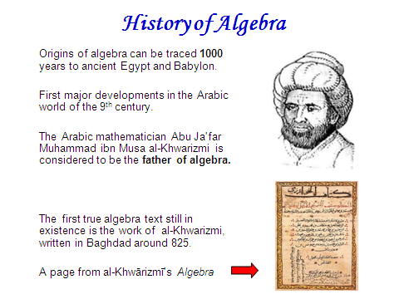



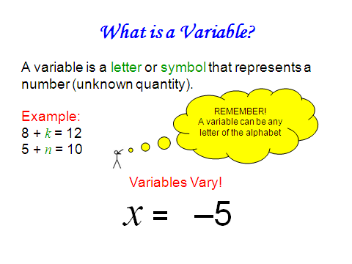

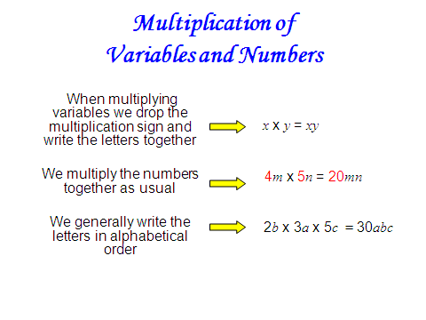

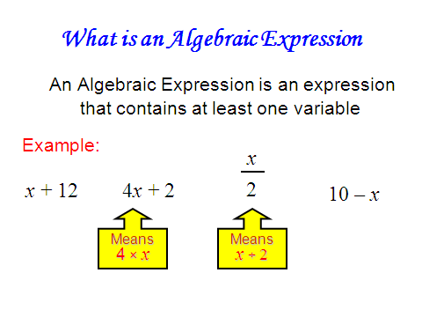

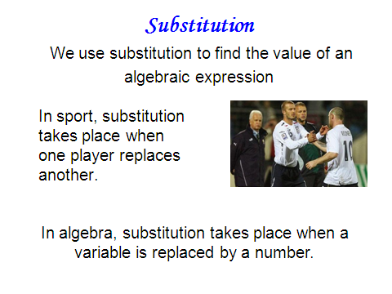

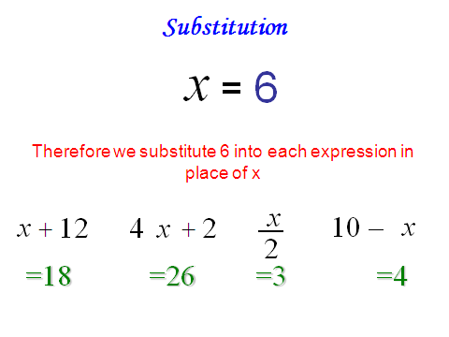

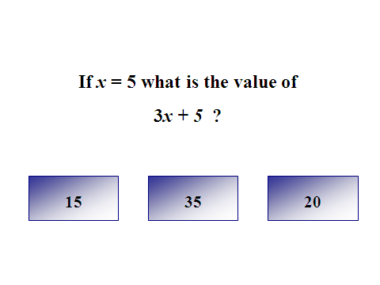

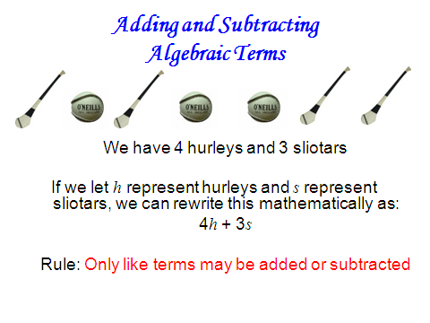

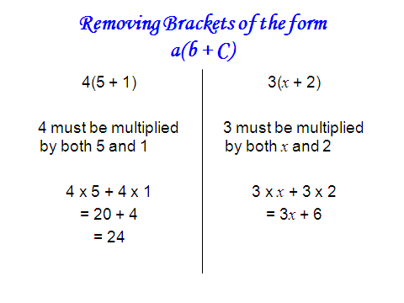

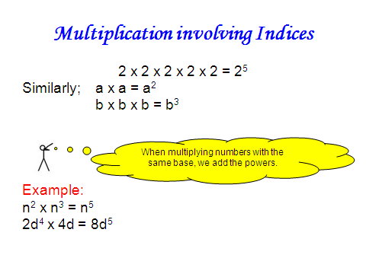

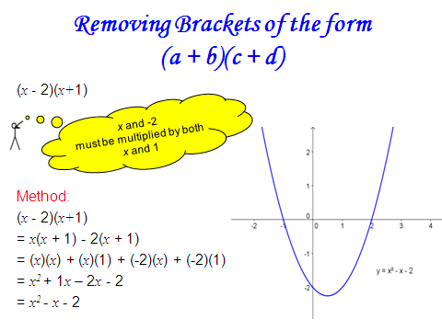



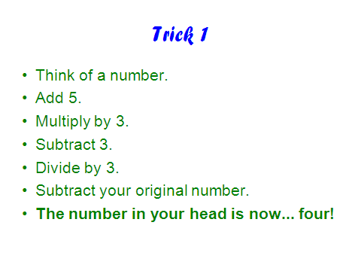

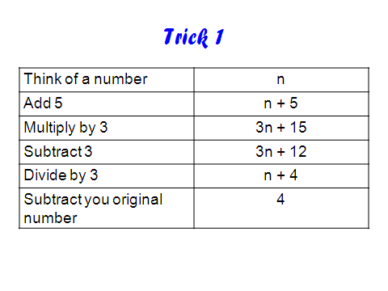

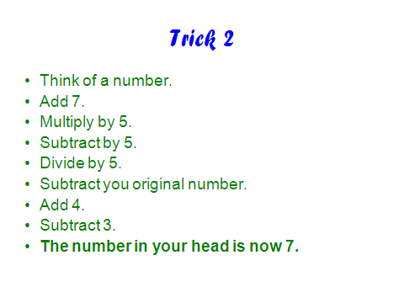

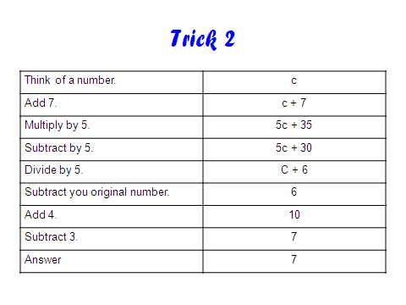

Math Magic!



Create your own magic by filling in each algebraic expression based on the directions provided

Directions | Algebraic Expression
Think of a number. | x
Add 12. | x + 12
Multiply by 3.
Subtract 3.
Divide by 3.
Subtract your original number.
Answer

Directions | Algebraic Expression
Think of a number.
Add 4.
Multiply by 3.
Subtract 3.
Divide by 3.
Subtract your original number.
Add 4.
Subtract 3.
Answer

________________________________________

Appendix H: Teaching Materials for Lesson 2 Phase 1

________________________________________

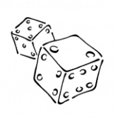

Round | Expression | Throw value | Evaluated Expression
1 | 3x
2 | 2x + 4
3 | 8 + x
4 | 6x + 9
5 | 4x + 10
6 | 6x – 2x
7 | 4x²
8 | 2x³ + x
9 | 3(x + 5)
10 | 2(x² + 4x)

What Sport is this?

a | b | c | d | e | f | g | h | i | j | k | l | M
50 | 48 | 45 | 42 | 40 | 36 | 35 | 32 | 30 | 28 | 25 | 1 | 21
n | o | p | q | r | s | t | u | v | w | x | y | Z
20 | 18 | 16 | 15 | 12 | 10 | 8 | 7 | 6 | 5 | 4 | 3 | 2

Clue 1: p + z
16 + 2 = 18 = o

Clue 2: y ÷ 3
3 ÷ 3 = 1 = l

Clue 3: e - w
40 – 5 = 35 = g

Clue 4: 3r
3(12) = 36 = f

Unscrambling gives…… golf



What Sport is this?

a | b | c | d | e | f | g | h | i | j | k | l | M
50 | 48 | 45 | 42 | 40 | 36 | 35 | 32 | 30 | 28 | 25 | 1 | 21
n | o | p | q | r | s | t | u | v | w | x | y | Z
20 | 18 | 16 | 15 | 12 | 10 | 8 | 7 | 6 | 5 | 4 | 3 | 2

- vy o ÷ v d – z n + w tx k + n

- c + y uw p ÷ x vy f – v e ÷ z

- b ÷ v r + t b – o tw a ÷ w 4z + r

- 3q i ÷ y 3r + x m – y 2n + w b ÷ x

- g ÷ w 4s + t sy + w xy m ÷ u

Extra Activity:
Think of other sports. Rewrite them using the code.
Can your classmates/ friends/ family figure out what they are?



________________________________________

Appendix I: Teaching Materials for Lesson 3 Phase 1

________________________________________



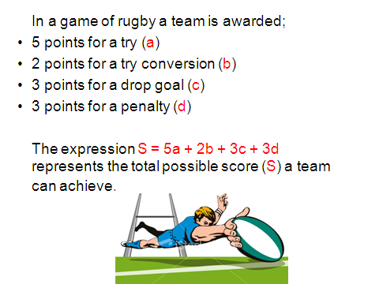

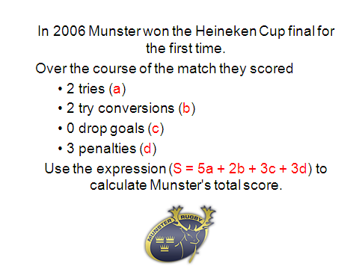

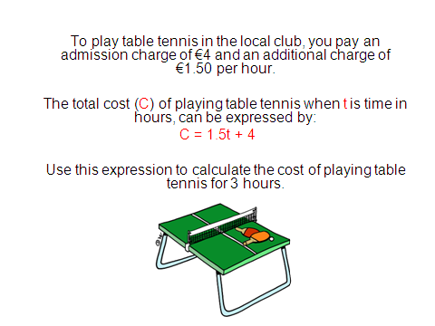

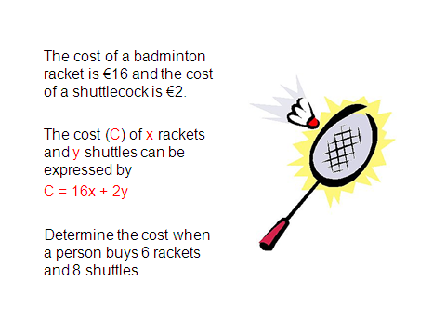

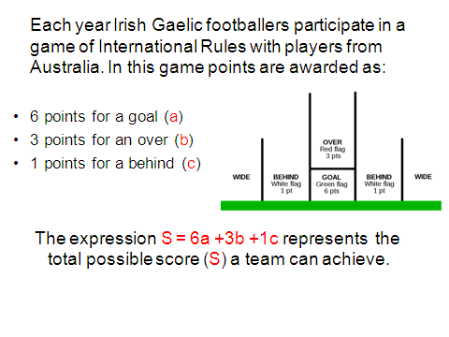

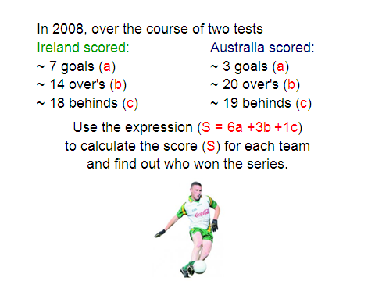

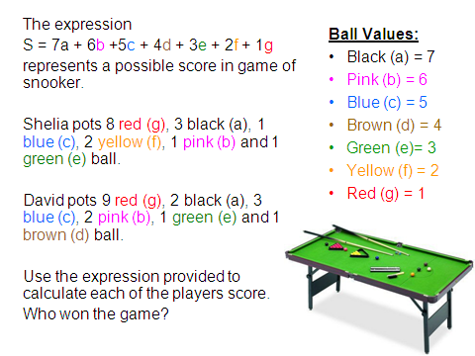

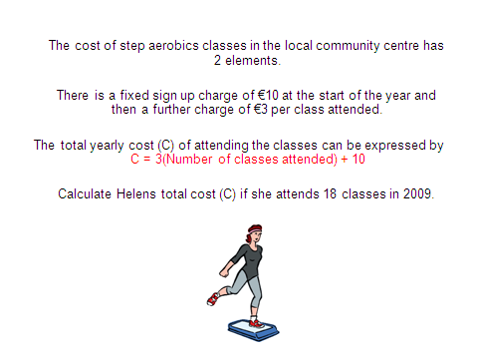
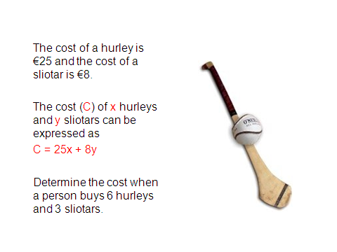

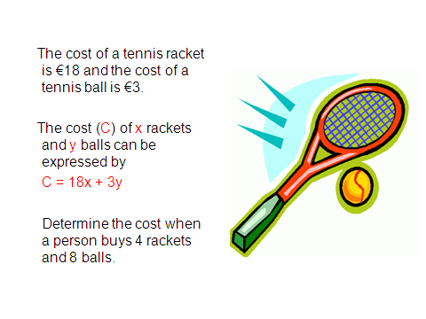

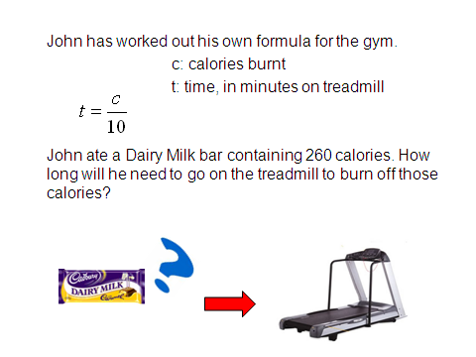
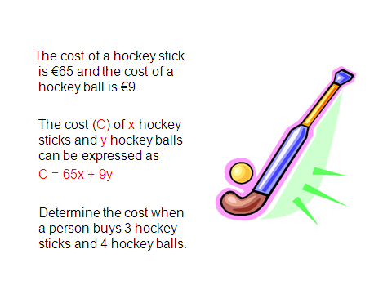

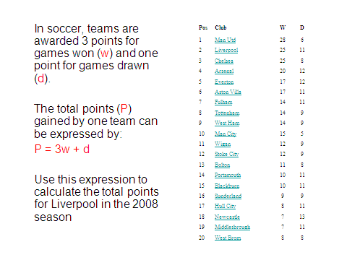

Postman Phil

Substitution Web Game

Help Phil deliver to the right houses by finding the value of the expression written on each door. Dougal the dog holds the value of ‘a’ in each case!!



Web Address:
http://www.bbc.co.uk/education/mathsfile/shockwave/games/postie.html

________________________________________

Appendix J: Teaching Materials for Lesson 4 Phase 1

________________________________________

Example of Algebra Snap Cards

Algebra
SNAP


abc

cab

bca

Algebra
SNAP

16

4²

2(8)

________________________________________

Appendix K: Teaching Materials for Lesson 1 Phase 2

________________________________________



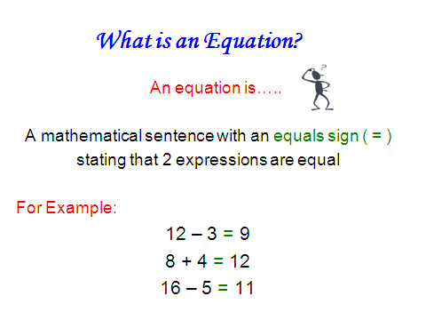

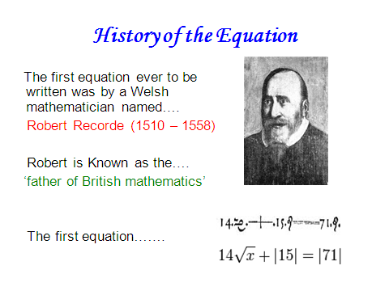

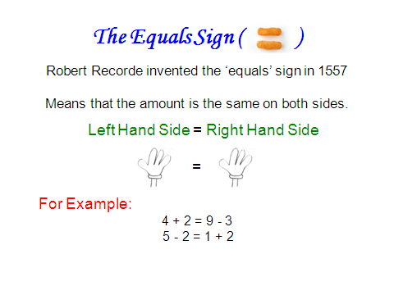

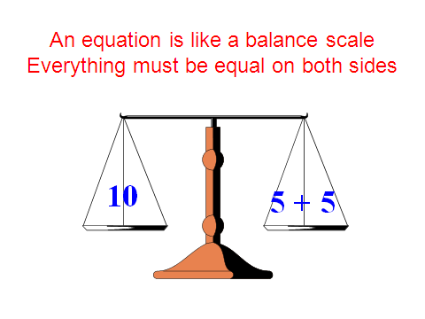

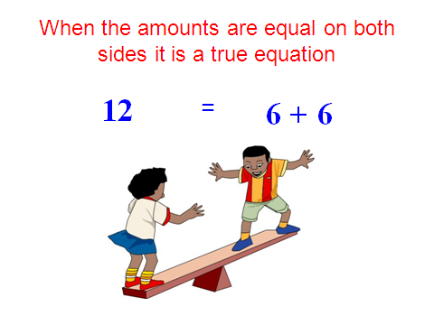
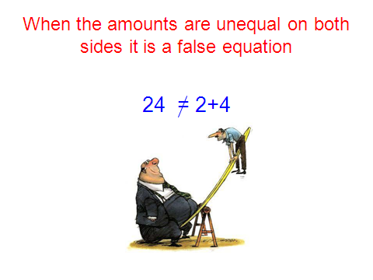

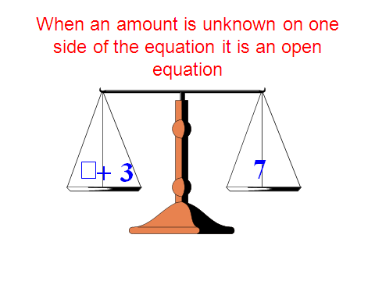

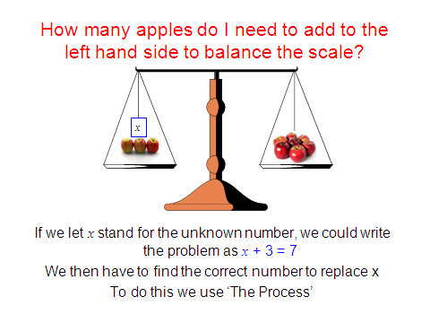
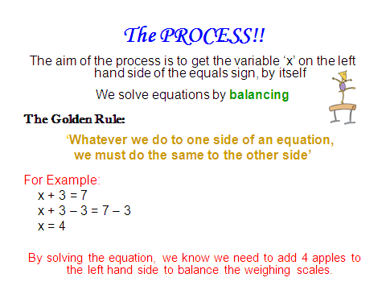

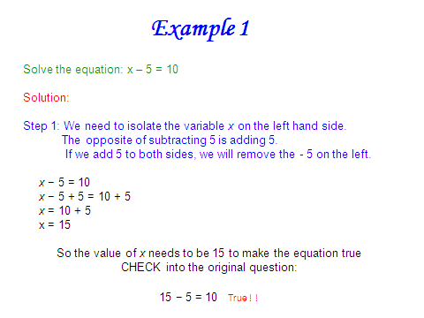

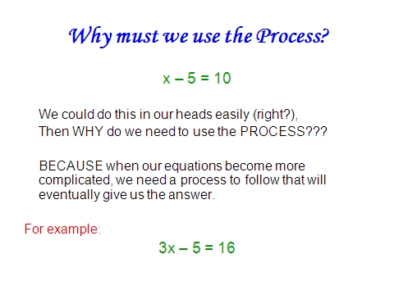
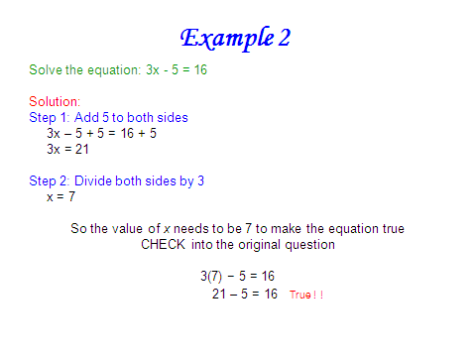

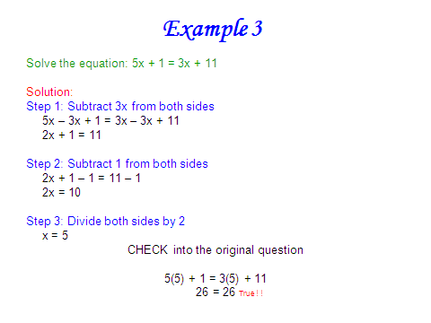

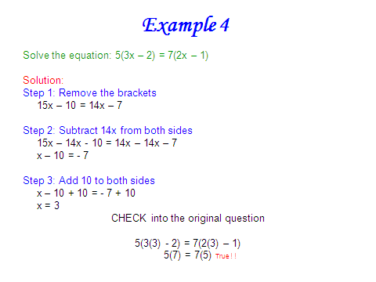
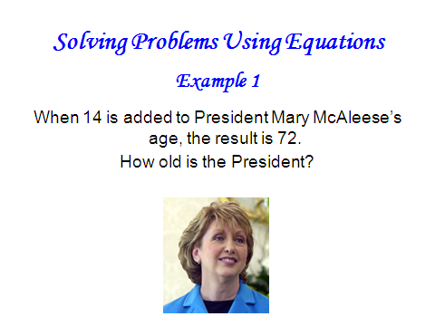

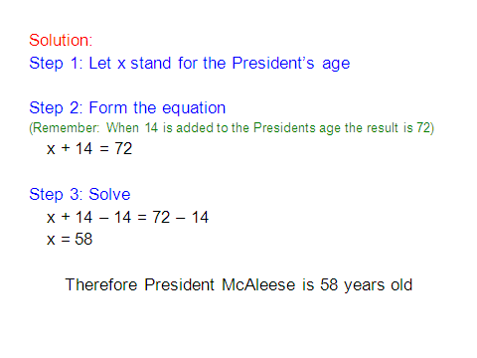

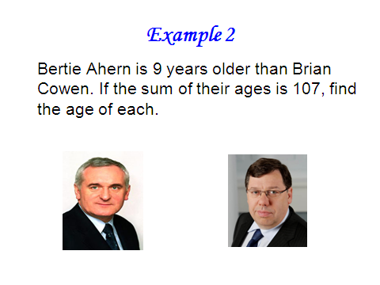
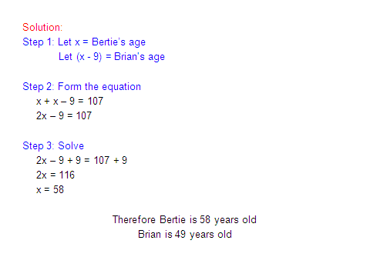

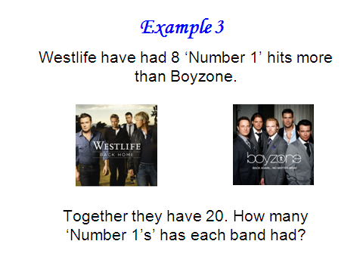

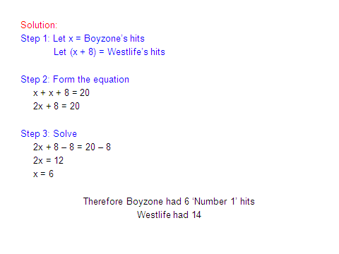

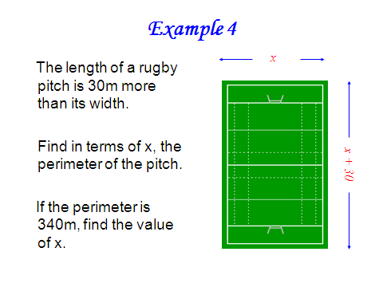

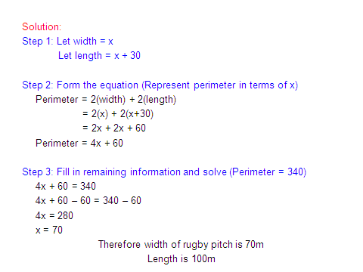

Fun Games on Internet

- Equation Match:
Help ancient mathematicians find matching pairs by working out the value of x in each equation.
www.bbc.co.uk/education/mathsfile/shockwave/games/equationmatch.html

- Balance Beam:
Solve for x, using the operations to keep the beam balanced.
http://nlvm.usu.edu/en/nav/frames_asid_201_g_4_t_2.html

- Algebra Planet Buster:
Solve linear equations and blast the planets.
www.aplusmath.com/Games/PlanetBlast/index.html

- Escape from Planet X
Choose the equation that matches the words, and build a space ship to escape from Planet X.
www.harcourtschool.com/activity/escape_planet_6/

________________________________________

Appendix L: Teaching Materials for Lesson 2 Phase 2

________________________________________

Game 1


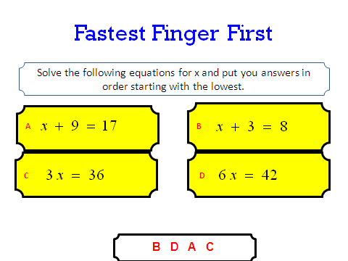
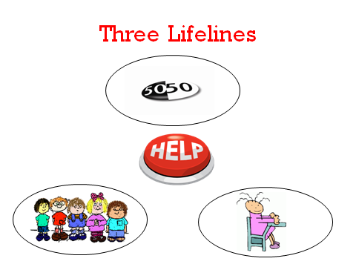
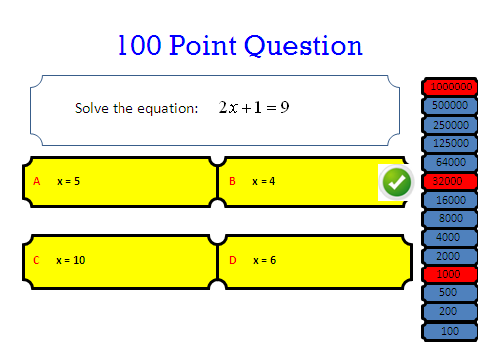

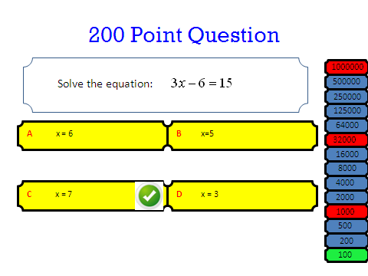

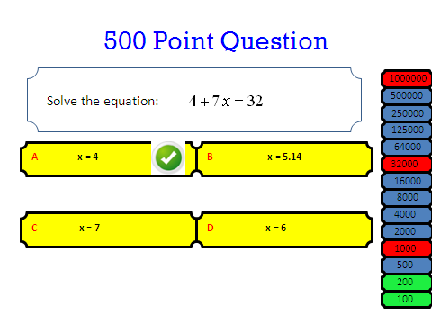
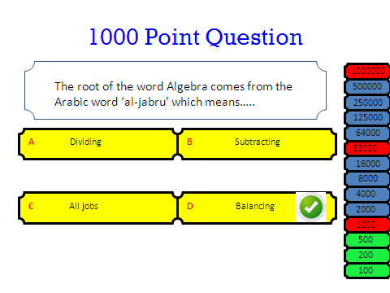

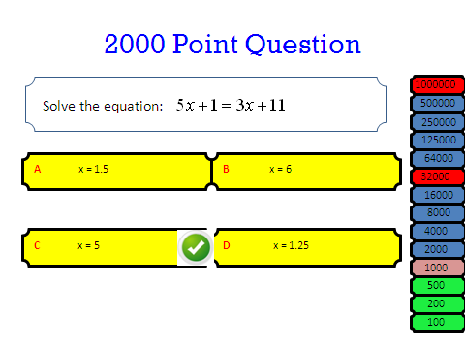

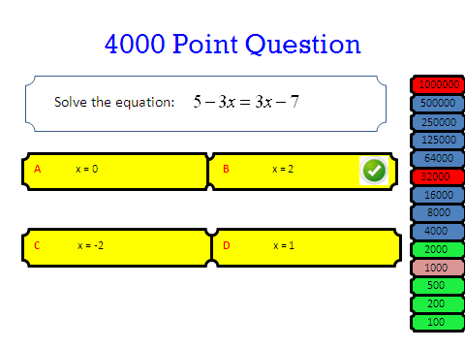
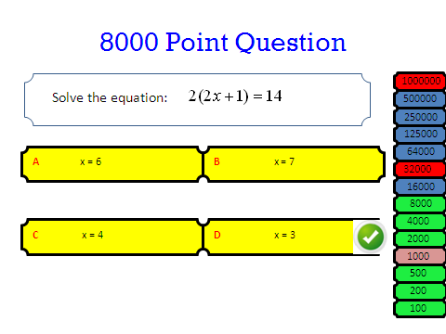

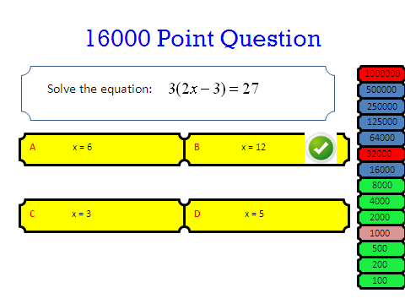

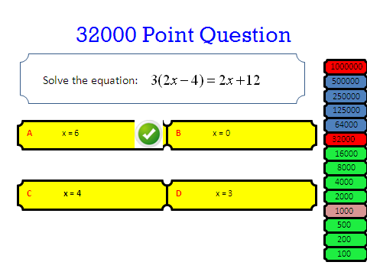
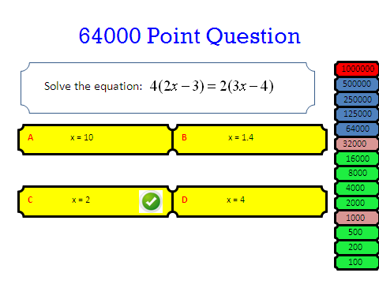

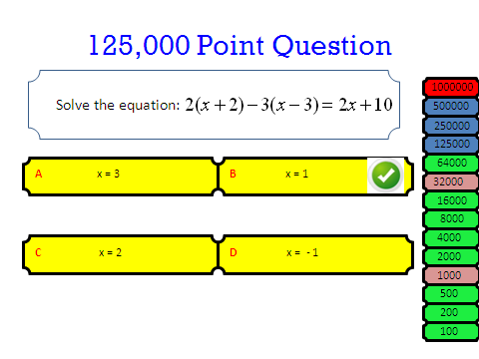

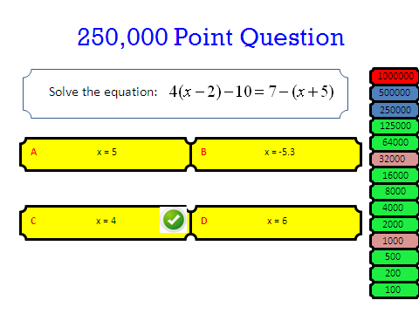
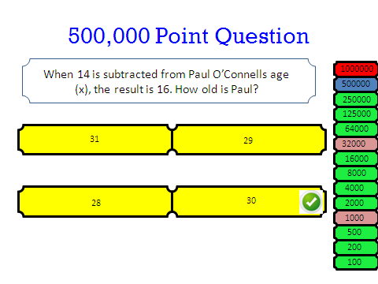

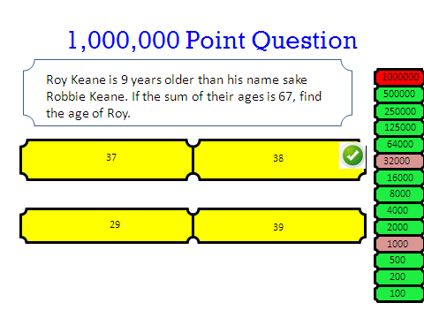

Game 2

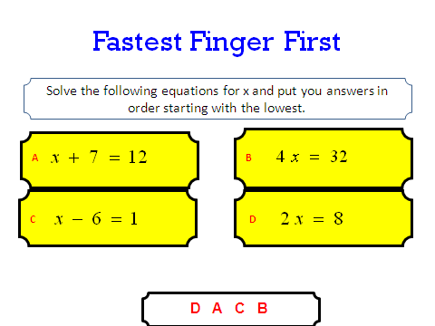

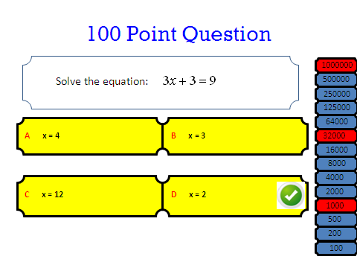

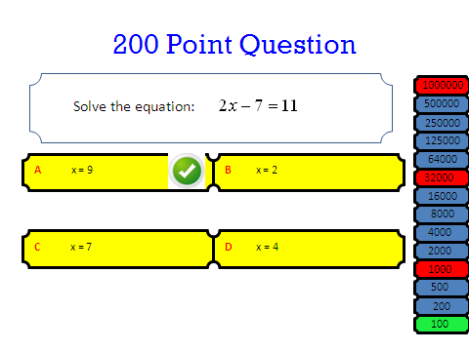

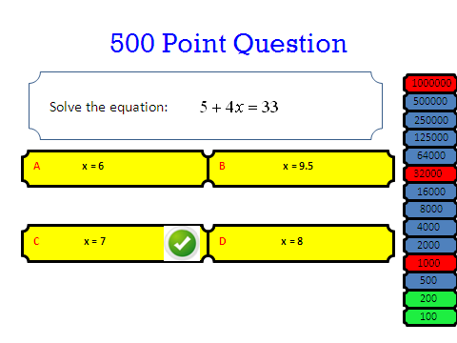

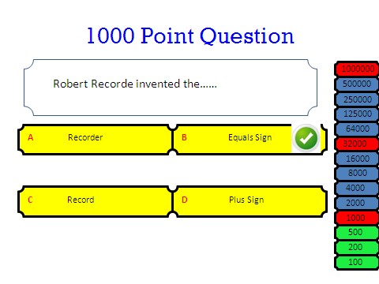

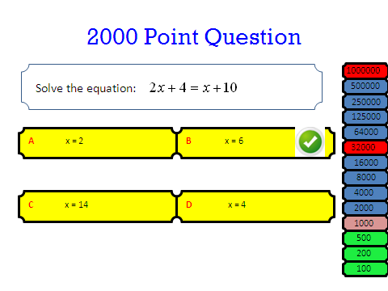

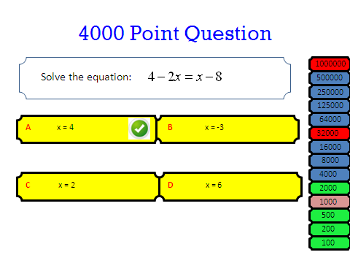
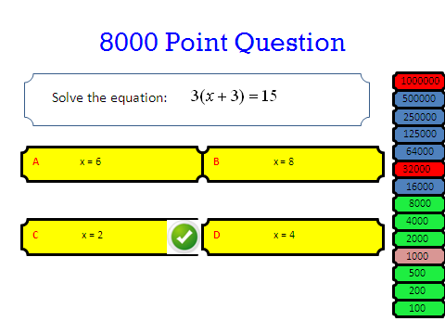

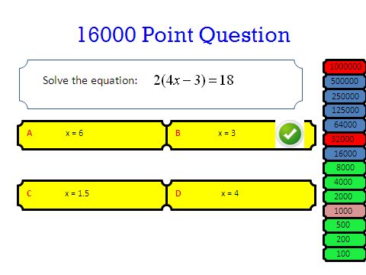

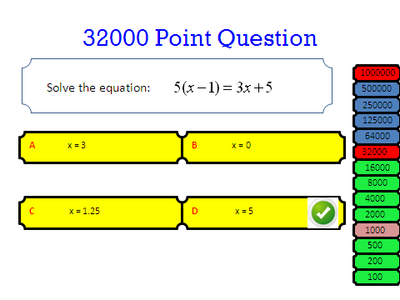

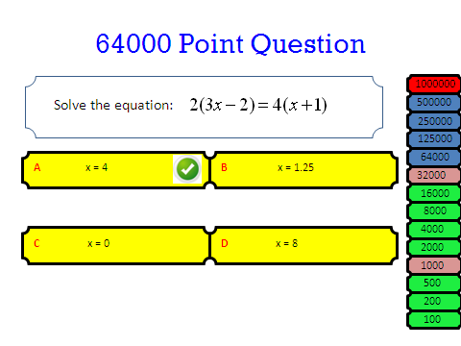

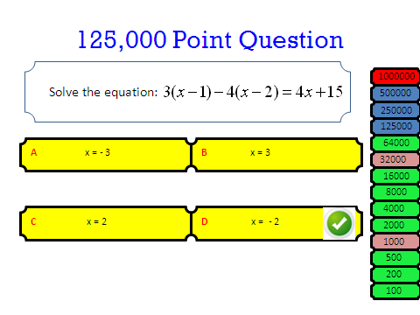

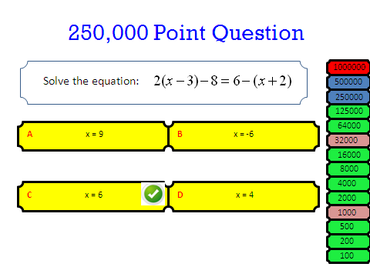

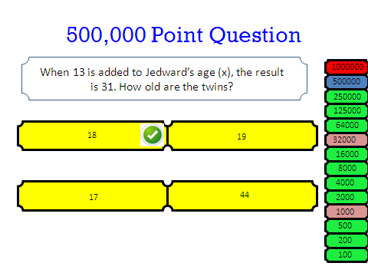

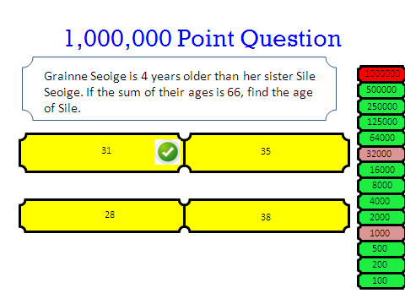

Equations Revision Worksheet

________________________________________

Appendix M: Teaching Materials for Lesson 3 Phase 2

________________________________________

Solve for x;

Solve for x;

Solve for x;

Solve for x;

Solve for x;

Solve for x;

Solve for x;

Solve for x;

Solve for x;

Solve for x;

Example of Team Control Card - Team A

Station | Answers of Equations a, b and c |  |  | Average/  Next Station
4 | a) | b) | c)
 | a) | b) | c)
 | a) | b) | c)
 | a) | b) | c)
 | a) | b) | c)
 | a) | b) | c)
 | a) | b) | c)
 | a) | b) | c)
 | a) | b) | c)
 | a) | b) | c)

Control Card

A | 4 | 9 | 10 | 6 | 2 | 7 | 3 | 8 | 5 | 1
B | 8 | 5 | 1 | 4 | 9 | 10 | 6 | 2 | 7 | 3
C | 10 | 6 | 2 | 7 | 3 | 8 | 5 | 1 | 4 | 9
D | 7 | 3 | 8 | 5 | 1 | 4 | 9 | 10 | 6 | 2
E | 1 | 4 | 9 | 10 | 6 | 2 | 7 | 3 | 8 | 5
F | 3 | 8 | 5 | 1 | 4 | 9 | 10 | 6 | 2 | 7
G | 9 | 10 | 6 | 2 | 7 | 3 | 8 | 5 | 1 | 4
H | 5 | 1 | 4 | 9 | 10 | 6 | 2 | 7 | 3 | 8
I | 2 | 7 | 3 | 8 | 5 | 1 | 4 | 9 | 10 | 6
J | 6 | 2 | 7 | 3 | 8 | 5 | 1 | 4 | 9 | 10

________________________________________

Appendix N: Teaching Materials for Lesson 4 Phase 2

________________________________________



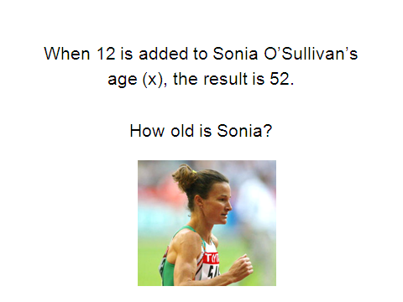

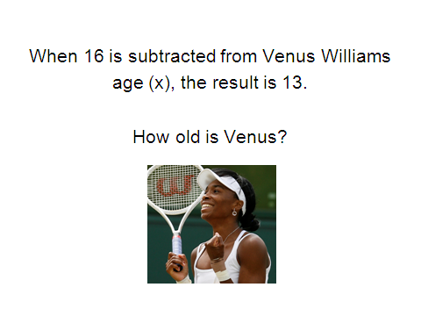

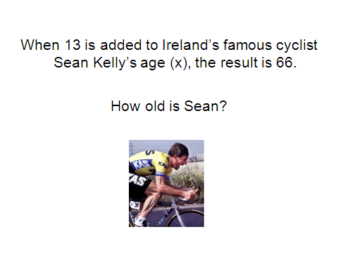

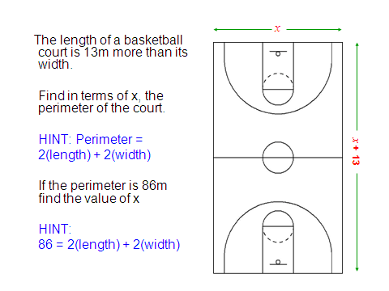

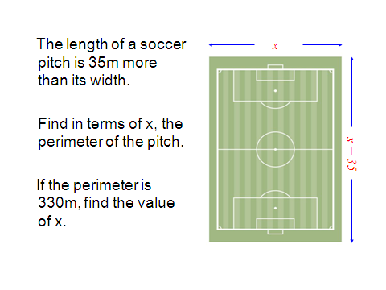

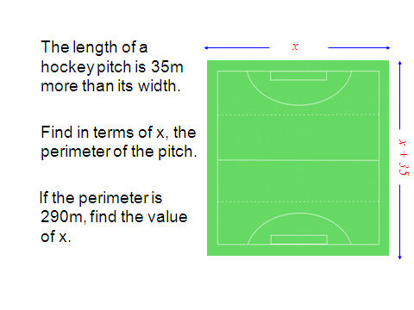

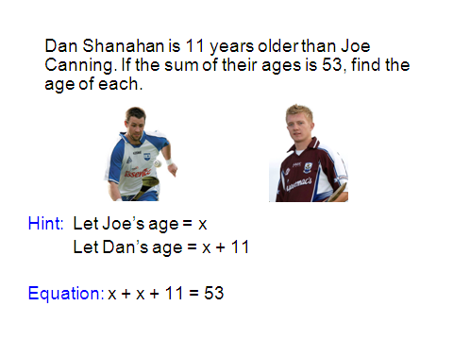

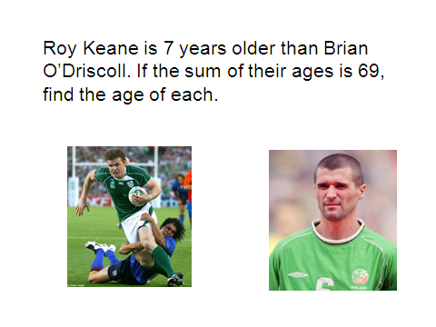

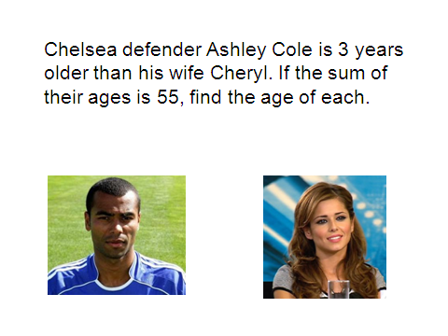

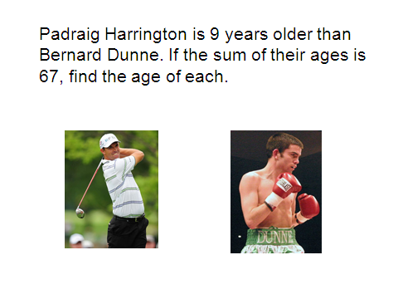

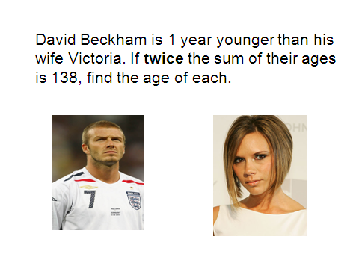

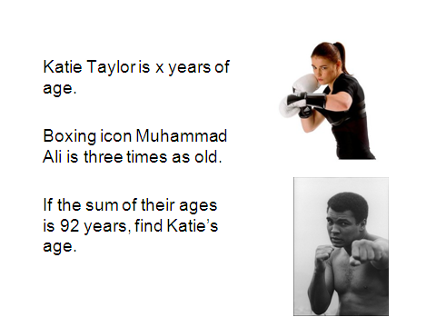



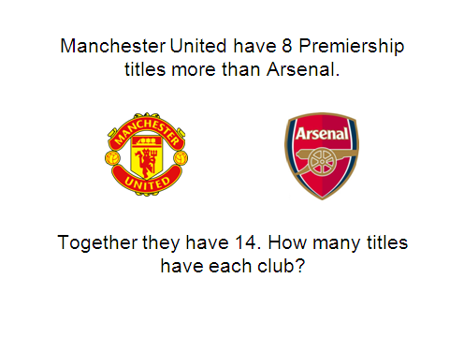

________________________________________

Appendix O: CD of ‘Teacher Guidelines’ Handbook

________________________________________

CD at back of Thesis

________________________________________

Appendix P: Correlation of Aiken’s Enjoyment Scale

________________________________________

Correlation of Aiken’s Enjoyment Scale

Item
 |  | Enjoy-a | Enjoy-b | Enjoy-c | Enjoy-d | Enjoy-e
1. | I enjoy going beyond the assigned work and trying to solve new problems in mathematics. | .604 | .601 | .737 | .743 | .659
2. | Mathematics is enjoyable and stimulating to me. | .761 | .828 | .866 | .858 | .786
3. | Mathematics makes me feel uneasy and confused. | .628 | .614 | .706 | .666 | .749
4. | I am interested and willing to use mathematics outside school and on the job. | .597 | .711 | .719 | .729 | .693
5. | I have never liked mathematics, and it is my most dreaded subject. | .757 | .788 | .816 | .812 | .793
6. | I have always enjoyed studying mathematics in school. | .748 | .821 | .780 | .802 | .830
7. | I would like to develop my mathematical skills and study this subject more. | .566 | .717 | .723 | .766 | .778
8. | Mathematics makes me feel uncomfortable and nervous. | .639 | .658 | .731 | .689 | .728
9 | I am interested and willing to acquire further knowledge of mathematics. | .660 | .725 | .757 | .804 | .649
10. | Mathematics is dull and boring because it leaves no room for personal opinion. | .714 | .757 | .772 | .770 | .771
11. | Mathematics is very interesting, and I have usually enjoyed classes in the subject. | .829 | .841 | .872 | .864 | .824

________________________________________

Appendix Q: List of Papers

________________________________________

List of Papers

Prendergast, M. and O’Donoghue, J. (2010) ‘A Framework for Teaching Algebra to Develop and Maintain Interest’ - Paper presented at London International Conference on Education (LICE), London, September 2010, 6th – 8^{th.}

Prendergast, M. and O’Donoghue, J. (2010) ‘Enhancing Student Interest in Algebra’ - Paper presented at British Educational Research Association (BERA) (Main Conference), University of Warwick, September, 1st – 3rd.

Prendergast, M. and O’Donoghue, J. (2009) ‘Continuous Professional Development in Mathematics Education: Considerations for the Irish Context’ - Paper presented at Mathematics Education Ireland (MEI) 3rd Conference, St. Patrick’s College Dublin, September, 24th – 25th.

Prendergast, M. and O’Donoghue, J. (2009) ‘An Investigation into the Nature of Effective Classroom Teaching in Mathematics with Special Reference to Junior Cycle’ - Paper presented at British Educational Research Association (BERA) (Student Conference), University of Manchester, September, 2nd – 5th.

________________________________________

Bibliography

Bibliography
Adu, E.O. and Olatundun S.O. (2007) ‘Teachers’ Perception of Teaching as Correlates of Students’ Academic Performance in Oyo State, Nigeria’, Essays in Education, 20, 57 [online], available: http://www.usca.edu/essays/vol202007/adu.pdf [accessed February 2008].

Advisory Committee on Mathematics Education (ACME) (2002) Continuing Professional Development for Teachers of Mathematics [online], available: http://www.acme-uk.org/downloaddoc.asp?id=41 [accessed May 2008].

Aghadiuno, M.C.K. (1992) ‘Mathematics: history, philosophy and applications to science’, International Journal of Mathematics Education and Science Technology, 23 (5), 683 – 690.

Aiken, L.R. (1974) ‘Two scale of attitude toward mathematics’, Journal for Research in Mathematics Education, 5, 67-71.

Alexander, P.A. (1997) The Path to Competence: A Lifespan Developmental Perspective on Reading [online], available: www.nrconline.org/publications/ThePathToCompetence.doc [accessed December 2008].

Algebra Planet Buster – Web Game [online], available: http://www.aplusmath.com/games/PlanetBlast/index.html [accessed July 2009].

Anthony, G. (1966) ‘Active Learning in a Constructive framework’, Educational Studies in Mathematics: An Educational Journal, London: Kluwer Academic Publishers, 31 (4) 349 – 369.

Armstrong, J. and Price, R.A. (1982) ‘Correlates and predictors of women’s mathematics participation’, Journal for Research in Mathematics Education, 13, 99 – 109.

Arnold, F. (1906) ‘The Psychology of Interest’, Psychological Review XII, 221-238, 291-315.

Artique, M. and Assude, T. (2000) ‘Teaching and Learning Algebra: Approaching Complexity through Complimentary Perspectives’ [online], available: http://pepite.univ-lemans.fr/English/4-txtBG-MA_icm2001.pdf [accessed December 2008].

Askey, R. (1999) ‘Good intentions are not enough’ [online], available: http://www.math.wisc.edu/~askey/ask-gian.pdf [accessed March 2008].

Backhouse, J., Haggarty, L., Pirie, S. and Stratton, J. (1992) ‘Improving the Learning of Mathematics’, London: Cassell.

Balance Beam – Web Game [online], available: http://nlvm.usu.edu/en/nav/frames_asid_201_g_4_t_2.html [accessed August 2009].

Ball, D.L. (2001) ‘Developing a mathematically proficient public: What are the problems, what do we know about them, and what would it take to solve them?’, accepted for Aspen Institute congressional conference on ‘Promoting Excellence in the New Economy: The Challenges to National Policy’, St, Petersburg, Florida, February 16 – 19, 2001.

Bandura, A. (1977) Social Learning Theory, New York: General Learning Press.

Bandura, A. (1997) Self-efficacy: The exercise of control, New York: W.H. Freeman.

Barker, B. (1997) ‘Girls world or anxious times: What’s really happening at school in the gender war?’, Educational Review, 49, 221 – 227.

Bartlett, F. C. (1932) Remembering: A study in experimental and social psychology, Cambridge: Cambridge University Press.

Baya’a, N.F. (1990) ‘Mathematics anxiety, mathematics achievement, gender, and socio economic status among Arab secondary students in Israel’, International Journal of Mathematics Education and Science Technology, 21 (2), 319 – 324.

Beaton, A.E., Mullis, V.S., Martin, M.O., Gonzalez, E.J., Kelly, D.L. and Smith, T.A. (1996) Mathematics Achievement in the Middle School Years: IEA’s Third International Mathematics and Science Study, Boston: TIMSS International Study Centre.

Bednarz, N, Kieran, C. and Lee, L. (1996) Approaches to Algebra – Perspectives for Research and Teaching, London: Kluwer Academic Publishers.

Belcastro, F.P. (1988) ‘Teaching alternative mathematical procedures’, International Journal of Mathematics Education and Science Technology, 19 (1), 165 – 168.

Belenkly, M. F., Clinchy, B. M., Goldberger, N. R., & Tarule, J. M. (1986) Women’s ways of knowing: The development of self, voice, and mind, New York: Basic Books.

Benn, R. (1997) Adults Count Too: Mathematics for Empowerment, NIACE, Great Britain.

Berger, E. (1991) Parents as partners in education: The school and home working together, New York: Macmillan.

Bergin, D.A. (1999) ‘Influence of classroom interest’ Educational Psychologist, 34, 87–98.

Berry, J. and Nyman, M.A. (2002) ‘Small - group assessment methods in mathematics’, International Journal of Mathematics Education, Science and Technology, 33 (5), 641 – 649.

Bigge, M.L. (1982) Learning Theories for Teachers (4th Edition), New York: Harper and Row.

Biggs, E.E. (1969) Freedom to Learn: An Active Learning Approach to Mathematics, Don Mills, Ontario: Addison – Wesley.

Biggs, J., & Moore, P. (1993) The process of learning, Sydney: Prentice Hall.

Birkenholz, R. J. (1999) Effective adult learning, Danville, IL: Interstate Publishers, Inc.

Boaler, J. (1997) Experiencing School Mathematics: Teaching styles, sex and setting, Buckingham: Open University Press.

Boaler, J. (2000) Multiple Perspectives on Mathematics Teaching and Learning: International Perspectives on Mathematics Education, Greenwood Publishing Group.

Boekaerts, M. and Boscolo, P. (2002) ‘Interest in Learning, Learning to be Interested’, Learning and Instruction, 12, 375–382.

Borko, H. (2004) ‘Professional Development and Teacher Learning: Mapping the Terrain’, Educational Researcher [online], 33 (8), 3 – 15, available: http://www.aera.net/uploadedFiles/Journals_and_Publications/Journals/Educational_Researcher/Volume_33_No_8/02_ERv33n8_Borko.pdf [accessed May 2008].

Bracey, G (1992) ‘If you ask me—Cut out Algebra! Mostly it's a useless, impractical exercise’, Washington Post (1992, June 12), 5, Section C.

Brown, J.C. (1915) ‘Curricula in Mathematics’, U.S. Bureau of Education, Bulletin, 1914, No. 45, Washington, D.C.

Brown, P. C. (1989) Involving parents in the education of their children, ERIC Digest.

Brown, C.A., & Borko, H. (1992) ‘Becoming a Mathematics Teacher in Impact’, in D.A Grouws (eds.) Handbook of Research on Mathematics Teaching and Learning, New York: Macmillan Publishing Company, 209 - 239.

Brown, E.T., Karp, K., Petrosko, J.M., Jones, J., Beswick, G., Howe, C. and Zwanzig, K. (2006) ‘Crunch of Catalyst: Teacher’s Beliefs and Practices regarding Calculator Use in Mathematics Instruction’, Science School and Mathematics, 107 (3).

Brumbaugh, D.K., Ashe, D.E., Ashe, J.L. and Rock, D. (1997) Teaching Secondary Mathematics, New Jersey: Lawrence Erlbaum Associates.

Bruner, J. (1960) The Process of Education, Cambridge, Mass.: Harvard University Press.

Bruner, J.S. (1975) Toward a Theory of Instruction, London: Harvard University Press.

Bryman, A. (1988) Doing Research in Organisations, London: Routledge.

Burton, L. (1990) Gender and Mathematics; An International Perspective, Cassell Educational Limited, Norwich.

Buttery, T. J., & Anderson, P. J. (1999) ‘Community, school and parent dynamics: A synthesis of literature and activities’, Teacher Education Quarterly, 111-112.

Carpenter, T., Lindquist, M., Matthews, W., and Silver, E. (1983) ‘Results of the third NAEP mathematics assessment: Secondary school’, Mathematics Teacher, 76(9), 652-659.

Carson, B.H. (1996) Quotations on Teaching, Learning and Education [online], available: http://www.ntlf.com/html/lib/quotes.htm [accessed August 2008].

Chacko, I (1989) ‘The relationship between selected teachers’ verbal behaviour and students’ achievement’, International Journal of Mathematics Education and Science Technology, 20 (1), 63 – 71.

Chazan, D. (1996) ‘Algebra for All Students’, Journal of Mathematical Behaviour, 15, 455-477.

Chief Examiners Report (1999; 2003; 2006) Junior Cert Examinations – Mathematics [online], available: http://www.examinations.ie/index.php?l=en&mc=en&sc=cr [accessed January 2010].

Choike, J.R. (2000) ‘Teaching Strategies for Algebra for All’, 93 (7), 556 – 560.

Clark, D. (1993). Teacher evaluation: A review of the literature with implications for educators, unpublished Seminar Paper, California State University at Long Beach.

Clarke, D. (1996) ‘Assessment’, in A.J. Bishop et al. (eds.) International Handbook of Mathematics Education (Part 2), Holland: Kluwer Academic Publications, 327 – 370.

Close, S., and Oldham, E. (2005) ‘Junior Cycle Second level mathematics examinations and the PISA mathematics framework’, in Close, S., Dooley, T. and Corcoran, D. (eds.), Proceedings of the First National Conference on Research in Mathematics Education, Dublin: St. Patrick’s College, 174 – 192.

Cobb, P., Wood, T., Yackel, E. and McNeal, B. (1992) ‘Characteristics of Classroom Mathematics Traditions: An Interactional Analysis’, American Educational Research Journal, 29 (3), 573 – 604.

Coben, D. (2003) Adult numeracy: review of research and related literature, London: National Research and Development Centre (NDRC).

Cockcroft, W.H. (1982) Mathematics Counts: Report of the Committee of Inquiry into the Teaching of Mathematics in Schools, London: HMSO.

Cohen, P.A., Manion, L. and Morrison, K. (2000) Research Methods in Education (5th Edition), London: Routledge and Falmer.

Conner, M.L. (2007) Learning from Experience- Ageless learner [online], available: http://agelesslearner.com/intros/experiential.html [accessed December 2007].

Coxford, A.F. and Shulte, A.P. (1988) ‘The Ideas of Algebra’, United States: The National Council of Teachers of Mathematics (NCTM).

Creswell, J.W. (2003) Research design: Qualitative, Quantitative, and Mixed methods approaches (2nd Edition), Thousand Oaks, CA: Sage.

Creswell, J.W. (2009) Research design: Qualitative, Quantitative, and Mixed methods approaches (3rd Edition), Thousand Oaks, CA: Sage.

Csikszentmihalyi, M. (1990) ‘Literacy and intrinsic motivation’, Daedalus, 119, 115 - 140.

Cuoco, A. (2003) ‘Teaching Mathematics in the United States’, Notices of the AMS, 50 (7), 777 – 787.

Darling Hammond, L. (2006) ‘Assessing Teacher Education: The Usefulness of Multiple Measures for Assessing Program Outcomes’, Journal of Teacher Education, 57(2), 120 -138.

Davey, B. (1991) ‘Evaluating teacher competence through the use of performance assessment task: An overview’, Journal of Personnel Evaluation in Education, 5 (1), 121-132.

Day, C. (1999) Developing teachers: the challenges of lifelong learning, London: Falmer Press.

Dean, J. (1991) Professional Development in School – Developing Teachers and Teaching, Philadelphia: Open University Press.

Dean, P.G. (1982) Teaching and learning mathematics, London: The Woburn Press.

Del Favero, L., Boscolo, P., Vidotto, G. and Vicentini, M. (2007) ‘Classroom discussion and individual problem-solving in the teaching of history: Do different instructional approaches affect interest in different ways?’, Learning and Instruction, 17, 635 – 657.

Denzin, N. K., & Lincoln, Y. S. (1994) ‘Introduction: Entering the field of qualitative research’, in N. K. Denzin and Y. S. Lincoln (eds.), Handbook of qualitative research, Thousand Oaks, CA: Sage, (1-17).

Denzin, N.K. and Lincoln, Y.S. (1998) Collecting and Interpreting Qualitative Materials¸ USA: Sage Publications.

Devlin, K. (1997) Mathematics: The Science of Patterns, New York: Henry Holt and Company.

Dewey, J. (1913) Interest and effort in education, New York: Houghton-Mifflin.

Dossey, J. (1992) ‘The nature of mathematics: Its role and influence’, in D.A. Grouws (eds.), Handbook of Research on Mathematics Teaching and Learning, New York: Macmillan.

Dowling, P. (1996) ‘A sociological analysis of school mathematics textbooks’, Educational Studies in Mathematics, 31, 389 - 415.

Drew, P.Y. and Watkins, D. (1998) ‘Affective Variables, Learning Approaches and Academic Achievement: A Casual Modelling Investigation with Hong Kong Territory Students’, British Journal of Educational Psychology, 68 (2), 173 – 188.

Dryfoos, J.G. (1990) Adolescents at Risk, New York: Oxford University Press.

Duffy, D. and O’Donoghue, J. (1992) ‘Use of the compiler as a mathematics teaching resource’, International Journal of Mathematics Education and Science Technology, 23 (5), 637 – 650.

Dweck, C.S. and Bush, E.S. (1976) ‘Sex Differences in Learned Helplessness I’, Developmental Psychology, 12, 2, 147 – 156.

ED.Gov – U.S, Department of Education- No Child Left Behind Act (2001) [online], available: http://www.ed.gov/policy/elsec/guid/states/index.html#aa [accessed March 2008].

Education Ireland [online], available: www.educationireland.ie [accessed August 2010].

Einstein, A., HeartQuotes [online], available: http://www.heartquotes.net/Einstein.html [accessed March 2009].

Eisenberg, T.A. (1975) ‘Behaviourism: The bane of school mathematics’, International Journal of Mathematics Education and Science Technology, 6 (2), 163 - 171.

Elliott, S.N. (1988) ‘Acceptability of Behavioural Treatments: Review of Variables that Influence Treatment Selection’, Professional Psychology: Research and Practice, 19 (1), 68 – 80.

Elwood, J., and Carlisle, K. (2003) ‘Examining gender’, Gender and achievement in the Junior and Leaving Certificate Examinations 2000/2001, Dublin: National Council for Curriculum and Assessment.

Emenalo, S.I., (1994) ‘Evolving mathematics culture through effective teaching – the Nigerian experience’, International Journal of Mathematics Education and Science Technology, 25 (3), 363 -366.

Equation Match – Web Game [online], available: http://www.bbc.co.uk/education/mathsfile/shockwave/games/equationmatch.html [accessed July 2009].

Ernest, P. (1995) ‘Values, gender and images of mathematics; a philosophical perspective’, International Journal of Mathematics Education and Science Technology, 26 (3), 449 – 462.

Ernest, P. (2004) ‘What is the Philosophy of Mathematics Education’, Philosophy of Mathematics Education Journal, 18.

Escape from Planet X – Web Game [online], available: http://www.harcourtschool.com/activity/escape_planet_6/ [accessed August 2009].

Estes, T. H. (1971) ‘A scale to measure attitude toward reading’, Journal of Reading, 135-138.

Eurydice (2005), National summary sheets on education systems in Europe and on-going reforms, [online], available: http://www.eurydice.org/ressources/eurydice/pdf/047DN/047_IE_EN.pdf [accessed April 2008].

Expert Group on Future Skills Needs (EGFSN, 2008) Statement on Raising National Mathematical Achievement, Dublin: EGFSN.

Fennema, E. (1985) ‘Explaining Sex Related Differences in Mathematics: Theoretical Models’, Educational Studies in Mathematics, 16, 303 – 320.

Fincher, C. (1994) ‘Learning Theory and Research’, in edited by Feldman, K.A and Paulson, M. (eds.) Teaching and Learning in the College Classroom, Ashe Reader Series, Needham, MA: Ginn Press [online], available: http://www.ntlf.com/html/lib/quotes.htm [accessed January 2008].

Finucane, P. (2004) Continuing Professional Development: The Experiences and Perceptions of a Sample of Irish Post Primary Teachers, unpublished thesis, (M.A.), University of Limerick.

Foddy, W.H. (1993) Constructing questions for Interviews and Questionnaires: Theory and Practice in Social Research, Cambridge: Cambridge University Press.

Fox, R. (2005) Teaching and Learning – Lessons for Psychology, United Kingdom: Blackwell Publishing.

Fredrickson, B.L. and Branigan, C. (2000) ‘Positive emotions’, in: T.J. Mayne and G.A. Bonanno (eds.) Emotions, New York: Guilford, 123–151.

Georgewill, J.W. (1990) ‘Causes of poor achievement in West African school certificate mathematics examinations in Rivers State secondary schools, Nigeria’, International Journal of Mathematics Education and Science Technology, 21 (3), 379 – 385.

Gill, O. and O’Donogue, J. (2006) ‘Exploring mathematics under-preparedness at third-level in Ireland’, in Moore, S., Carr, P., Crehan, M., Crowley, J., Flynn, D., Morgan, P. and Shannon, P. (eds.) Keeping Students at University- The Retention Debate at Third Level, Dublin: Intersource Group Publishing, 153 – 168.

Glasser, W. (b. 1925) Thinkexis.com [online], available: http://thinkexist.com/quotes/william_glasser/ [accessed June 2008].

Glover, D. and Law, S. (2002) Improving Learning – Professional Practice in Secondary Schools, Buckingham, Philadelphia: Open University Press.
Good, T. L. and Brophy, J. E. (1990) Educational psychology: A realistic approach (4th Edition), White Plains, New York: Longman.
Gottfredson, L.S. (1981) ‘Circumscription and compromise: A developmental theory of occupational aspirations’, Journal of Counselling Psychology, Monograph. Nr. 28(6), 545-579.

Gourneau, B. (2005) Five Attitudes of Effective Teachers: Implications for Teacher Training [online], available: http://www.usca.edu/essays/vol132005/gourneau.pdf [accessed April 2008].

Greenwood, J. (1993) ‘On the Nature of Teaching and Assessing Mathematical Power and Mathematical Thinking’, Arithmetic Teacher, 144 – 152.

Griffin, G.A. (1989) ‘A descriptive study of student teaching’, Elementary School Journal, 89, 343-364.

Grouws, D.A. (1992) Handbook of Research on Mathematics Teaching and Learning, New York: Macmillan Publishing Company.

Guskey, T.R. (1986) ‘Staff Development and the Process of Teacher Change’, Educational Researcher, 15 (5), 5 – 12 [online], available: http://www.jstor.org/stable/1174780 [accessed May 2008].

Hanafin, J. (1992) Co-Education and Attainment: A Study of the Gender Effects of Mixed and Single Sex Schooling on Examination Performance, unpublished PhD Thesis: University of Limerick.

Handal, B. (2003) ‘Profiling Teachers; Constructivist and Behaviourist Oriented Mathematics’, International Online Journal of Science and Mathematics Education [online], available: www.upd.edu.ph/~ismed/online/articles/profiling/intro.htm [accessed December 2007].

Handal, B., & Herrington, A. (2003) ‘Re-examining categories of computer-based Learning in mathematics education’, Contemporary Issues in Technology and Teacher Education, 3(3), 275-287.

Hannan et al. (1983) Schooling and Sex Roles, Dublin: ERSI General Research Series, Paper No.113.

Harris, M. (1997) ‘Women and working mathematics; Ignoring a Majority?’, in Leach, F. and Little, A. (eds.) Education, Culture and Economics: Dilemmas for Development, New York: Garland.

Heath, A.F. and Clifford, P. (1990) Class Inequalities in Education in Twentieth Century [online], available: http://www.jstor.org/view/09641998/di993071/99p0066s/0 [accessed January, 2007].

Heid, K. (1995) ‘The impact of technology, mathematical modelling and meaning on the content, learning, and teaching of secondary school algebra’, Journal of Mathematical Behaviour, 14, 121 – 137.

Hembree, R. & Dessart, D. (1986) ‘Effects of Hand-Held Calculators in Pre-College Mathematics Education: A Meta-Analysis’, Journal for Research in Mathematics Education, 17(2), 83-89.

Hergenhalm, B.R. and Olson, M.H. (2001) An Introduction to Theories of Learning (6th Edition), New Jersey: Prentice Hall.

Herscovics, N. and Linchevski, L. (1994) ‘A Cognitive Gap between Arithmetic and Algebra’, Educational Studies in Mathematics, 27 (1), 59-78.

Hidi, S. (2006) ‘Interest: A unique motivational variable’, Educational Research Review, 1, 69–82.

Hidi, S., & Anderson, V. (1999) ‘Situational interest and its impact on reading and expository writing’, in Renniger, K. A., Hidi, S., and Krapp, A. (eds.) The role of interest in learning and development, Hillsdale, NJ: Erlbaum.

Hidi, S. and Baird, W. (1988) ‘Strategies for increasing text-based interest and students’ recall of expository texts’, Reading Research Quarterly, 23, 465–483.

Hidi, S., Berndorff, D., & Ainley, M. (2002) ‘Children’s argument writing, interest and self-efficacy: an intervention study’, Learning and Instruction, 12, 429 - 446.

Hidi, S and Harackiewicz, J.M. (2000) ‘Motivating the Academically Unmotivated: A Critical Issue for the 21st Century’, Review of Educational Research, 70 (2) 151-179.

Hidi, S., & Renninger, A. (2006) ‘The four-phase model of interest development’, Educational Psychologist, 41, 111–127.

Hinzman, K. P. (1997) Use of manipulatives in mathematics at the middle school level and their effects on students’ grades and attitudes [online], available http://eric.ed.gov [accessed January 2009].

Hitchcock, G. and Hughes, D. (1995) Research and the Teacher: A Qualitative Introduction to School based Research (3rd Edition), London: Routledge.

House, P. A. (1988) ‘Reshaping school algebra: Why and how?’, in Coxford, A. F. (eds.) The NCTM Yearbook: The Ideas of Algebra. Reston, VA: NCTM.

Ingersoli, R.M. (1999) ‘The problem of under qualified teachers in American secondary schools’, Educational Researcher, 28 (2).

Irwin, K. (1994) ‘On-going Development as a Teacher of Mathematics’, in J. Neyland (eds.) Mathematics Education: A Handbook for Teachers, New Zealand: The Wellington College of Education, 1, 367 – 374.

Irwin, K.C., & Britt, M.S. (1999) ‘Teachers’ Knowledge of Mathematics and Reflective Professional Development’, in Jaworski, B. et al (eds.) Mathematics Teacher Education: Critical International Perspectives, London: Falmer, 91-101.

Jones, C. (2007) ‘Quantitative and Qualitative Research: Conflicting Paradigms of Perfect Partners?’ [online], available: http://www.networkedlearningconference.org.uk/past/nlc2004/proceedings/symposia/symposium4/jones.htm [accessed February 2010].

Kaput, J.J. (2000) Teaching and Learning a New Algebra with Understanding, Dartmouth, MA: National Centre for Improving Student Learning and Achievement in Mathematics and Science.

Karther, D. E., & Lowden, F. Y. (1997) ‘Fostering effective parent involvement’, Contemporary Education, 69 (1), 41-44.

Kellett, J. (1998) Teaching Algebra [online], available: http://www.partnership.mmu.ac.uk/cme/Student_Writings/CDAE/Janine_Kellett/Janine_Kellett.html [accessed January 2009].

Kendal, M. and Stacey, K. (2004) ‘Algebra: A World of Difference’, in Stacey, K., Chick, H. and Kendal, M. (eds.) The Future of the Teaching and Learning of Algebra – The 12th ICMI Study, London: Kluwer Academic Publishers.

Kieran, C. (1992) ‘The learning and teaching of school algebra’, in D. Grouws (eds.), Handbook of research on mathematics teaching and learning, New York: Macmillan Publishing Company, 390-419.

Kieran, C. (1996) ‘The changing face of school Algebra’, in 8th international congress on mathematical education selected lectures, S.A.E.M. ‘THALES’, 271 – 286.

Kieran, C. (2004) ‘The Core of Algebra: Reflections on its Main Activities’, in Stacey, K., Chick, H. and Kendal, M. (eds.) The Future of the Teaching and Learning of Algebra – The 12th ICMI Study, London: Kluwer Academic Publishers.

Kilpatrick, J. (1992) ‘A History of Research in Mathematics Education’, in D.A. Grouws (eds.) Handbook of Research on mathematics Teaching and Learning, New York: Macmillan Publishing Company, 3 – 39.

Kyriacou, C. (1986) Effective Teaching in Schools, England: Basil Blackwell Ltd.

Kyriacou, C. (1998) Essential Teaching Skills (2nd Edition), United Kingdom: Nelson Thornes Ltd.

Knezek, G., Muta, H., Voogt, J., Christensen, R., Moore, D., Southworth, J., Tada, M., and Jones, G. (2000) ‘Information and communication technologies in hands-on science: Emerging trends across three nations’, Journal of Computers in Mathematics and Science Teaching, 19 (3), 277-295.

Knodel, J. (1997) The closing of the gender gap schooling; The case of Thailand, Comparative Education, 33 (1), 61 – 86.

Kogelman, S. and Warren, J. (1978) Mind over Math, New York: Dial Press.

Koonce, D., & Harper, W. (2005) ‘Engaging African American parents in the schools: A community-based consultation model’, Journal of Educational and Psychological Consultation, 16(1), 55-74.

Korbosky, R., Fraser, B.J. and Tobin, K. (1989) ‘The potential of case studies of exemplary mathematics teaching’, International Journal of Mathematics Education and Science Technology, 20 (6), 885 - 896.

Krapp, A. (2002) ‘Structural and dynamic aspects of interest development: theoretical considerations from an ontogenetic perspective’ Learning and Instruction, 12, 383 – 409.

Kulm, G. (1980) Research on Mathematics Attitude, in R. J. Shumway (eds.) Research in mathematics education, Reston, VA: National Council of Teachers of Mathematics, 356-387.

Lafortune, L. and Kayler, H. (1992) Les Femmes Font des Maths, Remue-ménage, Montréal.

Lantz, A.E. and Smith, G.P. (1981) ‘Factors influencing the choice of non-required mathematics courses’, Journal of Education Psychology, 73, 825 – 827.

Lawrenz, F., Gravely A., and Ooms, A. (2006) ‘Perceived Helpfulness and Amount of Use of Technology in Science and Mathematics Classes at Different Grade Levels’, Science School and Mathematics, 106 (3).

Lee, L. (1996) ‘An initiation into algebraic culture through generalisation activities’, in Bednarz, N, Kieran, C. and Lee, L. (eds.) Approaches to Algebra – Perspectives for Research and Teaching, London: Kluwer Academic Publishers.

Leder, G.C. (1988) Teacher Student Interaction; The Mathematics Classroom, 14, 107 – 111.

Leder, G. C. (1994) ‘Research in mathematics education — constraints on construction?’, in G. Bell (eds.) Challenges in mathematics education: Constraints on construction. Proceedings of the 17th Annual Conference of the Mathematics Education Research Group of Australia, Lismore: MERGA, 31-48.

Leedy, M.G., LaLonde, D. and Runk, K. (2003) Gender equity in mathematics: Beliefs of students, parents and teachers, 103 (6), 285 – 291.

Leedy, P.D. (1993) Practical research: planning and design (5th Edition), New York: Macmillan.

Leedy P.D. and Ormrod, J.E. (2001) Practical Research: Planning and Design (7th Edition), New Jersey: Merrill Prentice Hall.

Lehane, J. (2006) Active Learning in Secondary School Mathematics: Focus on Algebra, unpublished thesis (PhD), University of Limerick.

Leitze, A.R. and Kitt, N.A. (2000) ‘Using Homemade Algebra Tiles to Develop Algebra and Pre - algebra Concepts’, Mathematics Teacher, 93 (6).

Le Metais, J. (1997) ‘Continuing Professional Development: the European Experience’, in Tomlinson, H. (eds.) Managing Continuing Professional Development in Schools, London: Paul Chapman Publishing Ltd.

Lingren, H.C. (1980) Educational Psychology in the Classroom, New York: Oxford University Press.

Lummis, M. and Stevenson, H.W. (1990) ‘Gender Differences in Beliefs and Achievement; A Cross Cultural Study’, Development Psychology, 26 (2), 254 – 263.

Lynch, K. and Lodge, A. (2002) Equality and Power in Schools, London: Routledge Falmer.

Lyons, M., Lynch, K., Close, S., Sheerin, E. and Boland, P. (2003) Inside Classrooms- The Teaching and Learning of Mathematics in the Social Context, Dublin: Institute of Public Administration.

MacGregor, M, (2004) ‘Goals and content of an algebra curriculum for the compulsory years of schooling’, in K. Stacey., H. Chick, & M. Kendal (eds.) The Future of Teaching and Learning of Algebra, The 12th ICMI Study, London: Kluwer, 313-328.

MacGregor, M. and Stacey, K. (1997) Students Understanding of Algebraic Notation, 11 – 15.

Mandla, P. (2000) The black teacher’s dilemma, Cape Town and Johannesburg: Skotavicee Publishers.

Markley, T. (2004) Defining the Effective Teacher: Current Arguments in Education [online] available: http://www.usca.edu/essays/vol112004/markey.pdf [accessed April 2008].

Marsh, H.W., Smith, I.D., and Barnes, J. (1985) ‘Multidimensional self concepts: Relations with sex and academic achievement’, Journal of Educational Psychology, 77, 581 – 596.

Marx, R.W., Blumenfeld, P.C., Krajcik, J.S. and Soloway, E. (1998) ‘New Technologies for Teacher Professional Development’, Teaching and Teacher Education, 14 (1), 35 – 52.

Mathematical Sciences Education Board (MSEB) (1993) Measuring counts – A Conceptual Guide for Mathematics Assessment, Washington, DC: National Academy Press.

Mayers, C. and Britt, M. (1995) ‘Constructivism in the Mathematics Classroom’, in J, Neyland (eds.) Mathematics Education: A Handbook for Teachers, Vol. 2, New Zealand: Wellington College of Education.

McCleod, D.B. (1992) ‘Research on effect in mathematics education: A reconceptualization’, in D.A. Grouws (eds.) Handbook of Research on Mathematics Teaching and Learning, New York: Macmillan.

McConway, O. (2006) Junior Certificate Math’s Support Service Action Research Final Report [online], available: http://maths.slss.ie/resources/Alge_tiles_Report.pdf [accessed March 2009].

McCrone Inquiry (2001) A Teaching Profession for the 21st Century [online], available: http://www.snct.org.uk/library/278/2001%20Teachers%20Agreement.pdf [accessed May 2008].

Merriam, S.B. (2001) Qualitative Research and Case Study Applications in Education, San Francisco: Jossey – Bass Publishers.

Midgley, C., Feldlaufer, H., and Eccles, J.S (1989) ‘Change in teacher efficacy and student self and task related beliefs in mathematics during the transition to junior high school’, Journal of Educational Psychology, 81, 247 – 258.

Mikk, J. (2000) Textbook: Research and Writing, New York: Lang.

Million, S. (1987) Demystifying teacher evaluation: The multiple-strategies model used as an assessment device, Paper presented at the annual meeting of the National Council of States on in-Service Education, San Diego, CA.

Mitchell, M. (1993) ‘Situational Interest: Its Multifaceted Structure in the Secondary School Mathematics Classroom’, Journal of Educational Psychology, 85 (3), 424 – 436.

Molland, J. (2004) ‘We’re all welcome here’, Scholastic Instructor, 115(1), 22-26.

Morgan C. and Morris, G. (1999) Good Teaching and Learning: Pupils and Teachers Speak, London: Open University Press.

Muijs, D. and Reynolds, D. (2001) Effective Teaching – Evidence and Practice, London: Paul Chapman Publishing.

Mukuni, E.M. (1987) A Critical Survey of Studies, Done in Kenya, on the Dependence of Attitudes Toward Mathematics and Performance in Mathematics on Sex Differences of the School Pupils, Proceedings of the 11th International Conference for the Psychology of Mathematics Education, 147 – 155.

Mulkeen A. (2004) Schools for the Digital Age: Information and Communication Technology in Irish Schools, Dublin: National Centre for Technology in Education.

Mullis, I.V.S., Martin, M.O., Fierros, E.G., Goldberg, A.L., Stemler, S.E. (2000) Gender Differences in Achievement, IEA’s Third International Mathematics and Science Study (TIMSS, 1999), TIMSS International Study Centre, Boston College.

Mulhern, F. & Rae, G. (1998) ‘Development of a shortened form of the fennemasherman mathematics attitudes scale’, Educational and Psychological Measurement, 58 (2), 295-306.

Mura, R. (1987) ‘Sex related differences in expectations of success in undergraduate mathematics’, Journal for Research in Mathematics Education, 18, 15 – 24.

Murphy, P. K., & Alexander, P. A. (2002) ‘What counts? The predictive powers of subject-matter knowledge, strategic processing, and interest in domain-specific performance’, The Journal of Experimental Education, 70, 197 - 214.

National Centre for Education Statistics (N.C.E.S.) Average length of school year and average length of school day, by selected characteristics: United States, 2003–04 [online], available: http://nces.ed.gov/surveys/pss/tables/table_2004_06.asp [accessed April 2008].

National Centre for Excellence in Mathematics and Science Teaching and Learning (NCE – MSTL) [online], available: www.nce-mstl.ie [accessed May 2010].

National Council for Curriculum and Assessment; Primary School Curriculum [online] available: http://www.curriculumonline.ie/index.asp?locID=349&docID=-1 [accessed November 2007].

National Council for Curriculum and Assessment (2002) Mathematics – Junior Certificate Guidelines for Teachers [online], available: http://www.curriculumonline.ie/uploadedfiles/PDF/jc_maths_guide.pdf [accessed March 2008].

National Council for Curriculum and Assessment (2005a) Review of Mathematics in Post – Primary Education, Department of Education and Science, Dublin: The Stationary Office.

National Council for Curriculum and Assessment (2005b) International Trends in Post – Primary Mathematics Education [online], available: http://www.ncca.ie/uploadedfiles/mathsreview/intpaperoct.pdf [accessed March 2008].

National Council for Curriculum and Assessment (NCCA, 2006) ‘Review of Mathematics in Post – Primary Education’, Irish Mathematics Society Bulletin, 11 -20.

National Council of Teachers of Mathematics (NCTM) (2000) Principles and Standards for School Mathematics [online], available: http://standards.nctm.org/document/index.htm [accessed May 2008].

National Research Council (1989) Everybody counts: A report to the nation on the future of mathematics education, Washington, DC: National Academy Press.

National Retired Teachers Association (NRTA) (2006) Staying Sharp: Current advances in brain research [online], available www.dana.org/WorkArea/downloadasset.aspx?id=14214 [accessed April 2010].

Nemirovsky, R. (1996) ‘A fundamental approach to algebra: Two issues that emerge’, in N. Bedarz, C. Kieran, and L. Lee (eds.) Approaches to algebra, Dordrecht, The Netherlands: Kluwer Academic, 295 – 313.

Neyland, J. (1994) Mathematics Education – A Handbook for Teachers (Vol. 1), New Zealand: Wellington College of Education.

Neyland, J. (1995) Mathematics Education – A Handbook for Teachers (Vol. 2), New Zealand: Wellington College of Education.

Ni Riordain, M. and Hannigan, A. (2009) Out of Field Teaching in Post primary Mathematics Education; An Analysis of the Irish Context, Limerick: NCE – MSTL.

Nickson, M. (1992) ‘The culture of the mathematics classroom: An unknown quantity?’, in D.A. Grouws (eds.) Handbook of research on mathematics teaching and learning, Macmillan publishing Company, New York, 101 - 114.

O’Donoghue, J. (1983) ‘Knowing about Mathematics: A Focus on teaching’, I.M.S. Newspaper, (9), 55 – 59.

O’Keeffe, L. (2010) An Investigation into the Nature of Mathematical Textbooks at Junior Cycle and their Role in Mathematics Education, unpublished thesis (PhD), University of Limerick.

Oldknow A., and Taylor R. (2000) Teaching Mathematics with ICT, London: Continuum.

Open University (1983) Routes To and Roots of Algebra, Open University: Milton Keynes.

Opyene – Eluck, P. and Opolot - Okurut, C. (1995) ‘Gender and school type differences in mathematics achievement of senior three pupils in central Uganda: an exploratory study’, Mathematics Education and Science Technology, 26, 871 – 886.

Organisation for Economic Co-opertaion and Development (OECD) (2010) PISA 2009 Results: Executive Summary [online], available: http://www.oecd.org/dataoecd/34/60/46619703.pdf [accessed November 2010].

Ormrod, J.E. (1999) Human Learning (3rd Edition) [online], available: www.teachnet.edb.utexas.edu/~lynda_abbott/Social.html [accessed December 2007].

Osterman, K.F. and Kottkamp, R.B. (1993) Reflective Practice for Educators – Improving Schooling Through Professional Development, Newbury Park, California: Corwin Press, Inc.

Oxford Dictionaries [online], available: http://oxforddictionaries.com/view/entry/m_en_gb0418130#m_en_gb0418130 [accessed May 2009].

Pallant, J. (2007) SPSS Survival Manual: A Step by Step Guide to Data Analysis using SPSS for Windows (3rd Edition), New York: Open University Press.

Papanastasiou, E. (1999) Teacher evaluation, unpublished manuscript, Michigan State University, East Lansing.

Perrot, E. (1982) Effective Teaching, England: Pearson education Limited.

Petrou, M. (2007) ‘Using Mixed Methods Methodology to Investigate Cypriot Pre – service Teachers Mathematics Content Knowledge’ [online], available: http://ermeweb.free.fr/CERME%205/WG11/11_Petrou.pdf [accessed February, 2010].

Pianata, R. C. (1999) Enhancing relationships between children and teachers, Washington, DC: American Psychological Association.

Pidegon, D.A. (1967) Achievement in mathematics, London.

Pierce, C.S. (1956) ‘The Essence of Mathematics’ in J.R. Newman (eds.) The World of Mathematics, Simon and Schuster, New York, 1773 – 1783.

Postman Phil – Substitution Web Game [online], available: http://www.bbc.co.uk/education/mathsfile/shockwave/games/postie.html [accessed August 2009].

Programme for International Student Assessment (PISA) (2003) Learning for Tomorrow’s World- First Results from PISA 2003, OECD [online], available: http://www.oecd.org/dataoecd/1/60/34002216.pdf [accessed February 2008].

Project Maths [online], available http://projectmaths.ie/ [accessed April 2010].

Public Policy Institute (2001) Year Round Schools: New Century, New Ideas [online], available: http://paulsimoninstitute.org/images/PDF/resolutions/yearroundschool.pdf [accessed April 2008].

Raymond, A.M. and Leinenbach, M. (2000) ‘Collaborative action research on the learning and teaching of algebra. A story of one mathematics teachers development’, Education Studies in Mathematics, 41(3), 283 – 307.

Reimers, T.M., Wacker, D.P. and Koeppl, G. (1987) ‘Acceptability of Behavioural Interventions: A Review of the Literature’, School Psychology Review, 16 (2), 212 – 227.

Relich, J. (1996) ‘Gender, self- Concept and Teachers of Mathematics’, Effects on Attitudes to Teaching and Learning, 30 (2), 179 – 195.

Renninger, A., Hidi, S., and Krapp, A. (1992) The role of interest in learning and development, Hillsdale, NJ: Lawrence Erlbaum Associates.

Rogers, C. and Freiberg, J. (1994) Freedom to Learn (3rd Edition), New Jersey: Prentice Hall.

Royer, J.M. and Allan, R.G. (1978) Psychology of Learning: Education Applications, New York: John Wiley & Sons, Inc.

RTE News, Wednesday 15th August 2007 Changes to maths curriculum to be introduced [online], available: http://www.rte.ie/news/2007/0815/exam.html [accessed March 2008].

Ruffell, M., Mason, J. and Allen, B. (1998) ‘Studying attitude to mathematics’, Educational Studies in Mathematics, 35 (1), 1 – 18.

Rules and Programme for Secondary Schools : 1999 / 00 (1999), Dublin: Government Publications.

Ryan, K., & Cooper, J. M. (2007) Those who can, teach (11th Edition), Boston: Houghton Mifflin Company.

Safford, K. (2000) Making Peace in the Maths Wars, NCSALL [online], available: http://www.ncsall.net/index.php?id=318 [accessed April 2009].

Safford – Ramus, K. (2008) Unlatching the Gate: Helping Adult Students Learn Mathematics, USA: Xlibris.

Sanders, W. (1999) ‘Teachers! Teachers! Teachers!’ Blueprint Magazine [online], available: http://www.ndol.org/blueprint/fall/1999/solutions4.html [accessed February 2008].

Sanders, W., Wright, W., & Horn, S. (1997) ‘Teacher and classroom context effects on student achievement: Implications for teacher evaluation’, Journal of Personnel Evaluation in Education, 4(1), 3-7.

Santoro, G.M. (1995) ‘What is computer-mediated communication?’, in Z.L. Berge & M.P. Collins, (eds.) Computer mediated communication and the online classroom: Overview and Perspectives [online], available: www.emoderators.com/moderators/santoro.html [accessed November 2007].

Sayers, R. (1994) ‘Gender Differences in Mathematics in Zambia, Educational Studies in Mathematics, 26; 389 – 40.

Seda, C. (2007) ‘Parental Involvement Unlocks Children’s Educational Potential’, Essays in Education, 19, 150 – 158.

Seegers, G. and Boekaerts, M. (1996), ‘Gender – related differences in self-reference cognitions in relation to mathematics’, Journal for Research in Mathematics Education, 27 (2), 215-240.

Shapiro, E.S. (1987) ‘Intervention Research Methodology on School Psychology’, School Psychology Review, 16 (3), 290 – 305.

Shulman, L.S. (1986) ‘Those who understand: Knowledge growth in teaching’, Educational Researcher, 15 (2), 4 – 14.

Silvia, P.J. (2001) ‘Interest and interests: The psychology of constructive capriciousness’, Review of General Psychology, 5, 270–290.

Sinclair, N. (2005) ‘Mathematics on the Internet’, in Johnston-Wilder S. and Pimm D. (eds.) Teaching Secondary Mathematics with ICT ,Maidenhead: Open University Press, 203 – 216.

Siu, Man – Keung and Tsing, Nam – Kiu (1984) ‘You are living in a world of mathematics’, International Journal of Mathematics Education and Science Technology, 15 (1), 47 – 52.

Skemp, R.R. (1971) The Psychology of Learning Mathematics, Harmondsworth: Penguin.

Smith, A. (2004) Making Mathematics Count – The Report of professor Adrian Smith’s Inquiry into Post – 14 Mathematics Education, The Stationary Office Limited.

Snowman, J. and Biehler, R. (2006), Psychology Applied to Teaching (11th Edition), Boston/ New York: Houghton Mifflin Company.

Stacey, K., Chick, H. and Kendal, M. (2004) The Future of the Teaching and Learning of Algebra, The 12th ICMI Study, London: Kluwer Academic Publishers.

Stacey, K. and MacGregor, M. (2000) ‘Learning the Algebraic Method of Solving Problems’, Journal of Mathematical Behaviour, 18(2), 149 – 167.

Stacey, K., & MacGregor, M. (2001) ‘Curriculum reform and approaches to algebra’, in R. Sutherland, T. Rojano, A. Bell & R. Lins (eds.) Perspectives on school algebra, Dordrecht, The Netherlands: Kluwer, 141-153.

Stage, E., Kreinberg, N., Eccles, J. and Becker, J. (1985) ‘Women in mathematics, science, and engineering’, Handbook for Achieving Sex Equity through Education, Baltimore: University Press.

State Examinations Commission (SEC) [online], available: www.examinations.ie [accessed September 2010].

Steen, L.A. (1990) On the Shoulders of Giants – New Approaches to Numeracy, MSEB, Washington D.C.: National Academy Press.

Stigler, J.W. and Hiebert, J. (2004) ‘Improving Mathematics Teaching’, Educational Leadership – Association for Supervision and Curriculum Development, 12 – 17.

Stromquist, N.P. (2000) ‘Truth, Voice and Qualitative Research’, Qualitative Research in Education, 13 (2), 139 – 152.

Sullivan, C. (2001) Rewarding excellence: Teacher evaluation and compensation, Alexandria, VA: National School Boards Association.

Sutherland (1997) Teaching and Learning Algebra pre – 19, Report of a Royal Society/ JMC Working Group [online], available: http://royalsociety.org/displaypagedoc.asp?id=11493 [accessed March 2009].

Sutherland, R. (2000) A comparative study of algebra curricula, London: Qualifications and Curricula Authority.

Sutherland, R. (2004) ‘A toolkit for analysing approaches to algebra’, in K.Stacey, H. Chick and M. Kendal (eds.) The Future of Teaching and Learning of Algebra, The 12th ICMI Study, Dordrecht: Kluwer Academic, 73–96.

Swank, P., Taylor,R., Brady, R. & Frieberg, T. (1989) ‘Sensitivity of classroom observation systems: Measuring teacher effectiveness’, Journal of Experimental Education, 57(2), 171-186.

Sykes, G. (1996) ‘Reform of and as professional development’, Phi Delta Kappan, 77, 465–467.

Symth, E., Dunne, A., McCoy, S. and Darmody, M. (2006) Pathways through the Junior Cycle, Dublin: The Liffey Express.

Szasz, T. (1973) Quote of the Day [online], available: http://www.macusers.com/quotes.html [accessed August 2008].

Tarr, J.E., Reys, J., Barker, D.D. and Billstein, R. (2006) ‘Selecting High Quality Mathematics Textbooks’, Mathematics Teaching in the Middle School, 12 (1), 50 – 54.

Teachernet, Length of school day/year [online], available: http://www.teachernet.gov.uk/management/atoz/l/lengthofschoolday/index.cfm?code=main [accessed April 2008].

Tiedemann, J. (2000) ‘Gender Related Beliefs of Teachers in Elementary School Mathematics’, Educational Studies in Mathematics, 41 (2), 191 – 207.

Tirosh, D., Even, R. and Robinson, N. (1998) ‘Simplifying Algebraic Expressions: Teacher Awareness and Teaching Approaches’, Educational Studies in Mathematics, 35(1), 51 – 64.

The Times (1999), Mathematics degree leads to higher earnings, The Times, 30
November.

Thompson, A.G. (1992) ‘Teachers beliefs and conceptions; A synthesis of the research’, in D.A. Grouws (eds.) Handbook of Research on Mathematics Teaching and Learning, New York: Macmillan.

Tobias, S. (1978) Overcoming Mathematics Anxiety, New York: W.W. Norton and Co.

Todt, E. (1990) ‘Entwicklung des Interesses.’, in H. Hetzer (eds.) Angewandte Entwicklungspsychologie des Kindes- und Jugendalters, Heidelberg: Quelle & Meyer, 213-264.

Tomlinson, H. (1997) Managing Continuing Professional Development in Schools, London: Paul Chapman Publishing Ltd.

Toumasis, C. (1993) ‘Fostering auto – learning abilities in mathematics: A Greek experience’, International Journal of Mathematics Education and Science Technology, 24 (4), 553 - 567.

Townsend, M. and Wilton, K. (2003) ‘Evaluating change in attitude towards mathematics using the ‘then – now’ procedure in a cooperative learning programme’, British Journal of Educational Psychology, 73(4), 473 – 487.

Tozer, S. E., Senese, G., & Violas, P.C. (2006) School and society historical and contemporary perspectives (5th Edition), New York: The McGraw-Hill.

Trafton, P.R. (1980) ‘Assessing the mathematics curriculum today’, in M.M. Lindquist (eds.) Selected issues in mathematics education, Berkeley, CA: McCutchan Publishing Corporation, 9 – 26.

Travers, K. and Westbury, I. (1990) The IEA Study of Mathematics I: Analysis of Mathematics Curricula, Oxford: Pergamon Press.

Ubuz, B., 1994, ‘Problem solving method with hand-out material: max – min word problems’, International Journal of Mathematics Education and Science Technology, 25 (3), 367 - 376.

Visser, D. (1988) The Influence of Socialisation and Emotional Factors on Mathematics Achievement and Participation, Proceedings of the 11th International Conference for the Psychology of Mathematics Education, 633 – 639.

Watson, A. (1998) Potential sources of inequity for teachers informal judgments about pupils mathematics, Paper presented at Mathematics Education and Society: An International Conference, Nottingham, September.

Watson, M. (2003) Learning to trust: Transforming difficult elementary classrooms through developmental discipline, San Francisco: Jossey-Bass.

Watson, A. (2004) ‘Red Herrings: “Best” Mathematics Teaching and Curricula’, British Journal of Educational Studies, 52 (4), 359 – 376.

Weiss, I. (1990) ‘Mathematics teachers in the United States’, International Journal of Educational Research, 14, 139 – 155.

Wenglinsky, H. (2000) How teaching matters: Bringing the classroom back into discussions of teacher quality, Princeton, NJ: The Milken Family Foundation and Educational Testing Service.

Wilson, S.M. and Berne, J. (1998) ‘Teacher Learning and the Acquisition of Professional Knowledge: An Examination of Research on Contemporary Professional Development’, Review of Research in Education, 24, 173 – 209 [online], available: www.jstor.org/stable/1167270 [accessed May 2008].

Wilson, B., & Wood, J. (1996) ‘Teacher evaluation: A national dilemma’, Journal of Personnel Evaluation in Education, 10(2), 75-82.

Wood, T., Cobb, P. and Yackel, E. (1991) ‘Change in teaching mathematics’, American Educational research Journal, 28 (3), 587 – 616.

Youniss, J. E. and Smollar, J. (1985) Adolescent Relations with Mothers, Fathers and Friends, London: The University of Chicago Press.

‘Students need to be encouraged to take Higher Level Maths for the Junior Certificate’ (Sitting Minister for Education, Marry Hanafin - RTE News, 15th August 2007, www.rte.ie).
See Appendix O
Appendix A
Appendix B
Appendix C
Appendix D
See Appendix O
Appendix E
Appendix F
See Appendix O
Appendix G
Appendix H
Appendix I
Appendix J
Appendix K
Appendix L
Appendix M
Appendix N
Appendix E
Appendix F
See Appendix O
Appendix P
See Appendix O
Appendix E
See Appendix G
Appendix H

