b)
a)
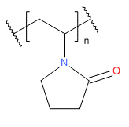
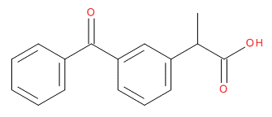

c)
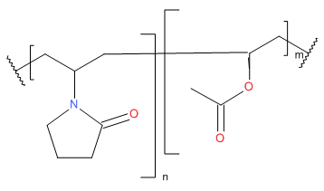

Figure 1: Chemical structures of a) ketoprofen b) polyvinylpyrrolidone c) polyvinylpyrrolidone-vinyl acetate where n:m 6:4

Figure 2: Surface tension, viscosity and conductivity of solutions subjected to spray drying and electrospraying

Polymer | PVP |  | PVPVA
Keto-profen loading | Electrosprayed | Spray dried | Electrosprayed | Spray dried
0% w/w | 1.a) | 1.b) | 1.c) | 1.d)
10% w/w | 2.a) | 2.b) | 2.c) | 2.d)
20% w/w | 3.a) | 3.b) | 3.c) | 3.d)

Figure 3: SEM images of particles produced using electrospraying and spray drying. The scale bar represents 2µm
Figure 4: Average diameter for electrosprayed and spray-dried polymer-ketoprofen systems

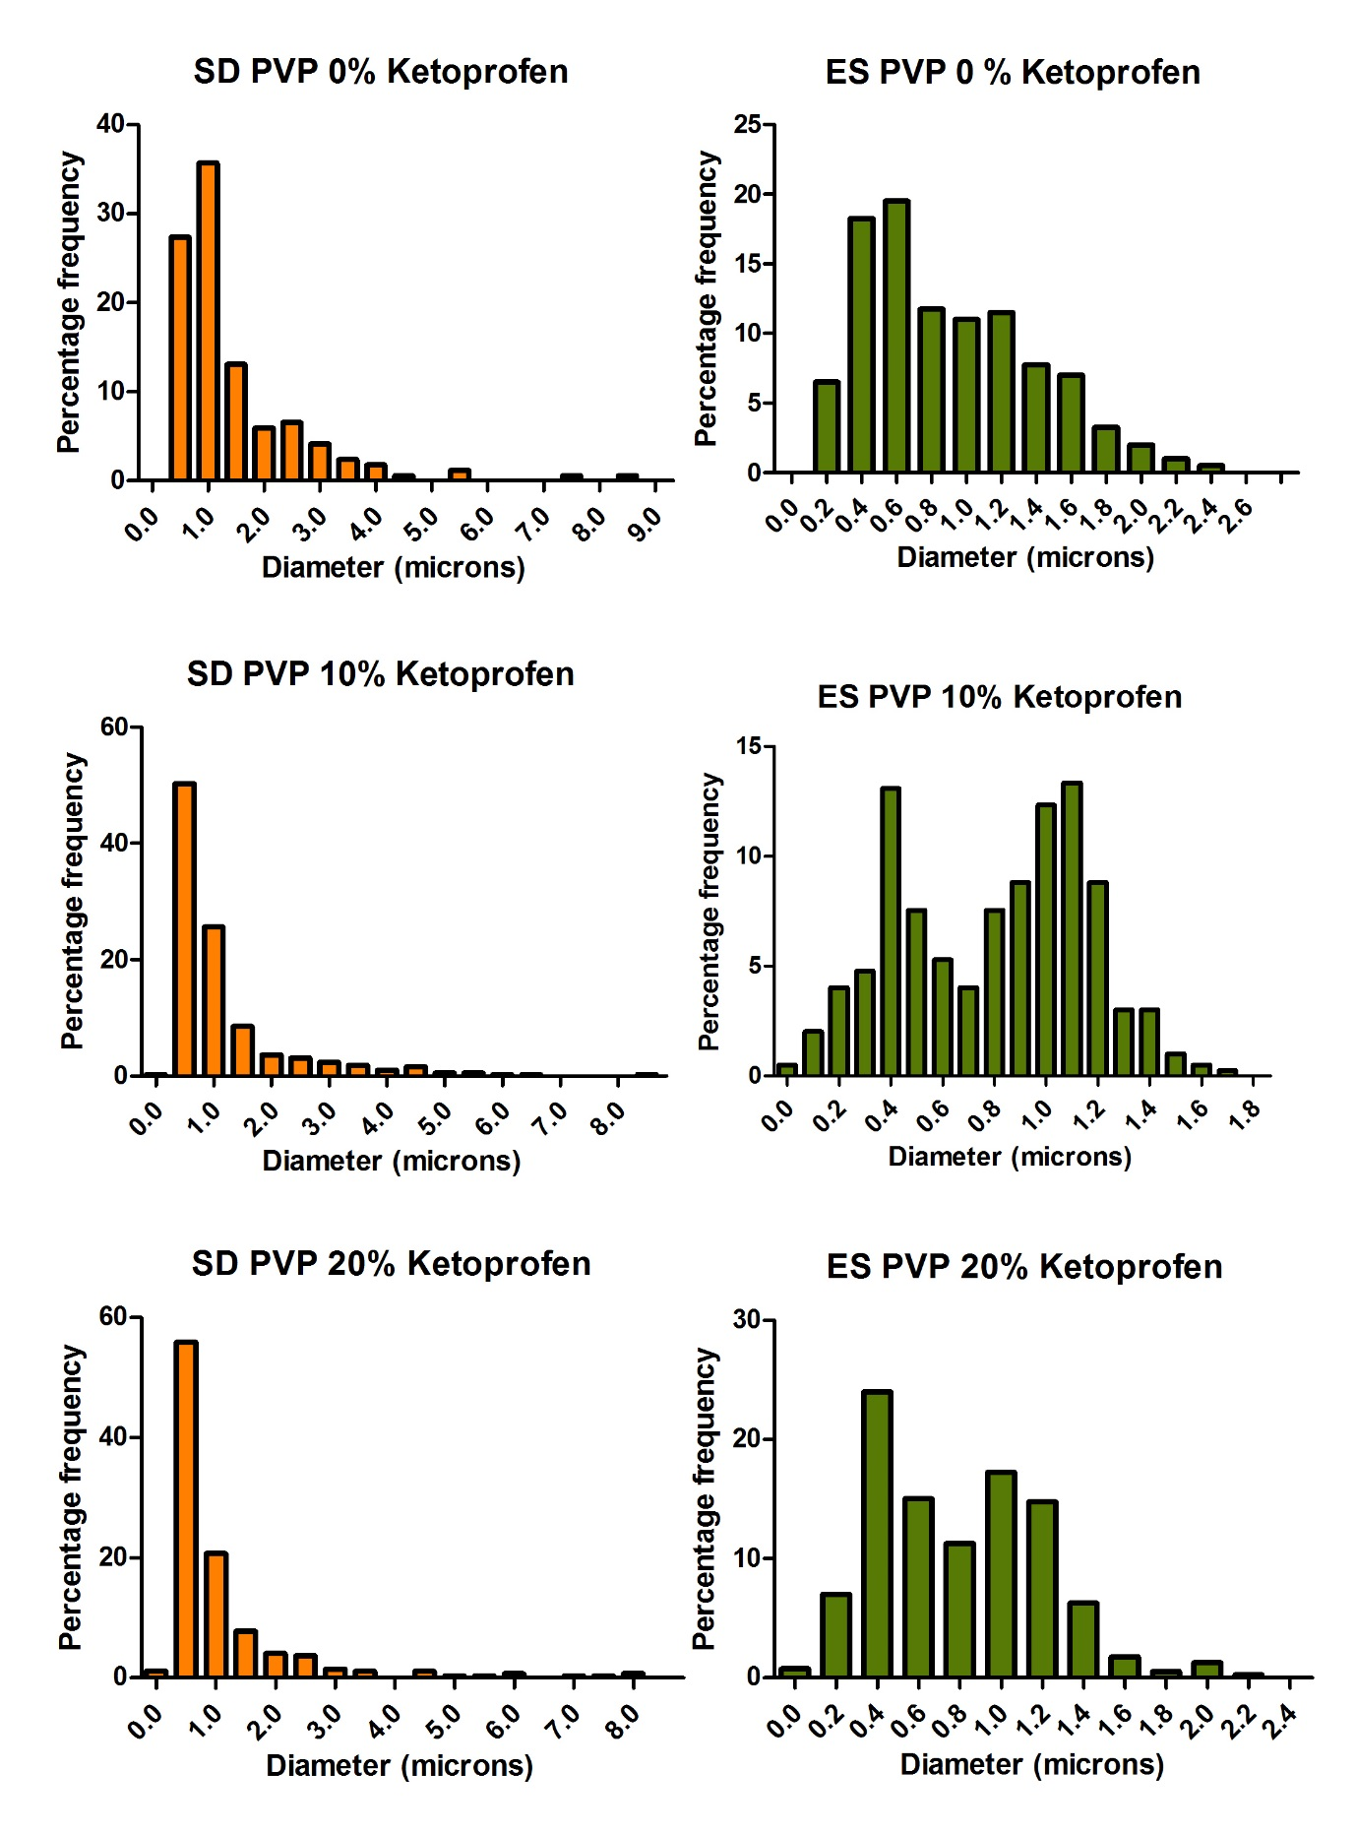
Figure 5: Particle diameter distribution for electrosprayed and spray-dried PVP-ketoprofen systems

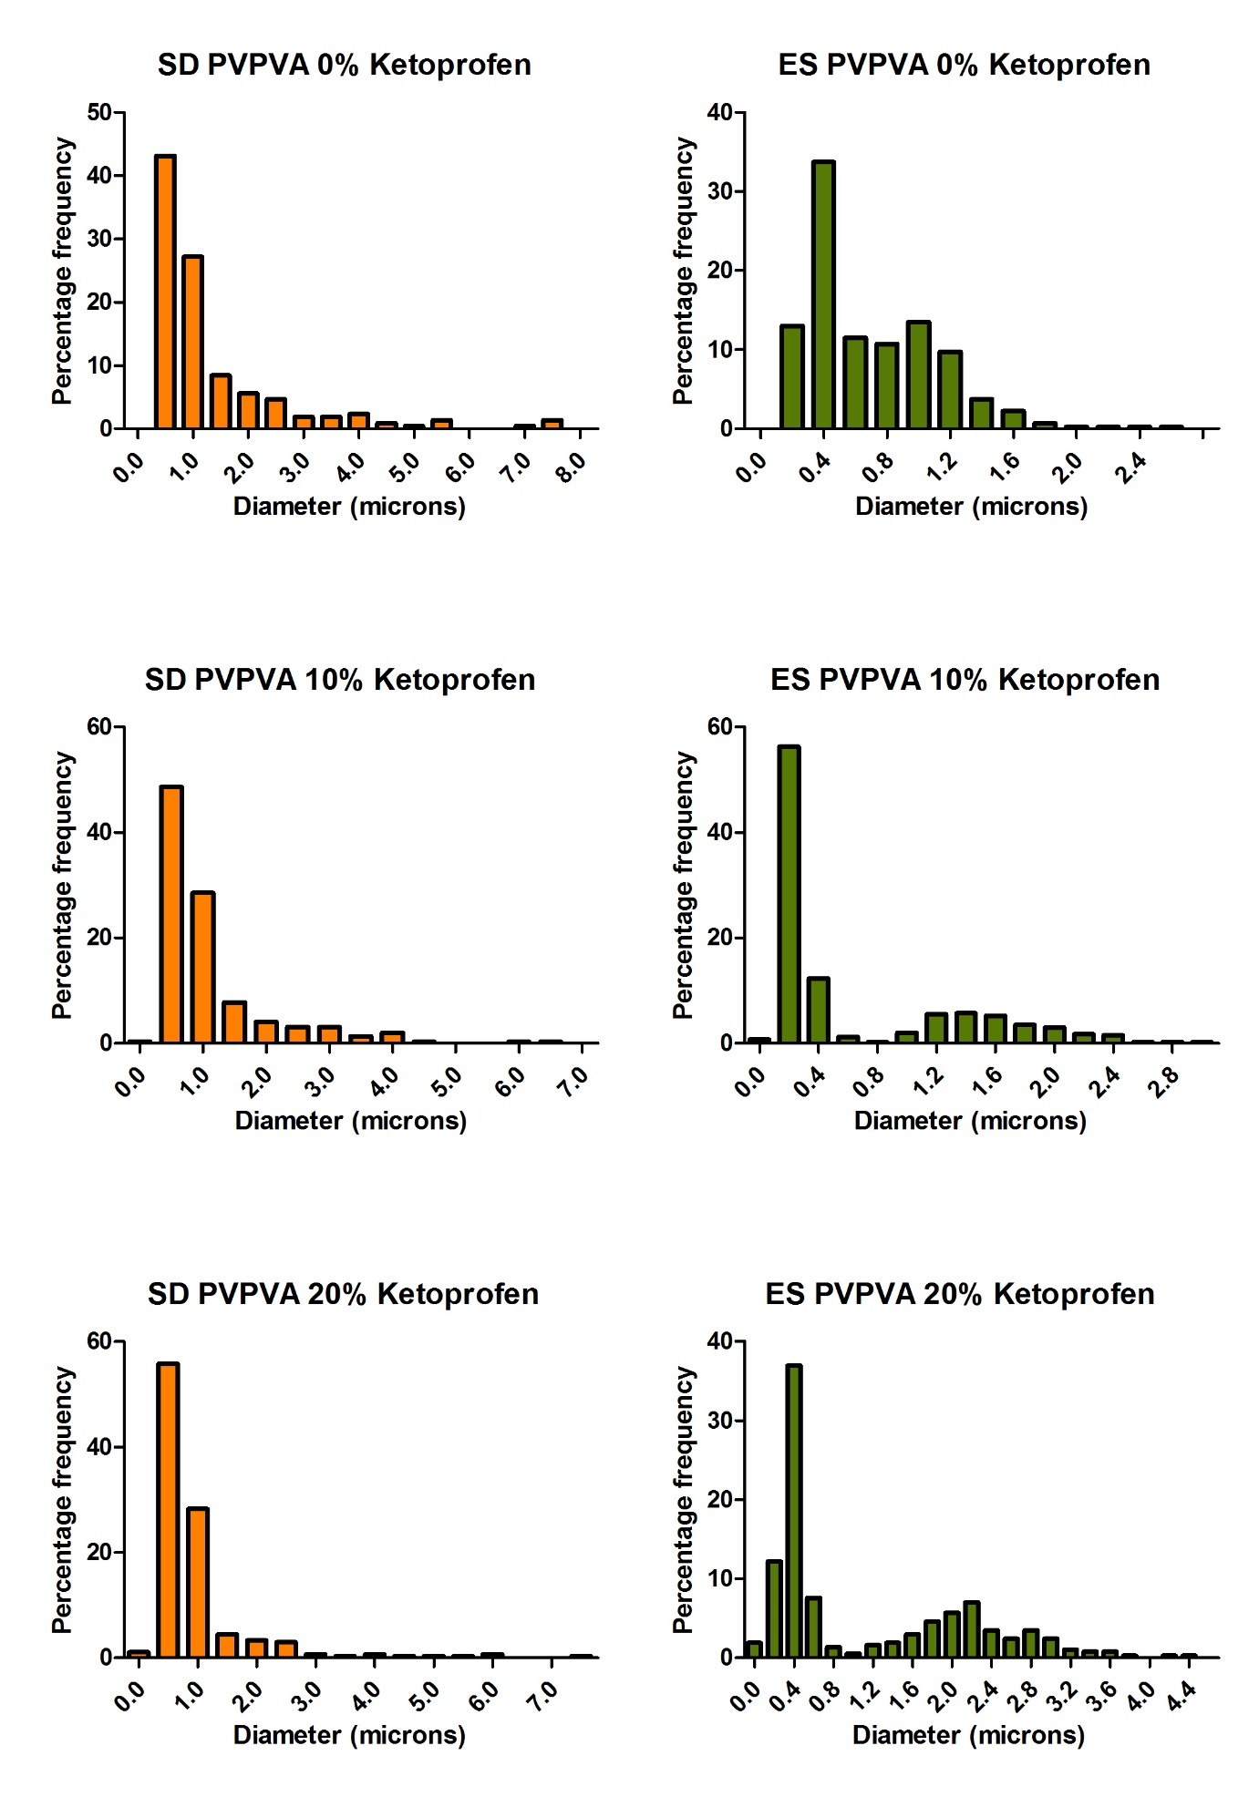
Figure 6: Particle diameter distribution for electrosprayed and spray-dried PVPVA-ketoprofen systems
Figure 7 i) spray-dried PVP ii) electrosprayed PVP iii) spray-dried PVP with 10% w/w ketoprofen iv) electrosprayed PVP with 10% w/w ketoprofen v) spray-dried PVP with 20% w/w ketoprofen vi) electrosprayed PVP with 20% w/w ketoprofen
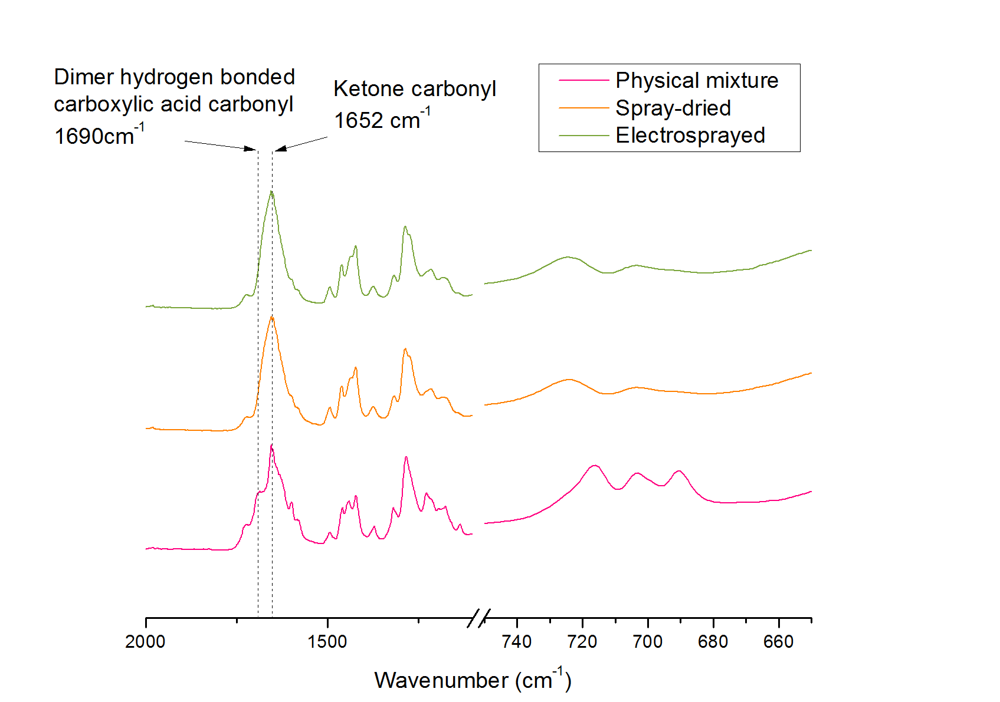
Figure 8: ATR-FTIR spectra for electrosprayed and spray-dried amorphous solid dispersions of PVP and ketoprofen 20% w/w. A physical mixture of PVP and crystalline ketoprofen 20% w/w is included as a control.

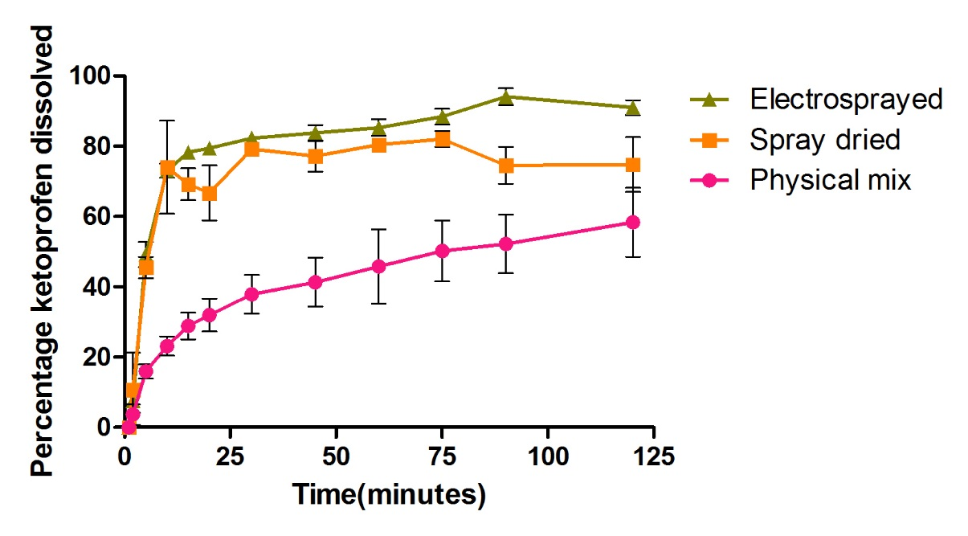
Figure 9: Dissolution profiles for electrosprayed and spray-dried amorphous solid dispersions of PVP and ketoprofen 20% w/w at pH 1.2

Figure 10: Surface moisture adsorption rates for electrosprayed (ES) and spray-dried (SD) amorphous solid dispersions of PVP and ketoprofen 20% w/w at various relative humidities

