Power Dynamics in Transaction Platforms: Adaptive Strategies of Platform-Dependent Entrepreneurs

Abstract
This study investigates the adaptive strategies of platform-dependent entrepreneurs (PDEs) to mitigate venture survival risks associated with power asymmetries on transaction platforms. Using an embedded single case study design, we explore the decade-long survival of a PDE's firm in EdTech, focusing on its relationship with two dominant platforms, Google Search and AdSense. Our findings culminate in a robust framework that elucidates the strategic responses of PDEs to the challenges of power imbalance and its exercise through platform governance. Critically, the study reveals that PDEs assert their self-determination in a two-step process that is best observed over time. Strategic subjectification, followed by multihoming and diversification, can be observed over a long temporal duration, emerging as crucial mechanisms for managing dependency risks. This study contributes to the platform strategy literature by shifting the focus from owners to participants, simultaneously illuminating entrepreneurial resilience amid power-related uncertainties.
- Keywords: power, dependency, transaction platform, risk, adaptive strategies, entrepreneurs, governance

Introduction
The increasing centrality of digital platforms across various sectors of the economy has sparked extensive scholarly and practical interest (Jacobides et al., 2018; O’Mahony & Karp, 2022; Hurni et al., 2022; Srinivasan & Venkatraman, 2018; Ojala et al., 2018; Rietveld & Schilling, 2021). In particular, transaction platforms (e.g., Amazon & eBay), which facilitate exchange between participants called sides, have become powerful intermediaries orchestrating entrepreneurial activity (Gawer, 2014; Nambisan, 2017; Cusumano et al., 2019; McIntyre et al., 2021; Jacobides et al., 2024). While existing research extensively focuses on the advantages of participation (Ceccagnoli et al. 2012; Teece 2018), and the strategic dominance of platform leaders (Eisenmann et al., 2006; Eisenmann et al., 2011; Helfat & Raubitschek, 2018), the adverse impacts of platform participation are often overlooked, particularly in light of recent anti-trust actions against giants such as Amazon and Apple (FTC.gov, 2023; Justice.gov, 2024).
Accordingly, Nambisan et al. (2018, p. 365) point out that the rapid expansion of entrepreneurial activity through platforms 'has been accompanied by the emergence of new types of dependencies and risks that are, at best, ill-understood.' Similarly, O'Mahony and Karp (2022, p. 530) note that 'little research examines how platform participants adapt their strategies when a platform owner changes the rules governing access and control'. This sentiment is equally echoed by Jacobides et al. (2024), who indicate that research has scarcely explored the strategies of platform participants, whose business ventures can be severely impacted by power asymmetries and its exercise as formal and informal platform governance mechanisms. Thus, research must investigate how various governance mechanisms shape the relationship between platform leaders and participants (Felin & Zenger, 2014; Cavallo et al., 2022).
As a result, this study focuses on platform-dependent entrepreneurs (PDEs), a vulnerable group of participants whose business survival depends on how well they manage the power asymmetries and governance risks in dominant platforms (Cutolo & Kenney, 2021; Tschang, 2021; Cavallo et al., 2022). While prior research suggests that PDEs surrender some or all of their autonomy and independence and align their business goals with those of the platform owner (Nambisan & Baron, 2013, p. 1073), a growing body of scholarship suggests a nuanced understanding (Hurni et al., 2022; Rahman et al., 2024). For example, Hurni et al. (2022) argue that PDEs actively enact their self-determination and contribute to platform success through unexpected innovations, implying they are not just passive recipients of platform leaders’ power. However, PDEs' strategies to assert their independence and balance power differentials are still poorly understood. Hence, this study sets out to answer the following research question:
  - How do platform-dependent entrepreneurs (PDEs) adapt their strategies over time to mitigate power-dependence risks on transaction platforms, and what are the implications of these evolving strategies for venture survival?

To begin, we draw upon a unified theory of power to explore the genesis of asymmetries, dependency risks, and adaptive strategies (Fleming & Spicer, 2007, 2014). Adaptive strategies such as multihoming (Cennamo et al., 2018) and diversification, which typically feature as platform-specific strategies for PDEs to manage these risks (Jacobides et al., 2018), are alternatively conceptualized as power-balancing (Cutolo & Kenney, 2021). Still, they do not fully explain the specific mechanisms and temporal order in which they combine with more abstract strategies to ameliorate threats and promote adaptation (Wen & Zhu, 2019; Wang & Miller, 2020; Cutolo & Kenny, 2021, p. 599; Tschang, 2021). Since dynamic capabilities are vital to a firm's adaptive strategies and survival in such high-velocity ecosystems (Teece et al., 1997; Eisenhardt & Martin, 2000; Wang & Ahmed, 2007), we integrate some of its theoretical assumptions in search of more robust explanations (Teece, 2018).
The empirical study adopts an embedded single case study methodology that investigates the decade-long survival of a PDE’s firm in the EdTech sector, particularly focusing on its relationship with two leading transaction platforms - AdSense and Google Search. This longitudinal investigation yields an evidence-based conceptual framework emerging from an abductive dialogue between theory and empirical observations. Consequently, the study makes three main contributions to the platform literature. First, it addresses the growing demand for research into the risks of platform participation and the strategies to mitigate them. Second, it challenges the assumption that PDEs mainly surrender much of their autonomy and align their business goals with the platform leader. Instead, it unveils a mosaic of power-balancing moves (Fleming & Spicer, 2007), strategically combined over time to deliver long-term adaptation and venture survival amid governance changes. Third, the study deviates from the usual research emphasis on the competitive strategies of platform leaders in illuminating the underexplored strategies of participants, who continuously contend with the risks and uncertainties emanating from power asymmetries. These contributions also raise practical implications for multiple stakeholders, which we explore.
The remainder of the paper is as follows. Section 2 explores the relevant literature on platform power and risks, leading to possible adaptive strategies. Section 3 outlines the methodology of the study. Our analysis of findings, in Section 4, is followed by a theoretical discussion in Section 5, leading to a conceptual framework with supporting propositions. Finally, section 6 presents our conclusions, identifying limitations and future research avenues.

Theoretical Background

Overview of Platform Research
Platform research in management studies originates from two main streams: 'product platforms' in engineering and 'exchange platforms' in economic and information systems theory. From these developments, Gawer (2014) proposed a unified framework that identifies three types of platforms: innovation, transaction, and combined hybrid models (Cusumano et al., 2019). Innovation platforms provide technologies for creating complementary offerings (e.g., SDKs & APIs), whereas transaction platforms, the focus of this study, serve as intermediaries that orchestrate exchanges between multiple, independent participants called sides – e.g., Amazon and Google Search (Cennamo & Santalo, 2013; McIntyre et al., 2021; Jacobides et al., 2024). These platforms govern interactions between different user groups, leveraging network effects, pricing strategies, and high switching costs to secure a competitive market position (Amit & Zott, 2001; Ceccagnoli et al., 2012; Huang et al., 2013). Given the winner-take-all dynamics of platform competition, they often dominate their markets, leading to significant power asymmetries between platform leaders and participants – e.g., Google's dominance in the global search engine space at over 90 per cent market share (StatCounter, 2023).
As transaction platform owners evolve into powerful self-governing intermediaries through network effects, they unilaterally decide rules on access and control, which significantly influence the outcomes for PDEs and their ventures (Parker et al., 2017; Gorwa, 2019; Zhang et al., 2022; O'Mahony & Karp, 2022; Islam et al., 2023). As governance involves a 'firm hand', it accentuates risks from power asymmetries (Jacobides et al., 2024, p. 8), which are ill-understood, and require further research (Nambisan et al., 2018; O'Mahony & Karp, 2022). Power asymmetries denote imbalances that largely favor platform leaders, which is not to diminish the argument that power dynamics on transaction platforms remain multidimensional.

Power Asymmetries & Power-Balancing on Transaction Platforms
Although power asymmetries favor platform leaders, Fleming and Spicer (2007, 2014) build on decades of research to advance a multidimensional framework of power. In this vignette, power is not only exerted by a dominant entity but can be resisted and re-balanced by less powerful ecosystem participants through obvious and opaque mechanisms (Foucault, 1982; Hurni et al., 2022; Rahman et al., 2024). This shatters the assumption that PDEs simply surrender to platform power. Thus, it points to a dynamic panorama of power, governance, dependency risks, and adaptive strategies needing further exploration (Ens et al., 2023). Regarding platform governance, it operates through distinct but interconnected layers. Governance modes set overarching frameworks (e.g., centralized vs. decentralized), while governance mechanisms handle daily interactions (Felin & Zenger, 2014; Cavallo et al., 2022). Formal mechanisms, such as contractual rules on access and control, establish explicit participation frameworks (O’Mahony & Karp, 2022). Meanwhile, informal relational mechanisms shape trust and compliance, particularly in dynamic, innovation-driven ecosystems. Critically, platform governance is adaptive, evolving with participant and owners’ needs, and reflects various dimensions of power within platform ecosystems (Fleming & Spicer, 2007; Hurni et al., 2022).
Two main research streams have contributed to understanding the multiple faces of power dynamics and governance: episodic and systemic perspectives (Foucault, 1982; Clegg, 1989). While the systemic perspective frames power as embedded in established institutions (Foucault, 1982), the episodic view focuses on direct and formal controls (Weber, 1947; Dahl, 1957; Polsby, 1963). Specifically, episodic perspectives conceptualize power as the capacity of Actor A to compel Actor B to act in a way that B would not have independently chosen (Dahl, 1957). Episodic perspectives critically acknowledge that power emerges from control over vital resources, which Actor B comes to depend on (Emerson, 1962; Pfeffer & Salancik, 1978). Control over resources affords asymmetric power advantages as Actor B simply self-subjugates (surrenders) to benefit. In the context of transaction platforms, these resources mainly derive from network effects, which enhance the platform's intrinsic value to participants, enabling data-driven insights, efficient market access, and reduced transaction costs (Amit & Zott, 2001).
Domination and coercion are central constructs of episodic power. Coercion involves direct, formal exercises of power (e.g., “do this or else”), while domination subtly shapes Actor B’s preferences at systemic, informal levels (Fleming & Spicer, 2007). The platform leader’s use of these power dimensions influences governance modes (e.g., centralized vs. open) and mechanisms (formal and informal processes) that implement participation rules (Cavallo et al., 2022). Episodic power often surfaces through formal governance actions such as unilateral shifts in platform terms, and through relational mechanisms, such as trust-building, which cumulatively shape long-term participation (Fleming & Spicer, 2007; Cavallo et al., 2022). On transaction platforms such as Amazon, where the governance mode usually centralized, coercion and domination are reinforced through access controls, amplifying power asymmetries and risks to participants, when compared to innovation ecosystems (Jacobides et al., 2024, p. 8).
To further the episodic view, Bachrach and Baratz (1962) introduce manipulation as a covert dimension by arguing that power extends beyond Actor A's coercion or domination of Actor B, to include the subtle removal of Actor B's capacity to act as they prefer. While coercion and domination appear on platforms as explicit/formal governance rules, such as unilateral changes in terms of platform participation, manipulation is covert, and therefore exercised in a non-transparent manner such as opaque changes to algorithmic ranking parameters (Gorwa, 2019; Katzenbach & Ulbricht, 2019; Gorwa et al., 2020; Stark & Pais, 2021; Ens et al., 2023). Additionally, platform manipulation includes misleading Actor B into falsely believing that governance rules are fair or in their interest (Fleming & Spicer, 2007, 2014). Hence, it has the potential to undermine trust, prompting adaptive strategies by participants. For example, Apple has often cited cybersecurity concerns as a justification for stringent rules that exclude certain apps from its iOS ecosystem; a move which several industry analysts have long considered suspect (Isaacson, 2011). Hence, a recent anti-trust lawsuit filed by the US Justice Department cites these measures as Apple's pretext to destroy competition and maintain monopoly power (Justice.gov, 2024). This dimension of power has mainly informed research that explores the abusive use of platform power by leaders, seen as betraying public trust.
However, since manipulation is often opaque, critics argue that the empirical basis of its conclusions remains tenuous and hard to falsify (Fleming & Spicer, 2007, p. 19). This criticism mirrors allegations in the world of practice, where accusations of platform manipulation through opaque algorithmic governance mechanisms can often be denied plausibly in a court of law by platform leaders (Katzenbach & Ulbricht, 2019). Episodic perspectives have influenced much of the thinking on platform power, governance, and dependency risks (Parker & van Alstyne, 2005; Jacobides et al., 2018; O'Mahony & Karp, 2022). However, as PDEs self-subjugate to benefit from platform resources, it unveils a poorly-understood fourth dimension of power mainly exercised by supposedly weaker dependents in a dominant entity’s ecosystem – subjectification (Fleming & Spicer, 2007, 2014).
Subjectification is a power dimension which influences individual identities, beliefs, and self-perceptions, aligning them with an ecosystem's prevailing norms and values (Fleming & Spicer, 2007, p. 13). Interpreted in a transaction platform context, it encompasses the subtle, informal, and opaque processes by which PDEs internalize the platform's values and norms. This internalization fosters self-awareness, self-regulation, and compliance, which may be achieved without direct control, or coercion from the platform leader. It suggests that by subjectifying and aligning their identities and practices with the platform leader’s expectations, PDEs can mitigate risks and navigate power asymmetries by fostering a deeper and more resilient integration within the platform’s structure. Still, a body of scholarship finds that studies of subjectification tend to place too much emphasis on micro-physical operations of power, downplaying agency and free will. Critics argue that this approach fails to observe how agents of subjectification sometimes wield it as a tool of resistance and power-balancing (e.g., Newton, 1998; Ackroyd & Thompson, 1999). Yet, subjectifying agents are shown to actively use, play with, and undermine dominant discourses and disciplines, thereby providing the micro-foundations of power-balancing strategies. This occurs when the self-regulation and compliance of these agents, mask hidden strategic intentions of resistance. It implies that the true power of subjectification may reside in its opacity, which makes it difficult for a domineering entity to perceive and act against.
As established, platform leaders exercise episodic forms of power through formal governance mechanisms that remove a PDE’s capacity to enact their agency and free will (Cutolo & Kenney, 2021). Therefore, the opacity of a PDE’s intentions can be powerful in terms of preventing platform leaders from sensing and formulating agency-undermining governance mechanisms. However, the opacity of intention does not necessarily imply that the less powerful entity plans to undermine the dominant one. Rather, it may reveal lesser-known strategies by which actors such as PDEs simultaneously strive to self-subjugate while strategically outmaneuvering platform leaders toward advancing long-term goals. Therefore, by subjectifying and mastering hegemonic platform rules, PDEs can gain power within those frameworks and use that power to resist and transform the conditions of their own subjectification. Hence, Fleming and Spicer (2007, p. 23) astutely state that subjectification results in an actor who ‘exuberantly grasps hold of his/her own destiny’.
By integrating episodic and systemic perspectives, Fleming and Spicer (2007, 2014) advance a unifying framework with four main power dimensions – domination, coercion, manipulation, and subjectification – deemed vital to analyzing power and governance on platforms (Hurni et al., 2022). The four dimensions are subsequently distilled in Table 1 and provide sensitizing constructs for empirically assessing how platform leaders and participants potentially negotiate power dynamics.
Table 1. Dimensions of Asymmetric Power & Power-balancing on Platforms
Power Dimensions | Conceptualization | Platform Manifestations
Domination | It refers to hegemonic institutions accepted as inevitable and natural. | - Platform leader domination is accepted as inevitable by PDEs, who consider it an emergent property of the collectively imbued power of network effects (Parker & Van Alstyne, 2005; Cennamo & Santalo, 2013; Cennamo et al., 2018); also, the owner's capacity to act as governor, imposing ecosystem governance rules.
Coercion | Direct and observable mobilization of power at the partnership level to persuade or compel an actor to do something or else (Fleming & Spicer, 2007, 2014). | - Platform owners coax individual participants (Parker & van Alstyne, 2005) – e.g., pressing them to comply with new platform rules or face punitive measures such as account suspension (Hurni et al., 2022).
Manipulation | Deliberate misuse or repurposing of hegemonic frameworks to achieve desired goals, often without participants' awareness. | - Platform leaders misuse the hegemonic framework to advance their goals in opaque ways – e.g., manipulating search engine results to favor their own products over participants (Gorwa, 2019; Gorwa et al., 2020).
Subjectification | Self-subjugation towards predefined roles – i.e., internalization of platform rules, values and norms. | - Through self-awareness and self-regulation, PDEs internalize platform expectations, shaping power-balancing strategies and behaviors in informal and opaque ways (Newton, 1998; Ackroyd & Thompson, 1999).
Source: Adapted from Fleming & Spicer (2007, 2014) & Hurni et al. (2022)

Power-Dependence Risks on Transaction Platforms
The exercise of asymmetric power advantages by platform leaders can precipitate significant venture disruption risks and periods of uncertainty for PDEs as governance mechanisms continue to evolve (Gorwa, 2019; Gorwa et al., 2020; Cavallo et al., 2022; Islam et al., 2023; O'Mahony & Karp, 2022, p. 533). Hence, the emerging research delineates five primary risks for PDEs' ventures linked to formal mechanisms such as rules on access and control: (a) customer separation, (b) algorithmic governance risks such as manipulating ranking parameters (Gorwa, 2019; Gorwa et al., 2020; Stark & Pais, 2021), (c) direct competition from the platform leader in the PDE's business (Wen & Zhu, 2019; Schreieck et al., 2023), (d) changing terms of participation, and (e) de-listing. These risks contrast with those encountered by entrepreneurs in traditional business ecosystems, which are less structured around a single dominant entity, enabling more varied relationships and a distributed power structure (Jacobides et al., 2018). As such, Cutolo and Kenney (2021) state that when traditional firms expand, they typically accumulate resources that can be used to cultivate their autonomy over critical value chain activities. Conversely, PDEs remain in a continued state of high dependency due to winner-take-all market dynamics, rendering their ventures perennially susceptible to sudden disruptions (Nambisan & Baron, 2013; Nambisan & Baron, 2021).
Significant venture survival risks such as platform de-listing and customer separation can arise from unilateral governance decisions such as restricting access. For example, Apple's App Store often requires application updates to align with new iOS versions and threatens app de-listing if participants fail to comply within a stated time limit. Likewise, recent anti-trust lawsuits in the US highlight risks from such forms of governance by alleging that Amazon manipulated pricing mechanisms and altered participation terms to benefit its Prime services (FTC.gov, 2023). These actions exemplify how platform leaders can exploit power asymmetries, generating venture survival risks to PDEs while also creating an environment of deep venture survival uncertainty regarding when or how they might manifest.
Notably, manipulation on transaction platforms often involves algorithmic governance, such as opaquely altering product ranking parameters or deploying computational agents to enforce rules (Gorwa et al., 2020; Stark & Pais, 2021). For instance, the FTC recently accused Amazon of manipulating search results to preferentially display its products - a practice echoed in similar whistleblower allegations reported by the Wall Street Journal (Grind et al., 2019), which alleged that Google routinely adjusted its search algorithms to favor large businesses over small ones. These allegations underscore the challenges of algorithmic governance opacity and the resulting challenges they generate, likened to PDEs shadowboxing with an invisible adversary. Therefore, opaque algorithmic manipulation is potentially among the most potent threats to PDEs' venture survival, demanding robust adaptive strategies.

Adaptive Strategies of Platform-Dependent Entrepreneurs
While extant research typically depicts PDEs as passive agents who subjectify and accept their weaker power position, recent studies suggest otherwise. Hence, they argue that PDEs actively adapt by enacting power-balancing strategies to assert their self-determination and autonomy (Hurni et al., 2022; Rahman et al., 2024). More observable acts of self-determination include mobilizing collective and governmental action to reverse unfavorable platform governance rules (Cutolo & Kenney, 2021; Rahman et al., 2024). However, individual responses to venture-specific threats are often opaque and poorly understood (Jacobides et al., 2018). As previously noted, this may be linked to the hidden application of subjectification as a power-balancing strategy aimed at enacting a PDE’s self-determination – see Section 2.2.

Multihoming & Diversification
The established platform literature identifies three observed strategies by which PDEs enact their self-determination, adapt, and promote venture survival: income diversification, platform multihoming, and channel multihoming (Jacobides et al., 2018; Cutolo & Kenney, 2021). Income diversification refers to generating revenue from multiple platforms or sales channels, while platform multihoming refers to forming relationships with more than one platform. Similarly, channel multihoming involves relying on multiple non-platform channels for transactions. Manifestations of channel multihoming include the active disintermediation of a dominant platform through establishing a direct connection with customers, and dependency dispersion which spreads dependencies across multiple channels (Zhu & Iansiti, 2019). Hence, the literature identifies actions such as the establishment of their website and active brand development as mechanisms PDEs adopt to realize disintermediation and dependency dispersion from transaction platforms (Cutolo & Kenney, 2021). However, such actions can only be successful if PDEs can establish the presence of a market beyond the platform; and if they can attract a high volume of traffic to their websites to drive meaningful conversions, which often requires time and resources. In other words, time and resource constraints can impede a PDE’s implementation of multihoming and income diversification.
Furthermore, building direct channels can initially involve subjectifying to the rules of a dominant platform such as search engines toward attracting users, which implies that multihoming and diversification may be infeasible at early stages of venture emergence. Therefore, determining the effectiveness of these strategies calls for a temporal analysis that longitudinally observes and explains the contexts in which they emerge and combine to promote adaptation and venture survival. Critically, the effectiveness of platform multihoming can be limited by the lack of viable platform alternatives, as with virtual monopolies such as Google Search, which controls an estimated 92% of the global search engine market share.
Additionally, since platform success largely derives from strong network effects, platform leaders are incentivized to implement governance mechanisms that prevent multihoming – e.g., lock-in and increased switching costs (Amit & Zott, 2001). For instance, by studying the case of the taxi transportation industry, Chung et al. (2023) found that dominant transaction platforms can collectively discourage multihoming by presenting similar governance risks that PDEs are bound to encounter across multi-homed platforms. Meanwhile, a body of scholarship reveals that multihoming can compromise product or service quality across platforms, as resource constraints compel PDEs to prioritize one platform over the other (Cennamo & Santalo, 2013; Cennamo et al., 2018). Thus, multihoming and income diversification may be easier said than done and, therefore, insufficient in explaining the gamut of adaptive strategies PDEs enact to promote their self-determination and balance power.

Strategic Agility & Dynamic Capabilities
Beyond platform-specific strategies of adaptation, the established strategy literature proposes dynamic capabilities (DCs) as an underlying theoretical framework for exploring a firm's adaptive strategies and survival in high-velocity ecosystems (Teece et al., 1997; Eisenhardt & Martin, 2000; Wang & Ahmed, 2007). Transaction platforms are high-velocity ecosystems from the perspective that governance rules change regularly, creating an atmosphere of Knightian uncertainty that PDEs need to manage (McMullen & Shepherd, 2006). In such ecosystems, successful firms are said to harness their DCs - specifically defined as adaptive, innovative, and absorptive capabilities (Wang & Ahmed, 2007). These capabilities allow firms to sense threats and seize opportunities for transformation through continuous business model innovation (Eshima & Anderson, 2017). Crucially, DCs materialize through the crucible of strategies such as agility, which contributes to organizational resilience in high-velocity ecosystems (Weber & Tarba, 2014; Lessard et al., 2016). Hence, Teece et al. (2016, p. 17) define strategic agility as ‘the capacity of an organization to efficiently and effectively redeploy/redirect its resources to value creating and value protecting (and capturing) higher-yield activities as internal and external circumstances warrant.’
Extant research has predominantly applied this perspective in exploring how platform leaders succeed and maintain ecosystem dominance (Helfat & Raubitschek, 2018; Jacobides et al., 2018; Rietveld & Schilling, 2021). However, since the successful realization of strategic agility largely depends on a firm's resource base, it remains unclear how resource-constrained PDEs can implement it (Evers, 2011; Urbano et al., 2013; Eshima & Anderson, 2017; Linnenluecke, 2017; Klofsten et al., 2021; Canhoto et al., 2021). As such, it raises questions regarding how agility harnesses a PDE’s DCs in promoting adaptation and venture survival. Therefore, as is the case with other platform-specific adaptive strategies explored above (i.e., multihoming & diversification), how PDEs manage resource constraints to remain agile in transaction platforms requires further investigation.
For guidance, the emerging digital entrepreneurship literature suggests possible explanations by noting that PDEs are naturally positioned to realize agility (Nambisan, 2017) by virtue of the intangible materiality of their software-based composition. This intangible materiality, in turn, enables the development of operationally lean organizations capable of rapidly modifying their value creation and delivery frameworks in response to change (Ghezzi & Cavallo, 2020; Nzembayie & Buckley, 2022). The efficiency of a lean organizational design fosters resource conservation and profit maximization, which can equip PDEs with the necessary resources for continuous business model innovation toward value creation and capture. This implies that platform-specific strategies such as diversification and multihoming, which underlie business model innovation, may represent platform-specific instantiations of more abstract strategies such as agility and subjectification (Zhu & Iansiti, 2019; Wang & Miller, 2020). However, these assumptions remain largely under-explored in the context of platform dependent entrepreneurship.

Tentative Conceptual Framework
Based on the literature, we develop a tentative conceptual framework below (Figure 1) for use in empirical data analysis, as consistent with an abductive approach (Edmondson & McManus, 2007; Van Maanen et al., 2007; Davidsson, 2016, p. 59). The framework integrates key constructs that act as ‘sensitizing notions’ (Timmermans & Tavory, 2012, p. 169) to empirically explore the complex interplay between power asymmetries, risks, and PDEs’ adaptive strategies in transaction platforms. The framework identifies power-dependence relations as asymmetrical, largely skewed in favor of platform leaders. Still, PDEs are assumed to be proactive agents, enacting their self-determination through concrete adaptive strategies such as multihoming and diversification – with these strategies potentially materializing more abstract strategies such as subjectification and agility.

Figure 1. Tentative Framework of Power-Dependence Risks & Adaptive Strategies
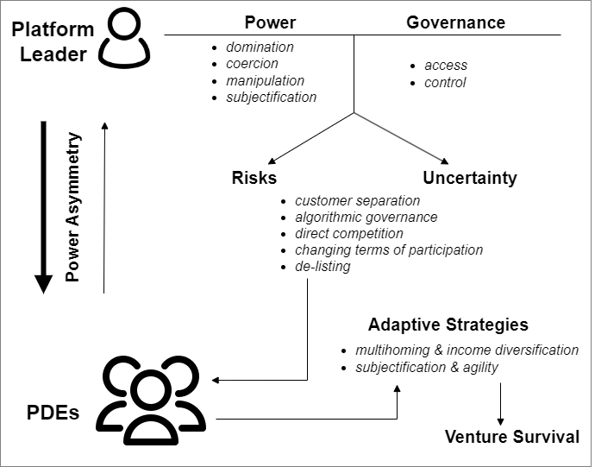
However, when juxtaposed against the established assumption of passive agents surrendering their autonomy to platform power, the range of potential adaptive strategies creates tensions that necessitate further exploration. As the literature indicates, resource constraints remain a key limitation that can undermine the implementation of adaptive strategies. Hence, a knowledge deficit remains regarding how these strategies evolve, combine, and become implemented over time to deliver venture survival. Moreover, the potential of strategic subjectification as a power-balancing strategy that can promote PDEs’ adaptation has hardly been considered in a transaction platform context. These knowledge deficits call for a deeper investigation into the gamut and manifestations of adaptive strategies that deliver venture survival under the limitations of resource constraints and the precarity of power asymmetries and governance mechanisms. The identified tensions and knowledge gaps underscore the need for a longitudinal research design to credibly answer the research question, with our tentative conceptual framework (Fig. 1) providing a tool for abductive analysis.

Methodology
Accordingly, we adopt a qualitative approach based on an embedded single case study design, in documenting the survival of a PDE's firm over a longitudinal timescale of a decade (Eisenhardt, 1989). As Yin (2018, p. 99) states, embedded single case studies include a unit of analysis and subunits. It mirrors the current case where the unit of analysis is a PDE's EdTech firm and the subunits are three platform-dependent ventures created under the firm. Following Eisenhardt and Graebner (2007, p. 27), case selection in embedded single case studies can be justified by one of the following reasons: 'chosen because they are unusually revelatory, … or opportunities for unusual research access'. Our case selection was informed by the unique opportunity to access a setting with a decade of digitally recorded and stored event data, providing revealing insights into the vicissitudes of power dynamics and its impact on the PDE's decision making and strategy.
Digital ventures are often virtualized organizations, making it hard for researchers with outsider positionalities to collect data and study their inner workings. However, as one of us is the founder of the firm who sought to make sense of his platform-dependent entrepreneurial journey through academic research, his insider positionality provided the opportunity to study the phenomenon due to a willingness to provide deep access. Our research design is ideal for answering the research question, as supported by Cyron (2022, p. 204), who points out that 'standard qualitative methods... struggle... to capture what is happening in the digital world' due to lack of such deep access.

Data Collection
Participant observation (PO) based on access from a native insider and their lived experiences (Berglund, 2007; Brannick & Coghlan, 2007; Spradley, 2016) was the primary method for data collection. This method of data collection is often valued but challenging to realize in case studies for reasons of access over long durations. We used it to generate insider narratives that provided the departure point for inquiry, followed by triangulation and contextualization through archival research. Archival research used digital trace data from the three ventures' data analytics systems to substantiate narratives, and web records to substantiate insider observations (Pentland et al., 2020). Data, such as email communications between the firm and the platform leader, analytics records, and revenue systems records captured in real-time, helped triangulate narratives accurately. Given the digitally time-stamped nature of such data, the temporal sequence of narratives could be established with a high degree of credibility, verifiability, and trustworthiness (Lincoln & Guba, 1985).
Our data collection approach is justified by Brannick and Coghlan (2007, p. 60) who argue that native researchers present a unique opportunity for studying organizational processes because' insider researchers are native to the setting and so have insights from the lived experience'. The insider researcher's observations from deep access, offer the basis for constructing narratives, which are triangulated by rich data from the firm's digital data records. However, since insider participant observations can be compromised by the native researcher's proximity to the organization, co-inquiry with non-native outsider researchers is recommended. As such, we adopt cooperative inquiry (Heron & Reason, 2006) in which two researchers with outsider positionalities were invited as co-inquirers who probed narratives, leading to additional information that caught blind spots and improved the insider researcher's reflexivity. This approach is well supported by recent calls in technology and information systems management disciplines, advocating practitioner-academic co-inquiry (e.g., Myers, 2023; Baskerville et al., 2023).

Data Analysis
To analyze data, we build on a critical realist epistemology that assumes reality to be layered, requiring researchers to delve into the causal mechanisms driving social phenomena (Sayer, 1997). Therefore, mechanism-based theorizing was used to generate insights from narratives about how various strategies interacted and contributed to venture survival over a decade (Ylikoski, 2019). Consistent with this model of theory building, narrative analysis is the primary method for data analysis. Narrative analysis is a combination of analytical approaches suitable for analyzing various aspects of organizational processes (Riessman, 2008). It demands creativity in data analysis (Langley, 1999), as opposed to merely following standard qualitative data analysis templates such as grounded theory (Köhler et al., 2022). Therefore, rather than fragmenting data in order to assign codes and categories, as in grounded theory (Strauss & Corbin, 1997), the temporal order of narrative data is more analytically significant in extracting themes. Accordingly, data are analyzed holistically (Saunders et al., 2016, pp. 600-601). Following Langley (1999, p. 700), we develop a visual map in Figure 2 because visual maps are “particularly attractive for the analysis of process data because they allow the simultaneous representation of a large number of dimensions, and they can easily be used to show precedence, parallel processes, and the passage of time”.
Therefore, while themes and categories can still be coded to surface causal mechanisms, they are done within their situational and temporal context, critically preserving the sequential and structural elements of each platform event narrative (Poole et al., 2000). Thus, thematic narrative analysis was used to identify causal mechanisms within the multiple layers of narratives. The multilevel analysis combined deductive and inductive reasoning in an abductive approach (Van Maanen et al., 2007; Timmermans & Tavory, 2012; Davidsson, 2016, p. 59), allowing us to cycle between narrative data and our conceptual framework in Figure 1 toward surfacing plausible explanations (i.e., not definitive explanations as consistent with positivistic forms of research).
Following Ylikoski (2019), mechanism-based explanations answer a 'a how-question underlying a causal why-question' (p. 16). Since our study seeks to explain how PDEs enact adaptive strategies to promote venture survival, we seek to explain the how, while using mechanism-based theorizing in explaining the why. Therefore, it was not sufficient to simply identify strategies but also to plausibly explain the opaque and hidden mechanisms, as well as the boundary conditions under which they interacted to deliver survival. Van de Ven (2007, p. 156) offers a similar argument in suggesting that the goal of mechanism-based theorizing is to establish narrative causality, which is 'loose'; that is, it only specifies the pattern or form that organizes events in space and time, as opposed to seeking variables as in quantitatively oriented methods. Our approach is well justified by eminent process methods theorists who argue that the temporal order and situational context in which events occur are critical in establishing efficient causality (Pentland, 1999; Van de Ven & Engleman, 2004) - that is, causes originating from the productive actions of agents such as PDEs in this case.

Findings

Case Background & Narrative Synthesis
This section presents the background and narrative synthesis of the case. The narrative introduces the case in the first-person voice of the insider participant researcher in their role as PDE, while we decompose and visualize its multiple dimensions, subsequently:
I incorporated my company in Hong Kong back in 2011 to organize the development of EdTech venture ideas aimed at the global language education market. The first venture (V1) was an early literacy product that began in May 2012. It is a structured curriculum supported by rich media learning and teaching resources. Its revenue model includes annual and bi-annual paid subscription plans. The site has relied on payment platforms such as PayPal, Stripe, and 2Checkout to process customer credit card transactions securely. The second venture (V2) was developed and went live in late 2012. It is a games-based language education platform. It is offered as a free website with over 1,000 rich media educational games. It relies heavily on Google's AdSense program for cost-per-click ad monetization. Meanwhile, a third venture (V3) was developed throughout 2014 and fully launched in 2016 as part of a diversification strategy. It is a structured digital English language education curriculum aimed at the primary EdTech market. Its core offerings are rich media interactive courses supported by a learning management system. Like V1, its revenue model is subscription-based.
Figure 2 below is a visual map of the PDE's firm and its ecosystem relationships, in a multidimensional matrix that summarizes critical events in their situational and temporal order of occurrence. The events focus primarily on the firm's Venture 2 (V2), which is its most profitable unit that was highly dependent on two of Google's transaction platforms (Search & AdSense). By focusing on V2, we provide the context to understand how the high dependencies and extremes of power imbalances generate risks, prompting adaptive strategies from PDEs.
Figure 2. Visual Map of PDE's Transaction Platform Ecosystem Relationships
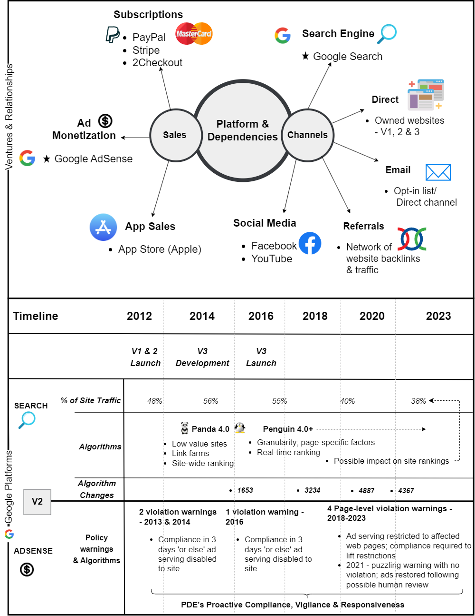

Google AdSense: Power-Dependence Risks & Adaptive Strategies
To determine how the PDE adapted to power dynamics on the AdSense platform, we begin by synthesizing specific risks and describing the boundary conditions of the platform. Against this backdrop, we accurately explain the mechanisms by which strategies drove venture survival.

Power-Dependence Risks on AdSense
Appendix A synthesizes the Google AdSense platform conditions and the nature of risks. In Appendices B and C, we show the thematic narrative analytical process by which the themes surfaced. As shown, PDEs on Google's AdSense deal with incessant risks of platform de-listing, algorithmic opacity, and unilateral policy changes. These risks further underscore the fact that they live in a state of perpetual vulnerability, especially given the dominance of the AdSense platform. AdSense is widely depicted as beneficial to PDEs and their ventures, which makes the prospect of a ban devastating. An estimated 2 million publishers depend on AdSense to monetize content, according to Google (Google AdSense, 2023). Google states that for ads placed directly on the publisher's website, it shares 68% of advertising revenue, mainly on a cost-per-click basis (CPC). It also allows website owners to place search ad codes on their web pages for a 51% revenue share.
Most importantly, advertisers do not relate directly with content publishers but sign up for another Google ad service called Google Ads (formerly AdWords), thus keeping both parties separated from each other. By keeping the two segments of the market separate, Google has full control over both sides (Graham & Elias, 2021). Thus, we substantiate the assertions by Cutolo and Kenney (2021) that platforms have an interest in keeping both sides of the market separate, with the potential for applying overt and covert power-wielding mechanisms (Hurni et al., 2022). The opaque nature of algorithmic governance mechanisms (Gorwa et al., 2020) makes it difficult to pinpoint the exact cause of policy violation warnings or outright bans (Cole, 2018). Although the PDE's V2 has not fallen victim to an outright ban in this case, triangulated narratives from similar PDEs indicate the devastating effect of a ban – see Appendices A and C.
Hence, PDEs report living in constant 'fear', evidencing Cutolo and Kenney's (2021) proposition stating that, unlike traditional businesses, threats to PDEs' ventures persist throughout their existence. Thus, longevity and subjectification through proactive compliance do not fully inoculate against the risk of de-listing as evidenced by the triangulated cases indicate (see Appendices A & C, e.g., nichepursuits.com). Marginalization of the AdSense platform is not a viable option either, due to the monopoly power and the tremendous value derived from the platform by PDEs (Teece, 2018). The lack of transparency (opacity) leaves room for potential manipulation (Fleming & Spicer, 2014; Gorwa, 2019; Hurni et al., 2022). Hence, a class action lawsuit against AdSense in 2014 alleged that Google unfairly retained revenue from banned accounts. Although Google denied any wrongdoing and a California court dismissed the case, Google curiously offered an 11-million-dollar settlement for publishers of terminated accounts (Bucher, 2018; Montti, 2018). The lack of transparency and the inability to influence or fully understand what goes on behind the implementation of AdSense policies leave PDEs in a perpetual state of vulnerability, thus necessitating adaptive strategies.

Adaptive Strategies on AdSense: Subjectification, Diversification & Multihoming
Insider narratives and supporting data in this case show how PDEs enact adaptive strategies to mitigate risks and promote venture survival on the AdSense platform. Consistent with theory (Figure 1) we identify these strategies as subjectification, income diversification, and platform multihoming. The following participant observer narrative serves to illustrate how these strategies emerged and their related mechanisms:

I have always known that putting all your eggs in one basket is a dumb strategy… So, to survive a ban, we reinvested profits from AdSense into the building of yet another subscription-based venture, which fully launched as V3 in 2016... This is designed to mitigate risks in one of three ways. First, we could replace all Google AdSense ad inventory on V2's popular website with ads for our two subscription-based websites (V1 & V3). I do not anticipate this move would generate as much revenue as we do from AdSense, but at least it enables us to survive since we have a good amount of traffic. Second, we still remain proactive in complying with AdSense policies and highly responsive in acting upon policy violation warnings… Third, I have created a separate new company AdSense account and linked it to an early-stage fourth venture (V4), currently in development. In the event of a ban, I hope to replace all ad codes from the banned account with codes from the company's AdSense account. Whether Google eventually bans the company's AdSense account is another story.

Subjectification emerges as a critical adaptive strategy, making other survival strategies possible (Fleming & Spicer, 2014; Hurni et al., 2022). Its underlying mechanisms are proactive compliance, resource acquisition, and redeployment, which play multiple roles. As shown, V2 has survived seven threats of an account ban (Figure 2 & Appendix B) in nearly a decade by being proactive and responsive in complying with changing AdSense policies (i.e., subjectifying – Fleming & Spicer, 2014). By subjectifying, it has managed to avoid the fate of the triangulated cases of other PDEs, briefly described in Appendices A and C. More importantly, subjectification mechanisms ensured that the PDE's venture (V2) acquired resources from the platform which were subsequently redeployed toward developing non-platform dependent ventures.
Meanwhile, the effectiveness of another subjectification mechanism which involves a re-entry workaround in case of a ban has not been tested. Still, triangulated cases show its potential as a subjectification mechanism. For instance, in further detailing their arbitrary account ban (see triangulated case in Appendices A & C), the PDE states the following:
However, what has not been shared is that in late April, I decided to form a NEW business entity and apply for Google Adsense with that new LLC. I was approved in under 24 hours. So, this new LLC of mine has had an approved Google Adsense account since late April. I started implementing the Adsense code onto my old sites just a couple of weeks later. I waited to publicly share this information because I wanted to be sure that I would get paid again. I wanted to see if placing the Adsense code on my old sites (from a previously banned Google Adsense account) would also ban this new Adsense account. This is not the case! My new business entity has been paid twice now... This raises the mystery even a little more as to why my original Adsense account was banned.

Therefore, subjectification through proactive compliance, responsiveness, and reentry workarounds is shown to enable PDEs to continuously reap the benefits of platform participation despite the risks (Fleming & Spicer, 2014; Hurni et al., 2022). Accordingly, this study concludes that subjectification enables survival via two main classes of mechanisms: resource acquisition and redeployment, and continuous platform participation. While resource acquisition, and redeployment enable business model innovation, continuous platform participation enables PDEs and their ventures to stay within the ecosystem, reaping the benefits of platform participation. Second, it enables resource acquisition, redeployed toward the implementation of autonomy-driven adaptive strategies (i.e., disintermediation & dependency dispersion) which can diversify a PDE's portfolio of businesses away from a monopoly platform. The rationale for subjectification can be plausibly explained by entrepreneurial uncertainty theory (McMullen & Shepherd, 2006) which argues that although there are risks of platform dependence, PDEs can hardly perceive if, how, or when they materialize in the life of their ventures. Therefore, while remaining aware of the risks, the case suggests that PDEs cannot afford to frame platform relations solely in a pessimistic light, assuming that their ventures will certainly suffer the crippling effects of dependency risks; neither can they afford to be complacent through naive optimism. As the case indicates, subjectification does not fully eliminate platform dependency risks and uncertainty; but rather helps to mitigate them through resource acquisition and redeployment.
Consequently, the PDE's company in this case is shown to adopt the interrelated strategies of income diversification and platform multihoming which are autonomy driven. Therefore, the case shows that the PDE began by subjectifying toward resource acquisition, and subsequent redeployment in the creation of non-platform dependent ventures such as V3 which diversified its revenue sources (see Figure 2). Income is relatedly diversified through multihoming on transaction platforms without extreme monopoly power, such as payment gateways (PayPal & Stripe). In this case, survival is secured because two main ventures of the PDE's firm (V1 & 3) eventually evaded relying solely on AdSense to generate revenue, guaranteeing a level of autonomy, and preventing the risk of abrupt firm collapse. Therefore, we confirm the theoretical observations that resource acquisition is an antecedent mechanism of organizational resilience and agility (e.g., Weber & Tarba, 2014; Teece et al., 2016; Eshima & Anderson, 2017). In the context of a monopoly platform, this study complements this understanding by showing that when harnessed as a strategy, subjectification presents a necessary first step in facilitating the acquisition of platform resources, geared toward enacting more resilient strategies.
Resilience is driven by two primary mechanisms: non-platform venture creation, and dependency dispersion, which are autonomy-led. A non-platform venture creation mechanism is here defined as the creation of new ventures with business models that are less reliant on a dominant platform. Meanwhile, a dependency dispersion mechanism does not fully eliminate platform dependency risks but seeks to migrate them to less risky business ecosystems through multihoming. Less risky platform ecosystems are those in which intense platform rivalry has decomposed market monopolies. As shown in Figure 2, we see such dependency dispersion as the creation of subscription-based business models that relied on payment processing transaction platforms (PayPal, Stripe & 2Checkout) where market monopolies have been broken up by intense platform rivalry.

Google Search Engine Platform: Risks & Adaptive Strategies
We now examine Google Search as the next interrelated dominant transaction platform. Similarly, we began by examining the characteristics of the platform and dependency risks, thereby establishing 'boundary conditions' (Tschang, 2021, p. 696) to understand the context in which the PDE's adaptive strategies emerged.

Algorithmic Rankings & Opacity Risks
Table 2 provides a summary of the conditions of the Google Search platform and highlights the risks and uncertainty associated with the opacity of algorithmic ranking criteria. Unlike AdSense, Google Search functioned as the primary channel for customer acquisition and brand development, as shown in Figure 2. Appendix D shows how we extract themes from narratives around Google Search.
Table 2. Google Search Platform Conditions & Risks
Aspect | Description
Google Search Dominance & Role | a dominant transaction platform that functions as a major channel of customer acquisition and brand development (90% global search market share)
Power-Dependence Risks | The opacity of changes to search engine ranking criteria highlights algorithmic ranking risks that could lead to a drop in rankings and sales.
Impact of Algorithmic Governance | Frequent search engine updates (e.g., Panda 4.0 & Penguin 4.0 – see Figure 2) introduce uncertainty in website ranking and traffic, affecting revenue and profit of PDEs.
PDE's Dependency on Google Search | Essential for organic traffic, low-cost sales, and revenue generation. For example, V1 and V3's sales conversion is only $45/transaction, V2's CPC ad revenue averages $0.20 for US/Canada – implying that low-cost of sales is a must for venture performance.
PDE's Site Performance | Google Search led to 46% of site visitors for V2 from Aug 2012 to Jul 2023. Lowest bounce rate on Google Search (40%) compared to others (46%) – see Chart 1 below for V2.
Algorithm Update Frequency | Drastic increase in algorithmic updates (4,887 in 2020) tracked by Moz, adding to the volatility and unpredictability of ranking criteria.
Impact of Algorithm Updates | Major and minor updates, such as Penguin and Panda, influence search rankings, with significant impact on site visibility and user base.
Insider Narrative | Lack of transparency in Google algorithm updates; reliance on interpretations by firms such as Moz, Semrush, and Search Engine Land.
Fluctuations in search engine rankings | Chart 2 shows the fluctuation in V2's search engine performance from 2013-2023, highlighting the impact of algorithm changes and the difficulty in pinpointing specific causes for ranking changes.
Google dominates the search engine landscape with more than 90% market share on all devices – mobile, desktop, and tablet (StatCounter, 2023). This makes it a virtual monopoly in the online search engine space, and an unavoidable channel for low-cost customer acquisition for the PDE's ventures. However, algorithmic governance risks are shown to be most potent as Google updates its search engine ranking parameters regularly (for example, Panda 4.0 & Penguin 4.0, mapped in Figure 2). Updates range from major to minor and introduce a level of uncertainty regarding how or when they may affect a website. Uncertainty is related to the opacity of its algorithmic ranking criteria (Gorwa et al., 2020). The risk for PDEs is the potential drop in website rankings in Google Search for key search terms, which has a domino impact on revenue and profitability. The following participant observer narrative shows the high levels of dependency on Google Search over the years as a platform for customer acquisition. The narrative is triangulated by digital trace data in charts 1 and 2 (supported by supplementary data supplied for review).
Google Search drives organic traffic to the sites which translates into low cost of sales and revenue generation. Since all ventures are B2C (Business to Consumer) retail businesses, the average sales unit per customer is very low, which means we need large volumes of free traffic and sales to remain profitable. For example, the average sales conversion is roughly $45 per transaction for V1 and V3 which are subscription based, while cost-per-click (CPC) ad revenue for V2 is roughly $0.20 for US and Canadian customers, and less than $0.08 for much of the rest of the world... To date, we have successfully attracted nearly 36 million users to V2's website, mainly through Google Search. In the period from August 2012 to July 2023, organic search channels led by Google Search accounted for 46% of site visitors… The bounce rate, which measures site engagement, was also lowest on Google Search at 40%, while the others were higher at 46%. Similarly, search traffic was responsible for developing other customer acquisition channels over time... As such, I can say without Google's Search platform, we would not be nearly as successful. I provide digital trace data from V2 in Chart 1 to illustrate this observation…
Chart 1. Organic Search versus Other Channels in Case of V2 – 2013-2023

Changes in Google search engine ranking algorithms pose a constant threat. As noted, without making it to the top page of Google's Search Engine Results Pages (SERPS) for specific keywords, a site could lose its ranking and search engine visibility, leading to a user base and sales decrease. Archival data from the leading search marketing firm, Moz, tracked Google's search engine algorithm updates between 2009 and 2021 and reports on how frequently they have been occurring (Meyers, 2023). The report shows an astonishing peak of 4,887 changes in 2020 from a low of 375 in 2009. The author (Dr. Meyers) also comments on the issue of opacity as follows:
"While we can't predict future changes, we can try to learn from the patterns of the past and read between the lines of Google's messaging. As machine learning drives more of Google search (and Bing's recent launch of ChatGPT capabilities will only accelerate this), the signals from Google will likely become less and less clear, but the themes of the next few years will probably be familiar. Google wants content that is valuable for searchers, and reflects expertise, authority, and trust. Google wants that content delivered on sites that are fast, secure, and mobile-friendly. Google doesn't want you to build sites purely for SEO or to clutter their (expensive) index with junk. How any of that is measured or codified into the algorithm is a much more complicated story, and it naturally evolves as the internet evolves. The last nine years can teach us about the future and Google's priorities, but there will no doubt be surprises."
Uncertainty is evident regarding how an algorithmic update might affect a site; an issue further linked to opacity. This case provides insight into how a PDE's ventures may be impacted by the opacity of such algorithmic ranking updates and how entrepreneurs perceive them. Hence, insider participant observations, supported by digital trace data in Chart 2, state the following:
We really have no insights into how Google's algorithmic updates work. We can only rely on released information and follow authoritative search engine marketing firms and blogs such as Moz, Semrush, and Search Engine Land for their interpretation of what changes mean. I present Chart 2 which I take from V2's backend analytics to illustrate how the ebb and flow of these rankings potentially impacted us in nearly a decade.

Chart 2. Search Engine Performance Overtime for V2 – 2013 - 2023

Chart 2 shows increases and decreases in search engine rankings since V2 was founded in late 2012 up to recent data extraction in July 2023. It is this data that is partly represented in the narrative synthesis in Figure 2. We note, in particular, the recent decline after the coronavirus pandemic, where the most numerically significant search engine ranking parameters were documented by Moz (4,887 changes in 2020 and 4,367 in 2021). Although it is plausible to attribute the decline to Google's search algorithm, it is different from definitively saying that they caused the decline. Rather, it is meant to highlight the difficulty in knowing exactly what caused it (opacity issue).

Adaptive Strategies in Google Search Platform: Channel Multihoming
The PDE's response to search engine algorithm governance risks, in this case, provides insights into possible adaptive strategies that firms can adopt. The following narrative from insider observations sheds light on survival strategies.

As the changes in Google's search engine rankings became too numerous over time, we gave up trying to react to each one and focused simply on known parameters while creating great content for our users. As such, our logic was that if we kept putting out authoritative content and building trust with our audience, we may either increase our direct traffic or the algorithms might pick on the signals and we will be positively impacted in the future…these days, you just don't know. Nevertheless, we stay vigilant and keep updated by following authoritative search engine marketing firms for their interpretations…
This narrative suggests that under such power-wielding risks by a dominant transaction platform, PDEs can only adapt by subjectifying to opaque algorithmic governance mechanisms while developing additional channels for customer acquisition (Fleming & Spicer, 2014; Hurni et al., 2022). The case of Google Search underscores that subjectification is not an effective survival strategy in the long term. As shown in Figure 2 and Chart 2, Google Search traffic has since dropped from a peak of 56% in 2015 to less than 39% between 2020 and 2023. However, the subsequent narrative of the PDE suggests that channel multihoming was a critical longer-term adaptive strategy, whose success mechanisms are disintermediation and dependency dispersion.
To ensure we do not rely solely on Google Search, our marketing efforts have also been focused on developing direct and referral traffic, which are equally low-cost customer acquisition channels. Direct channels are our own websites, while referrals are other websites sending traffic to us (see Figure 2). To encourage direct visits, we incorporate site bookmarking tools across all our content to encourage users to save and share them directly on their browsers and favorite websites. That way we get many returning visits. This also has the added benefit of increasing brand recognition, meaning our returning users come back directly to us, not through an intermediary such as Google Search. Our referral strategy works differently and involves providing access to free content to tempt other websites to link back to us. Digital marketers like us call this strategy 'link-baiting'. We also participate in social media channel promotion, but it does not deliver as well as the other channels for some reason. We have also managed to build an opt-in email list for V2 of over 100,000 contacts and 25000 for Vs 1 and 3, which allows us to reach out to our loyal users directly.
While Google Search was by far the most impactful channel for customer acquisition, the firm engaged in channel multihoming, as shown in Chart 1. This is manifest in the development of other channels, such as direct traffic to its own websites and email list building (disintermediation mechanisms), the referral channel, which is traffic from an assortment of other websites, and social media platforms. These developments also required resources in terms of time and finance, making resource acquisition through subjectification a fundamental mechanism. The combined effect of channel multihoming was that more than 50% of the company's web traffic eventually relied on channels other than Google Search over time, as shown in Chart 1. This has ensured that while the negative impact of changing search engine algorithm rankings has caused a drop in sales and profits since 2021, it has not completely threatened the existence of V2. Based on a multilevel analysis of the narratives on Google Search above, we code and extract key themes in Appendix D.

Discussion
This study set out to answer the question: How do platform-dependent entrepreneurs (PDEs) adapt their strategies over time to mitigate power-dependence risks on transaction platforms, and what are the implications of these evolving strategies for venture survival? Hence, we conducted an embedded single case study over a longitudinal timescale, detailing the decade-long survival of a PDE's firm and its three EdTech ventures. Through an abductive cycling between empirical data and our tentative conceptual framework from the literature in Figure 1, we arrive at Figure 3 as a robust, evidence-based framework for providing more granular explanations regarding how PDEs adapt their strategies in response to power asymmetries and dependency risks. As shown, adaptive strategies manifest in a two-step process of 1) subjectification toward resource acquisition, and resource redeployment toward realizing 2) resource-intensive autonomy-driven strategies. As this process can only be credibly observed over time, the study highlights the criticality of our longitudinal approach and temporality in analysis.

Figure 3. Framework for Explaining PDEs' Adaptive Strategies Against Power Asymmetries
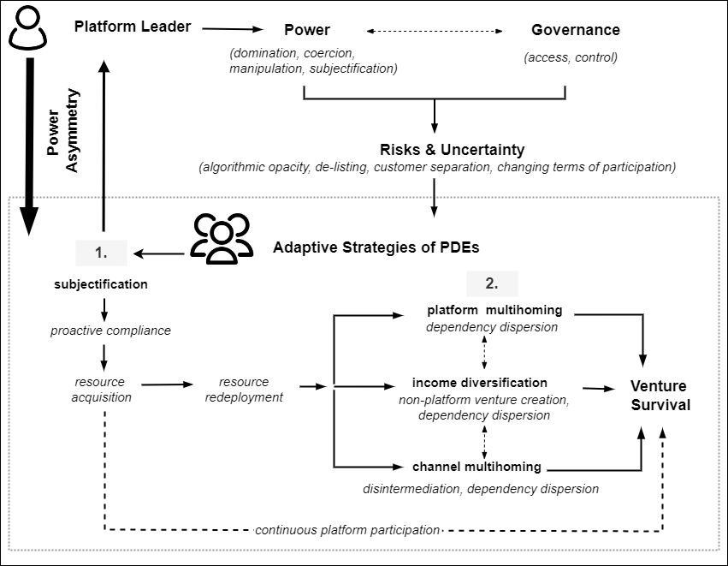
Figure 3 contributes to transaction platform theory (Gawer, 2014; Cusumano et al., 2019; McIntyre et al., 2021) by unveiling the mechanisms through which platform-dependent entrepreneurs (PDEs) adapt to risks and deep uncertainty emanating from power asymmetries and governance mechanisms (Jacobides et al., 2018, 2024). It begins by identifying four main risks of power asymmetries and related governance mechanisms such as access and control (O'Mahony & Karp, 2022) – algorithmic opacity, de-listing, customer separation, and unilateral changes in terms of participation (Cutolo & Kenney, 2021; Stark & Pais, 2021). Critical among them is the opacity of algorithmic governance mechanisms which remains most menacing, as it also presents an added layer of deep uncertainty (Teece et al., 2016). Deep uncertainty linked to opaque algorithmic governance is akin to a specter haunting venture survival in insidious ways. Hence, there is a difficulty of not knowing how or when algorithmic rules change, and what impact it might have on a PDE's venture – positive or negative. Likewise, its inherent opacity further compromises a PDE's ability to enact an agile response, putting them on a constant edge. Hence, an environment of Knightian uncertainty persists, marked by unknown unknowns that may foreshadow venture collapse (McMullen & Shepherd, 2006).
However, this study complements the view that PDEs do not simply surrender or subjectify (Nambisan & Baron, 2013) but adapt by enacting high levels of self-determination through business model innovation and long-term strategic thinking (Hurni et al., 2022). The adaptive strategies adopted, represent a complex and simultaneous interweaving of platform subjectification and power balancing through deliberate autonomy seeking.

Subjectification: Acquiescence-driven Adaptive Strategies
Subjectification emerges as an acquiescence-driven strategy that is a pivotal antecedent of autonomy-led strategies such as multihoming and diversification (see Figure 3, step 1). As noted, subjectification is a power dimension which influences individual identities, beliefs, and self-perceptions, aligning them with an ecosystem's prevailing norms and values (Fleming & Spicer, 2007, p. 13). Critically, scholars have noted that when integrated with agency, subjectification may mask a hidden power-balancing move that is potent, yet poorly understood (Newton, 1998; Ackroyd & Thompson, 1999). This longitudinal case study affirms this observation and elucidates how PDEs can strategically harnesses subjectification as an adaptive strategy by reframing it as a means to an end.
Through the mechanism of proactive compliance, subjectification can work to secure a PDE's venture standing on a transaction platform, especially at initial phases. This allows a PDE’s firm to generate necessary resources which are subsequently redeployed toward business model innovation, inoculating against risks of sudden collapse in the long term. Hence, strategic subjectification contributes to the realization of strategic agility, defined by Teece et al. (2016) as an organization’s capacity to efficiently and effectively acquire and redeploy resources toward value creation and capture. Therefore, observing subjectification only at early phases, or simply using short term cross-sectional snapshots, may mislead researchers into assuming that PDEs are simply surrendering. With the benefit of a decade-long temporal observation, this study reveals that subjectification is far from surrendering; but is rather the departure point for a long-term survival strategy that promotes resource acquisition and subsequent redeployment, deemed critical to enacting a PDE’s self-determination and venture resilience. Therefore, this study shows that subjectification can strategically deliver venture survival when applied as a temporary enabler of resilience-building, which materializes autonomy-driven strategies such as income diversification and multihoming (Weber & Tarba, 2014; Cennamo et al., 2018). Hence, we arrive at the following proposition (1A):
Proposition 1A: Subjectification is a default adaptive strategy, especially needed in the early phases of platform participation as it can enable PDEs to acquire and redeploy resources toward more autonomy-driven strategies that promote long term venture survival.
Furthermore, given the nature of power-dependence risks and uncertainty, subjectification can continue to promote venture survival and success when risks do not materialize. Therefore, subjectification can enable venture survival by providing the twin benefits of continuous platform participation and the cultivation of firm autonomy. However, although subjectification can drive venture survival, it is not considered reliable in the long run, compelling PDEs to enact their self-determination through autonomy-driven strategies that hinge on business model innovation. Hence, we arrive at a related proposition (1B):
Proposition 1B: Subjectification and its corresponding mechanism of proactive compliance can promote the survival of PDEs' ventures through the mechanisms of continuous platform participation, resource acquisition, and redeployment toward business model innovation.

Autonomy-driven Strategies & Power Balancing Mechanisms
Most crucially, the study identifies autonomy-driven adaptive strategies as vital to power-dependence risk mitigation and venture survival over the long term. These strategies include platform multihoming, income diversification, and channel multihoming (Cennamo & Santalo, 2013). Autonomy-driven strategies are concerned with developing a level of independence from a platform through disintermediation, dependency dispersion, and non-platform venture creation (see Figure 3, step 2). These strategies are partly motivated by the lack of trust, emanating from the tendency of platform owners to wield power unfairly, and the resulting uncertainty it creates. While the emerging research identifies autonomy-driven strategies as possible adaptive strategies through which PDEs mitigate risks of venture collapse, they seldom explain the causal mechanisms underlying their effectiveness (Cennamo et al., 2018; Cutolo & Kenny, 2021). Accordingly, this study highlights the causal mechanisms (disintermediation, dependency dispersion, & non-platform venture creation) by which such strategies prove effective.
Non-platform ventures are designed to adopt a different business and revenue model that is less reliant on a dominant platform but may simply disperse dependencies onto less risky ecosystems where platform competition has resulted in multiple competing platforms that break up monopolies – in this case, subscription model with dependencies on FinTech platforms – see Figure 2. Thus, dependency dispersion emerges as an interrelated mechanism of an income diversification strategy, allowing a PDE to build multiple redundancies that spread dependencies away from a dominant platform leader. Such redundancies inoculate against a sudden and total collapse of a PDE's firm, creating the capacity to enact an agile response. Similarly, platform and channel multihoming (Cennamo & Santalo, 2013; Cennamo et al., 2018), deliver venture survival by preventing collapse from overreliance on a dominant transaction platform. Meanwhile, channel multihoming is found to promote survival through a combination of two mechanisms: disintermediation and dependency dispersion. Disintermediation works by developing direct channels (e.g., owned websites, brand & mailing lists) that reduce reliance on a dominant transaction platform channel, while dependency dispersion expands other non-platform channels of customer acquisition and revenue generation, containing the risk of overreliance. Accordingly, we arrive at the following proposition:
Proposition 2: Multihoming and income-diversification are effective as long-term adaptive strategies for PDEs due to the mechanisms of disintermediation and dependency dispersion; but they may not be feasible at the initial stages of venture emergence due to resource limitations.

Theoretical Implications
The findings of this study make three main contributions to the platform literature at the nexus between power asymmetries, governance, dependency risks, and participant strategies on transaction platforms (Fleming & Spicer, 2014; Hurni et al., 2022; Teece, 2018; Nambisan, 2017; Nambisan et al., 2018; Cutolo & Kenney, 2021).
First, the study responds to increasing calls for research into the risks of platform participation and the strategies used to ameliorate them (Nambisan et al., 2018; Jacobides et al., 2018; Cutolo & Kenney, 2021; O’Mahony & Karp, 2022). Within the 'boundary conditions' (Tschang, 2021) of two of Google's dominant transaction platforms (AdSense and Search), it delves into the distinctive classes of venture survival risks experienced by PDEs, which prompt adaptive strategies. Therefore, while acknowledging the benefits of platform participation as in previous studies (Teece, 2018), it contradicts the prevailing wisdom that platform participation is usually beneficial (Ceccagnoli et al. 2012; Teece, 2018). By unraveling the dark side of dependency (Nambisan & Baron, 2021), it responds to the need for research into the risks and uncertainties involved (Cutolo & Kenney, 2021). Given the difficulty of observing how PDEs strategize to navigate dependency risks, this study benefits from deep access presented by insider participant inquiry, unveiling a decade of evolving risks linked to platform governance and the venture survival uncertainties they unleash. Centrally, it underscores the perniciousness of algorithmic governance risks (Gorwa, 2019; Gorwa et al., 2020; Stark & Pais, 2021) which can stall an effective response due to a lack of transparency, culminating in insights into adaptive strategies of PDEs.
Second, this study contradicts the predominant assumption that PDEs surrender (subjectify) much of their autonomy and align their business goals with the platform leader (Nambisan & Baron, 2013). Instead, it emphasizes the merits of emerging counterarguments which maintain that because the success of a platform also depends on the self-determination and proactiveness of PDEs as drivers of innovation (e.g., Hurni et al., 2022; Rahman et al., 2024) platform power dynamics are multidimensional (Fleming & Spicer, 2007, 2014). Critically, the findings underscore the value of subjectification as a first step in a journey of adaptation, which, when viewed over a short temporal duration, may have misled researchers into viewing it solely as surrendering rather than a strategic power play by PDEs. Therefore, while self-subjugation at the initial stages appears to be accepting a weaker power position, it is shown to be a vital resource acquisition strategy needed to build resilience (Weber & Tarba, 2014; Ghezzi & Cavallo, 2020). Consequently, the study affirms that power dynamics on transaction platforms is a process marked by the continuous wrestling between the platform leader's desire for control and the self-determination and proactivity of PDEs (Hurni et al., 2022).
Furthermore, this study emphasizes the need to consider the dynamic and multidimensional nature of power and governance (Foucault, 1982) when analyzing risks and adaptive strategies on platforms. It calls for a broader view of platform governance, encompassing both formal and informal mechanisms that shape the adaptive strategies of platform-dependent entrepreneurs over time (Cavallo et al., 2022). By highlighting governance as both formal (e.g., explicit rules, access control) and informal/relational (e.g., trust-building), the study provides a more holistic understanding of how governance influences the interactions between platform owners and participants. This expanded perspective enhances platform studies, governance theory, and entrepreneurial strategy by revealing how governance mechanisms not only generate risks but also foster resilience and adaptation in diverse digital ecosystems.
Third, the study departs from the predominant tendency to explore platform strategy and dynamic capabilities mainly from the platform leader's perspective (e.g., Eisenmann et al., 2011; Helfat & Raubitschek, 2018; Jacobides et al., 2018; Stark & Pais, 2021); instead shedding light into the strategies of participants such as PDEs, who battle incessantly with the risks and uncertainties of power asymmetries and the vicissitudes of changing governance mechanisms. Particularly, while dynamic capabilities encompass agility as a fundamental strategy for adaptation and survival (Weber & Tarba, 2014; Teece et al., 2016), it is less observed from the perspective of resource-constrained PDEs. By unveiling the evolving strategies and mechanisms by which PDEs implicate agility (i.e., first subjectify to acquire resources, then apply them toward resilience-building), this study contributes to a nuanced understanding of how participants leverage dynamic capabilities to navigate power asymmetries on transaction platforms.

Practical Implications
Finally, the study also offers practical value to aspiring entrepreneurs, platform leaders, and policymakers assuming distinct roles in platform ecosystems. First, the strategies that emerge from this study can form part of an aspiring PDE's toolkit which can be harnessed in enacting their self-determination on monopolistic transaction platforms. The study shows that survival on transaction platforms demands long-term strategic thinking which may begin with subjectifying toward resource acquisition and rapid redeployment in autonomy-inducing business model innovation. Therefore, PDEs operating in dominant platform ecosystems cannot afford to be complacent. They must recognize that even when all appears safe, collapse is never far away. Beyond the scope of this study, anecdotal evidence abounds of the sudden de-listing of PDEs from platforms such as Uber, Airbnb, and Apple's App Store, causing elevated levels of stress (Nambisan & Baron, 2021). Thus, leveraging our framework in Figure 3 as a strategic planning tool can facilitate the long-term inoculation of a PDE's firm against known risks.
Second, from a platform leader's perspective, the study highlights the challenges participants face on transaction platforms, such as the constant fear of sudden venture collapse, which might exacerbate the current backlash against platform leaders such as Apple and Amazon. Left unaddressed, such backlash results in participants enlisting governmental agents as power balancers who may introduce anti-trust regulations that undermine platform power eventually (Jacobides et al., 2024) – e.g., the EU's Digital Markets Act of 2022. Platform leaders can leverage the insights of this study to restore public trust, by pre-empting and alleviating hidden struggles that contribute to negative press. As self-governing entities, platform leaders can harness their power for good, cultivating a fairer ecosystem for all sides.
Furthermore, by unraveling how PDEs take a long-term strategic view in a two-step process from subjectification to autonomy, the study affirms assertions by Jacobides et al. (2024, p. 10) that endogenous governance failures through abusive power-wielding can contribute to the erosion of trust and the long-term undermining of platform power. Thus, this study further sheds light on the critical role of formal and informal governance mechanisms, such as trust-building, which can be harnessed to reposition platform power as a force for good. The study suggests that long-term adaptive strategies are primarily motivated by an erosion of trust, which introduces risks and uncertainties, leading PDEs to enact adaptive, autonomy-seeking behaviors. Therefore, trust-building and the restoration of lost trust can help current platform leaders overcome public misgivings about asymmetric platform power.

Conclusions
In this study, we explore the adaptive strategies that enable PDEs to mitigate risks from power asymmetries and dependency on dominant transaction platforms toward promoting venture survival. We leveraged deep access to a case setting to study the decade-long, and ongoing survival of a PDE's firm in EdTech. Consequently, we show that power dynamics on transaction platforms are multidimensional and highlight the strategic rebalancing by PDEs who contend with persistent venture survival risks. More importantly, our study emphasized that while platform dependency presents significant risks, PDEs are not merely passive actors surrendering to platform dominance, as often assumed. Rather, they can actively engage in strategic maneuvrings to adapt and promote venture survival. Since their adaptive strategies are seldom explored, we delve into the mechanisms by which PDEs enact their self-determination with a high degree of granularity. Thus, we contribute to shifting the focus of platform studies from an overemphasis on platform leaders' strategies to those of platform participants.
However, our research has limitations. First, the specific focus on a single firm and a pair of interrelated platforms owned by the same parent company (Alphabet) – Google Search and AdSense - underscores the limitations of our study. We anticipate that some of the strategies we identify may be more applicable under various ecosystem conditions but cannot be certain. For example, our case relates to platform relations which are virtual monopolies with no credible competitors to match. As such, we estimate that the pressure to adopt long-term strategic thinking regarding venture survival may be stronger than in ecosystems where monopolies have been partially decomposed. Under such ecosystem conditions, it is unknown how much power-dependence risks may be pronounced. Similarly, it is not clear how the presence of multiple competing platforms alters a PDE's perception of risk, and the motivation to enact particular strategies. Therefore, the conclusions of this study should be interpreted along the qualitative traditions of naturalistic generalizability, as opposed to statistical or law-like generalizations as in quantitative research (Lincoln & Guba, 1985). Future research can extrapolate and test the findings on other platforms and industries, enriching and enhancing the findings of this study, using a variety of research methods and designs, with the two main propositions of this study, offering a useful departure point for inquiry.
Declaration of generative AI and AI-assisted technologies in the writing process
The authors did not use ChatGPT or related generative AI technologies to author this paper. However, a variety of AI tools (Grammarly, Writefull & ChatGPT 4/Custom GPT) were used solely to enhance readability, check for typographical errors, reduce redundancies, and suggest improvements to sentences in the style of leading works in the platform literature.

References

Amit, R., & Zott, C. (2001). Value creation in e‐business. Strategic management journal, 22(6‐7), 493-520.
Bachrach, P., & Baratz, M. S. (1962). Two faces of power. The American Political Science Review, 56(2), 947–952. https://doi. org/10.2307/1952796
Baskerville, R., Vom Brocke, J., Mathiassen, L., & Scheepers, H. (2023). Clinical research from information systems practice. European Journal of Information Systems, 32(1), 1-9.
Berglund, H. (2007). Researching entrepreneurship as lived experience. Handbook of qualitative research methods in entrepreneurship, 3, 75-93.
Brannick, T., & Coghlan, D. (2007). In defense of being "native": The case for insider academic research. Organizational research methods, 10(1), 59-74.
Bucher, A. (2018) Google adsense class action settlement, Top Class Actions. Available at: https://shorturl.at/cqZ14 (Accessed: 07 August 2023).
Canhoto, A. I., Quinton, S., Pera, R., Molinillo, S., & Simkin, L. (2021). Digital strategy aligning in SMEs: A dynamic capabilities perspective. The Journal of Strategic Information Systems, 30(3), 101682.
Cavallo, A., Burgers, H., Ghezzi, A., & Van de Vrande, V. (2022). The evolving nature of open innovation governance: A study of a digital platform development in collaboration with a big science centre. Technovation, 116, 102370.
Ceccagnoli, M., Forman, C., Huang, P., & Wu, D. J. (2012). Cocreation of value in a platform ecosystem: The case of enterprise software. MIS Quarterly, 36(1), 263–290.
Cennamo, C., & Santalo, J. (2013). Platform competition: Strategic trade-offs in platform markets. Strategic Management Journal, 34(11), 1331–1350.
Cennamo, C., Ozalp, H., & Kretschmer, T. (2018). Platform architecture and quality trade-offs of multihoming complements. Information Systems Research, 29(2), 461-478.
Chung, H. D., Zhou, Y. M., & Ethiraj, S. (2023). Platform governance in the presence of within-complementor interdependencies: evidence from the rideshare industry. Management Science.
Clegg, S. R. (1989). Frameworks of power. SAGE Publications.
Cole, S. (2018) Google AdSense banned a random web page about a 32-year-old bill because it was about sexual abuse, VICE. Available at: https://www.vice.com/en/article/ne5j3z/google-adsense-banned-a-random-web-page-about-a-32-year-old-bill-because-it-was-about-sexual-abuse (Accessed: 31 July 2023).
Cusumano, M. A., Gawer, A., & Yoffie, D. B. (2019). The business of platforms: Strategy in the age of digital competition, innovation, and power (Vol. 320). New York: Harper Business.
Cutolo, D., & Kenney, M. (2021). Platform-dependent entrepreneurs: Power asymmetries, risks, and strategies in the platform economy. Academy of Management Perspectives, 35(4), 584-605.
Cyron, T. (2022). Using digital methods for the study of entrepreneurship-as-practice. In Research Handbook on Entrepreneurship as Practice (pp. 204-221). Edward Elgar Publishing.
Dahl, R. A. (1957). The concept of power. Behavioral Science, 2(3), 201–215.
Davidsson, P. (2016). Researching entrepreneurship. Cham: Springer.
Digeser, P. (1992). The fourth face of power. The Journal of Politics, 54(4), 977–1007.
Edmondson, A. C., & McManus, S. E. (2007). Methodological fit in management field research. Academy of management review, 32(4), 1246-1264.
Eisenhardt, K. M. (1989). Building theories from case study research. Academy of management review, 14(4), 532-550.
Eisenhardt, K. M., & Graebner, M. E. (2007). Theory building from cases: Opportunities and challenges. Academy of management journal, 50(1), 25-32.
Eisenhardt, K. M., & Martin, J. A. (2000). Dynamic capabilities: what are they?. Strategic management journal, 21(10‐11), 1105-1121.
Eisenmann, T., Parker, G., & Van Alstyne, M. (2011). Platform envelopment. Strategic management journal, 32(12), 1270-1285.
Eisenmann, T., Parker, G., & Van Alstyne, M. W. (2006). Strategies for two-sided markets. Harvard business review, 84(10), 92.
Emerson, R. M. (1962). Power-Dependence Relations. American Sociological Review, 31-41.
Ens, N., Hukal, P., & Blegind Jensen, T. (2023). Dynamics of control on digital platforms. Information Systems Journal.
Eshima, Y., & Anderson, B. S. (2017). Firm growth, adaptive capability, and entrepreneurial orientation. Strategic management journal, 38(3), 770-779.
Evers, N. (2011). International new ventures in "low tech" sectors: a dynamic capabilities perspective. Journal of Small Business and Enterprise Development.
Felin, T., & Zenger, T. R. (2014). Closed or open innovation? Problem solving and the governance choice. Research policy, 43(5), 914-925.
Fleming, P., & Spicer, A. (2007). Contesting the corporation: Struggle, power and resistance in organizations. Cambridge University Press.
Fleming, P., & Spicer, A. (2014). Power in management and organization science. Academy of Management Annals, 8(1), 237-298.
Foucault, M. (1982). The subject and power. Critical Inquiry, 8(4), 777–795.
FTC.gov (2023) FTC sues Amazon for illegally maintaining monopoly power, Federal Trade Commission. Available at: https://www.ftc.gov/news-events/news/press-releases/2023/09/ftc-sues-amazon-illegally-maintaining-monopoly-power (Accessed: 21 January 2024).
Gawer, A. (2014). Bridging differing perspectives on technological platforms: Toward an integrative framework. Research policy, 43(7), 1239-1249.
Ghezzi, A., & Cavallo, A. (2020). Agile business model innovation in digital entrepreneurship: Lean startup approaches. Journal of business research, 110, 519-537.
Google AdSense (2023) Google adsense - earn money from website monetization, Google. Available at: https://adsense.google.com/start/ (Accessed: 31 July 2023).
Gorwa, R. (2019). What is platform governance?. Information, communication & society, 22(6), 854-871.
Gorwa, R., Binns, R., & Katzenbach, C. (2020). Algorithmic content moderation: Technical and political challenges in the automation of platform governance. Big Data & Society, 7(1), 2053951719897945.
Graham, M. and Elias, J. (2021) How google's $150 billion advertising business works, CNBC. Available at: https://www.cnbc.com/2021/05/18/how-does-google-make-money-advertising-business-breakdown-.html (Accessed: 31 July 2023).
Grind, K. et al. (2019). How google interferes with its search algorithms and changes your results, The Wall Street Journal. Available at: https://www.wsj.com/articles/how-google-interferes-with-its-search-algorithms-and-changes-your-results-11573823753 (Accessed: 03 August 2023).
Helfat, C. E., & Raubitschek, R. S. (2018). Dynamic and integrative capabilities for profiting from innovation in digital platform-based ecosystems. Research policy, 47(8), 1391-1399.
Heron, J., & Reason, P. (2006). The practice of cooperative inquiry: Research' with'rather than 'on’people. Handbook of action research: Concise paperback edition, 144-154.
Huang, P., Ceccagnoli, M., Forman, C., & Wu, D. J. (2013). Appropriability mechanisms and the platform partnership decision: Evidence from enterprise software. Management Science, 59(1), 102-121.
Hurni, T., Huber, T. L., & Dibbern, J. (2022). Power dynamics in software platform ecosystems. Information systems journal, 32(2), 310-343.
Isaacson, W. (2011). Steve jobs. New York: Simon & Schuster.
Islam, H. A., Farrell, M., Nair, A., & Zhang, J. (2023). Understanding transaction platform governance and conflicts: A configuration approach. Technological Forecasting and Social Change, 189, 122382.
Jacobides, M. G., Cennamo, C., & Gawer, A. (2018). Towards a theory of ecosystems. Strategic management journal, 39(8), 2255-2276.
Jacobides, M. G., Cennamo, C., & Gawer, A. (2024). Externalities and complementarities in platforms and ecosystems: From structural solutions to endogenous failures. Research Policy, 53(1), 104906.
Jovanovic, M., Sjödin, D., & Parida, V. (2022). Co-evolution of platform architecture, platform services, and platform governance: Expanding the platform value of industrial digital platforms. Technovation, 118, 102218.
Justice.gov (2024) Justice Department sues Apple for monopolizing smartphone markets, Office of Public Affairs | Justice Department Sues Apple for Monopolizing Smartphone Markets | United States Department of Justice. Available at: https://www.justice.gov/opa/pr/justice-department-sues-apple-monopolizing-smartphone-markets (Accessed: 09 May 2024).
Katzenbach, C., & Ulbricht, L. (2019). Algorithmic governance. Internet Policy Review, 8(4), 1-18.
Klofsten, M., Urbano, D., & Heaton, S. (2021). Managing intrapreneurial capabilities: An overview. Technovation, 99, 102177.
Köhler, T., Smith, A., & Bhakoo, V. (2022). Templates in qualitative research methods: Origins, limitations, and new directions. Organizational Research Methods, 25(2), 183-210.
Langley, A. (1999). Strategies for theorizing from process data. Academy of Management review, 24(4), 691-710.
Lessard, D., Teece, D. J., & Leih, S. (2016). The dynamic capabilities of Meta‐multinationals. Global Strategy Journal, 6(3), 211-224.
Lincoln, Y. S., & Guba, E. G. (1985). Naturalistic inquiry. sage.
Linnenluecke, M. K. (2017). Resilience in business and management research: A review of influential publications and a research agenda. International Journal of Management Reviews, 19(1), 4-30.
Lukes, S. (1974). Power - A radical view. Macmillan.
McGee, P. (2022) Meta and alphabet lose dominance over US digital ads market, Financial Times. Available at: https://www.ft.com/content/4ff64604-a421-422c-9239-0ca8e5133042 (Accessed: 29 July 2023).
McIntyre, D., Srinivasan, A., Afuah, A., Gawer, A., & Kretschmer, T. (2021). Multi-sided platforms as new organizational forms. Academy of Management Perspectives, 35(4), 566-583.
McMullen, J. S., & Shepherd, D. A. (2006). Entrepreneurial action and the role of uncertainty in the theory of the entrepreneur. Academy of Management review, 31(1), 132-152.
Meyers, P. (2023) 9 years of the Google Algorithm, Moz. Available at: https://moz.com/blog/nine-years-of-google-algorithm (Accessed: 29 July 2023).
Montti, R. (2018) Google settles lawsuit alleging it unfairly kept adsense earnings, Search Engine Journal. Available at: https://www.searchenginejournal.com/adsense-lawsuit/248135/ (Accessed: 07 August 2023).
Myers, M. D. (2023). Introducing a new genre for EJIS. European Journal of Information Systems, 32(2), 107-107.
Nambisan, S. (2017). Digital entrepreneurship: Toward a digital technology perspective of entrepreneurship. Entrepreneurship theory and practice, 41(6), 1029-1055.
Nambisan, S., & Baron, R. A. (2013). Entrepreneurship in innovation ecosystems: Entrepreneurs’ self–regulatory processes and their implications for new venture success. Entrepreneurship theory and practice, 37(5), 1071-1097.
Nambisan, S., & Baron, R. A. (2021). On the costs of digital entrepreneurship: Role conflict, stress, and venture performance in digital platform-based ecosystems. Journal of Business Research, 125, 520-532.
Nambisan, S., Siegel, D., & Kenney, M. (2018). On open innovation, platforms, and entrepreneurship. Strategic Entrepreneurship Journal, 12(3), 354-368.
Newton, T. (1998). Theorizing subjectivity in organizations: The failure of Foucauldian studies?. Organization studies, 19(3), 415-447.
Nzembayie, K. F., & Buckley, A. (2022). Digital entrepreneurship: Disruption and new venture creation. Edward Elgar Publishing.
Ojala, A., Evers, N., & Rialp, A. (2018). Extending the international new venture phenomenon to digital platform providers: A longitudinal case study. Journal of World Business, 53(5), 725–739.
O'Mahony, S., & Karp, R. (2022). From proprietary to collective governance: How do platform participation strategies evolve?. Strategic Management Journal, 43(3), 530-562.
Parker, G. G., & Van Alstyne, M. W. (2005). Two-sided network effects: A theory of information product design. Management science, 51(10), 1494-1504.
Parker, G., Van Alstyne, M., & Jiang, X. (2017). Platform ecosystems. Mis Quarterly, 41(1), 255-266.
Pentland, B. T. (1999). Building process theory with narrative: From description to explanation. Academy of management Review, 24(4), 711-724.
Pentland, B. T., Recker, J., Wolf, J. R., & Wyner, G. (2020). Bringing context inside process research with digital trace data. Journal of the Association for Information Systems, 21(5), 5.
Pfeffer, J., & Salancik, G. R. (1978). The external control of organizations: A resource dependence perspective. New York: Harper & Row .
Polsby, N. W. (1963). Community power and political theory. Yale University Press.
Poole, M. S., Van de Ven, A. H., Dooley, K., & Holmes, M. E. (2000). Organizational change and innovation processes: Theory and methods for research. Oxford University Press.
Rahman, H. A., Karunakaran, A., & Cameron, L. D. (2024). Taming platform power: Taking accountability into account in the management of platforms. Academy of Management Annals, 18(1), 251-294.
Riessman, C. K. (2008). Narrative methods for the human sciences. Sage.
Rietveld, J., & Schilling, M. A. (2021). Platform competition: A systematic and interdisciplinary review of the literature. Journal of Management, 47(6), 1528-1563.
Saunders, M., Lewis, P. and Thornhill, A. (2016) Research methods for business students. 7th edn. Harlow: Pearson Education Limited.
Sayer, A. (1997). Critical realism and the limits to critical social science. Journal for the theory of social behaviour, 27(4), 473-488.
Schreieck, M., Ondrus, J., Wiesche, M., & Krcmar, H. (2023). A typology of multi‐platform integration strategies. Information Systems Journal.
Spradley, J. P. (2016). Participant observation. Waveland Press.
Srinivasan, A., & Venkatraman, N. (2018). Entrepreneurship in digital platforms: A network‐centric view. Strategic Entrepreneurship Journal, 12(1), 54-71.
Stark, D., & Pais, I. (2021). Algorithmic management in the platform economy. Sociologica, 14(3), 47-72.
StatCounter (2023) Search engine market share worldwide, StatCounter Global Stats. Available at: https://gs.statcounter.com/search-engine-market-share (Accessed: 31 July 2023).
Strauss, A., & Corbin, J. M. (1997). Grounded theory in practice. Sage.
Teece, D. J. (2018). Profiting from innovation in the digital economy: standards, complementary assets, and business models in the wireless world. Research Policy.
Teece, D. J., Pisano, G., & Shuen, A. (1997). Dynamic capabilities and strategic management. Strategic management journal, 18(7), 509-533.
Teece, D., Peteraf, M., & Leih, S. (2016). Dynamic capabilities and organizational agility: Risk, uncertainty, and strategy in the innovation economy. California management review, 58(4), 13-35.
Thompson, P., & Ackroyd, S. (1995). All quiet on the workplace front? A critique of recent trends in British industrial sociology. Sociology, 29(4), 615-633.
Timmermans, S., & Tavory, I. (2012). Theory construction in qualitative research: From grounded theory to abductive analysis. Sociological theory, 30(3), 167-186.
Tiwana, A., Konsynski, B., & Bush, A. A. (2010). Research commentary—Platform evolution: Coevolution of platform architecture, governance, and environmental dynamics. Information systems research, 21(4), 675-687.
Tschang, F. T. (2021). Platform-dependent entrepreneurs: Participants in an expanding universe of platforms?. Academy of Management Perspectives, 35(4), 696-701.
Urbano, D., Alvarez, C., & Turró, A. (2013). Organizational resources and intrapreneurial activities: an international study. Management Decision, 51(4), 854-870.
Van de Ven, A. H., & Engleman, R. M. (2004). Event-and outcome-driven explanations of entrepreneurship. Journal of Business Venturing, 19(3), 343-358.
Van Maanen, J., Sørensen, J. B., & Mitchell, T. R. (2007). The interplay between theory and method. Academy of management review, 32(4), 1145-1154.
Vanian, J. (2023) Amazon’s advertising business grew 19%, while Google and Meta both deal with slowdowns, CNBC. Available at: https://www.cnbc.com/2023/02/02/amazons-advertising-business-grew-19percent-unlike-google-meta.html (Accessed: 01 August 2023).
Wang, C. L., & Ahmed, P. K. (2007). Dynamic capabilities: A review and research agenda. International journal of management reviews, 9(1), 31-51.
Wang, R. D., & Miller, C. D. (2020). Complementors' engagement in an ecosystem: A study of publishers'e‐book offerings on Amazon Kindle. Strategic Management Journal, 41(1), 3-26.
Weber, M. (1947). The theory of social and economic organization. Oxford University Press.
Weber, Y., & Tarba, S. Y. (2014). Strategic agility: A state of the art introduction to the special section on strategic agility. California management review, 56(3), 5-12.
Wen, W., & Zhu, F. (2019). Threat of platform‐owner entry and complementor responses: Evidence from the mobile app market. Strategic Management Journal, 40(9), 1336-1367.
Zhang, Y., Li, J., & Tong, T. W. (2022). Platform governance matters: How platform gatekeeping affects knowledge sharing among complementors. Strategic Management Journal, 43(3), 599-626.
Zhu, F., & Iansiti, M. (2019). Why Some Platforms Thrives... and Others Don't What Alibaba, Tencent, and Uber teach us about networks that flourish. The five characteristics that make the difference. Harvard Business Review, 97(1), 118-125.

Appendices

Appendix A: Dependency Risks for PDEs in Google AdSense
Table 1. Dependencies and Risks on AdSense
Aspects | Details
Platform market power & dependency | PDEs heavily depend on Google AdSense for revenue. V2, since its launch in late 2012, generated over a million US dollars from AdSense. AdSense’s ease of use and market dominance make it a preferable choice despite risks. The platform’s monopoly is evident with its significant global online advertising market share, alongside Facebook. Google and Facebook commanded nearly 50% of the global advertising market in 2020, and in the same year Alphabet (Google0 generated an estimated 80% of its revenue from online advertising (e.g., McGee, 2022; Vanian, 2023)
AdSense revenue sharing model | AdSense operates as a virtual monopoly, especially in the advertising business model, connecting directly with content publishers. It allows publishers to monetize their website content by embedding code for targeted ads. Around 2 million publishers use AdSense. The platform offers 68% revenue share for direct website ads and 51% for search ads. Advertisers and publishers are kept separate, giving Google full control over both market segments.
Dependency risks for dependent ventures | PDEs face risks like de-listing, changing terms, separation from advertisers, and algorithmic policy enforcement errors. These risks lead to a constant fear of account banning. Despite proactive compliance, the threat of de-listing persists. PDEs have little control and lack transparency over AdSense's algorithmic governance, leading to potential misjudgements and wrongful bans.
Impact of AdSense ban | An AdSense ban is devastating, worsened by the opaque nature of algorithmic governance. The lack of transparency makes it difficult to understand the cause of policy violation warnings or bans. Several archival records and personal narratives from PDEs reveal the distress and significant impact of such bans. Alternatives to AdSense exist but often fail to match its financial returns.
Insider narrative | We live in constant fear of being banned from the AdSense program for reasons beyond our control or something we missed due to frequent changes in policy. Since 2012, we have had over 7 policy warnings... We are proactive and responsive in staying compliant. There is no other platform like AdSense, so banning us would be disastrous. However, Google appears to use policy enforcement algorithms that work well for the most part but are sometimes a hit-and-miss. On one occasion, suspected algorithmic policy detectors falsely singled out our web pages for violations and suspended ad-serving. We failed to find the supposed violations and simply requested a Google review, which concluded that our page was compliant and ad serving restored...
Triangulated case narratives from banned ventures | Case 1 (nichepursuits.com) - In early April, I got the dreaded email from Google AdSense that stated in part this: ‘After reviewing our records, we've determined that your AdSense account poses a risk of generating invalid activity... we've found it necessary to disable your AdSense account. Your outstanding balance and Google's share of the revenue will both be fully refunded back to the affected advertisers.’ …Clicking on your own ads or asking friends and family to do so is a quick way to get your AdSense account banned. But, the traffic sources for my sites are pretty much 100% organic traffic from search engines and I NEVER click on my own ads or ask others to do so. So, looking at things from my own end I'm confident I don't have fake traffic that's causing the AdSense team at Google to flag me up for invalid clicks. I've actually been using AdSense now for over 15 years and have never had issues in the past. All I can say is that Google has obviously changed something on their end…I started testing AdSense alternatives … Some of these performed better than others, but none were ever very close to the high payouts that I was earning from AdSense”.  Case 2 (monetizepro.com)- “The worst thing was that I was not cheating the system, heck I did NOT even once click on my own ads on my site…ever! I navigated around my website like I was walking on eggshells. I took an AdSense course to make sure I set everything up correctly and maximized my CPM’s. It was either some organic level of bot traffic that spiked on my site, a bad traffic source(s) or a rogue competitor who decided to buy fake traffic with the goal of eliminating me as a competitor.”

Appendix B: AdSense - Thematic Narrative Analysis
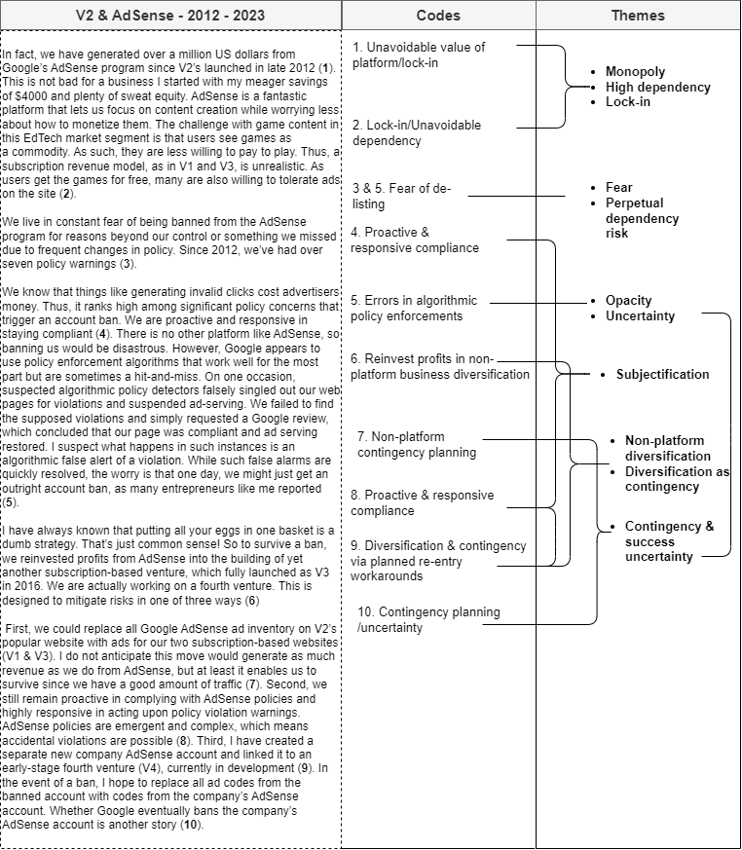

Appendix C: AdSense Triangulation - Thematic Narrative Analysis
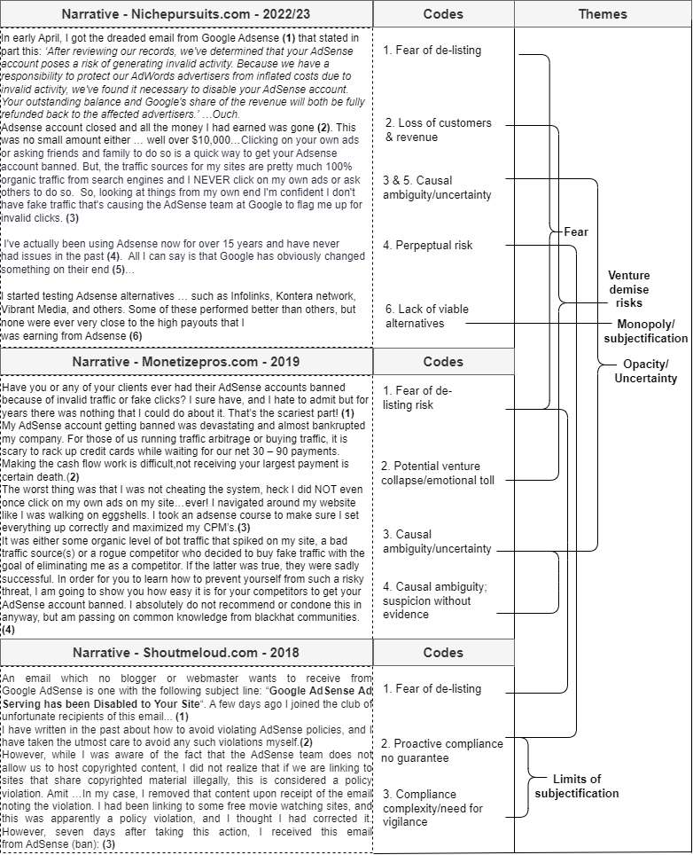

Appendix D: Google Search - Thematic Narrative Analysis
