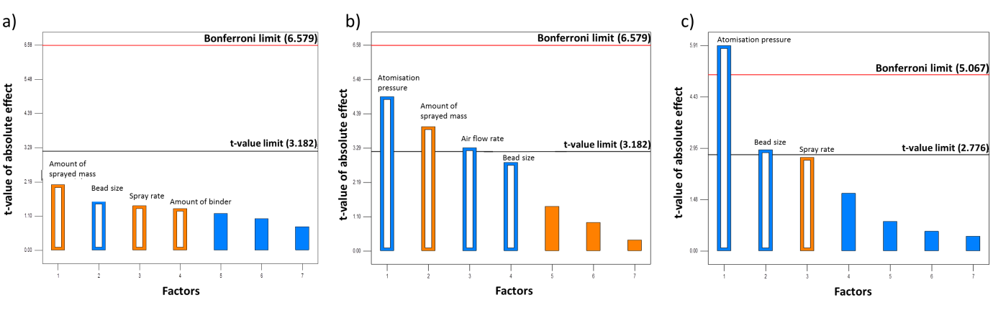 Figure 1. Pareto charts depicting the influence of the seven factors assessed on the Taguchi DOE design. Key: a) Degree of crystallinity; b) Loading efficiency and c) Attrition expressed as intact beads recovered after the coating process. Orange bars represent a positive effect of the factor on the response while blue bars represent a negative effect. (For interpretation of the references to colour in this figure legend, the reader is referred to the web version of this article.)

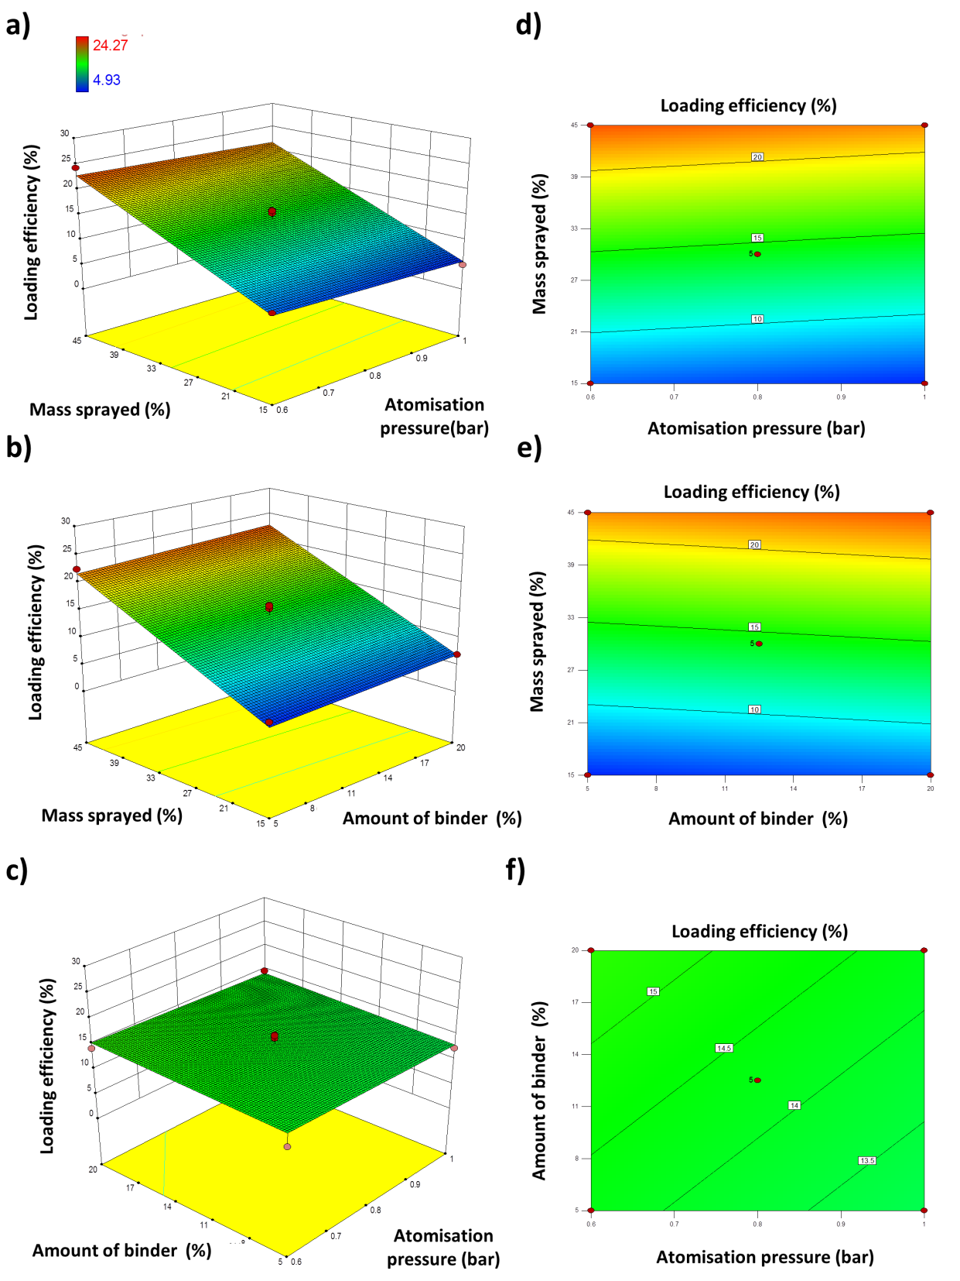
Figure 2. 3D response surface (a, b, c) and 2D contour plots (e, f, g) showing the influence of the atomization pressure, the amount of sprayed mass and the amount of binder on the loading efficiency.

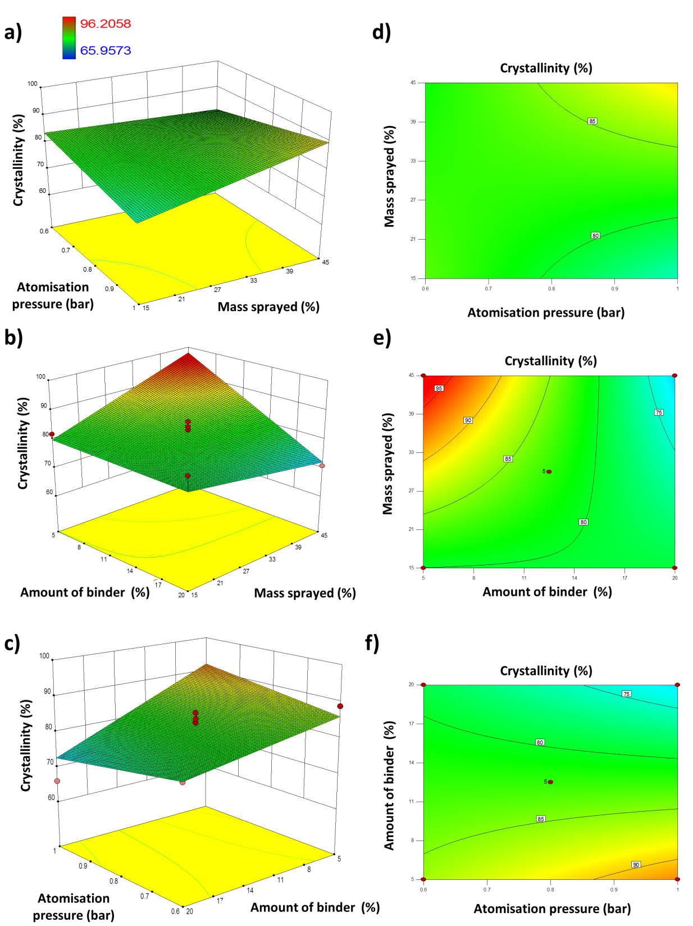

Figure 3. 3D response surface (a, b, c) and 2D contour plots (e, f, g) showing the influence of the atomization pressure, the amount of sprayed mass and the amount of binder on the degree of crystallinity.

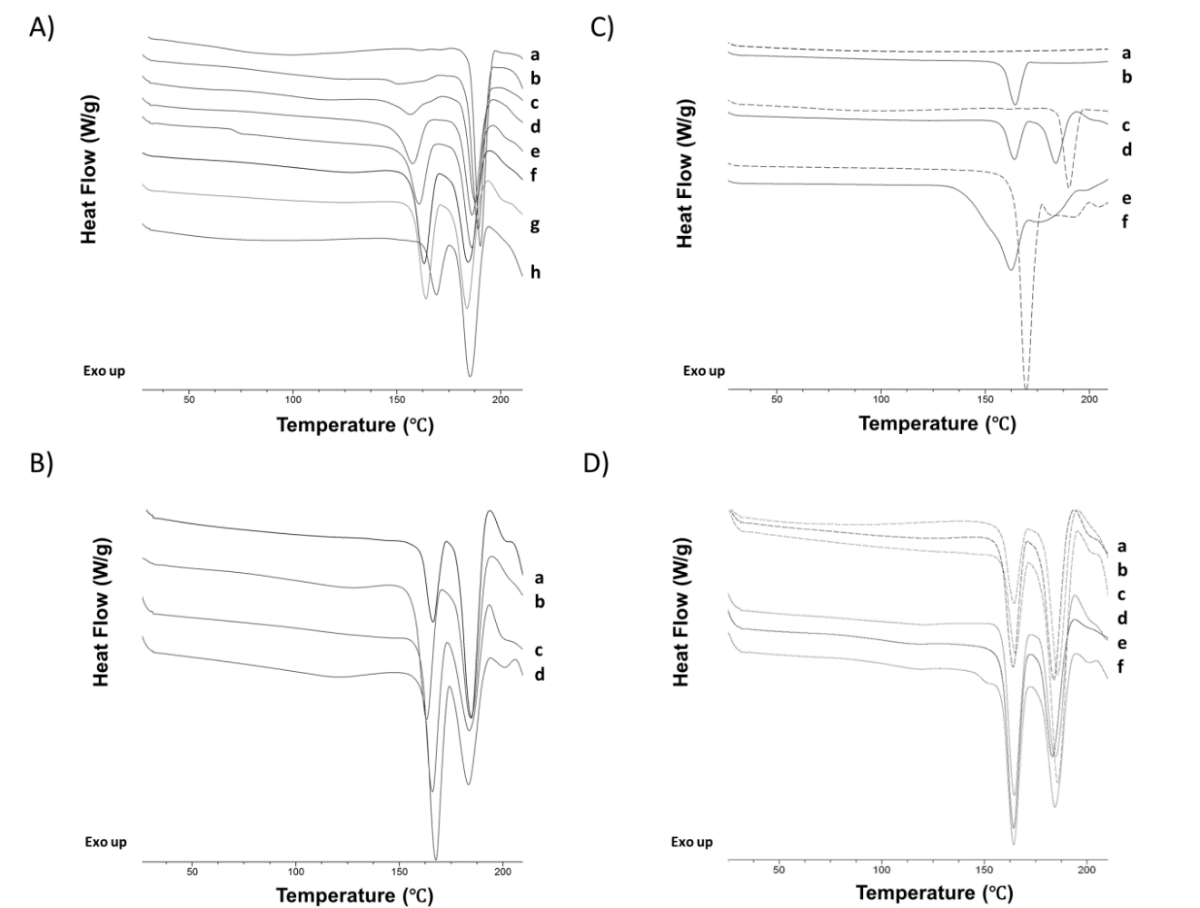

Figure 4. DSC thermograms. A) Effect of binder concentration on 500 µm non-pareil sugar beads. a-Uncoated beads; b-Beads coated with 50% cocrystal:50% PVP; c- Beads coated with 60% cocrystal:40% PVP; d-Beads coated with 70% cocrystal:30% PVP; e-Beads coated with 80% cocrystal:20% PVP; f-Beads coated with 90% cocrystal:10% PVP; g-Beads coated with 95% cocrystal:5% PVP; h- Beads coated with 100% cocrystal:0% PVP. B) Effect of different types of binder on 500 µm beads. a- Sugar beads coated with 90% cocrystal:10% Inulin; b- Sugar beads coated with 90% cocrystal:10% PVP; c- Sugar beads coated with 90% cocrystal:10% Eudragit L100-55; d-Sugar beads coated with 90% cocrystal:10% HPMC AS. C) Effect of 500 µm bead composition. a- Uncoated microcrystalline beads; b- Microcrystalline beads coated with 95% cocrystal:5% PVP; c- Uncoated sugar beads; d- Sugar beads coated with 95% cocrystal:5% PVP; e—Uncoated tartaric acid beads; f- Tartaric acid beads coated with 95% cocrystal:5% PVP. D) Effect of bead size and scale-up. a- 5g-Batch of sugar beads 250 µm coated with 95% cocrystal:5% PVP; b- 5g-Batch of sugar beads 500 µm coated with 95% cocrystal:5% PVP; c- 5g-Batch of sugar beads 1000 µm coated with 95% cocrystal:5% PVP; d- 25g-Batch of sugar beads 250 µm coated with 95% cocrystal:5% PVP; e-25g-Batch of sugar beads 500 µm coated with 95% cocrystal:5% PVP; f- 25g-Batch of sugar beads 1000 µm coated with 95% cocrystal:5% PVP.

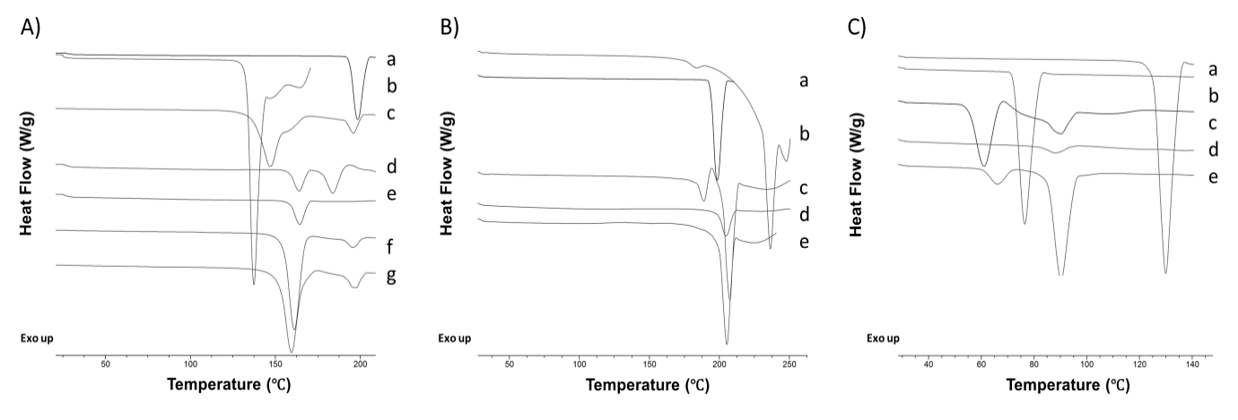
Figure 5. DSC thermograms. A) SDM:4ASA cocrystal. a- SDM raw material; b- 4ASA raw material; c-Physical mixture of SDM:4ASA in 1:1 molar ratio; d- 500 µm sugar beads coated with 95% SDM:4ASA cocrystal:5% PVP; e- 500 µm microcrystalline beads coated with 95% SDM:4ASA cocrystal:5% PVP; f-SDM:4ASA cocrystal obtained by spray drying; g- SDM:4ASA cocrystal obtained by solvent evaporation. B) SDM:NA cocrystal. a-NA raw material; b- SDM raw material; c- Physical mixture of SDM:NA in 1:1 molar ratio;.d- 500 µm microcrystalline beads coated with 95% SDM:NA cocrystal:5% PVP; e-SDM:NA cocrystal obtained by spray drying. C) IBU:NAM cocrystal. a-NAM raw material; b- IBU raw material; c- Physical mixture of IBU:NAM in 1:1 molar ratio; d- 500 µm sugar beads coated with 95% IBU:NAM cocrystal:5% PVP; e-SDM:NA cocrystal obtained by solvent evaporation.

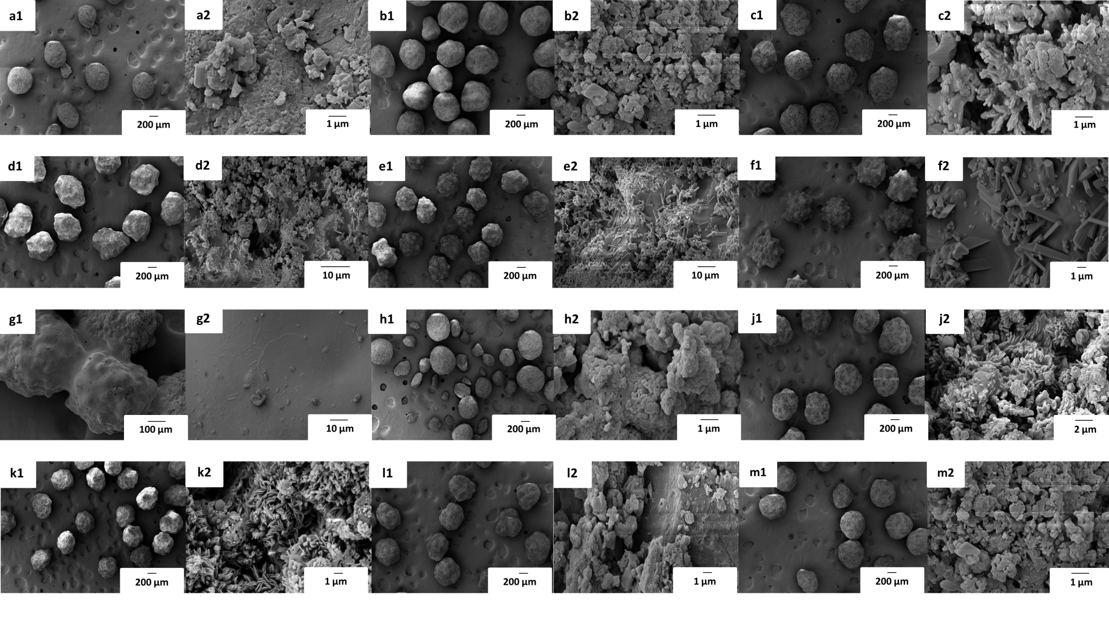
Figure 6. Micrographs of SDM:4ASA cocrystal-coated beads 500 µm. a) Sugar beads coated with 100% cocrystal:0% PVP; b) Sugar beads coated with 95% cocrystal:5% PVP; c) Sugar beads coated with 90% cocrystal:10% PVP; d) Sugar beads coated with 80% cocrystal:20% PVP; e) Sugar beads coated with 70% cocrystal:30% PVP; f) Sugar beads coated with 60% cocrystal:40% PVP; g) Sugar beads coated with 50% cocrystal:50% PVP; h) Sugar beads coated with 90% cocrystal:10% Inulin; j) Sugar beads coated with 90% cocrystal:10% HPMC AS; k) Sugar beads coated with 90% cocrystal:10% Eudragit; l) Tartaric acid beads coated with 95% cocrystal:5% PVP; m) Microcrystalline cellulose beads coated with 95% cocrystal:5% PVP.
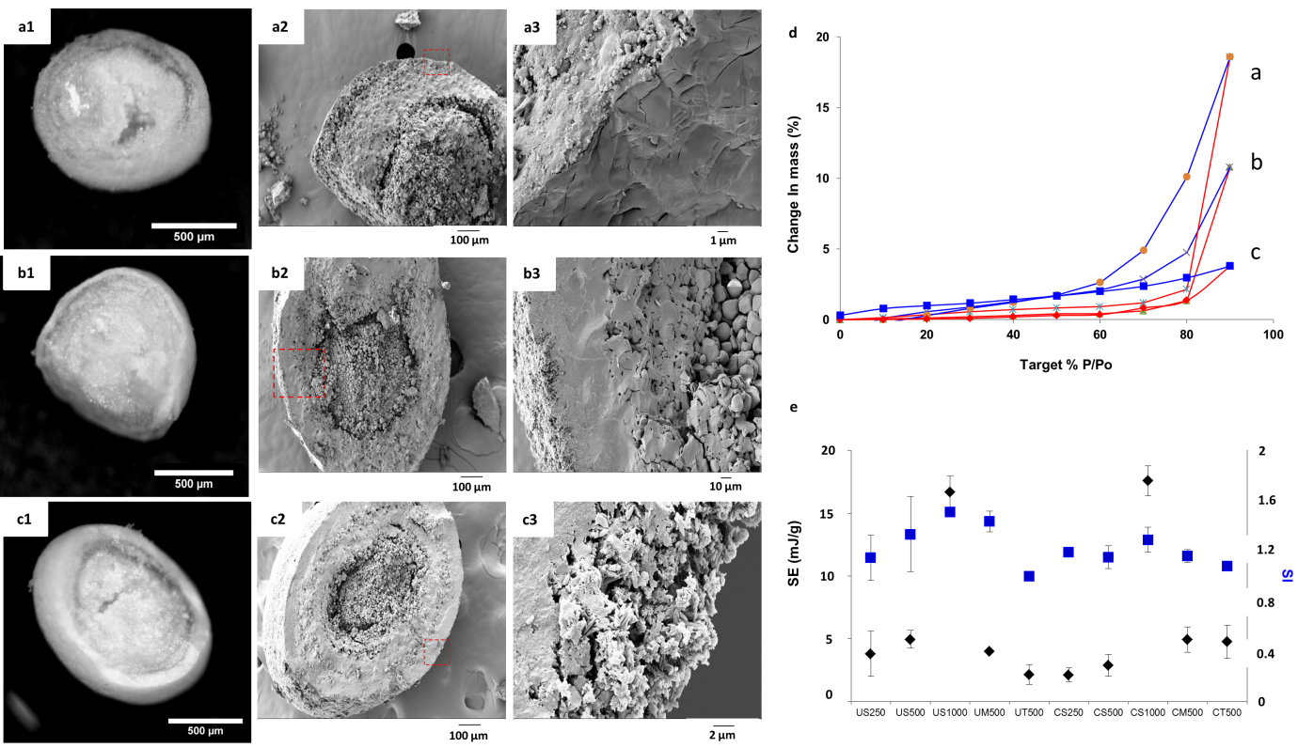
Figure 7. DVS profile and imaging of uncoated and coated non-pareil sugar 1000 µm beads. A) Optical (a1) and SEM image (a2, a3) of uncoated sugar beads; B) Optical (b1) and SEM image (b2, b3) of 5g-Batch of sugar beads coated with 95% cocrystal:5% PVP; C) Optical (c1) and SEM image (c2, c3) 25g-Batch of sugar beads coated with 95% cocrystal:5% PVP; Micrographs 3 correlate with the magnification of the red square of micrographs 2. D) Moisture sorption (blue line) and desorption (red line) proﬁles of: a- uncoated (blank) sugar beads 500 µm, b-5g-Batch of sugar beads 500 µm coated with 95% cocrystal:5% PVP, c- 25g-Batch of sugar beads 500 µm coated with 95% cocrystal:5% PVP. E) SE (-♦-) and SI (-■-) values for uncoated beads and 25 g batch 4SDM:4ASA cocrystal coated beads. Key: U-uncoated, C-coated, S-sugar, M-microcrystalline cellulose, T-tartaric acid, 250- 180-250 µm bead size, 500- 425-500 µm bead size and 1000- 850-1000µm bead size.

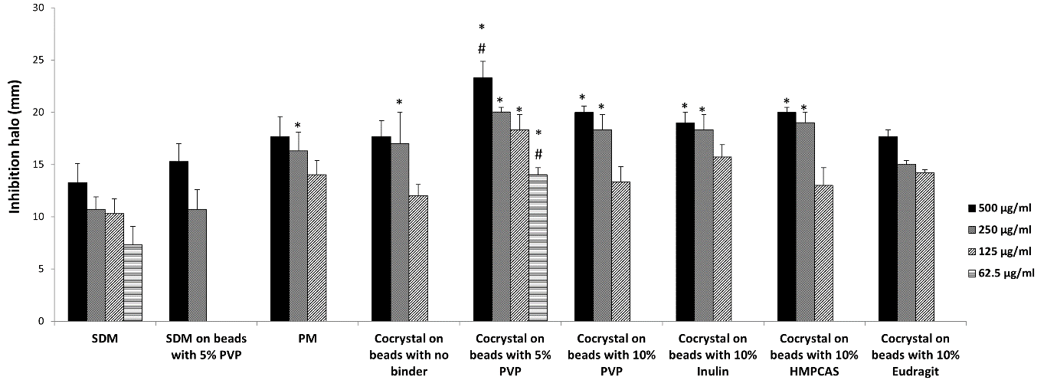
A
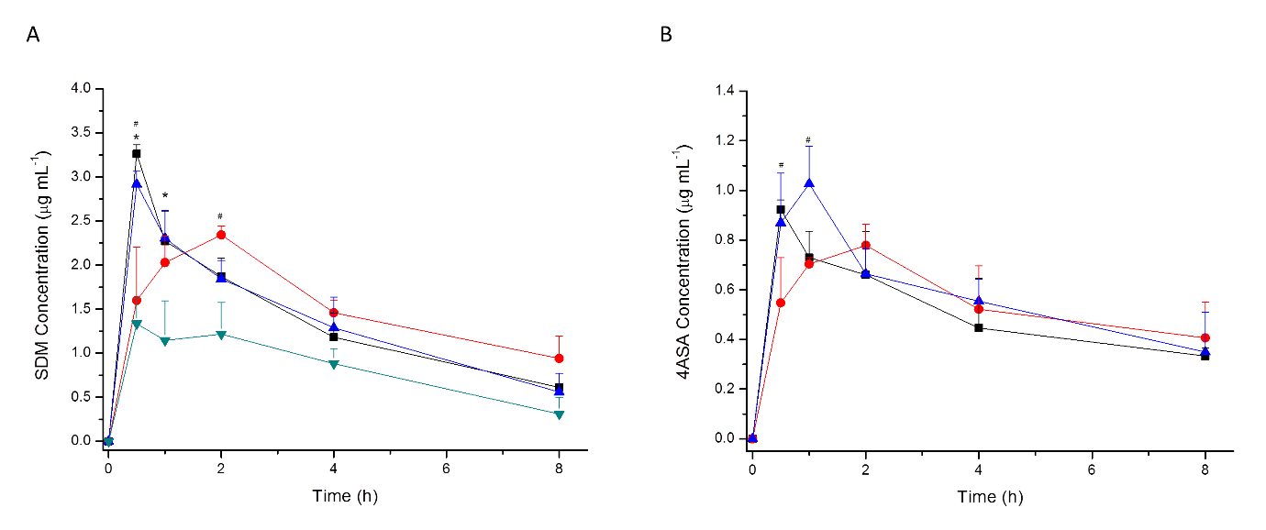
C
B
Figure 8 (A) In vitro antimicrobial activity against S. aureus. In all cases, the efficacy of SDM:4ASA 1:1 molar ratio cocrystal was tested on non-pareil sugar 500 µm beads. Key: SDM, raw material; PM, physical mixture of SDM and 4ASA in 1:1 molar ratio; * p<0.05 compared to SDM; (B&C) SDM:4ASA cocrystal pharmacokinetic profile after single dose oral administration of 15 mg/kg for SDM and 8.3 mg/kg for 4ASA in CD-1 mice. Formulations tested: Polymorph II cocrystal-coated on non-pareil sugar beads (-▲-), polymorph I cocrystal generated by milling (-■-), polymorph II cocrystal generated by spray drying (-●-) and raw SDM (-▼-). A) SDM plasma concentrations. B) 4ASA plasma concentrations. Statistically signiﬁcant diﬀerences: * = p < 0.05 versus SDM; # = p < 0.05 versus PII-SD.

