Controlling defect and dopant concentrations in graphene by remote plasma treatments
John B. Mc Manus ¹, Alison Hennessy¹, Conor P.Cullen¹, Toby Hallam², Niall McEvoy¹, and Georg S. Duesberg^{*1,3}
¹ School Chemistry, Centre for Research on Adaptive Nanostructures and Nanodevices (CRANN) and Advanced Materials and Bioengineering Research (AMBER), Trinity College Dublin, Dublin 2, Ireland
² School of Electrical and Electronic Engineering, Newcastle University, Newcastle upon Tyne, United Kingdom
³ Institute of Physics, EIT 2, Faculty of Electrical Engineering and Information Technology, Universität der Bundeswehr, München, Germany

Keywords graphene, plasma treatment, nitrogen doping, graphene transistor, CVD

This report details the controllable doping of graphene through post-growth plasma treatments. Defects are controllably introduced into the lattice using argon plasma, following this sample are exposed to ammonia/hydrogen plasma. During this nitrogen atoms get incorporated causing partial restoration of the graphene lattice. The damage levels are characterised by Raman and X-ray photoelectron spectroscopies. The incorporation of nitrogen into the graphene lattice provides significant n-doping. This is confirmed by the fabrication of graphene field-effect transistors which show clear n-type behaviour and mobilities not significantly less than those of pristine graphene. Thus this work demonstrates the viability of plasma treatments to reliably dope graphene.

1 Introduction Graphene has been extensively studied over the last 15 years and has paved the way for novel electronic devices based on 2D materials. Despite the growing realisation that graphene cannot live up to all of its heralded promise, it still has the ability to revolutionise numerous areas of research. Real strides have been made towards making graphene industrially relevant in areas such as electrocatalysis, biological sensors, fuel cells and field emission sources [1, 2].
These applications require graphene to be modified and tailored to perform optimally. One of the fundamental ways to modify semiconductors is doping. While doping may be achieved in many ways, one large-scale, non-volatile approach is modification by exposure to plasma. Plasma treatments allow for controlled introduction of dopants or functionalities into the graphene without the need for wet chemical steps[2].
Most plasma treatments modify graphene by breaking sp² bonds, providing the opportunity for other atoms or functional groups to be incorporated into the lattice[3]. Mild plasma treatments have also been used to remove polymer residue and other contaminants from graphene’s surface to improve its electrical properties, without causing large-scale damage[4].
A range of gases can be used to form the plasma depending on the desired outcome. Certain plasmas, such as argon, serve to simply introduce damage to the lattice, while others such as nitrogen or oxygen can substitute for a carbon atom, mimicking doping in 3D semiconductors.
Graphene treated with oxygen plasma becomes p-doped due the electron with-drawing nature of the bonded oxygen species, as outlined by Nourbaksh et al.[5]. At higher levels of oxygen functionalisation, the presence of a bandgap was also detected. The use of plasma to n-dope graphene with nitrogen atoms has previously been shown by a number of groups[6]. Kato et al. investigated the edge functionalisation and doping of graphene nanoribbons. They used room-temperature NH₃ plasma to controllably functionalise, predominantly edge sites [7]. Zeng et al. used nitrogen plasma to change the work function of graphene through the introduction of increased concentrations of graphitic N, increasing the electron concentration[8]. Ammonia plasma has also been used to electron dope graphene. Lin et al. demonstrated doping of mechanically exfoliated graphene by post-growth exposure to ammonia plasma and characterised the C-N bond types present intensively[9].
In this report we follow the work of McEvoy et al. and focus on the plasma doping of graphene with nitrogen in a controllable manner[10]. Our method involves a two-step process whereby we first introduce damage into the graphene lattice with argon plasma and then simultaneously heal the defects and dope the graphene with a combined NH₃/H₂ plasma. As the samples are situated downstream of the source, the plasma has lost much of its kinetic energy before interacting with the sample, ensuring limited damage[11]. We systematically examine the defect creation and doping through Raman spectroscopy and X-ray photoelectron spectroscopy (XPS). Finally, the electrical properties and doping levels of the argon damaged and nitrogen doped samples are confirmed by graphene field effect transistor (GFET) device measurements.
2 Experimental
2.1 Graphene growth Graphene was grown using a method similar to that described previously [12];[13]. Briefly, graphene was grown by CVD on 25μm copper foil. The samples were placed in a tube furnace where the temperature is increased to 1035˚C under H₂ flow (50 sccm, 0.4 Torr). The samples were then annealed at this temperature for 60 minutes followed by a 30 minute growth phase with H₂ (5 sccm) and CH₄ (10 sccm) gas flow at ~0.2 Torr. The furnace was then cooled to room temperature under 3 sccm H₂ flow. The samples were transferred to Si/SiO₂ wafers by spinning on a PMMA layer and then etching the Cu foil in ammonium persulfate solution, the details of which can be found in [14].
2.2 Plasma treatment An R³T TWR 2000T microwave radical generator was used to perform the plasma treatment of the graphene. During Argon plasma exposure the conditions were typically 200 sccm of Ar gas with a chamber pressure of ~2 Torr. While for the NH₃/H₂ plasma 50 sccm of each gas was used giving a pressure of ~1 Torr. For NH₃ plasma, 100 sccm was used and again ~1 Torr pressure. Samples were positioned ~30 cm downstream of the plasma source meaning that no direct heating of the samples took place. Furthermore the generated ions are energetically relaxed by this point, reducing surface damage.
2.3 Characterisation and analysis A Witec Alpha 300R with a 532 nm excitation laser, with a power of ~1 mW, was used to collect the Raman spectra shown herein. All Raman measurements were taken after samples were transferred to SiO₂ and using a spectral grating with 600 lines/mm and a 100x objective lens. Raman maps were generated by taking scans every 250 nm in the x and y directions, typically over an area of 20 x 20 μm. Spectra shown are averages over these maps, with ~10,000 spectra being used for each.
XPS was performed on graphene samples on Cu foil to avoid the polymer contamination usually associated with transferred films. It was carried out using monochromated Al Kα X-rays from an Omicron XM1000 MkII X-ray source and an Omicron EA125 energy analyser. An Omicron CN10 electron flood gun was used for charge compensation and the binding energy scale was referenced to the copper 2p_{3/2} core-level at 932.6 eV. Core-level scans were recorded with analyser pass energy of 15 eV. Analysis was performed using CasaXPS software. Graphene was fitted with an asymmetric line shape due to its metallic nature; all other components were fitted using 30% Gaussian-Lorentzian line shapes. Relative atomic percentages were calculated using the relative sensitivity factors provided by the software CasaXPS.
All electrical measurements were carried out with a Janis probe station in vacuum (~10⁻⁵ mbar). GFET electrodes (Ti/Au 5/40 nm) were deposited after plasma treatment by electron beam evaporation and patterned using shadow masking.

3 Results and discussion Graphene growth was carried out on Cu foils followed by polymer supported transfer[12];[13].The Raman spectrum of pristine, transferred graphene on SiO₂ is shown in Fig. 1(a). The primary features of the spectrum are sharp and well characterised 2D (~2680 cm⁻¹) and G (~1590 cm⁻¹) peaks. The 2D peak can be fitted with a single Lorentzian, FWHM 31cm⁻¹, in agreement with other reports of monolayer graphene with some defect-induced broadening [12, 15]. The intensity ratio of the 2D to G peaks is ~1.2. This is less than the usually quoted value of above 2 for monolayer graphene, however this may be due to damage of the film during polymer transfer or doping from any remaining polymer residue[16]. While the graphene is predominantly monolayer in nature, small areas of bilayer islands are observed. These are visible in Figure 1 (d) and also Fig.S1 in the supplementary information. For consistency only the monolayer regions were analysed in the results.

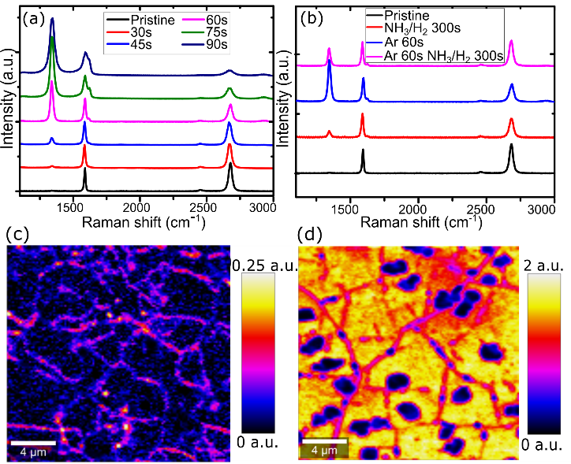
Figure 1 (a) Raman spectra of pristine graphene and after various exposure times of Ar plasma on SiO₂. All spectra are normalised to the G peak intensity. (b) Raman spectra of graphene treated by NH₃/H₂ and/or Ar plasma. All normalised to the G peak intensity. (c-d) Raman maps of I_{D/G} intensity of pristine graphene and graphene after 60 seconds Ar exposure respectively. Bilayer islands are visible as regions of low intensity in (d).
In perfect sp² carbon systems, like graphene, the D peak is Raman forbidden. It becomes activated by a single-phonon intervalley scattering process, when momentum conservation is satisfied by the presence of defects[17]. The variation of D to G ratio with carbon crystalline size was first explored by Tuinstra and Koenig[18] and the ratio of the intensity of the D to G peak, I_{D/G}, is now often used as a measure of the defect density and quality of graphene. In this sample, the I_{D/G} is less than 0.02 indicating the low defect level and high crystallinity of the graphene[15].

The graphene samples were treated with downstream, argon plasma for different durations ranging from 30 to 90 seconds. The evolution of the Raman spectrum of graphene, scaled to the G peak intensity, is shown in Fig. 1(a). The most noticeable change is the dramatic increase in the intensity of the D peak with increasing plasma exposure. This indicates an increase in defect levels due to the plasma radicals damaging the graphene[17]. Examining the D to G intensity ratio, I_{D/G}, it is found to increase gradually from below 0.2 to approximately 4 when the Ar exposure time is increased. This gradual increase is an attribute of the strong level of control possible in this system for introducing defects into monolayer graphene.
The 2D peak intensity is sensitive to electron scattering rates in the graphene. With increasing Ar exposure the 2D peak is observed to broaden and reduce in intensity, consistent with increasing defect concentration inducing higher scattering rates[19]. The D’ peak (~1620 cm⁻¹) is also evident in the Raman spectra after more than 60 seconds of Ar plasma treatment. The D’ peak is activated by a single-phonon intravalley scattering process, and, similar to the D peak, defects are required to satisfy momentum conservation. The ratio of the integrated areal intensity of the D to D’, A_{D/D’}, can be related to the type of defects present in the sample[17]. When the D and D’ peaks were fitted, A_{D/D’} was found to be above 13, indicating the predominance of sp³ type carbon defects in the sample.
Fig. 1(c-d) show Raman maps of the D to G peak intensity ratios of pristine graphene and graphene treated with 60 seconds of Ar plasma respectively. The pristine sample shows a very low I_{D/G} intensity throughout, with the grain boundaries visible as the only areas showing any significant defect concentration. After 60 seconds in Ar plasma, the D peak intensity is greatly increased, the scale of this image is over an intensity range 8 times larger than that of the pristine sample. The areas of lowest intensity are bilayer islands which are much more resistant to plasma damage. Interestingly the grain boundaries are now also areas with lower I_{D/G}, in contrast to the image of the pristine graphene.
Plasmas have previously been used to successfully incorporate nitrogen atoms into the lattice of graphene[9, 20]. However, the treatment of graphene by ammonia plasma alone forms very few substitutional N sites, and those which do form show a preference for edges and pre-existing defects, making it inappropriate as a general approach for doping[7]. In our previous work, we have shown that oxygen plasma followed by NH₃/H₂ is an effective way to introduce N atoms into the graphitic lattice. However oxygen can chemically react to form oxygen functionalities such as carboxyl, carbonyl, hydroxyl groups, and can also remove carbon atoms as CO or CO₂ leading to irreversible damage[4]. To avoid this, Ar plasma is used to introduce controllable, randomly distributed defects to the graphene. The Ar does not chemically bind to the surface, leaving the sites available for the subsequent ammonia plasma to react. NH₃/H₂ plasma, was used as previous work had found that along with incorporating N atoms, this plasma also serves to heal defects in the graphene.[10].
Fig. 1(b) shows the Raman spectra of samples treated with various combinations of Ar and NH₃/H₂ plasmas. In line with earlier reports, the spectra of the sample treated with 300 seconds NH₃/H₂ only has a small D peak component and marginally reduced 2D peak. To introduce a controllable population of vacancy defects, and to provide more available sites for incorporation of N atoms throughout the graphene, rather than predominantly at edge sites, the graphene was pretreated with Ar plasma.[21] As expected the sample becomes much more defective following Ar treatment, but notably, following the NH₃/H₂ plasma, the D peak intensity was reduced and the 2D peak was somewhat restored due to N atoms being incorporated into the lattice. While not the primary focus of this study, a comparison between the effect of graphene exposed to Ar and NH₃ only and exposed to Ar and NH₃/H₂ is shown in Fig.S2. Both show a qualitatively similar trend in the Raman spectra. The XPS analysis, Fig.S3, also shows the same components present with minor differences in relative intensities.
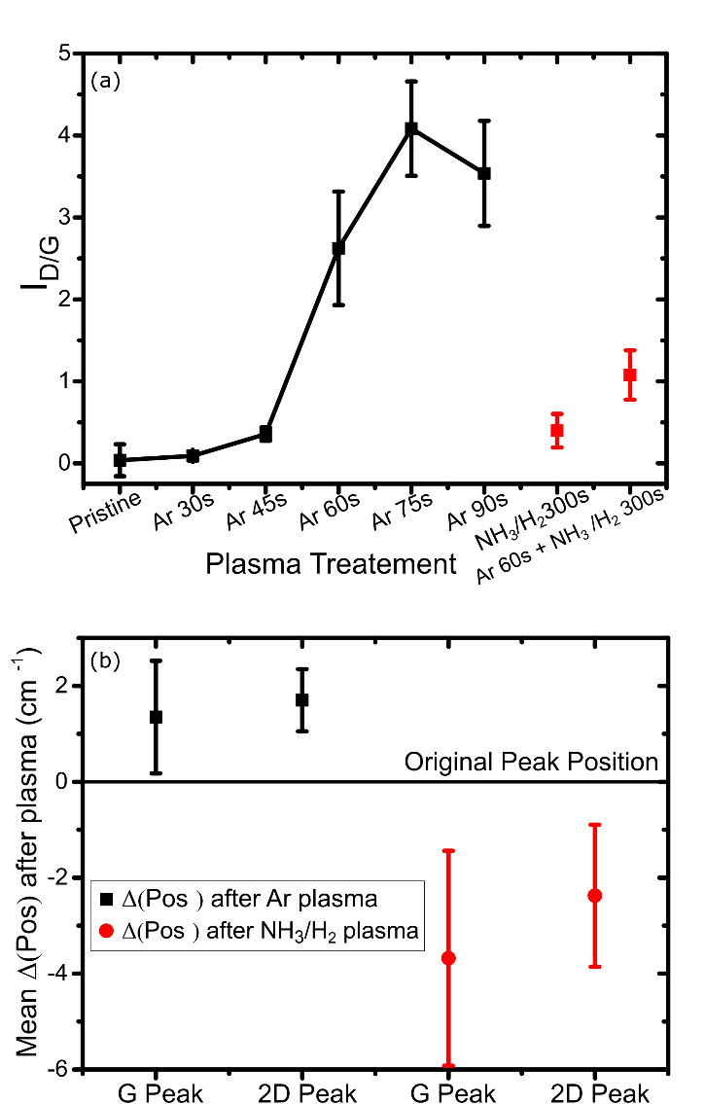

Figure 2 (a) Ratio of the Raman peak intensity of the D and G peaks, I_{D/G}, for different plasma exposures. (b) The average shift in peak position of the 2D and G Raman peaks after both Ar and NH₃/H₂ plasma treatments.

To allow further analysis of the Raman data after plasma exposure, certain peak behaviours were extracted and the trends plotted. Fig. 2(a) shows the trend of Raman D to G peak intensity ratio for different plasma treatments. For the Ar plasma, the ratio increases gradually by over an order of magnitude, showing that the Ar plasma clearly causes controllable damage throughout the lattice, which can be tuned by modifying the plasma exposure time. The reduction in intensity for the 90s Ar sample is consistent with the expected change in the relationship between the intensity of the D peak and the defect concentration at these defect levels. In this region the sample is likely transitioning from what is described as stage 1 amorphisation, namely graphene with individual point defects, to stage 2. Due to the decreasing presence of graphitic carbon in this stage, the I_{D/G} decreases in stage 2. This amorphisation trajectory is described fully in references [22, 23]. As previously discussed, the 300s of NH₃/H₂ plasma causes comparably very little damage.
The shift in the Raman 2D and G peak positions are known to be an indicator of doping. Fig. 2(b) shows the mean peak position shift of the G and 2D peaks after Ar plasma treatment, and subsequent NH₃/H₂ plasma. After Ar plasma the peaks reproducibly shift to higher wavenumbers. This is consistent with increased p-doping in the sample. When the samples are then exposed to the ammonia containing plasma, the peaks shift back to lower wavenumbers indicating a reduction of holes in the sample, or increased n-doping[24].

To gain a greater understanding of the influence of both plasma treatments on graphene, XPS was carried out on the above samples. Due to the dominant effect of residual polymer on the XPS signal post transfer, plasma treated graphene on Cu foil was analysed. Fig. 3(a) shows the C 1s core level region for pristine graphene, graphene treated with 60s Ar plasma and graphene treated with 60s Ar plasma followed by 300s NH₃/H₂ plasma. Analysis of the pristine graphene shows the characteristic asymmetric C=C peak as the primary component. There are other smaller contributions from sp³ hybridised carbon and various carbon-oxygen species, indicative of a low level of defects present in the sample[25]. After 60s of Argon plasma the spectrum is changed slightly. The C=C component is broadened and there is a marked increase in the presence of various carbon-oxygen species. This is attributed to the defective graphene sites oxidising when exposed to air between plasma treatment and XPS analysis. Noticeably, there is very little reduction in the signal from C=C indicating only minor damage to the graphene. This is in sharp contrast with the large increase in defect concentration implied by the Raman analysis, and the electrical results discussed later. This result may be due to the XPS being carried out on graphene on Cu foil, making it less susceptible to plasma damage than on SiO₂[21]. To confirm this, XPS was carried on transferred graphene on SiO₂, Fig.S4. Here a significant reduction in C=C content was observed post argon plasma treatment, in line with what other analysis techniques indicate.
The third sample is exposed to argon and ammonia/hydrogen plasmas in succession with no exposure to air in between. While this sample also has an increase in sp³ carbon, the contribution from carbon-oxygen species in this sample is significantly less than that for the Ar only treatment. The expected binding energy for C-N is also in this same region (within ~0.2eV), making deconvolution two difficult[26].
Due to the inability to reliable quantify any C 1s C-N component, the N 1s core-level region was also measured by XPS, Fig. 3(b). Neither the pristine, nor Ar treated sample, showed any significant signal in this region. The Ar and NH₃/H₂ treated sample contains an appreciable signal centred at ~399.5 eV. This was deconvoluted into 4 components, graphitic, pyridinic, pyrollic/amine and nitrogen adatoms[27-29]. It should be noted there is large variation in the reported binding energies of these peaks in the literature[30]. It is the graphitic nitrogen which has been reported to n-dope graphene[29]. Compositional analysis using the XPS data (Fig. S5) reveals a nitrogen level of ~2.5 at. % overall. This is a strong indication of the incorporation of N atoms into the graphene lattice. An estimated ~7% of this is graphitic nitrogen, which would contribute to n-doping of the sample. As seen above for the C 1s peak, the plasma treatment is less effective on as-grown graphene on Cu than on transferred graphene on SiO₂. For this reason we expect this nitrogen doping level to be a lower estimate of the doping level expected for graphene on SiO₂.

Figure 3 (a) C 1s XPS spectra of graphene samples exposed to no plasma, 60s Ar plasma, and 60s Ar and 300s NH₃/H₂ plasmas respectively. (b) XPS of the N 1s region of the same three samples
To analyse the effects of the plasma treatments on the electrical characteristics of the graphene, field effect transistors were fabricated, an image of one such device is shown in Fig. 4(b) . The two-terminal IV response of the pristine, Ar plasma treated and Ar and NH₃/H₂ plasma treated graphene are shown in Fig. 4(a) inset. Unsurprisingly, the pristine graphene has the lowest resistance as plasma treatments introduce defects and functional groups which would be expected to reduce conductivity[31]. We use the transfer characteristic of the devices, shown in Fig. 4(a), to extract the field-effect mobility. The pristine graphene shows an electron mobility of ~1200 cm²V⁻¹s⁻¹ and a hole mobility of ~1500 cm²V⁻¹s⁻¹. While these are lower than some reported previously for graphene [32, 33], they are good values for back-gated CVD-grown graphene on SiO₂[34]. This sample is heavily p-doped with the Dirac point at ~48 V which we attribute to residual polymer and adsorbates[14].The Ar plasma treated samples exhibit much reduced current levels and are strongly p-doped. For our devices the Dirac point is outside the measurement window of ±80V. This is in line with other studies which have found Ar plasma exposure serves to p-dope graphene[35]. In contrast, the samples treated with Ar and NH₃/H₂ plasmas show a negative shift in the Dirac point. The Dirac point shifts by 45V to a value of 3V. Both of these are in line with the expected doping types indicated by position shift of the Raman peaks.
In addition to the doping, the gate response is restored after the ammonia treatment, indicating a partial healing of the lattice damage introduced by the argon. After this plasma treatment, the mobility is ~500 cm⁻²V⁻¹s⁻¹ for both holes and electrons. This reduction, in comparison to the pristine values, is expected due to the damage caused by the plasma treatments or by non-graphitic N atoms such as pyridinic and pyrrolic N. However, it is a significant improvement from that seen after Argon damage alone which gave hole mobilites below 50 cm⁻²V⁻¹s⁻¹. Through further optimisation of the transfer process, less heavily p-doped samples can be obtained. Figure 4(c), shows that the Ar and NH₃/H₂ plasma treatments shift the Dirac point from ~20V to ~-25V, switching the graphene character from p-doped to an equivalent level of n-doping.
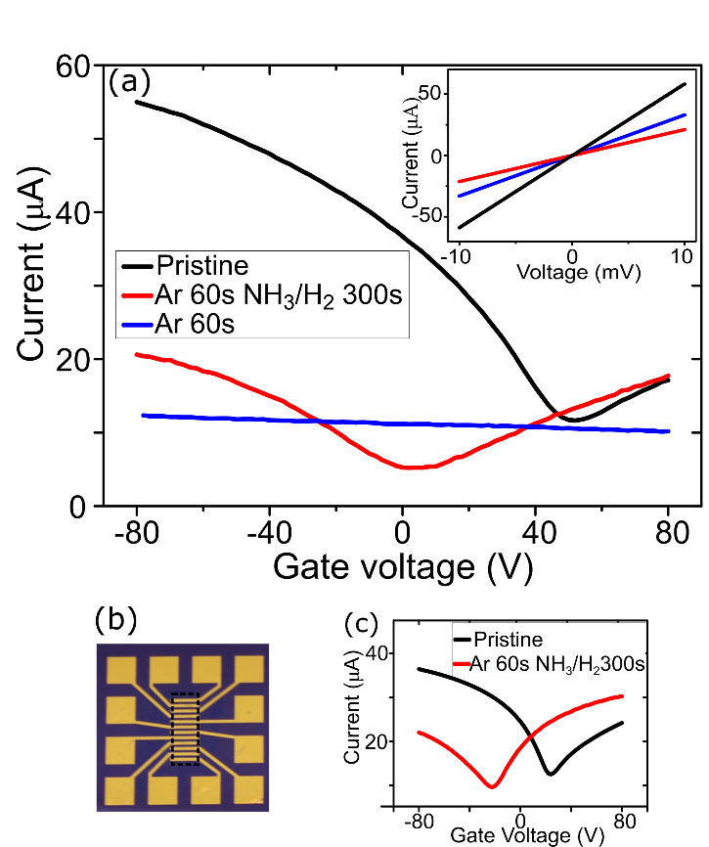
Figure 4 (a) Gate voltage sweeps of pristine, Ar treated and Ar NH₃/H₂ treated graphene samples, V_{DS} = 5mV. Inset: two-terminal IV measuremnts of the same samples. (b) Picture of the GFET device structure with graphene outlined. (c) Transfer curve of GFET device before and after plasma treatments indicating the switch from p- to n-type doping.
The electrical results demonstrate that the plasma treatments cause a shift of the Dirac point by 45 to 50V after treatment. This shift is consistent across multiple samples irrespective of the starting level of p-doping as was seen in Fig. 4. All devices show a Dirac point shift of 45-50V which is equivalent to a doping level change of ~3.5 x 10¹² cm⁻². The XPS analysis estimated the atomic percent of graphitic nitrogen to be ~0.2 at. %, which is equivalent to a doping level on the order of 7 x 10¹² cm⁻², assuming each graphitic nitrogen donates ones electron[29]. Despite the significant error associated with the XPS analysis, this agreement between techniques is further evidence indicating the ability of our plasma treatments to incorporate nitrogen dopants into the graphene lattice.
These results demonstrate the applicability of using plasma exposure as a method to dope graphene. While there is some reduction in mobility values after plasma treatment, on the order of 50-60%, the mobility for both holes and electrons is still ~500 cm⁻²V⁻¹s⁻¹. The ability to strongly and reproducibly modify the Dirac point position has the potential to outweigh the disadvantage of somewhat reduced mobility for many applications.
We have successfully used a remote Argon plasma to introduce a controllable concentrations of defects in monolayer graphene on SiO₂. This was confirmed through Raman and XPS analysis. The damaged graphene offered a platform for the subsequent use of NH₃/H₂ plasma to introduce nitrogen atoms to the graphene. The combined Ar and NH₃/H₂ plasma treatments provided reproducible electron doping of the graphene on the order of 10¹² cm⁻². While further work is needed to understand clearly the bonding configuration of the nitrogen atoms, this works provides clear evidence of the effectiveness of this two-step plasma doping to modulate the charge carriers in graphene.
Acknowledgements . J. B. Mc M. acknowledges an Irish Research Council scholarship, Project 204486, Award 13653. G. S. D. acknowledges the support of SFI under Contract No. 12/RC/2278 and PI_15/IA/3131. N. M. acknowledges support from SFI through 15/SIRG/3329.
References
1. Choi, W., et al., Synthesis of Graphene and Its Applications: A Review. Critical Reviews in Solid State and Materials Sciences, 2010. 35(1): p. 52-71.
2. Dey, A., et al., Plasma engineering of graphene. Applied Physics Reviews, 2016. 3(2): p. 021301.
3. Meyyappan, M., Plasma nanotechnology: past, present and future. Journal of Physics D: Applied Physics, 2011. 44(17): p. 174002.
4. Peltekis, N., et al., The effect of downstream plasma treatments on graphene surfaces. Carbon, 2012. 50(2): p. 395-403.
5. Amirhasan, N., et al., Bandgap opening in oxygen plasma-treated graphene. Nanotechnology, 2010. 21(43): p. 435203.
6. Wang, X., et al., N-Doping of Graphene Through Electrothermal Reactions with Ammonia. Science, 2009. 324(5928): p. 768-771.
7. Kato, T., et al., Room-Temperature Edge Functionalization and Doping of Graphene by Mild Plasma. Small, 2011. 7(5): p. 574-577.
8. Tuning the work function of graphene by nitrogen plasma treatment with different radio-frequency powers. Applied Physics Letters, 2014. 104(23): p. 233103.
9. Lin, Y.-C., et al., Structural and Chemical Dynamics of Pyridinic-Nitrogen Defects in Graphene. Nano Letters, 2015. 15(11): p. 7408-7413.
10. McEvoy, N., et al., Functionalisation of graphene surfaces with downstream plasma treatments. Carbon, 2013. 54: p. 283-290.
11. Deshmukh, S.C. and D.J. Economou, Remote plasma etching reactors: Modeling and experiment. Journal of Vacuum Science & Technology B: Microelectronics and Nanometer Structures Processing, Measurement, and Phenomena, 1993. 11(2): p. 206-215.
12. Li, X., et al., Large-Area Synthesis of High-Quality and Uniform Graphene Films on Copper Foils. Science, 2009. 324(5932): p. 1312-1314.
13. Kumar, S., et al., CVD growth and processing of graphene for electronic applications. physica status solidi (b), 2011. 248(11): p. 2604-2608.
14. Hallam, T., et al., Strain, Bubbles, Dirt, and Folds: A Study of Graphene Polymer-Assisted Transfer. Advanced Materials Interfaces, 2014. 1(6): p. 1400115-n/a.
15. Ferrari, A.C., et al., Raman Spectrum of Graphene and Graphene Layers. Physical Review Letters, 2006. 97(18): p. 187401.
16. DasA, et al., Monitoring dopants by Raman scattering in an electrochemically top-gated graphene transistor. Nat Nano, 2008. 3(4): p. 210-215.
17. Eckmann, A., et al., Probing the Nature of Defects in Graphene by Raman Spectroscopy. Nano Letters, 2012. 12(8): p. 3925-3930.
18. Tuinstra, F. and J.L. Koenig, Raman Spectrum of Graphite. The Journal of Chemical Physics, 1970. 53(3): p. 1126-1130.
19. Basko, D.M., Theory of resonant multiphonon Raman scattering in graphene. Physical Review B, 2008. 78(12): p. 125418.
20. Controllable graphene N-doping with ammonia plasma. Applied Physics Letters, 2010. 96(13): p. 133110.
21. Larionova, T., et al., Comparative characterization of graphene grown by chemical vapor deposition, transferred to nonconductive substrate, and subjected to Ar ion bombardment using X-ray photoelectron and Raman spectroscopies. Diamond and Related Materials, 2017. 76: p. 14-20.
22. Lucchese, M.M., et al., Quantifying ion-induced defects and Raman relaxation length in graphene. Carbon, 2010. 48(5): p. 1592-1597.
23. Cançado, L.G., et al., Quantifying Defects in Graphene via Raman Spectroscopy at Different Excitation Energies. Nano Letters, 2011. 11(8): p. 3190-3196.
24. Lee, J.E., et al., Optical separation of mechanical strain from charge doping in graphene. Nature Communications, 2012. 3: p. 1024.
25. Ederer, J., et al., Determination of amino groups on functionalized graphene oxide for polyurethane nanomaterials: XPS quantitation vs. functional speciation. RSC Advances, 2017. 7(21): p. 12464-12473.
26. Li, Y., Z. Wang, and X.-J. Lv, N-doped TiO2 nanotubes/N-doped graphene nanosheets composites as high performance anode materials in lithium-ion battery. Journal of Materials Chemistry A, 2014. 2(37): p. 15473-15479.
27. Zhang, C., et al., Synthesis of Nitrogen-Doped Graphene Using Embedded Carbon and Nitrogen Sources. Advanced Materials, 2011. 23(8): p. 1020-1024.
28. Boutchich, M., et al., Atmospheric pressure route to epitaxial nitrogen-doped trilayer graphene on 4H-SiC (0001) substrate. Applied Physics Letters, 2014. 105(23): p. 233111.
29. Mattia, S., et al., Tuning nitrogen species to control the charge carrier concentration in highly doped graphene. 2D Materials, 2016. 3(1): p. 011001.
30. Wang, H., T. Maiyalagan, and X. Wang, Review on Recent Progress in Nitrogen-Doped Graphene: Synthesis, Characterization, and Its Potential Applications. ACS Catalysis, 2012. 2(5): p. 781-794.
31. Skrypnyk, Y.V. and V.M. Loktev, Electrical conductivity in graphene with point defects. Physical Review B, 2010. 82(8): p. 085436.
32. Bolotin, K.I., et al., Ultrahigh electron mobility in suspended graphene. Solid State Communications, 2008. 146(9–10): p. 351-355.
33. Banszerus, L., et al., Ultrahigh-mobility graphene devices from chemical vapor deposition on reusable copper. Science Advances, 2015. 1(6).
34. Nayfeh, O.M., et al., Increased mobility for layer-by-layer transferred chemical vapor deposited graphene/boron-nitride thin films. Applied Physics Letters, 2013. 102(10): p. 103115.
35. Thiyagarajan, K., B. Saravanakumar, and S.-J. Kim, Gate-Tunable Photoresponse of Defective Graphene: from Ultraviolet to Visible. ACS Applied Materials & Interfaces, 2015. 7(4): p. 2171-2177.

* Corresponding author: e-mail duesberg@unibw.de, Phone: +49 89 6004 4036, Fax: +49 89 6004 3877

