“The Taste of ‘Data Soup’ and the Creation of a Pipeline for Transnational Historical Research
Jennifer Edmond, Natasa Bulatovic and Alexander O’Connor

Introduction
Unlike the natural, biological and many physical sciences, the historian’s object of study is never directly accessible. What she has instead is her sources, those physical remnants of the past which provide better or worse evidence of the events that occurred, and sometimes of the causes of those events. The primacy of the source, and in particular the primary source, as the bedrock of the historical research method, creates a certain continuity over the centuries, but this is not to say that historical research paradigms are static. Modern research infrastructures must therefore be sensitive to the ways in which historical research practices in the 21st Century are distinct from those of earlier eras. In particular, new environments for research must take into account the affordances of technology to reveal connections and support or refute hypotheses, as well as enabling the increasingly widespread transnational approaches to history. The Collaborative EuropeaN Digital Archival Research Infrastructure (CENDARI) Project has the intersection of these trends at its core, reimagining the analogue landscape of research sources for medieval and modern history (specifically the First World War) and infrastructure for a digital age.

The conceptual design of the CENDARI environment was informed by two interlinked processes. The first of these was a desk research and survey phase with the goal of capturing the historian’s own perspectives on the processes and practices by which they engage with their sources. Particular emphasis was placed in this process on the impact of transnational approaches on researcher engagement with their source material. The fact that the concept of the ‘transnational’ has been a part of historical enquiry for almost a century, does not necessarily mean that there is a consensus around precisely what is as a distinct forrm of historical practice. For some, it is a characteristic of the object of study, with, for example, the Red Cross occupying a firmly defined space outside of but interconnected with the national. For others, it is a more complex reflection of the interaction between the generation of modern scholars and their scholarship (Winter, 2014). Regardless of how we define it or bound it, however, transnational approaches to history seem not only appropriate to the era in which we find ourselves, but also to Europe as a federation of distinct cultural spaces, in which historians have a particular sensitivity toward fragmentation and diversity (Clavin, 2010).

As might be expected, the largely national organisation of traditional knowledge infrastructures (libraries, archives and museums) was not felt to be a particularly good fit for the approaches seeking to emphasise transnational phemonema: in fact many researchers felt that they needed to take care not to let national narratives inherent in archival structures effect their research outcomes (Beneš et al., 2014). The potential inherent in the digitisation of content to resolve these issues is largely still just that: a potential. In spite of the massive increase in availability of content (a key asset for the modern historian), many important archives and collections remain ‘hidden,’ either due to their scale, lack of budget to digitise resources, lack of accessible finding aids or other political factors. These factors hamper attempts by historians to take balanced transnational approaches. Finally the research in this phase of the CENDARI fundamental work also highlighted the heterogenous nature of historical sources: while the historians interviewed did show some bias toward the use of archival sources, the importance of library-based and other sources was also confirmed (Beneš et al., 2014). This finding seems to go hand-in-hand with the emphasis on the importance of personal relationships with content holding institutions, and the fact that a good relationship with the right librarian or archivist could make or break a project. These factors in particular highlight the difficulties inherent in transferring analogue historcal research processes to the digital environment, as it is precisely these serendipitous and dialogic encounters between individuals and between sources from different origens (often catalogued according to different standards) that are the hardest to reinvent in virtual space.

The second prong of the CENDARI project’s approach to designing for its users was implementated via a participatory design methodology, allowing a balanced and gradual convergence between the established analogue practices and the emerging technical specifications. This staged approach began with three very high level design sessions (resulting in video prototypes created by the participants), then moved through the development of user stories (in the form of responses to the statement “I want to … so that I can …”) and user scenarios. The scenarios were far more detailed than the stories, while still deplying the same basic approach of translating complex researcher descriptions of their work into a series of statements able to be validated through a test case or input/output relationship. The final stage of the process involved the thorough co-development of system workflows for two ‘prototype’ research questions (one medieval, one modern).

The results of these investigations have driven a project toward a design that is based in the idea that a digital research infrastructure is quite different from a library ‘on the net,’ or indeed from the current paradigm for a digital library. This distinction informs CENDARI’s basic vision, making it a project very much of its time and place as a European ifrastructure project. As such, it seeks to facilitate work without defining narrowly how that work must be done; it seeks to federate access to sources without replicating the access and preservation missions of the collection holding institutions; and it seeks to align itself with best practices across a number of the research fields involved in its development, including computer science, information management, and medieval and modern history (Edmond, 2013).

The architecture of the system itself is therefore based on a number of key principles arising out of the methodological research and design process. First of all, the system had to be able to manage a variety of data types and standards in a single environment. This heterogenous information environment was a key requirement from the historians, in particular in the context of pursuing transnational approaches (where comparable data might need to be found in proxies rather than directly equivalent data sets). This requirement is not one current data standards facilitate particularly well (with different standards dominant between archives and libraries) and gave rise to the characterisation of the CENDARI environment as ‘data soup,’ a hearty mixture of objects, descriptions and sources. It was also very clear that linking information, in particular via notes and annotations, was a key researcher task for which satisfactory tools were not available. The project took this as a mandate both to develop a VRE environment for the purpose, but also to ensure that maximal benefit was drawn from semantic web and linked data approaches to capturing and registering individual and shared knowledge. A fundamental challenge is the recognition that two files can each, separately, fully conform to the same specification but still require substantially different processes to be ingested into uniform knowledge base. The difference between data (digital representation of the content), information (the order and structure of the content) and knowledge (the semantics and signficicance of the content) is at the heart of this difficulty: the human brain traverses levels of interpretation with a fluid transparency that computational approaches cannot even begin to emulate. The infrastructure challenge is to lay down a network of data, information and knowledge rails that lead to human insight.

The final strong message that came from the user requirements research underlying the CENDARI architecture was the desire for more effective tools to facilitate communication among historians. While technically very possible, this has been the least easy to implement, as the wider ecosystem does not encourage sharing among historians, with their traditionally lengthy research and publication cycles. In fact, even some basic aspects of the technical design have needed to be rethought on the basis of their implication for user privacy and the protection of intellectual property. Within this landscape, the CENDARI project has emerged with a set of defining principles aimed at both advancing the community’s awareness of what they need, and presenting a model for how these needs can be met, while remaining sensitive to the current realities of the production and valuation of historical research. A thorough cognisance of the existing practices both as percevied by historians, and as actually executed by them, was an absolute necessity for CENDARI to be able to have any useful effect. In part this meant helping to overcome data, information and knowledge challenges separately; it also meant understanding that a total end-to-end replacement was desirable only to a tiny minority of users.

The goals of the CENDARI project therefore cross a number of traditional boundaries – between content holders and content users, between technology and humanities, but also between the digital and the analogue worlds of scholarship. As such, CENDARI has committed to:
- Creating a robust ‘enquiry environment’ capable of supporting far more than search and browse functionality, and doing so at a point in the research process where it does not specifically determine how that process must unfold
- Resisting existing inequities in digital provision among national and regional systems. To merely enhance and add functionality to already well-established digital collections like those of the Bibliotheque national de France and the Imperial War Museum would not only be a failure, but a potential betrayal of the historical record, making well- known collections even easier to work with, while other collections and perspectives are left ever less accessible
- To integrate at a deep level within the project the analogue processes known and trusted by scholars and archivists, in the knowledge that the digital environment can only supplement, rather than supplant, them.

Technical Approach
The technology challenge that these objectives create is one of attempting to reconcile deep and shallow technical and conceptual heterogeneity. Data emerges from knowledge institutions as descriptions of fonds, collections and the archives themselves, sometimes with digitised text but often without. There is little consistency in the markup approach, even within the context of standards such as EAD, EAG, MARC and so on: their consistency can, for example, be effected by policy decisions about which fields an institution chooses to include, or what they are filled with. One archive might choose creator to refer to the digital object creator, while another might use it to refer to the creator of the original artefact. The choice of natural language can vary, as can the names for entities such as places and people. Placenames are a perfect example of this phenomenon, encompassing the choice of which name is used for a town that may have had several (concurrent) labels, and of how to encode non-latin characters. This is the input view of the CENDARI ‘data soup’, ingesting as wide a variety of formats and data, and unifying it before overlaying semantic conceptual knowledge and exposing resulting entities for use by reseachers. Structuring knowledge from individual researchers, communities and collections has the advantage of allowing researchers to focus on making the connections needed for scholarly insight.

To achieve this, the project has taken a two pronged approach to data management in the CENDARI environment, comprised of a “dataspace” and a “blackboard,” two key conceptual frameworks which allow deposited or referenced data or metadata records and intelligence relevant to the interpretation of that data to be kept separate and combined in a use-case appropriate manner.

The system is built around a knowledge store, which records provenance information and maintains privacy for users. Access to this store is via a unified Data API, that incorporates functions for semantic retrieval, access control and identification, and authentication. This unified interface allows for the blackboard/dataspace model to provide tailored content with the requested level of annotation, in the format needed, at the time requried.

The Dataspace
The dataspace approach to management of data originating from heterogeneous sources has been proposed as an alternative to the classical data integration methods: data from different sources (dataspaces) coexist (Franklin et. al., 2005) together in their original form, while their integration for specific application and integration scenarios is incremental, and evolves together with the underlying technical infrastructure (Alvaro, et. al., 2011) in a “pay-as-you-go” fashion. Similar ideas have emerged in the development Ultra-Large Scale Systems (ULS) (Northrup, 2006), with the goal to create “a supporting data architecture that remains viable in a freely evolving, interdependent collective of systems, people, policies, cultures, and economics, very little of which will ever be under our control” (Yoakum-Stover, 2008). The Dataspace approach is based on development of a unified (domain-specific agnostic) model for data, which assumes that the original data models are maintained at their sources, thus places no restrictions in the vocabularies, models and local data constraints. Leveraging computational methods which rely on scale and work with diversity (instead against it), as well as cultivating the data heterogeneity and “dirt in data” (Yoakum-Stover, 2010) in order to get higher level of knowledge, can be achieved by the unification of data access rather than immediate harmonization into a single data model or ontology. The unification approach is based on decoupling the storage model from the domain data models, decoupling domain data models from data and, eventually, considering the data model itself from a higher level of abstraction, in order to represent the data and semantics of any data set.

The Blackboard
The second key concept is that of the Blackboard. The Blackboard system Hayes-Roth, 1985) can be illustrated with a following metaphor (Corkhill, 1991): a group of specialists are working cooperatively to solve a specific problem, by using a “blackboard” (or a whiteboard nowadays) as a common workplace to develop the solution. Each of them checks what other specialists are writing on the board, each specialist may contribute with their own problem-solution and intermediate results in case there is sufficient information on the board in order for the specialist to apply own expertise. This process continues until eventually the problem has been solved. A specialist is therefore present in a so-called waiting state, and listens to the information and new results that are coming from other specialists on the whiteboard, and contributes when his specific expertise is called for. Even though historical research may not be always be perceived as a “problem solving” process in the same way as in the exact sciences, where hypotheses are proposed and tested according to scientific method, the blackboard approach (as a model for CENDARI) fosters knowledge creation, contributing information and sharing results, empowered by provenance info.

Rather than attempting to tag each piece of data in the system with the intelligence required to interpret it (knowing that interpretation can be hugely varied in the context of historical research) the Blackboard model keeps the intelligence separate, and applies knowledge resources – which may take the form of multilingual ontologies, linked open data resources, specialist data bases or any number of others – iteratively, and after the fact of data ingestion/integration into the data space.

Knowledge Workflows
Within the basic structure of data-space and blackboard, the CENDARI system is composed of a series of services that support a number of knowledge workflows. The service integration allows for a flexible approach that varies depending on the nature of the data to be imported and the tasks to be performed. The workflows themselves include:
- bulk ingestion of content, for example from an archive, with semi-automatic enrichment
- iterative ingestion of user-generated content with semi-automatic enrichment
- enquiry and authoring within the environment
These processes take place across a number of different public and private data spaces. These represent background knowledge (such as that sourced from large-scale public knowledge bases like DBPedia or Freebase), domain-specific knowledge, and individual contributions that have been made public. The semi-automatic enrichment occurs via the authoring environment supporting assisted manual annotation, using named entity recognition and disambiguation services. This allows the markup of people, places, events and other key contents of the documents. In the enquiry workflow, keywords are expanded with semantic knowledge: synonyms are added to cross-lingual or cross-temporal queries, for example. The components delivering these workflows are described in more detail below, and consist of a variety of data sources and types, pipelines for data integration, and protocols for authentication and authorisation.

1. Data in CENDARI
All data within the CENDARI system are somehow relevant for research in one or both of our case study areas: World War One or Medieval European culture. Above and beyond this unifying rationale, the ‘data soup’ is comprised of quite a heterogeneous mix, including raw data, knowledge base, connected data or data produced by CENDARI toolkits. These different data types have differing provenances and require slightly different management techniques.

Raw data are either harvested into the system from various online sources (such as archives or libraries), or uploaded manually to the CENDARI repository. They are the most diverse in terms of incoming formats, data structure, languages, richness, quality, granularity and/or licenses. Data in this category range from various XML formatted data such as EAD, TEI, MODS or custom formats, database exports from, for example, an Access database, PDF files or other document formats, through to RDF formatted data. While harvested data are most often metadata records, manually uploaded data are usually unstructured and descriptive.

Knowledge base data are comprised of externally acquired domain knowledge bases (such as DBPedia, Freebase, CIDOC, VIAF etc.), the ontologies provided or created within CENDARI, such as the CENDARI Archival Ontology (CENDARI WP6 Team, 2014, CENDARI WP 7 Team, 2014) or information derived from raw data by CENDARI data integration services (collection knowledge). These data are well structured, although semantic and language varieties still persist.

Connected data are externally maintained raw data or knowledge bases, for which access and discovery are facilitated through service integration with CENDARI. Chunks of these data have potential to become part of the CENDARI ‘data soup’ where particular research requires it. Similarly to raw data, connected data are heterogeneous, though usually with a well-defined and known structure, and generally enable highly granular access to both metadata and content.

CENDARI-produced data are natively the least heterogeneous when it comes to structure and formats, as their formats are determined by the CENDARI tools and services through which data are created by the end users. These data come in form of Notes or Archival Research Guides, User annotations (created through the annotation tools), manually uploaded documents or multimedia. Language heterogeneity persists.

Regardless of what category data belong to, there are several common principles applied, following the dataspace/blackboard conceptualisation and implementation:
- Each piece of data is grouped within a dataspace, which holds access permissions and delineates data coming from various providers, researchers or research projects.
- Data are not transformed to a single metadata format – even though e.g. EAD and its CENDARI extension (CENDARI Team WP5, 2013) (to fit fine granular descriptions up to the level of items) are selected as a standardized format for archival collections and fonds.
- Basic provenance information is maintained for all data (at a minimum who created/modified the data and when)
- Data can be acquired at any time, depending on CENDARI knowledge about the data. Transformations and processing can be triggered immediately or delayed to the point when there is enough information and technical support
- Results of data transformations and provenance information about the applied transformation are persistent, and are linked to the original data
- Data are versioned

Data integration
The CENDARI data integration platform (DIP) is implemented as an integration of polyglot data persistence, data processing components and REST based data services. Figure 1 provides simplified view of DIP.

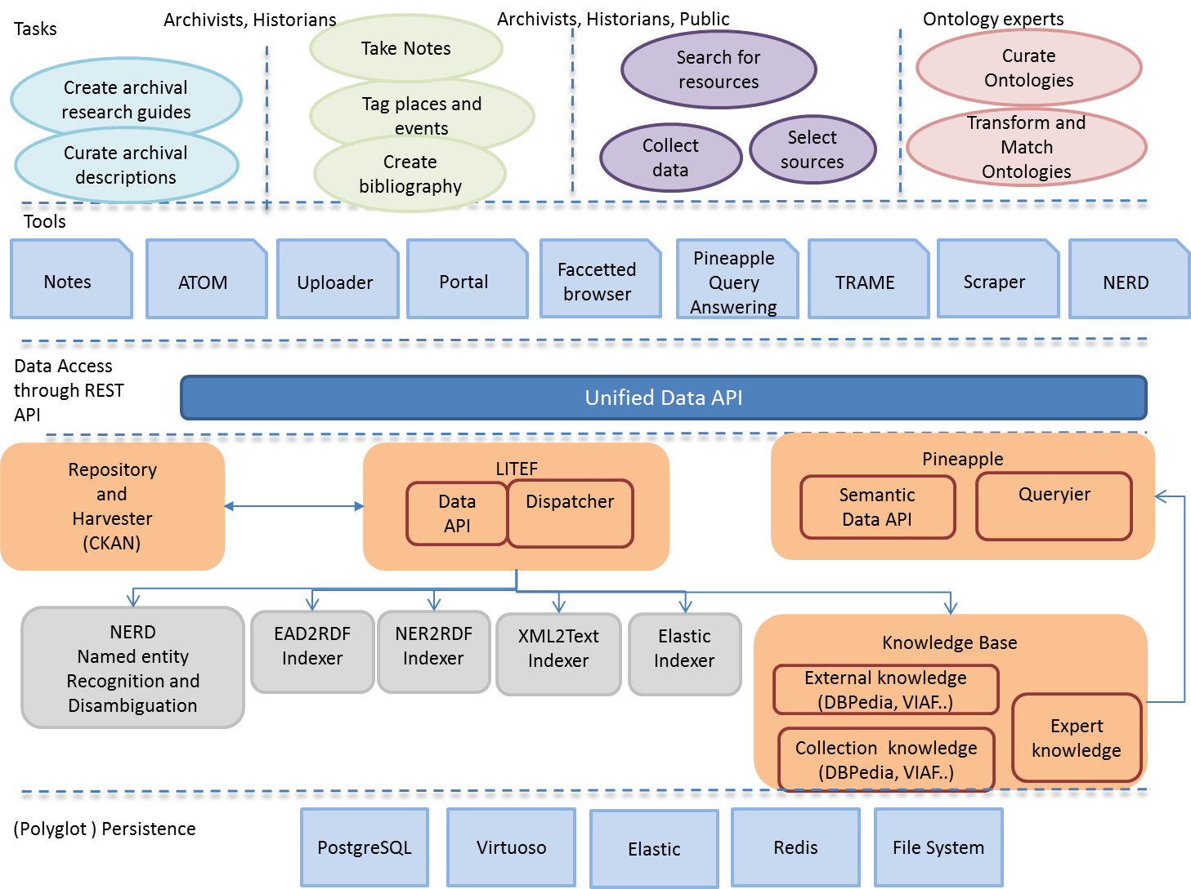
Figure 1: DIP within CENDARI Platform

At the highest level, researchers deploy various tools to perform their research tasks, such as creating archival research guides (ARG), searching for resources, taking notes, visualising data etc. CENDARI Users are, first and foremost, historical researchers, some of whom may be archivists, given the collections intensive approach of CENDARI or members of the general public, given the openness of the resource. They may also be interested in different kinds of content, for example, if they are ontology experts.

To facilitate their work processes (as described above and documented in the project deliverables referenced) the project has developed a number of specific user-facing tools, including: a notetaking environment; content uploader; facetted browser; and a content scraper. In addition, the TRAME metasearch engine, which existed before CENDARI was launched, has been extended to work with semantic data and knowledge bases. In addition to CENDARI-made developments, some external tools have been integrated as well, such as the ATOM open source software, which assists in data entry for archival descriptions.

While tools may retain their local data, all data and content relevant for historical research are saved in the repository through the CENDARI Data API. The repository solution is based on CKAN open source software, which provides fine-grained authorization mechanisms for data. CKAN itself comes with an RPC-style API, but a deliberate decision was made to develop instead a RESTful Data API to facilitate dataspaces through both repository (content layer) and knowledge base data access (semantic data layer), as well as to integrate and expose additional services in the future. In addition, this leaves open the possibility to switch the repository solution easily in the future in case it does not facilitate future requirements and applications.

The Data API is implemented as one component of the LITEF service. Its other component, the LITEF Dispatcher is used for orchestration of data integration and processing components. In essence, LITEF ‘listens’ to new or modified content in the repository and calls available indexers and processors that perform data indexing and transformations. Figure 2 shows an illustration of the processing pipelines orchestrated by LITEF:

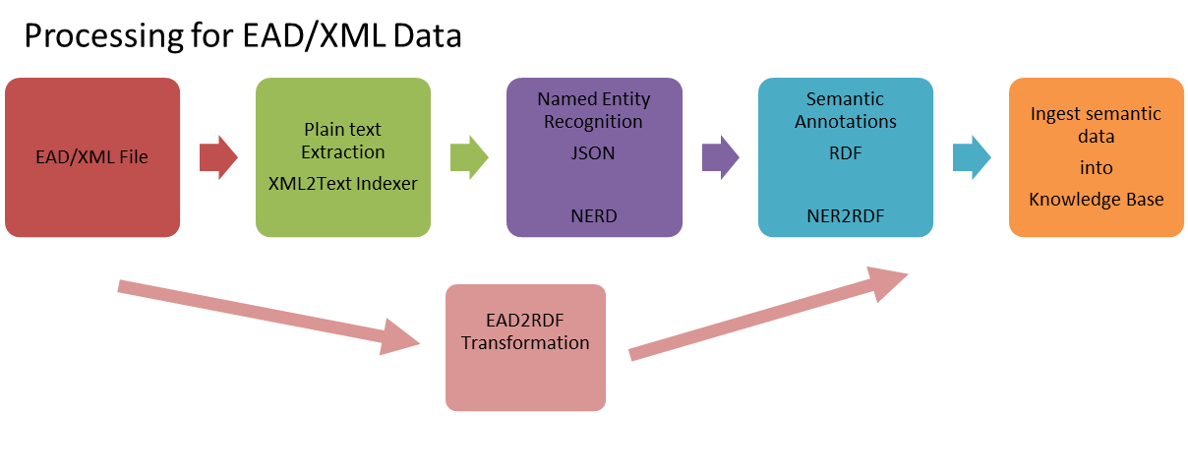
Figure 2: Example workflow for EAD Processing through CENDARI DIP

When a new EAD file is sent to the Data API (or harvested into the Repository), LITEF calls several services, which perform various transformations or computations over the data and provide an output. The whole processing does not happen at once for each file: LITEF is built as an actor system (Hewitt, 1976), which passes and translates various messages between other services within the DIP. Message passing is asynchronous and processes do not share any data between themselves and are not aware of the other processing components.

Indexing itself is performed in a modified blackboard system by a set of plugin-based indexers so that it is easy to extend the system and support more formats and new transformations, as the system evolves both technically and in content. Novel in this approach is that there is no central point of decision as to which indexers should be performed in which order. LITEF simply calls all available indexers – they themselves ‘decide’ if they are relevant to the processing of the input data or not (based on their internal configuration).
One of potential drawbacks of this approach is the lack of an immediate result from the transformations right after data are created in or ingested into the system. For CENDARI, the real-time processing is not needed. An advantage is that DIP can adopt any number of data processing components, even in physically distributed, but networked environment, as well as replace existing components independently from the overall processing pipeline. The intermediate results after each step of the processing pipeline persist as files, and are retrievable through the Data API for each resource.

The processing and indexing services represented in Figure 2 (NERD, NER2RDF indexer, Elastic indexer etc.) have been developed within the project. NERD is a Named Entity Recognition and Disambiguation REST service based on state of the art statistical techniques. The service is customized automatically to the historical field, and WW1 more particularly, using word sense disambiguation. Entities are resolved against FreeBase. It also provides a multilingual support but at lower precision/recall than for English. The service itself stores various machine-learning models and a local version of FreeBase to ensure its performance.

Finally, the CENDARI Knowledge Base is supported through the open source edition of the Virtuoso triple store. For each resource in the Repository, there is a named graph created in the triple store. For each dataspace in CENDARI there is as well a separate named graph in the triple store, containing only basic dataspace properties. Named graphs derived from resources reference the dataspace they belong to through a property that points to its URI.

The access to the CENDARI Knowledge base for components outside of the DIP is provided through the semantic layer of the Data API and the Pineapple service. Pineapple attempts to address the issue that users are often limited not by their expertise, but by their ability to use a search interface effectively to obtain results (Ageev et. al., 2011). The software should aim therefore to facilitate users answering research questions with less strict requirements around the formulation of system-specific queries. Pineapple uses semantic reasoning to address three types of problems that users described. The first is handling label mismatches, such as equivalent town names (‘Breslau’, ‘Wroclaw’, ‘Wrocław’ might all refer to the same location in different naming schemes). The second is allowing entity-based knowledge to help with queries (‘all ranks below Field Marshal’ includes ‘General, Colonel, Major’ etc.) and finally to begin to elicit ‘hidden knowledge’ (such as detecting promotions as instances of the same person with different ranks over time). The data soup allows Pineapple to begin to address these challenges in specific cases, but the general problem remains open. Nonetheless, it is a promising approach to making digital inquiry a less burdensome task of information and data management.

Authentication and Authorization
Given that the CENDARI development is meant for the use of historical researchers, rather than software engineers, it is important that this rich set of services appear to the user through a unified and seamless experience. All data CRUD components (‘Create-Read-Update-Delete’) used by CENDARI therefore support a unified authentication mechanism, provided through the pan European research infrastructure DARIAH’s AAI and DARIAH Shibboleth implementation. Both CKAN and ATOM software have been customized for this purpose. Components developed within CENDARI have been natively enabled for Shibboleth-based authentication from the very beginning.

CENDARI uses the CKAN data permissions model and CKAN Repository as single point of reference for data permissions. All components that need to provide data access to the end users through various query mechanisms (i.e. Pineapple Querier, Elastic search, Data API) actually use the same information to provide authorised access to the data and appropriate results to the end user in real time.

Not ‘YASABE’
It is worth recalling at this point that CENDARI calls the system it is building an ‘Enquiry Environment” – not a research environment per se, and not a digital library. We consider this to be a critical nuance for a number of reasons:

- CENDARI will never, and should never, be a place to undertake a complete research project from beginning to end. Instead, it seeks specifically to support the initial stages of a scholarly project, the process of asking and testing hypotheses, and of initially investigating the existence of useful, comparable archival data to support associated conclusions. Historians will still need to travel to archives, as we will never digitise everything, and will have a lot of work to do to ever include the intelligence of the specialist librarian or archivist in our systems. That said, CENDARI is eager, and should always be open, to new data acquisition, as the richer the environment, the better the services and initial enquiry can be.
- The process of enquiry means different things for different subfields of history. For example, even within CENDARI, we find that the difference in the desired level of granularity in the systems between our medieval and modern case studies is very great. In the former case, the goal is to reflect the scholarly environment at item level, whereas in the modern case, the goal is to reflect a fuller picture of sources at collection level. These are not so much strategic choices as pragmatic ones, as they have been determined not by ideals of policy but by the state of the collections and the research state of the art in the sub-disciplines. Reconciling these differing positions within the discipline of history not only progresses the tasks before CENDARI now, but also prepares the framework we are developing for possible eventual extension for other disciplines, where there may yet again be differences in intensity and focus within usage patterns for comon resources. Developing a common set of services able to facilitate work on different types of problem demonstrates the key objective of CENDARI: to identify what transferable practices exist in the humanities, and to assist researchers in their discovery process through serendipity and inquiry.
- The gold standard for scholarship is that the process of knowledge creation be transparent and reproduceable. The gold standard for an infrastructure is that it facilitate an activity without rigidly determining how that activity should be performed, or what vehicles must be used within the infrastructure. The CENDARI system should allow for these two somewhat contradictory goals to be harmonised, through pervasive provenance tracking on the level of the raw data sources, provision of flexible tools, and development of a supportive environment for capturing and exposing the process of scholarly knowledge creation..
By adapting this kind of flexible approach, CENDARI will leverage the previous investment in digital libraries and projects without creating ‘Yet Another Search and Browse Environment’ (that is, not ‘YASABE’) for a fragile and incompete set of resources. As such, we hope that CENDARI will act as a demonstrator for the overcoming of independent data silos without overly incentivising research activities based only on well-developed digital resources.

Aknowledgements

We gratefully acknowledge the European Commission for funding the CENDARI project (project ID 284432) and the broader CENDARI team, whose work is reflected in this paper. This work is also partially supported by the Science Foundation Ireland (Grant 12/CE/I2267) as part of the ADAPT Centre at Trinity College Dublin, and by the support of the Max Planck Digital Library.

References

Ageev, Mikhail, Qi Guo, Dmitry Lagun, and Eugene Agichtein. "Find it if you can: a game for modelling different types of web search success using interaction data." In Proceedings of the 34th international ACM SIGIR conference on Research and development in Information Retrieval. ACM, 2011, pp. 345-354.

Beneš, Jakub et. al.. Report on Archival Research Practices, Deliverable 4.1 of the CENDARI Project. Finalised August 2014, available at: www.cendari.eu/wp-content/uploads/CENDARI_D4.1-Report-on-Archival-Practices.pdf

CENDARI WP4 Team. Domain Use Cases, Deliverable 4.2 of the CENDARI Project. Finalised August 2014, available at: www.cendari.eu/wp-content/uploads/CENDARI_D4.2-Domain-Use-Cases-final2.pdf

CENDARI WP6 Team. Guidelines for Ontology Building, Deliverable 6.3 of the CENDARI Project. Finalised July 2014, available at: www.cendari.eu/wp-content/uploads/CENDARI-_D6.3-Guidelines-for-Ontology-Building.pdf

CENDARI WP6 Team. Collection Level Guidelines. Finalised December 2013, available at: http://www.cendari.eu/wp-content/uploads/1-0CollectionDescriptionDocumentation.doc

CENDARI WP7 Team. Data Integration Toolkit and Repository, Deliverable 7.2 of the CENDARI project. Finalised July 2014, abstract available at: http://www.cendari.eu/wp-content/uploads/CENDARI_D7.2-Data-integration-toolkit-and-Repository-aggregated-abstract.pdf (full text available on request)

Clavin, Patricia. “Time, Manner, Place. Writing Modern European History in Global, Transnational and International Contexts.” European History Quarterly, 40:4 (2010), pp. 624-640.

Corkill, Daniel. Blackboard Systems. AI Expert, Volume 6, Number 9. January 1991 https://mas.cs.umass.edu/paper/218

Edmond, Jennifer. 2013. “CENDARI’s Grand Challenges: Building, Contextualising and Sustaining a New Knowledge Infrastructure.“ International Journal of Humanities and Arts Computing. Vol 7.1-2, pp. 58-69.

Fernandes, Alvaro A. A., Cornelia Hedeler, Khalid Belhajjame, Lu Mao, Chenjuan Guo, Norman W. Paton, Suzanne M. Embury. “A Functional Model for Dataspace Management Systems.” Springer Book in Intelligent Query Processing. 2011, Pages 305-341, http://link.springer.com/chapter/10.1007%2F978-3-642-28323-9_12

Franklin, M., A. Halevy, and D. Maier. “From databases to dataspaces: A new abstraction for information management.” Sigmod Record, 34(4): 2005, pp. 27.33.

Hayes-Roth, B.. “A Blackboard architecture for control.” Artificial intelligence, Volume 26, Issue 3, July 1985, pp 251–321

Hewitt, Carl. “Viewing Control Structures as Patterns of Passing Messages.” Massachusetts Institute of Technology, Artificial Intelligence Laboratory, 1976

Northrup, Linda, Study lead. Ultra-Large-Scale Systems: The Software Challenge of the Future. Pittsburgh, PA: Carnegie Mellon Software Engineering Institute, June 2006, ix-3, http://www.sei.cmu.edu//library/abstracts/books/0978695607.cfm.

Winter, Jay. “Introduction.” Cambridge History of the First World War. Cambridge University Press, 2014, pp. 1-10.
Yoakum-Stover, S.. Keynote speech, “Data and Dirt”, 25 Top Information Manager Symposium, Dec 21, 2010 http://www.information-management.com/resource-center/?id=10019338 (Part 1, Part 2 and Part 3)

Yoakum-Stover, S. and Malyuta, T. Unified Integration Architecture for Intelligence Data, DAMA International Europe Conference 2008, November 2008, London, UK.

Faculty of Arts Humanities and Social Sciences and Trinity Long Room Hub, Trinity College Dublin
Max Planck Digital Library
ADAPT Centre, KDEG, School of Computer Science & Statistics, Trinity College Dublin
See http://dbpedia.org/
https://www.freebase.com/
See https://github.com/CENDARI/
See http://git-trame.fefonlus.it/index.html for more information
See https://www.accesstomemory.org/en/ for more information
See http://ckan.org/ for more information
See https://github.com/CENDARI/litef-conductor for more information
Valid both for processing services, as well as for multiple distributed instances of LITEF, thus enabling integration of various DIPs, each having its own specific focus.
See Grobid (2008-2015) https://github.com/kermitt2/grobid and https://github.com/kermitt2/grobid-ner
It is very important to record the URI of the dataspace to which the resource belongs, as it facilitates the authorization through the querying and retrieval components.
See https://www.dariah.eu/
See https://de.dariah.eu/web/guest/aai

