PUZOLANICIDAD DE CENIZAS VOLANTES Y DE FONDO DE INCINERADOR DE RESIDUOS URBANOS

¹Radson Lima Figueiredo;
²Sara Pavía.

Department of Civil, Structural and Environmental Engineering, Trinity College Dublin
e-mails: limafigr@tcd.ie, pavias@tcd.ie.

POZZOLANIC PROPERTIES OF BOTTOM ASH AND FLY ASH FROM A WASTE INCINERATOR PLANT

Abstract  Including ashes in mortars recycles waste and lowers the CO₂ emissions and raw material consumption associated to production making materials more sustainable. This paper assesses the physical properties and reactivity of the incinerator bottom ash (IBA) and incinerator fly ash (IFA) from a waste incinerator plant to evaluate their potential as pozzolanic additions to lime mortar. Their fineness (over 70% of their volume falls into the lime range 1.445 – 138.038 µm) are their high specific surface areas (greater than those of other pozzolans) suggest reactivity. The chemical test evidenced that all the ashes combine lime and are therefore reactive. The presence of chlorine, sulfur and alkalis in the fly ash may adversely impact durability. The higher Si, Al and Fe in the bottom ashes agree with the presence of silicates (gehlenite anorthite cristobalite) and oxides (corundum and hematite). The bottom ash significantly reduced the compressive strength of the lime which suggests lower activity. The fine bottom ash increases the flexural strength of the lime by 47% however, the compressive strength of the lime is approximately halved. Conversely, the fly ash improves the compressive and flexural strengths of the lime by 14% and 90% respectively which suggests a higher activity.  Key words: Bottom ash; fly ash; pozzolanic activity; hydrated lime. | Resumen  El uso de cenizas en morteros reduce emissiones de CO₂ y materials primas durante la producción; y permite reciclar basura haciendo los morteros mas sostenibles. Este trabajo estudia las propiedades físicas y reactividad de cenizas volantes y de fondo de incinerador procedentes de una planta de incineración de la República Checa.  El tamaňo de partícula (con mas del 70% del volume en el rango de la cal 1.445 – 138.038 µm) y su alta superficie específica (superior a algunas típicas puzolanas) sugieren reactividad. La presencia de cloro, azufre, sodio y potasio puede perjudicar la durabilidad. El contenido en sílice, aluminio y hierro de las cenizas de fondo esta de acuerdo con la presencia de silicatos (cristobalita, anortita, gelenita) y óxidos (hematites y corindón). Las cenizas de fondo reducen la resistencia mecánica a la compresión de la cal de manera significativa lo cual sugiere una actividad puzolánica menor. Por el contrario, las cenizas volantes incrementan la resistencia mecánica de la cal (14% a la compresión y 90% a la flexión) lo que sugiere una mayor actividad puzolánica.  Palabras clave: Ceniza de incinerador; ceniza volante; pozuolanicidad; cal hidratada.

INTRODUCTION
The remarkable increase in population and urbanisation of the past century has led to the proliferation of solid waste. Solid waste is a response to urbanisation and economic development, an output of a resource-intensive, consumer-based lifestyle which is becoming a great problem in the world. According to The World Bank [1] waste volumes are increasing faster than the rate of urbanisation and are expected to increase to 2.2 billion tonnes by 2025. Therefore, the amount of waste generated per capita is critically escalating.
Incineration is a practical management alternative for addressing the treatment of municipal solid waste (MSW). This approach, however satisfying problems related to the volume of waste such as the availability of landfills, faces other challenges. One of the challenges is the disposal of municipal solid waste incinerator (MSWI) ashes, which requires a complimentary sanitary landfill where waste is isolated from the environment until it is considered safe i.e. completely degraded biologically, chemically and physically. Moreover, the properties of the uncombusted MSW are different from the MSWI residues, which may not be appropriate for sanitary landfill in terms of resources conservation and environmental safety [2].
The chemical characteristics of MSWI ashes, including ground incinerator bottom ash (IBA) and incinerator fly ash (IFA) (mainly composed of silica, alumina, calcium oxide and iron oxide) and their fineness suggest a pozzolanic potential for these materials. Pozzolans contain active silica/alumina that can react with lime in the presence of water producing cementing hydrates similar to those produced upon hydration of hydraulic binders such as portland cement of hydraulic lime. Therefore, replacing conventional binders with these ashes can recycle waste and lower the CO₂ emissions and the raw material consumption associated with binder production, making building materials more sustainable.
Several authors have considered the use of bottom ash from MSW incineration in building materials [3-8]. Filipponi et al. (2003) [3] claim a low chemical reactivity for bottom ash and the need to enhance reactivity. In contrast, Lin et al. (2008) [5] state that incinerator bottom ash is active when combined with PC and identified Ca(OH)₂, CSH (tobermorite) and CAH (calcium aluminate hydrate) as the main hydration products in incinerator bottom ash slag- PC pastes. Jurič et al (2006) [9] studied the properties of bottom ash concrete concluding on a satisfactory quality for low strength requirements and the feasibility of IBA use in PC concrete.
This paper assesses the physical properties and reactivity of IBA and IFA from a waste incinerator plant to evaluate their potential as pozzolanic additions.

METHODOLOGY
A hydrated lime (CL90-S) complying with EN 459-1 [13] and a siliceous sand with grading and composition complying with the European CEN standard sand were used. The ashes were sourced from a waste incinerator plant in the Czech Republic. The raw IBA was oven dried at 105 °C for 24h, it was sieved into two fractions: fine (<1mm) and coarse (1 – 2.8mm). A particle size reduction was then carried out using a TEMA T100 Disc Mill t 1000 RpM with a maximum sample of 150 g during 1 minute. Homogenisation was ensured by subsampling with a Rotary Sample Divider laborette 27 to guarantee representativity when small quantities were required.
The bottom ashes are produced by burning at a temperature of approximately 950⁰C at a combustion time of approximately 20 minutes. However, the internal temperature of the incinerator is not monitored therefore, the temperature reached by the ashes during production is not known.

Grading, specific surface area and microstructure of the ashes
The particle size distribution was measured by laser diffraction using a Mastersizer 2000, composed of three units, the Mastersizer 2000 unit; the Hydro 2000G wet dispersion unit; and the Autosampler 2000. This method measures the angular distribution and intensity of the light by particles in suspension and utilises the Mie theory of diffraction for the prediction of laser particle size results.
The specific surface area of the ashes was determined with a Quantachrome Nova 4200e and the BET method which measures the specific surface area based on the physical adsorption of gas molecules on the ashes.
The mineralogical composition and amorphous character of the pozzolans were analysed by X-Ray Diffraction (XRD), using a Phillips PW1720 XRD with a PW1050/80 goniometer and a PW3313/20 Cu k-alpha anode tube at 40kV and 20mA. All measurements were taken from 3 to 60 degrees (2θ) at a step size of 0.02 degrees/second.
The microstructure was determined with a scanning electron microscope (SEM), Tescan Mira XMU which revealed the surface topography, morphology and pore system. Backscattered electron (BE) signal detector was preferred for observation and image acquisition.

Chemical composition
The analysis of major oxides was performed by Inductively Coupled Plasma – Atomic Emission Spectroscopy (ICP-AES) analysis. A sample is added to lithium metaborate/lithium tetraborate flux (0.90 g), mixed well and fused in a furnace at 1000ºC. The resulting melt is then cooled and dissolved in 100 mL of 4% nitric acid/2% hydrochloric acid. This solution is then analysed by ICP-AES and the results are corrected for spectral inter-element interferences. Oxide concentration is calculated from the determined elemental concentration, and the result is reported in that format.
Loss on ignition (LOI) was used to determine the unburnt carbon content by thermal decomposition furnace, where a prepared sample (1.0 g) is placed in an oven at 1000ºC for one hour, cooled and then weighed. The percent loss on ignition is calculated from the difference in weight.

Reactivity of ash by electrical conductivity
The conductivity variation of a lime-ash suspension over time was measured to assess the ability of the ash to combine lime - Ca(OH)₂ – and thus its reactivity. The ashes were added to saturated hydrated-lime solutions. The solutions were kept in sealed flasks to avoid water evaporation and carbonation. A thermostatic bath was used to maintain the flasks at constant temperature (20ºC). The loss in conductivity was then measured at intervals over 168 hours using a WTW Conductivity Meter ProfiLine Cond 197i.

Reactivity of ash by strength development
Strength development indicates the progress of the pozzolanic reaction as it increases with the amount of cementing hydrates produced. The preparation of prismatic specimens for the assessment of the compressive and flexural strengths was carried out in agreement with EN 459-2 [10]. Prisms of 40 x 40 x 160 mm were produced with a ratio by mass (lime: ash: aggregate: water) of 1:1:3:1.5. A control mix was produced with the ratio 2:3:2 (lime: sand: water). The specimens were demolded after three days and cured for 90 days in a curing chamber at 20 °C and 60% relative humidity. The compressive and flexural strengths were assessed following EN 459-2 [10] and EN 196-1 [11] respectively using a Zwick loading machine.

RESULTS

Composition, microstructure and physical properties of the ashes
The rate of a pozzolanic reaction is driven, in the early stages, mainly by the physical properties of the ash, such as particle size and specific surface area [12]. These properties therefore determine the short-term reactivity of a pozzolan.
The particle size distribution for the ashes is depicted in Fig. 1. It is evident that, after sieving, the fine bottom ash IBA presents a similar particle size distribution than the fly ash-IFA whereas the coarser fraction of the bottom ashes have a wider, more scattered distribution. It is also noted that fine bottom and fly ashes are slightly finer than the hydrated lime, and even though the base of their curves are slightly wider than the lime, more than 94% of their particles fall into the binder range (1.44 µm to 138.04 µm). This evidences that the grinding of the fine IBA grinding reduced the particle size to the lime range. In the same grinding conditions the coarse IBA achieved a considerable reduction, with 72.76% of its particles within the lime range.
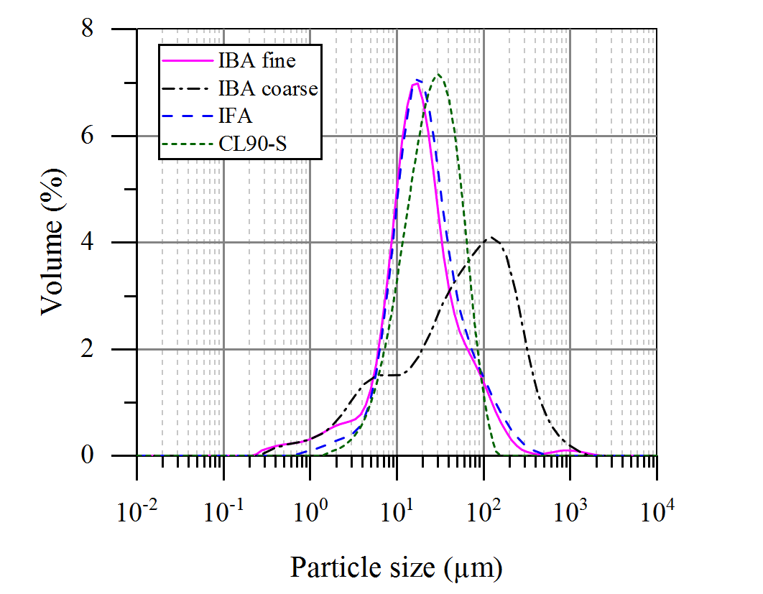
Fig. 1: Particle size distribution

Table 1 shows the particle size distribution of the ashes including D values, D10 (10 % cumulative undersize particle size distribution), D50 (median diameter) and D90 (90% cumulative undersize particle size distribution). The 45 µm residues are given as percentage values. This parameter is important in the cement industry to determine fineness as it is known that, under standard curing conditions, clinker particles coarser than approximately 30 microns are incompletely hydrated at 28 days.
Surface area is also a key parameter as it drives early hydration and thus early strength development. According to the results (Table 1), the specific surface area of the incinerator ashes is greater than that of typical supplementary cementing materials such as GGBS and PFA, however, lower than RHA or MS [13]. As it can be seen from Table 1, the bottom ashes (IBA fine and IBA coarse) have a higher specific surface area, 7.42 m²/g and 5.74 m²/g respectively, while the fly ash IFA shows a slightly lower value of 5.27 m²/g. This suggests that the bottom ashes may be lightly more porous.

Table 1: D values, residue at 45 µm and specific surface area
 | D10 | D50 | D90 | 45 µm residue (%) | Specific surface area (m²/g)
IBA fine | 5.09 | 16.53 | 64.23 | 18.03 | 7.42
IBA coarse | 4.14 | 56.43 | 247.03 | 58.52 | 5.74
IFA | 7.04 | 18.69 | 68.98 | 20.49 | 5.27
CL90-S | 8.15 | 24.13 | 57.98 | 24.68 | -

The porosity and microstructure of the ashes were further evidenced with SEM. The technique showed the uneven particle size distribution of the ashes (Fig. 2) consisting of a heterogeneous mixture of prismatic, spherical, flaky and rounded particles. Agglomerations of round particles are observed in the bottom ashes, agreeing with former authors [13-18]. However, coated with fine flaky shaped particles, agglomerations were also observed in the fly ash, matching with findings in previous literature [19-21]. The spherical particles are reported to be produced from melt droplets during the incineration process of the MSW [19].
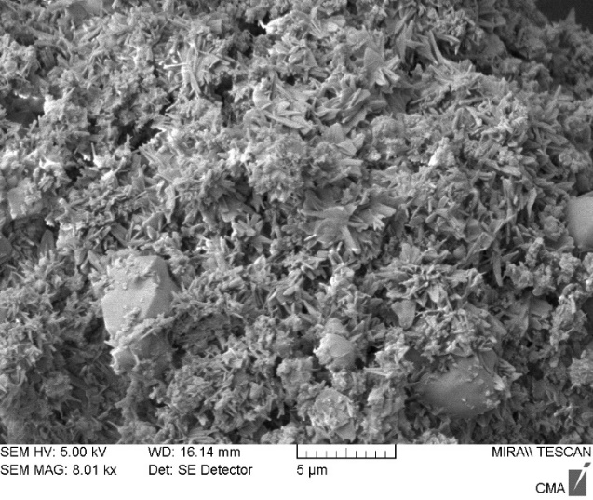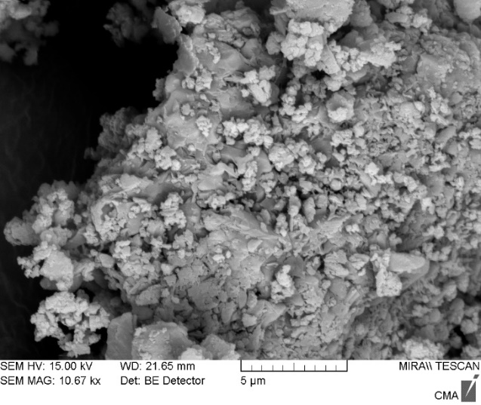
Fig. 2: SEM micrograph of IBA fine (left) and IFA (right) showing agglomerates, which cause porosity to build up and increase the surface area of a particle.

The chemical composition of the ashes is included in Table 2. According to the results, the bottom ashes show higher SiO₂, over 5 times the amount in the fly ash. However, the fly ash’s calcium content (43%) is more than twice the content in the bottom ashes. Previous authors have reported lower Ca values varying from 24 to 27% for MSWI fly ashes [22-24]. The iron and aluminium content are also significantly lower in the fly ash while the chlorine, sulfur and alkalis are higher (mainly potassium).

Table 2: Chemical composition (%).
 | IBA fine | IBA coarse | IFA
SiO₂ | 32.90 | 38.70 | 7.64
Al₂O₂ | 11.10 | 13.15 | 3.71
Fe₂O₃ | 9.00 | 9.00 | 1.15
CaO | 21.00 | 21.00 | 43.7
MgO | 1.90 | 2.15 | 1.30
K₂O | 1.77 | 2.00 | 4.84
TiO₂ | 1.61 | 1.75 | 0.69
P₂O₅ | 1.56 | 1.76 | 0.84
SO₃ | - | 1.95 | 2.26
Na₂O | 1.96 | 2.82 | 2.92
MgO | 1.90 | 2.15 | 1.30
SrO | 0.04 | 0.05 | 0.04
BaO | 0.20 | 0.26 | 0.10
Cl | 0.72 | 0.61 | >2.00
LOI | 12.30 | 8.19 | 16.65

According to the XRD analysis, the mineralogy of the ashes consists mainly of calcite, quartz, and hematite; with lower amounts of gehlenite- Ca₂Al₂SiO₇ - (fine bottom ash), halite - ClNa -(in the coarse bottom ash and the fly ash) and corundum also in the coarse ash. The mineralogical composition of the ashes appears in Table 3. The mineralogy of the coarse bottom ash, which also includes the calcium-rich feldspar anorthite - Ca(Al₂Si₂O₈) as a main component, appears in the XRD trace in Fig. 3. Ceramics and metamorphism, gehlenite and anorthite appear at temperatures over 850 °C which agrees with the production temperature of the ashes. The minerals and LOI in the fly ash suggest that this ash has a higher organic content and reached lower temperature in the incinerator.
Corundum (Al₂O₃) is a high-temperature, crystalline form of aluminium oxide that typically occurs in metamorphic and igneous rocks therefore, it is also consistent with the high production temperature of the ashes. The presence of silica as cristobalite agrees with other authors that found significant cristobalite in other ashes from agricultural industries [25, 26]. Cordeiro et al. (2009) [25] found cristobalite in sugarcane bagasse burnt at temperatures varying from 700 to 900 °C and Pavia et al. as the main component of rice husk ash (RHA).
Table 3: Mineralogical composition
 | Main | Minor and accessory
IBA fine | Calcite, quartz, hematite, | gehlenite
IBA coarse | Calcite, quartz, hematite, anorthite | cristobalite, corundum, halite
IFA | Calcite, quartz, hematite, | halite

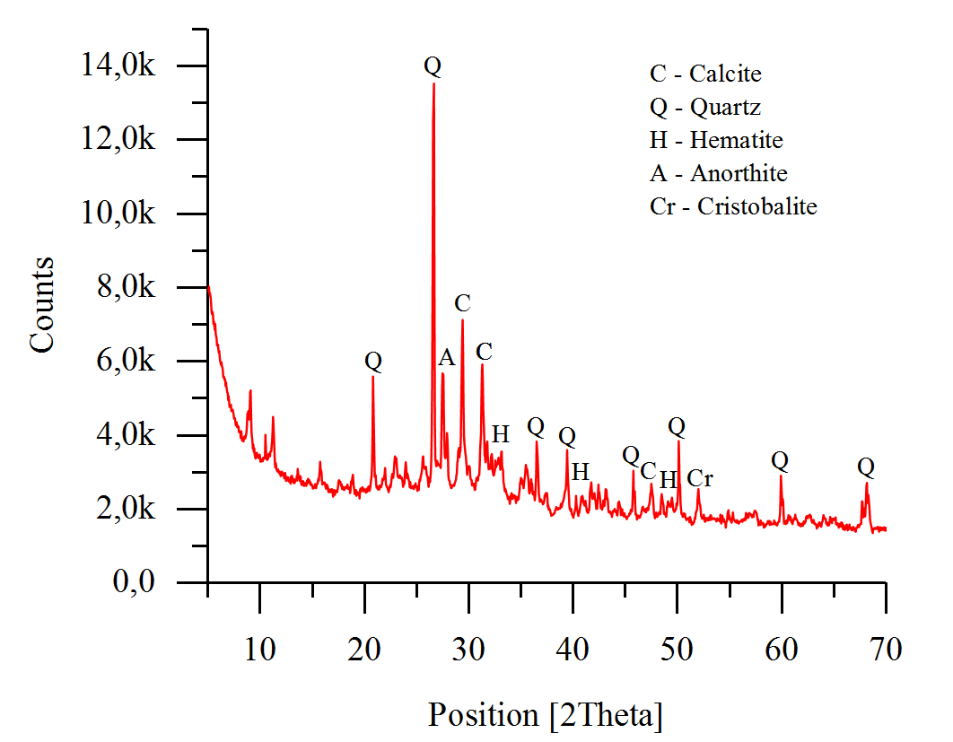
Fig. 3: XRD patterns of IBA coarse

Reactivity
The chemical reactivity test evidenced that all the lime/ash suspensions progressively lowered conductivity, attesting that the ashes were capable of combining lime thus showing reactivity. The losses of electrical conductivity were higher on the bottom ashes, with IBA coarse being the most reactive in solution, followed by IBA fine and finally IFA.
It is noted that the fly ash IFA remains dormant between 24 and 48 hours and later steadily increases reactivity, while the bottom ashes show dormant stages later. The reactivity shows roughly 4 phases [27, 28], phases I and IV are common to all whereas phases II-III are typical of the bottom ashes.
Phase I – In the first 24 hours, the steep curve slopes reflect the 12% conductivity loss of the solutions and thus the quick combination of lime by the ashes. By the end of phase I, the fine and coarse bottom ashes have the same conductivity.
Phase II – Between 24 and 48 hours the lesser steep curves indicate a drop in the reaction rate. Phase III – Between 48 and 96 hours the bottom ashes significantly reduce chemical activity falling into a dormant period. Phase IV – After 96 hours the steeper slopes suggest new increased reactivity.
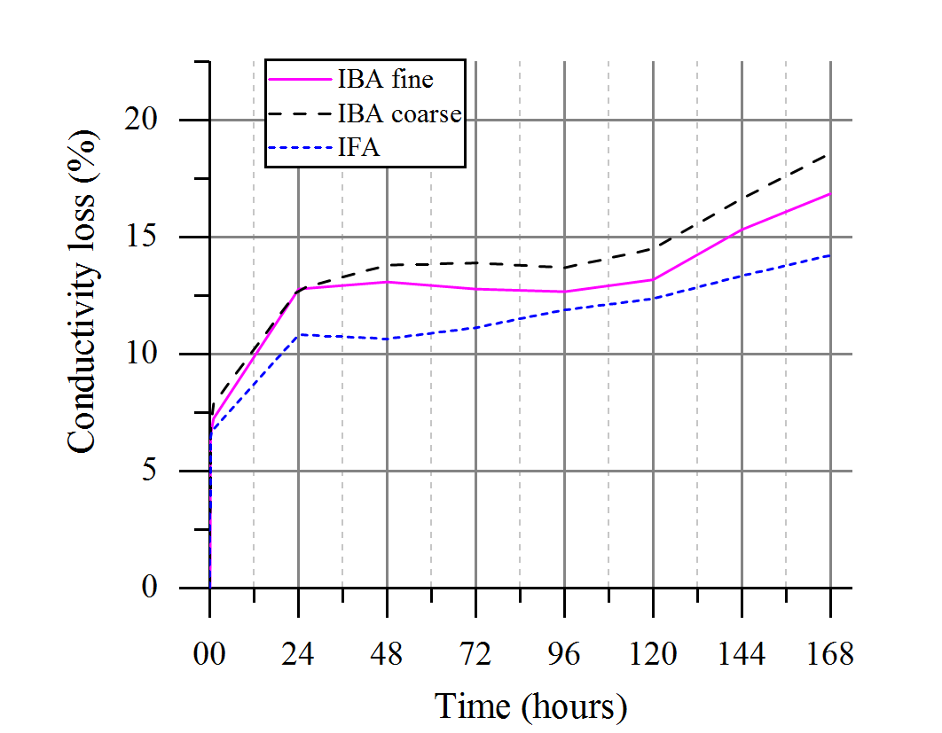
Fig. 4: Conductivity loss over time (%).
The mechanical activity index measured as the ratio of the compressive and flexural strengths of the lime/pozzolan mix to a standard lime/sand mix is included in
Table 4.The replacement of hydrated lime with fly ash improved the compressive and flexural strength of lime: the compressive strength was enhanced by 14% and the flexural strength by 90%. In contrast, the bottom ash significantly decreased the compressive strength of lime after 90 days. However, the fine bottom ash slightly increased the lime’s flexural strength.

Table 4: Mechanical properties and activity index.
 | Compressive strength (MPa) | Flexural strength (MPa) | Activity index (%)
 | Compressive strength (MPa) | Flexural strength (MPa) | Compressive strength | Flexural strength
Control mix | 2.45 | 0.39 | 100 | 100
IBA fine | 1.05 | 0.57 | 42 | 147
IBA coarse | 0.78 | 0.38 | 31 | 96
IFA | 2.79 | 0.74 | 114 | 190

Discussion of results
The low silica, iron and aluminium and higher Ca, chlorine, sulfur and alkalis (mainly potassium) of the fly ash agrees with its mineral composition including significant calcite and traces of halite. The presence of chlorine, sulfur and alkalis in the fly ash may adversely impact durability. The higher Si, Al and Fe in the bottom ashes also agrees with the presence of calcium silicates/ aluminates and significant hematite determined by XRD.
Some of the reactivity results are contradictory. For example, the coarse bottom ash is the most reactive in solution however, it significantly reduced the compressive strength of the lime which suggests lower activity. Conversely, in solution, the fly ash show less chemical activity as it combines less lime at a lower speed than the bottom ash however, it improves the compressive and flexural strengths of the lime by 14% and 90% respectively which suggests a higher activity.
The increase of 47% flexural strength of the lime by the fine bottom ash agrees with its fine particle size (finer than lime) and its substantially greater specific surface area however, the compressive strength of the lime is approximately halved by the fine bottom ash suggesting a low activity in the generation of pozzolanic hydrates.
Although the conductivity loss shows that the bottom ashes combine more lime at a faster pace (Fig. 4), it is observed that the fly ash shows greater conductivity variation (Fig. 5). This is due to the different initial conductivity. While the initial conductivity of the IBA-lime solution is 9.8 mS/cm, which is the conductivity of the lime, the initial value for IFA-lime solution is 17.09 mS/cm, as the fly ash possesses a conductivity greater than lime in solution. Therefore, considering the variation in conductivity the fly ash is the most reactive. Agreeing with the mechanical test results.
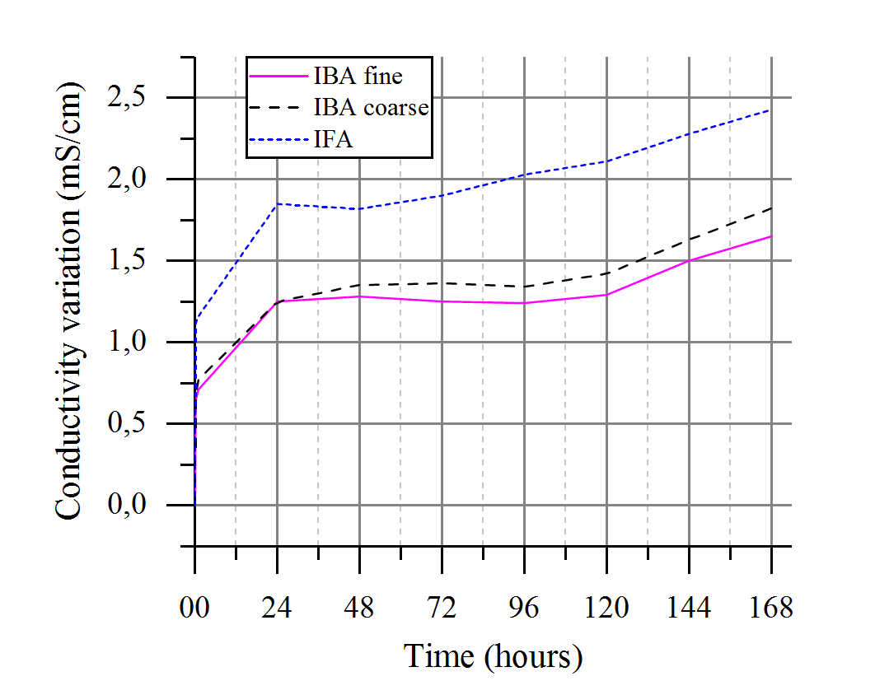
Fig. 5: Conductivity variation (mS/cm).
According with the mechanical test the fine bottom ash is more reactive than the coarse however the chemical test places the ashes opposite. This disagreement may be due to the higher percentage of metals in the coarse bottom ash. In particular aluminium, causes expansion due to the hydrogen produced by cathodic reaction of electrochemical process of corrosion, causing a decrease on the density and strength [29]. Furthermore, IBA fine possesses a higher specific surface area, which is an important driver of the early strength development [30].
A positive correlation was found between the conductivity variation and compressive strength. Fig. 6 presents the fitted line plot of the regression analysis for the studied ashes.
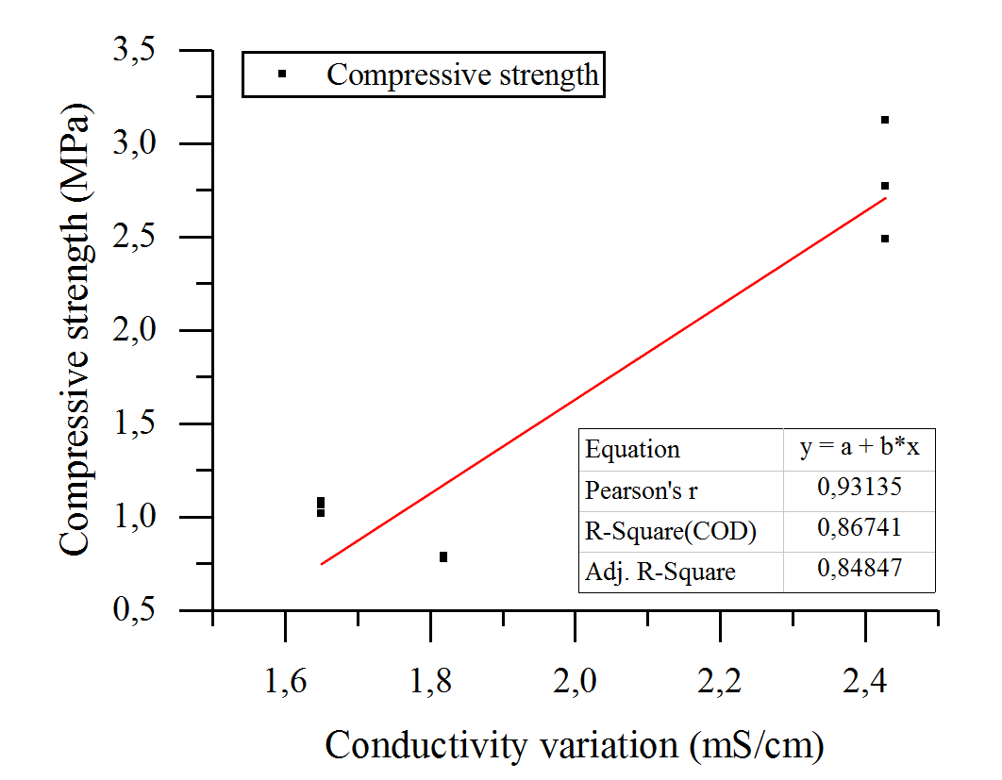
Fig. 6: Correlation between conductivity variation and compressive strength.
The fly ash significantly increased the compressive strength of the lime alone by 14% and the flexural strength by 90%. Although the bottom ashes did not achieve compressive strength values as high as the control mix, they reached compelling results when tested for flexural strength. IBA fine presenting a higher strength than the control mix by 47% and IBA coarse achieving 96% of the control strength.
A good correlation was also found between the amount of CaO and the compressive strength. Fig. 7 shows the linear fit for the cited correlation with a slope significantly different from zero at the 0.05 level, meaning that there is a significant relationship between the variables. Analysis of Variance (ANOVA) was undertaken to determine the results significance.
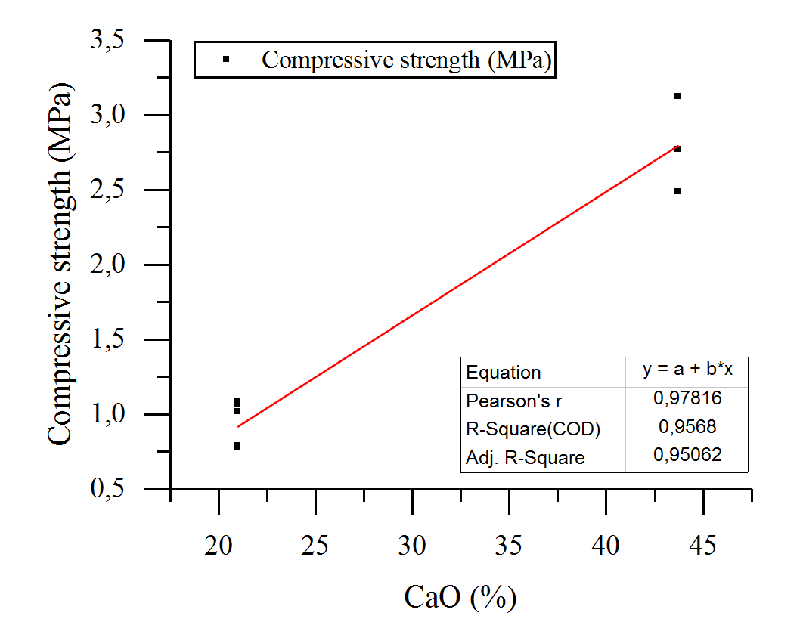
Fig. 7: Correlation between CaO and compressive strength

It has been reported that high-calcium fly ash leads to a more rapid strength gain, as the large amounts of CaO, when released in solution, can react with the glass phase rendering these fly ashes as self-pozzolanic [31].

CONCLUSIONS
The electrical conductivity and strength development tests evidenced reactivity for the ashes as expected from their fineness and high specific surface areas. IFA and IBA fine significantly increased the flexural strength of hydrated lime alone. The compressive strength of the mix containing fly ash enhanced the strength of the hydrated lime by 14%.
The tests place the bottom ashes in different order of reactivity. IFA was the most reactive in both tests. The conductivity test places the ashes in decreasing reactive order as: IFA, IBA coarse and IBA fine. Whereas, the compressive strength place them as: IFA, IBA fine and finally IBA coarse.
The compressive strength development shows a positive linear relationship with the conductivity variation of the lime-ash solutions. While flexural strength presents a positive correlation with the loss on ignition of the ashes.

ACKNOWLEDGEMENTS
The authors wish to thank the Brazilian National Counsel of Technological and Scientific Development (CNPq) – Ministry of Science, Technology, Innovations and Communications – for financing this investigation. The authors thank Michael Grimes of the Materials Laboratory in the Department of Civil Engineering for his help with physical testing; Aran Rafferty of CRANN for his assistance with the BET analysis; and Derek Simpson of the Centre for Microscopy and Analysis –CMA- in Trinity College for their assistance with the SEM analyses.

BIBLIOGRAPHICAL REFERENCES
[1] Hoornweg, D., & Bhada-Tata, P. (2012). What a waste: a global review of solid waste management.
[2] Hjelmar, O. (1996). Disposal strategies for municipal solid waste incineration residues. Journal of Hazardous Materials, 47(1), 345-368. doi:https://doi.org/10.1016/0304-3894(95)00111-5.
[3] Filipponi, P., Polettini, A., Pomi, R., & Sirini, P. (2003). Physical and mechanical properties of cement-based products containing incineration bottom ash. Waste Management, 23(2), 145-156. doi:http://dx.doi.org/10.1016/S0956-053X(02)00041-7.
[4] Müller, U., & Rübner, K. (2006). The microstructure of concrete made with municipal waste incinerator bottom ash as an aggregate component. Cement and Concrete Research, 36(8), 1434-1443. doi:http://dx.doi.org/10.1016/j.cemconres.2006.03.023.
[5] Lin, K., Chang, W., & Lin, D. (2008). Pozzolanic characteristics of pulverized incinerator bottom ash slag. Construction and Building Materials, 22(3), 324-329.
[6] Carrasco, B., Cruz, N., Terrados, J., Corpas, F. A., & Pérez, L. (2014). An evaluation of bottom ash from plant biomass as a replacement for cement in building blocks. Fuel, 118, 272-280. doi:http://dx.doi.org/10.1016/j.fuel.2013.10.077.
[7] Cabrera, M., Galvin, A. P., Agrela, F., Carvajal, M. D., & Ayuso, J. (2014). Characterisation and technical feasibility of using biomass bottom ash for civil infrastructures. Construction and Building Materials, 58, 234-244. doi:http://dx.doi.org/10.1016/j.conbuildmat.2014.01.087.
[8] Hinojosa, M. J. R., Galvín, A. P., Agrela, F., Perianes, M., & Barbudo, A. (2014). Potential use of biomass bottom ash as alternative construction material: Conflictive chemical parameters according to technical regulations. Fuel, 128, 248-259. doi:http://dx.doi.org/10.1016/j.fuel.2014.03.017.
[9] Jurič, B., Hanžič, L., Ilić, R., & Samec, N. (2006). Utilization of municipal solid waste bottom ash and recycled aggregate in concrete. Waste Management, 26(12), 1436-1442. doi:http://dx.doi.org/10.1016/j.wasman.2005.10.016.
[10] BS EN 459-2:2010 Building Lime. Test Methods. (2010). In (Vol. BS EN 459-2:2010, pp. 68): BSI Standards Limited.
[11] BS EN 196-1:2005 Methods of Testing Cement. (2005). In (Vol. BS EN 196-1:2005, pp. 36): BSI Standards Limited.
[12] Massazza, F. (1998). Pozzolana and pozzolanic cements. Lea’s chemistry of cement and concrete, 4, 471-635.
[13] Walker, R., & Pavía, S. (2011). Physical properties and reactivity of pozzolans, and their influence on the properties of lime–pozzolan pastes. Materials and structures, 44(6), 1139-1150.
[14] González-Fonteboa, B., Carro-López, D., de Brito, J., Martínez-Abella, F., Seara-Paz, S., & Gutiérrez-Mainar, S. (2017). Comparison of ground bottom ash and limestone as additions in blended cements. Materials and Structures, 50(1), 84.
[15] Sathonsaowaphak, A., Chindaprasirt, P., & Pimraksa, K. (2009). Workability and strength of lignite bottom ash geopolymer mortar. Journal of Hazardous Materials, 168(1), 44-50. doi:http://dx.doi.org/10.1016/j.jhazmat.2009.01.120.
[16] Kurama, H., & Kaya, M. (2008). Usage of coal combustion bottom ash in concrete mixture. Construction and Building Materials, 22(9), 1922-1928. doi:http://dx.doi.org/10.1016/j.conbuildmat.2007.07.008.
[17] Wang, Y., Huang, L., & Lau, R. (2016). Conversion of municipal solid waste incineration bottom ash to sorbent material for pollutants removal from water. Journal of the Taiwan Institute of Chemical Engineers, 60, 275-286. doi:http://dx.doi.org/10.1016/j.jtice.2015.10.013.
[18] Tang, P., Florea, M. V. A., Spiesz, P., & Brouwers, H. J. H. (2016). Application of thermally activated municipal solid waste incineration (MSWI) bottom ash fines as binder substitute. Cement and Concrete Composites, 70, 194-205. doi:http://dx.doi.org/10.1016/j.cemconcomp.2016.03.015.
[19] Bayuseno, A. P., & Schmahl, W. W. (2011). Characterization of MSWI fly ash through mineralogy and water extraction. Resources, Conservation and Recycling, 55(5), 524-534. doi:http://dx.doi.org/10.1016/j.resconrec.2011.01.002.
[20] Thipse, S. S., Schoenitz, M., & Dreizin, E. L. (2002). Morphology and composition of the fly ash particles produced in incineration of municipal solid waste. Fuel Processing Technology, 75(3), 173-184. doi:http://dx.doi.org/10.1016/S0378-3820(02)00007-3.
[21] Kutchko, B. G., & Kim, A. G. (2006). Fly ash characterization by SEM–EDS. Fuel, 85(17–18), 2537-2544. doi:http://dx.doi.org/10.1016/j.fuel.2006.05.016.
[22] Siddique, R. (2010). Use of municipal solid waste ash in concrete. Resources, Conservation and Recycling, 55(2), 83-91. doi:https://doi.org/10.1016/j.resconrec.2010.10.003.
[23] Felekoğlu, B., Türkel, S., & Kalyoncu, H. (2009). Optimization of fineness to maximize the strength activity of high-calcium ground fly ash – Portland cement composites. Construction and Building Materials, 23(5), 2053-2061. doi:http://dx.doi.org/10.1016/j.conbuildmat.2008.08.024.
[24] Wang, S. (2014). Compressive strengths of mortar cubes from hydrated lime with cofired biomass fly ashes. Construction and Building Materials, 50, 414-420.
[25] Cordeiro, G. C., Toledo Filho, R. D., Tavares, L. M., & Fairbairn, E. d. M. R. (2009). Ultrafine grinding of sugar cane bagasse ash for application as pozzolanic admixture in concrete. Cement and Concrete Research, 39(2), 110-115. doi:http://dx.doi.org/10.1016/j.cemconres.2008.11.005.
[26] Pavía, S., Walker, R., Veale, P., & Wood, A. (2014). Impact of the properties and reactivity of rice husk ash on lime mortar properties. Journal of Materials in Civil Engineering, 26(9), 04014066.
[27] Walker, R. (2013). A Study of the Properties of Lime-Hemp Concrete with Pozzolans. (Doctor of Philosophy), Trinity College Dublin, Dublin Ireland.
[28] McCarter, W. J., & Tran, D. (1996). Monitoring pozzolanic activity by direct activation with calcium hydroxide. Construction and Building Materials, 10(3), 179-184. doi:http://dx.doi.org/10.1016/0950-0618(95)00089-5.
[29] Bertolini, L., Carsana, M., Cassago, D., Quadrio Curzio, A., & Collepardi, M. (2004). MSWI ashes as mineral additions in concrete. Cement and Concrete Research, 34(10), 1899-1906. doi:http://dx.doi.org/10.1016/j.cemconres.2004.02.001.
[30] Hewlett, P. (2003). Lea's chemistry of cement and concrete: Butterworth-Heinemann.
[31] Barnes, P., & Bensted, J. (2002). Structure and performance of cements: CRC Press.

