Whelan, A.^{1, 2,3}, Gaul, R.^{1, 2}, Gunning, P³, Lally, C.^{1, 2}
¹ Trinity Centre for Bioengineering, Trinity Biomedical Sciences Institute, Trinity College Dublin
² Department of Mechanical and Manufacturing Engineering, School of Engineering, Trinity College Dublin
³ Structural Heart R&D, Boston Scientific Corporation, Galway

email: (whelana5@tcd.ie)

Investigation of Collagen Fibre Orientation In Bovine Pericardium

Introduction
At present, the primary method of replacing dysfunctional heart valves is open-heart surgery and this is unsuitable for high-risk patients with pre-existing comorbidities. Recent data pertaining to the percutaneous alternative, transcatheter aortic valve implantation (TAVI), supports its use as a safe and effective alternative to surgery [1]. Although TAVI devices offer improved hemodynamics in comparison to mechanical valves, their long-term performance is compromised by the limited durability of the bovine pericardium (BP) leaflets employed therein. While premature device failure is commonly attributed to leaflet calcification and/or mechanical fatigue, the exact failure mechanism is not fully understood [2]. It is known, however, that the mechanical behaviour of BP is dictated by the organization of its collagen fibres [3]. Furthermore, mechanical fatigue may also be a precursor to calcification, as structural disintegration of BP leaflets from fatigue can promote nucleation sites for calcification [4]. In order to better understand the fatigue life of BP leaflets in vivo and potentially improve the performance of current devices, more comprehensive studies investigating the architecture and reorientation of collagen fibres in BP under loading are required. The aim of this work is to use small angle light scattering (SALS) to determine the predominant fibre orientation of BP tissue in advance of and following mechanical testing. This non-destructive technique enables exploration of the role of fibre reorientation in the long-term mechanical behaviour of the tissue.

sals of bovine pericardium
SALS is an optical method of determining collagen fibre orientation in collagenous tissues which involves passing a laser beam through the tissue and estimating fibre orientation from the scattered light distribution. SALS has previously been employed to determine the preferred collagen fibre direction (PD) in BP, with both local and global variability described in the literature [5-7]. Additionally, reorientation of fibres towards the direction of loading during mechanical testing has been reported [5]. Therefore, in this study, specimens for SALS were cut from a patch of glutaraldehyde fixed BP to investigate fibre orientation, and possible reorientation, with load application. Firstly, specimens were punched from different locations across the patch to assess global PD variation. Local fibre orientation homogeneity was also assessed, by repeating SALS at various locations along the specimen length. To determine the influence of loading on fibre orientation, specimens were subsequently uniaxially preconditioned for 5 cycles, between 0.1MPa and 1MPa.

RESULTS & DISCUSSION
Principally, SALS illustrated a high degree of variability in PD amongst unloaded specimens from a singular BP patch. PD inhomogeneity was also seen along the length of individual BP specimens. Moreover, fibre reorientation towards the direction of loading was observed in a number of specimens following uniaxial preconditioning (see fig. 1 (B, C)). These outcomes support the aforementioned results published in the literature [5-7].
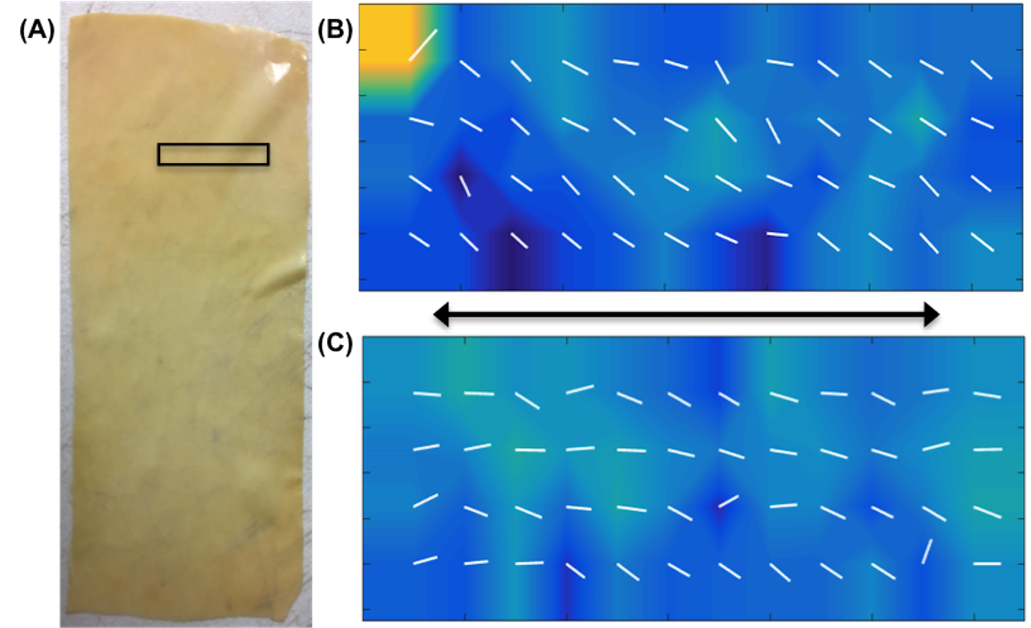
Figure 1: (A) Rectangular sheet of BP, box denotes specimen cut for SALS. (B) SALS fibre contour plot of specimen pre-load application. (C) SALS fibre contour plot of specimen post-load application. Arrow indicates tensile loading direction
Future perspectives
While the above preliminary results indicate the direction of load application influences the resulting fibre orientation of BP specimens, further mechanical testing is required to better understand the relationship between loading direction and fibre reorientation, and consequently, fibre orientation and mechanical performance.
Future work will include cyclic tensile loading of BP specimens for low cycle numbers, in conjunction with incremental fibre orientation examination. The motivation for this arises from studies reporting the significance of the initial cycles in dictating the subsequent mechanical behaviour of BP tissue [5,8]. The non-destructive nature of SALS is particularly suited to such studies, enabling stepwise determination of the correlation between fibre reorientation and increasing cycle number. Additional mechanical tests such as creep, stress relaxation and uniaxial tensile tests, will also be conducted to supplement the investigation of the role of fibre reorientation on the fatigue life of BP with a view to increasing the durability of BP leaflets.

References
[1] Mylotte et al., J. Am. Coll. Cardiol., 62(3), 210–219, 2013.
[2] Martin, Biomech Model Mechanobiol, 12, 645, 2013.
[3] Alavi et al., Ann Biomed Eng., 41(3), 547–561, 2013.
[4] Vesely, Cardiovasc Pathol, 12(5)277-286, 2003.
[5] Sun et al., J Biomed Mater Res A, 69 (4), 658-669, 2004.
[6] Mavrilas et al., J. Biomech, 38(4), 761–768, 2005
[7] Liao et al., Acta Biomater., 1(1), 45-54, 2005.
[8] Yves et al., J Mech Behav Biomed Mater, 61, 55-61,2016

ACKNOWLEDGEMENTS
This project has received funding from the Irish Research Council and Boston Scientific Corporation, Galway (EBPPG/2016/353).

