Ciliotherapy Treatments to enhance Biochemically- and Biophysically-induced Mesenchymal Stem Cell Osteogenesis: A Comparison Study

Corrigan, M. A.^{1,2}, Ferradaes, T. M.^{1,2,3}, Riffault, M. ^{1,2,4}, Hoey, D.A.^{1,2,4}
¹Trinity Centre for Bioengineering, Trinity Biomedical Sciences Institute, Trinity College, Dublin, D02 R590, Ireland
²Dept. of Mechanical and Manufacturing Engineering, School of Engineering, Trinity College Dublin, Dublin 2, D02 DK07, Ireland
³School of Engineering, Universidade Federal do Estado do Rio de Janeiro, Avenue Pasteur, 458, Urca, Rio do Janeiro, Brazil
⁴Advanced Materials and Bioengineering Research Centre, Trinity College Dublin & RCSI, Dublin 2, D02 VN51, Ireland

Abbreviated Title
Ciliotherapies to enhance stem cell osteogenesis

Abstract
Introduction
New approaches to treat osteoporosis have focused on promoting bone formation through the targeting of osteoblasts and their progenitors, mesenchymal stem cells (MSCs). The primary cilium is a singular cellular extension known to play an important role in biochemical and biophysical osteogenic induction of MSCs. Defects in ciliary structure have been associated with a plethora of diseases. Thereofre targeting the cilium therapeutically (ciliotherapies) has emerged as a potential new treatment modality. Therefore, this study performed a comparison analysis on known ciliotherapies and their potential effects in mediating MSC osteogenic differentiation.
Methods
MSCs were treated with forskolin, lithium chloride (LiCl) or fenoldopam to investigate the effect on ciliogenesis and cilia-associated signalling. Moreover, both early and long term biochemical and biophysical (fluid shear) induced osteogenic differentiation was examined in terms of osteogenic gene expression and bone matrix deposition following each treatment.
Results
LiCl and fenoldopam were found to enhance MSC ciliogenesis to a similar degree. LiCl significantly altered Hedgehog (HH) and Wnt signalling which was associated with inhibited osteogenic gene expression, while fenoldopam demonstrated enhanced early osteogenesis. Long term treatment with both ciliotherapies did not enhance osteogenesis, however LiCl had detrimental effects on cell viability. Intriguingly both ciliotherapies enhanced MSC mechanosensitivity as demonstrated by augmented osteogenic gene expression in response to fluid shear, which over longer durations resulted in enhanced matrix deposition per cell.
Conclusions
Therefore, ciliotherapies can be utilised to enhance MSC ciliogenesis resulting in enhanced mechanosensitivity, however, only fenoldopam is a viable ciliotherapeutic option to enhance MSC osteogenesis.

Key words
Bone; Oscillatory fluid shear; Primary Cilium; Mechanobiology; Hedgehog; Wnt
Introduction
Osteoporotic patients are prone to low impact fractures because of the significant depletion in bone density and quality. This occurs due to an imbalance in the bone remodelling cycle where bone formation rates can no longer match the bone resorption activity. Most of the current therapies inhibit bone resorption to restore balance, however over 25% of patients don’t respond well to treatment and rare but disabling side effects are associated with these treatments [4]. To overcome limitations in anti-catabolic therapies for osteoporosis, anabolic bone forming therapies targeting the osteoblast and its progenitor, the mesenchymal stem cell (MSC), are emerging in the form of intermittent parathyroid hormone (PTH) and sclerostin antibodies. PTH is currently the only clinically approved treatment but effectiveness plateaus at 2 years [1]. Sclerostin antibodies are showing promise in phase 3 clinical trials. Despite this promise, there are concerns linking sclerostin to cardiovascular disease [14]. A key mediator of bone anabolism is physical loading and thus represents a novel avenue to enhance bone formation. The adaptation of bone tissue to mechanical loading requires sensation of the surrounding mechanical environment as well as transduction of these cues into changes in intracellular behaviour [12]. The molecular mechanisms mediating environmental responses such as from physical activity could form novel therapeutic targets to enhance bone formation, as osteoporotic patients do not possess sufficient bone strength to withstand high impact exercise directly.
MSCs are multipotent cells which form the source of bone forming osteoblasts and are abundant within the marrow of long bones [10]. The adaptation of bone to mechanical loading requires the MSC population to differentiate to support the finite osteoblast population [7]. Marrow is displaced during physical activity eliciting a shear stress on the cells predicted to be in the range of 0.5 and 8Pa, depending on viscosity and anatomical location [28]. Physiological relevant oscillatory fluid shear generated during daily ambulation has been shown to upregulate osteogenic genes COX-2, OPN, DLX-5 and the master osteogenic transcription factor RUNX-2 leading to the osteogenic lineage commitment of MSCs [19, 24, 25, 39]. Understanding the mechanisms by which stem cells sense their microenvironment leading to a pro-osteogenic response is critical to the development of new anabolic therapies that target these mechanisms.
In recent years, the primary cilium has emerged as an important organelle involved in regulating cellular behaviour in response to its extracellular environment, particularly in bone [17, 21]. The primary cilium is a microtubule-based appendage that is present in singular form on the surface of most mammalian cells. Extending into the extracellular milieu the cilium is ideally positioned and equipped, via specific localisation of receptors and ion channels to act as a biochemical and biophysical cellular sensor [17]. Moreover, the high surface to volume ratio of the ciliary microdomain, the close proximity of signal components with the cilium, and the fact that the cilium is spatially removed from the rest of the cytosol facilitates rapid signal activation and transduction [16]. Of note, the hedgehog and Wnt pathway are regulated through localisation of receptors to the ciliary microcompartment, two pathways intrinsically linked to differentiation. The sonic hedgehog (SHH) plays a key role during skeletogenesis, where SHH ligand binds to the receptor Patched (PTCH) activating Gli transcription factors which in turn drive MSC osteogenesis [20]. Furthermore, Wnt signalling plays an important regulatory role in MSC osteogenesis via β-catenin signalling, upregulating osteogenic transcription factors while simultaneously inhibiting adipogenesis and chondrogenesis [3]. Antibodies against endogenous antagonists of the Wnt pathway such as sclerostin and dickkopf-1 are now being utilised to promote bone formation and fracture healing. In MSCs, primary cilia play a role in interpreting biochemical signals in osteogenic differentiation and lack of a functional primary cilium reduces the expression of early markers of differentiation [41]. Furthermore, the primary cilium regulates TGFβ induced recruitment in human MSCs [26]. In addition, the antenna like structure of the cilium protruding into the extracellular space exposes it to surrounding fluid movement. It was first shown in kidney epithelia that cilia deflection is dependent on the flow of urine [37]. The importance of the MSC primary cilium in the bone forming response to loading was demonstrated in vivo where murine bone marrow, including the stem cell population, were depleted of primary cilia. Here, the bone formation rate in response to ulna loading was inhibited in the presence of absent or dysfunctional stem cell cilia [5]. Furthermore, the response of hMSCs to oscillating fluid shear in vitro, which characteristically results in enhanced osteogenic markers, is blunted in the absence of primary cilia [8, 19, 22]. Given the potent role of the cilium in MSC osteogenesis, this cellular organelle represents an ideal target for therapeutic development.
Alteration in cilia structure have been associated with a plethora of diseases [15] and thus have fuelled several investigations on methods to alter cilia incidence and length as a potential therapy, known as ciliotherapies. The adenylyl cyclase activator forskolin can increase cilium length in kidney collecting duct, kidney epithelium and bone mesenchymal cells via an increase in PKA activity, mediated through cAMP [36]. Modulation of axoneme length is perceived to be a mechanism to regulate the cilium-mediated fluid shear response in the kidney which becomes defective in polycystic kidney disease [2]. Lithium chloride is an FDA approved treatment for bipolar and manic depression which has been used to lengthen primary cilia in a range of cell types [9]. The elongation of the cilium axoneme is mediated by inhibiting GSK3β in algae and human fibroblast studies, where it was found to promote the acetylation of alpha tubulin [29, 30]. However, in murine brain and neuron cells lithium was not associated with GSK3β interference but effects the AC3-cAMP pathway [29, 32]. Recent studies in a rat model validate the use of lithium in vivo as a cilium elongating agent and as a therapy to alter hedgehog signalling associated with progression of osteoarthritis [40]. Through the study of a well characterized ciliopathy, Polycystic Kidney Disease (PKD), where cilia are shortened and patients experience hypertension, the drug fenoldopam has been discovered to alter cilia. Fenoldopam treatment ameliorates PKD associated hypertension in murine models [23]. Interestingly, fenoldopam induced increases in cilium length heighten the sensitivity of kidney cells to fluid shear highlighting this approach as a potential option to increase the cilium-mediated osteogenic response in MSCs to fluid shear [43].
Given the role of the primary cilium in signal transduction in MSCs, both biochemical and biophysical, this study set out to target this activity to promote MSC differentiation. The first objective was to optimize the length of the MSC primary cilium using known cilium-altering compounds, forskolin, lithium chloride and fenoldopam and determine the impact of these treatments on MSC behavior. The second objective was to use the optimized treatments to increase the bone forming response of MSCs in the presence of physiologically relevant biochemical and biophysical signals.

Materials and Methods
Mesenchymal stem cell culture
The murine mesenchymal stem cell line C3H10T1/2 was obtained from ATCC (LGC Standards). MSCs were maintained in Dulbecco’s modified Eagle’s medium (DMEM) with low glucose (Sigma-Aldrich) supplemented with 10% fetal bovine serum (FBS) (Labtech) and 1% penicillin streptomycin (P/S) (Sigma). For long term studies MSCs were supplemented with 10mM β-glycerophosphate (Sigma) and 0.05mM ascorbic acid (Sigma) as well as dexamethasone (Sigma) at either 10nM (minimal supplements) to provide the components necessary for osteogenic matrix formation or 100nM (full supplements) to biochemically induce osteogenic differentiation as a positive control.
Biochemical modulation of cilium length
Three separate ciliotherapies known to increase the length of the cilium axoneme in various cell types were utilized in this study. Two concentrations of forskolin (Sigma) [36], lithium chloride (Sigma) [40] and fenoldopam mesylate (Sigma) [23] were compared in MSCs as detailed in Table 1. These concentrations were selected based on previous studies which have demonstrated alterations in cilia length in kidney cells [2, 42], endothelial cells [23], chondrocytes [40], and osteocytes [38]. A time course study was conducted whereby each treatment was applied for either 1hr or 24hrs followed by fixation for cilia structural analysis. Cells were imaged at 4x (N.A. 0.13) phase contrast following each treatment to determine the overall effects on morphology and cell viability. Furthermore, a live-dead assay was performed, whereby calcein acetoxymethyl stain was utilised to label live cells and ethidium homodimer-1 to stain damaged or dead cells. The stains were diluted to 4mM and 2mM respectively in PBS and the monolayer incubated for 1 hour and 37°C. For long term studies treatments were applied throughout the culture period.
Immunocytochemistry
MSCs were seeded on fibronectin coated glass coverslips for 24 hours before serum starvation in DMEM low glucose, 0.5% FBS, 1% P/S for 48 hours. After fixation in neutral buffered formalin for 10 minutes (Sigma), coverslips were permeabilised in 0.1% Triton X-100 for a further 10 minutes and non-specific binding sites were blocked using 1% w/v BSA (Sigma) in PBS for 2 hours at room temperature. The primary antibody targeting the primary cilium (acetylated α tubulin, ab24610, Abcam) or β-catenin (active beta catenin, 05-665, Merck Millipore) was applied overnight at 4°C, diluted 1:1500 in blocking solution. Next, the primary antibody targeting pericentrin (ab448, Abcam) was applied for 1 hour at room temperature at a dilution of 1:1000. Alexa 594 and Alex 488 secondary antibodies were applied in tandem for 1 hour at room temperature at 1:500. Finally, phalloidin (Alexa 488 phalloidin, A12370, Life Technologies) was applied to the β-catenin stained samples for 20 minutes. DAPI (Sigma) was applied for 5 minutes in PBS prior to sample mounting on glass slides using Prolong gold mounting medium (Invitrogen). Imaging was performed on an Olympus IX83 (Olympus) epifluorescent microscope at 100x (N.A. 1.40 Oil). Images were acquired as z-stacks, taking the first slice when the primary cilium came into focus and the last when the acetylated α tubulin stain was no longer in focus at any point along the axoneme. The distance between slices was maintained at 0.25µm.
Measurement of primary cilium incidence and length
Primary cilium incidence was defined as positive staining for acetylated α tubulin on a cord protruding from two centrosomes stained by pericentrin. The length of the cilium was calculated by constructing a right-angled triangle to capture the length that may lie within multiple planes between the coverslip and slide as outlined in Rowson et al. [34]. Briefly, the number of slices in the z direction and the thickness of each slice were taken as one side, the length of the cilium in a maximum projection of all slices was taken as another side, the length of the cilium was calculated as the hypotenuse of the triangle formed by these two sides.
Measurement of β-catenin nuclear localisation
β-catenin intensity within the nucleus was measured by creating a mask around the nucleus limiting both the intensity and size of the object defined as a nucleus in the DAPI channel (Image J). The intensity of β-catenin within this region of interest was corrected for average background intensity for the same area in pixels. Average corrected nuclear intensity was compared to the vehicle control for each treatment.
Gene expression
TRI reagent (Sigma) was used to extract RNA per the manufacturer’s protocol. The concentration of RNA in each sample was measured using a Nanodrop spectrophotometer and sample purity was checked via 260/280 and 260/230 absorbance ratios. A minimum of 100ng of RNA was reverse transcribed to cDNA using the High-Capacity cDNA Reverse Transcription Kit (Applied Biosystems). The efficiency of the reverse transcription was monitored by quantifying cDNA using a Qubit single stranded DNA assay (Invitrogen). Quantitative polymerase chain reactions (qPCR) were prepared for all samples using SYBR Select Master Mix with ROX passive dye (Applied Biosystems, 4472903) and custom designed primers (Sigma) for 18s, Cox2, Opn, Dlx5, Runx2, Gli1, Ptch1 and Axin2 for amplification using the ABI 7500 real time PCR machine (Applied Biosystems) as outlined in Supplementary Table 1. The relative quantity of each sample was calculated with reference to 18s and expressed as fold change normalised to the control group.
Mechanical stimulation
Parallel plate flow chambers, designed in house as described previously, were used for short term fluid shear application [39]. Briefly, MSCs were seeded on fibronectin (10µg/ml) coated glass slides, assembled between two plates and attached to a programmable syringe pump (New Era Pump Systems). Oscillating fluid flow (OFF) was applied through a 10ml syringe (Becton Dickinson) at 104ml/min, subjecting cells to a shear stress of 2Pa, at a frequency of 2Hz. This stimulus was applied for 2 hours. The no flow controls were similarly assembled within the chambers but were not subjected to fluid shear. For long term studies an orbital shaker (Dragon Lab) was used to apply a spatiotemporal fluid shear of minimum 0.3Pa , exceeding 1Pa at the edge of the well, across the wells of a 6 well plate containing 1.8ml of medium as previously demonstrated in [35]. Shear stress was applied for 2 hours/day, 5 days/week for 21 days.
Extracellular matrix deposition
To investigate extracellular matrix formation, cells were fixed in formalin following 21 days in culture. Collagen deposition was stained using 1% picrosirius red (Sigma) under gentle agitation at room temperature, after 1 hour all wells were rinsed twice in 0.5% acetic acid and distilled H₂O. Calcium staining was performed using alizarin red S at 1% for 20 minutes at room temperature and rinsed in distilled H₂O until the background was clear of stain. Images were acquired using 2x (NA 0.06) and 10x (NA 0.25) objectives. Collagen deposition was quantified by scraping picrosirius stain from each well in PBS and centrifuging at 14000g for 10 minutes. The pellet collected was dissolved in 0.5M NaOH and absorbance measured at 550nm [13]. Calcium stain was extracted via incubation in 10% acetic acid for 30 minutes under gentle agitation followed by heating at 85°C for 10 minutes. Cell debris was collected by centrifugation at 20,000g for 15 minutes and the pH adjusted to pH4.1-4.5 before measuring absorbance at 405nm.
DNA Quantification
To monitor MSC proliferation the quantity of DNA was measured using a picogreen double stranded DNA assay (Invitrogen) following long term culture. Briefly, cells were rinsed twice in PBS and lysed in 0.2% v/v Triton X100, 10mM Tris pH 8, 1mM EDTA on ice for 20 minutes. Lysates were sonicated for 1 minute then vortexed for 1 minute and returned to ice for 5 minutes before repeating these mechanical disruption steps 4 times more at 5-minute intervals. Samples were then flash frozen in liquid nitrogen and homogenized by passing through a 21-gauge needle 10 times. Following the kit protocol 1xTE buffer was used to dilute the picogreen solution. DNA stock was diluted in 1xTE to form standards. picogreen solution was added to wells containing the standards and samples in triplicate. After shaking and a 3-minute incubation at room temperature, protected from light, fluorescence was excited at 480nm and read at 520nm. The concentration of samples in DNA/ml was calculated from the equation of the trendline fitted to the standard curve.
Data analysis
Box plots used for cilium length illustrate the 25th and 75th percentile values, whiskers represent 5th and 95th percentile values and the line is at the median, black dots represent points outside of the 5th and 95th percentile. A two-way ANOVA was used to test the effect of treatment on cilium formation, a one-way ANOVA was used to test the effect on cilium length. The mean fold change gene expression relative to the control group is presented along with the standard error of the mean. The nuclear intensity of β-catenin is presented as fold change relative to the vehicle control. The effect of treatment on Gli1, Ptch1 and Axin2 and basal Cox2, Opn, Runx2 and Dlx5 and β-catenin intensity was analysed using an unpaired t-test with Welch’s correction in the case of unequal variance in the groups tested. The effect of treatment on MSCs in full osteogenic supplements was analysed via an unpaired t-test, with Welch’s correction where the variances are unequal. The effect of treatment on the response of MSCs to fluid flow and the quantity of DNA, collagen and calcium was analysed with a two-way ANOVA and Bonferroni post-test.

Results
The effect of ciliotherapy treatment on mesenchymal stem cell primary cilia incidence and length.
Ciliotherapies lithium chloride and fenoldopam, but not forskolin, increase cilium incidence and length in mesenchymal stem cells. To determine an optimal cilium promoting treatment regime for MSCs, low and high concentrations of forskolin (10µM and 100µM), lithium chloride (50mM and 100mM) and fenoldopam (10µM and 50µM) were applied for 1 hour and 24 hours. Each treatment was not found to affect cell morphology or viability at each time point and concentration (supplementary figure 1 and 2). Surprisingly, forskolin treatment did not increase the number of ciliated cells or length of the cilium as expected. There was a significant decrease in mean cilium length following treatment with low concentrations of forskolin after one hour compared to vehicle control (23.28% decrease; p<0.001) (Figure 1E). Although there was an increase in the number of cilia in the 24-hour group (p<0.01) this was an effect of time in culture rather than treatment. Time in culture increased % ciliation in all 3 treatments (Figure 1 D, F, H). Lithium chloride treatment had a significant effect on % ciliation following 1 hour of treatment (p<0.05) but the effect was not significant following 24 hours culture. As expected, lithium chloride treatment increased cilium length at both concentrations and time points. Although the length percentage increases were highest after 1 hour at 50mM (138.24%, p<0.001), the changes were most consistent and the % ciliation was optimal after 24 hours 100mM treatment (130.96%, p<0.001) (Figure 1G). The effect of fenoldopam was only seen at the 24-hour time point and in the 50µM treatment concentration, where a significant increase in cilium length was witnessed (114.38%, p<0.001) (Figure 1 I). Therefore. two distinct treatments can elongate the MSC primary cilium significantly following 24 hours in culture, 100mM LiCl increases median length by 0.58µm, 50µM fenoldopam increases median length by 0.41µm.

The effect of ciliotherapy treatment on cilia-associated signalling in MSCs.
Given the positive effects of lithium chloride and fenoldopam on cilium length, the impact of the optimised treatment regimens (24 hours treatment with 100mM LiCl or 50µM Fenoldopam) on cilia-associated signalling was investigated. To examine the effects on hedgehog signalling the expression of mRNA encoding Ptch1 and Gli1 were quantified via qPCR. Lithium chloride treatment leads to a decreasing trend of expression in both Ptch1 (0.60±0.20-fold change) and Gli1 (0.32±0.13-fold change), which is not seen in fenoldopam (Figure 2A, B). Activity of the Wnt pathway was analysed via the localisation of beta catenin to the nucleus (positive control, supplemental figure 3) and the expression of Axin2. LiCl treatment elicits a considerable increase in beta catenin localisation to the nucleus (p=0.0955) and a significant increase in Axin2 expression (p<0.05) (Figure 2C-E). Neither beta catenin localisation nor Axin2 were changed following fenoldopam treatment (Figure 2F-H). Therefore, both hedgehog and Wnt signalling are altered by LiCl treatment, however fenoldopam did not influence either pathway.

The effect of ciliotherapy treatment on early MSC osteogenesis.
- Basal osteogenic gene expression
Considering the role of the primary cilium in mediating MSC osteogenic differentiation under biochemical induction, the impact of ciliotherapy treatments on levels of osteogenic markers at the gene level were investigated. LiCl resulted in a decrease in Opn (p<0.05) expression, and a decreasing trend in Runx2 (p=0.0967) and Dlx5 (p<0.001) expression (Figure 3B-D). In contrast, fenoldopam resulted in a significant 5.29±1.46-fold increase in Cox2 and a 2.09±1.62-fold increase in Runx2 (Figure 3E, G). In summary, LiCl treatment resulted in an anti-osteogenic effect whereas fenoldopam treatment is supportive of osteogenic signaling, demonstrating a diverse effect on osteogenesis despite similar effects on cilia length.
- Mechanosensitivity
To investigate the influence of ciliotherapy treatments on the role of the cilium in MSC mechanosensitivity, the ciliotherapy treated MSCs were exposed to 2Pa fluid shear, oscillating at 2Hz for 2 hours. Strikingly, in both treatments the flow induced increase in Cox2 was enhanced compared to vehicle controls (Figure 4A, E). There is a significant effect of fluid shear on Cox2 expression in all cases (LiCl p<0.001, fenoldopam p<0.05) however, the fold change compared to no flow controls increased following treatment, with a 6.65±1.55-fold increase in H₂O but a 9.31±2.63-fold increase following LiCl treatment and a 11.98±6.52-fold change in DMSO but a 22.48±7.93-fold increase following fenoldopam treatment. The no flow group is reproduced from Figure 3 for comparison purposes to illustrate the effect of mechanical stimulation. Despite the increase in basal no flow Cox2 levels with DMSO, elongation of the cilium correlates with an increased Cox2 response to flow. Fluid shear induced an upregulation in Opn in both treatment groups (Figure 4B- 1.31±0.38-fold, Figure 4F-1.63±1.00 fold) but the shear conditions applied here didn’t significantly affect Runx2 and resulted in a decrease in Dlx5 (Figure 4D-p<0.01, Figure 4H p<0.01). As in basal conditions, LiCl treatment suppresses the expression of Opn (p<0.05), Runx2 (0.57±0.09 fold) and Dlx5 (p<0.001) and fenoldopam didn’t affect osteogenic markers. This therefore demonstrates that elongation of the primary cilium enhances MSC mechanosensitivity but in a gene dependent manner.

The effect of ciliotherapy treatment on biochemical induction of MSC osteogenic lineage commitment
Following the analysis of short term changes, the implications of ciliotherapy treatments on proliferation via DNA quantification and full osteogenic differentiation via osteogenic matrix formation were investigated over 21 days culture in osteogenic induction medium. DNA significantly decreased following LiCl treatment when compared to the vehicle controls at day 21 (p<0.05, Figure 5A, C) which is consistent with the matrix staining where fewer cells are visualised. Fenoldopam treatment did not influence cell proliferation (Figure 5B). Total collagen and calcium deposition is decreased following LiCl treatment (p<0.001, p<0.01 respectively) due to poor cell viability in this group. When normalised to the DNA content, the collagen and calcium produced increases with LiCl (p=0.0744, p<0.01) (Figure 5E, I). Fenoldopam treatment had no considerable effect on collagen deposition and led to a slight but significant decrease in the total quantity of calcium produced (p<0.05) (Figure 5F, J). Overall, treatment with LiCl increased the matrix deposition of the population of surviving cells, however due to significant cell death following this treatment the total quantity of bone tissue is dramatically reduced. Fenoldopam treated MSCs did not display any adverse effects on cell viability although no apparent increase in MSC osteogenic lineage commitment was observed following chemical induction.

The effect of ciliotherapy treatment on biophysical induction of MSC osteogenic lineage commitment.
Considering the influence of ciliotherapies in early adaptation to fluid shear (Figure 4), the impact on osteogenic commitment in response to fluid shear was analysed via matrix deposition. Fluid shear did not change the LiCl induced decrease in cell survival. Following fenoldopam treatment cell proliferation was decreased with fluid shear. This contrasts with the increase seen under flow in vehicle controls (Figure 7A). The fluid shear conditions applied were not sufficient to change total collagen concentration in response to flow in H₂O and caused a slight but significant decrease in collagen with DMSO (p<0.05) (Figure 6D, 7D). Interestingly, when normalised to DNA content the quantity of collagen/DNA significantly increased in response to flow (p<0.05, 1.76-fold change) (Figure 6F). A similar trend in collagen/DNA is seen with fenoldopam treatment (Figure 7F). The application of fluid shear following increased overall calcium deposition in both control and treatment groups (LiCl-p<0.05, Fenoldopam-p<0.01). While LiCl treatment significantly increased the calcium produced per cell in response to flow (p<0.001, 2.37-fold), fenoldopam treatment increased the mechanoresponse both in terms of total calcium (p<0.01) and calcium per cell (p<0.05) (Figure 6G, 7E, G). In summary, MSCs treated with the ciliotherapies LiCl or fenoldopam exhibit an increased response to fluid shear in terms of bone matrix production, however due to the poor effects of LiCl on cell viability, fenoldopam is the recommended ciliotherapy to enhance MSC ciliogenesis, mechanosensitivity and osteogenesis.

Discussion
New approaches to treat osteoporosis have focused on promoting bone formation through the targeting of osteoblasts and their progenitors, mesenchymal stem cells. The primary cilium is a singular cellular extension that represents a distinct cellular compartment known to play an important role in biochemical and biophysical osteogenic induction of MSCs. Defects in the cilium leading to alterations in its structure have been associated with a plethora of diseases, and thus targeting ciliary structure therapeutically with ciliotherapies has emerged as a potential new treatment modality. Therefore, given the important role of the MSC cilium in bone physiology, this study performed a comparison analysis on known ciliotherapies and their potential effects in mediating MSC osteogenic differentiation. Two established ciliotherapies, LiCl and fenoldopam, were found to enhance MSC ciliogenesis to a similar degree but have diverse effects on cilia-associated signalling pathways and early osteogenic differentiation. LiCl significantly altered HH and Wnt signalling which was associated with inhibited osteogenic gene expression, while fenoldopam demonstrated enhanced early osteogenesis. Long term treatment with both ciliotherapies did not enhance osteogenesis, however LiCl had detrimental effects on cell viability. Intriguingly, both ciliotherapies enhanced MSC mechanosensitivity as demonstrated by augmented osteogenic gene expression in response to fluid shear, which over longer durations resulted in enhanced bone matrix deposition per cell. Therefore, known ciliotherapies can be utilised to enhance ciliogenesis in MSCs resulting in enhanced mechanosensitivity, although based on our findings, only fenoldopam is a viable therapeutic option due to poor cell viability following long term LiCl treatment. Fenoldopam therefore represents a novel ciliotherapeutic option to enhance MSC osteogenesis and treat bone loss diseases such as osteoporosis.
Ciliogenesis in MSCs and the length of the ciliary axoneme can be significantly increased by the application of 100mM LiCl or 50µM Fenoldopam for 24 hours. Surprisingly, forskolin treatment did not increase cilium length at concentrations which were effective in collecting duct and kidney epithelial cells [2, 36]. Forskolin is an adenylyl cyclase activator which highlights a potential disparity in the cAMP-PKA pathway in kidney cells and MSCs. LiCl treatment elongated MSC primary cilia 1.21-fold which is in line with the 1.43-fold change seen in osteocytes and 2-fold change seen in chondrocytes [38, 40]. The modulation of cilia via LiCl is mediated by a downregulation in adenylate cyclase III according to mechanistic studies in synoviocytes, where LiCl has a similar effect on cilium length. Fenoldopam elicits a 1.18-fold change in MSC cilium length, similar to the effect displayed in osteocytes, 1.29-fold and vascular endothelial cells, 1.4-fold [23, 38]. The target of fenoldopam is dopamine receptor 5 and is expressed on the cilia of epithelial and endothelial cells [43]. Hence our data demonstrates that known ciliotherapies are effective at enhancing stem cell ciliogenesis through diverse mechanisms.
The identification of two regimes which significantly elongate cilia via distinct mechanisms presents a novel tool to study the role of axoneme length in ciliary function. Increasing cilia length increases the surface area of the ciliary membrane which houses receptors probing the extracellular environment. In addition, the mechanical properties of the ciliary axoneme modelled most recently as a rotational spring are altered with axoneme length. Increased length generates greater bending energy at the basal body promoting the movement of signalling molecules from within the ciliary membrane to the cytosol [11, 18, 33]. Furthermore, the axoneme length increases by a similar magnitude in both treatments (LiCl 0.42µm, fenoldopam 0.49µm) facilitating comparison of the effect of axoneme length on the response to stimuli. Despite similar increases in ciliary length, the hedgehog and Wnt pathways were significantly altered following LiCl treatment, yet fenoldopam doesn’t affect either of these cilia-associated pathways. This therefore demonstratrd a diverse and potentially non-ciliary effect of these treatments. This alteration in signalling following LiCl treatment is consistent with that previously demonstrated where LiCl significantly inhibited HH signalling in chondrocytes [40] and enhanced Wnt signalling in myoblasts [44]. Moreover, LiCl treatment inhibited osteogenic gene expression, which is consistent with a decrease in HH signalling [31], while fenoldopam enhances early MSC osteogenesis. The effect of fenoldopam, a dopamine receptor agonist, on basal Runx2 expression mirrors the early pro-osteogenic response of osteoblasts to dopamine [27]. Despite disparate effects on basal osteogenic gene expression elongation of the primary cilium enhanced the fluid shear mediated increases in Cox2 expression in all groups, demonstrating a consistent increase in cellular mechanosensitivity with elongated primary cilia. This finding is consistent with the hypothesis that the cilium is a fluid shear mechanosensor where it is hypothesised that enhanced bending due to a longer axoneme may activate mechanosensitive ion channels at the base of cilium [8]. Cox2 is required to produce PGE2 and has roles in MSC osteogenesis, loading-induced bone formation and fracture repair [46]. Previous studies have linked the primary cilium to fluid shear-induced Cox2 upregulations among other early osteogenic markers [19, 39] and the increased mechano-regulated Cox2 response is mirrored in osteocytes treated to elongate cilia [38]. Taken together, the early response of MSCs with elongated cilia shows some support for ciliotherapies as a tool for promoting osteogenic differentiation with fenoldopam showing the greatest promise.
Despite similar effects on MSC ciliogenesis, due to LiCl’s detrimental effect on cell viability, fenoldopam is the only ciliotherapy suitable for use as a skeletal targeted therapeutic. Completely different effects on cell viability were seen following 21 days of treatment, where LiCl had adverse effects while fenoldopam had minimal influence. The effect of lithium may be attributed to the high concentrations applied to optimize cilium length as lithium treatments at 5mM has previously been shown to support MSC proliferation via GSK3beta inhibition [47]. Intuitively, the loss of cell numbers under the influence of LiCl leads to marked decreases in overall collagen and calcium production following long term treatment indicating that this ciliotherapy is not a viable option to enhance bone regeneration. However, the cells which survive and differentiate are more osteogenic in terms of collagen and calcium production per cell. Previously, LiCl treatment has demonstrated a pro-osteogenic effect [45] which has been linked to the activation of β-catenin in bone tissue [6]. Our findings suggest that LiCl does not impact MSCs in the same way. Previous applications of much lower concentration, less than 20mM, did not alter the production of alizarin under the same biochemical supplements [47]. The influence of fenoldopam on biochemical differentiation was subtle in terms of collagen and calcium deposition. Normalising for the number of cells per sample, the calcium deposition of MSCs subjected to fluid shear is greatly improved following treatment with either ciliotherapy, which is consistent with early gene expression in response to fluid shear, demonstrating enhanced mechanosensitivity. The collagen response is significantly upregulated with LiCl, but the upward trend is not significant in fenoldopam. This increase in calcium production in response to flow in both treatments supports a role for the primary cilium as a mechanosensor in fluid shear mediated osteogenesis. Furthermore, it suggests that the length of cilia is influential in this process. However, the suitability of these agents as a therapy to increase bone formation is disputable due to the non-ciliary and potential toxic effects of these drugs at high concentrations. The effect of lithium chloride on cell survival dissuades use past 2 hours in MSCs. Fenoldopam (commercial name: Corlopam) is currently used as an FDA approved intervention to relieve high blood pressure so the implications that its application could have considerable risk in other tissues is minimal, although attention should be paid to individuals who suffer from low blood pressure. Additional studies are required to determine whether concentrations currently approved for in vivo use can elicit an increase in MSC cilia length and osteogenesis as demonstrated in this study. Lastly it must be considered that the murine MSC cell line used in this study is not equivalent to human bone marrow derived MSCs both in terms of species and tissue origin. Despite previous demonstrations of similar ciliogenesis and biophysically induced cilia-mediated osteogenesis in C3H10T1/2s [8, 19, 22, 26, 39], future work will have to test the effect of these conditions on human primary MSCs for clinical applications.
Conclusion
This study demonstrates that known ciliotherapies, LiCl and fenoldopam, can be utilised to enhance ciliogenesis in mesenchymal stem cells. Both cilium enhancing treatments increase the sensitivity of MSCs to fluid shear induced by physical exercise, in terms of mRNA and matrix deposition. However, the influence of LiCl on hedgehog and Wnt signalling, as well as its impact on cell viability doesn’t support its use as a therapy to enhance MSC osteogenesis. Despite minimal effects of fenoldopam on biochemical osteogenic induction of MSCs, this ciliotherapy is effective at enhancing biophysical induction through enhanced mechanosensitivity and thus represents a novel ciliotherapeutic option to enhance MSC osteogenesis and treat bone loss diseases such as osteoporosis.

Acknowledgements
This work was supported by a European Research Council Grant 336882 (to D.A.H.); Science Foundation Ireland European Research Council (ERC) Support Grant SFI 13/ERC/L2864 (to D.A.H.).
Conflict of Interest:
M.A. Corrigan declares that she has no conflict of interest. T. M. Ferradaes declares that she has no conflict of interest. M. Riffault declares that he has no conflict of interest. D. A. Hoey declares that he has no conflict of interest.
Ethical approval:
This article does not contain any studies with human participants or animals performed by any of the authors.

References
1. Baron R, Hesse E (2012) Update on Bone Anabolics in Osteoporosis Treatment: Rationale, Current Status, and Perspectives. J Clin Endocr Metab 97:311-325
2. Besschetnova TY, Kolpakova-Hart E, Guan Y et al. (2010) Identification of signaling pathways regulating primary cilium length and flow-mediated adaptation. Curr Biol 20:182-187
3. Bodine PVN (2006) Wnt signaling in osteoblast differentiation and bone formation. Bone 38:S8-S8
4. Cairoli E, Eller-Vainicher C, Ulivieri FM et al. (2014) Factors associated with bisphosphonate treatment failure in postmenopausal women with primary osteoporosis. Osteoporos Int 25:1401-1410
5. Chen JC, Hoey DA, Chua M et al. (2016) Mechanical signals promote osteogenic fate through a primary cilia-mediated mechanism. FASEB J 30:1504-1511
6. Chen Y, Whetstone HC, Lin AC et al. (2007) Beta-catenin signaling plays a disparate role in different phases of fracture repair: implications for therapy to improve bone healing. PLoS Med 4:e249
7. Corral DA, Amling M, Priemel M et al. (1998) Dissociation between bone resorption and bone formation in osteopenic transgenic mice. Proc Natl Acad Sci U S A 95:13835-13840
8. Corrigan MA, Johnson GP, Stavenschi E et al. (2018) TRPV4-mediates oscillatory fluid shear mechanotransduction in mesenchymal stem cells in part via the primary cilium. Sci Rep 8:3824
9. Curran G, Ravindran A (2014) Lithium for bipolar disorder: a review of the recent literature. Expert Rev Neurother 14:1079-1098
10. Dominici M, Pritchard C, Garlits JE et al. (2004) Hematopoietic cells and osteoblasts are derived from a common marrow progenitor after bone marrow transplantation. Proc Natl Acad Sci U S A 101:11761-11766
11. Downs ME, Nguyen AM, Herzog FA et al. (2014) An experimental and computational analysis of primary cilia deflection under fluid flow. Computer Methods in Biomechanics and Biomedical Engineering 17:2-10
12. Duncan RL, Turner CH (1995) Mechanotransduction and the functional response of bone to mechanical strain. Calcif Tissue Int 57:344-358
13. Eichholz KF, Hoey DA (2018) Mediating human stem cell behaviour via defined fibrous architectures by melt electrospinning writing. Acta Biomater 75:140-151
14. Evenepoel P, D'haese P, Brandenburg V (2014) Romosozumab in Postmenopausal Women with Osteopenia. New Engl J Med 370:1664-1664
15. Hildebrandt F, Benzing T, Katsanis N (2011) Mechanisms of Disease: Ciliopathies. New Engl J Med 364:1533-1543
16. Hilgendorf KI, Johnson CT, Jackson PK (2016) The primary cilium as a cellular receiver: organizing ciliary GPCR signaling. Curr Opin Cell Biol 39:84-92
17. Hoey DA, Chen JC, Jacobs CR (2012) The primary cilium as a novel extracellular sensor in bone. Front Endocrinol (Lausanne) 3:75
18. Hoey DA, Downs ME, Jacobs CR (2012) The mechanics of the primary cilium: An intricate structure with complex function. Journal of Biomechanics 45:17-26
19. Hoey DA, Tormey S, Ramcharan S et al. (2012) Primary cilia-mediated mechanotransduction in human mesenchymal stem cells. Stem Cells 30:2561-2570
20. James AW (2013) Review of Signaling Pathways Governing MSC Osteogenic and Adipogenic Differentiation. Scientifica (Cairo) 2013:684736
21. Jansen KA, Donato DM, Balcioglu HE et al. (2015) A guide to mechanobiology: Where biology and physics meet. Biochim Biophys Acta 1853:3043-3052
22. Johnson GP, Stavenschi E, Eichholz KF et al. (2018) Mesenchymal stem cell mechanotransduction is cAMP dependent and regulated by adenylyl cyclase 6 and the primary cilium. J Cell Sci
23. Kathem SH, Mohieldin AM, Abdul-Majeed S et al. (2014) Ciliotherapy: a novel intervention in polycystic kidney disease. J Geriatr Cardiol 11:63-73
24. Kreke MR, Huckle WR, Goldstein AS (2005) Fluid flow stimulates expression of osteopontin and bone sialoprotein by bone marrow stromal cells in a temporally dependent manner. Bone 36:1047-1055
25. Kulterer B, Friedl G, Jandrositz A et al. (2007) Gene expression profiling of human mesenchymal stem cells derived from bone marrow during expansion and osteoblast differentiation. Bmc Genomics 8
26. Labour MN, Riffault M, Christensen ST et al. (2016) TGFbeta1 - induced recruitment of human bone mesenchymal stem cells is mediated by the primary cilium in a SMAD3-dependent manner. Sci Rep 6:35542
27. Lee DJ, Tseng HC, Wong SW et al. (2015) Dopaminergic effects on in vitro osteogenesis. Bone Res 3:15020
28. Metzger TA, Kreipke TC, Vaughan TJ et al. (2015) The in situ mechanics of trabecular bone marrow: the potential for mechanobiological response. J Biomech Eng 137
29. Miyoshi K, Kasahara K, Miyazaki I et al. (2011) Factors that influence primary cilium length. Acta Med Okayama 65:279-285
30. Nakakura T, Asano-Hoshino A, Suzuki T et al. (2015) The elongation of primary cilia via the acetylation of alpha-tubulin by the treatment with lithium chloride in human fibroblast KD cells. Med Mol Morphol 48:44-53
31. Nakamura T, Naruse M, Chiba Y et al. (2015) Novel Hedgehog Agonists Promote Osteoblast Differentiation in Mesenchymal Stem Cells. J Cell Physiol 230:922-929
32. Ou Y, Ruan Y, Cheng M et al. (2009) Adenylate cyclase regulates elongation of mammalian primary cilia. Exp Cell Res 315:2802-2817
33. Resnick A (2015) Mechanical properties of a primary cilium as measured by resonant oscillation. Biophys J 109:18-25
34. Rowson D, Knight MM, Screen HR (2016) Zonal variation in primary cilia elongation correlates with localized biomechanical degradation in stress deprived tendon. J Orthop Res 34:2146-2153
35. Salek MM, Sattari P, Martinuzzi RJ (2012) Analysis of fluid flow and wall shear stress patterns inside partially filled agitated culture well plates. Ann Biomed Eng 40:707-728
36. Sharma N, Kosan ZA, Stallworth JE et al. (2011) Soluble levels of cytosolic tubulin regulate ciliary length control. Mol Biol Cell 22:806-816
37. Singla V, Reiter JF (2006) The primary cilium as the cell's antenna: signaling at a sensory organelle. Science 313:629-633
38. Spasic M, Jacobs CR (2017) Lengthening primary cilia enhances cellular mechanosensitivity. Eur Cell Mater 33:158-168
39. Stavenschi E, Labour MN, Hoey DA (2017) Oscillatory fluid flow induces the osteogenic lineage commitment of mesenchymal stem cells: The effect of shear stress magnitude, frequency, and duration. J Biomech 55:99-106
40. Thompson CL, Wiles A, Poole CA et al. (2016) Lithium chloride modulates chondrocyte primary cilia and inhibits Hedgehog signaling. FASEB J 30:716-726
41. Tummala P, Arnsdorf EJ, Jacobs CR (2010) The Role of Primary Cilia in Mesenchymal Stem Cell Differentiation: A Pivotal Switch in Guiding Lineage Commitment. Cell Mol Bioeng 3:207-212
42. Tuson M, He M, Anderson KV (2011) Protein kinase A acts at the basal body of the primary cilium to prevent Gli2 activation and ventralization of the mouse neural tube. Development 138:4921-4930
43. Upadhyay VS, Muntean BS, Kathem SH et al. (2014) Roles of dopamine receptor on chemosensory and mechanosensory primary cilia in renal epithelial cells. Front Physiol 5:72
44. Yang YJ, Yang JZ, Liu RX et al. (2011) Accumulation of beta-catenin by lithium chloride in porcine myoblast cultures accelerates cell differentiation. Mol Biol Rep 38:2043-2049
45. Zamani A, Omrani GR, Nasab MM (2009) Lithium's effect on bone mineral density. Bone 44:331-334
46. Zhang X, Schwarz EM, Young DA et al. (2002) Cyclooxygenase-2 regulates mesenchymal cell differentiation into the osteoblast lineage and is critically involved in bone repair. J Clin Invest 109:1405-1415
47. Zhu Z, Yin J, Guan J et al. (2014) Lithium stimulates human bone marrow derived mesenchymal stem cell proliferation through GSK-3beta-dependent beta-catenin/Wnt pathway activation. FEBS J 281:5371-5389

Table 1: Concentrations and solvents for biochemical treatments to elongate primary cilia.
Treatment | Concentration |  | Vehicle
Forskolin | 10µM | 100µM | DMSO
LiCl | 50mM | 100mM | H₂O
Fenoldopam | 10µM | 50µM | DMSO

Figures
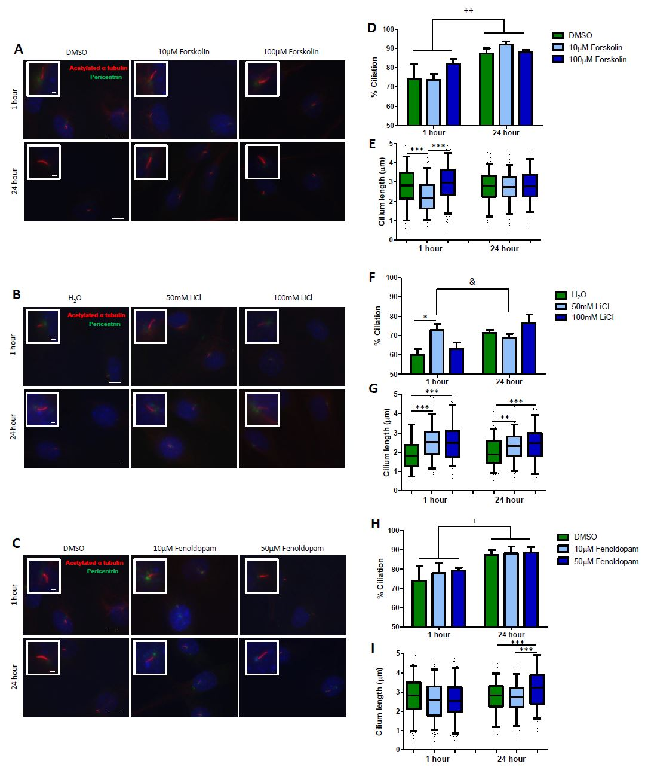
Figure 1: Representative images of MSCs following treatment with A Forskolin or vehicle, DMSO, B Lithium Chloride (LiCl) or vehicle, H₂O and C Fenoldopam or vehicle, DMSO, for 1 hour and 24 hours at 100x fluorescence (red channel- acetylated alpha tubulin, green channel- pericentrin and DAPI) (scale bar 10µm), inset shows zoom on cilium (scale bar 1µm). D, F, H Percentage of cells in each group with a primary cilium N=3, n=194-275. Bars illustrate % ciliated cells, mean±SEM, statistical analysis, two-way ANOVA, +p<0.05, ++p<0.01 effect of time in culture, &p<0.05 different effect of treatment at different time points, *p<0.05 significant difference between treatments in the 1-hour time point group. E, G, I Length of cilium following each treatment, N=3, n=194-275. Box plot illustrates 25th and 75th percentile values, whiskers represent 5th and 95th percentile values, line at median, black dots represent points outside of the 5th and 95th percentile, statistical analysis, one-way ANOVA with Bonferroni post-test, *p<0.05, *p0.01, ***p<0.001, significant difference between labelled groups.

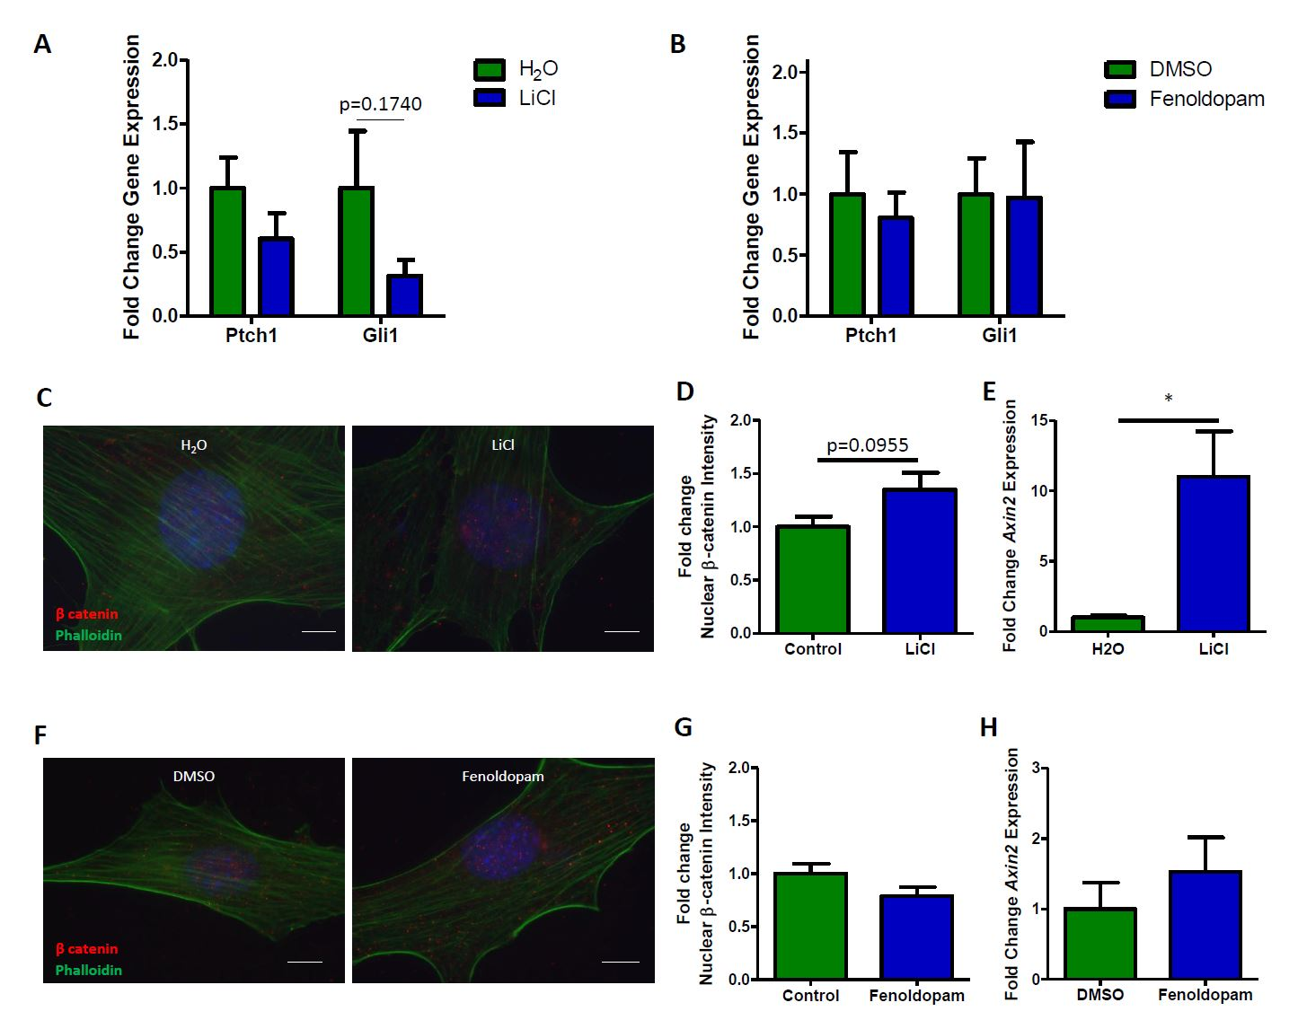
Figure 2: Effect of biochemical primary cilium elongation on Hedgehog and Wnt pathway activity. A, B Ptch1 and Gli1 expression following 24 hours of A 100mM LiCl or B 50µM Fenoldopam treatment, N=3, n=7-10. Bars illustrate mean±SEM, NS, not significant, statistical analysis, unpaired two tailed t-test. C, F Representative images of immunofluorescent staining of βcatenin in MSCs at 100x fluorescence (red channel- β-catenin, green channel- phalloidin and DAPI) (scale bar 10µm) D, G fold change intensity of β- catenin in the nucleus of MSCs (N=3, n=36-37), E, H Axin2 expression (N=2, n=3-6) following 24 hours of C-E 100mM LiCl and F-H 50µM Fenoldopam treatment, bars illustrate mean±SEM, NS, not significant, statistical analysis, unpaired two tailed t-test.

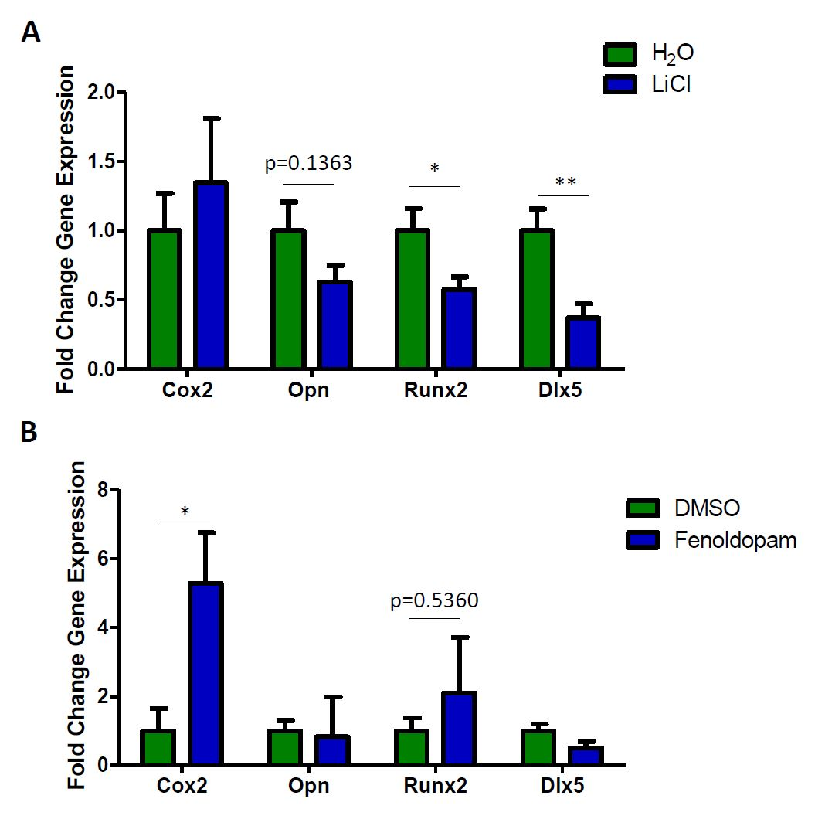
Figure 3: Effect of biochemical primary cilium elongation on osteogenic gene expression. Cox2, Opn, Runx2 and Dlx5 expression following 24 hours of A 100mM LiCl or B 50µM Fenoldopam treatment, N=3, n=4-6. Bars illustrate mean±SEM, NS, not significant, *p<0.05, statistical analysis, unpaired two tailed t-test.

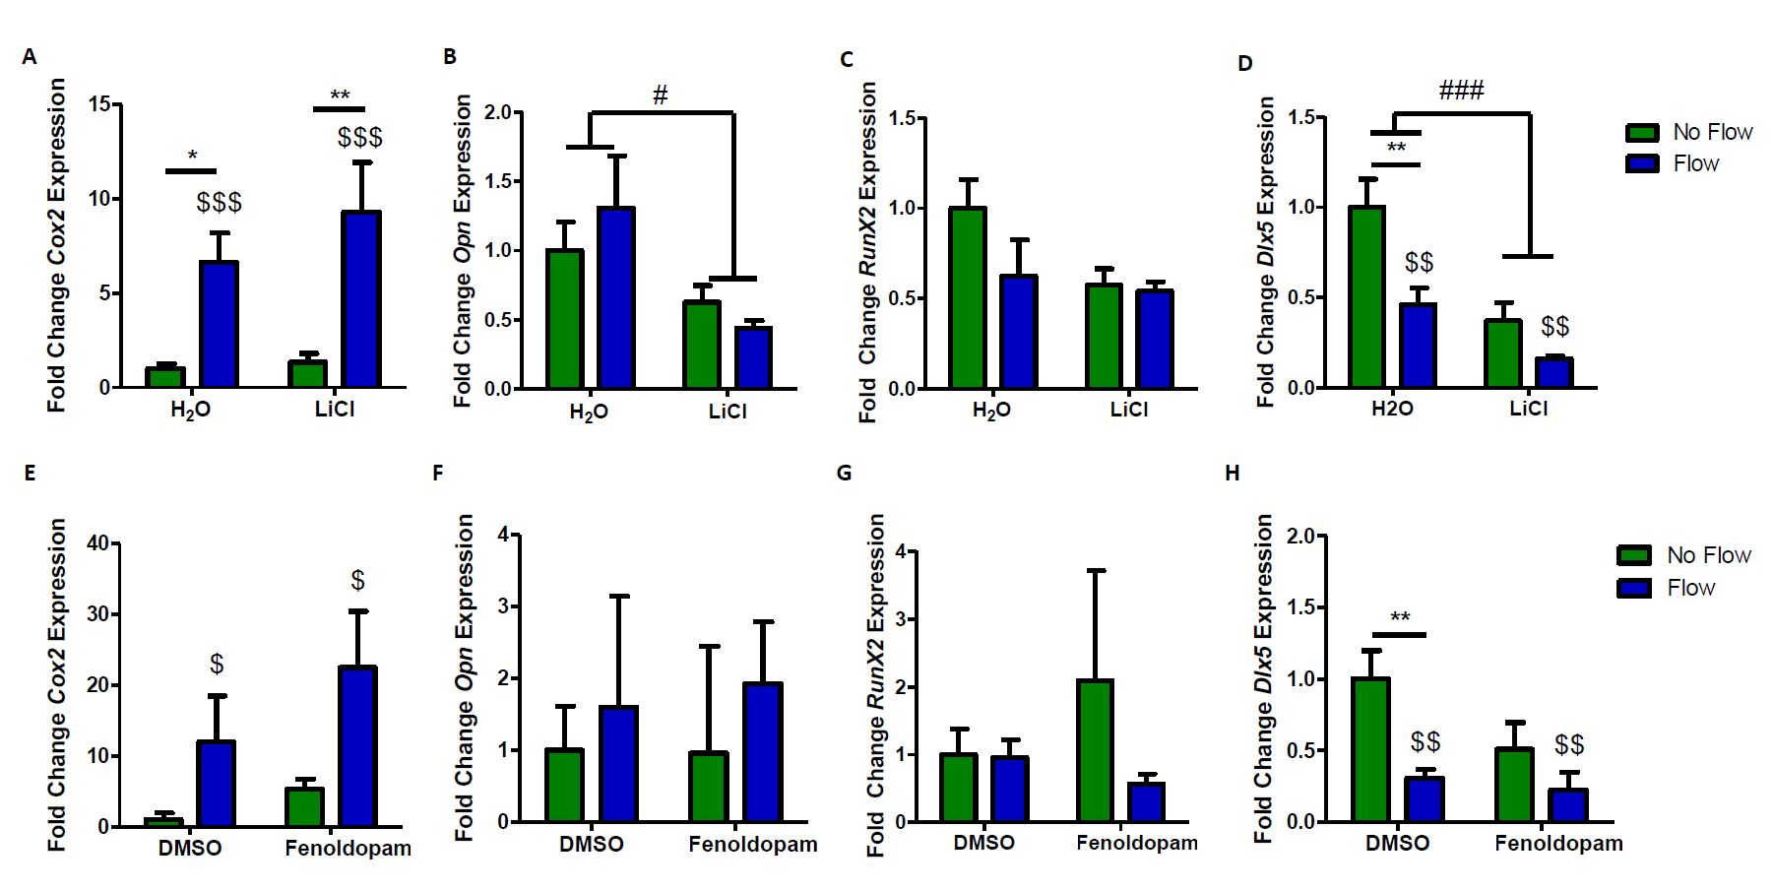
Figure 4: Osteogenic marker expression following 2 hours of 2Pa 2Hz OFF in each group A-D Lithium Chloride or vehicle, H₂O and E-H Fenoldopam or vehicle, DMSO represented as Mean ±SEM, N=3, n=5-12. No flow data is reproduced from figure 3 as control. statistical analysis, 2 way ANOVA with Bonferroni post-hoc test; $$p<0.01, $$$p<0.001 effect of flow on gene expression, #p<0.05, ###p<0.001 effect of treatment on gene expression, *p<0.05, **p<0.01 effect of flow within individual treatment groups.
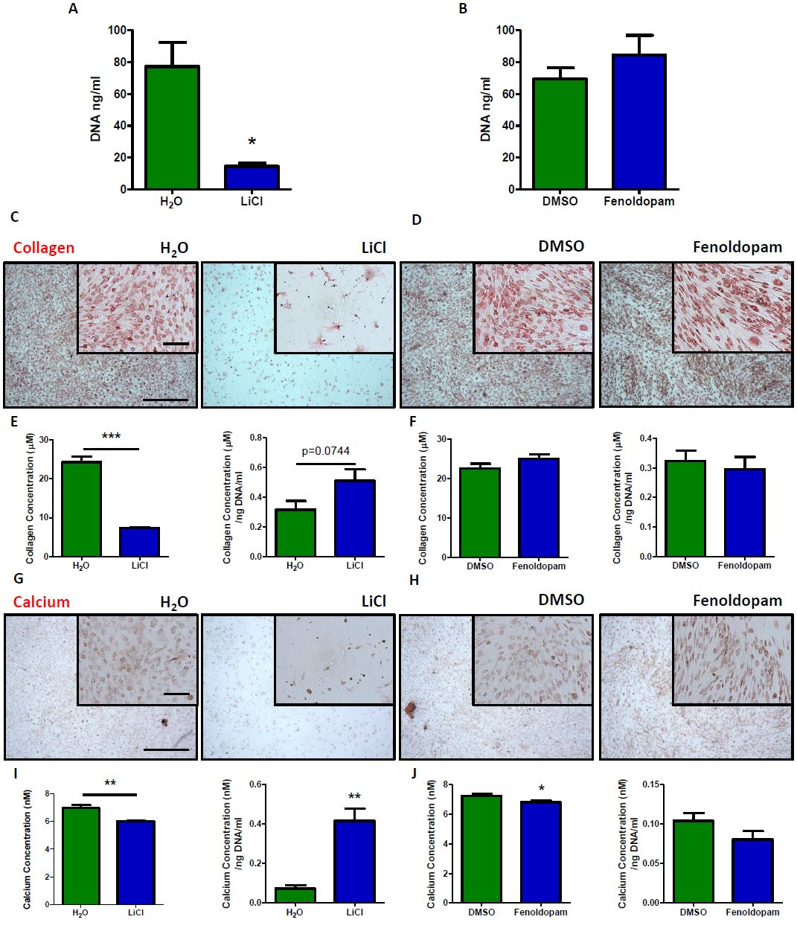
Figure 5: Quantification of DNA content following treatment with A 100mM LiCl or vehicle, H₂O and B 50µM Fenoldopam or vehicle, DMSO for 21 days with full osteogenic supplements under static conditions. N=1, n=5-6, Mean±SEM, *p<0.05, student’s t-test with Welch’s correction. C, D, G, H Representative images of extracellular matrix staining C, D Picrosirius and G, H Alizarin Red, following treatment with C, G LiCl or vehicle, H₂O and D, H Fenoldopam or vehicle, DMSO after 21 days culture in full osteogenic supplements, scale =500µm and 100µm in the inset. E, F, I, J Quantification of matrix staining E, I total collagen and collagen normalized to DNA content and F, J total calcium and calcium normalized to DNA content from each group, student’s t-test, *p<0.05, **p<0.01, ***p<0.001.

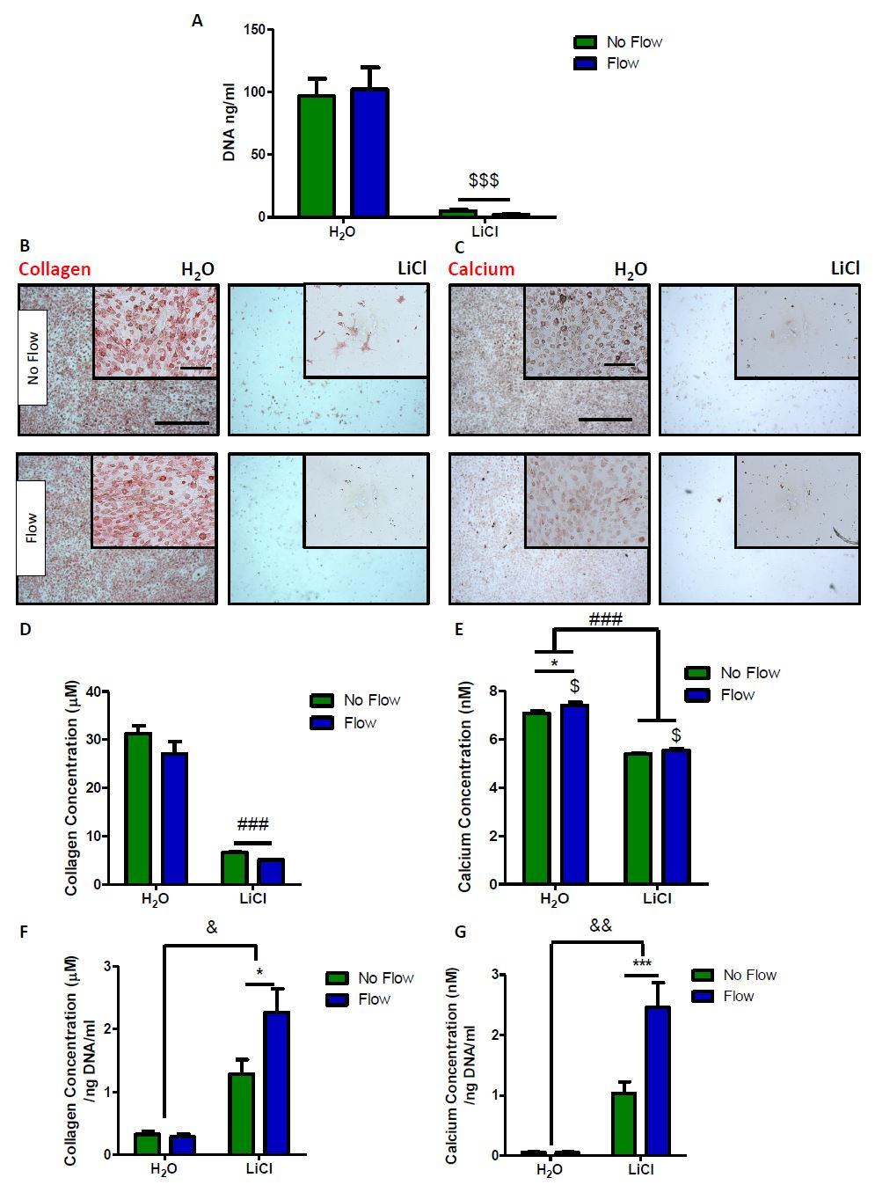
Figure 6: A, Quantification of DNA content following treatment with LiCl or vehicle, H₂O for 21 days cultured in either static, No Flow, or mechanically stimulated, Flow. B, C Representative images of extracellular matrix staining B Picrosirius, C Alizarin Red staining, following treatment, scale =500µm and 100µm in the inset. D-G Quantification of matrix staining D, E total collagen and calcium concentration extracted from each group. F, G Extracellular matrix normalized to DNA quantification F collagen and G calcium, two-way ANOVA, $p<0.05, effect of flow on collagen and calcium concentration. ###p<0.001 effect of treatment, *p<0.05, ***p<0.001 Bonferroni post test, effect of flow on individual treatment groups, &p<0.05, &&p<0.01 difference between the effect of flow in each treatment.
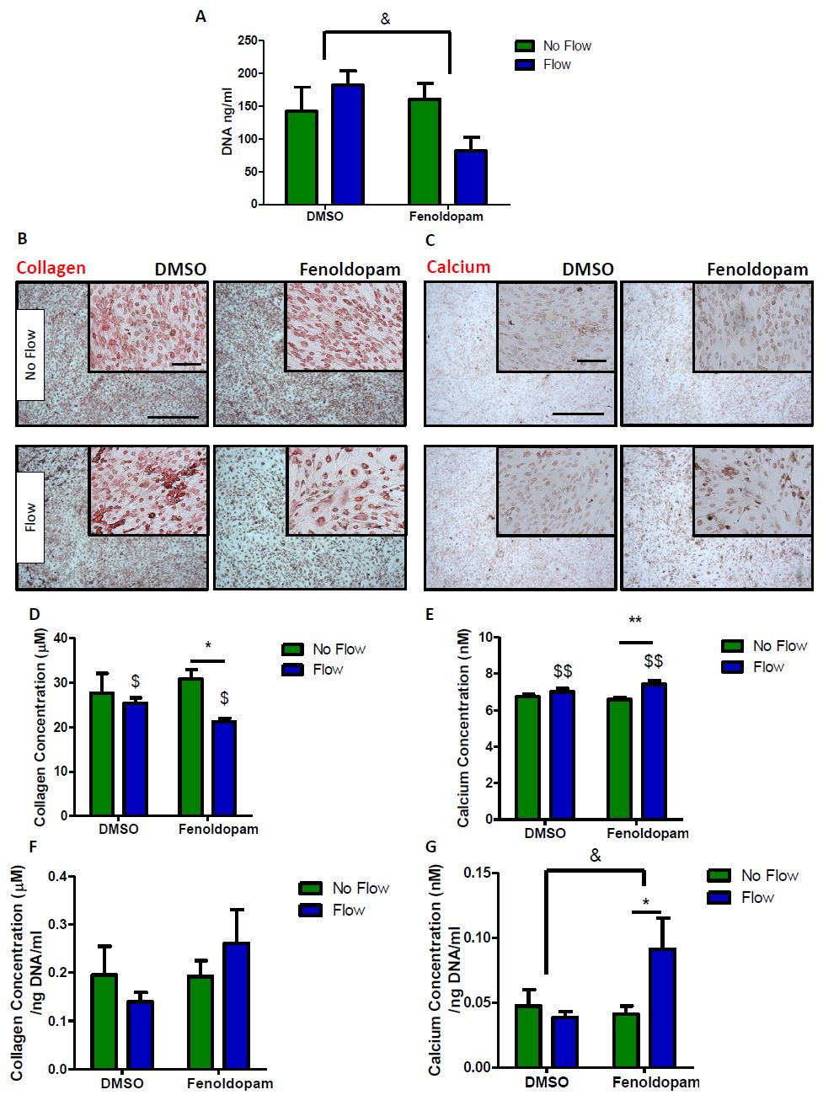
Figure 7: A, Quantification of DNA content following treatment with Fenoldopam or vehicle, DMSO for 21 days cultured in either static, No Flow, or mechanically stimulated, Flow. B, C Representative images of extracellular matrix staining B Picrosirius, C Alizarin Red staining, following treatment, scale =500µm and 100µm in the inset. D-G Quantification of matrix staining D, E total collagen and calcium concentration extracted from each group. F, G Extracellular matrix normalized to DNA quantification F collagen and G calcium, two-way ANOVA, $p<0.05, effect of flow on collagen and calcium concentration. ###p<0.001 effect of treatment, *p<0.05, ***p<0.001 Bonferroni post test, effect of flow on individual treatment groups, &p<0.05, &&p<0.01 difference between the effect of flow in each treatment.

