Generative AI Platforms as Institutional Catalysts of Digital Entrepreneurship: Enablement, Dependence and Power Dynamics

Abstract
This study theorizes how recent generative AI (Gen AI) platforms operate as institutional catalysts of platform-dependent entrepreneurship (PDE). Integrating institutional theory, the external enablement framework, and innovation platform theory, we propose an integrative framework for explaining the emergence of PDE under reliance on non-substitutable, platform-governed capabilities. Using an abductive mixed-method case study of OpenAI’s ecosystem (2020–2025), we trace how governance, boundary resources, and institutional signals shape entrepreneurial feasibility, scaling, and vulnerability. Our analysis identifies four catalytic institutional mechanisms—Infrastructure Provision, Capability Scaffolding, Market Legitimization, and Ecosystem Orchestration—that enable venture creation while simultaneously generating dependence. Temporal analysis reveals an enablement–dependence paradox: platforms accelerate entry by democratizing frontier capabilities, yet accumulate dependencies that expose ventures to governance shocks. Empirically, we show how enthusiasm gave way to crisis during OpenAI’s GPT-5 release, illustrating governance overreach, trust erosion cascades, and choice removal as control. We conclude with theoretical, strategic, and policy implications.
- Keywords: Institutional Catalysts, External Enablement, Innovation Platform, Governance, Dependence

Introduction
The rapid diffusion of generative AI (Gen AI) platforms, exemplified by OpenAI’s ChatGPT and Google’s Gemini, marks a consequential juncture for digital entrepreneurship (Nambisan, 2017). Remarkably, ChatGPT achieved 100 million active users within just two months of its launch in 2022, a record-setting adoption rate for a consumer application (Hu, 2023). Its rapid uptake and the broadened capability surface of large language models (LLMs) have not only added new tools; they have widened the feasible set of entrepreneurial offerings across sectors (Hu, 2023; Maslej et al., 2024). Hence, scholars and practitioners increasingly frame Gen AI as a general-purpose technology with potential to reshape industries and reconfigure institutional norms (Mollick, 2024). Yet precisely because Gen AI platforms now mediate access to foundational capabilities, the conditions under which entrepreneurship is enabled or constrained, and the terms on which it persists, are changing in ways that extant theories only partially explain.
We focus on platform-dependent entrepreneurship (PDE), a nascent category of digital entrepreneurship. In PDE, a venture’s core value creation and capture are non-viable off-platform because essential capabilities are owner-governed and switching costs, whether technical, contractual, or demand-side, render multihoming infeasible in the relevant window (Cutolo & Kenney, 2021; Jacobides et al., 2018, 2024; Nzembayie et al., 2024). This makes PDE a distinct subcategory of digital entrepreneurship where governance and power asymmetries shape the nature of entrepreneurial uncertainty. Unlike transaction platforms such as app stores (iOS and Android) and e-commerce marketplaces (e.g., Amazon) where platform dependence centers on distribution, Gen AI-powered PDE is capability-dependent: acceptable-use and safety policies determine what can be built, pricing and rate limits shape unit economics, and model iteration can improve or degrade product performance irrespective of market traction. This frames emerging Gen AI platforms in the software innovation platform category, foregrounding a core tension (Gawer, 2014; Tiwana et al., 2010; Fernandes et al., 2022; Hurni et al., 2022). On one side, platforms democratize advanced capabilities and compress experimentation cycles (von Hippel, 2009); on the other, the same platforms define the rules of access and control, creating exposure to unilateral governance shifts (Chen et al., 2022; O’Mahony & Karp, 2022). The established literature illuminates parts of this puzzle such as digital affordances and generativity (Majchrzak & Markus, 2012; Yoo et al., 2012; Zittrain, 2006), external enablers of new venture creation (Davidsson et al., 2020; Kimjeon & Davidsson, 2022), and platform architectures and governance (Gawer, 2014; Ghazawneh & Henfridsson, 2013); but it rarely integrates them to show how capability access, governance, and institutional legitimation co-produce PDE ecosystems dynamics over time.
Following recent calls for integrative research between entrepreneurship and emerging technologies (Liguori et al., 2024; Vigoda-Gadot & Mizrahi, 2024), we aim to develop a theoretically cohesive account which theorizes how Gen AI platforms simultaneously act as institutional catalysts and gatekeepers. We define institutional catalysts as actions/processes that reconfigure field-level resource flows (e.g., lowering access/skill/cost barriers), thereby expanding the opportunity set for entrepreneurs. Institutions, formal rules and informal norms, shape what is legitimate and auditable, while external enablers such as step-change AI models and the new venture creation tools they provide, expand the technical possibility frontier (North, 1990; Baumol, 1993; Baumol & Strom, 2007; Urbano et al., 2019; Davidsson et al., 2020). Innovation platform design converts that potential into organized entrepreneurial activity through modular architectures and boundary resources and provide governance structures that shape the emergence and destinies of dependent ventures (Gawer & Phillips, 2013; Ghazawneh & Henfridsson, 2013). In Gen AI ecosystems, this conversion mechanism is unusually consequential because the locus of dependence is capability-dependent.
Accordingly, we ask: How do generative AI platforms act as institutional catalysts of platform-dependent entrepreneurship (PDE), and through what enabling mechanisms do they foster and sustain AI-powered ecosystems? We address this question, we begin by synthesizing institutional theory, external enablement framework, and innovation platform theory into an integrative conceptual framework that specifies how external enablers, boundary resources, and governance interact to expand, filter, and stabilize entrepreneurial action. Second, we conduct an abductive and process-driven mixed-method case study of the emerging OpenAI ecosystem using archival materials, process mapping, and sentiment analysis to examine how capability access, policy shifts, and institutional signals shape PDE formation, scaling, and outcomes (Cutolo & Kenney, 2021; Wen, 2023; Rahman et al., 2024; Nzembayie et al., 2024). Consequently, we identify and unpack four core mechanisms (Infrastructure Provision, Capability Scaffolding, Market Legitimization, and Ecosystem Orchestration) through which Gen AI platforms act as institutional catalysts of AI-powered PDE and define the boundary conditions under which they apply.
Our study advances digital entrepreneurship theory on three fronts. First, it specifies Gen AI-powered PDE as an analytically distinct phenomenon and explains why capability-gated dependence requires different assumptions than distribution-gated dependence. Second, it weaves institutional theory and the external enablement framework with innovation platform theory to explain not only that platforms enable entrepreneurship but how that enablement is converted into durable ventures under asymmetric power dynamics and the uncertainty of their changing governance regimes (Hurni et al., 2022). Empirically, it explores a focal ecosystem (OpenAI’s ChatGPT) in which enabling releases, boundary resource adoption, and governance updates occur at a cadence that makes their effects observable in real time.
The remainder of the paper proceeds as follows. Section 2 develops the theoretical background and the integrated framework. Section 3 details the methodology and case context. Section 4 presents the findings. Section 5 discusses theoretical and practical implications. Section 6 concludes with limitations and directions for future research.

Theoretical Background
This section develops an integrated account of how Gen AI platforms both catalyze and discipline entrepreneurial ecosystems. Large language models (LLMs) exposed as cloud endpoints expand what entrepreneurial teams can build, while platform rules, pricing, and interfaces delimit what can be sustained. We foreground platform-dependent entrepreneurship (PDE), defined as venture activity whose core value creation and capture are non-viable off-platform because access to foundational capabilities is governed by a platform owner and switching costs—technical, contractual, and demand-side—render multihoming infeasible within the relevant strategic window (Cutolo & Kenney, 2021; Nzembayie et al., 2024). Unlike platform settings where dependence centers on distribution (transaction platforms), Gen AI-powered PDE in the context of this research (e.g., OpenAI’s GPT models) is capability-dependent: platform decisions alter the product’s capability surface, reshape unit economics through inference pricing and rate limits, and set legal permissibility via acceptable-use and safety policies. To unravel this domain, we integrate institutional and external enablement lenses with platform theory to explain how enablement and dependence are co-produced and why Gen AI-powered PDE warrants distinct treatment.

The Evolution of Gen AI Platform Technologies
Gen AI has emerged from recent advances in machine learning and artificial intelligence, particularly the development of deep learning architectures. Unlike predictive or analytical AI, which primarily identifies and reports statistical patterns, GenAI generates novel digital content—text, images, and audio—based on user prompts (Mollick, 2024).
These advances are grounded in deep neural networks (DNNs), multilayered computational systems inspired by biological neural processes that detect patterns and make inferences from large datasets (Mitchell, 2019, 2021). A critical inflection point occurred in 2012, when researchers demonstrated that graphics processing units (GPUs) could efficiently scale the training of DNNs (Nzembayie & Buckley, 2022).
Building on these advances, the introduction of the Transformer architecture by Vaswani et al. (2017) from Google, marked another paradigm shift. By replacing sequential processing with parallel computation and implementing a self-attention mechanism, Transformers enabled more efficient handling of long-range dependencies in data. This innovation underpins today’s Large Language Models (LLMs) such as OpenAI’s GPT models, Anthropic’s Claude, Google’s Gemini, and Meta’s Llama, which support fluent text generation, summarization, and increasingly multimodal outputs. Although computationally expensive to develop, LLMs have been scaled through platform-based business models that invite user co-creation, forming the genesis of Gen AI-powered PDE. The combination of cloud infrastructure and open-source frameworks has further democratized access (e.g., Llama from Meta), reducing barriers for resource-constrained innovators and enabling new pathways of capability-dependent entrepreneurial activity (von Hippel, 2009; Townsend & Hunt, 2019; Troise et al., 2021; Giuggioli & Pellegrini, 2023).
It is important to note, however, that Transformer-based LLMs represent only one type of foundation model. Diffusion models, such as Stable Diffusion, constitute another important class, providing the basis for text-to-image systems like DALL·E 3 and Midjourney. Recent research has emphasized the integration of LLMs with diffusion models, enabling increasingly multimodal systems capable of generating coherent combinations of text, image, and audio (Hu, 2023; Maslej et al., 2024). We subsequently unravel these technological changes in the context of institutional theory and the external enablement framework.

Institutional Theory & External Enablement of PDE
Institutional theory holds that formal regulations and informal norms channel entrepreneurial behavior by defining what is legitimate, auditable, and fundable (North, 1990; Baumol, 1993; Baumol & Strom, 2007). Entrepreneurs can also act as institutional entrepreneurs, mobilizing resources and alliances to reshape field rules when templates are incomplete or contested (DiMaggio, 1988; Garud et al., 2007; Elert & Henrekson, 2017; Urbano et al., 2019). In Gen AI ecosystems, institutional channels are increasingly private-order as well as public. Platform governance operates as an institutional regime implemented through boundary resources—APIs, SDKs, documentation, policy portals, and telemetry dashboards—that both resource third-party innovation and secure platform integrity (Ghazawneh & Henfridsson, 2013; Gawer & Phillips, 2013; Chen et al., 2022).
These boundary resources act as institutional scaffolding: they standardize interaction and lower entry costs while embedding ventures in rule-enforcing toolchains aligned with the platform’s risk posture (Ghazawneh & Henfridsson, 2013; O’Mahony & Karp, 2022). Governance structures, whether open or close, and governance mechanisms such as degree of access and control (Jacobides et al., 2018; O’Mahony & Karp, 2022) help to translate external enablement into credible offerings; at the same time they codify obligations—rate limits, decide on software deprecation schedules, and safety constraints—that shape product scope and economics (Zimmerman & Zeitz, 2002; Davidsson et al., 2020; Truong et al., 2023).
Entrepreneurs and platform owners are institutional actors within this regime (Urbano et al., 2019). They jointly engage in institutional entrepreneurship (Bruton et al., 2010)—forming alliances, crafting assurance narratives, and sometimes lobbying—to align nascent rules with feasible business models (DiMaggio, 1988; Garud et al., 2007; Elert & Henrekson, 2017). Platform owners likewise work the field through standard-setting and public discourse shaping, co-evolving private governance with emergent public regulation (e.g., the EU AI Act). Thus, they shape the very pathways through which external enablers are converted into new ventures (Mair & Martí, 2009; Diao et al., 2021; Gawer, 2022). Thus, we identify governance-mediated enablement as a central construct emerging at the nexus between institutions and technological change. That is, pricing stability, versioning and deprecation practices, and the scope of permitted use determine whether the same technological shock (a new model, a cost drop) yields durable opportunities or transient experiments (Davidsson et al., 2020; Kimjeon & Davidsson, 2022).
External enablement (EE) framework complements institutions theory by presenting a useful theoretical lens for understanding how emerging AI technologies drive AI-powered PDE (Truong et al., 2023). EE refers to the mechanisms through which nontrivial environmental shifts objectively enlarge entrepreneurial opportunities through supply- (e.g., resource access) and demand-side (demand expansion) mechanisms (Davidsson et al., 2020). From this perspective, recently emerging Gen AI platforms and the proprietary models they create, represent nontrivial shifts in technology that open new possibilities for new venture creation. Foundation models such as LLMs delivered via cloud endpoints democratize sophisticated capabilities, extending digital affordances—what purposeful actors can do with technology—while compressing the time and cost from idea to artifact (Majchrzak & Markus, 2012; Nambisan, 2017; Chalmers et al., 2021; Obschonka & Audretsch, 2020; Shepherd & Majchrzak, 2022; Davidsson et al., 2020; Kimjeon & Davidsson, 2022; Obschonka et al., 2025). Yet enablement converts to realized entrepreneurship only through institutional channels that assign legitimacy (Zimmerman & Zeitz, 2002), specify accountability, and coordinate exchange.
Placing Gen AI–powered PDE at this intersection clarifies how enablement produces dependence. Step-change capabilities accessed through standardized interfaces catalyze rapid entry and experimentation; simultaneously, customers experience products through the latency, quality, safety posture, and drift properties of a specific provider, making substitution risky within strategic windows. Provider-specific assets—prompt libraries, evaluation harnesses, monitoring telemetry, compliance artifacts—accumulate and convert initial affordances into switching and compliance debt. Adopting first-party safety and evaluation stacks accelerates legitimation and enterprise acceptance while coupling ventures to the provider’s policy lexicon, logging infrastructure, and deprecation cadence (Zimmerman & Zeitz, 2002; Ghazawneh & Henfridsson, 2013). The typical trajectory is recognizable: a burst of entry enabled by boundary resources and democratized capability, followed by architectural and organizational choices that tie ventures more tightly to the platform core—co-producing innovation and vulnerability in a manner distinctive to capability-dependent platform entrepreneurship (Tiwana et al., 2010; Gawer, 2014; Gawer, 2022). As capability-dependent PDE falls within the innovation platform category, innovation platform theory presents a vital theoretical strand to integrate.

Innovation Platform Theory and Gen AI-Powered PDE Ecosystems
To complete our theoretical triad toward a robust framework, innovation platform theory provides a more granular explanation on how Gen AI platforms power PDE (Gawer, 2014). Innovation platform theory explains how modular architectures and boundary resources connect the extensible codebase of a software system core and peripheral modules that interoperate with it (Tiwana et al., 2010; Gawer, 2014; Cusumano et al., 2019; Hurni et al., 2022). Gen AI platforms appear to instantiate this logic with vividly. The extensible codebase such as a foundation model, open up capabilities that entrepreneurs combine with interoperable modules such as data and workflows to create complements (Jacobides et al., 2018, 2024).
Platform generativity, implying the capacity of a software system to produce unanticipated outcomes from diverse and loosely coupled audiences, drives PDE (Zittrain, 2006). Generativity is evidenced by the reprogrammability, affordances and recombinant innovations that reduce the gap from idea to product (Yoo et al., 2012). In practice, boundary resources script participation by standardizing data flows, embedding policy checks, and generating audit-relevant telemetry; they thus both enable and constrain, consistent with the resourcing and securing duality of boundary resources (Ghazawneh & Henfridsson, 2013).
Since Gen AI-powered PDE is capability-dependent, power, exercised through governance mechanisms, directly shape how entrepreneurs create and capture value (Hurni et al., 2022). Software deprecations can eliminate entire feature categories; pricing shifts can invert unit economics; latency or rate-limit changes can degrade performance below customer thresholds; software deprecations can force costly refactors; and platform envelopment can reallocate value from complements to the core (Eisenmann et al., 2011; Parker et al., 2017; Cutolo & Kenney, 2021). Gatekeeping policies further shape complementor behavior by altering cooperation and competition in the periphery (Wen, 2023): stricter access control as in closed governance models (as opposed to open source) can increase complementor knowledge sharing and coordination, whereas lapses can tilt interactions toward competition and reduce sharing, with implications for ecosystem vitality (Zhang, Li, & Tong, 2020; Wen, 2023). With perceived risk of power imbalances, dependent complementors such as platform-dependent entrepreneurs (PDEs) may respond through selective multihoming where viable platform alternatives emerge (Cennamo et al., 2018) or develop abstraction layers to limit risks.
Crucially, the architecture–governance nexus is dynamic. Boundary resources and rules are tuned over time as platforms release new capabilities or constraints and complementors adapt their code, products, and strategies—a distributed, iterative co-evolution documented in other platform contexts and directly relevant to Gen AI (Eaton et al., 2015). This distributed tuning perspective helps explain why Gen AI ventures must repeatedly realign with enabling releases (new models, modalities) and governance recalibrations (policy tightening, software deprecation), rather than treating either as one-off events.

Toward an Integrative Theoretical Framework
By integrating the three theoretical strands (institutions-enablement and innovation platform theory), we advance a tentative conceptual framework with propositions that plausibly explain how Gen AI platforms act as institutional catalysts enabling entrepreneurial opportunities while simultaneously producing dependence and reconfiguring power. We present our framework in Table 1 below and use it as the basis for abductive analysis of empirical research (Timmermans & Tavory, 2012).

Table 1. Tentative Conceptual Framework & Propositions
Theoretical Mechanism | Platform Action |  | Venture Response |  | Institutional Outcome | Empirical Focus
Institutional Scaffolding | Deploy boundary resources (APIs, SDKs, policies, tools) |  | Adopt platform toolchains & standards |  | Legitimation acceleration & standardization | Compliance adoption, enterprise acceptance
External Enablement | Democratize AI capabilities via cloud endpoints |  | Rapid experimentation & market entry |  | Expanded entrepreneurial possibility space | Entry rates, time-to-market compression
Governance Mediation | Exercise policy control & rule enforcement |  | Strategic adaptation (multihoming etc.) or resistance |  | Power asymmetry establishment | Policy change responses, switching costs
Capability Dependence | Control core functionality & access |  | Deep integration commitment |  | Lock-in & ecosystem vulnerability | Platform-specific investments, exit barriers
Process Dynamics & Propositions
Stage |  | Key Dynamic |  | Testable Proposition
Enablement |  | Capability provision → venture creation |  | P1: Greater enablement increases dependence via legitimation
Integration |  | Boundary resources → standardization |  | P2: Predictable governance drives deep integration
Control |  | Governance exercise → power asymmetry |  | P3: Integration depth correlates with platform power
Co-evolution |  | Mutual adaptation → ecosystem stability |  | P4: Adaptation costs balance switching costs at equilibrium
The starting point is the institutional environment and the nontrivial changes happening within that enable PDE. Foundation models exposed via cloud endpoints with generative power that expands digital affordances and democratizes sophisticated capabilities, act as external enablers (Majchrzak & Markus, 2012; Nambisan, 2017; Davidsson et al., 2020; Kimjeon & Davidsson, 2022). Conversion from possibility to viable venturing, however, runs through institutional channels governed as much by private order as by public regulation. Platforms implement boundary resources—APIs, SDKs, documentation, safety/evaluation stacks—that both resource third-party innovation and encode the platform’s rules of participation (Ghazawneh & Henfridsson, 2013; Gawer & Phillips, 2013; Gawer, 2022; O’Mahony & Karp, 2022). These boundary resources operate as institutional scaffolding: they standardize interaction, lower entry costs, and render ventures legible to enterprise buyers and investors, thereby accelerating legitimation (North, 1990; Baumol, 1993; Baumol & Strom, 2007; Zimmerman & Zeitz, 2002). At the same time, they discipline development through pricing, rate limits, versioning/deprecation, and acceptable-use provisions that shape scope, unit economics, and legal viability.
The core dynamic is governance-mediated enablement. Predictable governance—stable pricing heuristics, transparent rate limits, disciplined versioning—encourages commitment and deep integration; opacity or volatility dampens conversion or diverts effort to less constrained spaces (Jacobides et al., 2018, 2024). As complementors adopt platform toolchains—not only for engineering utility but to meet stakeholder expectations—legitimation accelerates while dependence deepens: workflows, artifacts, and assurance language become entangled with provider interfaces and policy terminology (Zimmerman & Zeitz, 2002). With growth, control shifts toward bottlenecks at the platform core; governance tightens to manage quality, safety, and cost, and margins compress for highly exposed ventures (Eaton et al., 2015). Complementors respond on technical, organizational, and institutional fronts—building abstraction layers, selectively multihoming (Cennamo et al., 2018) where quality permits, specializing in niches, and engaging standards and policy arenas to seek portability and predictability (DiMaggio, 1988; Garud et al., 2007; Elert & Henrekson, 2017; Urbano et al., 2019). The cycle then repeats as capabilities and constraints co-evolve through distributed tuning of interfaces and rules (Eaton et al., 2015).
This process view situates PDE as a capability-dependent form of digital entrepreneurship: ventures are viable on-platform because access to foundational capabilities is platform-governed and switching costs—technical, contractual, and demand-side—render multihoming infeasible within the relevant strategic window (Cutolo & Kenney, 2021; Cennamo et al., 2018; Nzembayie et al., 2024). Network effects remain relevant for growth, but they do not by themselves explain PDE outcomes; what is distinctive is how the governance of capability access and the co-evolution of private and public institutional orders, enacted through boundary resource design, determine whether external enablement becomes durable advantage or transient experiment (Ghazawneh & Henfridsson, 2013; Davidsson et al., 2020; Gawer, 2022).
Boundary conditions clarify where the framework applies most strongly. It is tailored to settings in which the platform controls non-substitutable capabilities within the venture’s planning horizon and governance materially affects unit economics or legal permissibility. Its traction weakens where open source local deployment approaches parity in quality and cost, and where acceptable use is stable and non-binding, or dependence is primarily distributional rather than capability-based. Under the stated conditions, the framework accounts for divergent venture trajectories: design choices that attract entrants—rich boundary resources, strong safety/evaluation stacks, rapid model iteration—also heighten exposure to policy and price moves, so apparently similar ventures separate as a function of adoption depth and the portability of evaluation and compliance assets (Zhang et al., 2020).
In sum, Gen AI platforms emerge as institutional catalysts and gatekeepers: they simultaneously expand entrepreneurial possibilities and create institutional dependence through governance-mediated enablement, producing co-evolutionary dynamics between capability provision and venture commitment. PDE is the patterned outcome of enablement turned operational, enabled by access to capabilities, disciplined by the rules that govern that access, and shaped by continual recalibration between private and public authority. We subsequently leverage the framework as an analytical tool in a case study that examines it key propositions.

Methodology

Research Design and Approach
We conducted an embedded case study (Yin, 2009) of the OpenAI platform ecosystem (June 2020–August 2025), blending sequential and convergent mixed-method approaches (Creswell et al., 2003), with the qualitative studying being primary. The case is the platform, and embedded cases are the ventures that depend on it. An embedded single case design is warranted for answering the research question because OpenAI constitutes a theoretically revelatory context: boundary resources (e.g., APIs, orchestration layers) and governance levers (pricing, access, software deprecations) changed at high cadence, creating observable shifts in entrepreneurial feasibility, redesign costs, and risk of dependence. The case boundary is defined by publicly announced OpenAI platform events and contemporaneous public community discourse about those events. Embedded units of analysis are (a) dated platform events, (b) matched community reactions, and (c) a corroborating catalogue of PDE ventures used for contextual triangulation rather than for primary identification.
The research design combines archival analysis (Ventresca & Mohr, 2017), temporal process mapping, and systematic sentiment analysis of critical incidents (Flanagan, 1954) to capture the temporal dynamics of platform ecosystem co-evolution over a five-year period (2020-2025). Our methodological approach is grounded in three key principles. First, we prioritize temporal granularity to capture the dynamic nature of PDE emergence, recognizing that enablement and dependence relationships evolve through iterative cycles of platform releases and ecosystem responses. Second, we employ triangulation across multiple data sources—platform release announcements, community reactions, and venture evidence—to validate theoretical constructs and ensure empirical robustness. Third, we adopted an abductive logic consistent with Timmermans and Tavory (2012) in maintaining theoretical sensitivity and using sensitizing concepts from institutional theory (North, 1990), the external enablement framework (Davidsson et al., 2020), and innovation platform theory (Tiwana et al., 2010; Gawer, 2014) as analytical lenses while remaining open to emergent patterns that extend or challenge existing frameworks.

Case Selection and Context
We selected the OpenAI ecosystem as our focal case for several theoretical and empirical reasons. Theoretically, OpenAI represents a paradigmatic example of a capability-dependent innovation platform ecosystem where ventures rely on foundational AI capabilities that cannot be easily replicated or substituted within relevant strategic windows (Tiwana et al., 2010). The platform's governance decisions directly affect venture value creation through model performance, pricing structures, and acceptable use policies, making it an ideal context for examining the enablement-dependence paradox.
Empirically, OpenAI's rapid evolution from research organization to platform provider offers a compressed timeline for observing institutional catalyst mechanisms in action. The platform's high-frequency release cycle (over 100 critical releases in five years) provides sufficient temporal granularity to trace how specific platform decisions trigger ecosystem responses. Additionally, its active developer community and extensive documentation create rich archival materials for systematic analysis. The temporal scope spans from June 2020 (GPT-3 API launch) through August 2025, capturing the complete evolution from foundation building through the recent crisis period that characterized the launch of OpenAI's GPT-5 model. This 62-month timeframe encompasses four distinct phases of platform ecosystem co-evolution, allowing us to examine how institutional catalyst mechanisms operate across different stages of ecosystem maturity.

Data Collection
Our research design employs a multi-source data collection strategy that triangulates evidence across three distinct but interconnected corpora to provide comprehensive empirical grounding for the theoretical framework. This approach follows established practices in digital entrepreneurship research (Nambisan, 2017) and platform studies (Parker et al., 2017) by combining platform-centric data with ecosystem participant perspectives and venture outcome evidence. This data collection strategy is designed to capture the temporal evolution of PDE relationships while maintaining analytical rigor through systematic inclusion criteria and transparent sampling procedures. Each corpus serves a specific analytical purpose within the broader analytical framework, enabling both inductive theory building and deductive validation of emergent theoretical constructs.
The five-year temporal scope (June 2020 - August 2025) encompasses the complete evolution of the OpenAI ecosystem from initial API launch through the 2025 governance crisis, providing sufficient temporal depth to identify evolutionary patterns while maintaining contemporary relevance. This timeframe captures critical inflection points including the GPT-3 API launch, ChatGPT breakthrough, GPT-4 advancement, and the recent governance challenges around GPT-5 that reveal the vulnerabilities inherent in platform-dependent business models. Table 2 subsequently decomposes our data collection strategy and corpus.
Table 2. Data Collection Summary
Data Corpus | Primary Sources | Unit of Analysis |  | Timeframe | Sample Size |  | Analytical Purpose
Platform Releases | OpenAI official announcements, API documentation, blog posts, press releases | Individual platform release or major announcement | June 2020 - August 2025 (62 months) |  | 100 releases | Identify institutional catalyst mechanisms through systematic coding
Community Sentiment | OpenAI Developer Community forum and Hacker News | Community reaction threads to major platform events | June 2020 - August 2025 (62 months) |  | 32 sentiment events | Track temporal evolution of platform-ecosystem relationships
Venture Enablement | Company websites, funding announcements, case studies, OpenAI customer stories | Individual venture or organization using OpenAI capabilities | June 2020 - August 2025 (62 months) |  | 24 ventures | Validate theoretical framework through empirical evidence of PDE patterns

Platform Release Documentation: We systematically collected and analyzed 100 platform releases from OpenAI's official website (openai.com), including API updates, model releases, policy changes, and deprecation announcements. These documents were sourced from OpenAI's official release notes, policy updates, developer documentation, and public announcements spanning June 2020-August 2025. Each release was coded for institutional mechanism type, enabling capabilities, governance implications, and temporal context. Platform releases were systematically extracted from official OpenAI documentation using manual extraction and verification procedures. Each release was coded for date, type, description, and institutional mechanism implications to preserve temporality and enable quantitative analysis of release patterns.
Community Sentiment Data: We conducted systematic sentiment analysis of community reactions from two primary platforms: the OpenAI Developer Community (community.openai.com) and Hacker News (news.ycombinator.com). These platforms were selected because they represent the primary venues where platform-dependent entrepreneurs discuss technical challenges, strategic concerns, and adaptation strategies. We used critical incident techniques (Flanagan, 1954) to identify 32 major platform events (such as model releases or policy changes) and systematically analyzed community reactions to these events. For each critical event, we identified representative community discussions through systematic search of both platforms, employing purposive sampling to select discussions that demonstrated theoretical relevance to PDE concerns. Sentiment coding followed established protocols for qualitative sentiment analysis, with scores ranging from -1.0 (highly negative) to +1.0 (highly positive).
Venture Enablement Evidence: We analyzed 24 ventures identified as platform-dependent, collecting evidence of their enablement relationships with OpenAI's platform (Appendix B). Evidence sources included official partnership announcements, company case studies, venture funding announcements, and public statements about platform integration. We focused on ventures that publicly declared enablement by OpenAI's models, searching for explicit mentions of AI model use with keywords such as "GPT-3" and "GPT-4" and triangulating this evidence through media reports and investment documentation. For example, Copy.ai provided Grade A evidence through official blog posts explicitly declaring GPT-3 integration, corroborated by Series A funding announcements and media coverage. Venture enablement relationships were established through triangulation of multiple evidence sources to ensure analytical rigor.

Analytical Approach
Our analytical approach combines qualitative data analysis as the primary method with quantitative elements as secondary triangulating evidence, following an adapted Gioia methodology (Gioia et al., 2013) integrated with temporal process analysis (Van de Ven & Engleman, 2004; Riessman, 2008) to capture the dynamic nature of platform-ecosystem relationships. The analysis progressed through systematic coding and thematic development while maintaining sensitivity to temporal patterns and evolutionary dynamics that characterize platform-dependent entrepreneurship.
Temporal-Thematic Analysis Framework: The analytical process began with systematic coding of platform releases to identify first-order concepts using in-vivo coding that preserved participants' language and platform terminology. This initial coding generated 47 first-order codes that captured immediate empirical observations from platform announcements, such as "API access provision," "developer enablement," "capability delivery," and "enterprise compliance." These first-order codes were then organized into second-order themes through axial coding and constant comparative analysis, resulting in 12 analytical categories including "Infrastructure Provisioning," "Knowledge Transfer," "Capability Scaffolding," and "Platform Maturation."
The second-order themes were further synthesized into four aggregate dimensions representing the institutional catalyst mechanisms: Infrastructure Provision (27.0% of coded excerpts), Capability Scaffolding (43.6% of coded excerpts), Market Legitimization (15.2% of coded excerpts), and Ecosystem Orchestration (14.2% of coded excerpts). This distribution reflects the platform's evolution from basic infrastructure provider to sophisticated capability enabler, with Capability Scaffolding emerging as the dominant mechanism.
Community Sentiment Integration: Community sentiment analysis was conducted parallel to platform release coding, with systematic sentiment scoring of reactions to 32 critical incidents. Sentiment patterns were analyzed both within individual phases and across the complete temporal scope, revealing a dramatic deterioration from highly positive (+0.8 average) during the foundation period to severely negative (-0.3) during the 2025 crisis. This sentiment evolution provided crucial validation of the theoretical constructs and demonstrated the temporal instability of platform-dependent relationships.
Venture Pattern Analysis: The 24 platform-dependent ventures were analyzed to identify response patterns and validate theoretical constructs through empirical evidence. Venture analysis revealed four distinct enablement patterns: Early Access Advantage (exemplified by Copy.ai's early GPT-3 integration), Simultaneous Launch, Deep Integration, and Feature Integration. These patterns demonstrated how different ventures navigate the enablement-dependence paradox and provided empirical grounding for the theoretical framework.
Temporal Phase Development: The analytical process identified four distinct temporal phases through systematic analysis of platform releases, community sentiment, and venture responses: Foundation Building (2020-2021), Capability Expansion (2022-2023), Ecosystem Orchestration (2024), and Crisis and Governance Overreach (2025). Each phase was characterized by distinct institutional catalyst mechanisms, community sentiment patterns, and venture response strategies, enabling comprehensive understanding of platform-ecosystem co-evolution. Gen AI (ChatGPT) was used only for grammar and phrasing edits; no analyses were produced by AI, and the authors verified all changes.
Crisis Dynamics Analysis: The 2025 governance crisis received intensive analytical attention as a critical case that revealed the vulnerabilities inherent in platform-dependent business models. This analysis led to the development of three new theoretical constructs: Platform Governance Overreach, Trust Erosion Cascade, and Choice Removal as Control Mechanism. These constructs extend existing platform governance theory and explain the rapid deterioration of platform-ecosystem relationships when governance overreach occurs.

Reliability and Validity Measures
We achieved inter-coder reliability through multiple rounds of independent coding with regular calibration sessions achieved substantial to near-perfect agreement across all analytical components (κ range: 0.78-0.88). The coding process involved two independent researchers who coded platform releases, community sentiment, and venture evidence separately before conducting calibration sessions to resolve disagreements and refine coding criteria. Higher reliability was achieved for clearly defined constructs such as institutional catalyst mechanisms (κ = 0.85-0.88), while more interpretive elements such as community sentiment showed substantial but slightly lower reliability (κ = 0.78-0.82).
To attain construct validity, each theoretical construct is supported by multiple empirical indicators across different data corpora, with explicit attention to alternative explanations and negative cases. The four institutional catalyst mechanisms are grounded in systematic analysis of 100 platform releases, validated through community sentiment patterns, and triangulated with venture response evidence. The enablement-dependence paradox is supported by temporal analysis showing the evolution from positive enablement (+0.8 sentiment) to negative dependence experiences (-0.3 sentiment) across the study period. Meanwhile, temporal validity is achieved through a chronological analysis which prevented retrospective bias by maintaining strict temporal sequencing and avoiding anachronistic interpretation of historical events. All platform releases, community reactions, and venture responses were analyzed in their original temporal context, with careful attention to the information available to participants at each point in time rather than imposing later knowledge on earlier events.
Furthermore, external validity was achieved through the comparison of constructs with existing platform literature and entrepreneurship research, ensuring consistency with established theoretical frameworks while extending them to address the unique characteristics of capability-dependent platform relationships. The institutional catalyst mechanisms align with existing innovation platform theory while adding specificity for AI-powered platforms. Internal validity was operationalized through the systematic attention to alternative explanations and rival hypotheses throughout the analytical process, with explicit consideration of confounding factors and alternative causal mechanisms. The crisis dynamics analysis particularly benefited from this approach, as multiple potential explanations for community sentiment deterioration were considered before concluding that governance overreach was the primary causal mechanism.
Data adequacy and saturation. We assessed saturation at two levels—code (no new first-order codes) and meaning (no changes to second-order themes/aggregate dimensions). After coding the full corpus (100 platform releases, 32 community-reaction incidents, 24 ventures), late-phase materials introduced no new themes; excerpts only elaborated existing categories, and the four aggregate mechanisms (Infrastructure Provision, Capability Scaffolding, Market Legitimization, Ecosystem Orchestration) remained stable across temporal phases. Together with inter-coder agreement (κ = 0.78–0.88), we conclude that both code and meaning saturation were achieved for our core constructs.

Findings
Our systematic analysis of the OpenAI ecosystem between 2020 and 2025 reveals how Gen AI platforms function as institutional catalysts of platform-dependent entrepreneurship (PDE) through four primary mechanisms and their accompanying sub-mechanisms: Infrastructure Provision, Capability Scaffolding, Market Legitimization, and Ecosystem Orchestration. The temporal analysis reveals a five-phase evolution that demonstrates both the enabling potential and inherent vulnerabilities of platform-dependent entrepreneurship. Community sentiment deteriorated from highly positive (+0.8) during the foundation period to severely negative (-0.3) during the 2025 crisis, illustrating the fragility of platform ecosystem relationships when governance overreach occurs. This empirical pattern validates our core theoretical proposition: platforms simultaneously enable new venture creation yet create vulnerabilities through power asymmetries and governance mechanisms that render dependence precarious. Following Langley (1999, p.700) we develop Figure 1 as a visual process map showing multiple dimensions to guide subsequent interpretations (supported by Appendix A).
Figure 1. Visual Process Map & Multidimensional Analysis
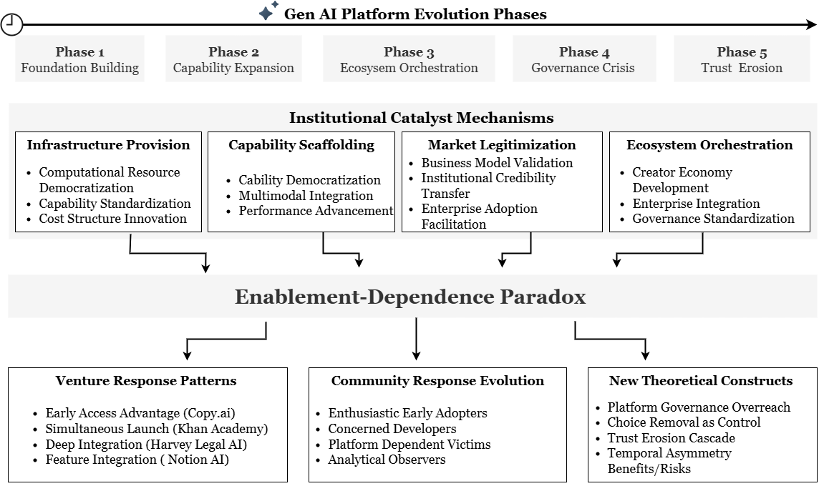

Institutional Catalyst Mechanisms: Empirical Validation
Our analysis of 100 platform releases reveals four distinct institutional catalyst mechanisms that explain how Gen AI platforms enable PDE. These mechanisms operate with varying intensity across temporal phases, creating complex dynamics that shape ecosystem evolution and venture outcomes. We present a synthesized version of the narrative thematic analysis in Figure 2 based on 100 excerpts drawn from archival records involving platform release announcements. The full analysis is available as supplemental resource.

Figure 2. Synthesized Thematic Narrative Analysis
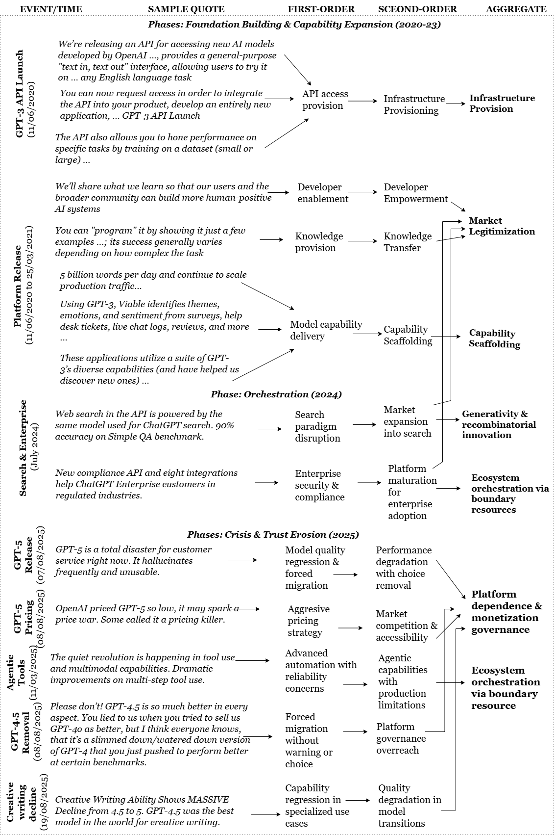
We support the analysis with Appendix C/Graph 1 which visually demonstrates the relative significance of each institutional catalyst mechanism based on our systematic coding of platform releases. Capability Scaffolding emerges as the dominant mechanism, accounting for 43.6% of coded excerpts, reflecting the platform's evolution from basic infrastructure provider to sophisticated capability enabler. Infrastructure Provision accounts for 27.0% of excerpts, establishing the foundational role of computational resource democratization. Market Legitimization (15.2%) and Ecosystem Orchestration (14.2%) represent more specialized mechanisms that become prominent during later phases of platform evolution. These mechanisms materialize the generativity of platform technology and the recombinatorial innovations they enable (Yoo et al., 2012).

Institutional Catalyst Mechanisms & Temporal Emergence
As the temporal order in which mechanisms emerge is critical in establishing their efficient causes (Van de Ven & Engleman, 2004), we conduct a granular analysis and interpretation of temporality and institutional mechanisms. We conduct sentiment analyses which serve to triangulate platform releases with the community’s reactions and concerns overtime. As these mechanisms are best understood in their situational and temporal contexts, we subsequently interpret them as such. Figure 3 below provides a comprehensive overview of sentiment evolution across the complete study period, revealing the dramatic shift from foundation-era enthusiasm to crisis-era backlash.

Figure 3. Temporal Sentiment Evolution (2020-2025)
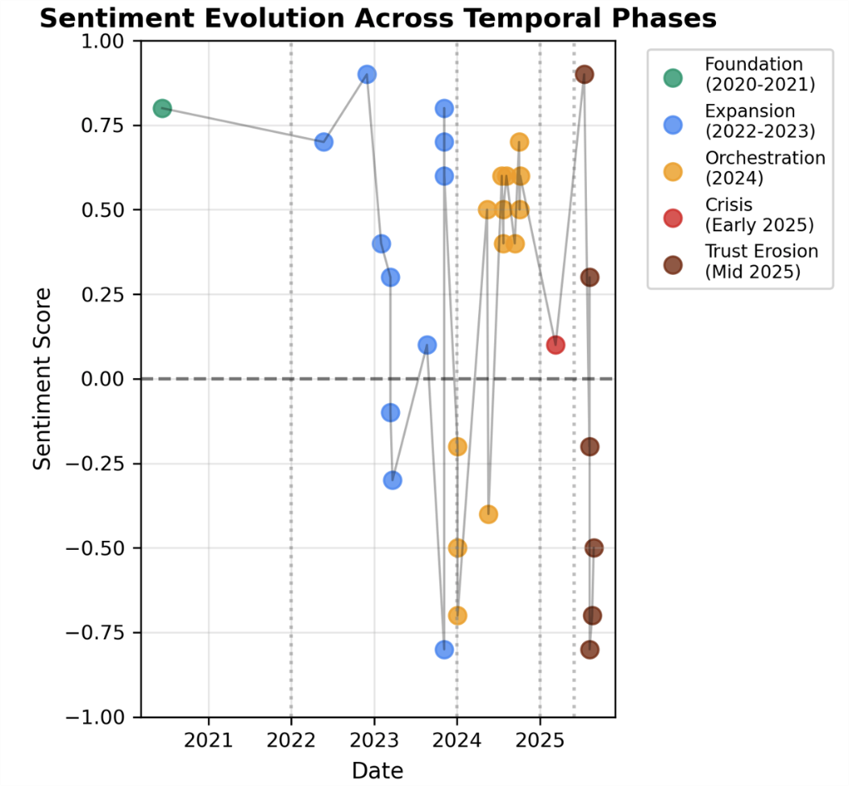
The temporal phases are clearly demarcated, with phase boundaries marked by vertical lines that correspond to major platform governance transitions. The coded scatter points reveal the clustering of sentiment patterns within each temporal phase. This visualization establishes the empirical foundation for our phase-by-phase analysis and demonstrates the temporal instability of PDE relationships. Meanwhile, Figure 4 expands on the average sentiment change over various phases on the left side, with the right side showing the evolution of theoretical constructs that capture community concerns.

Figure 4. Phase-Wise Sentiments and Concern Constructs
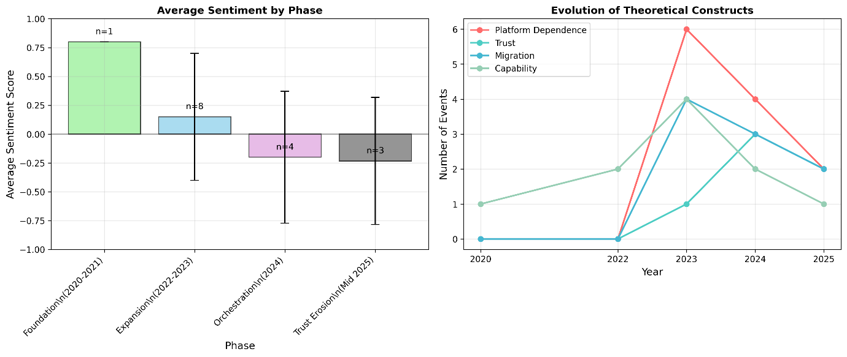

Phase 1: Foundation Building (2020-2021) - Infrastructure and Legitimization
The foundation phase established the fundamental architecture for PDE through two dominant institutional mechanisms: Infrastructure Provision and Market Legitimization. The GPT-3 API launch in June 2020 represented a watershed moment, providing unprecedented access to advanced LLM capabilities through a simple "text in, text out" interface that democratized AI capabilities previously confined to well-funded research laboratories.
Infrastructure Provision Mechanisms. Our analysis reveals that this operated through three primary sub-mechanisms during this phase: computational resource democratization, capability standardization and cost structure innovation. Computational Resource Democratization made sophisticated LLM technology accessible to ventures without requiring substantial capital investment in model training or hosting infrastructure. The API abstracted away the complexity of large-scale model deployment, allowing entrepreneurs to focus on application development rather than infrastructure management. Capability Standardization established common interfaces and data formats that reduced integration complexity and enabled rapid prototyping. The standardized API design lowered technical barriers to entry while creating a foundation for ecosystem development. Cost Structure Innovation introduced usage-based pricing that aligned platform costs with venture growth, reducing upfront investment requirements and enabling experimentation at scale.
As shown in Figures 3 and 4 above, community sentiment during this phase was overwhelmingly positive (+0.8 average), with reactions characterized by excitement about unprecedented capability access. Representative community quotes capture this enthusiasm: "GPT-3 is so much powerful and versatile that it opens up an entire universe of possibilities." (community.openai.com – April 2022). The absence of platform dependence concerns (0% of events) reflects the novelty of the offering and the lack of established alternatives for comparison.
Market Legitimization Mechanisms. Market Legitimization operated through the establishment of new business model categories and the validation of AI-powered value propositions. OpenAI's positioning of GPT-3 as a general-purpose language model created conceptual space for ventures to explore diverse applications without being constrained by narrow use-case definitions. This broad framing legitimized experimentation across sectors and enabled the emergence of novel business models. The platform's emphasis on safety and responsible AI development provided institutional credibility that facilitated venture fundraising and enterprise adoption. Early ventures like Copy.ai leveraged this legitimacy to secure funding and establish market positions, demonstrating how platform legitimacy transfers to ecosystem participants.
Venture Response Patterns. During this phase, venture responses included Experimental Adoption and Early Access Advantage. Based on excerpts published on its website, Copy.ai exemplifies the latter: founded in 2020, it leveraged early (private-beta) access to OpenAI’s GPT-3. The company grew quickly and went on to raise a substantial amount of seed funding in the millions of dollars. As suggested, venture strategies during this phase focused on capability exploration rather than dependency mitigation, reflecting the positive sentiment and absence of governance concerns. The low switching costs and experimental nature of early applications meant that platform dependence was viewed as an external enabler of AI-driven opportunity rather than a risk.

Phase 2: Capability Expansion (2022-2023) - Scaffolding & Boundary Resourcing
The capability expansion phase marked a fundamental shift in platform ecosystem dynamics through the introduction of ChatGPT (November 2022) and GPT-4 (March 2023). These releases demonstrated the platform's evolution from infrastructure provider to capability scaffolding platform, offering increasingly sophisticated tools that enabled new categories of entrepreneurial activity. Figures 3 and 4 above reveal the complexity of sentiment dynamics during the expansion phase, with the left panel showing mixed sentiment patterns and the right panel demonstrating the emergence of theoretical constructs that would become central to later crisis dynamics. The error bars in the left panel indicate increasing variance in community responses, reflecting growing awareness of both opportunities and risks associated with platform dependence. The right panel shows the first appearance of platform dependence concerns and trust issues, foreshadowing the governance challenges that would emerge in subsequent phases.
Capability Scaffolding Mechanisms. Capability Democratization reached unprecedented scale with ChatGPT's consumer launch, achieving 100 million users within two months and establishing Gen AI as a mainstream technology category. This mass adoption created market validation for AI-powered ventures and expanded the potential customer base for platform-dependent applications. Multimodal Integration through GPT-4's vision capabilities expanded the entrepreneurial possibility space beyond text processing to include image understanding, document analysis, and visual content generation. This capability expansion enabled ventures to address more complex use cases and develop more sophisticated value propositions. Performance Advancement through GPT-4's improved reasoning capabilities raised the quality threshold for AI applications, enabling ventures to tackle previously infeasible problems while simultaneously increasing customer expectations for AI performance.
Community Response. Community sentiment during this phase exhibited greater complexity, ranging from highly positive (0.9 for ChatGPT launch) to mixed (0.3 for GPT-4 release). The emergence of platform dependence concerns (appearing in 60% of events) reflects growing awareness of the implications of capability dependence and costs. Representative community reactions illustrate this tension. For instance, following the release of GPT-4, a member on Hacker News commented: "The way GPT-4 handles the system details is way better. It really sticks to the role given. Absolutely amazing results. Unfortunately, I realized how much more expensive the GPT-4 API is." Appendix C/Graph 2 captures how different types of platform decisions generate distinct community responses during this phase.
Major model releases show positive sentiment, reflecting excitement about capability advancement, while pricing changes and API modifications generate more mixed responses as the community begins to grapple with the economic implications of platform dependence. The sample sizes (n values) indicate the frequency of different event types, with model releases and capability announcements dominating platform communication during this expansion period. The introduction of pricing concerns marks a critical shift in community discourse, as ventures began to grapple with the unit economics implications of platform dependence. The mixed sentiment reflects the simultaneous recognition of capability advancement and growing awareness of dependency risks. It should be noted, however, that categories with very small sample sizes (e.g., n ≤ 2) may not be representative and should be interpreted with caution.

Phase 3: Ecosystem Orchestration (2024) - Maturation and Governance Tightening
The ecosystem orchestration phase marked the platform's evolution toward comprehensive ecosystem management through the introduction of the GPT Store, enterprise compliance tools, and advanced API capabilities. This phase demonstrates how platforms transition from capability provision to active ecosystem orchestration, introduces new forms of governance that both enable and constrain entrepreneurial activity.
Ecosystem Orchestration Mechanisms. Creator Economy Development through the GPT Store launch (October 2024) established new monetization pathways for platform-dependent entrepreneurs while creating additional dependency layers. The store's revenue-sharing model incentivized ecosystem participation while concentrating value capture within the platform's governance framework. Enterprise Integration Acceleration through compliance APIs and security enhancements enabled platform penetration into regulated industries, expanding the addressable market for platform-dependent ventures while introducing new governance requirements. These tools simultaneously enabled enterprise adoption and embedded ventures more deeply into platform-specific compliance frameworks. Advanced Capability Integration through features like Structured Outputs API and Realtime API provided sophisticated development tools that enhanced venture capabilities while increasing technical dependency on platform-specific implementations.
Community Sentiment Patterns. Community sentiment during this phase remained positive to mixed (0.5 to 0.6 average), though platform dependence concerns appeared in 75% of analyzed events. The community began to articulate more sophisticated understanding of dependency risks while maintaining enthusiasm for capability advancement. We paraphrase representative reactions as follows: The GPT Store creates new opportunities for developers to monetize their custom GPTs, though the same discussions highlighted platform dependency concerns. The emergence of Strategic Awareness in community discussions reflects growing sophistication in understanding platform dynamics and dependency implications. The evidence suggests that PDEs may have begun to develop more nuanced strategies for managing platform relationships while maximizing capability access.

Enablement & Venture Response Evolution
Venture responses during this phase evolved from experimental adoption to Production Deployment and Deep Integration strategies. Appendix C/Graph 3 illustrates the distribution of venture response patterns that emerged during this phase, with typical cases of each approach, drawn from the 24 PDE ventures sampled (see Appendix B). Our systematic analysis of 24 platform-dependent ventures reveals four distinct enablement patterns that demonstrate different approaches to managing the enablement-dependence paradox. This triangulation analysis provides empirical grounding for understanding how ventures navigate platform relationships while building sustainable businesses.
Early Access Advantage Pattern. The Early Access Advantage pattern, exemplified by Copy.ai, demonstrates how timing advantages can create sustainable competitive positions in platform-dependent markets. Copy.ai's founding in October 2020, approximately four months after the GPT-3 API announcement, enabled the venture to establish market position and secure funding before competitors gained platform access. This pattern requires ventures to identify platform opportunities early and commit resources to platform-specific development before market validation. The risks include platform dependency without proven market demand, while the benefits include first-mover advantages and preferential platform relationships during early ecosystem development.
Simultaneous Launch Pattern. The Simultaneous Launch pattern, demonstrated by Khan Academy's Khanmigo, involves coordinated development between platform and venture to maximize integration benefits. This pattern requires close collaboration with platform providers and alignment of development timelines, creating opportunities for deep integration while accepting high dependency levels. Khan Academy's approach demonstrates how established organizations can leverage platform capabilities to enhance existing value propositions while maintaining core business independence. The educational context provides additional legitimacy for AI integration, facilitating user acceptance and regulatory compliance.
Deep Integration Pattern. The Deep Integration pattern, exemplified by Harvey's legal AI platform, involves building core venture functionality around platform capabilities while accepting high dependency levels in exchange for competitive differentiation. This pattern enables ventures to address complex problems that would be infeasible without platform capabilities but creates substantial switching costs and vulnerability to platform governance changes. Harvey's success demonstrates how deep integration can create sustainable competitive advantages in specialized domains where platform capabilities provide unique value. However, as of this writing, the venture's stated dependence on GPT-4 and custom model training creates substantial exposure to platform governance decisions and pricing changes.
Feature Integration Pattern. The Feature Integration pattern, demonstrated by Notion's AI features, involves incorporating platform capabilities as enhancements to existing products while maintaining core functionality independence. This pattern provides balanced exposure to platform benefits and risks, enabling ventures to benefit from capability advancement while preserving strategic flexibility. Notion's approach demonstrates how established platforms can integrate generative AI capabilities without fundamentally altering their value propositions or creating excessive dependency. This pattern may be most suitable for ventures with established market positions and diversified capability portfolios.

Phases 4 & 5: Platform Governance Crisis & Dependency Risks
As shown in Figure 1 above, the early 2025 period which was Phase 4, marked the beginning of a governance crisis that fundamentally altered platform ecosystem relationships, become a highly critical incident worthy of standalone analysis. This phase demonstrates how accumulated dependency relationships can become sources of vulnerability when platform governance priorities shift away from ecosystem support toward internal optimization.
Crisis Triggering Events. Forced Migration initiatives required ventures to adapt to new platform architectures without adequate transition support, imposing significant technical and financial burdens on dependent entrepreneurs. The Assistants API deprecation announcement exemplifies this pattern, forcing ventures to rebuild core functionality while questioning platform reliability. Quality Regression Incidents through model updates that degraded performance in specific use cases created direct business impact for dependent ventures. The GPT-4.5 to GPT-5 transition in creative writing capabilities represents a critical case where platform optimization conflicted with venture needs. The strong negative sentiment is captured by a user who states: “Please don’t! GPT-4.5 is so much better in every aspect. You lied to us when you tried to sell us GPT-4o as better, but I think everyone knows, that it’s a slimmed down/watered down version of GPT-4 that you just pushed to perform better at certain benchmarks.”
Communication Breakdown through inadequate advance notice and limited consultation on governance changes eroded trust and created uncertainty about future platform direction. Community reactions reveal growing frustration with unilateral decision-making: " GPT-5 might be “smart” in abstract reasoning, but it lacks the determinism, precision, and obedience that GPT‑4.1 provided — and which developers heavily rely on. I respectfully ask OpenAI to bring back GPT-4.1 as an optional model under legacy access...." These strong reactions would eventually prompt OpenAI to rescind its decision, reinstating access to legacy models with the famous “we totally screwed up” comment from its CEO, Sam Altman reported in the media. Figure 5 visualizes the enablement-dependence paradox that becomes acute during this crisis phase.

Figure 5. Enablement-Dependence Paradox
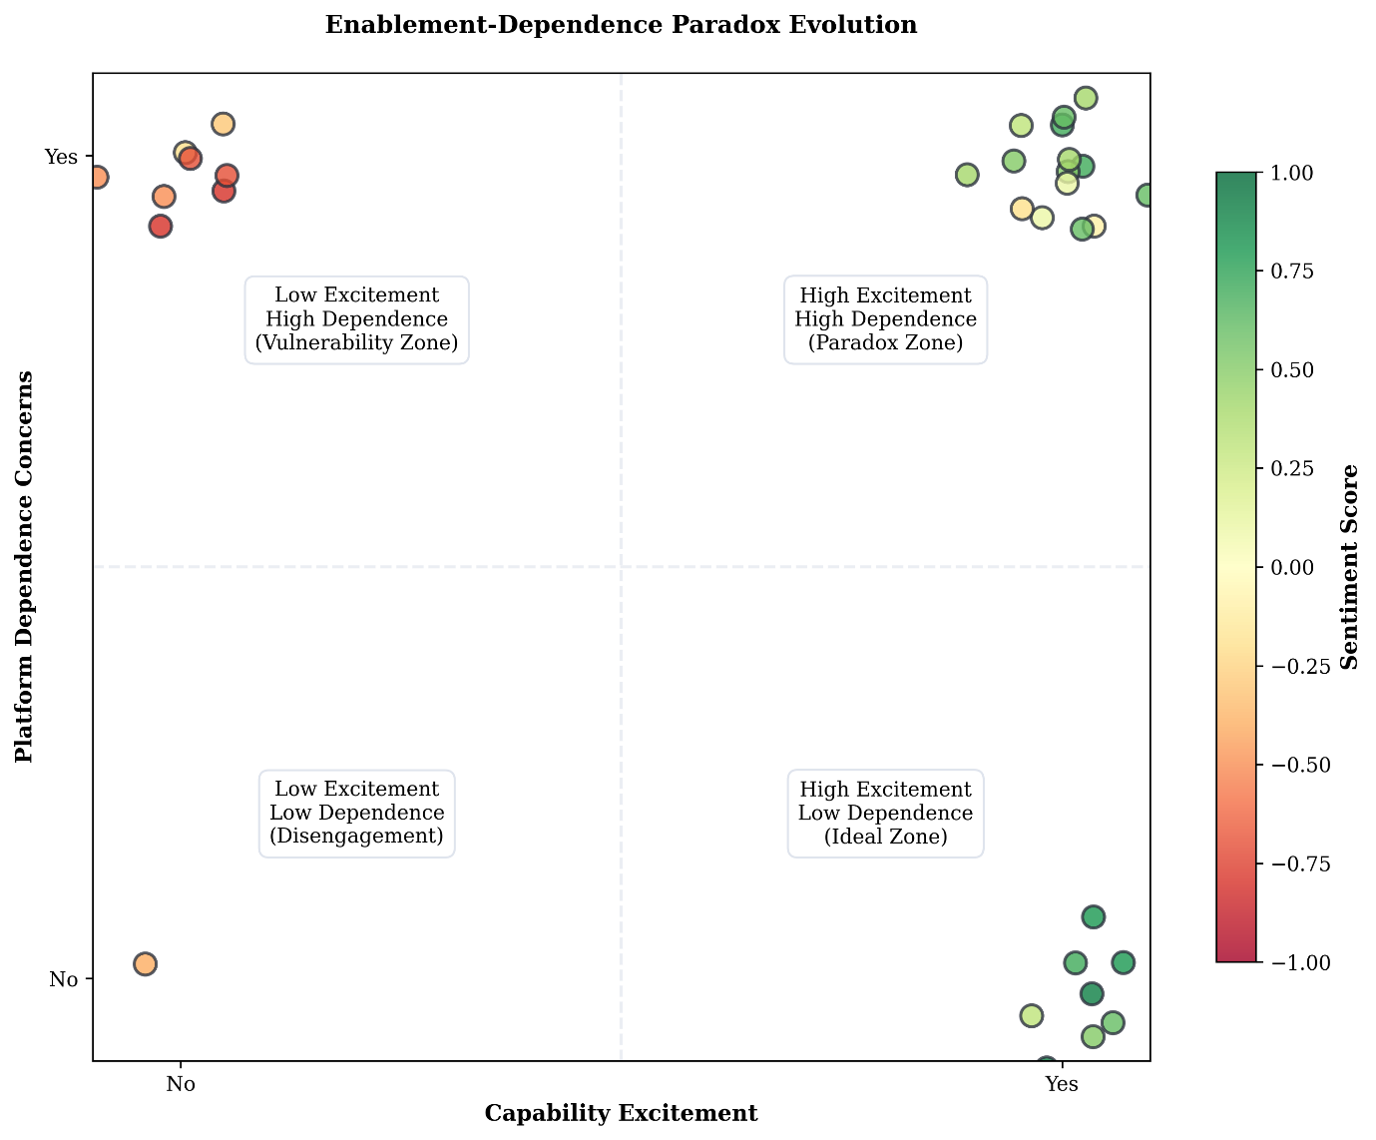
The scatter plot reveals how events cluster in different quadrants, with crisis-period events predominantly falling in the "Paradox Zone" (high excitement, high dependence) and "Vulnerability Zone" (low excitement, high dependence). The coding by sentiment score shows how the paradox manifests through negative sentiment even when capability excitement remains high, demonstrating the temporal asymmetry of benefits and risks in platform-dependent relationships.
Institutional Mechanism Breakdown. The crisis phase reveals how institutional catalyst mechanisms can reverse when governance priorities shift. Infrastructure Provision became Infrastructure Disruption as platform changes imposed costs rather than reducing them. Capability Scaffolding transformed into Capability Constraint as new limitations and requirements reduced venture flexibility. Market Legitimization began to erode as platform governance decisions created uncertainty about the sustainability of platform-dependent business models. Ecosystem Orchestration shifted toward Ecosystem Control as the platform prioritized internal optimization over ecosystem health.
Community Sentiment Deterioration. Community sentiment during this phase showed significant deterioration, with mixed to negative reactions (0.1 to 0.4 average) and the emergence of trust concerns in 40% of events. The community discourse shifted from capability excitement to risk management, with increasing discussion of diversification strategies and alternative platforms.
Governance Overreach and Community Backlash. Phase 5, occurring from the mid-2025 period onwards, represents a watershed moment in AI-powered PDE, demonstrating how accumulated governance overreach can trigger rapid trust erosion and a fundamental questioning of platform-dependent business models.

Governance Overreach Mechanisms
Choice Removal as Control Mechanism emerged as a new theoretical construct during the crisis phases, exemplified by the forced removal of GPT-4.5 access without user choice or adequate transition support. This represents a qualitatively different form of platform control that exploits switching costs and sunk investments to force adoption of inferior alternatives. Quality Regression Tolerance reflects the platform's assumption that dependent ventures will accept capability degradation due to high switching costs. The GPT-5 release with acknowledged quality regression in creative writing demonstrates how platforms may prioritize internal objectives over ecosystem value creation when dependency relationships are strong. Trust Erosion Cascade describes the rapid deterioration of platform relationships when governance overreach is perceived. Unlike gradual sentiment decline, trust erosion exhibits cascade characteristics where individual incidents trigger broader questioning of platform reliability and long-term viability.

Community Backlash Dynamics
Community sentiment reached unprecedented negative levels (-0.8 for forced migration events), with reactions characterized by anger, betrayal, and active consideration of platform abandonment. The discourse shifted from capability optimization to survival strategies, with ventures actively seeking alternatives and developing contingency plans. Representative community reactions capture the severity of trust erosion: "Instead of adding GPT-5 as an option alongside existing models, OpenAI simply removed access to all other models. No warning... No choice." This quote illustrates how choice removal as a control mechanism generates particularly strong negative reactions that extend beyond specific technical concerns to fundamental questions about platform governance legitimacy.

Synthesis: Temporal Dynamics and Theoretical Integration
Our empirical analysis validates the core propositions of our theoretical framework while revealing new dynamics that extend existing theories of digital entrepreneurship and platform governance. The five-phase evolution demonstrates how platform-dependent entrepreneurship relationships exhibit temporal instability, with enablement benefits dominating early phases while dependence vulnerabilities become apparent during governance crisis periods.
Figure 1 above synthesizes our empirical findings into an integrated theoretical framework that captures the dynamic relationships between institutional catalyst mechanisms, the enablement-dependence paradox, and temporal evolution. The central paradox connects to four institutional mechanisms that operate with varying intensity across the five temporal phases shown at the bottom. This framework provides a comprehensive account of how Gen AI platforms function as institutional catalysts while creating new forms of entrepreneurial vulnerability. The enablement-dependence paradox emerges as the central theoretical insight, capturing the fundamental tension between capability access and strategic vulnerability that characterizes PDE. The temporal asymmetry of this paradox—with benefits realized immediately and costs accumulating over time—helps explain why ventures may rationally enter into platform-dependent relationships despite long-term vulnerability risks.
The institutional catalyst mechanisms provide the specific processes through which platforms enable entrepreneurial activity while creating dependency relationships. The relative impact of these mechanisms varies across temporal phases, with Infrastructure Provision dominating foundation phases, Capability Scaffolding driving expansion phases, and Ecosystem Orchestration characterizing maturation phases. The new theoretical constructs that emerge from crisis dynamics—Platform Governance Overreach, Trust Erosion Cascade, and Choice Removal as Control Mechanism—extend existing platform governance theory by specifying how accumulated dependency relationships can be exploited when platform priorities shift away from ecosystem support. This empirical analysis provides comprehensive validation for our theoretical framework and propositions while revealing the temporal instability and inherent vulnerabilities of PDE relationships. The findings demonstrate that while Gen AI platforms can function as powerful institutional catalysts for entrepreneurship, they also create new forms of entrepreneurial uncertainty and vulnerability that require careful theoretical and practical attention. The next section discusses the implications of the findings.

DISCUSSION
This empirical study has unraveled the mechanisms through which Gen AI platforms function as institutional catalysts of PDE—the central question of this research. We identified four primary mechanisms that both enable and constrain PDE—Infrastructure Provision, Capability Scaffolding, Market Legitimization, and Ecosystem Orchestration—and traced their temporal dynamics. The analysis surfaces a core enablement–dependence paradox at the heart of capability-dependent PDE: the same mechanisms that enable venture creation also generate dependencies that become vulnerabilities when platform governance priorities shift. Enablement benefits dominate during foundation and expansion phases; dependence vulnerabilities crystallize during governance crises. In doing so, we specify Gen AI–powered PDE as an analytically distinct phenomenon that requires assumptions different from distribution-dominant logics of platform dependence and highlight how governance and institutional ordering mediate whether external enablers convert into durable ventures (Davidsson, Recker, & von Briel, 2020; Cutolo & Kenney, 2021; Gawer, 2014). We develop Figure 6 as a conceptual framework that encapsulates our theoretical contribution.
Figure 6. Conceptual Framework for Institutional Catalysts of AI-Powered PDE
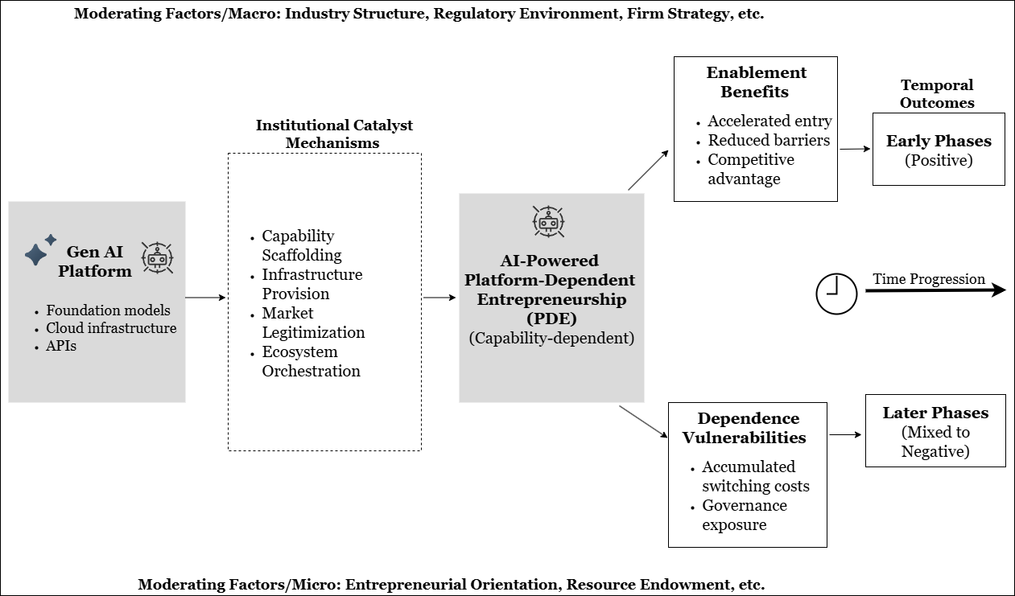
Our conceptual framework illustrates how Gen AI platforms function as institutional catalysts of PDE through an enablement-dependence paradox. The framework demonstrates that Gen AI platforms, equipped with foundation models, cloud infrastructure, and APIs, activate four institutional catalyst mechanisms—Capability Scaffolding, Infrastructure Provision, Market Legitimization, and Ecosystem Orchestration—that collectively enable the formation of AI-powered platform-dependent ventures. However, this catalytic process simultaneously generates two divergent pathways: enablement benefits that accelerate market entry, reduce barriers, and create competitive advantages during early phases; and dependence vulnerabilities that accumulate switching costs and governance exposure, leading to mixed-to-negative outcomes in later phases. The framework reveals that while Gen AI platforms democratize access to advanced capabilities and foster rapid entrepreneurial activity, they also create structural dependencies that expose ventures to platform governance risks over time, with macro-level factors (industry structure, regulatory environment) and micro-level factors (entrepreneurial orientation, resource endowment) moderating these dynamics throughout the temporal evolution of the ecosystem.
Reframing our findings through the quartet of institutional scaffolding–enablement–governance–dependence lens clarifies the mechanism–action–response–outcome chain: (1) Institutional scaffolding via boundary resources (APIs, SDKs, safety/evaluation stacks, policy) prompts adoption of platform toolchains, accelerating legitimation and standardization with enterprise buyers; (2) External enablement via cloud endpoints democratizes frontier capabilities, catalyzing rapid experimentation and entry, thereby expanding the entrepreneurial possibility space; (3) Governance mediation—pricing, rate limits, versioning, compliance enforcement—elicits strategic adaptation or resistance (abstraction layers, selective multihoming), consolidating core-centered power; (4) Capability dependence, where access to non-substitutable functionality is platform-controlled, induces deep integration commitments, heightening lock-in and ecosystem vulnerability.
The findings support P1–P4: P1, enablement heightens dependence through legitimation; P2, predictable governance induces deep integration, whereas volatility dampens commitment; P3, integration depth increases platform bargaining power via switching costs; and P4, co-evolution yields a dynamic equilibrium in which complementor adaptation costs bound switching, stabilizing participation amid ongoing recalibration of interfaces and rules.

Theoretical Contributions and Framework Extensions
Through this study, we contribute to institutions and digital entrepreneurship research as follows: (1) we delineate Gen AI–powered PDE as a distinct phenomenon; (2) we theorize institutional catalyst mechanisms in a dynamic process model; (3) we validate the enablement–dependence paradox as a core construct; (4) we extend platform governance and trust constructs to capability-dependent contexts; and (5) we integrate External Enablement (EE) with governance-mediated institutionalization in Gen AI ecosystems (Urbano et al., 2019; Davidsson et al., 2020; Nzembayie et al., 2024).
First, we show that Gen AI–powered PDE is characterized by capability dependence rather than distribution dependence. Whereas classic platform relationships hinge on market access, Gen AI PDE depends on access to non-substitutable, platform-governed capabilities within strategic windows—conditions akin to software innovation platforms where an extensible core and boundary resources shape venture possibilities (Gawer, 2014; Tiwana et al., 2010; Ghazawneh & Henfridsson, 2013). In contrast to transaction settings, acceptable-use policies, rate limits, pricing, software deprecation and iteration of foundation models modulate feasibility and unit economics, rendering governance a first-order determinant of viability. Temporally, capability dependence unfolds in phases: infrastructure democratizes experimentation (foundation), scaffolding enables more complex propositions (expansion), orchestration concentrates control (maturation), and governance overreach can precipitate constraint (crisis). This dynamic aligns with process-oriented views of venture creation and ecosystem evolution calling for temporal granularity.
Second, we extend institutional entrepreneurship by specifying how platforms act as institutional catalysts that both resource and discipline entrepreneurial action through boundary resources and rules (North, 1990; Bruton, Ahlstrom, & Li, 2010; Ghazawneh & Henfridsson, 2013). Infrastructure Provision democratizes access to advanced capabilities yet can reverse during crises when architectural changes impose costs (Gawer & Phillips, 2013). Capability Scaffolding—our most prevalent mechanism—lowers development costs and expands affordances while deepening dependence on platform toolchains (Chalmers et al., 2021; Ghazawneh & Henfridsson, 2013). Market Legitimization transfers credibility to AI-powered models, accelerating enterprise adoption but exposing ventures to spillovers from platform controversies. Finally, Ecosystem Orchestration reflects a shift from infrastructure to governance, creating new monetization routes while concentrating direction-setting power (Eisenmann, Parker, & Van Alstyne, 2011; Chen et al., 2022).
Third, our study develops and validates an enablement–dependence paradox distinctive to capability-dependent platforms. Temporal asymmetry explains rational entry: ventures reap immediate benefits (capability access, compressed time-to-market) while dependence costs accumulate and surface when governance shifts—consistent with uncertainty-centric accounts of entrepreneurial action and processual views of new venture creation. Capability intensity moderates this trade-off: deeper integrations yield stronger differentiation and higher exposure to policy and pricing moves (Chalmers et al., 2021). Our study distills resolution strategies observed among more resilient ventures: (i) feature-level integration to preserve core product independence; (ii) selective multihoming where quality parity allows (Cennamo, Ozalp, & Kretschmer, 2018); and (iii) abstraction layers that buffer API/policy changeovers as platforms and complements co-evolve (Eaton et al., 2015; O’Mahony & Karp, 2022).
Fourth, we introduce three constructs that extend platform governance theory to capability-dependent contexts. Platform Governance Overreach describes leveraging dependency to enforce platform-benefiting changes—via choice removal, switching-cost exploitation, and sunk investment leverage—shifting value distribution under meta-organizational governance (Chen et al., 2022; O’Mahony & Karp, 2022). Trust-Erosion Cascade captures how perceived overreach triggers incident amplification, collective sensemaking, and identity transformation—from enthusiastic complementor to reluctant dependent—echoing concerns about unchecked platform power (Rahman et al., 2024). Finally, Choice Removal as Control Mechanism formalizes how eliminating viable model/version alternatives increases governance leverage in capability-dependent settings (Parker et al., 2017; Hurni et al., 2022).
Finally, we extend EE theory by articulating governance-mediated enablement: the conversion of environmental shocks (e.g., step-change models, price drops) into sustained opportunities depends on the transparency, stability, and timing of platform governance (Davidsson et al., 2020; Kimjeon & Davidsson, 2022). Enablement reversal occurs when the same mechanisms that once reduced barriers (APIs, evaluation/safety stacks) subsequently impose costs (deprecations, policy tightening), in line with our observed crisis dynamics. Boundary resources thus operate as institutional scaffolding that both legitimates and constrains—accelerating enterprise acceptance while embedding ventures in provider-specific rule systems (Ghazawneh & Henfridsson, 2013; Gawer & Phillips, 2013).

Practical and Policy Implications
Our study raises critical implications for policy and practice. Practical implications are offered to both aspiring Gen AI-powered PDEs and platform owners. Policy implications explore how regulatory bodies can nurture a healthy ecosystem for Gen AI-powered PDE.
Aspiring PDEs. For aspiring Platform-dependent entrepreneurs (PDEs), our study provides actionable strategic insights for entrepreneurs navigating platform-dependent business models. The identification of four distinct enablement patterns—Early Access Advantage, Simultaneous Launch, Deep Integration, and Feature Integration—offers strategic frameworks for managing the enablement-dependence paradox. Portfolio Dependency Management emerges as a critical capability for platform-dependent entrepreneurs. Ventures that successfully navigate platform relationships develop diversified approaches that balance platform optimization with risk mitigation (Nzembayie et al., 2024). This includes maintaining relationships with multiple platform providers (multi-homing) where feasible (Cennamo et al., 2018), developing abstraction layers that reduce switching costs, and preserving core capabilities that can function independently of platform access.
Likewise, Temporal Strategy Alignment must involve matching venture strategies to platform lifecycle phases. During foundation and expansion phases, aggressive platform integration strategies may be optimal for capturing competitive advantages. During orchestration and crisis phases, defensive strategies that prioritize independence and flexibility become more important (Nzembayie et al., 2024). Furthermore, Governance Risk Assessment requires systematic evaluation of platform governance patterns, communication practices, and historical treatment of dependent ventures. This study reveals warning signs of potential governance overreach, including unilateral policy changes, inadequate consultation processes, and exploitation of dependency relationships for platform benefit.
Platform Owners. Our findings offer insights for platform owners seeking to build sustainable ecosystems while maintaining necessary control over platform evolution. The crisis dynamics observed in 2025 demonstrate how governance overreach can rapidly undermine ecosystem health and platform legitimacy. This confirms assertions by Jacobides et al. (2024) that structural governance failures can undermine platform power in the long term. Governance Transparency emerges as critical for maintaining ecosystem trust and preventing crisis cascades. Platforms that provide clear communication about governance changes, adequate transition periods, and consultation processes are more likely to maintain positive ecosystem relationships even during difficult transitions.
Dependency Risk Mitigation involves platform design choices that reduce venture vulnerability while maintaining platform control. This includes providing migration tools, maintaining backward compatibility, and offering choice in platform evolution rather than forcing adoption of new capabilities. Ecosystem Health Monitoring requires systematic attention to community sentiment, venture adaptation costs, and ecosystem vitality indicators. Our sentiment analysis methodology provides a framework for platforms to monitor ecosystem health and identify potential crisis points before they escalate.
Policymakers & Regulators. For regulators and policymakers, the concentration of capability control in generative AI platforms raises important questions about market structure, competition policy, and the governance of critical digital infrastructure. Our analysis reveals how platform governance decisions can have far-reaching effects on dependent ventures and broader innovation ecosystems. Platform Governance Accountability emerges as a policy priority given the significant impact of platform decisions on dependent entrepreneurs. Traditional competition policy frameworks may be insufficient for addressing the unique dynamics of capability-dependent platform relationships, where switching costs and technical dependencies erect formidable barriers to competition.
Innovation Ecosystem Protection requires policy frameworks that balance platform innovation incentives with protection for dependent entrepreneurs. This includes consideration of governance standards, transition requirements, and mechanisms for addressing platform overreach. Digital Infrastructure Governance involves recognizing Gen AI platforms as critical digital infrastructure that requires appropriate governance frameworks. The capability-dependent nature of these platforms creates systemic risks that may require regulatory attention to ensure ecosystem stability and innovation continuity.

Conclusion
This study theorizes how generative-AI platforms operate as institutional catalysts of platform-dependent entrepreneurship (PDE). Tracing the OpenAI ecosystem from 2020 to 2025, we show that platforms simultaneously enable and constrain venturing through capability-dependent ties. We distinguish PDE from distribution-dependent relationships and specify a dynamic process in which Infrastructure Provision, Capability Scaffolding, Market Legitimization, and Ecosystem Orchestration vary in salience across phases, producing a pronounced asymmetry between early enablement and later exposure to governance shocks. The core insight is the enablement–dependence paradox: immediate access to frontier capabilities compresses development and accelerates market entry, while dependence costs accumulate and surface when rules, pricing, or model behavior shift. Capability intensity amplifies this trade-off, explaining both rapid scaling in foundation/expansion and sudden distress during orchestration/crisis. We extend platform governance with constructs of governance overreach, trust-erosion cascades, and choice removal as control, and integrate institutional, external enablement, and innovation-platform perspectives to show that governance can reverse enablement without any decline in technical frontier. Practically, we foreground portfolio dependency management for entrepreneurs, credible choice and transparency for platform owners, and accountability standards where platforms act as critical digital infrastructure.

Limitations, Boundary Conditions & Future Research
This study is not without its limitations. First, our evidence centers on a single, leading Gen AI ecosystem (OpenAI) over a compressed period, which conditions generalizability to other platforms and more mature settings. For instance, our case features a Gen AI platform with closed governance structures, challenging the extension of our findings to open platforms (e.g., Llama). Second, the event-based process research approach relies primarily on public trace data and archival materials; voices absent from public forums and ventures under confidentiality may be underrepresented. Third, venture-level integration depth, switching costs, and adaptation expenditures are approximated from available sources rather than audited internal data. Finally, although the research design supports process inference, causal identification around specific governance shocks remains limited.
These limitations present opportunities for future research. First, comparative studies across multiple AI platforms can test boundary conditions and assess how architecture and governance designs modulate PDE dynamics. Longer-horizon panel work should track whether enablement reversals persist or attenuate as ecosystems stabilize. Second, micro-foundational inquiries could model how founders price dependency risk and when abstraction layers or multihoming deliver net performance gains; quasi-experimental tests around policy changes would sharpen causal claims. Third, measurement work is needed to operationalize capability intensity, quantify reversal thresholds, and develop ecosystem health indices that combine sentiment, migration debt, and venture outcomes. Finally, cross-domain investigations—in cloud, payments, and regulated verticals—can examine whether capability-dependent governance produces similar paradoxes and which regulatory guardrails best preserve innovation while curbing exploitative dependency.

Concluding Statement
Taken together, our analysis suggests that the next phase of digital entrepreneurship will be shaped as much by the governance of capability platforms as by advances in AI capability itself. By centering the enablement–dependence paradox and specifying levers for entrepreneurs, platform owners, and regulators, we offer a practical blueprint for building ventures and ecosystems that remain innovative by design and resilient by default.

References
Baumol, W. J. (1993). Formal entrepreneurship theory in economics: Existence and bounds. Journal of business venturing, 8(3), 197-210.
Baumol, W. J., & Strom, R. J. (2007). Entrepreneurship and economic growth. Strategic entrepreneurship journal, 1(3‐4), 233-237.
Bruton, G. D., Ahlstrom, D., & Li, H. L. (2010). Institutional theory and entrepreneurship: where are we now and where do we need to move in the future?. Entrepreneurship theory and practice, 34(3), 421-440.
Cennamo, C., Ozalp, H., & Kretschmer, T. (2018). Platform architecture and quality trade-offs of multihoming complements. Information Systems Research, 29(2), 461-478.
Chalmers, D., MacKenzie, N. G., & Carter, S. (2021). Artificial intelligence and entrepreneurship: Implications for venture creation in the fourth industrial revolution. Entrepreneurship Theory and Practice, 45(5), 1028-1053.
Chen, L., Tong, T. W., Tang, S., & Han, N. (2022). Governance and design of digital platforms: a review and future research directions on a meta-organization. Journal of management, 48(1), 147-184.
Creswell, J. W., Plano Clark, V. L., Gutmann, M. L., & Hanson, W. E. (2003). Advanced mixed methods research designs. Handbook of mixed methods in social and behavioral research, 209(240), 209-240.
Cusumano, M. A., Gawer, A., & Yoffie, D. B. (2019). The business of platforms: Strategy in the age of digital competition, innovation, and power (Vol. 320, pp. 1-5). New York: Harper Business.
Cutolo, D., & Kenney, M. (2021). Platform-dependent entrepreneurs: Power asymmetries, risks, and strategies in the platform economy. Academy of Management Perspectives, 35(4), 584-605.
Davidsson, P., Recker, J., & Von Briel, F. (2020). External enablement of new venture creation: A framework. Academy of Management Perspectives, 34(3), 311-332.
Diao, M., Kong, H., & Zhao, J. (2021). Impacts of transportation network companies on urban mobility. Nature Sustainability, 4(6), 494-500.
DiMaggio, P. J. (1988). Interest and agency in institutional theory. In L. Zucker (Ed.), Institutional patterns and organizations: Culture and environment (pp. 3–21). Cambridge: Ballinger.
Eaton, B., Elaluf-Calderwood, S., Sørensen, C., & Yoo, Y. (2015). Distributed tuning of boundary resources. MIS quarterly, 39(1), 217-244.
Eisenmann, T., Parker, G., & Van Alstyne, M. (2011). Platform envelopment. Strategic management journal, 32(12), 1270-1285.
Elert, N., & Henrekson, M. (2017). Entrepreneurship and institutions: a bidirectional relationship. Foundations and Trends® in Entrepreneurship, 13(3), 191-263.
Fernandes, C., Ferreira, J. J., Veiga, P. M., Kraus, S., & Dabić, M. (2022). Digital entrepreneurship platforms: Mapping the field and looking towards a holistic approach. Technology in Society, 70, 101979.
Garud, R., Hardy, C., & Maguire, S. (2007). Institutional entrepreneurship as embedded agency: An introduction to the special issue. Organization studies, 28(7), 957-969.
Gawer, A. (2014). Bridging differing perspectives on technological platforms: Toward an integrative framework. Research policy, 43(7), 1239-1249.
Gawer, A. (2022). Digital platforms and ecosystems: remarks on the dominant organizational forms of the digital age. Innovation, 24(1), 110-124.
Gawer, A., & Phillips, N. (2013). Institutional work as logics shift: The case of Intel’s transformation to platform leader. Organization studies, 34(8), 1035-1071.
Ghazawneh, A., & Henfridsson, O. (2013). Balancing platform control and external contribution in third‐party development: the boundary resources model. Information systems journal, 23(2), 173-192.
Gioia, D. (2021). A systematic methodology for doing qualitative research. The Journal of Applied Behavioral Science, 57(1), 20-29.
Gioia, D. A., Corley, K. G., & Hamilton, A. L. (2013). Seeking qualitative rigor in inductive research: Notes on the Gioia methodology. Organizational research methods, 16(1), 15-31.
Giuggioli, G., & Pellegrini, M. M. (2023). Artificial intelligence as an enabler for entrepreneurs: a systematic literature review and an agenda for future research. International Journal of Entrepreneurial Behavior & Research, 29(4), 816-837.
Hu, K. (2023) CHATGPT sets record for fastest-growing user base - analyst note | reuters. Available at: https://www.reuters.com/technology/chatgpt-sets-record-fastest-growing-user-base-analyst-note-2023-02-01/ (Accessed: 26 December 2024).
Hurni, T., Huber, T. L., & Dibbern, J. (2022). Power dynamics in software platform ecosystems. Information systems journal, 32(2), 310-343.
Jacobides, M. G., Cennamo, C., & Gawer, A. (2018). Towards a theory of ecosystems. Strategic management journal, 39(8), 2255-2276.
Jacobides, M. G., Cennamo, C., & Gawer, A. (2024). Externalities and complementarities in platforms and ecosystems: From structural solutions to endogenous failures. Research Policy, 53(1), 104906.
Kimjeon, J., & Davidsson, P. (2022). External enablers of entrepreneurship: A review and agenda for accumulation of strategically actionable knowledge. Entrepreneurship theory and practice, 46(3), 643-687.
Langley, A. (1999). Strategies for theorizing from process data. Academy of Management review, 24(4), 691-710.
Liguori, E. W., Muldoon, J., Ogundana, O. M., Lee, Y., & Wilson, G. A. (2024). Charting the future of entrepreneurship: a roadmap for interdisciplinary research and societal impact. Cogent Business & Management, 11(1), 2314218.
Mair, J., & Marti, I. (2009). Entrepreneurship in and around institutional voids: A case study from Bangladesh. Journal of business venturing, 24(5), 419-435.
Majchrzak, A., & Markus, M. L. (2012). Technology affordances and constraints in management information systems (MIS). Encyclopedia of Management Theory,(Ed: E. Kessler), Sage Publications.
Maslej, N. et al. (2024) Artificial Intelligence Index Report 2024, arXiv.org. Available at: https://doi.org/10.48550/arXiv.2405.19522.
McDermott, G. A., Corredoira, R. A., & Kruse, G. (2009). Public-private institutions as catalysts of upgrading in emerging market societies. Academy of Management Journal, 52(6), 1270-1296.
Mitchell, M. (2019). Artificial intelligence: A guide for thinking humans. Penguin UK.
Mitchell, M. (2021). Why AI is harder than we think. arXiv preprint arXiv:2104.12871.
Mollick, E. (2024) Co-Intelligence: Living and Working with AI. Penguin.
Morgan, D. L. (2023). Exploring the use of artificial intelligence for qualitative data analysis: The case of ChatGPT. International journal of qualitative methods, 22, 16094069231211248.
Nambisan, S. (2017). Digital entrepreneurship: Toward a digital technology perspective of entrepreneurship. Entrepreneurship theory and practice, 41(6), 1029-1055.
North, D. C. (1990). Institutions, institutional change and economic performance. Cambridge: Cambridge University Press.
Nzembayie, K. F., & Buckley, A. (2022). Digital entrepreneurship: Disruption and new venture creation. Edward Elgar Publishing.
Nzembayie, K. F., Evers, N., & Urbano, D. (2024). Power dynamics in transaction platforms: Adaptive strategies of platform-dependent entrepreneurs. Technovation, 138, 103114.
Obschonka, M., & Audretsch, D. B. (2020). Artificial intelligence and big data in entrepreneurship: a new era has begun. Small Business Economics, 55, 529-539.
Obschonka, M., Gregoire, D. A., Nikolaev, B., Ooms, F., Lévesque, M., Pollack, J. M., & Behrend, T. S. (2025). Artificial intelligence and entrepreneurship: a call for research to prospect and establish the scholarly AI frontiers. Entrepreneurship Theory and Practice, 49(3), 620-641.
O'Mahony, S., & Karp, R. (2022). From proprietary to collective governance: How do platform participation strategies evolve?. Strategic Management Journal, 43(3), 530-562.
Parker, G., Van Alstyne, M., & Jiang, X. (2017). Platform ecosystems. MIS quarterly, 41(1), 255-266.
Rahman, H. A., Karunakaran, A., & Cameron, L. D. (2024). Taming platform power: Taking accountability into account in the management of platforms. Academy of Management Annals, 18(1), 251-294.
Riessman, C. K. (2008). Narrative methods for the human sciences. Sage.
Shepherd, D. A., & Majchrzak, A. (2022). Machines augmenting entrepreneurs: Opportunities (and threats) at the Nexus of artificial intelligence and entrepreneurship. Journal of Business Venturing, 37(4), 106227.
Timmermans, S., & Tavory, I. (2012). Theory construction in qualitative research: From grounded theory to abductive analysis. Sociological theory, 30(3), 167-186.
Tiwana, A., Konsynski, B., & Bush, A. A. (2010). Research commentary—Platform evolution: Coevolution of platform architecture, governance, and environmental dynamics. Information systems research, 21(4), 675-687.
Townsend, D. M., & Hunt, R. A. (2019). Entrepreneurial action, creativity, & judgment in the age of artificial intelligence. Journal of Business Venturing Insights, 11, e00126.
Troise, C., Matricano, D., & Sorrentino, M. (2021). Open innovation platforms: Exploring the importance of knowledge in supporting online initiatives. Knowledge Management Research & Practice, 19(2), 208-216.
Truong, Y., Schneckenberg, D., Battisti, M., & Jabbouri, R. (2023). Guest editorial: Artificial intelligence as an enabler for entrepreneurs: an integrative perspective and future research directions. International Journal of Entrepreneurial Behavior & Research, 29(4), 801-815.
Urbano, D., Aparicio, S., & Audretsch, D. (2019). Twenty-five years of research on institutions, entrepreneurship, and economic growth: what has been learned?. Small business economics, 53, 21-49.
Van de Ven, A. H., & Engleman, R. M. (2004). Event-and outcome-driven explanations of entrepreneurship. Journal of business venturing, 19(3), 343-358.
Vaswani, A., Shazeer, N., Parmar, N., Uszkoreit, J., Jones, L., Gomez, A. N., ... & Polosukhin, I. (2017). Attention is all you need. Advances in neural information processing systems, 30.
Ventresca, M. J., & Mohr, J. W. (2017). Archival research methods. The Blackwell companion to organizations, 805-828.
Vigoda-Gadot, E., & Mizrahi, S. (2024). The digital governance puzzle: Towards integrative theory of humans, machines, and organizations in public management. Technology in Society, 77, 102530.
Von Hippel, E. (2009). Democratizing innovation: the evolving phenomenon of user innovation. International Journal of Innovation Science, 1(1), 29-40.
Wen, Y. (2023). Rightful resistance: How do digital platforms achieve policy change?. Technology in Society, 74, 102266.
Yin, R. K. (2009). Case study research: Design and methods (Vol. 5). sage.
Yoo, Y., Boland Jr, R. J., Lyytinen, K., & Majchrzak, A. (2012). Organizing for innovation in the digitized world. Organization science, 23(5), 1398-1408.
Zimmerman, M. A., & Zeitz, G. J. (2002). Beyond survival: Achieving new venture growth by building legitimacy. Academy of management review, 27(3), 414-431.
Zittrain, J. (2006). The generative Internet. Harvard Law Review, 119(7), 1975–2040.

Appendices

Appendix A. Key Events Across Time
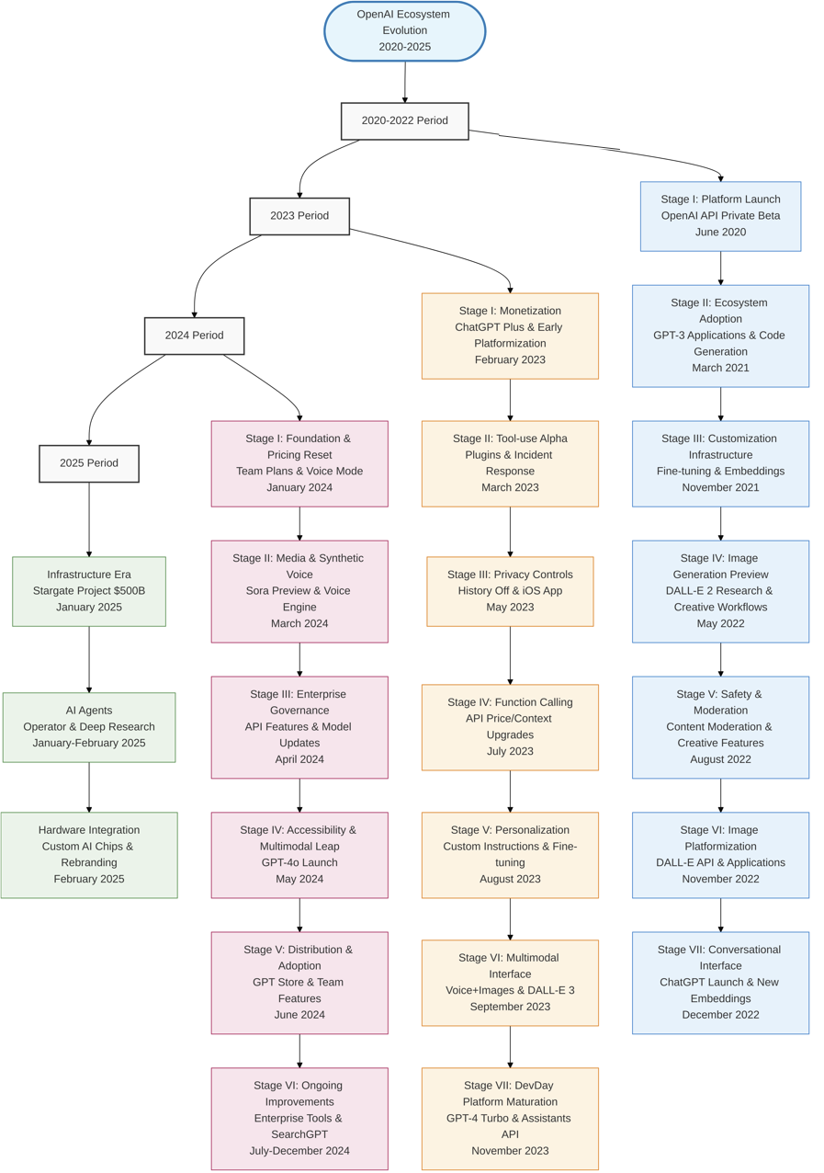

Appendix B. 24 Platform-Enabled Ventures Analyzed
# | Venture Name | Core Value Proposition | Industry | Primary Platform Tech | Founding/Integration Period | Venture Adoption Pattern
1. | Harvey AI | AI assistant for legal professionals, automating tasks like legal research, contract analysis, and due diligence. | Legal Tech | GPT-4, Fine-Tuning, Custom Models | 2022 | Deep Integration
2. | Copy.ai | AI-powered copywriter that generates marketing copy, blog posts, social media content, and emails. | Marketing Tech, Content Creation | GPT-3, GPT-4 | 2020 | Early Access Advantage
3. | Descript | All-in-one audio and video editing platform that allows editing via a text transcript, powered by AI features. | Creator Economy, Media Tech | Whisper, GPT models for summarization | 2017 (AI integration post-2020) | Feature Integration
4. | Mem | AI-powered self-organizing workspace and note-taking app that acts as a "second brain." | Productivity Software, SaaS | GPT-3, Embeddings | 2019 | Early Access Advantage
5. | Speak | AI-powered language learning application that provides real-time conversational practice and feedback. | EdTech, Language Learning | Whisper, GPT models | 2016 (AI integration post-2021) | Simultaneous Launch
6. | Duolingo (Max) | Language learning platform using GPT-4 for features like "Explain my Answer" and "Role Play." | EdTech, Language Learning | GPT-4 | 2011 (GPT-4 integration 2023) | Simultaneous Launch
7. | Khan Academy (Khanmigo) | Educational non-profit using GPT-4 as an AI-powered tutor and teaching assistant. | EdTech, Non-Profit | GPT-4 | 2008 (GPT-4 integration 2023) | Simultaneous Launch
8. | Stripe | Financial infrastructure company using GPT-4 to enhance user support, parse documentation, and combat fraud. | FinTech | GPT-4 | 2010 (GPT-4 integration 2023) | Feature Integration
9. | Morgan Stanley | Wealth management firm using a custom GPT-4 model to access and synthesize its vast internal knowledge base for financial advisors. | FinTech, Wealth Management | GPT-4, Custom Models | 1935 (GPT-4 integration 2023) | Deep Integration
10. | Be My Eyes | Mobile app connecting blind and low-vision individuals with volunteers and an AI visual assistant powered by GPT-4. | Accessibility Tech, Social Impact | GPT-4 (Vision) | 2015 (GPT-4 integration 2023) | Simultaneous Launch
11. | Viable | AI analytics platform that aggregates and analyzes qualitative customer feedback using fine-tuned models. | Data Analytics, SaaS | GPT-3, GPT-4, Fine-Tuning | 2020 | Early Access Advantage
12. | Elicit | AI research assistant that automates literature reviews by finding relevant papers and summarizing key findings. | Research Tech, EdTech | GPT-3 | 2021 | Early Access Advantage
13. | Replit (Ghostwriter) | Browser-based IDE with an AI-powered coding assistant for code generation, explanation, and debugging. | Developer Tools, Cloud IDE | Codex, GPT models | 2016 (AI integration post-2021) | Feature Integration
14. | Warp | Modern terminal with an integrated AI assistant for command search, debugging, and workflow automation. | Developer Tools | Codex, GPT models | 2020 | Feature Integration
15. | Shutterstock | Stock media provider integrating DALL-E to allow users to generate custom images on its platform. | Media, Creator Economy | DALL-E 2, DALL-E 3 | 2003 (DALL-E integration 2022) | Feature Integration
16. | Salesforce (Einstein GPT) | CRM platform integrating OpenAI models into its products, including Slack, for summarization and content generation. | Enterprise Software, CRM | GPT-3.5, GPT-4 | 1999 (AI integration 2023) | Deep Integration
17. | Keeper Tax | Financial app for freelancers that uses AI to identify tax-deductible expenses from bank statements. | FinTech, Tax Software | GPT-3 | 2017 | Early Access Advantage
18. | Algolia | Search-as-a-service provider using GPT models to power semantic search and natural language query understanding. | Enterprise Search, SaaS | GPT-3 | 2012 (AI integration 2021) | Deep Integration
19. | Notion (AI) | All-in-one workspace platform that integrated AI features for writing, summarizing, and brainstorming. | Productivity Software, SaaS | GPT-3, GPT-4 | 2016 (AI integration 2023) | Feature Integration
20. | Consensus | AI-powered search engine for scientific research that extracts and synthesizes findings from academic papers. | Research Tech, Search | GPT-4 | 2022 | Deep Integration
21. | Klarna | Global payments and shopping service using OpenAI models to power its AI assistant for customer service. | FinTech, E-commerce | GPT-4, Assistants API | 2005 (AI integration 2023) | Deep Integration
22. | Casetext | AI legal research technology that uses LLMs to help lawyers find relevant authorities faster. | Legal Tech | GPT-4 | 2013 | Deep Integration
23. | Nabla (Copilot) | Digital health startup using AI to turn patient conversations into clinical documentation. | Health Tech | GPT-3 | 2018 | Deep Integration
24. | Atlassian | Enterprise software company integrating OpenAI models into products like Jira for intelligent filtering and Confluence for automated definitions. | Enterprise Software, Collaboration | GPT-4 | 2002 (AI integration 2023) | Feature Integration

Appendix C – Descriptive Quantitative Data
Graph 1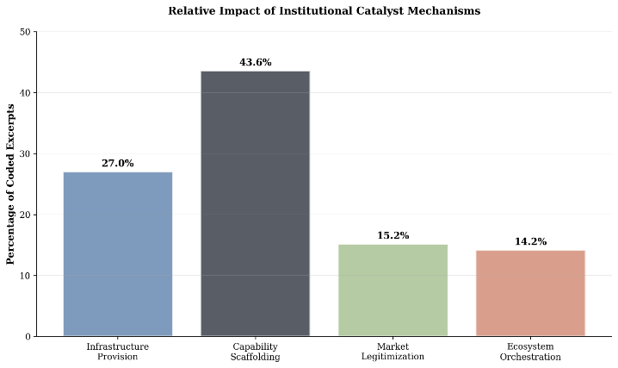 | Graph 2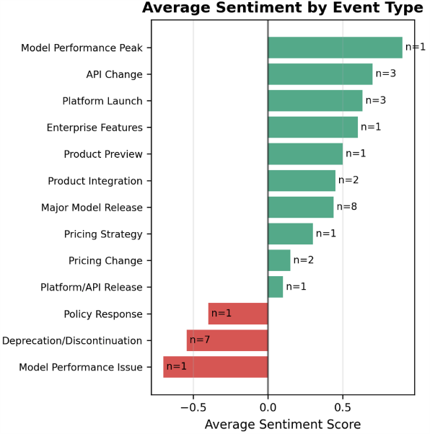
Graph 3
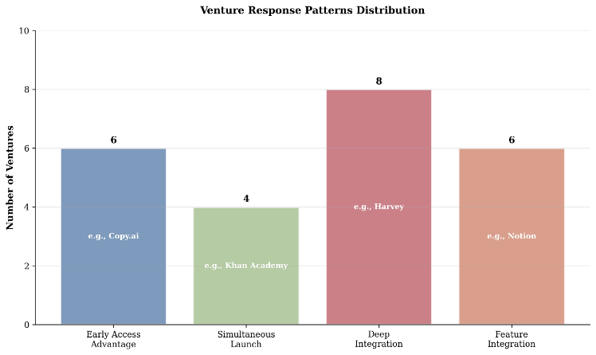

Self-attention helps the model focus on the most relevant parts of the input for each word, creating a better, context-aware understanding.
APIs (Application Programming Interfaces) enable software systems to talk to each other and share resources.
SDKs (Software Development Kits) provide developers the tools to build complementary platform offerings.
Software deprecation is when a feature is marked as outdated, but still usable for the moment, and scheduled to be removed in the future.
By an abstraction layer, we mean a stable, venture-owned interface that standardizes how core functions (e.g., generation, retrieval, moderation) are invoked and logged while translating to multiple platform APIs. This architectural decoupling reduces switching costs, enables selective multihoming, and buffers the venture from governance or pricing shocks at the provider level.

