Assessing the spatial burden in healthcare accessibility of low-income families in Rural Northeast Brazil
Highlights:
- Rural Northeast Brazil presents concerning rates of several health indicators
- Low-income households in that area can be located by proxies that are already known
- 53% of them are farther than 5km from the nearest Primary care centre
- Over 60% are farther than 10km from the closest Hospital or Emergency care unit

Abstract
Introduction
This paper explores the spatial burden in healthcare accessibility of low-income families in rural Northeast Brazil. The Northeast region accounts alone for more than half (63%) of the population living in extreme poverty in Brazil and the majority of these people (57%) live in rural areas. To overcome the scarcity of geospatial data in such context, this study proposes an innovative proxy for tracking the location of the rural low-income households.
Methods
A dataset composed of the location of almost half a million cisterns provided by the Federal Government to low-income households of this region is evaluated in terms of accuracy and Euclidean distance to healthcare centres (Primary care, Emergency Care and Hospitals) by means of statistical and GIS tools.
Results
Evidence shows that such dataset, beyond having an inaccuracy of less than 105 meters, is also substantially representative. The findings on healthcare accessibility show that 53.5% of the rural low-income population in Northeast Brazil are living farther than 5km from the nearest Primary care centre and over 60% are at a distance greater than 10km from the closest higher complexity healthcare centre (Hospitals and Emergency care units).
Conclusions
These results emphasise that the majority of this rural low-income population, who mostly live in a walking world (Porter, 2002), experience an insurmountable spatial burden preventing them from accessing public health services. It is argued that the availability of geo-location of low-income households registered in Social Programs (like the Cisterns Program) would enable a significant step forward in the Brazilian Transport and Public health planning. This study not only calls attention to the major hurdle faced by low-income families in Northeast Brazil but also offers a direction to where and for whom new transport and health interventions are particularly needed in the Latin American context.

Resumo
Introdução
Este artigo explora a barreira espacial na acessibilidade de famílias de baixa renda aos serviços de saúde no Nordeste rural do Brasil. A região Nordeste representa sozinha mais da metade (63%) da população que vive em extrema pobreza no Brasil. Dessas, 57% reside em áreas rurais. Para superar a escassez de dados geoespaciais de tal contexto, este estudo propõe uma variável (proxy) inovadora para o rastreamento da localização das famílias rurais de baixa renda.
Métodos
Um conjunto de dados composto pela localização de 493.659 cisternas fornecidos pelo Governo Federal a domicílios de baixa renda dessa região é avaliado em termos de sua precisão e distância Euclidiana a centros de saúde (Atenção Primária, Atendimento de Emergência e Hospitais) por meio de ferramentas estatísticas e de SIG.
Resultados
As evidências mostraram que essa base de dados, além de possuir uma imprecisão de menos de 105 metros, também é substancialmente representativa. Os achados sobre acessibilidade aos serviços de saúde mostram que 53,5% da população rural de baixa renda do Nordeste do Brasil vive a mais de 5 km da unidade de atenção primária mais próxima. Além disso, acima de 60% da população vive a uma distância superior a 10 km do centro de atendimento de saúde de maior complexidade (hospitais e unidades de atendimento de emergência).
Conclusões
Esses resultados enfatizam que a maioria da população rural de baixa renda, que vive principalmente em um “mundo caminhável” (Porter, 2002), experiencia uma severa barreira espacial que impede o acesso aos serviços públicos de saúde. Argumenta-se que a disponibilidade da localização (latitude e longitude) das famílias de baixa renda cadastradas em Programas Sociais (como o Programa Cisternas) possibilitaria um avanço significativo no planejamento brasileiro de Transportes e de Saúde Pública. Este estudo não só chama a atenção para o grande obstáculo enfrentado pelas famílias de baixa renda no Nordeste do Brasil, mas também oferece uma direção para onde e para quem novas intervenções de transporte e saúde são particularmente necessárias no contexto latino-americano.

Resumen
Introducción
Este artículo explora la barrera espacial sobre la accesibilidad de las familias de bajos ingresos a los servicios de salud en las zonas rurales del noreste de Brasil. Solo la region nordeste del país concentra más de la mitad (63%) de la población que vive en pobreza extrema en Brasil. De estos, el 57% reside en zonas rurales. Para superar la escasez de datos geoespaciales en este contexto, este estudio propone una variable (proxy) innovadora para rastrear la ubicación de las familias rurales de bajos ingresos.
Métodos
Un conjunto de datos compuesto por la ubicación de 493,659 cisternas instaladas por el Gobierno Federal en hogares de bajos ingresos en esta región se evalúa en términos de distancia y precisión Euclidianas a los centros de salud (Atención primaria, Atención de emergencia y Hospitales) mediante herramientas estadísticas y de SIG.
Resultados
La evidencia ha demostrado que esta base de datos, además de tener una imprecisión de menos de 105 metros, también es sustancialmente representativa. Los hallazgos sobre accesibilidad a los servicios de salud muestran que el 53.5% de la población rural de bajos ingresos en el noreste de Brasil vive a más de 5 km de la unidad de atención primaria más cercana. Además, más del 60% de la población vive a una distancia superior a 10 km del centro de atención en salud de mayor complejidad (hospitales y unidades de atención de emergencia).
Conclusiones
Estos resultados enfatizan que la mayoría de la población rural pobre, que vive principalmente en un "mundo caminante" (Porter, 2002), experimenta una barreira geo-espacial demasiada que impide el acceso a los servicios de salud pública. Se argumenta que la disponibilidad de ubicación (latitud / longitud) de las familias de bajos ingresos inscritas en programas sociales (como el programa Cisternas) haría un avance significativo en la planificación de transporte y salud pública de Brasil. Este estudio no solamente arroja luz sobre el gran obstáculo al que se enfrentan las familias de bajos ingresos en el noreste de Brasil, sino que también proporciona una orientación hacia dónde y para quién son más necesarias las nuevas intervenciones de transporte y salud en el contexto latinoamericano.

Keywords: Healthcare accessibility, Spatial analysis; Low-income; Northeast Brazil.

- Introduction
More than half (63%) of the population living in extreme poverty in Brazil, live in the Northeast region (IBGE, 2010). The majority of these people (57%) still live in rural areas (IBGE, 2010), creating the largest pocket of rural poverty in Latin America (Coirolo and Jill, 2008). The living conditions in this context are often worsened by many factors other than just lack of income. Studies addressing the multi-dimensional concept of poverty (Narayan et al., 2000; Alkire and Santos, 2014; Benevenuto and Caulfield, 2019) have shown that factors such as access to education, basic infrastructure, and healthcare have a direct influence on how people experience poverty.
The lengthy distances to healthcare centres have long been recognised as a major determinant of the use of health services (Shannon et al., 1969; Stock, 1983; Thaddeus and Maine, 1994; Adedini et al., 2014; Fluegge et al., 2018). Low spatial accessibility of healthcare exerts has a twofold burden, firstly by discouraging to seeking care, and secondly by being an actual impedance to reaching medical care once the decision to seek it has been made (Gabrysch and Campbell, 2009).
An increasing body of literature has been dedicated to evaluating spatial access to healthcare including methods based on minimum travel-distance (Apparicio et al., 2008), gravity models (Haynes et al., 2003), kernel-density estimation (Spencer and Angeles, 2007), and floating catchment areas (Luo and Wang, 2003). However, mostly due to a lack of accurate data, especially spatial data, quantitative research on this topic still falls short in the context of low-income and remote rural areas (Serajuddin, 2015).
As emphasised by Garcia-Subirats et al. (2014), very few quantitative studies exist examining access to healthcare in Latin America. Yet, a few notable exceptions dedicated to specific health outcomes have pointed to the same direction of the international studies mentioned above. Particularly in Northeast Brazil, de Souza et al. (2000) have shown that accessibility of biomedical care was reported by mothers as a determinant factor of delays in seeking professional care when their infants had potentially life-threatening symptoms. Likewise, other authors have also reported that the greatest impediments in the utilization of healthcare for the Brazilian rural population are related to difficulties of geographical access, either perceived by long journey times, lengthy distances or low availability of transport (Osorio et al., 2011; Travassos, 2006).
This topic has gained a lot of recent attention in Brazil due to the structural changes in the program “Mais Médicos” (More Doctors). Since 2013. This program has added 4,917 physicians, to work in remote and deprived areas of Brazil (Santos et al., 2017). Despite strong political and methodological criticism over such Program (CFM, 2018), evidence has shown improvements in the number of municipalities with more than 1 physician per 1,000 (from 163 to 348 municipalities) and in the coverage of primary care of municipalities which have enrolled to this program (from 77.9% to 86.3%) (Santos et al., 2017). Moreover, Fontes et al. (2018) have also pointed out a significant reduction in hospital admissions in municipalities included in the program. However, there is still no evidence published to date (to the authors' knowledge) showing neither the health outcomes associated with such initiative nor its impact upon the spatial accessibility of health services in rural and deprived areas. The scarcity of spatially disaggregated data in regions like Northeast Brazil is once again one of the major barriers to address urgent questions like these.
This study proposes a novel strategy to measure the spatial burden that is potentially preventing the low-income population in rural Northeast Brazil from accessing healthcare services. Whilst much has been written on the transport and health dialogue of more economically vibrant and data-rich contexts, the present paper contributes to the literature by i) assessing healthcare accessibility in an often-overlooked region ii) proposing an innovative proxy for a quantitative accessibility evaluation of the rural Northeast Brazil iii) shedding light on the transport issues that undermine public health in rural low-income contexts iv) devising practical policy recommendations to address the concerning health outcomes of the case study region.
Combining the healthcare centres’ locations with a proxy for the low-income households’ location, the present paper proposes a quantitative assessment of this ever more concerning issue. The distances between households facing income poverty and healthcare centres are calculated by means of GIS tools and then described spatially and statistically. We conclude by highlighting some policy recommendations drawn upon our findings, and by identifying the gaps that still need to be further studied in this field.

- Public health challenges in Rural Northeast Brazil
Despite the investment in public policies and the creation of the Brazil's publicly funded healthcare system (SUS) in 1988, which follows a guiding principle of equity, regional and socio-economic disparities are still prevalent in the overall health outcomes in Brazil (Szwarcwald et al., 2016; Rasella et al., 2013; Barros et al., 2011). Evidence shows that the North and Northeast regions, which have the lowest average income (IBGE, 2010), have historically presented the most unsatisfactory rates of several health indicators that are usually associated with limited accessibility of Health Services (Albuquerque, 2017; Szwarcwald et al., 2016; Victoria et al., 2011). These concerning trends are hereafter represented and further considered by two specific indicators, namely, life expectancy at birth, and Mortality in children younger than 5 years (i.e. under-5 mortality).
Life expectancy is particularly suitable indicator to measure the impact of healthcare accessibility since it summarizes the social, health, and general well-being conditions of a population by considering mortality rates in their different age groups. All causes of death are contemplated when estimating such indicator, including diseases and external causes, such as violence and accidents (UNDP et al., 2010). Likewise, Under-5 Mortality is an internationally applied indicator also widely used to evaluate coverage and adequate access to healthcare (Walker, 2013; Gabrysch and Campbell, 2009). This is due to the fact that some of the main strategies to reduce its occurrence (i.e. timely treatment, immunization, and skilled care during pregnancy and childbirth) (WHO, 2015) depend on the services mostly or sometimes only provided at healthcare centres.
The Human Development Atlas in Brazil (UNDP et al., 2010) reports that the levels of Life Expectancy are consistently lower in the North-eastern states of Brazil, whereas the Under-5 mortality is substantially higher for the same states. These differences are depicted in Figure 1 to highlight the spatial pattern of such figures.
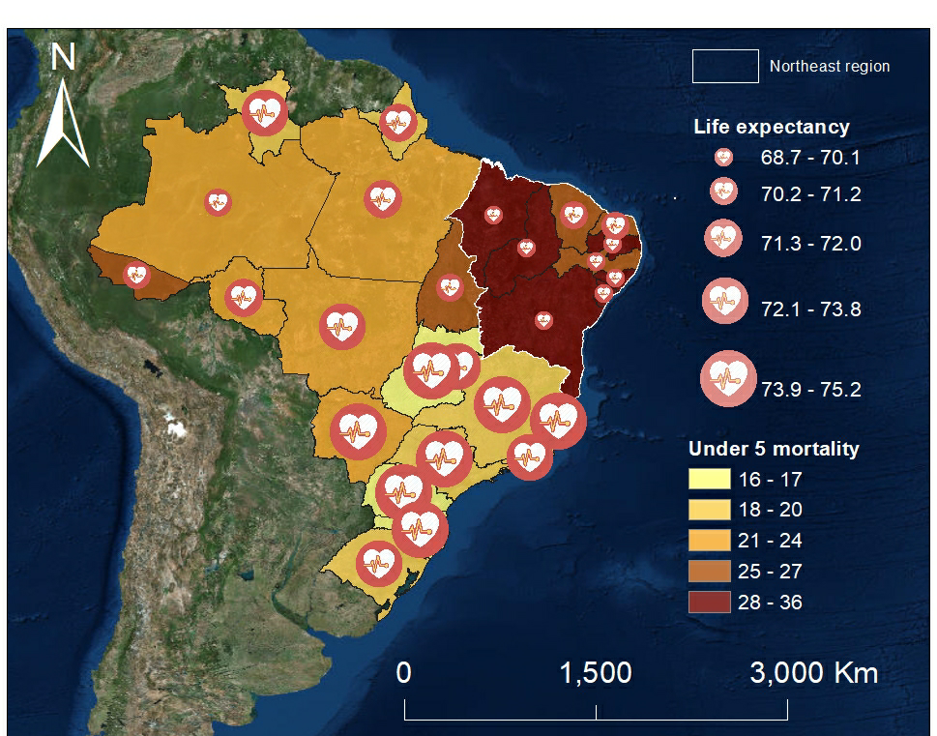
Figure 1: Vital statistics in Brazilian states. i) Life Expectancy [years] in the colour scale and ii) Under 5 mortality [per 1000 live births] in the symbol scale
The health indicators applied in this study can be found in more recent datasets (IBGE, 2013). As the present study builds on data from the latest Census in 2010 (IBGE, 2010) to keep temporal consistency among variables older health indicators are used. Perhaps the most concerning limitation of the Brazilian health Database (DATASUS) is that, despite the thorough disaggregation level in terms of socio-economic, demographic and health variables, such database falls short in the spatial disaggregation aspect.
Currently, there is no disaggregation publicly available of such datasets for urban/rural areas at a municipality level, or by areas smaller than a municipality (i.e. electoral division, census sector, etc). In that sense, location-based comparisons and correlations of health indicators become limited to the few health indicators included in the Brazilian Census, which is also timewise limited (once every 10 years) and only disaggregated by location (urban/rural) at the state level.
Nevertheless, when comparing such state-wise health indicators by location it is possible to spot major disparities between urban and rural areas in the North Eastern states. Figures 2 and 3 show the difference in Life Expectancy might be up to 3.4 years lower in rural areas compared to urban areas of a same state (e.g. Sergipe state). Similarly, the number of Under 5 mortality (per 1,000 live births) is up to 44% higher in rural areas compared to the urban figure of the same state (also Sergipe).
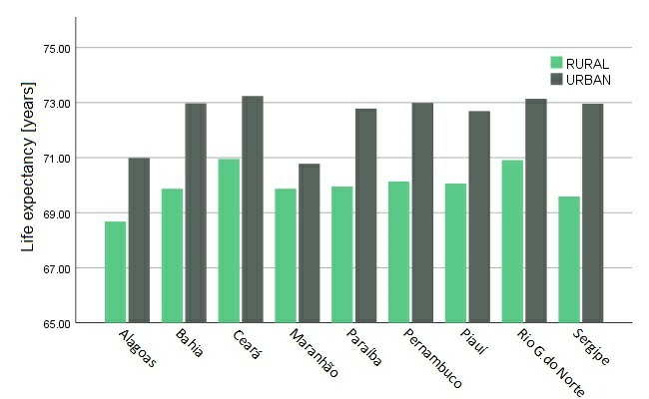
Figure 2: Life expectancy [years] of states in Northeast Brazil comparing urban and rural rates

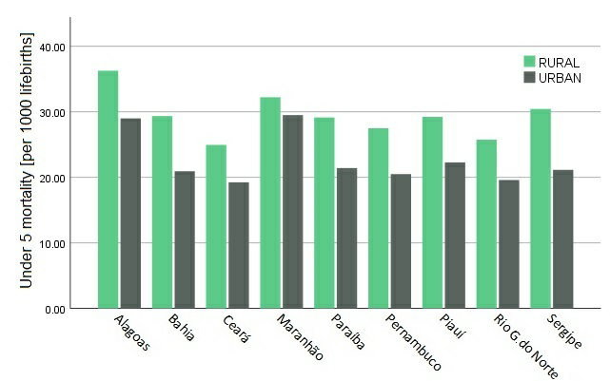
Figure 3: Under 5 mortality [per 1000 live births] of states in Northeast Brazil states comparing urban and rural rates
When the municipalities’ statistics are analysed in groups of similar Share of Rural Population and Average income of Municipality other clear trends emerge. As expected, the location and income differences appear to reflect the performance of the assessed health indicators, following trends previously described in similar studies (Szwarcwald et al., 2016; Rasella et al., 2013; Victoria et al. 2011). More interestingly, what stands out in Figure 4 and 5 is that the differences in Life Expectancy and Under 5 mortality are much more exacerbated by the rurality levels in lower average income municipalities (first, second and third quintile) than the affluent ones.
While Life Expectancy in the richest quintile is virtually not affected by the share of rural population, people living in highly urbanised municipalities of the second poorest quintile live on average 3 years more than those from municipalities with higher rurality levels from the same income quintile. Similarly, Figure 4 and 5 indicate that, in the second quintile of Average Income, the Under-5 mortality is 44% higher in municipalities with a greater share of rural population² than the more urbanised ones¹.
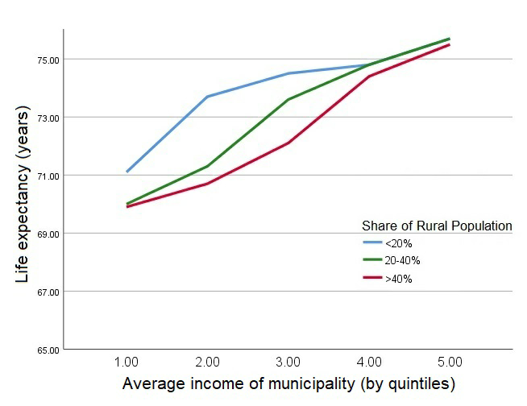
Figure 4: Life expectancy [in years] stratified by quintiles of average income and clustered by share of the rural population

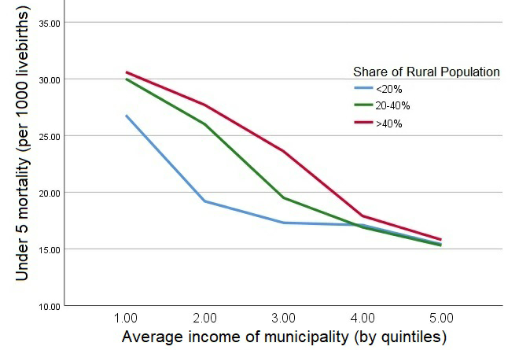
Figure 5: Under 5 mortality [per 1,000 livebirths] stratified by quintiles of average income and clustered by share of the rural population
Thus far, this section has attempted to provide a brief summary of the health challenges particularly affecting rural low-income families of Northeast Brazil. The next session will describe a method for evaluating a spatial barrier that is potentially preventing them from accessing health services.

- Accessibility of healthcare services at a household level
3.1 Households in extreme poverty
Datasets showing the precise coordinates of households living in extreme poverty are rarely publicly available. Either for being considered sensitive information or simply due to the absence of such spatial data, these coordinates have been substantially underexplored in quantitative accessibility evaluations. This study proposes an innovative variable as a proxy for mapping these households in order to investigate their accessibility patterns and devise some transport and health policy recommendations.
Due to the very dry climate and a constant lack of water resources in Northeast Brazil, the Brazilian Federal Government launched in 2003 the project P1MC (Programme for 1 Million Cisterns). This project aims to deliver 1 million water tanks (cisterns) to families considered to be living below the poverty line in the semi-arid region of Northeast Brazil (ASA, 2018). Since the extent of such climate and economic underdevelopment pattern also covers the north part of the immediate region below (Southeast), the Brazilian Federal Government has also incorporated these municipalities within the scope of such programme. Figure 6 represents an aerial and a front view of a typical cistern provided by this project. It is also worth mentioning that not all low-income households in this region have been beneficiaries of such program.
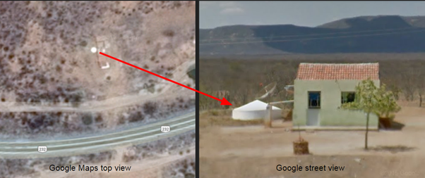
Figure 6: Typical cistern and low-income household in Rural Northeast Brazil
A dataset composed of 493,659 locations (Latitude and Longitude) of such cisterns has been provided by the Brazilian Semi-Arid Articulation (ASA) in cooperation with the Superintendency for the Development of the Northeast Brazil (SUDENE) for the present academic purpose. Each cistern is usually located a few meters from at least one low-income household registered in the social programmes of the Federal Government. Therefore, it is argued that this dataset might represent the most accurate and representative proxy to track the location of rural low-income households in rural Northeast Brazil. Figure 7 presents such points plotted over the Semi-arid region of Northeast Brazil.
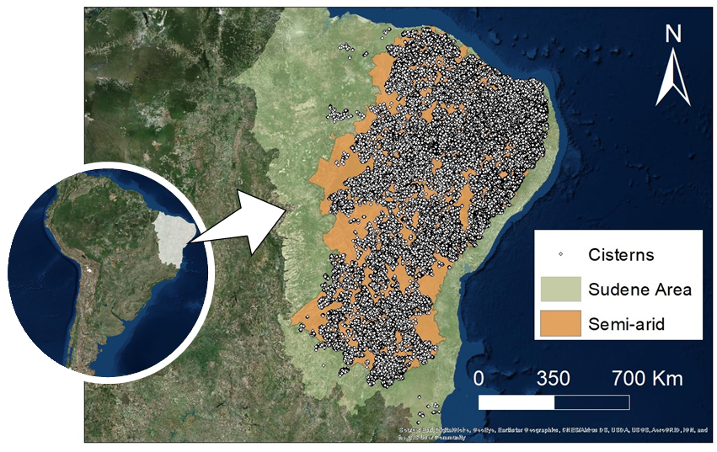
Figure 7: Spatial distribution of cisterns in Northeast Brazil

The cistern location dataset is the result of an effort of ASA in compiling a number of smaller datasets containing the cisterns’ locations of different sub-regions in Northeast Brazil. Since the cisterns of each of these sub-regions have been mapped by different governmental agencies for different purposes using a few different coordinate systems, the complete location dataset compiled by ASA has never been used before. In that sense, an accuracy checking of such complete dataset is then proposed.
Considering that these cisterns present a very regular pattern of elements for image interpretation, a geospatial object-based-image analysis (Blaschke, 2010) has been conducted to perform a systematic scanning of the plotting accuracy. According to Lillesand et al. (2014), the fundamental elements of image interpretation can be described as follows:
- Shape: general form, configuration or outline of the object (e.g. regular circle);
- Size: must be considered in the context of the image scale (e.g. 4 meters of diameter in a 1:1000 scale);
- Pattern: relate to the spatial arrangement of the object (e.g surrounded by at least one house);
- Tone: refers to the relative brightness or colour of the object (e.g. opaque whitish);
- Texture: is the frequency of tonal change on an image (e.g. regular smooth)
Since the satellite imagery datasets that are publicly available for this region present a spatial resolution of 10 meters or higher, and the cistern diameter is around 4 meters, the object-based-image analysis had to be done manually using the world imagery base map layer available in ArcMap 16.1. In this sense, to determine the accuracy of such plotting, the distances between the plotted coordinates and the closest visible cistern (that met all the image interpretation criteria) were individually measured for a sample of 384 points (randomly selected). The traditional sampling formula proposed by Krejcie and Morgan (1970) has been used to calculate a representative sample size for such dataset:
$$n=\frac{N∙p∙(1-p)∙(Z_{\frac{α}{2}})}{p∙\left(1-p\right)∙\left(Z_{\frac{α}{2}}\right)+(N-1)∙E^{2}}$$
Where:
- $n$ is the sample size to be estimated (384 points)
- $N$ is the population size (493,659 for this case)
- $Z_{\frac{α}{2}}$ is the critical value that corresponds to the desirable confidence degree (in this case 1,96 for a confidence degree of 95%, assuming a normal distribution)
- $p$ is the likelihood of the expected event (assumed as 50% when unknown)
- $E$ is the adopted error margin (± 5% for this case)

3.2 Healthcare centres
The geodata applied to this study has been provided by the Brazilian Ministry of Health, which comprehends the location of four different types of healthcare centres (Ministério da Saúde, 2018):
- Primary care:
  - Basic care unit (UBS) - 40,612 points. The UBS is the main place where interdisciplinary primary care professionals actuate for a defined population in a geographically determined area. It is preferably the first contact of the patient in the healthcare network.
  - Family health support nucleus (NASF) - 4,417 points. The NASF were created in 2008 by the Brazilian Ministry of Health, with the intention to expand the scope and spectrum of care actions on the primary care and to increase its resolution. So, the professional team will always depend on local health needs.
- Hospitals and emergency care:
  - Emergency care unit (UPA) - 425 points. The UPA is part of the Emergency Care Network. Its objective is to concentrate the healthcare of intermediate complexity, forming a network organized in conjunction with basic attention and hospital attention, decreasing queuing in hospital emergency rooms, as well as increasing the service capacity of the SUS. As they are also a recent government initiative, there are only 425 of such units, which represent only 12.4% of the total non-primary care analysed.
  - Hospitals - 3,406 points. Centres of a wide range of medium and high complexity healthcare services.
3.3 Spatial burden estimate
Accessibility-related studies commonly use GIS tools to estimate service areas based on driving/cycling/walking distances or time from an origin, for example a household, or neighbourhood, to the closest opportunity/facility, such as schools, hospitals, or even job opportunities (Pereira, 2018; Guagliardo, 2004). Yet, the accuracy level of such estimates deeply relies on the quality of the transport network datasets.
In contrast, Rural Northeast Brazil is predominantly covered by non-paved secondary and tertiary roads and footpaths that are in many cases not mapped neither by the Government authority nor even by large mapping platforms (HERE maps®, Google maps®, and OpenStreetMap®). Figure 8 depicts the discrepancies between the catchment areas using Driving distance (estimated by ArcGIS online) and Euclidean radius methods (buffers) from small towns in Pernambuco state in Northeast Brazil.
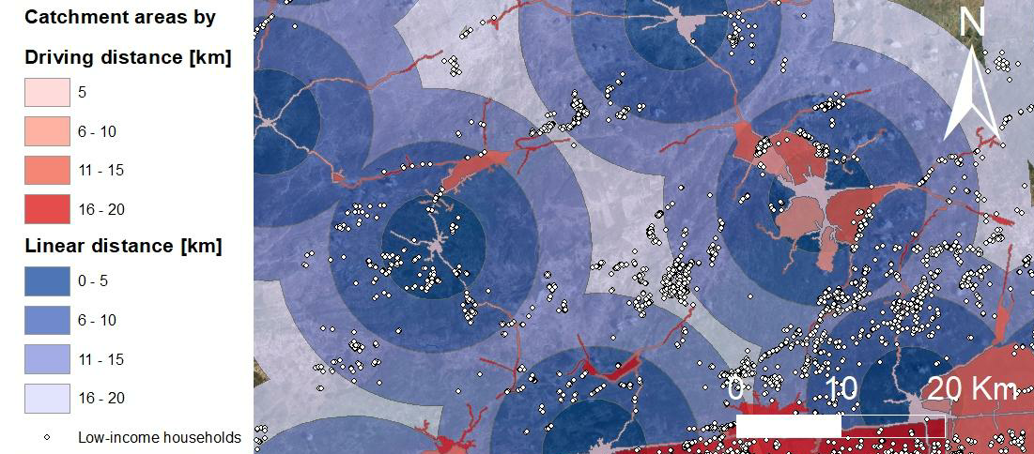
Figure 8: Comparison of catchment areas by Euclidean radius and Driving distance around the municipalities of Brejo de Madre de Deus and Poção in Northeast Brazil (Source: Benevenuto et al., 2018)

Figure 8 shows that many roads which connect low-income households to urban centres and healthcare centres are not mapped yet, which creates several gaps in the service areas estimated by driving distance (reddish scale). Moreover, if only the areas where transport-related data is available were selected to be assessed, a significant caveat would be introduced in the analysis as such areas are generally more urbanised and economically vibrant. Therefore, in order to include also areas that have been persistently overlooked in the academic literature (perhaps, precisely for not having accurate and timely transport-related data), a simpler travel impedance method had to be applied.
Tanser et al. (2006) argue that conventional models using network analysis are not appropriate for areas where people mostly walk to the nearest service, and public transport is unregulated and its coverage is temporal and can be spatially sporadic. Therefore, following other studies of healthcare accessibility in similar contexts of the Global South (Francis et al., 2009; Tanser et al., 2006; Noor et al., 2003; Tanser et al., 2001), the present methodology applies the Euclidean method to provide a comprehensive and consistent spatial distance evaluation.
Even though this method does not include extra distances caused by natural barriers (rivers, cliffs, etc) and road curvatures, it allows keeping consistency among all regions despite the gaps of the mapped transport network. As it can be seen in Figure 8, any estimate of travel impedance estimate based on such road network dataset would be inconsistent since many non-paved roads and footpaths connecting many low-income households (white dots) are not mapped yet.

- RESULTS AND DISCUSSION
4.1 Cisterns as a proxy for low-income households
The geospatial object-based-image analysis performed with the 384 cisterns’ locations has shown that these points are on average 104.83 meters away from the real cistern observed on the satellite view. Figure 9 shows the descriptive statistics and a frequency distribution graph of such plotting imprecisions, highlighting that 81.4% of the cases have an inaccuracy of less than 200 meters. Only for 0.8% of the cases (8 points), no cistern was identified in a search radius of 3,000 meters - which is still in accordance to the error margin of 5% expected from such sample size.
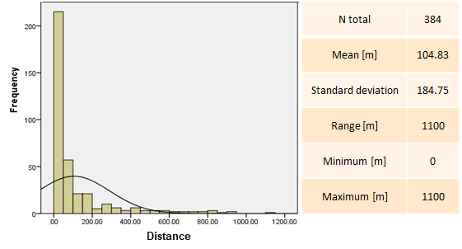
Figure 9: Descriptive statistics of the cistern plotting accuracy
It is safe then to state that this cisterns’ locations dataset offers a good proxy for the rural low-income households in Northeast Brazil. This dataset represents an accurate and representative collection of information that can be utilised for better understanding of the spatial burden faced by low-income families in such region.
In terms of spatial analysis, it is important to remark, though, that comparisons between municipalities are only possible between those with mapped cisterns. In other words, municipalities with no cisterns or with cisterns that were not mapped yet could be misrepresented by this proxy when comparing regions or establishing rankings of prioritisation. Therefore, the following analysis primarily focuses on describing statistically the limited accessibility patterns of such households, rather than creating a regional index of accessibility based on such proxy. In the following items, some of the accessibility patterns of such households were described.

4.2 Access to healthcare centres
The distances from the 493,659 low-income households to the nearest Euclidean healthcare centre were calculated for both types of healthcare units. A summary of the findings related to access to health services are presented in Figure 10.
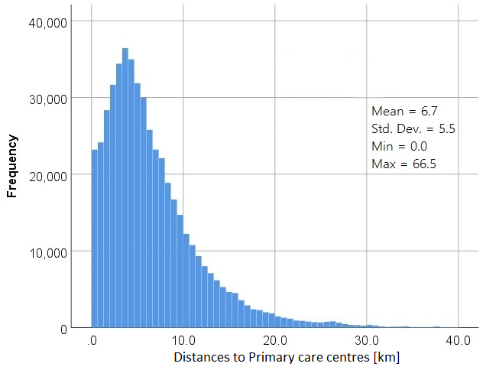
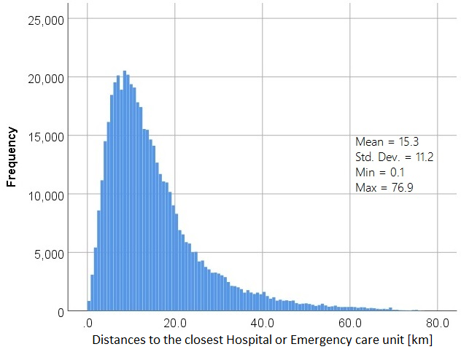
Figure 10: Frequency distribution of households by distance to healthcare centre
When the closest healthcare facility is evaluated, considering both hospitals, emergency and primary care units, 96.508 rural low-income households (approximately 20% of the sample) appear to be located farther than 10 km in Euclidean distance from any healthcare centre. Considering that people in extreme poverty mostly live in a walking world (Porter, 2002), and that Euclidean measurements are often underestimated, it is argued that people living under such spatial burden are virtually excluded from the public healthcare system and require urgent action from policymakers.
Previous studies assessing the spatial accessibility of health services by Euclidean distances have applied threshold distances of up to 5 km for Primary care and 25 km for Hospitals and emergency care to define remoteness from health services (Bell et al., 2012; Jordan et al. 2004). Figure 11 summarises the distribution of the assessed households in 5 different strata of remoteness from health services.
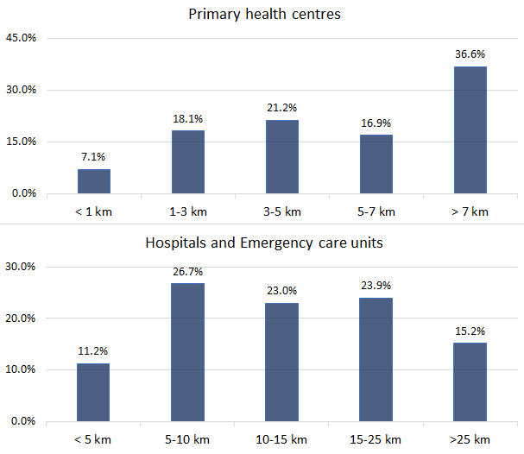
Figure 11: Distribution of distances by remoteness from health services thresholds
Since the proposed proxy is not evenly distributed among the Northeastern municipalities, any quantitative correlation between the average spatial burden of the municipalities and their respective health indicators could mislead to biased interpretations of the data. That said, on the other hand, it is undeniable that at a macro level such lengthy distances separating low-income families to health services contribute directly to the poor health indicators.
Neutens et al. (2014) argue that there is convincing evidence showing that spatial barriers between patients and health services providers contribute to lower healthcare utilization, which entails a limited uptake of preventive services and eventually give rise to poorer health outcomes. Particularly in the Northeast Brazil context, Macinko et al. (2007) have reported evidence supporting the hypothesis that higher physician supply is associated with lower infant mortality. Macinko et al. (2007) also state that the real vital statistics from deprived rural areas (for instance the ones shown in section 2) are likely to be even worse than what it is measured since there is evidence of undercounting of child mortality in such places.
The implemented public policies and investments in primary healthcare, including the Mais Médicos program, that were carried out in recent years have contributed to improving the living conditions of the population located at remote and deprived regions of Northeast Brazil (Silva et al., 2018). However, in the semi-arid region, which is at the heart of Northeast Brazil, and where rurality and poverty levels are higher, doctors and healthcare infrastructure remain still scarce (Nogueira et al., 2016). This lack of biomedical professionals in such areas is also evident in the study Demografia Médica no Brasil, conducted in 2018 (Scheffer et al., 2018), which shows that there are 8.4 times more doctors per 1,000 people in the North Eastern capitals than in the secondary and tertiary municipalities.
It is argued that the simple location (latitude/longitude) collection of the low-income households registered in Social Programs (like P1MC) would enable a significant step forward in the Brazilian Transport and Public health planning. While this spatial data remains unavailable, the presented dataset acts as an accurate and statistically significant (nearly half a million households) proxy for representing the quantitative accessibility patterns of families living under such conditions.
Although the proposed proxied dataset is still of limited use for ranking priority areas, Figure 12 is an attempt to highlight areas with a higher concentration of rural low-income households (mapped by the cisterns) located farther than 10 km from any healthcare centre.
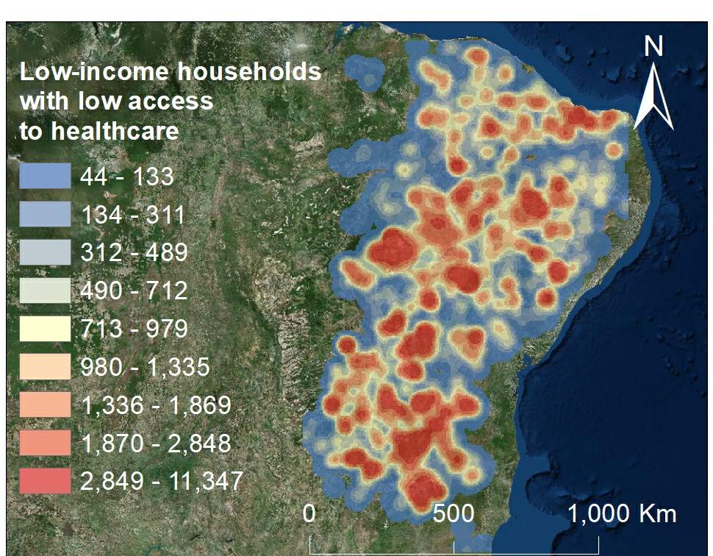
Figure 12: Concentration of low-income households (proxied by cisterns) located farther than 10 km from any healthcare centre

- Conclusion
The present study was designed to explore the spatial burden in healthcare accessibility of low-income families in namely, the cisterns’ locations. There is enough evidence to support the use of such dataset as a proxy for the rural low-income households’ location of this region since its inaccuracy less than 105 meters and the sample size is substantially representative (493,659 households). Considering that each cistern supplies water for an average of 5 people (Assis, 2012), it is estimated that such location dataset may represent the location of nearly 2.5 million people living in extreme poverty in Northeast Brazil.
However, it is important to remark that some municipalities do not present any mapped cistern within its perimeter. In that sense, we maintain that this dataset should be mainly used for drawing statistical analysis, rather than geospatial rankings and density evaluations. In other words, the absence of mapped cisterns in some municipalities should not be taken as an indicator of the absence of low-income households.
Thus, although it is possible to spot some priority areas that are in most risk of been prevented from health services due to the spatial burden (as shown in Figure 12), further research still needs to develop indicators applicable to all municipalities of this region. More accurate and disaggregated results will also require a comprehensive mapping of the transport network, as well as the full geocodification of addresses of the families registered in the Federal Social Programs, like P1MC.
The findings show that 53.5% of the rural low-income population in Northeast Brazil are living farther than 5km from the nearest Primary care centre and over 60% are at a distance greater than 10km from the closest centre of higher complexity care services (Hospitals and Emergency care units). These results emphasise that the majority of this rural low-income population, who mostly live in a walking world (Porter, 2002), experience an insurmountable spatial burden preventing them from accessing public health services.
Overall, this study strengthens the idea that it is necessary to create multidisciplinary teams to devise strategies as well as creative and lasting solutions to address the barriers of transportation, social disparities and access to health. Future research is needed to further investigate the impacts of transport infrastructure investments and accessibility improvements on health outcomes of remote and deprived areas such as Rural Northeast Brazil. The limitation of both, spatial data and health data at a municipality and rural/urban level, are likely to be additional challenges in this work. Thus, it is recommended the use of innovative proxies (like cisterns’ locations) as auxiliary tools for public policy planning and decision making.

- References
Adedini, S.A., Odimegwu, C., Bamiwuye, O., Fadeyibi, O. and Wet, N.D., 2014. Barriers to accessing healthcare in Nigeria: implications for child survival. Global health action, 7(1), p.23499.
Albuquerque, M.V.D., Viana, A.L.D.Á., Lima, L.D.D., Ferreira, M.P., Fusaro, E.R. and Iozzi, F.L., 2017. Desigualdades regionais na saúde: mudanças observadas no Brasil de 2000 a 2016. Ciência & Saúde Coletiva, 22, pp.1055-1064.
Alkire, S. and Santos M. E., 2014. Measuring Accurate Poverty in the Developing World: Robustness and Scope of the Multidimensional Poverty Index. World Development Vol. 59, 251-274. DOI: 10.1016/j.worlddev. 2014.01.026
Apparicio, P., Abdelmajid, M., Riva, M. and Shearmur, R., 2008. Comparing alternative approaches to measuring the geographical accessibility of urban health services: Distance types and aggregation-error issues. International journal of health geographics, 7(1), p.7.
Articulação do Semiárido Brasileiro (ASA), 2018. Programa 1 milhão de cisterna, retrieved from http://www.asabrasil.org.br/acoes/p1mc
Assis, T. R. P., 2012. Sociedade civil e a construção de políticas públicas na região semiárida brasileira: o caso do programa um milhão de cisternas rurais (P1MC). Revista de Políticas Públicas, 16(1).
Barros, M.B.D.A., Francisco, P.M.S.B., Zanchetta, L.M. and César, C.L.G., 2011. Trends in social and demographic inequalities in the prevalence of chronic diseases in Brazil. PNAD: 2003-2008. Ciencia & saude coletiva, 16(9), pp.3755-3768.
Bell, S., Wilson, K., Shah, T.I., Gersher, S. and Elliott, T., 2012. Investigating impacts of positional error on potential healthcare accessibility. Spatial and spatio-temporal epidemiology, 3(1), pp.17-29.
Benevenuto, R. and Caulfield, B., 2019. Poverty and transport in the global south: An overview. Transport Policy, 79, pp.115-124. DOI: 10.1016/j.tranpol.2019.04.018
Benevenuto, R., Fernandez Jr., F. Caulfield, B., 2018. From rural poverty to urban amenities - Assessing the risk of accessibility poverty in rural Northeast Brazil. In European Transport Conference papers 2018, Dublin, Ireland. Association for European Transport (AET). Available at https://aetransport.org/en-gb/past-etc-papers/conference-papers-2018?abstractId=5895& state=b
Blaschke, T., 2010. Object based image analysis for remote sensing. ISPRS journal of photogrammetry and remote sensing, 65(1), pp.2-16.
Coirolo, L.; Lammert, J., 2008. Rural Poverty Reduction in Northeast Brazil: Achieving Results through Community-Driven Development. en breve; No. 125. World Bank, Washington, DC. © World Bank. https://openknowledge. worldbank.org/handle/10986/10279 License: CC BY 3.0 IGO.
Conselho Federal de Medicina (CFM), 2018. Considerações sobre o programa mais médicos. Available at https://portal.cfm.org.br/images/PDF/ 2018_pesquisa_maismedicos.pdf
Datasus, 2010. Razao entre óbitos informados e estimados. Available at http://tabnet.datasus.gov.br/cgi/idb2011/a1802b.htm. Retrieved in 11/Dec/18.
de Souza, A.T., Peterson, K.E., Andrade, F.M.O., Gardner, J. and Ascherio, A., 2000. Circumstances of post-neonatal deaths in Ceara, Northeast Brazil: mothers’ health care-seeking behaviors during their infants’ fatal illness. Social science & medicine, 51(11), pp.1675-1693.
Fluegge, K., Malone, L.L., Nsereko, M., Okware, B., Wejse, C., Kisingo, H., Mupere, E., Boom, W.H. and Stein, C.M., 2018. Impact of geographic distance on appraisal delay for active TB treatment seeking in Uganda: a network analysis of the Kawempe Community Health Cohort Study. BMC public health, 18(1), p.798.
Fontes, L.F.C., Conceição, O.C. and Jacinto, P.D.A., 2018. Evaluating the impact of physicians' provision on primary healthcare: Evidence from Brazil's More Doctors Program. Health economics.
Francis, R.L., Lowe, T.J., Rayco, M.B. and Tamir, A., 2009. Aggregation error for location models: survey and analysis. Annals of Operations Research, 167(1), pp.171-208.
Gabrysch, S. and Campbell, O.M., 2009. Still too far to walk: literature review of the determinants of delivery service use. BMC pregnancy and childbirth, 9(1), p.34.
Garcia-Subirats, I., Vargas, I., Mogollón-Pérez, A.S., De Paepe, P., da Silva, M.R.F., Unger, J.P. and Vázquez, M.L., 2014. Barriers in access to health care in countries with different health systems. A cross-sectional study in municipalities of central Colombia and north-eastern Brazil. Social Science & Medicine, 106, pp.204-213.
Guagliardo, M.F., 2004. Spatial accessibility of primary care: concepts, methods and challenges. International journal of health geographics, 3(1), p.3.
Haynes, R., Lovett, A. and Sünnenberg, G., 2003. Potential accessibility, travel time, and consumer choice: geographical variations in general medical practice registrations in Eastern England. Environment and Planning A, 35(10), pp.1733-1750.
Instituto Brasileiro de Geografia e Estatística (IBGE), 2010. Censo Demográfico – 2010, retrieved from http://www.censo2010.ibge.gov.br in May 2018.
Instituto Brasileiro de Geografia e Estatística (IBGE), 2013. Projeção da população do Brasil por sexo e idade para o período 2000-2060; Projeção da população das Unidades da Federação por sexo e idade 2000-2030. Rio de Janeiro Disponível em: <http://www.ibge.gov.br/home/estatistica/populacao/ projecao_da_populacao/2013/default.shtm>.
Jordan, H., Roderick, P., Martin, D. and Barnett, S., 2004. Distance, rurality and the need for care: access to health services in South West England. International journal of health geographics, 3(1), p.21.
Krejcie, R.V. and Morgan, D.W., 1970. Determining sample size for research activities. Educational and psychological measurement, 30(3), pp.607-610.
Lillesand, T., Kiefer, R.W. and Chipman, J., 2014. Remote sensing and image interpretation. John Wiley & Sons.
Luo, W. and Wang, F., 2003. Measures of spatial accessibility to health care in a GIS environment: synthesis and a case study in the Chicago region. Environment and Planning B: Planning and Design, 30(6), pp.865-884.
Macinko, J., de Souza, M.D.F.M., Guanais, F.C. and da Silva Simoes, C.C., 2007. Going to scale with community-based primary care: an analysis of the family health program and infant mortality in Brazil, 1999–2004. Social science & medicine, 65(10), pp.2070-2080.
Ministério da Saúde, 2018. UPA e UBS. Sabe o que significam essas siglas? Retrieved from http://www.blog.saude.gov.br/servicos/33620-upa-e-ubs-sabe- o-que-significam-essas-siglas.html
Narayan, D., Patel, R., Schafft, K., Rademacher, A., Koch-Schulte, S., 2000. Voices of the poor Can anyone hear us? Oxford University Press for the World Bank.
Neutens, T., 2015. Accessibility, equity and health care: review and research directions for transport geographers. Journal of Transport Geography, 43, 14-27.
Nogueira, P.T.A., Bezerra, A.F.B., Leite, A.F.B., Carvalho, I.M.D.S., Gonçalves, R.F. and Brito-Silva, K.S.D., 2016. Características da distribuição de profissionais do Programa Mais Médicos nos estados do Nordeste, Brasil. Ciência & Saúde Coletiva, 21, pp.2889-2898.
Noor, A. M., Zurovac, D., Hay, S. I., Ochola, S. A., & Snow, R. W., 2003. Defining equity in physical access to clinical services using geographical information systems as part of malaria planning and monitoring in Kenya. Tropical Medicine and International Health, 8(10), 917–926. doi:10.1046/j.1365-3156.2003.01112.x
Osorio, R.G., Servo, L.M.S. and Piola, S.F., 2011. Necessidade de saúde insatisfeita no Brasil: uma investigação sobre a não procura de atendimento. Ciência & Saúde Coletiva, 16, pp.3741-3754.
Pereira, R. H. M., 2018. Ex-Ante Evaluation of the Accessibility Impacts of Transport Policy Scenarios: Equity and Sensitivity to Travel Time Thresholds for Bus Rapid Transit Expansion in Rio De Janeiro. Available at SSRN: https://ssrn.com/abstract=3147748 or http://dx.doi.org/10.2139/ ssrn.3147748
Porter, G., 2002. Living in a walking world: rural mobility and social equity issues in sub-Saharan Africa. World development, 30(2), pp.285-300.
Rasella, D., Aquino, R. and Barreto, M.L., 2013. Impact of income inequality on life expectancy in a highly unequal developing country: the case of Brazil. J Epidemiol Community Health, pp.jech-2012.
Santos, L. M. P., Oliveira, A., Trindade, J.S., Barreto, I.C., Palmeira, P.A., Comes, Y., Santos, F.O., Santos, W., Oliveira, J.P.A., Pessoa, V.M. and Shimizu, H.E., 2017. Implementation research: towards universal health coverage with more doctors in Brazil. Bulletin of the World Health Organization, 95(2), p.103.
Serajuddin, U., Uematsu, H., Wieser, C., Yoshida, N. and Dabalen, A., 2015. Data deprivation: another deprivation to end. The World Bank. Policy Research working paper; no. WPS 7252. Washington, D.C.: World Bank Group. http://documents.worldbank.org/curated/en/700611468172787967/Data-deprivation-another-deprivation-to-end
Shannon, G.W., Bashshur, R.L. and Metzner, C.A., 1969. The concept of distance as a factor in accessibility and utilization of health care. Medical Care Review, 26(2), pp.143-161.
Scheffer, M., Cassenote, A., Guilloux, A. G. A., Biancarelli, A., Miotto, B. A., & Mainardi, G. M., 2018. Demografia médica no Brasil 2018. Demografia Médica no Brasil 2018. São Paulo, SP: FMUSP, CFM, Cremesp, 2018. 286 p. ISBN: 978-85-87077-55-4.
Silva, E.N.D., Ramos, M.C., Santos, W., Rasella, D., Oliveira, A. and Santos, L.M.P., 2018. Cost of providing doctors in remote and vulnerable areas: Programa Mais Médicos in Brazil. Revista Panamericana de Salud Pública, 42, p.e11.
Spencer, J. and Angeles, G., 2007. Kernel density estimation as a technique for assessing availability of health services in Nicaragua. Health Services and Outcomes Research Methodology, 7(3-4), pp.145-157.
Stock, R., 1983. Distance and the utilization of health facilities in rural Nigeria. Social science & medicine, 17(9), pp.563-570.
Szwarcwald, C.L., de Souza Júnior, P.R.B., Marques, A.P., de Almeida, W.D.S. and Montilla, D.E.R., 2016. Inequalities in healthy life expectancy by Brazilian geographic regions: findings from the National Health Survey, 2013. International journal for equity in health, 15(1), p.141.
Tanser, F., Gijsbertsen, B., & Herbst, K., 2006. Modelling and understanding primary health care accessibility and utilization in rural South Africa: An exploration using a geographical information system. Social Science & Medicine, 63(3), 691–705. doi:10.1016/j.socscimed.2006.01.015
Tanser, F., Hosegood, V., Benzler, J., & Solarsh, G., 2001. New approaches to spatially analyse primary health care usage patterns in rural South Africa. Tropical Medicine and International Health, 6(10), 826–838. doi:10.1046/j.1365-3156.2001.00794.x
Thaddeus, S. and Maine, D., 1994. Too far to walk: maternal mortality in context. Social science & medicine, 38(8), pp.1091-1110.
Travassos, C., de Oliveira, E.X. and Viacava, F., 2006. Desigualdades geográficas e sociais no acesso aos serviços de saúde no Brasil: 1998 e 2003. Ciência & Saúde Coletiva, 11, pp.975-986.
United Nations Development Programme (UNDP), João Pinheiro Foundation and Institute of Applied Economic Research (IPEA), 2010. Atlas do desenvolvimento humano no Brasil. Available at http://www.atlasbrasil.org.br/ 2013/pt/consulta/
Victora, C.G., Aquino, E.M., do Carmo Leal, M., Monteiro, C.A., Barros, F.C. and Szwarcwald, C.L., 2011. Maternal and child health in Brazil: progress and challenges. The Lancet, 377(9780), pp.1863-1876.
Walker, N., Yenokyan, G., Friberg, I.K. and Bryce, J., 2013. Patterns in coverage of maternal, newborn, and child health interventions: projections of neonatal and under-5 mortality to 2035. The Lancet, 382(9897), pp.1029-1038.
World Health Organization, 2015. MDG 4: Reduce child mortality. Available at https://www.who.int/topics/millennium_development_goals/child_mortality/en/

This indicator is included in Sustainable Development Goal 3 https://sustainabledevelopment.un.org/sdg3
Rural share less than 20%
Rural share greater than 40%
ASA is a network composed of more than 3.000 civil society organizations of different purposes including NGOs, rural unions, farmers associations, cooperatives, and other entities that act in defence of the rights of people living in the Semi-arid region of Northeast Brazil.
SUDENE is a Brazilian governmental agency in charge of planning and stimulating the social and economic development of the North Eastern region of Brazil
For example Sentinel-2 (available at https://sentinel.esa.int/) or Landsat-8 (available https://landsat.gsfc.nasa.gov/)
The resolution of such base map offered by ArcMap 16.1 is less than 1 meter per pixel.
Mostly by means of OpenTripPlanner, QGIS, ArcGIS®, or Sugaraccess®
For example: General Transit Feed Specification (GTFS) datasets
Brazilian National Transport Infrastructure Department (DNIT)
It is estimated that only 78.1% of the infant deaths in Northeast region were registered in 2010 (Datasus, 2010).

