Received 00th January 20xx,
- Institute of Physics, University of Silesia, SMCEBI, 75 Pulku Piechoty 1A, 41-500 Chorzow, Poland
- School of Pharmacy and Pharmaceutical Sciences, Trinity College Dublin, College Green, Dublin 2, Ireland
- Clinical Department of Laryngology, School of Medicine in Katowice, Medical University of Silesia, Poniatowskiego 15, 40-055 Katowice, Poland
‡Authors contributed equally to this work (ZW and WS)
Corresponding author: zaneta.wojnarowska@smcebi.edu.pl
Electronic Supplementary Information (ESI) available: DSC thermograms of LD/PRL and LD-HCl/PRL-HCL. See DOI: 10.1039/x0xx00000x
Accepted 00th January 20xx
DOI: 10.1039/x0xx00000x
www.rsc.org/
The Effect of Electrostatic Interactions on the Formation
of Pharmaceutical Eutectics
Z. Wojnarowska^{a,b}*‡, W. Smolka^{c‡}, J. Zotova^{b},J. Knapik-Kowalczukª A. Sherif^{b}, L. Tajber^{b} and M. Paluchª
Over the past decade the formation of pharmaceutical eutectics has become a very attractive strategy to increase bioavailability of active pharmaceutical ingredients (APIs). A great advantage of a eutectic phase, which can be obtained by simple physical mixing of solid materials, is the possibility to attain a material with desired physicochemical properties only by varying the molar ratio of the parent components. In this work, we have investigated the ability of two protic ionic liquids (PILs), which are hydrochloride salts of lidocaine and prilocaine, as well as their non-ionic counterparts, to form eutectic mixtures. To get an insight into the calorimetric properties of the formed dipolar and ionic mixtures, differential scanning calorimetry was employed. The mechanism of formation of deep eutectic mixtures on the molecular lever was investigated by ab initio quantum mechanics calculations. The effect of electrostatic interactions on the eutectic transition, glass forming ability, physical stability of pharmaceutical eutectics was also revealed.

Introduction

Deep eutectic mixtures (DEMs) are promising materials for many electrochemical,, and pharmaceutical applications. Formation of active pharmaceutical ingredients (APIs)-based eutectics is a well-known strategy to enhance the pharmaceutical performance of drugs,,,, while favouring their processability and synergistic effects. Many DEMs show a characteristic properties of protic ionic liquids (PILs) as they are mixtures of ionized and neutral molecules and no complicated synthetic pathways are required to achieve the proton transfer reaction between a Brønsted acid and the corresponding base . DEMs are prepared by simple physical mixing of two (or more) solid organic materials to yield a free flowing fluid with a melting temperature below that of individual component. As a consequence, by varying the molar ratio of the parent components, it is possible to modify the physicochemical properties of API-DEMs, such as melting point, eutectic and glass transition temperatures, viscosity and solubility.
Eutectic mixtures can be formed comprising different APIs, , excipients or an API and an excipient, thereby providing a wide scope of their applications in the pharmaceutical industry. The ability of APIs to form DEMs has been demonstrated for the first time in 1981, by Broberg and coworkers and 2 years later by Brodin et al. In these accounts, the authors studied the phase transition and solubility of binary systems composed of two anesthetic agents. Subsequent to these studies, more than 10 years later Stott investigated DEMs of ibuprofen and different terpenes as enhancers of skin permeation. It has been reported that such binary formulations can increase the solubility, permeation and absorption of the API. On the other hand, more recently, DEMs of choline chloride, menthol and three APIs: acetylsalicylic acid, benzoic acid and phenylacetic acid were prepared and characterized by Aroso et al. Additionally, it has been shown that mixing of APIs with hydrogen bond donors such as amines, acids or alcohols leads to the formation of partially ionized eutectic mixtures with enhanced cell membrane permeation rates. ,
Surprisingly, despite such a wide interest in DEMs in general, there does not seem to appear any thorough study of these systems as regards their fundamental behaviour at the molecular level. According to the literature, strong hydrogen bond interactions between the parent compounds are required to reduce the crystal lattice energy and consequently decrease the melting point of the eutectic mixture. However, the glass-forming ability and crystallization of DEMs are still not fully documented and described. Additionally, the role of intermolecular interactions in the formation of eutectic liquids is still poorly understood. It is nonetheless well known that the molecular dynamics of van der Waals liquids can be satisfactorily described by means of empirical Lennard-Jones (LJ) equation, including both repulsive and attractive forces between the particles. However, for materials entirely composed of ions, the electrostatic long-range interactions are considered as the dominant factor that determines their properties, such as melting point or glass transition temperature and thus capability to form a eutectic system.
In this paper we have chosen hydrochloride salts of two anesthetic agents, lidocaine (LD) and prilocaine (PRL), to explore the ability of protic ionic liquids (PILs) to form eutectic mixtures. As a reference, the binary mixtures of base forms (unionized) of LD and PRL were also examined. Although the chemical structures of the unionized and ionic forms of the APIs may appear very similar, the character of molecular interactions is entirely different. While non-ionic anesthetic agents are considered as van der Waals liquids, their hydrochloride salts belong to the PILs class. Due to the relatively high value of ΔpK_{a} between the APIs and HCl, defined as pK_{a(base)} - pK_{a(acid)} (ΔpK_{a} ≈14), LD-HCl and PRL-HCl can be regarded as mostly ionized and as a consequence, the Coulomb interactions between cations and anions are dominant in ionic DEMs. To understand the properties of LD/PRL and LD-HCl/PRL-HCl compositions, calorimetric studies were complemented by ab initio quantum mechanics calculations. The obtained results enable us to answer the following questions: i) Do the electrostatic interactions affect the ability to form DEMs? ii) What is the glass-forming ability and crystallization behaviour of the studied DEMs?

Experimental
Crystalline lidocaine (LD), lidocaine hydrochloride (LD-HCl) and prilocaine hydrochloride (PRL-HCl) were purchased from Sigma-Aldrich (Ireland) as crystalline powders. Prilocaine (PRL) was sourced from Glentham Life Sciences (UK). All materials were of chemical purity greater than 98%. DEMs were prepared by mixing the two components in a range of molar ratios. The mixing of LD and PRL resulted in liquid materials, while to form clear liquid solutions comprising PRL-HCl mixed with LD-HCl heating to 170 °C was required.

Calorimetric measurements DSC measurements were carried out using a PerkinElmer Diamond DSC unit (USA). The unit was refrigerated using an ULSP B.V. 130 cooling system (Netherlands). A heating rate of 10°C/min was used with nitrogen (40 ml/min) as the purge gas. Samples were analyzed in 18 μL aluminum, non-hermetic crucibles. The unit was calibrated with indium and zinc standards.

Crystallographic Analysis. The crystallographic data was analyzed by Mercury® (version 3.9) using the 2017 version of the Cambridge Structural Database (CSD) software.

Computational Methods. Gaussian03 software was employed to optimize the structures of LD and PRL. The B3LYP/6-31++G(d,p) level of density functional theory (DFT) was utilized and no constrains on the geometry of molecules was imposed. The GaussView03 package was then applied to visualize the results. A number of global electronic descriptors were calculated according to Koopmans’ theorem, assuming that electron affinity (A) can be expressed in terms of HOMO (Highest Occupied Molecular Orbital) orbital energy (E_{HOMO}), while ionization energy (I) can be expressed as LUMO (Lowest Unoccupied Molecular Orbital) orbital energy (E_{LUMO}). Therefore global reactivity descriptors, including energy band gap (ΔE), absolute electron negativity (χ), chemical potential (μ), absolute hardness (η), global softness (S), electrophilicity index (ω) and maximum electronic charge (ΔN_{max}) can be determined as presented in refs. [,,]. Electrophilicity charge transfer (ECT), indicating the direction of charge flow between interacting molecules, can be calculated as $ECT={ΔN}_{\max{LD}}-{ΔN}_{\max{PRL}}$.
DFT studies were utilized to calculate the geometry of the LD and PRL molecules as well as to calculate a range of global electronic descriptors. The energy gap between HOMO and LUMO helps to describe the chemical behavior and electrical properties of molecules, with lower energies indicating higher reactivity and lower stability.²⁴ The HOMO/LUMO energy gap for LD and PRL, based on the computed structures, is 3.782 and 4.136 eV, respectively (Table 1). Global reactivity parameters, such as absolute electron negativity (χ), chemical potential (μ), absolute hardness (η), global softness (S) and electrophilicity index (ω), listed in Table 1, also indicate the better stability of PRL. Hardness is a measure of resistance to change in the electron distribution in a molecule, thus higher values of hardness (and lower of softness) suggest greater stability of the system. The chemical potential and electrophilicity index parameters give an indication of the electrophile/nucleophile propensity to give/accept an electron. Lower values of μ and ω are typical of a nucleophile (in this case PRL), while LD will exhibit electrophilic properties. The electrophilicity charge transfer (ECT) value is 0.225, thus suggesting that PRL is an electron donor, while LD possesses electron acceptor properties.
The molecular electrostatic potential (MEP) of LD and PRL, calculated from DFT studies, allows us to visualize charged parts of the studied molecules. As presented in Fig.1 the regions with positive potential are marked in blue and are localized on hydrogen atoms attached to the amide nitrogen in LD and PRL. On the other hand, the carbonyl oxygen of LD and PRL as well as the secondary amine nitrogen of PRL present more reactive area of the molecules and are colored in red.
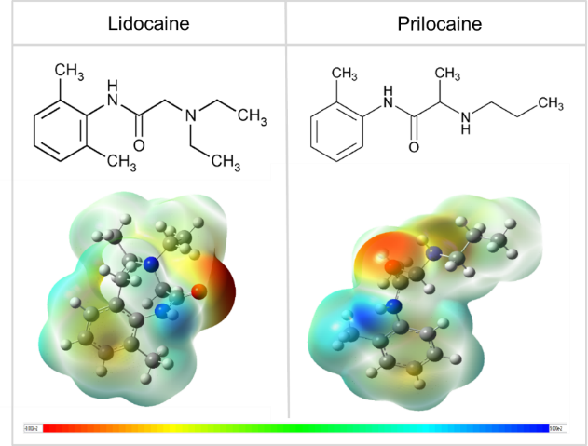

Figure 1. Molecular electrostatic potential maps of LD (left) and PRL (right).

Table 1 Global reactivity parameters of LD and PRL.
 | E_{HOMO} (eV) | E_{LUMO} (eV) | ΔEª (eV) | χ^{b} | μ^{c} | η^{d} | S^{e} | ω^{f} | ΔN_{max}
LD | -9.061 | -5.279 | 3.782 | 7.170 | -7.170 | 1.891 | 0.529 | 13.593 | 3.791
PRL | -9.442 | -5.306 | 4.136 | 7.374 | -7.373 | 2.068 | 0.484 | 13.147 | 3.566
ªΔE - energy band gap; ^{b}χ - absolute electron negativity; ^{c}μ - chemical potential; ^{d}η - absolute hardness; ^{e}S - global softness;
and ^{f}ω - electrophilicity index of LD and PRL.

Results & Discussion
Electrostatic interactions vs ability to form deep eutectics. According to many reports, ionization of a molecule strongly affects its melting point as well as the liquid-glass transition.^{29,30} Due to the strong electrostatic interactions dominating in an ionic system the energy required for melting is much higher than that needed to melt a non-ionic material, and this is manifested in an increase in the T_{m} value. This is clearly visible when PRL is converted to PRL-HCl. As presented in Fig. 2, in this particular case T_{m} increases by more than 100 K when PRL becomes ionic. On the other hand, the LD → LD-HCl conversion does not lead to substantial changes in the melting point.
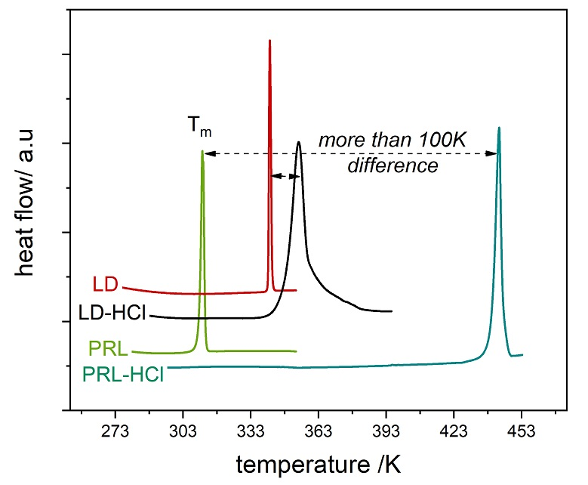
Figure 2. DSC scans of LD, PRL and their ionic counterparts. The endothermic peaks indicate the melting point of given system. The melting transitions of pure LD (T_{m} = 340 K), PRL (T_{m} = 310.3 K), LD-HCl (T_{m}=…K) and PRL-HCl (T_{m}=….. K) are clearly visible.

In the context of these results the question arise: Do the electrostatic interactions affect the ability to form DEMs?
To address this question DSC measurements were performed on several LD/PRL and LD-HCl/PRL-HCl mixtures. The changes in the heat flow were monitored upon heating with a temperature ramp of 10 K/min. The representative thermograms obtained during heating of LD-HCl/PRL-HCl mixtures are collected in Figure 3. As presented therein, five of eight studied LD-HCl/PRL-HCl mixtures, containing between 0.5 and 0.9 mole fraction of PRL-HCl, are characterized by two endothermic events – one being close to the T_{m} of pure LD-HCl and the second, markedly higher, with a characteristic behavior of a liquidus curve. It is also clear that the T_{m} of PRL-HCl decreases with an increase in the LD-HCl concentration and becomes undetectable if only the number of lidocaine molecules extends the amount of PRL-HCl particles.

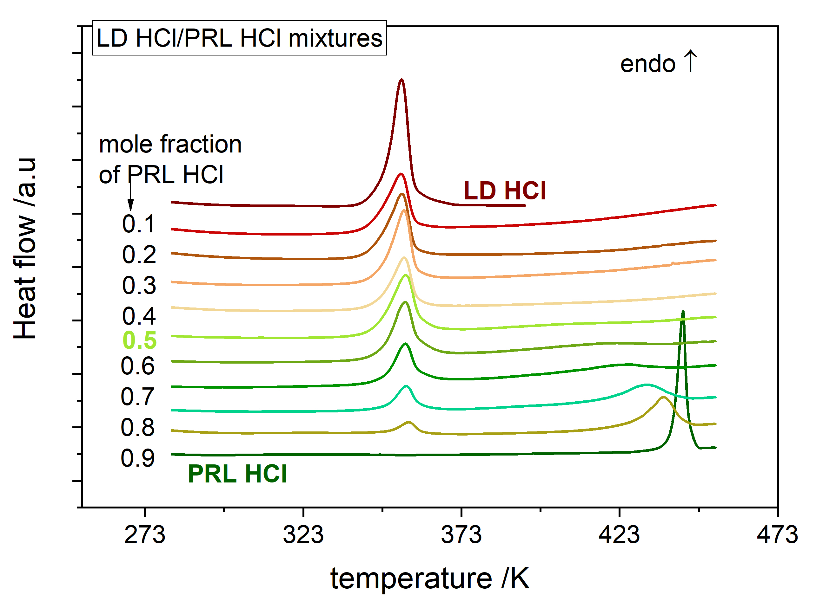
Figure 3 DSC scans of LD-HCl/PRL-HCl mixtures recorded with a temperature ramp of 10 K/min. The upper line presents the data of pure LD-HCl while the bottom curve was obtained for pure PRL-HCl. The mole fraction of PRL-HCL is indicated on the left hand side.
This is well visualised in the form of phase diagrams (Figure 4A). However, the position of the eutectic point is not obvious from the experimental data of ionic mixtures. To reveal the eutectic transition of LD-HCl/PRL-HCl, the Schroeder-van Laar equation was employed.
$lnx_{i}=-\frac{∆_{fus}H_{i}^{°}}{R}\left(\frac{1}{T}-\frac{1}{T_{fus}}\right)$ (1)
In this formula x_{i} is the mole fraction of the studied components at given temperature T; R is the gas constant while $∆_{fus}H_{i}^{°}$ (J/mol) and T_{fus} denote the molar enthalpy of fusion and melting temperature of pure component, respectively.
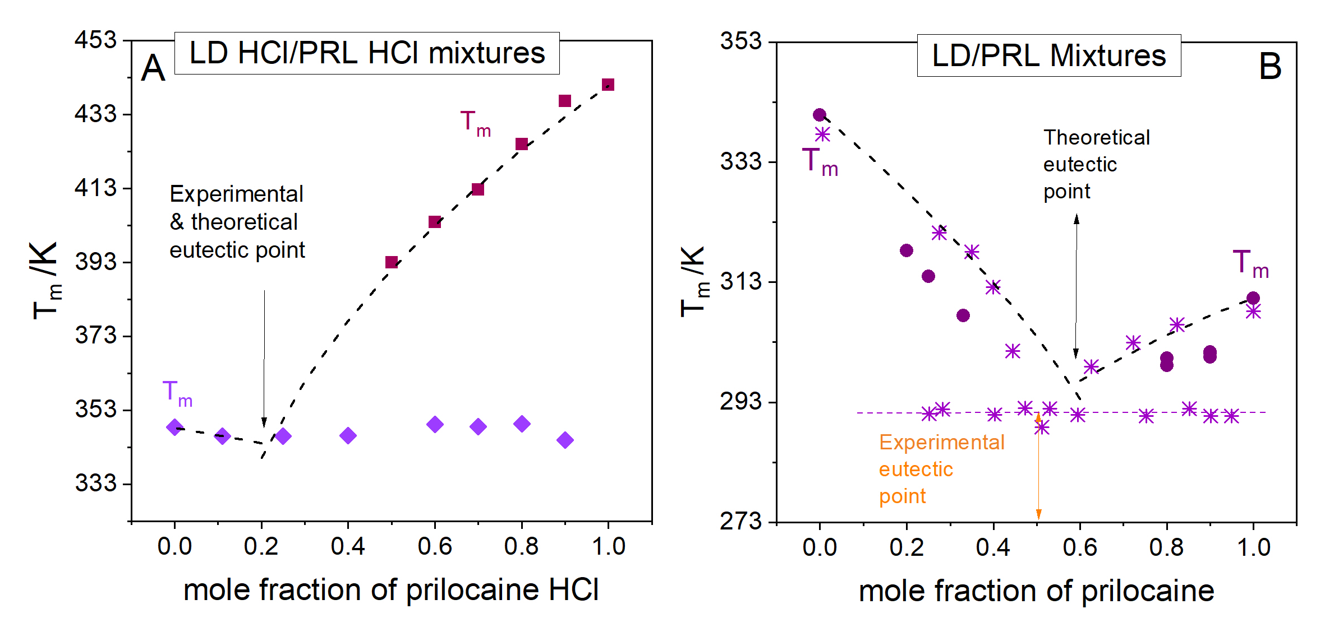
Figure 4 Phase diagrams of LD/PRL and LD-HCl/PRL-HCl eutectic mixtures. The violet stars in panel (a) were taken from ref. [15]. Dashed black lines present the prediction of Schroder-van Laar equation (Eq. 1).

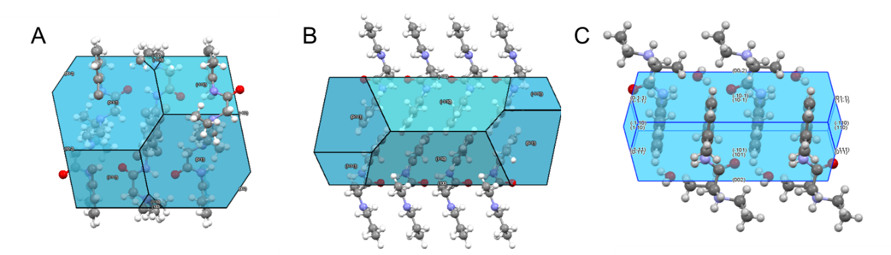

Figure 5. Predicted BFDH crystal morphology of: a) LD (viewed down the b axis), b) PRL (viewed down the b axis) and c) LD-HCl (viewed down the a axis).

Such procedure enables us to predict the curvature of LD-HCl and PRL-HCl liquidus curves as well as to estimate the most probable position of the eutectic temperature and the eutectic concentration. As presented in Figure 4A the theoretically determined T_{m}(x) lines coincide well with the experimental points collected for ionic mixtures. Thus, the Schroder-van Laar model can be applied to extrapolate the empirical data and determine the eutectic composition. Accordingly, mixing of 1 mole of LD-HCl and 4 mole of PRL-HCl results in a single eutectic point occurring at 343 K i.e. a little bit below T_{m} of pure LD-HCl. Since the eutectic temperature falls much above room temperature, the ionic eutectic remain solid at the temperature of its preparation.
On the other hand, from the LD-PRL phase diagram supplemented by data reported in ref. [15] it can be noticed that both liquidus curves merge at a single eutectic point which occurs at a 1:1 mole/mole composition and T_{eutectic}<T_{room}, which makes the 1:1 composition liquid at the temperature of its preparation. Importantly, in comparison to the LD-HCl/PRL-HCl eutectic, the non-ionic DEM contains more lidocaine molecules. This allows higher concentrations of LD-HCl to be formulated into the preparation and maintained during the application. It is also interesting to note that, in contrast to ionic samples, the experimental and theoretical liquidus curves of LD and PRL do not coincide with each other, confirming the occurrence of molecular interactions (e.g. H-bonding) between the condensed phases of these drugs. This result suggests that ionization of APIs strongly affects the H-bonds formation and thereby the ability to form the eutectic phase. According to our crystallographic and DFT studies, the key chemical groups involved in this intermolecular interaction, i.e. the carbonyl group of LD and –N-H moiety of PRL, are exposed on two parallel planes of crystal, specifically (-1-11) and (11-1) for LD and (100) and (-100) for PRL (see Fig. 5A and 5B). Thus, during the formation of the LD-PRL eutectic by physical mixing of crystalline materials, PRL acts as a H-bond donor, while LD as a H-bond acceptor. As regards LD-HCl, the acceptor groups (the diethylamine) are present on (002) and (00-2) planes, while the carbonyl moiety is exposed on (011) and (0-1-1) planes (see Fig. 5C). Thus, potentially LD-HCl can also act as an acceptor molecule when interacting with PRL-HCl. Nevertheless, due to the a strong attractive electrostatic contribution pulling the counterions together and repulsive forces between LD⁺ and PRL⁺ cations, the H-bonding interactions between LD-HCl and PRL-HCl become strongly suppressed. Additionally, considering the higher polarity (and stability) of PRL molecules and the large difference in T_{m} between the studied salts one can expect that in contrast to H-bonded LD-HCl electrostatic forces dominate in PRL-HCl. Therefore, the formation of ionic eutectic is possible only for small concentrations of PRL-HCl.
The glass-forming ability and cold crystallization of ionic and non-ionic DEMs.
To verify the glass-forming ability of the studied mixtures, quench cooling of molten materials was employed. The representative thermograms obtained during heating of glassy LD/PRL compositions are presented in Fig. 6.
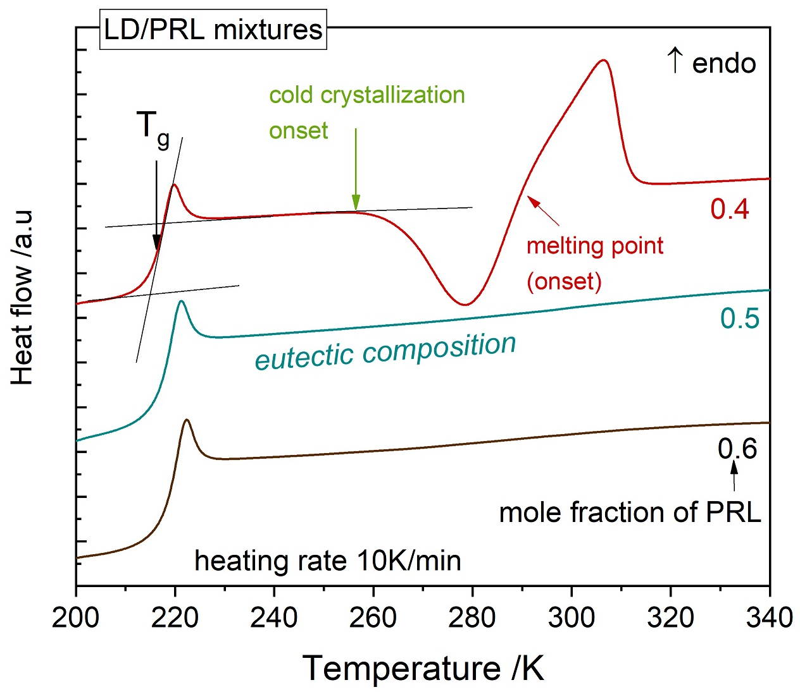
Figure 6. The representative DSC scans of glassy LD/PRL compositions.
In all the cases the glass transition temperature (T_{g}) was taken as the midpoint of the heat flow jump while the onset temperature was used for both crystallization and melting events. All the data is presented in Figure 7a and 7b, for LD-HCL/PRL-HCl and LD/PRL compositions, respectively. As it can be seen in Figure 7a, every LD-HCl/PRL-HCl composition can be easily obtained in an amorphous state. Additionally, as a consequence of the relatively high value of T_{g}, all ionic DEMs take the form of glassy solids at room temperature. Additionally, no signs of crystallization were observed during their long-term storage. However, increasing temperature above 393 K results in solidification of two of the studied systems, i.e. pure PRL-HCl and LD-HCl/PRL-HCl^{0.9m.f} mixture. Considering that for LD-HCl/PRL-HCl^{0.9m.f} the exothermic peak, identified as the crystallization process, appears at temperature 10 K higher than the crystallization of pure PRL HCl and it completely disappears during the heating of LD-HCl/PRL-HCl^{0.8m.f}, one can assume that already one molecule of LD-HCl per four molecules of PRL-HCl eliminate completely the crystallization tendency of the supercooled ionic mixture. It is also likely that simple steric effects are responsible for suppressing the crystallization of this ionic binary system.
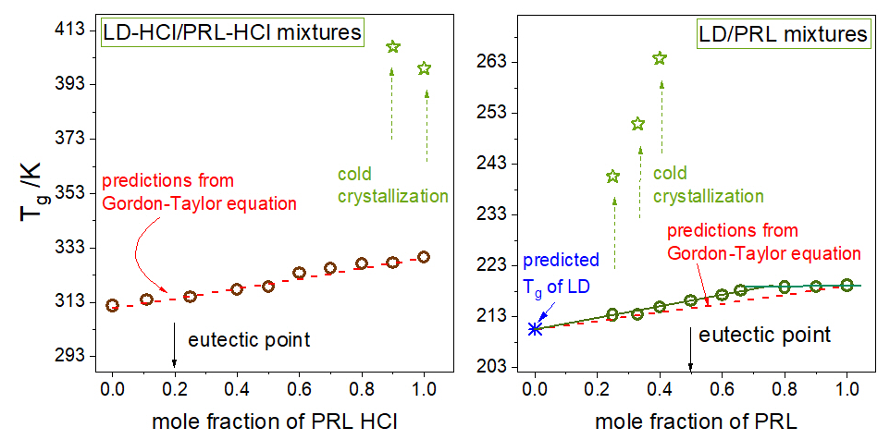

Figure 7. The glass transition temperature of LD/PRL and LD-HCl/PRL-HCl mixtures determined from DSC scans at the heating rate of 10 K/min.

Interestingly, the change from ion-ion to van der Waals interactions affects strongly the glass-forming ability of LD-PRL based mixtures. In contrast to ionic compositions, all classified as good glass-formers, it is practically impossible to obtain an amorphous system containing less than 0.3 mole fraction of PRL. Even an increase in the cooling rate to 300 K/min does not help to achieve pure amorphous LD and the glassy mixture containing 0.2 mole fraction of PRL. Since the rest of the studied drug-drug mixtures, including the eutectic composition, can be easily transformed to the glassy state, one can expect that at least two molecules of PRL per one molecule of LD are required to suppress this immense crystallization tendency of LD. Also, it is noteworthy that the lack of electrostatic interactions between LD and PRL was found to strongly reduce the temperature of the liquid-glass transition, which is in agreement with other reports on ionic and non-ionic APIs.,,, The mixtures containing the base forms of LD and PRL undergo the vitrification process in the temperature range from 213 to 218 K i.e. much below the freezing point of water. As a result, at room temperature their molecular mobility is strongly enhanced in comparison to the ionic drug-drug mixtures. Thereby, in comparison to ionic DEMs one could expect higher probability toward nucleation and crystal growth in dipolar binary systems. Nevertheless, considering the definition of a eutectic system it becomes obvious that the storage of a eutectic composition at a temperature above the eutectic temperature guarantees its stability in the liquid state. This rule is also satisfied herein, as even a one-year storage of the eutectic composition (1:1) as well as LD/PRL^{0.6m.f} mixture at 298 K, i.e. 7 K above the eutectic point, does not result in the crystal formation. Importantly, the transition from the conventional liquid state down to the supercooled region also does not result in crystal formation. On the other hand, even a slight decrease in the PRL concentration below the eutectic composition results in cold crystallization of supercooled LD/PRL mixtures. This process is well visible on DSC thermograms as an exothermic peak (see Figure 6). In this context it is interesting to thoroughly examine thermodynamics of the studied systems in the vicinity of liquid-glass transition i.e. where the structural dynamics is not as fast as far above T_{g} and the kinetic energy of molecules is not as high as in the normal liquid state. To investigate this issue in details, first the T_{g}-x^{m.f} behavior of LD/PRL and LD-HCl/PRL-HCl mixtures were analysed.
As presented in Fig. 7, regardless of interactions dominating in the studied system, the T_{g} increases with an increase in prilocaine concentration. Interestingly, the T_{g} values of LD-HCl/PRL-HCl systems increase in a linear fashion and satisfy predictions of the Gordon-Taylor equation:

$T_{g}\left(x\right)=\frac{x_{1}T_{g1}+Kx_{2}T_{g2}}{x_{1}+Kx_{2}}$ (2)

where x₁ and x₂ denote the weight fractions of each component; T_{g1} and T_{g2} correspond to the glass transition temperature of each component, T_{g} is the glass transition temperature of the mixture, while K is defined as the ratio of ΔC_{p2}/ΔC_{p1}.
In contrast, the T_{g} values of LD/PRL mixtures do not increase in a linear manner but reveal a characteristic kink when the mole fraction of PRL achieves the value of 0.7. According to literature, such a breakdown of the Gordon-Taylor behaviour is usually explained in terms of specific intermolecular interactions (e.g. hydrogen bonds) between molecules in a binary system. This is in agreements with the predictions of Schroder-van Laar model discussed above. As PRL may interact with LD molecules, it can be treated as a crystallization inhibitor of this anesthetic agent.
Another problem being worth to address is whether or not the intermolecular interaction already found between LD and PRL molecules affect the length scale of the global molecular mobility at T_{g} and how does the drug ionization influence this parameter? To answer these questions one need to estimate the number of dynamically correlated molecules N_{α}(T_{g}) (i.e. moving in the same manner with similar relaxation time) for all studied herein ionic and dipolar mixtures. For this purpose the Donth formula is usually employed. In this approach the number of dynamically correlated particles can be estimated by the following equation:
$N_{α}^{D}\left(T_{g}\right)=\frac{N_{A}\left(\frac{1}{C_{p}^{glass}}-\frac{1}{C_{p}^{liquid}}\right)k_{B}T_{g}^{2}}{M{\left(δT\right)}^{2}}$ (3)
where T_{g} is the glass transition temperature, k_{B}–Boltzman constant, M–molar mass, C_{p}– the isobaric heat capacities of glass and liquid at T_{g}, and δT=ΔT/2.5 is the average temperature fluctuation calculated as the temperature interval ΔT where the heat capacity changes from 16 to 84% of the total heat capacity step ΔC_{p} at T_{g} (see Fig. 8A).

Figure 8 A) Temperature dependences of specific heat capacity C_{p} for the representative DEMs. B) The numbers of dynamically correlated molecules N_{α}(T_{g}) for dipolar DEMs (green bars) and ionic DEMs (brown bars) calculated by means of Donth model.
Comparing the representative dependences of C_{p}(T) measured for ionic and non-ionic DEMs (Figure 8A) one can easily see that the ΔC_{p} seems to be similar in both these cases, while the width of the glass transition event (ΔT) for LD-HCl/PRL-HCl compositions is twice as large in comparison to the non-ionic systems, which can strongly affect the value of N_{α}. Indeed, for ionic DEMs the length scale of global mobility was found to be three times smaller (N_{α}≈56) than that of LD/PRL compositions (N_{α}≈163), which makes ionic mixtures dynamically heterogeneous (see Figure 8B). Interestingly, a low number of N_{α} was determined for ionic systems despite their relatively high values of T_{g}. Thus, one can state that the width of the glass transition event (ΔT), being twice as large for LD-HCl/PRL-HCl compositions (see Fig. 9A), play a decisive role in the Donth model. Additionally, it becomes clear that the electrostatic interactions, when dominate in a given system, reduce strongly the value of N_{α}. Similar results have been obtained for other systems of the protic ionic liquids class.
An additional interesting outcome of the analysis, as shown in Figure 8B, is that the value of N_{α} is practically independent on the PRL/PRL-HCl concentration. This is because the thermodynamic parameters remain practically constant within the series of the studied mixtures. On the other hand, an increase in T_{g} observed for ionic compositions is compensated by the increase in ΔT. An invariant length scale of global dynamics within each studied series of compounds suggests also that the different composition of binary mixtures does not affect the dynamics at the molecular level. And thus, the global mobility cannot be treated as the factor responsible for cold crystallization of some of the systems.

Conclusions
In this paper we have investigated two anesthetic agents, lidocaine hydrochloride (LD-HCl) and prilocaine hydrochloride (PRL-HCl) as well as their unionized counterparts, to explore the effect of intermolecular interactions on the formation and thermodynamic properties of eutectic mixtures. The phase diagrams constructed for LD/PRL and LD-HCl/PRL-HCl mixtures revealed that in the both studied systems the liquidus curves meet at single eutectic point, which occurs at 1:1 and 4:1 mole/mole composition, respectively. We have also noticed that the experimental T_{m}(x^{m.f}) and T_{g}(x^{m.f}) points of ionic mixtures follow the theoretical Schroder-van Laar and Gordon-Taylor predictions, which is not the case for the neutral samples. These results confirm the existence of specific intermolecular interactions (H-bonding) in non-ionic DEMs. At the same time, due to the strong attractive forces pulling the counterions together and repulsive interactions between LD⁺ and PRL⁺ cations, the H-bond network between LD-HCl and PRL-HCl disintegrates making the formation of ionic eutectics possible only for a low concentration of PRL-HCl. Interestingly, considering the group of dipolar mixtures (comprising LD and PRL), the thermodynamic properties of the samples were found to be surprisingly similar, including T_{g} (218±5K) and the length scale of structural dynamics described by means of N_{α} parameter (N_{α}=163). On the other hand, ionic mixtures (LD-HCl/PRL-HCl) were found to be much more diverse. We have found a 15 K difference in T_{g} values between the starting components and for the binary samples the T_{g} increased with an increase in the PRL-HCl content. In comparison to dipolar LD/PRL systems, the number of dynamically correlated particles, reflecting the heterogeneity of given system at T_{g}, is much smaller for ionic binary mixtures. The electrostatic interactions existing between the ionic compounds of LD and PRL were also found to reduce the crystallization tendency of binary mixtures.
Acknowledgements
This publication has emanated from research conducted with the financial support of Science Foundation Ireland (SFI) under Grant Numbers 15/CDA/3602 and supported by the Synthesis and Solid State Pharmaceutical Centre (SSPC), financed by a research grant from Science Foundation Ireland (SFI) and co-funded under the European Regional Development Fund (Grant Number 12/RC/2275). Authors are also deeply grateful for the financial support by the National Science Centre within the framework of the Symfonia3 project (Grant No. DEC-2015/16/W/NZ7/00404).
Conflicts of interest
There are no conflicts to declare.
Notes and references

Nkuku, C. A.; LeSuer R. J. J. Phys. Chem. B. 2007, 111 (46), 13271-13277
Smith, E. L.; Abbott, A. P.; Ryder, K. S. Chem. Rev. 2014, 114 (21), 11060-11082
Paiva, A.; Craveiro, R.; Aroso, I.; Martins, M.; Reis, R.L.; Duarte, A.R.C.. ACS Sustainable Chem. Eng. 2014, 2 (5), 1063-1071
Cherukuvada, S.; Nangi, A. Chem. Commun. 2014, 50, 906-923
Berton, P. et. al. ACS Med. Chem. Lett., 2017, 8 (5), pp 498–503
Sánchez-Leija, R.L.; Pojman, J.A.; Luna-Bárcenas G.; Mota-Morales, J.D. J. Mater. Chem. B. 2014, 2, 7495-7501
Wang, H.; et al. Chem. Sci. 2014, 5, 3449-3456
Andrew P. Abbott, Essa I. Ahmed, Kamalesh Prasad, Idrees B. Qader, Karl S. Ryder Fluid Phase Equil. 2017, 448, 2–8.
Thipparaboina, R.; Thumuri, D.; Chavan, R.; Naidu, V.G.M.; Shastri, N.R. Eur. J. Pharm. Sci. 2017, 104, 82-89.
A. P. Abbott, D. Boothby, G. Capper, D. L. Davies and R. K. Rasheed, J. Am. Chem. Soc., 2004, 126, 9142–9147
Zhang, Q.; De Oliveira Vigier, K.; Royera, S.; Jérôme, F. Chem. Soc. Rev., 2012, 41, 7108–7146
Zhang, Q.; De Oliveira Vigier, K.; Royera, S.; Jérôme, F. Chem. Soc. Rev., 2012, 41, 7108–7146
Gorniak, A.; Wojakowska, A.; Karolewicz, B.; Pluta, J. J. Therm. Anal. Calorim. 2011, 104, 1195–1200.
Jain, H.; Khomane, K.S.; Bansal, A.K.; Cryst. Eng. Comm. 2014, 16, 8471–8478.
Broberg, B.F.J.; Evers, H.C.A. European Pat. No. 0,002,425, 1981
Brodin, A.; Nyqvist-Mayer, A.; Wadsten, T.; Forslund, B.; Broberg, F. J. Pharm. Sci. 1984, 73, 4.
Stott, P.W.; Williams, A.C.; Barry, B.W. J. Control. Release. 1998, 50 (1–3), 297-308
Aroso, I.M.; Silva, J.C.; Mano, F.; Ferreira, A.S.;, Dionísio, M.; Sá-Nogueira, I.; Barreiros, S.; Reis, R.L.; Paiva, A.; Duarte, A.R. Eur. J. Pharm. Biopharm. 2016, 98, 57–66
Duarte, A.R.C.; Ferreira, A.S.; Barreiros, S.; Cabrita, E.; Reis, R.L.; Paiva, A. Eur. J. Pharm. Biopharm. 2017, 114, 296-304
Li, Z.; Lee, P.I. Int. J. Pharm. 2016, 505 (1-2), 283-288
Macrae, C. F.; Edgington, P. R.; McCabe, P.; Pidcock, E.; Shields, G. P.; Taylor, R.; Towler, M.; van de Streek, J. Mercury: J. Appl. Crystallogr. 2006, 39, 453–457.
Frisch, M.; Trucks, G.; Schlegel, H.; Scuseria, G.; Robb, M.; Cheeseman, J.; Montgomery, J.; Vreven, T, J.; Kudin, K.; Burant, J.; et al. Gaussian 03, Revision C.02; Gaussian, Inc., Wallingford CT, 2004.
Koopmans, T. Physica 1934, 1, 104–113.
Pandey, J.; Prajapati, P.; Shimpi, M. R.; Tandon, P.; Velaga, S. P.; Srivastava, A.; Sinha, K.; Khan, E.; Shukla, A.; Srivastava, A.; Sinha, K. RSC Adv. 2016, 6, 74135–74154.
Klopman, G. J. Am. Chem. Soc. 1968, 90, 223–234
Mesallati, H.; Mugheirbi, N.A.; Tajber, L. Crystal Growth & Design 2016, 16, 11 6574-6585
Vektariene, A.; Vektaris, G.; Svoboda, J. Arch. Org. Chem. 2009, 311–329.
Meltzer, V.; Pincu, E. Cent. Eur. J. Chem. 2012, 10, 5, 1584-1589
Kaminski K.; Kaminska E.; Adrjanowicz K.; Grzybowiska K.; Wlodarczyk P.; Paluch M.; Burian A.; Ziolo J.; Lepek P.; Mazgalski J.; Sawicki W. J Pharm Sci. 2010, 99(1):94-106.
Kaminski K.; Adrjanowicz K.; Wojnarowska Z.; Grzybowska K.; Hawelek L.; Paluch M.; Zakowiecki D.; Mazgalski J. J Pharm Sci. 2011 100(7):2642-57
Wojnarowska, Z., Wang, Y., Pionteck, J., Grzybowska, K., Sokolov, A. P. & Paluch, M. Phys. Rev. Lett. 111 225703 (2013)
Rams-Baron, M.; Wojnarowska, Z.; Jedrzejowska, A.; Swiety-Pospiech, A.; Paluch, M. RSC Advances 2016, 14
Gordon, M.; Taylor, J. S. J. Appl. Chem. 1952, 2, 493.
Kelley, F. N.; Bueche, F. J. Polym. Sci. 1961, 50, 549−556.
Donth, E. The Glass Transition, Relaxation Dynamics in Liquids and Disordered Materials 2001 (Springer, Berlin)
Grzybowska, K.; Grzybowski, A; Wojnarowska, Z.; Knapik, J.; Paluch, M. Scientific Reports volume 5, Article number: 16876 (2015)

