2D Nanosheets from Fool’s gold by LPE: High performance lithium-ion battery anodes made from stone
Harneet Kaur¹, Ruiyuan Tian¹, Ahin Roy², Mark McCrystall¹, Ross Smith¹, Dominik Valter Horvath¹, Valeria Nicolosi² and Jonathan N. Coleman¹*
¹School of Physics, CRANN & AMBER Research Centres, Trinity College Dublin, Dublin 2,
Ireland
²School of Chemistry, CRANN & AMBER Research Centres, Trinity College Dublin, Dublin 2,
Ireland
*colemaj@tcd.ie (Jonathan N. Coleman); Tel: +353 (0) 1 8963859.

Keywords: liquid-phase exfoliation, non-layered material, pyrite mineral, iron-disulfide, Nanosheets, lithium-ion battery

ABSTRACT
Recently, it has been shown that it is possible to apply liquid-phase exfoliation to non-layered materials, yielding quasi-2D nanosheets. It has been proposed that even a slight bonding anisotropy in the starting crystal will lead to a platelet-like geometry, albeit with low aspect ratio. While this development opens the way to many previously unexplored 2D materials, a particularly interesting class of crystals for exfoliation are natural-occurring mineral ores due to their diversity and abundance. Here we describe the liquid-phase exfoliation of the natural mineral, pyrite, also known as fool’s gold. The exfoliation process yields highly crystalline, low aspect ratio nanosheets with stoichiometry FeS₂, with all impurity and non-platelet material removed during a two-step centrifugation protocol. These 2D pyrite flakes can be fabricated into lithium-ion battery anodes which show remarkable capacities of >1200 mAh g⁻¹.

INTRODUCTION
Liquid-phase exfoliation (LPE) is a widely-used method to produce 2D materials from layered van der Waals (vdW) bulk crystals.¹⁻³ This method yields few-layer nanosheets with thickness of ~1-20 nm and lateral sizes of ~50-1000 nm dispersed in liquids.⁴ LPE has been used to produce a wide range 2D materials including elemental materials (graphite,⁵ black phosphorus,^{6, 7} etc), transition-metal dichalcogenides,^{1, 3} metal oxides,^{8, 9} and MXenes,^{10, 11} to name but a few. While most of the early materials exfoliated using LPE were synthetic layered materials, recently there has been a realisation that many naturally occurring layered materials exist that could be exfoliated to give interesting 2D materials e.g., Franckeite and cylindrite.¹²⁻¹⁶
Furthermore, in the last 2-3 years, pioneering work has shown that LPE can also be used to produce quasi-2D nanosheets from non-layered (non-vdW) materials, starting with the natural mineral haematite, α-Fe₂O₃.¹⁷ Since then, LPE has been applied to a range of non-layered materials, including boron carbide,¹⁸ iron disulfide,¹⁹ and metal borides,²⁰ all materials held together by strong chemical bonds. While LPE of layered materials involves a combination of fragmentation (breaking chemical bonds) and delamination (breaking vdW bonds),⁴ exfoliation of non-layered materials only involves fragmentation and is thought to require anisotropic bonding in the bulk crystal^{17, 19, 21} if quasi-2D platelets are to be produced.
The ability to exfoliate non-layered materials will lead to the discovery of plethora of new 2D nanosheets with a range of properties and potential for novel applications. We believe that naturally occurring minerals are class of compounds which are very exciting with respect to LPE. In addition to the layered minerals described above, there are, of course, a very large number of non-layered minerals which might be exfoliated due to their anisotropic bonding schemes. These materials have many advantages: they are abundant, environmentally friendly, cheap and usually nontoxic. Following the initial study describing LPE of hematite,¹⁷ a recent paper²¹ has described the exfoliation of the natural mineral ores galena, goethite and calcite. However, this is just the tip of the iceberg with many materials in need of study.
The most abundant sulphide mineral is pyrite²² (FeS₂). It can be found in sedimentary, metamorphic, and igneous rocks²²⁻²⁴ and is commonly recognized by its cubic crystal and gold lustre, leading to its common name of fool’s gold.²² Although a processed, purified form of pyrite has previously been exfoliated to yield quasi-2D nanosheets,¹⁹ it would be extremely interesting to demonstrate that the untreated mineral, in essence a stone, could be converted to nanosheets without any prior purification.
Here, we demonstrate the exfoliation of 2D pyrite flakes from its natural mineral using LPE. Liquid-exfoliated flakes were characterised using various spectroscopic and microscopic techniques. XRD Scherrer analysis, combined with AFM and TEM, confirms the cleavage of bulk pyrite into nano flakes of thickness ~29 nm. Furthermore, TEM, HR-TEM, EDX and Raman spectroscopy confirms the resultant nanosheets to be highly crystallinity with crystal structure and stoichiometry which match the bulk crystal (FeS₂). Further, we have fabricated lithium-ion battery anodes from composites of pyrite flakes and carbon nanotubes finding extremely high capacities.

RESULTS AND DISCUSSION
A commercially sourced pyrite mineral was used as a starting material. This material is essentially a stone consisting of an amalgam of crystallites, many of which display well-defined facets as shown in figure 1(a). The mineral was crushed with an agate mortar and pestle and was washed using a mild sonication in 2-propanol (see methods) to remove any soluble impurities (refer SI 1, for the SEM images of crushed and treated mineral).^{25, 26} As shown in the SI 2-3, if exfoliation is performed without this washing step, the resultant dispersion tend to be unstable and the nanosheets appear to be coated with impurity material. After treatment, a clear colour change in the crushed mineral was observed as shown in figure 1(b) with the treated mineral consisting of gold-coloured fine crystals (size ~10-100 μm, as shown in SI 1). This treated powder was used as the starting material for the LPE. This procedure involves probe sonication of the powder in N-methyl-2-pyrrolidone (NMP) solvent. The aim of this step is to break up pyrite with the aim of creating a significant population of quasi-2D nano-platelets.¹⁹ The LPE process was followed by a 2-step centrifugation process²⁷ to remove very large and very small particles, yielding a sediment that could be redispersed in 2-propanol to obtain a dispersion of exfoliated pyrite (Figure 1(c)). Critically, it was hoped that this centrifugation process would remove all non-2D structures from the dispersion. For example, any large unexfoliated material will be removed during the low-speed step. In addition, the high-speed step is crucial to remove both small particles, as well as soluble impurities and solvent degradation products (refer SI 4). Drying and weighing showed that this procedure yields dispersed solids with a mass-yield (compared to starting solid mass) of 0.1-0.15 wt%. This is considerably lower than the yields of 3-3.5 wt% achieved with the synthetic material¹⁹. However, this comparison is not appropriate as the centrifugation regime used here was significantly different to that reported in reference.¹⁹
Microscopy
The morphology, crystallinity and structure of exfoliated pyrite flakes were studied using transmission electron microscopy (TEM). As shown in figure 2a(i), the exfoliated pyrite consists of flakes with a quasi-2D geometry. No non-platelet morphologies were observed throughout the specimen, confirming that such structures can be removed in the centrifugation protocol. Figure 2a(ii) shows an isolated flake of pyrite with high-resolution TEM (Figure 2a(iii)) signifying its highly crystalline structure. The spacing between the atomic planes was calculated to be 0.27 nm, which matches with the miller indices 200 of bulk pyrite. The high angle annular dark field (HAADF) image from the flake (Figure 2a(iv)) shows the arrangement of iron atoms, with the spacing between the atomic planes in the image indexed to the 111 and 2$\overline{2}$0 miller indices of bulk pyrite structure. The zone axis perpendicular to these atomic planes is [11$\overline{2}$], which corresponds to the large-area-facet of this nanosheet. This matches well with our previous reported results on iron disulfide.¹⁹ In addition, the [11$\overline{2}$] atomic plane is equivalent to 112 or 211 atomic planes (because pyrite has cubic crystal lattice structure).
To study the elemental composition of these flakes, energy dispersive X-ray spectroscopy (EDS) attached to the TEM was used. This allows us to determine the atomic percentage of the elements on flake-by-flake basis. Random isolated flakes in the TEM grid were chosen and EDS spectrum was acquired. An example of an EDS spectra acquired on a single flake is shown in figure 2(b). It confirms the presence of iron and sulfur atoms with no observable impurity material. A statistical distribution on the atomic percentage ratio of sulfur to iron over 26 individual flakes is shown in figure 2(c). The mean atomic percentage ratio <S:Fe> is found out to be 2:1, indicating a chemical composition of stoichiometric FeS₂.
Atomic force microscopy (AFM) has been used to study thickness and aspect ratio of the pyrite flakes. Figure 2(d) shows an AFM image of pyrite flakes. Clearly, the flakes have length in tens to hundreds of nanometres. Apparent height profiles were extracted for each individual flake to estimate the thickness (t) and length (L) of the flakes, and a statistical analysis has been performed. Figure 2(e-f) shows the statistical distribution of the thickness and length of the flakes with a total of 75 flakes analysed to obtain the distributions. The mean length and thickness of the flakes were found to be 121 ± 7 nm and 29 ± 2 nm respectively (standard errors). Figure 2(g) shows the statistical analysis of the aspect ratio (L/t) of the flakes. The mean value is found to be ⁓ 4, which is very low compared to values of 10-100 found in layered materials.⁴ However, it is consistent with measured aspect ratios for flakes produced by LPE from other non-layered materials.^{18, 19} Indeed, it has been proposed that low aspect ratios are to be expected in such materials due to low bonding anisotropy in such materials.^{4, 19}
Optical spectroscopy
Furthermore, Raman spectroscopy has been employed to study the bonding and symmetry in mineral and exfoliated pyrite. The positions of the Raman active vibrational modes are indicative of the different polymorphs present in the mineral ore and can be used to study the purity of the mineral. As shown in figure 3(a), the crushed mineral consists of two high intensity modes centred at 342 cm⁻¹, and 374 cm⁻¹. These modes correspond to the characteristic E_{g} and A_{g} vibrations of sulfur dimer in pyrite.²⁸⁻³⁰ After the treatment of the mineral, no change in the positions of the modes were observed, signifying the perseverance of the pristine mineral structure. However, after exfoliation, a clear red shift of 3 cm⁻¹ in both E_{g} and A_{g} modes were observed. Such effects are to be expected because of the confinement of lattice vibrations in nanoscale pyrite and are indicative of significant thinning after exfoliation.^{30, 31}
Extinction spectra of the exfoliated dispersion has also been measured to get insights on the optical absorption of pyrite flakes. As reported previously,^{32, 33} scattering contributes significantly to nanosheet dispersions. Therefore, an integrating sphere was used to differentiate the contributions from absorbance and scattering in the extinction spectra. Figure 3(b) shows the extinction, absorbance, and scattering coefficient spectra of the dispersion. The extinction and absorbance coefficients display similar line-shapes. While the extinction is non-zero over all wavelengths due to the scattering contribution, the absorption shows a bandedge at 985 nm corresponding to a 1.25 eV optical gap. It should be noted that, as we showed previously, FeS₂ shows significant size dependence of its optical spectra.¹⁹ The means that the optical properties shown in figure 3(b) are specific to the nanosheet size distribution produced in this particular case.
X-ray diffraction
X-ray powder diffraction (XRD) was used to study the crystal structure and purity of both crushed and treated pyrite mineral, as well as a film of exfoliated pyrite which was made by drop-casting the dispersion onto a silicon wafer. As shown in figure 3(c), the crushed mineral shows the presence of sharp diffraction peaks at 2Ɵ = 28.5°, 33.0°, 37.0°, 40.7°, 47.4°, 56.2°, and 59.0°, which matches well with the cubic crystal system (space group Pa$\overline{3}$) of iron disulfide (reference, JCPDS card no. 042-1340). A low intensity diffraction peak at 2Ɵ = 46° (as shown by an asterisk in figure 3(c)) has also been observed in the crushed mineral which may be attributed to the impurities in it. This signal may be associated with iron carbonate, FeCO₃ (JCPDS card number 00-029-0696) although it is impossible to be certain based on a single diffraction peak. After the treatment process, the diffractogram has the same peaks as that of the crushed powder except that the peak at 2Ɵ = 46°, corresponding to the impure phase, disappears (Figure 3(c)). The diffractogram from the exfoliated pyrite shows the same diffraction peak positions as that of the treated mineral, but with broadening in the full-width half maximum (β). We note that no trace of impurity material was observed in the XRD scans of the treated, exfoliated material (although impurities may be present in small, undetectable quantities).
Information on crystallite size can also be extracted from the XRD spectra. According to the Scherrer equation,³⁴
where l is the measure of the dimension of the particle in a direction perpendicular to the reflecting plane (also called as crystallite domain size), K is the shape factor, λ is X-ray wavelength, β is the full width at half maximum intensity and, Ɵ is the Bragg angle; such that an increase in β is associated with decrease of crystallite size, l. Therefore, to get insight into l, each diffraction peak is fitted with Lorentzian line shape to extract β.
Figure 3(d) shows the variation in β for crushed, treated, and exfoliated pyrite. Going from crushed to treated pyrite, most peak widths (and so crystallite sizes) do not change. However, we observe a significant increase in β from ~1.7 to ~2.9 mrad for both the 211 and 311 atomic planes, implying a thinning of crystallites in directions perpendicular to these planes. As treatment involves mild sonication, this change may reflect a partial exfoliation and could imply preferential cleavage in these planes. This results in a decrease in the average crystallite size from 85 and 93 nm for the crushed powder to 49 and 52 nm in the treated powder for 211 and 311 directions respectively. Because the 211 and 311 atomic planes have similar surface energies, close to ⁓ 2 J m⁻², which are relatively low compared to other atomic planes (e.g. ⁓ 3 J m⁻² for 111 and 222 atomic planes)²³ makes preferential cleavage along these planes likely. This observation is consistent with the TEM analysis (as explained above) which shows large area planes can be 211 in nature.
After exfoliation, a clear further increase in β was observed for all atomic planes implying a decrease in the crystallite size over a range of directions. For all the atomic planes shown in figure 3(c), the resultant average crystallite sizes in exfoliated pyrite were similar within the range 23-29 nm. Interestingly, this value is close to the value of crystallite size obtained using AFM for exfoliated pyrite (above). This suggests that XRD analysis can be used to obtain the thickness of the flakes obtained after exfoliation. For 2D materials such as graphene, the crystallite size extracted from XRD can be used to calculate the thickness of the nanosheets as they have only one preferred plane of cleavage.³⁵ However, in case of non-layered materials, it is not clear which plane should undergo preferential cleavage. If the broadening of the peaks shown in figure 3(c) is associated with the relatively small thickness of quasi 2D platelets of FeS₂, this data would imply that there is no one cleavage plane but that cleavage occurs over a range of planes including 111, 200, 210, 210, 220, 311 and 222. This would be an interesting result as it would mean that it is not only the low bonding strength planes that fracture during exfoliation of FeS₂. It is possible that the mild sonication used in the treatment/washing step resulted in exfoliation along preferential planes (211 and 311) while prolonged sonication during the exfoliation step was aggressive enough to yield exfoliation along other atomic directions.
If it were only the low bonding strength planes that fracture during exfoliation of FeS₂, we would expect to see break broadening only for the peaks associated with low bonding energy planes. That we see broadening in peaks associated with both low and higher-energy planes imply exfoliation to occur along planes with a range of fracture energies. However, under these circumstances it is surprising that quasi 2D platelets were obtained at all as, if fragmentation occurs along many atomic directions, one might expect quasi-0D particles to form. This calls into question our suggestion about the importance of bonding anisotropy in the exfoliation of non-layered materials.¹⁹ This makes it important to consider alternative explanations of the exfoliation process, especially in the light of very recent results showing that isotropic materials such as silicon³⁶ and boron carbide¹⁸ can be exfoliated.
Battery applications
FeS₂ is also a promising material for both lithium and sodium ion battery anodes with a theoretical capacity of 890 mAh g⁻¹.^{37, 38} Recently, we have demonstrated that electrodes formed from composites of FeS₂ nano-platelets and carbon nanotubes could achieve a stable lithium storage capacity of ~900 mAh g⁻¹ (normalised to FeS₂ mass).¹⁹ It would be well worth demonstrating that FeS₂ nanoplatelets derived from natural pyrite mineral could also achieve equally good performance as lithium-ion battery electrodes.
To test this, we mixed the dispersions of liquid exfoliated natural pyrite FeS₂ nanoplatelets and single wall carbon nanotubes in a FeS₂:nanotube mass ratio of 75:25. The mixed dispersion was vacuum filtered to form films with an overall loading of 0.4 mg/cm², leading to an electrode thickness of ~2 μm. The films were dried in a vacuum oven and then cut to the required dimensions for battery testing (see methods). An SEM image of a cross section of such an electrode is shown in figure 4(a). We are aware that this electrode loading is too low, and the nanotube content is too high, to be used in practical electrodes. However, we emphasise that our aim is not to demonstrate practical electrodes but to investigate what performance level is achievable using an exfoliated mineral.
As shown in figure 4(b), cyclic voltammetry (CV) was performed at a scanning rate of 0.1 mVs⁻¹ to study the electrochemical Li storage mechanism. These spectra contain all of the expected oxidation and reduction peaks and are very similar to those previously reported for electrodes of both quasi-2D FeS₂-nanotube composites¹⁹ and composites of FeS₂ nanoparticles mixed with carbon nano-fibres.^{19, 39, 40}
The reduction peaks at 1.3 V vs. Li⁺/Li are related to the conversion reaction to form Fe and Li₂S:
(1)
As observed previously,^{39, 41} the reduction peak at 1.3 V vs. Li⁺/Li shifts to 1.4 V vs. Li⁺/Li after the first cycle, suggesting different reaction mechanisms between them. Zhang et al.^{40, 42} reported that, there would be two reduction peaks at the first reduction process, which are shown as follows:^{40, 42}
(2)
(3)
However, the two reduction potentials are close and always overlap, it is usually shown one strong reduction peak at the first CV curve. Thus, Equation (1) is the combination of Equation (2) and (3).
After the 1st reduction process, the oxidation peaks at 1.95 and 2.55 V vs. Li⁺/Li, with their reduction peaks at 1.41 and 2.02 V vs. Li⁺/Li, can be assigned to a new reaction model for the redox couples, which were proposed by Zhang et al.⁴⁰ It might be a hybrid of Li/FeS cell and the Li/S cell, not the Li/FeS2 cells. They are described as follows:⁴⁰
(4)
(5)
It means the redox couple at 1.95 V is due to the conversion between metallic Fe to FeS, and the redox couple at 2.55 V corresponds to the oxidization of Li₂S to sulfur. Therefore, the reduction peaks at 1.41 and 2.02 V are oxidation peaks of reduction peaks at 1.95 and 2.55 V in sequence.

We performed basic lithium storage characterisation for these FeS₂/CNT electrodes. For cyclability measurements, the Galvanostatic charge and discharge capacity were measured for 100 cycles at 4.0 A g⁻¹, with an example of the typical behaviour shown in figure 4(c). Here, the capacity of the first cycle was 1650 mAh g⁻¹ for discharge and 1025 mAh g⁻¹ for charge at 4.0 A g⁻¹, with an initial coulombic efficiency of 62%. All capacities are normalised to FeS₂ mass. Over the first 5 cycles, the capacity decreased to ~900 mAh g⁻¹ for both charge and discharge capacity, while the coulombic efficiency increased to >99%, behaviour which might be attributed to the formation of solid-electrolyte-interface (SEI). After roughly 10 cycles, the specific capacity showed some fluctuations but was reasonably stable in the range 900-1050 mAh g⁻¹ (CE~100%) for both charge and discharge capacity until at least 140 cycles. Similar results were found so long as enough (>30 μL) electrolyte was used. If lower electrolyte volumes were used, we found the capacity to be unstable (see SI 5). However, it is worth noting that for some electrodes we found the initial capacity to be much lower, but to increase over ~50 cycles before reaching ~1000 mAh g⁻¹ (see SI 6). Such increasing of capacity was previously observed for composites of FeS₂ nano materials mixed with carbon-based additives reported by us¹⁹ and other researchers,^{40, 43} and has been attributed to kinetic activation of the electrode. We propose that small batch-to-batch variations in electrode morphology, perhaps associated with dispersion quality, can result in electrodes such as that in figure 3(c) which don’t require activation or electrodes which must be activated as shown in the SI 6.
The rate performance of our electrodes was measured as well, with voltage profiles shown in figure 4(d) and rate dependent cycling data in figure 4(e). For a current of 0.1 A g⁻¹, the charge and discharge capacities after the first cycle were similar at ~1240 mAh g⁻¹ but fell off to ~550 mAh g⁻¹ as the current was increased to 8 A g⁻¹. When the current was returned to 0.1 A g⁻¹, the specific charge and discharge capacities were ~1452 mAh g⁻¹, which were higher than those at the beginning. However, this is consistent with the cycling-induced capacity increase referred to above. Considering the electrode density, the low-rate capacity of 1240 mAh g⁻¹ is equivalent to a volumetric capacity of ~1800 mAh cm⁻³ (normalised to the entire electrode volume).
Interestingly, these low rate capacities are somewhat higher that our previous measurements of ~900 mAh g⁻¹.¹⁹ This is probably due to the fact that the nanotube content used in the current work (25wt%) is higher than that used previously¹⁹ (20 wt%). It is known that the capacity of composite electrodes increases with nanotube content,⁴⁴ although a saturation of capacity would have been expected by a nanotube loading of 20wt%. In any case, this data implies that it is possible to produce FeS₂-based electrodes with capacities well beyond the theoretical capacity^{37, 38} of 890 mAh g⁻¹. We note that higher than expected capacities in the range 1000-1200 mAh g⁻¹ have been observed previously for FeS₂, although the underlying reasons do not appear to be understood.^{39, 45-47} Such anomalously high capacities have also previously been observed for a range of metal chalcogenides and oxides.⁴⁸ In the case of MoO₂ for example, the anomalously high capacity is attributed to the formation of a lithium-rich phase at the surface of the MoO₂ particles.⁴⁹ It is entirely possible that such a phase or indeed an interfacial capacitive contribution is wholly or partially responsible for the excess capacity. Although it is beyond the scope of this work, it would be interesting to explore just how high a capacity can be achieved if electrode activation and nanotube content were to be fully optimised.

CONCLUSION
Here we have demonstrated liquid phase exfoliation of the mineral pyrite or fool’s gold. This process results in the formation of quasi 2D platelets of FeS₂ with all non-2D and non-FeS₂ structures removed in the centrifugation process. The nanosheets are crystalline, have the correct stoichiometry and have thicknesses of ~29 nm and lateral sizes of ~120 nm. That the nanosheet aspect ratios are small (~4) is due to the limited bonding anisotropy associated with non-layered crystals. Finally, we have used these nanosheets to fabricate lithium-ion battery anodes with capacities of >1000 mAh g⁻¹.

METHODS
Materials
Pyrite stone was purchased from the company ThrowinStones, North Carolina, United States. Solvents, N-methyl-2-pyrrolidone and 2-propanol were purchased from Sigma Aldrich HPLC grade > 99%. P3-SWNT was purchased from Carbon Solutions with carbonaceous purity > 90%.
Treatment of pyrite stone and exfoliation
The pyrite stone was first crushed with agate mortar pestle and then dispersed in 2-propanol solvent. Probe sonication was then used to dissolve the impurities using sonic tip (VibraCell VCX, 750W) for 2 hours at pulse of 6s on and 2s off, at an amplitude of 55%. The dispersion obtained was then subjected to a centrifugal force of 100g for 2 hours at 10ºC (Hettich Mikro 220R centrifuge, rotor radius 91mm) and the supernatant consisting of the dissolved impurities is decanted. The sediment was collected and dried at 60°C. This is referred to as treated pyrite which is used as a starting material for the exfoliation.
The treated pyrite (1600 mg) was dispersed in 80 ml of N-methyl-2-pyrollidone solvent in a 100 ml metallic beaker. The mixture is subjected to the probe sonication using sonic tip for a time period of 9 hours at 55% amplitude with pulse 6s on-2s off, at a temperature of 7°C maintained by the chiller. After sonication, the dispersion obtained was centrifuged at 630g for 2 hours at 10ºC. The sediment consisting of thick flakes and unexfoliated material was discarded and the supernatant was subjected to a second centrifugation at 2540g for 2 hours at 10ºC. This high-speed centrifugation step resulted in yellowish-orange colour supernatant consists of very small particles, dissolved impurities, and degraded solvent products (refer to SI). The supernatant is decanted, and the sediment obtained after this step was dispersed in 2-propanol for the characterization. As a control experiment, pristine crushed pyrite stone was also exfoliated without any pre-treatment at the same conditions.
Characterization
Perkin Elmer Lambda 1050 spectrometer has been used to acquire the extinction and absorption measurements of the dispersion using quartz cuvettes with pathlength (l) of 4 mm. The concentration of the dispersion was calculated by the filtering 1 ml of dispersion onto membranes and weighing the mass difference. This was used to calculate the extinction coefficient by using Beer Lambert Law, , where ε is the extinction coefficient, A is the extinction, c is the concentration and l is the path length of the cuvette. For the absorbance measurement, an integration sphere of radius 150 mm has been used in the setup and the absorbance coefficient is also calculated in a similar way to extinction coefficient. Scattering coefficient spectra is calculated by subtracting the absorbance coefficient spectra from the extinction coefficient spectra. JEOL 2100 has been used for the TEM imaging. Holey carbon grids of 400 mesh were used at an accelerating voltage of 200 KV. The grids were prepared by drop-casting ⁓20 μl of dispersion (⁓0.1 mg/ml) onto the holey carbon grid. The grid was kept in vacuum oven at 80ºC, overnight prior to the TEM measurements. The EDS spectra was acquired using 80 mm² X-mas detector from Oxford instrument attached to the JEOL 2100. FEI TITAN microscope has been used for HR-TEM and STEM measurement. The HAADF imaging was carried out at 300 KV. The grids were prepared in the same way as for JEOL 2100. The XRD measurements were done using PanAlytical X'Pert Pro diffractometer from 2Ɵ range of 25º to 65º on crushed pyrite mineral, treated pyrite mineral and onto the films prepared on Si/SiO₂ wafers (⁓300 nm oxide thickness). The wafers were first cleaned by rinsing with clean IPA and solvent is blow off using Argon gas. The wafer is pre-heated at 60ºC, and ⁓0.5 ml of the dispersion (⁓0.5mg/ml) is drop-casted, drop by drop. Immediately after deposition, the substrate was transferred to vacuum oven at 80ºC, for 2 hours prior to measurements. Horiba Jobin Yuon LabRAM ARAMIS setup has been used for Raman spectroscopy. A 532 nm laser (laser power 2 mW, power is adjusted using neutral density filter) has been used to excite the samples with 10X objective. 1800 g/mm grating is used to disperse the signal onto the CCD detector at -70ºC. The samples for the Raman measurements were prepared by drop casting the dispersion (⁓0.5mg/ml) onto the heated silicon wafer coated with 300 nm of silicon dioxide. Bruker Multimode 8 microscope setup has been used for the AFM studies. ScanAsyst mode was used to acquire the images using OLTESPA R3 cantilevers on films prepared by drop-cast diluted dispersion (⁓0.005 mg/ml) on pre-heated Si/SiO₂ wafer followed by rinsing in IPA and blow-dry using argon gas gun.
Electrochemical Characterisation
The composited electrodes of FeS₂ nanosheets/SWCNT were fabricated by vacuum-filtration of mixed dispersions of FeS₂ nanosheets and SWCNTs in IPA. The 0.1 mg mL⁻¹ SWCNT dispersions were prepared by using a horn-tip sonic probe (Vibracell CVX, 750W)~2. Celgard 2320 (with a thickness of 20 μm) was used as the filtration membrane. The films were cut into the required dimensions for electrochemical testing. The active mass loading of FeS₂ in electrodes was 0.3 mg cm⁻², while the mass loading of SWCNT was 0.1 mg cm⁻² (25wt%), The approximate electrode thickness was ~2 μm. More details could be found in our previous work.¹⁹ the density of these films was approximately 2 g/cc, consistent with a porosity of ~60 %.
The coin cells assembly were performed in a glovebox filled with highly pure argon gas (O₂ and H₂O levels < 0.1 ppm). And Li-metal (diameter, 14mm; MTI Corp.) used as the counter/reference electrode and Celgard C212 (thickness 16 μm) was used as a separator. The electrolyte was Lithium hexafluoridophosphate (LiPF₆, 1.2 M) in ethylene carbonate/ ethyl methyl carbonate (EC/EMC, 1:1 in vol/vol, BASF) with 10 wt.% fluoroethylene carbonates (FEC, Sigma Aldrich).
Cyclic voltammetry of the cells was conducted by using a galvanostat-potentiostat (VMP-3, Biologic) between 0.05 and 3.0 V vs. Li⁺/Li at a scanning rate of 0.1 mV s⁻¹ for 10 cycles. The electrochemical properties of the FeS₂ anodes were measured within a voltage range of 0.05 – 3 V by a potentiostat, using the symmetric galvanostatic charge/discharge mode (Arbin). The cyclabilities of the electrodes were evaluated at 4.0 A g⁻¹. For rate capacity measurements, there were 4 cycles at 0.1 A g⁻¹, followed by 10 cycles at varies high current rates. It went back to 0.1 A g⁻¹ for 5 cycles to check the cells at the end. The specific capacities (Q/M) of the electrodes were normalized to the mass of FeS₂. And the Coulomb efficiency was calculated from the ratio of charge capacity to discharge capacity.

ACKNOWLEDGEMENTS: We acknowledge the European Research Council Advanced Grant (FUTURE-PRINT) and the European Union under Graphene Flagship cores 2 & 3 (grant agreements 785219 and 881603). We have also received support from the Science Foundation Ireland (SFI) funded centre AMBER (SFI/12/RC/2278) and availed of the facilities of the SFI-funded AML and ARM labs. MMcC thanks the Irish research council for support.

FIGURES
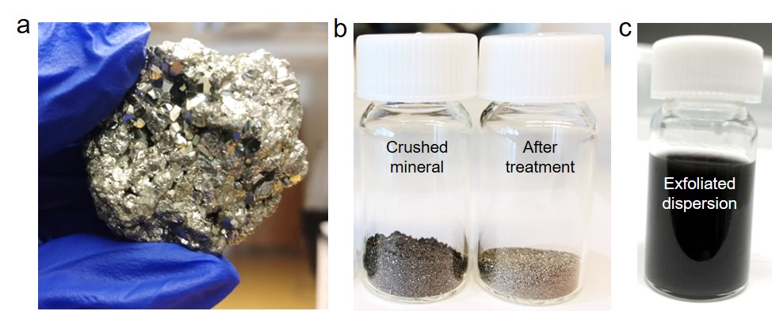
Figure 1: Mineral of pyrite and its exfoliation. Photograph of (a) pyrite mineral, (b) crushed mineral before and after cleaning treatment, (c) exfoliated pyrite dispersion obtained after liquid-phase exfoliation process.

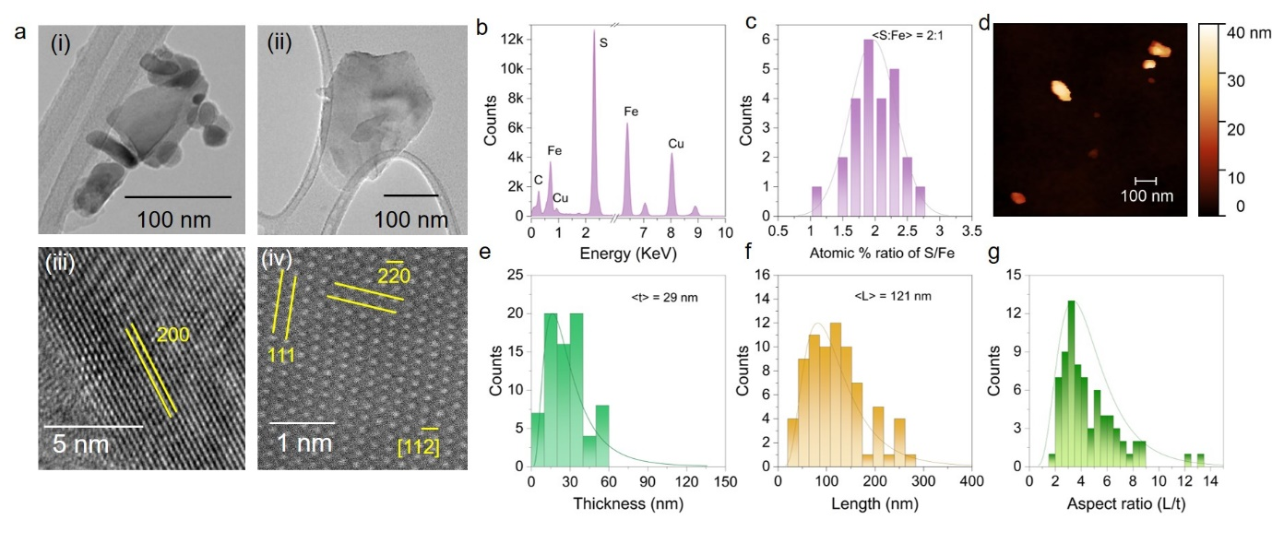
Figure 2: Structural and aspect ratio studies on exfoliated pyrite flakes. (A) TEM, HR-TEM and STEM imaging, (i) a cluster of flakes showing their 2D morphology, ⁵ an ultra-thin flake of pyrite, (iii) HR-TEM confirming its crystalline nature, the distance between atomic plane is 0.27 nm, indexed to 200 miller index of bulk pyrite, (iv) STEM image showing atomic planes with lattice spacing 0.31 nm and 0.19 nm indexed to 111 and 2$\overline{2}$0 miller indices of cubic pyrite structure. The zone axis perpendicular to these planes is 11$\overline{2}$. (b) EDS spectra from an isolated flake shown in (a-ii), shows presence of iron and sulfur elements. The carbon and copper signal were from TEM grid. (c) Statistical distribution of the atomic percentage ratio of sulfur to iron. The mean value is found to be 2:1. (d) AFM image of the pyrite flakes. (e-g) Statistical distribution of the thickness (t), length (L) and aspect ratio (L/t). The mean t, L and L/t is 29 nm, 121 nm and 4.

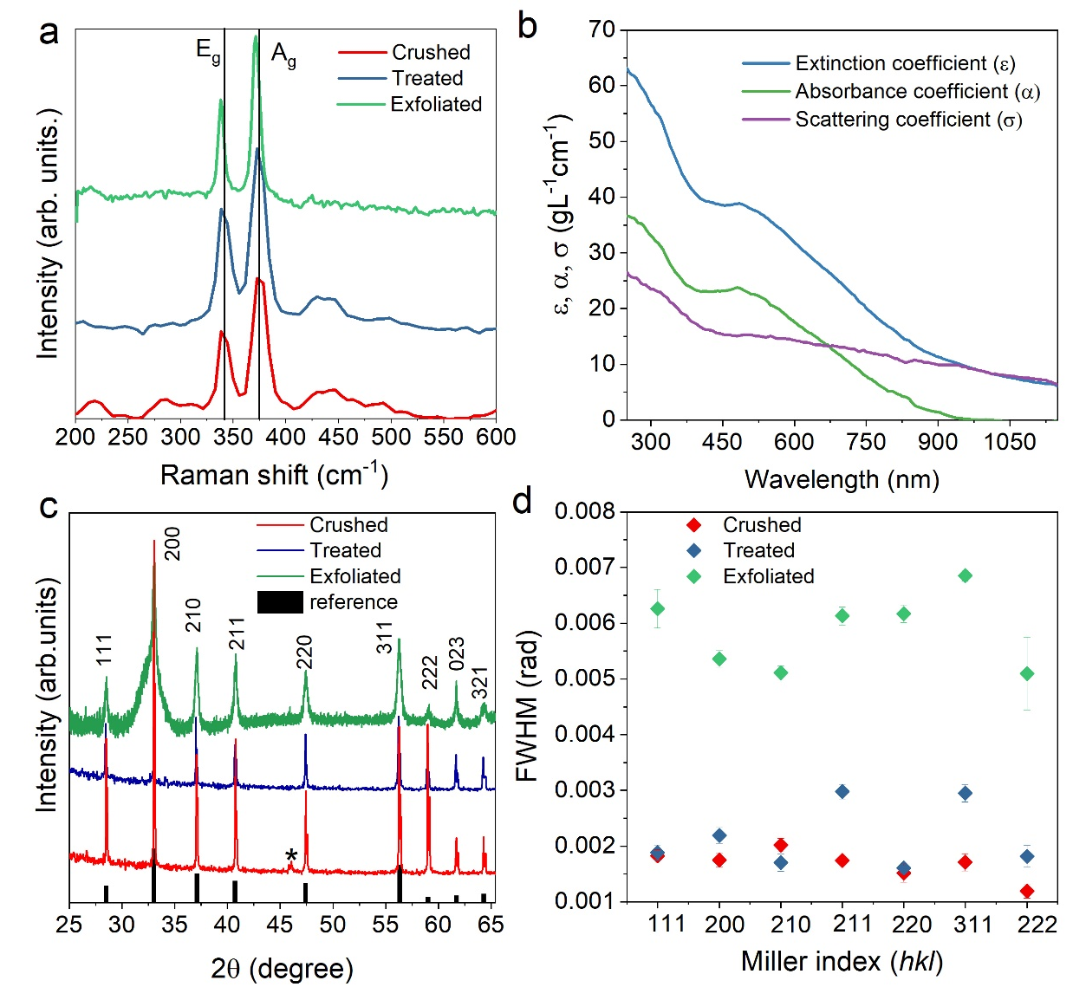
Figure 3: Optical spectroscopy and X-ray diffraction studies. (a) shows the Raman spectra of crushed, treated, and exfoliated pyrite. Two high intensity modes were assigned to the E_{g} and A_{g} vibrations of sulfur-dimer in pyrite. Vertical lines were drawn to clearly show the red shift in both the modes after exfoliation. (b) Extinction, absorption, and scattering coefficient spectra of the dispersion of pyrite. (c) shows the X-ray diffractogram of crushed, treated, and exfoliated pyrite. The atomic planes were assigned using the cubic crystal lattice structure of iron disulfide, space group: Pa̅3, JCPDS card no. 42-1340 (reference). (d) shows the full width at half maximum (β) of diffraction peaks of crushed, treated, and exfoliated pyrite for different miller indices. The diffraction peaks were fitted with Lorentzian line shape to extract the β.

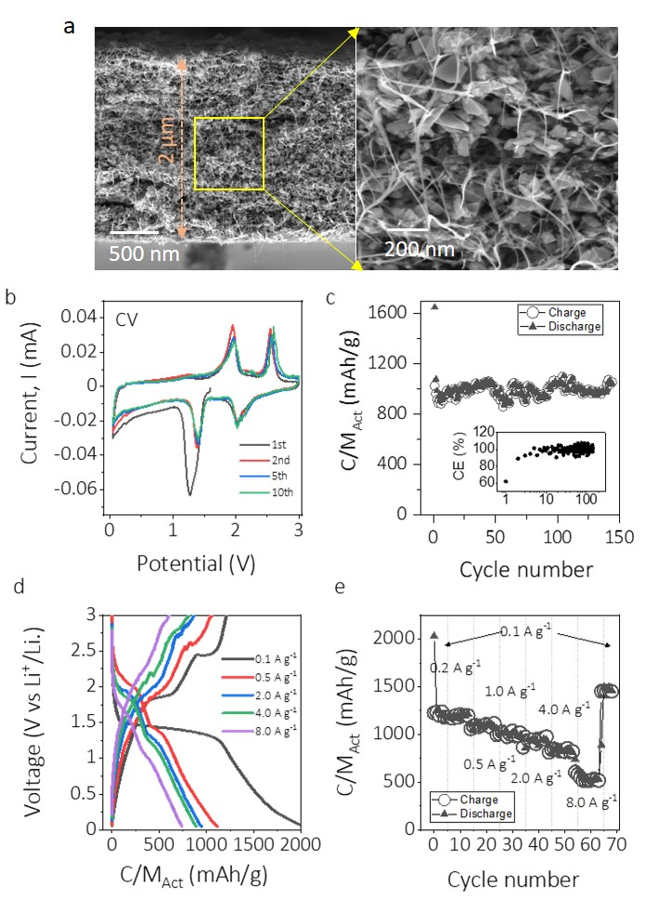
Figure 4. Performance of composites of natural FeS₂ nanosheet/SWCNT (25 wt.%) as lithium-ion battery anodes. (a) Cross-sectional SEM image of a composite of FeS₂ flakes/SWCNT (25 wt.%). (b) Cyclic voltammograms with a scan rate of 0.1 mV s⁻¹. (c) Specific capacity versus cycle number for an FeS₂/SWCNT electrode cycled at 4 A g⁻¹. Coulombic efficiency is shown in the inset. (d) Galvanostatic charge−discharge curves measured at different currents. (e) Capacity as a function of both discharge and charge current with Coulombic efficiency shown in the inset. Total electrode mass loadings were 0.4 mg cm⁻² (Active+CNT) and approximate thicknesses 2 μm.

ToC fig
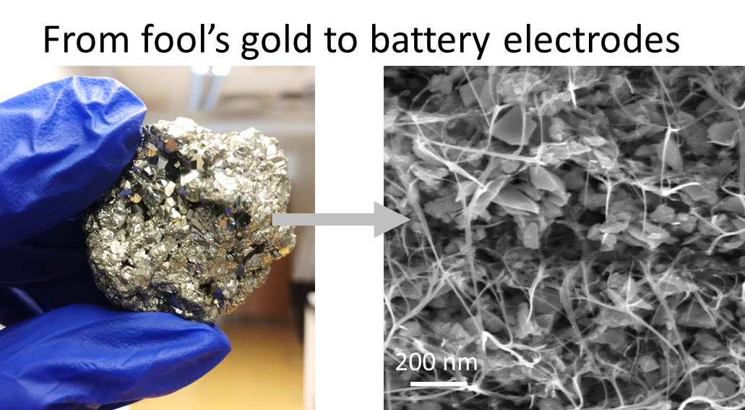

References
1. Nicolosi, V.; Chhowalla, M.; Kanatzidis, M. G.; Strano, M. S.; Coleman, J. N., Liquid exfoliation of layered materials. Science 2013, 340 (6139), 1226419.
2. Coleman, J. N., Liquid‐phase exfoliation of nanotubes and graphene. Advanced Functional Materials 2009, 19 (23), 3680-3695 %@ 1616-301X.
3. Huo, C.; Yan, Z.; Song, X.; Zeng, H., 2D materials via liquid exfoliation: a review on fabrication and applications. Science bulletin 2015, 60 (23), 1994-2008 %@ 2095-9273.
4. Backes, C.; Campi, D.; Szydlowska, B. M.; Synnatschke, K.; Ojala, E.; Rashvand, F.; Harvey, A.; Griffin, A.; Sofer, Z.; Marzari, N., Equipartition of energy defines the size–thickness relationship in liquid-exfoliated nanosheets. ACS nano 2019, 13 (6), 7050-7061 %@ 1936-0851.
5. Hernandez, Y.; Nicolosi, V.; Lotya, M.; Blighe, F. M.; Sun, Z.; De, S.; McGovern, I. T.; Holland, B.; Byrne, M.; Gun'Ko, Y. K., High-yield production of graphene by liquid-phase exfoliation of graphite. Nature nanotechnology 2008, 3 (9), 563-568 %@ 1748-3395.
6. Yasaei, P.; Kumar, B.; Foroozan, T.; Wang, C.; Asadi, M.; Tuschel, D.; Indacochea, J. E.; Klie, R. F.; Salehi‐Khojin, A., High‐quality black phosphorus atomic layers by liquid‐phase exfoliation. Advanced Materials 2015, 27 (11), 1887-1892 %@ 0935-9648.
7. Kaur, H.; Yadav, S.; Srivastava, A. K.; Singh, N.; Schneider, J. J.; Sinha, O. P.; Agrawal, V. V.; Srivastava, R., Large area fabrication of semiconducting phosphorene by Langmuir-Blodgett assembly. Scientific reports 2016, 6 (1), 1-8 %@ 2045-2322.
8. Boland, J. B.; Harvey, A.; Tian, R.; Hanlon, D.; Vega-Mayoral, V.; Szydlowska, B.; Griffin, A.; Stimpel-Lindner, T.; Jaskaniec, S.; Nicolosi, V., Liquid phase exfoliation of MoO 2 nanosheets for lithium ion battery applications. Nanoscale Advances 2019, 1 (4), 1560-1570.
9. Kalantar-zadeh, K.; Ou, J. Z.; Daeneke, T.; Mitchell, A.; Sasaki, T.; Fuhrer, M. S., Two dimensional and layered transition metal oxides. Applied Materials Today 2016, 5, 73-89 %@ 2352-9407.
10. Maleski, K.; Ren, C. E.; Zhao, M.-Q.; Anasori, B.; Gogotsi, Y., Size-dependent physical and electrochemical properties of two-dimensional MXene flakes. ACS applied materials & interfaces 2018, 10 (29), 24491-24498 %@ 1944-8244.
11. Mariano, M.; Mashtalir, O.; Antonio, F. Q.; Ryu, W.-H.; Deng, B.; Xia, F.; Gogotsi, Y.; Taylor, A. D., Solution-processed titanium carbide MXene films examined as highly transparent conductors. Nanoscale 2016, 8 (36), 16371-16378.
12. Frisenda, R.; Niu, Y.; Gant, P.; Munoz, M.; Castellanos-Gomez, A., Naturally occurring van der Waals materials. Npj 2d Materials and Applications 2020, 4 (1).
13. Molina-Mendoza, A. J.; Giovanelli, E.; Paz, W. S.; Angel Nino, M.; Island, J. O.; Evangeli, C.; Aballe, L.; Foerster, M.; van der Zant, H. S. J.; Rubio-Bollinger, G.; Agrait, N.; Palacios, J. J.; Perez, E. M.; Castellanos-Gomez, A., Franckeite as a naturally occurring van der Waals heterostructure. Nature Communications 2017, 8.
14. Niu, Y.; Villalva, J.; Frisenda, R.; Sanchez-Santolino, G.; Ruiz-Gonzalez, L.; Perez, E. M.; Garcia-Hernandez, M.; Burzuri, E.; Castellanos-Gomez, A., Mechanical and liquid phase exfoliation of cylindrite: a natural van derWaals superlattice with intrinsic magnetic interactions. 2d Materials 2019, 6 (3).
15. Savjani, N.; Lewis, E. A.; Pattrick, R. A. D.; Haigh, S. J.; O'Brien, P., MoS2 nanosheet production by the direct exfoliation of molybdenite minerals from several type-localities. Rsc Advances 2014, 4 (67), 35609-35613.
16. Selvaggio, G.; Chizhik, A.; Nissler, R.; Kuhlemann, I.; Meyer, D.; Vuong, L.; Preiss, H.; Herrmann, N.; Mann, F. A.; Lv, Z.; Oswald, T. A.; Spreinat, A.; Erpenbeck, L.; Grosshans, J.; Karius, V.; Janshoff, A.; Giraldo, J. P.; Kruss, S., Exfoliated near infrared fluorescent silicate nanosheets for (bio)photonics. Nature Communications 2020, 11 (1).
17. Balan, A. P.; Radhakrishnan, S.; Woellner, C. F.; Sinha, S. K.; Deng, L.; de Los Reyes, C.; Rao, B. M.; Paulose, M.; Neupane, R.; Apte, A., Exfoliation of a non-van der Waals material from iron ore hematite. Nature nanotechnology 2018, 13 (7), 602-609 %@ 1748-3395.
18. Guo, Y.; Gupta, A.; Gilliam, M. S.; Debnath, A.; Yousaf, A.; Saha, S.; Levin, M. D.; Green, A. A.; Singh, A. K.; Wang, Q. H., Exfoliation of boron carbide into ultrathin nanosheets. Nanoscale 2021, 13 (3), 1652-1662.
19. Kaur, H.; Tian, R.; Roy, A.; McCrystall, M.; Horvath, D. V.; Lozano Onrubia, G.; Smith, R.; Ruether, M.; Griffin, A.; Backes, C.; Nicolosi, V.; Coleman, J. N., Production of Quasi-2D Platelets of Nonlayered Iron Pyrite (FeS2) by Liquid-Phase Exfoliation for High Performance Battery Electrodes. ACS Nano 2020, 14 (10), 13418-13432.
20. Gilliam, M. S.; Yousaf, A.; Guo, Y.; Li, D. O.; Momenah, A.; Wang, Q. H.; Green, A. A., Evaluating the Exfoliation Efficiency of Quasi-2D Metal Diboride Nanosheets Using Hansen Solubility Parameters. Langmuir 2021, 37 (3), 1194-1205 %@ 0743-7463.
21. Liu, S.; Xie, L.; Qian, H.; Liu, G.; Zhong, H.; Zeng, H., Facile preparation of novel and active 2D nanosheets from non-layered and traditionally non-exfoliable earth-abundant materials. Journal of Materials Chemistry A 2019, 7 (25), 15411-15419.
22. Rickard, D., Pyrite: A natural history of fool's gold. Oxford University Press: 2015.
23. Arrouvel, C.; Eon, J.-G., Understanding the surfaces and crystal growth of pyrite FeS2. Materials Research 2019, 22 (1 %@ 1516-1439).
24. Paszkowicz, W.; Leiro, J. A., Rietveld refinement study of pyrite crystals. Journal of alloys and compounds 2005, 401 (1-2), 289-295 %@ 0925-8388.
25. Harvey, A.; Boland, J. B.; Godwin, I.; Kelly, A. G.; Szydłowska, B. M.; Murtaza, G.; Thomas, A.; Lewis, D. J.; O’Brien, P.; Coleman, J. N., Exploring the versatility of liquid phase exfoliation: producing 2D nanosheets from talcum powder, cat litter and beach sand. 2D Materials 2017, 4 (2), 025054 %@ 2053-1583.
26. Harvey, A.; He, X.; Godwin, I. J.; Backes, C.; McAteer, D.; Berner, N. C.; McEvoy, N.; Ferguson, A.; Shmeliov, A.; Lyons, M. E. G., Production of Ni (OH) 2 nanosheets by liquid phase exfoliation: from optical properties to electrochemical applications. Journal of Materials Chemistry A 2016, 4 (28), 11046-11059.
27. Backes, C.; Szydlowska, B. M.; Harvey, A.; Yuan, S.; Vega-Mayoral, V.; Davies, B. R.; Zhao, P.-l.; Hanlon, D.; Santos, E. J. G.; Katsnelson, M. I.; Blau, W. J.; Gadermaier, C.; Coleman, J. N., Production of Highly Monolayer Enriched Dispersions of Liquid-Exfoliated Nanosheets by Liquid Cascade Centrifugation. Acs Nano 2016, 10 (1), 1589-1601.
28. Vogt, H.; Chattopadhyay, T.; Stolz, H. J., Complete first-order Raman spectra of the pyrite structure compounds FeS2, MnS2 and SiP2. Journal of physics and chemistry of solids 1983, 44 (9), 869-873.
29. López, A.; Frost, R. L., Raman spectroscopy of pyrite in marble from Chillagoe, Queensland. Journal of Raman Spectroscopy 2015, 46 (10), 1033-1036 %@ 0377-0486.
30. Bryant, R. N.; Pasteris, J. D.; Fike, D. A., Variability in the Raman spectrum of unpolished growth and fracture surfaces of pyrite due to laser heating and crystal orientation. Applied spectroscopy 2018, 72 (1), 37-47.
31. Yang, C. C.; Li, S., Size-dependent Raman red shifts of semiconductor nanocrystals. The Journal of Physical Chemistry B 2008, 112 (45), 14193-14197 %@ 1520-6106.
32. Backes, C.; Smith, R. J.; McEvoy, N.; Berner, N. C.; McCloskey, D.; Nerl, H. C.; O’Neill, A.; King, P. J.; Higgins, T.; Hanlon, D., Edge and confinement effects allow in situ measurement of size and thickness of liquid-exfoliated nanosheets. Nature communications 2014, 5 (1), 1-10 %@ 2041-1723.
33. Harvey, A.; Backes, C.; Boland, J. B.; He, X.; Griffin, A.; Szydlowska, B.; Gabbett, C.; Donegan, J. F.; Coleman, J. N., Non-resonant light scattering in dispersions of 2D nanosheets. Nature Communications 2018, 9.
34. Holder, C. F.; Schaak, R. E., Tutorial on powder X-ray diffraction for characterizing nanoscale materials. ACS Publications: 2019.
35. Huh, S. H., X-ray diffraction of multi-layer graphenes: instant measurement and determination of the number of layers. Carbon 2014, 78, 617-621 %@ 0008-6223.
36. Wang, Y.; Cai, R.; Zhang, J.; Cui, J.; Qin, Y.; Zhang, Y.; Wu, J.; Chatterjee, K.; Ajayan, P. M.; Wu, Y., Directly Exfoliated Ultrathin Silicon Nanosheets for Enhanced Photocatalytic Hydrogen Production. The Journal of Physical Chemistry Letters 2020, 11 (20), 8668-8674 %@ 1948-7185.
37. Whittingham, M. S., Lithium Batteries and Cathode Materials. Chemical Reviews 2004, 104 (10), 4271-4302.
38. Zhu, Y.; Fan, X.; Suo, L.; Luo, C.; Gao, T.; Wang, C., Electrospun FeS2@Carbon Fiber Electrode as a High Energy Density Cathode for Rechargeable Lithium Batteries. ACS Nano 2016, 10 (1), 1529-1538.
39. Fan, H. H.; Li, H. H.; Huang, K. C.; Fan, C. Y.; Zhang, X. Y.; Wu, X. L.; Zhang, J. P., Metastable Marcasite-FeS2 as a New Anode Material for Lithium Ion Batteries: CNFs-Improved Lithiation/Delithiation Reversibility and Li-Storage Properties. Acs Applied Materials & Interfaces 2017, 9 (12), 10708-10716.
40. Zhang, S. S., The redox mechanism of FeS2 in non-aqueous electrolytes for lithium and sodium batteries. Journal of Materials Chemistry A 2015, 3 (15), 7689-7694.
41. Pan, G. X.; Cao, F.; Xia, X. H.; Zhang, Y. J., Exploring hierarchical FeS2/C composite nanotubes arrays as advanced cathode for lithium ion batteries. Journal of Power Sources 2016, 332, 383-388.
42. Zhang, S. S.; Tran, D. T., Mechanism and Solution for the Capacity Fading of Li/FeS2Battery. Journal of The Electrochemical Society 2016, 163 (5), A792-A797.
43. Xue, H.; Yu, D. Y. W.; Qing, J.; Yang, X.; Xu, J.; Li, Z.; Sun, M.; Kang, W.; Tang, Y.; Lee, C.-S., Pyrite FeS2 microspheres wrapped by reduced graphene oxide as high-performance lithium-ion battery anodes. Journal of Materials Chemistry A 2015, 3 (15), 7945-7949.
44. Tian, R.; Griffin, A.; McCrystall, M.; Breshears, M.; Harvey, A.; Gabbett, C.; Horváth, D. V.; Backes, C.; Jing, Y.; Heine, T.; Park, S.-H.; Coelho, J.; Nicolosi, V.; Nentwig, M.; Benndorf, C.; Oeckler, O.; Coleman, J. N., Liquid Exfoliated SnP3 Nanosheets for Very High Areal Capacity Lithium-Ion Batteries. Advanced Energy Materials 2021, 11 (4), 2002364.
45. He, J.; Li, Q.; Chen, Y.; Xu, C.; Zhou, K.; Wang, X.; Zhang, W.; Li, Y., Self-assembled cauliflower-like FeS2 anchored into graphene foam as free-standing anode for high-performance lithium-ion batteries. Carbon 2017, 114, 111-116.
46. Xu, Q.-T.; Li, J.-C.; Xue, H.-G.; Guo, S.-P., Effective combination of FeS2 microspheres and Fe3S4 microcubes with rGO as anode material for high-capacity and long-cycle lithium-ion batteries. Journal of Power Sources 2018, 396, 675-682.
47. Xu, Q.-T.; Xue, H.-G.; Guo, S.-P., FeS2 walnut-like microspheres wrapped with rGO as anode material for high-capacity and long-cycle lithium-ion batteries. Electrochimica Acta 2018, 292, 1-9.
48. Tian, R.; Breshears, M.; Horvath, D. V.; Coleman, J. N., The Rate Performance of Two-Dimensional Material-Based Battery Electrodes May Not Be as Good as Commonly Believed. ACS Nano 2020, 14 (3), 3129-3140.
49. Shon, J. K.; Lee, H. S.; Park, G. O.; Yoon, J.; Park, E.; Park, G. S.; Kong, S. S.; Jin, M.; Choi, J.-M.; Chang, H.; Doo, S.; Kim, J. M.; Yoon, W.-S.; Pak, C.; Kim, H.; Stucky, G. D., Discovery of abnormal lithium-storage sites in molybdenum dioxide electrodes. Nature Communications 2016, 7 (1), 11049.

