A spheroid model of early and late-stage osteosarcoma mimicking the divergent relationship between tumour elimination and bone regeneration.
Fiona E. Freeman, Ross Burdis, Olwyn R. Mahon, Daniel J. Kelly, and Natalie Artzi*

Supplementary Information

Supplementary Figure 1: Development of a 3D model of early and late-stage osteosarcoma. (A, B) Images and H&E staining of MSCs and SaOS2 spheroids 72 hours following seeding. (C) DNA content, (D) Average spheroid diameter, (E) ALP activity and (F) VEGF release. (G-L) mRNA levels of β-Catenin, MMP9, MMP2, SOX9, RUNX2, and ALP were analysed by qRT-PCR 72 hours post-seeding. All data is represented as means ± SD n=6 (25 spheroids per experimental replicate) for biochemical assays, n=3 (25 spheroids per experimental replicate) for PCR analysis. Statistical differences were assessed using one-way ANOVA with the addition of Tukey’s correction for multiple comparisons testing. *p < 0.05, **p < 0.01, ***p < 0.001, ****p < 0.0001.
Supplementary Figure 2: The cytotoxic effect of Doxorubicin on MSCs and SaOS2 cells was evaluated and the IC₅₀ was determined.
Supplementary Figure 3: Percentage Cell Survival normalised to Day 0 for (A) early-stage osteosarcoma and (B) late-stage Osteosarcoma.
Supplementary Table 1: Primer sequences
Gene | Forward | Reverse
TGFb3 | TGTTGAGAAGAGAGTCCAAC | ATCACCTCGTGAATGTTTTC
VEGF | GCAGAATCATCACGAAGTGGTG | TCTCGATTGGATGGCAGTAGCT
RunX2 | GCAGTATTTACAACAGAGGG | TCCCAAAAGAAGTTTTGCTG
Sox9 | CTCTGGAGACTTCTGAACG | AGATGTGCGTCTGCTC
Col1A | GCTATGAATGAGAAATCAACCG | TCATCTCCATTCTTTCCAGG
Supplementary Figure 4: Representative image of the gating strategy used for flow cytometry analysis.
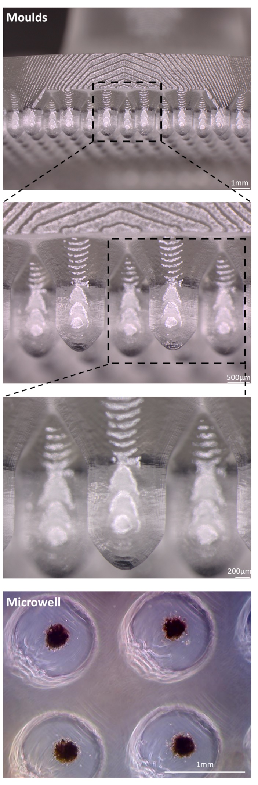
Supplementary Figure 5: Magnification images of microwell moulds and microwells formed.
Supplementary Figure 6: (A) Schematic of the cell ratios investigated. (B) Average spheroids area determined using imageJ (n=8). Two-way ANOVA was performed with the addition of Tukey’s correction for multiple comparisons testing. ALP activity following 5 days of culture (n=3). (C) One-way ANOVA was performed with the addition of Tukey’s correction for multiple comparisons testing. Error bars denote standard deviation.

