Module 2
Introduction to Cyberbullying
Conor Mc Guckin¹, Lucie Corcoran¹, Niall Crowley¹, Mona O’Moore¹, Juan Calmaestra², Rosario del Rey², Rosario Ortega² and Joaquín A. Mora-Merchán³
⁽¹⁾ Trinity College Dublin (Ireland)
⁽²⁾ University of Cordoba (Spain)
⁽³⁾ University of Seville (Spain)

Some Questions to Begin:
- How would you define cyberbullying (Try to capture it in one sentence)?
- What do you think the main differences are between cyberbullying and more traditional forms of bullying (such as physical or verbal bullying in school)?
- In what ways do you think cyberbullies can attack their victims?
- Does cyberbullying ever have serious effects on a victim? If so, how do you think cyberbullying affects children and adolescents?
- In what ways do children and adolescents try to cope with cyberbullying?

2.1 Summary
- Since the birth of the Internet a new form of bullying behaviour has emerged. Bullying has converged with the cyber world, producing the phenomenon we now call cyberbullying;
- Cyberbullying can be classified in two ways: by the channel through which the abuse occurs and by the nature of the abuse itself;
- Tactics used by cyberbullies to victimize their targets include bashing, harassment, denigration, exclusion, impersonation, flaming, trickery, outing, cyber stalking, and posing;
- It is thought that around 10% of children are involved in cyberbullying. This is based on European studies to date;
- Victims of cyberbullying express negative feelings such as rage and frustration with 10% of victims stating that they felt stressed by their experiences. Cyberbullying has also been linked to low self-esteem, loneliness, depression, difficulties with school functioning and in some cases has been a contributing factor in incidents of adolescent suicide.

2.2 Introduction
As discussed in Module 1, the last 15 years have seen changes in how we communicate with others which were previously unimaginable. The boom in the use of information and communication technologies (henceforth referred to as ICT’s) has created a whole new environment in which we can develop positive personal relationships.

For further information about the use of ICT’s by children and young people, please see Module 1: Introduction to New Media.

These changes have drastically altered the way in which adults communicate with each other, but they have had an even greater impact among those young enough to have grown up in an age dominated by ICT’s. Social Networks, Chats, Forums and SMS are all habitually used by adolescents to communicate with each other when face-to-face communication is not possible. Indeed, for some, these may be preferable to face-to-face communication.

On the other hand, bullying is evolving towards new forms of aggression. Its path has converged with that of the ICT's, producing the phenomenon we now call cyberbullying. A simple definition of cyberbullying is that it refers to bullying conducted through electronic communication devices, such as computers with Internet access or mobile phones. Recent advances include cell phones with ‘smart’ technology (e.g., the iPhone). Although cyberbullying is a relatively new issue, we have already gained a lot of insight into the problem through increased interest from researchers. Research has highlighted that cyberbullying has the potential for very serious repercussions for children who are victimized. Research, along with the media spotlight shining on a number of public cases of cyberbullying, which have lead to adolescent suicide, have made society more aware of this new phenomenon and have raised demands for preventative measures to be taken. This manual is intended as a step in that direction, with this Chapter providing an introduction to the phenomenon, its nature, patterns, potential impact and coping strategies.

For further information about bullying, please look at the webpage of The Anti-Bullying Centre and The Anti-Bullying Alliance which you can find in the section ‘Useful Websites’ at the end of this chapter.

2.3 Objectives and learning outcomes

The aim of this Chapter is to give you a good understanding of the nature of cyberbullying. This will be achieved by focusing on two major areas.

- Defining cyberbullying. It would be helpful for you to know what cyberbullying is, and to be aware of its nature and its peculiarities. Since the phenomenon has evolved recently, society is not yet fully familiar with it. With the continual advances in technology, the nature and definitions of cyberbullying are constantly being revised. This chapter is, therefore, intended to serve as an introduction. By the end of the chapter you should have a clear understanding of cyberbullying and the various methods used to cyberbully.

- Recognising the potential effects of cyberbullying. Cyberbullying is often perceived as a childish prank, or something which cannot cause its victims any real harm. Using examples, this chapter will also address the potential consequences of cyberbullying.

These objectives will be achieved by:
- Introducing you to the cyberbullying phenomenon;
- Addressing how cyberspace differs from the real world;
- Helping you to understand the various methods used to cyberbully;
- Raising awareness of how cyberbullying can affect children and adolescents.


Activity 2.1 ‘What is cyberbullying?’ is planned to help you to become familiar with the term cyberbullying and its meaning, the defining characteristics of it, and the ways in which it occurs.


Resource 2.1 - Video ‘Let’s fight it together’. A film on cyberbullying from Childnet International.

2.3.1 Activity 2.1 ‘What is cyberbullying?’

Activity 2.1 ‘What is cyberbullying?’

Before you begin to read this chapter, watch Resource 2.1 - Video ‘Let’s fight it together’ and try to answer the following questions:

What happened in the story?

What forms of cyberbullying were used?

What happened to Joe? And what happened to the bullies?

How did Joe feel?

How would Joe be affected by this - both in the short-term and in the long-term?

How would Joe have been affected in the short-term and long-term had the cyberbullying not been reported?

How do you think the bullies felt when the cyberbullying came to light?
- Would you have done something different if you were Joe's mother or father?

2.3.2 Resource 2.1 - Video ‘Let’s fight it together’

Resource 2.1 - Video ‘Let’s fight it together’
Created by: Childnet International http://www.childnet.com
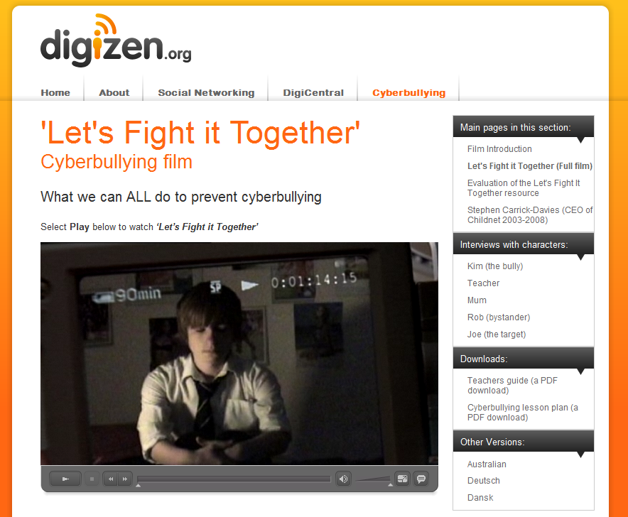
URL: http://old.digizen.org/cyberbullying/fullFilm.aspx

In addition please watch interviews with the various characters of the story:
Interview with Kim (the bully) - URL: http://old.digizen.org/cyberbullying/kim.aspx?video=l
Interview with the teacher - URL: http://old.digizen.org/cyberbullying/teacher.aspx
Interview with Mum - URL: http://old.digizen.org/cyberbullying/mum.aspx
Interview with Rob (the bystander) - URL: http://old.digizen.org/cyberbullying/rob.aspx

2.4 Summary of current knowledge and thinking

2.4.1 Bullying and Cyberbullying

2.4.1.2 Traditional bullying
Over the last 40 years, researchers have been studying the phenomenon described in the 1970's as ‘bullying’. Dan Olweus, who was the first researcher to carry out scientific research on bullying defines bullying in the following way ⁽¹⁾ -
We say a student is being bullied when another student, or a group of students:
- Say mean and unpleasant things or make fun of him or her or call him or her mean and hurtful names;
- Completely ignore or exclude him or her from their group of friends or leave him or her out of things on purpose;
- Hit, kick, push and shove around, or threaten him or her;
- Tell lies or false rumours about him or her or send mean notes and try to make other students dislike him or her;
- And things like that.

Most experts ⁽¹⁻⁴⁾ agree that in order for behaviour to constitute bullying, it must meet at least three conditions: (i) intention to cause harm to the victim, (ii) repetition of the abusive behaviour over a period of time, and (iii) an imbalance of power between the victim and bully/bullies. However, some experts argue that if severe enough, one instance of abuse can be deemed to constitute bullying especially if it serves to intimidate on an ongoing basis ⁽⁵⁾.

There are five main types of traditional bullying - physical, verbal, gesture, exclusion, and extortion. All forms of bullying are associated with the very real potential for psychological harm and impaired educational and social achievement. Bullying is often shrouded in secrecy which exacerbates the effects of the abuse and this is commonly referred to as the code of silence ⁽⁶⁾. The code of silence prevents the reporting of cases of bullying to adults through fear of how the perpetrators or the peer group may react. This ‘code’ is also present in an online environment as victims often fail to report abuse to their parents or teachers.
So why are some children singled out by bullies? O'Moore⁽⁵⁾ describes how bullies will choose a victim for any number of reasons, such as: speaking with a different accent; wearing different clothes; being a different religion; coming from another country; having a different social or economic background; having a learning difficulty; or being gifted. And if there is no reason, the bully will often invent one. Furthermore, she describes the characteristics of a child who is more likely to be victimized. These young people tend to display some of the following characteristics: an anxious, sensitive, shy, insecure and cautious temperament; few good friends; low self-esteem; a passive, non-aggressive, or non-assertive manner; an emotionally reactive manner; and clumsy behaviour when attempting to enter or join a peer group. On the other hand, the typical bully is described as having: a need to dominate others; low self-control; an impulsive nature; low anxiety; a tendency to blame the victim for their own bad behaviour; tough poise; a positive perception of aggression; a lack of sensitivity and empathy; a tendency towards other anti-social behaviour; a loud manner; and sometimes they have also been victims themselves. There is much disagreement as to the reasons why some children engage in bullying behaviour. O'Moore⁽⁵⁾ believes that bullying is an attempt to manipulate relationships with the aim of meeting one's psychological needs, e.g., desire to control, assertion of dominance, attention seeking, showing off, or improving one's social status.

Salmivalli and colleagues ⁽⁷⁾ investigated bullying behaviours within a group context. They took the perspective that bullying is a group process which also includes bystanders, and is not merely a relationship involving only the bully/bullies and the victim/victims. They identified six main roles, as follows: bully; victim; reinforcer (of the bully); assistant (of the bully); defender (of the victim); and outsider (who does nothing). This shows how bystanders can react in diverse ways and also highlights their importance in terms of how they can influence bullying. Research ⁽⁸⁾ carried out in 2004 indicated that children who held anti-bullying attitudes or expressed moral disapproval of bullying, were more likely to defend victims or to stay outside of bullying completely. By contrast children who displayed opposing attitudes were more likely to engage in bullying behaviour or to give support to bullies.

Bullying has been linked to a number of negative effects, both short-term and long-term. Irish-based research⁽⁹⁾ found that children in both primary and post-primary education who were involved in bullying behaviour as victims, bullies, or both had lower self-esteem compared with children who were uninvolved in bullying. Children who were both bullies and victims (bully-victims) displayed the lowest self-esteem of all groups. In addition, more frequent bullying or victimization was associated with lower self-esteem. Furthermore, research conducted in Finland indicated a higher prevalence of depression and suicidal ideation among both bullies and victims ⁽¹⁰⁾. Victims of bullying have also been linked with health problems. One study ⁽¹¹⁾ indicated that children who were victimized by bullies at the start of the school year were at greater risk of developing new health related symptoms during the school year, including depression, anxiety, bedwetting, abdominal pain, and feeling tense. These studies highlight the potential repercussions of bullying.

2.4.1.2 Cyberbullying
By contrast, cyberbullying is still a relatively new phenomenon and researchers have yet to reach a consensus on many aspects of this issue. Due to its unique nature, it has been necessary to provide a different definition for cyberbullying. The various communication channels, immediacy and the lack of face-to-face contact bring differential characteristics ⁽¹²⁾ to cyberbullying. Peter Smith and colleagues ⁽¹³⁾ define cyberbullying as an aggressive intentional act carried out by a group or individual, using electronic forms of contact, repeatedly and over time against a victim who cannot easily defend him/herself. Nancy Willard ⁽¹⁴⁻¹⁵⁾, focussing especially on the social dimension of the problem, considers that cyberbullying is being cruel to others by sending or posting harmful material or engaging in other forms of social cruelty using the Internet or other digital technologies. Bill Belsey ⁽¹⁶⁾ states that cyberbullying involves the use of ICT’s as a platform for intentional, repetitive, hostile conduct by a group or individual aimed at causing harm to others. More recently, cyberbullying has been defined in the following way by Tokunaga ⁽¹⁷⁾, who attempts to combine the main elements put forward by various definitions:

Cyberbullying is any behaviour performed through electronic or digital media by individuals or groups that repeatedly communicates hostile or aggressive messages intended to inflict harm or discomfort on others.

Cyberbullying is structured by a relational dynamic with at least two well defined roles: aggressor and victim. Although witnesses of cyberbullying may take on a type of bystander role, the characteristics of the various types of 'cyber bystander' requires further investigation. Research conducted in Canada ⁽¹⁸⁾ has indicated that witnesses of cyberbullying often react in diverse ways, with some bystanders joining in, some cheering on the cyberbully, others watching but not participating, some leaving the online environment, some objecting to others but not to the cyberbully, others objecting directly to the cyberbully, some trying to help or befriend the victim and others reporting to someone who might help. This is certainly indicative of the capacity of the bystander to help the target of cyberbullying, to do nothing, or to increase their suffering.

Unlike traditional bullying behaviour, the element of repetition takes a different form in cases of cyberbullying. For example, a cyberbully may post a humiliating video clip only once. However, each time it is viewed or posted elsewhere, it can be perceived as a repetition of the victimization ⁽¹⁹⁾.

Cyberbullying differs from traditional forms of bullying in a number of ways. For instance, the power imbalance in cyberbullying is not based on physical size and may be based more on superior technological skills or on the ability to conceal one's identity ⁽²⁰⁾. Technology also affords bullies the opportunity to harass a victim no matter where they are and no matter what time of the day or night it is ⁽²¹⁾. Therefore, cyberbullying transcends the limitations that the physical environment of the school places on traditional bullying. In cases of face-to-face bullying, a bully can often see the victim's reaction to an incident. However, in the cyber world this is rarely the case, and so a cyberbully may be detached from the victim and as a result will be less likely to feel guilt (Batheja, 2004 as cited by Raskauskas & Stoltz, 2007) ⁽²³⁾. Although there is a need to differentiate between bullying and cyberbullying, the behaviour is essentially the same in both cases, and this should become clear as you learn about the forms and the impact of cyberbullying.

2.4.2 Overlap between Bullying and Cyberbullying

There is abundant evidence demonstrating a close relationship between involvement, in the same role, in traditional forms of bullying and in cyberbullying ⁽²⁴⁻²⁷⁾. In other words, a child who is victimized in school is more likely to be victimized online. Over two thirds, for example of cyber-victims were found by O’Moore and Minton ⁽²¹⁾ to be traditional victims. Similarly two thirds of cyber-bullies were also traditional bullies.


You can find further information about the characteristics of bullying and cyberbullying in, Resource 2.2 'Differences and similarities between bullying and cyberbullying'.

2.4.2.1 Resource 2.2: ‘Differences and similarities between bullying and cyberbullying’

Resource 2.2: ‘Differences and similarities between traditional bullying and cyberbullying’
 | Bullying | Cyberbullying
Intentionality | The perpetrators act in a deliberate manner: spontaneous or casual acts are not considered cases of bullying. | The perpetrator must deliberately intend to harm or annoy the victim if a situation is to be described as a case of cyberbullying.
Repetition | If an individual’s behaviour is to be considered bullying it should occur more or less consistently over a period of time. However, if one incident is particularly severe it can be considered bullying provided that it serves to intimidate on an ongoing basis. | The repetition may be quantified in terms of the number of times a certain incident (e.g., image, video, text, web post, etc.) is sent, posted, or viewed.
Imbalance of power | A power imbalance, either real or imagined, is created between the victim and the perpetrator. This occurs whether the aggression is physical or psychological. | Cyberbullying also involves an imbalance of power. However, the imbalance could be a result of the bully’s superior skills with technology, or their ability to hide their true identity with their advanced computer skills or through the use of pseudonyms. The power imbalance can be caused by the fact that the victim does not know his/her bully, and therefore cannot locate the bully or defend him/herself against their attacks.
Number of bystanders | In some cases, only the bully/bullies and victim/victims are aware of an episode of bullying. At other times it is also known by the rest of the class, and on rare occasions, is known throughout the school. | This type of abuse may take two very different forms: actions open to public scrutiny, such as denigrating a victim in a video posted on the Internet, or private situations known only to the bully/bullies and the victim/victims, such as exchanges of emails or communication via instant messaging.
Anonymity | Generally, the victim knows the bully/bullies. Only with specific forms of bullying, such as spreading rumours, or damaging of personal belongings could a bully remain anonymous. | Some bullies are able to remain anonymous due to the ease with which one can conceal their identity in cyberspace. This can increase the bully’s sense of impunity and at the same time intensify the victim’s sense of vulnerability.
24/7 | In more ‘traditional’ forms of bullying, victims can only be subject to abuse during school hours or on the way to or from their school. This is due to the limited physical access a bully has to the victim. | A victim of cyberbullying can be targeted at any time of day or night and in virtually any location. Timetables and safe physical spaces are eliminated, and aggression can even occur during the school holidays. In other words, cyberbullying does not recognise the normal ‘physical’ boundaries of traditional forms of bullying.

2.4.3 Methods of Cyberbullying

Cyberbullying can be classified in two ways: by the medium/media through which the abuse occurs, such as SMS, MMS, phone calls, email, chat rooms, instant messaging, or websites (including social network sites such as Facebook and Twitter), and by the nature of the abuse itself, such as flaming, harassment, denigration, impersonation, outing, trickery, exclusion, cyber stalking, bashing, or posing. These methods of cyberbullying are presented in greater detail in Resources 2.4 - 2.11. It is important to remember that these classifications are provisional because they could vary in the future due to technological advances. For example, smart phones now allow users to surf the net as they would with a computer.

Resource 2.1 Video ‘Let’s fight it together’ provides an example of cyberbullying amongst students.

Resource 2.3 'Classification of cyberbullying' will help to familiarize you with the various methods used to cyberbully.

Resource 2.4 ' Lucy posts her holiday photos ' offers an example of impersonation and bashing.
Resources 2.5 - 2.11 are available at the end of the chapter under Additional resources.

2.4.3.1 Resource 2.3 - ‘Classifications of cyberbullying’

Resource 2.3 - ‘Classifications of cyberbullying’
By Media: (cp. Smith et al, 2008):
SMS: Sending or receiving abusive text messages by mobile phone;
MMS: Taking, sending or receiving unpleasant photos and/or videos using mobile phones (e.g., happy slapping);
Phone calls: Making or receiving upsetting phone calls (e.g., malicious prank calls);
Email: Malicious or threatening emails sent directly to a victim, or about a victim to others (See Resource 2.6 - Narrative 'Email to a girl') ;
Chat rooms: Intimidation or abuse when participating in chat rooms (See Resource 2.8 - 'Chatroom discussion') ;
Instant Message: Abusive instant messages (MSN, Yahoo, AIM, etc.) (See Resource 2.7 - Narrative 'Three girls chatting') ;
Websites: Where secret or personal details are revealed in an abusive way or where nasty or unpleasant comments are posted. May also involve uploading humiliating photos or videos on a webpage or posting degrading polls (See Resource 2.9 Narrative 'Critical comments on Facebook) .

By Behaviours: (cp. Willard, 2007):
Flaming: An intense, short-lived argument that often includes offensive, rude and vulgar language, insults, and sometimes threats. Flaming can occur via text or instant messaging, in blogs, on social networking sites, in chat rooms, discussion boards, or online gaming sites (See Resource 2.4 - 'Lucy posts her holiday photos') ;
Harassment: Repeatedly sending nasty, mean, and insulting messages (See Resource 2.9 Narrative 'Critical comments on Facebook') ;
Denigration: “Dissing” someone online. Sending or posting gossip or rumours about a victim to damage his or her reputation or friendships;
Impersonation: Pretending to be someone else and sending or posting material to get that person in trouble or danger or to damage that person’s reputation or friendships (See Resource 2.4: 'Lucy posts her holiday photos') ;
Outing: Disclosing secrets or personal and private information about the person that embarrasses or humiliates him/her. A common way to “out” someone is to forward a message from the target that contains intimate or personal information to others (See Resource 2.10 - Narrative ‘Pictures out of hand, out of reach’) ;
Trickery: Talking someone into revealing secrets or embarrassing information, then sharing it online (See Resource 2.5 – Narrative 'Broken promises') ;
Exclusion: Intentionally and cruelly excluding someone from an online group. Being excluded from participating in online activities with their peers, which can bring on feelings of rejection (See Resource 2.11 – 'Narrative Social exclusion in virtual world') ;
Cyber stalking: Repeated, intense harassment and denigration that includes threats or creates significant fear (See Resource 2.4: 'Lucy posts her holiday photos') ;

Bashing and Posing are also terms which are used to describe forms of cyberbullying.
Bashing – Using the Internet or a mobile phone to commit direct verbal or visual attacks at any time. Cyberbullies may post comments on blogs or send text messages from a phone. They may also take photos of targets or steal a photo from an online source to alter images in demeaning ways or add derogatory comments and post them online for others to see. One particular trend (happy slapping) is the videoing of students being beaten, which are then uploaded online (See Resource 2.4: 'Lucy posts her holiday photos', Resources 2.6 Narrative 'Email to a girl', and 2.7 'Three girls chatting', and 2.8 'Chatroom discussion') ;
Posing – A form of indirect attack where a cyberbully creates online content pretending to be the target. Alternatively they might use the target’s user access information to engage in abuse, such as, posting defamatory comments. When the cyberbully pretends to be the target and says mean things about the target’s friends, it can cause those friends to reject them (See Resource 2.4: Lucy posts her holiday photos) .

2.4.3.2 Resource 2.4: Lucy posts her holiday photos

Resource 2.4: Lucy posts her holiday photos

Example of impersonation and bashing

Lucy is a 16 year old girl who went on a holiday to a marvellous beach resort in Andalusia with her friends. When she got back, she decided to post the photos from her holiday on the web page of her social network so that her other friends could see what a good time they had. She uploaded pictures of her sightseeing, her parties in the evening and her days on the beach. A few weeks later she began to find herself in strange situations. Men she didn’t know greeted her in the street and made comments about her. They said she was prettier with fewer clothes and things like that. Some of them even made sexual advances.

A few days later she began to receive similar comments at school. Lucy was very surprised. She didn’t understand why all this was happening and she began to get very worried. One of her friends asked her why she had posted her photos on a contacts page on the Internet. Lucy told her she knew nothing about that, and she asked her friend to give her the Internet address where she had seen her pictures.

When she went onto the page she discovered the photos of herself in her swimsuit which she had posted on her social network site, but they were alongside comments about what she liked, what she didn't like and how she was looking for relationships with anyone who might be interested. Lucy couldn’t believe what she was reading. Someone had posted her photos on that site. It was horrible. Lucy could find no explanation. She had disabled the photo download option on her social network site. Nobody could download her photos. Lucy then logged onto her social network account and started to leave insulting, derogatory messages on all her friends’ pages. She was furious about what was happening to her.

After writing the messages she saw that she had received a private message from a stranger called Blue Air, thanking her for the marvellous beach photos. She then realized that it had not been her friends who had posted her photos on the other site, and she regretted the comments she had written. But it was too late. Her messages had been sent and now she couldn’t edit them. Lucy’s friends turned their backs on her for all the insults she had sent them, and, even though she tried to apologize, her words were still there on the social network pages. Every time her friends saw them they got angry with her again.

And how did Blue Air get the photos? Easy: Lucy had her social network page configured to allow anyone to see its content. Blue Air saw her profile and decided to download her photos. Although Lucy had the download option in her account disabled so that nobody could download her photos, there are still many easy ways to access and save images accessible to anyone with a good knowledge of computers.

2.5 Some data about cyberbullying

2.5.1 How many children are involved in cyberbullying?
Several studies have investigated the number of children and adolescents who are involved in cyberbullying, as a bully or victim. However, findings differ from one piece of research to the next due to variations, such as, the changing nature of the cyberbullying phenomenon (media used etc.), and how the research was conducted (different definitions used, different sample sizes, age groups studied, instruments used to measure bullying behaviour, cultural differences, etc.). Despite such differences, researchers are working hard to reach a consensus on these issues (e.g., the work being done in COST IS0801 Cyberbullying: coping with negative and enhancing positive uses of new technologies, in relationships in educational settings). The prevalence of victimization through cyberbullying has been very wide ranging in Europe, with percentages fluctuating between 1% and 50%. In most studies, however, and with a small number of exceptions, prevalence found has been around 10% ^{(19-20, 24, 26-40)}. However, there is some evidence that this trend is on the increase.

A recent study conducted across 25 countries in Europe - ‘EU Kids Online’ ⁽⁴¹⁾ investigated children’s experiences of bully-victim problems in the previous year. A total of 25,142 children between the ages of 9 and 16 who use the Internet along with one of their parents were interviewed. The research indicated that 13% of 9 to 16 year olds had suffered bullying in a face-to-face (f2f) environment, whereas 6% were bullied on the Internet and 3% were bullied using mobile phones. Further findings indicate that:
- A total of 10% of children surveyed admitted that they had engaged in bullying others in an f2f environment, whereas 3% had abused someone online and 2% had done so via mobile phones.
- When focusing on those children who reported receiving nasty or hurtful messages on the Internet, 29% of their parents reported that the child had been cyberbullied. However, the majority of these parents reported that the child had not been bullied online and 15% said they did not know whether their child had been cyberbullied.
- The parents with the greatest awareness of their child’s victimization were those who were either parents of a girl, or a child aged between 11 and 14 years.
- Of those children who had been bullied online, the majority (77%) talked to somebody about the experience, with 52% reporting that they talked to a friend about it, and 42% reporting that they told a parent what had happened.
- Children who had suffered online bullying reported various feelings regarding the incident. However, 85% of victims were upset by the episode.

2.5.2 Further information
The percentages victimized by bullying both online and offline across European countries as reported by the EU Kids Online report are displayed in Resource 2.12 'Prevalence of online and offline bullying in Europe'.

Resource 2.13 - ‘Cyberbullying in Europe: Research’ provides an overview of the situation in the partner countries of the CyberTraining project - Germany, Ireland, Spain, Portugal, and the UK. (These resources are only available in English).

Resource 2.14 - ‘Transnational comparative analysis: The situation in Europe (English)’ will also provide some insight into the bullying problem in Europe.
Resource 2.15 - ‘Cyberbullying: A cross-national comparison’ can also be availed of to provide an overview of cyberbullying research in 16 countries.

2.5.2.1 Resource 2.12 - ‘Prevalence of online and offline bullying in Europe’ (EU Kids Online report)

Resource 2.12 - ‘Prevalence of online and offline bullying in Europe’ (EU Kids Online report)

2.5.2.2 Resource 2.13 - ‘Cyberbullying in Europe: Research’

Resource 2.13 - ‘Cyberbullying in Europe: Research’
‘Cyberbullying in Europe: Research’ provides an overview of the situation in the partner countries of the CyberTraining project (http://www.cybertraining-project.org/) - Germany, Ireland, Spain, Portugal, and the UK. (These resources are only available in English).

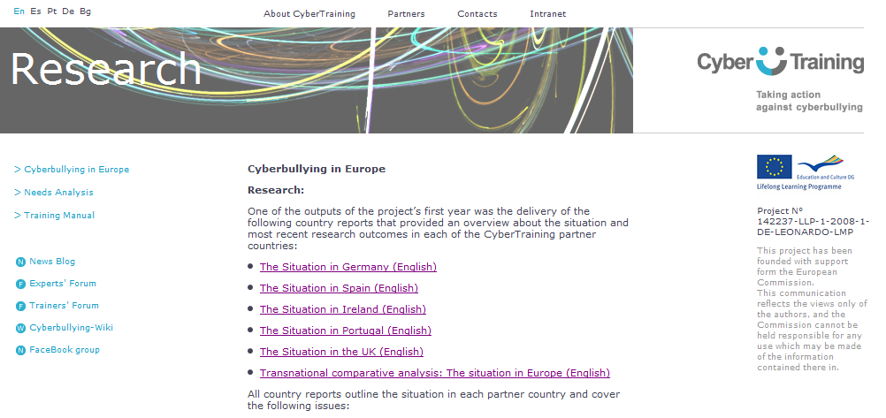

Created by: The CyberTraining project http://www.cybertraining-project.org/
URL: http://www.cybertraining-project.org/page.php?lang=En&page=8

2.5.2.3 Resource 2.14 - ‘Transnational comparative analysis: The situation in Europe (English)’

Resource 2.14 - ‘Transnational comparative analysis: The situation in Europe (English)’
‘Transnational comparative analysis: The situation in Europe (English)’ will also provide some insight into the bullying problem in Europe.
Created by: The CyberTraining project http://www.cybertraining-project.org/

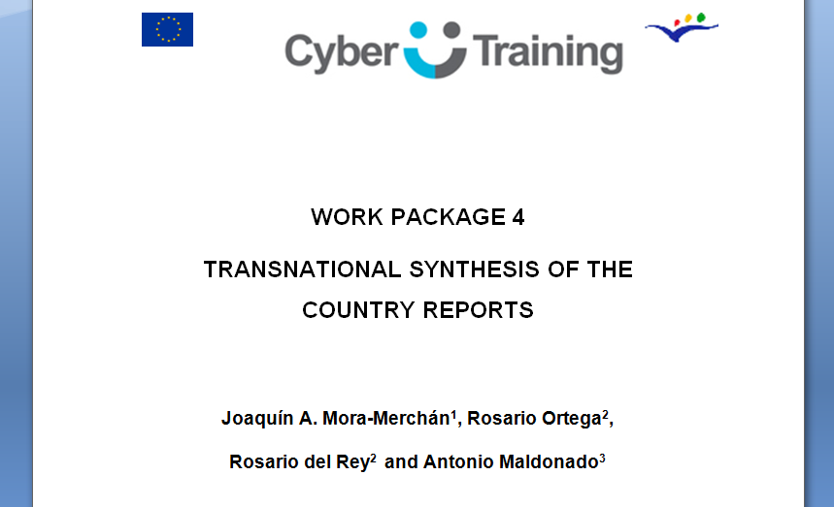

URL: http://cybertraining-project.org/reports/Transnational%20comparative%20analysis%20The%20situation%20in%20Europe.doc

2.5.2.4 Resource 2.15 - ‘Cyberbullying: A cross-national Comparison'

Resource 2.15 - ‘Cyberbullying: A cross-national Comparison'
‘Cyberbullying: A cross-national comparison’ (http://www.alphagalileo.org/ViewItem.aspx?ItemId=98996&CultureCode=en) can be availed of to provide an overview of cyberbullying research in 16 countries.
URL: http://www.alphagalileo.org/ViewItem.aspx?ItemId=98996&CultureCode=en

2.6 Factors which may Contribute to Cyberbullying Experiences

Some research has investigated the impact of parental mediation on experiences of cyber victimization. One study ⁽⁴²⁾ indicated that parental monitoring, with an emphasis on which Websites a child is allowed to access was an effective protection strategy against cyberbullying. It was also suggested that cyber victimization was associated with having an active profile on a social network site, participation in public chat rooms, and participation on YouTube and yet victimization was not associated with playing games online. Cybervictims were also linked to greater use of the Internet and mobile phones and were also more likely to disclose personal information in cyberspace. Other research ⁽⁴³⁾ indicated that children who had poor parental relationships, involving a lot of conflict (in the case of girls) and poor communication (in the case of boys), were more commonly engaging in intimate online friendships. These intimate relationships could leave adolescents open to exploitation.

Whilst a number of studies suggest that girls tend to be cyber victims more often than boys ^{(24, 28, 32, 44)}, some have found either no difference between sexes ⁽⁴⁵⁻⁴⁶⁾ or that, on the contrary, boys are more involved than girls ⁽²⁶⁾. Therefore, there is little clarity so far in relation to gender differences.

With regard to the age of victims, the importance of this factor is not clear at present. Prevalence levels seem to remain stable during adolescence before declining from the age of 16 onwards ^{(19, 36)}. However, the EU Kids Online research ⁽⁴¹⁾ which is the most comprehensive overview of cyberbullying in Europe to date, indicates that being bullied online is more common among older children. One researcher ⁽¹⁷⁾ claims that cyberbullying can occur at any age but that those aged 12 to 14 may be at greater risk. There is a real concern that cyberbullying will begin to emerge even earlier due to the fact that children are now using mobile phones and the Internet at such a young age (as highlighted in Chapter 1) .

2.7 Impact of Cyberbullying

Opinions are mixed as to whether cyberbullying is as harmful as, or indeed more harmful than, traditional forms of bullying. Research carried out in the UK ⁽¹³⁾ indicated that young people feel that the impact of cyberbullying depends on the method used to cyberbully. For instance, children reported that humiliating photos, videos, and nasty phone calls were more damaging than traditional forms of bullying. They considered abuse on a web page or a nasty text message to be equally as harmful as traditional forms of bullying. However, cyberbullying via chat rooms, emails and instant messaging were deemed to be less harmful than traditional bullying. Regardless of which type of bullying is ‘worse,’ experts agree that cyberbullying can have tremendously damaging effects on children regardless of whether they are a bully or a victim.

Research has linked victims of cyberbullying with poor self-esteem, feelings of frustration, anger, sadness, hopelessness, loneliness and depression, with some victims expressing an inability to concentrate at school, and others feeling that they are forced to stay offline ⁽⁴⁶⁻⁴⁸⁾. Victims also often feel suspicious of others, as they are unaware of the identity of the bully ⁽⁴⁹⁾. Other studies indicate a link between suicidal thoughts and behaviours and cyber victimization. Recent research ⁽⁴⁴⁾ found that involvement in cyberbullying, either as a bully or a victim was linked to increased likelihood of suicidal ideation. However, victimization was more likely to predict suicidal thoughts and behaviours than perpetration. Cyber victimization has also been linked to increased likelihood of self-harm ⁽⁵³⁾.

In the short time since the emergence of cyberbullying, there have already been a number of suicides linked to cyber victimization. These cases of “cybercide” are explored in resources 2.18 - 2.19. However, it should be remembered that these are extreme and rare occurrences. Ongoing cyber victimization has more potential for long-term problems and more severe cases of cyberbullying are more strongly associated with poor mental health and social difficulties ⁽¹⁷⁾.

Activity 2.2 ‘Cyberbullying isn’t a game’ aims to generate some reflection on the potential impact of cyberbullying, highlighting the fact that cyberbullying is “not merely a childish prank.”

2.7.1 Activity 2.2 - ‘Cyberbullying isn’t a game’

Activity 2.2 - ‘Cyberbullying isn’t a game’
Purpose
Many people underestimate the potential for harm in relation to cyberbullying. However, cyberbullying can have far-reaching effects. In this activity we would like you to think about the consequences of cyberbullying.
Resources
Resource 2.16 - Video ‘Polish Spot: Cyberbullying'
Resource 2.17 - ‘Guide for discussing the story’
In addition to these resources you can also use Resource 2.18 – ‘A Cyberbullying Suicide Story - Ryan Halligan age 13’ or Resource 2.19 – ‘Israeli teen kills himself following Facebook chat’

Procedure
Watch the video ‘Polish Spot: Cyberbullying' and discuss it in terms of the impact it has on the victim. Now reflect in your team about the effects of cyberbullying on Dominika and other children like her who suffer cyberbullying (for this you could use the guide that we propose: Resource 2.17).

Note: Cases of suicide following cyberbullying are extremely rare.

2.7.2 Resource 2.16 - Video ‘Polish Spot: Cyberbullying'.

Resource 2.16 - Video ‘Polish Spot: Cyberbullying'.
Provided by: Klicksafe
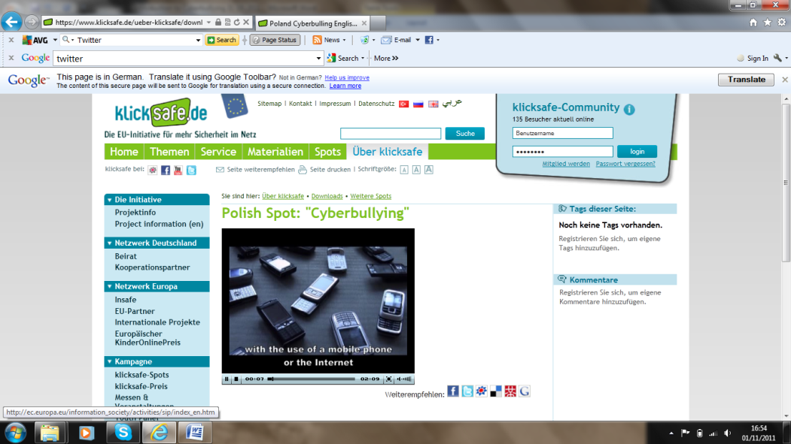

URL: www.klicksafe.de/ueber-klicksafe/downloads/weitere-spots/poland-cyberbulling-englisch.html

2.7.3 Resource 2.17 - ‘Guide for discussing the story’

Resource 2.17 - ‘Guide for discussing the story’

The session organizer should facilitate the discussion by posing the following questions:

Has this video affected your perception of cyberbullying?

Did you think cyberbullying could have serious consequences?

How would you have reacted as Dominika's parent?

Do you think there was something Dominika could have done to counteract the abuse?

Did anything else strike you while watching this video?

2.8 Coping with Cyberbullying

A number of studies have investigated how young people attempt to cope with cyber victimization. One researcher ⁽¹⁷⁾ has highlighted that victims often use technological coping strategies to prevent further bullying, such as strict privacy settings, changing usernames or email addresses. However, little is known about the effectiveness of these strategies. Passive reactions are also sometimes employed, such as ignoring the cyberbully. It has also been suggested that approximately 15-35% of victims confront cyberbullies and request that they stop their behaviour, and this is sometimes combined with the threat of telling an adult. However, it is rare that victims do inform an adult as some youths consider seeking help from a parent as a reaction used by 'kids'. It has also been suggested that adolescents do not tell an adult about their victimization because they feel that they "need to learn to deal with it themselves" or that they are worried that parents might restrict their Internet access ⁽⁵¹⁾.
Researchers in Germany ⁽⁴⁶⁾ have identified four coping strategies employed by cybervictims:
- Aggressive coping: e.g., "I threaten to beat him/her up";
- Helpless coping: e.g., "I don't know what to do";
- Cognitive coping: Victims do not seek help from stronger individuals and do not resort to aggression, but try to address the problem themselves, using a diplomatic approach. They attempt to reason with the bully or to understand the bully's motive;
- Technical coping: e.g., "I switch off my computer," "I change my email address or nickname and only give them to people I can trust," and "I show the messages to a grown-up."

In the USA researchers ⁽⁵⁴⁾ also identified different coping strategies that could be used in response to cyber victimization. High school students were interviewed about the different ways that a cybervictim could cope with the bullying. Three types of response emerged from the interviews: Reactive coping; Preventive coping; and No way to prevent cyberbullying. Reactive coping was broken down into four sub-categories: Avoidance; Acceptance; Justification; Seeking social support. Preventive coping also included two sub-types: Talk in person; and Increased security and awareness.

Avoidance referred to avoiding the cyberbully or the cyberbullying situation, with the aim of protecting oneself from the negative effects. Examples of avoidance coping include deleting messages, blocking contact, or ignoring the problem completely. Acceptance involves accepting cyberbullying as part of life and concentrating on the positive. Justification refers to coping methods where the victim focuses on reasons why the cyberbullying should not upset them. These students often felt that cyberbullying (as opposed to face-to-face bullying) should not be taken seriously, e.g., because it showed a lack of courage. Seeking social support refers to looking to others for help and includes getting advice from others, and asking someone with authority to put a stop to the bullying. Students could seek social support from a variety of people, including other students, parents, or police.

In terms of preventive coping strategies, students were discussing ways of reducing the chance of being victimized. Talk in person was a coping strategy which required students to talk to someone in person, as opposed to talking in cyberspace. This would help them to avoid misperceptions due to lack of intonation, something which can often occur in cyberspace. For example, sarcastic comments are sometimes misinterpreted due to the lack of intonation, which can then trigger an aggressive response. Students can also prevent an argument from descending into cyberbullying by discussing the issue in person. Increased security and awareness is a coping strategy whereby cyberbullying can be prevented if students take safety precautions (e.g., protect their password, limit how much personal identifying information they share) and have general awareness about security (e.g., knowing which websites might be unsafe).

Finally, some students felt that there was no way to prevent cyberbullying. These students believed that it was too easy for cyberbullies to continue the bullying. Further research is required to reach a consensus on the most effective coping methods.

2.9 Cyberbullying and the law
In some instances, very severe cases of cyberbullying have led to perpetrators facing prosecution
(e.g., the trials of Phoebe Prince's bullies - http://en.wikipedia.org/wiki/Suicide_of_Phoebe_Prince). Indeed, there have also been efforts to create legislation which directly addresses cyberbullying (e.g., see http://www.ibls.com/internet_law_news_portal_view.aspx?id=2095&s=latestnews). Although there is currently no such legislation in Ireland, there is existing legislation which indirectly addresses specific cyberbullying behaviours.

An overview of the relevant Irish laws is provided in Resource 2.20 - ‘Cyberbullying and the Law in Ireland.’

2.9.1 Resource 2.20 - ‘Cyberbullying and the Law in Ireland.’

Resource 2.20 - ‘Cyberbullying and the Law in Ireland.’

a. Criminal Damage Act, 1991:
Section 5(1) deals with the unauthorised accessing of data:
A person who without lawful excuse operates a computer
(a) within the State with intent to access any data kept either within or outside the State, or
(b) outside the State with intent to access any data kept within the State,
shall, whether or not he accesses any data, be guilty of an offence. On summary conviction, that person can be imprisoned, fined or both.

b. Non-Fatal Offences Against the Person Act, 1997:
Section 10(1) says that:
Any person who, without lawful authority or reasonable excuse, by any means including by use of the telephone, harasses another by persistently following, watching, pestering, besetting or communicating with him or her, shall be guilty of an offence.
Section 10(2) says that a person harasses another when:
(a) he or she, by his or her acts intentionally or recklessly, seriously interferes with the other's peace and privacy or causes alarm, distress or harm to the other, and
(b) his or her acts are such that a reasonable person would realise that the acts would seriously interfere with the other's peace and privacy or cause alarm, distress or harm to the other.
As well as imprisonment, a fine or both, whether on summary conviction or conviction on indictment, a court may also, or as an alternative, order under section 10(3):
that the person shall not, for such period as the court may, specify, communicate by any means with the other person or that the person shall not approach within such distance as the court shall specify of the place of residence or employment of the other person.

c. Post Office Amendment Act, 1951:
Section 13 (1) of this Act, has been amended a number of times, including by the Communications Regulation (Amendment) Act 2007, Part 2. It now says that:
Any person who
(a) sends by telephone any message that is grossly offensive, or is indecent, obscene or menacing
or
(b) for the purpose of causing annoyance, inconvenience, or needless anxiety to another person
(i) sends by telephone any message that the sender knows to be false, or
(ii) persistently makes telephone calls to another person without reasonable cause,
commits an offence.
On summary conviction or conviction on indictment, that person can be imprisoned, fined or both.

Further information is provided at the end of the module. This includes the following resources:
- Resource 2.3 - ‘Differences and similarities between bullying and cyberbullying’;
- Resource 2.5 – Narrative ‘Broken promises’;
- Resource 2.6 - Narrative ‘Email to a girl’;
- Resource 2.7 – Narrative ‘Three girls chatting’;
- Resource 2.8 - Narrative ‘Chatroom discussion’;
- Resource 2.9 - Narrative ‘Critical comments on Facebook’;
- Resource 2.10 - Narrative ‘Pictures out of hand, out of reach’;
- Resource 2.11 – Narrative ’Social exclusion in virtual world’;
- Resource 2.12 - ‘Prevalence of online and offline bullying in Europe’ (EU Kids Online report);
- Resource 2.13 - ‘Cyberbullying in Europe: Research’;
- Resource 2.14 - ‘Transnational comparative analysis: The situation in Europe (English)’;
- Resource 2.15 - ‘Cyberbullying: A cross-national Comparison';
- Resource 2.18 - 'A Cyberbullying Suicide Story -- Ryan Halligan age 13';
- Resource 2.19 - ‘Israeli teen kills himself following Facebook chat’

2.10 Conclusion

This chapter has highlighted the fact that there are five main types of traditional bullying, including physical, verbal, gesture, exclusion, and extortion. Cyberbullying is any behaviour performed through electronic or digital media by individuals or groups that repeatedly communicates hostile or aggressive messages intended to inflict harm or discomfort on others. Cyberbullying can be classified in two ways: by the medium/media through which the abuse occurs, such as SMS, MMS, phone calls, email, chat rooms, instant messaging, or websites, and by the nature of the abuse itself, such as flaming, harassment, denigration, impersonation, outing, trickery, exclusion, cyber stalking, bashing, or posing. The prevalence of cyber victimization in Europe is estimated to be around 10%. Cyber victimization has been linked to negative outcomes such as: low self-esteem; loneliness and depression; and decreased ability to concentrate at school. Research has indicated that children and adolescents use a variety of coping strategies following a cyberbullying incident. However, it is vital that parents play an active role in guiding their children's online behaviour and help them to prevent and counter risk. The next chapter will give advice on how parents can address cyberbullying with a number of strategies.

Go back to the questions at the very start of this chapter. How would you answer these questions now?

2.11 Activities
Overview
Activity 2.1 ‘What is cyberbullying?’ is planned to help you to become familiar with the term cyberbullying and its meaning, the defining characteristics of it, and the ways in which it occurs.
Activity 2.2 ‘Cyberbullying isn’t a game’ aims to generate some reflection on the potential impact of cyberbullying, highlighting the fact that cyberbullying is “not merely a childish prank.”

2.12 Resources
The following resources provide further information and examples regarding the topics within the module. Use these to research the relevant themes found in this module interactively, independently and in more detail.

Overview
Resource 2.1 - Video ‘Let’s fight it together’. A film on cyberbullying from Childnet International.
Resource 2.2 - 'Differences and similarities between bullying and cyberbullying'. Further information about the characteristics of bullying and cyberbullying.
Resource 2.3 'Classification of cyberbullying' will help to familiarize you with the various methods used to cyberbully.
Resource 2.4 ' Lucy posts her holiday photos ' offers an example of impersonation and bashing.
Resource 2.5 - Narrative ‘Broken promises’

Resource 2.6 – Narrative ‘Email to a girl’
Resource 2.7 - Narrative ‘Three girls chatting’
Resource 2.8 - Narrative ‘Broken discussion
Resource 2.9 - Narrative ‘Critical comments on Facebook’

Resource 2.10 - Narrative ‘Pictures out of hand, out of reach’
Resource 2.11 - Narrative ’Social exclusion in virtual world’
Resource 2.12 'Prevalence of online and offline bullying in Europe'. The percentages victimized by bullying both online and offline across European countries as reported by the EU Kids Online report.

Resource 2.13 - ‘Cyberbullying in Europe: Research’ provides an overview of the situation in the partner countries of the CyberTraining project - Germany, Ireland, Spain, Portugal, and the UK. (These resources are only available in English).

Resource 2.14 - ‘Transnational comparative analysis: The situation in Europe (English)’ will also provide some insight into the bullying problem in Europe.
Resource 2.15 - ‘Cyberbullying: A cross-national comparison’ can also be availed of to provide an overview of cyberbullying research in 16 countries.
Resource 2.16 - Video ‘Polish Spot: Cyberbullying' . A video on cyberbullying.
Resource 2.17 - ‘Guide for discussing the story’ . Questions related to ‘Polish Spot: Cyberbullying‘.
Resource 2.18 - 'A Cyberbullying Suicide Story -- Ryan Halligan age 13'
Resource 2.19 - ‘Israeli teen kills himself following Facebook chat’

2.13 Additional resources

2.13.1 Resource 2.5 - Narrative ‘Broken promises’

Resource 2.5 – Narrative ‘Broken promises’
Example of trickery

15 year old ‘Sarah’ was sitting in front of her computer at home, chatting with her boyfriend ‘Tom’. He asked her to undress in front of the web camera; he would like to watch her. Tom promised her he was alone, and that he would not record it. She went along with it.

It turned out that Tom was not alone though; he was sitting by his computer together with his friend ‘Byron’. Tom and Byron watched Sarah’s webcam session, and Tom also broke his other promise to his girlfriend, as he recorded Sarah’s act.

Tom then published the video on Internet.

The video clip of Sarah undressing in front of her webcam spread like wild-fire among the youngsters in their hometown. Sarah was considered ‘loose’ and called a bitch. Many of the teens argued that she was the one to blame because she should have known better.

Sarah needed professional help from psychiatrists to handle this. She changed her name, and the family decided to move to another part of the country in order to enable her to start over again. Her boyfriend’s request, broken promises and fatal publishing, in addition to her peers’ judgement, left her with emotional scars for life.

2.13.2 Resource 2.6 – Narrative ‘Email to a girl’

Resource 2.6 - Narrative ‘Email to a girl’

Example of a negative use of emails

‘Hi Rita!

Enclosed a few photos I took of you and Nathan at the party. U seem pretty keen on him, uh?! Bet his girlfriend would be interested looking at this stuff … I‘m considering uploading them on Facebook, any comments or suggestions? I’m ready for anything U know.

Cheers,

Timmythecool’

2.13.3 Resource 2.7 - Narrative ‘Three girls chatting’

Resource 2.7 – Narrative ‘Three girls chatting’

Example of a negative use of instant messages

Narrative log from MSN, three girls (14 years) chatting. Nicknames: Sugarlizz14, Ritababe and AlwaysonAmy

Sugarlizz14: Hi Ritababe, considering changing your nickname from Ritababe to Ritabitch?

Ritababe: What u mean?

AlwaysonAmy: Hi Rita! Hear u tryin hook up with Mary’s boy, Nathan? ;-P

Ritababe: I’m not! Don’t know what u talkabout!!!!!

Sugarlizz14: Heard somebody took pictures at the party…..??

AlwaysonAmy: Heard u were quite tight, Rita oh yeah!!!!!!

Ritababe: Where did u get this crap from?

Sugarlizz14: Bet everybody but Mary knows by now, ……….

2.13.4 Resource 2.8 - Narrative ‘Broken discussion

Resource 2.8 - Narrative ‘Chatroom discussion’

Example for a negative use of chatrooms

Nightrider15: Hi Timmythecool! Ure cool, I’ve seen ur sexy pics from the party hahaha! :-D

BlondwithIQ15: U r an idiot Nightrider, only idiots upload such stuff and only brainless applaud it!!!!

Timmythecool: Who r u f*** b****?? Doesn’t like the truth? Whats ur problem?!!

BlondwithIQ15: All Im tryin to say is that it aint cool to publish private pics and they do not tell the truth, bet u manipulated them too before posting them.

Timmythecool: F**** brainless Blondie, send me your picture and I’ll manipulate U too!

Nightrider15: Haha, Blondie, not so smart anymore? Hi Timmy, I know who she is, Amy in B-class. I’ll email u her picture, hahaha.

BlondwithIQ15: You don’t, you f****!

Timmythecool: Great Nightrider thanXX!!!!! I’ll ***in turn u into a b*** Amy, I know who u r now!!!!!!!

2.13.5 Resource 2.9 - Narrative ‘Critical comments on Facebook’

Resource 2.9 - Narrative ‘Critical comments on Facebook’

Example of a negative use of social networking sites

‘Mary’, a thirteen year old girl took some pictures of herself at the beach during her summer holiday, wearing a bikini. She liked the pictures and posted them on her Facebook profile.

Comments from her Facebook friends started to pop in, and some of them were clearly impolite. The numbers of comments grew, and with them an increasing number of negative responses on her body and looks.

The comments on her pictures became very troublesome for Mary, to the degree that she did not show up at school when the holiday was over. After a few days, the school started to search for her, and it became clear that the reason she did not go to school was that she couldn’t stand to see the people who had written comments to her on Facebook.

2.13.6 Resource 2.10 - Narrative ‘Pictures out of hand, out of reach’

Resource 2.10 - Narrative ‘Pictures out of hand, out of reach’

Example of a negative use of a digital camera and an image sharing site

Two girls, ‘Lisa’ (14) and ‘Tracey’ (16) were friends. Suddenly, something happened between them which broke up their relationship. Because of this, Tracey decided to seek revenge on her friend Lisa.

A while ago, pornographic pictures of Lisa were taken at a party. Tracey decided to publish these pictures and created a website where she posted the photos, including photos of Lisa’s face. Posting the website was a quick and easy thing to do, but the consequences became severe – for Lisa, and herself.

The police came to know of a private website where someone had posted pictures of a nude minor girl - images of sexual abuse of children - which is a very serious matter. They tracked the computer that had created the website and published the pictures.

The website had been up and running for 24 hours, and had almost 700 hits until it was closed down. When the police arrived at Tracey’s home, they found all the evidence they needed in order to charge her with publishing child pornography. The case ended in court.

14-year old Lisa came to know about the pictures through rumours among local youngsters. The exposure has been a great burden for her and her parents.

According to newspapers, Tracey severely regrets her acts. Creating the website was an easy thing to do, removing the pictures and the damage they caused afterwards is impossible. The moment the pictures of Lisa hit the World Wide Web, the damage was done. Irreversible.

2.13.7 Resource 2.11 - Narrative ’Social exclusion in virtual world’

Resource 2.11 – Narrative ’Social exclusion in virtual world’
Example for a negative use of a virtual world

A female participant is being socially excluded by other avatars online. Posting in a forum:
‘Hi everybody! Important message: Keep RitAvatar out of everything, she is a bitch and deserves no better. It’s Rita’s avatar u know. Don’t chat with her, don’t interact with her and dump her from all yur friend lists! Spread this all over!’

2.13.8 Resource 2.18 - ‘A Cyberbullying Suicide Story -- Ryan Halligan age 13’

Resource 2.18 - ‘A Cyberbullying Suicide Story -- Ryan Halligan age 13’
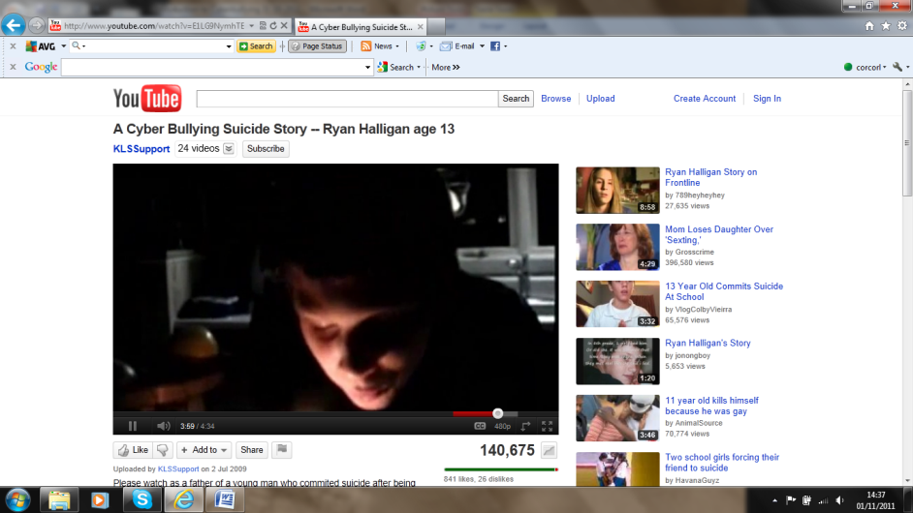
http://www.youtube.com/watch?v=E1LG9NymhTE

2.13.9 Resource 2.19 - ‘Israeli teen kills himself following Facebook chat’

Resource 2.19 - ‘Israeli teen kills himself following Facebook chat’
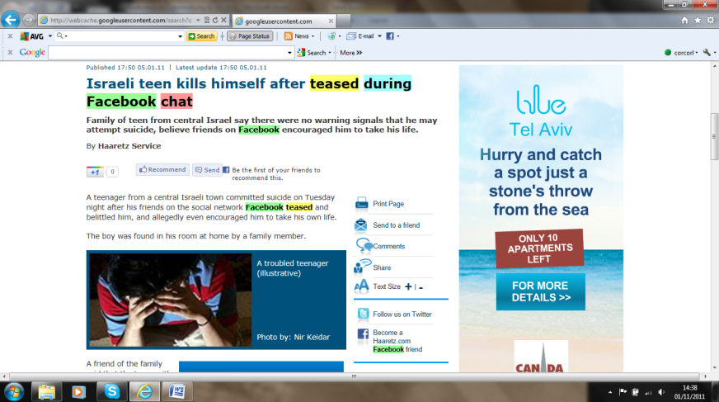
http://webcache.googleusercontent.com/search?client=gmail&rls=gm&hl=iw&q=cache:f37d9v_WqB0J:http://www.haaretz.com/news/national/israeli-teen-kills-himself-after-teased-during-facebook-chat-1.335400+teased+during+Facebook+chat&ct=clnk

2.14 References
¹ Olweus, D., Bullying at school: What we know and what we can do. 1993, Oxford: Blackwell.
² Olweus, D., Bullying en la escuela: datos e intervención. En J. Sanmartín. Violencia y Escuela: IX Reunión Internacional sobre biología y sociología de la violencia. . 2005, Valencia: Centro Reina Sofía para el Estudio de la Violencia.
³ Olweus, D., Sweden, in The nature of school bullying: A cross-national perspective, P.K. Smith, et al., Editors. 1999, Routledge: London.
⁴ Ortega, R. and J.A. Mora-Merchán, Violencia Escolar: Mito o Realidad. 2000, Sevilla: Mergablum.
⁵ O’ Moore, M., Understanding school bullying: A guide for parents and teachers. 2010, Dublin: Veritas.
⁶ Del Rey, R. and R. Ortega, Violencia Escolar: claves para comprenderla y afrontarla. Escuela Abierta, 2007. 10: p. 77-89.
⁷ Salmivalli, C., et al., Bullying as a group process: Participant roles and their relations to social status within the group. Aggressive Behavior, 1996. 22: p. 1-15.

⁸ Salmivalli, C. and M. Voeten, Connections between attitudes, group norms, and behaviour in bullying situations. International Journal of Behavioural Development, 2004. 28(3): p. 246–258.

⁹ O'Moore, M. and C. Kirkham, Self-esteem and its relationship to bullying behaviour. Aggressive Behavior, 2001. 27: p. 269–283.

¹⁰ Kaltiala-Heino, R., et al., Bullying, depression, and suicidal ideation in Finnish adolescents: school survey. BMJ, 1999. 319: p. 348-351.

¹¹ Fekkes, M., et al., Do bullied children get ill, or do ill children get bullied? A prospective cohort study on the relationship between bullying and health-related symptoms. Pediatrics, 2006. 117: p. 1568-1574.

¹² Ortega, R., et al., The emotional impact on victims of traditional bullying and cyberbullying. A study of Spanish adolescents. Zeitschrift für Psychologie/Journal of Psychology, 2009. 217(4): p. 197-204.
¹³ Smith, P.K., et al., An investigation into cyberbullying, its forms, awareness and impact, and the relationship between age and gender in cyberbullying. A Report to the Anti-Bullying Alliance. Retrieved July, 7 2010 from http://www.education.gov.uk/research/data/uploadfiles/RBX03-06.pdf, 2006.
¹⁴ Willard, N., Cyberbullying and Cyberthreats. Effectively managing internet use risks in schools Retrieved August, 20 2007 from http://new.csriu.org/cyberbully/docs/cbctpresentation.pdf, 2006.
¹⁵ Willard, N., I can´t see you – you can´t see me. How the use of information and communication technologies can impact responsible behavior. Center for Safe and Responsible Internet Use. Retrieved June, 10 2007 from http://new.csriu.org/cyberbully/docs/disinhibition.pdf 2004.
¹⁶ Belsey, B., Cyberbullying: An emerging threat to the “always on” generation. Retrieved October, 14 of 2010 from http://www.cyberbullying.ca 2006.
¹⁷ Tokunaga, R.S., Following you home from school: A critical review and synthesis of research on cyberbullying victimization. Computers in Human Behaviour, 2010. 26: p. 277-287.
¹⁸ Li, Q., Cyberbullying in high schools: A study of students' behaviour and beliefs about this new phenomenon. Journal of Aggression, Maltreatment and Trauma, 2011. 19(4): p. 372-392.
¹⁹ Slonje, R. and P.K. Smith, Cyberbullying: Another main type of bullying? Scandinavian Journal of Psychology, 2008. 49: p. 147-154.
²⁰ Vandebosch, H. and K. Van Cleemput, Cyberbullying among youngsters: Profiles of bullies and victims. New Media and Society, 2009. 11(8): p. 1349-1371.
²¹ O'Moore, M. and S.J. Minton, Cyber-Bullying: The Irish Experience, in Handbook of Aggressive Behaviour Research, C.Q.S. Tawse, Editor. 2009, Nova Science Publishers, Inc.: New York. p. 269-292.
²² Mc Guckin, C., P.K. Cummins, and C.A. Lewis, f2f and cyberbullying among children in Northern Ireland: Data from the Kids Life and Times Surveys. Psychology, Society, & Education, 2010. 2(2): p. 83-96.
²³ Batheja, A., Cyberbullies’ torments have much wider reach. In J. Raskauskas & A. D. Stoltz (2007). Involvement in Traditional and Electronic Bullying Among Adolescents. Developmental Psychology, 2004. 43(3): p. 564-575.
²⁴ Ortega, R., J. Calmaestra, and J.A. Mora-Merchán, Cyberbullying. International Journal of Psychology and Psychological Therapy, 2008. 8(2): p. 183-192.
²⁵ Li, Q., Cyberbullying in schools: A research of gender differences. School Psychology International, 2006. 27: p. 157-170.
²⁶ Kapatzia, A. and E. Sygkollitou, Cyberbullying in middle and high schools: prevalence, gender and age differences. 2008, University of Thessaloniki, Greece.
²⁷ MSN.uk, MSN cyberbullying report: Blogging, instant messaging and email bullying amongst today´s teens. Retrieved August, 20 2007 from http://help.uk.msn.com/safetyandsecurity/usefulresources/article.aspx?cp-documentid=4171778, 2006.
²⁸ Smith, P.K., et al., Cyberbullying: its nature and impact in secondary school pupils. The Journal of Child Psychology and Psychiatry, 2008. 49(4): p. 376-385.
²⁹ Balding, J., Young People in 2004: the health-related behaviour questionnaire results for 44,430 young people between the ages of 10 and 15. Schools Health Education Unit, Exeter, England., 2005.
³⁰ Alpha Research. Safer Internet for children: Qualitative Study in 29 European Countries, National Analysis: Bulgaria. Retrieved April, 7 2010 from http://ec.europa.eu/information_society/activities/sip/docs/eurobarometer/qualitative_study_2007/bulgaria.pdf. , 2007.
³¹ Avilés, J.M., Ciberbullying: Diferencias entre el alumnado de secundaria. Boletín de Psicología, 2009. 96: p. 79-96.
³² Blaya, C., Cyberbullying and happy slapping in France: a case study in Bordeaux. In press.
³³ Bornerådet, Bornerådet (2006). Mobning og konflikt 2006: En undersøgelse i 9. klasse. (Bullying and conflict: A survey in grade 9.). Retrieved April 1 2010, from: http://www.boerneraadet.dk/files/Brd.dk%20Filbibliotek/PDF%20FILER/PANELRAPPORTER%20OG%20PIXIE%20(DONE)/Mobning%20og%20konflikt/Mobning%20og%20konflikt%20low.pdf 2006.
³⁴ Bornerådet, Mobbning 2008. Retrieved April 1 2010, from: http://www.boerneraadet.dk/files/Brd.dk%20Filbibliotek/PDF%20FILER/PANELRAPPORTER%20OG%20PIXIE%20(DONE)/Mobning%202008/Mobning%202008.pdf, 2008.
³⁵ Corcoran, L., I. Connolly, and M. O’Moore, Cyberbullying: a new dimension to an old problem, in Psychological Society of Ireland Annual Conference, . 2008: The Mount Wolseley Hotel, Tullow, County Carlow, Ireland.
³⁶ Calmaestra, J., R. Ortega, and J.A. Mora-Merchán, Las TIC y la convivencia. Un estudio sobre formas de acoso en el ciberespacio. Investigación en la Escuela, 2008. 64: p. 93-103.
³⁷ NCH, Putting you in the picture: mobile phone bullying survey 2005. Retrieved August, 20 2007 from http://www.filemaker.co.uk/educationcentre/downloads/articles/Mobile_bullying_report.pdf, 2005.
³⁸ Ombudsman - UNICEF. Violencia escolar: el maltrato entre iguales en la educación secundaria obligatoria. 1999-2006. 2007, Madrid: Publicaciones de la Oficina del Defensor del Pueblo.
³⁹ Thyholdt, R. and G. Englund, PrevU Rapport 2009:03. Om mobbning (About bullying). Retrieved April 1, 2010, from: http://www.goteborg.se/prevu 2009.
⁴⁰ Van den Eijnden, R.J.J.M., et al., Monitor Internet en jongeren: Pesten op Internet en het psychosociale welbevinden van jogeren. 2006, Rotterdam: IVO Factsheet.
⁴¹ Livingstone, S., et al., Risks and safety on the internet: The perspective of European children. Full Findings. 2011, LSE, London: EU Kids Online.
⁴² Mesch, G.S., Parental mediation, online activities, and cyberbullying. CyberPsychology and Behaviour, 2009. 12(4): p. 387-393.
⁴³ Wolak, J., K.J. Mitchell, and D. Finkelhor, Escaping or connecting? Characteristics of youth who form close online relationships. 2003.
⁴⁴ Noret, N. and I. Rivers, The prevalence of bullying by text message or email: results of a four year study, in British Psychological Society Annual Conference. 2006: Cardiff.
⁴⁵ Ybarra, M.L. and K.J. Mitchell, Online aggressor/targets, aggressors, and targets: a comparison of associated youth characteristics. Journal of Child Psychology and Psychiatry, 45, 1308–1316. Journal of Child Psychology and Psychiatry, 2004. 45: p. 1308-1316.
⁴⁶ Patchin, J. and S. Hinduja, Bullies move beyond the schoolyard: A preliminary look at cyberbullying. Youth Violence and Juvenile Justice, 2006. 4: p. 148-169.
⁴⁷ Beran, T. and Q. Li, Cyber-harassment: A Study of a New Method for an Old Behavior. Journal of Educational Computing Research, 2005. 32(3): p. 265-277.
⁴⁸ Trablus, T., T. Heiman, and D. Olenik-Shemesh, Cyber bullying and face to face bullying among adolescents in Israel, in Coping with negative and enhancing positive uses of new technologies. 2011: University of Turku, Finland.
⁴⁹ Raskauskas, J. and A.D. Stoltz, Involvement in Traditional and Electronic Bullying Among Adolescents. Developmental Psychology, 2007. 43(3): p. 564-575.
⁵⁰ Hinduja, S. and J.W. Patchin, Bullying, cyberbullying and suicide. Archives of Suicide Research, 2010. 14: p. 206-221.
⁵¹ Juvonen, J. and E.F. Gross, Extending the school grounds? - Bullying experiences in cyberspace. Journal of School Health, 2008. 78(9): p. 496-505.
⁵² Riebel, J., R.S. Jager, and U.C. Fischer, Cyberbullying in Germany - an exploration of prevalence, overlapping with real life bullying and coping strategies. Psychology Science Quarterly, 2009. 51(3): p. 298-314.
⁵³ Hay, C. and R. Meldrum, Bullying victimization and adolscent self harm: Testing hypotheses from general strain theory. Journal of Youth and Adolescence, 2010. 39: p. 446-459.

⁵⁴Parris, L., et al., High school students' perceptions of coping with cyberbullying. Youth & Society, 2011: p. 1-23.

2.15 Useful Websites
- LAECOVI: Laboratorio de estudios sobre convivencia y prevención de la violencia (Laboratory of studies on convivencia and violence prevention), http://www.laecovi.es
- Anti-Bullying Centre. http://www.abc.tcd.ie
- Anti-Bullying Alliance. http://www.anti-bullyingalliance.org.uk/
- In Brief (Free legal information about cyberbullying), http://www.inbrief.co.uk/cyberbullying.htm
- WiredKids, http://www.stopcyberbullying.org
- Webpage of Bill Belsey, “www.cyberbullying.ca - Always On, Always Aware!, http://www.cyberbullying.ca/
- Center for Safe and Responsible Internet Use, http://csriu.org/cyberbully
- Bullying UK, http://www.bullying.co.uk/index.php/make-a-poster.html
- CyberSmart, http://cybersmart.org/
- http://www.internetsafety.ie/website/ois/oisweb.nsf/page/DPCY-7K2LKD1649222-en
- EU Kids Online:
- www2.lse.ac.uk/.../EUKidsOnline/EUKidsII%20(2009.../EUKidsOnlineIIReports/D4FullFindings.pdf
1. Risky communication online: New short report published for Safer Internet Day, 8 February 2011.
http://www2.lse.ac.uk/media@lse/research/EUKidsOnline/EUKidsII%20(2009-11)/EUKidsOnlineIIReports/CommsOnlineShortreport.pdf
2. http://www2.lse.ac.uk/media@lse/research/EUKidsOnline/Home.aspx
3. European report: Risks and safety on the internet: the perspective of European children.www2.lse.ac.uk/media@lse/research/EUKidsOnline/EUKidsII%20(2009-11)/EUKidsOnlineIIReports/D4FullFindings.pdf
Get With IT!: http://www.internetsafety.ie/website/ois/oisweb.nsf/page/DPCY-7LYJ4V1343473-en/$File/Final%20-%20Low%20Res.pdf

Link to another module - 1.1
Link to http://www.abc.tcd.ie and http://www.anti-bullyingalliance.org.uk/
Internal link within module to 2.3.1
Internal link within module to 2.3.2
Internal link within module to 2.3.2
Some researchers ⁽¹⁶⁾ distinguish between ‘traditional’ bullying and ‘f2f’ (face-to-face) bullying. As the name suggests, f2f bullying only refers to bullying which is done in a face-to-face manner and could be considered to be a category within traditional bullying.
- Internal link within module to 2.4.2.1
Internal link within module to 2.12
Internal link within module to 2.3.2
Internal link within module to 2.4.3.1
Internal link within module to 2.4.3.2
Internal link within module to 2.13
Internal link within module to 2.13.2
Internal link within module to 2.13.4
Internal link within module to 2.13.3
Internal link within module to 2.13.5
Internal link within module to 2.4.3.2
Internal link within module to 2.13.5
Internal link within module to 2.4.3.2
Internal link within module to 2.13.6
Internal link within module to 2.13.1
Internal link within module to 2.13.8
Internal link within module to 2.4.3.2
Internal link within module to 2.4.3.2
Internal link within module to 2.13.2
Internal link within module to 2.13.3
Internal link within module to 2.13.4
Internal link within module to 2.4.3.2
Internal link within module to 2.5.2.1
Internal link within module to 2.5.2.2
Link to http://www.cybertraining-project.org/
Internal link within module to 2.5.2.3
Internal link within module to 2.5.2.4
Internal link within module to 2.1
Internal link within module to 2.13.8
Internal link within module to 2.7.1
Internal link within module to 2.7.2
Internal link within module to 2.7.3
Internal link within module to 2.13.8
Internal link within module to 2.13.9
Internal link within module to 2.7.2
Internal link within module to 2.7.3
- Internal link within module to 2.4.2.1
Internal link within module to 2.4.3.1
Internal link within module to 2.13.1
Internal link within module to 2.13.2
Internal link within module to 2.13.3
Internal link within module to 2.13.4
Internal link within module to 2.13.5
Internal link within module to 2.13.6
Internal link within module to 2.13.7
Internal link within module to 2.5.2.1
Internal link within module to 2.5.2.2
Internal link within module to 2.5.2.3
Internal link within module to 2.5.2.4
Internal link within module to 2.13.8
Internal link within module to 2.13.9
Internal link within module to 2.3.1
Internal link within module to 2.7.1
Internal link within module to 2.3.2
- Internal link within module to 2.4.2.1
Internal link within module to 2.4.3.1
Internal link within module to 2.4.3.2
Internal link within module to 2.13.1
Internal link within module to 2.13.2
Internal link within module to 2.13.3
Internal link within module to 2.13.4
Internal link within module to 2.13.5
Internal link within module to 2.13.6
Internal link within module to 2.13.7
Internal link within module to 2.5.2.1
Internal link within module to 2.5.2.2
Link to http://www.cybertraining-project.org/
Internal link within module to 2.5.2.3
Internal link within module to 2.5.2.4
Internal link within module to 2.7.2
Internal link within module to 2.7.3
Internal link within module to 2.13.8
Internal link within module to 2.13.9

