Emulating Synaptic Response in n- and p- channel MoS₂ Transistors by Utilizing Charge Trapping Dynamics.
Shubhadeep Bhattacharjee*^{1,3}, Rient Wigchering,¹ Hugh G. Manning,² and John. J. Boland,² Paul K. Hurley^{1*}
¹ Tyndall National Institute, and the School of Chemistry, University College Cork, Cork, Ireland
² Advanced Materials and Bioengineering Research (AMBER) Centre, Trinity College Dublin, Dublin 2, Ireland.
³ Dept. of Physics and Astronomy, University of Manchester, M13 9PL

*Corresponding authors: s.bhattacharjee@tyndall.ie, paul.hurley@tyndall.ie.
Abstract: Brain-inspired, neuromorphic computing aims to address the growing computational complexity and power consumption in modern von-Neumann architectures. Progress in this area has been hindered due to the lack of hardware elements that can mimic neuronal/synaptic behavior which form the fundamental building blocks for artificial neural networks. In this work, we leverage the short/long term memory effects due to the electron trapping events in an atomically thin channel transistor that mimic the exchange of neurotransmitters and emulate a synaptic response. Re-doped (n-type) and Nb-doped (p-type) molybdenum di-sulfide (MoS₂) field-effect transistors are examined using pulsed-gate measurements, which identify the time scales of electron trapping/de-trapping. The devices demonstrate promising trends for short/long term plasticity in the order of ms/minutes, respectively. Interestingly, pulse paired facilitation (PPF), which quantifies the short-term plasticity, reveal time constants (𝜏₁ = 27.4 ms, 𝜏₂ = 725 ms) that closely match those from a biological synapse. Potentiation and depression measurements describe the ability of the synaptic device to traverse several analog states, where at least 50 conductance values are accessed using consecutive pulses of equal height and width. Finally, we demonstrate devices, which can emulate a well-known learning rule, spike time-dependent plasticity (STDP) which codifies the temporal sequence of pre- and post-synaptic neuronal firing into corresponding synaptic weights. These synaptic devices present significant advantages over iontronic counterparts and are envisioned to create new directions in the development of hardware for neuromorphic computing.

Introduction
Despite the enormous success of scaling the complementary metal-oxide-semiconductor (CMOS) transistor, the inability to control the rising computational complexity and associated power consumption have revealed inherent limitations of the von-Neumann architecture¹. In the von-Neumann model, the logic and memory elements are functionally and physically separated, and connected via a data bus which is expected to facilitate rapid and efficient exchange of information². With the increasing operational frequencies and computing requirements, one of the primary bottlenecks in terms of data throughput and power consumption/heat dissipation is centered on the capability of the data exchange buses³. The recognition of this limitation was concurrent with the development of artificial intelligence (AI) algorithms that mimic the low-power learning algorithms in the biological brain^{4,5}. The biological computing paradigm is essentially non-Von Neumann; computation and memory are tightly interwoven in functionality and morphology⁵. In contrast to the sequential instruction set in CMOS architecture; learning and computing in the brain happen in a parallel, event-based manner. Therefore, the attempt to integrate an essentially non-Von Neumann AI algorithm into a von-Neumann CMOS architecture is reaching limits due to two core issues vis-à-vis complexity/scalability and power consumption⁶⁻⁸. To replicate the analog computing scheme of one synapse, at least 10 CMOS transistors are warranted⁹. Considering that these architectures demand tightly interwoven elements, the scalability of these systems becomes a primary challenge⁸. Furthermore, in conjunction with the aforementioned issue, large power (>1000 W) is consumed by such platforms to perform tasks that the human brain achieves with < 4 W¹⁰. This points to the immediate need to explore electronic devices that can mimic the synaptic/neuronal response and are ideally compatible with the existing integrated circuit fabrication facilities.
Memristive devices have been employed to successfully demonstrate synaptic behavior and emulate learning rules with a variety of physical mechanisms (resistive switching, phase change, spintronic)^{6,11}. This approach presents the dual advantages of scalability and very low power consumption¹². However, because these devices are two-terminal, the signal transmission is inhibited during the learning operation, where the output signal is fed back to the synaptic device¹³. Since the signal transmission and learning function cannot be carried out simultaneously, the emulation of a natural synaptic response is hindered and the complexity of the read-out/learning circuitry is significantly increased. To address this issue, three-terminal ‘iontronic’ transistors were developed where both signal transmission (through source-drain terminals) and learning (through the gate terminal) can be achieved simultaneously^{14,15}. While the use of ‘movable’ alkali metal ions through a gel electrolyte intuitively matches the signal transmission mechanism in a biological synapse; however, this approach will be difficult to implement in the alkali metal–ion free policy of CMOS fabrication facilities¹⁴.
In this work, we demonstrate that the dynamics of charge trapping and de-trapping in a single n- and p- channel MoS₂ transistor can be effectively employed to mimic a synaptic response [Fig. 1(a,b)]. Owing to their inherent ‘thinness’, electronic transport in two-dimensional materials demonstrates an enhanced susceptibility to the influence of trapped charges in the surrounding medium ¹⁶⁻¹⁸. This is generally observed by a reduced mobility and a large hysteresis in the device transfer characteristics¹⁹. The presence of a hysteresis, where the drain current becomes a multi-value variable with respect to the gate voltage is a serious issue for digital computing. However, as we shall demonstrate in this work the same hysteresis induces multi-states, which can be effectively engineered to mimic synaptic memory and learning. First, we examine the trapping and de-trapping dynamics of electron traps using pulsed measurements, and assess their stability and the ability to tune many intermediate conductance states. Next, we perform a careful evaluation of the essential synaptic behaviors such as potentiation and depression (P-D), pulse paired facilitation (PPF) and spike time-dependent plasticity (STDP), which codify the ‘event-based’, parallel, analog-computing paradigm in these devices. Remarkably, the time constants for short and long-term plasticity in these devices are commensurate with those observed in biological synapses. We envision that the controlled engineering of a simple physical mechanism (trapping dynamics in 2D semiconductor/insulator material systems) can help re-shape the development of synaptic elements for next-generation neuromorphic computing.
Results and Discussion
MoS₂ flakes of Rhenium (Re) n-doped and Niobium (Nb) p-doped serve as the channel material for n-FET and p-FET, respectively, on thermally grown SiO₂/p++ Si [Fig. 1(c)] (Please see Methods for more details). The study was conducted for transistors with both polarities to emphasize the universality of the physical mechanisms and serve as a platform for future CMOS integration. The choice of a constrained channel thickness enabled through the use of an atomically thin 2D semiconductor, is instrumental in maximizing the effect of charge trapping and de-trapping events in the gate oxide on the measured drain current and hence the synaptic weights. The pulsed signal was applied to the back gate and the response of the drain current (I_{ds}) to these pulses was measured at a constant drain-source bias (V_{ds}) [Fig. 1(b)] (please see Methods for more details). In this case, the drain current serves as the excitatory postsynaptic current (EPSC), which is a direct measure of the device conductance as a function of time. The pre- and post-synaptic pulses, which are applied on the SiO₂/Si++, back gate and the MoS₂ channel can be thought of as an analog to the synaptic fluid where neurotransmitters (in this case trapped charges) are released and absorbed. Electrical measurements were performed in two configurations. First, standard DC measurements using a B1500 semiconductor device analyzer (SDA) were performed with the underlying SiO₂ used as the back gate. Second, the pulsed measurements were performed using the Keithley 4200 semiconductor characterization system (SCS) with additional pulse measurement units (PMU). All measurements were performed in ambient conditions. In [Fig. 1(d)] we examine the DC characteristics of the devices, where the clockwise and anti-clockwise hysteresis for the n-FET and p-FET can be attributed to the trapping and de-trapping of electrons from acceptor like (n-FET) and donor-like (p-FET) traps in the MoS₂/SiO₂ structure, as commonly seen in other thin-film semiconductors^{17,20}. In back-gated MoS₂ transistors, the primary source of trapped charges has been attributed to the MoS₂/SiO₂ interface and surface absorbents/water dipoles on the top MoS₂ surface²¹. The hysteresis behavior can be understood as follows: sweeping of the gate to positive biases increases the occupancy of electron traps, thus inducing a positive (negative) shift of the threshold voltage of the n-FET (p-FET) and hence decreasing (increasing) the channel conductance for the same gate bias. The equivalent trap density (N_{trap}) at the MoS₂/SiO₂ interface can be estimated by the following expression,
N_{trap} = C_{ox} |V_{th} (for) - V_{th} (rev)|/q - Eqn. 1,
where C_{ox} = 4 x 10⁻⁸ F/cm⁻² is the oxide capacitance of the SiO₂ back gate, V_{th} is the threshold voltage of the (for) forward and (rev) reverse sweep and q is the elemental charge constant. The N_{trap} of 3.2x10¹² cm⁻² for n-FET and 5.9x10¹² cm⁻² for p-FET is estimated for a V_{bg} swing of ± 40 V. A larger trap density and hence more defective interface of Nb-MoS₂ as compared Re-MoS₂ with SiO₂ is further evidenced by the degraded sub-threshold slope of the p-FET vis-à-vis n-FET [please see Supporting Information S1 for semi-log plot of transfer characteristics]. The field-effect mobility of the n-FET ~ 26.2 cm⁻²V⁻¹s⁻¹ and p-FET ~ 12.6 cm⁻²V⁻¹s⁻¹ can also be evaluated using the standard long channel approximation,
$μ_{FE}=\frac{L}{C_{ox} W{ V}_{ds}}\frac{dI_{ds}}{{dV}_{gs}}$ - Eqn. 2.,
where L/W is the length to width ratio of the transistor at a source-drain voltage (V_{ds}) of 50 mV. The field-effect mobility values calculated for these devices are smaller than those reported with an un-doped channel, which is expected due to the additional impurity scattering¹⁸. To gain further insight into the charge trapping behaviour, the hysteresis of the transistors was measured as a function of the V_{gs} sweep range and delay/sweep time [Supporting Information S2]. The magnitude of the hysteresis loops, and the associated charge trapping, is determined by the maximum V_{bg} and the hold time in accumulation. Next, we proceed to the focus of this work; using controlled pulses to trap and de-trap electrons from the MoS₂ channel and hence modulate the channel conductance, which represents the EPSC. As illustrated in [Fig. 1(e)], for an n-channel device a large change in the threshold voltage is observed before (red curve) and after (blue curve) the application of a series of 50 pulses to the back-gate with a magnitude of 0V to -20 V and a width of 500 ms (indicated by blue potentiation pulses in the figure inset). The average density of trapped charges per pulse can be calculated using Eqn-1 to be ~ 2.9x10¹¹cm⁻². Furthermore, the initial position of the threshold voltage can be recovered by applying the same number of pulses of the opposite polarity +12 V (indicated by red depression pulses). This suggests the ability to control different conductance states of the device repeatedly and reversibly using appropriate pulses applied to the back gate. A more nuanced examination of the same effect will be demonstrated shortly in the form of potentiation and depression measurements. The same effect is also reproduced for the p-channel device but with the opposite polarity for potentiation and depression [please refer Supporting Information S3].
The foundational basis of the biological brain to learn, memorize and forget hinges on the plasticity of synapses .i.e. the ability to change the ‘conductance state’ depending on the previous history of action potentials²². The plasticity of the brain can be broadly sub-divided into long and short-term plasticity (LTP, STP), distinguished by their characteristic retention time(s). While the LTP is postulated to be responsible for experience-dependent modification of the synaptic weights (i.e. learning), the STP is largely effective for motor functions, auditory and visual perception etc²³. Therefore, we focus on the STP and LTP behavior of the charge trapping devices by examining the transient response of the EPSC (or channel conductance) when a single pulse is applied at a time, t = 0. [Fig. 2(a)] and [Fig. 2(b)] illustrates the response of the channel conductance (EPSC) as a function of time when pulses of different height and width are applied to the back gate of the n-channel MoS₂ transistor. The back gate pulse polarity is selected to drive the n channel MoS₂ MOSFET to the off condition. The plot shows the evolution of the EPSC after the pulse has returned to the baseline value of 2 V, which demonstrates a sharp rise from the pre-pulse level, followed by a rapid decrease and subsequent slower decrease, indicative of the two time constants associated with the trapping/emission of electrons from defect sites. The two time constants associated with the electron trapping/emission process is more clearly seen in the log time plot (see Supporting Information S4) which has been observed in back gated MoS₂ MOSFETs²⁴. The fast (~0.2 s) and slow (~5 s) time constants for n- and p- type device are extracted using a double exponential function for a pulse height and width 10 V and 100 ms respectively (see Supporting Information S5). The time constants for three n-type and two p-type devices are presented in Supporting Table S1. The presence of two-time constants for electron trapping or de-trapping is central to the emulation of a synaptic response. As we shall demonstrate shortly, using a pulsed paired facilitation (PPF) technique, the initial fast transient (typically < 1 s after the gate voltage pulse is applied) can accurately codify the short-term plasticity^{25,26}. The change in the conductance of the synaptic transistor with respect to the baseline and the decay rate can be modulated by varying the pulse height and width respectively. As seen in [Fig. 2(a,b)], for a pre-synaptic pulse width of 50 ms, which is in the same range of action potentials as in biological systems, the conductance value shows a distinguishable ‘memory effect’ with reasonable stability for the measurement window of >10 s. Furthermore, the long-term retention of these devices can be extended to a few minutes by modulating the number of trapped charges introduced at the MoS₂ /dielectric interface, which demonstrates reasonable stability of conductance state with a very slow decay [see Supporting Information S6]. This behavior can be taken to represent long-term plasticity. Eventually, there is a very gradual decay of the memory effect due to electron capture by defect sites. However, this phenomenon can be controlled in future design iterations by including a trapping and tunneling layer as commonly implemented in modern floating-gate memories. [Fig. 2 (c)] delineates the short/long-term plasticity into volatile and non-volatile memory effects as a function of pulse width²⁷.
As indicated earlier, we perform pulse-paired facilitation (PPF) measurements to extract the characteristic time constants for short-term plasticity²⁶. In PPF measurements we monitor the EPSC when the device is subjected to a pair of pre-synaptic pulses (of the same magnitude) separated by a short time duration, Δt, typically in the order of 10-1000 ms²⁶. As shown in [Supporting Information S7], the EPSC amplitude generated by the second pulse is greater than the first when a pulse of W = 5 ms is separated by a duration, Δt =75 ms. The PPF index can be extracted by the formula
$PPF= \frac{∆{EPSC}_{Peak}}{∆{EPSC}_{1}} ×100\%$ - Eqn.3,
where the ΔEPSC_{Peak} is the difference between the peak current amplitude between the second and first pulse and ΔEPSC₁ is the difference between the peak after the first pulse and the baseline (before the first pulse was applied)²⁷. [Fig. 2(d)] illustrates the PPF% as a function of pulse separation Δt from 10 -1000 ms for both p- and n-type devices. As is observed for biological synapses, the PPF% rapidly falls with increasing pulse separation. This can be explained as follows, let us suppose when the first pre-synaptic pulse is applied electrons are emitted from n trap sites in the device (neurotransmitters in a biological synapse) which is seen with the EPSC current value reaching a peak value, say I₁ (n) which is a function of n. After a short time Δt, which is much lessthan the time required to reach steady-state conductance, a few trapped sitesre-capture electrons, making the number of trapped sites n-Δn. When the second pre-synaptic pulse is applied, let us assume (for the sake of simplistic understanding) that electrons are emitted from n trap sites, taking the total tally of trapped carriers to 2n-Δn and therefore changing the peak instantaneous current to I₂(2n-Δn) such that I (2n)> I₂(2n-Δn) > I₁(n). Since the re-capture of electrons into trap-sites is an exponential function of time Δn∝ e ^{Δt}; then for, for Δt → 0, I₂ → I (2n) (PPF% ≤ 50 %) and Δt → ∞, I₂ → I₁ (PPF% = 0). The PPF% exhibited by our samples can be fit to a double exponential function,
${PPF}_{fit}= A_{1}e^{-\frac{∆t}{τ_{1}}}+A_{2}e^{-\frac{∆t}{τ_{2}}}$ - Eqn. 4
where 𝜏₁ and 𝜏₂ are the relaxation time constants associated with fast- and slow- term relaxation phases. The extracted values of (𝜏₁, 𝜏₂) for the n-FET and p–FET are (111.9 ms, 1140 ms) and (27.4 ms, 725 ms). By coincidence, these values are strikingly close to those of the biological synapse (40 ms, 300 ms)²⁸.
Next, we proceed to examine potentiation-depression (P-D) and spike time-dependent plasticity (STDP) in these synaptic devices, which is a crucial property in regard to the realization of neuromorphic circuits. P-D refers to the ability of the synaptic device to cyclically traverse through a multitude of analog conductance states when subjected, ideally, to pulses of consistent heights and widths²⁹. [Fig. 3(a)] demonstrates that both the n-FET and p-FET devices can access up to 50 such conductance states in a repeatable manner over several cycles. The pulse height (- 10 V, + 5 V, with a baseline of 2 V) and width (100 ms) was optimized to ensure multi-cycle behavior without any significant shift to the initial baseline between consecutive cycles. The conductance states were determined by measuring the EPSC in the 200 ms rest period, with V_{bg} (rest) = 2 V, in between two consecutive pulses at a constant V_{ds} of 1 V and 2 V for the n- and p-type transistors respectively. The higher value of V_{ds} for the p-type transistor was to compensate for the lower mobility in Nb- MoS₂. [Supporting information S8 presents the repeatable, multi-cycle potentiation-depression characteristics of such devices for 600 pulses (12 cycles)].
Here, it shall be instructive to estimate the energy dissipation per pulse during potentiation and depression for this device. The average energy consumed per pulse E = $ΔI_{ds} V_{ds} t_{pulse}$ where, $ΔI_{ds}$ is average change in drain source current per potentiation/depression pulse V_{ds} = 1 V and $t_{pulse}$ = 100 ms. Using the data presented in Fig 3(a) we arrive at 1.6 (2.8) nJ for n(p)-FET. We compare these values with the one of the best values reported from three-terminal devices with similar architecture but utilizing ion-transport²⁹. In this work²⁹, Yang et.al. report a value of ~25 pJ for a 100 ms pulse width, which was achieved at a much lower source drain voltage of 50 mV. Since our devices show near-linear transfer characteristics with $I_{ds}{∝V}_{ds}$ ,the energy consumption scales as square of drain voltage $E∝V_{ds}^{2}$. Therefore, in principle, at a drain voltage of 50 mV one can project our devices to work at 4(7) pJ per pulse for n(p)-FET device demonstrating, as expected, a lower energy dissipation per pulse for an electron device compared to an iontronic device. In another report, W Zu et.al.³⁰ utilize nanowire structures (and hence very small W/L ratio in a transistor) to achieve very small I_{ds} (in pA) for small V_{d} = 20 mV to demonstrate ~fJ power consumption, the lowest in literature. Though these reports may be scientifically interesting, the low drain voltage voltage and current biasing conditions used in these reports will be challenging to implement in a practical circuit without low-noise amplifiers at each stage. Nonetheless, it is instructive to calculate the lowest theoretical limit of power consumption in the charge trapping synaptic devices reported in this work. Since the fundamental mechanism of our devices depends on the trapping and de-trapping of charge carriers the lowest possible limit of energy consumption will be E = $ΔQ_{trap} V_{ds}$, where $ΔQ_{trap}$ is the number of traps contributing per pulse. This of course assumes that all other DC, parasitic and transistor biasing currents to be zero and that a generation of $ΔQ_{trap}$ at the MoS₂/SiO₂ interface induces equal number of charges in the channel. As demonstrated in Fig 1(e) and Supplementary S3, one could calculate the $ΔN_{trap}$ (trap density) per pulse by measuring the shift in the threshold voltage of the transistor averaged over many pulses. Subsequently $ΔQ_{trap}$ = $q ΔN_{trap} A$, where q is the fundamental charge constant, 1.6 x10⁻¹⁹ and A is the area of the device. Considering our devices which are ~5μm² in area, this yields a value of 0.64 fJ (for 50 ms pulse) and 2.56 fJ (500 ms pulse) for a V_{ds} of 1 V.
In addition to systematic traversing of conductance states, a synaptic device is also expected to emulate commonly known learning rules, whereby the channel conductance is encoded as a function of the temporal firing of the pre- and post- synaptic neurons. Amongst many postulated rules, STDP is widely believed to be the basis of learning, information storage, and refinement of neuronal pathways, as popularized by the adage ‘neurons that fire together, wire together’³⁰. In STDP, the conductance of the channel (ΔG) is potentiated or depressed based on whether the pre-synaptic neuron fires before or after the post-synaptic neuron and the magnitude of the potentiation or depression is exponentially determined by the time difference (Δt) between the two firings³¹. Mathematically, this can be expressed as:
$For Δt≥0, ΔG ∝ e^{-\frac{∣Δt∣}{τ_{+}}}$; $For Δt≤0, ΔG ∝ -e^{- \frac{∣Δt∣}{τ_{-}}}$ - Eqn. 5
Where, $Δt≥0$ ($Δt ≤0$) refers to the case where pre-synapse fires before (after) the post synapse and 𝜏₊, 𝜏₋ are the respective time constants. To examine STDP behavior in our devices we use a commonly prescribed mapping function for three-terminal geometries that transform/codifies the time difference between two pulses to varying magnitudes of the pre-synaptic pulses^{32,33}. This is enabled by using a 2x1 multiplexer connected to the gate terminal, where the post-synaptic neuron is used as a control signal to modulate the pre-synaptic pulse and grounded terminal (see Supporting Information S9 for pulsing scheme drain current characteristics)³³. [Fig. 3(b,c)] demonstrates the STDP response for n- and p-type FETs, both showing exponential modulation of channel conductance (%G) as a function of Δt, where,
(G, synaptic weight %) = (G_{before}-G_{after})/G_{before} × 100% - Eqn. 6,
G_{before} and G_{after} are the conductance of the channel before and after the application of the post-synaptic pulse. The shape of the symmetric Hebbian post and pre-synaptic pulses are also illustrated in the insets. The extracted time constants for potentiation and depression (𝜏₊, 𝜏₋) for n-FET and p-FET is (4.77 s, 4.96 s) and (8.84 s, 6.65 s) respectively.
Conclusions
In summary, we demonstrate how the simple process of electron trapping/de-trapping events in a back-gated MoS₂ transistor can electrically mimic the release and absorption of neurotransmitters/ions in a biological synapse. The well-separated double time constants in the (de-)/trapping dynamics at the 2D/dielectric interface is crucial to integrate long synaptic plasticity with PPF, STDP and potentiation /depression characteristics, which are employed in the design of spiking neural networks (SNNs). The use of charge trapping devices offers potential advantages in terms of reliability and manufacturability over “iontronic” devices. To generalize our observations and demonstrate complementary behavior, which shows promise for CMOS integration, we examine both n- (Re-doped) and p-doped (Nb-doped) MoS₂ transistors as three-terminal synaptic devices. The charge trapping and release from defect states in the devices exhibits time constants which allows the emulation of both short- and long-term plasticity, an important property in biological synapses which aids learning and memory. Interestingly, PPF measurements on these devices, which quantify the short-term plasticity reveal time constants that closely resemble those from a biological synapse. Furthermore, potentiation-depression characteristics showing at least 50 analog conductance states and the ability of these devices to codify commonly used learning rules such as STDP lays special emphasis on the flexibility and adaptability of charge trapping devices. The extraction of the plasticity, PPF and STDP related time constants from this work can be used to initiate circuit level simulations for SNNs. The efficacy of trapping/de-trapping events in the gate oxide in emulating the behavior of biological synapses opens up new avenues in the design of neuromorphic devices.

Methods
Re-doped and Nb- doped MoS₂ crystals procured from HQ Graphene were exfoliated on 85 nm SiO₂ using the scotch-tape method. Thin flakes in the optimal range of 4-8 nm were identified using optical contrast and confirmed using atomic force microscopy. Flakes thinner than this suffer from reduced drain currents and mobility because of a larger band-gap and poorer contacts; whereas, drain current in thicker films become less sensitive to the trapped charges in the MoS₂/SiO₂ system, and hence are undesirable. On the selected flakes, source-drain contacts with a channel length and width of 1 um were defined using electron beam lithography (EBL). Next, a mid-gap metal Ni/Au (20/40) which shows reasonable contacts to both n and p doped MoS₂ was deposited using electron beam evaporation, followed by a lift-off step. [Fig. 1(c)] presents an optical image of one of the fabricated transistors. Electrical measurements were performed in two configurations. First, standard DC measurements using a B1500 semiconductor device analyzer (SDA) were performed with the underlying SiO₂ used as the back gate. Second, the pulsed measurements were performed using the Keithley 4200 semiconductor characterization system (SCS) with additional pulse measurement units (PMU).
Acknowledgments
P.K.H. and all authors at Tyndall acknowledge support from Science Foundation Ireland through the INVEST (15/IA/3131), P.I Grant 16/IA/4462, 18/IF/6324, and AMBER 2 projects (12/RC/2278_P2).
Supplementary Information: Semi-log plot of transfer characteristics, hysteresis loops as a function of sweep voltage and delay time, trap per pulse in a p-type transistor, extraction of fast and slow time constants with device statistics, conductance stability for few minutes, EPSC measurement in PPF, 600 cycles of potentiation and depression measurements, STDP measurement schematic and pulsing scheme with raw data.
Figures
Fig 1: (a) Schematic representation of the synaptic response where action potentials control the. release and absorption of neurotransmitters, with an associated excitatory postsynaptic current (EPSC), (b) The measurement scheme is illustrated in the cartoon, where charge trapping and de-trapping dynamics in an atomically thin channel 2D material (in our case Re- or Nb- doped MoS₂) is used to mimic the synaptic response, where the presynaptic pulse is applied on the back-gate terminal and the excitatory post-synaptic current [EPSC] is measured at the source-drain terminal at a constant drain bias of 1 V. (c) Optical microscope image of fabricated Re-doped MoS₂ transistor on an SiO₂ (85 nm) substrate which also serves as the back-gate. (d) DC characterization of a hysteresis loop for both Re- (n-type, red curve) and Nb- (p-type, blue curve) doped MoS₂ transistors showing clear evidence of electron trapping and de-trapping. (e) Shift in threshold voltage after 50 consecutive pulses to the gate, in order to determine the average charge trapping/de-trapping after each pulse.
Fig 2: Pulsed measurements: Transient response of EPSC conductance as a function of (a) pulse height and (b) pulse width with a single pulse applied at time, t = 0 sec for a n-channel MoS₂ FET, at a constant V_{ds} = 1 V, baseline/rest value of V_{bg} = +2 V (c) Delineation of short- and long-term plasticity effects seen in the charge trapping devices, which are responsible for motor functions and experience-based learning in synapses. (d) Quantification of short-term plasticity using pulse paired facilitation measurements which shows time constants closely resembling those from a biological synapse for both n- and p- type devices. Please note V_{ds} = 1 V and 2 V for n- and p-type devices respectively.
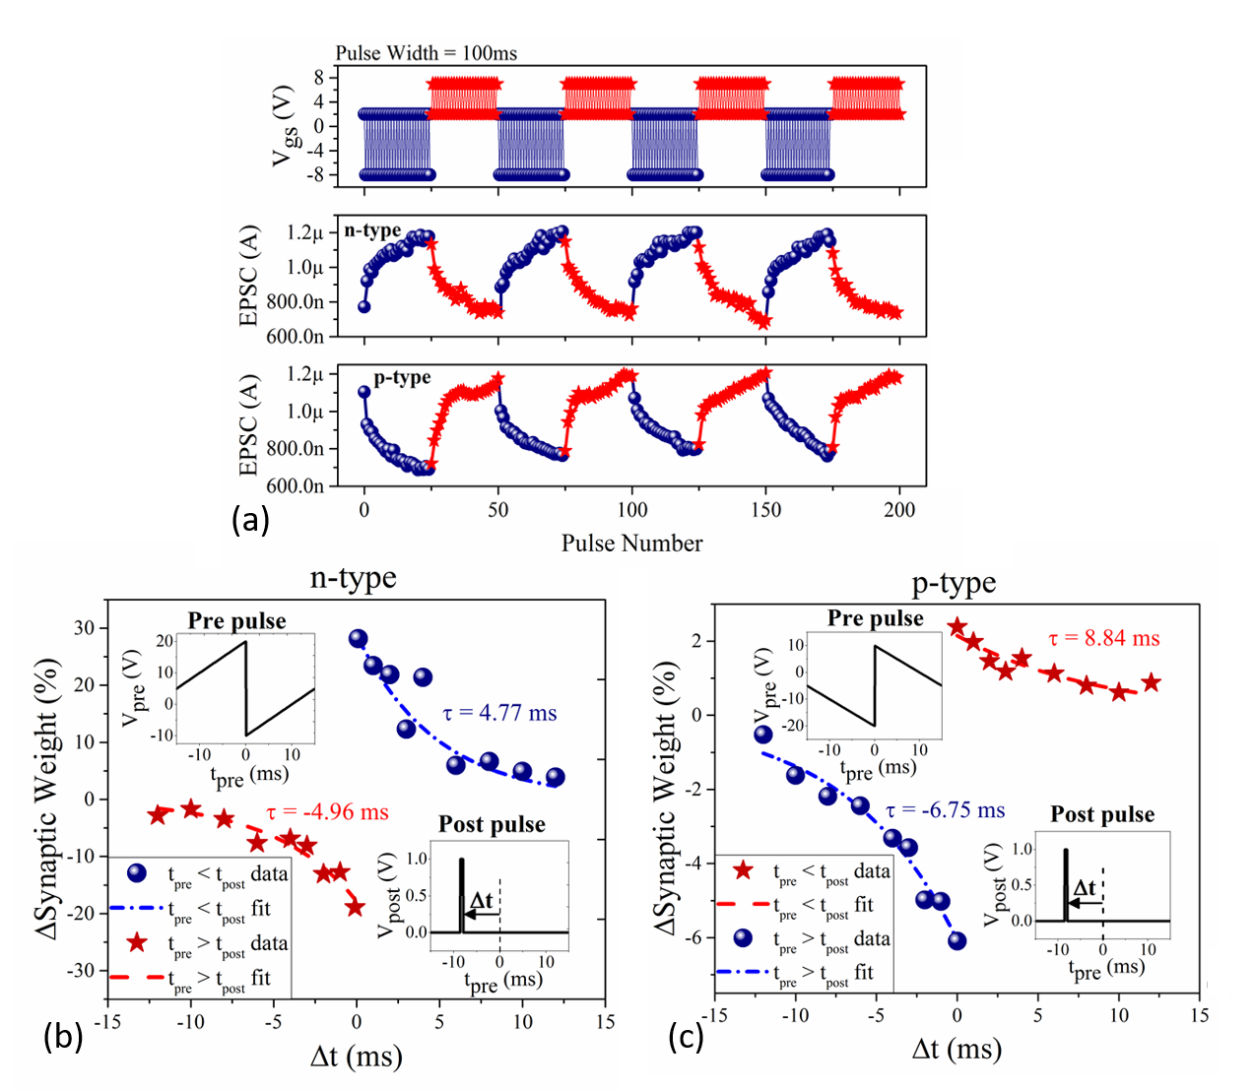
Fig 3: (a) Potentiation and depression measurements show the multi-cycle ability to traverse through at least 50 analog conductance states for both n- and p- type devices. Please note V_{ds} = 1 V and 2 V for n- and p-type devices respectively. Spike time-dependent plasticity that encodes the temporal firing of pre-synaptic neurons as channel conductance (ΔG, synaptic weight (%) shows excellent resemblance to biological synapse for both (b) n-type and (c) p-type devices.
References:
¹ Yuan Taur, Douglas A Buchanan, Wei Chen, David J Frank, Khalid E Ismail, Shih-Hsien Lo, George A Sai-Halasz, Raman G Viswanathan, H-JC Wann, and Shalom J Wind, Proceedings of the IEEE 85 (4), 486 (1997).
² John Von Neumann, IEEE Annals of the History of Computing 15 (4), 27 (1993).
³ Meikei Ieong, Kathryn W Guarini, Victor Chan, Kerry Bernstein, Rajiv Joshi, Jakub Kedzierski, and W Haensch, presented at the Proceedings of the IEEE 2003 Custom Integrated Circuits Conference, 2003., 2003 (unpublished).
⁴ Chris Eliasmith, Terrence C Stewart, Xuan Choo, Trevor Bekolay, Travis DeWolf, Yichuan Tang, and Daniel Rasmussen, science 338 (6111), 1202 (2012).
⁵ Paul A Merolla, John V Arthur, Rodrigo Alvarez-Icaza, Andrew S Cassidy, Jun Sawada, Filipp Akopyan, Bryan L Jackson, Nabil Imam, Chen Guo, and Yutaka Nakamura, Science 345 (6197), 668 (2014).
⁶ Daniele Ielmini and Stefano Ambrogio, Nanotechnology 31 (9), 092001 (2019).
⁷ Navnidhi K Upadhyay, Hao Jiang, Zhongrui Wang, Shiva Asapu, Qiangfei Xia, and J Joshua Yang, Advanced Materials Technologies 4 (4), 1800589 (2019).
⁸ Giacomo Indiveri and Shih-Chii Liu, Proceedings of the IEEE 103 (8), 1379 (2015).
⁹ Elisabetta Chicca, Davide Badoni, Vittorio Dante, Massimo D'Andreagiovanni, Gaetano Salina, Luciana Carota, Stefano Fusi, and Paolo Del Giudice, IEEE Transactions on Neural Networks 14 (5), 1297 (2003).
¹⁰ David Silver, Aja Huang, Chris J Maddison, Arthur Guez, Laurent Sifre, George Van Den Driessche, Julian Schrittwieser, Ioannis Antonoglou, Veda Panneershelvam, and Marc Lanctot, nature 529 (7587), 484 (2016).
¹¹ Changhyuck Sung, Hyunsang Hwang, and In Kyeong Yoo, Journal of Applied Physics 124 (15), 151903 (2018).
¹² Duygu Kuzum, Shimeng Yu, and HS Philip Wong, Nanotechnology 24 (38), 382001 (2013).
¹³ Zhiyong Wang, Laiyuan Wang, Masaru Nagai, Linghai Xie, Mingdong Yi, and Wei Huang, Advanced Electronic Materials 3 (7), 1600510 (2017).
¹⁴ Jiadi Zhu, Yuchao Yang, Rundong Jia, Zhongxin Liang, Wen Zhu, Zia Ur Rehman, Lin Bao, Xiaoxian Zhang, Yimao Cai, and Li Song, Advanced Materials 30 (21), 1800195 (2018).
¹⁵ Li Qiang Zhu, Chang Jin Wan, Li Qiang Guo, Yi Shi, and Qing Wan, Nature communications 5 (1), 1 (2014).
¹⁶ Shubhadeep Bhattacharjee, Kolla Lakshmi Ganapathi, Hareesh Chandrasekar, Tathagata Paul, Sangeneni Mohan, Arindam Ghosh, Srinivasan Raghavan, and Navakanta Bhat, Advanced Electronic Materials 3 (1), 1600358 (2017).
¹⁷ Dattatray J Late, Bin Liu, HSS Ramakrishna Matte, Vinayak P Dravid, and CNR Rao, ACS nano 6 (6), 5635 (2012).
¹⁸ Nan Ma and Debdeep Jena, Physical Review X 4 (1), 011043 (2014).
¹⁹ Naveen Kaushik, David MA Mackenzie, Kartikey Thakar, Natasha Goyal, Bablu Mukherjee, Peter Boggild, Dirch Hjorth Petersen, and Saurabh Lodha, npj 2D Materials and Applications 1 (1), 1 (2017).
²⁰ Jae Bon Koo, Chan Hoe Ku, Sang Chul Lim, Seong Hyun Kim, and Jung Hun Lee, Applied physics letters 90 (13), 133503 (2007).
²¹ Isha M Datye, Alexander J Gabourie, Chris D English, Kirby KH Smithe, Connor J McClellan, Ning C Wang, and Eric Pop, 2D Materials 6 (1), 011004 (2018).
²² Ami Citri and Robert C Malenka, Neuropsychopharmacology 33 (1), 18 (2008).
²³ Naoki Hiratani and Tomoki Fukai, PloS one 9 (7) (2014).
²⁴ Yury Yu Illarionov, Gerhard Rzepa, Michael Waltl, Theresia Knobloch, Alexander Grill, Marco M Furchi, Thomas Mueller, and Tibor Grasser, 2D Materials 3 (3), 035004 (2016).
²⁵ Paul E Schulz, Erik P Cook, and Daniel Johnston, Journal of Neuroscience 14 (9), 5325 (1994).
²⁶ Lynn E Dobrunz, Emily P Huang, and Charles F Stevens, Proceedings of the National Academy of Sciences 94 (26), 14843 (1997).
²⁷ Chuan Sen Yang, Da Shan Shang, Nan Liu, Gang Shi, Xi Shen, Ri Cheng Yu, Yong Qing Li, and Young Sun, Advanced Materials 29 (27), 1700906 (2017).
²⁸ Robert S Zucker and Wade G Regehr, Annual review of physiology 64 (1), 355 (2002).
²⁹ Yoeri van de Burgt, Ewout Lubberman, Elliot J Fuller, Scott T Keene, Grégorio C Faria, Sapan Agarwal, Matthew J Marinella, A Alec Talin, and Alberto Salleo, Nature materials 16 (4), 414 (2017).
³⁰ Christian Keysers and Valeria Gazzola, Philosophical Transactions of the Royal Society B: Biological Sciences 369 (1644), 20130175 (2014).
³¹ Fei Yu and Li Qiang Zhu, physica status solidi (RRL)–Rapid Research Letters 13 (6) (2019).
³² Tathagata Paul, Tanweer Ahmed, Krishna Kanhaiya Tiwari, Chetan Singh Thakur, and Arindam Ghosh, 2D Materials 6 (4), 045008 (2019).
³³ Jian Shi, Sieu D Ha, You Zhou, Frank Schoofs, and Shriram Ramanathan, Nature communications 4 (1), 1 (2013).

Supporting Information
Emulating Synaptic Response in n- and p- channel MoS₂ Transistors by Utilizing Charge Trapping Dynamics.
Shubhadeep Bhattacharjee*¹, Rient Wigchering,¹ Hugh G Manning,² and John. J. Boland,² Paul K. Hurley^{1*}
¹ Tyndall National Institute, University College Cork, Cork, Ireland
² Advanced Materials and Bioengineering Research (AMBER) Centre, Trinity College Dublin, Dublin 2, Ireland
*Corresponding authors: s.bhattacharjee@tyndall.ie, paul.hurley@tyndall.ie.
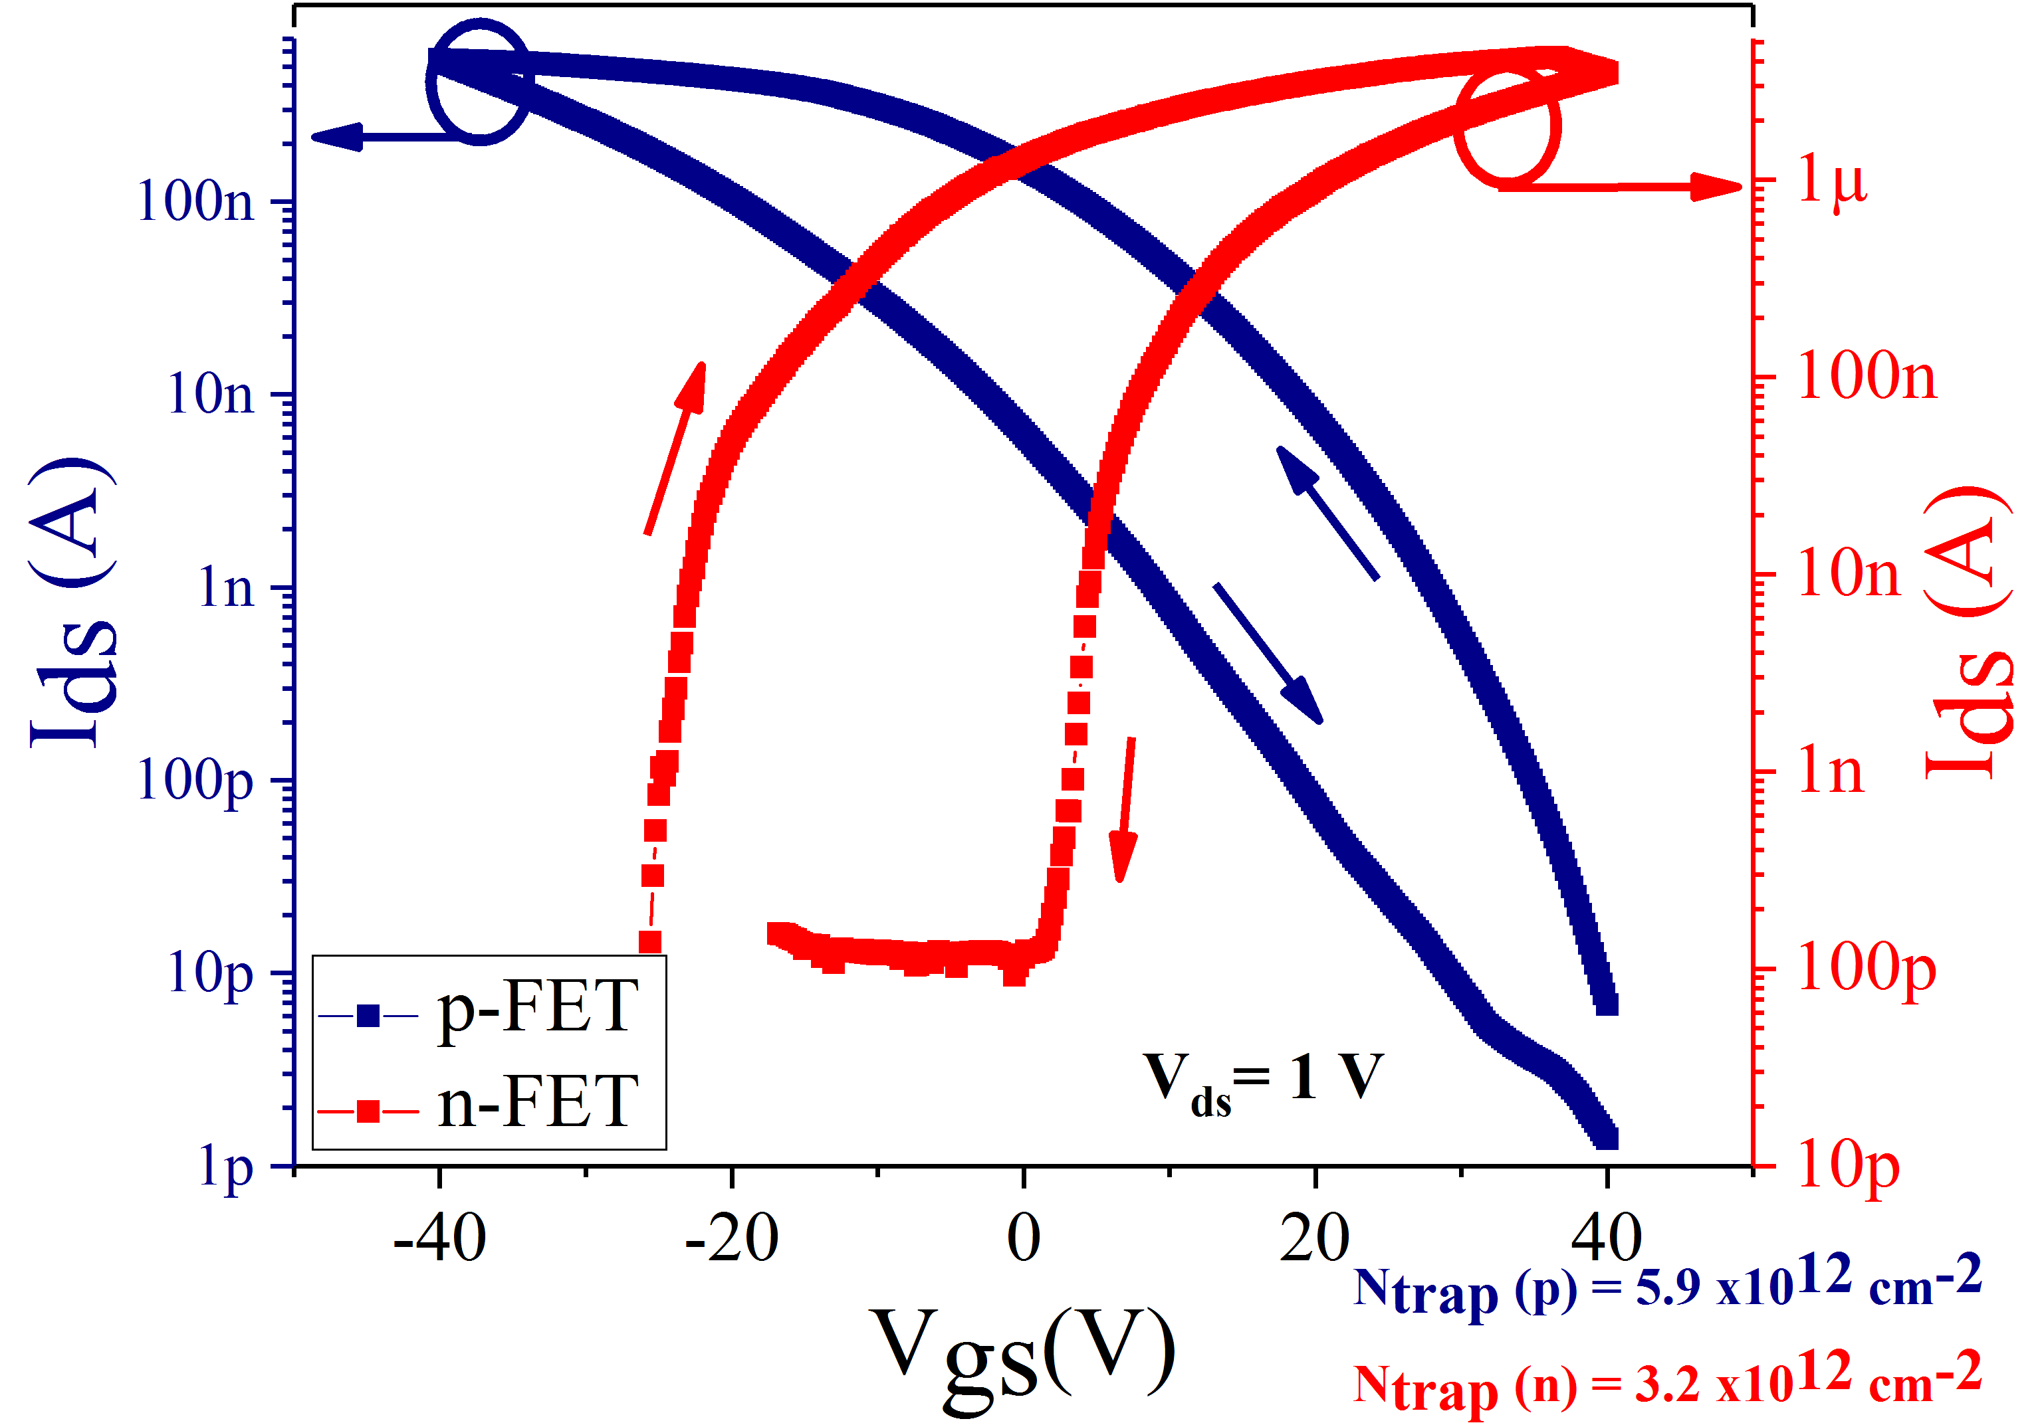
Fig S1. DC characteristics of n-FET (red) and p-FET (blue) in semi-log plot. The p-FET demonstrates a degraded sub-threshold swing in comparison to n-FET indicating more defective interface with SiO₂ as also evidenced by larger number of traps for the same gate sweep of $±$ 40 V.
Fig S2. Broadening of the hysteresis loop with an increase in (a) delay time between two consecutive measurement points (b) sweep range of the gate voltage. The results show classical signatures of electron charge trapping for a n-FET.
Fig S3: P-type transistor subjected to 50 consecutive pulses of 50 ms for potentiation (+20 V) and depression (-20 V). The shift in the threshold voltage (at constant V_{ds}= 1 V) was used to calculate the N_{trap} per pulse ~ 8.1 x10¹⁰ cm⁻²
Fig S4: The Fig 1(b) from main manuscript re-plotted in log time scale to illustrate two distinct electron de-trapping relaxation regimes.
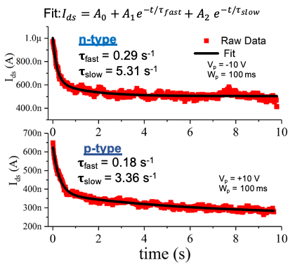
Fig S5: Fast and slow time constants extracted for the best n- and p- type device fitted to a double exponential. The devices having the most distinct fast and slow time constants are good candidates to extract secondary synaptic parameters.
Device ID | doping | N_{trap}, (cm⁻²) ±40 V V_{gs} sweep | Fast time constant (s⁻¹) | Slow time constant  (s⁻¹)
Dev 1 | Re (n) | 3.2 x10¹² | 0.29 | 5.31
Dev 2 | Re (n) | 3.6 x10¹² | 0.23 | 2.26
Dev 3 | Re (n) | 2.9 x10¹² | 0.51 | 4.83
Dev 4 | Nb (p) | 5.9 x10¹² | 0.18 | 3.36
Dev 5 | Nb (p) | 4.8 x10¹² | 0.33 | 2.85

Table S1: The fast and slow time constants extracted for three n-type and two p-type devices.
Fig S6: Slow decay and reasonable retention of synaptic conductance over > 3 mins for a pulse height of 15 V and pulse width of 500 ms.
Fig S7: Pulse paired facilitation measurements: EPSC amplitude when two closely spaced pulses are applied to the gate terminal of an n-channel MoS₂ transistor, pulsing conditions: V_{bg} (pre-pulse/rest) = +2 V and V_{bg} (during pulse) = -20 V, pulse width, W = 5 ms,separated by a duration, Δt = 75 ms, measured at a constant V_{ds} = 1 V. The ΔEPSC_{Peak} is the difference between the peak current amplitude between the second and first pulse and ΔEPSC₁ is the difference between the peak after the first pulse and the baseline.
Fig S8 : Multi-cycle repeatability of potentiation-depression characteristics for an n-type device. Please note the device takes the initialisation (first) cycle to attain a reliable number of trap states and hence conductance values.
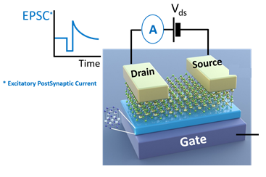
2x1 Mux
V_{post}
V_{pre}
0

Fig S9. Schematic for spike time dependent plasticity measurements, the change in the conductance of the device from which the synaptic weight change (w%) is calculated in response to the pre and post synaptic pulses. Here, the pre-synaptic Hebbian shaped pulsing scheme facilities the mapping of the time difference (Δt) between the pre- and post-synaptic pulse into the magnitude of applied gate pulses.

