THE PREVALENCE OF OROPHARYNGEAL DYSPHAGIA IN ADULTS PRESENTING WITH TEMPOROMANDIBULAR DISORDERS ASSOCIATED WITH RHEUMATOID ARTHRITIS: EXAMINING THE EVIDENCE.
Ó. Gilheaney¹; L. Zgaga²; I. Harpur³; G. Sheaf³; L. Keifer¹; S. Béchet¹; M. Walshe¹.
¹Department of Clinical Speech and Language Studies, Trinity College Dublin, Dublin, Ireland.
²Public Health and Primary Care, Trinity College Centre for Health Sciences, Dublin, Ireland.
³Library of Trinity College Dublin, Trinity College Dublin, Dublin, Ireland.
Introduction: Temporomandibular disorders (TMDs) are the most frequent non-dental orofacial pain disorders. They are conditions associated with pain and dysfunction of the temporomandibular joint (TMJ) and associated structures. TMDs are the second most common musculoskeletal/neuromuscular disorders, and the most commonly reported signs and symptoms include pain (96.1%), otological symptoms (82.4%), headache (79.3%) and TMJ discomfort/dysfunction (75%) (Cooper & Kleinberg, 2007). These features are often accompanied by joint movement restrictions, joint sounds and dental wear. TMDs may be related to rheumatoid arthritis (RA). Little is known about the prevalence of RA-related TMDs. These TMDs are important to research as pain and movement restrictions may result in oropharyngeal dysphagia, with subsequent repercussions on quality of life (QOL).
Materials and Methods: A systematic search of the literature was completed. Electronic databases, grey literature, and reference lists of included studies were searched from inception to February 2016, with no date or language restriction. Studies reporting the frequency of oropharyngeal dysphagia in adults presenting with TMD and RA were included. Study eligibility was assessed by 3 independent reviewers. Methodological quality of included studies was assessed by 2 independent reviewers using an adapted JBI tool and the Down’s and Black Tool. Meta-analysis of findings was conducted.
Results: This search yielded a total of 19 eligible studies (Fig. 1). Typical difficulties experienced by patients with RA included: impaired swallowing (24.63%) (Fig 2.) and mastication (30.69%), and masticatory pain (29.97%) and fatigue (21.26%), among others. Study quality was typically deemed to be moderate to good.
Conclusions: TMJ difficulties in RA frequently result in oropharyngeal dysphagia, with potential QOL repercussions. Research is required to address the assessment and treatment of swallowing difficulties in RA.
References:
- Cooper & Kleinberg, Cranio 2007; 25:114

Figure 1: PRSIMA Figure
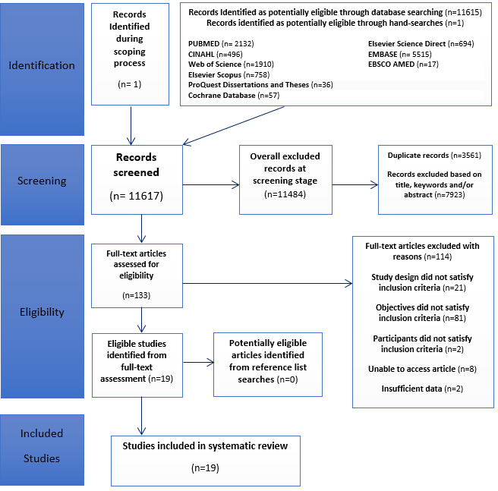

Figure 2: Forest Plot detailing the Prevalence of Impaired Swallowing


