Supplementary material
Engineering of pharmaceutical cocrystals in an excipient matrix: spray drying versus hot melt extrusion

David Walsh^{a,b}, Dolores R. Serrano^{c}, Zelalem Ayenew Worku^{a,b}, Atif M. Madi^{a,b}, Peter O’Connellª, Anne Marie Healy^{a,b*}

ª School of Pharmacy and Pharmaceutical Sciences, Trinity College Dublin, Dublin 2, Ireland.
^{b} SSPC, Synthesis and Solid State Pharmaceutical Centre, Ireland.
^{c} School of Pharmacy, Universidad Complutense de Madrid, Plaza Ramón y Cajal s/n, 28040 Madrid, Spain.

*Corresponding author:
Anne Marie Healy
School of Pharmacy and Pharmaceutical Sciences
Trinity College Dublin
Dublin 2, Ireland.
Tel.: +353 1 896 1444
E-mail address: healyam@tcd.ie
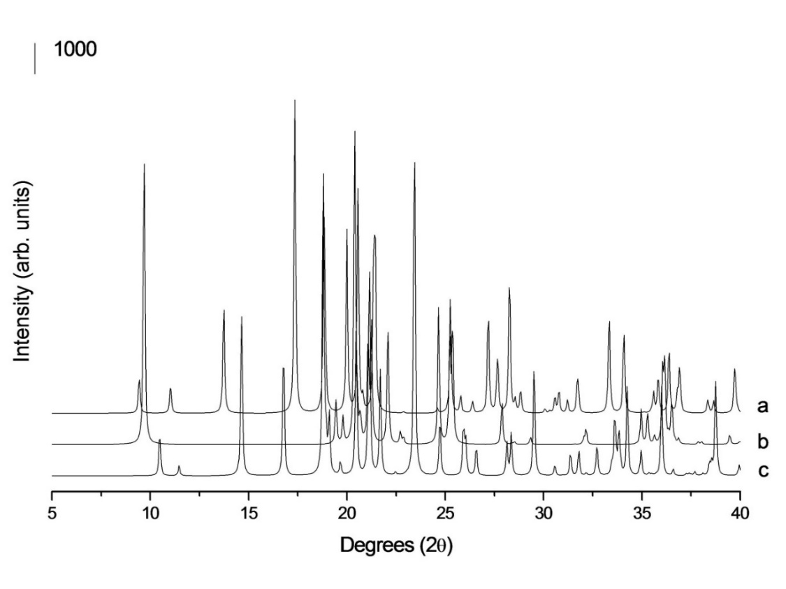
Figure S1. PXRD data of mannitol polymorphs generated from single crystal data (in the Cambridge Crystallographic Data Centre) using Mercury software. a) Alpha, b) Delta, c) Beta.
Figure S2. PXRD data of INA polymorphs: a) Unprocessed INA, b) EHOWIH05, c) EHOWIH04, d) EHOWIH03, e) EHOWIH02, f) EHOWIH01, g) Co-spray dried INA with Soluplus (50:50 %w/w ratio). b-f are Mercury software-calculated PXRD patterns of INA polymorphs based on single crystal data (in the Cambridge Crystallographic Data Centre).
Figure S3. PXRD patterns of a) Negative control of IBU:mannitol prepared by spray drying, b) Unprocessed IBU, c) Unprocessed mannitol, d) Alpha mannitol, e) Beta mannitol, f) Delta mannitol. d-f are Mercury software-calculated PXRD patterns of mannitol polymorphs based on single crystal data (in the Cambridge Crystallographic Data Centre).

Figure S4. PXRD patterns of a) Negative control of INA:mannitol prepared by spray drying, b) Unprocessed INA, c) EHOWIH05, d) EHOWIH04, e) EHOWIH03, f) EHOWIH02, g) EHOWIH01. Patterns c-g are Mercury software-calculated PXRD patterns of INA polymorphs based on single crystal data (in the Cambridge Crystallographic Data Centre).
Figure S5. PXRD patterns of a) Negative control of INA:mannitol prepared by spray drying, b) Unprocessed mannitol, c) Alpha mannitol, d) Beta mannitol, e) Delta mannitol. c-e are Mercury software-calculated PXRD patterns of mannitol polymorphs based on single crystal data (in the Cambridge Crystallographic Data Centre).

Figure S6. PXRD patterns of a) Negative controls of IBU:xylitol by HME, b) Unprocessed IBU, c) Unprocessed xylitol, d) Xyltol04, e) Xyltol03, f) Xyltol02, g) Xyltol01, h) Xyltol. d-h are Mercury software-calculated PXRD patterns of xylitol polymorphs based on single crystal data (in the Cambridge Crystallographic Data Centre).
Figure S7. PXRD patterns of a) Negative control of INA:xylitol by HME, b) Unprocessed INA, c) EHOWIH05, d) EHOWIH04, e) EHOWIH03, f) EHOWIH02, g) EHOWIH01. c-g are Mercury software-calculated PXRD patterns of INA polymorphs based on single crystal data (in the Cambridge Crystallographic Data Centre).

Figure S8. PXRD patterns of a) Negative control of INA: xylitol by HME, b) Unprocessed xylitol, c) Xyltol04, d) Xyltol03, e) Xyltol02, f) Xyltol01, g) Xyltol. c-g are Mercury software-calculated PXRD patterns of xylitol polymorphs based on single crystal data (in the Cambridge Crystallographic Data Centre).
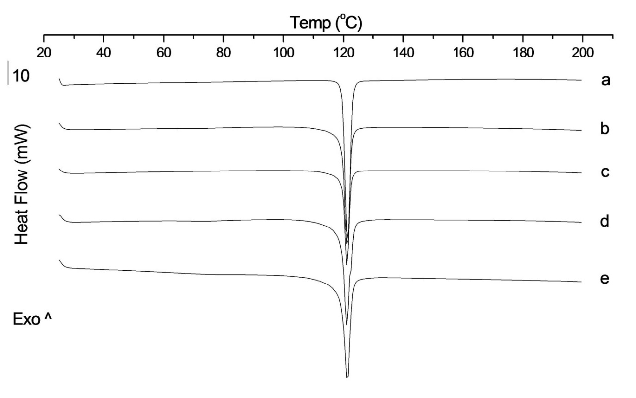
Figure S9. DSC curves of physical mixtures of spray dried cocrystal and Soluplus. a) Spray dried cocrystal, b) Physical mixture of cocrystal and Soluplus (%w/w 90:10), c) Physical mixture of cocrystal and Soluplus (%w/w 85:15), d) Physical mixture of cocrystal and Soluplus (%w/w 80:20), e) Physical mixture of cocrystal and Soluplus (%w/w 70:30).
Figure S10. DSC curves of a) Unprocessed INA, b) Co-spray dried INA with Soluplus (50:50 %w/w ratio), c) Physical mixture of cocrystal and (b) 80:20 (%w/w).
Figure S11. mDSC curves of a) SD-S-10, b) SD-S-15, c) SD-S-20. d) SD-S-30.

Figure S12. mDSC curves of a) SD-P-10, b) SD-P-20.

Figure S13. TGA curves of raw materials. a) IBU, b) INA, c) xylitol, d) mannitol, e) Soluplus and f) PVP K15.

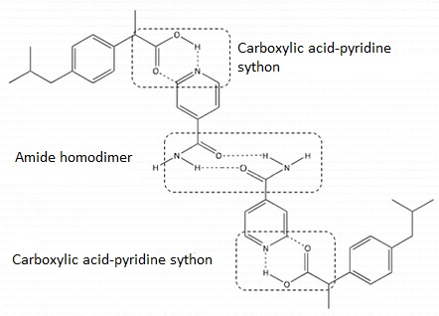
Figure S14. Cocrystal formation occurs at a 2:2 molar ratio of API:coformer, with the formation of an amide homodimer between two INA molecules and the formation of two carboxylic acid-pyridine sythons between IBU and INA. Image obtained from: (Li et al., 2016).

Figure S15. Intrinsic dissolution profile of unprocessed IBU at 37 ºC.

References:

Li, S., Yu, T., Tian, Y., McCoy, C.P., Jones, D.S., Andrews, G.P., 2016. Mechanochemical Synthesis of Pharmaceutical Cocrystal Suspensions via Hot Melt Extrusion: Feasibility Studies and Physicochemical Characterization. Molecular Pharmaceutics 13, 3054-3068.

