Experiential Pedagogies for Cultivating Entrepreneurial Mindsets: Action Design Learning as Tailored Framework

Abstract
Despite the recent recognition of experiential learning as an effective pedagogy for cultivating entrepreneurial mindsets, it still lacks a robust and tailored conceptual foundation primed for adoption in entrepreneurship education (EE). Addressing this deficit, this research integrates action learning and design learning to propose Action Design Learning (ADL) as a bespoke and adaptable framework for experiential learning in EE. ADL fosters entrepreneurial mindsets by placing first- and second-person learning at the core of pedagogy, using emergent entrepreneurial artifacts as focusing devices. Through longitudinal insider action research, the framework is abductively evaluated across two cases in Irish universities, culminating in a functional adaptation primed for adoption. The study reveals that ADL provides a robust conceptual foundation that educators can readily apply in designing and delivering high-impact curricula that foster metacognitive abilities deemed foundational to an entrepreneurial mindset. Consequently, this study contributes to the experiential learning discourse by offering a theoretically grounded pedagogy that overcomes skepticism about the efficacy of this approach in promoting high-impact EE.

- Keywords: Entrepreneurship education, experiential learning, design learning, action learning, entrepreneurial mindset, pedagogy
- Type of Paper: Research Paper

Introduction
Entrepreneurship education (EE) has recently gravitated toward experiential learning models, which are considered effective for cultivating entrepreneurial mindsets in university settings (Pittaway & Cope, 2007; Hägg & Gabrielsson, 2020; Nzembayie & Coghlan, 2024). Experiential learning, characterized by active engagement in concrete experiences followed by critical reflection (Kolb, 1984; Kolb & Kolb, 2009), has long been advocated across multiple disciplines as a pedagogy for promoting deep learning (Flanagan, 1954; Schön, 1983, 1987; Gibbs, 1988). It contrasts with traditional pedagogy (i.e., behaviorism) based on knowledge transmission, with learners as passive receivers. As the limitations of traditional approaches become apparent (Bewayo, 2015; Nabi et al., 2017), experiential pedagogies, exemplified by practices such as design thinking and lean startup, have garnered significant interest (Neck & Greene, 2011; Neck & Corbett, 2018; Hägg & Gabrielsson, 2020; Schultz, 2022).
However, the theoretical and philosophical foundations upon which such experiential learning practices translate into entrepreneurial mindsets and capabilities remain poorly articulated. Consequently, scholars identify a deficit in conceptual and philosophical foundations that integrate education theories to articulate how learning by experience results in impactful learning outcomes such as mindsets (Bell & Bell, 2020; Hägg & Kurczewska, 2021). Accordingly, Fayolle (2018, p. 692) bemoans the lack of ‘strong intellectual and conceptual foundations, drawing from the fields of entrepreneurship and education’ to strengthen the delivery of entrepreneurial learning outcomes. Poor articulation of conceptual foundations contributes to suboptimal implementation, resulting in incoherent curriculum design, inconsistent assessment of learning outcomes, and skepticism about the efficacy of experiential learning models (Hägg & Gabrielsson, 2020; O’Flynn et al., 2023). As such, this study aims to answer the question: How can experiential learning be more effectively articulated and tailored as a pedagogical approach to cultivating entrepreneurial mindsets in university settings?
To answer this question, we briefly revisit contemporary debates in the EE literature, focusing on establishing a conceptual alignment between the entrepreneurial process phenomenon and experiential learning. By establishing a pedagogical alignment, we explore the learning outcomes of an experiential learning model, which are the mindsets and the related capabilities they generate. Finally, by combining two experiential pedagogies, action learning (Revans, 1982, 1998) and design learning (Schön, 1992), and aligning them with a solid conceptual understanding of the entrepreneurship phenomenon, we advance action design learning (ADL) as a tailored experiential pedagogy for cultivating entrepreneurial mindsets. Through longitudinal insider action research (Coghlan, 2019), we abductively evaluate its conceptual assumptions through pedagogical practices and student reflections in two Irish universities. The outcome is a functional ADL framework primed for adoption, which we discuss.
Consequently, this study makes three main contributions to the literature on experiential learning in EE. First, it provides ADL as a tailored framework for impactful experiential learning, addressing current deficits related to solid conceptual foundations. Second, it highlights the merits of the recent repositioning of entrepreneurship as a domain of design (Berglund et al., 2020; Dimov et al., 2023), affording clarity by reconceptualizing emergent entrepreneurial artifacts as focusing devices for experiential learning (Selden & Fletcher, 2015; Berglund & Glaser, 2022). Third, it provides entrepreneurship educators with an accessible conceptual framework for the coherent and consistent design of high-impact learning outcomes.
The rest of the paper unfolds as follows. Section 2 provides a comprehensive literature review, culminating in the positioning and development of ADL as a suitable pedagogy for experiential EE. Section 3 discusses the methodology, followed by the findings in Section 4. Section 5 provides a discussion, and Section 6 is the conclusion.

Theoretical Background

Pedagogical Alignment & Experiential Learning in EE
A body of research argues that traditional pedagogies that dominated the earlier decades of EE, with business plan production and entrepreneurial intentions as outcomes, fail to develop genuine entrepreneurial mindsets and capabilities (Nabi et al., 2017; Schultz, 2022). Consequently, Watson and McGowan (2020) found that six months after graduation, the capabilities of students taught traditional approaches were mainly limited to business plan production and investor pitching rather than the actual implementation of entrepreneurial projects.
Traditional approaches to EE mainly materialize behaviorism, a theory of pedagogy based on third-person knowledge transmission, with learners as passive receivers. Thus, behaviorism fails to realize pedagogical alignment, a core tenet of most successful curriculum designs. Defined as a logical consistency between the phenomenon being taught or learned, the needs of learners, and the instructional design and methods used to deliver learning outcomes, pedagogical alignment is critical to the legitimacy of formal education programs (Reeves, 2006; Edmondson & McManus, 2007). In recent years, scholars have noted the pedagogical misalignment between behaviorism and its capacity to deliver learning outcomes that prepare students for the practice of real-world entrepreneurship – hence the recent pivot toward experiential learning models (Nabi et al., 2017; Hägg & Gabrielsson, 2020).

Pedagogical Alignment: Understanding the Entrepreneurship Phenomenon
To resolve misalignment issues, one must begin by unraveling the true nature of the entrepreneurship phenomenon. First, there is a broad consensus that entrepreneurship is a complex, multidimensional phenomenon defined by action under uncertainty and related imperfections (e.g., resource scarcity) in pursuing opportunities. Hence, McMullen and Shepherd (2006) argue that entrepreneurial action is a product of the amount of uncertainty perceived and the willingness to bear uncertainty. It implies that actors unwilling to bear uncertainty are less likely to act entrepreneurially. Therefore, EE should focus on developing the willingness to act under uncertainty, while bearing the ambiguities that entrepreneurial journeys unravel.
Recent scholarship more concretely articulates action in the pursuit of opportunity as the conceptualization, design, and development of problem-solving artifacts (Selden & Fletcher, 2015; Berglund et al., 2020). Such action is usually collaborative, making co-creation a core assumption in core theories of the entrepreneurial process – e.g., effectuation and bricolage (Sarasvathy, 2001; Baker & Nelson, 2005). Therefore, action and interaction involving collaborating agents result in the instantiation of artifacts that materialize entrepreneurial opportunities as solutions to societal problems (Lackéus, 2020). Given that entrepreneurial artifacts represent the interface between actors and their environments, a body of recent scholarship argues that entrepreneurship is a field of design (Simon, 1969, 1996; Dimov et al., 2023; Dimov, 2016; Romme & Reymen, 2018; Berglund et al., 2020; Seckler et al., 2021; Dimov, 2020).
As design-based co-creation is fundamentally uncertain, it denotes a process marked by nonlinearity and dynamism resulting in three classes of emergent artifacts: abstract, material, and narrative artifacts (Berglund & Glaser, 2022). Abstract artifacts include new venture ideas, while material artifacts refer to physical goods or services including digital products that entrepreneurs create as concrete outcomes of entrepreneurial action. Finally, narrative artifacts consist of business models and pitches that entrepreneurs use to communicate their ideas. Appreciating a design-based perspective in EE is critical as it provides the foundation for effectively adopting experiential learning. Doing so envisions the reframing of entrepreneurial artifacts as focusing devices for experiential learning.

Experiential Re-alignment: Design Thinking & Lean Startup
While the realignment of EE from behaviorist to experiential learning has recently been embraced, the dominance of practices such as design thinking (Brown & Katz, 2011) and lean startup (Ries, 2011), raises questions about their efficacy as pedagogies for cultivating entrepreneurial mindsets and capabilities (Schultz, 2022). Scholars caution that the adoption of such pedagogies as models of experiential learning has unfolded without a sound theoretical and philosophical grasp of how mindsets and skill sets are developed through practice (Fayolle, 2018, p. 692; Sarooghi et al., 2019; Hägg & Kurczewska, 2021; O’Flynn et al., 2023). This lack of a robust intellectual foundation threatens to undermine efforts toward re-aligning EE with experiential learning models.
Kolb (1984) establishes the basis of experiential learning through four key elements: concrete experience, reflective observation (Schön, 1983), abstract conceptualization, and active experimentation. It denotes experiential learning as an iterative model of pedagogy that begins with experience, followed by mental processing that eventually leads to further action. This model of pedagogy departs from behaviorism, appearing more consistent with the recursive nature of action encapsulated in design-based theories of the entrepreneurship phenomenon. Since entrepreneurial action originates from the inner sanctum of individual cognition and motivation, it favors a model of pedagogy that centralizes concrete experiences at its core and entrepreneurial mindsets as learning outcomes (Dimov & Pistrui, 2022; Nzembayie & Coghlan, 2024). Therefore, a pedagogy that shifts learning from third-person knowledge transmission (behaviorism) to first-person learning that values students’ subjective experiences is better aligned. First-person learning implies the integration of cognitivism in pedagogy, a theory of education that conceptualizes learning as mental processing, typically following concrete experience in practice. Thus, unlike behaviorism, it shifts the object of entrepreneurial learning from external third-person knowledge transmission to mental processes, encapsulating critical reflections that capture and evidence entrepreneurial mindsets in action.
However, since entrepreneurial action is fundamentally collaborative (Sarasvathy, 2001), it suggests that an interactionist model of pedagogy that combines first- and second-person learning as the core of an experiential learning framework appears more robust and tailored to EE. Second-person learning emanates from the meaning we derive from taking co-creating value with others. Collaboration in entrepreneurship takes many forms, such as interacting and working with teams and target audiences and engaging with mentors. It mirrors design principles, which conceptualize entrepreneurial artifacts emerging at the interface between actors and their environment (Simon, 1969; Berglund et al., 2020).
Therefore, second-person learning must blend with first-person learning at the core of a pedagogy that places subjective and intersubjective experiences at the heart of learning. This implies that a tailored experiential learning pedagogy for EE must be underpinned by social constructivism. Social constructivism is an education theory which maintains that learning is inherently social and that interaction with peers, teachers, and the community is essential for developing the skills and mindsets necessary for personal growth (Vygotsky, 1978). As the pragmatist philosopher John Dewey argues, meaning-making through experience is the result of interaction, making education a social process (Dewey, 1944, 1946). Therefore, a robust experiential learning pedagogy for EE must create a space where learners co-create problem-solving artifacts with relevant actors, simultaneously co-constructing their own understanding of the phenomenon.
Nevertheless, since the abstract conceptualizations of experiential learning that arise from collaborative action help learners assert general truths about experiences, a degree of knowledge transmission is necessary. This implies the incorporation of behaviorist learning models by introducing entrepreneurship theories and conceptual frameworks that support students in making meaning of their first and second-person experiences. Thus, a philosophical alignment with pragmatism emerges, depicting a robust experiential pedagogy for EE as an intricate blend of varied entrepreneurship and education theories for impactful learning outcomes.

Outcomes of Experiential Learning: Mindsets & Capabilities
Exactly what learning outcomes experiential pedagogies are meant to cultivate has also suffered from poor conceptual articulation. Recently, scholars have argued that experiential models of pedagogy should focus on developing entrepreneurial mindsets and capabilities as the core of learning outcomes, marking a shift from an overemphasis on intentions and propensities associated with behaviorism (Neck & Corbett, 2018; McLarty et al., 2023). Entrepreneurial mindsets are considered more impactful and aligned because they shape a learner’s capacity to act under various entrepreneurial circumstances. However, what constitutes entrepreneurial mindsets has also suffered from articulation and fragmentation, which in turn contributes to issues of inconsistent assessment of learning outcomes (Daniel, 2016; Fayolle, 2018; Lackéus, 2020). However, research by Kuratko et al. (2021) unveils an entrepreneurial mindset framework that comprises a triad of cognitive, behavioral, and emotional dimensions, increasingly deemed valuable in articulating experiential learning outcomes.
The cognitive dimension of the entrepreneurial mindset framework is of paramount importance. It represents a complex network of mental structures that enable judgments and decisions related to opportunity assessment and action under uncertainty. As identified by Baron (2004), cognitive adaptability is a fundamental aspect of this dimension. It is characterized by flexibility and self-regulation, which are essential in managing dynamic and imperfect entrepreneurial journeys. Similarly, Haynie et al. (2010) conclude that the foundations of an entrepreneurial mindset are metacognitive, with metacognition being implicated in an individual’s capacity for creative problem-solving under challenging circumstances (Hamidi et al., 2008). As Flavell (1979) argues, metacognition relates to being aware of and controlling one’s own thought processes, which helps improve learning and problem-solving. Therefore, as the basis of an entrepreneurial mindset, cultivating strong metacognition materializes increasingly self-aware individuals who can act and reflect to gain insight. Since concrete action and reflection are hallmarks of experiential models of pedagogy (Kolb, 1984; Kolb & Kolb, 2009), they cultivate metacognitive abilities through the crucible of concrete action, experimentation, and reflections, which leads to increased self-awareness. Thus, it underscores the importance of first-person learning at the core of a tailored experiential learning pedagogy.
Meanwhile, the behavioral dimension of the mindset triad recognizes that cognition must ultimately be manifested through action in the world (Bird & Schjoedt, 2017). Therefore, the behavioral dimension extends the cognitive dimension through the capacity for rapid sensing, action, and mobilization under uncertainty (McMullen & Shepherd, 2006; Shepherd et al., 2010). Therefore, experiential learning projects must be challenging enough to foster behavioral mindset capabilities based on dynamic action and interaction. The behavioral mindset dimension, therefore, dissolves the notion of entrepreneurial capabilities as innate and preexisting, rendering obsolete previous questions about the teachability of entrepreneurship (Pittaway & Cope, 2007; Fayolle et al., 2018). Furthermore, since entrepreneurial behavior centrally manifests as the co-creation of artifacts in an environment (Sarasvathy, 2001), action and interaction in a tailored experiential pedagogy could harness multiple behavioral capacities encapsulated under this mindset dimension (Lackéus, 2020).
Finally, the emotional dimension interacts with cognitive and behavioral by focusing on stress management and self-regulation of the ego under challenging entrepreneurial circumstances (Lackéus, 2014). As Baron (1998) points out, entrepreneurs operate under circumstances that trigger stress and other negative emotions, leading to errors in judgment. Given the uncertainty inherent in entrepreneurial experiences, stress results from discrepancies between expectations and unfolding reality (Wright & Zahra, 2011). Therefore, developing emotional maturity to cope with stressful entrepreneurial journeys is vital. Accordingly, Lackéus (2020) notes that these circumstances also create ideal conditions for emotional learning experiences if they can be well replicated in EE classrooms. Educators then watch out for the emergence of metacognitive abilities that foster emotional self-regulation toward achieving long-term goals (Lackéus, 2014). Critically, emotional self-regulation also increases willingness to bear uncertainty and tolerate ambiguity, fostering passion, perseverance, and skills.
Additionally, Kuratko et al. (2021) point out that emotional self-regulation involves regulating the ego to promote successful outcomes. The entrepreneurial ego manifests a strong internal locus of control, which, although beneficial to entrepreneurial self-efficacy, can lead to excessive control tendencies, undermining the relational aptitude needed for the co-creation of value. Without self-regulation of the ego, collaborator input is perceived as relinquishing control (Sarasvathy, 2001). Therefore, to evaluate the efficacy of experiential learning, educators should examine how students become self-aware and self-regulate against the harmful effects of stress and ego, concurrently avoiding errors in judgment, such as confirmation bias and the escalation of commitment when confronting disconfirming evidence (Kahneman & Tversky, 1977, 1979). Based on the mindset triad, we envisage a first- and second-person core of a tailored experiential pedagogy, where critical reflection on action is central to most forms of assessments. Such pedagogy also uses emerging entrepreneurial artifacts to evaluate the behavioral dimensions of mindset cultivation, which might explain the appeal of design models in EE (Schultz, 2022).

Toward a Tailored Pedagogy for Experiential Learning in EE
Advancing a tailored experiential pedagogy for cultivating entrepreneurial mindsets in EE requires a pragmatic combination of various learning modalities, with first- and second-person experiences remaining central. To this end, we combine the relevant facets of two established experiential learning pedagogies, action learning and design learning, into a bespoke framework.

Action Learning
Action Learning (AL) is defined as ‘learning by doing,’ which appears intuitive but belies its profound conceptual and philosophical foundations (Zuber-Skerritt, 2001). This fuzzy definition calls for fine-tuning to be ready for adoption in a specific context (Coghlan & Coughlan, 2010; Brook et al., 2012). Conceptually, AL ascends from Revans's (1982, 1998) works, which encapsulate this approach in the formula L = P + Q. In this formula, learning (L) is the combination of programmed knowledge (P) and questioning insight (Q). It implies that real learning occurs through a balance of applying existing theories (P) while engaging in practice and thoughtful reflection (Q). Thus, AL incorporates the merits of third-person learning (P) epitomized by behaviorism toward supporting the first and second-person learning (Q) core, underpinned by cognitivist and social constructivism theories of education. As such, it affirms the need for pragmatism in a robust experiential pedagogy for EE.
However, tailoring AL as a tool for cultivating entrepreneurial mindsets in EE presents several challenges. First, educators might struggle to see how AL connects to a general conceptual understanding of the entrepreneurship phenomenon (P), making it challenging to apply and evaluate how it helps cultivate entrepreneurial mindsets. Second, since the quality of AL experiences can vary depending on the educator’s skill and knowledge, it could result in inconsistent application and uneven learning outcomes. Third, the potential for superficial learning exists if critical reflection and feedback processes are not adequately emphasized (Q) at the core of first and second-person learning. Finally, that on which AL experiences are based requires clear articulation to suit the EE context, without which the poor selection of experiential learning projects can impact experiential learning efficacy (Brook et al., 2012).
Thus, AL, in its original form, fails to fully address issues of clear conceptual articulation regarding how knowledge derives from entrepreneurial practice. To this end, we consider design learning a valuable complement to a tailored experiential pedagogy for cultivating entrepreneurial mindsets.

Design Learning
Grounded in the pragmatic philosophy of John Dewey, DL is an iterative pedagogy involving reflective processes in which learners engage in problem solving by creating, manipulating, and evaluating artifacts (Schön, 1992). These artifacts serve as both tools for thinking and concrete representations of ideas, enabling learners to externalize their thought processes and receive feedback from their environment (Gómez Puente et al., 2011; Gómez Puente et al., 2013). Through creating and refining these artifacts, learners engage in cycles of action and reflection, facilitating more profound understanding and skill development within a collaborative, social context (Schön, 1983, 1987, 1992). Thus, it adds context to action learning by conceptualizing artifacts as focusing devices for ‘learning by doing’.
Critically, DL is consistent with the notion of entrepreneurship as a form of design discussed above. From this perspective, emerging entrepreneurial artifacts (Selden & Fletcher, 2015) can similarly be conceptualized as focusing devices for experiential learning projects. As Berglund and Glaser (2022) point out, entrepreneurial artifacts typically begin as conceptual artifacts, such as venture ideas, iteratively emerging as narrative and material artifacts in subsequent stages, such as business models and product prototypes. Thus, educators can structure iterations of design learning projects around different classes of emergent entrepreneurial artifacts. Hence, Lahn and Erikson (2016) state that by emphasizing artifact-mediated action, DL may strengthen systematic self-reflection in a tailored experiential pedagogy for EE.
However, while design-based pedagogies, such as design thinking and lean start-up approaches, have attracted interest in EE (Schultz, 2022), this interest has not been matched by a deep understanding of the conceptual and philosophical underpinnings of design in pedagogy for cultivating entrepreneurial mindsets. Instead, they mainly provide a series of design tools and processes such as experimentation, prototyping, and co-creation (Ries, 2011; Brown & Katz, 2011) but stop short of explaining how such design practices cultivate mindsets. Therefore, while DL affords the potential to transform EE, the multitude of frameworks and tools described under this model of pedagogy fails to articulate its unifying logic and how it effectively delivers entrepreneurial learning outcomes (Sarooghi et al., 2019). Thus, integrating the more established AL framework with DL envisions a robust and tailored experiential pedagogy for EE.

Tentative Action Design Learning Framework for Mindset Cultivation
By combining AL with DL, we advance Action Design Learning (ADL) as a tailored conceptual framework for cultivating entrepreneurial mindsets in EE. We visualize this integration in Figure 1 below, offering a tentative conceptual framework for use in abductive analysis (Timmermans & Tavory, 2012). As shown, the framework places subjective first-person learning and intersubjective second-person learning at the core of ADL, with emerging entrepreneurial artifacts as focusing devices for structuring experiential learning experiences. Through increased self-awareness emanating from collaborative action and reflection and feedback encapsulated in emergent artifacts, students harness their metacognitive abilities to become increasingly aware of themselves and self-regulate to achieve shared goals. Thus, metacognitive abilities, deemed foundational to an entrepreneurial mindset, are harnessed as outcomes.
Figure 1. Action Design Learning Framework for EE
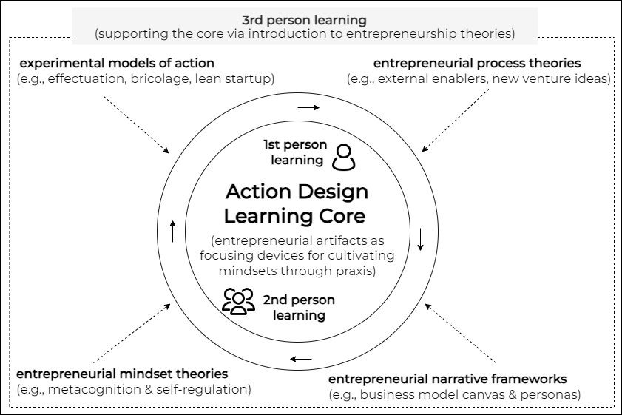
Furthermore, by designing entrepreneurial artifacts through hands-on practice, learners cultivate the behavioral dimensions of an entrepreneurial mindset, which is the capacity to rapidly sense and act under the challenges of entrepreneurial journeys (McMullen & Shepherd, 2006). Consistent with Lackéus (2020), critical incidents of learning are created, whereby discrepancies emerge between students’ envisioned solutions and disconfirming feedback from end users, which triggers negative emotions and conditions for making poor judgment. Therefore, how students manage such challenging moments of stress and contain their ego toward realizing successful outcomes offers evidence in assessments of entrepreneurial mindsets in action.
Finally, through third-person learning, entrepreneurship theories are introduced, allowing students to gain insight by linking experiences at the core with abstract theories and concepts established in the entrepreneurship literature. Thus, entrepreneurship theories are introduced, such as experimental models of entrepreneurial action (Sarasvathy, 2001; Baker & Nelson, 2005; Ries, 2011; Brown & Katz, 2011) towards providing conceptual frameworks for aiding the design, enactment, and critical reflection on experiences in artifact co-creation. Similarly, narrative frameworks, such as the business model canvas and personas, can help develop and communicate narrative artifacts at the ADL core. Key theoretical constructs included in the framework are expatiated in a table in Appendix A.
Ultimately, ADL provides a robust experiential learning pedagogy tailored to EE by blending subjective and intersubjective learning at the core with objective learning as supportive and peripheral. Therefore, while rooted in pragmatism and anchored in cognitivist and social constructivist theories of learning, it does not disregard the merits of behaviorism. Subsequently, we empirically explore the fundamental assumptions of our tailored ADL framework through abductive insider inquiry (Timmermans & Tavory, 2012).

Methodology
This study employs an insider action research design within a longitudinal framework, focusing on two cases that apply and evaluate ADL principles across Irish universities (Brannick & Coghlan, 2007; Coghlan, 2019; Nzembayie & Buckley, 2020). The multimethod insider research approach integrates three inquiry models (Nzembayie et al., 2019): first-person inquiry through reflective practice (Schön, 1983), second-person collaborative inquiry (Heron & Reason, 2006), and third-person inquiry via an abductive dialogue between data and theory (Torbert, 2006; Timmermans & Tavory, 2012; Coghlan & Shani, 2021). This approach allows native insider researchers (Brannick & Coghlan, 2007) to study their practice through lived experiences in real-time case studies (Berglund, 2007). The two cases occur across different Irish university settings. The first case explored and iteratively examined assumptions of an ADL (Case 1) approach, while the second (Case 2) applied and refined it more deliberately as an approach to EE. Following Eisenhardt (2021, p. 149), case selection was based on access to settings where the focal phenomenon is likely to occur, enhancing theory building through observed similarities and differences. This insider engagement in teaching and research positions researchers to enact, observe, reflect, and learn about best practices in the optimal delivery of EE.
The lead researcher, a serial entrepreneur turned academic, initiated the study in 2021, after noticing the gap between dominant pedagogical practices in EE and his lived entrepreneurial experiences. To address this, he co-inquired with peers and undertook a postgraduate certificate in university learning and teaching between 2021 and 2022, providing the setting for the first case (Case 1). This certification course involved structured reflection with professional educators and peers, promoting rigorous reflective practice (Schön, 1983). The process of documenting and reflecting on critical learning incidents in collaboration with peers continued into Case 2 in a different university setting in the 2022/23 academic year, resulting in a wide variety of data and archival records aiding triangulation and third-person abductive inferencing (Coghlan & Shani, 2021).

Data Collection
Data collection encompassed various recorded accounts. First, the lead educator's application of ADL practices and the documentation of critical learning incidents in a reflective portfolio provided a primary data source (Flanagan, 1954). The reflective portfolio, which included a wealth of rich data, served as an assessment tool required by the teaching certificate program, continuing post-completion. Second, student reflections, corroborated by archival records, were pivotal in demonstrating how the educator's design and delivery, using principles of ADL, impacted the cultivation of entrepreneurial mindsets. The comprehensive data collection and triangulation efforts enhanced the authenticity and trustworthiness of the reflective narratives (Lincoln & Guba, 1986).

Data Analysis
The study employed thematic narrative analysis to extract findings from rich reflective narratives in Case 1, supported by archival records (Riessman, 2003, 2008). Unlike grounded theory, which fragments data for analysis, thematic narrative analysis is holistic, examining events in their situational and temporal contexts while focusing on emerging themes to aid mechanism-based explanations (Van de Ven, 2007; Ylikoski, 2019). Using this approach, we analyzed reflections from a group of students in Case 1, who initially provided evidence of the potential impact of an ADL approach in cultivating mindsets. Case 2 then uses the critical reflections of a cohort of 32 MSc students, employing thematic analysis to select, extract, and triangulate insights that reinforce and expand on observations in Case 1. By combining educator and student reflections, the study provides mechanism-based explanations regarding how ADL contributes to developing entrepreneurial mindsets in university settings. Thematic analysis was aided by the literature and our tentative conceptual framework in Figure 1, which offered concepts and constructs to focus the search for explanations. To effectively conduct thematic analysis, data reduction began by distilling volumes of rich data into critical event narratives, with theory as a focusing instrument.

Findings
This section presents the results of the study. First, it describes the case settings, which provides a necessary backdrop for understanding the cases. Then, it concisely presents the implementation of ADL principles in pedagogical design, followed by student reflections, which evidenced its effectiveness in cultivating entrepreneurial mindsets. Finally, key challenges are explored through the reflective accounts of the lead researcher.

Case Settings: Pedagogical & Institutional Contexts
We construct Table 1 below to outline the key similarities and differences between the pedagogical and institutional settings of both cases. Thus, we highlight the temporal and situational context of course delivery, as documented by the lead researcher. The setting provides the backdrop for understanding the two cases and insights extracted from them.

Table 1. Comparison of the similarities between settings of the two cases
Aspect | Case 1 | Case 2
Context | Undergraduate course in a Business Studies program (starting Sept. 2021) – during COVID-19 | MSc course in an Entrepreneurship program (Starting February 2023) – post-COVID
Duration | 12 weeks in a single semester | 6 weeks of ADL approach followed by 2 weeks of project completion work
Session Length | Weekly 2-hour lectures | Weekly 3-hour sessions
Educational Level | Third-year elective course in entrepreneurship | Compulsory course of an M.Sc. Entrepreneurship program
Professional Development | Part of the certification in university learning and teaching included peer observations and portfolio development as assessments – see Appendix D. | Post-certification completion in a new university with the lead researcher having greater influence over course design. Continuous reflection with peers.
Student Assessments | Individual and group assessments with an emphasis on reflective journaling and reporting from design projects | Mainly individual projects with reflective journals and reports from design projects
Experiential Learning Models | Gibb's (1988) and Kolb's (1984) models were introduced to aid the capture and critical reflection on ADL projects (Schön, 1983) from the first day. | Same models, same approach as in Case 1
Educator’s Capacity for Influence | Limited due to late appointment as the course instructor, having minimal scope for changing predefined learning outcomes - nevertheless broad enough to allow experimentation – e.g., predefined business plan production was scrapped. | Significant, with flexibility in course and outcome design as a program co-director. With the freedom to deepen continuous experimentation, the ADL principles were applied more aggressively.
Institutional Setting | The entrepreneurship course was part of an undergraduate Business Studies degree at an Irish university and one of two electives students had to pick. | The entrepreneurship course was embedded within a dedicated entrepreneurship MSc program in another Irish university.
As shown, the two cases shared core similarities and several differences linked to institutional setting. In Case 1, two interrelated types of assessments were performed during the 12 weeks – individual and group. The students were tasked with keeping a reflective journal from the very beginning as part of the individual assessment. Experiential learning models from Kolb (1984) and Gibbs (1988) were also introduced on the first day to help structure students’ reflections on critical incidents of learning (Flanagan, 1954). Students initiated new venture ideas (conceptual artifacts), followed by their articulation as business models (narrative artifacts), subsequently enacting, designing, and reflecting on the process of their emergence as prototypes (concrete/material artifacts). As students progressed through the courses and participated in ongoing ADL projects, they were tasked with constantly documenting and reflecting on critical incidents of learning as a core part of assessment.
Case 2 had a similar parameter but involved more mature MSc students. As mature and highly self-motivated students in a dedicated entrepreneurship program, compared to Case 1, students had a clearer idea of what they were trying to achieve from the course and the MSc program. Therefore, they were allowed to do their projects in groups or individually. Individual projects were especially preferred by students who wanted to advance their ventures into full-fledged businesses after completing the program.

Implementation of ADL in Pedagogical Design
Table 2 summarizes how the lead researcher incorporated theory in designing experiential learning in Case 1, to facilitate the cultivation of entrepreneurial mindsets. Consistent with third-person inquiry (Torbert, 2006; Coghlan & Shani, 2021), the ADL framework in Figure 1 iteratively provided the theoretical basis for the design and implementation of a tailored experiential pedagogy in an abductive approach. The table shows how first- and second-person learning formed the core of pedagogy, with third-person learning being supportive. Lessons were designed in such a way that entrepreneurial artifacts became focusing devices (Berglund et al., 2020) for experimentation, action, and reflection. The educator introduced and discussed fundamental entrepreneurship theories in weekly lessons structured to anticipate the temporal stages of student project milestones. Students used these theories to formulate action and design principles, thus supporting their projects.

Table 2. Experiential Learning Projects and ADL Implementation
Aspect | Details
Assessment Artifacts | 1. Development and evaluation of new venture ideas, i.e., abstract and narrative artifacts 2. Implementation of the idea as a prototype, i.e., website, product samples, etc.
Assessment Components & Artifacts | 1. Group report with visualized designs as narrative artifacts.  2. Five-minute presentation pitch.  3. Prototype/MVP of the product / service (where feasible) as material artifacts 4. Reflective journals.
Timing | 1. First assessment due in week 4.  2. Second assessment due in week 12.
Student Tasks (1st & 2nd person learning) | - Identify a business problem in groups.  - Develop and evaluate as a new venture idea.  - Document decisions in reflective journals.
3rd Person Knowledge Transmission | - Progressive introduction of entrepreneurship theory.  - Classroom discussions and case studies for introducing theory  - Introduction to digital design tools and platforms for prototyping (e.g., Canva.com, draw.io, placeit.net, etc.).
Grading Criteria | - Decision-making and judgments made under entrepreneurial circumstances.  - Documentation of decisions on pivoting or discarding ideas.  - Evidence of entrepreneurial mindsets in action – metacognition/self-awareness, behavioral & emotional self-regulation
Key Insights | - Authentic learning experiences materialize through ADL.  - Evidence of high impact on students' mindsets
Example Project | - Creation of an app and digital platform for finding tradespeople in Ireland.  - Engagement with potential end users and photographic evidence - Second-person learning.
Challenges Encountered | - The non-linear nature of the project was unusual for students who were used to the predictability of planning and execution in other management courses.  - Ensuring students understand that pivoting or discarding ideas is not a failure, but a part of the entrepreneurial process was an initial challenge.
Purpose | - To illustrate the implementation of a structured yet flexible approach to teaching entrepreneurship using ADL as a conceptual basis for experience.  - To demonstrate the effectiveness of focusing on the process (idea development, evaluation, pivoting) rather than the final product.  To showcase how ADL pedagogy can mimic authentic learning experiences and impact students' entrepreneurial mindsets.  - To highlight the importance of documenting the decision-making process in fostering an entrepreneurial mindset through critical reflection.

Entrepreneurial Mindset Cultivation: Analysis of Student Reflections
In Case 1, we sampled a student’s reflections, capturing events undertaken by her group, who took the exercise seriously and achieved outstanding results. Given that entrepreneurship education was an optional course in a degree program other than entrepreneurship, the sample reflection helped signal ADL's potential in cultivating entrepreneurial mindsets among students with a strong motivation for studying entrepreneurship. Figure 2 below presents a narrative thematic analysis of the sample.
Figure 2. Thematic Narrative Analysis in Case 1
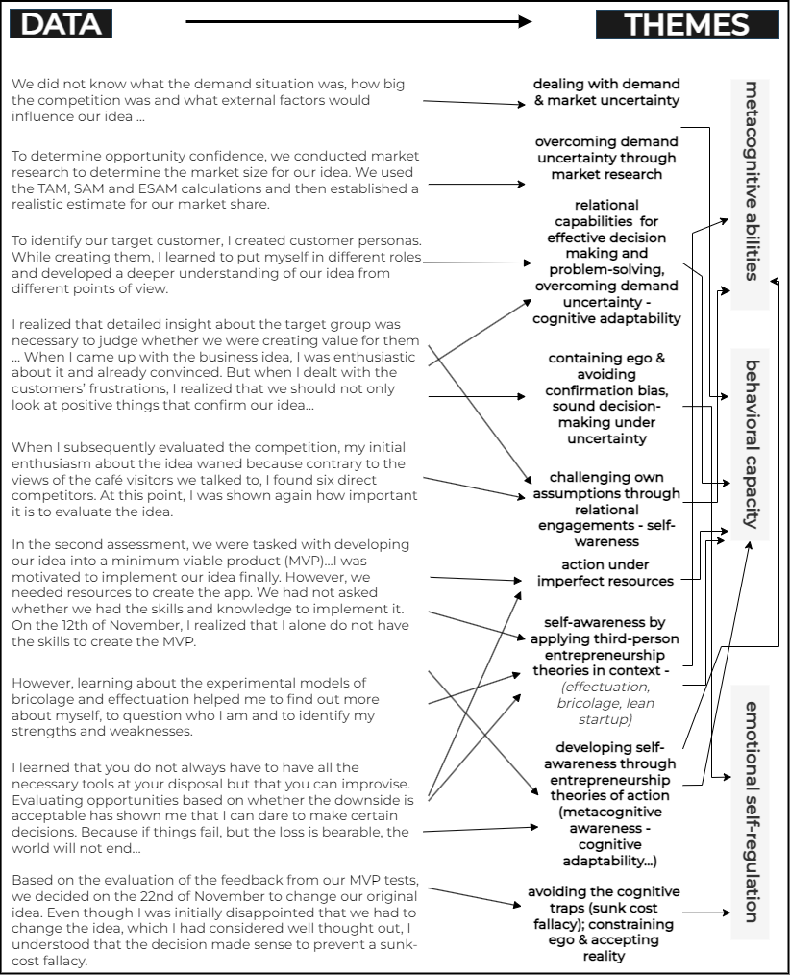
Case 2 enabled us to determine how the deliberate application of ADL principles under more ideal conditions can foster entrepreneurial mindsets. Thus, we explored the entire cohort of 32 student reflections, extracting 10 critical samples to focus our thematic analysis (see Figure 3). The samples were selected because the students’ reflections were among the most critical, as opposed to descriptive.
Figure 3. Thematic Analysis from Case 2
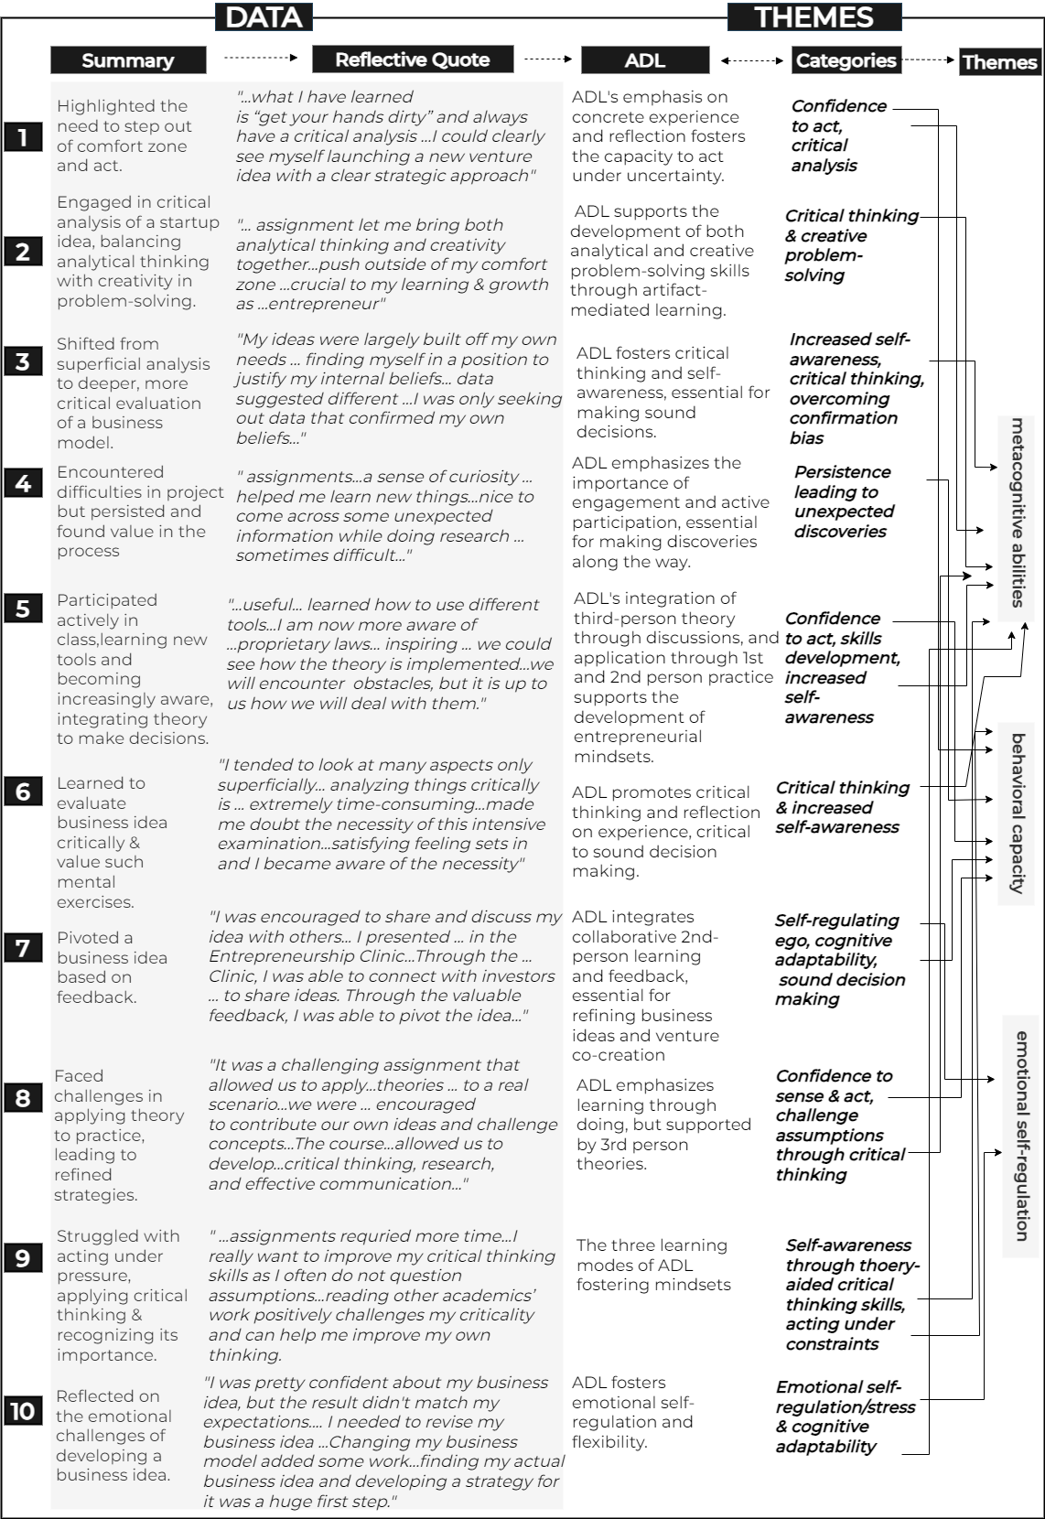

Substantial evidence appears between the two cases, showcasing the capacity of an ADL approach to foster the three dimensions of an entrepreneurial mindset.

Interpretation of Results: An Abductive Analysis
The results indicate that ADL contributes to fostering the three dimensions of the entrepreneurial mindset triad: cognitive, behavioral, and emotional (Kuratko et al., 2021). First, the cognitive and behavioral dimensions emerge more strongly as an ADL model engages students in the practice of new venture creation and critical reflection. Metacognition, deemed foundational to an entrepreneurial mindset (Haynie et al., 2010), manifests strongly as increased self-awareness, self-regulation, cognitive adaptability, and critical thinking (Flavell, 1979). As metacognition facilitates sound judgment under uncertainty, it unsurprisingly permeates behavioral and emotional mindset dimensions.
As shown, metacognition enables students to challenge their own assumptions, catch and attend to cognitive traps in decision-making such as ‘confirmation bias’ and ‘sunk cost fallacy’ (Kahneman & Tversky, 1977, 1979), which ultimately leads to sound decision-making under the error-inducing challenges of entrepreneurial journeys (Baron, 1998). For instance, in Case 1, the student states: 'when I dealt with the customers’ frustrations, I realized that we should not only look at positive things that confirm our idea’. They also state that ‘based on the evaluation of the feedback from our MVP tests, we decided…to change our original idea’. By facing reality and making uncomfortable but sound decisions, students manifest relevant metacognitive abilities needed to adapt to the demands of entrepreneurship journeys (McLarty et al., 2023).
Second, the behavioral dimension of the mindset triad is equally recurrent and strongly integrated with the metacognitive dimension, showcasing the interrelationship between thinking and acting. This is expected, given that relevant cognitions previously discussed materialize through the crucible of rapid sensing, action, and mobilization under uncertainty and resource constraints (Kuratko et al., 2021). In particular, the capacity for venture co-creation and skills in the design of problem-solving artifacts come across in student reflections. This supports the view that experiential learning can foster entrepreneurial behavior through dynamic, interactive learning environments, thereby underscoring the merits of social constructivist theories at the core of ADL (Vygotsky, 1978). As the uncertainty and related constraints of entrepreneurship are replicated through an ADL pedagogy, students report being ‘pushed out of their comfort zone’ deemed critical in fostering resilience, which is critical to dealing with the discrepancies that emerge between expectations and the reality of inherently uncertain entrepreneurial journeys.
Furthermore, the iterative process of developing a minimum viable product (MVP), along with iterations of feedback loops, is shown to materialize the value of ‘design’ within an ADL framework, which cultivates the behavioral mindset dimension. Likewise, by applying third-person theories in context, students develop problem-solving skills using a variety of design tools and principles. For instance, when faced with resource constraints, knowledge of the principles of bricolage helps spur action, stated as follows in Case 1: ‘I learned that you do not always have to have all the necessary tools at your disposal but can improvise’. This mindset spurred action under imperfect circumstances, materializing the behavioral dimension of the mindset triad (Kuratko et al., 2021). Indeed, students’ ability to integrate a variety of third-person knowledge in context is evident as they apply concepts from experimental models of entrepreneurial action - bricolage (Baker & Nelson, 2005), effectuation (Sarasvathy, 2001), and lean start-up (Ries, 2011) as decision-making frameworks, aiding the formulation, enactment, and refinement of problem-solving artifacts.
Finally, although less recurrent, the results also highlight some of the emotional challenges of an entrepreneurial journey that ADL brings out. Thus, students reported feeling stressed across both cases when discrepancies emerged between their assumptions and disconfirming reality. They also indicated a temptation to double down rather than reign in their ego, accept reality, and pivot accordingly. However, by honing their metacognitive abilities, they learn to self-regulate and manage stressful scenarios, eventually accepting reality. Thus, they develop the emotional resilience encapsulated in the entrepreneurial mindset triad, underpinned by related mindsets such as metacognition.
Consequently, this study supports and evidences assumptions in an ADL framework in Figure 1, affording a robust and bespoke experiential learning framework for cultivating entrepreneurial mindsets in university settings. This critical framework facilitates a structured and meaningful application of experiential learning in EE, blending first and second-person learning at the core with third-person learning as supportive. However, adopting an ADL approach has its fair share of challenges. Hence, an analysis of the educator’s reflections subsequently sheds light on some of these challenges, which should be anticipated and pre-empted.

Challenges in Applying ADL: Student & Educator Perspectives
From the educator’s reflections in Appendix C, this study reveals that adopting an ADL approach can indeed be challenging under various circumstances. These challenges mainly relate to capacity and the issue of an entrenched pedagogy in business schools rooted in behaviorism. We present a theory-aided abductive analysis (Torbert, 2006) of the educator’s reflections in Table 3 below.

Table 3. Challenges of Applying ADL
Themes | Related Literature | Analysis
Challenge of behaviorist learning ingrained in students | Traditional knowledge transmission pedagogies are so ingrained in students’ assumptions of learning that they can be hard to shake off (Nabi et al., 2017). | The reflection highlights the difficulty students face when transitioning from behaviorist learning models to ADL, which emphasizes open-ended, reflective, and process-oriented learning.
Initial student anxiety regarding project failure | ADL focuses on the learning process, including critical decisions and judgments, rather than just outcome products (Kolb, 1984; Schön, 1992; Revans, 1998). | Students' anxiety reflects a misalignment between traditional product-focused assessments and ADL's process-oriented evaluations, requiring educators to clarify the assessment criteria.
Necessity of introducing students to ADL's overall logic | The need for clear articulation of experiential learning models and how they differ from traditional methods (Fayolle, 2018; Hägg & Kurczewska, 2021). | The reflection underscores the importance of preparing students for the ADL approach from the outset, including differences in assessment and learning expectations compared to behaviorism.
Student difficulty in maintaining reflective journals | Experiential learning requires documentation and reflection as key components (Kolb, 1984; Schön, 1983). | The struggle with maintaining reflective journals suggests that students may be unaccustomed to reflection as a mode of learning, which is essential in fostering metacognition from experience.
Variable student commitment levels in elective vs. dedicated programs | Commitment and engagement are higher in programs where students have a strong interest in the subject matter (Schultz, 2022). | The observation reflects the impact of course relevance on student engagement, with more optimal results in dedicated entrepreneurship programs where students are more invested – e.g., Case 2 as opposed to Case 1, which was an elective.
Resource and energy intensity of ADL, contrasted by being rewarding | Experiential learning is known to be labor-intensive, often requiring more resources and effort than traditional methods (Nabi et al., 2017). | The reflection aligns with the literature, indicating that while ADL is resource-intensive, it is also rewarding. The demand for institutional support is crucial for the scalability of ADL.
Detailed feedback required in ADL and its feasibility with small class sizes | Personalized feedback is a key element in experiential learning but may be challenging with larger groups (Lackéus, 2020). | Small class sizes are ideal for an ADL approach because they allow effective and detailed feedback. However, without institutional support, larger class sizes may hinder this process.
Time and energy demands on educators, especially with highly motivated students | The intense involvement required in experiential learning can lead to educator burnout if not properly managed (Hägg & Kurczewska, 2021). | The educator's reflection reveals the dual-edged nature of ADL: while it fosters deep student engagement, it also demands significant time and energy from educators, necessitating institutional support.
Personal satisfaction derived from the transformative impact of ADL on students | Experiential learning can be highly rewarding for both students and educators due to its impactful nature (Schultz, 2022). | Despite the challenges, the reflection underscores the personal satisfaction educators can derive from witnessing student transformation, reinforcing the value of ADL in entrepreneurship education.
This analysis highlights the challenges and benefits of adopting an Action Design Learning (ADL) approach in entrepreneurship education, as reflected in the educator's experiences. The reflection aligns with existing literature, illustrating the complexities of shifting from behaviorist pedagogies to more dynamic experiential learning models. Key points include the need for clear communication of ADL's logic, the importance of reflective practices, the challenges associated with resource intensity, and the rewarding nature of seeing positive student outcomes that can counteract the disadvantages. This analysis emphasizes that while ADL presents significant demands on both students and educators, its potential for deep and transformative learning justifies the effort, requiring adequate institutional support. Based on the results, we subsequently expatiate the conceptual underpinnings of the ADL framework into a functional framework in Figure 4.

Discussion
This study aimed to determine how experiential learning can be more effectively articulated and tailored as a pedagogical approach to cultivating entrepreneurial mindsets in university settings. It began by exploring relevant entrepreneurship and education theories, leading to a tentative conceptual framework that positions Action Design Learning (ADL) as a suitable and tailored experiential pedagogy for cultivating entrepreneurial mindsets in EE (see Figure 1). Through insider action research, which involved applying and documenting ADL principles across two Irish universities, we affirm the value of this approach. Consequently, we develop a functional pedagogical framework at the nexus between theory and empirical results, subsequently presented in Figure 4. This detailed framework charts a process supported by concrete guidelines for operationalizing ADL as a suitable and tailored pedagogy for cultivating entrepreneurial mindsets in university settings. We discuss its value as a tool for operationalizing ADL for experiential learning and a curriculum design aid.

Figure 4. Functional ADL Pedagogy for Mindset Cultivation 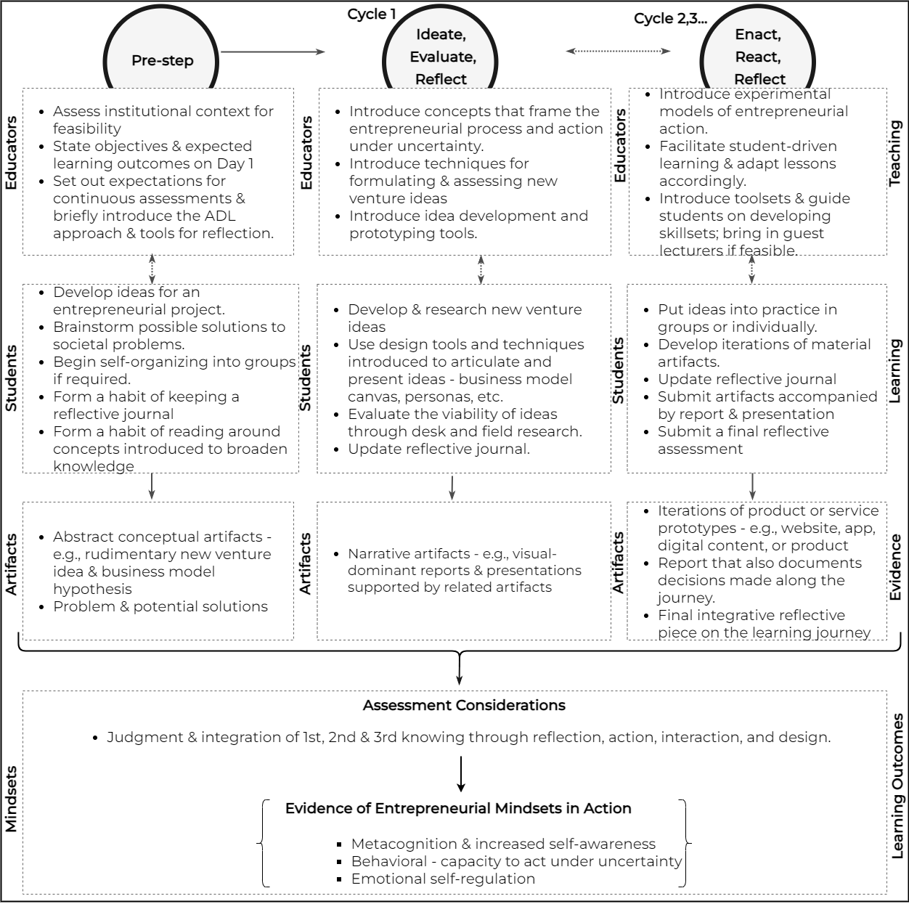

Operationalizing ADL for Experiential Learning
As illustrated in Figure 4, implementing experiential learning through ADL (Action Design Learning) involves an iterative process that begins with an initial pre-step and is followed by design cycles, with emergent entrepreneurial artifacts serving as focal devices. This process is structured into four interrelated sections, each defined by the roles of actors and artifacts. The teaching section delineates the role of educators, while the learning section defines the role of students. The evidence section emphasizes the importance of entrepreneurial artifacts in structuring and demonstrating experiential learning outcomes (Berglund & Glaser, 2022). This approach underscores the importance of reframing entrepreneurship as a design-oriented field (Selden & Fletcher, 2015; Berglund et al., 2020; Dimov et al., 2023), wherein entrepreneurial artifacts are reinterpreted as tools for experiential learning. Finally, the learning outcomes section outlines the mindset triad (Kuratko et al., 2021) and the integration of first-, second-, and third-person learning perspectives, which educators should focus on when evaluating student outcomes (see Fig. 1).
Empirical evidence from this study suggests that the initial interaction with students (pre-step) is critical for setting the tone for an ADL experience and managing expectations. Given that this approach reverses the traditional model of knowledge transmission (Nabi et al., 2017), which students might be more familiar with, it is crucial to introduce or emphasize models of action and reflection, such as Kolb (1984) and Gibbs (1988), during this initial encounter. Additionally, a brief introduction to ADL’s pedagogical approach and expected learning outcomes is essential, with Figures 1 and 4 also serving as helpful visual communication aids. Experiences from this study indicate that allocating at least thirty minutes to an hour in the first meeting to explain this approach can significantly enhance student understanding of the purpose of this model of pedagogy, thereby increasing engagement.

ADL as Functional Framework for Course & Program Design
The potential application of the ADL framework as a flexible tool for curriculum design and delivery is of critical significance. Rather than being a rigid structure, ADL is a versatile framework that can be adapted to various educational contexts, assisting educators in designing courses and programs that foster entrepreneurial mindsets as lasting outcomes. While ADL is most applicable to designing semester-long courses or multi-year programs, it is flexible enough to accommodate different educational constraints. The number of ADL cycles can be adjusted to fit the specific needs of a short course or an entire entrepreneurship program. However, at a minimum, a pre-step and two ADL cycles are necessary for meaningful mindset development. Therefore, ADL is encapsulating and well-suited to capturing the three key phases of most entrepreneurship and innovation processes: search (initiation), exploitation (action), and outcomes.

Course Design with ADL
When designing a semester-long course using ADL, educators must consider the constraints of the academic calendar. Given the diversity of creative ideas that students may pursue in their ADL projects, the expected learning artifacts will vary and must be assessed accordingly. For instance, developing a fully functional digital prototype, such as software or a website, is more feasible within a semester than creating physical artifacts or services, which require more time and resources. In such cases, narrative artifacts supported by computer-generated prototypes may suffice to elicit necessary feedback from target audiences, while fostering relevant mindsets.
Case 1 exemplifies this approach, where students effectively used computer-generated prototypes (Appendix B) to gather meaningful feedback from their target audiences. This case suggests that entrepreneurship education should include developing basic digital design skills as part of the behavioral dimension of the mindset triad. Non-technical business students in both cases learned to use template-based digital design platforms such as Canva and WordPress to visualize and instantiate their ideas as prototypes, demonstrating their ability to sense and act under entrepreneurial constraints. With the rise of generative AI tools like Midjourney and OpenAI’s ChatGPT, we anticipate that such rapid idea visualization and prototyping will become increasingly accessible and widespread.

Program Design with ADL
When designing an entire program using the ADL framework, it serves as a comprehensive tool for determining the focus of each course or module. For example, a module on Ideation and Business Modeling might prioritize the early stages of the entrepreneurial process, focusing on the search for scalable ideas rather than on prototyping. In such cases, the module would naturally emphasize the pre-step and first cycle of ADL, with narrative artifacts as key deliverables and learning outcomes being focused on specific aspects of the mindset triad, such as metacognitive awareness. Conversely, modules centered on the core of entrepreneurial action, such as New Venture Creation, would focus on later cycles of ADL, assessing learning outcomes related to action under uncertainty and resource constraints. Thus, when designing entire programs, Figure 4 of the ADL framework becomes a valuable tool for identifying and emphasizing relevant components for each module or course.
Moreover, Figure 4's applicability is even broader for entrepreneurship courses that cover the entire entrepreneurial process in specific contexts such as International Entrepreneurship, Social Entrepreneurship, and Digital Entrepreneurship. Case 2, an international entrepreneurship module within an MSc program, highlights the framework’s utility in facilitating impactful experiential learning through the initiation and enactment of cross-border new venture ideas. Collectively, these cases underscore the effectiveness of the ADL framework as a powerful tool for designing and delivering experiential learning in entrepreneurship education.

Implications for Theory & Practice
This study significantly advances the discourse on experiential pedagogies in entrepreneurship education (EE) across three critical dimensions. First, it addresses the longstanding need for a solid theoretical foundation for experiential learning in EE by introducing and validating ADL (Action Design Learning) as a comprehensive and tailored framework. Despite the increasing recognition of the value of experiential learning, its growth has been stymied by a lack of robust intellectual and conceptual underpinnings (Fayolle, 2018; Bell & Bell, 2020; Hägg & Kurczewska, 2021). Although design thinking and lean startup methodologies have gained traction as experiential learning models (Sarooghi et al., 2019; Schultz, 2022), their limited conceptual and philosophical articulation as tools for cultivating entrepreneurial mindsets reveals a significant knowledge gap. This study fills that gap by conceptualizing the ADL framework (Fig. 1) and empirically validating its functional application (Fig. 4), providing a powerful experiential tool that integrates the design-based perspective of entrepreneurship with action-oriented and design learning theories in education.
Second, this research contributes to the growing repositioning of entrepreneurship as a field of design by presenting ADL as its pedagogical counterpart (Berglund et al., 2020; Dimov et al., 2023). By framing entrepreneurship through a design lens, ADL enables the development of a new foundation for experiential learning where emergent entrepreneurial artifacts—such as new venture ideas, business models, and products—serve as central focusing devices. This approach enhances the consistent articulation of mindsets and competencies essential for evaluating the impact of experiential entrepreneurial learning. Moreover, aligning with the broader calls to expand the mission of EE beyond mere start-up creation to include societal value creation (Lackéus, 2020), ADL supports the cultivation of transformative mindsets coupled with students’ design capabilities needed in solving multiple societal challenges. Thus, it achieves a pedagogical alignment with the design-based view of entrepreneurship, positioning it as a critical component of contemporary EE.
Finally, this study offers entrepreneurship educators a practical and empirically-supported pedagogical framework (Fig. 4) for designing impactful experiential learning courses and programs. By bridging the gap between theoretical constructs and practical application, the ADL framework equips educators with a versatile tool for developing and articulating the outcomes of an experiential curriculum. It ensures a coherent interpretation and consistent evaluation of experiential learning outcomes, thereby facilitating a shift from traditional knowledge transmission to a functional pedagogy that effectively cultivates entrepreneurial mindsets (Nabi et al., 2017). This transition is essential for preparing students to navigate the complexities of entrepreneurial journeys in an increasingly dynamic and uncertain world.

Conclusion
In conclusion, this study set out to address the critical gap in the theoretical and conceptual foundations of experiential learning in entrepreneurship education (EE) by developing and validating Action Design Learning (ADL) as a bespoke pedagogy for cultivating entrepreneurial mindsets in university settings. By integrating the principles of action learning and design learning, ADL emphasizes both first- and second-person learning, effectively leveraging entrepreneurial artifacts to structure meaningful experiences and foster critical reflection. This approach not only grounds experiential learning in well-established educational theories and philosophies but also enhances its credibility as a robust model for EE.
Through a longitudinal insider investigation conducted across two Irish universities, this study provides compelling evidence of ADL's practical efficacy in engaging students and nurturing transformative entrepreneurial mindsets and problem-solving competencies. The findings contribute to the broader discourse on experiential pedagogies by offering a solid theoretical foundation that addresses the existing conceptual deficits, thereby reinforcing the legitimacy and impact of experiential learning in EE.
However, the insider action research design employed in this study, while rich in context and insight, presents inherent limitations that must be acknowledged. The methodology, which involved self-evaluation by insider participant researchers across two cases, may have led to potential blind spots despite rigorous efforts to mitigate these through collaborative inquiry, abductive reasoning, and triangulation. These limitations highlight the need for further research employing diverse methodologies to test, validate, and extend the ADL framework.
Looking forward, we envision a dynamic community of scholars who will engage in this ongoing inquiry, applying, testing, and critiquing the ADL framework using a range of quantitative and qualitative methods. Such continued exploration is essential for refining and expanding the theoretical underpinnings of ADL and for ensuring its adaptability and relevance in diverse educational contexts. Ultimately, this study advances EE by not only proposing a strong theoretical foundation for experiential learning but also by setting the stage for a more nuanced and evidence-based understanding of how entrepreneurial mindsets can be effectively cultivated in higher education.

References
Baker, T., & Nelson, R. E. (2005). Creating something from nothing: Resource construction through entrepreneurial bricolage. Administrative Science Quarterly, 50(3), 329-366.
Baron, R. A. (1998). Cognitive mechanisms in entrepreneurship: Why and when entrepreneurs think differently than other people. Journal of Business Venturing, 13(4), 275-294.
Baron, R. A. (2004). The cognitive perspective: A valuable tool for answering entrepreneurship's basic “why” questions. Journal of Business Venturing, 19(2), 221-239.
Bell, R., & Bell, H. (2020). Applying educational theory to develop a framework to support the delivery of experiential entrepreneurship education. Journal of Small Business and Enterprise Development, 27(6), 987-1004.
Berglund, H. (2007). Researching entrepreneurship as lived experience. Handbook of qualitative research methods in entrepreneurship, 3, 75-93.
Berglund, H., & Glaser, V. L. (2022). The artifacts of entrepreneurial practice. In N. A. Thompson, O. Byrne, A. Jenkins, & B. T. Teague (Eds.), Research handbook on entrepreneurship as practice (pp. 168–186). Edward Elgar Publishing Limited.
Berglund, H., Bousfiha, M., & Mansoori, Y. (2020). Opportunities as artifacts and entrepreneurship as design. Academy of Management Review, 45(4), 825-846.
Bewayo, E. D. (2015). The overemphasis on business plans in entrepreneurship education: Why does it persist. Journal of Small Business and Entrepreneurship Development, 3(1), 1-7.
Bird, B., & Schjoedt, L. (2017). Entrepreneurial behavior: Its nature, scope, recent research, and agenda for future research. Revisiting the Entrepreneurial Mind: Inside the Black Box: An Expanded Edition, 379-409.
Brannick, T., & Coghlan, D. (2007). In defense of being “native”: The case for insider academic research. Organizational Research Methods, 10(1), 59-74.
Brook, C., Pedler, M., & Burgoyne, J. (2012). Some debates and challenges in the literature on action learning: the state of the art since Revans. Human Resource Development International, 15(3), 269-282.
Brown, T., & Katz, B. (2011). Change by design. Journal of Product Innovation Management, 28(3), 381-383.
Coghlan, D. (2019). Doing action research in your own organization. Doing Action Research in Your Own Organization, 1-240.
Coghlan, D., & Coughlan, P. (2010). Notes toward a philosophy of action learning research. Action Learning: Research and Practice, 7(2), 193-203.
Coghlan, D., & Shani, A. B. (2021). Abductive reasoning as the integrating mechanism between first-second-and third-person practice in action research. Systemic Practice and Action Research, 34, 463-474.
Daniel, A. D. (2016). Fostering an entrepreneurial mindset by using a design thinking approach in entrepreneurship education. Industry and Higher Education, 30(3), 215-223.
Davidsson, P. (2015). Entrepreneurial opportunities and the entrepreneurship nexus: A re-conceptualization. Journal of Business Venturing, 30(5), 674-695.
Davidsson, P., Grégoire, D. A., & Lex, M. (2021). Venture Idea Assessment (VIA): Development of a needed concept, measure, and research agenda. Journal of Business Venturing, 36(5), 106130.
Davidsson, P., Recker, J., & von Briel, F. (2020). External enablement of new venture creation: A framework. Academy of Management Perspectives, 34(3), 311-332.
Dewey, J. (1944) Democracy and Education. New York: The Free Press.
Dewey, J. (1946), Experience and Education, The Macmillan Company, New York, NY.
Dimov, D. (2016). Toward a design science of entrepreneurship. In Models of start-up thinking and action: Theoretical, empirical and pedagogical approaches (pp. 1-31). Emerald Group Publishing Limited.
Dimov, D. (2020). Opportunities, language, and time. Academy of Management Perspectives, 34(3), 333-351.
Dimov, D., & Pistrui, J. (2022). Entrepreneurship education as a first-person transformation. Journal of Management Inquiry, 31(1), 49-53.
Dimov, D., Maula, M., & Romme, A. G. L. (2023). Crafting and assessing design science research for entrepreneurship. Entrepreneurship Theory and Practice, 10422587221128271.
Edmondson, A. C., & McManus, S. E. (2007). Methodological fit in management field research. Academy of management review, 32(4), 1246-1264.
Eisenhardt, K. M. (2021). What is the Eisenhardt Method, really?. Strategic organization, 19(1), 147-160.
Fayolle, A. (2018). Personal views on the future of entrepreneurship education. In A research agenda for entrepreneurship education. Edward Elgar Publishing.
Flanagan, J. C. (1954). The critical incident technique. Psychological bulletin, 51(4), 327.
Flavell, J. H. (1979). Metacognition and cognitive monitoring: A new area of cognitive–developmental inquiry. American Psychologist, 34(10), 906.
Gibbs G (1988). Learning by Doing: A guide to teaching and learning methods. Further Education Unit. Oxford Polytechnic: Oxford.
Gómez Puente, S. M., van Eijck, M., & Jochems, W. (2011). Towards characterising design-based learning in engineering education: a review of the literature. European Journal of Engineering Education, 36(2), 137-149.
Gómez Puente, S. M., Van Eijck, M., & Jochems, W. (2013). A sampled literature review of design-based learning approaches: A search for key characteristics. International Journal of Technology and Design Education, 23(3), 717-732.
Hägg, G., & Gabrielsson, J. (2020). A systematic literature review of the evolution of pedagogy in entrepreneurial education research. International Journal of Entrepreneurial Behavior & Research.
Hägg, G., & Kurczewska, A. (2021). Toward a learning philosophy based on experience in entrepreneurship education. Entrepreneurship Education and Pedagogy, 4(1), 4-29.
Hamidi, D. Y., Wennberg, K., & Berglund, H. (2008). Creativity in entrepreneurship education. Journal of small business and enterprise development, 15(2), 304-320.
Haynie, J. M., Shepherd, D., Mosakowski, E., & Earley, P. C. (2010). A situated metacognitive model of the entrepreneurial mindset. Journal of Business Venturing, 25(2), 217-229.
Heron, J., & Reason, P. (2006). The practice of co-operative inquiry: Research ‘with’rather than ‘on’people. Handbook of action research: Concise paperback edition, 144-154.
Kahneman, D., & Tversky, A. (1977). Intuitive prediction: Biases and corrective procedures. Decisions and Designs Inc Mclean Va.
Kahneman, D., & Tversky, A. (1979). Prospect theory: An analysis of decision under risk. Econometrica, 47, 278.
Kolb, A. Y., & Kolb, D. A. (2009). Experiential learning theory: A dynamic, holistic approach to management learning, education and development. The SAGE handbook of management learning, education and development, 7, 42.
Kolb, D. A. (1984). Experiential learning: Experience as the source of learning and development (Vol. 1). Englewood Cliffs, NJ: Prentice-Hall.
Kuratko, D. F., Fisher, G., & Audretsch, D. B. (2021). Unraveling the entrepreneurial mindset. Small Business Economics, 57(4), 1681-1691.
Lackéus, M. (2014). An emotion based approach to assessing entrepreneurial education. The International Journal of Management Education, 12(3), 374-396.
Lackéus, M. (2020). Comparing the impact of three different experiential approaches to entrepreneurship in education. International Journal of Entrepreneurial Behavior & Research, 26(5), 937-971.
Lahn, L. C., & Erikson, T. (2016). Entrepreneurship education by design. Education+ Training, 58(7/8), 684-699.
Lincoln, Y. S., & Guba, E. G. (1986). But is it rigorous? Trustworthiness and authenticity in naturalistic evaluation. New directions for program evaluation, 1986(30), 73-84.
McLarty, B. D., Hornsby, J. S., & Liguori, E. W. (2023). Advancing entrepreneurial mindset: What do we know and where do we go?. Journal of Small Business Management, 61(1), 1-11.
McMullen, J. S., & Shepherd, D. A. (2006). Entrepreneurial action and the role of uncertainty in the theory of the entrepreneur. Academy of Management Review, 31(1), 132-152.
Nabi, G., Liñán, F., Fayolle, A., Krueger, N., & Walmsley, A. (2017). The impact of entrepreneurship education in higher education: A systematic review and research agenda. Academy of Management Learning & Education, 16(2), 277-299.
Neck, H. M., & Corbett, A. C. (2018). The scholarship of teaching and learning entrepreneurship. Entrepreneurship Education and Pedagogy, 1(1), 8-41.
Neck, H. M., & Greene, P. G. (2011). Entrepreneurship education: known worlds and new frontiers. Journal of Small Business Management, 49(1), 55-70.
Nzembayie, K. F., & Buckley, A. P. (2020). Entrepreneurial process studies using insider action research: Opportunities & challenges for entrepreneurship scholarship. European Management Review, 17(3), 803-815.
Nzembayie, K. F., & Coghlan, D. (2024). Entrepreneurship education as first-person transformation: Interiority as an operationalizing mechanism. Journal of Business Venturing Insights, 21, e00471.
Nzembayie, K. F., Buckley, A. P., & Cooney, T. (2019). Researching pure digital entrepreneurship–A multimethod insider action research approach. Journal of Business Venturing Insights, 11, e00103.
O’Flynn, E., Stephens, S., Cunningham, I., Burke, A., & McLaughlin, C. (2023). Experiential learning and the entrepreneurial university: An Irish case study. Industry and Higher Education, 37(5), 663-672.
Osterwalder, A., & Pigneur, Y. (2010). Business model generation: a handbook for visionaries, game changers, and challengers (Vol. 1). John Wiley & Sons.
Pittaway, L., & Cope, J. (2007). Entrepreneurship education: A systematic review of the evidence. International Small Business Journal, 25(5), 479-510.
Reeves, T. C. (2006). How do you know they are learning? The importance of alignment in higher education. International Journal of Learning Technology, 2(4), 294-309.
Revans, R. (1998) ABC of Action Learning. Empowering Managers to Act to Learn from Action. Third edition. Lemos and Crane, London.
Revans, R. W. (1982). What is action learning?. Journal of Management Development.
Ries, E. (2011). The lean start-up: How today's entrepreneurs use continuous innovation to create radically successful businesses. Crown Books.
Riessman, C. K. (2003). Analysis of personal narratives. Inside interviewing: New lenses, new concerns, 331-346.
Riessman, C. K. (2008). Narrative methods for the human sciences. Sage.
Romme, A. G. L., & Reymen, I. M. (2018). Entrepreneurship at the interface of design and science: Toward an inclusive framework. Journal of Business Venturing Insights, 10, e00094.
Sarasvathy, S. D. (2001). Causation and effectuation: Toward a theoretical shift from economic inevitability to entrepreneurial contingency. Academy of Management Review, 26(2), 243-263.
Sarooghi, H., Sunny, S., Hornsby, J., & Fernhaber, S. (2019). Design thinking and entrepreneurship education: Where are we, and what are the possibilities?. Journal of Small Business Management, 57, 78-93.
Schön, D. A. (1983). The reflective practitioner: How professionals think in action. New York: Basic Books. (Reprinted in 1995).
Schön, D. A. (1987). Educating the reflective practitioner: Toward a new design for teaching and learning in the professions. Jossey-Bass.
Schön, D. A. (1992). The theory of inquiry: Dewey's legacy to education. Curriculum inquiry, 22(2), 119-139.
Schultz, C. (2022). A balanced strategy for entrepreneurship education: Engaging students by using multiple course modes in a business curriculum. Journal of Management Education, 46(2), 313-344.
Seckler, C., Mauer, R., & vom Brocke, J. (2021). Design science in entrepreneurship: Conceptual foundations and guiding principles. Journal of Business Venturing Design, 1(1-2), 100004.
Selden, P. D., & Fletcher, D. E. (2015). The entrepreneurial journey as an emergent hierarchical system of artifact-creating processes. Journal of Business Venturing, 30(4), 603-615.
Shepherd, D. A., Patzelt, H., & Haynie, J. M. (2010). Entrepreneurial spirals: Deviation–amplifying loops of an entrepreneurial mindset and organizational culture. Entrepreneurship theory and practice, 34(1), 59-82.
Simon, H. A. (1969). The architecture of complexity. Sciences of the artificial. Cambridge, MA: MITPress.
Simon, H. A. (1996). The sciences of the artificial. MIT Press.
Timmermans, S., & Tavory, I. (2012). Theory construction in qualitative research: From grounded theory to abductive analysis. Sociological theory, 30(3), 167-186.
Torbert, W. R. (2006). The practice of action inquiry. Handbook of action research: Concise paperback edition, 207, 218.
Van de Ven, A. H. (2007). Engaged scholarship: A guide for organizational and social research. Oxford University Press, USA.
Vygotsky, L. (1978). Mind in society: The development of higher psychological processes. Harvard University Press
Watson, K., & McGowan, P. (2020). Rethinking competition-based entrepreneurship education in higher education institutions: Towards an effectuation-informed coopetition model. Education+ Training, 62(1), 31-46.
Wright, M., & Zahra, S. (2011). The other side of paradise: Examining the dark side of entrepreneurship. Entrepreneurship Research Journal, 1(3), 20123002.
Ylikoski, P. (2019). Mechanism-based theorizing and generalization from case studies. Studies in History and Philosophy of Science Part A, 78, 14-22.
Zuber-Skerritt, O. (2001). Action learning and action research: paradigm, praxis and programs. Effective change management through action research and action learning: Concepts, perspectives, processes and applications, 1(20), 1-27.

Appendices

Appendix A – Constructs & Expatiation of Figure 1
Table 1. Constructs in an ADL Framework for EE
Components | Description
Entrepreneurship as Design (phenomenon) | Entrepreneurship as action; opportunities as artifacts; an emergent hierarchical system of artifact-creating processes; entrepreneurship as design involving action/interaction under uncertainty, ambiguity & imperfect circumstances resulting in abstract, narrative, and material artifacts including digital (e.g., Berglund et al., 2020; Seckler et al., 2021; Dimov et al., 2023; Berglund & Glaser, 2022).
Implications for Learning | - Entrepreneurial artifacts afford focusing devices for design-based learning.  - How it feels to bear uncertainty and lead under imperfect circumstances (McMullen & Shepherd, 2006) must be experienced, not merely taught.  - Co-creation means learning needs a social dimension with an emphasis on relational aptitude (Vygotsky, 1978).  - Entrepreneurial uncertainty means design learning unfolds in non-linear iterations, leading to a hierarchy of emergent artifacts (see Selden & Fletcher, 2015).
ADL Pedagogy | - Action learning that centralizes design is a more accurate framing for EE.  - Entrepreneurial artifacts act as focusing devices for experiential projects.  - First-person reflection in and on action is necessary to develop insights from experience (Schön, 1983, 1987; Dimov & Pistrui, 2022).  - Second-person collaborative learning is necessary to develop relational capabilities, materializing Vygotsky’s (1978) social constructivism.
1st & 2nd Person Learning as Core | - First-person subjective and second-person intersubjective learning through action design experiences remain core, and contribute to the emergence of entrepreneurial mindsets; Second-person learning develops relational capabilities for value co-creation.
3rd Person Learning as Peripheral Supportive | Explicit teaching and learning of theoretical knowledge are important but supportive of the core of learning (i.e., 1st & 2nd person):  - Entrepreneurial process theories; new venture ideas (NVIs) as problem/solution pairing (Davidsson, 2015; Davidsson et al., 2021)  - External enablement framework can function as a tool for assessing the environment in which design artifacts emerge and perform (see Davidsson et al., 2020).  - Experimental theories of entrepreneurial action – effectuation, bricolage, lean start-up, design thinking – as conceptual mechanisms for formulating design principles and realizing design artifacts (Sarasvathy, 2001; Baker & Nelson, 2005; Ries, 2011; Brown & Katz, 2011).  - Explicit awareness of entrepreneurial mindsets (Kuratko et al., 2021) in facilitating intellectual self-awareness can enhance learners’ reflexivity.  - Narrative frameworks such as business model canvas (Osterwalder & Pigneur, 2010

Appendix B – Sample of Narrative Artifact from Case 1
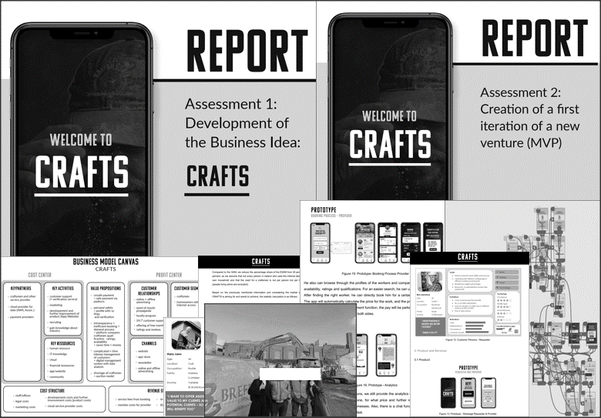

Appendix C – Educator’s Reflections on Challenges of ADL
I underestimated the degree to which behaviorist learning logic was ingrained in students. It meant that students initially struggled to understand the assessments that were based on the fluidity and the open-ended process of ADL. Hence, many students kept asking anxiously, 'What if our project fails and we have nothing to write about?’ Over time, students realized that they were not being assessed solely on how well they planned and delivered an artifact but on the critical decisions and judgments made on their entrepreneurial learning journeys. More importantly, I learned that it is vital to remind students to focus on the learning process through critical reflection, not the fact that their project idea ‘failed’. Thus, educators adopting an ADL pedagogical approach must introduce students to the overall logic of the course and assessments from the beginning by explicitly stating how it differs from more traditional forms of learning and assessments to which they might have been accustomed. Relatedly, some students were not accustomed to documenting events in reflective journals. Therefore, it was necessary to constantly remind the students at every meeting that their critical judgment under uncertainty and how they faced unanticipated challenges were the focus of learning, i.e., the core. It helped them overcome fears about having nothing to write about or receiving a poor grade. The idea that they could pivot, make adjustments to their artifacts or projects, and arrive at a conclusion to discontinue its development based on new input on their learning journey appeared particularly strange. Second, a key challenge faced in Case 1 was that not every student brought the same level of commitment to the course. This may be partly explained by the fact that the course was an elective course in an overall business degree other than entrepreneurship. Therefore, the results were naturally more optimal in Case 2, which was a dedicated entrepreneurship MSc program.
As a lecturer, I find that ADL is more energy-intensive and involved than traditional teaching experiences. Furthermore, since student assessments require detailed feedback, ADL may be more feasible with smaller groups than with large class sizes: 52 students in Case 1 and 34 in Case 2 are quite manageable. As a facilitator, the unique challenge of every student’s project implies that educators may find themselves providing overtime assistance to students. As observed in Case 2, it was not uncommon for students to drop by for a quick chat and feedback on their projects, only for discussions to go over time. Furthermore, although I had designed a marking rubric for my assessments, grading took a long time, as detailed feedback had to be carefully considered to enrich the learning experience. I also found that some highly passionate students may begin to see the educator as a private consultant on projects they look to develop upon course completion, an observation particularly seen in Case 2. I have had what I thought would be a thirty-minute walk-in discussion turn into two hours involving a highly motivated student who was actually a nascent entrepreneur already in the process of developing a digital platform. Although none of us noticed how fast the time flew by, I was nonetheless depleted of energy at times, as my other academic tasks still awaited my attention. Moreover, the level of involvement in Case 2 would not have been possible in Case 1, where my teaching load at the previous university averaged 14 hours a week. This was different in my new institution in Case 2, where contact teaching hours were a reasonable 3 to 9 hours a week, depending on varied circumstances. Regardless of the intense workload, seeing the transformative impact that an ADL approach can have on students was personally satisfying. It would be ideal if lecturers adopting this approach were offered more resources, time, and flexibility. Given that my class sizes were manageable, I anticipate that this approach might not scale with very large class sizes without the necessary institutional support.

Appendix D – Professional Observation of Lectures in Case 1

PG Certificate in University Learning and Teaching

Peer Observation Form
Peer observation of teaching is an opportunity for observers and observees to mutually enhance teaching practice, opening up dialogue through shared practice and solving of problems in teaching contexts. This form acts as a catalyst for conversation around teaching practice.
Observee Name: (anonymized) | Module Code and Name: Anonymized, Entrepreneurial Studies
Observer name: (anonymized) | Number of students: 52
Date of observation: 10/11/2021 | Class duration: 2 hours

Online Platform (if used):
Pre-observation priorities for the session (to be filled in by the observer in advance of the session)

What does the observee want specific feedback on? This may be linked to an aspect of your portfolio (for example: student engagement, time management, questioning strategies, use of technology, etc.)
- I am hoping to improve the effectiveness of my delivery of new concepts to a large group
- Engage students more effectively rather than simply transmitting information.

Observation (to be filled in by the observer)
Topic of session | Bricolage and Effectuation as Experimental Models of Entrepreneurial Action
Date of observation | 10/11/2021
Comment on the specific feedback identified above | Delivery of new concepts to group: During the observed class, a variety of strategies were employed to help students to understand the concept of Bricolage  Engage students: Students were encouraged to engage through a variety of different strategies eg questioning, sharing ideas/thoughts, peer to peer discussion/ problem solving exercises etc
Comments on accessibility of the session, materials and presentation of content for the session. | The presentation was well thought out, clear and appropriate for the size of class and learning space. An additional mic enhanced audibility. Powerpoint slides were well designed and structured.  Unfortunately, there are limitations in the design of the lecture room: having the lights on, causes glare on the screen. As a result, small print on one of the slides could not be read from the back of the class. (although slides were to be circulated after class.) When the lights are switched off, the room is relatively dark. A combination of having the doors open, mask wearing and the room acoustics meant it was difficult to hear some of the comments made by students at the front of the room. The fixed desk tiered seating limits also limits some peer to peer/small group interactions.
Beginning of the session:
Were the students welcomed and introduced to the session in an appropriate way? | The session started a few minutes late (The previous one was late finishing) There were no latecomers.  The class was welcomed in a friendly manner. It was noted that one of the students had not attended in the previous week.  The plan for the session was clearly outlined and contextualized.
Were the intended learning outcomes, or overview of the lesson outlined and/or shared and linked to previous/future assessments? | The class started with a recap of the previous week’s session. Students were asked to put their hands up or to provide verbal responses to questions. References were made to future classes and programme assignments.
Any additional comments | There was a clear aim evident from the start that all students were being actively encouraged to contribute to the session. It might be helpful to make it clear what students would be able to do by the end of the class – perhaps as specific learning outcomes, or in the preparation of their group projects. It wasn’t clear why an explanation of bricolage was being provided specifically for Erasmus students rather than for everyone. Also be careful when pointing out that a student hadn’t attended a class ( Its good that you noticed, but you don’t know why they weren’t there– it could be for personal reasons)
Style and approach
Brief comments on the general tone, delivery, pace, time management of the session and style of the session. | There was evidence that the session had been well planned out. It was clearly structured and coordinated. Effort was made to make the session interesting, fun and dynamic by employing a variety of engaging class and small group activities. The application to real life examples increased the authenticity and relevance of the tasks. All students were encouraged to participate. Moving around the class, speaking to smaller student groups helped to break down boundaries between the class and the lecturer. Knowing the names of students also makes students feel more involved and part of a community.
How well were teaching aids/materials used to enhance students’ learning? Considerate of student diversity/inclusive of all students. | Powerpoint slides were used to help structure the session. These were well designed and used effectively to highlight /illustrate key points. These would also provide a useful learning resource after the class. A variety of design techniques were employed within the slides. Embedded video and hyperlinks enriched the content and provided useful triggers for discussion in class. Great to see links to personal projects – you could see how students became more attentive when you shared these experiences
Any other comments on style and approach? | Quick fire questions and idea generation can create a real buzz to the learning experience, but some students can feel under pressure to think on their feet. Having small group discussion removes this pressure, but can still result in the same people repeatedly reporting back. All students except the back row had laptops open at the beginning of the class. As it was raised during the class, it would be worth clarifying when students are to have laptops open to take notes /closed to contribute to discussions. It is a good strategy to ask students to read out a prepared piece of work, so they get accustomed to speaking in class. Consider another way to do this rather than reading out a Powerpoint slide on the screen. Perhaps ask group rapporteurs to take turns to read out key points eg one minute to report back, or try a flipchart exercise.
Student Participation
To what extent were students encouraged to share their views? Rapport/Sensitivity to students’ reaction | A number of different exercises were used to help students to learn and to share their views and ideas. Effort was made to vary the engagement method – the order and structuring of the exercises was effective and built towards a project based application. Links to past/current personal experiences were helpful to understand process and demonstrate how good learning can emerge from unanticipated outcomes. All the students appeared to engage with the different activities – although not all students spoke in class.  Individual responses were handled well – whether they had responded in the way you wanted or not.
How well were students’ questions and contributions handled during the session? Use of different questioning levels? | Student responses to questions and tasks were encouraged, ideas were teased out and developed. Different strategies were employed. Students didn’t ask questions.
To what extent were the students encouraged to interact with each other? (Class discussion/debate/group/peer work) | Peer to peer interaction was encouraged through small group activities and project group discussion.Perhaps have students work on different tasks, then report back to each other. Can they feedback what they liked/areas for development etc Could project groups ask for specific feedback?
To what extent were opportunities provided for the students to apply the learning to their own context/examples? | There were opportunities for students to link personal knowledge/ experiences to generating ideas /problem solving activities The final task enabled students to apply what had been learned during the class to their projects. This was complemented by suggestions made by the lecturer
Any additional comments | Effort was made to encourage all students to participate throughout the class. However, the same individuals tended to respond while others required additional encouragement. Several individuals did not contribute to the main class discussion. It can be difficult not to go to the same groups first each time. You might also want to explore other questioning techniques and consider a more structured way of reporting back – see below.
Close of Session
How effectively were the learning objectives/outcomes revisited towards the end of the session? | It was good to have a recap prior to the break. Consider asking if there was anything they would like you to go over again. You could use polling software to do this. Also perhaps ask some preparatory questions for the second session?
To what extent was the session linked to other resources and sessions? | Links were being made to resources, software, ideas, assignments etc throughout the session
Any further comments about the close of the session? (Assessment of learning/ checking for learning, Summary of the session/plenary) | The ongoing application to assigned project work provided an effective way to gauge whether the students had fully understood the concepts. However consider ways for students to gather this information and share with each other and as a class via an online white board/collaborative space.
Summary, Suggestions and Recommendations
Comment on two of the most effective elements of the session | Good student engagement The variety of different engaging activities built into the session was an effective way to help students to learn core concepts. A sense of being part of a learning community where you could exchange ideas and experiences was evident. Everyone was encouraged to participate.  Authentic applied learning opportunities The application of theory to past real life examples, effort to draw upon personal experience and knowledge to support ongoing project work was helpful and increased relevance of content for students
Comment on two suggested areas for further development | Shift towards student directed activities You already have incorporated a range of different and effective ways to engage your students in class. Now consider ways to further develop these engagement strategies by making them more student directed: Offer choices, perhaps the class has to make a selection between two problems or case studies to discuss. Project groups could identify topics they would like you to cover or feedback they would like you and/or another student group to provide etc.  Structuring contributions in class.  Some ideas generated during the class can get lost or forgotten. As you encourage the development of your entrepreneurial community, perhaps pull these ideas/solutions etc together on the whiteboard/in Powerpoint. You might also want to consider using Vevox to ask for phrases, words to describe etc and then display on the screen. In this way, everyone is contributing to one shared output – all individual’s ideas are being displayed and valued.  You might also want to consider different ways to report back in class: eg you have one minute to outline, sell your idea, list/argue three key points,  Build in three feedback opportunities in class, then rotate between rapporteurs
Reflection for the observer (what benefit(s) can you take from the observation for your own practice) | The impact of using real life case study examples to increase authenticity and relevance to students. Thank you for allowing me to observe your class (researcher name anonymized name) – a very enjoyable learning experience.
Observer signature: Anonymized Date: 12/11 /21_________
Observee signature: Anonymized Date: 10/11/2021

