Toward the development of a constitutive model to capture arterial collagen fibre remodelling and damage

Milad Ghasemi (1,2), David.R.Nolan (1,2), Caitríona Lally (1,2)

1.Trinity Centre for Bioengineering, Trinity Biomedical Science Institute, Trinity College Dublin, Ireland

2.Department of Mechanical and Manufacturing Engineering, Trinity College Dublin, Ireland

Introduction
The mechanical behaviour of arteries is most commonly described using a hyperelastic anisotropic material model, whereby two families of collagen fibres are embedded in a soft matrix [1], see Figure 1.

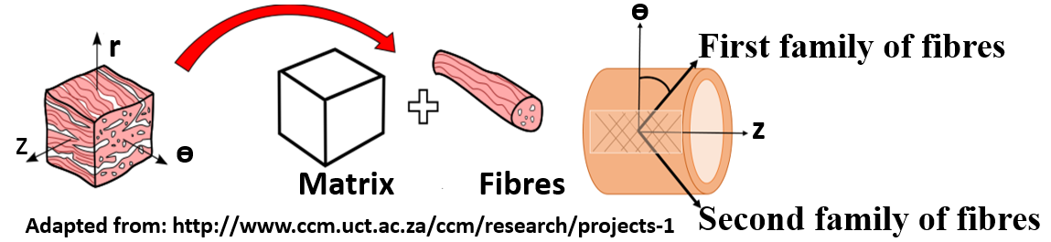
Figure 1: Arterial tissue consisting of two families of collagen fibres embedded in a soft matrix
Collagen fibres are the main load bearing constituents of arterial walls [1,2]. To-date, fibre orientation has been the primary focus of investigations of the mechanical behaviour of arteries [2-4], however, the inherent quality of collagen fibres is equally important [2,5]. In cases of chronic or acute diseases and during interventions, arterial tissues may be subjected to supraphysiological loading conditions which can induce damage within the tissue. The main aim of this research is to develop a constitutive model which can adequately capture collagen fibre reorientation and the quality of collagen fibres in arterial tissues, particularly in case of supraphysiological loading condition.

Material and Methods
Collagen fibre directions evolve in vivo to optimize the load bearing capacity of the tissue [2-4]. In this research, remodelling of collagen fibres is investigated using the periodic distribution function, ρ(θ), presented in [1], where both fibre direction and dispersion are subjected to remodelling rules. The preferred mean fibre direction is defined to be between the two largest principal strain directions, as α_{p}=arctan(ε₁/ε₂). The dispersion of fibres is also defined as a function of the ratio of the two largest principal strain values [4]. The reorientation of collagen fibres toward the preferred distribution is then modelled incrementally using a first order rate equation, see Figure 2.

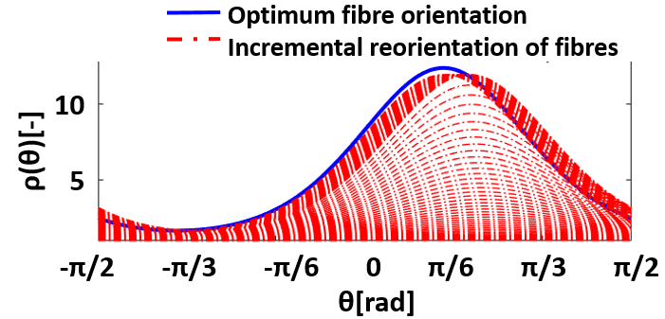
Figure 2:Incremental reorientation of one family of collagen fibres toward optimum fibre distribution.
Continuum damage mechanics has been widely employed to investigate the response of arteries to such supraphysiological loading conditions [5]. Here, similar to the procedure suggested in [5], continuous and discontinuous damage is simulated through the concept of internal variables using the evolution of a fictitious strain energy function. Four primary mechanical phenomena can be captured in arteries using this approach: softening (known as Mullins effect), permanent set, hysteresis (continuous damage) and fibre rupture, see Figure 3.
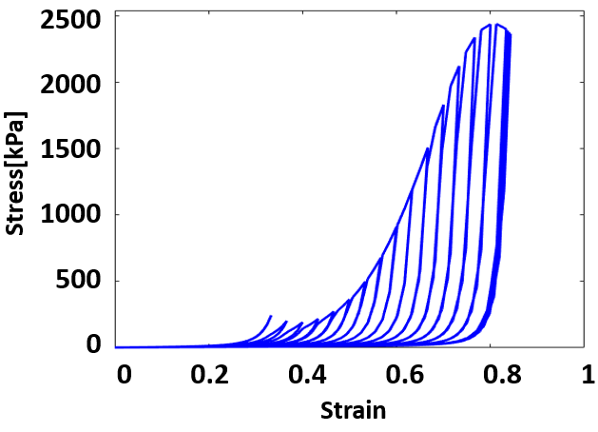
Figure 3: Cyclic uniaxial tension test of the media of a human carotid artery in the axial direction exhibiting Mullins effect, permanent set, hysteresis and fibre rupture.

Discussion
Although computational remodelling algorithms in literature can predict the collagen fibre architecture in arterial walls, they do not generally provide insights into the quality of such fibres. These measures are important since they can be attributed to very common phenomena in arterial tissues where supraphysiological loading conditions are imposed on the arteries; including stiffening of arterial walls during hypertension, atherosclerosis or damage following interventional procedures.
The future goal of this project is to develop a remodelling algorithm that can be validated using experimental and clinical data and will incorporate collagen quality and reorientation.

References
- Gasser et al, J R Soc Interface, 3:15-35, 2006.
- Driessen et al, J Biomech Eng,127:329-336,2005
- Creane et al, BMMB, 6: 869-82, 2012.
- Driessen et al, BMMB,7:93-103,2008
- Balzani et al, CMAME,213:139-151,2012

Acknowledgements
This project has received funding from the European Research Council (ERC) under the European Union's Horizon 2020 research and innovation programme (grant agreement No. 637674).

