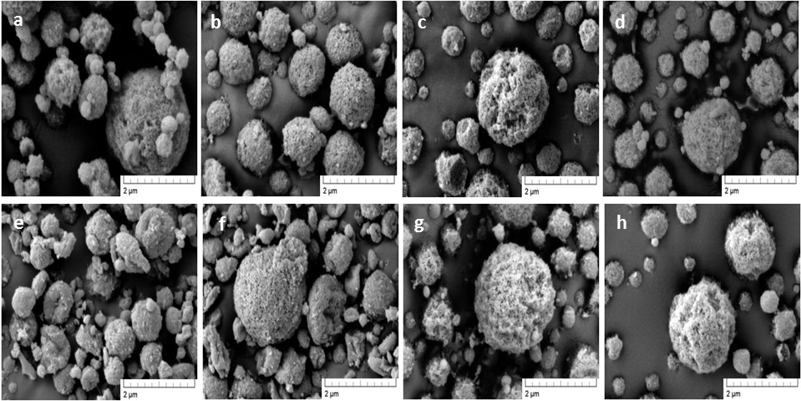
Figure 1 SE micrographs of spray dried (a) sCT:R, (b) sCT:R:HPβCD 5:57:38, (c) sCT:R:HPβCD 5:38:57, (d) sCT:T, (e) sCT:T:HPβCD 5:67:28, (f) sCT:T:HPβCD 5:57:38, (g) sCT:T:HPβCD 5:38:57 and (h) sCT:T:HPβCD 5:28:67.

Figure 2 Particles pore diameter distribution by BJH (Barret-Jovner-Halenda) adsorption of (a₁) sCT:raffinose composite systems and (b₁) sCT:trehalose composite systems; and average pore diameter as a function of specific surface area (SSA) of spray dried (a₂) sCT:raffinose composite systems and (b₂) sCT:trehalose composite systems.

Figure 3 FTIR spectra of amide region I of sCT as supplied, (a) sCT:raffinose composite systems and, (b) sCT:trehalose composite systems.

Figure 4 In vitro aerosol deposition profile by use of a NGI of (a) sCT:raffinose composite systems and (b) of sCT:trehalose composite systems as calculated % of recovered emitted dose vs. NGI stages. MA – mouth adapter IP – induction port

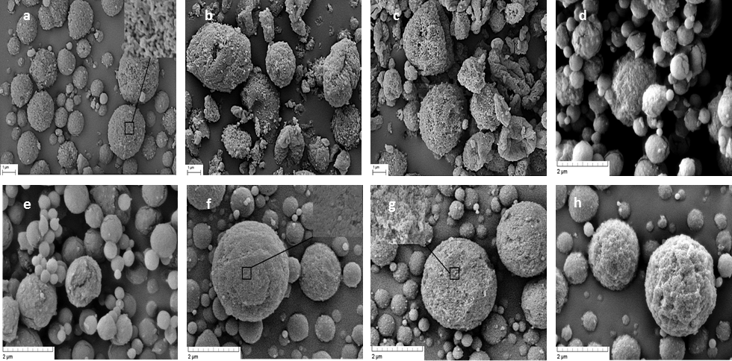
Figure 5 SE micrographs of (a) sCT:R, (b) sCT:R:HPβCD 5:57:38, (c) sCT:R:HPβCD 5:38:57, (d) sCT:T, (e) sCT:T:HPβCD 5:67:28, (f) sCT:T:HPβCD 5:57:38, (g) sCT:T:HPβCD 5:38:57 and (h) sCT:T:HPβCD 5:28:67, stored at 4 ⁰C/ 5% RH.
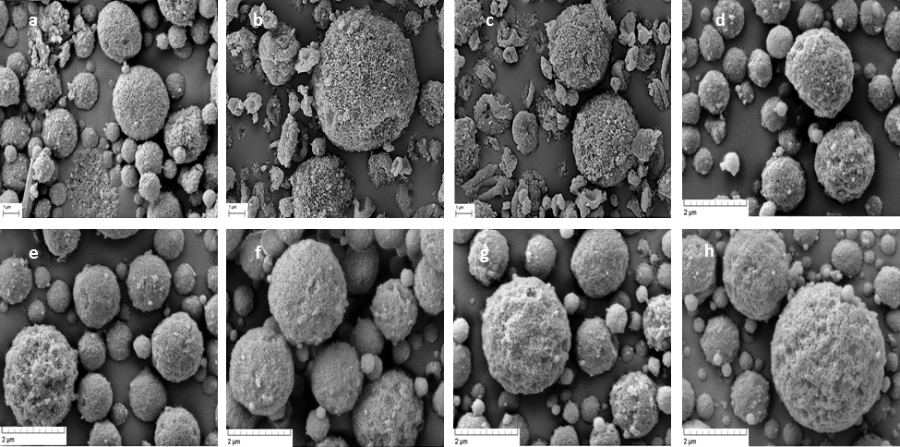
Figure 6 SE micrographs of (a) sCT:R, (b) sCT:R:HPβCD 5:57:38, (c) sCT:R:HPβCD 5:38:57, (d) sCT:T, (e) sCT:T:HPβCD 5:67:28, (f) sCT:T:HPβCD 5:57:38, (g) sCT:T:HPβCD 5:38:57 and (h) sCT:T:HPβCD 5:28:67, stored at 25 ⁰C/ 5% RH.

Figure 7 Mean plasma sCT vs time profiles in rats following (a) sCT intravenous delivery and (b) spray dried sCT composite systems intratracheal delivery.

