Head and Neck Cancer Series of Lectures 2013
Dr Sarah Brody and Dr Denise MacCarthy
A series of lectures on the care of the head and neck cancer patient was recently held in the Dublin Dental University Hospital (DDUH). The series was organised by Dr Sarah Brody, Executive Registrar and Dr Denise MacCarthy between 19 February and 19 March. The lectures were very well attended and generated excellent feedback.

The first series of lectures was entitled “Diagnosis and the Journey of the Head and Neck Cancer Patient”. Dr Claire Healy gave a detailed overview of the diagnosis and epidemiology of head and neck cancer. This was followed by Ms Lia Mills who spoke eloquently about her personal experiences of head and neck cancer. Lia has published a memoir of her experiences entitled “In Your Face”. Ms Margaret McGrath outlined the physical and personal challenges faced by the head and neck cancer patient. The chair of this session was Professor Leo Stassen.
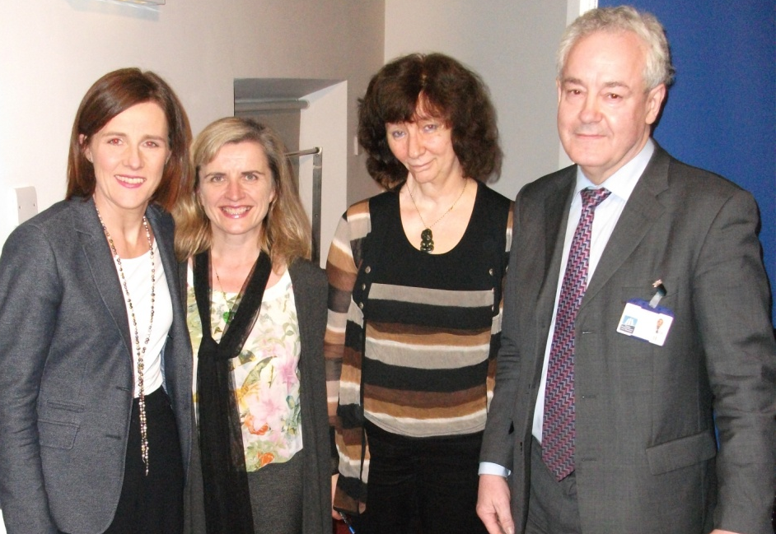
Dr Claire Healy, Senior Lecturer-Consultant in Oral Medicine, DDUH, Ms Margaret McGrath, Head and Neck Cancer Nurse Specialist, The Mater Hospital, Ms Lia Mills, Head and Neck Cancer Survivor and Author, Professor Leo Stassen Professor of Oral and Maxillo Facial Surgery, DDUH.
In the second series of lectures, Dr Sinead Brennan discussed the role of radiotherapy in the management of head and neck cancer, providing evidence base for current therapeutic regimes. Ms Agnella Craig outlined the role of the radiation therapist in managing patients with head and neck cancer including an excellent description of preparation for radiotherapy, including fabrication of the mask. This was followed by a presentation on the pre-radiation dental visit by Dr Denise MacCarthy and finally a thorough description of the prosthodontic rehabilitation of the head and neck cancer patient by Dr Osama Omer who provides dental prosthetic rehabilitation for patients following surgery.

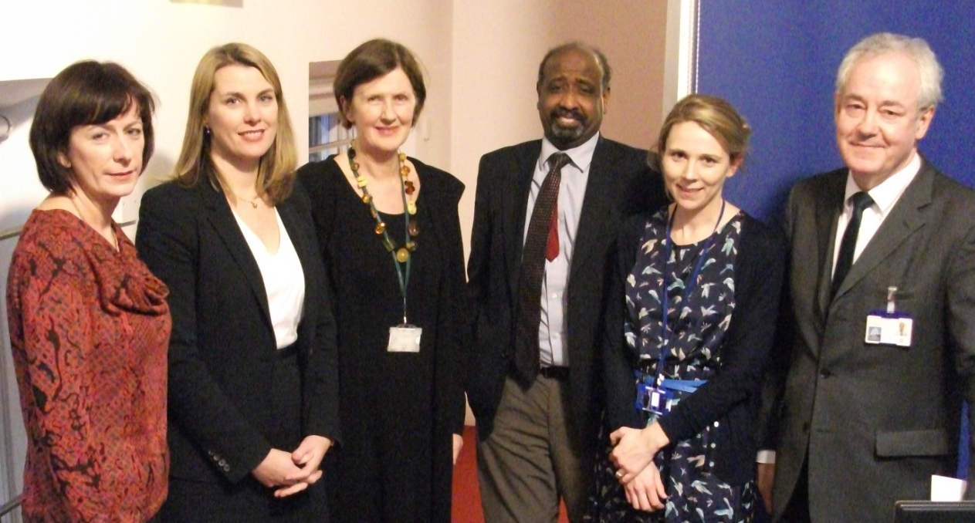
Ms Agnella Craig, Assistant Professor in Radiation Therapy, TCD, Dr Sinead Brennan, Radiation Oncologist, St Luke’s Hospital, Dr Denise MacCarthy, Senior Lecturer-Consultant and Head of Division of Restorative Dentistry & Periodontology, DDUH, Dr Osama Omer, Senior lecturer/Consultant in Prosthodontics, Dr Sarah Brody, Executive Registrar, DDUH, Professor Leo Stassen, Professor of Oral and Maxillo Facial Surgery, DDUH.

In the third lecture series, Mr Kumara Ekanayake addressed the surgical management of head and neck cancer showing many of the extensive and complex cases he has treated during his career to date. The role of the tracheostomy nurse specialist was very clearly explained by Ms Joy Norton, demonstrating her obvious expertise in this area. The evening concluded with Dr Osman presenting an analysis of the literature surrounding chemotherapy in the management of head and neck cancer. This evening was chaired by Professor Stephen Flint.
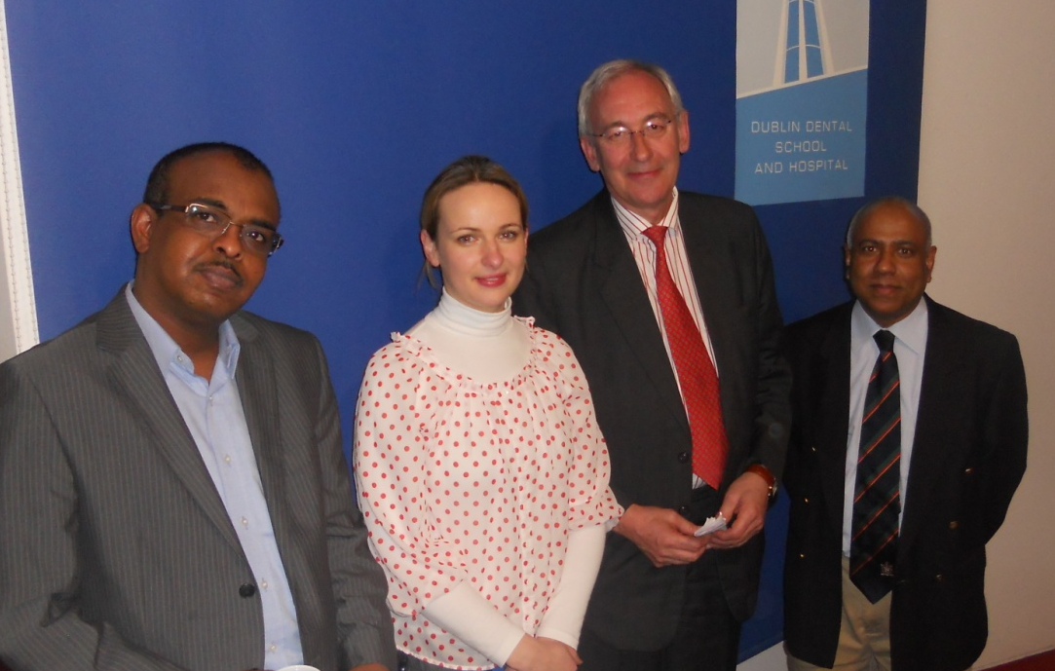
Dr Namer Osman, Consultant Medical Oncologist, St James’ Hospital, Ms Joy Norton, Tracheostomy Nurse Specialist, St James’ Hospital, Professor Stephen Flint, Professor of Oral Medicine, DDUH, Mr Kumara Ekanayake, Senior lecturer-Consultant in Oral and Maxillofacial Surgery, DDUH

The final lecture series was opened by Ms Noreen O’Regan who gave an in depth presentation on the issues around speech and language therapy for the head and neck cancer patient. She included several video clips to enhance the understanding of the audience of these difficulties. The management of nutrition during and post treatment for head and neck cancer was thoroughly described by Ms Yvonne Lydon. Both of these lectures also addressed the problems faced by the individuals who cannot speak or swallow – an understanding of these issues is very important for the dental team. The final speaker was Dr. Alison Connolly who brought us through the psychological impact of cancer for head and neck patient. She drew on the clinical issues and examples presented by the earlier speakers, demonstrating the interdependence of all the members of the team who provide care for the head and neck cancer patient. This session was chaired by chaired by Professor June Nunn.
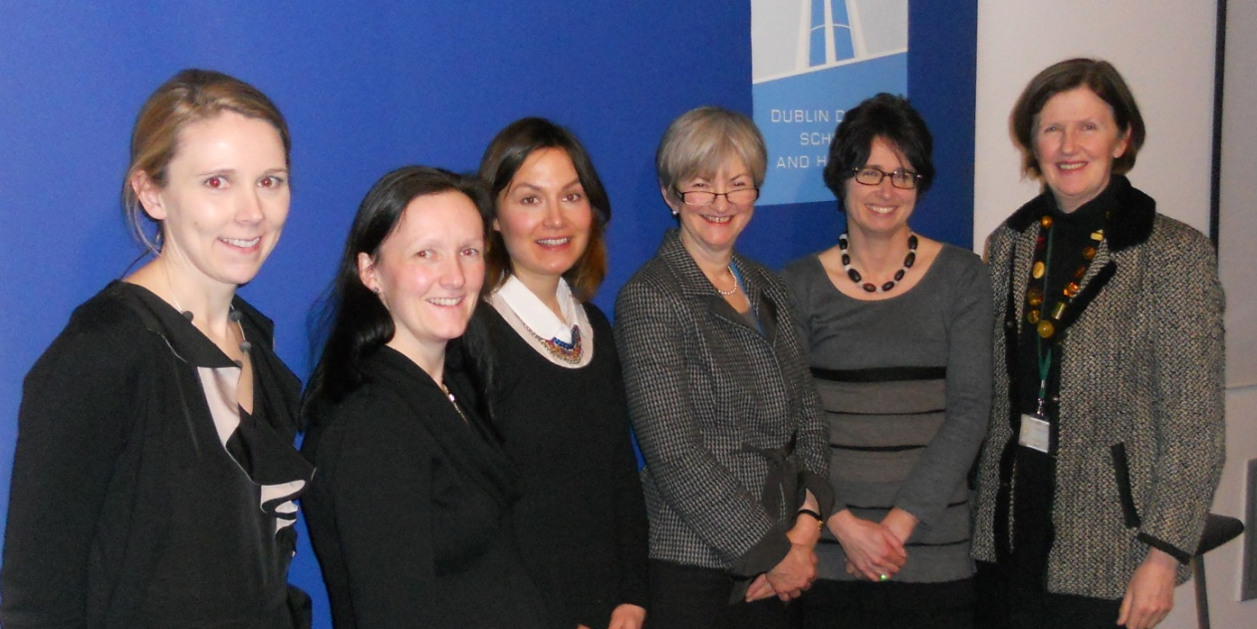
Dr Sarah Brody, Executive Registrar, Ms Yvonne Lydon, Senior Clinical Nutritionist St James’ Hospital, Dr. Alison Connolly, Counselling Psychologist, St Luke’s Hospital, Professor June Nunn, Dean, DDUH, Ms Noreen O’Regan, Senior Speech and LanguageTherapist, St James’ Hospital, Dr Denise MacCarthy, Senior Lecturer-Consultant and Head of Division of Restorative Dentistry & Periodontology.

We are very grateful to all the speakers who gave so willingly of their time to take part in this series of lectures. The audiences were large each evening, drawing from staff and students of the Dental Hospital, School of Radiation Therapy, School of Speech and Language Therapy, Maxillo Facial Unit in St James Hospital, St Lukes Hospital, the Mater Hospital and also members of staff in TCD. Our thanks also to the staff in the DDUH who helped with this project – Lena Doherty, Denis Murphy, Frank Keane, Niall McDermott, Christy Kavanagh, Dalva O’Brien, Deborah O’Connor and Dr Rory Boyd (photographs). Finally, Professor Leo Stassen, Professor June Nunn and Ms Pat O’Boyle for their support.

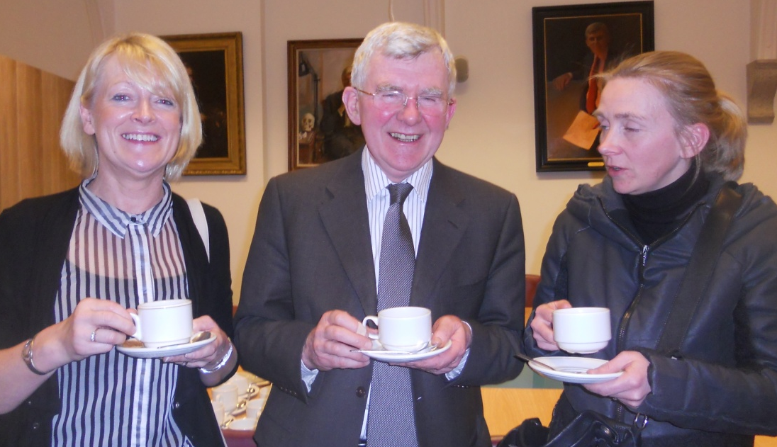

Ms Geraldine Clarke, Professor Derry Shanley and Ms Wenda Thomas.

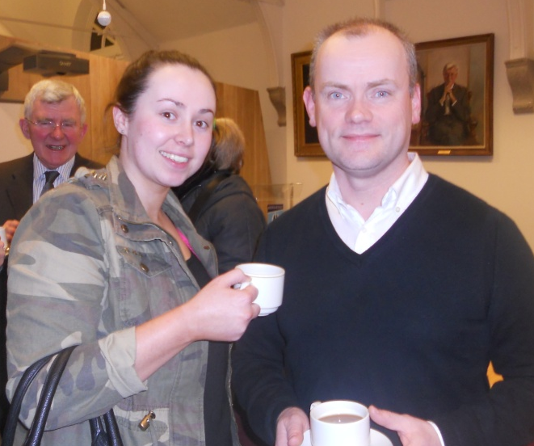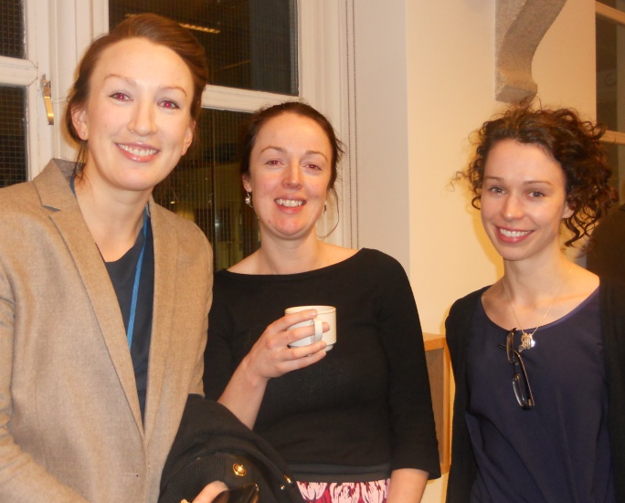
Dr Marie O’Neill, Dr Anna Beaty, Dr Eimear McHugh
Ms Sarah Dillon, Dr Bobby Gorby

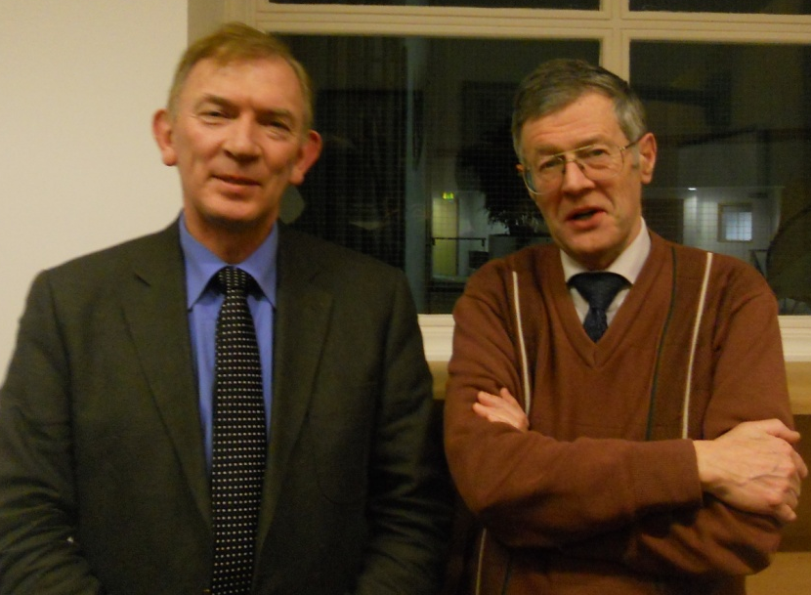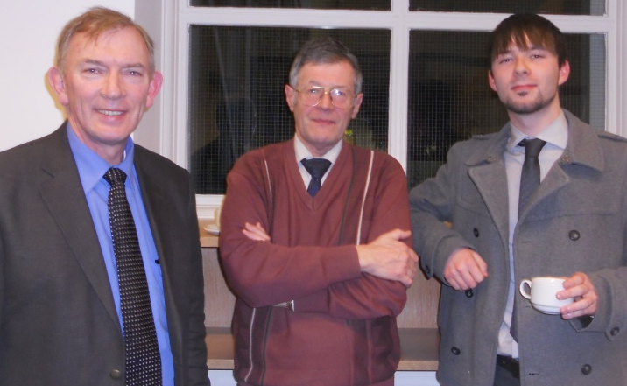
Dr Gerry Gavin and Dr Peter Hayden and Mr David Reynolds
Dr Gerry Gavin and Dr Peter Hayden

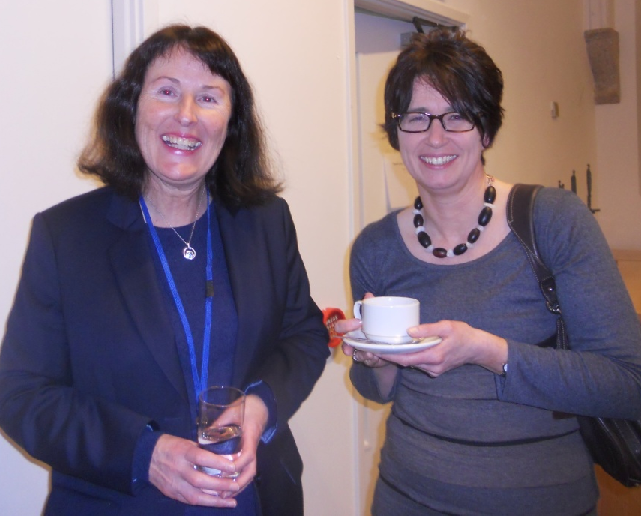
Ms Pat O’Boyle (CEO) and Ms Noreen O’Regan

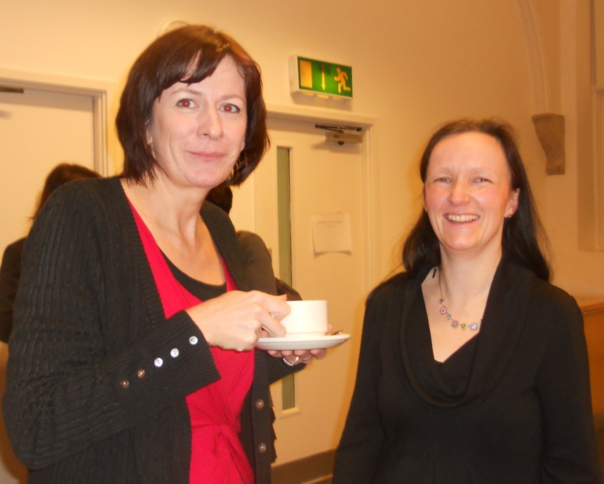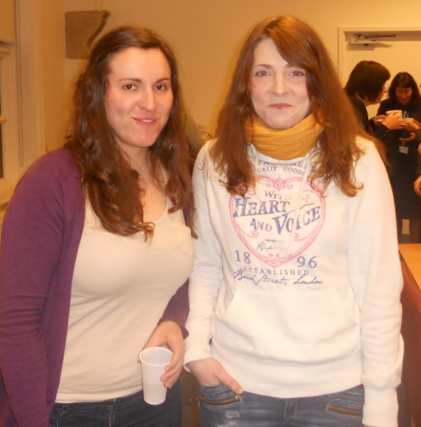
Dr Agnella Craig and Ms Yvonne Lydon

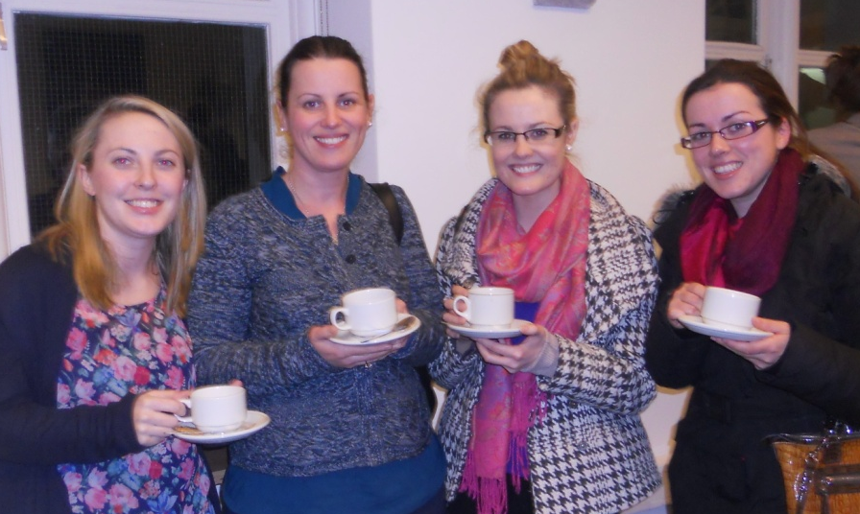
Jessica Molloy, Claire Parkes, Caoimhe Mulgrew, Kirstine Coffey, SALT from the Mater and St James Hospitals

