GENOMICS TOOLS TO STUDY MEMBRANE-BASED SYSTEMS
Muhammad Ali, Lucia Ruiz Haddad, Mohamed Fauzi Haroon, and Pascal E. Saikaly

The learning objectives of this chapter are the following:
- Designing an experimental plan for omics-based study for membrane-based systems
- Omics tools to investigate microbial communities of membrane-based systems
- Introduction to state-of-the-art bioinformatics tools and reference database resources
- Application of genome-resolved metatranscriptomics approach to study the activity of microorganisms

Introduction
The performance of membrane-based operations is significantly decreased by the accumulation of microbes and chemical foulants on the membrane surface. Thus, biofouling is the main operational challenge for membrane-based processes (Flemming et al., 2011). Various molecular biological techniques are utilized to understand the behaviour of microbes in membrane-based water treatment systems. These techniques enable the analysis of microbes’ taxonomy, morphology, physiology, and ecology. The molecular methods can be applied to study membrane-based systems for fast, reliable and cheap identification of relevant microorganisms. The most common molecular methods include polymerase chain reaction (PCR), quantitative polymerase chain reaction (qPCR), fluorescence in situ hybridization (FISH), denaturing gradient gel electrophoresis (DGGE), and terminal restriction fragment length polymorphism (T-RFLP) (Lovley, 2003; Nielsen et al., 2009). However, these techniques fail to address the function of microorganisms and the mechanisms underlying their interactions due to limited throughput as compared to their high-throughput sequencing-based counterparts and cannot resolve abundance and activity for functionally important microbes in low concentrations (Hugenholtz, 2002). Now, the cost of culture-independent next-generation sequencing (NGS) technologies rapidly decreases (Fig. 1), significantly improving our understanding and functions in various natural (Alqahtani et al., 2019; Bougouffa et al., 2013; Garcias-Bonet et al., 2018; Speth et al., 2017; Wang et al., 2013) and engineered (Ali et al., 2020b; Ali et al., 2019; Matar et al., 2021; Rehman et al., 2019) ecosystems.

Most environments harbour a diverse range of organisms (genomes). The metagenome is the entire DNA content of an environment, so it includes the collection of individual genomes. Metagenomes allow to 1) Obtain a gene catalogue of the environment; 2) Screen for genes that confer novel functions (Ali et al., 2020a; Garcia Martin et al., 2006); 3) Discover and characterize new bacterial candidate divisions, and 4) Reconstruct microbial genomes via metagenome assembly and binning (Albertsen et al., 2013), offering novel insights into the microbial functions and metabolic pathways involved in complex microbial systems. On the other hand, metatranscriptomics is the entire RNA content of a given environment. High-throughput sequencing can be applied for metagenomics or metatranscriptomics, where all the DNA or expressed genes (mRNA) from a certain community are sequenced to resolve abundance and activity for functionally important microbes in low concentrations. Metatranscriptomics analysis presents unique challenges due to RNA’s short half-life and the variability in sequencing coverage caused by the molecule’s secondary structure. Unlike metagenomes, metatranscriptomes can shed light on the activity of environmental populations. As a result, metagenomes and metatranscriptomes from the same samples can be analyzed together to identify “active” microorganisms and their gene expression patterns caused by the metabolic activities of the microbial community (Ali et al., 2020b; Shaw et al., 2020).

Metagenomics, metatranscriptomics, and next-generation sequencing (NGS) revolutionize microbiology and ecology research. However, the most challenging aspect, particularly for newcomers, is the bioinformatics analysis of the massive sequencing data (Desai et al., 2012). Therefore, this chapter covers high-performance bioinformatics computing methods, tools, and pipelines. Besides, the experimental design and sample preparations are critical preliminary steps in determining the dependability, comparability, and (cost-)effectiveness of the sequence data and analytical result (Desai et al., 2012; Goodrich et al., 2014; Knight et al., 2012; Kunin et al., 2008; Thomas et al., 2012). For example, several factors can cause bias in sequence data or render all experimental efforts less significant (Kunin et al., 2008; Scholz et al., 2012). As a result, this chapter will provide a comprehensive technical guide for using metagenomics in the study of microbiology and ecology of membrane-based systems (Fig. 2).

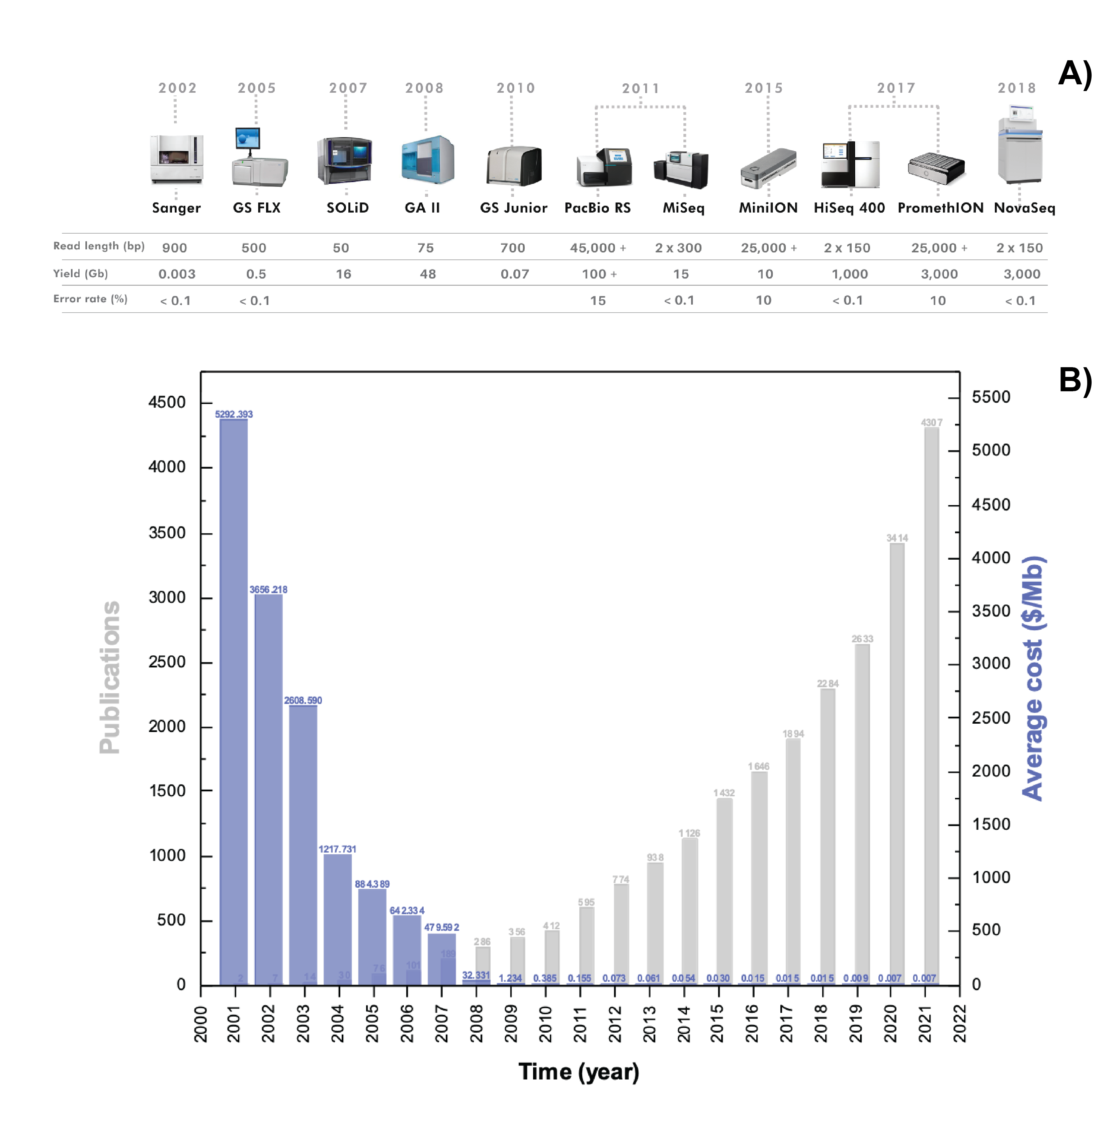
Figure 1: A) Timeline for sequencing technology development. The data is adopted from this link https://figshare.com/articles/dataset/developments_in_NGS/100940?file=5470844. B) Cost of per raw megabase of DNA Sequencing. https://www.genome.gov/about-genomics/fact-sheets/DNA-Sequencing-Costs-Data and Number of publications using metagenomics tools. Data obtained from PubMed: metagenom*[Title/Abstract]

This chapter presents the relevant concepts and protocols required for the experimental design, sample preparation, library construction, and NGS sequencing. These steps are crucial for metagenomics analysis of microbial communities in membrane-based bioengineered systems operated for research or industrial aims (e.g., bioenergy production and bioremediation). Additionally, the methods for annotating metagenomic and metatranscriptomics data are compared, and their conditions of applicability are discussed. Likewise, the chapter provides an overview of the most cited, user-friendly, rigorous, and complete bioinformatics analysis tools and reference database resources, along with some analysis examples. These metagenomic data mining strategies and resources will make it simpler for users to select the best resources to meet their needs. Finally, the significant pitfalls and limitations of applying metagenomics are discussed.

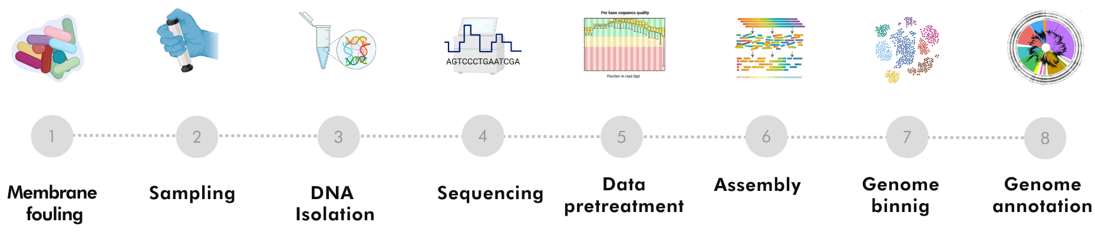
Figure 2: Step-by-step workflow for metagenomics experiment. “Created with BioRender.com”

Experimental Design and Sample Preparation

Experimental Design in a Metagenomics
A rigorous design of an experimental plan is vital for acquiring data to answer the scientific question of interest in membrane-based systems. The following key aspects should be considered when designing omics experiments. First, an adequate number of technical and biological replicates of experimental samples is necessary for statistically meaningful analyses. Technical replicates are repeated measurements of the same sample, demonstrating the protocol’s variability. Therefore, technical replicates measure the reproducibility of the data generated using identical NGS protocols (e.g., library construction and sample multiplexing) and molecular methods (e.g., DNA extraction and PCR amplification). Besides, biological replicates are parallel measurements of biologically distinct samples (at least three) within one experimental group (e.g., the same treatment or condition). This captures the random biological variation within a group, which may be a subject of study or a noise source. Understanding biological variation allows an accurate assessment of the effectiveness and differences between different experimental groups. Besides replicates, positive and negative controls may be required to ensure no contamination occurs among samples. Many metagenomics-based studies failed to address this issue adequately. Now that the sequencing costs have been significantly reduced, the economic constraints should not be used to compromise experimental rigour.

Moreover, decisions must be made at different experimental stages, including selecting the following: physiochemical parameters, biological parameters, sequencing platform, sample preservation, quality control, bioinformatics tools, and reference databases. Physiochemical parameters include temperature, pH, conductivity, alkalinity, turbidity, dissolved oxygen, metals, nutrients, etc. Biological parameters include the sample size and the scales (temporal or spatial). The sequencing platform will be determined by the desired depth, sequence length, and error rate (Fig. 1A). While sampling preparation includes methods for fixing or storing samples on-site (RNA latter or freezing). Finally, quality control allows for increased amount and purity of DNA or RNA, especially when yield is low or microbial diversity is high. This could be accomplished through amplification, assembly, and binning steps. On the other hand, compiling metadata is an equally important step in the process. Correlating reactor performance with the structure and functions of microbial communities requires synchronous preservation of biological samples and regular monitoring of reactor performance (removal rates, production rate, biodegradation, and accumulation) in different operating conditions.

Sample Collection and Preservation
Sample collection and preservation are the first critical steps in an omics-based study. For sampling from a membrane-based system, the following factors should be considered: biomass type (e.g., an attached vs. suspended biomass), bioreactor configuration (e.g., plug flow vs. mixed), modification (e.g., presence of carriers or baffles), mixing state and operating time and condition. These factors affect biomass distribution and evenness, granule size, substrate gradients, and mass transfer, leading to a heterogeneous microbial composition within a membrane-based system. In certain membrane systems, when extracting DNA material, it may be necessary to obtain a sample by cutting a piece of the membrane, typically measuring at least 1 – 5 cm². Multiple samples can be collected separately to reflect microbial heterogeneity, or a composite sample can be taken to represent average microbial profiles. DNA extraction of sludge/slurry samples is preserved at −80 °C (Mason et al., 2012) or fixed in 50% ethanol before storage at −20 °C (Zhang et al., 2012). In contrast, centrifugation and membrane filtration are viable methods for recovering microbial cells in samples containing less biomass such as effluent samples (Thomas et al., 2012). For mRNA-based studies, two preservation methods are frequently used: 1) Flash freezing with liquid nitrogen and 2) Immersion in RNAlater, which is widely used to recover high-quality mRNA (Riesgo et al., 2012).

DNA Extraction
An optimized protocol for DNA/RNA extraction is essential to any analysis of microbial composition and function. The microbes differ enormously in their resistance to different lysing methods (Thomas et al., 2012). Hence, microbes with cell walls that are difficult to lyse will effectively seem less abundant if sub-optimal extraction protocols are used. Thus, the method for DNA/RNA extraction needs to be robust to cope with the challenges.

The protocols and kits used for DNA/RNA extraction should be consistent throughout a study to increase the reliability and comparability of data (Goodrich et al., 2014). These kits should be used following the manufacturer’s instructions. Likewise, in 2012 Thomas and co-workers established a guide for isolating high-quality nucleic acid for NGS library preparation and sequencing. Following the extraction of DNA and RNA, their quality must be determined using various quality indicators. Generally, the ratio of absorbance at 260 and 280 nm is used to assess the purity of DNA and RNA. A ratio of 1.8 is commonly accepted as pure DNA, and a value of 2.0 is recognized as pure RNA. (Lucena-Aguilar et al., 2016). At the same time, lower ratios indicate the presence of non-nucleic acid content, such as protein, phenol, or other contaminants that absorb strongly at or near 280 nm. Besides, the absorbance ratio of 260/230 can be used as a secondary measure of nucleic acid purity. The typical values for nucleic acid samples are between 2.0-2.2 (Lucena-Aguilar et al., 2016). If the ratio is lower, it may indicate the presence of contaminants that absorb at 230 nm. These absorbance parameters should be checked with spectrophotometers or qubit.

Library Preparation
Library construction transforms the RNA/DNA into a format compatible with the sequencing platforms. Various physical, enzymatic, and chemical methods can be used for fragmentation and size selection required for library preparation on the different sequencing platforms (see Fig. 1A for desired read length). The library preparation strategy, the sequence length, and the sequencing platforms’ length and depth are all essential considerations for sequencing. Moreover, technical details on sequencing library construction have been well documented (Head et al., 2014). However, library preparation generally shares similar principles and considerations regardless of the sequencing platform. For example, two objectives are to maximize library complexity (e.g., a lower ratio of artificial duplicate reads may indicate higher complexity) and to minimize PCR or other amplification-based biases (e.g., less amplification and more sample RNA/DNA). Therefore, a paired-end (PE) library is recommended over a single-end library. A PE improves the performance of metagenome (e.g., scaffolding and chimera detection) (Peng et al., 2012), binning (e.g., tracking multiple-copy genes) (Albertsen et al., 2013), and enables the use of computational tools designed to consider PE relationships (Imelfort et al., 2014).

Sequencing platforms
The expected sequence depth is related to the biodiversity and complexity of microbial samples. Generally, the soil (Roesch et al., 2007) and sediments (Roesch et al., 2007) harbor more diverse microbial species than the bioengineered ecosystems (Dueholm et al., 2022; Wang et al., 2012a; Wu et al., 2019). For biological wastewater treatment systems, higher biodiversity is generally detected in 1) full-scale than lab-scale bioreactors (Matar et al., 2021), 2) biofilm than suspended sludge and 3) activated sludge than anaerobic sludge (Ali et al., 2019; Trego et al., 2020). Recent attempts to assemble large complex soil metagenomes suggest that 80% of the sequencing data could not be assembled due to the low coverage. For instance, even 300 Gb sequencing data are insufficient to deeply cover a localized soil sample (Howe et al., 2014). In contrast, in an enriched microbial system, more than 45% of the metagenomics reads could be effectively assembled (Albertsen et al., 2013).

The following equation can calculate the required sequencing depth for a given genome coverage in metagenomic samples.

Sequencing Depth = (Genome Size x Coverage x 100)/(Relative Abundance)

Here,
Genome Size = Bacterial genome length (usually between 2.5- 5 Mbp)
Coverage = Required depth coverage (between 5 to 10X)
Relative Abundance = Expected relative abundance of targeted bacteria species. The relative abundance value might be estimated from previous studies on similar ecosystems.

For example, a sample with a relative abundance of 0.5% for the target bacteria species and a genome size of 3Mbp will require 6 Gb of sequencing depth to achieve 10X coverage. Furthermore, a sequencing depth of 6Gb and a PE read length of 150bp will produce 300bp (150bp×2) per reading, 20 million of paired reads((6Gb)⁄(300bp)), and 40 million of single reads((6Gb)⁄(150bp)). Illumina has recently been the most popular commercial sequencing platform due to its high data throughput and low per-base cost (van Dijk et al., 2014). Notably, the short but high-quality PE sequences (100−150 bps) generated by Illumina’s platforms could be used to rectify (> 99.9% accuracy) (Koren et al., 2012) and concatenate the low-quality but exceptionally long reads (e.g., 20 kb) from third-generation sequencing platforms, (van Dijk et al., 2014) such as PacBio RS and nanopore technologies.

Bioinformatics Analysis.
Bioinformatics studies biological data in conjunction with computer science and statistics. This field is constantly evolving and developing new tools to make metagenomics/metatranscriptomics analysis and genetic engineering simpler and more reliable. The main steps required for bioinformatics analysis are listed below

Data Pre-treatment.
Raw sequencing reads must be pre-treated to ensure that only high-quality sequences (clean reads) are used for the downstream analysis. Before pre-treatment, FASTQC can be used to check the data quality (base quality, GC content, ambiguous bases, length distribution, sequence duplication levels, and adapter content). In general, data pre-treatment includes the following steps: adaptors/linkers removal, demultiplexing (assign reads to samples using index reads or barcodes), quality control, dereplication (identifying unique sequences and abundances), and reads overlapping (for PE library sequencing) etc.

Amplicon-based approach
Amplicon-based sequencing is a useful tool for understanding microbial community composition and diversity. It is a cost-effective and computationally simple method (Bodilis et al., 2012). However, an amplicon-based analysis could not always classify microbes to a lower taxonomic level, such as genus or species. Also, generally, it targets hypervariable region(s) of the 16S rRNA gene, which does not provide the functional identity of the microbe (Siegwald et al., 2017). Though, efforts are made to manually curate the existing 16S rRNA gene database (SILVA, (Pruesse et al., 2012)) to provide information about the physiology (function) and ecology of the microorganisms present in bioengineered ecosystems (Albertsen et al., 2015; Dueholm et al., 2022). For amplicon sequencing data processing, there are numerous open-source packages available, such as QIIME (Caporaso et al., 2010), USEARCH (Edgar, 2013), MOTHUR (Schloss et al., 2009), etc.

Metagenomics, read-based approach
Bioinformatics analyses of metagenomic data can be performed using short-reads, assembled contigs (assembled overlapping reads), or reconstructed draft genomes through a self-accelerating data mining circle. The first strategy for metagenomic analysis is to directly use unassembled clean reads for the quantitative analysis of microbial community composition and function. The assembly-free approach is advantageous when studying rare organisms (with low sequencing depth or coverage) to avoid bias, such as their removal due to their inability to be assembled. In an assembly-free (read-based) approach, reads are directly compared against a reference database for taxonomic profiling and functional analyses. Generally, unassembled short reads retain the original abundance information and enable quantitative comparisons of microbial taxa, functional genes, and metabolic profiles (Yang et al., 2013). However, they have a large amount of data and lack resolution for taxonomic and functional annotations.

Metagenomics, assembly-based approach
The assembly is a computational process that connects the clean short-reads sequences to form long contigs (>1,000 bp). This is especially relevant to 1) Recover genomic sequences (via binning as discussed in sections 15.3.5 and 15.3.6; 2) Analyze full-length protein-coding genes; 3) Identify strain-specific genomes (Langille et al., 2010); 4) Analyze the genetic content (e.g., at the strain or species level), especially for uncultured microorganisms. Moreover, a metagenomic assembly reduces the data size to be analyzed in the downstream processing, though assembly requires substantial computational resources (Howe et al., 2014). Two assembly strategies are used depending on whether a reference database is used: reference-based and de novo. Reference-based assembly aligns short-read fragments with reference genomes. However, this analysis cannot capture the differences between the genomes of novel species, resulting in an underestimation of microbial diversity in an open microbial system. (e.g., activated sludge, soil) (Howe et al., 2014). As a result, a de novo strategy should be used when genetic novelty and diversity are high.

Metagenome-assembled Genome (MAG) Binning.
The continuously decreasing sequencing cost has allowed researchers to access environmental metagenomes at increasing sequencing depths (e.g., > 50 Gbp). As a result, sufficient resolution can be obtained to retrieve partial or near-complete genomes of rare (1%), novel, and/or uncultured microorganisms from complex communities (Albertsen et al., 2013). Binning is the computational process of clustering the assembled contigs or the short reads into groups representing an individual genome/taxon or genomes/taxa of closely related microorganisms (Albertsen et al., 2013; Wrighton et al., 2012). Binning can be based on genomic signatures such as 1) sequence composition, 2) homology, 3) coverage (abundance), or 4) a combination of these. Composition-based binning algorithms typically group DNA sequences based on their conserved nucleotide compositions, such as the tetranucleotide frequencies and GC content (McHardy et al., 2007). These methods can be improved by providing sample-specific training data sets (e.g., a long DNA fragment with marker genes). The homology-based binning methods are based on a similarity search against existing genomes. However, this method is limited by the quality and representativeness of reference databases, the poor taxonomic resolution of short reads, and the accuracy and/or sensitivity of alignment tools. As a result, they are unreliable for assigning short reads. They often require longer assembled contigs (e.g., > 1 kb for the expert-trained PhyloPythiaS package) and manual efforts to ensure high assignment accuracies. Homology-based tools include MetaPhlAn2, MetaPhyler, and CARMA3. These are commonly applied for the taxonomic classification of shotgun metagenomic reads based on similarity comparisons with reference marker genes such as 16S rRNA, rpoB, or clade-specific markers. Besides, some packages consider the composition and homology of sequences for taxonomic classification and clustering, such as MEGAHIT (Li et al., 2016), Metabat (Kang et al., 2015) and MetaCluster (Wang et al., 2012b).

Supervised and unsupervised binning.
Two unsupervised approaches have been widely applied to reconstruct high-quality genomes of uncultured organisms from metagenomes: Tetra-ESOM (Dick et al., 2009) and “differential coverage binning” (Albertsen et al., 2013). Tetra-ESOM analyzes the composition of DNA signatures by clustering tetranucleotide frequencies using emergent self-organizing maps (ESOM). While “differential coverage binning” categorizes contigs based on their differential coverage profiles across multiple related metagenomes with the assumption that contigs from the same microorganisms will have similar abundance (coverage) profiles in a single metagenome. These draft genomes can be refined further using composition-based paired-end tracking, reassembly, and manual curation techniques. Several automated pipelines for platforms like CONCOCT (Alneberg et al., 2014), MaxBin (Wu et al., 2016), and Metabat (Kang et al., 2015) allow genome reconstruction based on the coverage profiles and composition (tetranucleotide frequency patterns). The completeness and contamination in reconstructed genomes have been estimated by the presence/absence of marker genes, such as essential single copy marker genes conserved in 95% of bacteria (Dupont et al., 2012), conserved phylogenetic marker genes (Wrighton et al., 2012), or clusters of orthologous groups (COGs) (Raes et al., 2007). Currently, CheckM is the only automated tool to assess the quality of a genome recovered from isolates, single cells, and metagenomes based on conserved marker genes (Parks et al., 2015).

Functional annotation.
Annotation is the process of analysing the structure and functions of assembled metagenomic contigs. Compared to unassembled short reads, assembled contigs are longer and more compact, allowing for a more robust and rapid analysis of specific species and their functional genes. Functional annotation of assembled contigs allows the prediction of the functional capacities of a microbial community. After genome assembly, binning, and gene calling are finished, several tools enable functional annotations. Gene function is commonly determined through similarity searches while using established tools like BLAST. However, it is computationally expensive and time-consuming to conduct a similarity search using BLASTX or PSI-BLAST, particularly for large query data sets and reference databases (such NCBI’s RefSeq). Tools such as USEARCH (Edgar, 2010) and DIAMOND (Buchfink et al., 2015) have been developed to overcome these computational challenges faster.

Genome-resolved Metatranscriptomics
Genome-resolved metatranscriptomics approach combines data from metagenomics and metatranscriptomics from the same environment to characterize “active” and “non-active” microorganisms and to compare gene expression patterns under different conditions such as treatment v/s control (Frias-Lopez et al., 2008; Haroon et al., 2013; Yu and Zhang, 2012). MAGs recovered from metagenomics are used to facilitate genome-resolved metatranscriptomics analyses for profiling the gene expression across the recovered population genomes (Ali et al., 2020b).

Data Sharing and Storage
Sharing sample metadata, sequence data, and computational results is a widespread and effective method for exchanging knowledge. Data exchange enables comparative studies and avoids the needless repetition of processing the same data sets or sequencing similar microbial ecosystems. Several public access databases have been established to promote sequencing data sharing and storage, such as the National Center for Biotechnology Information (NCBI) and Genomes OnLine Database (GOLD).

BIOINFORMATICS ANALYSIS WORKFLOW EXAMPLES
The following sections describe the simple bioinformatics workflow examples for process amplicon, metagenomics and metatranscriptomics datasets.

Amplicon Sequences Processing Workflow
The amplicon sequences analysis workflow is shown in Fig. 3A. The first step of the process is to re-label the sequences in the raw FASTQ files with the corresponding sample name/ID. This enables the identification of the sequences from a specific sample in the later processing stages. The re-labelling can be performed using USEARCH (Edgar, 2013) with the command fastx_relabel. Subsequently, re-labelled forward and reserve sequences of different samples are concatenated separately into a single file. Then, the concatenated forward and reserve sequences are quality-filtered using trimomatic (Bolger et al., 2014) with the settings SLIDINGWINDOW:5:3 and MINLEN:275, these settings should be adjusted based on the raw quality of the dataset determined through FASTQC package. The quality filtered sequences are hits to the PhiX genome USEARCH command filter_phix. PhiX genome-based library is an ideal sequencing control (typically with > 1% spike-in) for run quality monitoring (cluster generation, sequencing, and alignment). Later, the trimmed and filtered forward and reverse reads were merged using FLASH (Fast Length Adjustment of Short Reads) (Magoc and Salzberg, 2011) with the settings –m 25 –M 200, these parameters should be adjusted based on the input data quality. FLASH merges paired-end reads to create consensus sequences. Following that, the merged reads are compared letter by letter to the set of unique sequences, a process known as dereplication, and carried out with the USEARCH command fastx uniques. Then, the cluster_otus command performs 97% Operational Taxonomic Unit (OTU) clustering of unique sequences using the UPARSE-OTU algorithm (Edgar, 2013). Taxonomy is assigned to OTUs using sintax command available in USEARCH package and MiDAS database (Dueholm et al., 2022). OTU abundances table is generated by mapping merged reads against the OTUs using otutab command available in USEARCH package. The OTU count and corresponding taxonomy table are imported into the Rstudio IDE environment using the ampvis2 package by the amp_load command (Andersen et al., 2018). The ordination plot (Fig 3B) and heatmap (Fig. 3C) were generated using ampvis2 package. All the scripts, metadata and exercise files are available at this link (https://drive.google.com/drive/folders/1swJIv9Z1pyD52Jo630d-ivBTOhxt7dHu?usp=share_link).

Genome-resolved Metagenomics
In general, metagenomics is used to extract the genomes of a microbial population in the sample. The recovered MAGs from metagenomics analysis facilitate genome-resolved metatranscriptomics analyses and gene expression profiling across the recovered population genomes. Genome-resolved metagenomics workflow is presented in Fig. 4. In this exercise, two independent biomass samples for metagenomics were collected from the MBR in a previous study (Ali et al., 2020b). Raw reads are processed for quality filtering using Cutadapt (Martin, 2011). Trimmed forward and reserve sequences of different samples are concatenated separately into a single file. Concatenated forward and reserve sequences were assembled using MEGAHIT (Li et al., 2016). The assembled contigs were reformatted to simplify deflines and to remove short contigs (<1000 bp) using anvi’o command anvi-script-reformat-fasta (Eren et al., 2021). The filtered reads were mapped back to the reformatted assembly file using Burrows-Wheeler Aligner (Li and Durbin, 2010) to generate coverage files for metagenomics binning. These files were converted to the sequence alignment/map (SAM) format using samtools (Li and Durbin, 2009). The SAM files are converted into a sorted and indexed BAM-file using samtools. Later, anvi’o uses sorted and indexed BAM-file in anvi-profile command to create a single profile that reports properties for each contig in a single sample based on mapping results. These profiles are merged into one anvi’o profile using anvi’o command anvi-merge. MAGs were obtained from assembled scaffolds by binning based on sequence composition, differential coverage, and read-pair linkage using metabat2 program (Kang et al., 2019). Generated MAGs collections are imported into the merged profile database using anvi’o command anvi-import-collection. The command anvi-interactive provides an interactive interface that allows to visualize the results of unsupervised binning, perform supervised binning, or refine existing bins. The MAGs are manually refined if needed by the command anvi-refine provided in anvi'o package. Once the binning collection is ready, the anvi-summarize command provides a summary. The obtained summary, as shown in Table 1, includes details about the MAG completion as well as statistics like mean coverage, variability, etc. Subsequently, MAGs are functionally annotated using Prokka (Seemann, 2014). Finally, taxonomic classifications are assigned to MAGs based on the Genome Database Taxonomy (GTDB) using the GTDB-Tk program (Chaumeil et al., 2022). Relative abundance values of metagenomics read that mapped to each MAG generated from “bins_percent_recruitment.txt”. All the scripts and exercise files are available at this link (https://drive.google.com/drive/folders/1DQVaqD2VpSx6YbZUjOMHI97XcNP4Go_I?usp=share_link).

Table 1. Files obtained from the anvi-summarize command:
File Name | Description
bins_summary.txt | Basic statistics of the recovered MAGs
bins_across_samples/bins_percent_recruitment.txt | Coverage and detection of the MAGs
bins_across_samples/mean_coverage.txt | The average number of sequencing reads that map to each MAG.
bin_by_bin | A folder with all the MAGs extracted from the metagenomics processing.

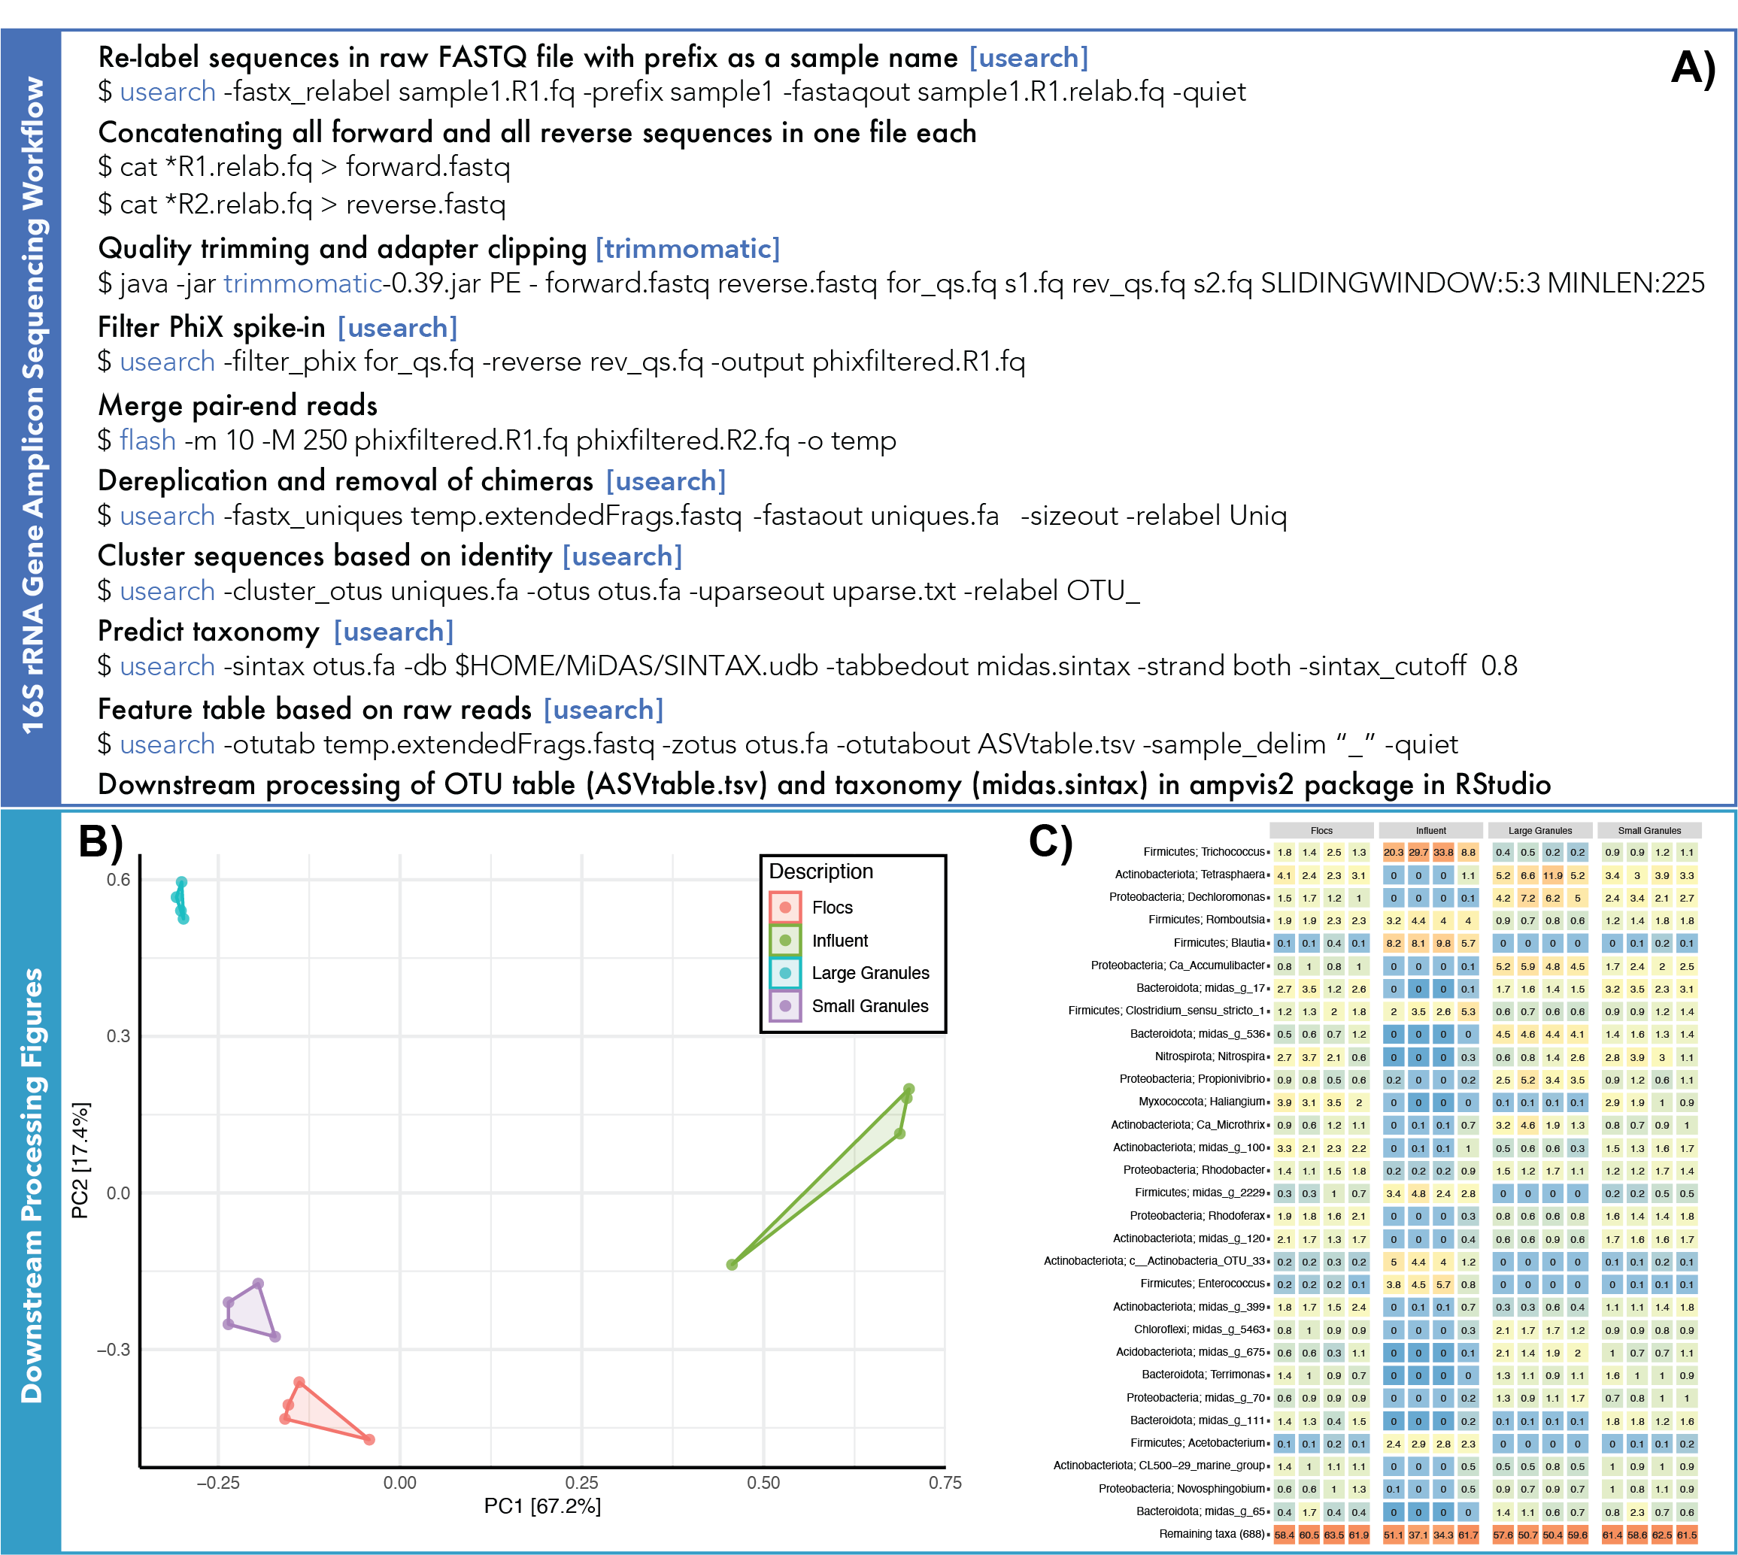
Figure 3: A) 16S rRNA gene Amplicon Sequencing Workflow. B) Ordination plot of influent wastewater, flocs, small granules, and large granules based on Principal Components Analysis (PCA). Hellinger transformation is used to perform PCA as it will produce a more ecologically meaningful result. C) Heatmap distribution of the dominant OTUs classified down to the genus level (f, o, c, and p represent family, order, class, and phylum, respectively) for the influent wastewater, flocs, small granules, and large granules. Figures in Panel B and C are adapted with permission from (Ali et al. Environmental Science & Technology, 2019, 53, 8291−8301). Copyright (2019) American Chemical Society.

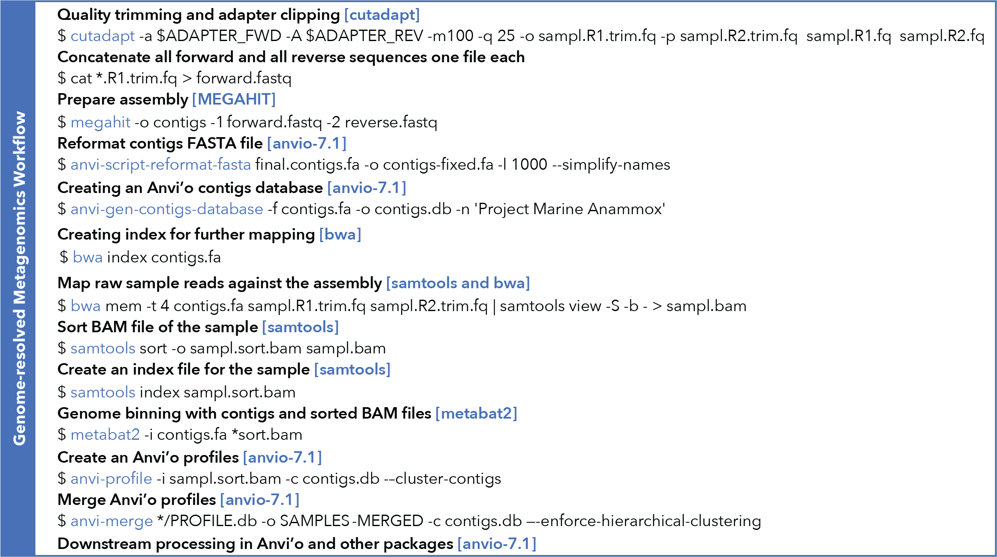
Figure 4: Genome-resolved Metagenomics Workflow.

Genome-resolved metatranscriptomics
In this exercise, metatranscriptomics samples are collected from the same MBR where metagenomics samples were collected (Ali et al., 2020b). Genome-resolved metatranscriptomics workflow is presented in Fig. 5A. The reads are mapped to the predicted protein-coding genes generated from Prokka for each MAG using USEARCH command usearch_global. Reads with a sequence identity below 0.98 were discarded. The count tables are used to generate gene expression of microorganisms represented by the MAGs recovered from the MBR. The gene expression is based on transcription per million (TPM) metatranscriptomics reads that are mapped to each MAG (Fig. 5B&C). TPM values are calculated by dividing the read counts by the MAG size (kilobases), which gives reads per kilobase (RPK) value. The RPK values in a sample are then added, and the resultant value is divided by 1,000,000 to obtain a “per million” scaling factor. Finally, the individual RPK values were divided by the “per million” scaling factor, yielding the TPM value. All the scripts and exercise files are available at this link (https://drive.google.com/drive/folders/1I_wbxtSBsYaL_OIy1wPlWqnkGIhin4Zg?usp=share_link). For further comparative analysis, the count tables can be imported to RStudio, processed using the default DESeq2 workflow (Love et al., 2014), and visualized using ggplot2. Principle component analysis (PCA) and hierarchical clustering analysis (HCA) of overall sample similarity can be performed using DESeq2 normalized count in the R platform.

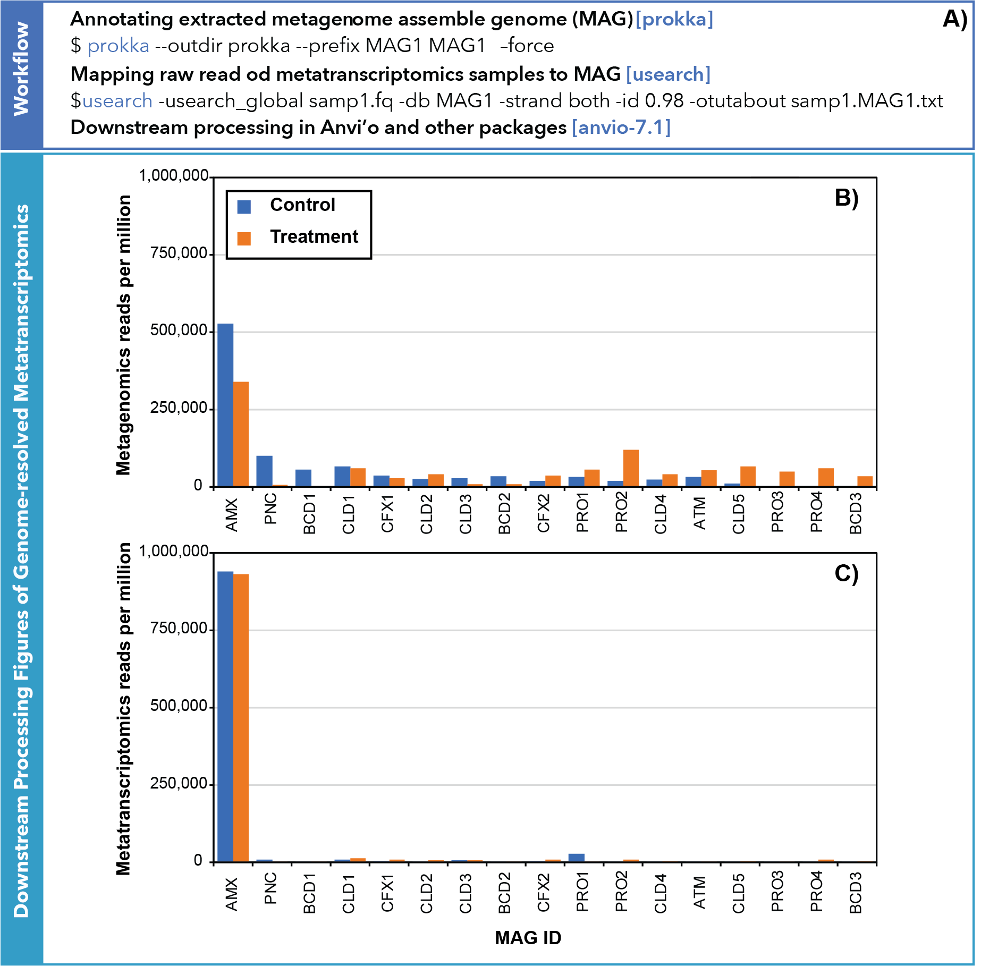
Figure 5: A) Genome-resolved Metatranscriptomics Workflow. B) Relative abundance and C) gene expression based on transcription per million (TPM) values of metagenomics and metatranscriptomics reads that mapped to each MAG recovered from the MBR. Figures in Panel B and C are adapted with permission from (Ali et al. Water Research, 2020, 170, 115345). Copyright (2019) Elsevier Ltd.

APPLICATIONS OF GENOMICS IN MEMBRANE FILTRATION RESEARCH
The use of 16S rRNA gene amplicon sequencing has been valuable for understanding the diversity and abundance of microorganisms in membrane-based water systems (Figure 3C) (Vries, 2022). For instance, it was used to create a microbiological database of bacteria detected in biofilms on rubber-coated valves in drinking water systems and to identify the specific bacterial phylum present in contaminated reverse osmosis (RO) membranes (Bereschenko, 2010; Beyer, 2019; Vries, 2022). Furthermore, by obtaining a thorough understanding of the bacterial communities within membranes, scientists have gained valuable insights regarding the types of microorganisms that are prone to causing fouling. These insights have been instrumental in refining membrane-cleaning strategies, specifically by targeting particular microorganisms or proactively preventing the formation of bacterial biofilms (Møllebjerg et al., 2023). Additionally, 16S rRNA and other omics data can be used for ordination analysis to reveal similarities and clustering patterns among samples in membrane processes (Figure 3B). The findings from such studies can provide valuable information about the microbial ecology within membranes, helping researchers to gain insights into the microbial communities present in membranes and understand how they relate to one another.
Genome-centric metagenomics processing provides a more comprehensive and refined approach than 16S rRNA analysis. For example, MAGs enabled the identification of microorganisms at the species level (Rehman et al., 2019). In Figure 6, two main aspects of genome-centric metagenomics analysis are presented. Firstly, it enables the construction of phylogenetic trees (Figure 6A). This allows us to understand the evolutionary relationships between different organisms and their role in the ecosystem. Secondly, genome-centric metagenomics processing allows the reconstruction of metabolic pathways using metagenome-assembled genomes (MAGs) based on gene presence or absence (Figure 6B). By analyzing the genetic content of MAGs, we can identify the presence or absence of specific genes involved in metabolic pathways. This information helps us understand the functional potential of microbial communities and their contributions to various biogeochemical processes in membrane-based systems. Overall, genome-centric metagenomics processing is a powerful tool that provides insights into the taxonomic and functional composition of microbial communities. It helps us understand the complex interactions between different organisms and their roles in ecosystem functioning. It also enables the discovery of genes that are enriched in biofilm development as well as the investigation of specific genes within microbial communities. These insights have played a crucial role in developing effective strategies to prevent biofouling. For example, antifouling strategies for seawater reverse osmosis (RO) membranes involve targeting the enriched Planctomycetes bacteria or employing inhibitory compounds such as azide, chlorate, cyanide, and thiocyanide to specifically target nitrate-reducing enzymes, which have been identified as enriched in the biofilm metagenome (Rehman et al., 2019).

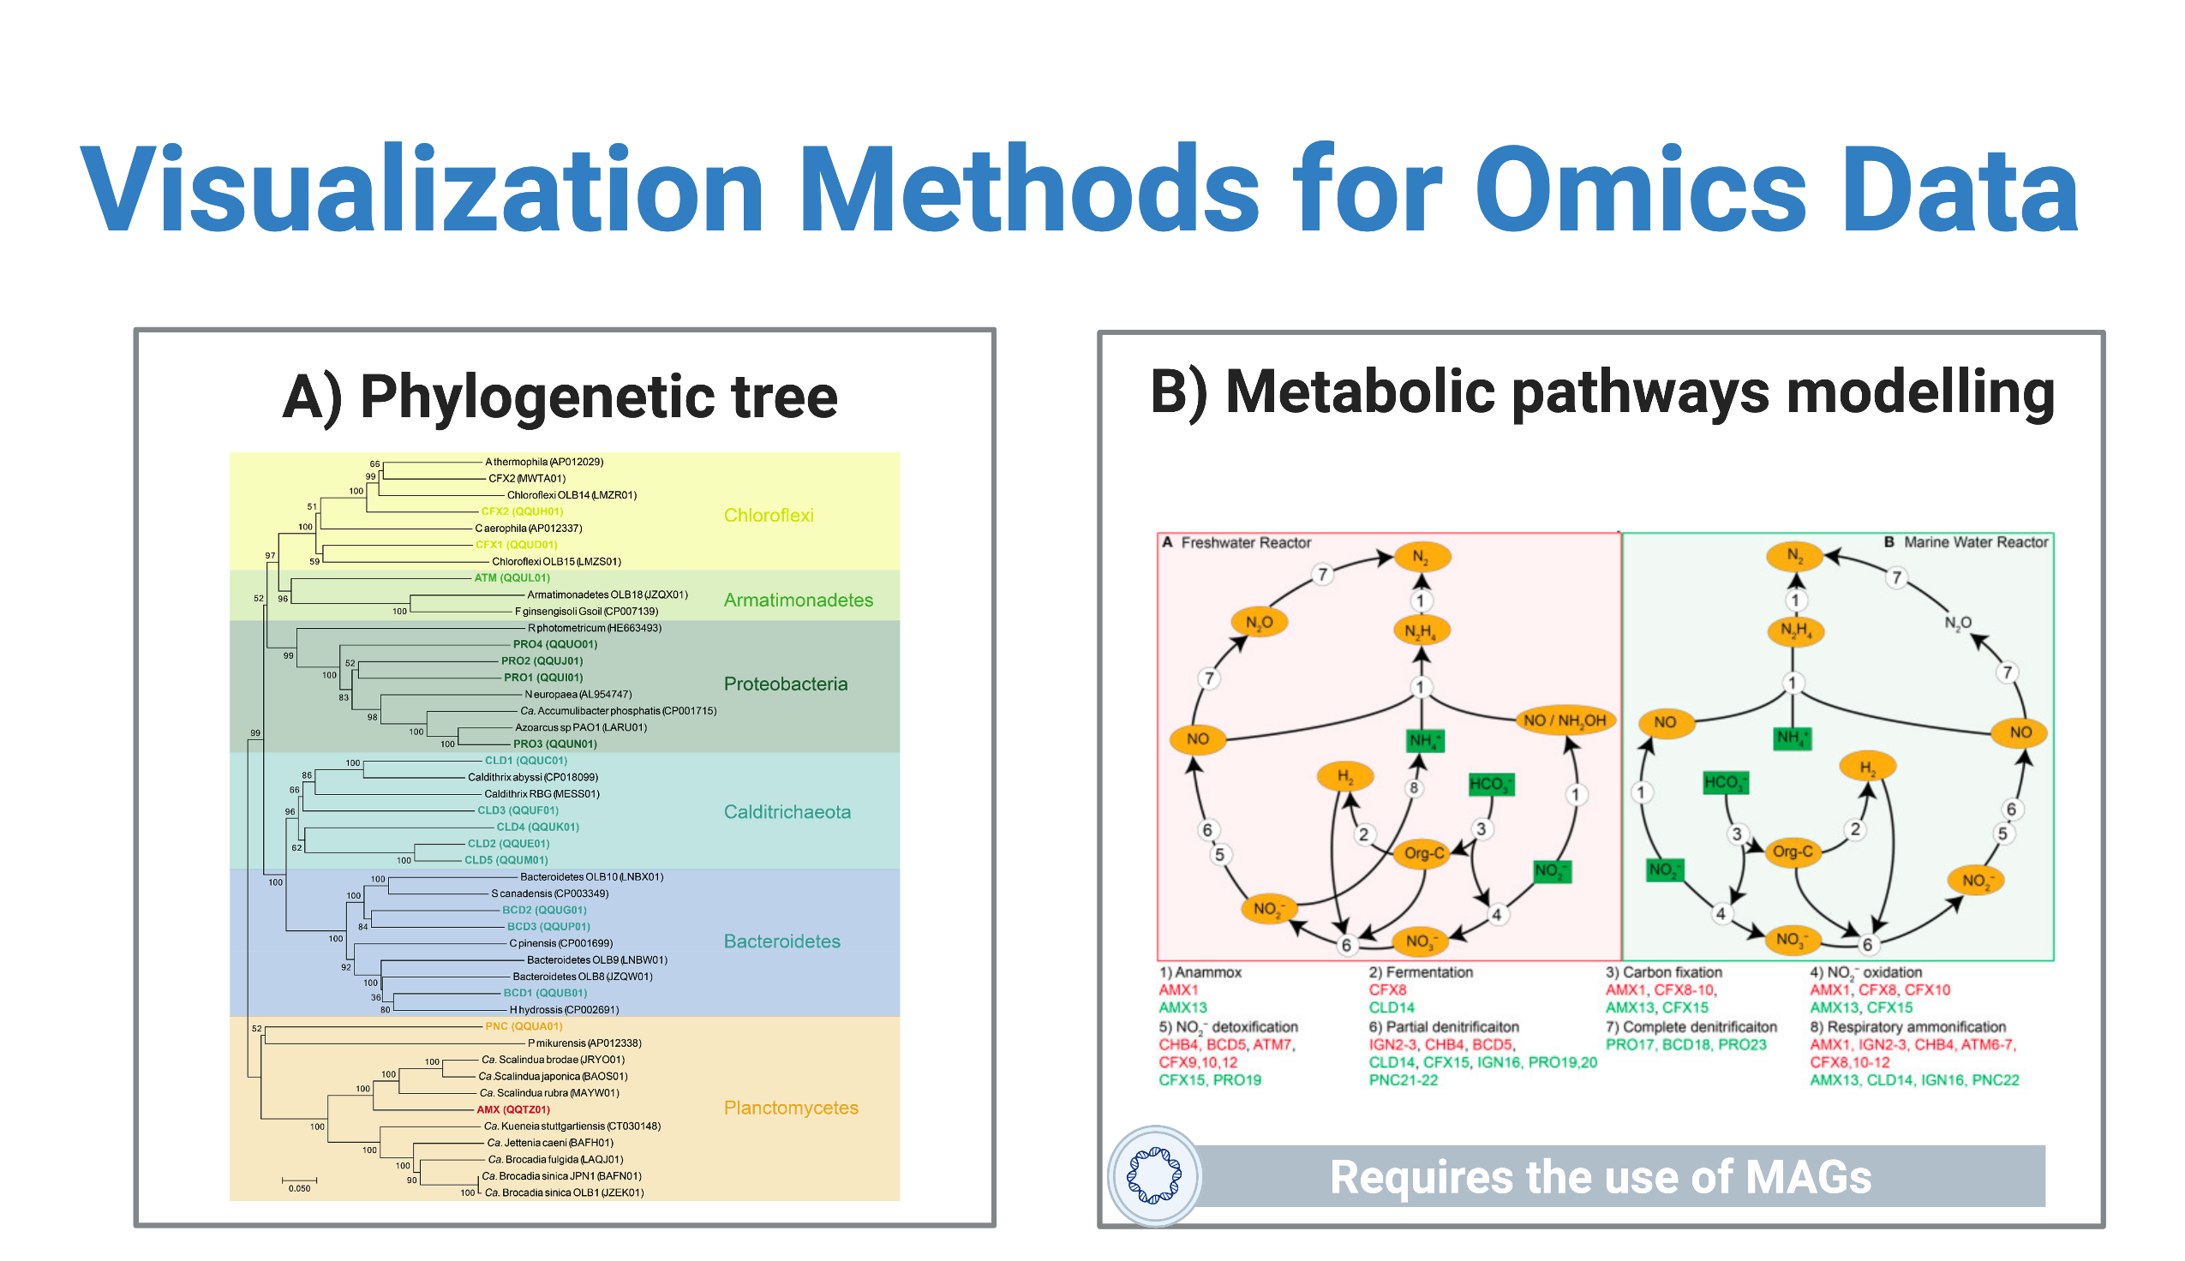
Figure 6: Genome-centric metagenomics processing enables the construction of A) Phylogenetic trees and B) Reconstruction of metabolic pathways using metagenome-assembled genomes (MAGs) based on gene presence or absence. Figures in Panel A is adapted with permission from (Ali et al. Water Research, 2020, 170, 115345). Copyright (2019) Elsevier Ltd. Figures in Panel B is adapted with permission from (Ali et al. Frontiers in Microbiology, 2020, 11, 1637.).

Outlook
Recently, metagenomics has been successfully employed to discover novel microorganisms. However, the following points should be considered in future omics-based studies, including membrane-based filtration systems.

1. The omics-based study reports a relative abundance of microbial species as an actual abundance in the system. However, the relative abundance derived from such analysis should not be considered or interpreted as the system's actual abundance.
2. Assembled genomes (MAGs) have clear advantages for further functional analyses. However, obtaining correct assemblies is still challenging. The presence of genomic repeats, short overlap lengths, and phylogenetically close organisms can result in false-positive assembly outputs, such as joining non-overlapping fragments from different parts of the genome or producing chimeric contigs from different organisms. Besides the difficulty in assembling low-abundance species and closely related strains (micro diversity), and the exclusion of significant amounts of unassembled data, an assembly-based annotation strategy can introduce biases for quantitative analysis.
3. NGS-based sequencing is still expensive because the cost rises with sequencing depth. Most omics-based studies use quantitative analysis due to the high cost of technical/biological replicates. This makes it challenging to determine whether observed differences (particularly small ones) within or between experimental groups are statistically significant and robust (after considering replicate variance). Therefore, future research should consider the reproducibility of omics data before delving into differentially expressed features.
4. The completeness of database resources inevitably affects the taxonomic and functional annotation of sequence data. However, the databases improve as researchers continue to investigate microbial dark matter.

Data Availability
All raw sequencing data associated with amplicon sequencing analysis taken from the previous study (Ali et al., 2019) are available at NCBI Sequence Read Archive under accession number SRP115069. All sequencing data associated with genome-resolve metagenomics analysis taken from a previous study (Ali et al., 2020b) is available at NCBI under BioProject PRJNA482223.

References
Albertsen, M., Hugenholtz, P., Skarshewski, A., Nielsen, K.L., Tyson, G.W. and Nielsen, P.H. 2013. Genome sequences of rare, uncultured bacteria obtained by differential coverage binning of multiple metagenomes. Nat Biotechnol 31(6), 533-538.
Albertsen, M., Karst, S.M., Ziegler, A.S., Kirkegaard, R.H. and Nielsen, P.H. 2015. Back to Basics--The Influence of DNA Extraction and Primer Choice on Phylogenetic Analysis of Activated Sludge Communities. PLoS One 10(7), e0132783.
Ali, M., Shaw, D.R. and Saikaly, P.E. 2020b. Application of an enrichment culture of the marine anammox bacterium "Ca. Scalindua sp. AMX11" for nitrogen removal under moderate salinity and in the presence of organic carbon. Water Res 170, 115345.
Ali, M., Shaw, D.R., Albertsen, M. and Saikaly, P.E. 2020a. Comparative Genome-Centric Analysis of Freshwater and Marine ANAMMOX Cultures Suggests Functional Redundancy in Nitrogen Removal Processes. Front Microbiol 11, 1637.
Ali, M., Wang, Z., Salam, K.W., Hari, A.R., Pronk, M., van Loosdrecht, M.C.M. and Saikaly, P.E. 2019. Importance of Species Sorting and Immigration on the Bacterial Assembly of Different-Sized Aggregates in a Full-Scale Aerobic Granular Sludge Plant. Environ Sci Technol 53(14), 8291-8301.
Alneberg, J., Bjarnason, B.S., de Bruijn, I., Schirmer, M., Quick, J., Ijaz, U.Z., Lahti, L., Loman, N.J., Andersson, A.F. and Quince, C. 2014. Binning metagenomic contigs by coverage and composition. Nat Methods 11(11), 1144-1146.
Alqahtani, M.F., Bajracharya, S., Katuri, K.P., Ali, M., Ragab, A., Michoud, G., Daffonchio, D. and Saikaly, P.E. 2019. Enrichment of Marinobacter sp. and Halophilic Homoacetogens at the Biocathode of Microbial Electrosynthesis System Inoculated With Red Sea Brine Pool. Front Microbiol 10, 2563.
Andersen, K.S., Kirkegaard, R.H., Karst, S.M. and Albertsen, M. 2018. ampvis2: an R package to analyse and visualise 16S rRNA amplicon data. bioRxiv.
Bereschenko, L.A. (2010) Biofilm development on new and cleaned membrane surfaces, Wageningen University.
Beyer, F. (2019) Microbiological and process technological aspects of nanofiltration and reverse osmosis membrane biofouling, Wageningen University.
Bodilis, J., Nsigue-Meilo, S., Besaury, L. and Quillet, L. 2012. Variable copy number, intra-genomic heterogeneities and lateral transfers of the 16S rRNA gene in Pseudomonas. PLoS One 7(4), e35647.
Bolger, A.M., Lohse, M. and Usadel, B. 2014. Trimmomatic: a flexible trimmer for Illumina sequence data. Bioinformatics 30(15), 2114-2120.
Bougouffa, S., Yang, J.K., Lee, O.O., Wang, Y., Batang, Z., Al-Suwailem, A. and Qian, P.Y. 2013. Distinctive microbial community structure in highly stratified deep-sea brine water columns. Appl Environ Microbiol 79(11), 3425-3437.
Caporaso, J.G., Kuczynski, J., Stombaugh, J., Bittinger, K., Bushman, F.D., Costello, E.K., Fierer, N., Peña, A.G., Goodrich, J.K., Gordon, J.I., Huttley, G.A., Kelley, S.T., Knights, D., Koenig, J.E., Ley, R.E., Lozupone, C.A., McDonald, D., Muegge, B.D., Pirrung, M., Reeder, J., Sevinsky, J.R., Turnbaugh, P.J., Walters, W.A., Widmann, J., Yatsunenko, T., Zaneveld, J. and Knight, R. 2010. QIIME allows analysis of high-throughput community sequencing data. Nature Methods 7, 335–336.
Chaumeil, P.A., Mussig, A.J., Hugenholtz, P. and Parks, D.H. 2022. GTDB-Tk v2: memory friendly classification with the Genome Taxonomy Database. Bioinformatics.
Desai, N., Antonopoulos, D., Gilbert, J.A., Glass, E.M. and Meyer, F. 2012. From genomics to metagenomics. Curr Opin Biotechnol 23(1), 72-76.
Dick, G.J., Andersson, A.F., Baker, B.J., Simmons, S.L., Thomas, B.C., Yelton, A.P. and Banfield, J.F. 2009. Community-wide analysis of microbial genome sequence signatures. Genome Biol 10(8), R85.
Dueholm, M.K.D., Nierychlo, M., Andersen, K.S., Rudkjobing, V., Knutsson, S., Mi, D.A.S.G.C., Albertsen, M. and Nielsen, P.H. 2022. MiDAS 4: A global catalogue of full-length 16S rRNA gene sequences and taxonomy for studies of bacterial communities in wastewater treatment plants. Nat Commun 13(1), 1908.
Dupont, C.L., Rusch, D.B., Yooseph, S., Lombardo, M.J., Richter, R.A., Valas, R., Novotny, M., Yee-Greenbaum, J., Selengut, J.D., Haft, D.H., Halpern, A.L., Lasken, R.S., Nealson, K., Friedman, R. and Venter, J.C. 2012. Genomic insights to SAR86, an abundant and uncultivated marine bacterial lineage. ISME J 6(6), 1186-1199.
Edgar, R.C. 2013. UPARSE: highly accurate OTU sequences from microbial amplicon reads. Nat Methods 10(10), 996-998.
Eren, A.M., Kiefl, E., Shaiber, A., Veseli, I., Miller, S.E., Schechter, M.S., Fink, I., Pan, J.N., Yousef, M., Fogarty, E.C., Trigodet, F., Watson, A.R., Esen, O.C., Moore, R.M., Clayssen, Q., Lee, M.D., Kivenson, V., Graham, E.D., Merrill, B.D., Karkman, A., Blankenberg, D., Eppley, J.M., Sjodin, A., Scott, J.J., Vazquez-Campos, X., McKay, L.J., McDaniel, E.A., Stevens, S.L.R., Anderson, R.E., Fuessel, J., Fernandez-Guerra, A., Maignien, L., Delmont, T.O. and Willis, A.D. 2021. Community-led, integrated, reproducible multi-omics with anvi'o. Nat Microbiol 6(1), 3-6.
Frias-Lopez, J., Shi, Y., Tyson, G.W., Coleman, M.L., Schuster, S.C., Chisholm, S.W. and Delong, E.F. 2008. Microbial community gene expression in ocean surface waters. Proc Natl Acad Sci U S A 105(10), 3805-3810.
Garcia Martin, H., Ivanova, N., Kunin, V., Warnecke, F., Barry, K.W., McHardy, A.C., Yeates, C., He, S., Salamov, A.A., Szeto, E., Dalin, E., Putnam, N.H., Shapiro, H.J., Pangilinan, J.L., Rigoutsos, I., Kyrpides, N.C., Blackall, L.L., McMahon, K.D. and Hugenholtz, P. 2006. Metagenomic analysis of two enhanced biological phosphorus removal (EBPR) sludge communities. Nat Biotechnol 24(10), 1263-1269.
Garcias-Bonet, N., Fusi, M., Ali, M., Shaw, D.R., Saikaly, P.E., Daffonchio, D. and Duarte, C.M. 2018. High denitrification and anaerobic ammonium oxidation contributes to net nitrogen loss in a seagrass ecosystem in the central Red Sea. Biogeosciences 15(23), 7333-7346.
Goodrich, J.K., Di Rienzi, S.C., Poole, A.C., Koren, O., Walters, W.A., Caporaso, J.G., Knight, R. and Ley, R.E. 2014. Conducting a microbiome study. Cell 158(2), 250-262.
Haroon, M.F., Hu, S., Shi, Y., Imelfort, M., Keller, J., Hugenholtz, P., Yuan, Z. and Tyson, G.W. 2013. Anaerobic oxidation of methane coupled to nitrate reduction in a novel archaeal lineage. Nature 500(7464), 567-570.
Head, S.R., Komori, H.K., LaMere, S.A., Whisenant, T., Van Nieuwerburgh, F., Salomon, D.R. and Ordoukhanian, P. 2014. Library construction for next-generation sequencing: overviews and challenges. Biotechniques 56(2), 61-64, 66, 68, passim.
Howe, A.C., Jansson, J.K., Malfatti, S.A., Tringe, S.G., Tiedje, J.M. and Brown, C.T. 2014. Tackling soil diversity with the assembly of large, complex metagenomes. Proc Natl Acad Sci U S A 111(13), 4904-4909.
Hugenholtz, P. 2002. Exploring prokaryotic diversity in the genomic era. Genome Biology 3(2), 1-8.
Imelfort, M., Parks, D., Woodcroft, B.J., Dennis, P., Hugenholtz, P. and Tyson, G.W. 2014. GroopM: an automated tool for the recovery of population genomes from related metagenomes. PeerJ 2, e603.
Kang, D.D., Froula, J., Egan, R. and Wang, Z. 2015. MetaBAT, an efficient tool for accurately reconstructing single genomes from complex microbial communities. PeerJ 3, e1165.
Kang, D.D., Li, F., Kirton, E., Thomas, A., Egan, R., An, H. and Wang, Z. 2019. MetaBAT 2: an adaptive binning algorithm for robust and efficient genome reconstruction from metagenome assemblies. PeerJ 7, e7359.
Knight, R., Jansson, J., Field, D., Fierer, N., Desai, N., Fuhrman, J.A., Hugenholtz, P., van der Lelie, D., Meyer, F., Stevens, R., Bailey, M.J., Gordon, J.I., Kowalchuk, G.A. and Gilbert, J.A. 2012. Unlocking the potential of metagenomics through replicated experimental design. Nat Biotechnol 30(6), 513-520.
Koren, S., Schatz, M.C., Walenz, B.P., Martin, J., Howard, J.T., Ganapathy, G., Wang, Z., Rasko, D.A., McCombie, W.R., Jarvis, E.D. and Adam, M.P. 2012. Hybrid error correction and de novo assembly of single-molecule sequencing reads. Nat Biotechnol 30(7), 693-700.
Kunin, V., Copeland, A., Lapidus, A., Mavromatis, K. and Hugenholtz, P. 2008. A bioinformatician's guide to metagenomics. Microbiol Mol Biol Rev 72(4), 557-578, Table of Contents.
Li, D., Luo, R., Liu, C.M., Leung, C.M., Ting, H.F., Sadakane, K., Yamashita, H. and Lam, T.W. 2016. MEGAHIT v1.0: A fast and scalable metagenome assembler driven by advanced methodologies and community practices. Methods 102, 3-11.
Li, H. and Durbin, R. 2009. Fast and accurate short read alignment with Burrows-Wheeler transform. Bioinformatics 25(14), 1754-1760.
Li, H. and Durbin, R. 2010. Fast and accurate long-read alignment with Burrows-Wheeler transform. Bioinformatics 26(5), 589-595.
Love, M.I., Huber, W. and Anders, S. 2014. Moderated estimation of fold change and dispersion for RNA-seq data with DESeq2. Genome Biol 15(12), 550.
Lovley, D.R. 2003. Cleaning up with genomics: applying molecular biology to bioremediation. Nat Rev Microbiol 1(1), 35-44.
Magoc, T. and Salzberg, S.L. 2011. FLASH: fast length adjustment of short reads to improve genome assemblies. Bioinformatics 27(21), 2957-2963.
Martin, M. 2011. Cutadapt removes adapter sequences from high-throughput sequencing reads. EMBNet Journal, 10-12.
Mason, O.U., Hazen, T.C., Borglin, S., Chain, P.S., Dubinsky, E.A., Fortney, J.L., Han, J., Holman, H.Y., Hultman, J., Lamendella, R., Mackelprang, R., Malfatti, S., Tom, L.M., Tringe, S.G., Woyke, T., Zhou, J., Rubin, E.M. and Jansson, J.K. 2012. Metagenome, metatranscriptome and single-cell sequencing reveal microbial response to Deepwater Horizon oil spill. ISME J 6(9), 1715-1727.
Matar, G.K., Ali, M., Bagchi, S., Nunes, S., Liu, W.T. and Saikaly, P.E. 2021. Relative Importance of Stochastic Assembly Process of Membrane Biofilm Increased as Biofilm Aged. Front Microbiol 12, 708531.
McHardy, A.C., Martin, H.G., Tsirigos, A., Hugenholtz, P. and Rigoutsos, I. 2007. Accurate phylogenetic classification of variable-length DNA fragments. Nat Methods 4(1), 63-72.
Møllebjerg, A., Zarebska, A., Nielsen, H.B., Hansen, L.B.S., Sørensen, S.R., Seredynska-Sobecka, B., Villacorte, L.O., Gori, K., Palmén, L.G. and Meyer, R.L. 2023. Novel high-throughput screening platform identifies enzymes to tackle biofouling on reverse osmosis membranes. Desalination 554.
Nielsen, P.H., Daims, H., Lemmer, H., Arslan-Alaton, I. and Olmez-Hanci, T. (2009) FISH Handbook for Biological Wastewater Treatment, IWA Publishing, London, UK.
Parks, D.H., Imelfort, M., Skennerton, C.T., Hugenholtz, P. and Tyson, G.W. 2015. CheckM: assessing the quality of microbial genomes recovered from isolates, single cells, and metagenomes. Genome Res 25(7), 1043-1055.
Peng, Y., Leung, H.C., Yiu, S.M. and Chin, F.Y. 2012. IDBA-UD: a de novo assembler for single-cell and metagenomic sequencing data with highly uneven depth. Bioinformatics 28(11), 1420-1428.
Pruesse, E., Peplies, J. and Glockner, F.O. 2012. SINA: accurate high-throughput multiple sequence alignment of ribosomal RNA genes. Bioinformatics 28(14), 1823-1829.
Raes, J., Korbel, J.O., Lercher, M.J., von Mering, C. and Bork, P. 2007. Prediction of effective genome size in metagenomic samples. Genome Biol 8(1), R10.
Rehman, Z.U., Ali, M., Iftikhar, H. and Leiknes, T. 2019. Genome-resolved metagenomic analysis reveals roles of microbial community members in full-scale seawater reverse osmosis plant. Water Res 149, 263-271.
Riesgo, A., Perez-Porro, A.R., Carmona, S., Leys, S.P. and Giribet, G. 2012. Optimization of preservation and storage time of sponge tissues to obtain quality mRNA for next-generation sequencing. Mol Ecol Resour 12(2), 312-322.
Roesch, L.F., Fulthorpe, R.R., Riva, A., Casella, G., Hadwin, A.K., Kent, A.D., Daroub, S.H., Camargo, F.A., Farmerie, W.G. and Triplett, E.W. 2007. Pyrosequencing enumerates and contrasts soil microbial diversity. ISME J 1(4), 283-290.
Schloss, P.D., Westcott, S.L., Ryabin, T., Hall, J.R., Hartmann, M., Hollister, E.B., Lesniewski, R.A., Oakley, B.B., Parks, D.H., Robinson, C.J., Sahl, J.W., Stres, B., Thallinger, G.G., Van Horn, D.J. and Weber, C.F. 2009. Introducing mothur: open-source, platform-independent, community-supported software for describing and comparing microbial communities. Appl Environ Microbiol 75(23), 7537-7541.
Scholz, M.B., Lo, C.C. and Chain, P.S. 2012. Next generation sequencing and bioinformatic bottlenecks: the current state of metagenomic data analysis. Curr Opin Biotechnol 23(1), 9-15.
Seemann, T. 2014. Prokka: rapid prokaryotic genome annotation. Bioinformatics 30(14), 2068-2069.
Shaw, D.R., Ali, M., Katuri, K.P., Gralnick, J.A., Reimann, J., Mesman, R., van Niftrik, L., Jetten, M.S.M. and Saikaly, P.E. 2020. Extracellular electron transfer-dependent anaerobic oxidation of ammonium by anammox bacteria. Nat Commun 11(1), 2058.
Siegwald, L., Touzet, H., Lemoine, Y., Hot, D., Audebert, C. and Caboche, S. 2017. Assessment of Common and Emerging Bioinformatics Pipelines for Targeted Metagenomics. PLoS One 12(1), e0169563.
Speth, D.R., Lagkouvardos, I., Wang, Y., Qian, P.Y., Dutilh, B.E. and Jetten, M.S.M. 2017. Draft Genome of Scalindua rubra, Obtained from the Interface Above the Discovery Deep Brine in the Red Sea, Sheds Light on Potential Salt Adaptation Strategies in Anammox Bacteria. Microb Ecol 74(1), 1-5.
Thomas, T., Gilbert, J. and Meyer, F. 2012. Metagenomics - a guide from sampling to data analysis. Microb Inform Exp 2(1), 3.
Trego, A.C., O'Sullivan, S., Quince, C., Mills, S., Ijaz, U.Z. and Collins, G. 2020. Size Shapes the Active Microbiome of Methanogenic Granules, Corroborating a Biofilm Life Cycle. mSystems 5(5).
van Dijk, E.L., Auger, H., Jaszczyszyn, Y. and Thermes, C. 2014. Ten years of next-generation sequencing technology. Trends Genet 30(9), 418-426.
Vries, H.J.d. (2022) Characterizing bacteria involved in fouling of spiral wound membranes, Wageningen University.
Wang, X., Hu, M., Xia, Y., Wen, X. and Ding, K. 2012a. Pyrosequencing analysis of bacterial diversity in 14 wastewater treatment systems in China. Appl Environ Microbiol 78(19), 7042-7047.
Wang, Y., Cao, H., Zhang, G., Bougouffa, S., Lee, O.O., Al-Suwailem, A. and Qian, P.Y. 2013. Autotrophic microbe metagenomes and metabolic pathways differentiate adjacent Red Sea brine pools. Sci Rep 3, 1748.
Wang, Y., Leung, H.C., Yiu, S.M. and Chin, F.Y. 2012b. MetaCluster 4.0: a novel binning algorithm for NGS reads and huge number of species. J Comput Biol 19(2), 241-249.
Wrighton, K.C., THOMAS, B.C., SHARON, I., MILLER, C.S., CASTELLE, C.J., VERBERKMOES, N.C., WILKINS, M.J., HETTICH, R.L., LIPTON, M.S., WILLIAMS, K.H., LONG, P.E. and BANFIELD, J.F. 2012. Fermentation, Hydrogen, and Sulfur Metabolism in Multiple Uncultivated Bacterial Phyla. Science 337(6102), 1661-1665.
Wu, L., Ning, D., Zhang, B., Li, Y., Zhang, P., Shan, X., Zhang, Q., Brown, M.R., Li, Z., Van Nostrand, J.D., Ling, F., Xiao, N., Zhang, Y., Vierheilig, J., Wells, G.F., Yang, Y., Deng, Y., Tu, Q., Wang, A., Global Water Microbiome, C., Zhang, T., He, Z., Keller, J., Nielsen, P.H., Alvarez, P.J.J., Criddle, C.S., Wagner, M., Tiedje, J.M., He, Q., Curtis, T.P., Stahl, D.A., Alvarez-Cohen, L., Rittmann, B.E., Wen, X. and Zhou, J. 2019. Global diversity and biogeography of bacterial communities in wastewater treatment plants. Nat Microbiol 4(7), 1183-1195.
Wu, Y.-W., Tang, Y.-H., Tringe, S.G., Simmons, B.A. and Singer, S.W. 2016. MaxBin: an automated binning method to recover individual genomes from metagenomes using an expectation-maximization algorithm. Microbiome 2, 26.
Yang, Y., Li, B., Ju, F. and Zhang, T. 2013. Exploring variation of antibiotic resistance genes in activated sludge over a four-year period through a metagenomic approach. Environ Sci Technol 47(18), 10197-10205.
Yu, K. and Zhang, T. 2012. Metagenomic and metatranscriptomic analysis of microbial community structure and gene expression of activated sludge. PLoS One 7(5), e38183.
Zhang, T., Shao, M.F. and Ye, L. 2012. 454 pyrosequencing reveals bacterial diversity of activated sludge from 14 sewage treatment plants. ISME J 6(6), 1137-1147.

