Electroconductive Melt Electrowritten Patches Matching the Mechanical Anisotropy of Human Myocardium

Dinorath Olvera, Mina Sohrabi, Gillian Hendy, Michael G. Monaghan*

Dr. D. O., M. S., Dr. M. G. M.
Trinity Centre for Biomedical Engineering, Trinity Biomedical Sciences Institute, Trinity College Dublin, 152 - 160 Pearse Street, Dublin 2, Ireland
E-mail: monaghmi@tcd.ie

Dr. G.H.
Spraybase®, Avectas Ltd., MaynoothWorks, Eolas Building, Maynooth, Kildare, Ireland.

Keywords: cardiac patches, melt electrospinning writing, auxetic materials, mechanical anisotropy, electroconductive materials

Cardiac patches represent a promising strategy for the treatment of myocardial infarction (MI). Here, an electroconductive cardiac patch that conforms to the mechanics of human myocardium is fabricated. By melt electrospinning writing (MEW) it is possible to fabricate an auxetic patch that can overcome the limited range of elasticity seen in conventional square patch designs. The auxetic patches can accommodate the strains and stresses exhibited by the human myocardium during diastole and systole. It is shown that the geometry of the auxetic patches could be fine-tuned to reflect anisotropic mechanical properties. The anisotropic ratio of effective stiffness (E₁/E₂) of the auxetic patches agrees with the directionally-dependent mechanics of the heart. Furthermore, in situ polymerization of doped-polypyrrole (PPy) on the auxetic patches confers electroconductive properties close to those reported of human myocardium. This approach demonstrates the potential use of a rational design of PPy-coated patches for their use as cardiac patches.

Cardiovascular diseases (CVDs) are a leading cause of death globally with 85% of all CVD deaths being due to stroke and myocardial infarction (MI).^{[1]} MI leads to the death of approximately 1 billion cardiomyocytes in the left ventricular wall of the heart within a few hours of an ischemic episode. The adult mammalian heart has a limited capacity for regeneration, and the myocardial tissue lost to ischemic injury is typically replaced by a fibrotic scar tissue.^{[2]} This ischemic region loses its ability to contract, imposing mechanical disadvantages that ultimately lead to heart failure (HF).^{[2]} One of the most studied hypotheses has been whether a cardiac patch can address this lost myocardium and restore functional myocardial contractility. Biomaterials and regenerative therapies present exciting approaches to reinforce the compromised tissue,^{[3,4]} deliver cells and/or growth factors to vitalize the tissue,^{[5,6]} impart electromechanical coupling across the infarct,^{[7,8]} and recapitulate the mechanical anisotropy of myocardium.^{[8–10]} These strategies are commonly based on the idea that for a cardiac patch to be successful it must meet the electrical and biomechanical needs of the heart muscle. Despite progress made to date, fabricating an electroconductive patch that also meets the mechanical demands of the human myocardium remains a challenge.
The loss of the highly organized laminar structure of ventricular myocardium and the formation of scar tissue following MI disturbs the coordinated impulse propagation.^{[11]} Tissue engineered cardiac patches have shown promising results to transmit electrical signals between cells.^{[4,12]} Electroactive biomaterials which include conductive polymers, piezoelectrics, photovoltaic materials and electrets have recently garnered much attention in the tissue engineering community.^{[13]} These materials can facilitate electrical signal propagation between cardiac cells when compared to insulating biomaterials; leading to synchronous contraction in cardiac constructs and to the expression of proteins involved in muscle contraction and electrical coupling in vitro and in vivo.^{[14–16]} Among the electroactive biomaterials, conductive polymers are attractive due to their inherent electrically conductive nature and ease of processing, and they can be fabricated to generate either transient or static electrical charges due to their physicochemical properties.^{[17,18]} In particular, polypyrrole (PPy) is biocompatible in vivo^{[19]} and shows chemical stability and relatively high conductivity (up to 4 X 10³ S m⁻¹) under environmental conditions.^{[20]} External electrical fields applied to scaffolds coated with PPy has generated in vitro tissue constructs with an increased maturation of cardiomyocytes when compared to uncoated scaffolds.^{[21,22]} In vivo, PPy-alginate injected into the infarct zone has yielded higher levels of arteriogenesis and enhanced infiltration of myofibroblasts into the infarct at 5 weeks post-treatment when compared to controls.^{[23]}
In addition to electroconductive properties, the mechanical behavior of the patch is pivotal to the heart’s contraction and function. Soft biological materials, like the heart, exhibit complex biomechanical behaviors (e.g. anisotropy, non-linearity and viscoelasticity); which can be difficult to engineer.^{[24]} The mechanical demands of the myocardium cannot be met using polyester-based thermoplastic polymers such as poly(ε-caprolactone) (PCL) which exhibit a low range of elasticity (strain ≤5%).^{[25,26]} However, PCL is among the most common synthetic biodegradable polymers investigated for tissue engineering (TE) and have previously been used in certain FDA (US Food and Drug Administration) approved biomedical and drug-delivery devices.^{[27]} Functionality of engineered materials can be often leveraged by its structural geometry. Some examples are the use of nanofiber interlocking,^{[28]} hollow-sphere structures,^{[29]} surface cracks,^{[30]} and pyramidal structures.^{[31]} Herein, we present a rational design for a cardiac patch. We hypothesized that the mechanical functionality of patches composed of PCL could be leveraged by its structural geometry. By melt electrospinning writing (MEW)^{[32,33]} an auxetic pattern, it was possible to fabricate a patch that conforms to the mechanical anisotropy of the myocardium. Auxetic materials have the atypical property of a negative Poisson’s ratio, which describes how such auxetic materials can expand in the axial and transverse directions simultaneously when stretched.^{[34]} The objective of this study was to create a cell-free electroconductive patch that mimics the mechanical anisotropy of native heart tissue. To do so, highly-ordered PCL patches with auxetic and non-auxetic designs were fabricated using MEW. Electroconductivity was imparted to these patches by in situ polymerization of PPy. Auxetic PCL patches had an anisotropic ratio of effective stiffness close to that of native myocardium. Furthermore, PPy-coated patches had conductivity values close to those reported for human myocardium and were cytocompatible with human MSCs in vitro.
A material that seamlessly stretches and relaxes with the heart muscle is desirable for a cardiac patch. To this end, we designed a missing-rib auxetic design akin to the foam structure previously investigated ^{[34]} (Figure 1 a). The missing-rib or lozenge grid unit cell is based upon the selective removal of ribs from a network without changes of internal angles, θ.^{[34]} Rotation is the dominant deformation mechanism for the auxeticity of missing-rib networks,^{[34,35]} thus when the network is under tension it deforms solely through changes in the θ angles, i.e. straightening of the longitudinal rods leads to opening of the undulated transverse rods through the connecting points, consequently the angle θ increases generating a transverse expansion of the structure (Figure 1 b). The out-folding and rotation processes reverse when unloading (Figure 1 b).
The geometry of the missing-rib auxetic was tailored to reflect the anisotropy exhibited in the myocardium, which is stiffer in the transverse direction compared to the longitudinal direction.^{[36–38]} The anisotropic nature of the heart tissue enables efficient mechanical contraction of the heart, and thus several tissue engineering approaches have conceived anisotropic structures.^{[10,39,40]} The angles were predetermined to ζ = 4π/9 (80°) and φ = 2π/9 (40°) to yield an anisotropic patch stiffer in the transverse direction than in the longitudinal direction (Figure 1 c). Theoretical models previously established in the literature^{[34,41]} were used to predict the mechanical properties of the auxetic patch. The Young’s moduli in the transverse (E_{Trans}) and in the longitudinal (E_{Long}) loading directions have been predicted by^{[34]} to be:
(Equation) (1)
$$E_{Trans}=k_{0} \frac{1}{{4A}^{2}}\frac{cot⁡(ζ-φ)}{\sin\left(φ\right)sin⁡(ζ-φ)}$$
(Equation) (2)
$$E_{Long}=k_{0} \frac{1}{{4A}^{2}}\frac{tan⁡(φ)}{\cos\left(φ\right)cos⁡(ζ-φ)}$$
where k₀ is the spring constant at hinge (see Figure 1 a). The anisotropic ratio of effective stiffness (E_{Trans}/E_{Long}) can be expressed as:
(Equation) (3)
$$\frac{E_{Trans}}{E_{Long}}= \frac{ \frac{k_{0}}{{4A}^{2}}\frac{cot⁡(ζ-φ)}{\sin\left(φ\right)sin⁡(ζ-φ)}}{ \frac{k_{0}}{{4A}^{2}}\frac{tan⁡(φ)}{\cos\left(φ\right)cos⁡(ζ-φ)}}= \frac{cot⁡(ζ-φ)\cos\left(φ\right)cos⁡(ζ-φ)}{\sin\left(φ\right)sin⁡(ζ-φ)tan⁡(φ)}$$
simplified:
(Equation) (4)
$$\frac{E_{Trans}}{E_{Long}}= \cot^{2}\left(ζ-φ\right)\cot^{2}(φ)$$
From Equation 4 it becomes evident that the anisotropic ratio of effective stiffness in a missing-rib structure depends on the angles ζ and φ. Thus, we adjusted the values of these angles so that E_{Trans}/E_{Long} would be within the range of anisotropic ratio of effective stiffness reported for native heart tissue, 1.9–3.9^{[8]} with the aim to closely match the mechanical anisotropy of the myocardium. Using ζ = 80° and φ = 40° would result in a theoretical anisotropic ratio of effective stiffness of 2.01. We tessellated the missing-rib or lozenge grid as reported in^{[42]} (Figure 1 d). As a control design, we fabricated a square mesh with a positive Poisson’s ratio (v = 1, Figure 1 e).
The dimensions of the (experimental) melt electrowritten patches, both square isotropic and auxetic anisotropic, agreed with the designed dimensions (Table 1). Side length (A) in the melt electrowritten square patch showed a deviation of ~8% from the design dimension. In the melt electrowritten auxetic patch, the large path (2B) corresponding to the transverse direction showed a deviation of ~1%, while a larger discrepancy can be observed in the shorter path (A) corresponding to the longitudinal direction (~25%) (Table 2). Melt electrowritten fiber diameters were intentionally larger than native myocardial fibers (~10 µm–16µm),^{[43,44]} but similar to cardiac patches fabricated by regular electrospinning (50–200 µm)^{[40]} and excimer laser microablation (~100 µm).^{[8,10]} The angles ζ and φ agreed with the design (error percent ~2.7% and ~7%). The anisotropic ratio of effective stiffness of the melt electrowritten geometry (experimental) was 2.36.
Electrically conductive patches were achieved by in situ chemical oxidative polymerization of pyrrole (Py) (Figure S1). Polymerization with chloride ions resulted in particles that grew from Py monomers adsorbed onto the surface of the PCL-fibers. A color change from white to black was observed after the coating process (Figure 2 a). The rich black color is associated to the oxidation state of PPy. SEM images showed the changes in surface roughness in response to Py polymerization (Figure 2 b, c). PPy coating can be observed on the surface of the PCL-fibers (Figure 2 c) and the characteristic regions of PPy particle aggregation^{[22]} were visible (Figure 2 d). Next, we analyzed the PPy-coated fibers using EDX to map the composition of the coating. EDX provided elemental identification at different areas of the PPy-coating and a relative quantitation of compositional information. The EDX spectra for the neat PCL fibers was dominated by carbon and oxygen peaks, which are the commonly detected elements for PCL^{[45]} (Figure S2). In the PPy-coated fibers the appearance of carbon, oxygen and nitrogen peaks constitute the presence of PPy; the presence of sulfur indicates the doping effect from SDBS^{[46]} (Figure S3). Presence of Fe and Cl suggests a residual of by-products FeCl₂ and HCl that are formed from FeCl₃ and from the cations H+ coming from the dehydrogenation of the Py monomers.^{[47]} Different areas of the coating showed a similar composition indicating a homogenous coating of PPy. The particle size distribution is shown in Figure 2 e; ~70% of the PPy particles were between 160 – 240 nm, median 193 nm. This range agrees with the range of reported particle size of PPy, 40 – 250 nm.^{[47,48]} The change in weight before and after the coating process is attributed to the mass of PPy. The average coating weight was 0.65 ± 0.12 mg for the square-patch and 0.77 ± 0.15 mg for the auxetic patch (P = 0.0896), and an average coating thickness of ~ 0.75 µm (754 ± 105 nm) determined by SEM images of focused ion beam (FIB)-milled sections (Figure 2 f).
The electroconductivity of the PPy-coated fiber patches was within the range for relevant tissue engineering applications, 0.01 S m⁻¹ – 10³ S m⁻¹.^{[18]} Using a two-probe resistivity set-up, we acquired I-V characteristic curves of the square and auxetic PPy-coated patches (Figure 3 a). The curves show a linear relation indicating a constant resistance within the voltage tested (± 3 V). The average electroconductivity of the square-meshes was 2.73 ± 0.3 S m⁻¹ (Figure 3 b). The average value of electroconductivity of the auxetic patches in the transverse direction was found to be 2.51 ± 0.7 S m⁻¹ and 2.07 ± 0.4 S m⁻¹ in the longitudinal direction (Figure 3 b). The conductivity of human heart tissue is ~0.57 S m⁻¹ (calculated from a resistivity of 175 Ω cm previously reported ^{[49]}). The conductivity values that we obtained are > 4 times higher than those of human heart, and they are comparable with other cardiac patches used for cardiac tissue engineering, 2.4 S m⁻¹ – 13.6 S m⁻¹.^{[8]} Conductivity values were calculated by taking the length between the two electrodes as the current travel distance. While this is true for the square pattern, it is more complex for the auxetic pattern. By following the auxetic pattern in each direction, it can be seen that the distance the current travels is longer than the distance between the two electrodes, with the longest route being in the longitudinal direction. Overall, the patterning has a significant effect on the conductivity of the auxetic patches in comparison to the square patches. The myocardium exhibits directionally-dependent electrical properties.^{[10,50]} Propagation of the electrical impulse is two-fold faster in the longitudinal direction than in the transverse direction of the heart muscle fibers.^{[51,52]} Here, the electroconductivity values obtained in the transverse direction were greater than in the longitudinal direction, with a ratio of electroconductivity (σ_{Long}/ σ_{Trans}) of 0.75. Nevertheless, the electrical conductivities of the auxetic patches reported here are higher than those reported for human myocardium. The electroconduction bridging capability of the patch was also tested ex vivo using freshly isolated skeletal muscle. The PPy-coated patches supported electrical conduction as a bridge between biological tissue. Two hind limb rat muscles were dissected and placed next to each other separated by a polydimethylsiloxane (PDMS) wall. The muscle tissues were bridged with the PPy-coated patch or with the insulating PCL patch. When bridging the two muscles with the PCL patch, contraction of the muscles was undetectable when 100-mA current was applied. In contrast with the PPy-coated patch, noticeable contraction of the muscles was observed as the circuit was closed (Video S1). This demonstrates electrical conduction of the PPy-coated patches with biological tissue.
The conductivity of the PPy-coated patches remained stable for the first 7 days across all conditions (Figure 3 c). On day 14 the conductivity of the square patches was ~68% of the initial conductivity, although this reading was not statistically significant (p = 0.1459). The conductivity of the auxetic patches in the transverse direction was ~68% of the initial conductivity (p = 0.0085) and ~56% of the initial conductivity in the longitudinal direction (p < 0.0001). There was no statistical difference between the three groups at day 14. The observed conductivity decay may be due to the use of SDBS, as it has been reported that PPy doped with long side chains benzenesulfonates, such as SDBS, can exhibit lower stability than other dopants.^{[53]} The degradation rate constant k was found to be 0.03 day⁻¹. PPy is used in biological applications due to its favorable biocompatibility in vitro and in vivo.^{[54,55]} Nevertheless, we determined the cytocompatibility of the PPy-coated PCL-fibers on human MSCs by performing a maceration study with the PPy-coated patches where the maceration media (expansion media with the eluates of the patches) was supplemented to the culture media of human MSCs in different volume fractions (Figure 3 d). Cell viability was similar across all groups as indicated by the reduction of tetrazolium dye MTT to formazan by the viable cells.^{[56]} Human MSCs cultured in 100% (v/v) maceration media showed a cell viability of 85.3 ± 2.1% which was statistically different from the control group (expansion media without maceration media, 0%) and groups supplemented with 0.5 – 10% (v/v) maceration media. PPy-coated patches were cytocompatible, however, repeated steps of washing prior cell culture are necessary to remove remnants of the synthesis (e.g. impurities, reactants, monomers and shorter oligomers) which are believed to cause reduced cytocompatibility.^{[17]} Additionally, neonatal cardiac fibroblasts were seeded onto the patches to determine their cytocompatibility when cells were in contact with the patches (Figure 3 e). No differences were observed in neonatal cardiac fibroblasts viability between PCL-patches and PPy-coated patches. Interestingly, it appeared to be more cells attached to the PPy-coated patches than to the uncoated PCL-patches.
Auxetic patches exhibited anisotropic mechanical properties closely resembling that of the human myocardium. Mechanical properties of the patches, coated and uncoated, were evaluated under uniaxial tensile loading conditions; a nonlinear stress-strain behavior was observed for all patches (Figure 4a; for uncoated patches see Figure S3). As the straight fibers of the patch with a square pattern are already taut, it was observed that the stress increases rapidly with applied tensile strains (Figure 4 a). In contrast, auxetic patches displayed a J-shaped stress-strain response (in both testing directions) with three distinct phases (toe, heel and linear) resembling those of biological soft materials^{[57]} (Figure 4 b). This behavior is analogous to the straightening and progressive tensioning of initially wavy collagen fibrils.^{[24]} The Young’s modulus of the square patches (tested in one direction) was 1.87 ± 0.75 MPa. When comparing the Young’s modulus of the auxetic patches in the longitudinal (short ribs) to transverse direction (long ribs), significant increases from 1.05 ± 0.13 to 2.09 ± 0.26 MPa were observed (Figure 4 a). As predicted from the equations, the manufactured auxetic patches evidenced anisotropic behavior, with an anisotropic ratio of effective stiffness, E_{Trans}/E_{Long} = 1.99. The anisotropic ratio of effective stiffness of the manufactured patches is in good agreement with the pre-designed behavior (E_{Trans}/E_{Long} = 2.01), and it is slightly below the numerical prediction from the experimental geometry (E_{Trans}/E_{Long} = 2.36), this deviation likely arises due to slight imperfections in the geometry of the fabricated samples and processing influences. The obtained anisotropic ratio of effective stiffness is within the range reported for native heart, 1.9–3.9^{[8]} as designed and predicted, and similar to those obtained in other anisotropic scaffolds.^{[8,10,58]} In all cases, the tensile modulus for the coated patches was similar than the corresponding uncoated PCL-patches (Figure S3), indicating that the coating process does not affect the mechanical properties of the PCL patches. Melt electrowriting enables the control over fiber deposition and therefore allows the creation of auxetic designs otherwise impossible to achieve with regular electrospinning.
Heart muscle mainly works within the nonlinear elastic region.^{[59]} The patches in this study with auxetic pattern display a nonlinear elastic region (i.e. J-shaped stress-strain curve) up to a strain of ε = ~28% in the transverse direction (yield stress, ~0.2 MPa) and ε = ~40% in the longitudinal direction (yield stress, ~0.2 MPa). During this phase, realignment and tensioning of the fibers is observed. Irrecoverable deformation occurs only on the fibers after they are fully taut (ε = ~0.45) and stretched beyond the yield point. The useful limit of the square patches is ε = 5% (yield stress ~0.1 MPa) beyond which the structure will no longer serve its purpose. The useful elastic limit of the auxetic patch extends to > 6X greater than the square patches. The magnitude of the stiffness and the uncoiling ratio of the auxetic patches closely match the physiological stretching and stiffness of the human heart, which deforms up to ε = 10% at the early stage of diastole (stiffness, 10–20 kPa) up to ε = 15–22% at the end of diastole (stiffness, 50 kPa).^{[59]} At ε = 10% the auxetic patch shows a stiffness of 9.4 kPa and at ε = 20% a stiffness of 36 kPa in the longitudinal direction and 90 kPa in the transverse. These results are comparable with scaffolds used in cardiac TE.^{[8,10]}
We dynamically stretched the patches in 5% strain increments until ε = 20%, we observed that on stress unloading after each cycle, the stress-strain curve of the auxetic patches almost paralleled the original loading curve of linearity (Figure 4 e). These mechanical properties arise from the geometrical structure rather than from that of the PCL bulk properties. The myocardium beats cyclically and constantly, therefore it is desirable for a cardiac patch to be able to deform cyclically and constantly without permanent deformation. Furthermore, no changes in conductivity after this dynamic cycling regime were found in the auxetic patches, while there was a significant reduction of conductivity in the square patches with cyclic deformation (Figure 4 f). The observed auxetic response (i.e. negative Poisson’s ratio) occurred over large deformations (up to ε = 40% in the transverse direction and until ε = 60% in the longitudinal direction) (Figure 5). The implication of a cardiac patch with a negative Poisson’s ratio can result in other properties, for example shear resistance, damage resistance, resilience and synclastic curvature^{[60]}, all of which are desirable properties in a cardiac patch.^{[8,61–63]}
In summary, we presented a cell-free electroconductive cardiac patch that conforms to the mechanics of human myocardium. Melt electrospinning writing (MEW) was used to pattern a missing-rib auxetic design using PCL. MEW facilitates the rapid fabrication of patches with a wide range of sizes (limited to the collector size), varied geometries and fiber diameters (820 nm – 140 µm).^{[64]} A vast amount of work with MEW has been done using polyesters which have the drawback of limited elastic deformation. Thus, efforts are focused in improving melt electrowritten scaffold deformation. Honeycomb is a common microstructure used for cardiac applications, hexagonal microstructures have shown deformations up to ɛ = 40%.^{[9]} Similarly, serpentine-like structures have shown elastic deformations of ɛ = 40%.^{[24]} Equally large deformations were observed in this work. Unlike other methods to fabricate cardiac patches for tissue engineering such as photolithography,^{[65]} and excimer laser microablation,^{[8,10]} MEW offers the benefit of a fibrillar pattern that could influence cellular behavior (e.g. cellular alignment),^{[66]} and physiologically-relevant thick scaffolds (5.9 – 7.2 mm mid-cavity of the left ventricular myocardial thickness).^{[33,67]} Furthermore, we showed that the PPy-coated auxetic patches are conductive (2–2.5 S m⁻¹) and cytocompatible with human MSCs. Hence, the findings presented here may lead to improved biomaterial designs toward treating MI. The use of melt electrowritten fibers coated with an electrically conductive polymer could have broad implications in printed electronics and circuits.

Experimental Section
Fabrication of poly(ε-caprolactone) (PCL) patches via melt electrospinning writing: Patches of poly(ε-caprolactone) (Mw 45 kDa, PCL, Sigma-Aldrich) were fabricated via melt electrospinning writing (MEW) using a commercially available instrument (MELT A-1204-0001-01D, Spraybase). MEW was performed at ambient conditions (not controlled), temperature 23–27 °C (accuracy ± 0.5 °C) and relative humidity 31–37% (accuracy ± 3% RH). PCL was loaded into the stainless-steel reservoir fitted with a 25-gauge copper nozzle separated 10 mm from the collector plate. All patches were fabricated at a constant melting temperature of T = 85 °C. Two designs were conceptualized using SEL Program Generator software (AIA America, Inc.). For the square design, we created a grid pattern of 20 X 20 mm with fiber spacing set to 2 mm and 14 stacked layers each oriented at 90° from the previous layer. An acceleration voltage of 7.5 kV was applied to the collector plate, an air pressure of 0.15 bar and a constant collector translational velocity of 8 mm s⁻¹ were used to generate fibers with a diameter of ~80 µm (80.1 ± 10.2 µm). For the missing-rib auxetic design, we created a pattern of 20 X 20 mm with 5 stacked layers, an acceleration voltage of 6 kV, an air pressure of 0.22 bar, and a constant collector translational velocity of 6 mm s⁻¹ to generate an auxetic pattern of fibers with a diameter of ~120 µm (120 ± 9.3 µm). The auxetic patch was designed so that the trajectory of the continuous writing path intersects at only one point in the unit cell. Patches were stored in a vacuum desiccator until use. Fiber diameter and interfiber area were measured from images acquired using brightfield microscopy (Olympus GX41, Olympus) equipped with a digital camera (MicroPublisher 6, QImaging) and quantified using ImageJ software (version 1.48, National Institutes of Health). Data is presented as the average ± the standard deviation (N = 3 patches/group, n = 3 images per patch, ROI > 30).

Preparation of electroconductive PPy-PCL patches: Methodology for the polymerization of PPy was adapted from^{[22,47]}. Sodium dodecylbenzenesulfonate (SDBS, ChemCruzTM Biochemical) and Py monomer (99%, extra pure, ACROS OrganicsTM) were prepared to a final concentration of 0.086 M and 0.084 M, respectively, in deionized water and mixed. PCL patches were immersed in the solution and ultrasonicated for 1 min (Branson 5510EDTH, Bransonic® ultrasonic cleaner). Patches were then incubated for 1 hr in the solution at 4 °C with constant rotation. The solution of SDBS and Py was removed and iron (III) chloride hexahydrate (FeCl₃ 6H₂O, ACROS OrganicsTM) at 0.137 M was added dropwise. The patches were incubated for 24 hrs at 4 °C with constant rotation covered from light. The coated patches were rinsed 3X with deionized water after polymerization of PPy and in the last rinse, ultrasonicated for 1 min. Patches were dried in a vacuum oven (VD 53 UL, Binder) at 37 °C for 1 hr. Dried, coated patches were weighed and stored under nitrogen at room temperature covered from light. The mass of the coating was calculated from the weight of the patches before and after the PPy coating. Data is presented as the average ± the standard deviation (N = 7–12 patches/group) and analyzed with two-tailed t-test (P < 0.05).

Resistivity measurements: Conductivity was calculated from acquired resistivity measurements. Specimens were positioned between parallel rectangular aluminum plates placed at distal ends of the specimen. Two multimeter alligator clips were fixed to each of the aluminum plates and connected to a sourcemeter (Keithley 2400 SourceMeter®, Keithley). DC voltage (V) was applied between the electrodes, and the I-V characteristics of the patches were recorded by sweeping the voltage between ± 3 V at 100 mV/s for 5 cycles. The resistivity (ρ) was calculated according to:
$$ρ=\frac{A}{L}R$$
where R is the resistance of the patch calculated from the slope of the V vs I plot between 2V and 3V, A is the cross-sectional area. L is the distance between the two electrodes (3 mm). The conductivity (σ) could then be calculated:
$$σ=\frac{1}{ρ}$$
To approximate predictions of electrical lifetime we used an exponential curve fit that corresponds to a first-order kinetics model of the time-dependent conductivity.^{[47,68]}
$$σ\left(t\right)=σ_{0}e^{-kt}$$
where k is the degradation rate constant, σ₀ is initial electrical conductivity, and σ(t) is electrical conductivity at time t.

Scanning electron microscopy (SEM) imaging, energy-dispersive X-ray spectroscopy (EDX), and focused ion beam (FIB): Discs (6–8 mm in diameter) were punched from the melt electrowritten patches using a dermal biopsy punch (Hibernia Medical Supplies). Samples were sputter-coated with carbon to a thickness of ~10 nm and visualized by SEM (Tescan S8000) operating at 5–10 keV and a working distance of 15 mm. The microscope was equipped with an energy dispersive X-ray analyzer (EDX). For the EDX analysis, the voltage was increased to 20 keV. The average particle size of the PPy coating was determined from SEM images, using ImageJ (version 1.48, National Institutes of Health). Data is presented as the distribution of particle size (N = 3, ROI > 25). For the FIB milling, fibers were milled perpendicular to the fiber axis using FIB and imaged with SEM (Zeiss Auriga dual-beam FIB, 30 kV voltage and 2 nA current was used for milling, and an accelerating voltage of 5 kV for imaging). The coating thickness was measured from the exposed fibers cross-sections using ImageJ.

Uniaxial tensile tests: To assess the mechanical properties of the patches, square and auxetic, coated and uncoated specimens were cut from melt electrowritten patches. Test specimens with overall length of 20 mm and a width of 13.5 mm were cut. Auxetic test specimens were cut with the same overall dimensions consisting of 5 (longitudinal) by 4 (transverse) unit cells. PCL uncoated specimens were stored in a vacuum desiccator until the testing day and the PPy-coated specimens under nitrogen. Specimens were mounted in custom-made grips (grip-to-grip separation L₀ = 17 mm) and subjected to a uniaxial tensile test at a constant rate of 0.1% strain s⁻¹ until failure (N = 4). Testing was performed using a single-column testing instrument (Zwick Roell Z050, Zwick Testing Machines, Ltd.) equipped with a 50 N load-cell. Auxetic specimens were tested in both the longitudinal and transverse directions. Stress was calculated as the ratio of the load (N) measured to the cross-sectional area (CSA). Strain was calculated as ε = ΔL/L₀, where ΔL is the change in distance between two points initially separated by the distance L_{0.} The elastic modulus, E, was calculated from the stress-strain curves in the linear region. The anisotropic ratio of effective stiffness was determined by calculating the ratio between the modulus obtained in both testing directions (E_{Tran}/E_{Long}). Yield stress and strain values were determined from the intersection of a 0.2% offset line.^{[69]} Poisson’s ratio (v) was calculated:
$$v=-\frac{ε_{Trans}}{ε_{Long}}$$
where ε_{Trans} is the transverse strain and ε_{Long} the longitudinal strain when the samples were subjected to longitudinal tension. The specimens were recorded during tensile loading (SMX-F50BN, Samsung), and the video was converted into images that were analyzed using image analysis software (ImageJ, version 1.48 National Institutes of Health) to calculate longitudinal and transverse strains. Another set of specimens (auxetic and square) were subjected to a cyclic loading test. A pre-load of 0.05 N was applied and specimens were subjected to a dynamic tensile loading regime of 4 cycles with an increase of 5% strain after each cycle.

MTT cell viability assay: Patches were sterilized in 70% ethanol. Sterile patches (coated auxetic patches, 20 X 20 mm, 0.65 mm thick) were immersed in 3 ml of expansion media at 37 °C for 48 hrs (maceration period) with constant agitation. Expansion media consisted of DMEM high glucose (DMEM GlutaMAX), 10% fetal bovine serum (FBS) and penicillin (100 U ml⁻¹)-streptomycin (100 μg ml⁻¹) (all from GIBCO, Invitrogen). After the maceration period, the patches were removed and the expansion media containing the degradation products of the coating were kept. Human bone marrow MSCs at passage 4 were plated in 6-well plates at a cell density of 0.1 X 10⁶ cell/well. Cells were allowed to attach for 24 hrs, after which the composite eluates at various concentrations ranging 0.5%−100% (v/v) were added to the wells. Cells were cultured with 100% (v/v) expansion media as control. Cells were maintained in in a humidified atmosphere at 37 °C, 5% CO₂. After 72 hrs, cell viability was assessed with an MTT assay according to manufacturer’s protocol.
Live/dead cell viability assay: Cardiac fibroblasts were isolated from the hearts of Wistar rat neonates at post-natal day 0–2. Briefly, hearts were harvested and collected in a petri dish with 1X PBS. Hearts were transferred to a petri dish and chopped to <~1 mm² pieces. Tissue was digested using 65 U ml⁻¹ of collagenase (C6885, Sigma) and 0.6 mg ml⁻¹ of pancreatin 4X (P1750, Sigma) in ADS buffer. The first digestion for 30 min at 37 °C allowed for the removal of blood cells and broken cells. After the second digestion the supernatant with the primary cardiac fibroblasts was collected and transferred to a tube with FBS to inactivate enzymatic activity. This step was repeated 4 times. The cell suspension was centrifuged at 300 G for 4 min at 4 °C. The cell pellet was resuspended in fibroblast medium which consisted of DMEM GlutaMAX, 10% FBS, penicillin (100 U ml⁻¹)-streptomycin (100 μg ml⁻¹) and 50 μg ml⁻¹ l-ascorbic acid 2-phosphate (Sigma-Aldrich). The suspension was plated and incubated at 37 °C, 5% CO₂ for 2 hrs to allow the fibroblasts to adhered to the tissue culture dish. The monolayer was washed 3X with warm PBS and fresh fibroblast media replenished. For cell seeding, scaffolds were punched from PCL and PPy-coated patches into 8 mm diameter discs using dermal biopsy punches (Hibernia Medical) and pre-conditioned in expansion media overnight. Cardiac fibroblasts in passage 2 were trypsinized and resuspended at 6.8 X 10⁶ cells ml⁻¹. Scaffolds were incubated in the cell suspension overnight under slow constant rotation. Cell-seeded scaffolds were transferred to custom-made stainless-steel holders to maintain the scaffolds suspended above tissue culture plastic. After 48 h, scaffolds were rinsed 2X with PBS and incubated in 2 µM calcein AM and 4 µM ethidium homodimer-1 (EthD-1) (both from Cambridge Bioscience) in PBS for 1 hr at 37 °C. Scaffolds were rinsed with PBS and visualized under a scanning confocal microscope (Leica SP8) at excitation/emission wavelengths of 495/515 nm for calcein and 495/635 nm for EthD-1. Images were processed in the Leica Application Suite X (LAS X) software.

Ex vivo test of patch functionality: The electroconduction of the patch was tested ex vivo using freshly isolated skeletal muscle tissue. The ex vivo test was performed using freshly isolated vastus lateralis of Wistar rats (female, about 250 g in weight; animals were used for another purpose and carcass was obtained after culling). A PDMS dish with two chambers divided by a solid wall (2 mm thick, 0.5 cm high) was used to separate the muscles apart. The muscle tissues were bridged with the PPy-coated patch or with the insulating PCL patch. ~2 ml of PBS were added to each chamber. A positive electrode was placed in one chamber and the earthed electrode in the second chamber and a 100-mA current was applied using a sourcemeter (Keithley 2400 SourceMeter®, Keithley).

Statistical methods: Data is presented as mean ± standard deviation. Statistical analysis was performed using Prism 8 (GraphPad Software). Experimental groups were analyzed for significant differences using one-way or two-way analysis of variance (ANOVA) or t-tests where appropriate. Tukey’s multiple comparison was used to compare conditions and a p value < 0.05 was considered significant. Sample size is indicated within the corresponding method section and figure legends.

Supporting Information
Supporting Information is available from the Wiley Online Library or from the author.

Acknowledgements
This work was supported by the Enterprise Ireland – Project number EI/IP/2017/0640. The authors would like to thank Nitika Groover, Song Wong, Matteo Solazzo, Peter O’Reilly, Jack Murphy, Ian Whelan and Sinead O’Rourke for their technical assistance, and James Kinsella for his technical advice. The authors would like to thank Dr. Jennifer Rouine and Gavin Davis for supplying animal tissue.

Conflict of Interest Statement
G. H. is a current employee of Avectas Ltd., the makers of Spraybase®.

References
[1] World Health Organization, Cardiovascular diseases (CVDs) 2017.
[2] M. A. Pfeffer, E. Braunwald, Circulation 1990, 81, 1161.
[3] T. Dvir, A. Kedem, E. Ruvinov, O. Levy, I. Freeman, N. Landa, R. Holbova, M. S. Feinberg, S. Dror, Y. Etzion, J. Leor, S. Cohen, Proc. Natl. Acad. Sci. U. S. A. 2009, 106, 14990.
[4] W.-H. Zimmermann, I. Melnychenko, G. Wasmeier, M. Didié, H. Naito, U. Nixdorff, A. Hess, L. Budinsky, K. Brune, B. Michaelis, S. Dhein, A. Schwoerer, H. Ehmke, T. Eschenhagen, Nat. Med. 2006, 12, 452.
[5] L. Ye, Y.-H. Chang, Q. Xiong, P. Zhang, L. Zhang, P. Somasundaram, M. Lepley, C. Swingen, L. Su, J. S. Wendel, J. Guo, A. Jang, D. Rosenbush, L. Greder, J. R. Dutton, J. Zhang, T. J. Kamp, D. S. Kaufman, Y. Ge, J. Zhang, Cell Stem Cell 2014, 15, 750.
[6] D. Bejleri, B. W. Streeter, A. L. Y. Nachlas, M. E. Brown, R. Gaetani, K. L. Christman, M. E. Davis, Adv. Healthc. Mater. 2018, 7, 1800672.
[7] C. P. Jackman, A. M. Ganapathi, H. Asfour, Y. Qian, B. W. Allen, Y. Li, N. Bursac, Biomaterials 2018, 159, 48.
[8] M. Kapnisi, C. Mansfield, C. Marijon, A. G. Guex, F. Perbellini, I. Bardi, E. J. Humphrey, J. L. Puetzer, D. Mawad, D. C. Koutsogeorgis, D. J. Stuckey, C. M. Terracciano, S. E. Harding, M. M. Stevens, Adv. Funct. Mater. 2018, 28, 1800618.
[9] M. Castilho, A. van Mil, M. Maher, C. H. G. Metz, G. Hochleitner, J. Groll, P. A. Doevendans, K. Ito, J. P. G. Sluijter, J. Malda, Adv. Funct. Mater. 2018, 28, 1803151.
[10] G. C. Engelmayr, Jr., M. Cheng, C. J. Bettinger, J. T. Borenstein, R. Langer, L. E. Freed, Nat. Mater. 2008, 7, 1003.
[11] S. A. Thompson, C. R. Copeland, D. H. Reich, L. Tung, Circulation 2011, 123, 2083.
[12] A. M. Martins, G. Eng, S. G. Caridade, J. F. Mano, R. L. Reis, G. Vunjak-Novakovic, Biomacromolecules 2014, 15, 635.
[13] B. Tandon, A. Magaz, R. Balint, J. J. Blaker, S. H. Cartmell, Adv. Drug Deliv. Rev. 2018, 129, 148.
[14] K. Hosoyama, M. Ahumada, C. D. McTiernan, D. R. Davis, F. Variola, M. Ruel, W. Liang, E. J. Suuronen, E. I. Alarcon, ACS Appl. Mater. Interfaces 2018, 10, 44668.
[15] J.-O. You, M. Rafat, G. J. C. Ye, D. T. Auguste, Nano Lett. 2011, 11, 3643.
[16] C.-W. Hsiao, M.-Y. Bai, Y. Chang, M.-F. Chung, T.-Y. Lee, C.-T. Wu, B. Maiti, Z.-X. Liao, R.-K. Li, H.-W. Sung, Biomaterials 2013, 34, 1063.
[17] R. Balint, N. J. Cassidy, S. H. Cartmell, Acta Biomater. 2014, 10, 2341.
[18] N. K. Guimard, N. Gomez, C. E. Schmidt, Prog. Polym. Sci. 2007, 32, 876.
[19] P. M. George, A. W. Lyckman, D. A. LaVan, A. Hegde, Y. Leung, R. Avasare, C. Testa, P. M. Alexander, R. Langer, M. Sur, Biomaterials 2005, 26, 3511.
[20] Y. Kudoh, Synth. Met. 1996, 79, 17.
[21] D. Kai, M. P. Prabhakaran, G. Jin, S. Ramakrishna, J. Biomed. Mater. Res. Part A 2011, 99A, 376.
[22] B. S. Spearman, A. J. Hodge, J. L. Porter, J. G. Hardy, Z. D. Davis, T. Xu, X. Zhang, C. E. Schmidt, M. C. Hamilton, E. A. Lipke, Acta Biomater. 2015, 28, 109.
[23] S. S. Mihardja, R. E. Sievers, R. J. Lee, Biomaterials 2008, 29, 4205.
[24] O. Bas, D. D’Angella, J. G. Baldwin, N. J. Castro, F. M. Wunner, N. T. Saidy, S. Kollmannsberger, A. Reali, E. Rank, E. M. De-Juan-Pardo, D. W. Hutmacher, ACS Appl. Mater. Interfaces 2017, 9, 29430.
[25] M. E. Hoque, W. Y. San, F. Wei, S. Li, M.-H. Huang, M. Vert, D. W. Hutmacher, Tissue Eng. Part A 2009, 15, 3013.
[26] S. Eshraghi, S. Das, Acta Biomater. 2010, 6, 2467.
[27] M. A. Woodruff, D. W. Hutmacher, Prog. Polym. Sci. 2010, 35, 1217.
[28] C. Pang, G.-Y. Lee, T. Kim, S. M. Kim, H. N. Kim, S.-H. Ahn, K.-Y. Suh, Nat. Mater. 2012, 11, 795.
[29] Z. W. Shan, G. Adesso, A. Cabot, M. P. Sherburne, S. A. Syed Asif, O. L. Warren, D. C. Chrzan, A. M. Minor, A. P. Alivisatos, Nat. Mater. 2008, 7, 947.
[30] D. Kang, P. V. Pikhitsa, Y. W. Choi, C. Lee, S. S. Shin, L. Piao, B. Park, K.-Y. Suh, T. Kim, M. Choi, Nature 2014, 516, 222.
[31] C.-L. Choong, M.-B. Shim, B.-S. Lee, S. Jeon, D.-S. Ko, T.-H. Kang, J. Bae, S. H. Lee, K.-E. Byun, J. Im, Y. J. Jeong, C. E. Park, J.-J. Park, U.-I. Chung, Adv. Mater. 2014, 26, 3451.
[32] T. D. Brown, P. D. Dalton, D. W. Hutmacher, Adv. Mater. 2011, 23, 5651.
[33] F. M. Wunner, M.-L. Wille, T. G. Noonan, O. Bas, P. D. Dalton, E. M. De-Juan-Pardo, D. W. Hutmacher, Adv. Mater. 2018, 30, 1706570.
[34] C. . Smith, J. . Grima, K. . Evans, Acta Mater. 2000, 48, 4349.
[35] Y. Jiang, Y. Li, Adv. Eng. Mater. 2018, 20, 1700744.
[36] V. P. Novak, F. C. P. Yin, J. D. Humphrey, J. Biomech. 1994, 27, 403.
[37] D. A. Pijnappels, S. Gregoire, S. M. Wu, Ann. N. Y. Acad. Sci. 2010, 1188, 7.
[38] D. A. Pijnappels, M. J. Schalij, A. A. Ramkisoensing, J. van Tuyn, A. A. F. de Vries, A. van der Laarse, D. L. Ypey, D. E. Atsma, Circ. Res. 2008, 103, 167.
[39] Y. Orlova, N. Magome, L. Liu, Y. Chen, K. Agladze, Biomaterials 2011, 32, 5615.
[40] Y. Wu, L. Wang, B. Guo, P. X. Ma, ACS Nano 2017, 11, 5646.
[41] I. G. Masters, K. E. Evans, Compos. Struct. 1996, 35, 403.
[42] R. Magalhaes, P. Subramani, T. Lisner, S. Rana, B. Ghiassi, R. Fangueiro, D. V. Oliveira, P. B. Lourenco, Compos. Part A Appl. Sci. Manuf. 2016, 87, 86.
[43] T. Hoshino, H. Fujiwara, C. Kawai, Y. Hamashima, Circulation 1983, 67, 1109.
[44] M. L. Higuchi, L. F. Moreira, J. M. Silvestre, P. S. Gutierrez, C. Savalli, N. Stolf, G. Bellotti, J. A. Ramires, A. Jatene, J. Card. Surg. 1999, 14, 401.
[45] M. Dziadek, E. Menaszek, B. Zagrajczuk, J. Pawlik, K. Cholewa-Kowalska, Mater. Sci. Eng. C 2015, 56, 9.
[46] M. Lorenzo, B. Zhu, G. Srinivasan, Green Chem. 2016, 18, 3513.
[47] C. M. Boutry, I. Gerber-Hörler, C. Hierold, Polym. Eng. Sci. 2013, 53, 1196.
[48] P. Jayamurgan, V. Ponnuswamy, S. Ashokan, T. Mahalingam, Iran. Polym. J. 2013, 22, 219.
[49] T. J. C. Faes, H. A. Van Der Meij, J. C. De Munck, R. M. Heethaar, Physiol. Meas 1999, 20, 1.
[50] C. Gabriel, A. Peyman, E. H. Grant, Phys. Med. Biol. 2009, 54, 4863.
[51] M. Valderrábano, Prog. Biophys. Mol. Biol. 2007, 94, 144.
[52] P. Steendijk, G. Mur, E. T. Van Der Velde, J. Baan, IEEE Trans. Biomed. Eng. 1993, 40, 1138.
[53] R. Ansari, E-Journal Chem. 2006, 3, 186.
[54] P. M. George, D. A. LaVan, J. A. Burdick, C.-Y. Chen, E. Liang, R. Langer, Adv. Mater. 2006, 18, 577.
[55] X. Wang, X. Gu, C. Yuan, S. Chen, P. Zhang, T. Zhang, J. Yao, F. Chen, G. Chen, J. Biomed. Mater. Res. 2004, 68A, 411.
[56] T. L. Riss, R. A. Moravec, A. L. Niles, S. Duellman, H. A. Benink, T. J. Worzella, L. Minor, Cell Viability Assays; Eli Lilly & Company and the National Center for Advancing Translational Sciences, 2004.
[57] K. Mitsuhashi, S. Ghosh, H. Koibuchi, Polymers (Basel). 2018, 10.
[58] M. Castilho, D. Feyen, M. Flandes-Iparraguirre, G. Hochleitner, J. Groll, P. A. F. Doevendans, T. Vermonden, K. Ito, J. P. G. Sluijter, J. Malda, Adv. Healthc. Mater. 2017, 6, 1700311.
[59] Q.-Z. Chen, S. E. Harding, N. N. Ali, A. R. Lyon, A. R. Boccaccini, Mater. Sci. Eng. R Reports 2008, 59, 1.
[60] J. B. Choi, R. S. Lakes, J. Mater. Sci. 1992, 27, 4678.
[61] H. M. A. Kolken, S. Janbaz, S. M. A. Leeflang, K. Lietaert, H. H. Weinans, A. A. Zadpoor, Mater. Horizons 2018, 5, 28.
[62] J. J. Warner, A. R. Gillies, H. H. Hwang, H. Zhang, R. L. Lieber, S. Chen, J. Mech. Behav. Biomed. Mater. 2017, 76, 145.
[63] M. N. Ali, J. J. C. Busfield, I. U. Rehman, J. Mater. Sci. Mater. Med. 2014, 25, 527.
[64] A. Hrynevich, J. N. Haigh, R. McMaster, A. Youssef, C. Blum, T. Blunk, G. Hochleitner, J. Groll, P. D. Dalton, A. Hrynevich, J. N. Haigh, A. Youssef, C. Blum, G. Hochleitner, J. Groll, P. D. Dalton, R. McMaster, T. Blunk, 2018.
[65] B. Zhang, M. Montgomery, L. Davenport-H, A. Korolj, M. Radisic, Sci. Adv. 2015, 1.
[66] T. L. Jenkins, D. Little, npj Regen. Med. 2019, 4, 15.
[67] N. Kawel, E. B. Turkbey, J. J. Carr, J. Eng, A. S. Gomes, W. G. Hundley, C. Johnson, S. C. Masri, M. R. Prince, R. J. van der Geest, J. A. C. Lima, D. A. Bluemke, Circ. Cardiovasc. Imaging 2012, 5, 500.
[68] A. Kaynak, Fibers Polym. 2009, 10, 590.
[69] D. Olvera, R. Schipani, B. N. Sathy, D. J. Kelly, Biomed. Mater. 2019.
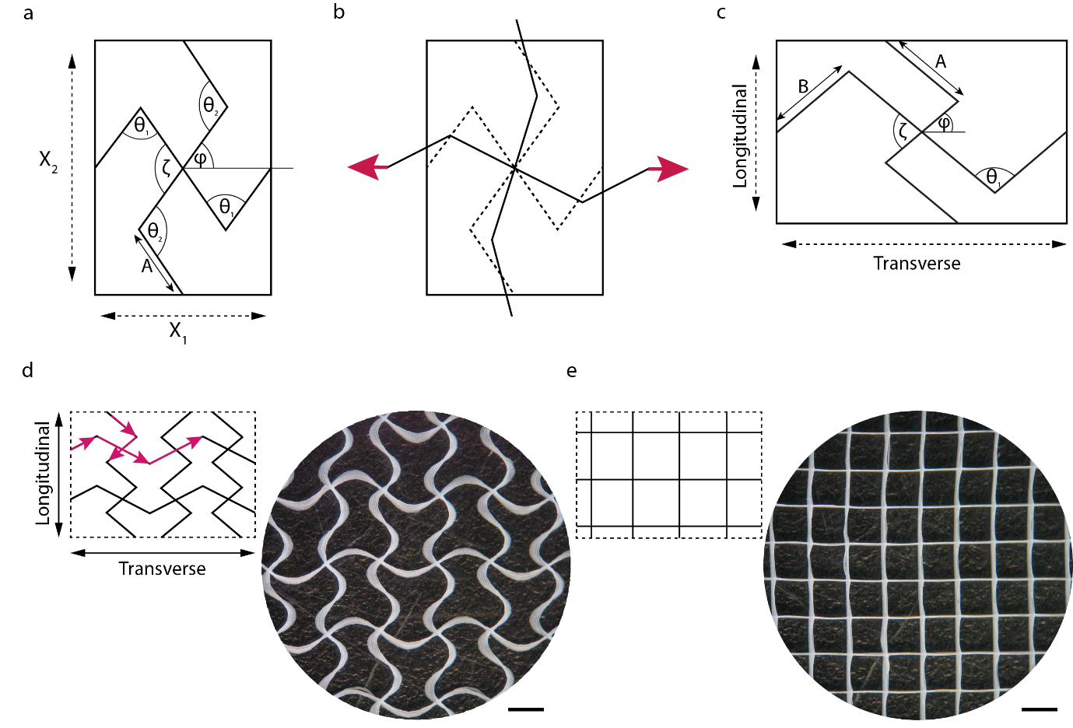

Figure 1. The missing-rib model and the fabrication of square and auxetic patches via MEW. a, Missing-rib unit cell of Smith et al.^{[34]}. b, Unit cell shown following a hinging deformation upon strain. Unit cell shown at two instants, the initial undeformed configuration (dotted line) and deformed configuration (solid line), strain indicated by arrows; the joints with angle θ are spring hinges. c, Missing-rib geometry for an anisotropic behavior where A is the longitudinal rib length, and B the transversal rib length. d, Design of the missing-rib unit cell tessellated into an auxetic pattern and stereo-image of the manufactured melt electrowritten patch; geometric parameters are ζ = 4π/9 (80°), φ = 2π/9 (40°), θ, A, B (2B is the length of the full rib). Arrows indicate the writing trajectory. Scale bar, 2 mm. e, Design of the square pattern tessellated into a pattern and stereo-image of the manufactured melt electrowritten patch. Scale bars, 2 mm.

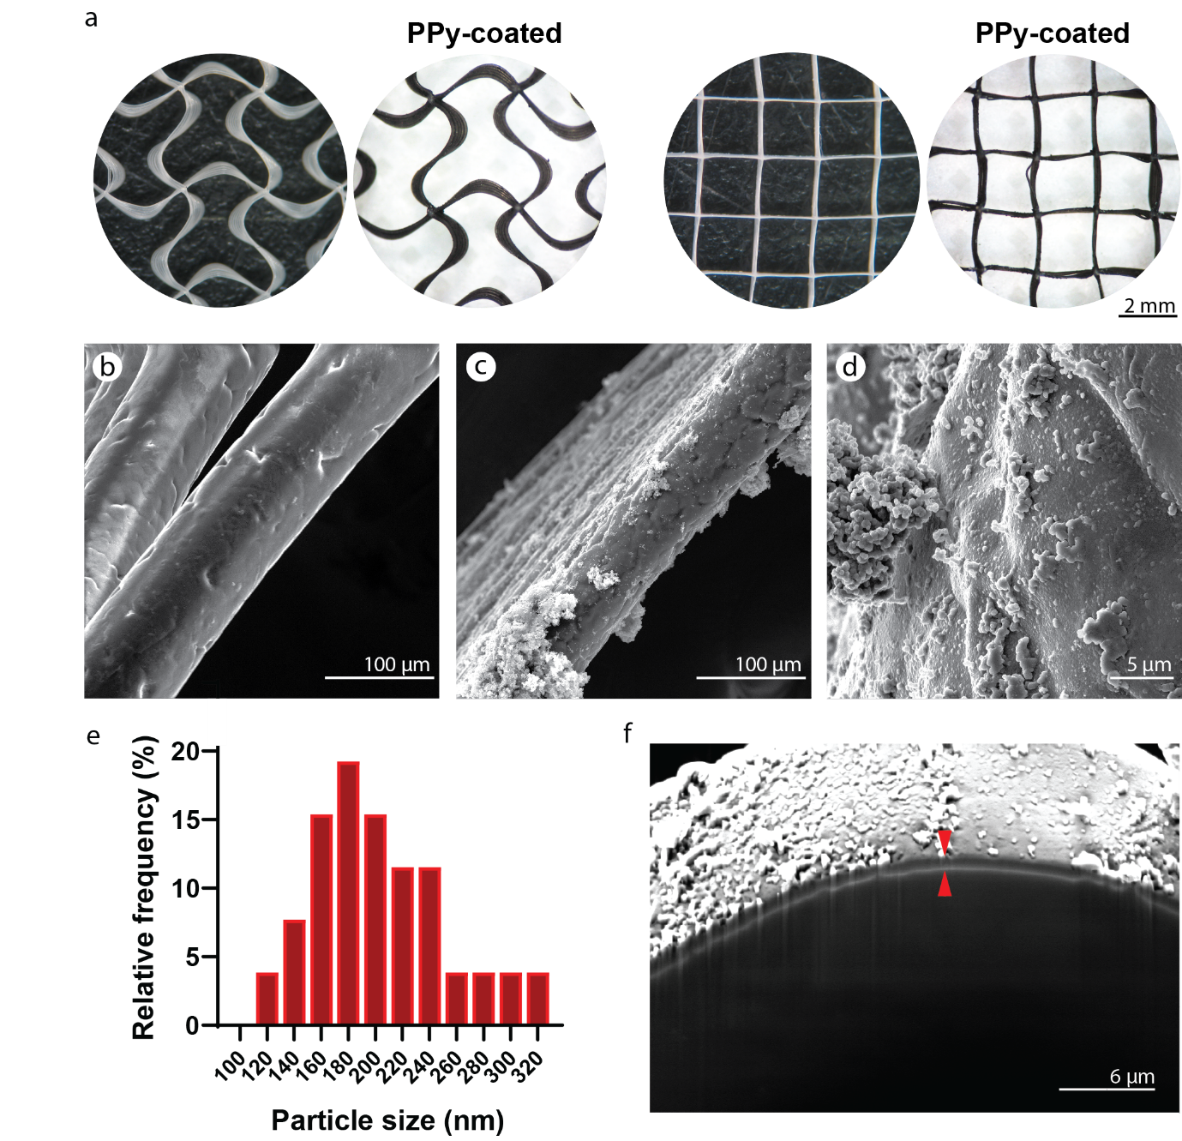
Figure 2. Polymerization of Py to create electroconductive patches. a, Stereo-images of uncoated and PPy-coated auxetic and square patches. Scale bars, 2 mm. b, SEM image of bare PCL fibers before coating (from a square patch). Scale bar, 100 μm. c, SEM image of PPy-coated fibers (square patch). Scale bar, 100 μm. d, Higher magnification SEM image of the PPy-coating particles. Scale bar, 5 μm. e, PPy particle size distribution in the coated fibers. f, SEM image of a focused ion beam (FIB)-milled cross-section of a PPy-coated fiber. Arrows indicate the thickness of the coating layer. Scale bar, 6 µm.

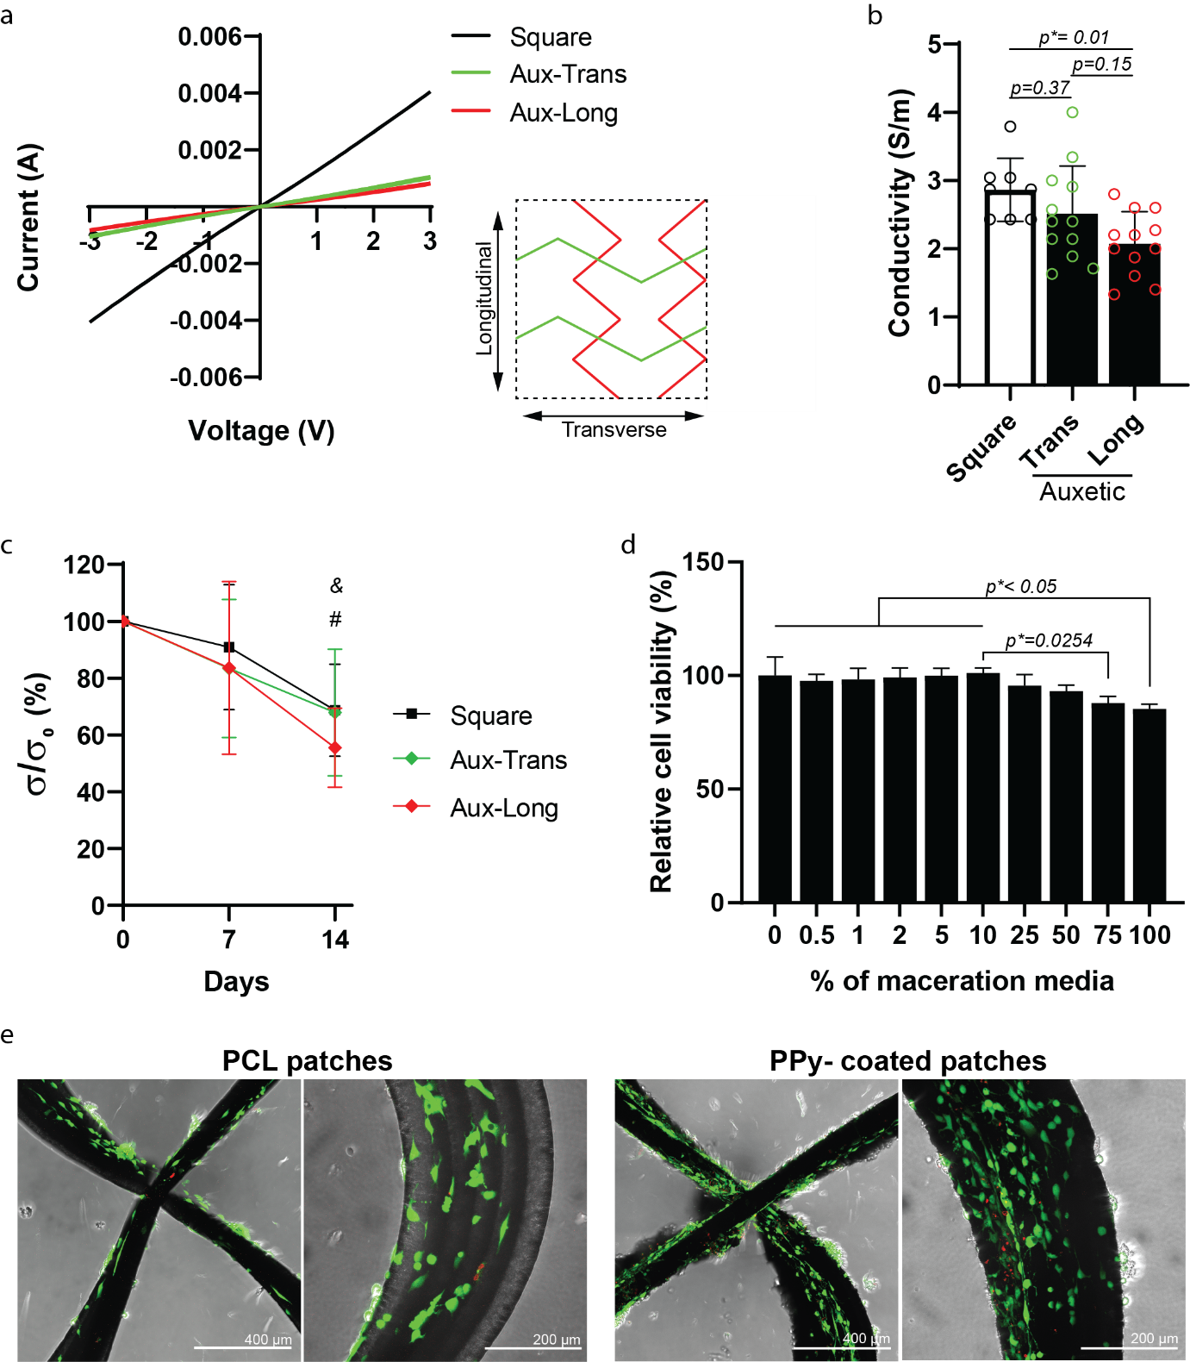
Figure 3. Electroconductivity of the PPy-coated patches. a, I/V curve characteristics of square and auxetic geometries in the transverse and longitudinal directions. b, Electroconductivity in S m⁻¹. Error bars, mean ± s.d., one-way ANOVA (p < 0.05) with Tukey’s multiple comparisons tests (N = 8–12 patches); p*, Tukey’s adjusted p value. c, Electroconductivity decay over time. #, denotes significance of aux-trans versus all groups at day 0, p ≤ 0.05; &, denotes significance of aux-long versus all groups at day 0 and day 7, p ≤ 0.05. Error bars, mean ± s.d., two-way ANOVA (p < 0.05) with Tukey’s multiple comparisons tests (N = 8–12 patches); p*, Tukey's adjusted p value. d, Cytocompatibility of PPy-coated patches with human MSCs. Data is normalized to hMSCs cultured with culture media supplemented with 0% (v/v) maceration media (control). Error bars, mean ± s.d., one-way ANOVA (p < 0.05) with Tukey’s multiple comparisons tests (N = 4 patches, n = 3); p*, Tukey’s adjusted p value. e, Live/dead staining. Calcein AM/EthD-1 cell viability staining of neonatal cardiac fibroblasts 48 hours after seeding onto the patches (green: alive, red: dead). Scale bars, 400 µm and 200 µm.

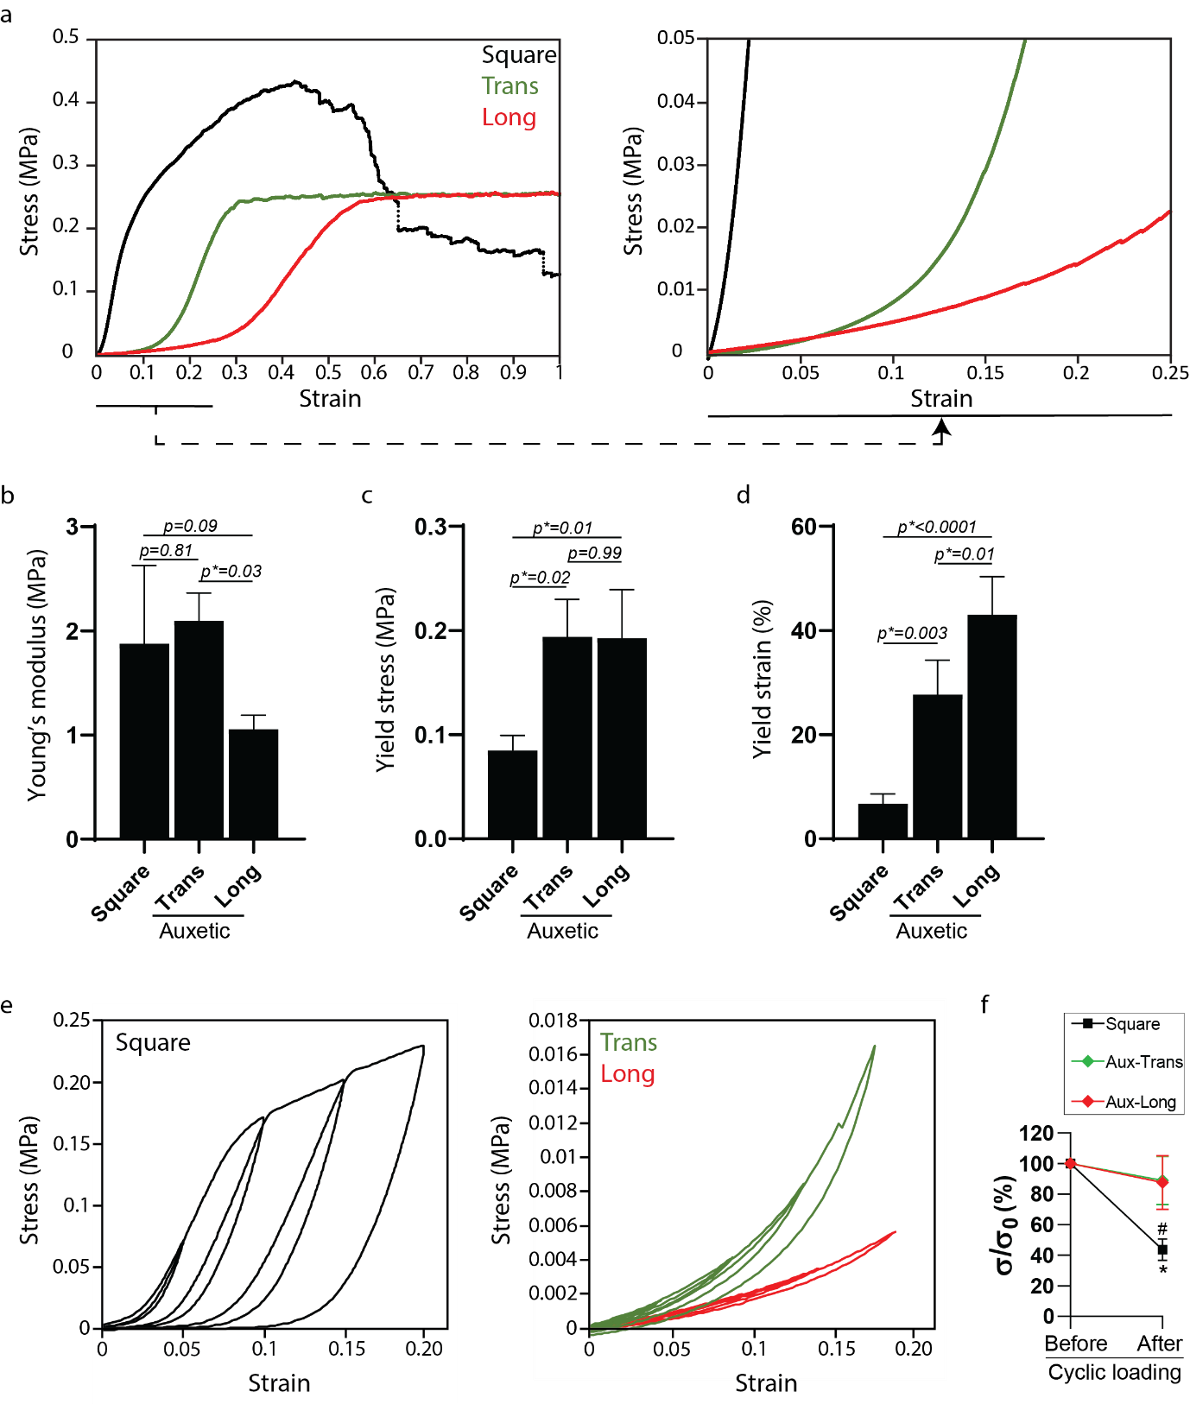
Figure 4. Mechanical properties of the square and the auxetic patches coated with PPy. a, Representative stress-strain curves of square and auxetic specimens; right panel shows stress-strain curves within physiologic regime^{[59]}. b, Young’s modulus. c, Yield stress. d, Yield strain. Error bars, mean ± s.d., one-way ANOVA (p < 0.05) with Tukey’s multiple comparisons tests (N = 4); p*, Tukey’s adjusted p value. e, Cyclic loading in 5% increments until ɛ = 20%. f, Electroconductivity before and after performing the cyclic loading regime in (e). #, denotes significance versus values before the cyclic loading, p= 0.0001. Error bars, mean ± s.d., two-way ANOVA (p < 0.05) with Tukey’s multiple comparisons tests. *, denotes significance versus aux-trans and aux-long, p < 0.005. Error bars, mean ± s.d., one-way ANOVA (p < 0.05) with Tukey’s multiple comparisons tests.

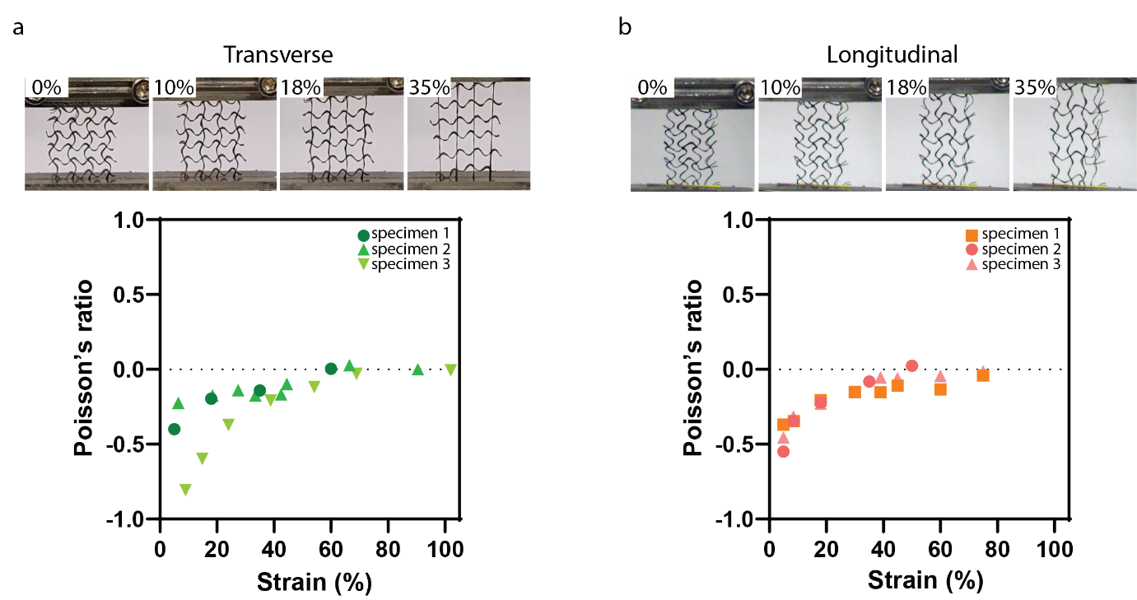
Figure 5. Strain-dependent Poisson’s ratio of the auxetic patch. a, Auxetic patch tested in the transverse direction (top) and Poisson’s ratio (bottom). b, Auxetic patch tested in the longitudinal direction (top) and Poisson’s ratio (bottom). The Poisson’s ratio remains negative until ε = 40% in the transverse direction and until ε = 60% in the longitudinal direction.

Table 1 Geometrical parameters and experimental values of the square design.^{a)}
 | A [mm] | Interfiber space [mm²]
Design | 2 | 4
Experimental | 1.84 ± 0.1 | 3.49 ± 0.06
^{a)} Data is presented as mean ± s.d.

Table 2 Geometrical parameters and experimental values of the missing-rib auxetic design.^{a)}
 | A [mm] | B [mm] | β [°] | φ [°] | E_{T}/E_{L} | Interfiber space [mm²]
Design | 3 | 2 | 80 | 40 | 2.017 | 10.5
Experimental | 2.23 ± 0.02 | 1.98 ± 0.05 | 77.82 ± 0.7 | 37.1 ± 0.9 | 2.361 | 7.97 ± 0.06
^{a)} Data is presented as mean ± s.d.
ToC text: An auxetic patch that matches the mechanical properties of the human myocardium is fabricated by melt electrospinning writing. The auxetic design was tuned to reflect the mechanical anisotropy of the myocardium. The patches coated with polypyrrole provide electrical conductivity while maintaining cell cytocompatibility. The findings presented here may lead to improved biomaterial designs for cardiac patches.

Keyword cardiac patches

D. O., M. S., G. H., M. G. M.*

Electroconductive Melt Electrowritten Patches Match the Mechanical Anisotropy of Human Myocardium

ToC figure
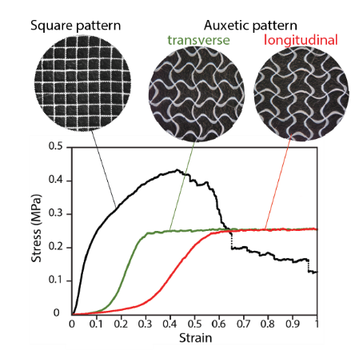

Copyright WILEY-VCH Verlag GmbH & Co. KGaA, 69469 Weinheim, Germany, 2018.

Supporting Information

Electroconductive Melt Electrowritten Patches Matching the Mechanical Anisotropy of Human Myocardium

Dinorath Olvera, Mina Sohrabi, Gillian Hendy, Michael G. Monaghan*

Figure S1. In situ chemical oxidative polymerization of Py on PCL fibers in the presence of SDBS and FeCl₃.
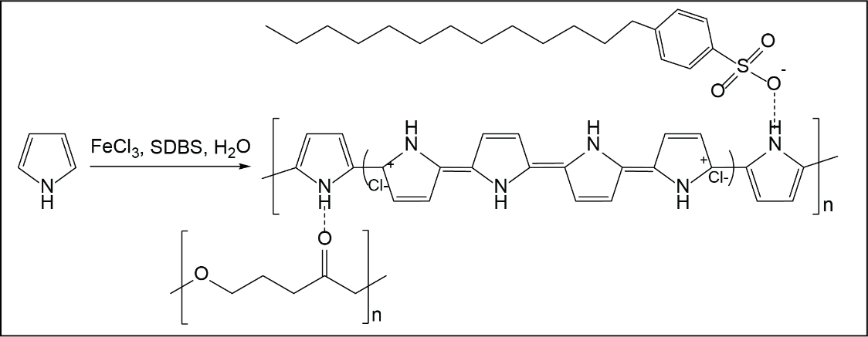

Figure S2. EDX spectra of neat PCL melt electrowritten fibers. Oxygen and carbon, and small amounts of silicon were detected in PCL fibers by EDX analysis.
Region 1
Region 2

100 µm

Region 1
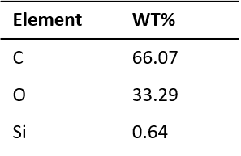
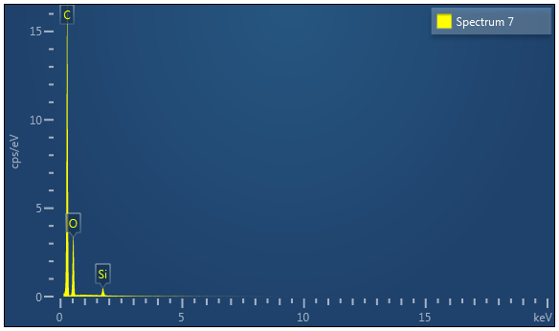

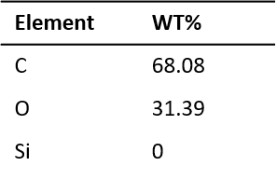
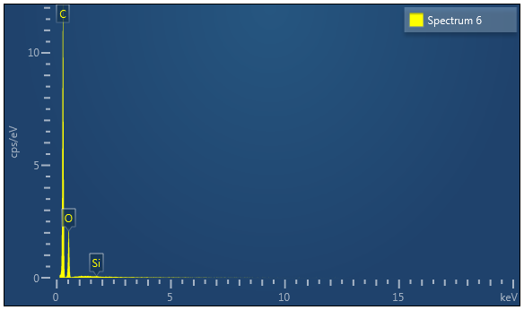
\
Region 2

Figure S3. EDX spectra of PPy-coated PCL melt electrowritten fibers. Oxygen, carbon, nitrogen, sulphur, Fe and Cl were detected in PPy-coated PCL fibers by EDX analysis.
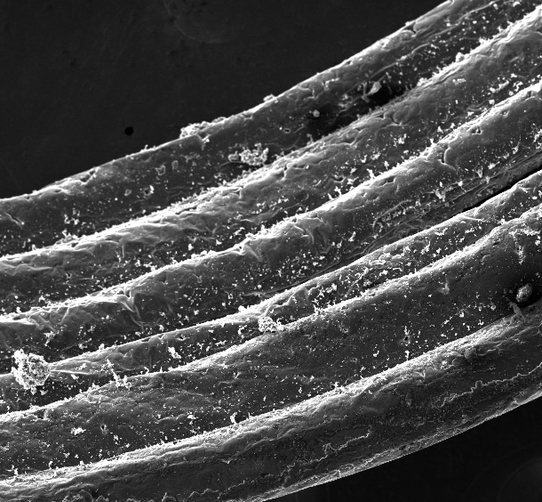
Region 2
Region 1
200 µm
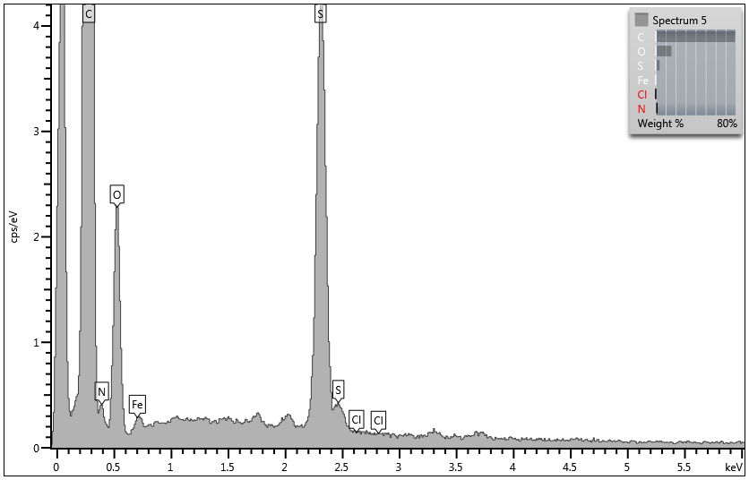
Region 1
Element | WT%
C | 73.81
N | 0.00
O | 23.50
S | 2.21
Cl | 0.00
Fe | 0.47

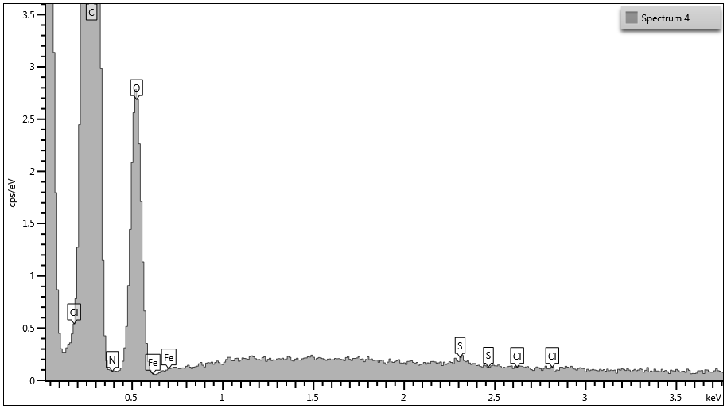
Region 2
Element | WT%
C | 70.96
N | 0.00
O | 28.82
S | 0.22
Cl | 0.00
Fe | 0.00
Figure S4. Mechanical properties of the square and the auxetic uncoated patches. a, Representative stress-strain curves of square and auxetic specimens; right panel shows stress-strain curves within physiologic regime. b, Young’s modulus. c, Yield stress. d, Yield strain. Error bars, mean ± s.d., one-way ANOVA (p < 0.05) with Tukey’s multiple comparisons tests (N = 4); p*, Tukey’s adjusted p value. e, Cyclic loading in 5% increments until ɛ = 20%.
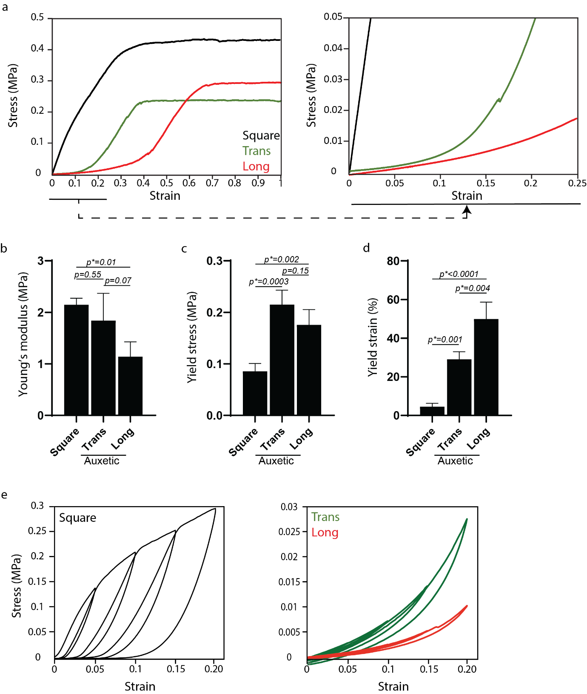

Video S1. Ex vivo electrical tissue conduction test. Freshly isolated skeletal muscles (rat vastus lateralis muscles) spaced apart by a 2 mm thick polydimethylsiloxane wall (2.5 cm high) and bridged with the PPy-coated patch or with the insulating PCL patch. A positive electrode was placed in one chamber and the earthed electrode in the second chamber and a 100-mA current was applied.

