Quantum Leaps for Deaf Studies in Ireland

The Centre for Deaf Studies, Trinity College Dublin, is delighted to announce the launch of a NEW four year Bachelor in Deaf Studies Programme. This full-time programme leads to a level 8 qualification in the National Framework of Qualifications and is accredited by Trinity College Dublin. Years 1 and 2 of the programme offer a solid basis in Deaf Studies and language studies. Students take some courses alongside students from across the College as part of the Broad Curriculum as well as core courses in Irish Sign Language over the four years of the degree. The programme leads to specialist options in ISL/English interpreting, ISL teaching or Deaf Studies in years 3 and 4 of the degree. This degree programme brings Ireland in line with best practice internationally and we are delighted to offer students in the last two years of the programme the option of studying abroad with one of our Erasmus partners, for example, the Humak Institute in Finland.

The first cohort of students arrived at CDS in September and are now hard at work to meet the challenges of a programme delivered mainly in Irish Sign Language by Deaf and hearing lecturers. Their pathway to an honours degree will see them developed ISL skills to a very high degree: we offer some of the highest number of hours of sign language input in our programme in comparison to our EU counterparts and we are convinced this makes a difference in terms of graduate competence. In total, one quarter of credits accrued by students for courses taken across the four years of the degree programme are given over to ISL teaching. Indeed, in the final two years of the programme, one third of teaching is ISL related, one third involves placements with relevant bodies or organisations in Ireland or abroad and one third is given over to subject specialism (e.g. interpreting skill development).

While we are very proud of the success in getting the Bachelor in Deaf Studies up and running, we must not overlook the success of the CDS Diploma progrmmes. External evaluators of our programmes have suggested that the level and quality of graduates in the 2 year CDS programmes are on par with graduates of 4 year programmes in other parts of Europe. The quality of content of the diploma programmes is an inherent part of the reason why these have been mapped as Level 7 qualifications in the National Framework of Qualifications. Indeed, the quality of graduates of the CDS Diploma programmes is evident if we assess what they have gone on to do having left CDS: graduates have completed undergraduate and postgraduate degrees in a range of subjects such as anthropology, education, cultural studies, law, linguistics and equality studies. Some graduates have been awarded prestigious Fulbright Scholarships to the USA while others have continued to work with the Deaf community in a range of capacities including as interpreters, resource or development officers with Deaf organisations, as teachers or special needs assistants to deaf children in mainstream, PHU and special schools. All told, they have made a difference and want to make a difference. Because so many of our Diploma students have been mature students, we wanted to ensure that the implementation of a degree programme would not deter mature candidates as we move forward. For this reason, 25% of places are held over for mature applicants (including deaf and hard of hearing students). For Trinity, a mature student is someone who is age 23 years or over in the year of entry to the programme. For all candidates (mature or school leaver), application must be made through the CAO before the 1st of February in the year of entry. Students should also bear in mind that it is possible to step out of the programme after 2 years with a Diploma in Deaf Studies. For those who already have a Diploma from the Centre, it may be possible to seek entry to year 3 of the degree programme when it comes on line in 2011-12. Interested candidates should contact the Centre well in advance as there will only be 5 places offered to returning students in each year 3 cohort.

CDS also engages in a range of research and development work. For example, each member of staff engages in individual research programmes as well as in projects that the Centre is awarded. For example, CDS are currently actively engaged in the European Commission funded D-Signs project, led by Bristol University and with partners from Wales (British Deaf Association), Greece (Systema Technologies), Cyprus (University of Nicosia), and the Czech Republic (Charles University) to develop an online learning environment for teaching the signed languages of the partner countries to public service workers under the Leonardo da Vinci Programme. The curriculum is aligned to the Council of Europe’s Common European Framework of Reference for Languages and aims to support early language learning for specialist staff, for example, the Gardai. Details of the project can be seen at: http://www.dsigns-online.eu/ We are currently half way through this project and in 2010 we expect to launch sample ISL content on this site. Ms. Carmel Grehan is the Irish coordinator of this project.

Another Leonardo da Vinci funded project that the Centre is engaged with is SIGNALL II. Led by Interesource Group (Ireland) Limited, other partners include the Irish Deaf Society, the Finnish Association of the Deaf (Finland), the University of Sussex (UK), Grant Advisor (Czech Republic) and FRP (Poland). This exciting project is nearing wrap-up stage and takes a course called Perspectives on Deafness, offered by the Centre for Deaf Studies and localizes it for roll-out in the partner countries. Content is offered multi-modally (i.e. with text and signed content) in an online learning environment and students can manage their learning effectively in any of a range of languages – signed (with voice-overs) and written. The content is enhanced significantly by the fact that we have undertaken a research project to provide us with a snapshot of attitudes to sign languages in each of the five partner countries – this will provide an update on the 1997 and 2001 reviews undertaken for the European Union of the Deaf, and crucially, offers the first insights into attitudes to sign languages in Poland and the Czech Republic. The online content is further supported by what seems to be the first text book on Deaf Studies taken from a Euro-centric viewpoint. This project is endorsed by the President of the World Federation of the Deaf and will form part of the offerings on the new Bachelor in Deaf Studies programme. See www.signallproject.eu for further details.

CDS were also successful in securing coveted Higher Education Authority funding for a Strategic Innovation Funded project (Cycle II) (SIF) in partnership with the Institute of Technology, Blanchardstown (ITB) and in collaboration with NUI Cork, the Tipperary Institute and the Limerick Institute of Technology. This is our SIF Deaf Studies in Ireland project. However, given significant funding cuts, the extensive roll-out of our Bachelor programme had to be put on hold and instead, CDS with ITB are working on creating the technical platform to roll out online learning in a manner that allows for sign language content to be made more readily available in online academic contexts. Dr. Markus Hoffman (ITB) is spearheading technical work on this and by January 2010 we aim to have a cutting edge platform for delivery of our Bachelor programme. Also linked to the SIF Deaf Studies in Ireland project, we have recruited two funded PhD students – Nora Bjork Thorvaldsdottir (Iceland) and Nora Ungar (Hungary) (both have strong links with their native Deaf communities) to work on aspects of linguistics and sociolinguistics in an Irish context over the coming three years. Both are now settling into CDS and working hard at developing their ISL skills! Other staff recruited to work at CDS on the SIF project and implementation of the Bachelor programme are Mr. John Bosco Conama (our Bachelor Programme coordinator), Ms. Laura Sadlier and Ms. Teresa Lynch.

Some other successes in 2008 and 2009 for the Centre include the receipt of the Language Label Award from Léargas to the SIGNALL project along with the selection of Dr. Lorraine Leeson (CDS) as a Language Ambassador. Both Dr. Leeson and Mr. Haaris Sheikh (IRG) represented Ireland in Tallinn at a conference on the Language Label Award in February 2009. Dr. Leeson was elected as a Fellow of Trinity College Dublin for her research work on ISL to date in May 2009. Scholarship or research achievement of a high order is the primary qualification for Fellowship, coupled with evidence of the candidate's contribution to the academic life of the College and an effective record in teaching.

If you would like to find out more about the Bachelor programme, come and meet us at the Trinity College Open Day on Wednesday 9 December 2009 from 9am to 3pm. See http://www.tcd.ie/business/undergraduate/open-day/ for more details. For more information about the Bachelor in Deaf Studies, see the Trintiy College Prospectus 2010 at http://www.tcd.ie/Admissions/

Mr. Markku Jokinen, President of WFD endorses the SIGNALL II project.

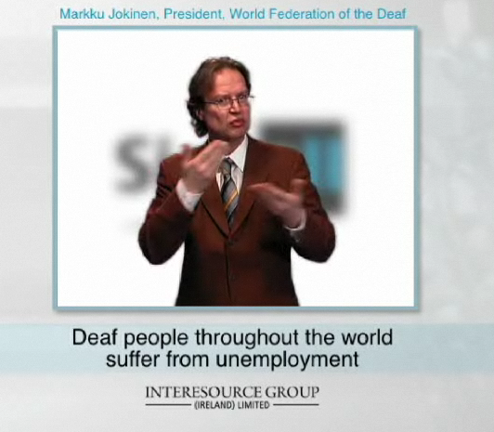

(below) Dr. Lorraine Leeson was elected a Fellow of Trinity College Dublin in 2009 for her research work on ISL to date.
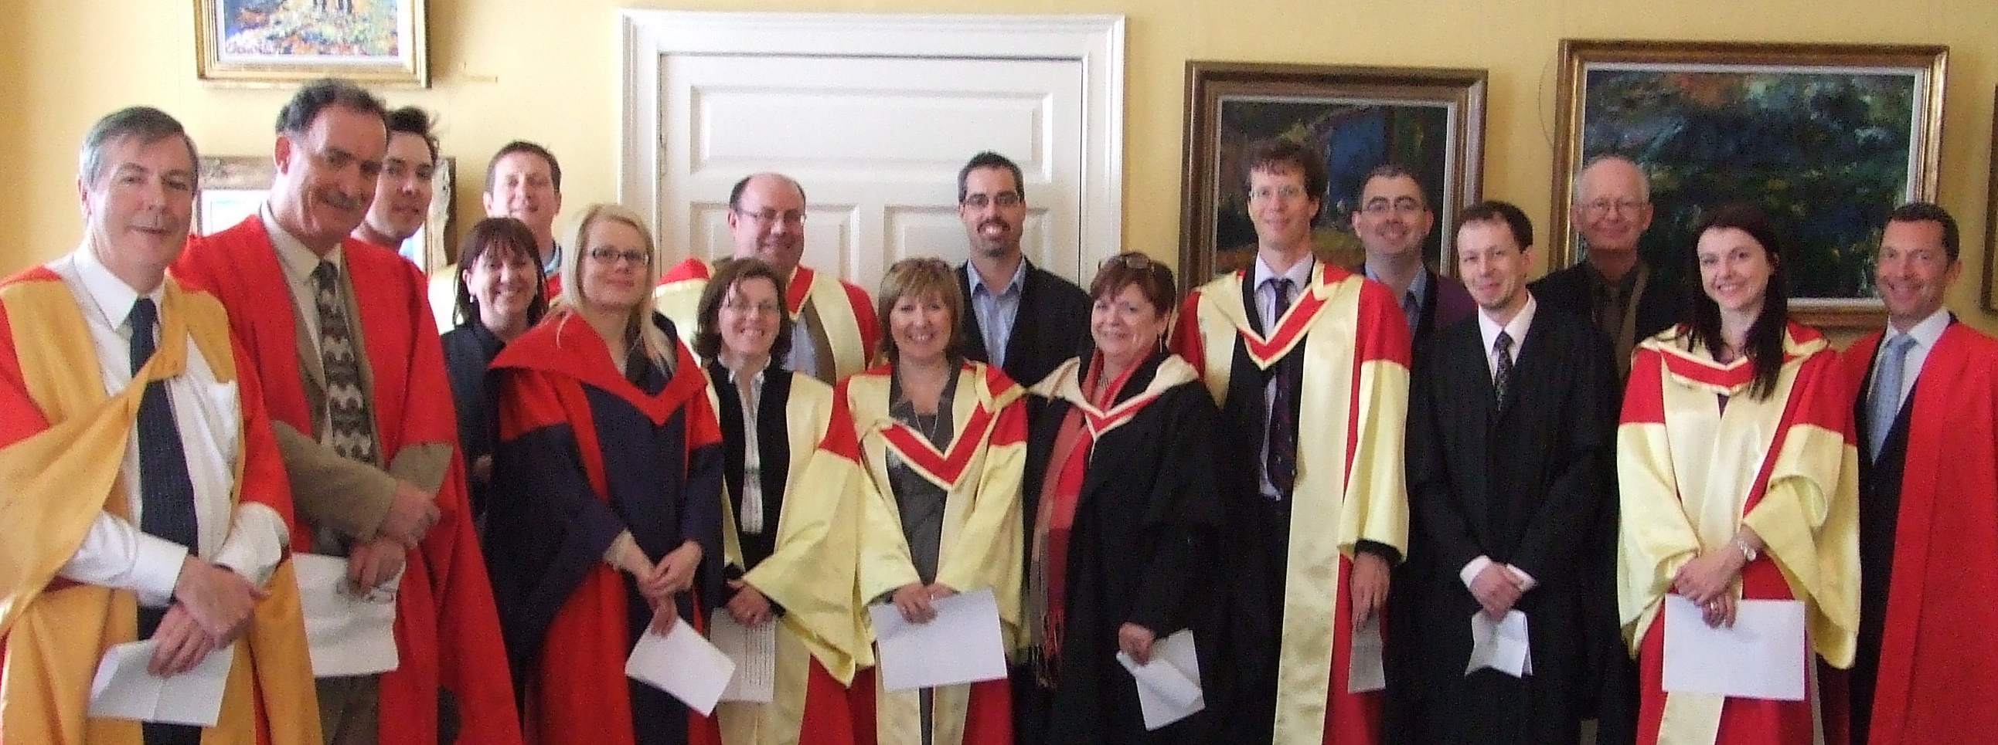

SIGNALL was awarded a Language Label Award in 2008 and Dr Lorraine Leeson was selected as a Language Ambassador by Leargas, the National Agency, for her work on Irish Sign Language. (Below: Dr. Lorraine Leeson (CDS) and Mr. Haaris Sheikh (Interesource Group (Ireland) Limited)).

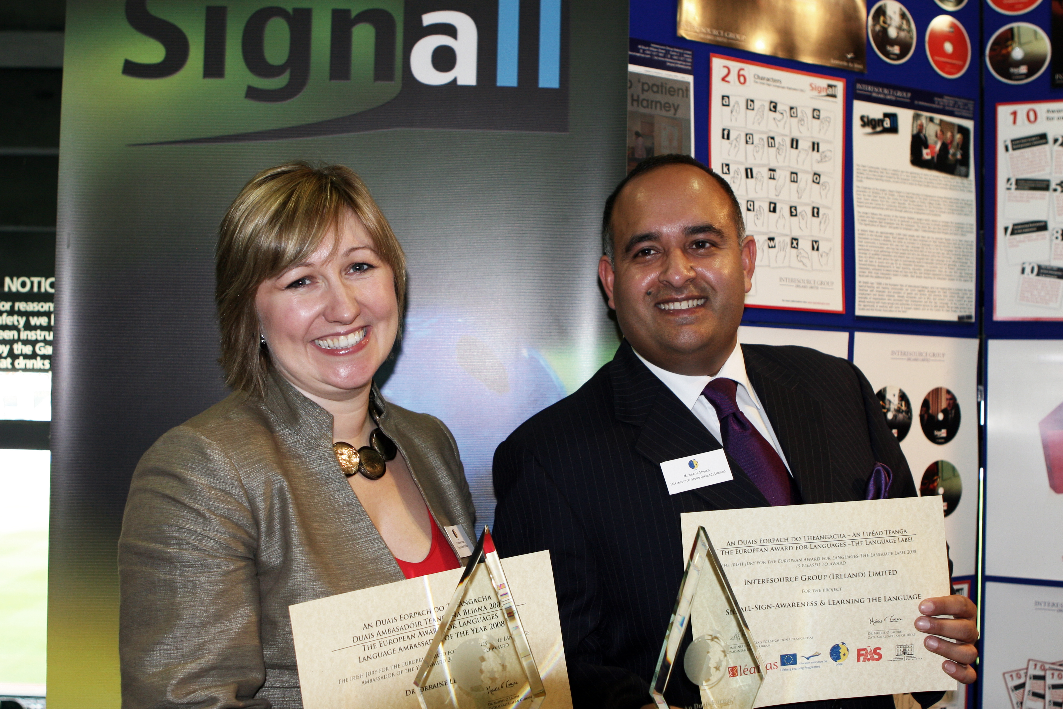

Ms. Carmel Grehan, Irish Coordinator of the D-Signs Project (below)



