Supporting Information for ZoolJLinnSoc sunbird manuscript

Supplementary Figures
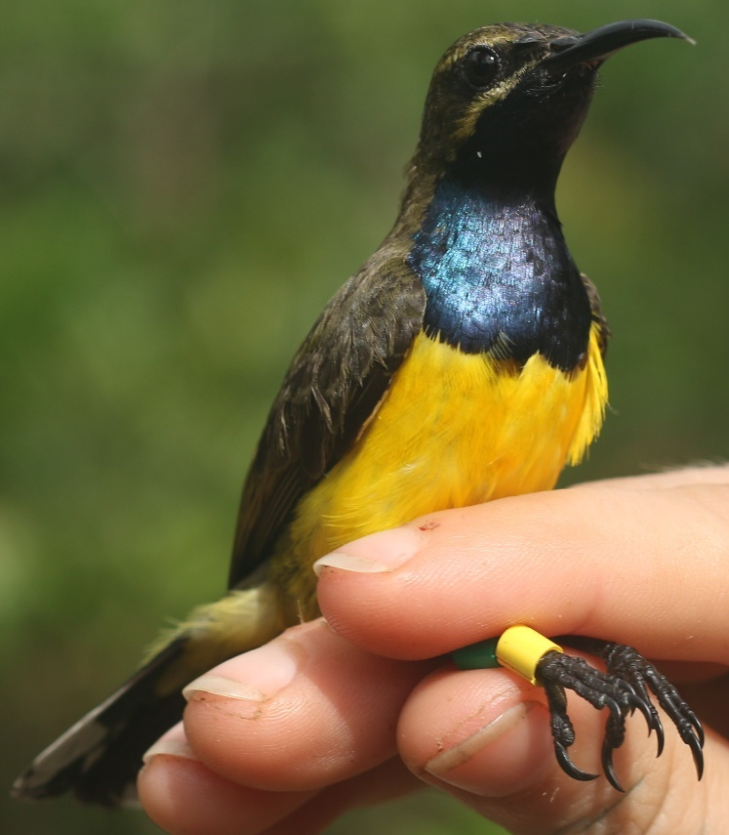
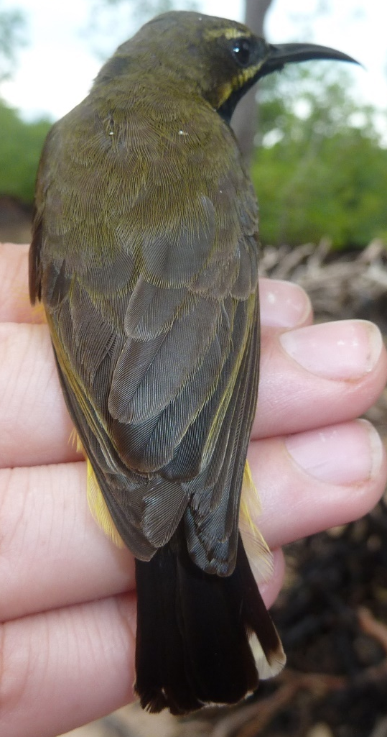
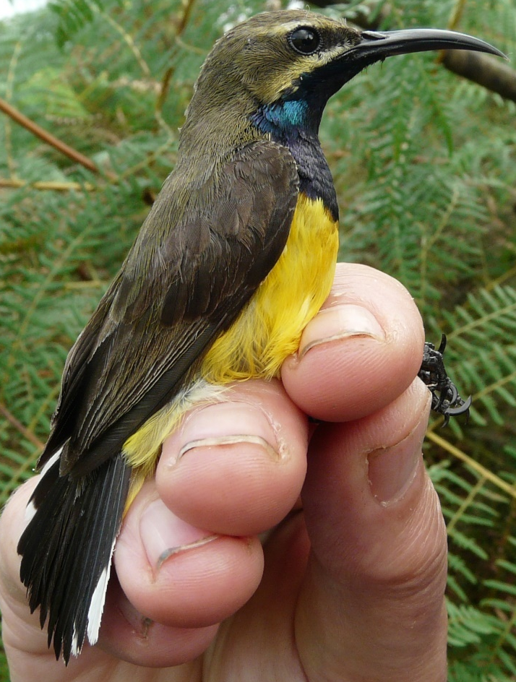
SUL2395
SUL0392

SUL2000

Figure S1: Male Olive-backed Sunbirds from Sulawesi and its land-bridge islands (“Sahul Sunbird”), photographed by the authors.

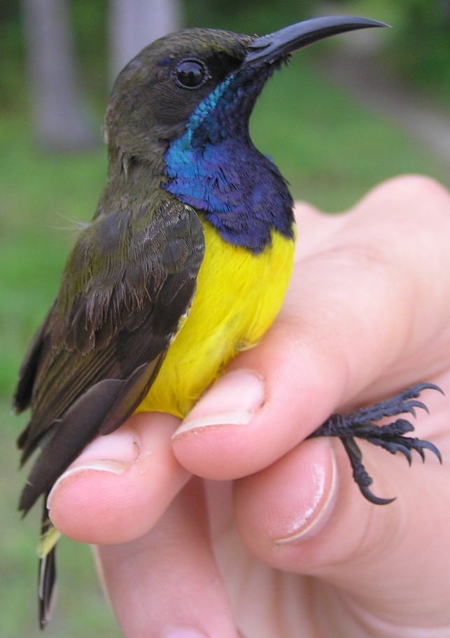
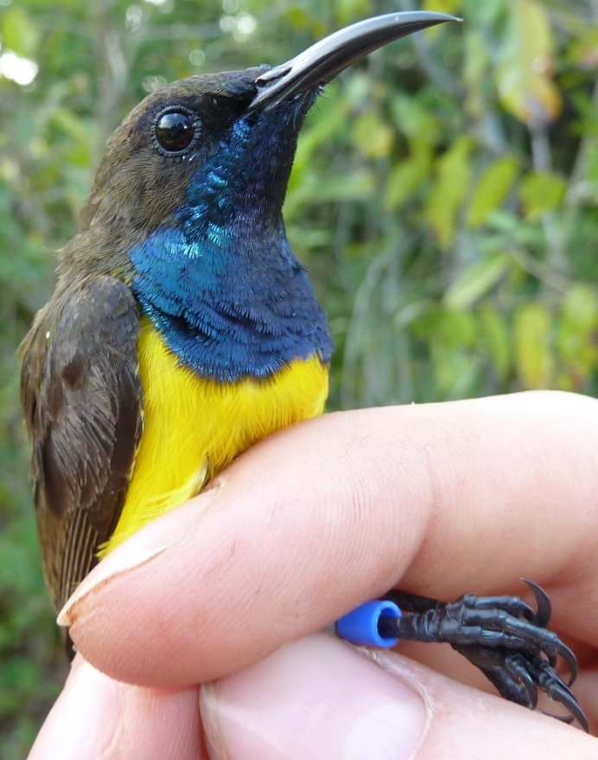
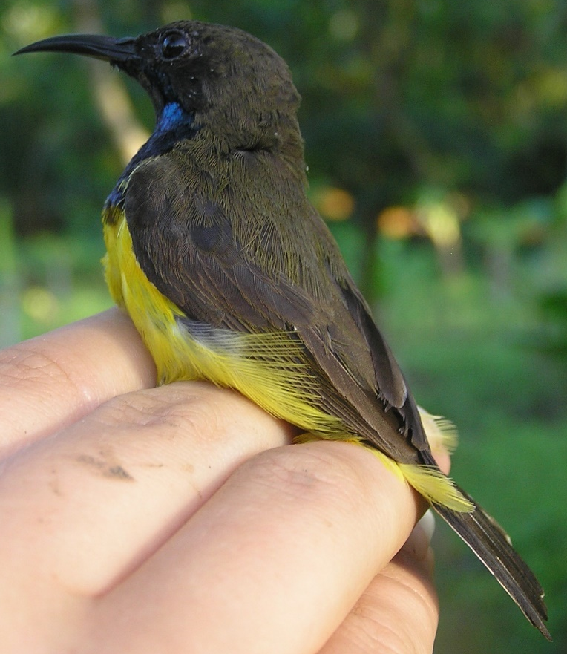
SUL1605
SUL2214

SUL1644

Figure S2: Male Olive-backed Sunbirds from the Wakatobi Islands (“Wakatobi Sunbird”), photographed by the authors.

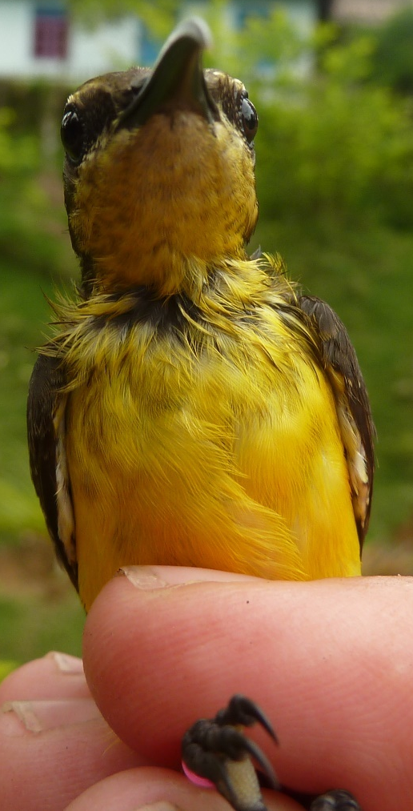
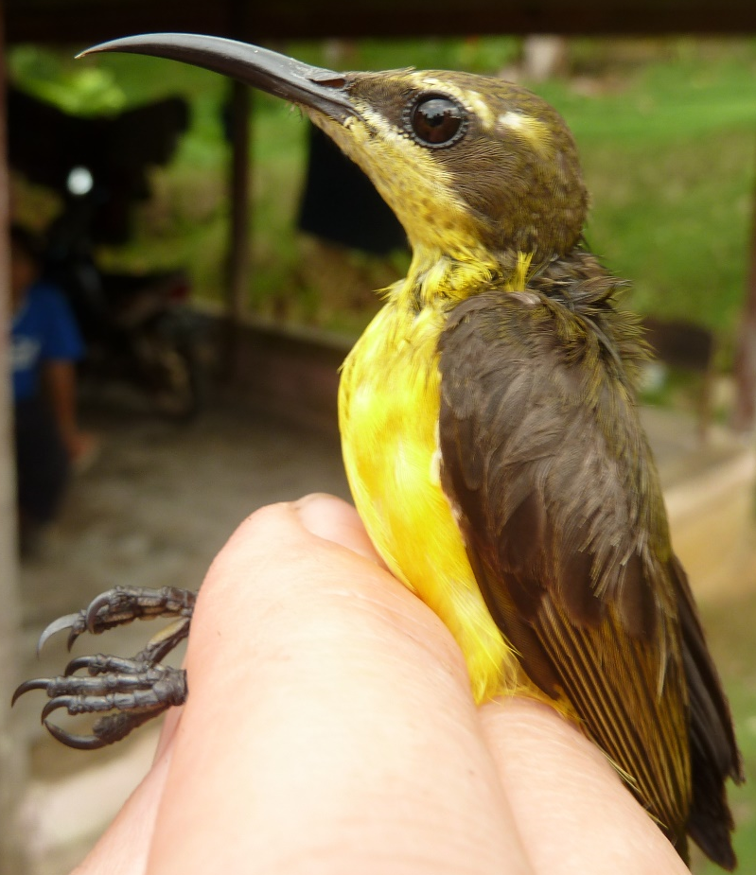
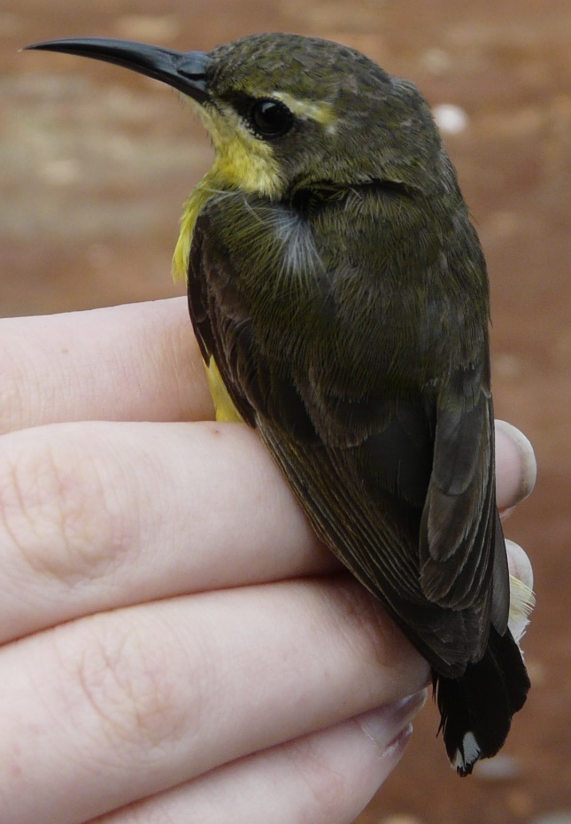
SUL1990

SUL0424
SUL1990

Figure S3: Female Olive-backed Sunbirds from Sulawesi and its land-bridge islands (“Sahul Sunbird”), photographed by the authors.

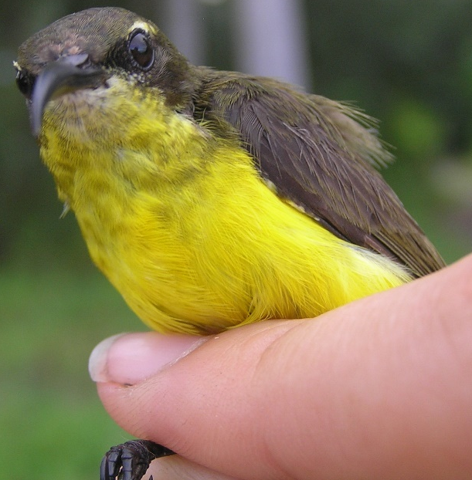
SUL1649
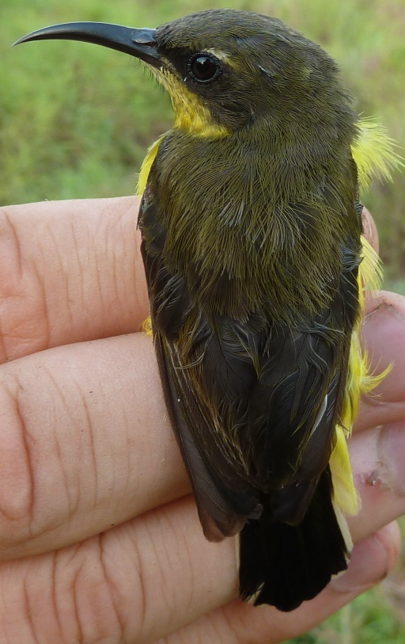
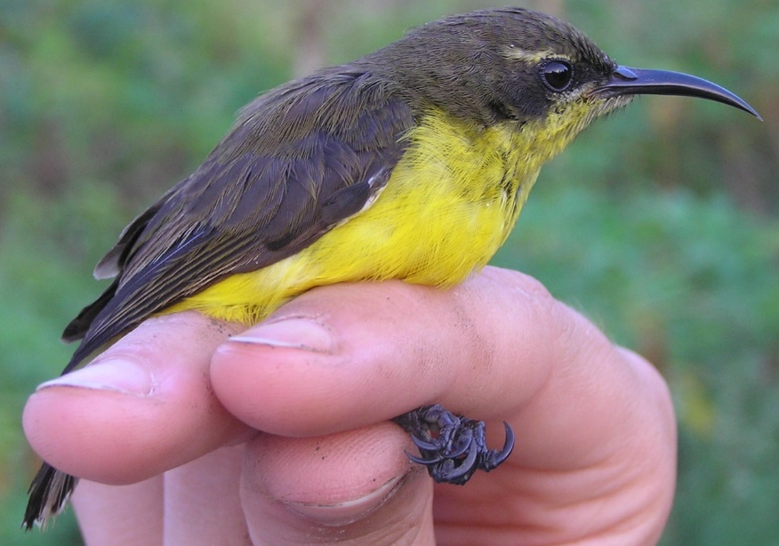
SUL1611

SUL2231

Figure S4: Female Olive-backed Sunbirds from the Wakatobi Islands (“Wakatobi Sunbird”), photographed by the authors.

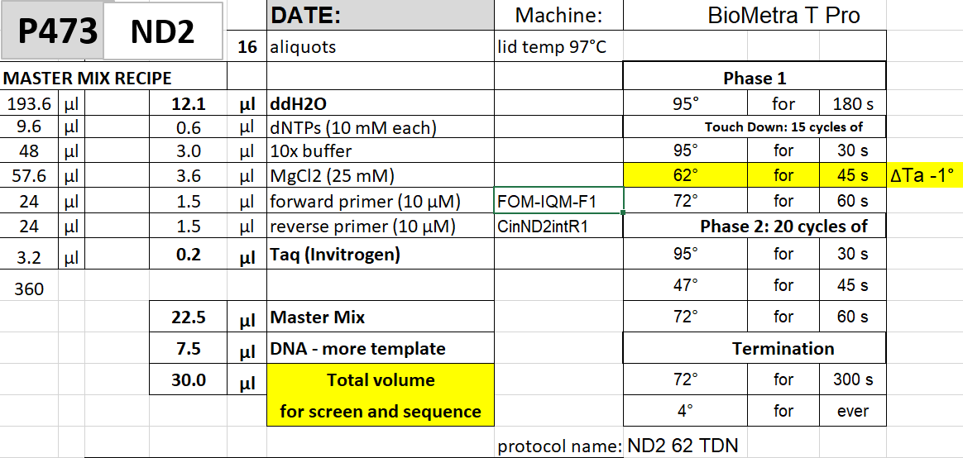

Figure S5: Example PCR protocol used in this study, showing the reagents and quantities in the master mix along with the thermal cycling program used. We used “touchdown” cycling programs to improve yield (Korbie and Mattick, 2008), starting at an annealing temperature (62°C in this example) that’s 10° above the melting temperature of the primers. The annealing temperature then drops (or “touches down”) by 1° per cycle over the following 14 cycles.

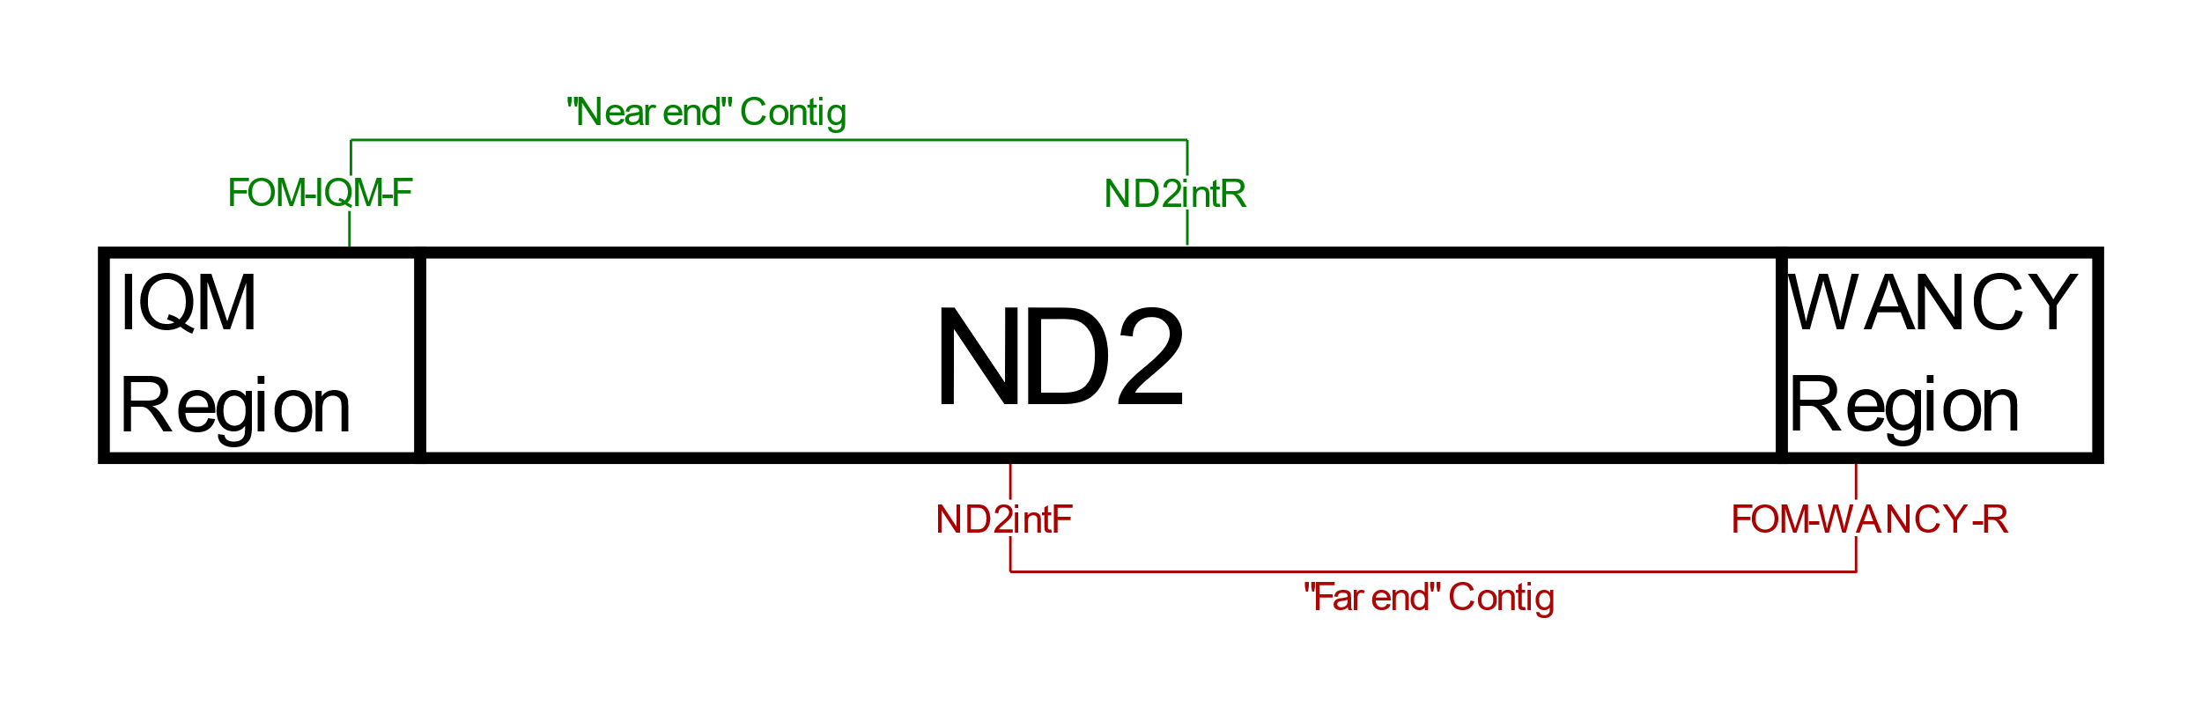

Figure S6: Diagram of the mitochondrial ND2 gene, labelled to demonstrate our sequencing technique. We used internal primers to sequence the gene in two halves, designing primers to bind to the IQM and WANCY regions and two sites in the ND2 gene. This gave two contiguous gene reads (contigs) with an area of overlap to allow them to be aligned. We used the same general external primers for all taxa and specific internal primers for each genus. More information on our primers is available in Table S2.

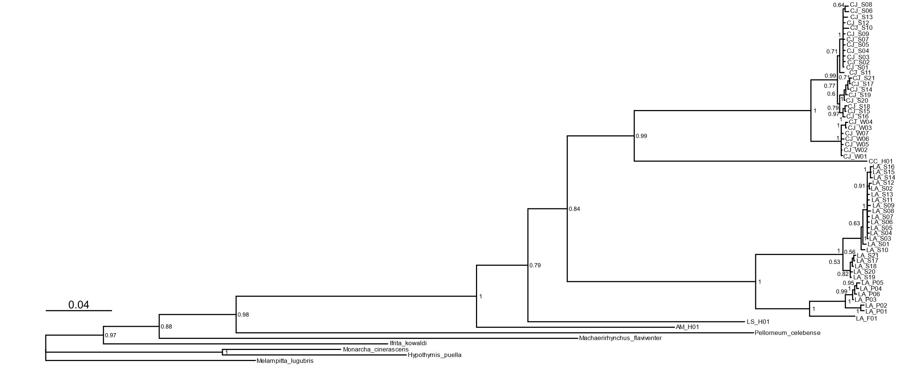

Figure S7: Full Bayesian tree on 1392bp concatenated ND2-ND3, showing all haplotypes and outgroup taxa. Nodes are labelled with Bayesian probabilities.

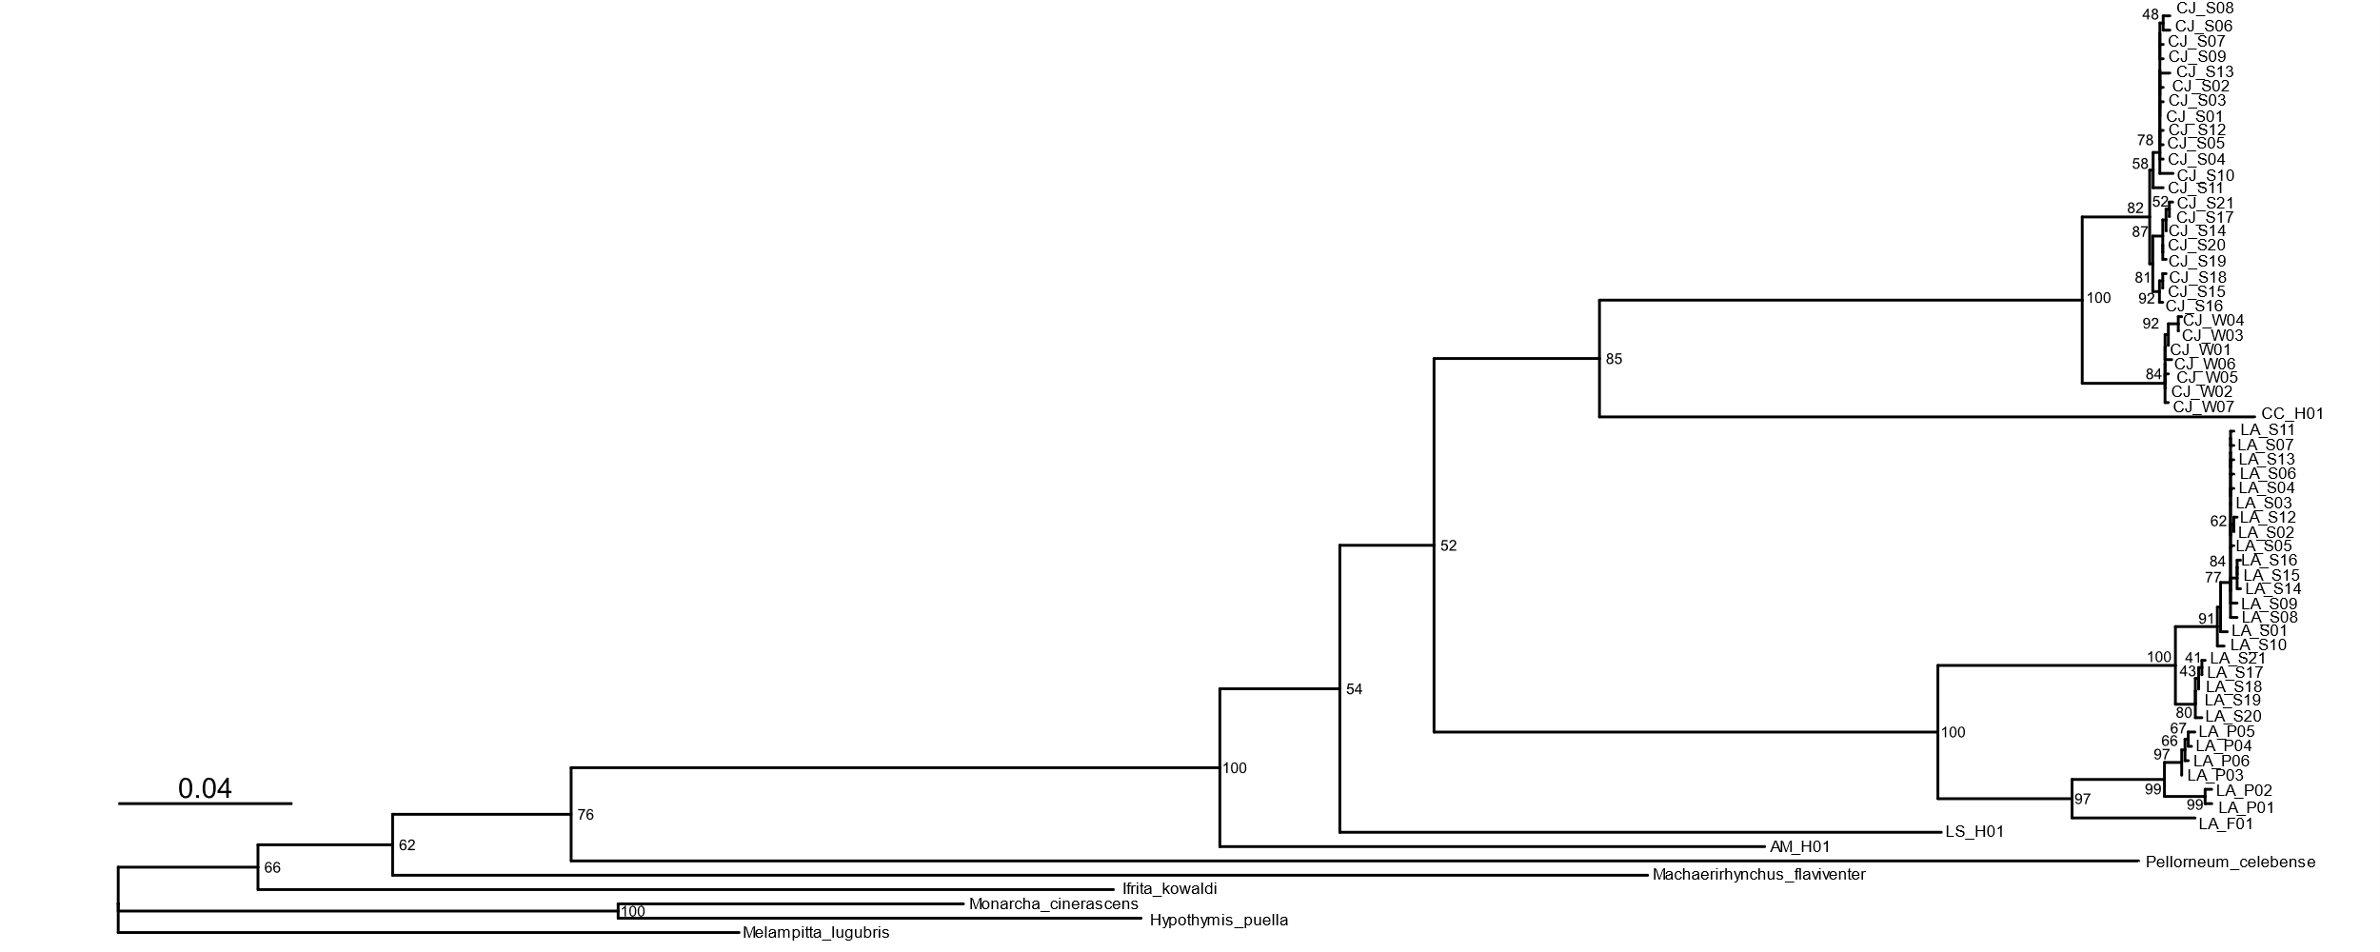

Figure S8: Full Maximum Likelihood (ML) tree on 1392bp concatenated ND2-ND3, showing all haplotypes and outgroup taxa. Nodes are labelled with bootstrap values.

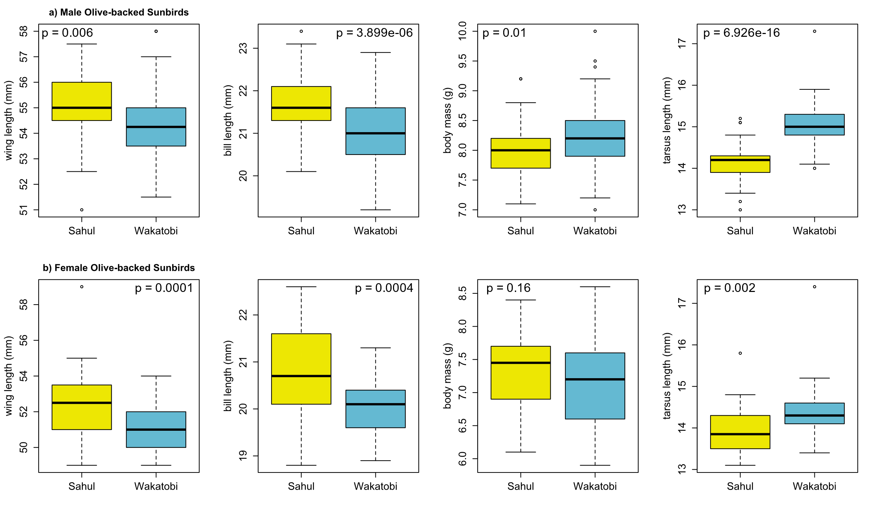

Figure S9: Boxplots of a) male and b) female Olive-backed Sunbird morphology, comparing the “Sahul Sunbird” to the “Wakatobi Sunbird”. The “Sahul Sunbird” includes the adult birds netted on Sulawesi, its land-bridge islands, and Menui, the “Wakatobi Sunbird” the adult birds netted on the Wakatobi Islands. P-values from Welch’s two-sample t-tests are reported for each comparison.

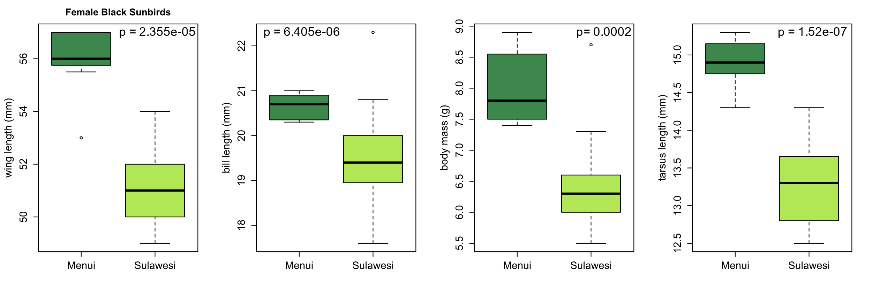

Figure S10: Boxplots of female Black Sunbird morphology, comparing the birds netted on Menui to those netted on Sulawesi and its land-bridge islands. P-values from Welch’s two-sample t-tests are reported for each comparison.

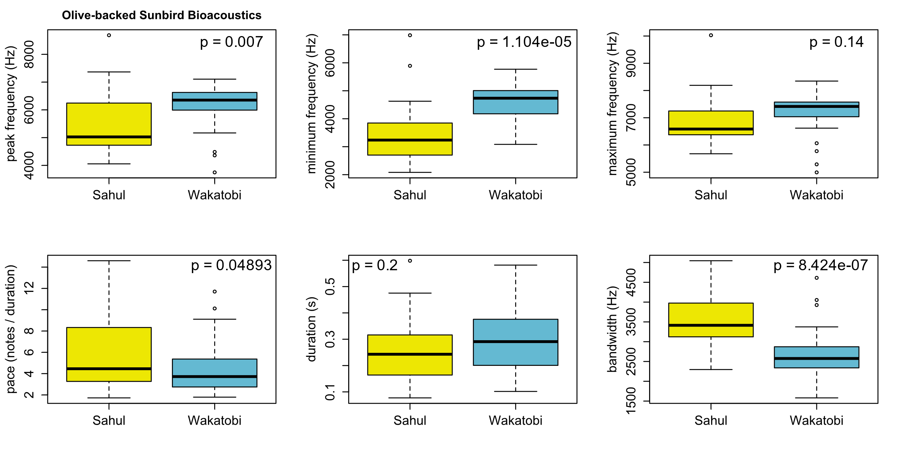

Figure S11: Boxplots of Olive-backed Sunbird bioacoustics, comparing the “Sahul Sunbird” to the “Wakatobi Sunbird”. The “Sahul Sunbird” includes the birds recorded on Sulawesi, its land-bridge islands, and Menui, the “Wakatobi Sunbird” the birds recorded on the Wakatobi Islands. P-values from Welch’s two-sample t-tests are reported for each comparison.

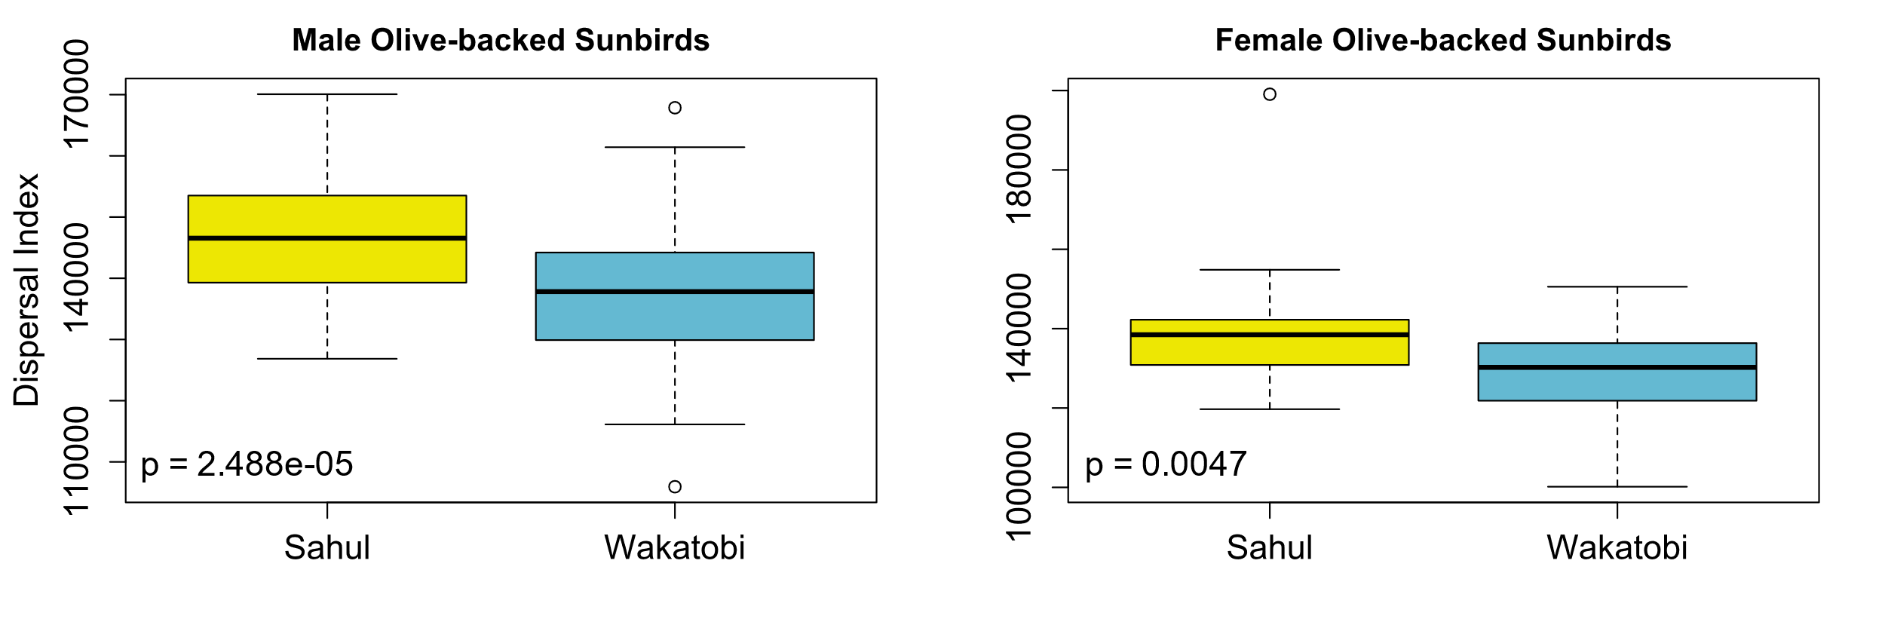

Figure S12: Boxplots of a) male and b) female Olive-backed Sunbird dispersal index, comparing the “Sahul Sunbird” to the “Wakatobi Sunbird”. The “Sahul Sunbird” includes the adult birds netted on Sulawesi, its land-bridge islands, and Menui, the “Wakatobi Sunbird” the adult birds netted on the Wakatobi Islands. P-values from Welch’s two-sample t-tests are reported for each comparison.

Supplementary Tables

Table S1: DNA samples used for phylogenetic reconstruction with full 1392bp concatenated sequences. Taxonomy (including subspecies of focal species) is according to Gill et al. (2022). Table is ordered taxonomically and then geographically, with outgroup taxa presented at the end.

Species | Subspecies | ID | ND2-ND3 haplotype | ND2 Accession | ND3 Accession | Region | Island | Locality | Collection Date | Latitude | Longitude | Source
Anthreptes malacensis | - | KUNHM 14049 | AM_H01 | KC122472 | KC122435 | Philippines | Dinagat | Loreto | 01-Aug-07 | 10.34368 | 125.6181 | Hosner et al. (2013)
Cinnyris chalybeus | - | MVZ RCKB Kirst3 | CC_H01 | KX904389 | KX904366 | Africa | South Africa | Cape Town | not provided | not provided | not provided | Bowie et al. (2016)
Cinnyris jugularis | frenatus | ANWC-B31242 | CJ_S01 | OM965843 | OM965960 | Sahul Shelf | Australia | Queensland: Haughton River | 14-May-99 | -19.4333 | 147.1167 | This Study
Cinnyris jugularis | frenatus | ANWC-B31256 | CJ_S02 | OM965844 | OM965961 | Sahul Shelf | Australia | Queensland: Haughton River | 14-May-99 | -19.3361 | 147.0975 | This Study
Cinnyris jugularis | frenatus | ANWC-B31257 | CJ_S03 | OM965845 | OM965962 | Sahul Shelf | Australia | Queensland: Haughton River | 14-May-99 | -19.3361 | 147.0975 | This Study
Cinnyris jugularis | frenatus | ANWC-B41514 | CJ_S04 | OM965846 | OM965963 | Sahul Shelf | Australia | Queensland: Killymoon Creek | 12-Oct-88 | -19.3917 | 146.9949 | This Study
Cinnyris jugularis | frenatus | ANWC-B41515 | CJ_S05 | OM965847 | OM965964 | Sahul Shelf | Australia | Queensland: Killymoon Creek | 12-Oct-88 | -19.3917 | 146.9949 | This Study
Cinnyris jugularis | frenatus | ANWC-B41523 | CJ_S01 | OM965848 | OM965965 | Sahul Shelf | Australia | Queensland: Killymoon Creek | 12-Oct-88 | -19.3917 | 146.9949 | This Study
Cinnyris jugularis | frenatus | ANWC-B43005 | CJ_S01 | OM965849 | OM965966 | Sahul Shelf | Australia | Queensland: McIlwraith Range Lowlands | 10-Aug-90 | -13.7389 | 143.4722 | This Study
Cinnyris jugularis | frenatus | ANWC-B43006 | CJ_S06 | OM965850 | OM965967 | Sahul Shelf | Australia | Queensland: McIlwraith Range Lowlands | 10-Aug-90 | -13.7389 | 143.4722 | This Study
Cinnyris jugularis | frenatus | ANWC-B43033 | CJ_S01 | OM965851 | OM965968 | Sahul Shelf | Australia | Queensland: McIlwraith Range Lowlands | 11-Aug-90 | -13.7056 | 143.5361 | This Study
Cinnyris jugularis | frenatus | ANWC-B43519 | CJ_S01 | OM965852 | OM965969 | Sahul Shelf | Australia | Queensland: Shoalwater Bay | 25-Apr-91 | -22.5083 | 150.725 | This Study
Cinnyris jugularis | frenatus | ANWC-B43521 | CJ_S07 | OM965853 | OM965970 | Sahul Shelf | Australia | Queensland: Shoalwater Bay | 27-Apr-91 | -22.6667 | 150.7917 | This Study
Cinnyris jugularis | frenatus | ANWC-B43683 | CJ_S08 | OM965854 | OM965971 | Sahul Shelf | Australia | Queensland: Shoalwater Bay | 11-Aug-91 | -22.5817 | 150.7222 | This Study
Cinnyris jugularis | frenatus | ANWC-B43742 | CJ_S07 | OM965855 | OM965972 | Sahul Shelf | Australia | Queensland: Shoalwater Bay | 16-Aug-91 | -22.6214 | 150.7728 | This Study
Cinnyris jugularis | frenatus | ANWC-B43757 | CJ_S09 | OM965856 | OM965973 | Sahul Shelf | Australia | Queensland: Shoalwater Bay | 19-Aug-91 | -22.7383 | 150.8033 | This Study
Cinnyris jugularis | frenatus | ANWC-B31315 | CJ_S01 | OM965857 | OM965974 | Sahul Shelf | Australia | Queensland: Victoria Creek | 17-May-99 | -18.6239 | 146.3292 | This Study
Cinnyris jugularis | frenatus | ANWC-B55994 | CJ_S01 | OM965858 | OM965975 | Sahul Shelf | New Guinea | Central Province: Pinu, PNG | 25-Oct-13 | -9.08646 | 146.8291 | This Study
Cinnyris jugularis | frenatus | ANWC-B57729 | CJ_S13 | OM965859 | OM965976 | Sahul Shelf | New Guinea | Northern Province: Oro Bay, PNG | 05-Jul-16 | -8.95216 | 148.5173 | This Study
Cinnyris jugularis | frenatus | ANWC-B57618 | CJ_S12 | OM965860 | OM965977 | Sahul Shelf | New Guinea | Northern Province: Popondetta, PNG | 29-Mar-16 | -8.76803 | 148.2349 | This Study
Cinnyris jugularis | frenatus | ANWC-B56335 | CJ_S10 | OM965861 | OM965978 | Sahul Shelf | New Guinea | Western Province: Bensbach, PNG | 22-Jul-14 | -8.90811 | 141.2625 | This Study
Cinnyris jugularis | frenatus | ANWC-B56395 | CJ_S11 | OM965862 | OM965979 | Sahul Shelf | New Guinea | Western Province: Bensbach, PNG | 24-Jul-14 | -8.88643 | 141.2561 | This Study
Cinnyris jugularis | infrenatus | SUL1843 | CJ_W03 | OM965863 | OM965980 | Wakatobi | Binongko | Haso, Indonesia | 06-Aug-10 | -5.91501 | 124.0409 | This Study
Cinnyris jugularis | infrenatus | SUL1844 | CJ_W03 | OM965864 | OM965981 | Wakatobi | Binongko | Haso, Indonesia | 06-Aug-10 | -5.91501 | 124.0409 | This Study
Cinnyris jugularis | infrenatus | SUL1847 | CJ_W03 | OM965865 | OM965982 | Wakatobi | Binongko | Haso, Indonesia | 06-Aug-10 | -5.91501 | 124.0409 | This Study
Cinnyris jugularis | infrenatus | SUL1848 | CJ_W03 | OM965866 | OM965983 | Wakatobi | Binongko | SakiSaki, Indonesia | 07-Aug-10 | -5.89765 | 124.0216 | This Study
Cinnyris jugularis | infrenatus | SUL1849 | CJ_W03 | OM965867 | OM965984 | Wakatobi | Binongko | SakiSaki, Indonesia | 07-Aug-10 | -5.89765 | 124.0216 | This Study
Cinnyris jugularis | infrenatus | SUL1850 | CJ_W03 | OM965868 | OM965985 | Wakatobi | Binongko | SakiSaki, Indonesia | 07-Aug-10 | -5.89765 | 124.0216 | This Study
Cinnyris jugularis | infrenatus | SUL1851 | CJ_W03 | OM965869 | OM965986 | Wakatobi | Binongko | SakiSaki, Indonesia | 07-Aug-10 | -5.89765 | 124.0216 | This Study
Cinnyris jugularis | infrenatus | SUL1648 | CJ_W03 | OM965870 | OM965987 | Wakatobi | Hoga | Genetics Lab, Indonesia | 23-Jul-10 | -5.46474 | 123.7613 | This Study
Cinnyris jugularis | infrenatus | SUL1649 | CJ_W02 | OM965871 | OM965988 | Wakatobi | Hoga | Genetics Lab, Indonesia | 23-Jul-10 | -5.46474 | 123.7613 | This Study
Cinnyris jugularis | infrenatus | SUL1650 | CJ_W02 | OM965872 | OM965989 | Wakatobi | Hoga | Genetics Lab, Indonesia | 23-Jul-10 | -5.46474 | 123.7613 | This Study
Cinnyris jugularis | infrenatus | SUL1651 | CJ_W06 | OM965873 | OM965990 | Wakatobi | Hoga | Genetics Lab, Indonesia | 23-Jul-10 | -5.46474 | 123.7613 | This Study
Cinnyris jugularis | infrenatus | SUL1657 | CJ_W02 | OM965874 | OM965991 | Wakatobi | Hoga | Genetics Lab, Indonesia | 23-Jul-10 | -5.46474 | 123.7613 | This Study
Cinnyris jugularis | infrenatus | SUL1579 | CJ_W05 | OM965875 | OM965992 | Wakatobi | Kaledupa | Ambeua, Indonesia | 17-Jul-10 | -5.49853 | 123.7563 | This Study
Cinnyris jugularis | infrenatus | SUL1629 | CJ_W02 | OM965876 | OM965993 | Wakatobi | Kaledupa | Ambeua, Indonesia | 21-Jul-10 | -5.49853 | 123.7563 | This Study
Cinnyris jugularis | infrenatus | SUL1604 | CJ_W02 | OM965877 | OM965994 | Wakatobi | Kaledupa | Latafe, Indonesia | 19-Jul-10 | -5.51335 | 123.7501 | This Study
Cinnyris jugularis | infrenatus | SUL1605 | CJ_W02 | OM965878 | OM965995 | Wakatobi | Kaledupa | Latafe, Indonesia | 19-Jul-10 | -5.51335 | 123.7501 | This Study
Cinnyris jugularis | infrenatus | SUL1124 | CJ_W02 | OM965879 | OM965996 | Wakatobi | Lintea Selatan | Lintea Selatan Island, Indonesia | 18-Sep-05 | -5.803 | 123.9057 | This Study
Cinnyris jugularis | infrenatus | SUL1125 | CJ_W03 | OM965880 | OM965997 | Wakatobi | Lintea Selatan | Lintea Selatan Island, Indonesia | 18-Sep-05 | -5.803 | 123.9057 | This Study
Cinnyris jugularis | infrenatus | SUL1147 | CJ_W03 | OM965881 | OM965998 | Wakatobi | Lintea Selatan | Lintea Selatan Island, Indonesia | 19-Sep-05 | -5.803 | 123.9057 | This Study
Cinnyris jugularis | infrenatus | SUL1150 | CJ_W03 | OM965882 | OM965999 | Wakatobi | Lintea Selatan | Lintea Selatan Island, Indonesia | 19-Sep-05 | -5.803 | 123.9057 | This Study
Cinnyris jugularis | infrenatus | SUL0806 | CJ_W02 | OM965883 | OM966000 | Wakatobi | Oroho | Oroho Island, Indonesia | 14-Sep-03 | -5.43495 | 123.6282 | This Study
Cinnyris jugularis | infrenatus | SUL1054 | CJ_W03 | OM965884 | OM966001 | Wakatobi | Runduma | Runduma Island, Indonesia | 14-Sep-05 | -5.3336 | 124.3363 | This Study
Cinnyris jugularis | infrenatus | SUL1059 | CJ_W03 | OM965885 | OM966002 | Wakatobi | Runduma | Runduma Island, Indonesia | 14-Sep-05 | -5.3336 | 124.3363 | This Study
Cinnyris jugularis | infrenatus | SUL1074 | CJ_W02 | OM965886 | OM966003 | Wakatobi | Runduma | Runduma Island, Indonesia | 14-Sep-05 | -5.3336 | 124.3363 | This Study
Cinnyris jugularis | infrenatus | SUL1106 | CJ_W04 | OM965887 | OM966004 | Wakatobi | Runduma | Runduma Island, Indonesia | 16-Sep-05 | -5.3336 | 124.3363 | This Study
Cinnyris jugularis | infrenatus | SUL1747 | CJ_W07 | OM965888 | OM966005 | Wakatobi | Tomia | Veva, Indonesia | 28-Jul-10 | -5.73644 | 123.9075 | This Study
Cinnyris jugularis | infrenatus | SUL0926 | CJ_W03 | OM965889 | OM966006 | Wakatobi | Tomia | Waha, Indonesia | 02-Sep-05 | -5.73443 | 123.9073 | This Study
Cinnyris jugularis | infrenatus | SUL0931 | CJ_W03 | OM965890 | OM966007 | Wakatobi | Tomia | Waha, Indonesia | 02-Sep-05 | -5.73443 | 123.9073 | This Study
Cinnyris jugularis | infrenatus | SUL1671 | CJ_W02 | OM965891 | OM966008 | Wakatobi | Tomia | Waumpale, Indonesia | 25-Jul-10 | -5.72556 | 123.9116 | This Study
Cinnyris jugularis | infrenatus | SUL1523 | CJ_W02 | OM965892 | OM966009 | Wakatobi | Wangi-wangi | Melai One, Indonesia | 11-Jul-10 | -5.34511 | 123.5535 | This Study
Cinnyris jugularis | infrenatus | SUL1526 | CJ_W02 | OM965893 | OM966010 | Wakatobi | Wangi-wangi | Melai One, Indonesia | 11-Jul-10 | -5.34511 | 123.5535 | This Study
Cinnyris jugularis | infrenatus | SUL0716 | CJ_W01 | OM965894 | OM966011 | Wakatobi | Wangi-wangi | Wangi-wangi Island, Indonesia | 07-Sep-03 | -5.3402 | 123.5484 | This Study
Cinnyris jugularis | infrenatus | SUL0719 | CJ_W01 | OM965895 | OM966012 | Wakatobi | Wangi-wangi | Wangi-wangi Island, Indonesia | 07-Sep-03 | -5.3402 | 123.5484 | This Study
Cinnyris jugularis | plateni | SUL1997 | CJ_S16 | OM965896 | OM966013 | Sulawesi | Buton | Labundobundo, Indonesia | 20-Jul-12 | -5.189 | 122.931 | This Study
Cinnyris jugularis | plateni | SUL2000 | CJ_S14 | OM965897 | OM966014 | Sulawesi | Buton | Labundobundo, Indonesia | 20-Jul-12 | -5.189 | 122.931 | This Study
Cinnyris jugularis | plateni | SUL2003 | CJ_S19 | OM965898 | OM966015 | Sulawesi | Buton | Labundobundo, Indonesia | 20-Jul-12 | -5.189 | 122.931 | This Study
Cinnyris jugularis | plateni | SUL2005 | CJ_S19 | OM965899 | OM966016 | Sulawesi | Buton | Labundobundo, Indonesia | 20-Jul-12 | -5.189 | 122.931 | This Study
Cinnyris jugularis | plateni | SUL2017 | CJ_S20 | OM965900 | OM966017 | Sulawesi | Buton | Labundobundo, Indonesia | 22-Jul-12 | -5.189 | 122.931 | This Study
Cinnyris jugularis | plateni | SUL1904 | CJ_S17 | OM965901 | OM966018 | Sulawesi | Buton | Waode Buri, Indonesia | 05-Jul-12 | -4.67735 | 123.2069 | This Study
Cinnyris jugularis | plateni | SUL1913 | CJ_S17 | OM965902 | OM966019 | Sulawesi | Buton | Waode Buri, Indonesia | 06-Jul-12 | -4.66073 | 123.1976 | This Study
Cinnyris jugularis | plateni | SUL0593 | CJ_S16 | OM965903 | OM966020 | Sulawesi | Kabaena | Enano, Indonesia | 21-Aug-03 | -5.2461 | 121.9556 | This Study
Cinnyris jugularis | plateni | SUL0512 | CJ_S17 | OM965904 | OM966021 | Sulawesi | Kabaena | Sikeli, Indonesia | 19-Aug-03 | -5.276 | 121.798 | This Study
Cinnyris jugularis | plateni | SUL0549 | CJ_S14 | OM965905 | OM966022 | Sulawesi | Kabaena | Sikeli, Indonesia | 20-Aug-03 | -5.276 | 121.798 | This Study
Cinnyris jugularis | plateni | SUL0135 | CJ_S14 | OM965906 | OM966023 | Sulawesi | Kabaena | Tangkeno, Indonesia | 10-Sep-99 | -5.27585 | 121.9205 | This Study
Cinnyris jugularis | plateni | SUL0404 | CJ_S16 | OM965907 | OM966024 | Sulawesi | Kabaena | Tangkeno, Indonesia | 14-Aug-03 | -5.2751 | 121.9198 | This Study
Cinnyris jugularis | plateni | SUL0406 | CJ_S14 | OM965908 | OM966025 | Sulawesi | Kabaena | Tangkeno, Indonesia | 14-Aug-03 | -5.2751 | 121.9198 | This Study
Cinnyris jugularis | plateni | SUL2476 | CJ_S18 | OM965909 | OM966026 | Sulawesi | Menui | Buranga, Indonesia | 05-Aug-17 | -3.584 | 123.1199 | This Study
Cinnyris jugularis | plateni | SUL2500 | CJ_S18 | OM965910 | OM966027 | Sulawesi | Menui | Buranga, Indonesia | 06-Aug-17 | -3.5732 | 123.1405 | This Study
Cinnyris jugularis | plateni | SUL2565 | CJ_S18 | OM965911 | OM966028 | Sulawesi | Menui | Buranga, Indonesia | 10-Aug-17 | -3.5774 | 123.0789 | This Study
Cinnyris jugularis | plateni | SUL2574 | CJ_S18 | OM965912 | OM966029 | Sulawesi | Menui | Buranga, Indonesia | 11-Aug-17 | -3.5767 | 123.0751 | This Study
Cinnyris jugularis | plateni | SUL2583 | CJ_S18 | OM965913 | OM966030 | Sulawesi | Menui | Buranga, Indonesia | 11-Aug-17 | -3.5767 | 123.0751 | This Study
Cinnyris jugularis | plateni | SUL2316 | CJ_S21 | OM965914 | OM966031 | Sulawesi | Muna | Kamama Mekar, Indonesia | 29-Jun-17 | -5.30763 | 122.6385 | This Study
Cinnyris jugularis | plateni | SUL0184 | CJ_S15 | OM965915 | OM966032 | Sulawesi | Siumpu | Siumpu Island, Indonesia | 19-Sep-99 | -5.6703 | 122.49 | This Study
Cinnyris jugularis | plateni | SUL2168 | CJ_S16 | OM965916 | OM966033 | Sulawesi | Southeast Sulawesi | Kendari, Indonesia | 05-Aug-12 | -3.991 | 122.557 | This Study
Cinnyris jugularis | plateni | SUL2178 | CJ_S20 | OM965917 | OM966034 | Sulawesi | Southeast Sulawesi | Kendari, Indonesia | 06-Aug-12 | -3.991 | 122.557 | This Study
Cinnyris jugularis | plateni | SUL2186 | CJ_S15 | OM965918 | OM966035 | Sulawesi | Southeast Sulawesi | Kendari, Indonesia | 06-Aug-12 | -3.991 | 122.557 | This Study
Cinnyris jugularis | plateni | SUL2190 | CJ_S14 | OM965919 | OM966036 | Sulawesi | Southeast Sulawesi | Kendari, Indonesia | 06-Aug-12 | -3.991 | 122.557 | This Study
Cinnyris jugularis | plateni | SUL2195 | CJ_S18 | OM965920 | OM966037 | Sulawesi | Southeast Sulawesi | Kendari, Indonesia | 07-Aug-12 | -3.991 | 122.557 | This Study
Cinnyris jugularis | plateni | SUL1385 | CJ_S18 | OM965921 | OM966038 | Sulawesi | Southeast Sulawesi | Rumbarumba, Indonesia | 26-Aug-07 | -4.42 | 122.804 | This Study
Cinnyris jugularis | plateni | SUL2400 | CJ_S18 | OM965922 | OM966039 | Sulawesi | Wawonii | Dimba, Indonesia | 15-Jul-17 | -4.0529 | 123.238 | This Study
Cinnyris jugularis | plateni | SUL2401 | CJ_S14 | OM965923 | OM966040 | Sulawesi | Wawonii | Dimba, Indonesia | 15-Jul-17 | -4.0529 | 123.238 | This Study
Cinnyris jugularis | plateni | SUL2405 | CJ_S15 | OM965924 | OM966041 | Sulawesi | Wawonii | Dimba, Indonesia | 15-Jul-17 | -4.0529 | 123.238 | This Study
Cinnyris jugularis | plateni | SUL2408 | CJ_S18 | OM965925 | OM966042 | Sulawesi | Wawonii | Dimba, Indonesia | 15-Jul-17 | -4.0529 | 123.238 | This Study
Cinnyris jugularis | plateni | SUL2415 | CJ_S20 | OM965926 | OM966043 | Sulawesi | Wawonii | Dimba, Indonesia | 15-Jul-17 | -4.0529 | 123.238 | This Study
Leptocoma aspasia | aspasia | ANWC-B56125 | LA_P01 | OM965927 | OM966044 | Sahul Shelf | New Guinea | Western Province: Bensbach, PNG | 08-Jul-14 | -8.88643 | 141.2561 | This Study
Leptocoma aspasia | aspasia | ANWC-B56144 | LA_P02 | OM965928 | OM966045 | Sahul Shelf | New Guinea | Western Province: Bensbach, PNG | 16-Jul-14 | -8.86682 | 141.2443 | This Study
Leptocoma aspasia | aspasia (vicina in other treatments) | ANWC-B57677 | LA_P03 | OM965929 | OM966046 | Sahul Shelf | New Guinea | Northern Province: Emo, PNG | 03-Jul-16 | -8.99451 | 148.5195 | This Study
Leptocoma aspasia | aspasia (vicina in other treatments) | ANWC-B57693 | LA_P04 | OM965930 | OM966047 | Sahul Shelf | New Guinea | Northern Province: Emo, PNG | 03-Jul-16 | -8.99451 | 148.5195 | This Study
Leptocoma aspasia | aspasia (vicina in other treatments) | ANWC-B57764 | LA_P05 | OM965931 | OM966048 | Sahul Shelf | New Guinea | Northern Province: Emo, PNG | 07-Jul-16 | -8.99451 | 148.5195 | This Study
Leptocoma aspasia | aspasia (vicina in other treatments) | ANWC-B57826 | LA_P03 | OM965932 | OM966049 | Sahul Shelf | New Guinea | Northern Province: Emo, PNG | 08-Jul-16 | -8.99451 | 148.5195 | This Study
Leptocoma aspasia | aspasia (vicina in other treatments) | ANWC-B57827 | LA_P06 | OM965933 | OM966050 | Sahul Shelf | New Guinea | Northern Province: Emo, PNG | 08-Jul-16 | -8.99451 | 148.5195 | This Study
Leptocoma aspasia | corinna | USNM 608697 | LA_B01 | NC_051024 | NC_051024 | Bismarck Archipelago | New Ireland | Weitin River Valley, PNG | 11-Feb-94 | -4.55 | 152.9525 | B10K Project Consortium
Leptocoma aspasia | porphyrolaema | SUL0323 | LA_S02 | OM965934 | OM966051 | Sulawesi | Buton | Kaikalu, Indonesia | 01-Aug-03 | -5.1753 | 122.8938 | This Study
Leptocoma aspasia | porphyrolaema | SUL1966 | LA_S08 | OM965935 | OM966052 | Sulawesi | Buton | Kusambi, Indonesia | 16-Jul-12 | -5.1561 | 122.8967 | This Study
Leptocoma aspasia | porphyrolaema | SUL0037 | LA_S01 | OM965936 | OM966053 | Sulawesi | Buton | Labundobundo, Indonesia | 26-Aug-99 | -5.186 | 122.906 | This Study
Leptocoma aspasia | porphyrolaema | SUL2256 | LA_S06 | OM965937 | OM966054 | Sulawesi | Buton | Labundobundo, Indonesia | 05-Jul-16 | -5.1861 | 122.9079 | This Study
Leptocoma aspasia | porphyrolaema | SUL1905 | LA_S06 | OM965938 | OM966055 | Sulawesi | Buton | Waode Buri, Indonesia | 05-Jul-12 | -4.67735 | 123.2069 | This Study
Leptocoma aspasia | porphyrolaema | SUL1909 | LA_S07 | OM965939 | OM966056 | Sulawesi | Buton | Waode Buri, Indonesia | 05-Jul-12 | -4.67735 | 123.2069 | This Study
Leptocoma aspasia | porphyrolaema | SUL0577 | LA_S03 | OM965940 | OM966057 | Sulawesi | Kabaena | Enano, Indonesia | 21-Aug-03 | -5.24747 | 121.9567 | This Study
Leptocoma aspasia | porphyrolaema | SUL0640 | LA_S04 | OM965941 | OM966058 | Sulawesi | Kabaena | Enano, Indonesia | 22-Aug-03 | -5.26493 | 121.9696 | This Study
Leptocoma aspasia | porphyrolaema | SUL0376 | LA_S03 | OM965942 | OM966059 | Sulawesi | Kabaena | Tangkeno, Indonesia | 12-Aug-03 | -5.27585 | 121.9205 | This Study
Leptocoma aspasia | porphyrolaema | SUL0407 | LA_S03 | OM965943 | OM966060 | Sulawesi | Kabaena | Tangkeno, Indonesia | 14-Aug-03 | -5.2751 | 121.9198 | This Study
Leptocoma aspasia | porphyrolaema | SUL2311 | LA_S12 | OM965944 | OM966061 | Sulawesi | Muna | Kamama Mekar, Indonesia | 29-Jun-17 | -5.30763 | 122.6385 | This Study
Leptocoma aspasia | porphyrolaema | SUL2340 | LA_S03 | OM965945 | OM966062 | Sulawesi | Muna | Kamama Mekar, Indonesia | 01-Jul-17 | -5.31328 | 122.6421 | This Study
Leptocoma aspasia | porphyrolaema | SUL2341 | LA_S13 | OM965946 | OM966063 | Sulawesi | Muna | Kamama Mekar, Indonesia | 01-Jul-17 | -5.31328 | 122.6421 | This Study
Leptocoma aspasia | porphyrolaema | SUL2176 | LA_S11 | OM965947 | OM966064 | Sulawesi | Southeast Sulawesi | Kendari, Indonesia | 06-Aug-12 | -3.991 | 122.557 | This Study
Leptocoma aspasia | porphyrolaema | SUL1323 | LA_S05 | OM965948 | OM966065 | Sulawesi | Southeast Sulawesi | Rumbarumba, Indonesia | 23-Aug-07 | -4.42 | 122.804 | This Study
Leptocoma aspasia | porphyrolaema | SUL1329 | LA_S03 | OM965949 | OM966066 | Sulawesi | Southeast Sulawesi | Rumbarumba, Indonesia | 23-Aug-07 | -4.42 | 122.804 | This Study
Leptocoma aspasia | porphyrolaema | SUL2049 | LA_S09 | OM965950 | OM966067 | Sulawesi | Southeast Sulawesi | Universitas Halu Oleo, Indonesia | 30-Jul-12 | -4.0136 | 122.5255 | This Study
Leptocoma aspasia | porphyrolaema | SUL2084 | LA_S10 | OM965951 | OM966068 | Sulawesi | Southeast Sulawesi | Universitas Halu Oleo, Indonesia | 01-Aug-12 | -4.0136 | 122.5255 | This Study
Leptocoma aspasia | porphyrolaema | SUL2384 | LA_S14 | OM965952 | OM966069 | Sulawesi | Wawonii | Dimba, Indonesia | 11-Jul-17 | -4.04969 | 123.2016 | This Study
Leptocoma aspasia | porphyrolaema | SUL2385 | LA_S15 | OM965953 | OM966070 | Sulawesi | Wawonii | Dimba, Indonesia | 11-Jul-17 | -4.04969 | 123.2016 | This Study
Leptocoma aspasia | porphyrolaema | SUL2386 | LA_S16 | OM965954 | OM966071 | Sulawesi | Wawonii | Dimba, Indonesia | 11-Jul-17 | -4.04969 | 123.2016 | This Study
Leptocoma aspasia | ssp nov | SUL2483 | LA_S18 | OM965955 | OM966072 | Sulawesi | Menui | Buranga, Indonesia | 05-Aug-17 | -3.5766 | 123.0751 | This Study
Leptocoma aspasia | ssp nov | SUL2507 | LA_S19 | OM965956 | OM966073 | Sulawesi | Menui | Buranga, Indonesia | 06-Aug-17 | -3.5732 | 123.1405 | This Study
Leptocoma aspasia | ssp nov | SUL2516 | LA_S20 | OM965957 | OM966074 | Sulawesi | Menui | Buranga, Indonesia | 07-Aug-17 | -3.5957 | 123.1772 | This Study
Leptocoma aspasia | ssp nov | SUL2571 | LA_S21 | OM965958 | OM966075 | Sulawesi | Menui | Buranga, Indonesia | 11-Aug-17 | -3.5767 | 123.0751 | This Study
Leptocoma aspasia | ssp nov | SUL2478 | LA_S17 | OM965959 | OM966076 | Sulawesi | Menui | Buranga, Indonesia | 05-Aug-17 | -3.584 | 123.1199 | This Study
Leptocoma sperata | - | LSUMNS B57444 | LS_H01 | JF956932 | JF956833 | Sunda Shelf | Borneo | Ulu Tungud FR, Sabah, Malaysia | not provided | not provided | not provided | Moyle et al. (2011)
Hypothymis puella | - | SUL1332 | OUTGROUP | MZ604444 | MZ604500 | Sulawesi | Southeast Sulawesi | Rumbarumba, Indonesia | 23-Aug-2007 | -4.42 | 122.804 | Ó Marcaigh et al. (2022)
Ifrita kowaldi | - | KUNHM 16238 | OUTGROUP | KP069628 | KP069843 | Sahul Shelf | New Guinea | Central Province, PNG | 19-Sep-2008 | -9.9998167 | 149.50718 | Andersen et al. (2015)
Machaerirhynchus flaviventer | - | KUNHM 4734 | OUTGROUP | KP069750 | KP069828 | Sahul Shelf | New Guinea | Morobe Province, PNG | 06-Oct-2002 | -6.08165 | 146.57225 | Andersen et al. (2015)
Melampitta lugubris | - | KUNHM 16522 | OUTGROUP | KP069651 | KP069917 | Sahul Shelf | New Guinea | Eastern Highlands Province, PNG | 10-Nov-2008 | -7.0610667 | 145.8244 | Andersen et al. (2015)
Monarcha cinerascens | - | SUL1714 | OUTGROUP | MZ604477 | MZ604533 | Wakatobi | Tomia | Fatu Kokahu, Indonesia | 26-Jul-2010 | -5.72707 | 123.90618 | Ó Marcaigh et al. (2022)
Pellorneum celebense | - | SUL2368 | OUTGROUP | MW387482 | MW387457 | Sulawesi | Muna | Wadia Bero, Indonesia | 02-Jul-2017 | -5.3608 | 122.5933 | Ó Marcaigh et al. (2021)

Table S2: PCR primers used in this study.
Primer Name | Locus | Description | Direction | Sequence (5’ to 3’) | Source
L10755-F | ND3 | External, general | Forward | GACTTCCAATCTTTAAAATCTGG | Chesser (1999)
DOC-ND3-R1 | ND3 | External, general | Reverse | TTGTTGAGTCGAAATCAACTG | O’Connell et al. (2019a)
FOM-IQM-F1 | ND2 | External, general | Forward | ATACCCCGRAAATGATGG | Ó Marcaigh et al. (2022)
FOM-WANCY-R2 | ND2 | External, general | Reverse | TGTTTAAGGCTTTGAAGGC | Ó Marcaigh et al. (2021)
LepND2intR3 | ND2 | Internal for Leptocoma | Reverse | CGGTTGCAGTTATTAGTG | This study
LepND2intF2 | ND2 | Internal for Leptocoma | Forward | TCCTAACCTCTGCAATCTC | This study
CinND2intR1 | ND2 | Internal for Cinnyris | Reverse | CGTAAGTGAGGATGATGG | This study
CinND2intF1 | ND2 | Internal for Cinnyris | Forward | ACAGGCCTTCTACTATCC | This study
CinND2intF2 | ND2 | Internal for Cinnyris | Forward | CAGGCCTCCTACTATCC | This study

Table S3: Additional Cinnyris jugularis ND2 sequences used to assess species status, with subspecies taxonomy according to Gill et al. (2022).
ID | Subspecies | ND2 Accession | Sequence Length | Region | Locality | Latitude | Longitude | Source
UAM 27651 | aurora | KF819319 | 697 bp | Philippines | Busuanga, The Philippines | not provided | not provided | Campbell (2013)
UAM 27653 | aurora | KF819318 | 697 bp | Philippines | Busuanga, The Philippines | not provided | not provided | Campbell (2013)
FMNH 345054 | jugularis | DQ469065 | 820 bp | Philippines | Tampayan, Sibuyan Island, The Philippines | 12 | 122.517 | Smith and Filardi (2007)
FMNH 358563 | jugularis | DQ469066 | 820 bp | Philippines | Lambingan Falls, Sibuyan Island, The Philippines | 12 | 122.583 | Smith and Filardi (2007)
FMNH 358566 | jugularis | GQ145271 | 1032 bp | Philippines | Tampayan, Sibuyan Island, The Philippines | 12 | 122.517 | Nyári et al. (2009)
UAM 21786 | jugularis | KF819310 | 697 bp | Philippines | Bohol, The Philippines | not provided | not provided | Campbell (2013)
UAM 21791 | jugularis | KF819311 | 697 bp | Philippines | Bohol, The Philippines | not provided | not provided | Campbell (2013)
UAM 25213 | jugularis | KF819313 | 697 bp | Philippines | Olango, The Philippines | not provided | not provided | Campbell (2013)
UAM 25214 | jugularis | KF819315 | 697 bp | Philippines | Negros, The Philippines | not provided | not provided | Campbell (2013)
UAM 25218 | jugularis | KF819317 | 697 bp | Philippines | Mindanao, The Philippines | not provided | not provided | Campbell (2013)
UAM 25219 | jugularis | KF819316 | 697 bp | Philippines | Mindanao, The Philippines | not provided | not provided | Campbell (2013)
UAM 25491 | jugularis | KF819312 | 697 bp | Philippines | Olango, The Philippines | not provided | not provided | Campbell (2013)
UAM25211 | jugularis | KF819314 | 697 bp | Philippines | Negros, The Philippines | not provided | not provided | Campbell (2013)
UAM 25337 | obscurior | KF819321 | 697 bp | Philippines | Luzon, The Philippines | not provided | not provided | Campbell (2013)
UAM 27650 | obscurior | KF819320 | 697 bp | Philippines | Luzon, The Philippines | not provided | not provided | Campbell (2013)
UWBM 58787 | flavigastra | DQ469068 | 820 bp | Solomon Islands | Garanga River, Isabel Island, Solomon Islands | -8.0783 | 159.4593 | Smith and Filardi (2007)
UWBM 60360 | flavigastra | DQ469069 | 820 bp | Solomon Islands | Kokomuruka, Guadalcanal Island, Solomon Islands | -9.5441 | 159.6381 | Smith and Filardi (2007)
UWBM 63225 | flavigastra | DQ469067 | 820 bp | Solomon Islands | Moli, Choiseul Island, Solomon Islands | -6.815 | 156.555 | Smith and Filardi (2007)
UWBM 66050 | flavigastra | DQ469070 | 820 bp | Solomon Islands | Arara, New Georgia Island, Solomon Islands | -8.4914 | 157.6482 | Smith and Filardi (2007)
LSUMNS B-84974 | ornatus | MN991400 | 1041 bp | Sunda Shelf | Lambir Hills, Sarawak, Borneo, Malaysia | not provided | not provided | Boyce et al. (2019)

Table S4: P-distances between ND2 haplotypes of Cinnyris jugularis. As this comparison was based on ND2 alone, haplotypes that varied in ND3 but not ND2 are omitted. Haplotypes S08, S20, S19, W05, and W04 contained the same ND2 sequences as S07, S14, S17, W02, and W03, respectively.
 | CJ_S01 | CJ_S02 | CJ_S03 | CJ_S04 | CJ_S05 | CJ_S06 | CJ_S07 | CJ_S09 | CJ_S10 | CJ_S11 | CJ_S12 | CJ_S13 | CJ_S14 | CJ_S15 | CJ_S16 | CJ_S17 | CJ_S18 | CJ_S21 | CJ_W01 | CJ_W02 | CJ_W03 | CJ_W06
CJ_S01
CJ_S02 | 0.0010
CJ_S03 | 0.0010 | 0.0019
CJ_S04 | 0.0010 | 0.0019 | 0.0019
CJ_S05 | 0.0010 | 0.0019 | 0.0019 | 0.0019
CJ_S06 | 0.0019 | 0.0029 | 0.0029 | 0.0029 | 0.0029
CJ_S07 | 0.0010 | 0.0019 | 0.0019 | 0.0019 | 0.0019 | 0.0029
CJ_S09 | 0.0010 | 0.0019 | 0.0019 | 0.0019 | 0.0019 | 0.0029 | 0.0019
CJ_S10 | 0.0029 | 0.0039 | 0.0039 | 0.0039 | 0.0039 | 0.0048 | 0.0039 | 0.0039
CJ_S11 | 0.0048 | 0.0058 | 0.0058 | 0.0058 | 0.0058 | 0.0068 | 0.0058 | 0.0058 | 0.0058
CJ_S12 | 0.0010 | 0.0019 | 0.0019 | 0.0019 | 0.0019 | 0.0029 | 0.0019 | 0.0019 | 0.0039 | 0.0058
CJ_S13 | 0.0029 | 0.0039 | 0.0039 | 0.0039 | 0.0039 | 0.0048 | 0.0039 | 0.0039 | 0.0058 | 0.0078 | 0.0039
CJ_S14 | 0.0048 | 0.0058 | 0.0058 | 0.0048 | 0.0058 | 0.0068 | 0.0058 | 0.0058 | 0.0077 | 0.0058 | 0.0058 | 0.0078
CJ_S15 | 0.0048 | 0.0058 | 0.0058 | 0.0058 | 0.0058 | 0.0068 | 0.0058 | 0.0058 | 0.0077 | 0.0058 | 0.0058 | 0.0078 | 0.0058
CJ_S16 | 0.0048 | 0.0058 | 0.0058 | 0.0058 | 0.0058 | 0.0068 | 0.0058 | 0.0058 | 0.0077 | 0.0058 | 0.0058 | 0.0078 | 0.0058 | 0.0019
CJ_S17 | 0.0058 | 0.0068 | 0.0068 | 0.0058 | 0.0068 | 0.0078 | 0.0068 | 0.0068 | 0.0087 | 0.0068 | 0.0068 | 0.0088 | 0.0010 | 0.0068 | 0.0068
CJ_S18 | 0.0058 | 0.0068 | 0.0068 | 0.0068 | 0.0068 | 0.0077 | 0.0068 | 0.0068 | 0.0087 | 0.0068 | 0.0068 | 0.0087 | 0.0068 | 0.0010 | 0.0029 | 0.0077
CJ_S21 | 0.0068 | 0.0078 | 0.0078 | 0.0068 | 0.0078 | 0.0087 | 0.0078 | 0.0078 | 0.0097 | 0.0078 | 0.0078 | 0.0098 | 0.0019 | 0.0078 | 0.0078 | 0.0010 | 0.0087
CJ_W01 | 0.0318 | 0.0328 | 0.0328 | 0.0329 | 0.0328 | 0.0339 | 0.0328 | 0.0328 | 0.0328 | 0.0298 | 0.0329 | 0.0339 | 0.0328 | 0.0328 | 0.0328 | 0.0339 | 0.0338 | 0.0349
CJ_W02 | 0.0308 | 0.0318 | 0.0318 | 0.0319 | 0.0318 | 0.0328 | 0.0318 | 0.0318 | 0.0318 | 0.0288 | 0.0319 | 0.0329 | 0.0318 | 0.0318 | 0.0318 | 0.0328 | 0.0328 | 0.0339 | 0.0010
CJ_W03 | 0.0328 | 0.0339 | 0.0339 | 0.0339 | 0.0338 | 0.0349 | 0.0338 | 0.0339 | 0.0338 | 0.0308 | 0.0339 | 0.0350 | 0.0338 | 0.0338 | 0.0338 | 0.0349 | 0.0348 | 0.0360 | 0.0029 | 0.0039
CJ_W06 | 0.0328 | 0.0339 | 0.0339 | 0.0339 | 0.0339 | 0.0349 | 0.0339 | 0.0339 | 0.0339 | 0.0308 | 0.0339 | 0.0350 | 0.0339 | 0.0338 | 0.0338 | 0.0349 | 0.0349 | 0.0360 | 0.0029 | 0.0019 | 0.0039
CJ_W07 | 0.0318 | 0.0329 | 0.0329 | 0.0329 | 0.0328 | 0.0339 | 0.0328 | 0.0329 | 0.0328 | 0.0298 | 0.0329 | 0.0340 | 0.0328 | 0.0328 | 0.0328 | 0.0339 | 0.0338 | 0.0350 | 0.0019 | 0.0010 | 0.0048 | 0.0029

Table S5: P-distances between concatenated ND2 haplotypes of Leptocoma aspasia. As this comparison was based on ND2 alone, haplotypes that varied in ND3 but not ND2 are omitted. P06 was the same as P03, P05 was the same as P04, S08 and S09 were the same as S03, S16 was the same as S15, S19 was the same as S18, S20 was the same as S17
 | LA_P01 | LA_P02 | LA_P03 | LA_P04 | LA_S01 | LA_S02 | LA_S03 | LA_S04 | LA_S05 | LA_S06 | LA_S07 | LA_S10 | LA_S11 | LA_S12 | LA_S13 | LA_S14 | LA_S15 | LA_S17 | LA_S18 | LA_S21
LA_P01
LA_P02 | 0.0029
LA_P03 | 0.0136 | 0.0146
LA_P04 | 0.0146 | 0.0156 | 0.0010
LA_S01 | 0.1080 | 0.1068 | 0.1022 | 0.1034
LA_S02 | 0.1032 | 0.1020 | 0.0975 | 0.0986 | 0.0039
LA_S03 | 0.1044 | 0.1032 | 0.0987 | 0.0998 | 0.0029 | 0.0010
LA_S04 | 0.1032 | 0.1020 | 0.0975 | 0.0986 | 0.0039 | 0.0019 | 0.0010
LA_S05 | 0.1032 | 0.1021 | 0.0975 | 0.0987 | 0.0039 | 0.0019 | 0.0010 | 0.0019
LA_S06 | 0.1055 | 0.1044 | 0.0998 | 0.1009 | 0.0039 | 0.0019 | 0.0010 | 0.0019 | 0.0019
LA_S07 | 0.1055 | 0.1044 | 0.0998 | 0.1009 | 0.0039 | 0.0019 | 0.0010 | 0.0019 | 0.0019 | 0.0019
LA_S10 | 0.1067 | 0.1055 | 0.1010 | 0.1021 | 0.0029 | 0.0029 | 0.0019 | 0.0029 | 0.0029 | 0.0029 | 0.0029
LA_S11 | 0.1032 | 0.1020 | 0.0975 | 0.0986 | 0.0039 | 0.0019 | 0.0010 | 0.0019 | 0.0019 | 0.0019 | 0.0019 | 0.0029
LA_S12 | 0.1045 | 0.1033 | 0.0987 | 0.0999 | 0.0048 | 0.0010 | 0.0019 | 0.0029 | 0.0029 | 0.0029 | 0.0029 | 0.0039 | 0.0029
LA_S13 | 0.1032 | 0.1020 | 0.0975 | 0.0986 | 0.0039 | 0.0019 | 0.0010 | 0.0019 | 0.0019 | 0.0019 | 0.0019 | 0.0029 | 0.0019 | 0.0029
LA_S14 | 0.1044 | 0.1032 | 0.0987 | 0.0998 | 0.0048 | 0.0029 | 0.0019 | 0.0029 | 0.0029 | 0.0029 | 0.0029 | 0.0039 | 0.0029 | 0.0039 | 0.0029
LA_S15 | 0.1056 | 0.1044 | 0.0998 | 0.1010 | 0.0039 | 0.0019 | 0.0010 | 0.0019 | 0.0019 | 0.0019 | 0.0019 | 0.0029 | 0.0019 | 0.0029 | 0.0019 | 0.0010
LA_S17 | 0.1054 | 0.1042 | 0.0997 | 0.0985 | 0.0146 | 0.0146 | 0.0136 | 0.0126 | 0.0146 | 0.0146 | 0.0146 | 0.0136 | 0.0146 | 0.0156 | 0.0146 | 0.0156 | 0.0146
LA_S18 | 0.1042 | 0.1030 | 0.0985 | 0.0973 | 0.0136 | 0.0136 | 0.0126 | 0.0116 | 0.0136 | 0.0136 | 0.0136 | 0.0126 | 0.0136 | 0.0146 | 0.0136 | 0.0146 | 0.0136 | 0.0010
LA_S21 | 0.1066 | 0.1054 | 0.1008 | 0.0997 | 0.0156 | 0.0156 | 0.0146 | 0.0136 | 0.0156 | 0.0156 | 0.0156 | 0.0146 | 0.0156 | 0.0166 | 0.0156 | 0.0166 | 0.0156 | 0.0010 | 0.0019
LA_B01 | 0.0523 | 0.0555 | 0.0503 | 0.0513 | 0.1040 | 0.1016 | 0.1004 | 0.1016 | 0.0993 | 0.1016 | 0.1016 | 0.1027 | 0.0993 | 0.1029 | 0.0993 | 0.1005 | 0.1016 | 0.0992 | 0.1003 | 0.1003

Table S6: Output of MANOVA on acoustics of Olive-backed Sunbirds from the Wakatobi Islands versus Sulawesi, Menui, and the land-bridge islands.
Df Pillai approx F num Df den Df Pr(>F)
songdata$population 1 0.38313 13.25 3 64 7.91e-07 ***
Residuals 66
---
Signif. codes: 0 ‘***’ 0.001 ‘**’ 0.01 ‘*’ 0.05 ‘.’ 0.1 ‘ ’ 1

Table S7: Output of MANOVA on morphology of female Olive-backed Sunbirds from the Wakatobi Islands versus Sulawesi, Menui, and the land-bridge islands.
Df Pillai approx F num Df den Df Pr(>F)
fOBSB$zone 1 0.44458 18.01 4 90 6.766e-11 ***
Residuals 93
---
Signif. codes: 0 ‘***’ 0.001 ‘**’ 0.01 ‘*’ 0.05 ‘.’ 0.1 ‘ ’ 1

Table S8: Output of MANOVA on morphology of male Olive-backed Sunbirds from the Wakatobi Islands versus Sulawesi, Menui, and the land-bridge islands.
Df Pillai approx F num Df den Df Pr(>F)
mOBSB$zone 1 0.55959 45.106 4 142 < 2.2e-16 ***
Residuals 145
---
Signif. codes: 0 ‘***’ 0.001 ‘**’ 0.01 ‘*’ 0.05 ‘.’ 0.1 ‘ ’ 1

Table S9: Output of MANOVA on morphology of female Black Sunbirds from Menui versus Sulawesi and the land-bridge islands.
Df Pillai approx F num Df den Df Pr(>F)
fBKSB$region 1 0.80934 30.776 4 29 4.663e-10 ***
Residuals 32
---
Signif. codes: 0 ‘***’ 0.001 ‘**’ 0.01 ‘*’ 0.05 ‘.’ 0.1 ‘ ’ 1

Table S10: Potential taxonomic revisions supported by our work. Current species and subspecies taxonomy is that of Gill et al. (2022). Where wider inferences are drawn, the specific taxa or islands we analysed are given in square brackets.
Species (Current) | Population | Subspecies (Current) | Revised Name | Notes | Supporting Evidence
Olive-backed Sunbird Cinnyris jugularis (Linnaeus, 1766) | Sulawesi, New Guinea, Australia, Solomon Islands | Multiple [plateni, flavigastra and frenatus] | Sahul Sunbird Cinnyris clementiae (Lesson, 1827) | Split proposed by Eaton et al. (2021) and supported by our work | mtDNA (697bp)
ditto | Wakatobi Islands | infrenatus | Wakatobi Sunbird Cinnyris infrenatus  (Hartert, 1903) | “Limbo split” suggested by Eaton et al. (2021) and supported by our work | mtDNA (1392bp)  Tobias score of 8 (based on plumage, bioacoustics, and morphology)  Morphology (MANOVA)  Bioacoustics (MANOVA)
ditto | Menui | Unassigned | C. j. plateni | Population first reported by Monkhouse et al. (2018). Our analysis clarifies that it belongs to the same subspecies as Sulawesi and its land-bridge islands. | mtDNA (1392bp)  Morphology (MANOVA)
ditto | The Philippines | Multiple [obscurior and jugularis] | Garden Sunbird Cinnyris jugularis (Linnaeus, 1766) | Split proposed by Eaton et al. (2021) and supported by our work | mtDNA (697bp)
ditto | Western Philippines [Busuanga] | aurora | Cinnyris aurora (Tweeddale, 1878) | Species-level split suggested by our work, more sampling needed to confirm | mtDNA (697bp)
ditto | Sunda Shelf [Borneo] | Multiple [ornatus] | Ornate Sunbird Cinnyris ornatus (Lesson, 1827) | Split proposed by Eaton et al. (2021) and supported by our work | mtDNA (697bp)
Black Sunbird  Leptocoma aspasia  (Lesson and Garnot, 1828) | Wallacea [Southeast Sulawesi and its land-bridge islands] | Multiple [porphyrolaema] | “Wallacean Black Sunbird” | Species-level split suggested by our work, more sampling needed to confirm | mtDNA (1392bp)
ditto | New Guinea | Multiple [aspasia] | “New Guinea Black Sunbird” | Species-level split suggested by our work, more sampling needed to confirm | mtDNA (1392bp)
ditto | Bismarck Archipelago | Multiple [corinna] | Leptocoma corinna (Salvadori, 1878) | Species-level split suggested by our work, more sampling needed to confirm | mtDNA (1392bp)
ditto | Southeast New Guinea [Northern Province, PNG] | aspasia | L. a. vicina  (Mayr, 1936) | The vicina subspecies of southeast New Guinea is recognised by Billerman et al. (2022) and Cheke et al. (2001) but lumped into the wider New Guinea subspecies by Gill et al. (2022). Our genetic analysis has shown that it is distinct. | mtDNA (1392bp)
ditto | Menui | Unassigned | L. a. ssp. nov. | Population first reported by Monkhouse et al. (2018). Our analysis clarifies that it does not belong to the same subspecies as Sulawesi and its land-bridge islands. | mtDNA (1392bp)  Morphology (MANOVA)

Appendix 1: Dispersal index methodology and rationale
The genetic pattern exhibited by Olive-backed Sunbirds is striking, as one cryptic species (the “Sahul Sunbird”) appears to maintain a range all the way from Sulawesi to Australia, while another (the “Wakatobi Sunbird”) has diverged substantially in a small archipelago nested within this range. We hypothesised that these populations might exhibit differences in dispersal ability which would play a role in their speciation (Claramunt et al., 2012), and so we calculated a proxy for the dispersal ability of the “Wakatobi Sunbird” and “Sahul Sunbird”.
Wing length alone is a poor measure of dispersal ability (Dawideit et al., 2009), but can be used to derive other morphological traits, such as wingspan. Using studies that provided data on both wing length (L) and wingspan (S), Garrard et al. (2012) developed the following formula to calculate wingspan:
S = 1.91L + 0.06
Due to the physical constraints of flight, wingspan is expected to scale with body mass (m) so that, whenever body mass increases by one unit, wingspan increases by three units (Garrard et al., 2012). For this reason, we calculated a shape parameter known as the dispersal index (sensu Garrard et al., 2012, O’Connell et al., 2019b, and Ó Marcaigh et al., 2022), which describes “wingspan to weight ratio”:
Dispersal index = S³/m
This allowed an investigation of variation in wingspan beyond that resulting from variation in body mass. We calculated the dispersal index of all of the Olive-backed Sunbirds that we had morphological data for. We then ran a Welch’s two-sample t-test to see if sunbirds from the Wakatobi Islands would differ in their dispersal ability, compared to the “Sahul Sunbird” populations of Southeast Sulawesi, its land-bridge islands, and Menui. This test found that the “Wakatobi Sunbird” has a considerably lower dispersal index than the “Sahul Sunbird” (p < 0.00005 in males, p < 0.005 in females).
Shifts in dispersal ability have been suggested as key drivers of diversification in island lineages (Diamond et al., 1976). The “Sahul Sunbird” exhibits a longer wingspan relative to its body mass, which may have enabled it to colonise the Sahul Shelf relatively recently (Schodde, 1977, Mayr and Diamond, 2001). Island taxa often lose their dispersal ability after colonisation, as adaptation to the local conditions favours other traits (Linck et al., 2016). The lower dispersal index of the “Wakatobi Sunbird” is in keeping with this hypothesis, and with the findings of studies on other birds in the Wakatobi Islands (O’Connell et al., 2019b) and elsewhere in the Indo-Pacific (Pedersen et al., 2018, Le Pepke et al., 2019).

Appendix 2: R code used in analyses

graphics.off()
rm(list=ls()) #WIPE

# ------------------------------------------------------------------------------
# PHYLOGENETICS
# ------------------------------------------------------------------------------

if (!requireNamespace("BiocManager", quietly = TRUE))
install.packages("BiocManager")

BiocManager::install("ggtree")
BiocManager::install("treeio")

library(treeio)
library(ggtree)
library(tidyverse)

#load Newick ML tree exported from IQTree
iqtreefile <- "D:/PhD/Sunbirds/Sunbirds_ML/SB_2021-12-23_haplotypes.fas.contree" #change path as appropriate

iqtree1 <- read.newick (iqtreefile, node.label="support") #read the IQ Tree
iqtree2 = tree_subset (iqtree1, "LA_P01", levels_back=7) #subset tree to remove outgroup
iqtree3 <- ggtree (iqtree2, size=2) + geom_treescale() + geom_nodelab(aes(label = support)) #add labels and bootstraps (not taxa)
iqtree4 <- collapse(iqtree3, MRCA(iqtree3, "CJ_S08", "CJ_S11")) #collapsing Australia/Papua OBSB
iqtree5 <- collapse(iqtree4, MRCA(iqtree4, "CJ_S21", "CJ_S16")) #collapsing Sulawesi OBSB
iqtree6 <- collapse(iqtree5, MRCA(iqtree5, "CJ_W04", "CJ_W07")) #collapsing Wakatobi OBSB
iqtree7 <- collapse(iqtree6, MRCA(iqtree6, "LA_S13", "LA_S10")) #collapsing Sulawesi BKSB
iqtree8 <- collapse(iqtree7, MRCA(iqtree7, "LA_S21", "LA_S20")) #collapsing Menui BKSB
iqtree9 <- collapse(iqtree8, MRCA(iqtree8, "LA_P05", "LA_P03")) #collapsing NORthern Province BKSB
iqtree10 <- collapse(iqtree9, MRCA(iqtree9, "LA_P02", "LA_P01")) #collapsing WEStern Province BKSB

iqtree10

svg(filename="D:/PhD/Sunbirds/Sunbird_Trees/collapsedIQTree_2022-01-06.svg", #change path as appropriate
pointsize=14,
width=25,
height=10, bg="transparent")
iqtree10
dev.off()

#load .con.tre exported from MrBayes using sumt
MrBayesfile <- "D:/PhD/Sunbirds/Sunbird_Bayesian/SB_2021-12-23_haplotypes.fas.nex.con.tre" #change path as appropriate

bayestree1 <- read.mrbayes (MrBayesfile)
bayestree2 = tree_subset (bayestree1, "LA_P01", levels_back=7) #subset tree to remove outgroup
bayestree2@data[["rprob"]] <- round(as.numeric(bayestree2@data[["prob"]]), digits=2) #rounding the Bayesian probabilities to match the ML bootstraps
bayestree3 <- ggtree (bayestree2, size=2) + geom_treescale() + geom_nodelab(aes(label = rprob)) #add labels and bayesian probability
bayestree4 <- collapse(bayestree3, MRCA(bayestree3, "CJ_S08", "CJ_S11")) #collapsing Australia/Papua OBSB
bayestree5 <- collapse(bayestree4, MRCA(bayestree4, "CJ_S21", "CJ_S16")) #collapsing Sulawesi OBSB
bayestree6 <- collapse(bayestree5, MRCA(bayestree5, "CJ_W04", "CJ_W07")) #collapsing Wakatobi OBSB
bayestree7 <- collapse(bayestree6, MRCA(bayestree6, "LA_S13", "LA_S10")) #collapsing Sulawesi BKSB
bayestree8 <- collapse(bayestree7, MRCA(bayestree7, "LA_S21", "LA_S19")) #collapsing Menui BKSB
bayestree9 <- collapse(bayestree8, MRCA(bayestree8, "LA_P05", "LA_P03")) #collapsing NORthern Province BKSB
bayestree10 <- collapse(bayestree9, MRCA(bayestree9, "LA_P02", "LA_P01")) #collapsing WEStern Province BKSB

bayestree10

svg(filename="D:/PhD/Sunbirds/Sunbird_Trees/collapsedBayesianTree_2022-01-06.svg", #change path as appropriate
pointsize=14,
width=25,
height=10, bg="transparent")
bayestree10
dev.off()

#making a Bayesian tree focused on Cinnyris
cinnyrisbayesian = tree_subset(bayestree1, "CC_H01", levels_back=1)
cinnyrisbayesian@data[["rprob"]] <- round(as.numeric(cinnyrisbayesian@data[["prob"]]), digits=2) #rounding

ggtree(cinnyrisbayesian) + geom_tiplab() + geom_treescale(x=0,y=10) +
geom_nodelab(aes(label = rprob), nudge_x = -0.0007, nudge_y = 0.25, size=3, colour = "black")

svg(filename="D:/PhD/Sunbirds/Sunbird_Trees/OBSBBayesianTree_2022-01-06.svg", #change path as appropriate
pointsize=14,
width=25,
height=10, bg="transparent")
ggtree(cinnyrisbayesian, size=2, bg="transparent") + geom_tiplab() + geom_treescale(x=0,y=10, fontsize=8, linesize=1) +
geom_nodelab(aes(label = rprob), nudge_x = -0.0007, nudge_y = 0.37, size=9, colour = "black")
dev.off()

#making a Bayesian tree focused on Leptocoma
leptocomabayesian = tree_subset(bayestree1, "LS_H01", levels_back=1)
leptocomabayesian@data[["rprob"]] <- round(as.numeric(leptocomabayesian@data[["prob"]]), digits=2) #rounding
leptocomabayesian2 <- ggtree (leptocomabayesian, size=2, bg="transparent")+ geom_tiplab() + geom_treescale(x=0,y=10) + geom_nodelab(aes(label = rprob)) #add labels and bayesian probability
leptocomabayesian3 <- collapse(leptocomabayesian2, MRCA(leptocomabayesian2, "CJ_S08", "CC_H01")) #collapsing Cinnyris because Leptocoma is not monophyletic

leptocomabayesian3

svg(filename="D:/PhD/Sunbirds/Sunbird_Trees/BKSBBayesianTree_2022-01-06.svg", #change path as appropriate
pointsize=14,
width=25,
height=10, bg="transparent")
leptocomabayesian3 + geom_tiplab() + geom_treescale(x=0,y=10, fontsize=7.5, linesize=1) +
geom_nodelab(aes(label = rprob), nudge_x = -0.0008, nudge_y = 0.37, size=7, colour = "black")
dev.off()

#exporting the full Bayesian and ML trees for the supplementaries

iqfull <- iqtree1

svg(filename="SunbirdMLTree_2022-01-06.svg", #change path as appropriate
pointsize=10,
width=25,
height=10, bg="transparent")
ggtree(iqfull, size=1, bg="transparent") + geom_tiplab() + geom_treescale(x=0,y=10, fontsize=7.5, linesize=1) +
geom_nodelab(aes(label = support), size=4, colour = "black")
dev.off()

bayesfull <- bayestree1
bayesfull@data[["rprob"]] <- round(as.numeric(bayesfull@data[["prob"]]), digits=2) #rounding

svg(filename="SunbirdBayesianTree_2022-01-06.svg", #change path as appropriate
pointsize=10,
width=25,
height=10, bg="transparent")
ggtree(bayesfull, size=1, bg="transparent") + geom_tiplab() + geom_treescale(x=0,y=10, fontsize=7.5, linesize=1) +
geom_nodelab(aes(label = rprob), size=4, colour = "black")
dev.off()

# ------------------------------------------------------------------------------
# MORPHOLOGY
# ------------------------------------------------------------------------------

library("effsize")

morphdata <- read.table("D:/PhD/Sunbirds/Sunbirds_for_Coauthors_2/Sunbirds_SupplementaryFileS3_Morphology.csv",header=TRUE,sep=",", fileEncoding="UTF-8-BOM")

#Only adult birds processed by the same author (NMM) were included in morphological analyses,
#and males and females were treated separately due to sexual dimorphism.
OBSB <-morphdata[which(morphdata$species_common.IOC_V10.1=="Olive-backed Sunbird" & morphdata$processedby == "NM" & morphdata$age == "fully_grown"
& morphdata$wing_length != 0 & morphdata$bill_length != 0 & morphdata$body_mass != 0 & morphdata$tarsus != 0),]

mOBSB <-morphdata[which(morphdata$species_common.IOC_V10.1=="Olive-backed Sunbird" & morphdata$processedby == "NM" & morphdata$age == "fully_grown"
& morphdata$sex == "male" & morphdata$wing_length != 0 & morphdata$bill_length != 0 & morphdata$body_mass != 0 & morphdata$tarsus != 0),]

fOBSB <-morphdata[which(morphdata$species_common.IOC_V10.1=="Olive-backed Sunbird" & morphdata$processedby == "NM" & morphdata$age == "fully_grown"
& morphdata$sex == "female" & morphdata$wing_length != 0 & morphdata$bill_length != 0 & morphdata$body_mass != 0 & morphdata$tarsus != 0),]

BKSB <-morphdata[which(morphdata$species_common.IOC_V10.1=="Black Sunbird" & morphdata$processedby == "NM" & morphdata$age == "fully_grown"
& morphdata$wing_length != 0 & morphdata$bill_length != 0 & morphdata$body_mass != 0 & morphdata$tarsus != 0),]

mBKSB <-morphdata[which(morphdata$species_common.IOC_V10.1=="Black Sunbird" & morphdata$processedby == "NM" & morphdata$age == "fully_grown"
& morphdata$sex == "male" & morphdata$wing_length != 0 & morphdata$bill_length != 0 & morphdata$body_mass != 0 & morphdata$tarsus != 0),]

fBKSB <-morphdata[which(morphdata$species_common.IOC_V10.1=="Black Sunbird" & morphdata$processedby == "NM" & morphdata$age == "fully_grown"
& morphdata$sex == "female" & morphdata$wing_length != 0 & morphdata$bill_length != 0 & morphdata$body_mass != 0 & morphdata$tarsus != 0),]

mBKSB$region <- mBKSB$island #BKSB Menui genetically distinct so we make a new column to split it off
mBKSB$region <- gsub(x=mBKSB$region, "Buton", "Sulawesi") #treating all the land-bridge islands together with Sulawesi
mBKSB$region <- gsub(x=mBKSB$region, "Kabaena", "Sulawesi") #treating all the land-bridge islands together with Sulawesi
mBKSB$region <- gsub(x=mBKSB$region, "Muna", "Sulawesi") #treating all the land-bridge islands together with Sulawesi

fBKSB$region <- fBKSB$island
fBKSB$region <- gsub(x=fBKSB$region, "Buton", "Sulawesi") #treating all the land-bridge islands together with Sulawesi
fBKSB$region <- gsub(x=fBKSB$region, "Kabaena", "Sulawesi") #treating all the land-bridge islands together with Sulawesi
fBKSB$region <- gsub(x=fBKSB$region, "Muna", "Sulawesi") #treating all the land-bridge islands together with Sulawesi

bwingbillr <- cor.test(BKSB$wing_length, BKSB$bill_length, method = "pearson") #checking correlations of BKSB morphological traits for MANOVA
bwingweightr <- cor.test(BKSB$wing_length, BKSB$body_mass, method = "pearson")
bwingtarsusr <- cor.test(BKSB$wing_length, BKSB$tarsus, method = "pearson")
bbillweightr <- cor.test(BKSB$bill_length, BKSB$body_mass, method = "pearson")
bbilltarsusr <- cor.test(BKSB$bill_length, BKSB$tarsus, method = "pearson")
bweighttarsusr <- cor.test(BKSB$body_mass, BKSB$tarsus, method = "pearson")

print.table ( list ( bwingbillr$estimate, bwingweightr$estimate, bwingtarsusr$estimate,
bbillweightr$estimate, bbilltarsusr$estimate, bweighttarsusr$estimate),
zero.print = ".", digits = 2, quote = T) #good correlation values, not too low or too high

m.bk.morphmulti <- manova(cbind(mBKSB$wing_length, mBKSB$bill_length, mBKSB$body_mass, mBKSB$tarsus) ~ mBKSB$region, data = mBKSB)
#MANOVA on Menui male BKSB (there are only two) vs land-bridge islands
print(summary(m.bk.morphmulti))

f.bk.morphmulti <- manova(cbind(fBKSB$wing_length, fBKSB$bill_length, fBKSB$body_mass, fBKSB$tarsus) ~ fBKSB$region, data = fBKSB)
#MANOVA on Menui female BKSB vs land-bridge islands
print(summary(f.bk.morphmulti))

#Tobias Scoring of morphology for male "Wakatobi Sunbird"
cohen.d(d=mOBSB$wing_length, f=mOBSB$zone)
cohen.d(d=mOBSB$bill_length, f=mOBSB$zone) #largest increase
cohen.d(d=mOBSB$body_mass, f=mOBSB$zone)
cohen.d(d=mOBSB$tarsus, f=mOBSB$zone) #largest decrease

#Tobias Scoring of morphology for female "Wakatobi Sunbird"
cohen.d(d=fOBSB$wing_length, f=fOBSB$zone) #largest increase
cohen.d(d=fOBSB$bill_length, f=fOBSB$zone)
cohen.d(d=fOBSB$body_mass, f=fOBSB$zone)
cohen.d(d=fOBSB$tarsus, f=fOBSB$zone) #largest decrease

#MANOVA on morphology in Wakatobi Sunbird
wwingbillr <- cor.test(OBSB$wing_length, OBSB$bill_length, method = "pearson")
wwingweightr <- cor.test(OBSB$wing_length, OBSB$body_mass, method = "pearson")
wwingtarsusr <- cor.test(OBSB$wing_length, OBSB$tarsus, method = "pearson")
wbillweightr <- cor.test(OBSB$bill_length, OBSB$body_mass, method = "pearson")
wbilltarsusr <- cor.test(OBSB$bill_length, OBSB$tarsus, method = "pearson")
wweighttarsusr <- cor.test(OBSB$body_mass, OBSB$tarsus, method = "pearson")

print.table ( list ( wwingbillr$estimate, wwingweightr$estimate, wwingtarsusr$estimate,
wbillweightr$estimate, wbilltarsusr$estimate, wweighttarsusr$estimate),
zero.print = ".", digits = 2, quote = T) #good correlation values, not too low or too high

f.obsb.morphmulti <- manova(cbind(fOBSB$wing_length, fOBSB$bill_length, fOBSB$body_mass, fOBSB$tarsus) ~ fOBSB$zone, data = fOBSB)
#MANOVA on Wakatobi Sunbird vs "Sahul Sunbird" in morphology of females
print(summary(f.obsb.morphmulti))

m.obsb.morphmulti <- manova(cbind(mOBSB$wing_length, mOBSB$bill_length, mOBSB$body_mass, mOBSB$tarsus) ~ mOBSB$zone, data = mOBSB)
#MANOVA on Wakatobi Sunbird vs "Sahul Sunbird" in morphology of males
print(summary(m.obsb.morphmulti))

# ANOVA assumes the residuals are normal
wresiduals<-m.obsb.morphmulti$residuals
hist(wresiduals)
#histogram shows they are

#making boxplots to illustrate morphological differences in Wakatobi Sunbird
svg(filename="D:/PhD/Sunbirds/Sunbirds_Morphology/OBSB_morphplots_2022-03-02.svg",
width=12,
height=7,
bg="transparent")

#margin order: bottom, left, top, right
par(mfrow=c(2, 4), cex.lab=1.3, cex.axis=1.3, mgp=c(2.6,1,0), mar=c(4, 4, 2.5, 2.1))
boxplot(mOBSB$wing_length ~ mOBSB$zone, col=c("#EDE703", "#64B9D2"), xlab=NULL, ylab="wing length (mm)",
names=c("Sahul", "Wakatobi"), main="a) Male Olive-backed Sunbirds")

boxplot(mOBSB$bill_length ~ mOBSB$zone, col=c("#EDE703", "#64B9D2"), xlab=NULL, ylab="bill length (mm)",
names=c("Sahul", "Wakatobi"))

boxplot(mOBSB$body_mass ~ mOBSB$zone, col=c("#EDE703", "#64B9D2"), xlab=NULL, ylab="body mass (g)",
names=c("Sahul", "Wakatobi"))

boxplot(mOBSB$tarsus ~ mOBSB$zone, col=c("#EDE703", "#64B9D2"), xlab=NULL, ylab="tarsus length (mm)",
names=c("Sahul", "Wakatobi"))

boxplot(fOBSB$wing_length ~ fOBSB$zone, col=c("#EDE703", "#64B9D2"), xlab=NULL, ylab="wing length (mm)",
names=c("Sahul", "Wakatobi"), main="b) Female Olive-backed Sunbirds")

boxplot(fOBSB$bill_length ~ fOBSB$zone, col=c("#EDE703", "#64B9D2"), xlab=NULL, ylab="bill length (mm)",
names=c("Sahul", "Wakatobi"))

boxplot(fOBSB$body_mass ~ fOBSB$zone, col=c("#EDE703", "#64B9D2"), xlab=NULL, ylab="body mass (g)",
names=c("Sahul", "Wakatobi"))

boxplot(fOBSB$tarsus ~ fOBSB$zone, col=c("#EDE703", "#64B9D2"), xlab=NULL, ylab="tarsus length (mm)",
names=c("Sahul", "Wakatobi"))

dev.off()

#making boxplots to illustrate morphological differences in Menui Black Sunbird
svg(filename="D:/PhD/Sunbirds/Sunbirds_Morphology/BKSB_morphplots_2022-03-02.svg",
width=12,
height=4,
bg="transparent")

#margin order: bottom, left, top, right
par(mfrow=c(1, 4), cex.lab=1.3, cex.axis=1.3, mgp=c(2.6,1,0), mar=c(4, 4, 2.5, 2.1))

boxplot(fBKSB$wing_length ~ fBKSB$region, col=c("#3d874c", "#b1e655"), xlab=NULL, ylab="wing length (mm)",
names=c("Menui", "Sulawesi"), main="Female Black Sunbirds")

boxplot(fBKSB$bill_length ~ fBKSB$region, col=c("#3d874c", "#b1e655"), xlab=NULL, ylab="bill length (mm)",
names=c("Menui", "Sulawesi"))

boxplot(fBKSB$body_mass ~ fBKSB$region, col=c("#3d874c", "#b1e655"), xlab=NULL, ylab="body mass (g)",
names=c("Menui", "Sulawesi"))

boxplot(fBKSB$tarsus ~ fBKSB$region, col=c("#3d874c", "#b1e655"), xlab=NULL, ylab="tarsus length (mm)",
names=c("Menui", "Sulawesi"))

dev.off()

#taking a look at dispersal index
mOBSB$wingspan <- ((mOBSB$wing_length * 1.91) + 0.06) #calculate wingspan from wing length following Garrard et al 2012 and O'Connell et al 2019
mOBSB$dispersal <- (mOBSB$wingspan)^3 / mOBSB$body_mass

t.test(dispersal ~ zone, data=mOBSB) #dispersal index is significantly lower in Wakatobi in males

fOBSB$wingspan <- ((fOBSB$wing_length * 1.91) + 0.06) #calculate wingspan from wing length following Garrard et al 2012 and O'Connell et al 2019
fOBSB$dispersal <- (fOBSB$wingspan)^3 / fOBSB$body_mass

t.test(dispersal ~ zone, data=fOBSB) #dispersal index is significantly lower in Wakatobi in females

# ------------------------------------------------------------------------------
# BIOACOUSTICS
# ------------------------------------------------------------------------------

library("effsize")

#Tobias Scoring of bioacoustics for "Wakatobi Sunbird"

songdata <- read.csv ("D:/PhD/Sunbirds/Sunbirds_Draft3/SupplementaryFileS2_Acoustics.csv")
cohen.d(d=songdata$peak_frequency, f=songdata$population)
cohen.d(d=songdata$notes, f=songdata$population)
cohen.d(d=songdata$minimum_frequency, f=songdata$population)
cohen.d(d=songdata$maximum_frequency, f=songdata$population)
cohen.d(d=songdata$pace, f=songdata$population)
cohen.d(d=songdata$duration, f=songdata$population)
cohen.d(d=songdata$bandwidth, f=songdata$population)

# MANOVA assumes that the variables are linearly related but not too strongly correlated, so we run Pearsons correlation tests. Correlation coefficients of 0.85 or more would violate this assumption.

peakminr <- cor.test(songdata$peak_frequency, songdata$minimum_frequency, method = "pearson")
peakmaxr <- cor.test(songdata$peak_frequency, songdata$maximum_frequency, method = "pearson")
peakdurr <- cor.test(songdata$peak_frequency, songdata$duration, method = "pearson")
peakbandr <- cor.test(songdata$peak_frequency, songdata$bandwidth, method = "pearson")
minmaxr <- cor.test(songdata$minimum_frequency, songdata$maximum_frequency, method = "pearson")
mindurr <- cor.test(songdata$minimum_frequency, songdata$duration, method = "pearson")
minbandr <- cor.test(songdata$minimum_frequency, songdata$bandwidth, method = "pearson")
maxdurr <- cor.test(songdata$maximum_frequency, songdata$duration, method = "pearson")
maxbandr <- cor.test(songdata$maximum_frequency, songdata$bandwidth, method = "pearson")
durbandr <- cor.test(songdata$duration, songdata$bandwidth, method = "pearson")

print.table ( list ( peakminr$estimate, peakmaxr$estimate, peakdurr$estimate, peakbandr$estimate, minmaxr$estimate,
mindurr$estimate, minbandr$estimate, maxdurr$estimate, maxbandr$estimate, durbandr$estimate),
zero.print = ".", digits = 2, quote = T)

# the temporal and spectral features have nothing to do with each other
# so we'll need to do our MANOVA with only spectral features

peakminr <- cor.test(songdata$peak_frequency, songdata$minimum_frequency, method = "pearson")
peakmaxr <- cor.test(songdata$peak_frequency, songdata$maximum_frequency, method = "pearson")
peakbandr <- cor.test(songdata$peak_frequency, songdata$bandwidth, method = "pearson")
minmaxr <- cor.test(songdata$minimum_frequency, songdata$maximum_frequency, method = "pearson")
minbandr <- cor.test(songdata$minimum_frequency, songdata$bandwidth, method = "pearson")
maxbandr <- cor.test(songdata$maximum_frequency, songdata$bandwidth, method = "pearson")

print.table ( list ( peakminr$estimate, peakmaxr$estimate, peakbandr$estimate, minmaxr$estimate,
minbandr$estimate, maxbandr$estimate),
zero.print = ".", digits = 2, quote = T)

#only peak, min, band are acceptably correlated

songmulti <- manova(cbind(songdata$peak_frequency, songdata$minimum_frequency, songdata$bandwidth) ~ songdata$population, data = songdata)
#MANOVA on Wakatobi Sunbird vs "Sahul Sunbird" in bioacoustics
print(summary(songmulti))

# ANOVA assumes the residuals are normal
residuals<-songmulti$residuals
hist(residuals)
#histogram shows they are

#boxplots of OBSB bioacoustics
svg(filename="D:/PhD/Sunbirds/Sunbird_Songs/OBSB_songplots_2022-03-02.svg",
width=10,
height=5,
bg="transparent")

par(mfrow=c(2, 3), cex.lab=1.3, cex.axis=1.3, mgp=c(2.6,1,0), mar=c(4, 4, 2.5, 2.1))

boxplot(songdata$peak_frequency ~ songdata$population, col=c("#EDE703", "#64B9D2"), xlab=NULL, ylab="peak frequency (Hz)",
names=c("Sahul", "Wakatobi"), main="Olive-backed Sunbird Bioacoustics")

boxplot(songdata$minimum_frequency ~ songdata$population, col=c("#EDE703", "#64B9D2"), xlab=NULL, ylab="minimum frequency (Hz)",
names=c("Sahul", "Wakatobi"))

boxplot(songdata$maximum_frequency ~ songdata$population, col=c("#EDE703", "#64B9D2"), xlab=NULL, ylab="maximum frequency (Hz)",
names=c("Sahul", "Wakatobi"))

boxplot(songdata$pace ~ songdata$population, col=c("#EDE703", "#64B9D2"), xlab=NULL, ylab="pace (notes / duration)",
names=c("Sahul", "Wakatobi"))

boxplot(songdata$duration ~ songdata$population, col=c("#EDE703", "#64B9D2"), xlab=NULL, ylab="duration (s)",
names=c("Sahul", "Wakatobi"))

boxplot(songdata$bandwidth ~ songdata$population, col=c("#EDE703", "#64B9D2"), xlab=NULL, ylab="bandwidth (Hz)",
names=c("Sahul", "Wakatobi"))

dev.off()

Supplementary References
Andersen, M. J., Hosner, P. A., Filardi, C. E. & Moyle, R. G. 2015. Phylogeny of the monarch flycatchers reveals extensive paraphyly and novel relationships within a major Australo-Pacific radiation. Molecular Phylogenetics and Evolution, 83: 118-36. https://doi.org/10.1016/j.ympev.2014.11.010
Billerman, S. M., Keeney, B. K., Rodewald, P. G. & Schulenberg, T. S. 2022. Birds of the World [Online]. Ithaca, NY, USA: Cornell Laboratory of Ornithology. Available: https://birdsoftheworld.org/bow/home [Accessed 21 January 2022].
Boyce, A. J., Shakya, S., Sheldon, F. H., Moyle, R. G. & Martin, T. E. 2019. Biotic interactions are the dominant drivers of phylogenetic and functional structure in bird communities along a tropical elevational gradient. The Auk, 136: ukz054. https://doi.org/10.1093/auk/ukz054
Campbell, K. K. 2013. Evolution in a tropical archipelago: Comparisons within and among 50 species of Philippine birds. Master of Science, University of Alaska Fairbanks
Cheke, R. A., Mann, C. F. & Allen, R. (2001) Sunbirds: A guide to the sunbirds, flowerpeckers, spiderhunters and sugarbirds of the world, London: Christopher Helm
Chesser, R. T. 1999. Molecular systematics of the rhinocryptid genus Pteroptochos. The Condor, 101: 439-446. https://doi.org/10.2307/1370012
Claramunt, S., Derryberry, E. P., Remsen, J. V., Jr. & Brumfield, R. T. 2012. High dispersal ability inhibits speciation in a continental radiation of passerine birds. Proceedings of the Royal Society B, 279: 1567-74. https://doi.org/10.1098/rspb.2011.1922
Dawideit, B. A., Phillimore, A. B., Laube, I., Leisler, B. & Böhning-Gaese, K. 2009. Ecomorphological predictors of natal dispersal distances in birds. Journal of Animal Ecology, 78: 388-95. https://doi.org/10.1111/j.1365-2656.2008.01504.x
Diamond, J. M., Gilpin, M. E. & Mayr, E. 1976. Species-distance relation for birds of the Solomon Archipelago, and the paradox of the great speciators. Proceedings of the National Academy of Sciences, 73: 2160-2164
Eaton, J. A., van Balen, B., Brickle, N. W. & Rheindt, F. E. (2021) Birds of the Indonesian Archipelago: Greater Sundas and Wallacea - Second Edition, Barcelona: Lynx Edicions
Garrard, G. E., McCarthy, M. A., Vesk, P. A., Radford, J. Q. & Bennett, A. F. 2012. A predictive model of avian natal dispersal distance provides prior information for investigating response to landscape change. Journal of Animal Ecology, 81: 14-23. https://doi.org/10.1111/j.1365-2656.2011.01891.x
Gill, F., Donsker, D. B. & Rasmussen, P. C. 2022. IOC World Bird List (v11.2) [Online]. Available: http://www.worldbirdnames.org/ [Accessed 20 January 2022].
Hartert, E. 1903. On the birds collected on the Tukang-Besi islands and Buton, south-east of Celebes, by Mr Heinrich Kühn. Novitates Zoologicae, 10: 18-38
Korbie, D. J. & Mattick, J. S. 2008. Touchdown PCR for increased specificity and sensitivity in PCR amplification. Nature Protocols, 3: 1452-1456. https://doi.org/10.1038/nprot.2008.133
Le Pepke, M., Irestedt, M., Fjeldså, J., Rahbek, C. & Jønsson, K. A. 2019. Reconciling supertramps, great speciators and relict species with the taxon cycle stages of a large island radiation (Aves: Campephagidae). Journal of Biogeography, 46: 1214-1225. https://doi.org/10.1111/jbi.13577
Lesson, R. P. 1827. Souï-Manga. In Dictionnaire des sciences naturelles, dans lequel on traite méthodiquement des différens êtres de la nature, considérés soit en eux-mêmes, d'après l'état actuel de nos connoissances, soit relativement à l'utilité qu'en peuvent retirer la médecine, l'agriculture, le commerce et les artes. Saivi d'une biographie des plus célèbres naturalistes par plusieurs proffeseurs du Jardin du Roi et des principales Écoles de Paris. (ed. G.-F. Cuvier), Vol. 50: SOUI - STE, pp. 1-41. Strasbourg: F. G. Levrault. https://doi.org/10.5962/bhl.title.42219
Lesson, R. P. & Garnot, P. 1828. Cinnyris aspasia. In Voyage autour du Monde exécuté par order du Roi, sur la Corvette de Sa Majeste, la Coquille, pendant les années 1822, 1823, 1824 et 1825., pp. livr. 7, pl. 30. Paris: Arthus Bertrand. https://doi.org/10.5962/bhl.title.57936
Linck, E., Schaack, S. & Dumbacher, J. P. 2016. Genetic differentiation within a widespread "supertramp" taxon: Molecular phylogenetics of the Louisiade White-eye (Zosterops griseotinctus). Molecular Phylogenetics and Evolution, 94: 113-121. https://doi.org/10.1016/j.ympev.2015.08.018
Linnaeus, C. 1766. Certhia jugularis. In Systema Naturae per Regna Tria Naturae, secundum Classes, Ordines, Genera, Species, cum Characteribus, Differentiis, Synonymis, Locis. Tomus I. Editio Duodecima, Reformata., pp. 185. Holmiae: Impensis direct. Laurentii Salvii. https://doi.org/10.5962/bhl.title.68927
Mayr, E. 1936. New subspecies of birds from the New Guinea region. American Museum Novitates, 869: 1-8
Mayr, E. & Diamond, J. (2001) The birds of Northern Melanesia: Speciation, ecology and biogeography, Oxford, UK: Oxford University Press
Monkhouse, J. R., O’Connell, D. P., Kelly, D. J., Analuddin, K., Karya, A., Marples, N. M. & Martin, T. E. 2018. The avifauna of Menui Island, south-east Sulawesi, Indonesia. Forktail, 34: 42-47
Nyári, Á. S., Peterson, A. T., Rice, N. H. & Moyle, R. G. 2009. Phylogenetic relationships of flowerpeckers (Aves: Dicaeidae): Novel insights into the evolution of a tropical passerine clade. Molecular Phylogenetics and Evolution, 53: 613-619. https://doi.org/10.1016/j.ympev.2009.06.014
Ó Marcaigh, F., Kelly, D. J., O’Connell, D. P., Dunleavy, D., Clark, A., Lawless, N., Karya, A., Analuddin, K. & Marples, N. M. 2021. Evolution in the understorey: The Sulawesi babbler Pellorneum celebense (Passeriformes: Pellorneidae) has diverged rapidly on land-bridge islands in the Wallacean biodiversity hotspot. Zoologischer Anzeiger, 293: 314-325. https://doi.org/10.1016/j.jcz.2021.07.006
Ó Marcaigh, F., O’Connell, D. P., Analuddin, K., Karya, A., Lawless, N., McKeon, C. M., Doyle, N., Marples, N. M. & Kelly, D. J. 2022. Tramps in transition: genetic differentiation between populations of an iconic "supertramp" taxon in the Central Indo-Pacific. Frontiers of Biogeography, 14: e54512. https://doi.org/10.21425/f5fbg54512
O’Connell, D. P., Kelly, D. J., Lawless, N., Karya, A., Analuddin, K. & Marples, N. M. 2019a. Diversification of a ‘great speciator’ in the Wallacea region: Differing responses of closely related resident and migratory kingfisher species (Aves: Alcedinidae: Todiramphus). Ibis, 161: 806-823. https://doi.org/10.1111/ibi.12688
O’Connell, D. P., Kelly, D. J., Lawless, N., O’Brien, K., Ó Marcaigh, F., Karya, A., Analuddin, K. & Marples, N. M. 2019b. A sympatric pair of undescribed white-eye species (Aves: Zosteropidae: Zosterops) with different origins. Zoological Journal of the Linnean Society, 186: 701-724. https://doi.org/10.1093/zoolinnean/zlz022
Pedersen, M. P., Irestedt, M., Joseph, L., Rahbek, C. & Jønsson, K. A. 2018. Phylogeography of a ‘great speciator’ (Aves: Edolisoma tenuirostre) reveals complex dispersal and diversification dynamics across the Indo-Pacific. Journal of Biogeography, 45: 826-837. https://doi.org/10.1111/jbi.13182
Schodde, R. 1977. Contributions to Papuasian ornithology VI. Survey of the birds of southern Bougainville Island, Papua New Guinea. CSIRO Australia Division of Wildlife Research Technical Paper, 34: 1-103. https://doi.org/10.80413/4v2a-9m13
Smith, C. E. & Filardi, C. E. 2007. Patterns of molecular and morphological variation in some Solomon Island land birds. The Auk, 124: 479-493. https://doi.org/10.1642/0004-8038(2007)124[479:Pomamv]2.0.Co;2
Tweeddale, A. 1878. Contributions to the Ornithology of the Philippines.—No. IX. On the Collection made by Mr. A. H. Everett in the Island of Palawan. Proceedings of the Zoological Society of London, 46: 611-624. https://doi.org/10.1111/j.1469-7998.1878.tb07993.x

