Predicting the price of taxicabs using Artificial Intelligence: A hybrid approach with clustering and ordinal regression
Abstract
With the increasing popularity of ride-hailing services, it becomes important to build transparent and explainable pricing models using AI. While the literature on this domain is growing steadily, the application of AI in pricing prediction is relatively new. We drew upon the New York City Taxi dataset to build pricing prediction models to bridge this gap. Our contributions are as follows. First, we created unique clusters for yellow and app-based cabs, leading to a dynamic pricing mechanism across different zones in New York City. Second, we converted a prediction problem into a classification problem by transforming the prices into four distinct quartiles. Third, we applied variable importance schemes to generate top predictors in each cluster. Fourth, our study reveals that differential effects of each predictor for cab-pricing across different clusters exist. Fifth, the “congestion surcharge” is significant for only a few clusters, and imposing such surcharges could hurt the overall taxicab industry. In this manner, our study contributes to the academic literature on taxicab pricing by offering transparent and actionable insights for stakeholders and policymakers, informed by robust AI-driven pricing models and empirical analyses of real-world data.

Keywords: NYC Taxi; Cab pricing; Artificial Intelligence, Clustering, Ordinal logistic regression

Introduction and Motivation
Taxis and cabs are high-end transportation modes that provide speedy, comfortable, and point-to-point service with 24-hour availability in many urban areas. The global market of the transportation service industry has increased in past decades and is expected to be valued at $7,518.4 billion at the end of 2023. In the United States, taxis are responsible for approximately 172 million annual trips, representing 11% of all fare-paying passengers. Similarly, in Hong Kong, more than one million people are served daily by these taxis, representing 10% of daily passenger transit volume (HKSAR Government, 2007). This statistic emphasises the importance of taxi services in populous and urban cities.
In the past few years, the New York City Taxi and Limousine Commission has increased the fares for yellow taxis, increasing overall charges by 23%. Similarly, when the congestion rates increased, it affected the operation of yellow taxis in New York City. Due to the easy availability of app-based taxi aggregators like Uber and Lyft, this pricing war is more prevalent in metropolitan operational areas. Therefore, the pricing mechanism in taxi services is very critical and complex (Li et al., 2021). There is always an intense pricing war between local non-app-based and app-based service providers like Uber, Lyft and Go. Recently, Uber has been outmanoeuvred in one of Japan's world’s largest taxi markets by Go, a local app-based taxi provider. In a similar context, South Korea-based local service provider Kakao Taxi captured most of the market share. Scholars also show that sometimes street-hailing can be more cost-efficient than e-hailing (Vignon et al., 2023).
In the current global scenario, every organisation is following dynamic pricing where, with the help of sophisticated prediction modelling, they can vary the prices from minute to minute. The pricing of Uber is quite different from the yellow cab. The metered rate on yellow cabs is different from the Uber platform pricing. In yellow cabs, drivers can earn less, more, or even the same money compared to the Uber booking platform, where the expected earnings are also provided in the latter. Based on the expected earnings, drivers can accept or decline the rides. So, to increase the revenue of taxi service providers, there should be an efficient pricing prediction model. Artificial Intelligence (AI) plays a big role in developing any taxi booking app. It helps predict pricing based on demand, supply, traffic conditions, and time of day, regulating the demand during each period (Li et al., 2021).
Artificial Intelligence (AI) is related to making machines or software mimic human behaviours and intelligence, eventually superseding, or augmenting human work. AI consists of a broad range of tools and techniques that allow machines to execute jobs that usually need human intelligence. Thus, AI tools and techniques play an important role in prediction models across domains, including finance, hospitality, healthcare, marketing, logistics, and more. For instance, Vijh et al. (2020) predicted the stock price of an organisation to maximise the profit and minimise the losses; Aghashahi and Bamdad (2023) predicted the future price of Bitcoin and Lee et al. (2020) developed a prediction model for the helpfulness of restaurant reviews that could help businesses make effective customer decision-making by using AI techniques. AI is becoming the new foundation of business operations and logistics (Rajendran et al., 2021) that has transformed the very nature of companies, how they operate and how they compete (Luo et al., 2019; Iansiti & Lakhani, 2020; Cheng et al., 2022). Amazon employed AI to predict product demand based on customer browsing patterns and purchase history.
While the recent literature has been growing steadily in the taxicab context, which examines them in multiple dimensions – pricing, demand, traffic-flow forecasting and shared mobility, the application of AI in each of these domains is relatively new (Avdeenko & Khateev, 2019; Kim, 2011; Liu et al., 2022; Ushakov et al., 2022). In this aspect, many factors influence the final pricing of the cab booking, such as congestion time, toll tax, travel distance, and booking time (Agarwal et al., 2022; Liu et al., 2022; Rammohan et al., 2023). In urban cities, parameters like distance to travel, timing of the bookings, and tolls are very important to set the final fare. Also, the anecdotal evidence highlights the importance and need for an efficient model to predict the pricing of products and services. In this context, our study focuses on taxi booking services and develops a prediction model to calculate the final price charged to passengers. Therefore, in this study, we explore the following three broad research questions:
RQ1: What are the major predictors of final prices of taxi services in metropolitan cities?
RQ2: What can be an effective mechanism of taxi zoning that policymakers and firms can adopt?
RQ3: How can we explain the differential effects in pricing prediction using classifier models?
In this study, we developed ordinal-logit-based models to predict the price of trips from yellow and app-based cabs. The contributions of our study are the following. First, we build AI-based predictive models for pricing in taxicab services. Second, we converted a prediction problem into a classification problem by transforming a continuous variable (i.e., price) into four quartiles. Third, we identify distinct clusters within the New York City taxi zones that are flexible yet responsive towards decision-making for firms operating in this business and beneficial for policymakers. We proposed unique clusters from two important predictors – pickup and drop-off locations, leading to eight and nine clusters for yellow cab and app-based cabs, respectively. Fourth, we built variable importance schemes using the predictors of taxi fares for each of these clusters, leading to dynamic pricing models applicable to different zones within New York City.
The remaining structure of the paper is as follows. Section 2 presents the literature review. Section 3 describes the data. Section 4 presents the empirical modelling, Section 5 presents the results, while Section 6 discusses the results and findings. Section 7 presents our study’s theoretical and managerial implications. Finally, Section 8 concludes this study with limitations and directions for future research.

Background Literature
Taxi service is one of the convenient public transportation options, which entails hiring a taxi for a particular trip or duration and providing a pliable door-to-door facility (Qian & Ukkusuri, 2015). Yellow taxi is one of the traditional transportation modes where the passenger can book their cab on the street or at the designated taxi stand. In contrast, an app-based taxi is a technologically advanced means of transportation that allows passengers to book rides by requesting nearby drivers using a mobile app. Nowadays, app-based ride-hailing companies such as OLA and Uber have gained traction over traditional taxi services for booking taxis. With the help of these apps, passengers can connect nearby drivers with all relevant information (such as taxi numbers or driver details), enabling them to make quick bookings and cashless transactions. In 2015, the NYC Taxi & Limousine Commission had 13,587 registered yellow taxis and 7,676 green taxis (Blasio & Joshi, 2016). The difference between yellow and green taxis is that green taxis can only pick up street hails in outer boroughs, while yellow taxis can provide service in the whole city.
Due to the rapid expansion of taxi services worldwide, numerous academic research has examined the different aspects of taxi-related issues. These studies are identified and categorised into two main groups. The first group is aimed at the operational and quantitative analysis of taxi services (In both ride-hailing and traditional taxis). This group focused on taxi services from different views, such as operational hours in Taipei city (Chang et al., 2010), congestion time (Yang et al., 2005; Liu et al., 2010), airport fees (Wadud et al., 2020; Choi & Park, 2022), Weather condition (Sun et al., 2020) and demand pricing (Yang et al., 2002; Yang et al., 2010; Zhong et al., 2022). Many researchers conducted their studies on the identification and analysis of factors affecting the successful adoption of ride-hailing services (Acheampong et al., 2020; Loa & Habib, 2021; Mitropoulos et al., 2021; Irawan et al., 2022; Laosinwattana et al., 2022). Few studies highlighted the factors which affect the ride-hailing demand and price, including traffic congestion, weather conditions, access time and transit destination (Liu et al., 2021; Wei et al., 2022; Agarwal et al., 2023; Vignon et al., 2023; Wang et al., 2023). In addition, several studies also examined the accident and safety issues in taxi services (Peng et al., 2020a; Peng et al., 2020b; Pan et al., 2022).
Wang et al. (2018) developed a system dynamics model of taxi operations under different scenarios for providing more efficient and integrated taxi dispatching (moving according to demand and supply) mechanisms in metropolises. In continuation, Kamga et al. (2012) suggested using integrated technologies for managing and streamlining the taxi dispatch at John F. Kennedy Airport. Apart from taxi dispatch operation, optimal routing of a vacant taxi is one of the prime concerns in taxi operations. Yu et al. (2019) investigated the vacant taxi routing problem by formulating a Markov decision process to optimise long-term expected profit and be computationally efficient. Similarly, Sayarshad et al. (2021) developed a dynamic routing model for electric taxis to maximise social welfare rather than reduce operational costs. Lei et al., 2020 analytically examine the regulation strategies on price control, Quantity restriction and taxes of the ride-hailing market through evolutionary game theory.
The second group focuses on the studies that performed analytical and quantitative analysis using trip datasets. Wang et al. (2016) investigated the pricing strategies of a ride-hailing platform in the context of the overall taxi market equilibrium through quantitative techniques. Similarly, many researchers employed analytical and quantitative approaches, including ordinal-logit, binary logistic regression, and clustering techniques (Liu et al., 2020; Alimo et al., 2022; Aguilera-García et al., 2022). Shi et al. (2022) examined the factors contributing to aberrant driving behaviours and road accidents among Chinese ride-hailing drivers using ordinal and binary logistic regression. Similarly, Yang et al. (2014) modelled the choice between transit and taxi modes using the NYC taxi trip dataset. Similarly, Parfenov et al. (2014) used the NYC taxi trip data to compare trip characteristics between summer (July) and non-summer (March) months. Using ordinal logit models, Tirachini and del Río (2019) computed the monthly frequency of ride-hailing use among affluent and young travellers. Many researchers conducted their studies using ordinal logistics modelling in different domains (Jayaram et al., 2010; Pérez-Ortiz et al., 2014; Qiao et al., 2021). In this regard, Abdella et al. (2020) assessed the sustainability impacts of food consumption integrated with economic input-output life cycle assessment through k-means clustering and logistic regression. We further summarised the literature on taxi services, as shown in Table 1.
Table 1. – Summary of related literature on taxi cabs
S.No | Author | Objectives | Methodology | Contribution
1 | Wang et al. (2023) | To efficiently estimate the real demand for street-hailing taxis utilising GPS data. | Probabilistic model,  Recursive decomposition | To analyse the taxi demand and propose more effective search strategies
2 | Poongodi et al. (2022) | To predict the  duration and price of a taxi trip | XGBoost and Multi-Layer Perceptron models | Prediction of  the taxi trip duration – is helpful in better planning
3 | Li & Szeto (2021) | To extend the traditional aggregate taxi model to describe the supply of rentee drivers | Economic model | Investigating the impact of taxi fleet size and fare adjustments on drivers and customers.
4 | Dey et al. (2021) | To examine taxi zones based on the demand data of NYC taxis for each month | NB-MNL Fractional split model,  Time elapsed  Correlation | The proportion of yellow cabs versus app-cabs operating in the NYC taxi industry.
5 | Kim et al., (2020) | To assess  demand volumes between two modes through a deep learning model. | Linear regression | To develop an efficient demand management system for the short-term period.
6 | Ulak et al., (2020) | To examine the value of convenience associated with taxis in New York City | Multilevel modelling | The trade-off between travel time and convenience
7 | Nguyen-Phuoc et al. (2020) | To explore the factors influencing ride-hailing passenger  satisfaction and loyalty intention | Partial Least Squares - Structural Equation Modelling | Suggestions to ride-hailing service providers on retaining existing passengers and help distinguish themselves from stiff competition.
8 | Lokhandwala and Cai (2018) | To analyse the potential benefits and drawbacks of traditional taxis and ridesharing. | Agent-Based Model, Simulation | This study focuses on reducing the fleet size without increasing waiting time.
9 | Yazici et al., (2016) | To determine and measure the variables that influence taxi drivers’ choice of airport pickup location | Logistic regression | This paper helps identify and rank factors affecting the driver’s decisions regarding the airport pickup location.
10 | Kamga et al. (2015) | To analyse the effect of weather on the revenue system for cab drivers | Computational analysis | Change in ridership and taxi supply for different periods and weather.
11 | Yang et al. (2010) | To examine the effects of nonlinear fare structures on taxi markets | Optimisation | Taxi fare discounts, long queues at problem spots.
12 | Our study | To predict the price of a taxicab ride through AI techniques | Clustering and ordinal regression | Propose novel taxi zones, variable importance schemes

Data Collection and Cleaning Steps

3.1 Data Source
The trip data for our study was publicly available on the New York City Taxi and Limousine Commission (NYCTLC) website for public use. The agency provides aggregated data from all transportation companies, including traditional yellow taxis and four app-based services - Uber, Lyft, Juno, and Via. The trip itinerary dataset for our modelling was collected for the period ranging from January 2022 to December 2022 for yellow taxis and four app-based services. The open dataset provides information on many variables, from which we selected those relevant to our analysis, e.g., passenger count, trip distance, rate codes, congestion surcharge and airport fees. The original data is available in PARQUET format at the source website. We read the datasets using the arrow package and created a tibble data format for subsequent analysis in the R platform.

3.2 Data Cleaning and Feature Engineering
To enhance the performance, interpretability and efficiency of machine learning models, relevant features (input variables) are selected, transformed, and created from raw data (Turner et al., 1999). This process is known as feature engineering. It is an iterative process and an important step in developing robust and accurate predictive models (Chia et al., 2021). Before conducting the empirical modelling, we cleaned the dataset. Upon careful inspection, we observed that some records from our final dataset needed to include a few variables. For the yellow cab dataset: (i) we found that there were no data records with “rate code 6” that indicated “group rides”. (ii) The “trip distance” variable was ideally supposed to measure the distance travelled. However, the descriptive statistics revealed that it represented the final taxi meter reading, not the difference between the initial and final readings. For instance, the mean was 16.487, std. deviation was 1838.989, with a maximum value of 25892.810. Therefore, we removed the variable from our modelling for yellow cabs. (iii) The data was cleaned to remove any record with payment types 4, 5 or 6 (4= Dispute; 5=Unknown; 6= Voided trip). Next, for the app-cabs dataset: (i) the variable “total time in seconds for passenger trip” was converted to minutes to reduce the variability. (ii) Sometimes, the app could not collect data for all fields, especially the flags such as shared match flag, access a ride flag, wav request flag, and wav match flag, and then we removed those incomplete records for these variables. Finally, based on the timestamp of the ride for both yellow cabs and the app-based cabs, we categorised a typical day into five time zones: morning, late morning, afternoon, evening, and late night. This allowed us to have a detailed examination of the trips, including the effect of time on the price variation. The descriptive details of the variables are presented in Tables 2 and 3 for yellow and app-based cabs, respectively.
Table 2. Descriptive statistics and a brief description of the variables (Yellow Taxi)
Variable Name | Description | N | Mean | Std. Dev. | Max | Min
Passenger Count | The number of passengers in the vehicle. This is a driver-entered value. (N) | 24,201 | 1.357 | 0.898 | 6.000 | 0.000
Rate Code ID | The final rate code is in effect at the end of the trip.1= Standard rate; 2=JFK; 3=Newark; 4=Nassau or Westchester; 5=Negotiated fare; 6=Group ride (C) | 24,201 | - | - | - | -
Store and Fwd Flag | This flag (=Y) indicates whether the trip record was held in vehicle memory before being sent to the vendor because the vehicle did not connect to the server. (B) | 24,201 | - | - | - | -
Payment Type | A numeric code signifying how the passenger paid for the trip.  1= Credit card; 2= Cash; 3= No charge; 4= Dispute; 5=Unknown; 6= Voided trip. The data was cleaned to remove any record with types 4, 5 or 6. (C) | 24,201 | - | - | - | -
MTA Tax | MTA (Metropolitan Transportation Authority) tax in USD is automatically triggered based on the metered rate in use. (N) | 24,201 | 0.496 | 0.044 | 0.800 | 0.000
Improvement Surcharge | Improvement surcharge in USD assessed trips at the flag drop. (N) | 24,201 | 0.998 | 0.033 | 1.000 | 0.000
Tip Amount | Tip amount in USD populated for credit card trips. (N) | 24,201 | 3.454 | 3.815 | 99.900 | 0.000
Congestion Surcharge | The total amount in USD was collected for the congestion surcharge on the trip. (N) | 24,201 | 2.304 | 0.672 | 2.500 | 0.000
Airport Fees | Flat fees in USD for pick up at LaGuardia and John F. Kennedy Airports. (N) | 24,201 | 0.117 | 0.364 | 1.250 | 0.000
Time of day | A typical day was categorised into five time zones: morning, late morning, afternoon, evening and late night (C) | 24,201 | - | - | - | -
Price | The meter calculates the time-and-distance fare, also known as the fare amount in USD. (N) | 24,201 | 18.957 | 17.743 | 346.000 | 0.000

Table 3. Descriptive statistics and a brief description of the variables (App Cabs)
Variable Name | Description | N | Mean | Std. Dev. | Max | Min
Trip Miles | Total miles for passenger trip (N) | 12,455 | 4.666 | 5.296 | 96.600 | 0.000
Trip Time | Total time in minutes for passenger trip (N) | 12,455 | 17.045 | 11.273 | 114.533 | 1.017
Tolls | The total amount in USD of all tolls paid in the trip (N) | 12,455 | 0.907 | 3.405 | 45.050 | 0.000
Congestion Surcharge | The total amount in USD collected on the trip for the NYC congestion surcharge (N) | 12,455 | 1.089 | 1.355 | 5.500 | 0.000
Airport Fees | Fees in USD for drop off and pick up at LaGuardia, Newark, and John F. Kennedy airports. (N) | 12,455 | 0.148 | 0.596 | 5.000 | 0.000
Tips | The total amount in USD of tips received from passenger (N) | 12,455 | 0.845 | 2.445 | 50.000 | 0.000
Driver Pay | Total drivers pay in USD (not including tolls or tips and net of commission, surcharges, or taxes) (N) | 12,455 | 15.678 | 12.129 | 189.770 | 0.000
Shared Request Flag | Did the passenger agree to a shared/pooled ride, regardless of whether they were matched? (Yes/No) (B) | 12,455 | - | - | - | -
Shared Match Flag | Did the passenger share the vehicle with another passenger who booked separately at any point during the trip? (Yes/No) (B) | 12,455 | - | - | - | -
Access a Ride Flag | Was the trip administered on behalf of the Metropolitan Transportation Authority (MTA)? (Yes/No) (B) | 12,455 | - | - | - | -
WAV Request Flag | Did the passenger request a wheelchair-accessible vehicle (WAV)? (Yes/No) (B) | 12,455 | - | - | - | -
WAV Match Flag | Did the trip occur in a wheelchair-accessible vehicle (WAV)? (Yes/No) (B) | 12,455 | - | - | - | -
Time of day | A typical day was categorised into five time zones: morning; late morning; afternoon, evening, and late night (C) | 12,455 | - | - | - | -
Price | Base passenger fare in USD. (N) | 12,455 | 19.781 | 15.230 | 257.410 | 2.470

3.3 Transformation of the prices from continuous variable to discrete classes
The response variable in our study, i.e., “the price paid by a passenger at the end of the taxi trip,” is continuous. The preliminary descriptive statistics reveal that the mean, std. deviation and maximum values are 18.957, 17.743 and 346, respectively. While continuous values can be infinitely many in empirical modelling, the response variable, once discretised, can span a limited number of intervals in a continuous spectrum (Delen & Sharda, 2005; Delen et al., 2007). Therefore, it was transformed into four ranges using standard quartiles. In contrast to past literature on pricing prediction (Avdeenko & Khateev et al., 2019; Poongodi et al., 2022), this was an important transformation step that we undertook. In this manner, we converted a prediction problem into a classification one to reduce the error in prediction modelling because (i) discrete values offer a better representation of human knowledge (Simon, 1981); (ii) discrete features are easy to understand, use, and explain (Liu et al., 2002). The following Table 4 explains the discretisation into four quartiles.
Table 4. – Discretisation of prices based on quartiles
Type of Cab | Q1 | Q2 | Q3 | Q4
Yellow Taxi | Up to USD 9.30 | USD 9.3-12.80 | USD 12.80-20.50 | USD 20.50 onwards
App-based | Up to USD 9.90 | USD 9.3-15.51 | USD 15.51-24.11 | USD 24.11 onwards

3.4 Clustering
Clustering is one of the unsupervised data mining techniques used for grouping the data objects consisting of n points into a k distinct set of clusters, each group exhibiting common traits throughout the data from which it is formed (Miao et al., 2022; Xie et al., 2020). There are two basic methods used in this technique: (i) a hierarchical approach, such as Ward’s method and a single linkage method (Gagolewski et al., 2016); (ii) a partitioning approach, such as k-means (Cavusgil et al., 2003). Further, we used the Silhouette method to identify the best number of clusters for Yellow Cabs (Figure 1) and App-based cabs (Figure 2).
We applied the k-means clustering to segregate the data records more logically across geographical locations. We used two variables: PULocationID (defined as the TLC Taxi Zone in which the taximeter was engaged and DOLocationID (defined as the TLC Taxi Zone in which the taximeter was disengaged). Based on this process, we created eight clusters for yellow cabs and nine for app-based cabs and calculated pair values for approximate location IDs – one each for pickup and drop-offs. Figures 1 and 2 show the optimal number of clusters. Tables 5 and 6 provide the details of the clustering that we created according to the pickup and drop-off IDs. We identified the calculated pickup location for each cluster by accurately segregating it into the zone and the borough within New York City, as shown in Figure 3. For instance, Table 5, Cluster 1 indicates all cab rides that began within pickup zone 69 (East Concourse, Bronx) and ended in drop-off zone 144 (Little Italy, Manhattan).
Table 5. – Calculated clusters depicting trips for yellow cabs
Cluster  # | Calculated Pickup |  |  | Calculated Drop-off |  |  | Count
Cluster  # | ID | Zone | Borough | ID | Zone | Borough | Count
1 | 69 | East Concourse | Bronx | 144 | Little Italy | Manhattan | 5,280
2 | 150 | Manhattan Beach | Brooklyn | 238 | Upper West Side North | Manhattan | 3,127
3 | 240 | Van Cortlandt | Bronx | 249 | West Village | Manhattan | 3,281
4 | 238 | Upper West Side North | Manhattan | 148 | Lower East Side | Manhattan | 4,024
5 | 233 | Turtle Bay | Manhattan | 61 | Crown Heights | Brooklyn | 2,089
6 | 152 | Manhattanville | Manhattan | 148 | Lower East Side | Manhattan | 4,439
7 | 70 | East Elmhurst | Queens | 237 | Upper East Side South | Manhattan | 2,760
8 | 120 | Highbridge Park | Manhattan | 56 | Corona | Queens | 3,925

Table 6. – Calculated clusters depicting trips for app-based cabs
Cluster  # | Calculated Pickup |  |  | Calculated Drop-off |  |  | Count
Cluster  # | ID | Zone | Borough | ID | Zone | Borough | Count
1 | 59 | Crotona Park | Bronx | 150 | Manhattan Beach | Brooklyn | 2,098
2 | 55 | Coney Island | Brooklyn | 236 | Upper East Side North | Manhattan | 1,985
3 | 49 | Clinton Hill | Brooklyn | 56 | Corona | Queens | 2,996
4 | 147 | Longwood | Bronx | 237 | Upper East Side South | Manhattan | 1,709
5 | 232 | Two Bridges | Manhattan | 145 | Long Island City | Queens | 1,919
6 | 231 | TriBeCa | Manhattan | 52 | Cobble Hill | Brooklyn | 1,076
7 | 150 | Manhattan Beach | Brooklyn | 56 | Corona | Queens | 1,106
8 | 147 | Longwood | Bronx | 149 | Madison | Brooklyn | 1,243
9 | 226 | Stuyvesant Heights | Brooklyn | 232 | Two Bridges | Manhattan | 2,868

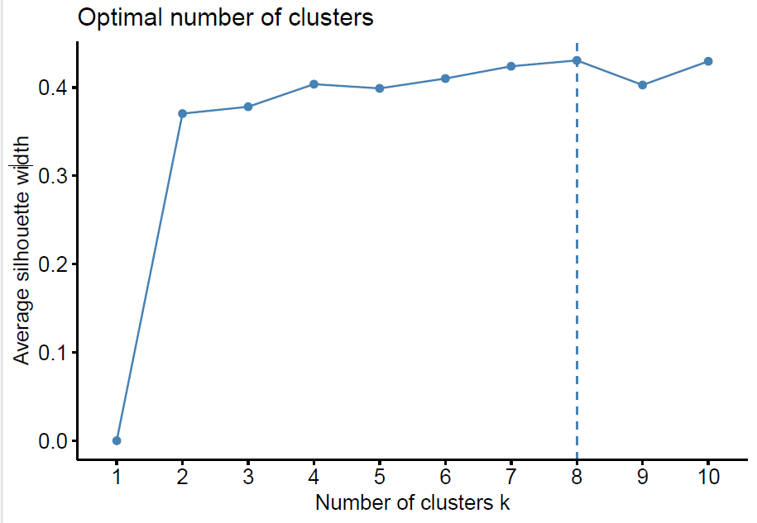
Figure 1 – Optimal number of clusters for Yellow Cabs
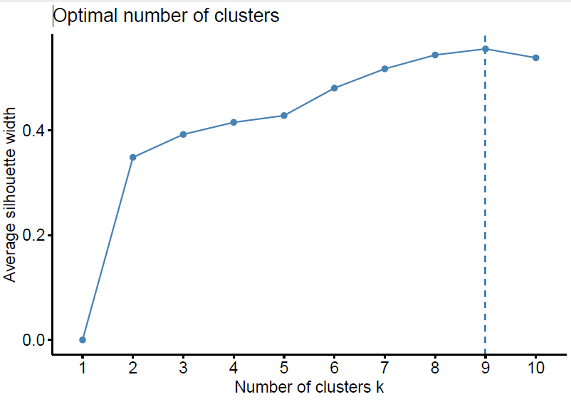
Figure 2 – Optimal number of clusters for app-based Cabs

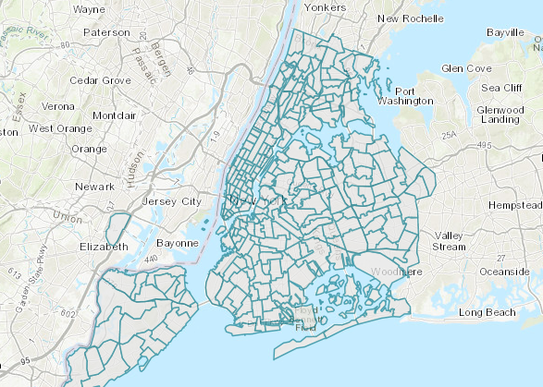
Figure 3 - New York City Taxi Zones (Adapted from the Princeton University Library)

Empirical Modelling

4.1 Using Ordinal Logistic Regression for modelling cab prices
The usual choice of empirical predictive models is classification techniques for categorical outcomes. Generally, three different classification models are commonly used: Binary Logistic Regression, Multinomial Logistic, and Ordinal Logistic Regression. When there are three or more categories with a natural ordering to the levels, but the ranking of the levels does not necessarily mean the intervals between them are equal, we generally choose the Ordinal Logistic Regression (Agresti, 2010; Osborne, 2017). Extant literature shows that ordinal logistic regression has been commonly used to model customer satisfaction (Aman & Smith-Colin, 2022; Chakraborty et al., 2022; Qiao et al., 2021; You et al., 2012; Zhou & Guo, 2017).
Ordinal logistic regression is a natural augmentation of logistic regression where the logit (i.e., the log odds) of a binary response is linearly related to the independent variables. (Cao et al., 2011) Unlike binary logit regression, where there is just one generalised linear model linking the log odds to the independent variables, ordinal logistic regression has multiple regression lines depending on the number of levels of the response variable (Supsermpol et al., 2023). Assume the response variable has “p” levels; there are (p-1) logits. One of the main assumptions of ordinal logistic regression is the proportional odds: the effect of an independent variable is constant for each increase in the level of the response. Hence, the output of an ordinal logistic regression will contain an intercept for each level of the response except one and a single slope for each explanatory variable.
Let Y be an ordinal response variable with $J$categories. Then $P\left(Y≤j\right)$ is the cumulative probability of Y less than or equal to a specific category $j$, $j=1, 2, … J$. Note that, $P\left(Y≤J\right)=1$. Then, the odds of being less than or equal a particular category can be defined by $\frac{P\left(Y≤j\right)}{P\left(Y>j\right)}$.
For $j=1,2,…, J$since $P\left(Y>J\right)=0$ and dividing by zero is undefined. Alternatively, we can also write $P\left(Y>j\right)=1-P\left(Y≤j\right)$. The log odds can be written as.
$\log{\frac{P\left(Y≤j\right)}{P\left(Y>j\right)}} = \operatorname{logit}\left(P\left(Y≤j\right)\right)$ (1)
The ordinal logistic regression model can be parametrised based on the features used in the model as follows.
$\log{i}t \left(P\left(Y≤j\right)\right) =β_{j0} +β_{j1}x_{1}+….+β_{jp}x_{p}$ (2)
where $β_{j0, }β_{j1,}……. β_{jp}$ are model coefficient parameters (i.e., intercepts and slopes) with “p” predictors for $j=1,2,….., J-1$.
Then, our estimation model for prices of yellow cab rides will be three sets of equations, one each for $j=1,2,3, given by$:
$$\log{i}t \left(P\left(price≤j\right)\right) =β_{j0} +β_{j1}Passenger Count+β_{j2}Rate Code ID$$
$$+β_{j3}Store and Fwd Flag+β_{j4}Payment Type+β_{j5}MTA Tax$$
$$+β_{j6}Improvement Surcharge+β_{j7}Tip Amount + β_{j8} Congestion Surcharge$$
$+β_{j9}Airport Fees +β_{j10}Time of day$ (3)

And our estimation model for prices of app-based cab rides will be three sets of equations, one each for $j=1,2,3, given by$:
$$\log{i}t \left(P\left(price≤j\right)\right) =β_{j0} +β_{j1}Trip Miles+β_{j2}Trip Time$$
$$+β_{j3}Tolls+β_{j4}Congestion Surcharge+β_{j5}Airport Fees$$
$$+β_{j6}Tips+β_{j7}Driver pay+ β_{j8} Shared Request Flag$$
$+β_{j9}Shared Match Flag+β_{j10}Access a Ride Flag+β_{j11}WAV Request Flag$ $+β_{j12}WAV Match Flag+β_{j13}Time of Day$ (4)

Results
We applied ordinal logistic regression to estimate the prices of cabs using the polr package in the R platform. We performed the modelling exercise twice: once with the yellow-cab data and then with the app-cab one. We present the results from yellow cab pricing models in Tables 7 and 8, while the results from app-based cab pricing models are presented in Tables 9 and 10.
Table 7. Results with Ordinal logit for modelling “price” (Set 01 Yellow cabs)
Dependent variable: Price
 | Overall | Cluster 1 | Cluster 2 | Cluster 3 | Cluster 4
Passenger Count | 0.084$^{**}$ | 0.066$^{**}$ | 0.093 | 0.020$^{**}$ | -0.022$^{**}$
 | (0.077) | (0.077) | (0.083) | (0.064) | (0.046)
RateCodeID2 | 37.265$^{****}$ | 22.876$^{****}$ | 22.926$^{****}$ | -24.792 | 25.372
 | (0.000) | (0.010) | (0.001) | (20.458) | (21.681)
RateCodeID3 | 26.079$^{***}$ | 15.664$^{***}$ | -31.612$^{***}$ | -51.195 | 27.550$^{****}$
 | (0.001) | (1.234) | (32.859) | (36.001) | (0.002)
RateCodeID4 | 1.336 | 1.988 | 9.241$^{****}$ | -6.119$^{****}$
 | (0.433) | (0.122) | (0.000) | (0.043)
RateCodeID5 | 15.501 | 26.115 | 12.672$^{****}$ | 20.669$^{****}$ | 16.949$^{****}$
 | (0.780) | (1.225) | (1.515) | (0.001) | (1.155)
Payment Type 1 | -1.255$^{****}$ | -0.668$^{****}$ | -2.050$^{****}$ | -0.777$^{***}$ | -0.981
 | (0.268) | (0.112) | (1.074) | (0.851) | (0.599)
Payment Type 2 | -0.286$^{**}$ | -1.675 | -1.275$^{*}$ | 0.286$^{**}$ | 0.216
 | (0.266) | (0.345) | (1.062) | (0.847) | (0.595)
Payment Type 3 | -1.198$^{****}$ | -1.092$^{***}$ | -2.337$^{**}$ | 0.020$^{**}$ | -1.558
 | (0.488) | (0.334) | (1.664) | (1.542) | (1.397)
MTA Tax | 1.488$^{****}$ | 3.334$^{****}$ | 3.636$^{****}$ | -4.784$^{****}$ | 1.117
 | (0.455) | (1.112) | (0.179) | (1.246) | (2.077)
Improvement Surcharge | 1.454$^{**}$ | 2.334$^{**}$ | 0.036 | 2.282$^{**}$ | -0.396
 | (0.620) | (1.116) | (0.022) | (4.568) | (0.384)
Tip Amount | 0.324$^{****}$ | 0.309$^{****}$ | 0.292$^{****}$ | 0.329$^{**}$ | 0.359$^{****}$
 | (0.016) | (0.233) | (0.067) | (0.051) | (0.038)
Congestion Surcharge | 0.068$^{**}$ | 0.195 | 0.040 | 0.078 | 0.599
 | (0.054) | (0.006) | (0.200) | (0.121) | (0.176)
Airport Fees | -2.890$^{****}$ | -1.776$^{***}$ | -4.378$^{****}$ | -1.330$^{****}$ | -0.507
 | (0.522) | (1.113) | (1.080) | (0.377) | (0.450)
Time of day_Evening | 0.290$^{*}$ | 0.334$^{*}$ | 0.292$^{*}$ | 0.471$^{*}$ | 0.365$^{***}$
 | (0.056) | (0.044) | (0.224) | (0.192) | (0.129)
Time of day_Late_Morning | -1.678$^{*}$ | -1.817$^{**}$ | -1.350$^{****}$ | -1.226$^{*}$ | -1.941$^{****}$
 | (0.124) | (0.233) | (0.494) | (0.416) | (0.258)
Time of day_Late_Night | 0.378$^{*}$ | 0.304$^{***}$ | 0.118$^{*}$ | 0.137$^{*}$ | 0.406$^{***}$
 | (0.377) | (0.255) | (0.272) | (0.219) | (0.148)
Time of day_Morning | -0.579$^{*}$ | -0.607$^{****}$ | -0.946$^{****}$ | -0.691$^{****}$ | -0.709$^{****}$
 | (0.133) | (0.190) | (0.222) | (0.182) | (0.127)
Store and Fwd Flag (Y) | 0.296$^{**}$ | -2.443$^{**}$ | 0.177$^{**}$ | -1.123$^{**}$ | 0.309$^{**}$
 | (0.255) | (0.255) | (0.079) | (0.700) | (0.650)
Intercept
1|2 | 1.126$^{**}$ | 2.377$^{**}$ | 2.511$^{*}$ | -5.984$^{**}$ | 5.770$^{***}$
 | (1.588) | (0.776) | (3.622) | (3.599) | (3.599)
2|3 | 4.220$^{****}$ | 3.114$^{****}$ | 6.204$^{**}$ | -12.773$^{**}$ | 9.370$^{***}$
 | (2.515) | (0.166) | (3.631) | (3.605) | (3.605)
3|4 | 9.546$^{****}$ | 8.990$^{***}$ | 11.925$^{****}$ | -6.403$^{**}$ | 15.894$^{***}$
 | (1.752) | (2.189) | (3.652) | (3.631) | (2.135)
Observations | 24,201 | 2,792 | 1,615 | 3,383 | 3,518
Pseudo R Square | 0.632 | 0.618 | 0.607 | 0.665 | 0.657
AIC | 19762.930 | 3398.75 | 1410.175 | 2009.206 | 3775.326
Note: $^{*}$p$<$0.1; $^{**}$p$<$0.05; $^{***}$p$<$0.01 $^{****}$p$<$0.001; Standard errors in parenthesis.
AIC=Akaike Information Criteria
Table 8. Results with Ordinal logit for modelling “price” (Set 02 Yellow cabs)
Dependent variable: Price
 | Overall | Cluster 5 | Cluster 6 | Cluster 7 | Cluster 8
Passenger Count | 0.084$^{**}$ | 0.099$^{**}$ | 0.077 | 0.048 | 0.066
 | (0.077) | (0.078) | (0.057) | (0.058) | (0.057)
RateCodeID2 | 37.265$^{****}$ | 15.744$^{***}$ | 82.370$^{****}$ | 34.738$^{****}$ | 42.384$^{****}$
 | (0.000) | (4.682) | (0.000) | (0.000) | (0.000)
RateCodeID3 | 26.079$^{***}$ | -31.700 | -9.601 | 10.955 | 24.889$^{****}$
 | (0.001) | (3.787) | (5.067) | (0.001) | (0.001)
RateCodeID4 | 1.336 |  |  | -3.021$^{****}$
 | (0.433) |  |  | (0.043)
RateCodeID5 | 15.501 | -81.415 | 12.611$^{****}$ | 14.944$^{****}$ | 7.888$^{****}$
 | (0.780) | (5.390) | (2.854) | (1.822) | (1.859)
Payment Type 1 | -1.255$^{****}$ | -2.468$^{***}$ | -0.559$^{***}$ | -1.873$^{**}$ | -0.260
 | (0.268) | (0.843) | (0.832) | (0.819) | (0.673)
Payment Type 2 | -0.286$^{**}$ | -1.270 | 0.702$^{*}$ | -1.095$^{*}$ | 0.011
 | (0.266) | (0.833) | (0.828) | (0.815) | (0.676)
Payment Type 3 | -1.198$^{****}$ | -0.594 | -5.759$^{**}$ | -12.382$^{****}$ | -0.245$^{****}$
 | (0.488) | (1.208) | (2.957) | (3.003) | (1.204)
MTA Tax | 1.488$^{****}$ | -19.238$^{****}$ | -4.019$^{****}$ | -2.163 | -12.368$^{***}$
 | (0.455) | (3.217) | (1.096) | (3.441) | (4.016)
Improvement Surcharge | 1.454$^{**}$ | 2.360$^{***}$ | 2.812 | 1.912 | -1.580
 | (0.620) | (0.569) | (1.434) | (1.584) | (0.621)
Tip Amount | 0.324$^{****}$ | 0.331$^{****}$ | 0.455$^{****}$ | 0.350$^{****}$ | 0.134$^{****}$
 | (0.016) | (0.060) | (0.048) | (0.046) | (0.035)
Congestion Surcharge | 0.068$^{****}$ | 0.062 | 0.034 | -0.193 | 0.072
 | (0.054) | (0.180) | (0.259) | (0.190) | (0.093)
Airport Fees | -2.890$^{****}$ | -6.363 | -7.818 | -4.797$^{***}$ | -0.886$^{***}$
 | (0.522) | (3.228) | (3.862) | (1.742) | (0.933)
Time of day_Evening | 0.290$^{*}$ | 0.125$^{*}$ | 0.372$^{*}$ | 0.277$^{**}$ | 0.104
 | (0.056) | (0.215) | (0.140) | (0.148) | (0.180)
Time of day_Late_Morning | -1.678$^{*}$ | -1.429$^{****}$ | -2.171$^{****}$ | -2.666$^{****}$ | -1.770$^{****}$
 | (0.124) | (0.409) | (0.337) | (0.448) | (0.337)
Time of day_Late_Night | 0.378$^{*}$ | -0.023 | 0.062 | 0.107 | -0.100
 | (0.377) | (0.253) | (0.174) | (0.180) | (0.222)
Time of day_Morning | -0.579$^{*}$ | -0.580$^{***}$ | -0.846$^{****}$ | -0.932$^{****}$ | -0.687
 | (0.133) | (0.203) | (0.145) | (0.154) | (0.174)
Store and Fwd Flag (Y) | 0.296$^{**}$ | 2.580$^{***}$ | 0.365 | 0.429 | -0.812
 | (0.255) | (0.901) | (0.079) | (0.700) | (0.931)
Intercept
1|2 | 1.126$^{**}$ | -70.459$^{****}$ | 8.437$^{****}$ | 4.447$^{***}$ | -3.964$^{***}$
 | (1.588) | (7.564) | (1.802) | (2.821) | (3.632)
2|3 | 4.220$^{****}$ | -67.039$^{****}$ | 12.195$^{****}$ | 8.268$^{****}$ | -0.805$^{***}$
 | (2.515) | (7.568) | (1.818) | (2.824) | (3.630)
3|4 | 9.546$^{****}$ | -60.564$^{****}$ | 19.775$^{****}$ | 15.630$^{****}$ | 5.409$^{***}$
 | (1.752) | (7.586) | (1.886) | (2.845) | (3.627)
Observations | 24,201 | 2,327 | 4,177 | 1,556 | 4,833
Pseudo R Square | 0.632 | 0.594 | 0.626 | 0.634 | 0.591
AIC | 19762.930 | 1547.494 | 2721.755 | 2712.271 | 2160.295
Note: $^{*}$p$<$0.1; $^{**}$p$<$0.05; $^{***}$p$<$0.01 $^{****}$p$<$0.001; Standard errors in parenthesis.
AIC=Akaike Information Criteria

Table 9. Results with Ordinal logit for modelling “price” (Set 01 App-based cabs)
Dependent variable: Price
 | Overall | Cluster 1 | Cluster 2 | Cluster 3 | Cluster 4
Trip Miles | 0.474$^{****}$ | 0.524$^{****}$ | 0.481$^{****}$ | 0.473$^{****}$ | 0.530$^{****}$
 | (0.024) | (0.073) | (0.071) | (0.085) | (0.063)
Trip Time | 0.002$^{****}$ | 0.002 | 0.001 | 0.001 | 0.002$^{****}$
 | (0.000) | (0.000) | (0.000) | (0.004) | (0.000)
Tolls | -0.035$^{**}$ | 0.006 | -0.239$^{***}$ | -0.047 | 0.166
 | (0.014) | (0.102) | (0.086) | (0.029) | (0.118)
Congestion Surcharge | 0.246$^{****}$ | 0.257$^{****}$ | 0.276$^{****}$ | 0.276$^{****}$ | 0.137$^{**}$
 | (0.019) | (0.058) | (0.059) | (0.061) | (0.063)
Airport Fees | 0.335$^{****}$ | 0.292 | 0.456$^{**}$ | 0.304 | -0.121$^{****}$
 | (0.083) | (0.188) | (0.201) | (0.254) | (0.000)
Tips | 0.067$^{****}$ | 0.081 | 0.033 | 0.073 | 0.124$^{***}$
 | (0.016) | (0.048) | (0.042) | (0.049) | (0.042)
Driver Pay | 0.450$^{****}$ | 0.388$^{****}$ | 0.462$^{****}$ | 0.529$^{****}$ | 0.388$^{****}$
 | (0.014) | (0.041) | (0.042) | (0.045) | (0.033)
Shared_match_flagY | 12.233$^{****}$ | 11.877$^{****}$ | 9.162$^{****}$ | 10.113$^{****}$ | 8.552$^{***}$
 | (0.000) | (2.135) | (3.093) | (1.177) | (2.252)
Access_a_ride_flagN | 0.339$^{****}$ | 0.196 | 0.538$^{****}$ | 0.703$^{****}$ | 0.142
 | (0.058) | (0.171) | (0.190) | (0.193) | (0.137)
Wav_request_flagY | -5.561$^{****}$ | -5.336$^{****}$ | -1.132 | 0.894$^{****}$ | -2.003$^{***}$
 | (0.001) | (0.015) | (0.372) | (0.000) | (0.000)
Wav_match_flagY | -0.917$^{****}$ | -0.783$^{***}$ | -0.564 | -0.767$^{**}$ | -0.842$^{***}$
 | (0.116) | (0.320) | (0.112) | (0.341) | (0.304)
Time of day_Evening | -0.014 | 0.022 | 0.262 | -0.025 | -0.097
 | (0.077) | (0.236) | (0.227) | (0.263) | (0.181)
Time of day_Late_Morning | 0.112 | 0.212 | 0.220 | -0.110 | -0.068
 | (0.111) | (0.326) | (0.345) | (0.411) | (0.259)
Time of day_Late_Night | 0.014 | -0.006 | 0.424 | 0.186 | -0.259
 | (0.091) | (0.273) | (0.284) | (0.299) | (0.224)
Time of day_Morning | 0.008 | -0.086 | 0.331 | -0.047 | -0.269
 | (0.070) | (0.222) | (0.215) | (0.240) | (0.164)
Intercept
1|2 | 5.478$^{****}$ | 5.112$^{****}$ | 5.593$^{****}$ | 5.480$^{****}$ | 5.400$^{****}$
 | (0.109) | (0.336) | (0.351) | (0.377) | (0.256)
2|3 | 8.734$^{****}$ | 8.192$^{****}$ | 8.522$^{****}$ | 8.841$^{****}$ | 8.642$^{****}$
 | (0.141) | (0.416) | (0.432) | (0.476) | (0.333)
3|4 | 14.071$^{****}$ | 13.539$^{****}$ | 13.271$^{****}$ | 14.574$^{****}$ | 13.936$^{****}$
 | (0.217) | (0.636) | (0.638) | (0.752) | (0.524)
Observations | 12,455 | 1,273 | 1,354 | 1,309 | 2,132
Pseudo R Square | 0.586 | 0.585 | 0.551 | 0.612 | 0.566
AIC | 11510.220 | 1291.724 | 1256.526 | 1091.250 | 2042.927
Note: $^{*}$p$<$0.1; $^{**}$p$<$0.05; $^{***}$p$<$0.01 $^{****}$p$<$0.001; Standard errors in parenthesis.
AIC=Akaike Information Criteria

Table 10. Results with Ordinal logit for modelling “price” (Set 02 App-based cabs)
Dependent variable: Price
 | Overall | Cluster 5 | Cluster 6 | Cluster 7 | Cluster 8 | Cluster 9
Trip Miles | 0.474$^{****}$ | 0.452$^{****}$ | 0.568$^{****}$ | 0.506$^{****}$ | 0.328$^{****}$ | 0.464$^{****}$
 | (0.024) | (0.079) | (0.070) | (0.074) | (0.072) | (0.074)
Trip Time | 0.002$^{****}$ | 0.002$^{****}$ | 0.001 | 0.002$^{**}$ | 0.001$^{***}$ | 0.001$^{**}$
 | (0.000) | (0.000) | (0.000) | (0.001) | (0.000) | (0.001)
Tolls | -0.035$^{**}$ | -0.002 | -0.010$^{****}$ | 0.027 | -0.113$^{**}$ | -0.025
 | (0.014) | (0.034) | (0.026) | (0.052) | (0.066) | (0.044)
Congestion Surcharge | 0.246$^{****}$ | 0.256$^{****}$ | 0.390$^{****}$ | 0.265$^{****}$ | 0.288$^{****}$ | 0.299$^{****}$
 | (0.019) | (0.062) | (0.059) | (0.061) | (0.054) | (0.059)
Airport Fees | 0.335$^{****}$ | 0.516$^{****}$ | 0.213 | 0.132 | 0.494$^{***}$ | 0.279
 | (0.083) | (0.109) | (0.152) | (0.135) | (0.162) | (0.149)
Tips | 0.067$^{****}$ | 0.057 | 0.023 | 0.069 | 0.137$^{***}$ | 0.071
 | (0.016) | (0.055) | (0.044) | (0.048) | (0.044) | (0.048)
Driver Pay | 0.450$^{****}$ | 0.417$^{****}$ | 0.493$^{****}$ | 0.457$^{***}$ | 0.550$^{****}$ | 0.479$^{****}$
 | (0.014) | (0.050) | (0.041) | (0.042) | (0.039) | (0.043)
Shared_match_flagY | 12.233$^{****}$ | 4.122$^{**}$ | 8.547 | 10.212 | 9.380 | 7.167
 | (0.004) | (0.102) | (0.000) | (0.000) | (0.125) | (0.332)
Access_a_ride_flagN | 0.339$^{****}$ | 0.056 | 0.231 | 0.283 | 0.662$^{****}$ | 0.308
 | (0.058) | (0.183) | (0.187) | (0.175) | (0.175) | (0.180)
Wav_request_flagY | -5.561$^{****}$ | -0.525 | -2.442 | -2.769 | -3.685 | -2.355$^{**}$
 | (0.001) | (0.407) | (0.195) | (0.150) | (0.188) | (0.235)
Wav_match_flagY | -0.917$^{****}$ | -1.116$^{**}$ | -1.164$^{***}$ | -0.924$^{***}$ | -1.441$^{****}$ | -1.176
 | (0.116) | (0.675) | (0.398) | (0.348) | (0.325) | (0.357)
Time of day_Evening | -0.014 | 0.015 | -0.174 | -0.070 | -0.174 | -0.101
 | (0.077) | (0.250) | (0.235) | (0.232) | (0.219) | (0.234)
Time of day_Late_Morning | 0.112 | 0.368 | -0.247$^{****}$ | -0.014$^{****}$ | 0.110 | 0.054
 | (0.111) | (0.376) | (0.367) | (0.353) | (0.314) | (0.353)
Time of day_Late_Night | 0.014 | 0.426 | 0.168 | 0.130 | -0.156 | 0.142
 | (0.091) | (0.311) | (0.295) | (0.282) | (0.256) | (0.286)
Time of day_Morning | 0.008 | 0.317 | -0.225$^{****}$ | -0.056$^{****}$ | -0.133 | -0.024
 | (0.070) | (0.229) | (0.222) | (0.214) | (0.201) | (0.216)
Intercept
1|2 | 5.478$^{****}$ | 5.331$^{****}$ | 5.711$^{****}$ | 5.480$^{***}$ | 5.788$^{****}$ | 5.578$^{****}$
 | (0.109) | (0.367) | (0.334) | (0.334) | (0.312) | (0.337)
2|3 | 8.734$^{****}$ | 8.669$^{****}$ | 9.157$^{****}$ | 8.827$^{****}$ | 9.263$^{****}$ | 8.979$^{****}$
 | (0.141) | (0.466) | (0.448) | (0.431) | (0.417) | (0.441)
3|4 | 14.071$^{****}$ | 14.188$^{****}$ | 14.837$^{****}$ | 14.384$^{****}$ | 14.430$^{****}$ | 14.460$^{****}$
 | (0.217) | (0.723) | (0.695) | (0.673) | (0.638) | (0.682)
Observations | 12,455 | 1,587 | 1,070 | 1,295 | 1,025 | 1,410
Pseudo R Square | 0.586 | 0.574 | 0.604 | 0.588 | 0.591 | 0.618
AIC | 11510.220 | 1106.806 | 1197.071 | 1290.711 | 1434.522 | 2139.084
Note: $^{*}$p$<$0.1; $^{**}$p$<$0.05; $^{***}$p$<$0.01 $^{****}$p$<$0.001; Standard errors in parenthesis.
AIC=Akaike Information Criteria

5.1 Variable Importance Schemes
Next, we applied variable importance techniques with the help of the varImp() function from the randomforest package. The aim of variable importance techniques is to determine which input features significantly influence the performance of the predictive model. Using a variable importance scheme helped us understand the relative importance of each predictor variable chosen in our empirical modelling. In addition, our preferred empirical model was ordinal logistic regression, similar to a multi-class classification problem. The Mean decrease accuracy plot illustrates how much accuracy is lost when a variable is removed from the model. The more the accuracy lost, the more important the variable is for the effective classification. The variables are listed in order of decreasing relevance. The plots from the variable importance schemes are shown in Figures 4 and 5 for yellow and app-based cabs, respectively. From Figure 4, we can easily intrepret that “tip amount” emerges as the most significant predictor of fares for yellow cabs. On the contrary, the least important predictors are more-or-less common across most clusters, such as “improvement surcharge”, “passenger count”, and “store and forward” flag. Similarly, in Figure 5, “driver pay” emerges as the most significant predictor of fares for app-based cabs. On the other hand, “airport fee” emerges as moderately significant for a few clusters, such as Cluster 2.
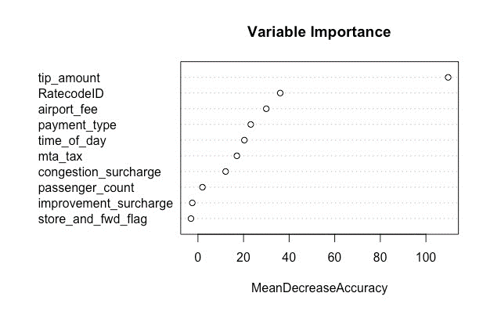
Figure 4 (a) – Variable Importance Plot for Cluster 2 (Yellow Cabs)

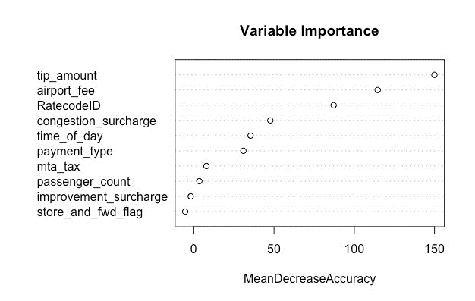
Figure 4 (b) – Variable Importance Plot for Cluster 4 (Yellow Cabs)

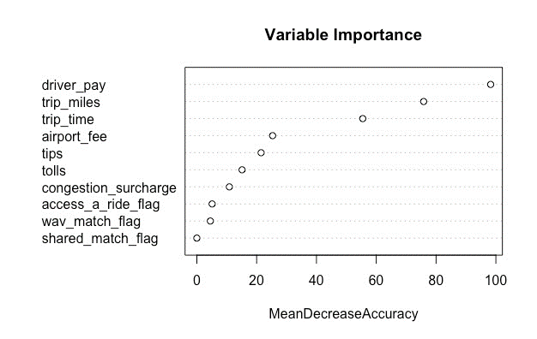
Figure 5 (a) – Variable Importance Plot for Cluster 2 (App Cabs)
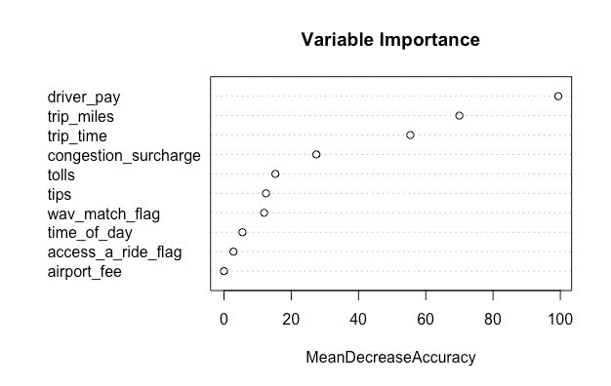
Figure 5 (b) – Variable Importance Plot for Cluster 6 (App Cabs)

5.2 Performance evaluation of the proposed methods
We present the predictive performance of our ordinal logistic regression models using the confusion matrices and standard classification metrics, such as precision, recall, F1-score and Area Under the Curve (AUC) values (Rajendran et al., 2021). The classification problem aims to generate four target classes – P1, P2, P3 and P4, and therefore, a simple accuracy measure is not sufficient to evaluate the performance of the models. We set the training: testing ratio at 80:20 per cent with a random selection of records from the input files. The metrics are presented in Table 11 and Table 12. We also plotted the Receiver Operating Characteristic (ROC) curves for the full file, accompanied by plots from three sample clusters for both yellow and app-based cabs. The ROC curve illustrates the performance of a classification model at different threshold levels. E.g. Cluster 1, 3 and 6 from yellow cabs, while Cluster 1, 2 and 8 from app-based cabs were presented in Figure 6 and Figure 7. (We presented the ROC curves from a few selected clusters only due to limitations in the manuscript pages).
Based on the ROC curves, we compared the performance of our classifier models across the entire dataset and then across each cluster. First, we compared across the full file of the Yellow taxi dataset, where the AUC values for each pricing class were reported as 0.957, 0.882, 0.866 and 0.974, respectively, for P1, P2, P3 and P4 price levels with a mean AUC value of 0.919. Therefore, their relationships are represented as ${AUC}_{P4}> {AUC}_{P1}> {AUC}_{P2}> {AUC}_{P3}$. This pattern can also be verified with Figure 6 (a) where the purple marker (P4) covers the highest area among the four pricing classes and the green marker (P1) trails close by.
Next, across Cluster 1 of Yellow Taxi, the AUC values for each pricing class P1, P2, P3 and P4 are 0.976, 0.908, 0.877 and 0.975, respectively, with an average AUC value of 0.934. Therefore, they can be represented as ${AUC}_{P1}≈ {AUC}_{P4}> {AUC}_{P2}> {AUC}_{P3}$ . This pattern can be verified with Figure 6 (b), where the purple marker (P4) and the green marker (P1) cover the highest area within the ROC plots.
Whereas, across Cluster 3 of Yellow taxi, the AUC values for each pricing class P1, P2, P3 and P4 are 0.957, 0.882, 0.866 and 0.974, respectively, with an average AUC value of 0.922. Therefore, they can be represented as ${AUC}_{P4}≈ {AUC}_{P1}> {AUC}_{P3}> {AUC}_{P1}$ . This pattern is also reflected in Figure 6 (c) where the purple marker (P4) treads the highest area among the four pricing classes and the green marker (P4) trails close by, while, the cyan marker (P3) is higher than the blue (P2). Finally, across Cluster 6 of Yellow taxi, the AUC values for each pricing class P1, P2, P3 and P4 are 0.964, 0.889, 0.870 and 0.976, respectively, with an average AUC value of 0.924. Therefore, their relationship can be represented as ${AUC}_{P4}> {AUC}_{P1}> {AUC}_{P2}> {AUC}_{P3}$ . This pattern is also reflected in Figure 6 (d). To summarise, we observed that our model performed the best for the highest and lowest levels of prices, i.e., P1 and P4.
Then, we compared across the full file of the App-based taxi dataset, where the AUC values for each pricing class were reported as 0.971, 0.869, 0.868 and 0.968, respectively, for P1, P2, P3 and P4 price levels with a mean AUC value of 0.918. Therefore, their relationships are represented as ${AUC}_{P1}≈ {AUC}_{P4}> {AUC}_{P2}≈ {AUC}_{P3}$. This pattern can also be verified with Figure 7 (a) where the green marker (P1) covers the highest area among the four pricing classes, with the highest recall value of 0.934 and the purple marker (P4) trails close by, with a relatively closer recall value of 0.735 (Table 12). Next, across Cluster 1 of App-based taxis, the AUC values for each pricing class P1, P2, P3 and P4 are 0.955, 0.880, 0.866 and 0.927, respectively, with an average AUC value of 0.907. Therefore, they can be represented as ${AUC}_{P1}> {AUC}_{P4}> {AUC}_{P2}≈ {AUC}_{P3}$ . This pattern can be verified with Figure 7 (b) where the green marker (P1) covers the highest area among the four pricing classes and the purple marker (P4) trails close by.
Whereas, across Cluster 3 of App-based taxis, the AUC values for each pricing class P1, P2, P3 and P4 are 0.973, 0.890, 0.867 and 0.976, respectively, with an average AUC value of 0.926. Therefore, they can be represented as ${AUC}_{P4}≈ {AUC}_{P1}> {AUC}_{P3}> {AUC}_{P2}$ . This behaviour is also reflected in Figure 7 (c), where the purple marker (P4) treads the highest area among the four pricing classes and the green marker (P4) trails close by. Finally, across Cluster 4 of App-based taxi, the AUC values for each pricing class P1, P2, P3 and P4 are 0.973, 0.884, 0.870 and 0.964, respectively, with an average AUC value of 0.923; therefore their relationship can be represented as ${AUC}_{P1}> {AUC}_{P4}> {AUC}_{P2}> {AUC}_{P3}$ . This pattern is also reflected in Figure 7 (d) where the purple marker (P4) and the green marker (P4) are close, with the TPR: FPR ratio being almost similar during the initial phase of the model but later higher for P1. To summarise, we observed that our models performed the best for the highest and the lowest price classes, i.e., P1 and P4. In contrast, the performance for the intermediate price classes, i.e., P2 and P3, were relatively lower.
Table 11. Performance Metrics of our empirical models for Yellow Cabs
Experiment on Full-File (Training = 19361 records; testing = 4840 records (20% of full-file)
 |  | Predicted Class
 |  | P1 | P2 | P3 | P4 |  | Pr | Rc | F1
Actual Class | P1 | 816 | 356 | 4 | 19 | 1195 | 0.854 | 0.683 | 0.759
Actual Class | P2 | 111 | 1020 | 51 | 27 | 1209 | 0.558 | 0.844 | 0.672
Actual Class | P3 | 16 | 439 | 670 | 56 | 1181 | 0.636 | 0.567 | 0.600
Actual Class | P4 | 13 | 12 | 329 | 901 | 1255 | 0.898 | 0.718 | 0.798
 | Total | 956 | 1827 | 1054 | 1003 | 4840
 | AUC | 0.957 | 0.882 | 0.866 | 0.974
Experiment on Cluster 1 (Training = 2234 records; testing = 559 records (20% of Cluster 1)
 |  | Predicted Class
 |  | P1 | P2 | P3 | P4 |  | Pr | Rc | F1
Actual Class | P1 | 65 | 10 | 0 | 0 | 75 | 0.677 | 0.867 | 0.760
Actual Class | P2 | 26 | 80 | 2 | 2 | 110 | 0.571 | 0.727 | 0.640
Actual Class | P3 | 3 | 47 | 83 | 6 | 139 | 0.643 | 0.597 | 0.619
Actual Class | P4 | 2 | 3 | 44 | 186 | 235 | 0.959 | 0.791 | 0.867
 | Total | 96 | 140 | 129 | 194 | 559
 | AUC | 0.976 | 0.908 | 0.877 | 0.975
Experiment on Cluster 3 (Training = 2707 records; testing = 676 records (20% of Cluster 3)
 |  | Predicted Class
 |  | P1 | P2 | P3 | P4 |  | Pr | Rc | F1
Actual Class | P1 | 161 | 15 | 0 | 6 | 182 | 0.732 | 0.885 | 0.801
Actual Class | P2 | 56 | 103 | 22 | 2 | 183 | 0.691 | 0.563 | 0.620
Actual Class | P3 | 3 | 31 | 159 | 7 | 200 | 0.757 | 0.795 | 0.776
Actual Class | P4 | 0 | 0 | 29 | 82 | 111 | 0.845 | 0.739 | 0.788
 | Total | 220 | 149 | 210 | 97 | 676
 | AUC | 0.957 | 0.882 | 0.866 | 0.974
Experiment on Cluster 6 (Training = 3342 records; testing = 835 records (20% of Cluster 6)
 |  | Predicted Class
 |  | P1 | P2 | P3 | P4 |  | Pr | Rc | F1
Actual Class | P1 | 182 | 24 | 0 | 3 | 209 | 0.795 | 0.871 | 0.831
Actual Class | P2 | 43 | 157 | 4 | 1 | 205 | 0.613 | 0.766 | 0.681
Actual Class | P3 | 2 | 69 | 114 | 15 | 200 | 0.713 | 0.570 | 0.633
Actual Class | P4 | 2 | 6 | 42 | 171 | 221 | 0.900 | 0.774 | 0.832
 | Total | 229 | 256 | 160 | 190 | 835
 | AUC | 0.964 | 0.889 | 0.870 | 0.976
Pr=Precision; Rc=Recall; F1 = F1 Score; AUC = Area under the Curve.

Table 12. Performance Metrics of our empirical model for App-based Cabs
Experiment on Full-File (Training = 9964 records; testing = 2491 records (20% of full-file)
 |  | Predicted Class
 |  | P1 | P2 | P3 | P4 |  | Pr | Rc | F1
Actual Class | P1 | 619 | 38 | 4 | 2 | 663 | 0.780 | 0.934 | 0.850
Actual Class | P2 | 164 | 372 | 40 | 16 | 592 | 0.631 | 0.628 | 0.629
Actual Class | P3 | 11 | 175 | 386 | 49 | 621 | 0.656 | 0.622 | 0.639
Actual Class | P4 | 0 | 5 | 158 | 452 | 615 | 0.871 | 0.735 | 0.797
 | Total | 794 | 590 | 588 | 519 | 2491
 | AUC | 0.971 | 0.869 | 0.868 | 0.968
Experiment on Cluster 1 (Training = 1019 records; testing = 254 records (20% of Cluster 1)
 |  | Predicted Class
 |  | P1 | P2 | P3 | P4 |  | Pr | Rc | F1
Actual Class | P1 | 39 | 6 | 1 | 0 | 46 | 0.765 | 0.848 | 0.804
Actual Class | P2 | 11 | 48 | 6 | 4 | 69 | 0.686 | 0.696 | 0.691
Actual Class | P3 | 1 | 13 | 50 | 11 | 75 | 0.649 | 0.667 | 0.658
Actual Class | P4 | 0 | 3 | 20 | 41 | 64 | 0.732 | 0.641 | 0.683
 | Total | 51 | 70 | 77 | 56 | 254
 | AUC | 0.955 | 0.880 | 0.866 | 0.927
Experiment on Cluster 2 (Training = 1084 records; testing = 270 records (20% of Cluster 2)
 |  | Predicted Class
 |  | P1 | P2 | P3 | P4 |  | Pr | Rc | F1
Actual Class | P1 | 42 | 4 | 0 | 0 | 46 | 0.712 | 0.913 | 0.800
Actual Class | P2 | 15 | 46 | 10 | 1 | 72 | 0.719 | 0.639 | 0.676
Actual Class | P3 | 2 | 14 | 46 | 4 | 66 | 0.605 | 0.697 | 0.648
Actual Class | P4 | 0 | 0 | 20 | 66 | 86 | 0.930 | 0.767 | 0.841
 | Total | 59 | 64 | 76 | 71 | 270
 | AUC | 0.973 | 0.890 | 0.867 | 0.977
Experiment on Cluster 8 (Training = 820 records; testing = 205 records (20% of Cluster 8)
 |  | Predicted Class
 |  | P1 | P2 | P3 | P4 |  | Pr | Rc | F1
Actual Class | P1 | 38 | 4 | 0 | 0 | 42 | 0.760 | 0.905 | 0.826
Actual Class | P2 | 10 | 29 | 5 | 0 | 44 | 0.659 | 0.659 | 0.659
Actual Class | P3 | 2 | 11 | 49 | 5 | 67 | 0.721 | 0.731 | 0.726
Actual Class | P4 | 0 | 0 | 14 | 38 | 52 | 0.884 | 0.731 | 0.800
 | Total | 50 | 44 | 68 | 43 | 205
 | AUC | 0.974 | 0.885 | 0.871 | 0.964
Pr=Precision; Rc=Recall; F1 = F1 Score; AUC = Area under the Curve.

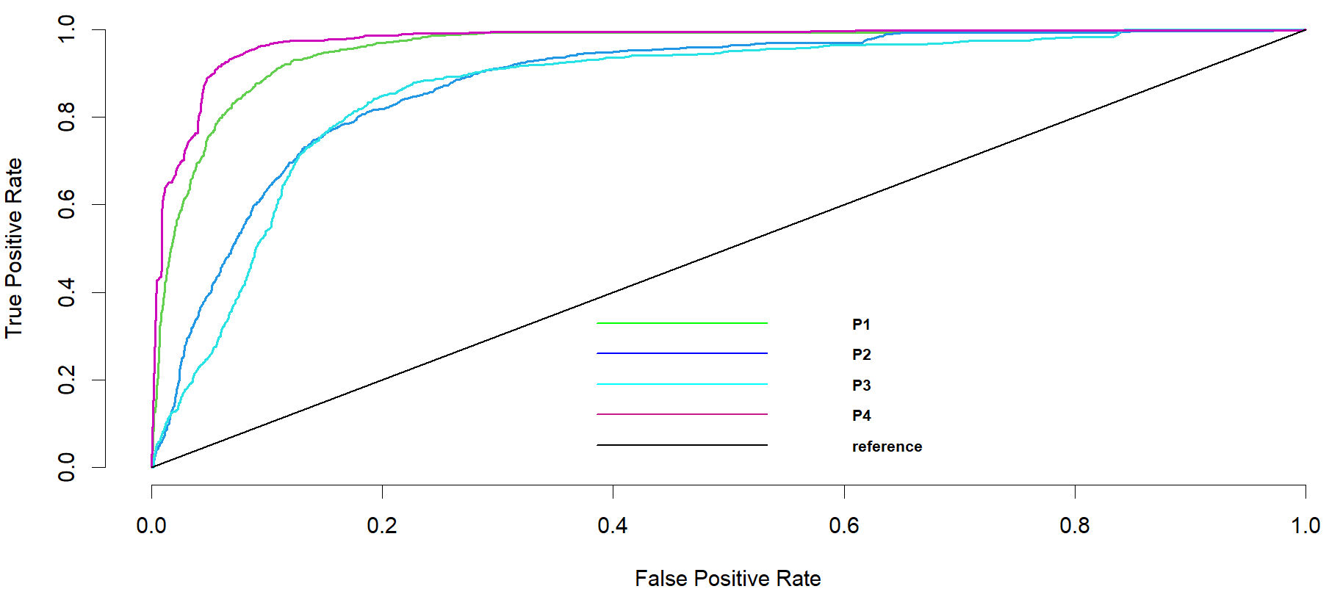
Figure 6 (a) – ROC Plot for Full-file (Yellow Cabs)
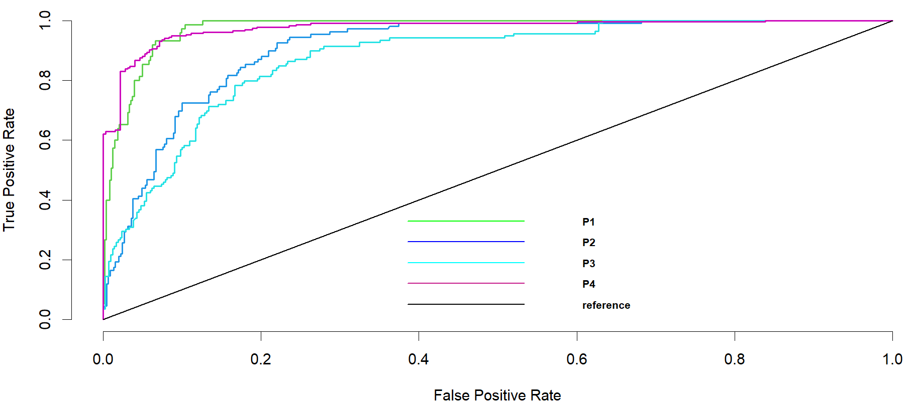
Figure 6 (b) – ROC Plot for Cluster 1 (Yellow Cabs)
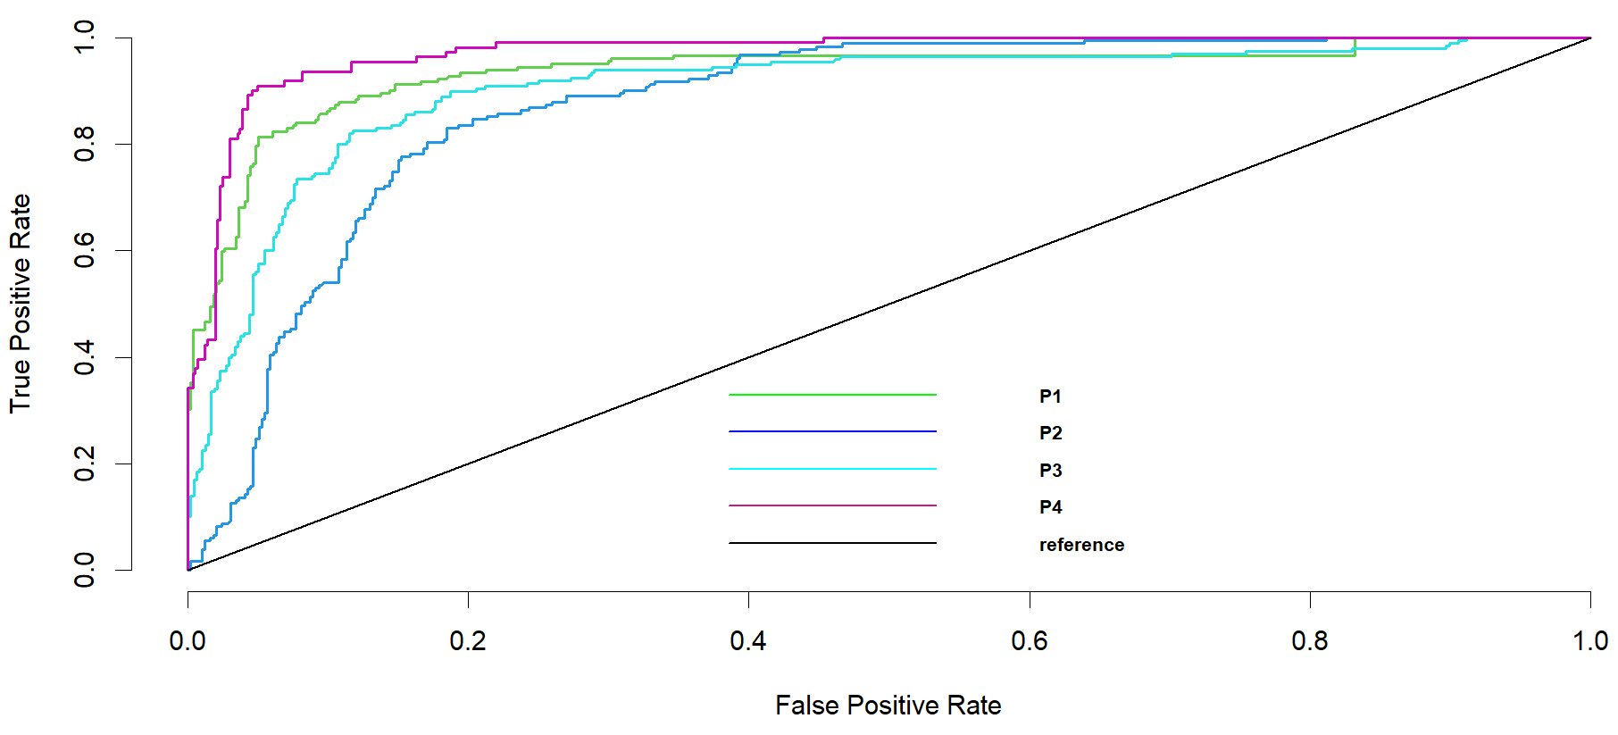
Figure 6 (c) – ROC Plot for Cluster 3 (Yellow Cabs)
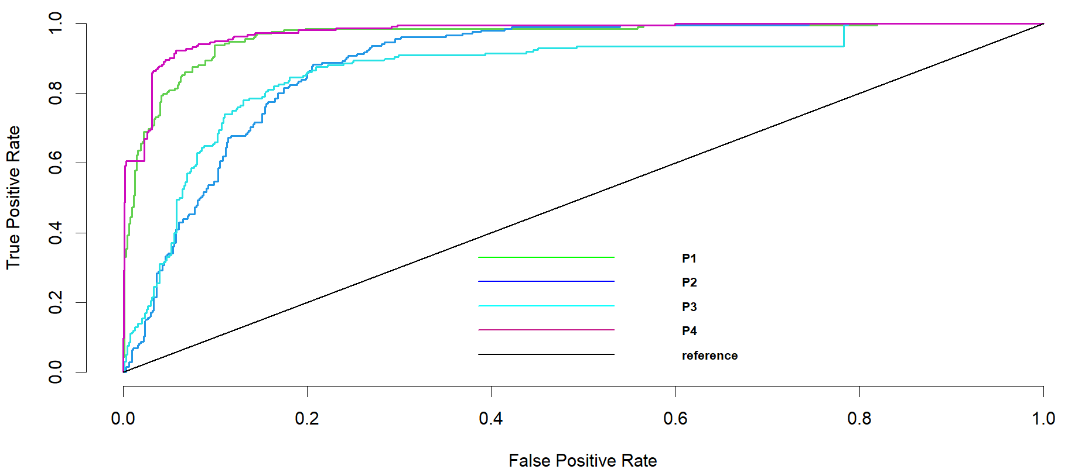
Figure 6 (d) – ROC Plot for Cluster 6 (Yellow Cabs)

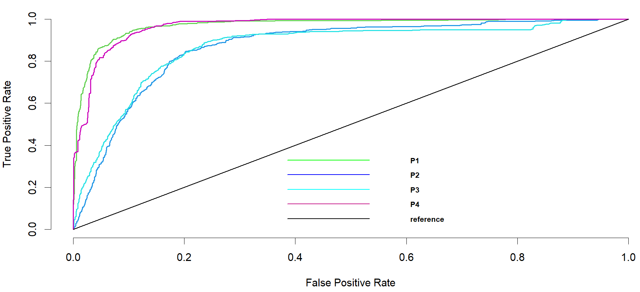
Figure 7 (a) – ROC Plot for Full-file (App-based Cabs)
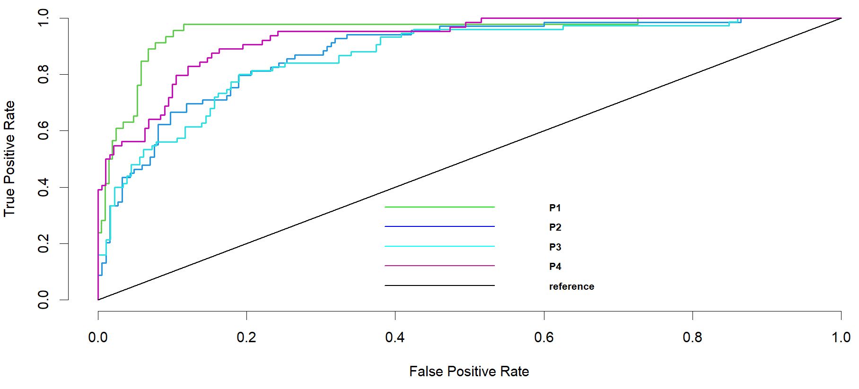
Figure 7 (b) – ROC Plot for Cluster 1 (App-based Cabs)
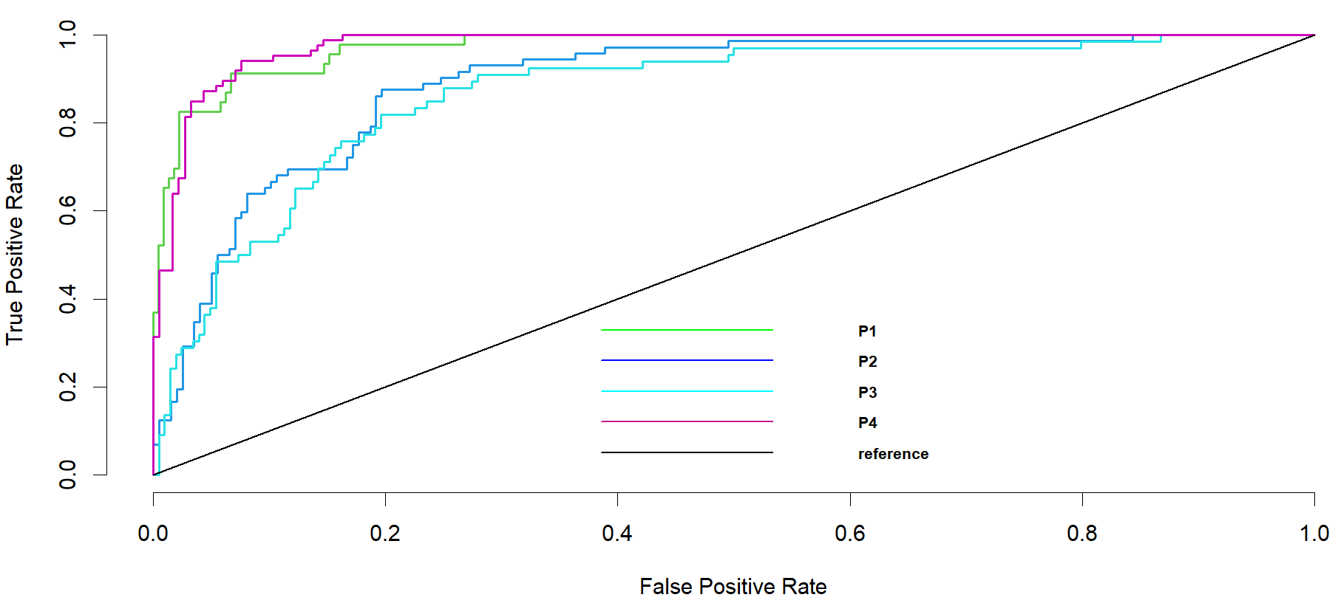
Figure 7 (c) – ROC Plot for Cluster 2 (App-based Cabs)
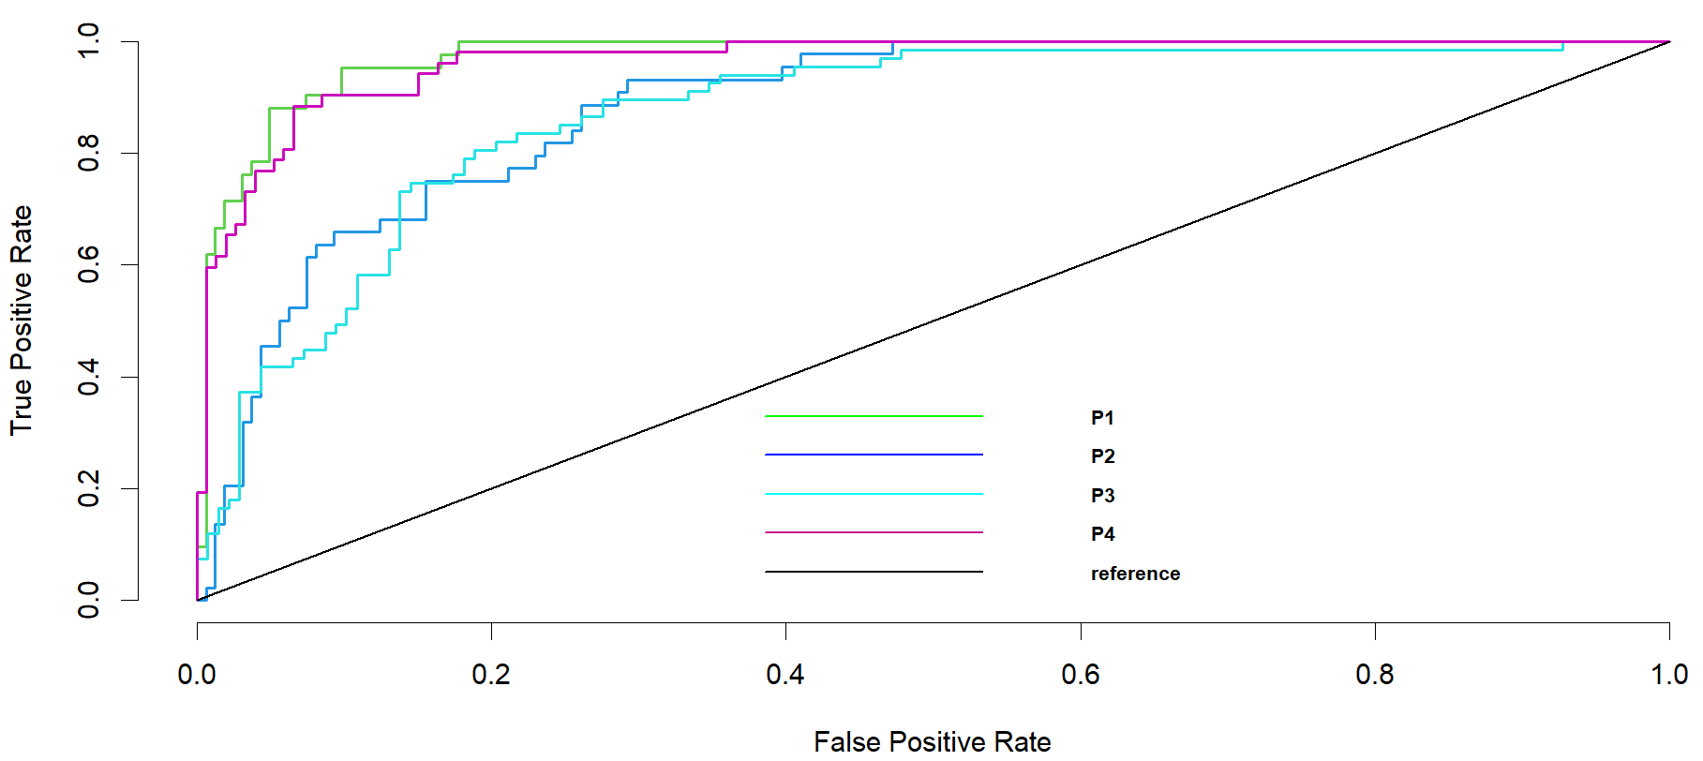
Figure 7 (d) – ROC Plot for Cluster 8 (App-based Cabs)

Discussion of Results and Findings

6.1 Yellow Cabs
First, among the different predictors of cab fares, we found that “passenger count” was consistently significant and positively impacted seven clusters, except for cluster 4, where the pickup and drop off locations for cluster 4 are Upper West Side and Lower East Side in Manhattan. Therefore, the increasing number of passengers taking a ride positively affects the cab pricing categories. This can be somewhat explained by the fact that if more people share a cab, multiple drop locations might be between the first pickup and final drop-off locations, leading to the meter running longer and higher fares.
Second, we test the impact of the various “Rate Code ID” categories on the price. The benchmark here is Rate Code ID 1, i.e., “Standard rate”. The results show that cluster coefficients 4, 5, 6, and 8 are missing. This indicates no trips to Nassau or Westchester within these four clusters. For the remaining categories, we can see that Rate Code ID 2 (JFK airport), concerning the benchmark standard rate code, consistently has a positive and significant impact on price categories, except for cluster 3, where the impact of Rate Code ID 2 is less than that of the standard rate (Rate Code ID 1). A similar pattern is also seen in Rate Code ID 5, where the impact on price category is consistently positive and significant except for cluster 5. So, in cluster 3 for Rate Code ID 2 and cluster 5 for Rate Code ID 5, the pricing category is higher for Rate Code 1. In the case of Rate Code 3 (Newark) clusters 2, 3, 5, and 6, the effect on the pricing category is lower than that of Rate Code 1.
Next, we found that “MTA Tax” is a significant predictor across all nine clusters. However, for clusters 1 and 2, the coefficients suggest that MTA tax positively impacts the price category. In all other clusters, it has a negative impact. This implies that with increasing MTA tax, the base price category for clusters 3 through 8 will be lower, whereas, for places in clusters 1 and 2, increased MTA tax implies a higher base price.
Third, we discuss the effects of different tips and surcharges on the base price. Also, the improvement surcharge and congestion surcharge mostly positively impact the price category in the eight clusters. However, a few clusters, like clusters 4 and 8, have a negative impact. For congestion surcharge, cluster 7 has a negative impact. In all other clusters, as the congestion surcharge increases, it also leads to a higher price category. This might be attributed to the fact that the routes that are more congested, leading to higher surcharges, are also the ones that are marked for their heavy traffic (Vignon et al., 2023). Thus, a pre-determined higher base price is fixed for such rides.
Fourth, “tip amount” is one of the important variables positively associated with the base price category. We can see a positive relationship for all eight clusters as expressed by the model’s coefficients. There might be a reverse causality in this case. It can be concluded that riders who are high tippers have a higher propensity to take high-base price destination rides. A similar consistent pattern is also seen in the “airport fee” variable. However, the relationship with the price category is negative and significant. This can be attributed to the fact that airport rides differ from regular rides (as indicated by the different Rate Code IDs). Thus, due to the airport fees already being added to the final price, the base price category is lower to maintain a final price commensurate with regular ride types.
Sixth, we discuss the effect of “time of day” on yellow cab prices. This is a categorical variable with “afternoon” as the benchmark category. A few interesting patterns have emerged from the model fitting. From the results, we can see that consistently, in the “morning” and “late morning” categories, the pricing category is lower than in the “afternoon”. These differences are also statistically significant. Due to the higher demand for cabs when work hours begin, the number of cabs is also higher. This could lead to a lower price category during this time of the day. However, with later times of day like “evening” and “late night”, the pricing category is higher as compared to “afternoon”. This can be attributed to the lateness of the hour when the cab is taken. Compared to a more regular hour in the afternoon, the late hours call for a higher price, possibly due to the dearth of available cabs.

6.2 App-based Cabs
First, among the different predictors of cab fares, we found that “trip miles” and “trip time” were consistently significant across all the nine clusters. Therefore, the app-based cab's run time and the trip's distance strongly affected the cab pricing mechanisms. Second, among the fees and surcharges, tolls were significant for a few clusters, such as clusters 2, 6 and 8. It could indicate that passengers travelling within these clusters were crossing tolled expressways or motorways while the rest of the clusters did not, and therefore they remained more-or-less unaffected. Similarly, “airport fees” were significant for Cluster 2,4,5,8 but unimportant for other clusters. E.g., the “airport fee” was insignificant for Cluster 6, i.e., passengers boarding from zone 231 (TriBeCa, Manhattan) and dropping off at zone 52 (Cobble Hill, Brooklyn). It could be possible that these passengers mostly avoided airport trips, so airport fees were redundant in their trip pricing. Next, we found that “driver pay” was an important variable that remained significant across all nine clusters. This could signify the importance of commissions in calculating the driver’s pay in app-based cabs versus yellow cabs.
Third, we discuss the effects of different flags during app-based cab trips. The “shared match flag” was significant for passengers in Clusters 1,2,3,4 and 5, while it did not manage to be important in the remaining clusters. It could indicate that passengers who began their trips from these clusters were likelier to share the vehicle with another passenger, even though they had booked separately at any point during the trip. Similarly, the option for wheelchair-accessible vehicles emerged as significant for a few clusters while jointly comparing the effects of the other variable “wheelchair match flag”. While “WAV Request Flag” and “WAV Match Flag” were jointly significant for Clusters 1,3, and 4 only, it indicates that passengers travelling within these three clusters could get a successful wheelchair-enabled cab while expressing intention during booking the ride. On the contrary, other clusters could not guarantee it. This could be an important metric for accessibility and support for differently-abled passengers. Fourth, we discuss the effect of “time of day” on app-cab fares. We find that the time of ride-booking does not play a major role in steering high prices in app-based cabs and does so in only two clusters: 6 and 7 during early and late morning.

6.3 Variable Importance Schemes
Next, we discuss the importance of different predictors for predicting cab prices across yellow and app-based cabs. The plots for two clusters from each cab type are presented in Figures 4 and 5. We find that for “yellow cabs”, the “tip amount” emerges as the most significant predictor of fares, followed by “rate code” and “airport fees.” On the contrary, the least important predictors are more-or-less common across most clusters, such as “improvement surcharge”, “passenger count”, and “store and forward flag.” Next, we examine the variable importance schemes for the “app-based cabs”. We find that the “driver pay” emerges as the most significant predictor of fares, followed by “trip miles” and “trip time.” On the other hand, “airport fee” emerges as moderately significant for a few clusters such as Cluster 2, i.e., passengers boarding from zone 55 (Coney Island, Brooklyn) up to zone 236 (Upper East Side North, Manhattan). Instead, the “airport fee” is insignificant for Cluster 6, i.e., passengers boarding from zone 231 (TriBeCa, Manhattan) and dropping off at zone 52 (Cobble Hill, Brooklyn). It could be possible that these passengers mostly avoided airport trips. In this manner, our study reveals interesting findings with the application of the variable importance scheme.

Implications of the study

7.1 Theoretical Implications
Our study offers several recommendations for scholars and academicians in the transportation industry. First, it contributes to the nascent body of studies on pricing prediction that applies data-mining and artificial intelligence techniques to predict prices and related factors (Agarwal et al., 2022; Battifarano & Qian, 2019; Poongodi et al., 2022; Wang et al., 2023). For instance, a few papers applied multiple machine-learning models to study the role of ride-hailing surge factors among taxi rides in Singapore (Agarwal et al., 2022) to predict Uber surge multipliers in Pittsburgh (Battifarano and Qian, 2022). This is a growing body of literature in the core transportation domain despite a bulk of literature having focussed on mathematical models, especially using game-theory and optimisation techniques (He et al., 2018; Milioti et al., 2022; Qiu et al., 2022; Sun et al., 2019; Xu et al., 2022; Zhong et al., 2022). In this aspect, although we applied ordinal logistic regression models, we computed the predictive performance of our models using the confusion matrices and classification metrics, such as precision, recall, F1-score and Area under the Curve (AUC) values (Rajendran et al., 2021).
Second, our study emphasises cluster-based recommendations, and through the execution of a variable-importance scheme, it reveals interesting predictors as significant contributors to the final fare paid by the passenger. For instance, contrary to popular belief that “trip time” and “distance” are the strongest contributors, “driver pay” emerges as the strongest feature in app-based cab services such as Uber and Lyft. While this may seem counterintuitive, it helps to add to the current body of literature on transportation, thereby realigning the emphasis on various strands of transportation research and informing current scholars in a revised direction of examination, such as pricing predictions and related factors. Because so far, a great deal of literature in transportation-related studies examining app-based cabs has focussed on surge prices (Agarwal et al., 2022; Battifarano and Qian, 2022) and demand-prediction (Cao et al., 2021; Zhang et al., 2020; Zhang et al., 2021). This is also highlighted by Chen et al. (2022), showing the top five themes as air transportation, network modelling, routing problems, maritime transportation and supply chains, but studies on taxicab pricing and related domains need to be more extensive.

7.2 Managerial implications
Our study offers recommendations for business and technical managers in the cab industry. In addition, it also offers simple policy recommendations for the taxi union and the administrative bodies overseeing important public services such as taxicabs. First, it identifies the major predictors that help to the prices of a typical cab ride: “tip amount”, “airport fees”, and “payment type” for “yellow cabs”, “driver pay”, “trip miles”, and “trip time” for app-based cabs, Using these findings, business managers in the app-cab industry can now re-design their pricing mechanisms based on innovative factors, not trip time and distance alone. This study provides insights and understanding on how pricing changes over time might affect consumer loyalty, market share, and overall profitability of the taxi industry. Moreover, it entails comprehending the benefits and drawbacks of dynamic pricing systems that change prices in response to real-time supply and demand situations.
Second, findings from our study reveal that differential effects of each predictor for cab pricing exist across different clusters. While these findings are familiar to the academic literature and the cab industry, they can offer new ideas for administrative bodies and policymakers, such as cab-only roads, timed cabs, or optimal route planning (Hao and Martin, 2022; Huang et al., 2023; Li et al., 2021). Using these findings, taxi industries can tailor personalised pricing strategies for different customer segments. Through this, taxi industries can attract customers from each segment based on their specific cluster features, ultimately increasing overall profitability. It is often the common notion that a few significant factors, such as high congestion en route, may lead to higher cab fares and damage the profitability of the taxicab industry. While this is not entirely untrue, our variable importance scheme shows that “congestion surcharge” is important only for a few clusters. Therefore, calculating taxicab pricing remains a grey area (Agarwal et al., 2023; Vignon et al., 2023).
Third, our variable importance scheme shows that policy decisions such as minimum driver pay implementation can hurt taxicab pricing (Hao and Martin, 2022; Huang et al., 2023; Li et al., 2021). Based on this scheme, the predictors across each cluster can be unique and help transportation agencies design different pricing schemes rather than a one-size-fits-all model. For instance, Figure 5 shows that within the app-cab industry, cluster 2 and cluster 6 have differential effects on airport fees. Further, the congestion surcharge is important for passengers within Cluster 2 while insignificant for passengers travelling within Cluster 6.

Conclusion and Future Scope of Research
During high demand or scarce availability, cab service providers may increase the prices based on their prediction models. Accurate pricing prediction enables the service providers to speculate the surge periods and dynamically predict the prices to match supply and demand. Therefore, this study developed ordinal-logit-based models to predict the price of trips from yellow cabs and app-based cabs for accurate forecasts based on various components of the final cab price as one of the first research works to explore the clusters for yellow cabs and app-based cabs leading to a dynamic pricing mechanism across zones by using data. The ultimate goal is to contribute to developing a dynamic pricing mechanism. This means that cab service providers can adjust prices in real time based on the predicted demand and availability of cabs in specific zones. The dataset used in our analysis is retrieved from the NYCTLC website for yellow taxis and four app-based services. This dataset likely includes historical information on yellow taxi trips and data from four app-based ride-sharing services.
The contributions of our study are the following. First, we build AI-based predictive models for pricing in taxicab services. Second, we converted a prediction problem into a classification problem by transforming a continuous variable (i.e., price) into four quartiles. Third, we identify distinct clusters within the New York City taxi zones that are flexible yet responsive towards decision-making for firms operating in this business and beneficial for policymakers. We proposed unique clusters from two important predictors – pickup and drop-off locations, leading to eight and nine clusters for yellow and app-based cabs, respectively. Fourth, we built variable importance schemes using the predictors of taxi fares for each of these clusters, leading to dynamic pricing models applicable to different zones within New York City.
Despite these important contributions, our study has a few limitations. First, our study built empirical models using cross-sectional datasets, which can be extended to time series and panel-data analysis. Second, the study can be extended with mixed-methods analysis by incorporating qualitative information such as interview excerpts of passengers and drivers. Third, the current study considers only data from New York City taxis, which can be easily extended to other metropolitan areas with the availability of open data.

References
Abdella, G. M., Kucukvar, M., Onat, N. C., Al-Yafay, H. M., & Bulak, M. E. (2020). Sustainability assessment and modeling based on supervised machine learning techniques: The case for food consumption. Journal of Cleaner Production, 251, 119661.
Acheampong, R. A., Siiba, A., Okyere, D. K., & Tuffour, J. P. (2020). Mobility-on-demand: An empirical study of internet-based ride-hailing adoption factors, travel characteristics and mode substitution effects. Transportation Research Part C: Emerging Technologies, 115, 102638.
Agarwal, S., Charoenwong, B., Cheng, S. F., & Keppo, J. (2022). The impact of ride-hail surge factors on taxi bookings. Transportation Research Part C: Emerging Technologies, 136, 103508.
Agarwal, S., Mani, D., & Telang, R. (2023). The impact of ride-hailing services on congestion: Evidence from indian cities. Manufacturing & Service Operations Management, 25(3), 862-883.
Aghashahi, M., & Bamdad, S. (2023). Analysis of different artificial neural networks for Bitcoin price prediction. International Journal of Management Science and Engineering Management, 18(2), 126-133.
Aguilera-García, Á., Gomez, J., Velázquez, G., & Vassallo, J. M. (2022). Ridesourcing vs. traditional taxi services: Understanding users’ choices and preferences in Spain. Transportation Research Part A: Policy and Practice, 155, 161-178.
Alimo, P. K., Rahim, A. B. A., Lartey-Young, G., Ehebrecht, D., Wang, L., & Ma, W. (2022). Investigating the increasing demand and formal regulation of motorcycle taxis in Ghana. Journal of Transport Geography, 103, 103398.
Avdeenko, T., & Khateev, O. (2019). Taxi service pricing based on online machine learning. In Data Mining and Big Data: 4th International Conference, DMBD 2019, Chiang Mai, Thailand, July 26–30, 2019, Proceedings 4 (pp. 289-299). Springer Singapore
Battifarano, M., & Qian, Z. S. (2019). Predicting real-time surge pricing of ride-sourcing companies. Transportation Research Part C: Emerging Technologies, 107, 444-462.
Cao, D., Zeng, K., Wang, J., Sharma, P. K., Ma, X., Liu, Y., & Zhou, S. (2021). BERT-based deep spatial-temporal network for taxi demand prediction. IEEE Transactions on Intelligent Transportation Systems, 23(7), 9442-9454.
Cao, Q., Duan, W., & Gan, Q. (2011). Exploring determinants of voting for the “helpfulness” of online user reviews: A text mining approach. Decision Support Systems, 50(2), 511-521.
Cavusgil, S. T., Chan, K., & Zhang, C. (2003). Strategic orientations in export pricing: a clustering approach to create firm taxonomies. Journal of International Marketing, 11(1), 47-72.
Chakraborty, I., Kim, M., & Sudhir, K. (2022). Attribute sentiment scoring with online text reviews: Accounting for language structure and missing attributes. Journal of Marketing Research, 59(3), 600-622.
Chang, H.-w., Tai, Y.-c., and Hsu, J. Y.-j. Context-aware taxi demand hotspots
prediction. International Journal of Business Intelligence and Data Mining, Vol. 5, 1,
2010, pp. 3-18.
Chen, S., Meng, Q., & Choi, T. M. (2022). Transportation research Part E-logistics and transportation review: 25 years in retrospect. Transportation Research Part E: Logistics and Transportation Review, 161, 102709.
Chia, Z. L., Ptaszynski, M., Masui, F., Leliwa, G., & Wroczynski, M. (2021). Machine Learning and feature engineering-based study into sarcasm and irony classification with application to cyberbullying detection. Information Processing & Management, 58(4), 102600.
Choi, J. H., & Park, Y. (2022). Exploring economic feasibility for airport shuttle service of urban air mobility (UAM). Transportation Research Part A: Policy and Practice, 162, 267-281.
Cohen, P., Hahn, R., Hall, J., Levitt, S., & Metcalfe, R. (2016). Using big data to estimate consumer surplus: The case of uber (No. w22627). National Bureau of Economic Research.
Correa, D. (2017). Exploring the taxi and Uber demands in New York City: An empirical analysis and spatial modeling. Available at SSRN 4229042.
De Blasio, B., Joshi, M., 2016. 2016 Taxicab Fact Book. City of New York. http://www.nyc.gov/html/tlc/downloads/pdf/2016_tlc_factbook.pdf. Accessed April 5, 2016.
Dey, B. K., Tirtha, S. D., Eluru, N., & Konduri, K. C. (2021). Transformation of ridehailing in New York City: A quantitative assessment. Transportation Research Part C: Emerging Technologies, 129, 103235.
Gagolewski, M., Bartoszuk, M., & Cena, A. (2016). Genie: A new, fast, and outlier-resistant hierarchical clustering algorithm. Information Sciences, 363, 8-23.
Hao, W., & Martin, L. (2022). Prohibiting cherry-picking: Regulating vehicle sharing services who determine fleet and service structure. Transportation Research Part E: Logistics and Transportation Review, 161, 102692.
He, F., Wang, X., Lin, X., & Tang, X. (2018). Pricing and penalty/compensation strategies of a taxi-hailing platform. Transportation Research Part C: Emerging Technologies, 86, 263-279.
Huang, N., Lien, J. W., & Zheng, J. (2023). To acquire or compete? Government intervention in transportation under different route structures. Transportation Research Part E: Logistics and Transportation Review, 172, 103033.
Iansiti, M., & Lakhani, K. R. (2020). Competing in the age of AI: Strategy and leadership when algorithms and networks run the world. Harvard Business Press.
Irawan, M. Z., Joewono, T. B., Belgiawan, P. F., Chalermpong, S., & Thaithatkul, P. (2022). Examining the ride-hailing adoption behaviors among older adults in an Indonesian city: The case of Yogyakarta. Transportation Research Interdisciplinary Perspectives, 16, 100729.
Jayaram, J., Tan, K. C., & Nachiappan, S. P. (2010). Examining the interrelationships between supply chain integration scope and supply chain management efforts. International journal of production research, 48(22), 6837-6857.
Kamga, C., Conway, A., Singhal, A., & Yazici, A. (2012). Using advanced technologies to manage airport taxicab operations. Journal of Urban Technology, 19(4), 23-43.
Kamga, C., Yazici, M. A., & Singhal, A. (2015). Analysis of taxi demand and supply in New York City: implications of recent taxi regulations. Transportation Planning and Technology, 38(6), 601-625.
Kim, S. Y. (2011). Prediction of hotel bankruptcy using support vector machine, artificial neural network, logistic regression, and multivariate discriminant analysis. The Service Industries Journal, 31(3), 441-468.
Kim, T., Sharda, S., Zhou, X., & Pendyala, R. M. (2020). A stepwise interpretable machine learning framework using linear regression (LR) and long short-term memory (LSTM): City-wide demand-side prediction of yellow taxi and for-hire vehicle (FHV) service. Transportation Research Part C: Emerging Technologies, 120, 102786.
Laosinwattana, W., Thaithatkul, P., & Chalermpong, S. (2022). Determinants of Ride-Hailing Applications Adoption: How Travelers’ Characteristics and Attitudes Affect the Adoption of New Online Mobility Platforms in Bangkok?. In Recent Advances in Transportation Systems Engineering and Management: Select Proceedings of CTSEM 2021 (pp. 805-819). Singapore: Springer Nature Singapore.
Lee, M., Kwon, W., & Back, K. J. (2021). Artificial intelligence for hospitality big data analytics: developing a prediction model of restaurant review helpfulness for customer decision-making. International Journal of Contemporary Hospitality Management, 33(6), 2117-2136.
Lei, L. C., Gao, S., & Zeng, E. Y. (2020). Regulation strategies of ride-hailing market in China: An evolutionary game theoretic perspective. Electronic Commerce Research, 20, 535-563.
Li, B., & Szeto, W. Y. (2021). Modeling and analyzing a taxi market with a monopsony taxi owner and multiple rentee-drivers. Transportation Research Part B: Methodological, 143, 1-22.
Li, B., Szeto, W. Y., & Luo, Q. (2021). A peak-period taxi scheme design problem: Formulation and policy implications. Transportation Research Part E: Logistics and Transportation Review, 146, 102148.
Liu, C., Qin, K., & Kang, C. (2015, July). Exploring time-dependent traffic congestion patterns from taxi trajectory data. In Proceedings of 2nd IEEE International Conference on Spatial Data Mining and Geographical Knowledge Services (ICSDM) (pp. 39-44).
Liu, S., Jiang, H., & Chen, Z. (2021). Quantifying the impact of weather on ride-hailing ridership: Evidence from Haikou, China. Travel Behaviour and Society, 24, 257-269.
Liu, Y., Jia, R., Ye, J., & Qu, X. (2022). How machine learning informs ride-hailing services: A survey. Communications in Transportation Research, 2, 100075.
Liu, Z., Chen, H., Li, Y., & Zhang, Q. (2020). Taxi demand prediction based on a combination forecasting model in hotspots. Journal of Advanced Transportation, 2020, 1-13.
Loa, P., & Habib, K. N. (2021). Examining the influence of attitudinal factors on the use of ride-hailing services in Toronto. Transportation Research Part A: Policy and Practice, 146, 13-28.
Lokhandwala, M., & Cai, H. (2018). Dynamic ride sharing using traditional taxis and shared autonomous taxis: A case study of NYC. Transportation Research Part C: Emerging Technologies, 97, 45-60.
Luo, X., Tong, S., Fang, Z., & Qu, Z. (2019). Frontiers: Machines vs. humans: The impact of artificial intelligence chatbot disclosure on customer purchases. Marketing Science, 38(6), 937-947.
Miao, S., Chen, X., Chao, X., Liu, J., & Zhang, Y. (2022). Context‐based dynamic pricing with online clustering. Production and Operations Management, 31(9), 3559-3575.
Milioti, C., Kepaptsoglou, K., Kouretas, K., & Vlahogianni, E. I. (2022). Driver perceptions on taxi-sharing and dynamic pricing in taxi services: evidence from Athens, Greece. Journal of Public Transportation, 24, 100022.
Mitropoulos, L., Kortsari, A., & Ayfantopoulou, G. (2021). A systematic literature review of ride-sharing platforms, user factors and barriers. European Transport Research Review, 13, 1-22.
Nguyen-Phuoc, D. Q., Su, D. N., Tran, P. T. K., Le, D. T. T., & Johnson, L. W. (2020). Factors influencing customer's loyalty towards ride-hailing taxi services–A case study of Vietnam. Transportation Research Part A: Policy and Practice, 134, 96-112.
Pan, H., Wang, Y., & Szűcs, G. (2022). Work-traffic crashes and aberrant driving behaviors among full-time ride-hailing and taxi drivers: a comparative study. Transportation Letters, 1-10.
Parfenov, S., Weeks, A., & Alam, Z. (2014). Travel Patterns of NYC’s Yellow Taxis: Routing, Activity and Results ESRI International User Conference. San Diego, CA.
Peng, Z., Wang, Y., & Luo, X. (2020b). How does financial burden influence the crash rate among taxi drivers? A self-reported questionnaire study in China. Traffic Injury Prevention, 21(5), 324-329.
Peng, Z., Zhang, H., & Wang, Y. (2020a). Work-related factors, fatigue, risky behaviours and traffic accidents among taxi drivers: a comparative analysis among age groups. International Journal of Injury Control and Safety Promotion, 28(1), 58-67.
Pérez-Ortiz, M., de La Paz-Marín, M., Gutiérrez, P. A., & Hervás-Martínez, C. (2014). Classification of EU countries’ progress towards sustainable development based on ordinal regression techniques. Knowledge-Based Systems, 66, 178-189.
Poongodi, M., Malviya, M., Kumar, C., Hamdi, M., Vijayakumar, V., Nebhen, J., & Alyamani, H. (2022). New York City taxi trip duration prediction using MLP and XGBoost. International Journal of System Assurance Engineering and Management, 1-12.
Qian, X. and Ukkusuri, S. V. Spatial variation of the urban taxi ridership using GPS data.
Applied Geography, 59, 2015, pp. 31-42.
Qiao, Y., Labi, S., & Fricker, J. D. (2021). Does highway project bundling policy affect bidding competition? Insights from a mixed ordinal logistic model. Transportation Research Part A: Policy and Practice, 145, 228-242.
Qiu, J., Huang, K., & Hawkins, J. (2022). The taxi sharing practices: matching, routing and pricing methods. Multimodal Transportation, 1(1), 100003.
Rajendran, S., Srinivas, S., & Grimshaw, T. (2021). Predicting demand for air taxi urban aviation services using machine learning algorithms. Journal of Air Transport Management, 92, 102043.
Rammohan, S., Marathe, R. R., & Sudarsanam, N. (2023). Recent advancements in revenue management of taxi services: a systematic review and research agenda. Management Review Quarterly, 1-27.
Sayarshad, H. R., Mahmoodian, V., & Gao, H. O. (2020). Non-myopic dynamic routing of electric taxis with battery swapping stations. Sustainable Cities and Society, 57, 102113.
Shi, J., Hussain, M., & Peng, D. (2022). A study of aberrant driving behaviors and road accidents in Chinese ride-hailing drivers. Journal of Transportation Safety & Security, 1-18.
Sun, J., Dong, H., Qin, G., & Tian, Y. (2020). Quantifying the impact of rainfall on taxi hailing and operation. Journal of Advanced Transportation, 2020, 1-14.
Sun, L., Teunter, R. H., Babai, M. Z., & Hua, G. (2019). Optimal pricing for ride-sourcing platforms. European Journal of Operational Research, 278(3), 783-795.
Supsermpol, P., Thajchayapong, S., & Chiadamrong, N. (2023). Predicting financial performance for listed companies in Thailand during the transition period: A class-based approach using logistic regression and random forest algorithm. Journal of Open Innovation: Technology, Market, and Complexity, 9(3), 100130.
Tirachini, A., & del Río, M. (2019). Ride-hailing in Santiago de Chile: Users’ characterisation and effects on travel behaviour. Transport Policy, 82, 46-57.
Turner, C. R., Fuggetta, A., Lavazza, L., & Wolf, A. L. (1999). A conceptual basis for feature engineering. Journal of Systems and Software, 49(1), 3-15.
Ulak, M. B., Yazici, A., & Aljarrah, M. (2020). Value of convenience for taxi trips in New York City. Transportation Research Part A: Policy and Practice, 142, 85-100.
Ushakov, D., Dudukalov, E., Shmatko, L., & Shatila, K. (2022). Artificial Intelligence as a factor of public transportation system development. Transportation Research Procedia, 63, 2401-2408.
Vignon, D., Yin, Y., & Ke, J. (2023). Regulating the ride-hailing market in the age of uberization. Transportation Research Part E: Logistics and Transportation Review, 169, 102969.
Vijh, M., Chandola, D., Tikkiwal, V. A., & Kumar, A. (2020). Stock closing price prediction using machine learning techniques. Procedia computer science, 167, 599-606.
Wadud, Z. (2020). An examination of the effects of ride-hailing services on airport parking demand. Journal of Air Transport Management, 84, 101783.
Wang, J., Miwa, T., & Morikawa, T. (2023). Recursive decomposition probability model for demand estimation of street-hailing taxis utilizing GPS trajectory data. Transportation Research Part B: Methodological, 167, 171-195.
Wang, N., Zheng, L., Shen, H., & Li, S. (2023). Ride-hailing origin-destination demand prediction with spatiotemporal information fusion. Transportation Safety and Environment, tdad026.
Wang, X., He, F., Yang, H., & Gao, H. O. (2016). Pricing strategies for a taxi-hailing platform. Transportation Research Part E: Logistics and Transportation Review, 93, 212-231.
Wei, K., Vaze, V., & Jacquillat, A. (2022). Transit planning optimization under ride-hailing competition and traffic congestion. Transportation Science, 56(3), 725-749.
Xie, Y. A., Liu, Z., Chan, K. Y., & Guan, X. (2020). Energy-spectral efficiency optimization in vehicular communications: Joint clustering and pricing-based robust power control approach. IEEE Transactions on Vehicular Technology, 69(11), 13673-13685.
Xu, K., Saberi, M., & Liu, W. (2022). Dynamic pricing and penalty strategies in a coupled market with ridesourcing service and taxi considering time-dependent order cancellation behaviour. Transportation Research Part C: Emerging Technologies, 138, 103621.
Yang, C., Morgul, E. F., Gonzales, E. J., & Ozbay, K. (2014). Comparison of mode cost by time of day for nondriving airport trips to and from New York City's Pennsylvania Station. Transportation Research Record, 2449(1), 34-44.
Yang, H., Fung, C. S., Wong, K. I., & Wong, S. C. (2010). Nonlinear pricing of taxi services. Transportation Research Part A: Policy and Practice, 44(5), 337-348.
Yang, H., Wong, S. C., & Wong, K. I. (2002). Demand–supply equilibrium of taxi services in a network under competition and regulation. Transportation Research Part B: Methodological, 36(9), 799-819.
Yang, H., Ye, M., Tang, W. H., & Wong, S. C. (2005). Regulating taxi services in the presence of congestion externality. Transportation Research Part A: Policy and Practice, 39(1), 17-40.
Yazici, M. A., Kamga, C., & Singhal, A. (2016). Modeling taxi drivers’ decisions for improving airport ground access: John F. Kennedy airport case. Transportation Research Part A: Policy and Practice, 91, 48-60.
Yu, X., Gao, S., Hu, X., & Park, H. (2019). A Markov decision process approach to vacant taxi routing with e-hailing. Transportation Research Part B: Methodological, 121, 114-134.
Zhang, C., Zhu, F., Lv, Y., Ye, P., & Wang, F. Y. (2021). MLRNN: Taxi demand prediction based on multi-level deep learning and regional heterogeneity analysis. IEEE Transactions on Intelligent Transportation Systems, 23(7), 8412-8422.
Zhang, C., Zhu, F., Wang, X., Sun, L., Tang, H., & Lv, Y. (2020). Taxi demand prediction using parallel multi-task learning model. IEEE Transactions on Intelligent Transportation Systems, 23(2), 794-803.
Zhong, Y., Yang, T., Cao, B., & Cheng, T. C. E. (2022). On-demand ride-hailing platforms in competition with the taxi industry: Pricing strategies and government supervision. International Journal of Production Economics, 243, 108301.
Zhou, S., & Guo, B. (2017). The order effect on online review helpfulness: A social influence perspective. Decision Support Systems, 93, 77-87.

https://www.intuz.com/blog/boost-market-value-with-ai-taxi-app-development
https://www.nytimes.com/2022/11/17/nyregion/taxi-fare-hike-nyc.html
https://nypost.com/2022/10/12/congestion-pricing-will-kill-nycs-iconic-yellow-cabs/
https://www.wsj.com/articles/new-york-taxi-drivers-see-state-fee-as-blow-to-battered-industry-1522620969
https://www.wsj.com/articles/the-taxi-prince-is-taking-on-uberand-winning-60f883df
https://www.wsj.com/articles/the-taxi-prince-is-taking-on-uberand-winning-60f883df
https://www.wsj.com/articles/now-prices-can-change-from-minute-to-minute-1450057990
https://www.wsj.com/articles/uber-reaches-deal-to-list-all-new-york-city-taxis-on-its-app-11648123201
https://www.forbes.com/sites/amazonwebservices/2021/12/03/predicting-the-future-of-demand-how-amazon-is-reinventing-forecasting-with-machine-learning/?sh=6ad12ebf1b6b
https://www1.nyc.gov/site/tlc/about/tlc-trip-record-data.page
New York Taxi zones: https://data.cityofnewyork.us/Transportation/NYC-Taxi-Zones/d3c5-ddgc
Paying too much in taxi app commissions: https://www.lynk.ie/blog-drivers/taxi-app-commission/
Struggling Taxi Drivers See Congestion Pricing as Fee That Breaks Their Backs: https://www.nbcnewyork.com/news/local/struggling-taxi-drivers-see-congestion-pricing-as-fee-that-breaks-their-backs/3833402/

