Article Type: Historical Perspective
Article Title: ‘Tint and Form’: The Geometric Philosophy Underlying Oliver Byrne’s Elements
Author Information:
- Clare Marie Moriarty (philosopher, researcher), Trinity College Dublin, Department of Philosophy, The Arts Building, Dublin 2, Ireland. Email: moriarcl@tcd.ie. ORCID: 0000-0003-0830-3746
Abstract:
Oliver Byrne published his ground-breaking and visually remarkable edition of Euclid’s Elements in 1847. The book is extraordinary: its pages are adorned with generous four-colour diagrams, illustrations and grids, and each proposition begins with an engraved decorative initial. Its aesthetic similarity to various stylistic themes of the Bauhaus and De Stijl movements has been noted, but little attention has been paid to the pedagogical and theoretical insights that shaped Byrne’s illustrative choices. In this article, the author explains some key philosophical ideas underlying the geometric illustrations and contextualises them amid Byrne’s wider mathematical preoccupations.
Word Count: 3,709 (main text, excl. footnotes and references), 4,395 (main text incl. all notes)

Oliver Byrne’s Euclid
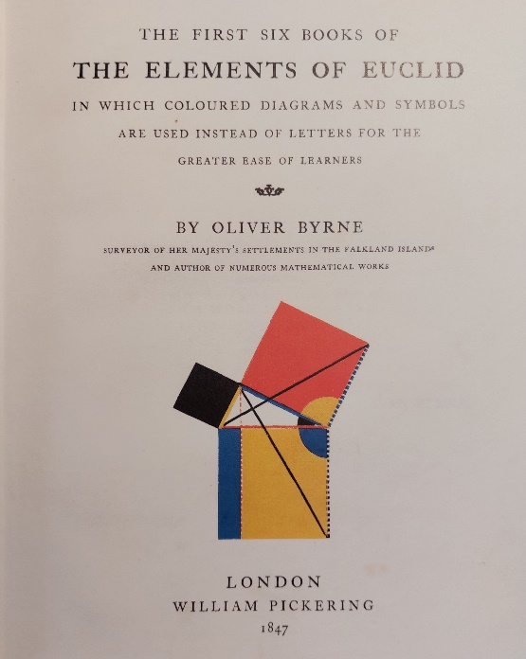
Oliver Byrne published his ground-breaking and visually remarkable re-working of Euclid’s Elements in 1847. The Elements was the most influential mathematical text in history and the locus classicus of rigorous axiomatic mathematics. The treatise—attributed to Euclid (fl. 300BC) but believed to be a compilation and expansion of the work of previous mathematicians—remained the centrepiece of formal mathematics education up until the nineteenth century. Byrne’s 1847 illustrated re-imagining of Euclid is extraordinary: its pages are adorned with generous four-colour diagrams, illustrations and grids, and each proposition begins with an engraved decorative initial. This article explains the pedagogical and philosophical insights that motivated Byrne’s unique publication and explores lines of influence in philosophical debates of the previous century. A new connection between Byrne and George Berkeley is also revealed, with analysis of the philosophical similarities that motivated both thinkers in their mathematical projects.
Fig. 1. Title page of Byrne’s Elements with diagram of pictorial illustration of the Pythagorean Theorem in bright red, yellow, blue, black and white [1].
The geometrical diagrams accompanying Oliver Byrne’s 1847 edition of (the first six books of) Euclid’s Elements are truly worthy of artistic attention. They anticipate many salient features of artistic movements that didn’t materialise for a further seventy years. Stylistic and visual comparisons to De Stijl and the Bauhaus are hard to resist—stark primary colours, sparse linear connections, and a restraint with respect to form combine to produce a striking aesthetic resemblance. Though Byrne’s illustrations have, in Euclid historian Benjamin Wardhaugh’s words “unexpectedly attained classic status” [2], Byrne never intended the drawings to be regarded for their artistic merit. The images were intended purely instrumentally. In the introduction, he prefaces their use in the following terms:
This work has a greater aim than mere illustration; we do not introduce colours for the purpose of entertainment, or to amuse by certain combinations of tint and form, but to assist the mind in its researches after truth, to increase the facilities of instruction, and to diffuse permanent knowledge [3].
That Byrne’s Elements was published at all seems unlikely in retrospect. Byrne was an Irish mathematician and an eccentric with polymathic interests—he published numerous mathematical and engineering texts, but he also produced political texts (including an illustrated manual with practical tips for “street and house fighting”), made discoveries in metallurgy and wrote against phrenology, among many other interests. His was a life marred with financial hardship and complicated relationships with employers. His biography paints a picture of an ingenious man more than capable of getting in his own way, professionally speaking [4]. That Byrne’s re-working of the Elements was published in the format it was is truly extraordinary, especially in an economic period acknowledged to have been particularly challenging for publishers and booksellers [5]. Byrne’s Elements is a masterpiece of early Victorian printing [6]. The publisher, William Pickering (1796-1854), was an innovator in his own right, having been a very early proponent of cloth-binding, amongst other technical developments [7]. He also produced miniature books under the label “Diamond Classics”, which provided readers with well-produced, inexpensive editions of classic texts like Dante’s Divine Comedy and Homer’s Iliad. Byrne’s Elements is lavishly printed in four colours with bold, generous diagrams on every page (see Fig 2). Each theorem begins with a decorative initial, engraved by the illustrious engraver Mary Byfield. Pickering re-introduced old-type Caslon font with its distinctive “long” lowercase s for many of his publications, including Byrne’s Elements. The combination of these innovations in colour illustration with decorative initials and font from a bygone era produces a distinctive overall appearance. Despite Byrne’s Elements selling poorly, Pickering’s biographer credits the publisher with “having fathered a gallant, if unsuccessful, experiment in education” [8]. The stereotype of the mathematical tome, heaving under the weight of sprawling, textual equations is completely subverted—in Byrne’s text, traditional mathematical notation seems underrepresented [9].
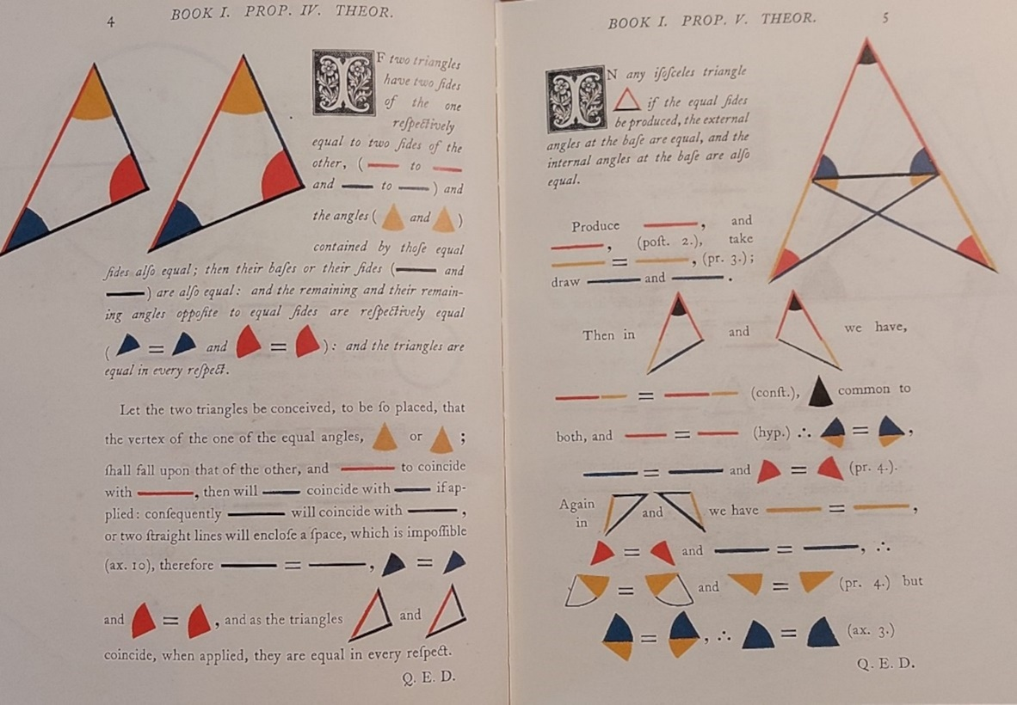
Fig. 2. Pages 4 and 5 of Byrne’s Elements [10].
For Byrne, the diagrams facilitated uptake of mathematical ideas and had a number of further benefits. Since ‘coloured representations, as pictures, cuts, diagrams, &c. are more easily fixed in the mind than mere sentences unmarked by any peculiarity’ [11] they assisted memorisation and retention. Byrne also suggested that young women, whose education was typically more heavily weighted towards aesthetic appreciation, may find something in geometry in colour that might be missed in the monochromatic alternative:
We are happy to find that the Elements of Mathematics now forms a considerable part of every sound female education, therefore we call the attention of those interested or engaged in the education of ladies to this very attractive mode of communicating knowledge, and to the succeeding work for its future development [12].
It is unsurprising that Byrne was interested in women’s education in technical subjects—his wife, Eleonor Rugg Byrne, was a published meteorologist; an impressive and unlikely accomplishment for a woman in early 19th century England [13]. He also considered the benefits of illustrated geometry to students with different learning needs:
It may also be worthy of remark, as tangible diagrams afford the only medium through which geometry and other linear arts and sciences can be taught to the blind, this visible system is no less adapted to the exigencies of the deaf and dumb [14].
Similarly democratic pedagogical insights are visible in lesser-known texts of Byrne’s. In The Young Geometrician (1865), Byrne offers an innovation that he believes will be of use to ‘the young Practical Geometrician, those intended for the Engineering profession, or practical Mechanical Draftsmen” [15]. Byrne’s system simplifies the toolkit necessary for geometric constructions: “instead of scale, compasses, and protractor, two set squares or triangular rulers, and a slip of brass, tin, or iron are employed.” His introduction appeals to the low cost and easy availability of the instruments necessary for the system [16].
When explaining the possibilities that learning geometry in colour presents for the reader, Byrne raises (at least) two more traditional philosophical issues in the representation of geometric figures: the first concerns immediacy of reference in mathematical signs, the second, the difficulty of accurately representing geometric properties in illustrated space.
Mathematical Signs
Byrne was interested in semiotics, or the functioning of signs [17]: ‘All language consists of representative signs, and those signs are the best which effect their purposes with the greatest precision and dispatch’ [18]. In thinking about what makes signage effective, we must consider what it is we want a sign to express. In traditional geometric proofs with diagrams, we use written language to isolate aspects of the geometric plane pictured in the diagram. This is usually done in a regularised way, following established conventions. For example, to denote a particular angle, three letters are usually supplied (e.g., ‘ABC’) which represent an ordered triple of points that describe the position of the angle’s vertex (B) and the points from which the arms of the angle originate (A and C).
The imposition of letters on shapes will invariably have a certain arbitrariness. Perhaps things will be arranged so that the angle most frequently referenced has a more memorable set of letters, but otherwise, it is just a sign as a kind of instruction, saying “when you read ‘ABC’ in the proof, you should go to the visual aid, find A, and follow the movement through B to C, and then attend to the angle there marked”.
Byrne suggests that, since designations like ‘ABC’ give no real information (except causing us to think about relevant but distinct objects like the points A, B and C), why not use a system of signs that draws the notational element and the diagrammatic element as close together as possible?
This reasoning has generally been carried on by words, letters, and black or uncoloured diagrams; but the use of coloured symbols, signs, and diagrams in the linear arts and sciences, renders the process of reasoning more precise, and the attainment more expeditious [19].
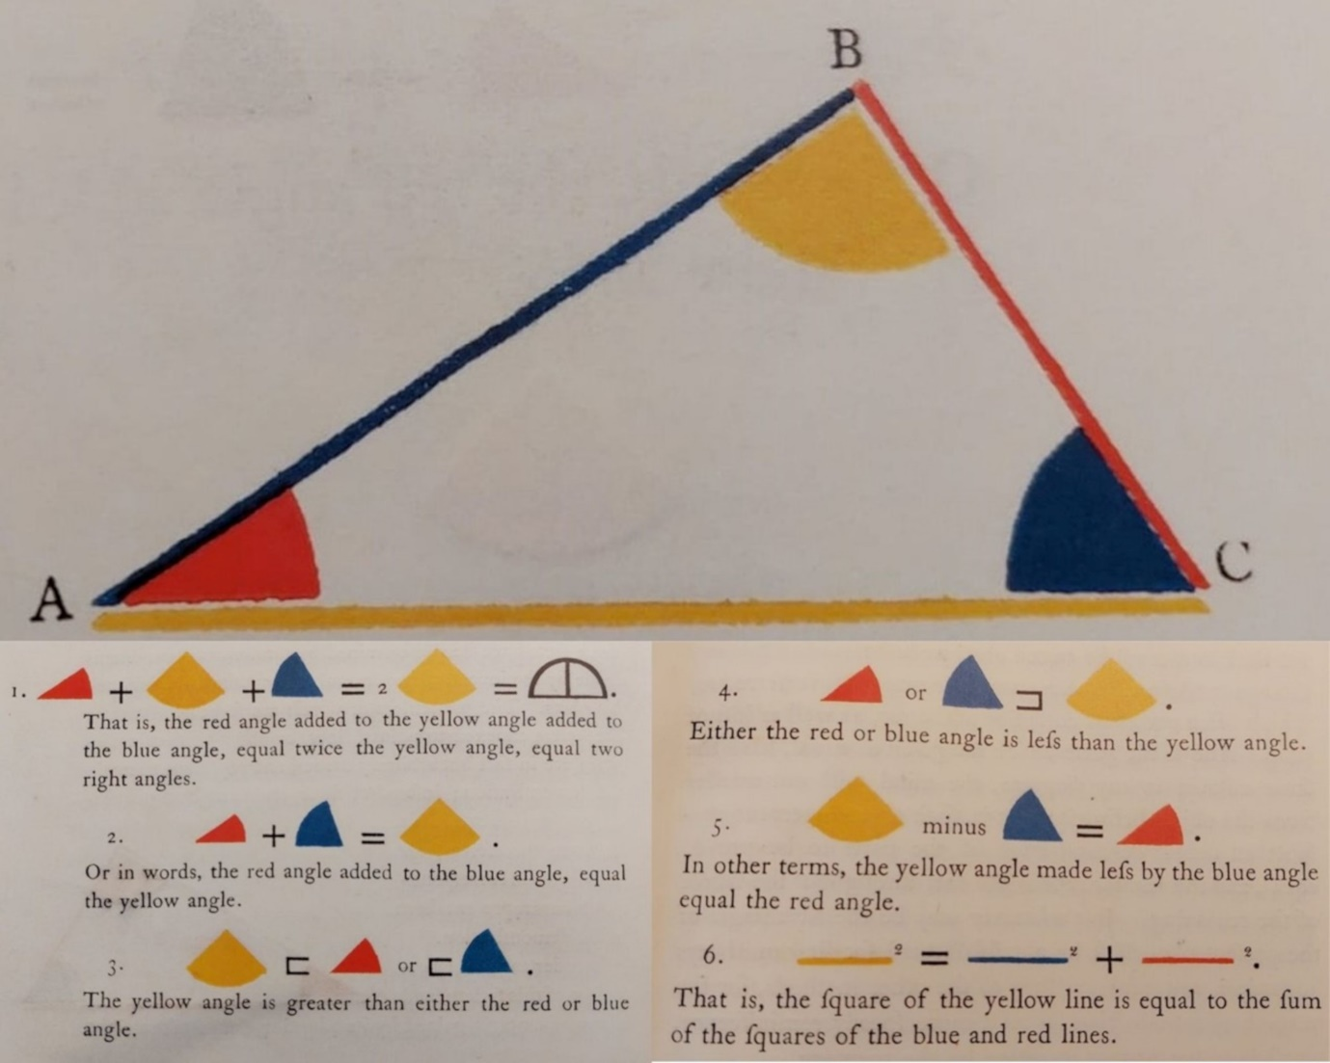
Fig. 3. Compilation of a diagram and related coloured, pictorial proof sections from pages ix, x and xi of Byrne’s Elements [20].
On Byrne’s model, a yellow angle (in the lower, proof-part of Fig.3) signifies the yellow angle in the diagram (top of Fig.3). Colour is vital to this process because it allows for discrimination between the various shapes that a mere sign of form (e.g., an angle, but not a yellow angle) could not. According to Byrne, this provides a nearly immediate signification, preventing the reader from doing the more complex work of beginning with an arbitrary name (‘ABC’), remembering the naming convention (three capital letters designate an angle), looking to the diagram to procedurally follow A through B to C to locate the geometric object under consideration, and then returning to the notation to see what use is being made of it. For Byrne, there is an immediacy in moving from a yellow angle to a yellow angle that (i) renders mistaken representation unlikely and (ii) means that reading and representing the contents of a complex sentence of mathematics requires less inferential and representational work. In Byrne’s words:
[W]hen lecturing on the principles or properties of figures, if we mention the colour of the part or parts referred to, as in saying, the red angle, the blue line, or lines, &c. the part or parts thus named will be immediately seen by all in the class at the same instant; not so if we say the angle ABC, the triangle PFQ, the figure EGKt, and so on; for the letters must be traced one by one before the students arrange in their minds the particular magnitude referred to, which often occasions confusion and error, as well as loss of time [21].
Byrne’s emphasis on the importance of effective mathematical illustration is equally clear in The Young Geometrician (1865). Its introduction expresses similar urgency around the need for illustrative accompaniments in mathematical pedagogy. In these diagrams, his focus is on aiding the reader in the recreation of geometric constructions. Thus, he needs to take the reader through a series of movements with a pair of rulers. In this text he uses colour coding to mark out the shape that needs to be moved in the constructions in each phase. This creative representation marks an expansion of the methodology in the Elements into directions for a more dynamic and applied procedure. In his own words:
In my Euclid the demonstrations are carried on by the use of coloured symbols, signs, and diagrams which renders the reasoning more precise, and the attainment more expeditious; but in this work, colour is made to indicate motion and also rest; for example, the red ruler has to be moved, while the blue ruler remains at rest [22].
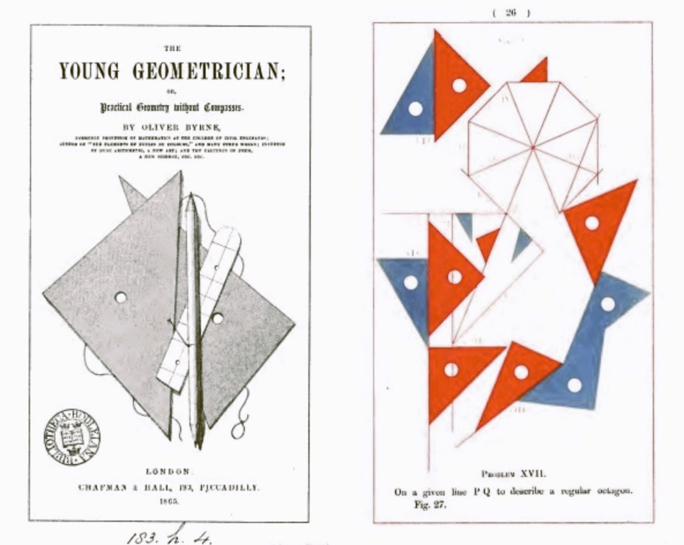
Fig. 4. Composite image of monochrome Title page and p. 26 (illustrated in red and blue) from The Young Geometrician (1865) [23].
Thus, both in his edition of Euclid’s Elements and in subsequent instructional texts, Byrne introduces philosophical and semiotic insights to challenge the conventional wisdom underlying the traditional organisation of mathematical diagrams used in teaching.
Picturing the Unpicturable
A further philosophical issue arises in Byrne’s methodology. In explaining the efficacy of coloured illustrations, he appealed to the importance of conveying an accurate sense of the objects of geometry. This is no mean feat. Consider the point, one of the primitive notions of geometry: by definition, a point has zero dimensions—no length, no breadth, no depth. If our canvass for illustrating a point is a blank printed page, we are in a difficult situation. The most accurate way to represent a point’s inherent properties would be to draw nothing at all. Historically, illustrators have drawn a small circle. This is understandable; given that the principal role of a point is to convey position, it is natural to feel a need to put something at (or, more precisely, surrounding) the relevant position. And yet, it’s easy to see how students might be misled into a mistaken sense of the true nature of the object in question.
Byrne described how colour might play a role in better depicting the nature of a mathematical point. He regarded the definition of a point as ‘that which has position, but not magnitude; or (…) position only, abstracted from the consideration of length, breadth, and thickness’ [24], as abstruse and likely to perplex learners. He continued:
Perhaps the following description is better calculated to explain the nature of a mathematical point to those who have not acquired the idea, than the above specious definition.
Let three colours meet and cover a portion of paper, where they meet is not blue, nor is it yellow, nor is it red, as it occupies no portion of the plane for if it did, it would belong to the blue, the red, or the yellow part; yet it exists, and has position without magnitude, so that with a little reflection, this junction of three colours on a plane gives a good idea of a mathematical point [25].
Fig. 5. Images of diagrams illustrating a point using coloured sectors and a line using coloured planes, from pages xiii and xiv of Byrne’s Elements [26]. 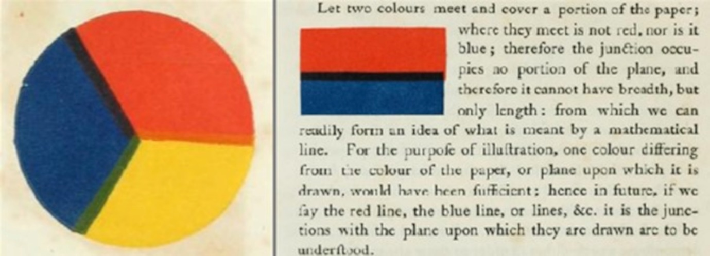
A line presents similar issues. Its definition as “length without breadth” is natural at first inspection, but when presented with the task of representing this empirically, we are stuck with the issue that we cannot depict length in true absence of breadth, because again, to do so faithfully leaves no mark on the page at all. Byrne sees an opportunity in the use of negative space suggested in the boundary (or, owing to printing technology, overlap) between two colours coming into contact.
Byrne’s motivation here is that the objects of geometry are abstract entities that cannot be represented accurately in empirical space. The monochromatic diagrams of classical mathematical illustration can be particularly misleading because they present a tempting approximation of the objects of geometry, according to which the student may be furnished with understandings of mathematical concepts that are flawed—for example, a concept of a mathematical point as a very small, filled circle, or of a line as a very short rectangle, when, strictly speaking, a point isn’t round at all and a line has no depth. Colour, according to Byrne, allows us to gesture at the true properties of geometrical objects by using negative space to suggest boundaries in a way that monochromatic, linear illustrations cannot. Thus, a point is the position suggested by three coloured sectors converging towards a common centre, and a line is a boundary between two blocks of colour.
Philosophical Influence
Byrne typically explains his drawings on pedagogical grounds alone, but it is worth thinking about philosophical influence in his motivations, especially given the breadth of his scholarly interests. As a comparison to Byrne’s mathematical diagrams, we might consider Dutch painter Piet Mondrian (1872-1944) and his Neo-plasticist aesthetic. Neo-plasticism, which employs only primary colours and horizontal and vertical lines, allowed Mondrian to present an abstract, pure version of art as “exact order” that “signifies the greater clarity of human consciousness in our time — and confirms human evolution” [27]. Mondrian found inspiration for his thinking on visual balance in pictures in the pre-Socratic philosopher Heraclitus’ doctrine of the “unity of opposites”, according to which contrary qualities are discovered in us as the same thing. Mondrian scholar Louis Veen saw the influence of the doctrine in Mondrian’s foregrounding of “opposing dualities” in his choices concerning “color vs non–color, horizontal vs vertical, small vs large, and matt vs glossy” [28]. 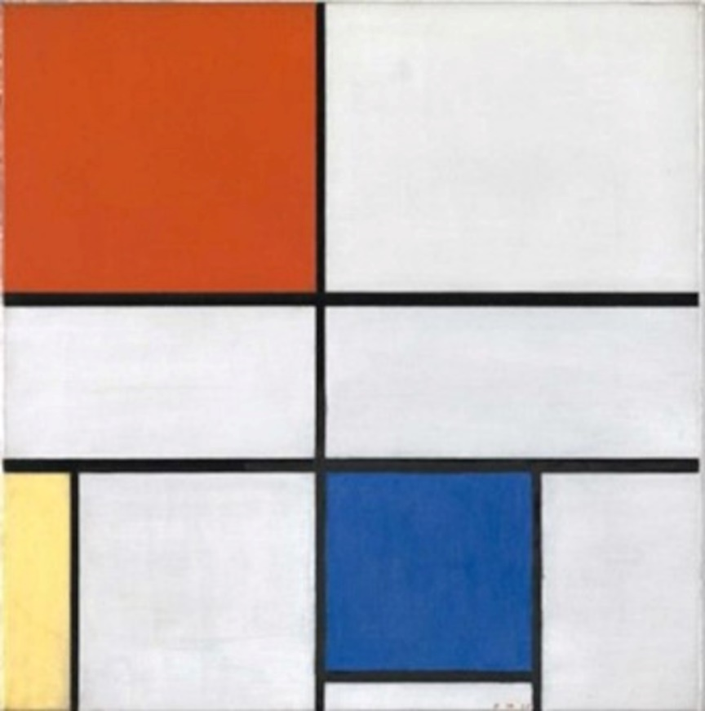Fig. 6. Piet Mondrian, Composition C (No. III) in Red, Yellow and Blue, oil on canvas, 56 x 52.2cm, 1935.
Byrne makes more mundane appeal to philosophical authority when emphasising the pedigree of the idea that geometrical learning is essential intellectual training:
If we wanted authorities to prove the importance and usefulness of geometry, we might quote every philosopher since the days of Plato. Among the Greeks, in ancient, as in the school of Pestalozzi and others in recent times, geometry was adopted as the best gymnastic of the mind [29].

A more theoretically potent influence may be found in the works of fellow Irish mathematical eccentric, George Berkeley (1685-1753). Berkeley is famous in the mathematics world for his 1734 criticism of calculus, The Analyst. Berkeley’s text decried the logical and metaphysical underpinnings of a theory so revered in the development of early modern mathematics that disagreement over who truly invented it (between Newton and Leibniz) caused a substantial and enduring rift between the scientific communities of Britain and continental Europe. Berkeley argued that calculus failed to live up to the standards of rigour advocated by mathematics. His critique of the logical coherence of infinitesimals and fluxions ultimately played a positive role in subsequent, more rigorous re-instantiations of calculus, and many of the key mathematicians contributing to that evolution cited Berkeley as a source of concerns that spurred them on in their work [30]. Even Abraham Robinson (1918-1974), in the 1960s, appealed to Berkeleyan objections when explaining the logic and metaphysics underlying his re-interpretation of a roughly Leibnizian, highly technical re-founding of analysis in his nonstandard model [31].
Significantly, like Byrne, Berkeley was deeply concerned with the functioning of mathematical signs, and the empirical inadequacy of much formal geometry was a dominant theme in his mathematical philosophy.
Few early modern thinkers devoted as much energy to thinking about semiotics and signs as Berkeley. When Berkeley offered a novel account of meaning in his 1732 dialogue Alciphron, he had his philosophical mouthpiece Euphranor say that he believes “the doctrine of signs a point of great importance and general extent, which, if duly considered, would cast no small light upon things, and afford a just and genuine solution to many difficulties” [32]. Berkeley’s own spin on “the doctrine of signs” represents a non-negligible part of his philosophical system, and to do it any justice here would outrun the humble business of this little paper, but it is fascinating how often Berkeley chooses examples of mathematical signs as exemplary of his thinking [33]. Equally, when Berkeley ruminates on what he takes to be the failure of mathematicians to take the philosophical concerns of their own discipline seriously, it is often in ignorance over the functioning of signs that he assigns the cause of the trouble. In the queries appended to the end of his critique of calculus, he asks:
Qu. 26 Whether mathematicians have sufficiently considered the analogy and use of signs? And how far the specific limited nature of things corresponds thereto [34]?

Further, Berkeley is renowned for a radical empiricism that found fault with the mismatch between the abstract properties of mathematical objects and the empirical world mathematics often sought to describe. This same radical empiricism caused him, in his private notebooks, to make the following remarks on the geometer’s definition of a line, familiar from Byrne’s grappling therewith above:
Demonstrations of the infinite divisibility of extension suppose length without breadth ⋀ [which] is absurd.
or invisible length
3 faults occur in the arguments of the Mathematicians, for divisibility ad infinitum. I. they suppose extension to exist without the mind or not perceiv'd. 2. they suppose that we have an idea of length without breadth. * or that length without breadth does exist. 3 that unite [sic] is divisible ad infinitum [35].

Though these notebooks were private (and undiscovered in Byrne’s time) Berkeley’s views on the empirical inadequacy of pure mathematics to the world it sought to describe are also available in the mathematical queries appended to The Analyst. There, the context is the mathematical propensity for invoking infinitely small and large entities, both of which Berkeley denounces, but he believes these tendencies arise from the general practice of considering the proper subjects of geometry as abstract general ideas.
Qu. 1 Whether the object of geometry be not the proportions of assignable extensions? And whether there be any need of considering quantities either infinitely great or infinitely small?
Qu. 20 Whether all arguments for the infinite divisibility of finite extension do not suppose and imply, either general abstract ideas or absolute external extension to be the object of geometry [36]?

At least in his early instructional texts, Byrne never follows the Berkeleyan conclusion that the abstract nature of pure geometrical objects makes them unsuitable subjects for a mathematical system that needs to apply to the experiential world. However, perhaps it is a recognition of this mismatch between theory and actuality that motivates his creative thinking in illustrating them.

Byrne’s last known work, The Trinal Calculus, was an obscure text, and like Berkeley’s The Analyst, it was directed towards what he regarded as logical problems with calculus and infinitesimal mathematics. It was never published, but the Department of Manuscripts and Archives at Trinity College Dublin contains an ornately decorated manuscript, titled “Oliver Byrne’s Trinal Calculus” complete with signature of “Mrs Eleonor Byrne.” By the time he was preparing The Trinal Calculus, Byrne was clearly thinking more about Berkeley’s mathematical ideas and a new discovery suggests that Berkeley’s objections to the rigour of calculus were front and centre in his mathematical motivations. Indeed, in his final text, where he attempted his own rigorous re-founding of calculus, we find the following fascinating acknowledgements of Berkeley’s influence. The subtitle on the title page of The Trinal Calculus reads ‘The Differential and Integral Calculus, under different forms and titles, have been based on visionary notions and false logic; these defects, which Bishop Berkeley and other writers clearly exposed, are fully remedied by The Trinal Calculus” [37]. (See Fig. 7.)
Byrne’s final mathematical project was an avowed continuation of Berkeley’s crusade against illogical foundations in calculus. As a final fascinating connection, the ‘Appendix’ to Byrne’s Trinal Calculus is simply the text of Berkeley’s Analyst. Behind a hand-illustrated titlepage for the appendix section sits a copy of Berkeley’s Analyst text, complete with Byrne’s annotations (see right hand side of Fig. 7).
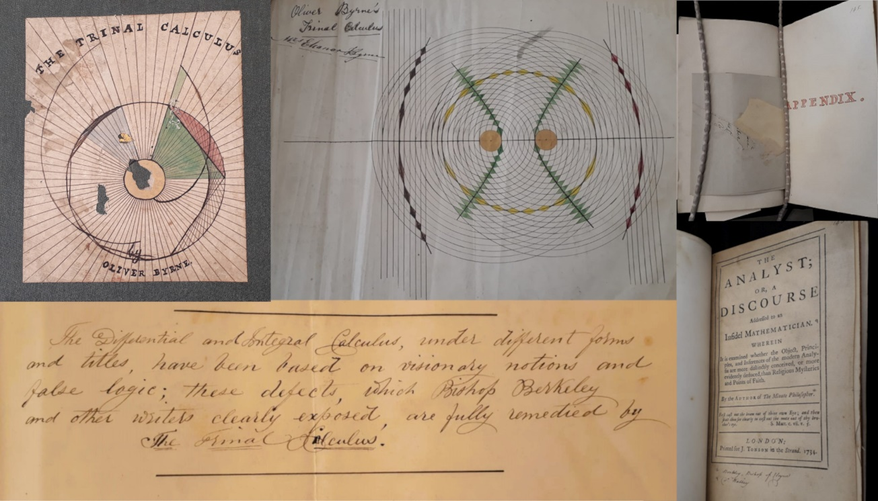
Fig. 7. Composite image, showing elements of The Trinal Calculus (IE TCD MS1205 in the Trinity College Dublin Manuscripts Archive). Clockwise: pictorial cover; hand illustrated frontispiece; appendix; copy of Berkeley’s The Analyst as the appendix section; the subtitle of the work, explaining Berkeley’s influential role. Courtesy of the Board of Trinity College Dublin [38].
This paper demonstrates a first connection between two of Ireland’s most interesting contributors to mathematical history. It suggests that a similar radical spirit dominated the mathematical interventions of Oliver Byrne and George Berkeley, and that in addition to the spiritual echoes of Berkeleyan themes in Byrne’s descriptions of his mathematical illustrations and the ideas that motivate them, a firm link in an unpublished text in the Trinity College Dublin Manuscripts Archive provides material evidence of the prominence of Berkeley’s ideas in Byrne’s mathematical motivations.

Acknowledgements
Funding for this research was provided by the Irish Research Council (Project: 209259; Award:15884). I would like to express gratitude to my colleagues Amelia McConville and Autumn Brown for inviting me to discuss Byrne at their series in the Science Gallery Dublin, my sister Aoife for giving me Byrne’s Euclid as a Christmas present in 2013, and Cydney Thompson for invaluable assistance with the images. I gratefully acknowledge the Board of Trinity College Dublin in permitting my reproduction of the materials from IE TCD MS1205 in Fig. 7.

Notes and References
- Oliver Byrne, The First Six Books of Euclid’s Elements (London: William Pickering, 1847). Byrne’s featured texts are all in the public domain.
- Benjamin Wardhaugh, Encounters with Euclid (London: William Collins, 2020) p. 310.
- Byrne [1] p. vii.
- Susan M. Hawes and Sid Kolpas, “Oliver Byrne: The Matisse of Mathematics,” Convergence, August 2015. Hawes & Kolpas provide a lucid account of Byrne's various professional disappointments and hardships, including: Byrne’s description of an early Euclid text as “in the press” that ultimately “never reached a seller”; his fifteen applications to the Royal Literary Fund for financial support, the first (in 1839) from debtor’s jail; money lost on a railway scheme that meant that in 1848 he was “compelled to deliver up in court the copyrights of very valuable books, [including] that of my ‘Euclid by Colours’; and, his claim that the publishers of the (successful) dictionary of engineering he spent over four years editing had contrived to deprive him of his royalties.
- Bernard Warrington, “William Pickering and the Book Trade in the Early Nineteenth Century,” Bulletin of the John Rylands Library 68, No. 1, 247-266. (1985)
- Given its rarity and beauty, Byrne’s Elements is extremely valuable. A current search at abebooks.com suggests a first edition might cost as much as $22,500. Fortunately, one can purchase an inexpensive beautiful full color facsimile, edited by art and architecture historian Werner Oechslin and published by Taschen America. I am grateful to an anonymous reviewer for this insight.
- Warrington [5] p.252.
- Geoffrey Keynes, William Pickering, Publisher (London: Galahad Press, 1969) p37.
- The book was one of only four chosen by Pickering to showcase his talents in a display at the Great Exhibition of 1851. See Warrington [5] p.259.
- Byrne [1] pp.4-5.
- Byrne [1] p. xii.
- Byrne [1] p. xvii.
- In 1869-70 Rugg Byrne published two texts dealing with weather prediction based on observed patterns of historical seasonal variations, the wind, and the phases of the moon. Eleanor Rugg Byrne, A Short Philosophical Treatise on the Atmosphere, and the Influence of the Changes of the Moon on the Weather; and the Variations of the Weather Represented by Weather Indicators, from the First of July 1869, to the First of January, 1870, to Which is Subjoined Interesting Matter, (London: E. & F. N. Spon, 1869) and The Useful Weather Guide, for the First Six Months of the Year 1870 (London: E. & F. N. Spon, 1870).
- Byrne [1] p. xii-xiii.
- Oliver Byrne, The Young Geometrician, or, Practical Geometry without Compasses (London: Chapman & Hall, 1865).
- Byrne [15] p. vii.
- Semiotics is the study of signs or how things (words, symbols etc.) can stand for other things. Traceable back at least to John Locke (1632-1704) (related to his “doctrine of ideas”), the study is often regarded as beginning (in its modern sense) with Ferdinand de Saussure (1857–1913) and Charles Sanders Peirce (1839–1914). See Lagopoulos, Alexandros Ph., and Karin Boklund-Lagopoulou, ‘A Brief History of Semiotics’, in Theory and Methodology of Semiotics, (The Hague: De Gruyter Mouton, 2021).
- Byrne [1] p. ix.
- Byrne [1] p. ix.
- Byrne [1] pp. ix-xi.
- Byrne [1] pp. xi-xii.
- Byrne [15] p.vi.
- Byrne [15] title page and p.26.
- Byrne [1] p. xiii.
- Byrne [1] p. xiii-xiv.
- Byrne [1] p. xiii-xiv.
- Piet Mondrian, H. Holtzmann and M. S. James, ‘General Principals of Neo-Plasticism’, The New Art, The New Life, (New York: Da Capo Press, 1993).
- Louis Veen, “Piet Mondrian on the Principles of Neo–Plasticism,” International Journal of Art and Art History, Vol. 5, No. 2, pp. 1-12 (2017), p. 6.
- Byrne [1] p. vii.
- Noteworthy examples across three centuries include Colin Maclaurin (1698-1746), Richard Dedekind (1831-1916), and Abraham Robinson (1918-1974).
- Abraham Robinson, “The Metaphysics of the Calculus”, Problems in the Philosophy of Mathematics, (Amsterdam: North-Holland, 1967), p.35.
- George Berkeley, The Works of George Berkeley, Bishop of Cloyne, Vols 1-9, (London: Thomas Nelson, 1948-57). See: Alciphron, Dialogue 7:13, p.307.
- In his first published work Miscellanea Mathematica, Berkeley proposes that the use of the radical sign for expressing square roots be overhauled in favour of a simpler signage (he suggested using Roman and Latin numerals to signify corresponding roots and powers). George Berkeley, Miscellanea Mathematica, (Dublin, Trinity College Dublin, 1707) p.41.
- Berkeley [32] The Analyst, p. 99.
- Berkeley [32] Philosophical Commentaries, notebook entries 21, 21a and 342.
- Berkeley [32] The Analyst, pp. 96-98.
- IE TCD MS1205 in Trinity College Dublin’s Manuscript Library. Permission courtesy of the Board of Trinity College Dublin.
- [37]

Biographical Information

Clare Marie Moriarty is an Irish Research Council Postdoctoral Fellow in the Philosophy Department of Trinity College Dublin. She received her PhD from King’s College London.
ORCID: 0000-0003-0830-3746

