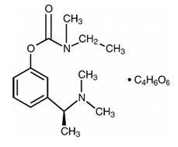
Figure 1 Rivastigmine hydrogen tartrate chemical structure
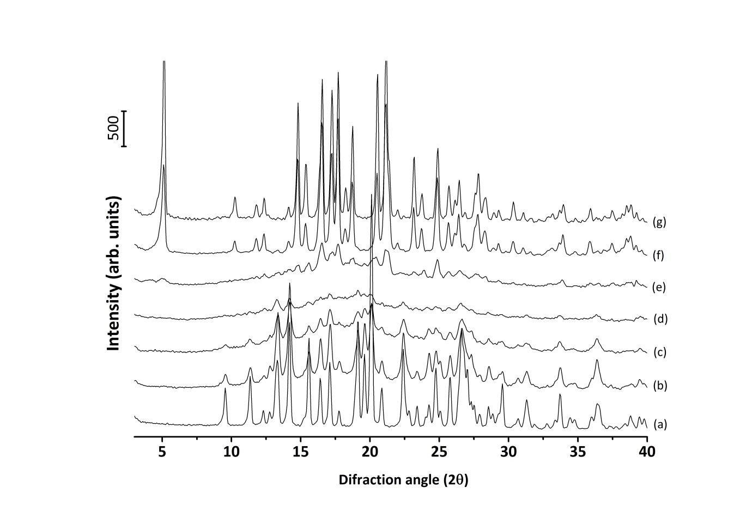
Figure 2 PXRD patterns of (a) RHT as supplied/form II, ball milled for (b) 15min, (c) 30min, (d) 1h, (e) 2h and (f) 3h, and (g) RHT form I recrystallized from isopropanol.
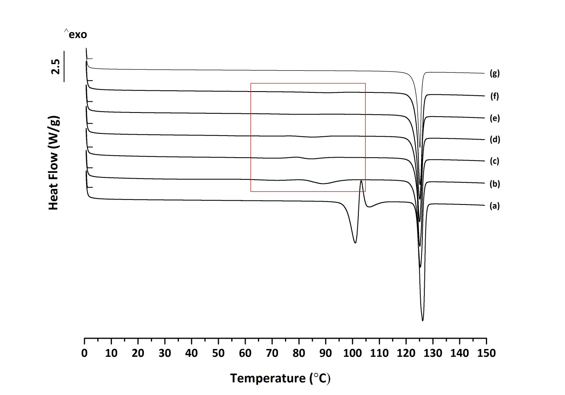
Figure 3 DSC scans of of of (a) RHT as supplied/form II, ball milled for (b) 15min, (c) 30min, (d) 1h, (e) 2h and (f) 3h, and (g) RHT form I recrystallized from isopropanol.
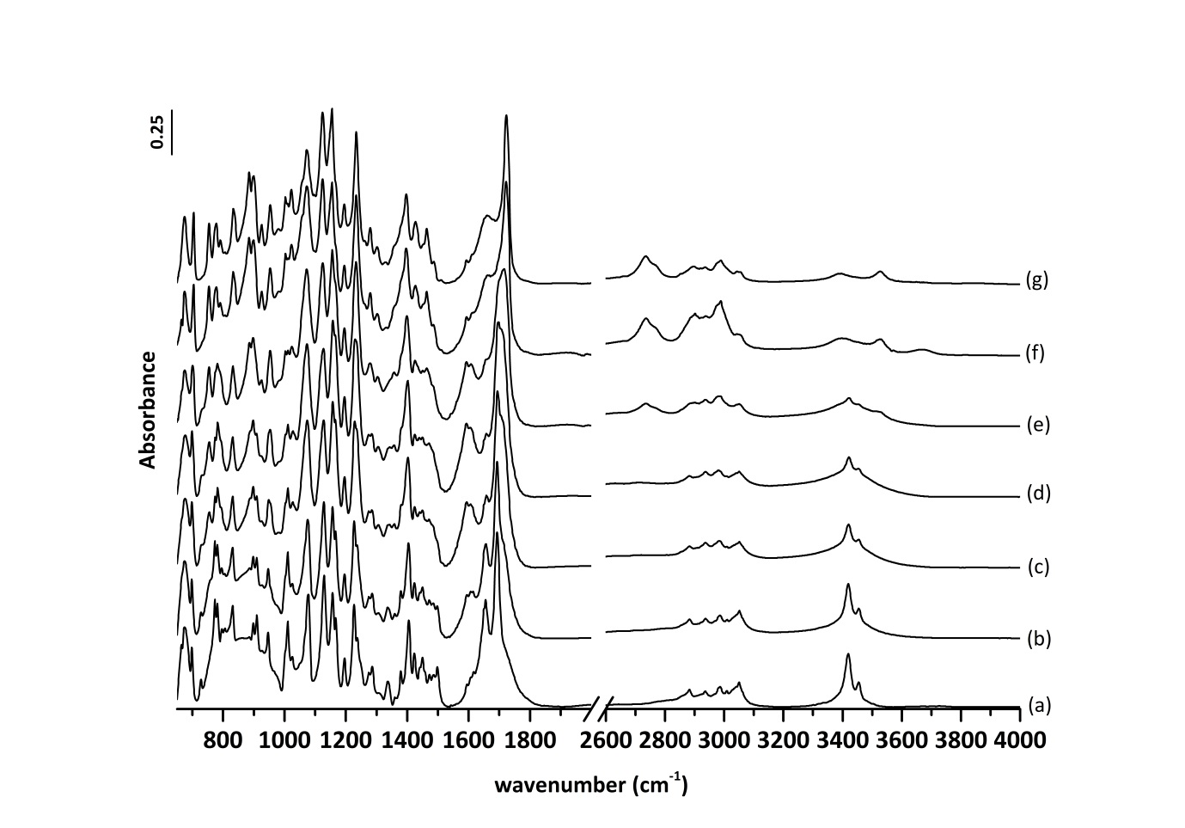Figure 4 ATR-FTIR spectra of of (a) RHT as supplied/form II, ball milled for (b) 15min, (c) 30min, (d) 1h, (e) 2h and (f) 3h, and (g) RHT form I recrystallized from isopropanol.

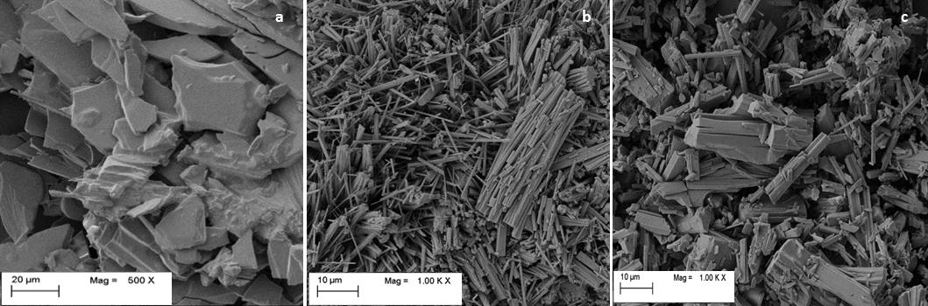
Figure 5 SE Micrographs of (a) RHT polymorphic form I, (b) RHT polymorphic form II and, (c) “as supplied” RHT.
A)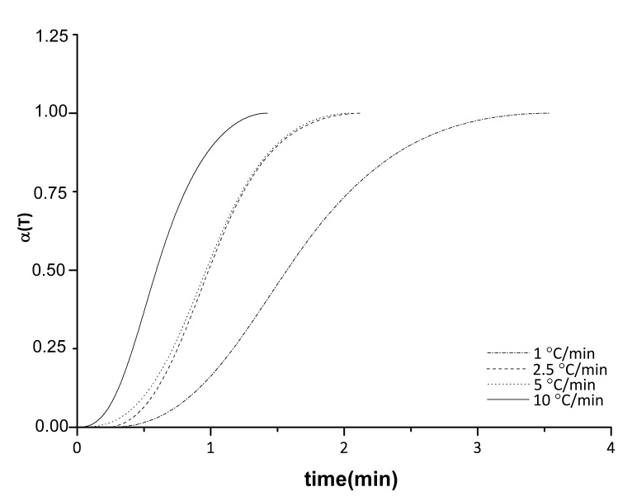
B)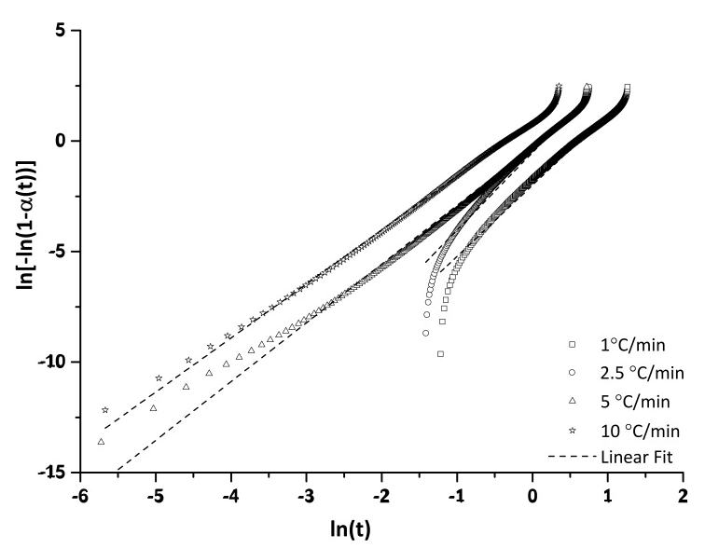
Figure 6 (A) Polymorphic transition degree (α(T)) as a function of transition time at different heating rates, and (B) Jeziorny-modified-Avrami plots for the polymorphic transition at different heating rates.

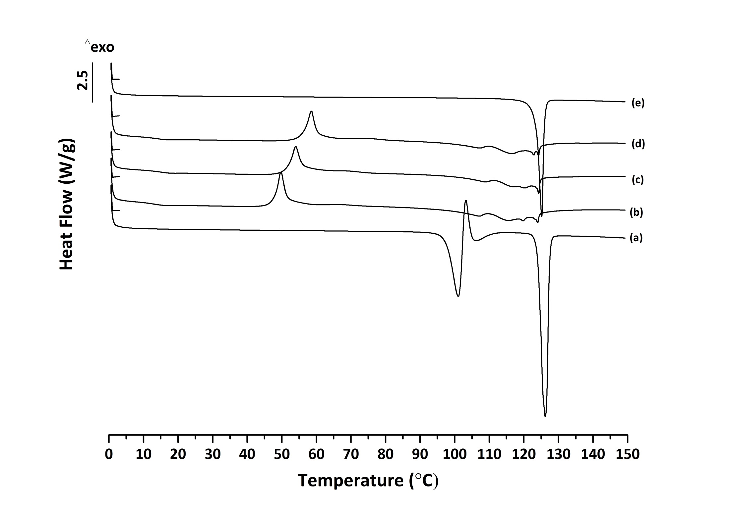
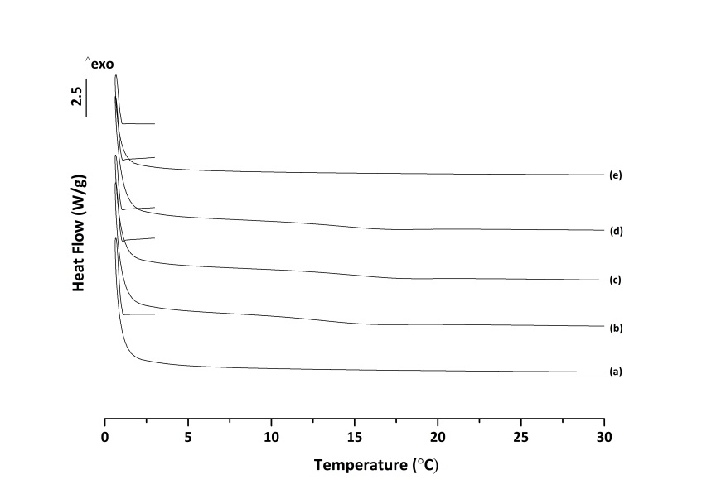
A) 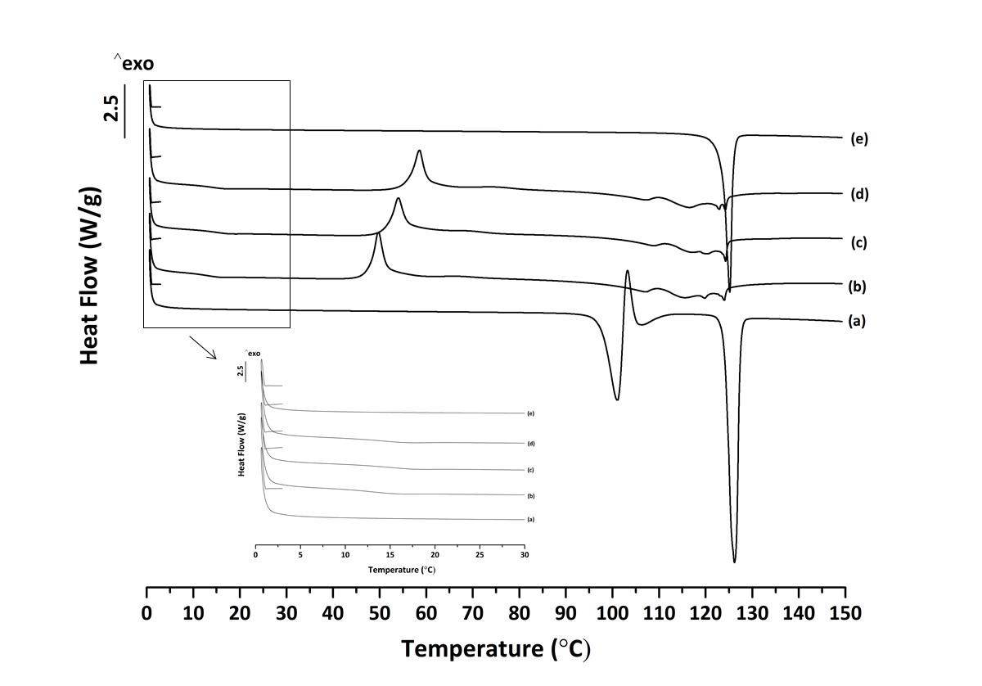
B) 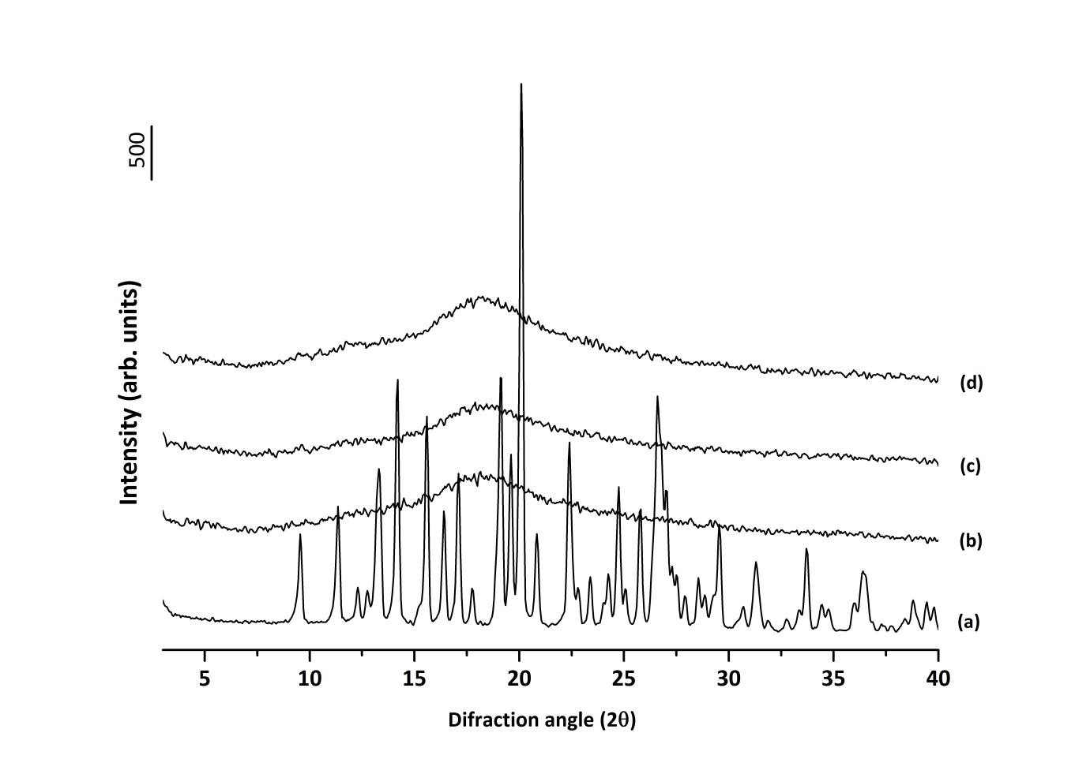
Figure 7 A) DSC scans of of of (a) RHT as supplied/form II, ball milled continuously for (b) 1h, (c) 2h and (d) 3h, and (e) RHT form I. B) PXRD patterns of (a) RHT as supplied/form II, ball milled continuously for (b) 1h, (c) 2h and (d) 3h.

A) 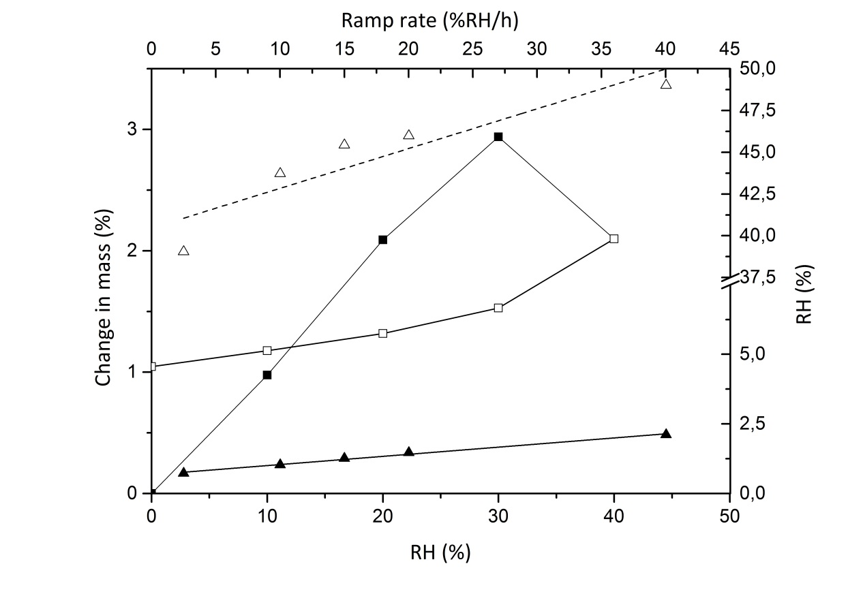
B) 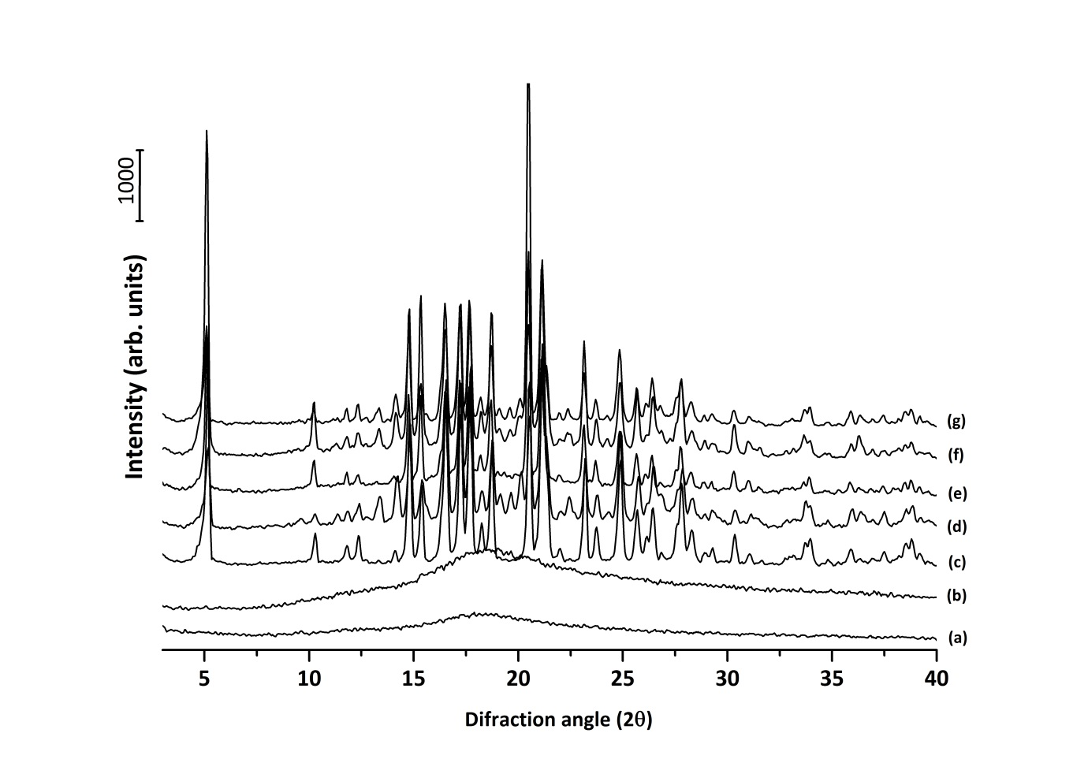Figure 8 A) DVS studies: RHT amorphous isotherms () sorption and () desorption; RHg versus ramping rate () and RHc versus ramping rate (), dash and solid lines are the linear fit to the ramping rate studies. B) PXRD patterns of (a) RHT amorphous, after DVS ramp studies at (b) 2.5%RH/h, (c) 10%RH/h, (d) 15%RH/h, (e) 20 %RH/h, (f) 40%RH/h, and (g) after DVS step study.

