Figure S1: TGA of physical mixture CAF:DAP(1:1) (A); cocrystal obtained by LAG CAF:DAP(1:1) using acetone (B), using ethanol (C) and using ethyl acetate(D); cocrystal obtained by spray drying CAF:DAP(1:1) using acetone (E), using ethanol (F) and using ethyl acetate (G).
Figure S2: FTIR spectra of physical mixture CAF:DAP(1:1) (A), cocrystal obtained by milling LAG CAF:DAP(1:1) using acetone (B), using ethanol (C) and using ethyl acetate(D). Cocrystal obtained spray drying CAF:DAP(1:1) using acetone (E), using ethanol (F) and using ethyl acetate (G).

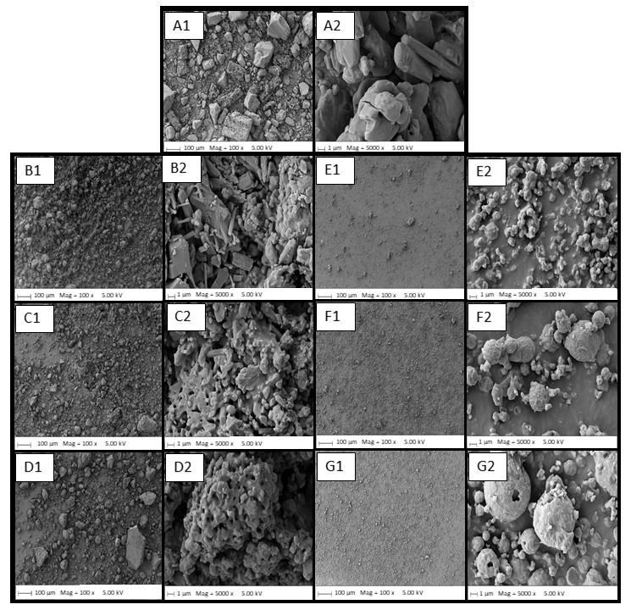
Figure S3: SEM of physical mixture CAF:DAP(1:1) (A1 and A2); cocrystal obtained by LAG CAF:DAP(1:1) using acetone (B1 and B2), using ethanol (C1 and C2) and using ethyl acetate(D1 and D2); cocrystal obtained by spray drying CAF:DAP(1:1) using acetone (E1 and E2), using ethanol (F1 and F2) and using ethyl acetate (G1 and G2). Magnification 1 = 100 X and 2 = 5.0K X

Table S1: Melting point and enthalpy energy obtained by DSC analysis (=3)
Sample | Temperature (ºC) | Enthalpy (J/g)
CAF | 161.1±0.6 | 18.6±0.6
 | 237.8±0.5 | 108.0±1.1
DAP | 83.3±0.0 | 7.5±0.1
 | 179.3±0.1 | 88.3±0.3
CAF/DAP(1:1) physical mixture | 83.4±0.3 | 3.3±0.5
 | 139.1±0.1 | 0.2±0.0
 | 162.0±0.6 | 36.6±3.5
 | 176.2±0.2 | 20.4±4.5
CAF/DAP(1:1)_SlowEvap_Acetone | 158.0±1.3 | 2.4±2.0
 | 176.9±0.1 | 67.4±23.8
CAF/DAP(1:1)_LAG 15_Acetone | 176.8±0.2 | 102.5±1.7
CAF/DAP(1:1)_LAG 30_Acetone | 176.7±0.1 | 103.01.5
CAF/DAP(1:1)_LAG 45_Acetone | 176.4±0.0 | 104.4±0.9
CAF/DAP(1:1)_SPRAY_Acetone | 175.6±0.1 | 98.9±0.2
CAF/DAP(1:1)_LAG 30_ethanol | 176.4±0.3 | 104.2±0.6
CAF/DAP(1:1)_SPRAY_EtOH | 176.3±0.2 | 99.8±1.9
CAF/DAP(1:1)_SLOW Evap_eEthylAcet | 83.2±0.0 | 0.8±0.6
 | 132.8±0.6 | 4.0±0.6
 | 159.5±0.2 | 5.1±1.1
 | 177.0±0.1 | 105.9±17.5
CAF/DAP(1:1)_LAG 30_Ethyl acetate | 176.6±0.1 | 104.3±0.4
CAF/DAP(1:1)_SPRAY_EthylAcet | 175.7±0.1 | 96.5±1.6

Table S2: Solubility of dapsone (DAP) from cocrystal samples obtained by milling and spray drying
Samples | Time
 | 30 min | 1 h | 2 h | 4 h | 24 h
 | Average ± SD  (µg/mL) | Average ± SD  (µg/mL) | Average ± SD  (µg/mL) | Average ± SD  (µg/mL) | Average ± SD  (µg/mL)
DAP API | 189.8 ± 8.5 | 188.6 ± 2.6 | 207.9 ± 16.2 | 209.8 ± 7.1* | 217.1 ± 7.8
CAF/DAP(1:1)_LAG 30_Acetone | 415.0 ± 9.4* | 447.5 ± 15.0* | 448.6 ± 0.0* | 448.0 ± 15.7* | 507.6 ± 32.1*
CAF/DAP(1:1)_LAG  30_ Ethanol | 412.5 ± 7.5* | 447.5 ± 14.3* | 437.0 ± 12.9* | 449.9 ± 19.3* | 501.5 ± 13.1*
CAF/DAP(1:1)_LAG  30_ Ethyl acet. | 395.2 ± 9.5* | 448.6 ± 26.7* | 435.1 ± 14.2* | 455.8 ± 12.4* | 526.4 ± 20.6*
CAF/DAP(1:1)_SPRAY_  Acetone | 401.0 ± 15.7* | 430.7 ± 15.7* | 422.6 ± 13.7* | 445.9 ± 18.8* | 506.5 ± 31.0*
CAF/DAP(1:1)_SPRAY_  Ethanol | 425.8 ± 13.5* | 442.1 ± 9.4* | 440.8 ± 8.4* | 459.9 ± 12.3* | 512.9 ± 17.5*
CAF/DAP(1:1)_SPRAY_  Ethyl acet. | 414.5 ± 14.2* | 428.5 ± 4.4* | 434.5 ± 2.5* | 445.9 ± 4.2* | 512.3 ± 32.7*
*(P <0.05) compared with DAP API

